S60 3.x
ICalUI
Design Document

Team name | Author
S60 Messaging team | Taneli Haverinen (taneli.haverinen@sysopendigia.com)

Change history:

Version | Date | Status | Comments
1.0 | 18.07.2006 | Approved

Table of contents:

1. Document control 5
1.1 References 5
1.2 Documentation conventions 5
1.3 Abbreviations 5
1.4 Definitions 5
2. General 7
2.1 Introduction 7
2.2 Component environment 7
2.3 Use cases 8
2.3.1 Create meeting request (as organizer) 9
2.3.2 Edit meeting request (as organizer) 9
2.3.3 Send iCal to recipients (as organizer) 10
2.3.4 Reschedule meeting request (as organizer) 10
2.3.5 Cancel meeting request (as organizer) 10
2.3.6 View meeting request/cancellation (as organizer) 11
2.3.7 Receive response (as organizer) 11
2.3.8 View meeting request/cancellation (as attendee or non-participant) 11
2.3.9 View from Calendar (as attendee or non-participant) 11
2.3.10 View from mail (as attendee or non-participant) 12
2.3.11 Respond to a request (as attendee) 12
2.3.12 Delete meeting request (as attendee or non-participant) 12
2.3.13 Reply via mail (as attendee or non-participant) 13
2.3.14 Forward (as attendee or non-participant) 13
2.4 Services required 13
2.4.1 From the Symbian OS subsystems 13
2.4.2 From the Domestic OS subsystems 14
2.4.3 From HW 14
2.5 Services provided 14
2.5.1 UI 14
2.5.2 SW IF 14
3. UI control hierarchy 15
4. Design 16
4.1 Class diagrams 16
4.1.1 Framework 16
4.1.2 Agenda Entry UI 16
4.1.3 MR Mailbox Utils 17
4.1.4 MR Viewer and MR Utilities interfaces 18
4.2 Class descriptions 18
4.2.1 Structs, type definitions and enumerations 18
4.2.1.1 MRCommands.hrh 18
4.2.2 Flag definitions 19
4.3 Operations 20
4.3.1 Launching MR Viewer from the Calendar application 20
4.3.2 Launching MR Viewer from Mail 21
4.3.3 Closing MR Viewer from the Calendar application 22
4.3.4 Closing MR Viewer from Mail 23
4.4 Backup and Restore 24
5. Variation 25
6. System resource usage 26
6.1 Files 26
6.2 Other data 26
6.2.1 Databases 26
6.2.2 Central Repository 26
6.2.3 Publish and Subscribe 26
6.3 Memory consumption 26
6.4 Task allocation 26
6.5 Performance 26
6.6 Timers 26
7. Security 27
7.1 Capabilities of this component 27
7.2 Input and output validation 27
7.3 Environmental assumptions 27
7.4 Additional enforcements 27
8. Exception handling 28
9. Usage 29
9.1 Building 29
9.2 User's guide 29
9.2.1 Using Agenda Entry UI 29
9.2.2 Using MR Mailbox Utilities 29
9.2.3 Third party ECom registration resources 30
9.2.4 Requirements for a third party MR Mail Adaptation 31

Document control

References
- RFC 2445 - Internet Calendaring and Scheduling Core Object Specification (iCalendar) | http://www.ietf.org/rfc/rfc2445.txt
- RFC 2446 - iCalendar Transport-Independent Interoperability Protocol (iTIP) Scheduling Events, BusyTime, To-dos and Journal Entries | http://www.ietf.org/rfc/rfc2446.txt
- RFC 2447 - iCalendar Message-Based Interoperability Protocol (iMIP) | http://www.ietf.org/rfc/rfc2447.txt

Documentation conventions
Code is shown with the Courier New font.
In diagrams, the following coloring convention is used:

Color | Description | Usage
 | The colored item belongs to ICalUI. | Component diagrams
 | The colored item is external, not belonging to ICalUI. | Component diagrams
 | The colored item is external and conceptual, not necessarily existing in real life as such. | Component diagrams
 | Denotes a concrete class. | Class diagrams
 | Denotes an abstract base class. | Class diagrams
 | Denotes a pure virtual interface class. | Class diagrams

Abbreviations
MR | Meeting Request
MTM | Message Type Module

Definitions
Third party | A Mail solution implementing the required ICalUI ECom interfaces and complementing the meeting request support.
CCalEntry | Symbian software representation of a Calendar event. Contains all the relevant data to implement iCal (see reference document [1]) and iTip (see reference document [2]) protocols.
Calendar DB | Calendar database where Calendar events are stored.
iCal | Internet Calendaring and Scheduling Core Object, see reference document [1].
iMip | iCalendar Message-Based Interoperability Protocol, see reference document [3].
iTip | iCalendar Transport-Independent Interoperability Protocol, see reference document [2].
MR entry | Any CCalEntry which represents a VEvent. An MR entry may represent either a request, a cancellation or a response.
VEvent | A Calendar component representing a meeting request, specified in reference document [1].

General

Introduction
This document describes the design of the S60 ICalUI subsystem. ICalUI is a collection of components and interfaces and it acts as an enabler to implement full support for receiving, handling and creating meeting requests.
Meeting requests are Calendar events, which consist of scheduling information and an attendee list wrapped in iCal objects, and which follow the iTip protocol to exchange status data and to update or cancel requests. Furthermore, the iMip protocol is used for transportation via email.
ICalUI operates in close relationship with the Calendar and Messaging frameworks.

Component environment
Figure 2.1 illustrates the ICalUI dependencies to its components and to services provided by other components. Some common Symbian OS components (such as EUSER, ESTOR, etc.) are omitted from the picture for clarity.
The components of ICalUI are the following:

Component | Type | Description
Agenda Entry UI | ECom component | An ICalUI entry point component acting as a switch to launch a proper viewer for CCalEntry objects.
MR Mailbox Utilities | ECom component | A collection of utility methods related to messaging binding of meeting requests.

Complementary components implemented by a third party are:

Component | Type | Description
Third party MR viewers | ECom component | The UI and required processing functionality to view MR entries.
Third party MR utilities | ECom component | A component implementing specified fundamental UI operations on MR entries.
Third party MR mail adaptation | Any | Any implementation, which supports receiving and sending MR entries via email.

ICalUI handles viewing CCalEntry objects received via messaging through a third party MR mail adaptation implementation, and furthermore editing and viewing entries in the Calendar application. Agenda Entry UI performs preliminary evaluation and propagates entries to the correct viewer or editor. CCalEntry objects may represent either MR entries (i.e. VEvents) or other supported types, such as VTodos. MR entries are launched in the MR Viewers plug-in, whereas in other cases, Calendar Editor is executed. Calendar Editor is an S60 component, whereas MR Viewers must be implemented by a third party.
MR Mailbox Utilities contains the necessary messaging related utilities and is provided by ICalUI. On the other hand, the implementation of MR Utilities is dependent on the used mail solution. Thus ICalUI specifies only the interface and the implementation is left for a third party. It is assumed that MR Mailbox Utilities and MR Utilities are also accessed from the third party implementation, but that is not definite and such dependencies are not shown in the diagram.
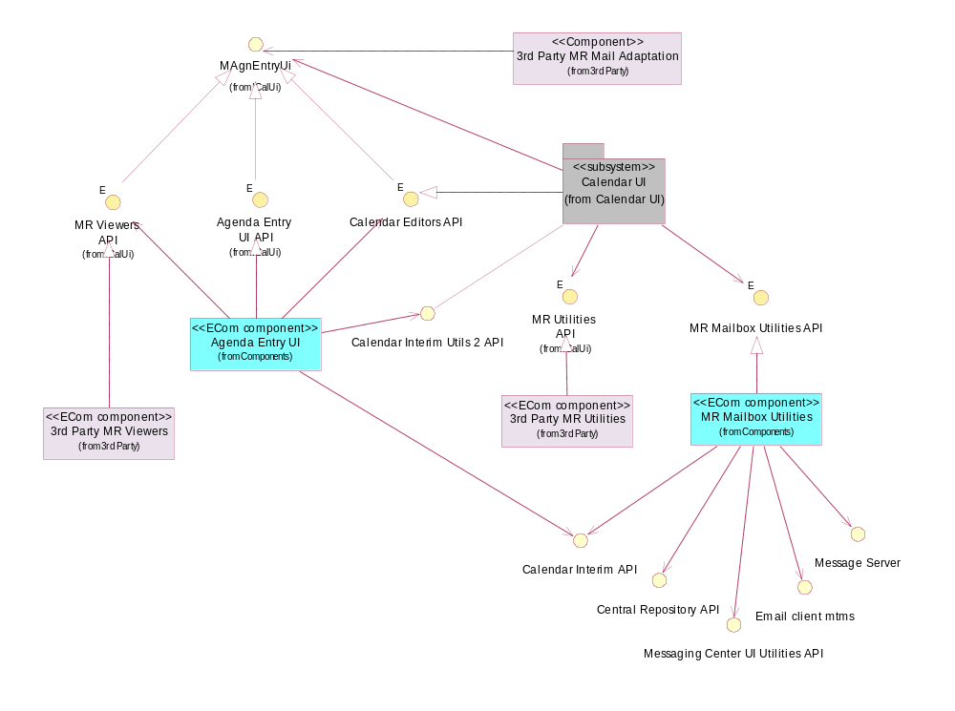
Figure 2.1 ICalUI component environment

Use cases
The most important use cases involving ICalUI are shown in Figure 2.2 and Figure 2.3. However, ICalUI acts only as an enabler and a third party implementation is needed to realize the use cases.
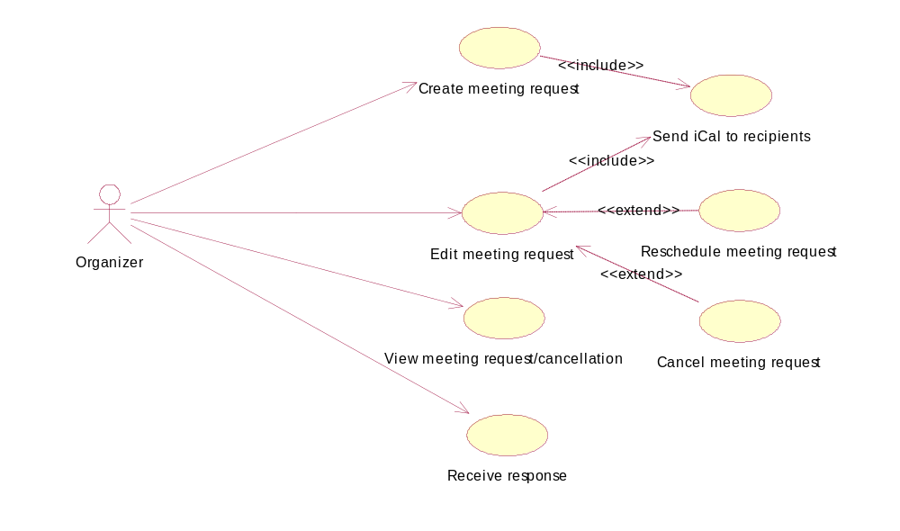
Figure 2.2 Meeting organizer use cases
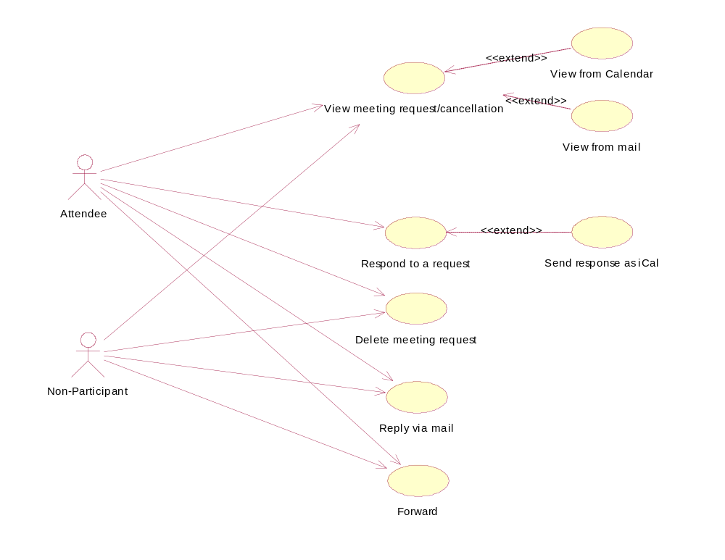
Figure 2.3 Attendee and non-participant use cases

Create meeting request (as organizer)
Summary | An organizer creates a new meeting request from scratch in the Calendar application.
Actor(s) | The organizer.
Frequency | Low frequency.
Preconditions
Description | The organizer creates a request for a new meeting, which may also be repeating. The request is usually sent immediately (see Section 2.3.3), but may also be saved without sending.
Exceptions | In case of low disk space, the request cannot be saved.  In case of an exit request from OS, the editor is closed and the request cannot be saved.
Postconditions | The new request is created in Calendar DB, with the attendee statuses marked as Please respond.

Edit meeting request (as organizer)
Summary | The organizer edits an existing meeting request in the Calendar application.
Actor(s) | The organizer.
Frequency | Low frequency.
Preconditions | A meeting request exists in Calendar DB.
Description | The organizer edits a meeting, which may also be repeating. The request is usually sent after the editing (see Section 2.3.3), but it may also be saved without sending. See Sections 2.3.4 and 2.3.5 for extensions of this case.
Exceptions | In case of low disk space, the modifications cannot be saved.  In case of an exit request from OS, the editor is closed and the modifications cannot be saved.
Postconditions | The request is updated in Calendar DB, with the attendee statuses marked as Please respond.

Send iCal to recipients (as organizer)
Summary | The organizer sends a request or a cancellation to attendees in the Calendar application.
Actor(s) | The organizer.
Frequency | Low frequency.
Preconditions | A valid request or cancellation has been created and has not been sent yet, a mailbox supporting the sending of MRs exists.
Description | The organizer sends a request or cancellation to attendees. The meeting request is sent via email.
Exceptions | In case of low disk space, the iCal cannot be sent.  In case of a network problem, the message is only moved to the Outbox for later sending.
Postconditions | The request status is marked as Sent.

Reschedule meeting request (as organizer)
Summary | The organizer reschedules a meeting in the Calendar application.
Actor(s) | The organizer.
Frequency | Low frequency.
Preconditions | See Section 2.3.2.
Description | The organizer reschedules a meeting or an instance of a meeting. This case is an extension of the use case described in Section 2.3.2.
Exceptions | See Section 2.3.2.
Postconditions | See Section 2.3.2.

Cancel meeting request (as organizer)
Summary | The organizer cancels a meeting in the Calendar application.
Actor(s) | The organizer.
Frequency | Low frequency.
Preconditions | See Section 2.3.2. Furthermore, the meeting must take place in the future.
Description | The organizer cancels a meeting or an instance of a meeting. This case is an extension of the use case described in Section 2.3.2.
Exceptions | See Section 2.3.2.
Postconditions | The request is marked as cancelled.

View meeting request/cancellation (as organizer)
Summary | The organizer views a meeting request or a cancellation from the Calendar application or Mail.
Actor(s) | The organizer.
Frequency | Low frequency.
Preconditions | The organizer has created the viewed request or cancellation.
Description | This is a rather rare use case in case of the organizer. Usually the organizer sees the MR entries in the Edit mode, but in the following cases only viewing is allowed:  - An MR entry is opened in the Calendar application but no MR-capable mailbox exists.  - An email containing an MR is opened from the Messaging application’s Outbox or Sent items.
Exceptions | In case of an exit request from OS, the viewer is closed.
Postconditions | None.

Receive response (as organizer)
Summary | The organizer receives a response to a request in the Messaging application.
Actor(s) | The organizer.
Frequency | Low frequency.
Preconditions | A request has been sent to a respondent.
Description | The organizer receives a response to the request, either to the entire meeting or possibly to an instance of a repeating meeting.
Exceptions | In case of an invalid response, the response is not accepted or saved.  In case of low disk space, the response cannot be saved.
Postconditions | The attendee status is updated.

View meeting request/cancellation (as attendee or non-participant)
Summary | An attendee or non-participant views a meeting request or a cancellation.
Actor(s) | An attendee or non-participant.
Frequency | Low frequency.
Preconditions | None.
Description | An attendee or non-participant views a meeting request or a cancellation. The request may also be an update to an earlier version, in which case more complicated iTip evaluation logic is involved. See Sections 2.3.9 and 2.3.10 for specializations of this use case.
Exceptions | In case of an exit request from OS, the viewer is closed.
Postconditions | None.

View from Calendar (as attendee or non-participant)
Summary | An attendee or non-participant views a meeting from the Calendar application.
Actor(s) | An attendee or non-participant.
Frequency | Low frequency.
Preconditions | A meeting exists in Calendar DB.
Description | This case is a specialization of the use case described in Section 2.3.8. The meeting already exists in Calendar DB. The user has the option to respond to the request if the user is an attendee (see Section 2.3.11).
Exceptions | See Section 2.3.8.  In case the MR entry is invalid or outdated, only viewing is allowed.
Postconditions | NOne.

View from mail (as attendee or non-participant)
Summary | An attendee or non-participant views a meeting from Mail.
Actor(s) | An attendee or non-participant.
Frequency | Low frequency.
Preconditions | An MR entry exists in the mailbox.
Description | This case is a specialization of the use case described in Section 2.3.8. If the MR entry is opened for the first time, it is automatically saved to Calendar DB. The user has the option to respond to the request if the user is an attendee (see Section 2.3.11).
Exceptions | See Section 2.3.8.  If the MR entry is invalid or outdated, only viewing is allowed.  In case of low disk space, the MR entry cannot be saved.
Postconditions | If the MR entry is opened for the first time, it is saved to Calendar DB.

Respond to a request (as attendee)
Summary | An attendee responds to a meeting request.
Actor(s) | An attendee.
Frequency | Low frequency.
Preconditions | An MR-capable mailbox must exist in the device.
Description | The attendee responds to a meeting request, either to the entire meeting or to an instance of it. The response is sent to the organizer as an iCal message via email. The decision is not definitive; the attendee may change the status later on. In case the meeting gets rescheduled, a new response is required. The attendee may also decide to change the attendance status without sending a response.
Exceptions | In case of low disk space, the iCal cannot be sent.  In case of a network problem, the message is only moved to the Outbox for later sending.
Postconditions | The attendee status is updated and the response is sent to the organizer.

Delete meeting request (as attendee or non-participant)
Summary | An attendee or non-participant deletes a meeting request from Calendar DB.
Actor(s) | An attendee or non-participant.
Frequency | Low frequency.
Preconditions | A meeting exists in Calendar DB.
Description | The attendee or non-participant deletes a meeting request from Calendar DB. The attendee may choose to send a response with the Declined status to the organizer.
Exceptions | None.
Postconditions | The meeting is deleted from Calendar DB.

Reply via mail (as attendee or non-participant)
Summary | An attendee or non-participant sends a reply via email.
Actor(s) | An attendee or non-participant.
Frequency | Low frequency.
Preconditions | None.
Description | The attendee or non-participant is viewing an MR entry and sends a reply via email to the organizer, message sender or to all meeting participants. This is only possible when viewing an MR entry in the Messaging application.
Exceptions | In case of low disk space, the email message cannot be created.  In case of a network problem, the message is only moved to the Outbox for later sending.
Postconditions | The email reply is sent, but it does not affect the MR in any way.

Forward (as attendee or non-participant)
Summary | An attendee or non-participant forwards an MR entry via email.
Actor(s) | An attendee or non-participant.
Frequency | Low frequency.
Preconditions | The meeting must take place in the future.
Description | An attendee or non-participant forwards an MR entry via email. This is only possible when viewing an MR entry in the Messaging application.
Exceptions | In case of low disk space, the email message cannot be created.  In case of a network problem, the message is only moved to the Outbox for later sending.
Postconditions | The MR entry is forwarded, but it does not affect the MR’s status in the user’s device in any way.

Services required

From the Symbian OS subsystems
The services listed in the following table are required.

API | Description
BAFL API | Used for descriptor arrays.
Calendar Interim API | Used for handling MR entries.
Calendar Interim Utils 2 API | Used for Calendar related utilities.
Central Repository API | Used for persistent data.
Character Conversion API | Used for character conversions.
CONE API | Used for accessing CONE.
ECom API | Used for implementing ECom plug-in architecture.
ESTOR API | Used for descriptor handling.
Mail Client MTM API | Used for mailbox handling.
Message Server Client Side API | Used for utilizing the Messaging framework.
Messaging UI Utilities API | Used for Messaging related utilities.

From the Domestic OS subsystems
This component does not have any direct interfaces to the Domestic OS side subsystems.

From HW
This component has no direct HW interfaces.

Services provided

UI
ICalUI itself acts as an enabler and does not provide UI services.

SW IF
Provided Service | Description | Protected
Agenda Entry UI API | An ECom interface and implementation for launching a proper viewer for CCalEntry objects. | Yes
MR Mailbox Utilities API | An ECom interface and implementation for a collection of utility methods related to messaging binding of meeting requests. | Yes
MR Viewer API | An ECom interface definition to be implemented by a third party. The implementation should handle the viewing of MR entries. | Yes
MR Utilities API | An ECom interface definition to be implemented by a third party. The implementation should handle predefined utility tasks. | Yes

UI control hierarchy
The component does not contain any UI or UI controls.

Design

Class diagrams

Framework
ICalUI is not based on a metamodel.

Agenda Entry UI
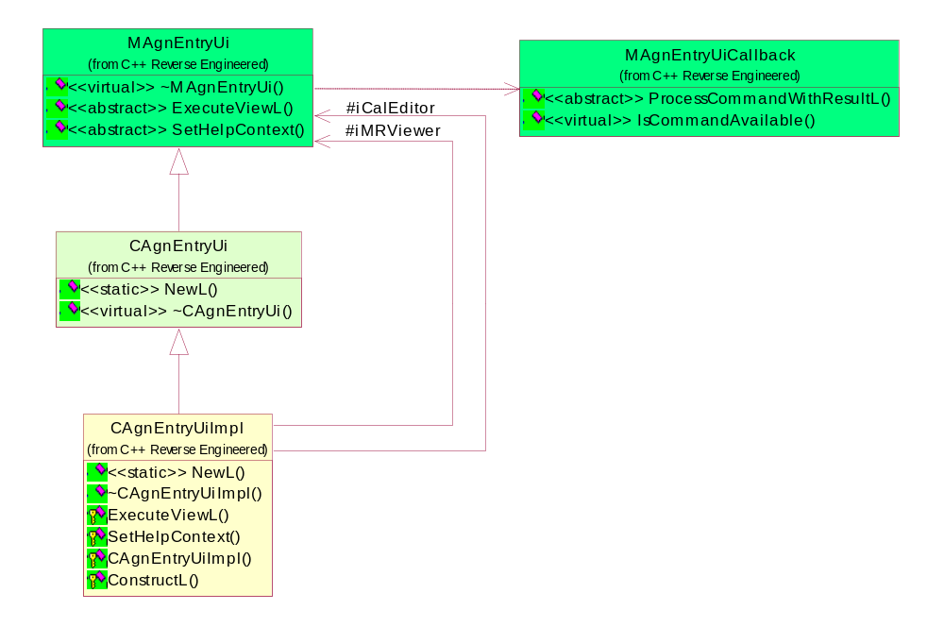
Figure 4.4 Agenda Entry UI structure
Figure 4.4 shows Agenda Entry UI. Firstly, MAgnEntryUi is an interface that is common to all editors and viewers for CCalEntry objects as explained in Section 2.2. Its main purpose is to specify a method for launching a viewer or editor and the input and output parameters to be used.
CAgnEntryUi on the other hand is the ECom interface for Agenda Entry UI. It allows the client to instantiate the plug-in, which is realized in the CAgnEntryUiImpl class.
MAgnEntryUiCallback specifies an interface that the client must realize in order to allow the client to handle commands that are not handled by the class deriving from MAgnEntryUi.

MR Mailbox Utils
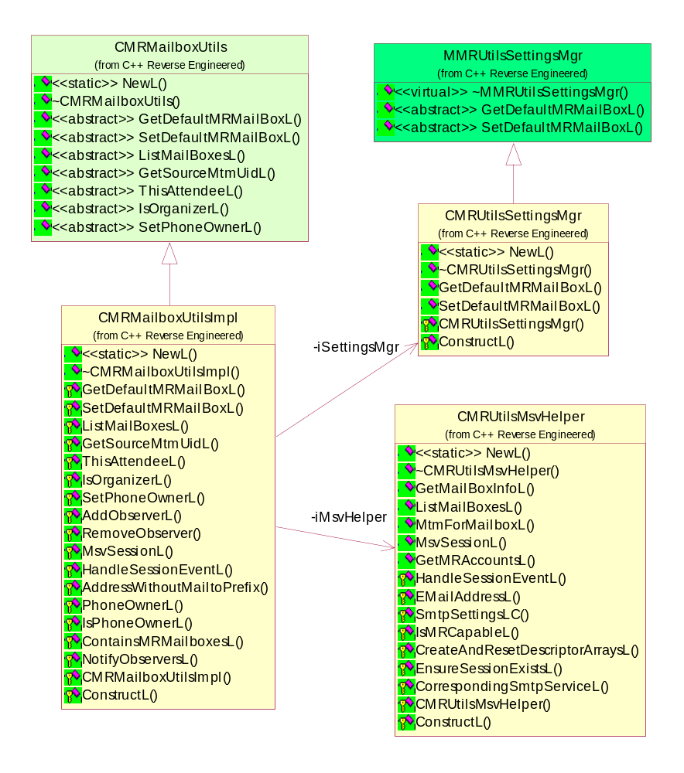
Figure 4.5 MR Mailbox Utils structure
Figure 4.5 shows MR Mailbox Utils. CMRMailboxUtils is an ECom interface class and the only class visible to the clients. CMRMailboxUtilsImpl is an ECom plug-in implementation class, and CMRUtilsMsvHelper and CMRUtilsSettingsMgr are internal helper classes encapsulating closely related responsibilities.

MR Viewer and MR Utilities interfaces
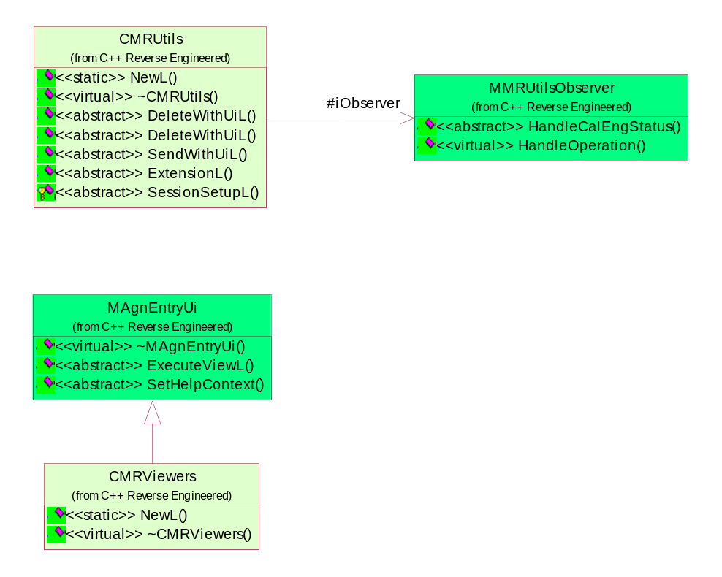
Figure 4.6 MR Viewer and MR Utilities interfaces
Figure 4.6 shows the interfaces that must be implemented by a third party. CMRUtils specifies an ECom interface for handling certain UI tasks with MR entries, and MMRUtilsObserver is needed to inform the client about the status of Calendar Interim API Engine as well as the status of asynchronous tasks.
CMRViewers is an ECom interface for viewing MR entries, inheriting from MAgnEntryUi, which is the common interface for all editors and viewers for CCalEntry objects as explained in Section 2.2.

Class descriptions
Refer to the class diagrams and the header files for the class descriptions.

Structs, type definitions and enumerations
See the class header files for the documentation of structs, type definitions and enumerations. Section 4.2.1.1 lists the UI commands that may be used with MAgnEntryUiCallback.

MRCommands.hrh
Enumeration's name | Description
EMRCommandRespondAccept | Command to respond and exit the viewer.
EMRCommandRespondTentative | Command to respond and exit the viewer.
EMRCommandRespondDecline | Command to respond and exit the viewer.
EMRCommandReplyToSender | Command to reply with an email message.
EMRCommandReplyToOrganiser | Command to reply with an email message.
EMRCommandReplyToAll | Command to reply with an email message.
EMRCommandForward | Command to forward a request as an email message.
EMRCommandRetrieve | Command to retrieve email attachments.
EMRCommandRemoveFromCalendar | Command to remove the MR from Calendar DB and exit the viewer.
EMRCommandShowCalendar | Command to launch the Calendar application.
EMRCommandAttachments | Command to view email attachments.
EMRCommandMessageDetails | Command to view email message details.
EMRCommandDisableAlarm | Command to disable request alarm.
EMRCommandShowDescriptionView | Command to launch the MR Details view.
EMRCommandShowAttendeesView | Command to launch the Attendee view.
EMRCommandShowSummaryView | Command to launch the MR Summary view.
EMRCommandSave | Command to save the request.
EMRCommandSaveFromFile | Command to save the MR to Calendar DB from a file.
EMRCommandSaveAndExit | Command to save the request and exit the viewer.
EMRCommandSend | Command to send the request and exit the viewer.
EMRCommandSendUpdate | Command to send an update and exit the viewer.
EMRCommandCancelMR | Command to cancel a request and exit the viewer.
EMRCommandDeleteMR | Command to delete a request and exit the viewer.

Flag definitions
ICalUI defines flags only for debugging purposes as shown in the following table.

Flag | Description
ICALUI_ENABLE_LOGGING | When ICalUI is compiled with this flag defined, debugging data is logged to a file if the directory c:\logs\icalui exists in the device.
ICALUI_ENABLE_MRDATA_LOGGING | This flag is for evaluating and testing data.  Note: Reserved for future use.

Operations

Launching MR Viewer from the Calendar application
Operation | Launching MR Viewer from the Calendar application.
Preconditions | It is assumed in this sequence that a third party MR solution is available in the device and that an MR-capable mailbox has been stored in the Central Repository setting and exists in the device.  The Calendar application has instantiated a MR Mailbox Utilities plug-in and has an open CCalSession object.
Description | The Calendar application first reads the mailbox to be used with MR Viewer, and sorts out the MTM UID name corresponding to that mailbox. That information is needed to resolve and instantiate the correct third party components via Agenda Entry UI (it is possible that several MR solutions for different MTMs exist in the device simultaneously).  The Calendar application then fills in the required input parameters and executes the viewer. At this stage, Agenda Entry UI detects that the entry to be viewed is an MR entry, and therefore decides to launch MR Viewer instead of a Calendar editor.
Inputs | For plug-in instantiation:  - const TDesC8& aMtmUid: The MTM UID name as a descriptor.  For viewer execution:  - RPointerArray<CCalEntry>& aEntries: The viewed MR entries. In case of a Calendar application array, always contains just one entry.  - TUid iCallingApp: The calling application, i.e. the Calendar application’s UID.  - CCalSession& iCalSession: The session handle.  - TAgnEntryUiEditorMode iEditorMode: The editor mode, i.e. ECreateNewEntry, EEditExistingEntry or EViewEntry.  - TCalTime iInstanceDate: Specifies the instance to be viewed in case the MR entry is a repeating meeting, otherwise not applicable.  - TMsvId iMailBoxId: The mailbox ID, not applicable with the Calendar application.  - TMsvId iMessageId: The message ID, not applicable with the Calendar application.  - CMsvSession* iMsgSession: The session handle, may be NULL.  - MAgnEntryUiCallback& aCallback: The callback reference.
Modifies | This sequence does not modify data.
Outputs
Postconditions | MR Viewer is launched according to iEditorMode and the MR entry data is processed and rendered in the UI. MR Viewer is ready for user actions.
Related To | See Sections 2.3.1, 2.3.2, 2.3.6 and 2.3.9..
Related Event | See Section 4.3.3.
Exceptions | In case of an exit request from OS, MR Viewer is closed.

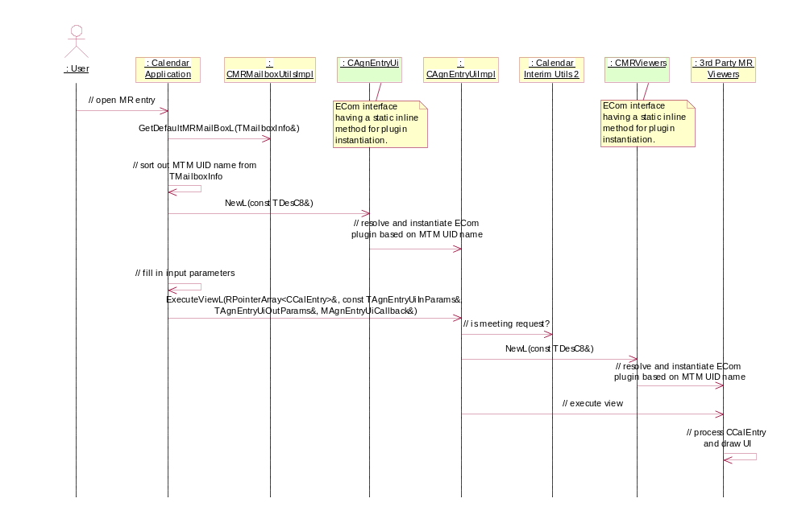
Figure 4.7 Launching MR Viewer from the Calendar application

Launching MR Viewer from Mail
Operation | Launching MR Viewer from Mail.
Preconditions | It is assumed in this sequence that a third party MR solution is available in the device, and that the third party MR Mail Adaptation has an e mail containing an iCal message and an open CCalSession object.
Description | The third party MR Mail Adaptation should import the iCal and sort out the MTM UID name of this particular third party mailbox. The rest of the sequence differs from the operation described in Section 4.3.1 only by the input parameters given.
Inputs | For plug-in instantiation:  - const TDesC8& aMtmUid: The MTM UID name as a descriptor.  For viewer execution:  - RPointerArray<CCalEntry>& aEntries: The viewed MR entries. In this scenario, there may be either just one entry or an originating entry and exceptions.  - TUid iCallingApp: The calling application, i.e. the third party Mail Adaptation UID.  - CCalSession& iCalSession: The session handle.  - TAgnEntryUiEditorMode iEditorMode: The editor mode, in this scenario should always be EViewEntry.  - TCalTime iInstanceDate: Specifies the instance to be viewed, not applicable in this scenario.  - TMsvId iMailBoxId: The mailbox ID of this particular third party mailbox.  - TMsvId iMessageId: The message ID of this particular email message.  - CMsvSession* iMsgSession: The session handle, not mandatory but in this scenario most probably available.  - MAgnEntryUiCallback& aCallback: The callback reference.
Modifies | This sequence does not modify data.
Outputs
Postconditions | MR Viewer is launched in the View-only mode and the MR entry data is processed and rendered in the UI. MR Viewer is ready for user actions.
Related To | See Sections 2.3.6, 2.3.7 and 2.3.10.
Related Event | See Section 4.3.4.
Exceptions | In case of an exit request from OS, MR Viewer is closed.

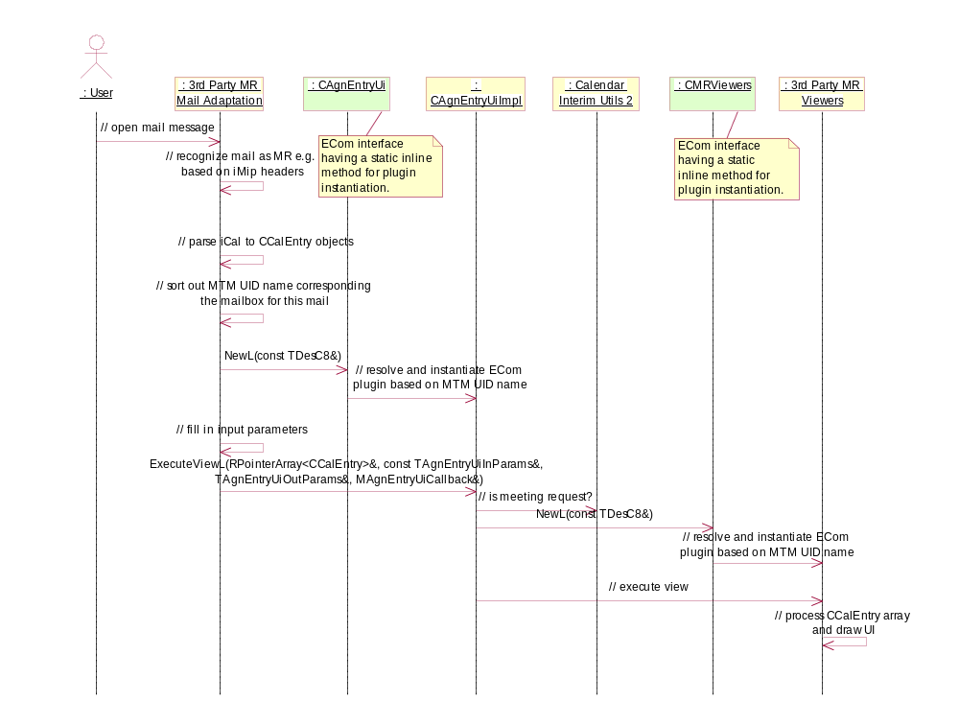
Figure 4.8 Launching MR Viewer from Mail

Closing MR Viewer from the Calendar application
Operation | Closing MR Viewer from the Calendar application.
Preconditions | MR Viewer is open.
Description | The user closes MR Viewer after editing or viewing an MR in the Calendar application.
Inputs | See Section 4.3.1 for the input parameter description.
Modifies | This sequence updates the edited entry in Calendar if MR Viewer has been executed in the ECreateNewEntry or EEditExistingEntry mode and the user performed modifying actions, i.e. the output action code was not ENoAction.
Outputs | From viewer execution:  - TAgnEntryUiAction iAction: The action that was performed, ENoAction, EMeetingSaved, EMeetingDeleted, EInstanceDeleted or EInstanceRescheduled.  - TCalTime iNewInstanceDate: Used with EInstanceRescheduled to inform the new DTSTART value.  - TInt: The return code, KErrNone or a system wide error code.
Postconditions | MR Viewer is closed and the control returns to the Calendar application.
Related To | See Sections 2.3.1, 2.3.2, 2.3.6 and 2.3.9.
Related Event | See Section 4.3.1.
Exceptions | In case of low disk space, the modifications cannot be saved.

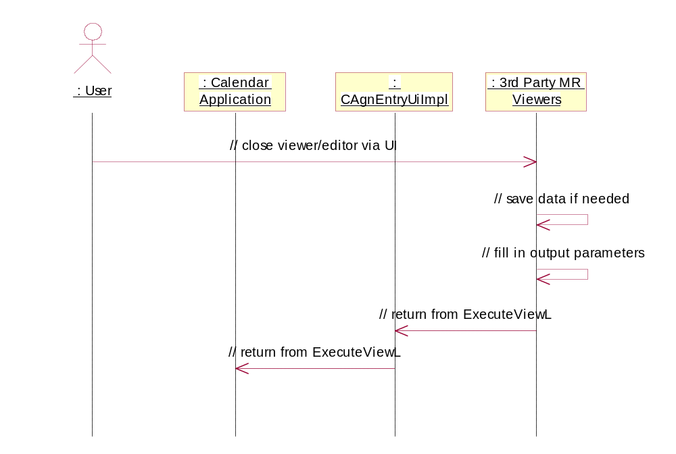
Figure 4.9 Closing MR Viewer from the Calendar application

Closing MR Viewer from Mail
Operation | Closing MR Viewer from Mail.
Preconditions | MR Viewer is open.
Description | The user closes MR Viewer after viewing an MR from an email message.
Inputs | See Section 4.3.2 for the input parameter description.
Modifies | MR Viewer may have updated Calendar DB while the MR Viewer was executing, but some implementations may save the updates in the closing phase.
Outputs | From viewer execution:  - TAgnEntryUiAction iAction: The action that was performed: ENoAction or EMeetingSaved.  - TCalTime iNewInstanceDate: Not applicable in this scenario.  - TInt: The return code, KErrNone or a system wide error code.
Postconditions | MR Viewer is closed and the control returns to the third party MR Mail Adaptation.
Related To | See Sections 2.3.6, 2.3.7 and 2.3.10.
Related Event | See Section 4.3.2.
Exceptions | In case of low disk space, the modifications cannot be saved.

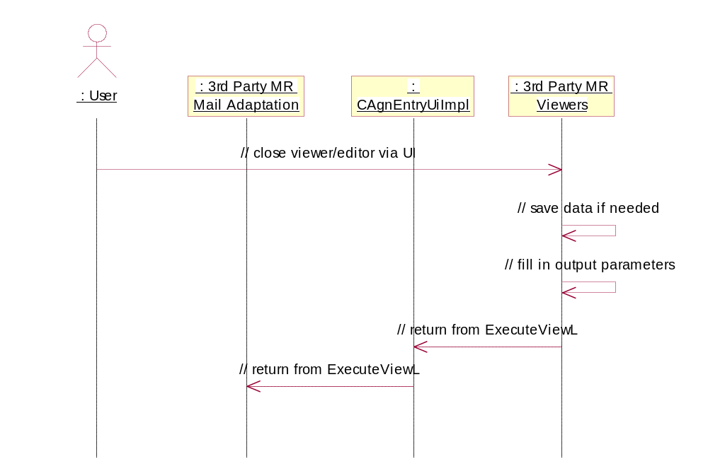
Figure 4.10 Closing MR Viewer from mail

Backup and Restore
The Central Repository data owned by this component (see Section 6.2.2) is included in backup and restore.

Variation
The feature flag __MEETING_REQUEST_ENABLER is used to determine whether Agenda Entry UI and MR Mailbox Utilities ECom components are compiled and included in a ROM image.

System resource usage

Files
This component does not use any files.

Other data

Databases
This component does not use any databases directly. MR entries are stored in Calendar DB using Calendar Interim API.

Central Repository
This component uses Central Repository to store the user’s setting for the MR mailbox to be used with the Calendar application. MR Mailbox Utilities API provides methods for getting and setting the data.

Publish and Subscribe
This component does not use Publish and Subscribe.

Memory consumption
Memory/Build | Consumption
ARMI URel | Approximately 8KB

Task allocation
This component does not start any processes or threads. It is executed in the Calendar application or third party MR Mail Adaptation execution context.

Performance
MR Mailbox Utilities, the class CMRUtilsMsvHelper in particular, needs to scan and list the mailboxes in the device that advertise support for MR handling. In order to optimize the performance, the list should be cached after the initial scan. MR Mailbox Utilities should register as MMsvSessionObserver to notice if re-scanning is needed.
The Agenda Entry UI class CAgnEntryUiImpl maintains Calendar Editor and MR Viewers ECom plug-ins to avoid unnecessary resolving in case of consecutive viewer launches.

Timers
This component does not use any timers.

Security

Capabilities of this component
Both Agenda Entry UI and MR Mailbox Utilities have the CAP_ECOM_PLUGIN capability.

Input and output validation
The CCalEntry objects given as input must conform to the iCal and iTip standards, and moreover they must fulfill the requirements of Calendar Interim API. If an invalid CCalEntry is given, the error may be recognized and handled either by ICalUI or by a third party component, but in some cases it may be handled within Calendar Interim API.

Environmental assumptions
This component does not make any assumptions about its environment.

Additional enforcements
This component does not have any additional security enforcements.

Exception handling
The leave mechanism of the Symbian OS environment is used to handle all runtime errors. Whenever possible, a leave results to a standard environment error message to the user and the operation started by the user is canceled.
Error TRAPs have been added to code only when necessary for the correct program logic or when a non-standard error message is specified. Functions are coded as transactions whenever possible: either the function call fully succeeds or the function leaves. If the function leaves, the program state is unchanged and all the resources allocated during the function execution are freed. Rolling back the program state is not always possible if the function has unrecoverable side effects.
The panic mechanism is only used to stop the program when a programming error is detected. Either a function tests its own behavior for correctness (postcondition) or a function tests that it is called with sensible parameters (precondition). All panics are triggered only from assertions (__ASSERT* macros). Panic messages are defined so that it is easy to find the code that triggered the panic. Panic messages consist of a class name and a panic number. Most asserts are on only in debug builds, but functions that can be called from other subsystem modules always check their parameters for validity.

Usage

Building
The ICalUI component can be built by issuing the following commands:
cd \s60\icalui\group
bldmake bldfiles
abld build

User's guide

Using Agenda Entry UI
The following code snippet depicts the usage of Agenda Entry UI from the Calendar application as described in Section 4.3.1. Error handling is omitted for simplicity.

// following member variables are defined:
// MAgnEntryUi* iAgnEntryUi
// CCalSession* iCalSession
// CCalenImporter* iImporter

// initialize agn entry ui
iAgnEntryUi = CAgnEntryUi::NewL( foobar_MTMName );
iCalSession = CCalSession::NewL();
iCalSession->OpenL( iCalSession->DefaultFileNameL() );

// import entry from a stream
iImporter->ImportICalendarL( iReadStream, iEntries );

// initialize input and output parameters
TUid uid = TUid::Uid( KUidCalendarApplication );
TCalTime instanceDate = iEntries[0]->StartTimeL();
MAgnEntryUi::TAgnEntryUiInParams inParams( uid,
*iCalSession,
MAgnEntryUi::EViewEntry );
inParams.iInstanceDate = instanceDate;
MAgnEntryUi::TAgnEntryUiOutParams outParams;

// execute viewer and read result
TInt result = iAgnEntryUi->ExecuteViewL( iEntries,
inParams,
outParams,
*this );

Using MR Mailbox Utilities
The following code snippet illustrates the usage of MR Mailbox Utilities. Error handling is omitted for simplicity.

// following member variables are defined:
// CMsvSession* iMsvSession
// CMRMailboxUtils* iUtils

// following local variables are defined:
// CCalEntry* entry

// initialize mailbox utils
iMsvSession = CMsvSession::OpenSyncL( *this );
iUtils = CMRMailboxUtils::NewL( iMsvSession );

// get MR mailbox
CMRMailboxUtils::TMailboxInfo info;
TInt result = iUtils->GetDefaultMRMailBoxL( info );

// set MR mailbox
TMsvId entryId = info.iEntryId;
TInt result = iUtils->SetDefaultMRMailBoxL( entryId );

// get list of MR capable mailboxes
RArray<CMRMailboxUtils::TMailboxInfo> mailBoxes;
iMailboxUtils->ListMailBoxesL( mailBoxes );

// set phone owner
TInt result = iUtils->SetPhoneOwnerL( *entry );

// get source MTM UID
TUid mtmUid;
TInt result = iUtils->GetSourceMtmUidL( *entry, mtmUid );

// get this attendee (phone owner or NULL)
CCalAttendee* attendee = iUtils->ThisAttendeeL( *entry );

// test if phone owner is organizer
TBool result = iUtils->IsOrganizerL( *entry );

Third party ECom registration resources
As explained in Section 2.5.2, a third party must implement the MR Viewers and MR Utilities ECom plug-ins. The following examples show the correct format of the registration resources.
The strings foobar_ViewersDllUID3 and foobar_UtilsDllUID3 stand for the required ECom DLL UIDs, and foobar_ViewersImplUID and foobar_UtilsImplUID denote the corresponding ECom implementation UIDs, whereas foobar_MTMUidName is the third party MTM UID name (e.g. “[10001029]” would be the UID name of the POP3 MTM).
The MR Viewers ECom registration resource:

#include <RegistryInfoV2.rh>
#include <MeetingRequestUids.hrh>

RESOURCE REGISTRY_INFO theInfo
{
resource_format_version = RESOURCE_FORMAT_VERSION_2;
dll_uid = foobar_ViewersDllUID3;
interfaces =
{
INTERFACE_INFO
{
interface_uid = KMRViewersInterfaceUID;
implementations =
{
IMPLEMENTATION_INFO
{
implementation_uid = foobar_UtilsImplUID;
version_no = 1;
display_name = "";
default_data = foobar_MTMUidName;
opaque_data = "";
rom_only = 0;
}
};
}
};
}

The MR Utilities ECom registration resource:

#include <RegistryInfoV2.rh>
#include <MeetingRequestUids.hrh>

RESOURCE REGISTRY_INFO theInfo
{
resource_format_version = RESOURCE_FORMAT_VERSION_2;
dll_uid = foobar_UtilsDllUID3;
interfaces =
{
INTERFACE_INFO
{
interface_uid = KMRUtilsInterfaceUID;
implementations =
{
IMPLEMENTATION_INFO
{
implementation_uid = foobar_UtilsImplUID;
version_no = 1;
display_name = "";
default_data = foobar_MTMUidName;
opaque_data = "";
rom_only = 0;
}
};
}
};
}

Requirements for a third party MR Mail Adaptation
The third party MR Mail Adaptation implementation is otherwise unrestricted, but the following requirements apply:
- MR Mail Adaptation must implement a Client MTM and have a valid MTM UID.
- MR Mail Adaptation must maintain Message Server entries for mailboxes and email messages.
- MR Mail Adaptation must support KMtmUiSupportMeetingRequest defined in MeetingRequestIds.hrh in order to be identified as an MR-capable mailbox.
- MR Mail Adaptation must support the function KMTMMailAddressRequestFunctionId defined in MeetingRequestIds.hrh in order to allow querying the email address associated with the mailbox.
- MR Mail Adaptation may support KMtmUiSupportICalCapability defined in MeetingRequestIds.hrh in order to advertise support for handling iCal attachments.
- MR Mail Adaptation may support KMTMResponseCommentFunctionId defined in MeetingRequestIds.hrh in order to advertise support for optional response comment when sending a response.

