App-Services Subsystem Architectural Description

Status: | <Draft>
Version: | <1.35>
Team/Department : | <Core Apps/Content & Messaging>

Contents
1 Introduction 4
1.1 Purpose and Scope 4
2 Subsystem Overview and Background 4
3 App-Services Architecture and API’s 5
3.1 The Subsystem components 5
3.1.1 App-Services/Alarmserver APIs 6
3.1.2 App-Services/Calcon APIs 11
3.1.3 App-Services/Chtmltocrtconv APIs 12
3.1.4 App-Services/Ealwl APIs 13
3.1.5 App-Services/Hlpmodel APIs 15
3.1.6 App-Services/Richtexttohtmlconv APIs 17
3.1.7 App-Services/Time Zone Server APIs 17
3.1.8 App-Services/TimeZoneLocalization APIs 26
3.1.9 App-Services/Versit APIs 28
3.2 Other Architectural Elaboration 32
3.2.1 AlarmServer 32
3.2.2 Data persistence 33
3.2.3 Versit 36
3.2.4 AlarmServer 38
4 System Architectural Requirements 38
4.1 Alarmserver 38
4.2 Time Zone Server 38
4.3 Timing Service Interaction 39
4.4 Central Repository 39
4.5 Publish and Subscribe API 39
4.6 Memory Constraints 40
4.7 TimeZoneLocalization 40
4.7.1 Use Case to System Architecture Mapping 40
4.7.2 Active Use Cases 40
4.7.3 Passive Use Cases 42
4.7.4 Component Responsibilities 43
4.7.5 Licensee Responsibilities 43
5 Security 44
5.1 Data caging and API policing 44
5.1.1 Accessing the Alarm Server data files 44
5.1.2 Chtmltocrtconv data files 44
5.1.3 The EALWL component 44
5.1.4 Hlpmodel data files 44
5.1.5 App-Services/Tz data storage 44
5.1.6 App-Services/TimeZoneLocalization data storage 44
5.1.7 Summary of the data files used by the App-Services subsystem 45
5.2 Backup and restore 45
5.2.1 App-Services/AlarmServer 45
5.2.2 App-Services/Tz 45
5.2.3 App-Services/TimeZoneLocalization Backup and restore 46
5.3 Capabilities granted to DLLs and executables 46
5.3.1 Capabilities granted to DLLs 46
5.3.2 Capabilities granted to executables 47
5.3.3 Capabilities required to use the subsystem 47
6 Further Information 48
6.1 References 48
6.2 Open Issues 48
6.3 Glossary 48

Introduction

Purpose and Scope
The App-Services Architectural Description details the architecture and APIs exposed by the App-Services Subsystem. It identifies the main use cases for the architecture and defines the requirements raised on other parts of the Symbian OS architecture to support these use cases.

Subsystem Overview and Background
The Application Services subsystem provides a set of shared application engines and utilities designed to be used both internally by other Symbian OS clients, and externally.
The diagram below shows how this subsystem fits with other parts of the Symbian OS.

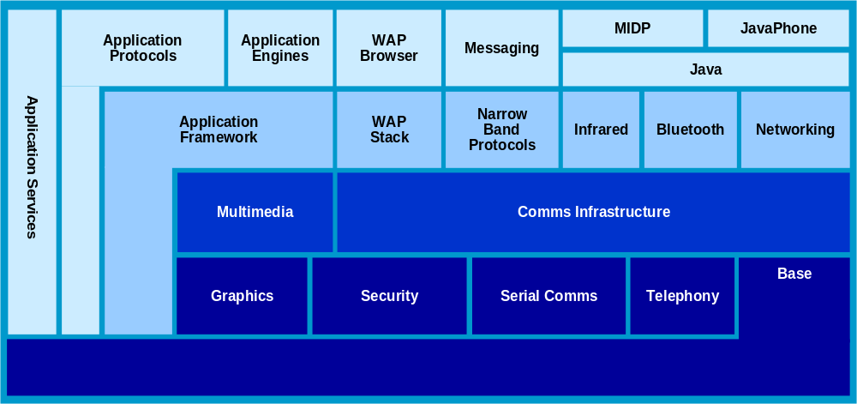

App-Services Architecture and API’s

The Subsystem components
The App Services subsystem contains the following components:
- App-Services/Alarmserver (Alarm Server)
This component provides SymbianOS with alarm related services.
- App-Services/Calcon (Calendar Converter)
This component provides an interface which can convert Chinese lunar calendar dates to Gregorian dates.
- App-Services/Chtmltocrtconv (HTML to Rich Text Converter)
The HTML to Rich Text converter provides a means of converting an HTML file to a SymbianOS rich text object stored in a file.
- App-Services/Ealwl (Alarm Server BC Layer)
Prior to Symbian OS 7.0, the alarm server was unified into alarm server. This BC layer provides the same interface as the old alarm server for accessing the new alarm server server. This component is removed from Symbian OS 9.0 and onwards.

- App-Services/Hlpmodel (Help Model)
The Help Model provides a centralised, read-only interface to all help files available on a Symbian OS device. Help files are essentially heavily compressed databases, each containing a series of help topics relating to different applications or subjects.

- App-Services/Richtexttohtmlconv (Rich Text to HTML Converter)
This component provides conversion from SymbianOS Rich Text to HTML.

- App-Services/Tz (Time Zone Server)
The Time Zone component architecture consists of a server and a client-side API. The (UTC offset) auto-update functionality is contained completely within App-Services/Tz—it exposes no client-side API except the auto-update configuration API and hence requires no direct connection to most client applications. Auto-update functionality is used to automatically update the UTC offset for changes in DST. The Time Zone Server is a time-permanent server—in other words, it is always running.
Notification of UTC offset updates to clients is handled by the Publish and Subscribe API. Notification is provided for any update to the UTC offset—for example, as a result of the current locale changing, as well as for changes in DST. Notification is “non-connected”—the ‘clients’ in this case do not need to be connected to the Time Zone Server to receive updates.
The auto-update configuration API allows DST updates to be enabled or disabled by clients with WriteDeviceData capability. The default is (initially) enabled, with the current configuration persisted using the Central Repository.
The Time Zone component provides functionality to define and access user-defined time zone data. This data is persisted in a SQLite database.
- App-Services/TimeZoneLocalization
This component provides localisation of Time Zone and city names as used by App-Services/TZ.
- App-Services/Versit (Versit)
Versit converts “plain text” data conforming to the Versit specifications ([R1][R2]) to and from data that can easily be read or created by other components such as the agenda model (App-Engines/Agnmodel) and the contacts model (App-Engines/Cntmodel).
General Description

App-Services/Alarmserver APIs
The following APIs are exposed by the App-Services/Alarmserver architecture:
API Name | Broad Purpose | Intended Users
Alarm Client | Allows clients to query, set, or modify system wide alarms. | Time/Alarm applications, system information or observer components (e.g. status panes).

API Purpose - Further Elaboration
The Alarmserver is a long running system server started on system start-up, which manages the queue of system-wide alarms. The client API allows interested parties to interact with all alarms currently maintained within the system.

In broad terms, the Alarm Client API allows clients to:
- Set alarms
- Remove alarms
- Query alarms
There are two types of alarms, floating alarms and fixed alarms. Floating alarms are given in local time, and they are rescheduled whenever the UTC offset changes. Fixed alarms are given in UTC time. These alarms are not rescheduled when an UTC offset change occur.
As well as the time when the alarm should expire, alarms themselves may include information such as a textural based message, an alarm sound, and any arbitrary data (e.g. a picture).

The following files are delivered by the App Services/Alarmserver architecture:
ROM filename | IPR Classification | Source | Notes
Alarmclient.dll | Optional Replaceable | Symbian | Defines the client API.
Alarmshared.dll | Optional Replaceable | Symbian | Contains shared objects (alarm class, IPC op-codes, repeat definitions, alarm states, etc) used by both client and server.
Alarmserver.exe/dll | Optional Replaceable | Symbian | The Alarm Server. This binary is an EXE when built for target hardware or a DLL for the Symbian OS Windows emulator.

Key Internal Relationships
The Alarmserver is implemented using the standard Symbian OS client-server architecture. It has an interface to the Alarm Alert Server, which is delivered as part of the app-framework/uikon component. The Alarmserver uses a connection to the Alarm Alert Server to allow a UI-level user notification to take place. The Alarm Alert Server Client API is defined by the Alarmserver itself.
Diagram 1: Abstraction of Alarmserver Deliverable
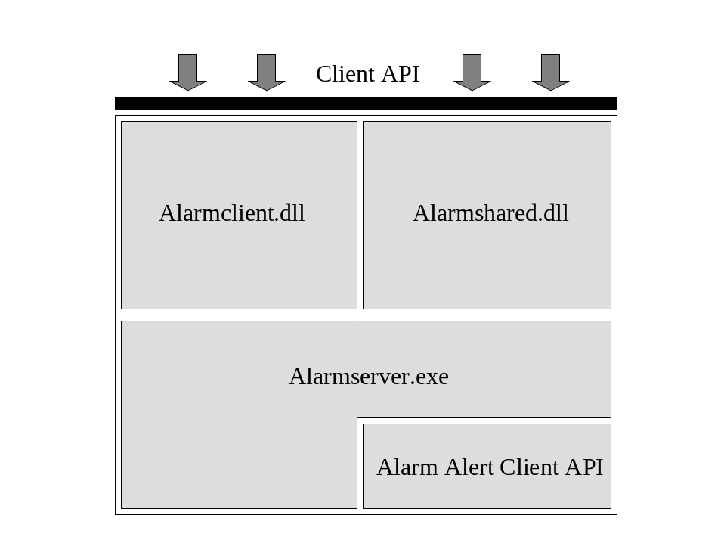
Clients of the Alarmserver need to link to both alarmclient.dll and alarmshared.dll.

Key External Relationships and Dependencies
Diagram 2: Dependencies
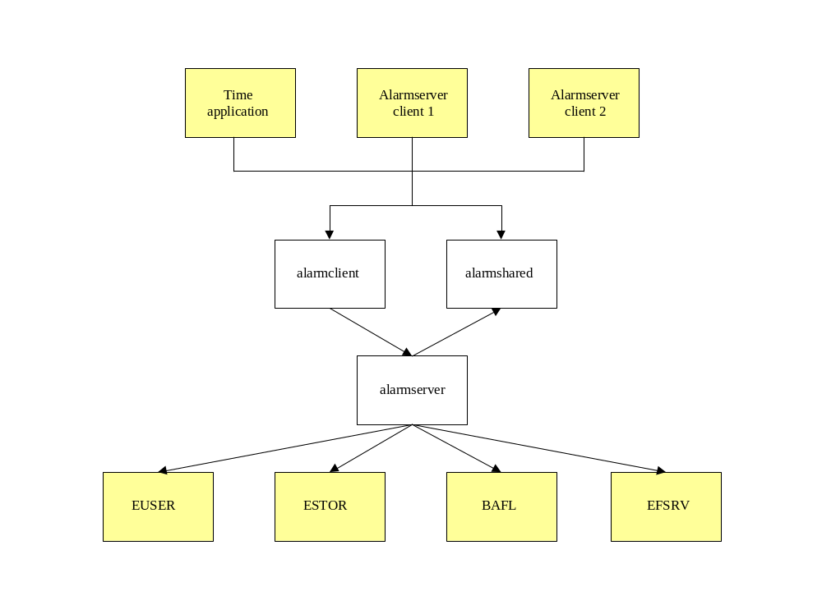
- EUSER – Access to base utilities – descriptors, date & time handling, etc
- ESTOR – Provides API to handle file store used for the backup(alarmserver.ini) file
- BAFL - Provides API to observe environment changes (changes to locale and system time), and allow backup server to backup and restore alarmserver.ini file
- EFSRV - Provides file server APIs used to access alarmserver.ini file

Diagram 3: Processes
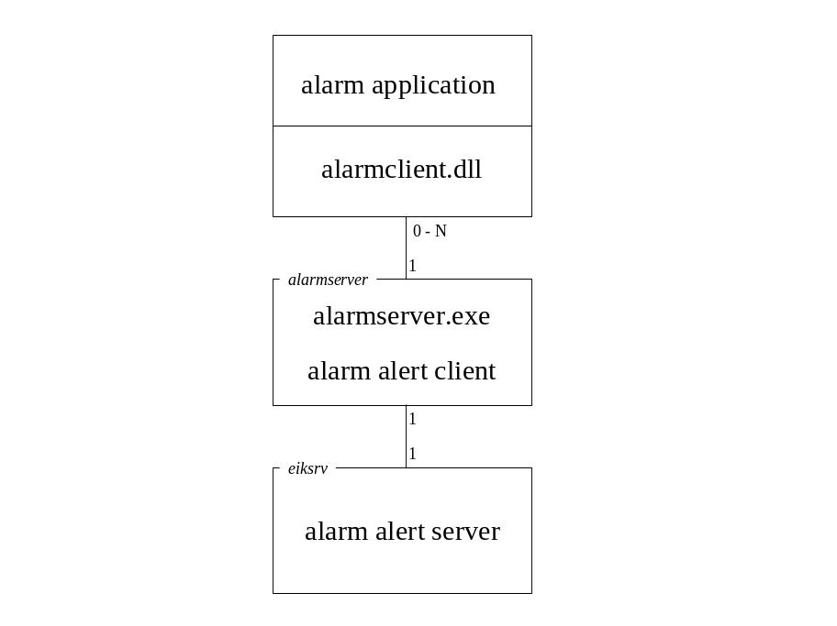
The Alarm Alert Server runs in the eiksrv process, and the Alarmserver connects to it when it is started. There can be any number of clients of the Alarmserver.
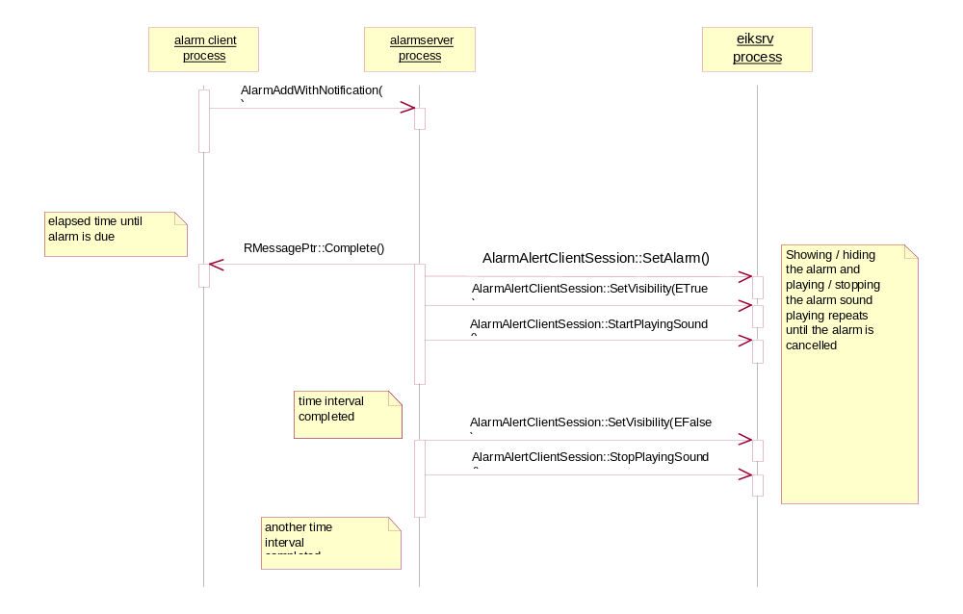

Diagram 4: Sequence Diagram for Adding An Alarm with Notification

The client makes an asynchronous request to add an alarm. When the alarm expires, the alarmserver notifies the client by completing the outstanding request.

App-Services/Calcon APIs
The following APIs are exposed by the App-Services/Calcon architecture:
API Name | Broad Purpose | Intended Users
Calendar Conversion  (CalendarConverter.h) | Allows conversion between Gregorian and Chinese Lunar dates. | Application and system developers requiring Chinese date support

Key Internal Relationships and Dependencies
There are no internal relationships or dependencies between App-Services/Calcon and other components within the subsystem.

Key External Relationships and Dependencies
App-Services/Calcon has a static dependency to Base/E32. It has no dynamic dependencies.
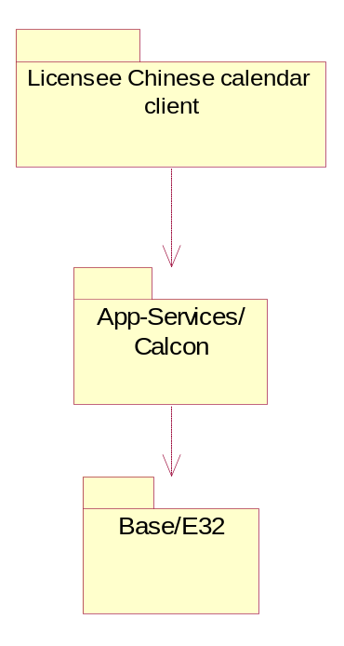

API Purpose - Further Elaboration

Calendar Conversion
Calendar Converter component supports the bi-directional conversion of Chinese lunar calendar dates to Gregorian calendar dates. Internally, these dates are stored as Julian days.

The following files are delivered by the App-Services/Calcon architecture:
ROM filename | IPR Classification | Source | Notes
ccon.dll | Optional Replaceable | Symbian | Provides calendar conversion API

App-Services/Chtmltocrtconv APIs
The HTML to rich text converter parses HTML documents and converts them into SymbianOS rich text format (as manipulated by Application-Framework/Etext). This component was introduced in order to provide an alternative method of reading MHTML (Messaging HTML) email on the Symbian OS without the need for a full web browser.
This component is a plug-in to the SymbianOS plug-in conversion framework (App-Framework/Conarc). No APIs are exposed by the App-Services/Chtmltocrtconv architecture.
Its intended users are clients requiring conversion of an HTML file to SymbianOS rich text stored in a file.
The parser supports HTML version 3.2. The specification that defines HTML 3.2 can be obtained at http://www.w3.org/TR/REC-html32. Among the character entities, support for only &gt, &lt and &nbsp has been provided. All other character entities will be treated as unknown.

Key Internal Relationships and Dependencies

Key External Relationships and Dependencies
This component is a plug-in to the Application Framework’s conversion architecture (App-Framework/Conarc).
As well as providing the conversion of HTML to CRichText, chtmltocrtconverter.cnv, also provides an implementation of the ConArc class CConverterLibrary, which accesses this specific converter via it’s UID. As well as depending on the base subsystem components such as Base/F32 and Base/Bafl the key external dependencies are Syslibs/Charconv, Graphics/Gdi, and App-Framework/Conarc.

The following ROM files are delivered or enabled by App-Services/Chtmltocrtconv:

ROM filename | IPR Classification | Source | Notes
chtmltocrtconverter.cnv | Optional Replaceable | Symbian | Uses API of CConverterBase class of the app-framework/conarc component.
chtmltocrtconverter.cnf | Optional Replaceable | Symbian | Resource file.
chtmltocrtconverter.rsc | Optional Replaceable | Symbian | Resource file.

App-Services/Ealwl APIs
App-Services/Ealwl is a software component designed to provide a convenient client interface to the App-Services/Alarmserver and the App-Services that is binary compatible with SymbianOS v6.1. That means it uses the same API enjoyed on SymbianOS v6.1, for connecting to the alarm server, to connect to the new and separated Alarm Server Server. The App-Services/Ealwl is removed from Symbian OS 9.0 and onwards.
The following APIs are exposed by EALWL for use with the alarm server:

API Name | Broad Purpose | Intended Users
Alarm Server Connection Interface  (RAlarmServer), | Encapsulates a set of services for connecting to the AlarmServer, adding and deleting alarms, changing alarm properties and receiving changes to alarms | Application developers. (Deprecated)

Physical Description
To allow multiple clients queuing alarms, the Alarm Server is partitioned as two-tier system. EALWL is a deprecated alternative to the usual top tier client interfaces provided with alarm server. It is delivered as single component.
The diagram below describes the hierarchical relation with the server.
Client API

Compatible Alarm Server Client Interface
(EALWL.dll)

Alarm Server

Diagram 5: Alarm Server components – a tiered view
The following ROM files are delivered or enabled by App-Services/ealwl:
ROM filename | IPR Classification | Source | Notes
ealwl.dll | Optional Replaceable | Symbian | Defines a SymbianOS v6.1 compatible API for accessing the new alarm server.

Key Internal Relationships and Dependencies
As a very thin interface to the Alarm Server, the EALWL is very simple in design and has no internal dependencies or relationships worthy of note.

Key External Relationships and Dependencies

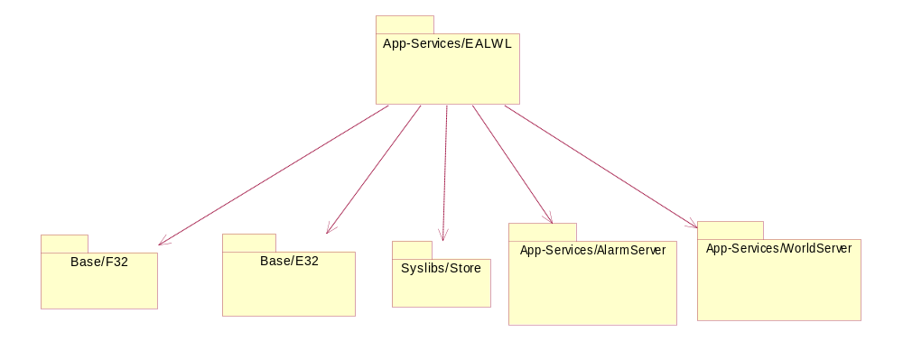

These external components are:
- Base/E32 [for basic OS user library – date/time, text, etc]
- SysLibs/Store [for permanent store access]
- Base/F32 [for file server support ]
- App-Services/AlarmServer [For actual Alarm Service functionality ]

API Purpose – Further Elaboration
The Alarmserver is a long running system server started on system start-up. It manages the queue of system-wide alarms. The client API allows interested parties to interact with all alarms currently maintained within the system.
In broad terms, the EALWL API allows clients to do the following:
- Connecting to the Alarm Server
Encapsulates a set of services for connecting to the Alarm Server
- Manipulating and Controlling Alarms
Includes operations for adding and deleting alarms and changing alarm properties
- Managing Collection of Alarms
Provides operations for listing alarms registered with the server
- Notifying Alarm Changes
Allows clients to register to receive notification of changes to alarms
- Manipulating and Controlling General Alarms Behaviour
Changes alarm server behaviour common to all alarms

App-Services/Hlpmodel APIs
The following APIs are exposed by the App-Services/Hlpmodel architecture:
API Name | Broad Purpose | Intended Users
Help Model | Provides read-only access to a collection of help files which are available on the device. | Help application UIs.
Help Launcher | Launches device specific help applications with a context sensitive identifier. | Help application UIs.

Key Internal Relationships and Dependencies
There are no internal relationships or dependencies between App-Services/Hlpmodel and other components within the subsystem.

Key External Relationships and Dependencies
App-Services/Hlpmodel is the application service used the licensee help applications.
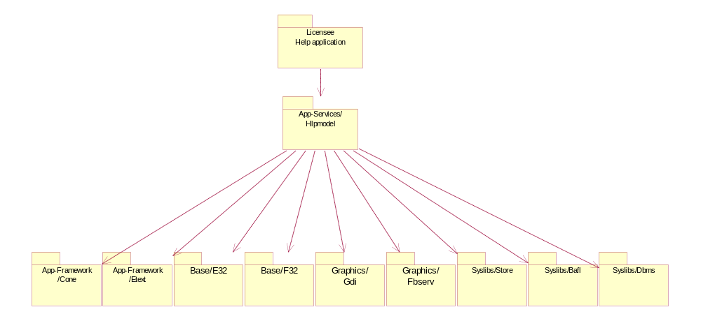
App-Services/Hlpmodel primary dependency is Syslibs/Dbms which is used to search and retrieve help information.
App-Services/Hlpmodel static dependencies are App-Framework/Cone, App-Framework/Etext, Base/E32, Base/F32, Graphics/Gdi, Graphics/Fbserv, Syslibs/Bafl, Syslibs/Dbms and Syslibs/Store.
It has no dynamic dependencies.

API Purpose - Further Elaboration

Help Model
App-Services/Hlpmodel allows help databases on a device to be searched for specific information.
Help databases contain rich text formatted data (including pictures) and metadata used to identify help information for searching.

Help Launcher
The help launcher is a small DLL that allows the device-specific help application to be launched with a context sensitive identifier, so that a suitable help topic is displayed within the help application

The following files are delivered by the App-Services/Hlpmodel architecture:
ROM filename | IPR Classification | Source | Notes
HlpModel.dll | Optional Replaceable | Symbian | The API for the help model.
HlpLch.dll | Optional Replaceable | Symbian | This DLL launches the help application for the device.

App-Services/Richtexttohtmlconv APIs
The following APIs are exposed by the App-Services/Richtexttohtmlconv architecture:
API Name | Broad Purpose | Intended Users

Key Internal Relationships and Dependencies

Key External Relationships and Dependencies
Messaging/Email/Clientmtms (imcm.dll) uses App-Services/Richtexttohtmlconv to send HTML email.

API Purpose - Further Elaboration

The following files are delivered by the App-Services/Richtexttohtmlconv architecture:
ROM filename | IPR Classification | Source | Notes
Rt2htmcv.cnv | Optional Replaceable | Symbian | Converter implementation
Rt2htmcv.cnf | Optional Replaceable | Symbian | Converter information file

App-Services/Time Zone Server APIs
[R1] describes the background to the development of this component and the need it fulfils. Its architecture, described herein, is provided by a collaboration of System services that manage time and historical zone information. It allows clients, especially synchronisation services, to obtain accurate conversion between any time expressed in UTC and local time for any time zone.
Time zone server allows clients to define and access user-defined time zone data. The user-defined time zone data comprises time zone rules and names. These are persisted in a SQLite database.

Logical View of the Architecture
Depicted below is a logical view of the functions in the Local Time Conversion and Configuration Services.
Time Zone Information Management

Local Time Conversion & Configuration Services
API
Figure 1: Logical View of Local Time Conversion and Configuration Services
[R1] describes these Functionalities in more details. The DST Project Design only focuses on providing these new functionalities:
- Local Time Conversion and Configuration. Responsible for converting time between UTC and Local (wall-clock) and setting the time zone.
Time Zone Information Management (also referred to as the ‘Time Zone Data Provider’ in this document and elsewhere). It manages the time-zone rules on the device. The rules are compiled from Olson’s TZ Database (at: http://www.twinsun.com/tz/tz-link.htm ). A description of this compiler, the TZCompiler, is beyond the scope of this document.

Component View of the Architecture
The Time Zone Component is deployed in the ‘Application Services/Other Application Services’ layer of the OS. The diagram below describes the internal modular arrangement.

Internal Dependencies
The diagram below shows the internal dependencies between the binaries in the App-Services/Tz component. This is made up of a client interface module, TzClient.dll, the server module proper, TzServer.exe and a SWI observer plug-in, tzswiobserverplugin.dll. Clients using the service will link their code with the client DLL. Through this interface they communicate with server using IPC calls.
The sub-system provides the following mapping of functionality to sub-component modules:
ROM filename | IPR Classification | Source | Notes
TzClient.dll | Optional, Replaceable  (Cat. E); | Symbian | Client interface to the Conversion and Configuration Service for Time Zone Setting and UTC-Local Time Conversions. Provides client-side caching of time zone rules for performance conversion.
TzServer.exe | Optional, Replaceable (Cat. E);  Configurable | Symbian | Server providing the Conversion and Configuration Service and Time Zone Information Management. Provides server-side caching of time zone rules on behalf of all clients.
tzswiobserverplugin.dll | Optional,  Replaceable  (Cat. E); | Symbian | Plug-in for observing SWI completion. This is used when time zone data is eclipsed on system drive. After the completion of SWI, this plug-in signals the tz server.

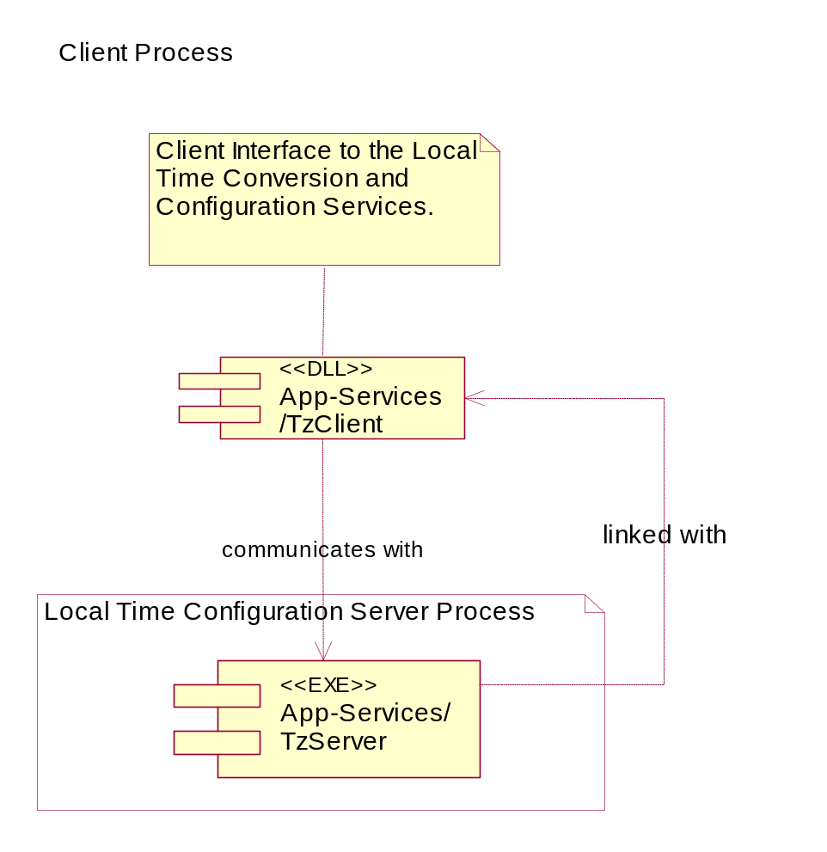
Figure 2: A Component view of the System Architecture. In this diagram each component represents a distinct loadable code binary. This notion is employed to separate out the Server exes from its interface dlls for presentation purposes only.

External Dependencies
The App-Services/TzServer component depends on a number of external components in the OS. These are shown in the diagram below.
These external components provide the following services to the TzServer:
Component | Service Provided
App-Services/BackupRestoreNotification | Provides back and restore event notification relay. Its location in App-Services binds the TzServer to the same OS layer or above.
Syslibs/Estor | Provide Stream Manipulation Services
Base/Euser | Provide basic OS data types support
Base/Efsrv | Provide File Handling Services
SysLib/BAFL | Provide text conversion services
Syslibs/SQLite | Provides SQLite database to store user-defined time zone data

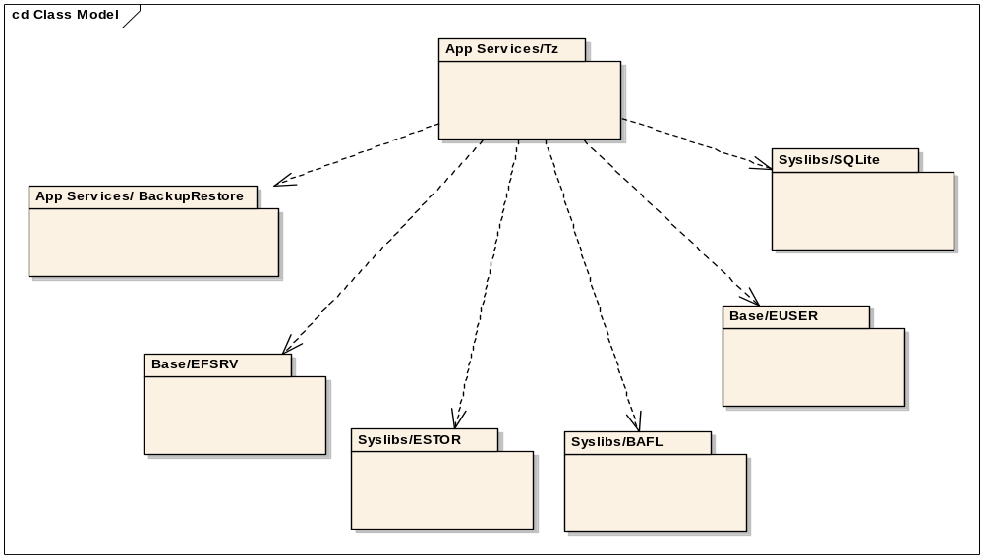
Figure 3 External dependencies of the App-Services/TzServer component

High Level Class View – The API

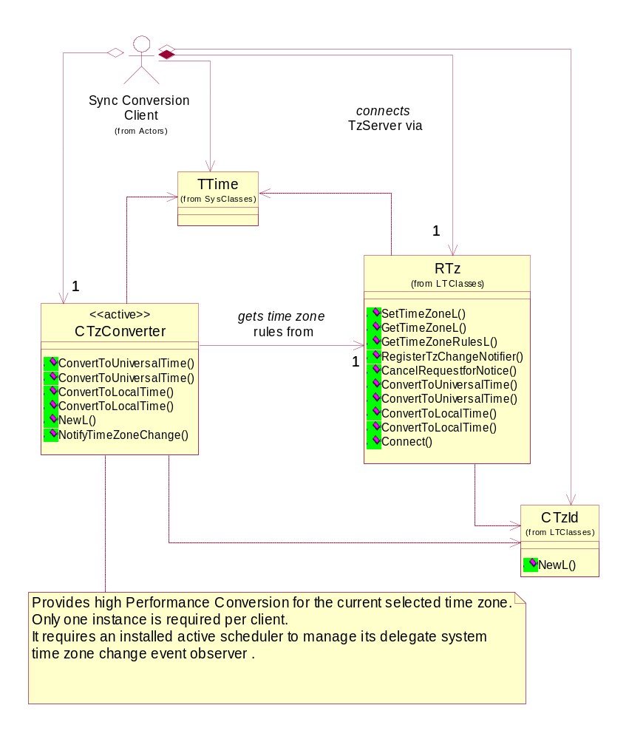

Figure 4 App-Services/Tz Server API. RTz provides the basic public interface to the Local Time Conversion and Configuration Services. For high performance conversions for the current selected time zone, use CTzConverter.
Clients taking advantage of the performance gains provided by CTzConverter must be running in a thread with an installed active scheduler.

API Description
The architectural overview above provided a breakdown of the system into the sub-components that will be delivered and used by application developers. Described below are the interfaces exposed to clients of the Local Time Conversion and Configuration Services. (See ‘High Level Class View – The API’ section above).

API Name | Broad Purpose | Intended Users
RTz  (from tz.h, TzClient.dll)  (classification: @publishedAll) | Provides methods for converting between UTC and Local times and for setting the current local time zone. Also provides methods to manipulate localization data. Provides methods to observe SWI completion during eclipsing of files. | All clients of the Local Time Conversion and Configuration Services
CTzConverter  (from tzconverter.h , TzClient.dll)  (classification: @publishedAll) | Provides higher performance conversion between UTC and Local times and for the current selected local time zone. | All clients of the Local Time Conversion and Configuration Services
CTzId  (from tz.h, TzClient.dll)  (classification: @publishedAll) | Encapsulates a Time Zone Identification | All clients of the Local Time Conversion and Configuration Services
TTime  (from e32std.h, euser.dll)  (classification: @publishedAll) | Existing Symbian OS class describing time in a compact form. | All clients of the Local Time Conversion and Configuration Services
CTzUserNames  (from tz.h, TzClient.dll)  (classification: @publishedPartner) | Encapsulates names for a user-defined time zone.
CTzUserData  (from tz.h, TzClient.dll)  (classification: @publishedPartner) | Allows clients to create, update, read or delete user-defined time zones.

Important Note:
CTzConverter delegates system time zone change event observation to an Active Object (not shown in the diagram above for simplicity). This means clients must be running in a thread with an installed Active Scheduler before creating a CTzConverter object.

System Architectural Requirements
The Time Zone Sub-system places the following requirements on clients and the Symbian OS in general:
- Local Time Conversion and Configuration Clients using the CTzConverter API must be running in a thread with an installed active scheduler.
- The Conversion and Configuration Services depends on an up-to-date Time Zone Information. Symbian provides a reference database which accurately matches its source, the Olson TZ Databases, at the time of introduction of the Time Zone System into the OS. Licensees must replace this reference with an up-to-date version of the database at phone build time. A TZ Database Compiler is supplied by Symbian with the Time Zone User documentation. The time zone database and the localization files (timezones.r* and timezonegroups.r* where “*” shows all the language variant files) can be upgraded either by the device user or by providing an over-the-air upgrade using a SIS file. Licensees must ensure that the SIS file eclipses both the localization files.
- The time zone configuration service, described by the ‘Set User Time Zone’ architecture use case, replaces the similar and older functionality in the TLocale Sub-System. These older TLocale time zone setting API will be modified to translate their zone settings to defaults within the new arrangement. The APIs will then be deprecated. All existing TLocale-client code using this functionality may need modifying to use the new API.

Key Internal Relationships and Dependencies
Figure 3-5 shows the relationship between the Time Zone Server and the Time Zone Server client-side API. The UTC offset auto-update functionality is completely contained within the Time Zone Server and provides no client-side API except for configuration of the auto-update functionality.—Note that client notification occurs through the Publish and Subscribe API, which is an external dependency.
Time Zone Server
UTC offset auto-update
DST auto-update functionality configuration
Time Zone Client API
Figure 3-5 Internal relationships of the Time Zone Server

Key External Relationships and Dependencies
The Time Zone Server and client-side API fit into the system architecture as shown in Figure 3-6.
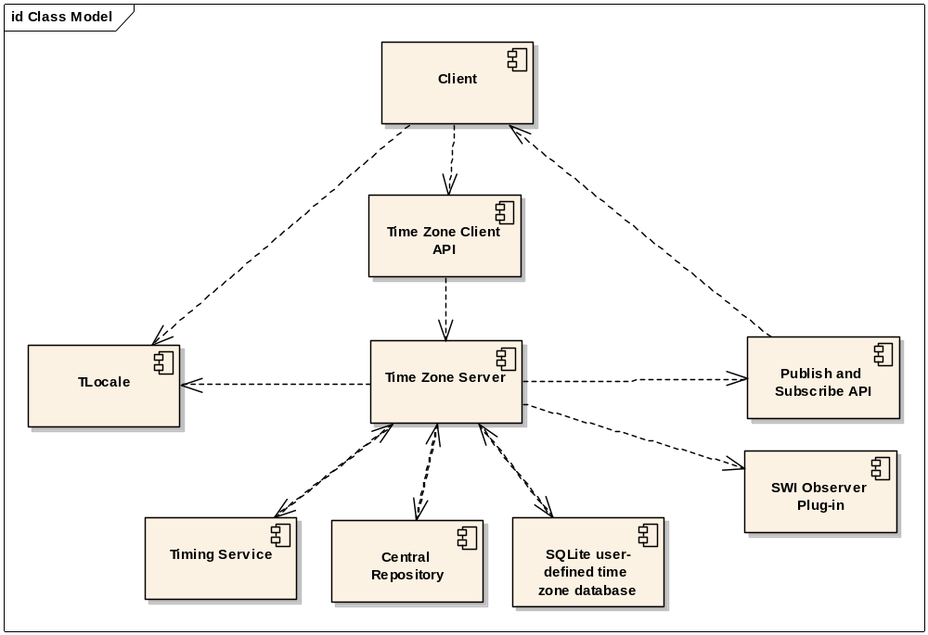
Figure 3-6 External Relationships of the Time Zone Server
Clients wishing to use the services of the Time Zone Server do so through the Time Zone Server client-side API. They may also subscribe for notification of updates using the Publish and Subscribe API. It follows that the Time Zone Server requires the Publish and Subscribe API to notify clients of changes in the UTC offset (normally due to a DST change).
The Time Zone Server requires a Timing Service to create DST change alarms. A DST change alarm is a timer that tells the Time Zone Server when the DST offset changes—thus causing the current UTC offset to change.
TLocale is used to store the UTC offset for the current time and locale, but the Time Zone Server is responsible for calculating the UTC offset and is the only system component that can modify its value—the Time Zone Server must be used to change the current time zone. Note that a read-only value of UTC offset can still be obtained from TLocale.
The auto-update functionality configuration must be persisted when the device is switched off, so the Central Repository is used to store this information.

API Purpose - Further Elaboration
The auto-update configuration API and the static linkages with TLocale, the Timing Service, the Central Repository and the Publish and Subscribe API are the only subjects for elaboration.
The Time Zone Server sets a DST change alarm using the Timing Service and this will complete the next time a DST change takes effect. The time of the DST change alarm will vary depending on the current locale and any DST rules that apply for that locale. When the DST change alarm completes or is cancelled, the Time Zone Server calculates when the next DST change will take effect, and a new DST change alarm is set for that date and time.
If the locale changes, any existing DST change alarm is cancelled as new DST rules may apply which will make its due date invalid. A new DST change alarm will be set corresponding to the next DST change expected from the new DST rules.
Changes in either the locale or DST status may necessitate changes to the UTC offset and both cases will be trapped by the Time Zone Server, as this is the component that handles both types of change.
If the auto-update configuration is disabled then the current DST Change Alarm will be cancelled but the current UTC offset (which may include an offset due to DST) will not be altered—it is up to client applications to set the configuration sensibly and to alter the UTC Offset (via the Time Zone Server) manually if necessary. If the configuration is enabled then the UTC Offset will be updated if necessary and a new DST Change Alarm will be set.
Clients of the Time Zone Server should register with the Publish and Subscribe API to receive notification of UTC offset changes. Note that the onus is on clients to update their UTC offset-dependent data. The Publish and Subscribe API only notifies a client of a change—it does not cause any specific update within the client.
UTC offset changes will also cause the (local) system time to change, which will then propagate to clients that use local times.

App-Services/TimeZoneLocalization APIs
The following APIs are exposed by the App-Services/TimeZoneLocalization architecture:
API Name | Broad Purpose | Intended Users
Time Zone Localization service | Provides localized Time Zone and city names | Applications wishing to display localized time zone information.

Key Internal Relationships and Dependencies
Client API
TimeZoneLocalization API
TimeZone-Localization
Data Reading/Writing
TimeZone-Localization
Data Structures
Figure 1: App-Services/TimeZoneLocalization internal dependencies.

App-Services/TimeZoneLocalization is implemented as a stand alone dll which provides all required functionality.
Applications using localized Time zone names simply link against TimeZoneLocalization.dll and create an instance as necessary.
However, the internal structure has been broken down into three key units:
- The provider, which publishes the component API
- The data reading and writing classes, which are responsible for reading and writing strings and other data from both the resource file and the DBMS that is used to persist user data.
- The data structures, which are used to collect data together into meaningful sets, such as cities, groups, etc.
The following files are delivered by the App-Services/TimeZoneLocalization architecture
ROM filename | IPR Classification | Source | Notes
TimeZoneLocalization.dll | Optional  Replaceable | Symbian | Handles reading of resource files, finding time zones, cites and groups and localisation.

Key External Relationships and Dependencies
App-Services/TimeZoneLocalization has a dependency on App-Services/Tz for provision of Time Zone Ids. It is likely that the most common use of App-Services/TimeZoneLocalization will be to provide localized strings for the current time zone – the id for which is obtained through the time zone server.
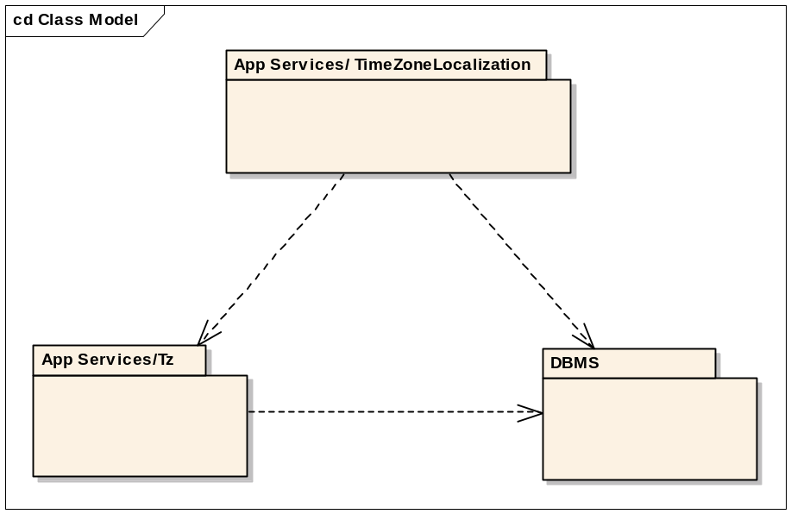
Figure 2: App-Services/TimeZoneLocalization External Relationships

App-Services/TimeZoneLocalization also makes use of the DBMS relational database for persisting user data. This relationship is shown in Figure 2. The database is owned by Tz while TimeZoneLocalization has access to it. This modification was made as a part of re-factoring of the component. The database file will be stored under the DBMS private directory. The persisted user data is stored separately from the App-Services/Tz cache.

API Purpose - Further Elaboration
App-Services/TimeZoneLocalization maps Time Zone ids as used by App-Services/Tz to localised strings supplied in a standard Symbian OS resource file format. App-Services/ TimeZoneLocalization provides access to the following localizable information for a particular time zone.
- Time Zone Standard Name (E.g. Greenwich Mean Time)
- Time Zone Daylight Savings Name (E.g. British Summer Time)
- Time Zone Short Standard Name (E.g. GMT)
- Time Zone Short Daylight Name (E.g. BST)
In addition to localizable time zone names, App-Services/ TimeZoneLocalization allows a number of cities to be associated with a time zone. Resource-defined city names are localizable and all cities can be grouped irrespective of the city’s associated time zone. App-Services/ TimeZoneLocalization can return a collection of all cities in a group or time zone, with easy access to the time zone id required by the time zone server.
App-Services/TimeZoneLocalization also maintains a cache of recently used time zones, along with localized values for the current time zone (according to the Time Zone Server), home time zone and a user specified zone of interest. Finally, user defined city names can be added to either time zone or city groups. The names of user-defined cities are not localizable and will always appear in the language in which they were added.
Any user entered data (city names and groupings), along with the current zone, home zone, zone of interest and two recently used zones will be persisted to file using the DBMS architecture.

App-Services/Versit APIs
The following APIs are exposed by the App-Services/Versit architecture:
API Name | Broad Purpose | Intended Users
Versit Parser Base Classes  E.g. CVersitParser | Provide a generic parser structure capable of internalising and externalising streams. | Developers would normally make calls to the base class methods for internalising, externalising and searching for Versit properties.
Versit Parser Properties  E.g. CParserProperty | The properties provide standard ways of storing Versit properties along with parameters and values. | Developers wishing to manipulate properties Versit properties.
Versit vCard  E.g. CParserVCard | Derived from the Versit base class, this class implements the methods necessary for vCard 2.1 support. | Developers wishing to include support for vCard 2.1 [R2] and any other Versit-like formatted data derived or related to this specification.
Versit vCalendar  E.g. CParserVCard | Derived from the Versit base class, this class implements the methods necessary for vCalendar 1.0 support. | Developers wishing to include support for vCalendar 1.0 [R3] and any other Versit-like formatted data.

API Purpose - Further Elaboration
The Versit libraries export a set of utility classes that allow users to parse and generate data formatted according to the specifications first published by the Versit consortium (The specifications are now owned by the IMC). The two main technologies that came from the Versit Consortium were vCard, an electronic business card, and vCalendar, an electronic calendaring and scheduling exchange format.
In broad terms, the Versit API allows clients to:
- Internalise Versit formatted data into container classes.
- Externalise contact and calendar data.
- Derive a custom Versit parser from the base classes
- Perform various utility functions (Searching, modifying etc.) on the data.

The following files are delivered by the App Services/Versit architecture:
ROM filename | IPR Classification | Source | Notes
Versit.dll | Optional Replaceable | Symbian | Exports the base Versit classes and methods common to all Versit parsers.
VCard.dll | Optional Replaceable | Symbian | Implements a vCard 2.1 parser & generator. Also includes vCard 2.1 and vCard 3.0 generator to support PBAP export. This generator shall be used only by Shortlink (Symbian internal component).
VCal.dll | Optional Replaceable | Symbian | Implements a vCalendar 1.0 parser & generator.
RVERSIT.MDL | Optional Replaceable | Symbian | Implements a Recognizer which recognises Versit vCalendar and vCard files and reports their file type. This is according to the standard Symbian OS file recognizer pattern.

Key Internal Relationships
The Versit libraries are designed to provide a self contained set of tools. As such, they have no internal dependencies with other App-Services components. The diagram below gives an abstract illustration of the internal dependencies of the Versit components themselves.
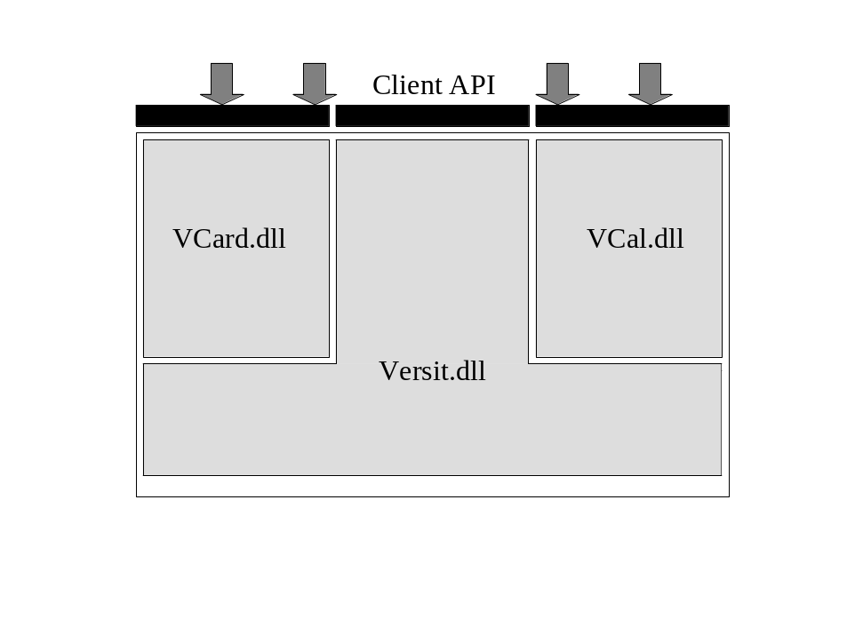
Figure 7: Abstraction of Versit deliverables

As the diagram above illustrates, it is possible to make use of the Versit.dll library on its own. If vCard or vCalendar support is required then the Versit library must be included as both vCard.dll and vCal.dll both depend on it.
It is also possible for users to develop their own Versit parsers using the base classes provided in Versit.dll and not include the vCard and vCalendar libraries.
Although this section is normally limited to the relationship within the App-Services component, a diagram showing the unit dependencies has also been included. This diagram reflects at a slightly more detailed level the relationship between the various Versit sub-components.

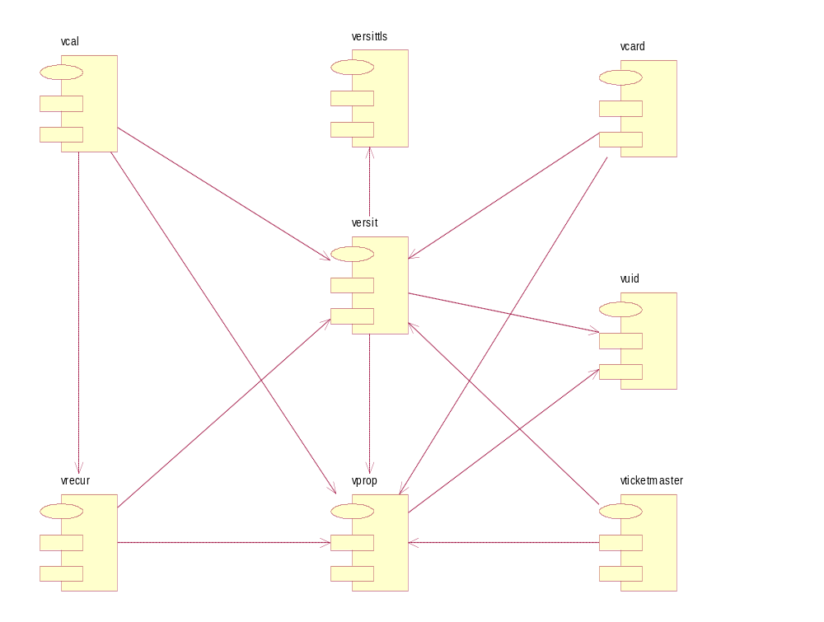
Figure 8 : Versit Internal Dependencies
Below is a table of the sub-components built for each DLL:

Versit.DLL | VCard.DLL | VCal.DLL
- Versit  - VProp  - VUtil  - VStaticUtils  - VersitTLS | - Vcard | - VCal  - VRecur

Key External Relationships and Dependencies
It is possible for any third party code to make use of the Versit libraries. The only Symbian OS components that have a dependency on Versit are the App-Engines. The application engines provide API’s which allow their users to import and export Versit formatted data.
The mechanism used to allow these operations differs depending on the application engine and the documentation associated to each should be referred to for more detail. As the diagram below shows, the two app-engines that make use of Versit are the Agenda Model and the Contacts Model. Both have separate modules/components to handle the Versit data; AgnVersit for the Agenda Model and CntVCard for the Contacts model.
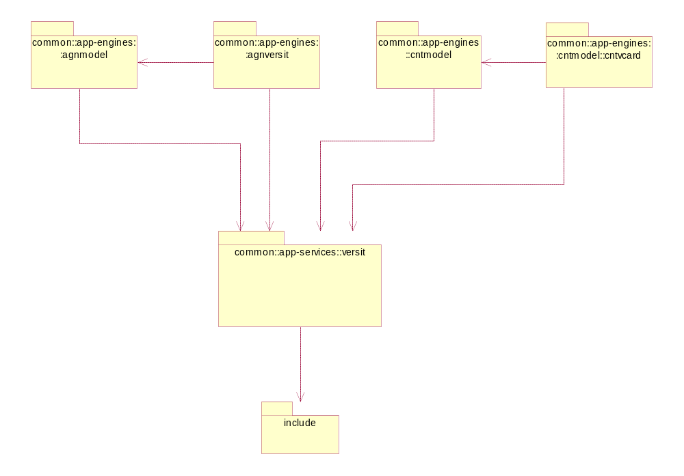
Figure 9: Versit External Dependencies
NOTE: Figure 3 shows that the Contacts Model and Agenda Model both depend on Versit. These components are dependent on values defined in Versit but have NO static code dependencies on Versit. That is to say that both the Contacts Model and the Agenda Model are capable of executing without Versit.
The Include package shown in the diagram represents the Symbian OS standard libraries, components that are external to App-Services and App-Engines. In the case of Versit, it has dependencies on the following libraries:
- BAFL
- EUser
- EStor
- EFSrv
- CharConv
- ConArc

Other Architectural Elaboration

AlarmServer
The Alarmserver is implemented using the standard Symbian OS client-server architecture, and hence multiple clients are supported. Also, alarmserver settings are persisted; an up to date file store of all alarms and internal settings is maintained.

Data persistence
App-Services/TimeZoneLocalization uses the DBMS API to store localisation data securely. Two databases will be used, the first containing a simple representation of the five cached time zones, the second containing all user-entered city information. The data is stored in two separate databases to allow a higher level of security for sensitive information such as the user’s home time zone. This means restricted access to the five cached zones.

Five Cached Time Zones
The term ‘Cached Zones’ refers to the following five time zones, which are stored in a cache for efficient access. Information on these zones is likely to be requested more often than with other time zones.
- Current time zone
- Home time zone
- Zone of Interest
- Recently used time zone 1
- Recently used time zone 2

The cached zones database table will store the following information for each cached zone:
- Time zone id
- Standard Name
- Daylight Saving Name
- Short Standard Name
- Short Daylight Saving Name
- City
- The group that city belongs to
- The resource ID of the Time Zone that the city belongs to

Column Name | TzId | Std Name | DST Name | Short Std Name | Short DST Name | City | CityGroup | ResourceId
Column Type  (from TDbColType) | EDbCol  Uint16 | EDbCol  Text | EDbCol  Text | EDbCol  Text | EDbCol  Text | EDbCol  Text | EDbCol  UInt8 | EDbCol  UInt32
The cached zones database structure.

Storing City Information for the Five Cached Time Zones
The database stores the information for the city that was used to select each of the five cached zones. All information that is required to construct a city object is stored. This is done, because there is no way to find which city was used to define the zone. It will be useful to be able to do this in the case of these five zones.

The Current Time Zone
This component is not responsible for setting the current time zone as this remains the responsibility of the Time Zone Server (App-Services/Tz). However, it is important that the Current Zone that is stored in the cache of five zones is always correct. Therefore, the process outlined in Figure 3 is followed when a request for the Current Zone is made.
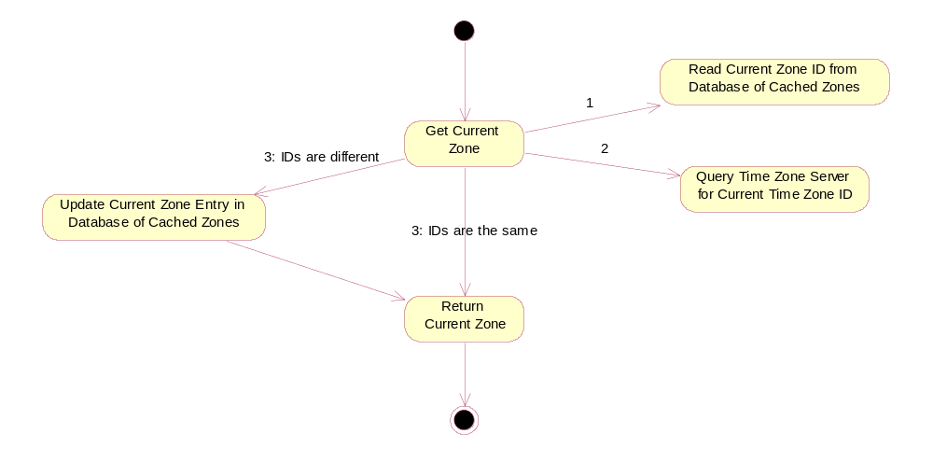
Figure 3: The process that is followed when the current Time Zone is requested.
When a request for the localized current time zone is made, a connection to the time zone server is established. The current time zone id is then checked against the current time zone id from the time zone server. If the ids match, then the strings are retrieved from the database and returned. If the ids do not match then the current time zone has changed. The new localization strings are retrieved from the resource file and stored in the database, replacing the previous row. The request for the localized time zone can now be completed.
As a result, the city used to select the current time zone cannot be known and the Default Exemplar City for the current zone will be stored.
User-added Cities
Each row of the table that stores the user-added cities will contain the information that is necessary to construct a city object, as follows.

Column Name | TzId | City | Group | ResourceId
Column Type  (from TDbColType) | EDbColUint16 | EDbColText | EDbColUInt8 | EDbColUInt32
The user-added cities database structure

Versit
This section shows makes use of sequence diagrams of typical Versit use-cases. The class diagram below shows the basic architecture of the parser classes.

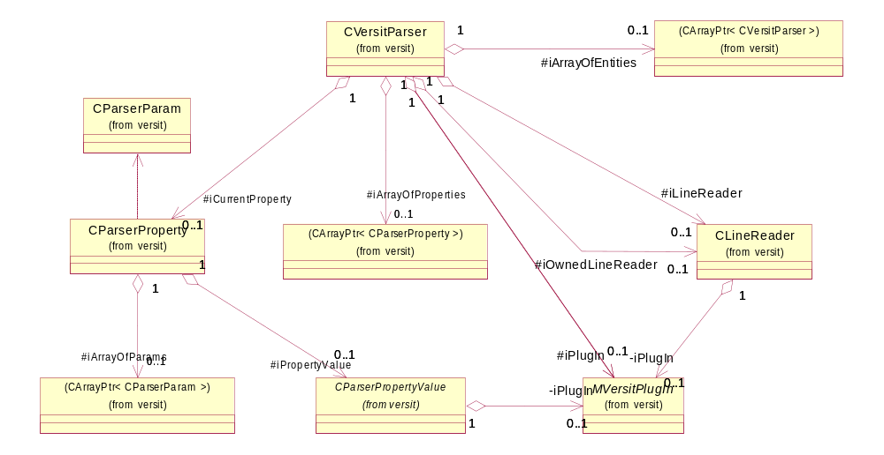
Figure 10 : Basic Parser Architecture
This design reflects the actual structure of any Versit formatted entity (represented here by the CVersitParser class). A Versit entity is composed of a number of properties. It may also contain any number of embedded entities. A Versit property is itself composed of a property value and a number of parameters.
This architecture ensures that the memory used by each parser is minimised because the objects required for storing the data are dynamically created as required.
The two use cases covered are the generic internalisation and externalisation of Versit data. In each of the sequence diagrams, not all of the messages have been included for clarity. They also only show the basic parsing of a property without any indication of loops used to handle multiple parameters and multiple properties. The aim is merely to show how the architecture is employed in dealing with the use cases.
The MVersitPlugIn class is used to allow users of the CVersitParser class to define specific low-level parser behaviour. The name can be a little misleading as it is not a Plug-In in the true sense of the word, but rather just an abstract class that users can implement to define behaviour. Specifically:
- Whitespace behaviour – Defining how white space characters should be handled when importing and whether they should be included during export.
- Line wrapping and formatting – Similar definition of behaviour for line wrapping during export.
- Encoding type – specifying the export encoding type.

Parsing and the use of plug-ins
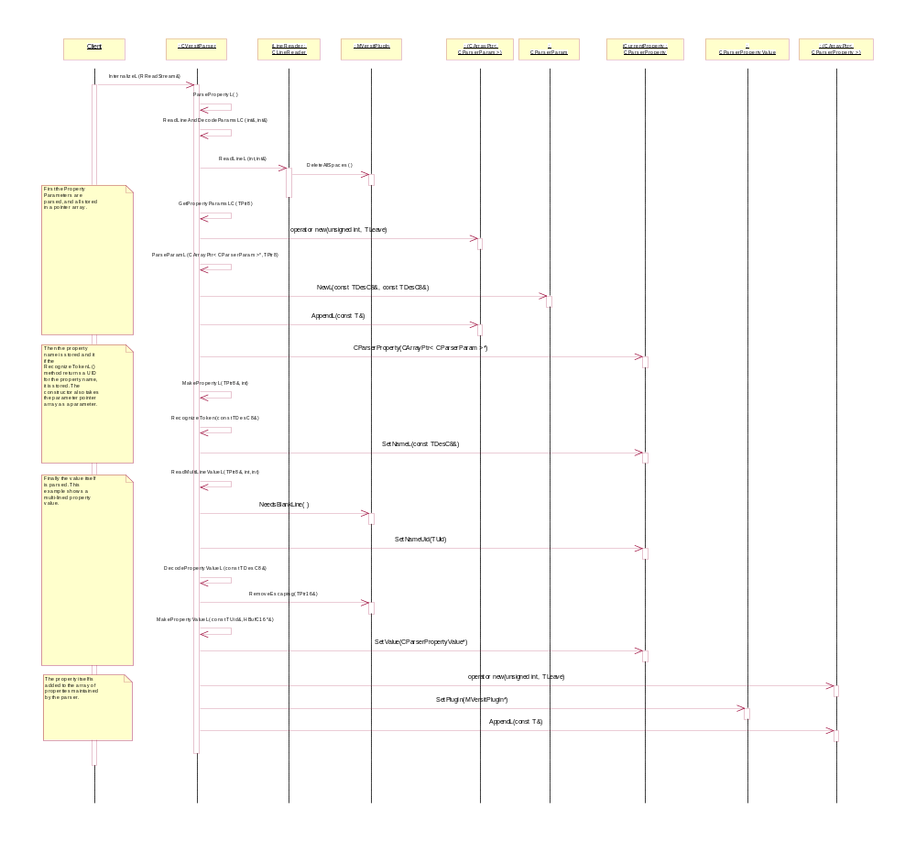
Figure 11 : Internalizing Versit Properties

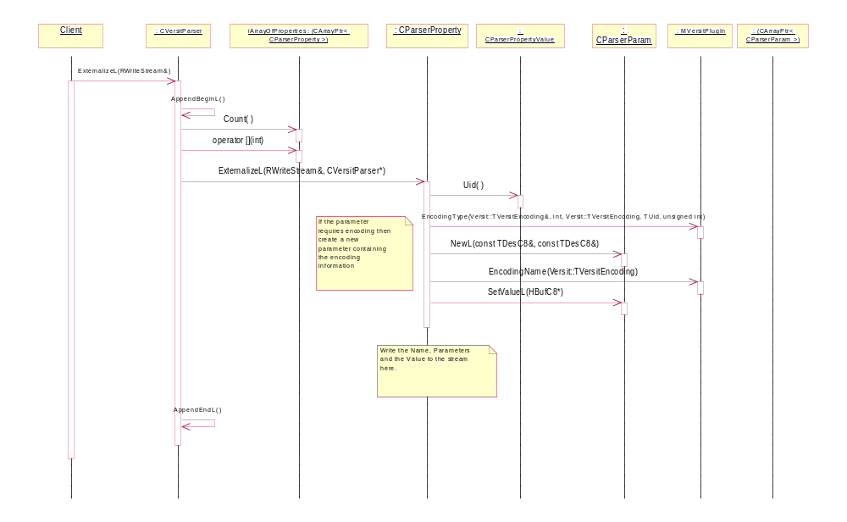
Figure 12 : Externalising Versit Properties

AlarmServer
The Alarmserver is implemented using the standard Symbian OS client-server architecture, and hence multiple clients are supported. Also, alarmserver settings are persisted; an up to date file store of all alarms and internal settings is maintained.

System Architectural Requirements

Alarmserver
The Alarmserver manages all alarms on the device. However, the alarm notification policy is the responsibility of the Alarm Alert Server. When an alarm expires, the Alarmserver indicates that an alarm dialog should be displayed, and that an alarm sound should be played, but it is the Alarm Alert Server’s responsibility to actually show the alarm and play the sound
Other than this interaction with the Alarm Alert Server and base components detailed in 3.2.1.3, there are no other architectural requirements needed to satisfy Alarmserver use cases.

Time Zone Server
The Time Zone Server’s UTC offset auto-update system will be used in the following circumstances:
- When the user changes the system time—as this may result in a change to the DST status.
- When the DST change alarm completes—in other words, when the DST status changes.
- When the current locale is changed—this can only occur via the Time Zone Server.
- When the system is booted (switched on)—the DST change alarm is not persisted when the device is switched off, so it must be re-calculated every boot time.
- When the auto-update configuration is set to enabled after being set to disabled.
The actions taken by the Time Zone Server auto-update system in each of these circumstances are as follows:
- The time zone rules are recalculated if necessary.
- The UTC offset is updated if necessary.
- The clients of the Time Zone Server are notified of any changes to the UTC offset using the Publish and Subscribe API. Note that the UTC offset may not change in every case, so notification may not always be necessary.
- If the current DST change alarm becomes invalid then it is deleted.
- A new DST change alarm is set if required.

Timing Service Interaction
The Timing Service is used to alert the Time Zone Server of a DST change. As the Time Zone Server is assumed to be permanently running (i.e. started when the device boots up and only stopped when the device powers down), the kernel timing service can be used—there is no need for a more complex solution.
Whenever the DST change alarm completes or is cancelled, an Active Object in the Time Zone Server’s UTC offset auto-update system has its RunL() method called, and appropriate action is taken. Note that this relies on the fact that the Time Zone Server is always running—if the Time Zone Server could be stopped then the Active Object would be deleted and the DST change alarm could not complete.
If the system time is changed by the user then the DST change alarm will be cancelled from within the timing service (a TRequestStatus of KErrAbort is returned) and the Time Zone Server will calculate a new alarm as necessary.
If the current locale is changed then any existing DST change alarm will be cancelled by the Time Zone Server and a new alarm will be calculated as necessary—only one DST change alarm will exist at any one time.
DST change alarms are not persisted within the Timing Service and will be calculated and set by the Time Zone Server during its boot procedure. Any outstanding alarms will also be cancelled by the server when it shuts down.

Central Repository
The class CRepository is used to securely access the Central Repository. The ROM version of the repository file has auto-update enabled by default. If the configuration is changed (via the Time Zone Server) then a writable copy of this file is created, but the default value will be restored during a full system reset. The Central Repository is documented in [R3].

Publish and Subscribe API
Clients interested in receiving notification of UTC offset changes should register with the Publish and Subscribe API using its Subscribe() method. An Active Object should be used to handle completion of the notification request and perform any functionality necessary.
It is expected that clients interested in UTC offset changes will then query either the Time Zone Server or TLocale for the latest UTC offset value. Note that clients may actually request notification and obtain updates without any dependency on the Time Zone Server itself.
It is the responsibility of clients to obtain the current value of the UTC offset when they start up. The Time Zone Server only notifies registered clients of changes as they occur—it does not cache notifications for non-registered clients.

Memory Constraints
The additional memory constraints of having the Time Zone Server permanently running are defined by the steady state memory consumption of the Time Zone Server (any transient spike in memory use caused by loading new rules will only occur when the server is either started or used). This value is dependent on the cache and is estimated to be around 1–2 kB.

TimeZoneLocalization

Use Case to System Architecture Mapping
A number of use cases are outlined in the PREQ876 (Final) Analysis document [R1]. These can be broken down into two main categories:
- Active use, which involves changing the data that App-Services/TimeZoneLocalization stores.
- Passive use, which involves simply viewing App-Services/TimeZoneLocalization’s data.

Active Use Cases
There are two principle examples of active use cases:
- The client needs a list of all instances of one of the following:
- Cities
- Groups
- Cities by Group
- Standard Names
- Daylight Names
- Short Standard Names
- Short Daylight Names.
One of these instances could then be chosen in order to set one of the following:
- The home zone
- The zone of interest.
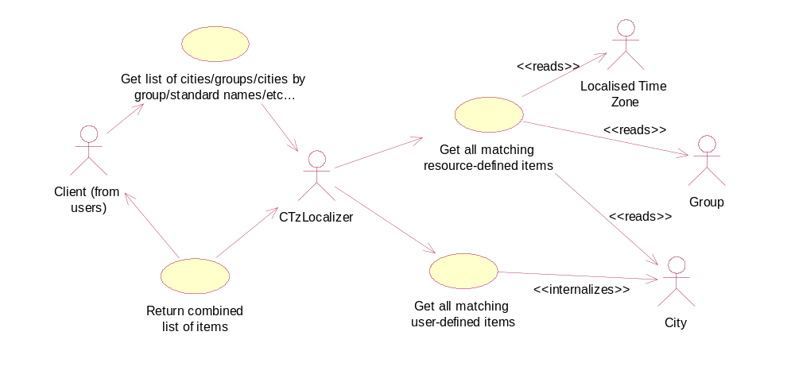
Figure 4: Use case diagrams for setting a zone after requesting a list of zones.
- The client wishes to administer the user-defined data, which will involve with the addition or removal of a user-defined city to/from a time zone.
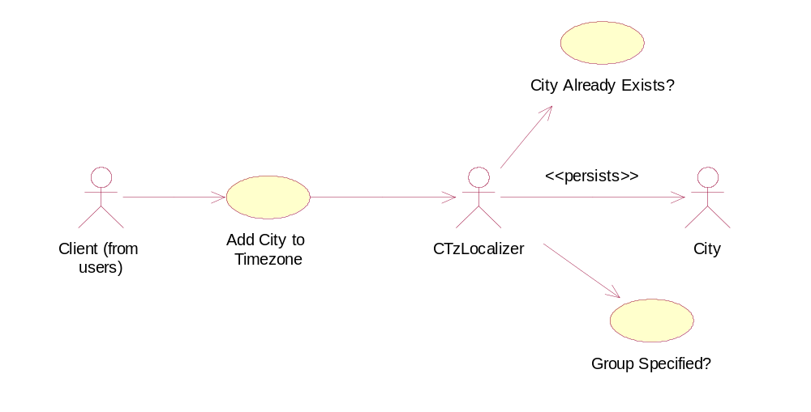
Figure 5: Use case diagram for adding and persisting user-defined cities.
It should be noted that a group can be optionally specified when a city is added and a city can only be added to a group on creation. In addition, a city can only be removed from its group by deleting the city altogether. The new city must not have the same name as an existing city.

Passive Use Cases
The principle example of passive use is when the client needs to display the current time, home time or time in the zone of interest along with a string representing that zone.
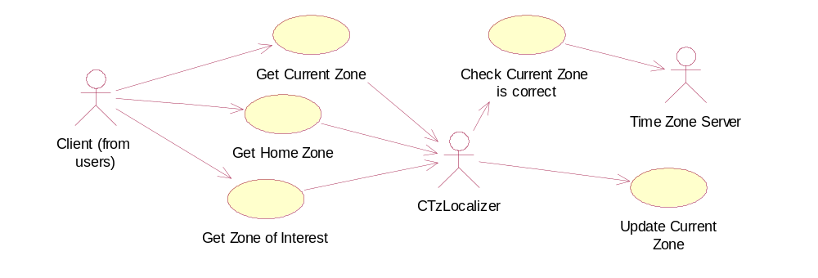
Figure 6: Use case diagram for obtaining localised data relating to the five cached zones.
It is also possible that the client has obtained a Time Zone ID from the Time Zone Server and the client then wishes to obtain localised data relating to that Time Zone ID. Therefore, a further use case exists in which the client makes requests using just the Time Zone ID.
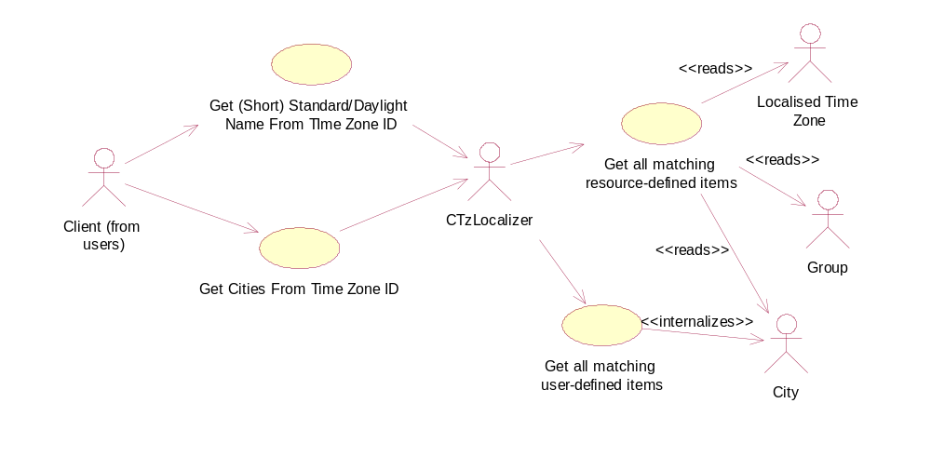
Figure 7: Use case diagram for obtaining localised data from Time Zone ID.

Component Responsibilities
App-Services/TimeZoneLocalization is responsible for providing localized, displayable text for time zone and city names. It is possible to present a collection of time zone names (and associated time zone ids) to the user for time zone selection, but App-Services/TimeZoneLocalization is not responsible for changing the system time zone. This remains the responsibility of the Time Zone Server. Applications using App-Services/TimeZoneLocalization to return localized strings will have access to the time zone id for the time zone in question, and this may be passed to the Time Zone Server to actually change the time zone.
Other than this interaction with the Time Zone Server and base components detailed in 3.2.1.3, there are no other architectural requirements needed to satisfy Time Zone localization use cases.

Licensee Responsibilities
App-Services/TimeZoneLocalization does NOT provide the actual data to be included in the resource files. The onus is on the licensee to provide the resource files required. A lot of the localization work has already been done by the ICU (International Components for Unicode), and the licensee will already have specific time zone ids to use for each Olsen Id, generated by the TzCompiler tool when creating the initial time zone database. Licensees should ensure that they provide timezones.r* and timezonegroups.r* for a specific language.

Security

Data caging and API policing

Accessing the Alarm Server data files
The alarm queue is stored in the Alarmserver.ini file. The file is stored in the Alarm server’s private directory to prevent direct access to it. Alarmserver.ini cannot be stored on removable media.
In order to add alarms, only the WriteUserData capability is needed.
For a client to get information about alarms, to change alarms or to delete alarms, there is no capability requirement as long as it is the same client that added the alarms. To get information about alarms, to change alarms or to delete alarms set by another client requires ReadUserData (to get information) and WriteDeviceData (to modify and delete).

Chtmltocrtconv data files
The resource file used by Chtmltocrtconv is located in the Z:\Resource\Convert directory. The component has been converted into an ECOM plug-in as part of platform security[R4].

The EALWL component
The Ealwl component has been removed from Symbian OS v9.0 and onwards, in other words, the component does not exist in any secure platform.

Hlpmodel data files
On the secure platform, the Hlpmodel databases (the Help files) are stored in the \Resource\Help directory. The Hlpmodel databases can be stored on removable media and will be searched for in the standard search order. If a file is already installed under a specific directory, SWInstall will not allow a SIS file to install a file with the same name and path unless the SIS file is seen as a valid update of the original one. The validation is done by means of stub SIS files.

App-Services/Tz data storage
Data Caging is enforced in this Sub-system to protect the remotely downloaded time zone rules database, tzdb.dbz, in the private area of the App-Services/TzServer at c:\private\1020383E\. Currently, system time zone selection is stored in TLocale and enjoys whatever security that component affords.
The auto-update configuration is the only addition to persisted data in the Time Zone Server. This uses the Central Repository, so data caging and backup and restore issues are handled implicitly. The Time Zone Server requires clients to have WriteDeviceData capability if they wish to modify the auto-update configuration. Time Zone Server itself is a protected server, so it is not possible to impersonate it.
The auto-update configuration is stored in a Central Repository file in c:\system\data\cenrep\. The default value is stored in a file in z:\system\data\cenrep\. This is stored in a secure region of the device and can only be accessed by the Central Repository.

App-Services/TimeZoneLocalization data storage
App-Services/TimeZoneLocalization splits its data into two categories
- Data defined in compiled resource files. This will typically be provided by the licensee and supplied in ROM.
- Data added by applications using the client side API. This will typically take the form of user-added cities and cached time zone information.
In both cases the data will be stored in a relational database located in the DBMS private directory. This has the effect that the data cannot be directly accessed, and all operations on the data should be performed using the provided API.
If a client simply wishes to retrieve the localized data for display, the ReadUserData capability is required.
Clients wishing to add user data through the client side API require WriteUserData capability.
Clients wishing to retrieve the cached time zones, must have the ReadDeviceData capability
Clients wishing to modify the cached time zones must have WriteDeviceData capability. The current time zone can only be changed internally.

Summary of the data files used by the App-Services subsystem
Description | Component | File name | Location in un-secured platform | Location in secured platform
Alarm Server INI file | Alarmserver | Alarmserver.ini | C:\System\Data | C:\Private\101F5027\  (alarm server private directory)
Chtmltocrtconv resource file | Chtmltocrtconv | Chtmltocrtconv.rsc | Z:\System\Convert | Z:\Resource\Convert
Hlpmodel database | Hlpmodel | *.hlp | Z:\System\Help | Z:\Resource\Help  C:\Resource\Help
Time Zone Server rules data base | Time Zone Server | tzdb.dbz |  | c:\private\1020383E\.  z:\private\1020383E\.
Time Zone Localization resource files | TimeZoneLocalization | timezones.r* and timezonegroups.r* |  | c:\resource\timezonelocalization  z:\resource\timezonelocalization

Backup and restore

App-Services/AlarmServer
The alarm server support the new secure Backup and Restore mechanism. No other components in App-Services have files to backup/restore. Alarm Server provides a registration file (backup_registration.xml), stored in their private data area, detailing the files to be backed up and restored and the mode supported (in this case Passive). During Backup/Restore operations, alarm server continues to run and observes the notification mechanism so that it knows when it cannot access its files and when it has to read in files replaced by a Backup/Restore operation. The alarm server is configured to use both the new secure method (which in turn uses the Publish and Subscribe API) and the old one (supplied by the Base Backup Server API). No specific measures are taken to verify the correctness of the restored data.

App-Services/Tz
The Client/Server Architecture allows the service to isolate its data from clients sufficiently to implement an effective policy which allows its database to be backed up without disconnecting clients. Time zone setting is currently stored in TLocale. In the future, the Central Repository will be used to hold this information and any additional ones that become necessary.
Initially, phones will ship with a ROM version of the Time Zone database. Subsequent to this, newer versions of this database may be installed onto the device over the air. This newer file, delivered to c:\private\1020383E\tzdb.dbz will require passive back-up. The system will return an error code if required to do an operation which requires the use of this file during restore.
The user-defined time zone database is stored at c:\private\1020383E\SQLite__tzuserdata.db. This database will need to be backed up and restored.
The Time Zone Server API exposes functions that allow conversion of times between UTC and other time zones—time calculation is based on the given locale and related DST rules. This API also allows the ability to set the current locale, and provide information about rules for the current time zone.
The functionality for auto-update of the UTC offset is entirely internal to the Time Zone Server—there is no client-exposed API for this part of the Time Zone Server except for configuration of the auto-update functionality. Auto-update ensures that the UTC offset of the current locale is automatically updated for changes in DST as and when they apply. Note that auto-update is only provided for the current locale—no updates are provided for alternative locales.

Backed of the configuration file is handled by the Central Repository. If for any reason the writable version of the Central Repository is corrupted, it is restored from the ROM version.

App-Services/TimeZoneLocalization Backup and restore
App-Services/TimeZoneLocalization takes advantage of the Backup and Restore framework to help prevent accidental data loss. The backup_registration.xml file, provided in the App-Services/TimeZoneLocalization private directory, specifies the data files to be backed up. App-Services/TimeZoneLocalization clients will be closed during back and restore operations. The only data to be backed up or restored is any user entered data, along with the cached zones. It is assumed that the initial compiled resource file will be supplied by the licensee and delivered in ROM, therefore there is no backup required for this file.

Capabilities granted to DLLs and executables
As part of the platform security work, all executables and DLLs have been given a capability level. The purpose is to give every executable and DLL a level of trustiness and to restrict malicious or badly implemented binaries from using the Symbian-provided servers.

Capabilities granted to DLLs
The capabilities for the App-Services subsystem DLLs are as follows:
ROM filename | Capability
ALARMCLIENT.DLL | All - Tcb
ALARMSHARED.DLL | All - Tcb
CHTMLTOCRTCONVERTER.CNV | All - Tcb
EALWL.DLL | All - Tcb
DBWRITER.DLL | All - Tcb
HLPMODEL.DLL | All - Tcb
HLPLCH.DLL | All - Tcb
RT2HTMCV.CNV | All - Tcb
VCAL.DLL | All - Tcb
VCARD.DLL | All - Tcb
SHENG.DLL | All – Tcb
TZCLIENT.DLL | All – Tcb
TIMEZONELOCALIZATION.DLL | All -Tcb
VERSIT.DLL | All - Tcb
RVERSIT.MDL | TrustedUI ProtServ
VTICKET.DLL | All - Tcb
tzswiobserverplugin.dll | protserv

All – Tcb means that all files, except files under /sys and /resource, are visible and extra write access is granted to files under /private.
ProtServ grants the right to a server to register with a protected name. The kernel prevents servers without ProtServ capability from using such a name, and therefore prevents protected servers from being impersonated.
RVERSIT.MDL is a plug-in for an Apparc server, and to be able to be loaded, it needs at least the same capability as the server it is loaded into.
TIMEZONELOCALIZATION clients will need WRITE_DEVICE_DATA capability to set the time zone. No security capability is required to read this current zone setting.
Tz clients will need WRITE_DEVICE_DATA capability to set the time zone. No security capability is required to read this current zone setting.

Capabilities granted to executables
The capabilities for subsystem executables are as follows:
Component | Executable | Capabilities
Alarmserver | Alarmserver.exe | Protserv
TZ | TZSERVER.EXE | writedevicedata protserv

WriteDeviceData -The Time Zone Server must have this capability to persist the auto-update configuration. Clients that wish to alter the auto-update configuration must also have this capability, but it should be possible for clients without this capability to use the other APIs of the Time Zone Server.

Capabilities required to use the subsystem
In general, clients of the alarm server are required to have only user capabilities, i.e. ReadUserData and WriteUserData. But under some circumstances, in other words, for a limited number of APIs, system capabilities are also required. See section 5.1.1 .

Further Information

References
No. | Document Reference | Version | Description
R1 | \\londata04\psisoft\Dev\GT\GT 0183 Core Apps\Technical\SGL.GT0183.207 App Services Functional Specification.doc |  | App-Services Functional Specification
R2 | http://www.imc.org/pdi/vcal-10.txt | 1.0 | Versit vCalendar specification
R3 | http://www.imc.org/pdi/vcard-21.txt | 2.1 | Versit vCard specification
R4 | //EPOC/master/common/generic/app-framework/Documentation/ |  | App Framework documentation in P4

Open Issues
The following issues need to be resolved before this document is completed;

Glossary
The following technical terms and abbreviations are used within this document.
Term | Definition
IMC | Internet Mail Consortium

Note that the Alarm Server stores clock alarms as UTC times, so the device does not need to be woken up in the event of a DST change occurring while it is switched off—any such change will have already been calculated in the setting of the clock alarm itself, so the alarm would wake the device at the correct time anyway.

