S60 5.1
Media File List
Design Document

Team name | Author
D RD S60 AF UIGT CN | Feng Wang

Change history:

Version | Date | Status | Comments
1.0 | 05.12.2008 | Approved

Table of contents:

1. Document control 5
1.1 References 5
1.2 Documentation conventions 5
1.3 Abbreviations 5
1.4 Definitions 5
2. General 6
2.1 Introduction 6
2.2 Component environment 6
2.3 Use cases 6
2.3.1 Audio file preview 6
2.3.2 Video file preview 7
2.3.3 Media file selection 7
2.4 Services required 7
2.4.1 From the Symbian OS subsystems 7
2.4.2 From the Domestic OS subsystems 8
2.4.3 From HW 8
2.5 Services provided 9
2.5.1 UI 9
2.5.2 SW IF 9
3. UI control hierarchy 10
3.1 Framework 10
3.2 Component 10
4. Design 11
4.1 Class diagrams 11
4.1.1 Framework 11
4.1.2 Component 11
4.2 Class descriptions 13
4.2.1 Structs, type definitions and enumerations 14
4.2.1.1 mediafilelist.h 14
4.2.1.2 Mediafiledialog.h 14
4.2.1.3 Mediafiledialogstate.h 15
4.2.1.4 Mediafilehandler.h 15
4.2.2 Flag definitions 15
4.3 Operations 15
4.3.1 Open media file dialog folder 15
4.4 Backup and Restore 16
5. Variation 17
6. System resource usage 18
6.1 Files 18
6.2 Other data 18
6.2.1 Databases 18
6.2.2 Central Repository 18
6.2.3 Publish and Subscribe 18
6.3 Memory consumption 18
6.4 Task allocation 18
6.5 Performance 18
6.6 Timers 18
7. Security 20
7.1 Capabilities of this component 20
7.2 Input and output validation 20
7.3 Environmental assumptions 20
7.4 Additional enforcements 20
8. Exception handling 21
9. Usage 22
9.1 Building 22
9.2 User's guide 22
9.2.1.1 Creating, deleting and launching Media File List 22

Document control

References

Documentation conventions
Code is shown with Courier New font.

Abbreviations
API | Application programming interface.
UI | User Interface
DLL | Dynamic Link Library
MDE | Metadata Engine

Definitions
Metadata object | Object which holds the metadata information of a defined content type.

General

Introduction
This document describes the design of the Media file list component. Media file list is used for selecting a media file. Media files can also be previewed. For reading media files from phone memory or external storage, media file list uses metadata engine. Media file list is implemented as a Symbian OS DLL.

Component environment
The key relationships of media file list are shown in Figure 2.1
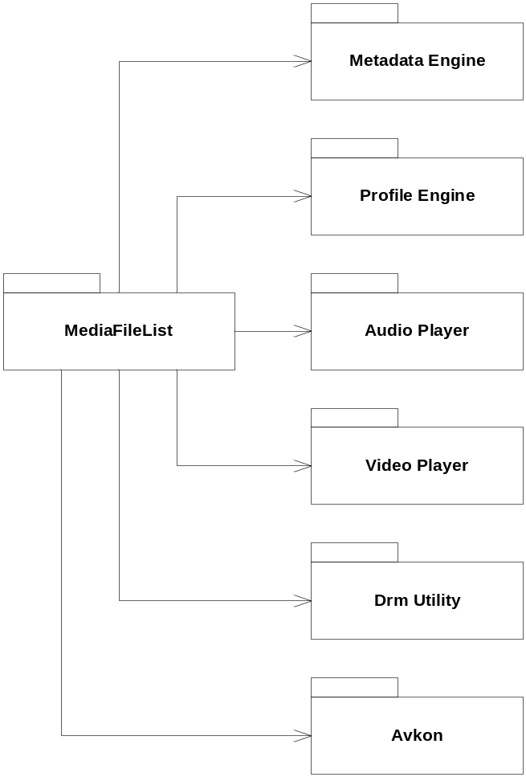
Figure 2.1 Component environment

Use cases

Audio file preview
Summary | User previews audio file.
Actor(s) | User interacts with the UI.
Frequency | Low
Preconditions | Media file list is open.
Description | User focuses audio file by navigating in the list or by using search field. After a short delay automatic audio preview starts.
Exceptions | In case of an error, an error message is displayed.
Postconditions
Illustrations

Video file preview
Summary | User previews video file.
Actor(s) | User interacts with the UI.
Frequency | Low
Preconditions | Media file list is open.
Description | User focuses video file by navigating in the list or by using search field. User then selects ‘Preview’ to start video player.
Exceptions | In case of an error, an error message is displayed.
Postconditions
Illustrations

Media file selection
Summary | User selects audio or video file.
Actor(s) | User interacts with the UI.
Frequency | Low
Preconditions | Media file list is open.
Description | User focuses audio or video file by navigating in the list or by using search field. User then selects focused file by clicking ‘Select’.
Exceptions | In case of an error, an error message is displayed.
Postconditions | Media file list returns selected file name to client. File can then be used e.g. as phone ringing tone.
Illustrations

Services required

From the Symbian OS subsystems
Services of Symbian OS infrastructure and S60 UI Application Framework are required.

API | Description
ecom.lib | Ecom plugin interface
apgrfx.lib | RApaLsSession
apmime.lib | TDataType
ws32.lib | RWindow
centrarepository.lib | Central repository
platformenv.lib | Platform environment
Aknskins.lib | Skin Library
egul.lib | CGulIcon
avkon.lib | UI Framework
bafl.lib | Basic Application Framework Library
commonengine.lib | Text Resolver
cone.lib | Control Environment
efsrv.lib | File Server
Eikcoctl.lib | Core Controls
eikcore.lib | Shared application environment
eikctl.lib | Core Controls
eikdlg.lib | Base dialogs
estor.lib | Symbian OS Base class
euser.lib | Symbian OS Base class
FeatMgr.lib | Feature Manager
Caf.lib | Content access framework
Cafutils.lib | Content access framework
CdlEngine.lib | CdlEngine
Profileengine.lib | Profile Engine
DrmAudioPlayUtility.lib | CDrmPlayerUtility
Mediaclientaudio.lib | CMdaAudioToneUtility
mediaclientvideo.lib | CVideoPlayerUtility
peninputClient.lib | RPeninputServer
DRMCommon.lib | Data Rights Management
DrmRights.lib | Data Rights Management
DrmHelper.lib | Data Rights Management
Drmutility.lib | Data Rights Management
mdccommon.lib | Metadata Engine
mdeclient.lib | Metadata Engine
harvesterclient.lib | Metadata Engine

From the Domestic OS subsystems
This component does not have any direct interfaces to the Domestic OS side subsystems.

From HW
This component has no direct HW interfaces.

Services provided

UI

Provided Service | Description
Media file list. | Media file list allows user to navigate in media file folders or use search field to select a media file. List has separate folders for tones,music, videos and recordings.

SW IF
This component implements API (class CMediaFileList) for displaying Media File List. See file mediafilelist.h for detailed descripton of the following functions and their parameters.

Provided Service | Description | Protected
ShowMediaFileListL | Displays media file list. | No
SetAttrL | Sets media file list attribute (e.g. audio player volume). | No
SetNullItemL | Sets custom item that appears at the end of media file list main view. | No

UI control hierarchy

Framework
Media file list uses Avkon component framework.

Component
Media file list inherits from Avkon component CAknDialog.

Design

Class diagrams

Framework
Media file list UI is implemented using AVKON component framework.
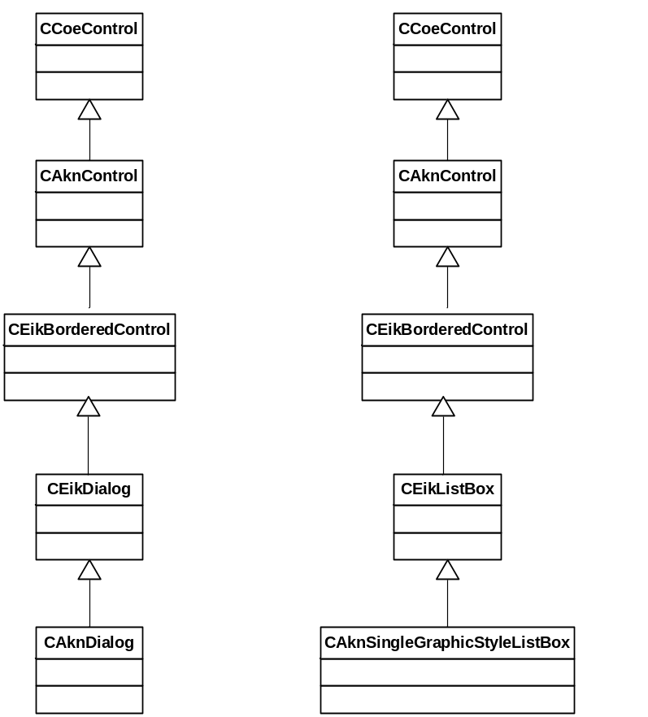
Figure 4.2 Component framework

Component
The following figures describe the main design object model of this subsystem.
Figure 4.3 shows design of CMediaFileDialog. CMediaFileDialog inherits from CAvkonDialog and contains CEikListBox for showing media files/folders. Dialog has CMediaFileHandler for quering media files from metadata engine. See class descriptions for classes used by CMediaFileDialog.
Notice that the current design does not allow displaying list that contains both media files and folders. This decision was made to minimize heap consumption (to avoid storing type information for each list item).
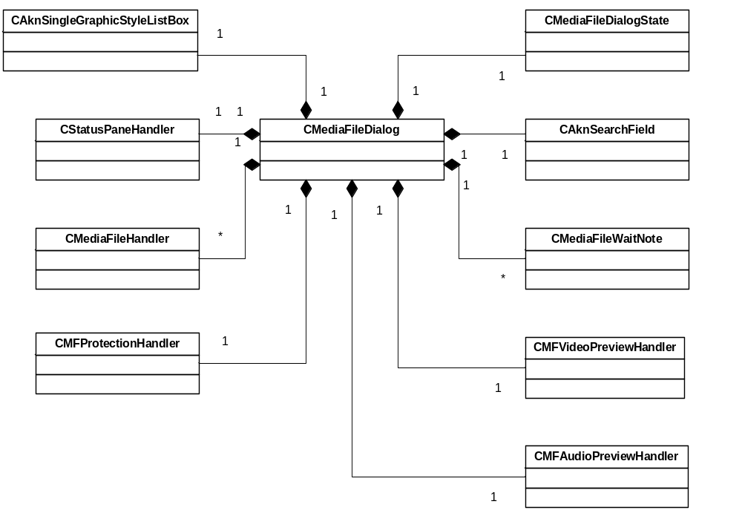
Figure 4.3 The design of CMediaFileDialog
Figure 4.4 shows design of CMediaFileHandler. CMediaFileHandler contains various methods for making metadata engine queries. CMediaFileDialog acts as MMediaFileHandlerObserver to get notifications from CMediaFileHandler. CMediaFileHandler capsulates all MDE related code. See class descriptions for classes used by CMediaFileHandler.
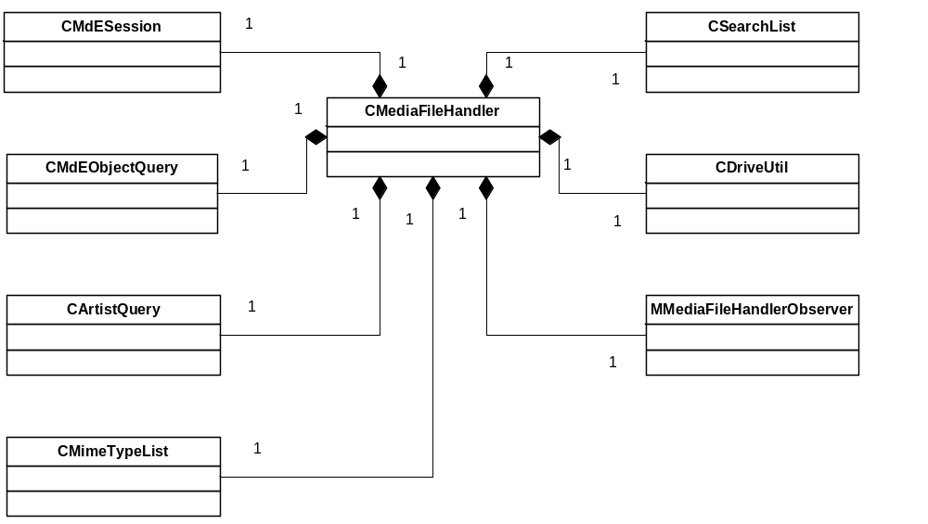
Figure 4.4 The design of CMediaFileHandler

Class descriptions
This section describes the classes in the Media File List.

Class | Description | Header file
CMediaFileList | Public API for displaying media file list. List is used for selecting/previewing audio and video files. | mediafilelist.h
CMediaFileDialog | CMediaFileDialog provides UI for media file list. Dialog has CEikListBox for displaying folders and media files. Dialog gets media file names from MDE. MDE handling is implemented in class CMediaFileHandler. | mediafiledialog.h
CMFListHandler | This class is used as the item array of listbox model. Listbox uses it to draw list items. CMFListHandler gets list item texts from CMediaFileHandler (metadata query result). This way there is no need to copy all list items into listbox model. | mediafiledialog.h
CMFListHandler  Observer | CMFListHandler uses CMFListHandlerObserver (CMediaFileDialog) to get listbox item texts. | mediafiledialog.h
CFindControl | Wrapper class for CAknSearchField. Search field is located at the bottom of the CMediaFileDialog. | mediafiledialog.h
TMFListItem | Represents media file folder. Contains information about the folder (e.g. folder name and list position). | Mediadialogstate.h
CMediaFileDialog  State | Used for maintaining MediaFileDialog state e.g. currently open folder and current list item position. | Mediadialogstate.h
CMediaFileData | Used for storing metadata information for one media file. | Mediafilehandler.h
MMediaFileHandlerObserver | For observing CMediaFileHandler events. | Mediafilehandler.h
CMediaFileHandler | Used for making media file queries. For example get all songs for one artist. Contains all MDE related operations. CMediaFileHandler stores results of last query in CSearchList. | Mediafilehandler.h
CSearchListItem | Data for one media file item CSearchList. | Mediafilehandler.h
CSearchList | List for storing results for one (most recent) metadata query. | Mediafilehandler.h
CArtistQuery | CArtistQuery is for storing all metadata for one artist. Once CArtistQuery is initialized it can be used to get artist subqueries without making more metadata queries. | Mediafilehandler.h
MPreviewHandler  Observer | For observing media file preview events. | Mediafilepreview.h
CMFPreviewHandlerBase | Base class for CMFAudioPreviewHandler and CMFVideoPreviewHandler. | Mediafilepreview.h
CMFAudioPreview  Handler | For previewing audio files (tones, music and recordings). | Mediafilepreview.h
CMFVideoPreview  Handler | For previewing video files. | Mediafilepreview.h
CMFProtection  Handler | For getting media file protection information (e.g. drm protection). If media file is protected and does not have necessary rights it cannot be used e.g. as ringing tone. | Mediafileprotection.h
CMediaFileDialog  Variation | CMediaFileDialogVariation is used to variate media file dialog. Main purpose is to prevent selecting certain mime types. These 'blocked' mime types are stored in central repository. This code is a direct copy from CProfilesLocalFeatures. | Mediafilevariation.h
CMediaFileWait  Note | MMediaFileWaitNote shows progress dialog.  Used in case metadata query takes more that 2 seconds. | Mediafilewaitnote.h
TMFDialogUtil | TMFDialogUtil is utility class for media file dialog. | mediafiledialogutils.h
MMFActiveCaller  Observer | MMFActiveCallerObserver is for observing CMFActiveCaller. | mediafiledialogutils.h
CMFActiveCaller | CMFActiveCaller is used for generating a call from active scheduler. Typical use is to start some operation after a short delay. | mediafiledialogutils.h
CNaviPaneHandler | This class is used for changing navipane title. | mediafiledialogutils.h
CStatusPane  Handler | This class is used for changing dialog title. | mediafiledialogutils.h
CDriveUtil | CDriveUtil is used for getting media file drive information. | mediafiledialogutils.h
CMimeTypeList | CMimeTypeList is used for storing mime types that are excluded from media file list. | mediafiledialogutils.h

Structs, type definitions and enumerations

mediafilelist.h
?Struct/Definition/name of Enumeration | ? Description
TMediaFileListAttribute | Contains attributes for displaying media file list (e.g. preview ringing volume). Used as parameter for function SetAttrL.
TMediaFileType | Type of media file. Used as parameter for function SetAttrL.
TNullItemIcon | Null item icon. Used as parameter for function SetAttrL.
TFolderType | Folder type. Used as parameter for function SetAttrL.

Mediafiledialog.h
?Struct/Definition/name of Enumeration | ? Description
TListOperationType | Listbox operation type (e.g. item selection).
TDelayedOperationType | Delayed operation type (e.g. audio file preview).

Mediafiledialogstate.h
?Struct/Definition/name of Enumeration | ? Description
TMediaFileListFolder | Folders used in media file list.
TMediaFileListIcons | Icons used in media file list.

Mediafilehandler.h
?Struct/Definition/name of Enumeration | ? Description
TMediaType | Media type.
TStorageType | Storage type.
TQueryAttribute | Query attribute.
TQueryType | Query type.

Flag definitions
This subsystem uses macros for debug traces. These macros are controlled using the following flags that are defined in debug.H.

?Flag | ? Description
_DEBUG | Enable debug traces.
__WINS__ | Use file logging.

Operations

Open media file dialog folder
Operation | Reading media file names from metadata engine into media file dialog listbox.
Preconditions | Media file dialog has been launched by the user.
Description | User opens a folder (e.g.. Music/All).
Inputs
Modifies | CMediaFileHandler makes metadata engine query and stores query results (e.g. song name) in the heap array (CSearchList).
Outputs
Postconditions | Media file dialog listbox shows media files of the currently open folder.
Related To
Related Event
Exceptions | In case of an error, an error message is displayed.

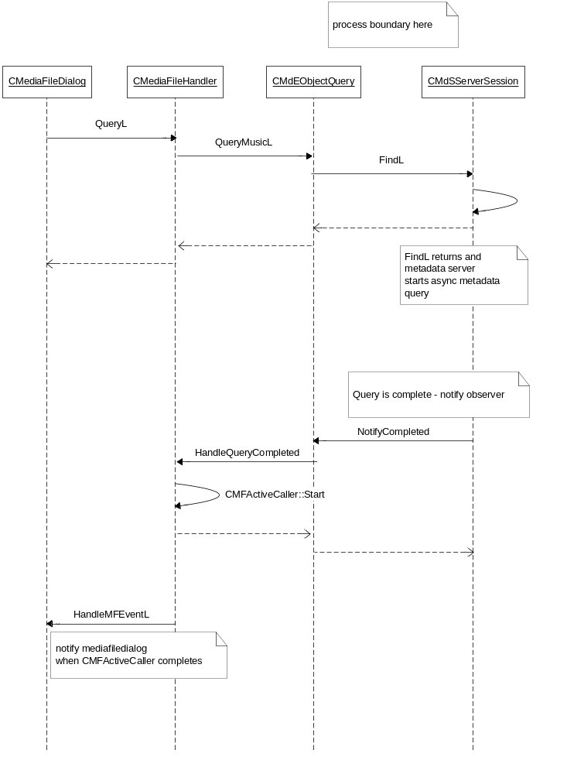
Figure 4.4 The sequence diagram metadata engine search

Backup and Restore
This component does not participate in backup and restore.

Variation
Media file list variation is done using the feature flags. If RD_VIDEO_AS_RINGING_TONE is defined, ‘Videos’ folder is included in the media file list main view.

System resource usage

Files
This component does not use any files.

Other data

Databases
This component does not use any databases.

Central Repository
Media file List reads several Central Repository keys and uses this information for local variation. These variation cases are mainly operator requirements, for example the blocking of non-DRM tones. Media file List reads also few Central Repository keys for getting information about the active profile.

Publish and Subscribe
This component uses Publish and Subscribe for enabling/disabling screen saver during media file preview.

Memory consumption
Media file list stores metadata engine query results in the heap. Amount of used heap depends of the number of media files on phone.

Memory/Build | Consumption
[WINSCW UDeb] | [3 361 kB]
[WINSCW URel] | [388 kB]
[ARMV5 UDeb] | [n/a]
[ARMV5 URel] | [n/a]

Task allocation
The application runs in the thread in which the application was launched.

Performance
In case phone has very large number of media files (e.g. >1000), there may be a delay before media files can be displayed. During this delay a wait note is displayed.

Timers
This component uses timers for starting an operation after a short delay. For example, audio file preview is started automatically (after one second) when the user focuses on some list item. Media file list does not use timers that run continuously.

Timer | Purpose | Interval | Lifetime
CMFActiveCaller | Generate active scheduler call after short delay. | 0 to 2 seconds | 0 to 2 seconds, before the delayed operation. Is stopped after the delay.

Security

Capabilities of this component

Capability | Justification
CAP_GENERAL_DLL | Media file list DLL needs general DLL capabilities.

Input and output validation
This component does not require or make any validation for data.

Environmental assumptions
This component does not make any assumptions about its environment.

Additional enforcements
This component does not have any additional security enforcements.

Exception handling
The leave mechanism of Symbian OS environment is used to handle memory exhaustion.

Usage

Building
Cd /s60/mw/devicemanagement/profilesservices/mediafilelist/group
bldmake bldfiles
abld build

User's guide

Creating, deleting and launching Media File List
TFileName fileName;
TInt nullItem = KErrNotFound;

CMediaFileList* list = CMediaFileList::NewL();
CleanupStack::PushL( list );

list->SetAttrL( CMediaFileList::EAttrTitle, _L("Select media file") );
list->SetAttrL( CMediaFileList::EAttrVolume, EProfileRingingVolumeLevel5 );
list->SetAttrL( CMediaFileList::EAttrRingingType, EProfileRingingTypeRinging );
list->SetAttrL( CMediaFileList::EAttrExcludeMimeType, _L("audio\\mp4") );

list->SetNullItemL( _L("Default tone"),
_L("C:\\Data\\Nokia_tune.aac"),
CMediaFileList::EMediaFileTypeAudio,
CMediaFileList::ENullItemIconDefaultTone );

list->SetNullItemL( _L("Off"), KNullDesC,
CMediaFileList::EMediaFileTypeAudio,
CMediaFileList::ENullItemIconNone );

list->ShowMediaFileListL( &fileName, &nullItem, NULL, NULL );

CleanupStack::PopAndDestroy( list );

