S60 3.x
Access Point Engine
Design Document

Team name | Author
CCC Budapest | Janos Bach (Janos.Bach@ccc.fi)

Change history:

Version | Date | Status | Comments
4.0 | 02.08.2005 | Approved
3.1 | 01.08.2005 | Proposal | All technical details revised. Editorial changes
3.0 | 22.06.2004 | Approved
2.1 | 13.04.2004 | Proposal | No (HS)CSD variation is added
2.0 | 08.04.2004 | Approved
1.1 | 07.04.2004 | Proposal | Added variation section
1.0 | 25.06.2003 | Approved

Table of contents:

1. Document control 5
1.1 References 5
1.2 Documentation conventions 5
1.3 Abbreviations 5
1.4 Definitions 5
2. General 6
2.1 Introduction 6
2.2 Component environment 6
2.3 Use cases 7
2.3.1 Read Access Point data 7
2.3.2 Update Access Point data 7
2.3.3 Delete Access Point data 8
2.3.4 Create new Access Point 8
2.3.5 Get the list of Access Points 8
2.3.6 Provide notification services 8
2.3.7 VPN Access Point support 9
2.3.8 Provide Utility services 9
2.4 Services required 9
2.4.1 From Symbian OS subsystems 9
2.4.2 From Domestic OS subsystems 9
2.4.3 From HW 9
2.5 Services provided 10
2.5.1 UI 10
2.5.2 SW IF 10
2.5.2.1 CActiveApDb 10
2.5.2.2 CApDataHandler 10
2.5.2.3 CApSelect 10
2.5.2.4 CApUtils 10
2.5.2.5 CVpnApEngine 11
3. UI control hierarchy 12
4. Design 13
4.1 Overview 13
4.1.1 Access Point Engine 13
4.1.2 Database administration 13
4.1.3 Listing of the available Access Points 13
4.1.3.1 Filters and sort order 14
4.1.4 Database table operations 14
4.1.5 Unique identifiers (UIDs) 15
4.1.6 Access Point data validation 15
4.1.7 Error handling 15
4.1.8 Concurrency 15
4.1.9 Dependency 15
4.1.10 System events 15
4.2 Class diagrams 16
4.3 Class descriptions 16
4.3.1 Structs, Type Definitions and Enumerations 17
4.3.1.1 ApAccessPointItem.h 17
4.3.1.2 ApDataHandler.h 17
4.3.1.3 ApEngineCommons.h 17
4.3.1.4 ApEngineConsts.h 17
4.3.1.5 ApEngineLogger.h 18
4.3.1.6 ApListItem.h 18
4.3.1.7 ApSelect.h 18
4.3.1.8 ApUtils.h 18
4.3.1.9 VpnApItem.h 18
4.3.2 Flag definitions 18
4.4 Operations 19
4.4.1 Reading an Access Point's data 19
4.4.2 Updating an Access Point’s data 19
4.4.3 Creating an Access Point from an already existing one 19
4.4.4 Creating an Access Point from supplied data 20
4.4.5 Deleting an Access Point 20
4.5 Backup and Restore 20
5. Variation 21
5.1 Protection 21
5.2 Ipv6 support 21
5.3 CSD support 21
5.4 WCDMA support 21
5.5 WLAN support 21
6. System resource usage 22
6.1 Files 22
6.2 Other data 22
6.2.1 Databases 22
6.2.2 Central Repository 22
6.2.3 Publish and Subscribe 22
6.3 Memory consumption 22
6.4 Task allocation 23
6.5 Performance 23
6.6 Timers 23
7. Security 24
7.1 Capabilities of this component 24
7.2 Input and output validation 24
7.3 Environmental assumptions 24
7.4 Additional enforcements 24
8. Exception handling 25
9. Usage 26
9.1 Creating a new Access Point 26
9.2 Reading Access Point data 26
9.3 Editing/updating an already existing one 26
9.4 Deleting an Access Point 27
9.5 Getting the list of Access Points 27
9.6 Using active database framework, notification services 27
9.7 Building 28
9.8 User's Guide 28
9.8.1 Concurrency considerations 28
9.8.2 Full Access Point management 28

Document control

References
- Series 60 Platform Object Oriented Design Guideline
- Series 60 Platform Coding Conventions Document
- OS System Documentation | Symbian document
- S60 Networking UI Specification

Documentation conventions
Code is shown with Courier New font.

Abbreviations
AP | Access Point. A term used globally for Internet and WAP Access Points.
CSD | Circuit Switched Data. A protocol for data transfer over GSM networks.
DNS | Domain Name Server. This server translates names such as www.symbian.com into an IP address (194.129.36.4).
GPRS | General Packet Radio Service. A mobile service that gives packet switched access over GSM to external data networks with high peak transfer capacity.
GSM | Global System for Mobile communications. A global telecommunications networking standard.
HSCSD | High Speed Circuit Switched Data. A protocol for increasing the speed of data transfer over GSM networks.
IAP | Internet Access Point
IP | Internet Protocol
ISDN | Integrated Services Digital Network
ISP | Internet Service Provider. A company that operates a chargeable dial-in service to the Internet for web browsing and email.
OTA | Over The Air
UID | Unique Identifier
WAP | Wireless Application Protocol. A specification for a set of communication protocols to standardize the way that devices, such as cellular telephones, can be used for Internet access.

Definitions
Bearer | A protocol, which is utilized for carrying WAP data.
Hayes | Hayes-compatible landline modem.

General
The Access Point Engine (ApEngine) subsystem provides a way to access and manage Access Points. An Access Point is a collection of data required for creating an Internet connection to use any of its services.
An Access Point contains all information required for a connection.
This document contains the architecture and API design for Access Point Engine.

Introduction
The Access Point Engine subsystem of S60 is a module providing access and managing the Access Points. An Access Point is a collection of data needed to establish an Internet connection.

Component environment
The key relationships between Access Point Engine and the components in its environment are shown in Figure 2.1
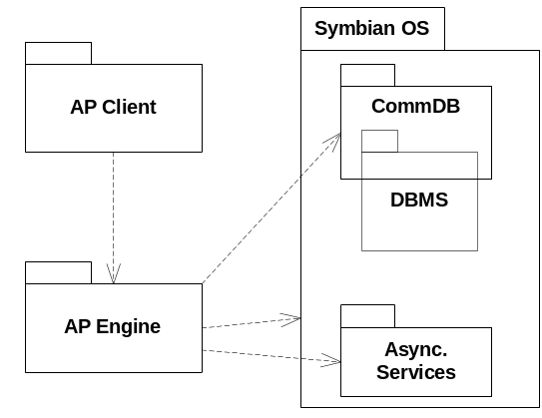
Figure 2.1 Component environment

Use cases
Read Access
Point data
Update Access
Point data
Delete Access Point
Create new
Access Point
Provide notification service
VPN Access Point support
Provide Utility services
Client Application
Get the list of
Access Points
Figure 2.2 Access Point Engine use cases

Read Access Point data
Summary | Reading up one access points data from Communication Database into a container
Actor(s) | Client application
Frequency | Low
Preconditions
Description | The client application requests the read of the specific Access Points data
Exceptions
Postconditions
Illustrations

Update Access Point data
Summary | Update an existing access points data in the Communication Database
Actor(s) | Client application
Frequency | Low
Preconditions
Description | The client application requests the updating of the specific Access Points data
Exceptions
Postconditions | The access points data is modified
Illustrations

Delete Access Point data
Summary | Delete one access points data from the Communication Database
Actor(s) | Client application
Frequency | Low
Preconditions
Description | The client application requests the deleting of the specific Access Points data
Exceptions
Postconditions | The specific access point is deleted
Illustrations

Create new Access Point
Summary | Create a new Access Point in Communication Database from a data container
Actor(s) | Client application
Frequency | Low
Preconditions
Description | The client application requests the creation of a new Access Points with specific data
Exceptions
Postconditions | A new Access Point is created
Illustrations

Get the list of Access Points
Summary | Reading up the list of the Access Points from Communication Database fulfilling specific filtering criteria into a container array
Actor(s) | Client application
Frequency | Low
Preconditions
Description | The client application requests the list of the specific Access Points
Exceptions
Postconditions
Illustrations

Provide notification services
Summary | Provides database change notifications for registered clients.
Actor(s) | Client application
Frequency | Low
Preconditions
Description | The client application requests the notifications and it is called back whenever the database is changed.
Exceptions
Postconditions
Illustrations

VPN Access Point support
Summary | Support for VPN Access Points, create/edit/delete.
Actor(s) | Client application
Frequency | Low
Preconditions
Description | The client application requests the operation on a VPN Access Point
Exceptions
Postconditions
Illustrations

Provide Utility services
Summary | Getting basic information about a specific Access Point like name, bearer type, ID
Actor(s) | Client application
Frequency | Low
Preconditions
Description | The client application requests the specific detail of the specific Access Point
Exceptions
Postconditions
Illustrations

Services required

From Symbian OS subsystems
API | Description
Basic services of Symbian OS infrastructure | E32, CONE, basic functionalities are required.
Comms | Services of Communications Database (CommsDB) are required, to manipulate Access Point data.
Feature Manager | To determine the supported features

From Domestic OS subsystems
This component does not have any direct interfaces to the Domestic OS side subsystems.

From HW
This component has no direct HW interfaces.

Services provided

UI
This component does not provide any UI.

SW IF

CActiveApDb
Provided Service | Description | Protected
NewL() | Creates an active database service where clients can register to receive notification on database change. | No
AddObserverL() | Registers the passed observer which must implement the MActiveApDbObserver protocol and automatically starts notification service if not yet started | No
RemoveObserver() | Removes the passed observer from the notification service and stops service if there are no more observers | No

CApDataHandler
Provided Service | Description | Protected
NewLC() | Creates an Access Point data handler object which can be used to handle Access Point data. | No
AccessPointDataL () | Registers the passed observer which must implement the MActiveApDbObserver protocol and automatically starts notification service if not yet started | No
UpdateAccessPointDataL() | Updates data stored in an existing Access Point | No
RemoveAPL() | Removes the given Access Point from the database | No
CreateFromDataL() | Create a new Access Point from supplied data | No

CApSelect
Provided Service | Description | Protected
NewLC() | Creates an Access Point selector object which filters the database according to the given filtering parameters to select specific Access Points. | No
SetFiltersL() | Sets filtering parameters for repeated filtering | No
AllListItemDataL() | Provides all the Access Points fulfilling the filtering criteria in a CApListItemList array. | No

CApUtils
Provided Service | Description | Protected
NewLC() | Creates an Access Point utility object | No
BearerTypeL() | Gets the bearer type of a given Access Point | No
IsValidNameL () | Returns whether a given name is valid or not | No
MakeValidNameL() | Creates and returns a valid name based on the passed one. | No
NameL() | Returns the name of a given Access Point | No

CVpnApEngine
Provided Service | Description | Protected
NewLC() | Creates a VPN Access Point data handler object which can be used to handle VPN Access Point data. | No
CreateVpnApL() | Creates a new VPN from the passed CVpnApItem | No
VpnDataL() | Reads up one VPN Access Point's data from the database | No
UpdateVpnDataL() | Updates data stored in an existing VPN access point | No
DeleteVpnL() | Removes the given VPN Access Point. | No

UI control hierarchy
The component does not contain any UI or UI controls.

Design

Overview

Access Point Engine
In S60, Access Points are stored in a database. The Symbian OS CommsDb is used over Symbian OS CommsDat to manage the database. Access Point Engine is a thin layer over the CommsDb to make the management easier for the Access Point UI. For details about the Symbian OS, Communication database, CommsDb and CommsDat, see reference document [3].
The Access Point database is hidden from the UI. Access Point Engine contains three main classes that satisfy very different needs of the client.
The first class of Access Point Engine, CApSelect, provides access to the main properties of each Access Point in two different ways. The first possibility is to navigate the Access Points and read their details one by one. The second possibility is to get all the main properties in a single function call. The second approach is preferred for the UI; it requires no effort to build up a list containing the Access Points.
The second class, CApDataHandler, provides methods for managing the Access Points: storage, retrieval, etc.
The third class, CApUtils, provides useful information for clients, e.g. returning the name of a given Access Point, determining Access Point name validity, etc.
All three classes encapsulate the CommsDB database and a session with the Symbian OS database server. Database integrity, atomicity of updates, transaction support and concurrency handling works as it is provided by the underlying Communication database.
A fourth class, CApAccessPointItem, is used to exchange data between Access Point Engine and the client.
A fifth class, CActiveApDb, encapsulates the active database functionality, including the notification of clients about database changes. A notification is performed with the MActiveApDbObserver mix-in class. To be able to utilize the notification feature, clients must implement the MActiveApDbObserver protocol and add themselves to the list of observers or remove themselves from it. CActiveApDb also uses a private thin helper class called CActiveApDbNotifier.
A sixth class, CApListItem, is used to encapsulate one item in the CApSelect class. Also a seventh class, a thin wrapper around CArrayPtrFlat<CApListItem> called CApListItemList, is provided to ensure leave-safety of the array and its elements. It implements only an empty constructor and a special destructor to ensure that elements are also destroyed.

Database administration
Database administration is automatic. When the Access Point database is opened, it is checked to be fully functional and is recovered as needed by the CommsDat. When it is closed, it is automatically compacted. The CommsDat performs these operations through it’s management.

Listing of the available Access Points
Access Point Engine supports the listing of all Access Points (including only the name, UID, bearer type and the type of the Access Point). This list can be filtered according to the type of the Access Point and the bearer type. By default, no filtering is done. The list is sorted according to the Access Point UIDs unless another order is specified. Methods for setting these properties are provided. Access Point Engine also provides methods to access individual elements either by navigating between each item or in one step as an array of elements. The list contains only the name, the UID, the bearer type and the type of the Access Point.

Filters and sort order
Access Point selection can be tailored by specifying one or more filters and/or a sort order. In case of filtering, only Access Points fulfilling the filtering rule(s) are shown in the given order. In case of changing the filtering or ordering, clients shall discard all previously read/received information and re-read them.
The following filters are supported:
- Access Point Type Filter: a TInt value indicating the type(s) of the Access Points to be included in the list. Only Access Points with the specified type(s) will be listed. The possible values are:
- KEApIspTypeInternetOnly
- KEApIspTypeWAPOnly
- KEApIspTypeInternetAndWAP
- KEApIspTypeWAPMandatory
- KEApIspTypeAll
- and their combinations (using the operator OR)
- Bearer Type Filter: a TInt value indicating the bearer type(s) of the Access Points to be listed. Only Access Points with the specified bearer(s) will be listed. The possible values are:
- EApBearerTypeCSD
- EApBearerTypeGPRS
- EApBearerTypeHSCSD
- EApBearerTypeAll, this one will be deprecated
- EApBearerTypeCDMA
- EApBearerTypeWLAN
- EApBearerTypeLAN
- EApBearerTypeLANModem
- EApBearerTypeAllBearers
- and their combinations (using the operator OR)

The filters are also in effect when counting items.
The filters remain set until overridden.
Access Point Engine supports the ordering of Access Points according to their UID or their name either in ascending or descending order. The sort orders remain set until overridden.
When navigating in the list of the available Access Points, the given filters are used. When navigating the list sequentially (using CApSelect::MoveNext() or CApSelect::MovePrev(), etc), elements are retrieved in an order that matches the current specified sort order.
Data retrieval methods and navigating keep the sort order untouched. Data manipulation methods, however, change the underlying database. Therefore, a client must take care of refreshing its data content. Using the included active database framework is recommended, but it is optional.

Database table operations
Most methods of Access Point Engine perform multiple database operations. For these, Access Point Engine uses transactions. Clients usually should not be aware of it. Access Point Engine will begin and commit all transactions, if required within the method, or use the client’s already started transaction, if there is any.
(This is not to be confused with automatic transactions managed by CommsDat. Those automatic transactions are not used by, and not accessible through, Access Point Engine.)
Most methods of Access Point Engine use simple filtering with manual handling (adding/removing records manually to achieve more complicated filtering) as SQL is no longer supported to complete their tasks.

Unique identifiers (UIDs)
All Access Points have a unique identifier, which is their primary identity. The UID is assigned by the database, and it cannot be changed. According to reference document [4], no two Access Points can have the same name in the whole database. Apart from the UID and the name, various Access Points can have the same properties. Therefore, Access Point Engine takes care about the unique name and UID and ensures that the names of the stored Access Points are unique.

Access Point data validation
Clients are free to create any number of Access Points and fill them with meaningful values. However, the maximum number of records in a table is limited to 255 by the Symbian OS’s CommsDat module. The data that is used to fill CApAccesPointItem is not validated; only the database integrity is checked and ensured.

Error handling
Most of the methods leave in case of recoverable error conditions, but in certain situations they can also panic. Panics is used when the error condition is caused by a programmatic error or in such fatal situations where no recovery is possible. Panicking on programmatic errors are done only in debug builds, whereas release builds usually leave, silently ignore or handle the case, whichever behavior is most suitable in the case in question. Clients may want to TRAP these leaves and take appropriate action when and where applicable.

Concurrency
Concurrency handling works as it is provided by the underlying CommsDat.
Also see Section 9.8.1.

Dependency
All the classes that use the database (that is, the CCommsDatabase or CActiveApDb object) remain intact during all operations. The database instance should be created first and destroyed last.

System events
All clients must watch for system events that are related to the database (or the permanent store containing the database). Such events include Backup / Restore and Power-down operations. In these cases, the client must finish database operations and close the database immediately.

Class diagrams
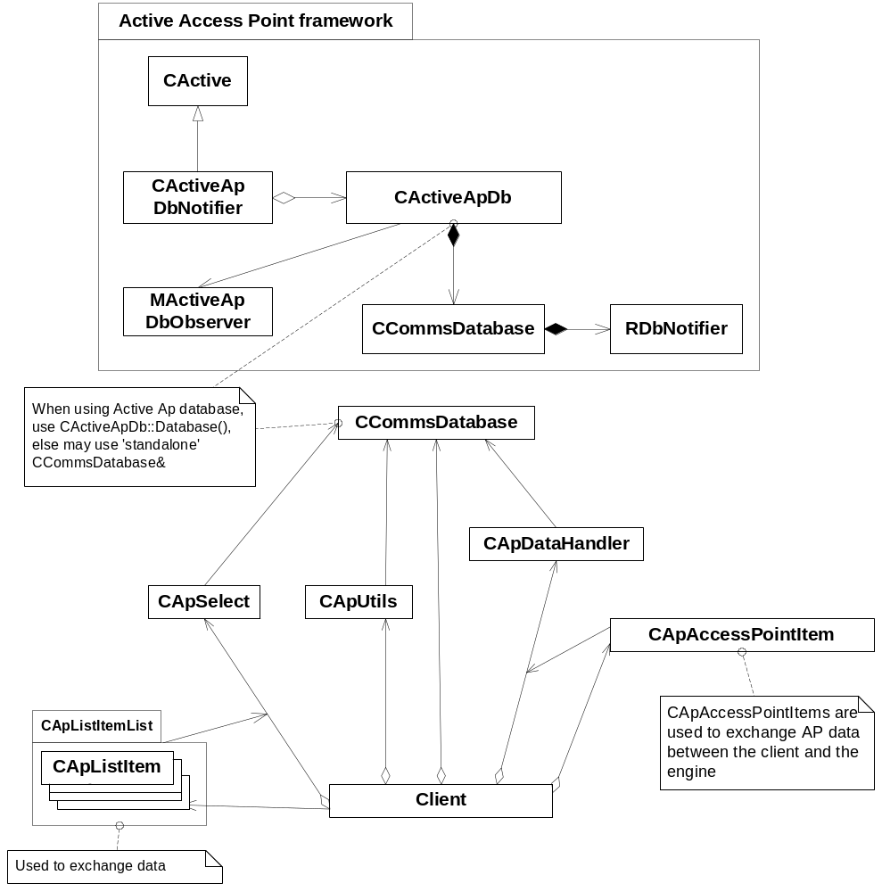
Figure 4.3 Access Point Engine API classes

Class descriptions
Class | Description | Header file
MActiveApDbObserver | Mixin protocol for notification service | ActiveApDb.h
CActiveApDb | Active database observer | ActiveApDb.h
CActiveApDbNotifier | Notifier for the active database | ActiveApDbNotifier.h
CApAccessPointItem | Container class for Access Point data | ApAccessPointItem.h
CApDataHandler | A class to handle Access Point data manipulation | ApDataHandler.h
ApCommons | A collection of static helper functions | ApEngineCommons.h
ApEngineLogger | Class for logging Access Point Engine activity | ApEngineLogger.h
CApItemCdmaData | Container class for CDMA data | ApItemCdmaData.h
CApItemExtra | Container class to hold extra Access Point data | ApItemExtra.h
CApItemWlanData | Container class for WLAN data | ApItemWlanData.h
CApListItem | Container class for one access point list item | ApListItem.h
TApListItemNameKey | Sorting key class for sorting according to Access Point name | ApListItemKey.h
TApListItemUidKey | Sorting key class for sorting according to Access Point UID | ApListItemKey.h
CApListItemList | A list of CApListItem objects to hold a list of access points | ApListItemList.h
CApSelect | A class to handle the filtering of access points for selection | ApSelect.h
CApUtils | Class containing utility functions | ApUtils.h
CVpnApEngine | A class to handle VPN Access Point data manipulation | VpnApEngine.h
CVpnApItem | Container class to hold VPN data | VpnApItem.h

Structs, Type Definitions and Enumerations

ApAccessPointItem.h
Struct/Definition/Enumeration's name | Description
enum TApMember | The different fields of an Access Point

ApDataHandler.h
Struct/Definition/Enumeration's name | Description
typedef struct THandlerExtra | Holds extra data

ApEngineCommons.h
Struct/Definition/Enumeration's name | Description
enum TApEnginePanicCodes | Panic codes

ApEngineConsts.h
Struct/Definition/Enumeration's name | Description
enum TApBearerType | Access Point bearer types
enum TApCallSpeed | Call speeds
enum TApCallType | Call types
enum TIPvType | IP version types
enum TWlanNetMode | WLAN network modes
enum TWlanSecMode | WLAN security modes
#define KApMaxConnNameLength | Maximum connection name length
#define KRetryWait | Wait before retry

ApEngineLogger.h
Struct/Definition/Enumeration's name | Description
enum TApEngineLogMask | Logging mask
#define APENGINE_LOG_MASK | Current logging mask
#define APENGINE_LOG_LEVEL | Current logging level

ApListItem.h
Struct/Definition/Enumeration's name | Description
typedef struct TApListItemExtra | Holds extra data.

ApSelect.h
Struct/Definition/Enumeration's name | Description
enum TVpnFilterType | VPN filtering types
typedef struct TSelectExtra | Holds extra data
typedef struct TVpnData | Holds VPN data

ApUtils.h
Struct/Definition/Enumeration's name | Description
typedef struct TUtilsExtra | Holds extra data

VpnApItem.h
Struct/Definition/Enumeration's name | Description
enum TVpnApMember | The different fields of a VPN Access Point

Flag definitions
This section specifies the flags (debug etc. flags) used by the component, and clarify their usage for the reader. Variation flags are defined in Chapter 5.
Flag | Description
__TEST_APENGINE_LOG_ENABLED | Test flag which enables logging Access Point Engine activities, it is undefined in product
__TEST_IPV6_SUPPORT | Test flag which enables testing of IPv6 support independently from the real feature status, it is undefined in product
__TEST_APENGINE_LOG__ | Test macro to enable logging
__TEST_CDMA_SUPPORT | Test flag which enables testing of CDMA support independently from the real feature status, it is undefined in product
__TEST_CSD_SUPPORT | Test flag which enables testing of CSD support independently from the real feature status, it is undefined in product
__TEST_HSCSD_SUPPORT | Test flag which enables testing of HSCSD support independently from the real feature status, it is undefined in product
__TEST_CDMA_WRITE_PROTECT | Test flag which enables testing of CDMA write protection support independently from the real feature status, it is undefined in product
__TEST_WLAN_SUPPORT | Test flag which enables testing of WLAN support independently from the real feature status, it is undefined in product
__TEST_LAN_BEARER | Test flag which enables testing of LAN support independently from the real feature status, it is undefined in product
WINS | Flag for windows specific code in MMP
__WINS__ | Flag for windows specific code

Operations

Reading an Access Point's data
Operation | Reading an Access Point’s data.
Preconditions | CApDataHandler has been created and the database has been opened.
Description | The data from an Access Point is read from the database.
Inputs | The UID of the Access Point to be read.
Modifies
Outputs | The data from the Access Point.
Postconditions
Related To
Related Event
Exceptions | Insufficient memory, the Access Point does not exist, a server connection failure.

Updating an Access Point’s data
Operation | Updating an Access Point’s data.
Preconditions | CApDataHandler has been created and the database has been opened.
Description | The data of an existing Access Point is modified.
Inputs | The Access Point whose data is to be updated.
Modifies | The data of the Access Point.
Outputs
Postconditions
Related To
Related Event
Exceptions | Insufficient memory, a server connection failure, a lock already present by another task, the Access Point does not exist, the data is read-only.

Creating an Access Point from an already existing one
Operation | Creating an Access Point from an already existing one.
Preconditions | The CApDataHandler object has been created and the database has been opened.
Description | An Access Point object is created from one that already exists in the database.
Inputs | The UID of the Access Point to copy from.
Modifies | The Access Point database.
Outputs | The newly constructed Access Point.
Postconditions
Related To
Related Event
Exceptions | Insufficient memory, a server connection failure, a lock already present by another task, the Access Point does not exist, attempting to create a new Access Point in protected tables.

Creating an Access Point from supplied data
Operation | Creating an Access Point from supplied data.
Preconditions | The CApDataHandler object has been created and the database has been opened.
Description | An Access Point is created based on the supplied data. The name of the Access Point is corrected to be unique, if necessary.
Inputs | The data on which the new Access Point will be based.
Modifies | The Access Point database.
Outputs | The newly constructed Access Point.
Postconditions
Related To
Related Event
Exceptions | Insufficient memory, a server connection failure, a lock already present by another task, attempting to create a new Access Point in protected tables.

Deleting an Access Point
Operation | Removing an Access Point from the database.
Preconditions | CApDataHandler has been created and the database has been opened.
Description | Removes a given Access Point from the database. In case of an error, the Access Point is not removed.
Inputs | The UID of the Access Point to be removed.
Modifies | The Access Point database
Outputs
Postconditions
Related To
Related Event
Exceptions | Insufficient memory, a server connection failure, a lock already present by another task, the Access Point does not exist, attempting to remove read-only records.

Backup and Restore
- The Access Point Settings UI accesses but does not own the Access Point data in the Communication database

Variation
The Access Point Engine uses variations for the following:
- Build time variation using __SERIES60_SETTINGS_PROTECTION
- Run-time variation using Feature Manager to query IPv6 support.
- Run-time variation using Feature Manager to query CSD support.
- Run-time variation using Feature Manager to query WCDMA support.
- Run-time variation using Feature Manager to query WLAN support.

Protection
This is build time variation using __SERIES60_SETTINGS_PROTECTION flag to determine whether access point and table protection is handled or not. If protection is handled, a small lock icon signals the protected access points in the UI and those access points cannot be edited or deleted.

Ipv6 support
This is runtime variation using Feature Manager to query if IPv6 is supported or not. The used feature flag is KFeatureIdIPv6.

CSD support
This is runtime variation using Feature Manager to query if CSD is supported or not. The used feature flag is KFeatureIdAppCsdSupport.

WCDMA support
This is runtime variation using Feature Manager to query if WCDMA is supported or not. The used feature flag is KFeatureIdProtocolWcdma.

WLAN support
This is runtime variation using Feature Manager to query if WLAN is supported or not. The used feature flag is KFeatureIdProtocolWlan.

System resource usage

Files
File | ApEngine.rss
Type | Private
Location | ROM
Format | Binary
Sharing | Not shared
Encryption | Not encrypted
Size estimate
Clean up | Permanent file
Description | Resource file

File | ApEngine.loc
Type | Private
Location | ROM
Format | Binary
Sharing | Not shared
Encryption | Not encrypted
Size estimate
Clean up | Permanent file
Description | Localization file

Other data

Databases
Access Point Engine uses CommsDb/CommsDat to persist Access Point data.

Central Repository
This component does not use Central Repository.

Publish and Subscribe
This component does not use Publish and Subscribe.

Memory consumption
Memory/Build | Consumption
WINSCW UDEB | 669 120 bytes
ARMV5 UREL | 45 210 bytes
Resource file (.RSC) | ~1 kb

Task allocation
This component runs in one thread, which is the thread of the client application.

Performance
The performance is determined by the underlying CommsDat storage system.

Timers
Access Point Settings UI does not use timers.

Security

Capabilities of this component
The capabilities of the Access Point Engine (ApEngine.dll) are defined as CAP_GENERAL_DLL that is “ALL –Tcb”.
As a shared library, the capabilities describe its level of trust, and this component can be trusted not to leak any capability protected information to unauthorized parties.

Input and output validation
Input data is supplied by the calling client.
Output data are what the module saves to the database.
- Data is normally validated according to the [4] specifications and are stored in the database.
- The database is considered to be structurally correct; tables must exist for correct operation.

Environmental assumptions
This component does not make any assumptions about its environment.

Additional enforcements
This component does not have any additional security enforcements.

Exception handling
The leave mechanism of Symbian OS environment is used to handle memory exhaustion and other system-wide errors.
The main possible reasons for leaving include the following:
- The system memory is exhausted.
- During creation, it fails to connect to the Communications database.
- The established connection to the database server breaks or terminates abnormally.

In debug builds, asserts are used to panic the thread and reveal programming errors. In release builds, such errors are silently ignored and do not cause abnormal termination (crash), but may cause failed operation.

Usage
To use the Access Point Engine module, users must link with the Access Point Engine library and include the header file(s):
#include < ApEngineConsts.h>

and the headers of the classes clients would like to use.
In every place where a function expects the CCommsDatabase class as a parameter, in case of use of the active database framework, it is advised to use the database from the active framework as follows:
CCommsDatabase* CActiveApDb:: Database();

Creating a new Access Point
CCommsDatabase *database = CCommsDatabase::NewL( EDatabaseTypeIAP );
CleanupStack::PushL( database );
CApAccessPointItem *apitem = CApAccessPointItem::NewLC();
CApDataHandler *handler = CApDataHandler::NewLC( *database );

// Now write in the values into apitem, some examples only, not neccessary.
// Used _L as beeing only example, in real code shall use _LIT or any descriptor
apitem->WriteTextL( EApWapAccessPointName, _L("First conn.") );
apitem->WriteTextL( EApWapCurrentBearer, TPtrC(WAP_IP_BEARER) );
apitem->WriteTextL( EApWapStartPage, _L("aUrlHere") );
apitem->WriteBool( EApWapWspOption, ETrue);
apitem->WriteUint( EApWapIspType, EWapIspTypeDialOut);
apitem->WriteLongTextL( EApIspLoginScript, _L("CHARMAP [CODE PAGE 1252]\nLOOP 10\n{\nSEND \"CLIENT\"+<0x0d>\nWAIT 3\n{\n\"SERVER\" OK\n}\n}\nEXIT KErrNoAnswer$\n\nOK:\nEXIT\n") );

// now create the access point
TUint32 auid = aphandler->CreateFromDataL( *apitem );
CleanupStack::PopAndDestroy( 3 ); // handler, apitem, database

Reading Access Point data
CCommsDatabase *database = CCommsDatabase::NewL( EDatabaseTypeIAP );
CleanupStack::PushL( database );
CApAccessPointItem *apitem = CApAccessPointItem::NewLC();
CApDataHandler *handler = CApDataHandler::NewLC( *database );

TUint32 auid = THE_ID_WE_WANT_TO_READ;
handler->AccessPointDataL(auid, *apitem);
CleanupStack::PopAndDestroy( 3 ); // handler, apitem, database

Editing/updating an already existing one
CCommsDatabase *database = CCommsDatabase::NewL( EDatabaseTypeIAP );
CleanupStack::PushL( database );
CApAccessPointItem *apitem = CApAccessPointItem::NewLC();
CApDataHandler *handler = CApDataHandler::NewLC( *database );

TUint32 auid = THE_ID_WE_WANT_TO_EDIT;
handler->AccessPointDataL(auid, *apitem);

// Now edit it, write in values into apitem, some examples only, not neccessary.
// Used _L as beeing only example, in real code shall use _LIT or any descriptor
apitem->WriteTextL( EApWapAccessPointName, _L("First conn.") );
apitem->WriteTextL( EApWapCurrentBearer, TPtrC(WAP_IP_BEARER) );
apitem->WriteTextL( EApWapStartPage, _L("aUrlHere") );
apitem->WriteBool( EApWapWspOption, ETrue);
apitem->WriteUint( EApWapIspType, EWapIspTypeDialOut);
apitem->WriteLongTextL( EApIspLoginScript, _L("CHARMAP [CODE PAGE 1252]\nLOOP 10\n{\nSEND \"CLIENT\"+<0x0d>\nWAIT 3\n{\n\"SERVER\" OK\n}\n}\nEXIT KErrNoAnswer$\n\nOK:\nEXIT\n") );

// now update the access point
TBool NameChanged( EFalse );
aphandler->UpdateAccessPointDataL(*apitem, aNameChanged );

CleanupStack::PopAndDestroy( 3 ); // handler, apitem, database

Deleting an Access Point
CCommsDatabase *database = CCommsDatabase::NewL( EDatabaseTypeIAP );
CleanupStack::PushL( database );
CApDataHandler *handler = CApDataHandler::NewLC( *database );

TUint32 auid = THE_ID_WE_WANT_TO_DELETE;
handler-> RemoveAPL ( auid );

CleanupStack::PopAndDestroy( 2 ); // handler, database

Getting the list of Access Points
CCommsDatabase *database = CCommsDatabase::NewL( EDatabaseTypeIAP );
CleanupStack::PushL( database );
CApSelect* sel = CApSelect::NewLC( *database, KEApIspTypeAll, EApBearerTypeAll,
EApSortNameAscending ); // filtering criterias can be OR-ed, e.g. EApBearerTypeCSD + EApBearerTypeHSCSD or KEApIspTypeInternetOnly + KEApIspTypeWAPOnly, etc.

CApListItemList* aList = new( ELeave )CApListItemList();
CleanupStack::PushL( aList );
TInt count = sel->AllListItemDataL( *aList );

.... Use the list of access points

CleanupStack::PopAndDestroy( 3 ); // database, sel, aList

Please note that deleting aList will also delete the items it contains, because the list owns its elements.

Using active database framework, notification services
To use the notification service, the client class must implement the MActiveApDbObserver mix-in protocol. This mix-in protocol has only one virtual function, virtual void HandleApDbEventL( TEvent anEvent ) = 0; which must be implemented in the client class to be able to use the notification service.
The passed event code indicates the type of the change. EDbChange means that a committed database write has happened. This is caused by writing to or deleting from the database and committing the changes (if a transaction is used, CommitTransaction() is called).
The event code EDbAvailable means that a read lock is removed from the database. It can be caused by RollBacks and Reads.
When a database event happens (EDbChanged) and the database is changed, the client’s implementation of HandleApDbEventL() is called and clients can refresh the view if they wish.
Once an object has registered itself as an observer, it receives notifications until the database is destroyed or the client removes itself from the list of observers.
Notification service is started automatically when the first observer registers itself and stopped automatically when the last observer removes itself.
When such a client would like to request notification service, it only has to register itself into the active database. This can be done by calling:
void CActiveApDb::AddObserverL( MActiveApDbObserver* anObserver );

where anObserver is a pointer to the observing class.
Canceling notification service can be achieved with removing the class from the observers:
void CActiveApDb::RemoveObserver( MActiveApDbObserver* anObserver );

This will prevent any new notifications from occurring.
Note: It is necessary to remove an observer before destroying it. Special care must be taken that when the client leaves, it shall not leave the object registered.

Building
The build sequence is:
cd \APEngine\group
bldmake bldfiles
abld build

User's Guide

Concurrency considerations
Transaction and concurrency handling works exactly as it is provided by the Communications database.
- Any access to the database tries to get a read-lock on the database. This fails if there is already a write-lock active.
- Any update operation tries to get a write-lock on the database, either by turning the existing read-lock into a write-lock, or creating a new one (automatic transactions). It fails if there is any kind of lock(s) on the database.

As a consequence, it is possible to get a deadlock situation: two clients begin a transaction with BeginTransaction(). Both get a read-lock. Now, if both wait until all locks are removed so that they can turn their lock to write-lock, both will wait forever. It is important that clients are programmed in such a way that they back up in such situations and remove their read-locks.
See reference document [3] for details.

Full Access Point management
It is important to note that the Communications database does not provide serialization. Therefore, it is vital that everyone keeps locks on the database for the shortest time possible. Especially, actions that require user input should be avoided with lock on. Therefore, Access Point Engine takes care of removing the locks so that clients do not have to take this into account.

