S60 3.x
Access Point Settings UI
Design Document

Team name | Author
CCC Budapest | Janos Bach (Janos.Bach@ccc.fi)

Change history:

Version | Date | Status | Comments
4.0 | 27.07.2005 | Approved
3.2 | 21.07.2005 | Draft | All technical details revised. Editorial changes.
3.1 | 13.04.2004 | Draft | No (HS)CSD variation is added.
3.0 | 08.04.2004 | Approved
2.1 | 07.04.2004 | Draft | Added variation section
2.0 | 25.11.2003 | Approved | Document validity updated.
1.0 | 18.06.2003 | Approved

Table of contents:

1. Document control 5
1.1 References 5
1.2 Documentation conventions 5
1.3 Abbreviations 5
1.4 Definitions 5
2. General 6
2.1 Introduction 6
2.2 Component environment 6
2.3 Use cases 6
2.3.1 View the list of access points 7
2.3.2 Deleting access points 7
2.3.3 Creating new access points 7
2.3.4 Modifying access points 8
2.3.5 Viewing access points detail 8
2.4 Services required 8
2.4.1 From Symbian OS subsystems 8
2.4.2 From Domestic OS subsystems 8
2.4.3 From HW 9
2.5 Services provided 9
2.5.1 UI 9
2.5.2 SW IF 9
3. UI control hierarchy 10
3.1 Framework 10
3.2 Component 10
4. Design 11
4.1 Class diagrams 11
4.1.1 Framework 11
4.1.2 Component 11
4.2 Class descriptions 13
4.2.1 Structs, Type Definitions and Enumerations 14
4.2.1.1 ApSelectorListboxModel.h 14
4.2.1.2 ApSettingsDeleteOperation.h 14
4.2.1.3 ApSettingsDlg.h 14
4.2.1.4 ApSettingsHandlerCommons.h 14
4.2.1.5 ApSettingsHandlerUI.h 14
4.2.1.6 ApSettingsHandlerUI.hrh 14
4.2.1.7 ApSettingsModel.h 14
4.2.2 Flag definitions 15
4.2.3 State diagrams 16
4.2.3.1 CApSettingsDeleteOperation 16
4.3 Operations 16
4.3.1 Deleting an access point 16
4.3.2 Creating new access points 17
4.3.3 Modifying access points 17
4.3.4 Viewing access points detail 17
4.4 Backup and Restore 18
5. Variation 19
5.1 HELP 19
5.2 Protection 19
5.3 Ipv6 support 19
5.4 CSD support 19
5.5 WCDMA support 19
5.6 WLAN support 19
6. System resource usage 20
6.1 Files 20
6.2 Other data 20
6.2.1 Databases 20
6.2.2 Central Repository 20
6.2.3 Publish and Subscribe 20
6.3 Memory consumption 20
6.4 Task allocation 21
6.5 Performance 21
6.6 Timers 21
7. Security 22
7.1 Capabilities of this component 22
7.2 Input and output validation 22
7.3 Environmental assumptions 22
7.4 Additional enforcements 22
8. Exception handling 23
9. Usage 24
9.1 Building 24
9.2 User's Guide 24

Document control

References
- S60 Networking UI Specification

Documentation conventions
Code is shown with Courier New font.

Abbreviations
AP | Access Point

Definitions
AVKON | UIKON extended GUI
CONE | Control environment
UIKON | GUI library for Symbian OS

General

Introduction
Access Point Settings is a separate, re-usable component having two main parts: Access Point Selector and Access Point Viewer. They allow the user to select, view, modify, create and remove Access Points. This component is utilized by applications requiring Access Point management and handling. Currently known possible clients are:
- WML Browser
- Messaging Centre
- General Settings
- Internet Connection Setup and Extended Error Handling.
- VPN Access Point Settings UI.

Component environment
The key relationships between the Access Point Settings component and the components in its environment are shown in Figure 2.1. The engine is not directly dependent on AVKON, CONE or on the view part of the application.
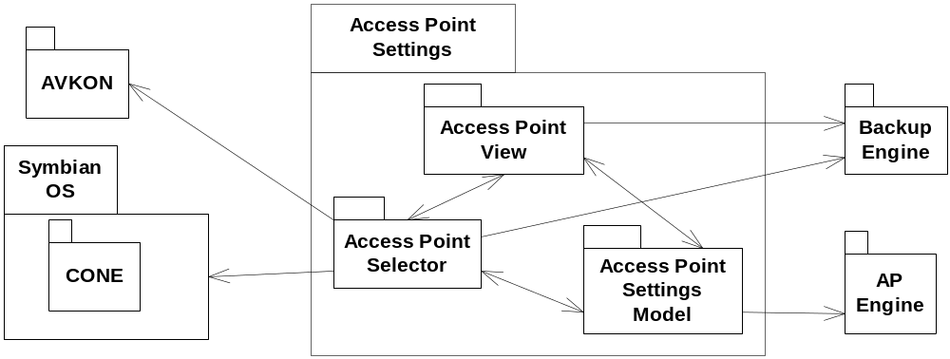
Figure 2.1 Component environment

Use cases
This module is called by applications wanting to access access point data. This module provides the user interface for listing, editing, creating and deleting access points. It uses AVKON and Symbian OS system components to communicate with the user, receives the user’s input, handles screen display along multilingual issues and also manages the physical storage of the data. The Access Point Settings UI use cases are shown in Figure 2.2
User
View the list of
access points
View / Modify
access point settings
Create new
access points
Delete
access points
Figure 2.2 Access Point Settings UI use cases.

View the list of access points
Summary | View the list of access points
Actor(s) | User
Frequency | Low
Preconditions
Description | User chooses to view the installed access points. Access Point Settings UI acts as a wrapper only.
Exceptions
Postconditions
Illustrations

Deleting access points
Summary | Deleting an access point
Actor(s) | User
Frequency | Low
Preconditions
Description | User chooses to delete an installed access points. Access Point Settings UI acts as a wrapper only.
Exceptions
Postconditions | The deleted access point is deleted.
Illustrations

Creating new access points
Summary | Create a new access point
Actor(s) | User
Frequency | Low
Preconditions
Description | User chooses to create a new access point. Access Point Settings UI acts as a wrapper only.
Exceptions
Postconditions | A new access point is created
Illustrations

Modifying access points
Summary | Modifying an existing access point
Actor(s) | User
Frequency | Low
Preconditions
Description | User chooses to modify the installed access point. Access Point Settings UI acts as a wrapper only.
Exceptions
Postconditions | The modified access point is saved with the modified data.
Illustrations

Viewing access points detail
Summary | Viewing an existing access points data
Actor(s) | User
Frequency | Low
Preconditions
Description | User chooses to view the installed access points data. Access Point Settings UI acts as a wrapper only.
Exceptions
Postconditions
Illustrations

Services required

From Symbian OS subsystems
API | Description
Basic services of Symbian OS infrastructure | E32, CONE, basic functionalities are required.
EIKON/AVKON | Service is required for user interface implementation.
Comms | Services of Communications Database (CommsDB) are required, to manipulate Access Point Settings.
ApEngine | Services of Access Point Engine (ApEngine) are required, to manipulate physical Access Point data.

From Domestic OS subsystems
This component does not have any direct interfaces to the Domestic OS side subsystems

From HW
This component has no direct HW interfaces

Services provided

UI
Provided Service | Description
Internet Access Point Settings | Networking UI Specification, reference document [1].

SW IF
This component operates as a ‘black box’ from the point of view of the other components. The only interface it provides allows the creation, the parameterization and execution with return values.
Provided Service | Description | Protected
NewLC | Two phased constructor. Creates the access point settings/selection handling UI object. | No
SetTextOverrideL | Sets possible overrides of some texts. By default, text is read from resources. This provides a way to change some of the text to a caller-supplied one. | No
TextOverrideL | Gets possible overrides of a text. | No
RunSettingsL | Starts the settings component.Creates dialog(s) from scratch, launches and executes them. | No
Cvt | Component Validation Test. | No
RunViewerL | Starts the viewer component. Creates dialog(s) from scratch, launches and executes it. | No

UI control hierarchy

Framework
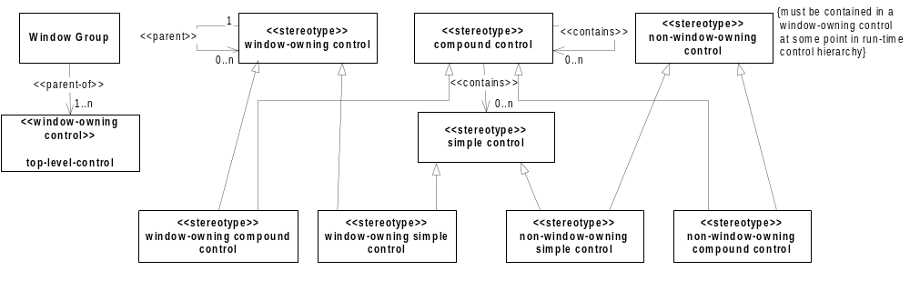
Figure 3.3 Control metamodel

Component
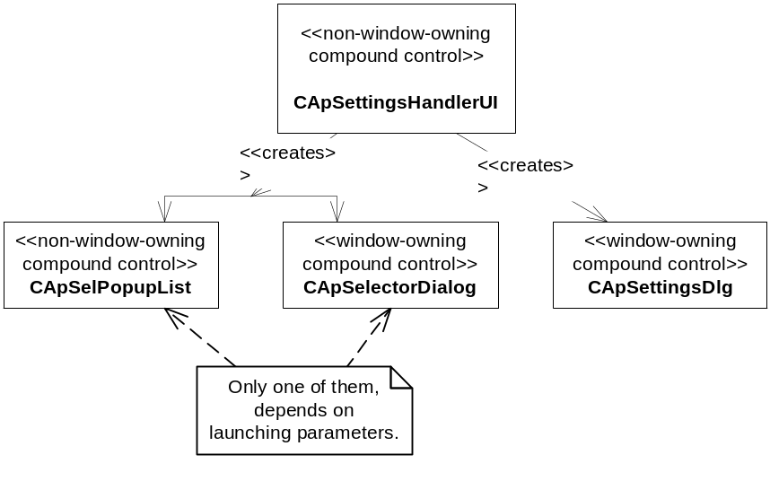
Figure 3.4 Access Point Settings control hierarchy

Design

Class diagrams

Framework
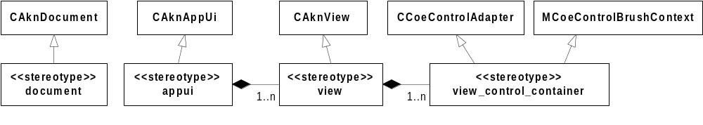
Figure 4.5 Metamodel definition

Component
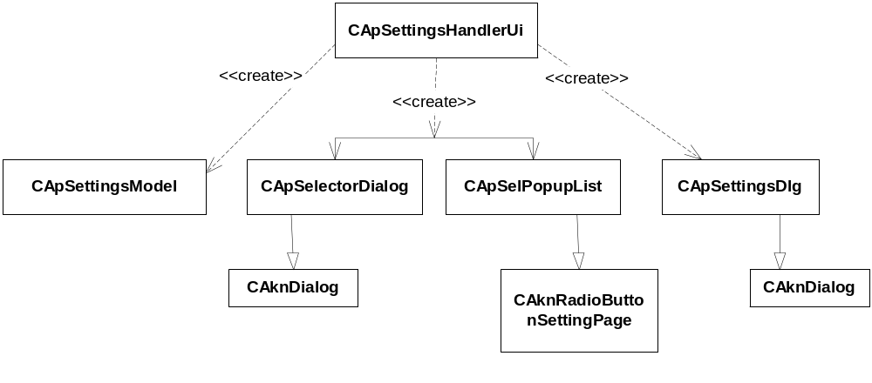
Figure 4.6 Overwiev
Figure 4.6 shows classes that are the backbone of Access Point Settings. Figure 4.7 shows how actual handling of the data relates to the Access Point Settings. It uses Active Access Point Database Framework, provided by ApEngine. Active Access Point Database Framework is a reusable component. CActiveApDb is an extension to CCommsDatabase, and provides Comms Database along with database and system event notifiers. CActiveApDb translates concurrent database events to a simple protocol. The protocol defines three events, focusing on database usage from the users’ point of view: the database either has changed or has become available again.
CApSettingsModel has a member variable, CActiveApDb* iDb, to provide access to the database. Both ‘views’ (CApSelectorDialog and CApSettings) implement the protocol MActiveApDbObserver, and through a callback function, they are notified about database changes. When the database is created and opened, a notifier is created. It is activated after the first observer has been added to the list of observers and remains active until no observers are present. The removal of the last observer deactivates the notification and it is destroyed when the database is destroyed. Any changes to the database are propagated to the currently active controls.
In both ‘views’ the data that is displayed to the user consists of Access Point(s). These Access Points are handled by the model and displayed by the view’s controls. Any control that needs to read or modify the data is given a pointer to the model.
Although Active Access Point Database Framework is part of ApEngine, it is still shown in detail in our model for a better understanding.
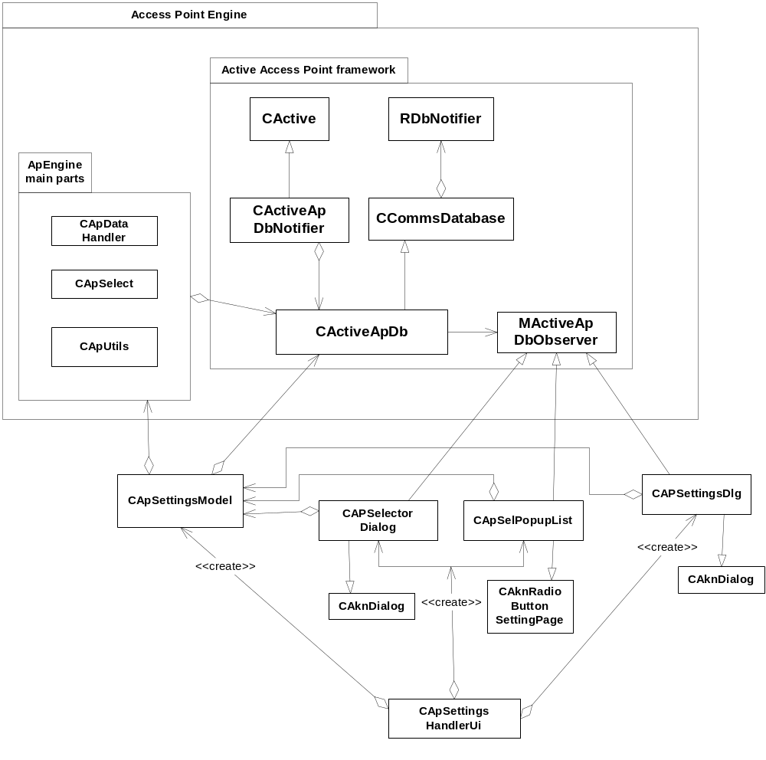
Figure 4.7 Access Point Settings model
Figure 4.8 shows the engine/model part of the component. It implements the data exchange. The view part of the application is isolated from the engine with this class. It provides access to ApEngine’s functionalities.
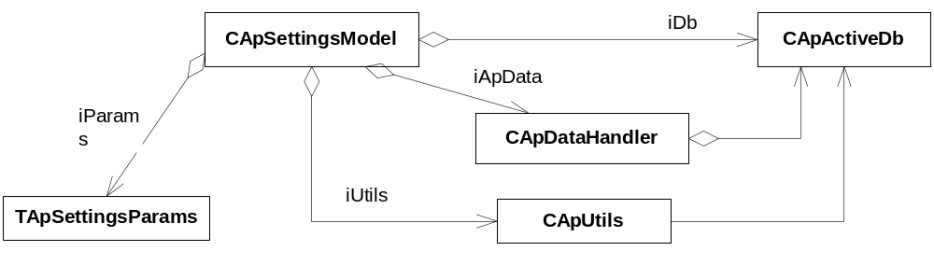
Figure 4.8 Engine/model part of the component

Class descriptions
Class | Description | Header file
CAccessPointTextSettingPage | Model for the access point listbox. It is an array of CApSelectorItem. | AccessPointTextSettingPage.h
CApMultiLineDataQueryDialog | A class to extend the functionality of the existing CAKnMultiLineIpQueryDialog to be able to accept 0 length settings... | ApMultiLineDataQueryDialog.h
CApNetSelectorListboxModel | Model for the network group selection listbox.It is an array of CApNetworkItem pointers; | ApNetSelectorListboxModel.h
CApNetSelPopupList | Pops-up network selector 'control' object. | ApNetSelPopupList.h
CApSelectorDialog |  | ApSelectorDialog.h
CApSelectorListbox | The Access Point listbox. It is an array of CApSelectorItem pointers; items are owned. | ApSelectorListbox.h
CApSelectorListboxModel | Model for the Access Point listbox. | ApSelectorListboxModel.h
CApSelPopupList | For Access Point selection. Pop-up Access Point selector 'control' object. | ApSelPopupList.h
CApSelQueryDialog |  | ApSelQueryDialog.h
CApSettingsDeleteOperation | Model for the Access Point settings UI. | ApSettingsDeleteOperation.h
CApSettingsDlg | Declares dialog for Access Point view/edit. | ApSettingsDlg.h
CApSettingsHandler | The main handler for the Access Point settings.  It contains the only public API for other (sub) systems. | ApSettingsHandlerUI.h
CApSettingsModel | Model for the Access Point settings UI. | ApSettingsModel.h
CFeatureManagerWrapper | Wraps FeatureManager to eliminate maintenance of existence of FeatureManager. | FeatureManagerWrapper.h
CTextOverrides | Helper class for the Access Point settings. | TextOverrides.h

Structs, Type Definitions and Enumerations

ApSelectorListboxModel.h
Struct/Definition/Enumeration's name | Description
enum TGraphicType | Events reported to the database observer

ApSettingsDeleteOperation.h
Struct/Definition/Enumeration's name | Description
enum TState | State of the finite state machine. See chapter 4.2.3.1

ApSettingsDlg.h
Struct/Definition/Enumeration's name | Description
enum TSaveAction | Indicates the action to be taken in case of save attempt

ApSettingsHandlerCommons.h
Struct/Definition/Enumeration's name | Description
enum TTextID | Identifies the 'overridable' text items in CApSettingsHandler
enum TTransactionResult | Tranxaction results
enum TApUiExitReason | Exit reasons
enum TSelectionListType | Selection list types
enum TSelectionMenuType | Selection menu types
enum TApSettingsHandlerUiPanicCodes | Panic codes

ApSettingsHandlerUI.h
Struct/Definition/Enumeration's name | Description
typedef struct TApSetHandlerExtra | Holds extra data

ApSettingsHandlerUI.hrh
Struct/Definition/Enumeration's name | Description
enum TApSelectorMenuCommands | Menu commands
enum TApSelectorDllDlgLineId | Dialog line IDs

ApSettingsModel.h
Struct/Definition/Enumeration's name | Description
typedef struct TApSettingsParams | holds filtering parameters

Flag definitions
This section specifies the flags (debug etc. flags) used by the component, and clarify their usage for the reader. Variation flags are defined in Chapter 5.
Flag | Description
__TEST_OOMDEBUG | Enables memory testing
__TEST_LOGGING | Enables logging
__TEST_LAN_BEARER | Enables LAN bearer testing
__TEST_CSD_SUPPORT | Enables CSD testing
__TEST_NO_HSCSD | Enables HCSD testint
__TEST_HSCSD_SUPPORT | Enables HCSD support testing
__TEST_WLAN_SUPPORT | Enables WLAN testing
__TEST_CDMA_WRITE_PROTECT | Enables CSMA write protection testing
__TEST_IPV6_SUPPORT | Enables IPV6 support testing
__TEST_USE_SHARED_DATA | Enables shared data use testing
__SERIES60_HELP | If defined, Help is shown in Options menu.
__SERIES60_SETTINGS_PROTECTION | Devices protect certain SW settings, like Internet access points.Operators can preset the phones already in the factory so that later user is not able to modify settings.
__WINS__ | Flag for windows specific code

State diagrams

CApSettingsDeleteOperation
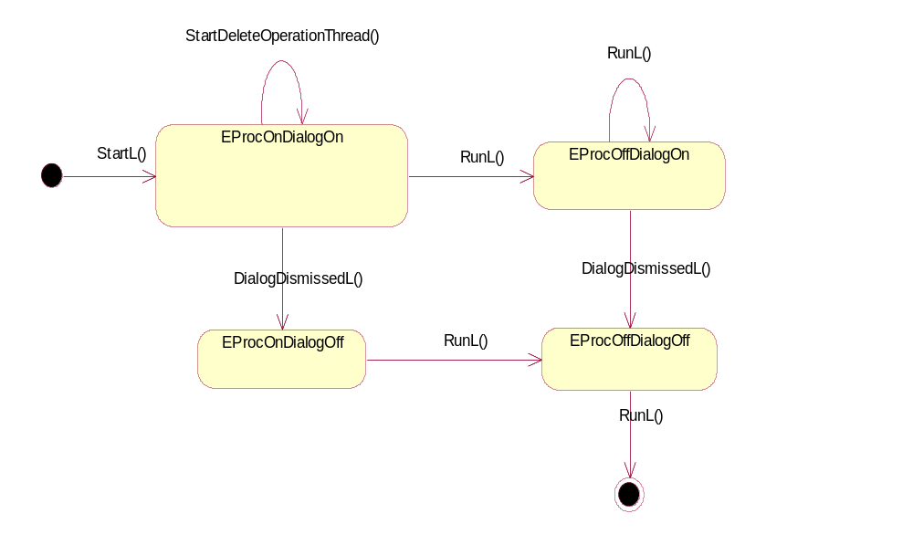
Figure 4.9 A statemachine describing the dynamic behavior of CApSettingsDeleteOperation

Operations
Operation | List Access Points
Preconditions | The Access Point Settings UI had been launched by the user
Description | Lists the available access points
Inputs
Modifies
Outputs
Postconditions
Related To
Related Event | The user has launched the Access Point UI
Exceptions

Deleting an access point
Operation | Deleting an access point
Preconditions | The Access Point Settings UI had been launched by the user and the user selected Delete from the menu or pressed the delete key.
Description | Deletes the currently selected access point.
Inputs
Modifies | Commdb data
Outputs
Postconditions | The deleted access point is physically deleted from the database
Related To
Related Event | The user selected Delete from the Options menu or pressed the delete key.
Exceptions

Creating new access points
Operation | Creating new access points
Preconditions | The Access Point Settings UI had been launched by the user and the user selected New access point from the menu.
Description | Creates a new access point, the new access point is offered for editing. The new access point is saved and data is validated only at the end of the editing.
Inputs
Modifies | Commdb data
Outputs
Postconditions | The new access point is saved
Related To
Related Event | The user selected New access point from the Options menu.
Exceptions

Modifying access points
Operation | Modifying access points
Preconditions | The Access Point Settings UI had been launched by the user and the user selected Edit from the menu.
Description | The currently selected access point is offered for editing. The access point is saved and data is validated only at the end of the editing.
Inputs
Modifies | Commdb data
Outputs
Postconditions | The modified access point is saved
Related To
Related Event | The user selected Edit from the Options menu.
Exceptions

Viewing access points detail
Operation | Viewing access points detail
Preconditions | The Access Point Settings UI had been launched by the user and the user selected Edit from the menu.
Description | The access point is offered for viewing/editing. If the access point is changed, it is saved and data is validated only at the end of the viewing/editing.
Inputs
Modifies | Commdb data
Outputs
Postconditions | The modified access point is saved
Related To
Related Event | The user selected Edit from the Options menu.
Exceptions

Backup and Restore
- The Access Point Settings UI accesses but does not own the Access Point data in the Communication database.

Variation
The Access Point Settings UI uses variations for the followings:
- Build time variation using __SERIES60_HELP
- Build time variation using __SERIES60_SETTINGS_PROTECTION
- Run-time variation using Feature Manager to query IPv6 support.
- Run-time variation using Feature Manager to query CSD support.
- Run-time variation using Feature Manager to query WCDMA support.
- Run-time variation using Feature Manager to query WLAN support.

HELP
Offering Help menu option and launching Help application is dependent on feature flag __SERIES60_HELP.

Protection
This is build time variation using __SERIES60_SETTINGS_PROTECTION flag to determine whether access point and table protection is handled or not. If protection is handled, a small lock icon signals the protected access points in the UI and those access points cannot be edited or deleted.

Ipv6 support
This is runtime variation using Feature Manager to query if IPv6 is supported or not. The used feature flag is KFeatureIdIPv6.

CSD support
This is runtime variation using Feature Manager to query if CSD is supported or not. The used feature flag is KFeatureIdAppCsdSupport.

WCDMA support
This is runtime variation using Feature Manager to query if WCDMA is supported or not. The used feature flag is KFeatureIdProtocolWcdma.

WLAN support
This is runtime variation using Feature Manager to query if WLAN is supported or not. The used feature flag is KFeatureIdProtocolWlan.

System resource usage

Files
File | ApSetUi.rss
Type | private
Location | ROM
Format | binary
Sharing | Not shared
Encryption | Not encrypted
Size estimate
Clean up | Permanent file
Description | Resource file

File | ApSettingsHandlerUi.loc
Type | private
Location | ROM
Format | binary
Sharing | Not shared
Encryption | Not encrypted
Size estimate
Clean up | Permanent file
Description | Localization file

Other data

Databases
Access Point Settings UI uses CommsDb/CommsDat to persist its settings.

Central Repository
This component does not use Central Repository.

Publish and Subscribe
This component does not use Publish and Subscribe.

Memory consumption
Memory/Build | Consumption
WINSCW UDEB | 3066296
ARMV5 UREL | 31286
Resource file (RSC) | ~7 kb

Task allocation
This component runs in one thread, which is the thread of the launching application.

Performance
The performance is determined by the underlying CommsDat storage system.

Timers
Access Point Settings UI does not use timers.

Security

Capabilities of this component
The capabilities of the Access Point Settings UI (ApSettingsHandlerUI.dll) are defined as CAP_GENERAL_DLL that is “ALL –Tcb”.
As a shared library, the capabilities describe its level of trust, and this component can be trusted not to leak any capability protected information to unauthorized parties.

Input and output validation
There is no Input data used by this component.
Output data are what the user sets in the UI.
Data is normally validated according to the [1] specifications and are stored in the database.
The database is considered to be structurally correct; tables must exist for correct operation.

Environmental assumptions
This component does not make any assumptions about its environment.

Additional enforcements
This component does not have any additional security enforcements.

Exception handling
The leave mechanism of Symbian OS environment is used to handle memory exhaustion and other system-wide errors.
The main possible reasons for leaving include the following:
- The system memory is exhausted.
- During creation, APSettingsHandlerUi fails to connect to the Comms database.
- The established connection to the database server breaks or terminates abnormally.

In debug builds, asserts are used to panic the thread and reveal programming errors. In release builds, such errors are silently ignored and do not cause abnormal termination (crash), but may cause failed operation.

Usage
To use the ApSettingsHandlerUi module, users must link with the ApSettingsHandlerUi library and include the header file: #include <ApSettingsHandlerUi.h>.

/*
First need to create the object. The constructor’s parameters will determine the used control, menu & behaviour
*/
CApSettingsHandler *ApUi = CApSettingsHandler::NewLC(
ETrue, // aStartWithSelection
EApSettingsSelListIsListPane, // this is used in gen. settings, all other apps
// shall use EApSettingsSelListIsPopUp
EApSettingsSelMenuNormal, // other types are also available,
// sets the menu type it will be using
KEApIspTypeAll, // Isp-type filtering if needed
EApBearerTypeAll, // Bearer type filtering, if needed
KEApSortNameAscending // ordering of the access points
);

TUint32 UserSelected( 0 ); // set it to some known value. 0 is not a valid ID,
// so can be used at the end for testing
// if selection had been made or not.
TUint32 OriginallyFocused( 0 ); // shall be set to a real, existing value.
//Although 0 is not a valid ID, setting 0 will do no harm.
//Also setting a non-existent ID will cause
// the first item to be focused.
/*
Now run the settings.
*/
ApUi->RunSettingsL( OriginallyFocused, UserSelected);
// UserSelected will be changed ONLY if the user really selects something.
// RunsettingsL returns a TInt which can be used to determine what
// had happened inside, although usually not needed
// If only interested in whether selection has been made or not,
// simply can use if ( UserSelected ) { .... }
/*
Clean up.
*/
CleanupStack::PopAndDestroy(); // ApUi;

Building
Build sequence:
cd \ApSettingsHandlerUi
bldmake bldfiles
abld build

User's Guide
This module is really flexible and supports the different needs of the different possible clients. It has two main ‘states’, an Access Point List-Viewer/Selector and an Access Point Editor. It is suitable for simple editing of an Access Point without having to enter the selector. It supports the selection and the editing of an Access Point. NewLC’s first parameter determines whether the selector is started or it enters the editing state at once.
CApSettingsHandler *ApUi = CApSettingsHandler::NewLC( EFalse, .....)

In case it is constructed as a viewer (not a selector), then the last three parameters (ISP type filter, Bearer type filter and Ordering) have no effect, they are simply ignored.
In case it is launched with the selector activated, the filtering parameters can be the combination of the possible filter types. Combining can be done by ORing them bitwise together. The selector shows only Access Points that fulfill ALL filtering criteria, meaning that they fulfill both ISP filter criteria and bearer type criteria.

