S60 3.2
Mobility Policy Manager
Design Document

Team name | Author
S60 Core BS NaC Net R&D | Heikki Osmonen

Change history:

Version | Date | Status | Comments
3.0 | 22.07.2007 | Approved | - Updated changes made during S60 3.2 implementation  - References to __BEARER_MGNT removed
2.0 | 06.09.2006 | Approved | - Updated for S60 3.2  - Fixed defects found in review
1.0 | 15.05.2006 | Approved

Table of contents:

1. Document control 5
1.1 References 5
1.2 Documentation conventions 5
1.3 Abbreviations 5
1.4 Definitions 5
2. General 6
2.1 Introduction 6
2.2 Component environment 6
2.2.1 Processes and threads 7
2.2.2 Libraries 7
2.2.3 Clients and servers 8
2.3 Use cases 8
2.3.1 Explicit connection IAP selection 8
2.3.2 Implicit connection IAP selection case 1 9
2.3.3 Implicit connection IAP selection case 2 11
2.3.4 Support of using existing PDP context per APN 12
2.3.5 Off-line mode 13
2.3.6 Maximum number of contexts exceeded 14
2.3.7 Ignoring the error 15
2.3.8 Propagating the error 16
2.3.9 Connection request during a voice call 17
2.3.10 Initialize message buffer for IAP notifications 18
2.3.11 Preferred IAP registration 19
2.3.12 Preferred IAP notification 21
2.3.13 Unregister preferred IAP notifications 22
2.3.14 Application leaves connection 23
2.3.15 IAP connection is stopped 24
2.3.16 Application joins connection 25
2.3.17 IAP connection is activated 26
2.3.18 User selects Easy WLAN 27
2.3.19 IAP connection is started 29
2.3.20 Application ends connection 30
2.3.21 Application migrates to carrier 31
2.3.22 Application accepts the carrier 33
2.3.23 Application ignores the carrier 34
2.3.24 Application rejects the carrier 35
2.3.25 Sort IAPs of specific SNAP 36
2.4 Services required 37
2.4.1 From the Symbian OS subsystems 37
2.4.2 From the Domestic OS subsystems 37
2.4.3 From HW 37
2.5 Services provided 37
2.5.1 UI 37
2.5.2 SW IF 38
3. UI control hierarchy 40
4. Design 41
4.1 Class diagrams 41
4.2 Class descriptions 43
4.2.1 Structs, type definitions and enumerations 45
4.2.1.1 mpmcommon.h 45
4.2.1.2 mpmconnmonreqs.h 45
4.2.1.3 rmpm.h 45
4.2.2 Flag definitions 45
4.3 Operations 46
4.3.1 Choosing the best IAP from DB 46
4.3.2 User dialog initiation 48
4.3.3 Support of using existing PDP context per APN 51
4.3.4 Off-line mode 52
4.3.5 Maximum number of contexts exceeded 54
4.3.6 Ignoring the error 55
4.3.7 Propagating the error 57
4.3.8 Connection request during a voice call 58
4.3.9 Initialize message buffer for IAP notifications 60
4.3.10 Preferred IAP registration 61
4.3.11 Preferred IAP notification 62
4.3.12 Unregister preferred IAP notifications 64
4.3.13 Application leaves connection 65
4.3.14 IAP connection is stopped 66
4.3.15 Application joins connection 68
4.3.16 IAP connection is activated 69
4.3.17 User selects Easy WLAN 71
4.3.18 IAP connection is started 73
4.3.19 Application ends connection 75
4.3.20 Application migrates to carrier 76
4.3.21 Application accepted the carrier 78
4.3.22 Application ignored the carrier 80
4.3.23 Application rejected the carrier 82
4.3.24 Sort IAPs of specific SNAP 83
4.4 Backup and Restore 85
5. Variation 86
6. System resource usage 87
6.1 Files 87
6.2 Other data 87
6.2.1 Databases 87
6.2.2 Central Repository 88
6.2.3 Publish and Subscribe 88
6.3 Memory consumption 88
6.4 Task allocation 89
6.5 Performance 89
6.6 Timers 89
7. Security 90
7.1 Capabilities of this component 90
7.2 Input and output validation 90
7.3 Environmental assumptions 90
7.4 Additional enforcements 90
8. Exception handling 91
9. Usage 92
9.1 Building 92
9.2 User's Guide 92

Document control

References

- S60 3.1 Bearer Management Subsystem Architecture Description
- S60 Connection Agent Dialog Server Design Document
- S60 Disconnect Dialog Design Document
- S60 Connection UI Utilities Design Document

Documentation conventions
Code is shown with the Courier New font.

Abbreviations

API | Application Programming Interface
BM | Bearer Manager
DB | Database
DLL | Dynamically Linked Library
IAP | Internet Access Point
ID | Identifier
MPM | Mobility Policy Manager
OS | Operating System
SNAP | Service Network Access Point

Definitions

Access Network ID | Formerly “Network ID”. Represents an IP-level routing domain. Used for routing purposes when private IP network addressing is in use. An Access Network ID is mapped to an IAP ID.
Destination Network ID | Target network (IP-level) of the services the application wants to use. It is defined as a group of Internet Access Point. It is similar to the concept of SNAP. SNAP ID is mapped internally to a Destination Network ID.
Explicit connection | Connection is brought up by explicitly starting a connection via the RConnection class (and eventually specifying the connection preference).
Implicit connection | Connection is brought up by connecting a socket.
Plug-in | A separately installed piece of software that increases or enhances the features of a main software module. Can easily be added without changing the main software module.
SNAP ID | Target network (IP-level) of the services the application wants to use. It is defined as a group of Internet Access Point. Applications can start a SNAP ID but not a Destination Network ID.

General

Introduction
Mobility Policy Manager is a component of the Bearer Management subsystem, whose purpose is to provide seamless and non-seamless mobility to the Symbian applications.
The main purpose of MPM is to choose the most preferred IAP in the destination network amongst the list of available IAPs.
The best IAP is chosen for both explicit and implicit connections. See Section 1.4 for definitions of both connection types. By using CommsDat database queries MPM resolves the highest ranked IAP for the connection.

Component environment
MPM is server implementation based on Symbian’s client-server framework. It provides a client control API for BM. MPM API is an internal S60 API. MPM utilizes CommsDat API and Agent Dialog API for finding out the most preferred IAP used for the connection.
The software context is depicted in reference document [1]. The component environment of MPM is depicted in Figure 2.1 and the component decomposition in Figure 2.2

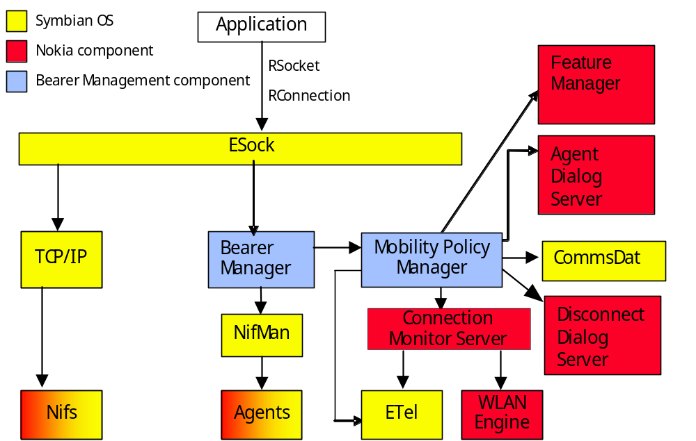
Figure 2.1 Component environment

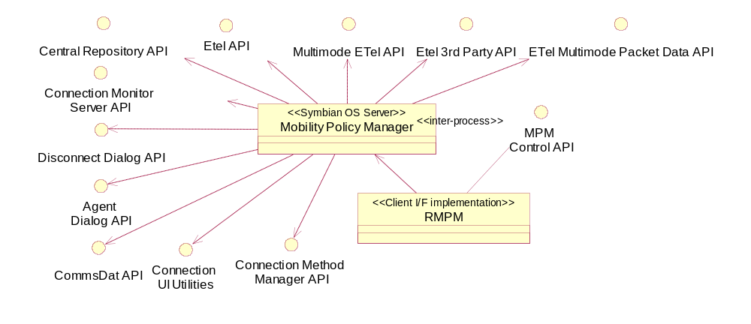
Figure 2.2 Mobility Policy Manager Decomposition

Processes and threads
MPM server process is started by BM with MPM control API method call LaunchServer(). The execution is done in process main thread. The MPM Control API (RMPM) is implemented as a DLL.

Libraries
The library dependencies are depicted in Figure 2.3. The flogger is only used in debug mode.

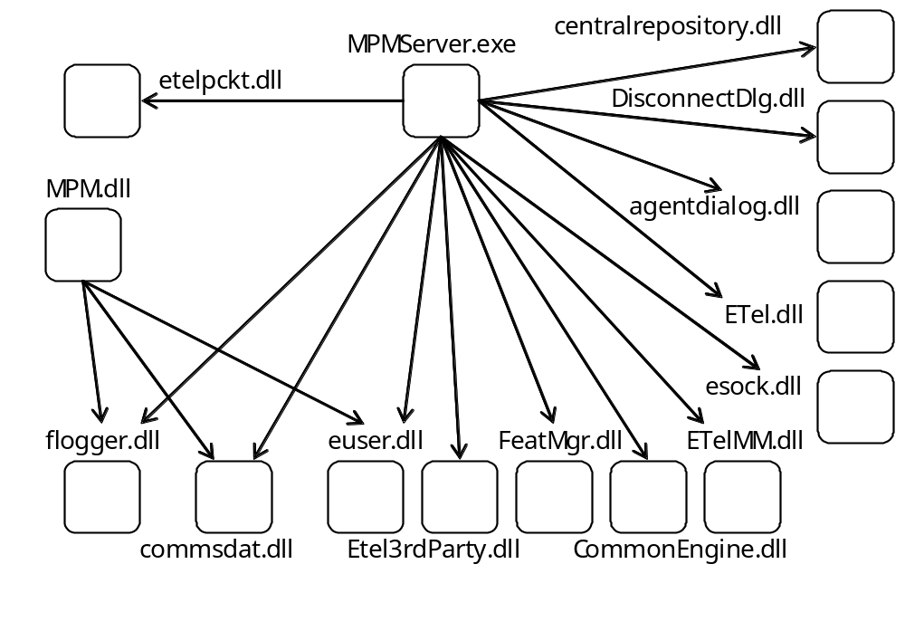
Figure 2.3 DLL dependency graph

Clients and servers
Mobility Policy Manager (MPM.exe) is a server serving Bearer Manager through client interface (MPM.dll) implementing MPM Control API. See also Figure 2.2.

Use cases

Explicit connection IAP selection

Summary | Describes explicit connection activation (destination network specified).
Actor(s) | Bearer Manager, Connection UI Utilities.
Frequency | Whenever application starts to make connection by specifying destination network it wants to reach.
Preconditions | Bearer manager gets request for explicit connection setup.
Description | - BM requests MPM to choose the best IAP.  - Client API handles the request and passes the message arguments to the server.  - MPM starts IAP selection for explicit connection.  - MPM gets a list of currently available IAPs from Connection Monitor. The first time MPM will get the list using the GetPckgAttribute method, after that it will listen to notifications from Connection Monitor and maintain own list.  - MPM makes query to internal database TActiveBMConn according to policy criteria.  - MPM displays connection establishment confirmation query.  - User confirms connection establishment of the IAP.  - MPM updates information about an active BM connection.  - Request returns to the client.
Exceptions | - [KerrNotFound] indicates that no suitable IAP was found.  - [KErrGsmOfflineOpNotAllowed] indicates that GSM/UMTS-connection was attempted in off-line mode.
Post conditions | The access network ID and IAP ID are valid for BM use.
Illustrations | Figure 2.4

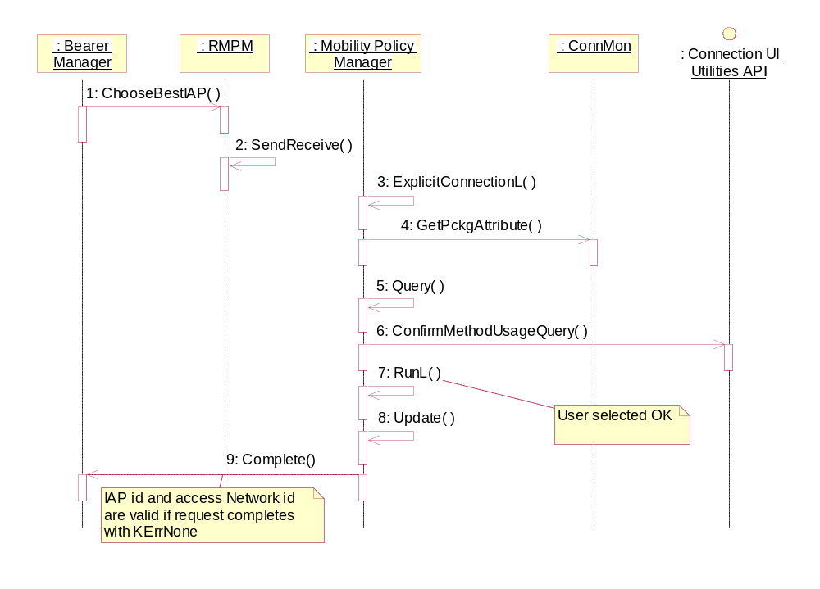
Figure 2.4 Explicit connection IAP selection

Implicit connection IAP selection case 1

Summary | Describes implicit connection activation (no destination network or IAP specified) and the phone user selects the destination network from the UI.
Actor(s) | Bearer Manager, phone user via UI.
Frequency | Whenever application starts to make connection by opening a socket without explicitly specifying destination network or IAP it wants to use.
Preconditions | User prompting defined in connection preferences passed to MPM.
Description | - BM requests MPM to choose the best IAP.  - Client API handles the request and passes the message arguments to the server.  - MPM starts IAP selection for implicit connection.  - MPM request Connection Monitor to scan WLAN networks in case there is a WLAN IAP configured in the phone (other than Easy WLAN).  - MPM gets a list of currently available IAPs from Connection Monitor.  - MPM initiates a user dialog via agent dialog server API.  - The request completes as user has done the choice from UI.  - MPM selects the best IAP for the destination network.  - Request returns to the client.
Exceptions | If connection to the dialog server fails or user cancels selection, returned error code is passed to Bearer Manager.
Post conditions | The access network ID and IAP ID are valid for BM further use.
Illustrations | Figure 2.5

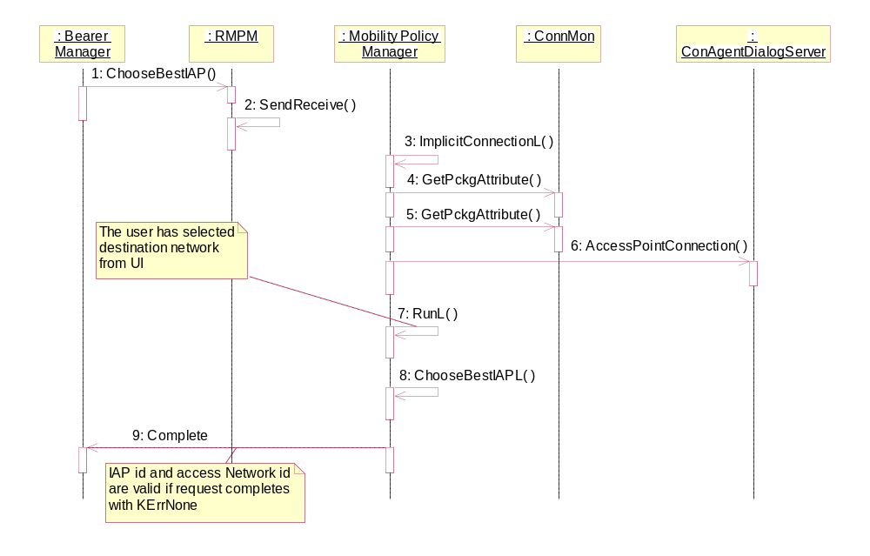
Figure 2.5 Implicit connection IAP selection case 1

Implicit connection IAP selection case 2

Summary | Describes implicit connection activation (no destination network or IAP specified) and the phone user selects IAP from the UI.
Actor(s) | Bearer Manager, phone user via UI.
Frequency | Whenever application starts to make connection by opening a socket without explicitly specifying destination network or IAP it wants to use.
Preconditions | User prompting defined in connection preferences passed to MPM.
Description | - BM requests to choose the best IAP.  - Client API handles the request and passes the message arguments to the server.  - MPM starts IAP selection for implicit connection.  - MPM request Connection Monitor to scan WLAN networks in case there is a WLAN IAP configured in the phone (other than Easy WLAN).  - MPM gets a list of currently available IAPs from Connection Monitor.  - MPM initiates a user dialog via agent dialog server API.  - The request completes as user has done the choice from UI.  - Request returns to the client.
Exceptions | If connection to the dialog server fails or user cancels selection, returned error code is passed to Bearer Manager.
Post conditions | The IAP ID is valid for BM further use.
Illustrations | Figure 2.6

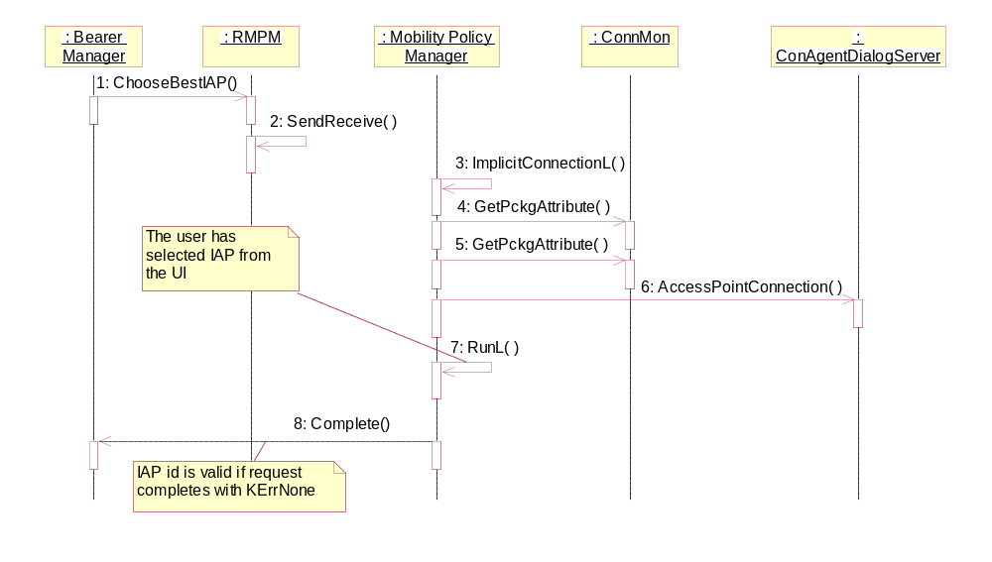
Figure 2.6 Implicit connection IAP selection case 2

Support of using existing PDP context per APN

Summary | In case of one GPRS/UMTS IAP is active and another one with the same APN is started, Bearer Manager attaches the RConnection to the existing connection.
Actor(s) | Bearer Manager.
Frequency | Whenever application starts to make connection and another connection with the same APN is already started.
Preconditions | Bearer manager gets request for connection setup.
Description | - BM requests MPM to choose the best IAP.  - Client API handles the request and passes the message arguments to the server.  - MPM starts handling of IAP selection.  - MPM gets a list of currently available IAPs from Connection Monitor.  - MPM makes query to internal database TActiveBMConn to check if connection to requested APN already exists.  - Request returns to the client.
Exceptions | [KerrNotFound] indicates that no suitable IAP was found.
Post conditions | The access network ID and IAP ID are valid for BM use.
Illustrations | Figure 2.7

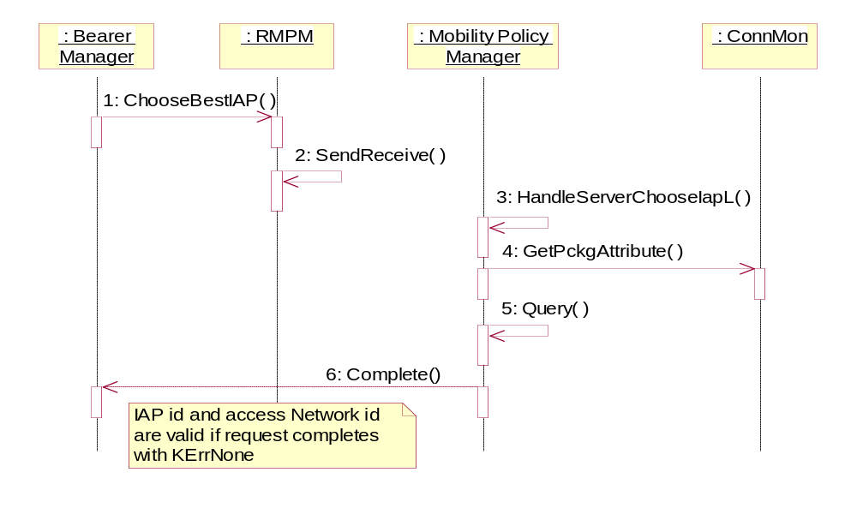
Figure 2.7 Support of using existing PDP context per APN

Off-line mode

Summary | Describes connection activation when the phone is in off-line mode.
Actor(s) | Bearer Manager.
Frequency | Whenever application starts to make GPRS/UMTS -connection and the phone is in off-line mode.
Preconditions | The phone is in off-line mode.
Description | - BM requests to choose the best IAP.  - Client API handles the request and passes the message arguments to the server.  - MPM starts handling of IAP selection.  - MPM gets a list of currently available IAPs from Connection Monitor.  - MPM checks the bearer type of IAP ID from CommsDat. It should be either LAN or WLAN.  - MPM checks if phone is in off-line mode from Central Repository.  - Request returns to the client.
Exceptions | [KErrNone] indicates that WLAN/LAN-connection was attempted in off-line mode.
Post conditions | [KErrGsmOfflineOpNotAllowed] is returned to Bearer Manager.
Illustrations | Figure 2.8

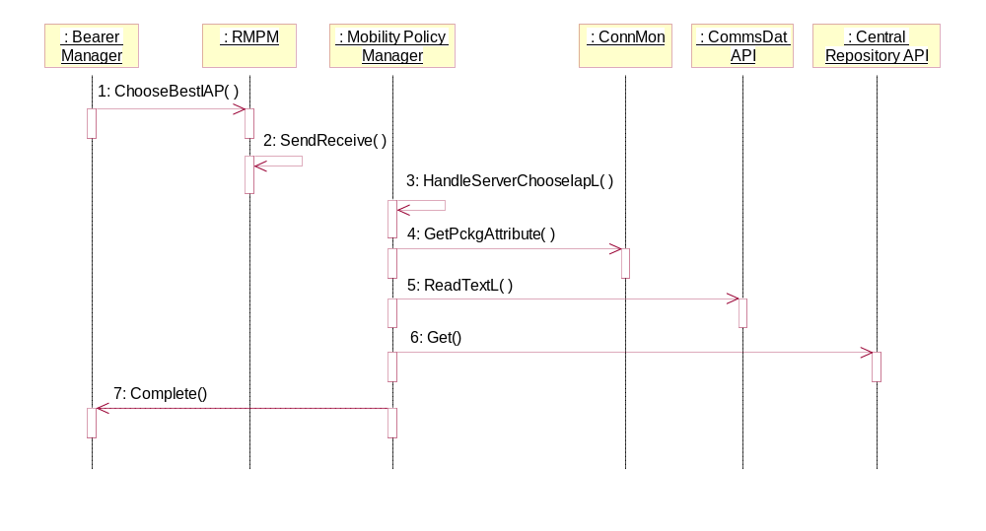
Figure 2.8 Off-line mode

Maximum number of contexts exceeded

Summary | Describes connection termination when the maximum number of contexts has been exceeded by network or phone.
Actor(s) | Bearer Manager, Connection UI Utilities, phone user via UI.
Frequency | Whenever application starts to make connection and the maximum number of contexts has been exceeded by network or phone.
Preconditions | Bearer Manager has detected an error in connection initiation.
Description | - BM requests MPM to process error.  - Client API handles the request and passes the message arguments to the server.  - MPM starts handling of error processing.  - MPM cancels displaying the wait note.  - MPM initiates a disconnect dialog via disconnect dialog server API.  - The request completes as user has done the choice from UI.  - Request returns to the client.
Exceptions | If connection to the disconnect dialog server fails or user cancels selection, returned error code is passed to Bearer Manager (EPropagateError).
Post conditions | MPM tells Bearer Manager to end the client connection with the appropriate error code (EDoReselection).
Illustrations | Figure 2.9

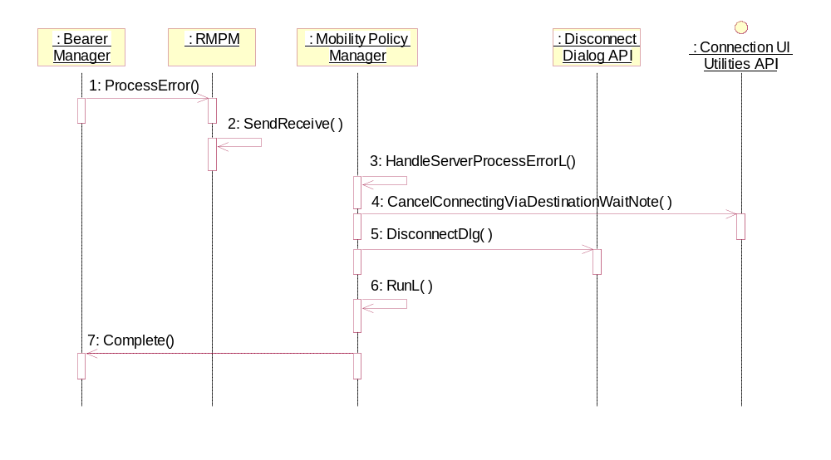
Figure 2.9 Maximum number of contexts exceeded

Ignoring the error

Summary | Describes error processing for a connection which has already been started.
Actor(s) | Bearer Manager, Connection UI Utilities.
Frequency | Whenever there is an error with a connection and there are other available IAPs.
Preconditions | A connection has been started.
Description | - BM requests MPM to process error.  - Client API handles the request and passes the message arguments to the server.  - MPM starts handling of error processing.  - MPM cancels displaying the wait note.  - MPM gets the IDs of available IAPs.  - MPM blacklists the IAP which had the error.  - MPM checks if there are preferred IAPs to be notified to applications.  - MPM removes the IAP which had the error from the blacklist.  - Request returns to the client.
Exceptions | If the error to be processed was [KErrTimedOut or KErrCancel], then MPM would tell Bearer Manager to end the client connection (EPropagateError).
Post conditions | MPM tells Bearer Manager to ignore the error and let MPM notify the application about a new preferred IAP (EIgnoreError).
Illustrations | Figure 2.10

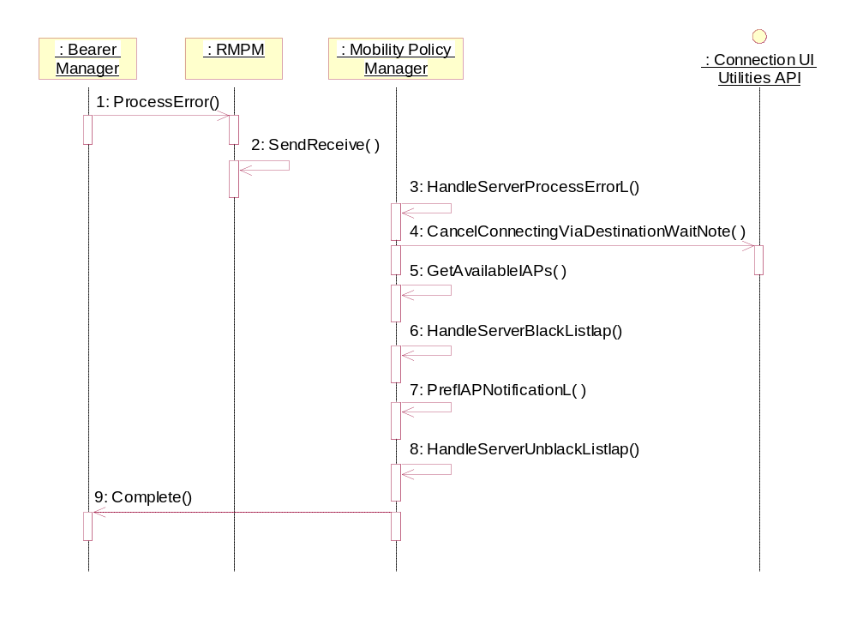
Figure 2.10 Ignoring the error

Propagating the error

Summary | Describes error processing for a connection which has already been started.
Actor(s) | Bearer Manager, Connection UI Utilities.
Frequency | Whenever there is an error with a connection and there are no other available IAPs.
Preconditions | A connection has been started.
Description | - BM requests MPM to process error.  - Client API handles the request and passes the message arguments to the server.  - MPM starts handling of error processing.  - MPM cancels displaying the wait note.  - MPM sends error notification with error code KErrNotFound.  - Request returns to the client.
Exceptions
Post conditions | MPM tells Bearer Manager to end the client connection (EPropagateError).
Illustrations | Figure 2.11

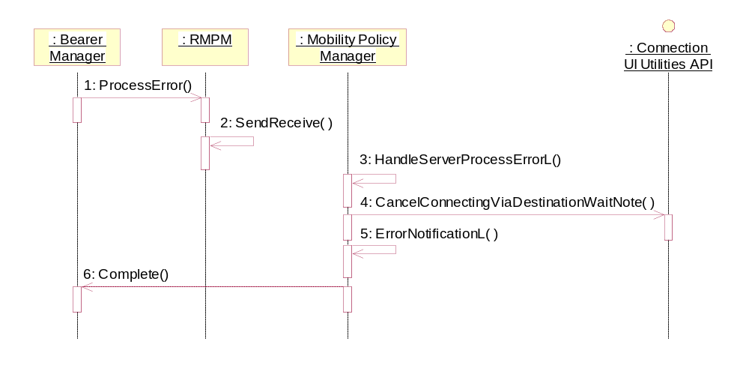
Figure 2.11 Propagating the error

Connection request during a voice call

Summary | Describes connection request during a voice call.
Actor(s) | Bearer Manager.
Frequency | Whenever application starts to make connection and voice call is active.
Preconditions | Bearer manager gets request for connection setup. Phone is in GSM mode.
Description | - BM requests to choose the best IAP.  - Client API handles the request and passes the message arguments to the server.  - MPM starts handling of IAP selection.  - MPM gets a list of currently available IAPs from Connection Monitor.  - MPM checks if voice call is active from ETel 3rd Party API.  - MPM checks whether phone is in GSM or 3G mode from Multimode ETel API.  - MPM checks if phone supports dual transfer mode from ETel Multimode Packet Data API.  - MPM checks the bearer type of IAP ID from CommsDat.  - Request returns to the client.
Exceptions | [KErrGprsServicesNotAllowed] indicates that GPRS-connection was attempted but phone did not support dual transfer mode.
Post conditions | The IAP ID is valid for BM further use.
Illustrations | Figure 2.12

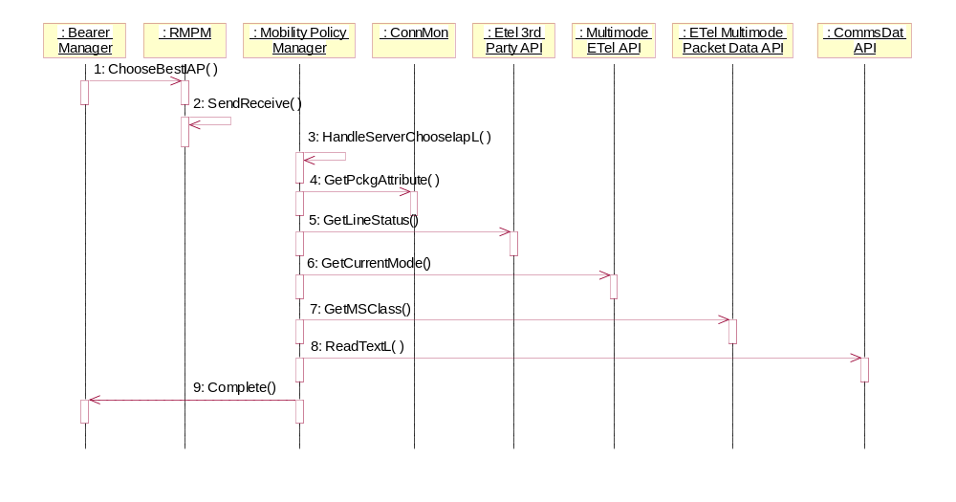
Figure 2.12 Connection request during a voice call

Initialize message buffer for IAP notifications

Summary | Describes initialization of message buffer for IAP notifications.
Actor(s) | Bearer Manager.
Frequency | Whenever Bearer Manager needs to support Application Level Roaming.
Preconditions | A connection has been started.
Description | - BM calls WaitNotification to initialize the message buffer for IAP notifications.  - Client API handles the request and passes the message arguments to the server.  - MPM starts handling of notification request.  - MPM adds a notification session pointer.
Exceptions | [KErrServerBusy] indicates that there was already outstanding notification request activity.
Post conditions | Message buffer is initialized.
Illustrations | Figure 2.13

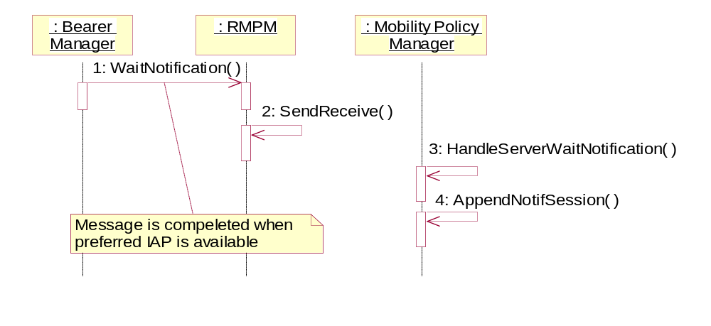
Figure 2.13 Initialize message buffer for IAP notifications

Preferred IAP registration

Summary | Describes registering for getting preferred IAP notifications.
Actor(s) | Bearer Manager.
Frequency | Whenever Bearer Manager needs to support Application Level Roaming.
Preconditions | A connection has been started. Message buffer has been initialized (see Section 2.3.10).
Description | - BM registers for getting preferred IAP notifications.  - Client API handles the request and passes the message arguments to the server.  - MPM starts handling of preferred IAP notification registration.  - MPM gets the network Id of an active BM connection.  - MPM gets the IAP ID of an active BM connection.  - MPM adds information about active BM preferred IAP notification registration.  - MPM finds preferred notification information which matches SNAP ID.  - If such a record is not found, then inserts new record.  - MPM gets the IDs of available IAPs.  - MPM checks the need for preferred IAP notification.  - If there are no preferred IAPs available, then request returns to the client.
Exceptions | [KErrArgument] indicates that BM provided unrecognized connection preference type.
Post conditions | Application has registered for receiving preferred notifications.
Illustrations | Figure 2.14

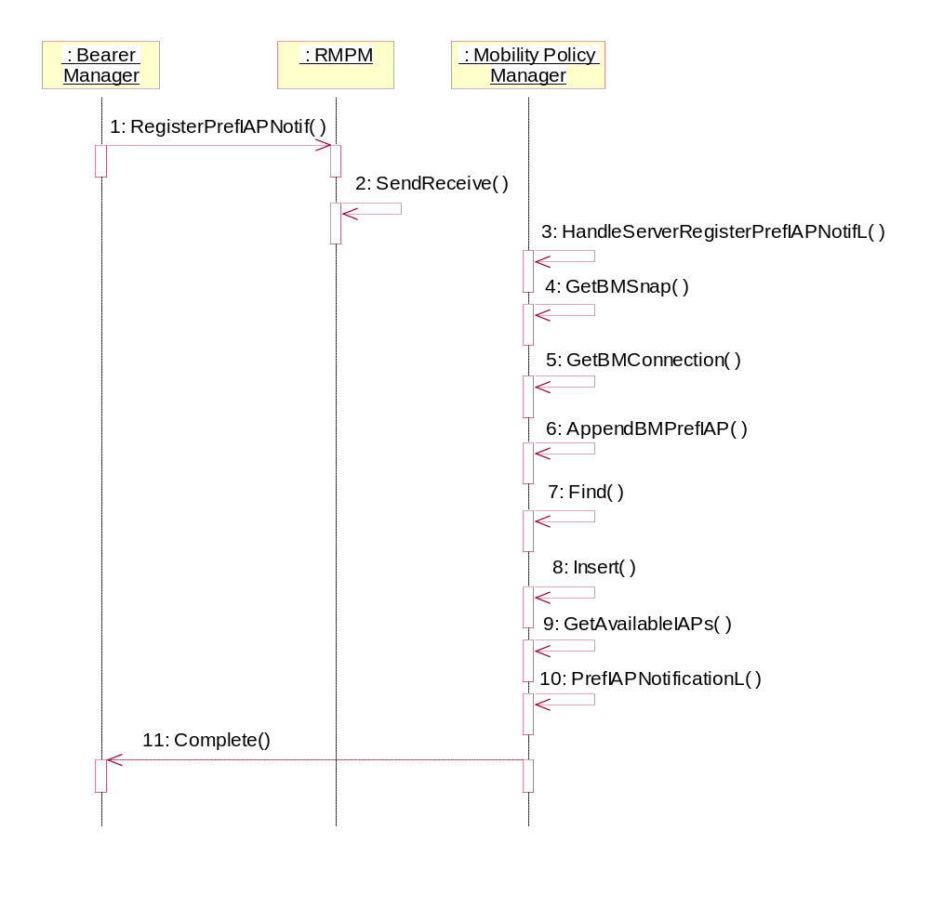
Figure 2.14 Preferred IAP registration

Preferred IAP notification

Summary | Describes sending preferred IAP notifications.
Actor(s) | Bearer Manager.
Frequency | Whenever Bearer Manager needs to support Application Level Roaming.
Preconditions | - Registration to the preferred IAP notifications has been completed (see Section 2.3.11).  - A preferred IAP has become available.
Description | - Connection Monitor informs that preferred IAP has become available.  - MPM gets the IDs of available IAPs.  - MPM checks the need for preferred IAP notification.  - MPM gets the list of available IAPs, where the blacklisted IAPs have already been removed.  - MPM gets the reference to active preferred IAP notifications.  - MPM selects the best IAP for the connection.  - MPM validates the given IAP.  - MPM notifies BM of preferred IAP.
Exceptions
Post conditions | The preferred IAP is valid for BM further use.
Illustrations | Figure 2.14

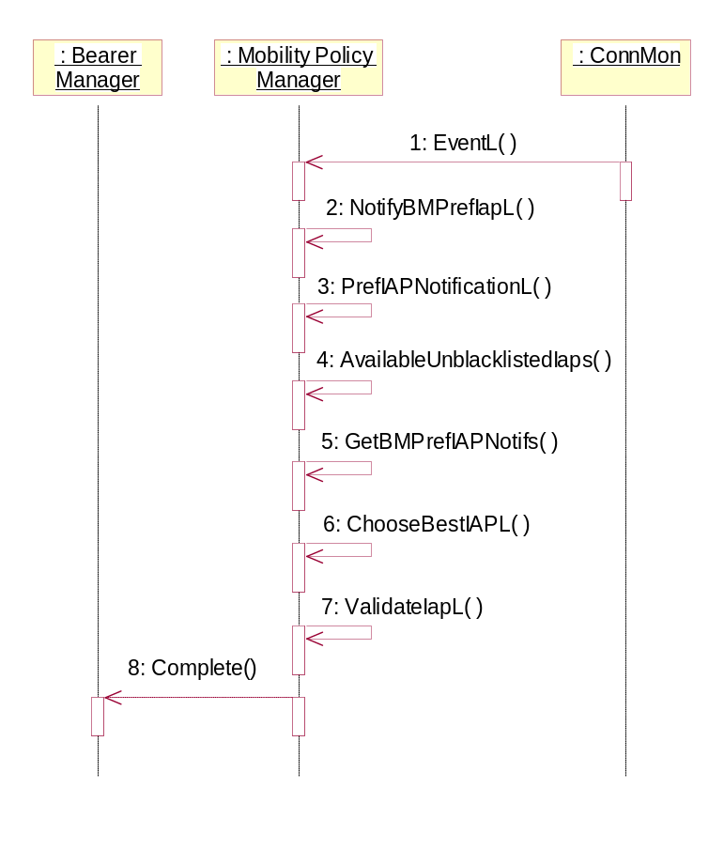
Figure 2.15 Preferred IAP notification

Unregister preferred IAP notifications

Summary | Describes unregistering the preferred IAP notifications.
Actor(s) | Bearer Manager.
Frequency | Whenever Bearer Manager needs to support Application Level Roaming.
Preconditions | - A connection has been started. Message buffer has been initialized (see Section 2.3.10).  - Bearer Manager has registered for getting preferred IAP notifications (see Section 2.3.11).
Description | - BM unregisters the preferred IAP notifications.  - Client API handles the request and passes the message arguments to the server.  - MPM starts handling of preferred IAP notification unregistration.  - MPM finds information about active BM preferred IAP notification registration.  - MPM removes information about active BM preferred IAP notification registration.  - Request returns to the client.
Exceptions
Post conditions | Registration for preferred IAP notifications has been removed.
Illustrations | Figure 2.16

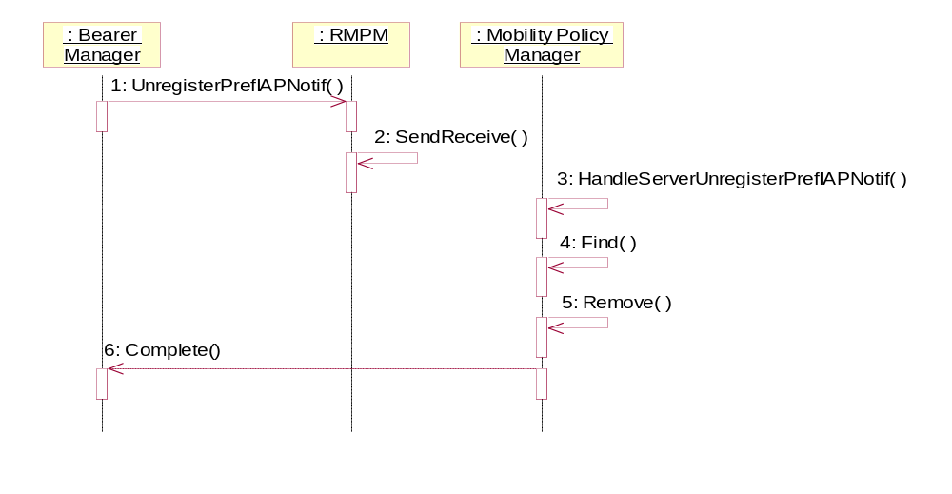
Figure 2.16 Unregister preferred IAP notifications

Application leaves connection

Summary | Describes MPM functionality when application leaves connection.
Actor(s) | Bearer Manager.
Frequency | Whenever application using data connection is roaming to preferred connection or when the connection is going down.
Preconditions | A connection has been started.
Description | - BM informs that application leaves connection.  - Client API handles the request and passes the message arguments to the server.  - MPM starts handling of application specific connection removal.  - MPM resets information about an active BM connection.  - Request returns to the client.
Exceptions
Post conditions | Information about an active BM connection has been reset.
Illustrations | Figure 2.17

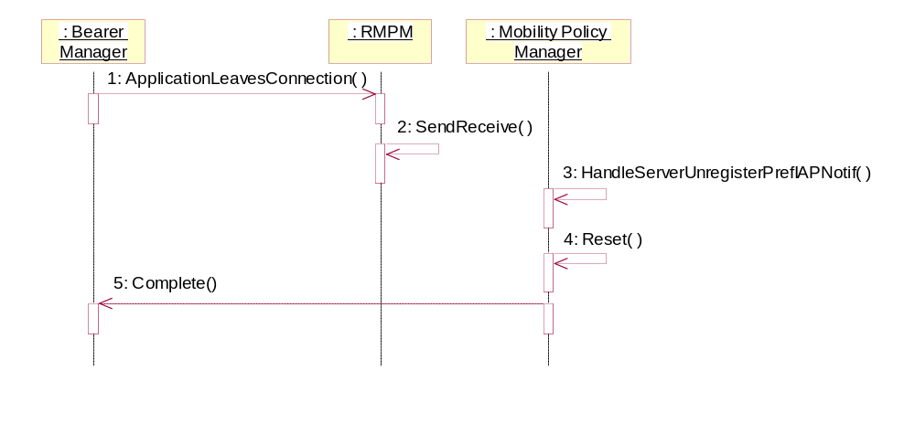
Figure 2.17 Application leaves connection

IAP connection is stopped

Summary | Describes MPM functionality when the whole IAP connection is stopped.
Actor(s) | Bearer Manager, Connection UI Utilities.
Frequency | Whenever the whole IAP connection is stopped.
Preconditions | A connection has been started.
Description | - BM informs that the whole IAP connection is stopped.  - Client API handles the request and passes the message arguments to the server.  - MPM starts handling of IAP connection removal.  - MPM removes the whole IAP information about an active BM connection.  - Request returns to the client.  - MPM cancels displaying the wait note.
Exceptions
Post conditions | The whole IAP information about an active BM connection has been removed.
Illustrations | Figure 2.18

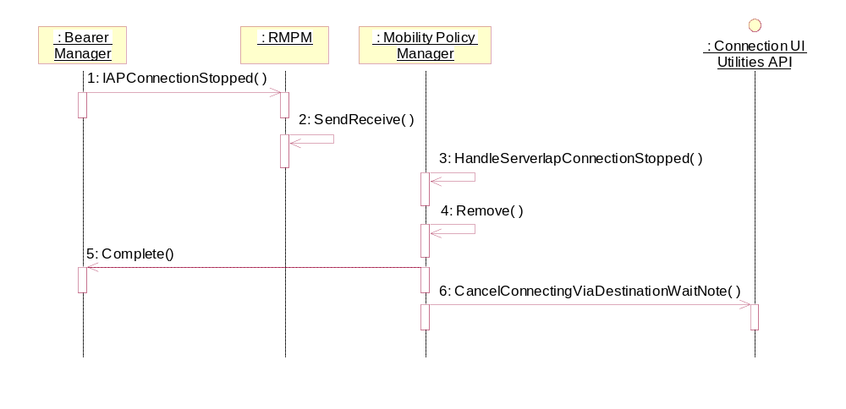
Figure 2.18 IAP connection is stopped

Application joins connection

Summary | Describes MPM functionality when application joins connection.
Actor(s) | Bearer Manager.
Frequency | Whenever application using data connection is roaming to preferred connection or when the connection is getting up.
Preconditions | A connection has been started.
Description | - BM informs that application joins connection.  - Client API handles the request and passes the message arguments to the server.  - MPM starts handling of application specific connection addition.  - MPM updates information about an active BM connection.  - MPM updates information about registration.  - Request returns to the client.
Exceptions
Post conditions | Information about an active BM connection has been updated.
Illustrations | Figure 2.19

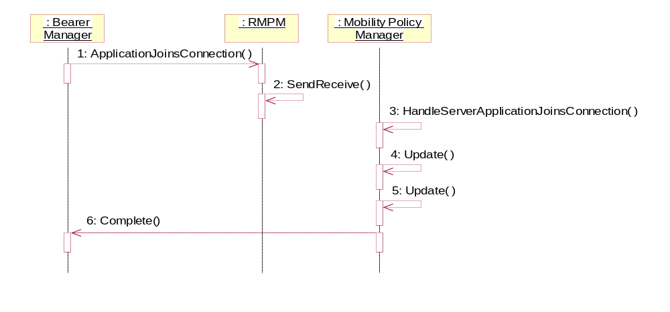
Figure 2.19 Application joins connection

IAP connection is activated

Summary | Describes MPM functionality when IAP connection is activated.
Actor(s) | Bearer Manager, Connection UI Utilities.
Frequency | Whenever application using data connection accepted the preferred carrier.
Preconditions | An IAP has been selected (see Section 2.3.1).
Description | - BM informs that IAP connection is activated.  - Client API handles the request and passes the message arguments to the server.  - MPM starts handling of IAP connection activation.  - MPM displays connecting wait note.  - Request returns to the client.
Exceptions
Post conditions | Connecting wait note is displayed.
Illustrations | Figure 2.20

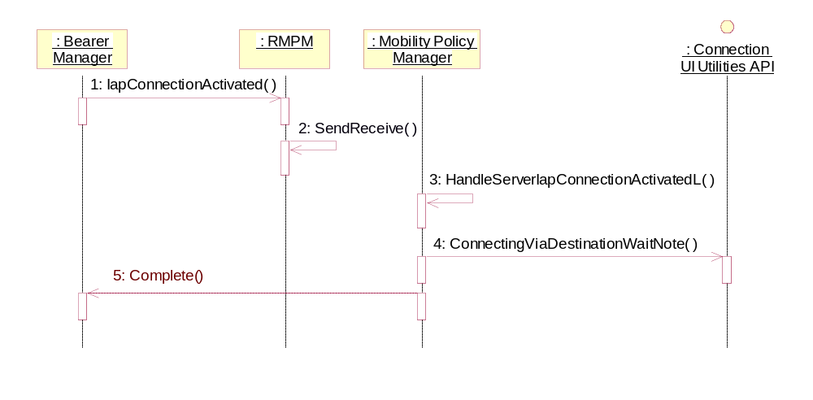
Figure 2.20 IAP connection is activated

User selects Easy WLAN

Summary | Describes implicit connection activation (no destination network or IAP specified) and the phone user selects Easy WLAN from the UI.
Actor(s) | Bearer Manager, Connection UI Utilities, phone user via UI.
Frequency | Whenever application starts to make connection by opening a socket without explicitly specifying destination network or IAP it wants to use.
Preconditions | User prompting defined in connection preferences passed to MPM.
Description | - BM requests MPM to choose the best IAP.  - Client API handles the request and passes the message arguments to the server.  - MPM starts IAP selection for implicit connection.  - MPM gets a list of currently available IAPs from Connection Monitor.  - MPM initiates a user dialog via agent dialog server API.  - CConnDlg requests sorting available IAPs belonging to the specified SNAP.  - MPM returns the sorted list to CConnDlg.  - User selects Easy WLAN from UI.  - Request returns to the client.  - BM informs that IAP connection is activated.  - Client API handles the request and passes the message arguments to the server.  - MPM starts handling of IAP connection activation.  - Request returns to the client.  - Connection UI Utilities informs the actual SSID of Easy WLAN.  - Client API handles the request and passes the message arguments to the server.  - MPM starts handling of Easy WLAN SSID.  - MPM displays connecting wait note with the actual SSID.  - Request returns to the client.
Exceptions | If connection to the dialog server fails or user cancels selection, returned error code is passed to Bearer Manager.
Post conditions | Connecting wait note is displayed.
Illustrations | Figure 2.21

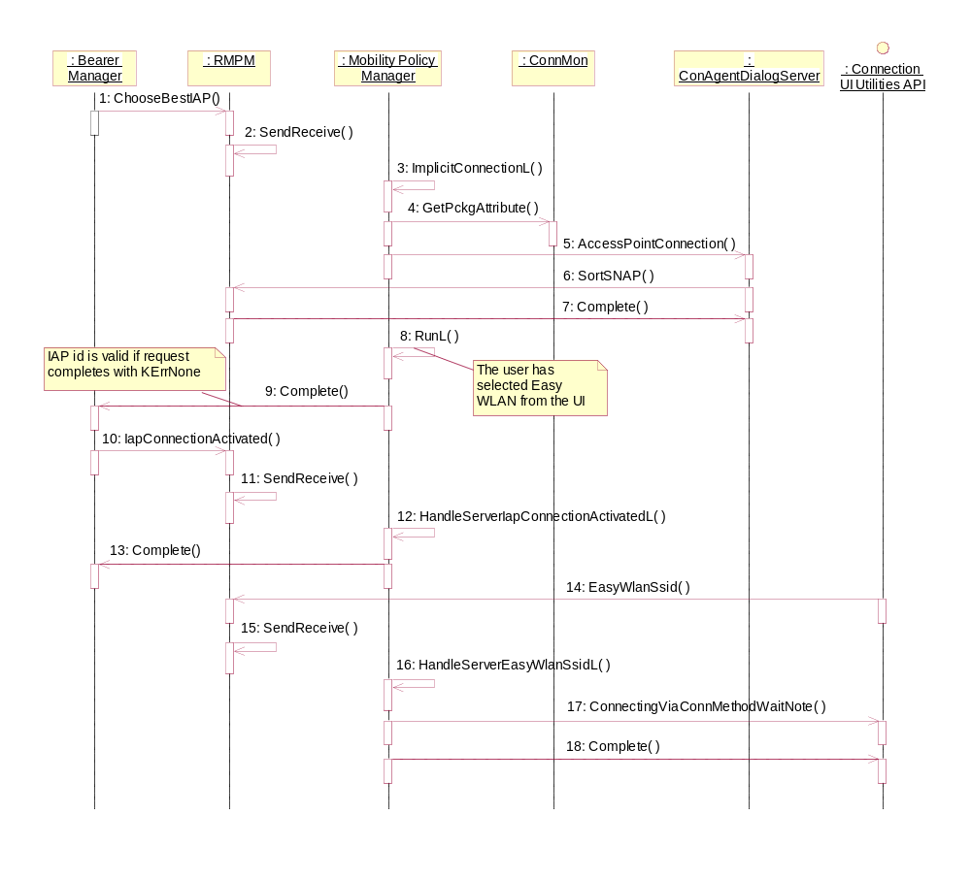
Figure 2.21 User selects Easy WLAN

IAP connection is started

Summary | Describes MPM functionality when the IAP connection is started.
Actor(s) | Bearer Manager, Connection UI Utilities.
Frequency | Whenever the IAP connection is started.
Preconditions | An IAP has been activated (see Section 2.3.17).
Description | - BM informs that the IAP connection is started.  - Client API handles the request and passes the message arguments to the server.  - MPM starts handling of IAP connection addition.  - MPM updates the IAP information about an active BM connection.  - Request returns to the client.  - MPM cancels displaying the wait note.  - MPM displays confirmation note.
Exceptions
Post conditions | The IAP information about an active BM connection has been inserted.
Illustrations | Figure 2.22

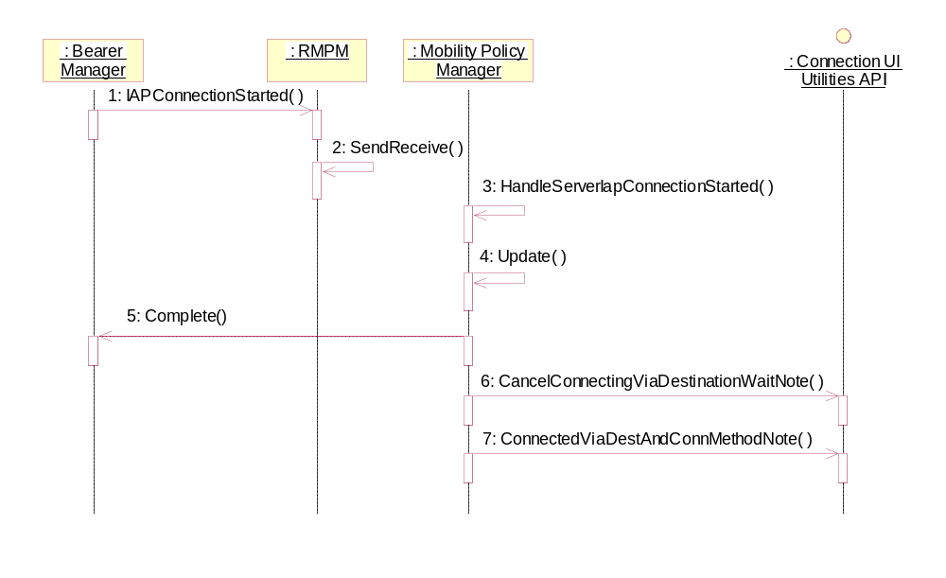
Figure 2.22 IAP connection is started

Application ends connection

Summary | Describes MPM functionality when application ends connection.
Actor(s) | Bearer Manager, Connection UI Utilities.
Frequency | Whenever application using data connection is closed.
Preconditions | - A connection has been started. Message buffer has been initialized (see Section 2.3.10).  - Bearer Manager has registered for getting preferred IAP notifications (see Section 2.3.11).
Description | - BM informs that application ends connection.  - Client API handles the request and passes the message arguments to the server.  - MPM starts handling of application connection ending.  - MPM cancels displaying the wait note.  - MPM unblacklists all IAPs related to this application when connection closes.  - MPM removes information about an active BM connection.  - Request returns to the client.
Exceptions
Post conditions | Information about an active BM connection has been removed.
Illustrations | Figure 2.23

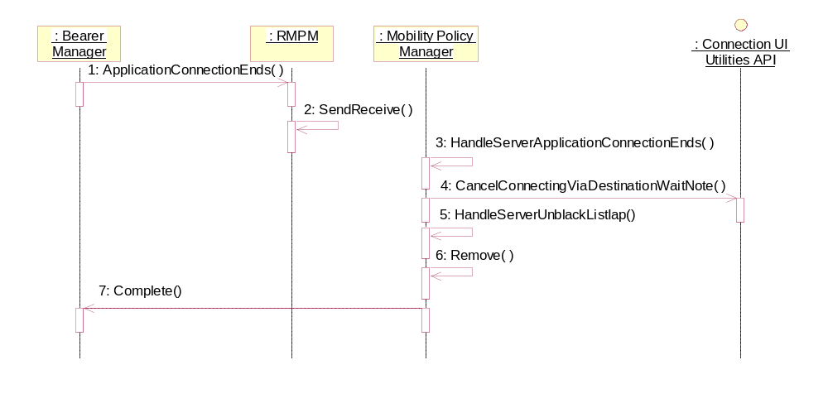
Figure 2.23 Application ends connection

Application migrates to carrier

Summary | Describes MPM functionality when application migrates to carrier.
Actor(s) | Bearer Manager, Connection UI Utilities.
Frequency | Whenever application using data connection is migrating to preferred carrier.
Preconditions | - A connection has been started. Message buffer has been initialized (see Section 2.3.10).  - Bearer Manager has registered for getting preferred IAP notifications (see Section 2.3.11).
Description | - BM informs that application migrates to carrier.  - Client API handles the request and passes the message arguments to the server.  - MPM starts handling of application migrating to carrier.  - Request returns to the client.  - MPM cancels displaying the wait note.  - MPM updates information about an active BM connection.  - MPM displays roaming confirmation query.  - User accepts roaming to the preferred IAP.  - MPM updates information about registration.  - MPM sends start IAP notification to BM.  - MPM completes start IAP notification message.
Exceptions
Post conditions | Information about an active BM connection has been updated.
Illustrations | Figure 2.24

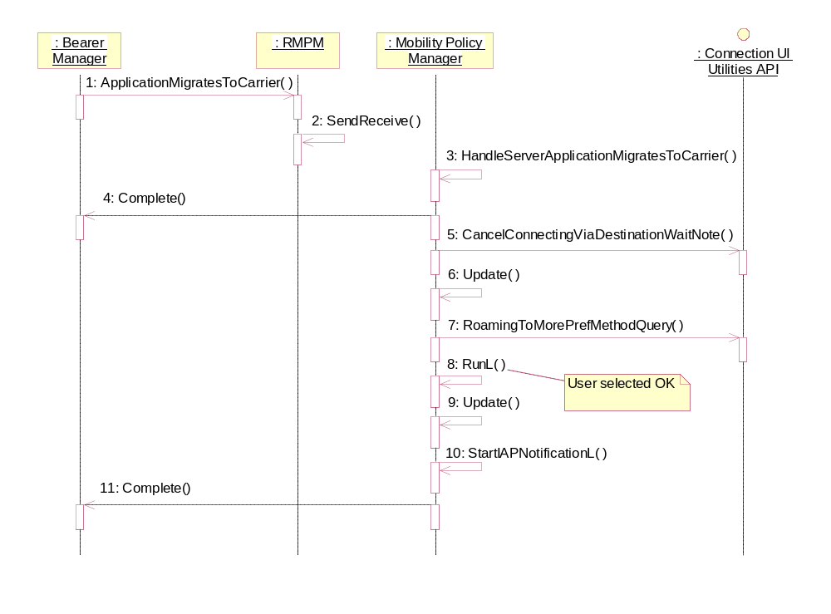
Figure 2.24 Application migrates to carrier

Application accepts the carrier

Summary | Describes MPM functionality when application accepts the carrier.
Actor(s) | Bearer Manager.
Frequency | Whenever application using data connection accepted the preferred carrier.
Preconditions | - A connection has been started. Message buffer has been initialized (see Section 2.3.10).  - Bearer Manager has registered for getting preferred IAP notifications (see Section 2.3.11).
Description | - BM informs that application accepted the carrier.  - Client API handles the request and passes the message arguments to the server.  - MPM starts handling of application accepting the carrier.  - MPM updates information about an active BM connection.  - MPM updates information about registration.  - Request returns to the client.
Exceptions
Post conditions | Information about an active BM connection has been updated.
Illustrations | Figure 2.25

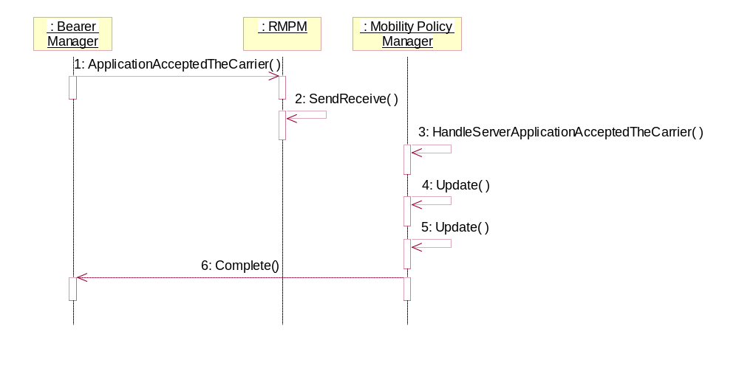
Figure 2.25 Application accepted the carrier

Application ignores the carrier

Summary | Describes MPM functionality when application ignores the carrier.
Actor(s) | Bearer Manager.
Frequency | Whenever application using data connection is ignoring the carrier.
Preconditions | - A connection has been started. Message buffer has been initialized (see Section 2.3.10).  - Bearer Manager has registered for getting preferred IAP notifications (see Section 2.3.11).
Description | - BM informs that application ignored the carrier.  - Client API handles the request and passes the message arguments to the server.  - MPM starts handling of application ignoring the carrier.  - MPM resets information about an active BM connection.  - MPM gets IDs of available IAPs.  - MPM blacklists the IAP which application ignored.  - MPM checks the need for preferred IAP notification.  - Request returns to the client.
Exceptions
Post conditions | Information about an active BM connection has been reset.
Illustrations | Figure 2.26

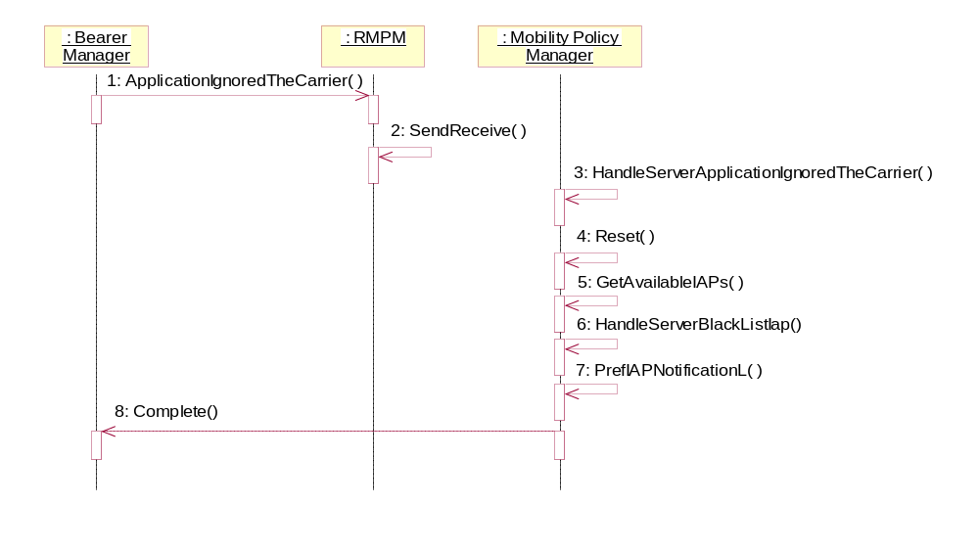
Figure 2.26 Application ignores the carrier

Application rejects the carrier

Summary | Describes MPM functionality when application rejects the carrier.
Actor(s) | Bearer Manager.
Frequency | Whenever application using data connection is rejecting the carrier.
Preconditions | - A connection has been started. Message buffer has been initialized (see Section 2.3.10).  - Bearer Manager has registered for getting preferred IAP notifications (see Section 2.3.11).
Description | - BM informs that application rejected the carrier.  - Client API handles the request and passes the message arguments to the server.  - MPM starts handling of application rejecting the carrier.  - MPM resets information about an active BM connection.  - MPM gets IDs of available IAPs.  - MPM blacklists the IAP which application ignored.  - MPM checks the need for preferred IAP notification.  - Request returns to the client.
Exceptions
Post conditions | Information about an active BM connection has been reset.
Illustrations | Figure 2.27

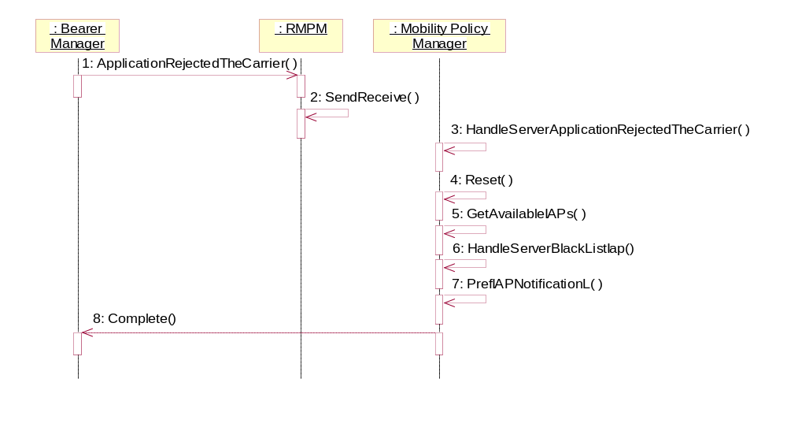
Figure 2.27 Application rejects the carrier

Sort IAPs of specific SNAP

Summary | Sort available IAPs belonging to the specified SNAP.
Actor(s) | Connection Dialog (CConnDlg).
Frequency | Whenever application starts to make connection by opening a socket without explicitly specifying SNAP or IAP it wants to use.
Preconditions | User prompting defined in connection preferences passed to MPM.
Description | - CConnDlg requests sorting available IAPs belonging to the specified SNAP.  - Client API handles the request and passes the message arguments to the server.  - MPM starts handling of sorting request.  - MPM finds the valid IAPs belonging to the specified SNAP.  - Returns the list of available IAPs, where the blacklisted IAPs have been removed.  - Determines the actual priorities for virtual IAPs and embedded SNAPs  - Finds the service type for the IAP and returns the global bearer priority for that service type.  - Request returns to the client.
Exceptions
Post conditions | CConnDlg has received TMpmSnapBuffer-type list which contains sorted IAPs.
Illustrations | Figure 2.28

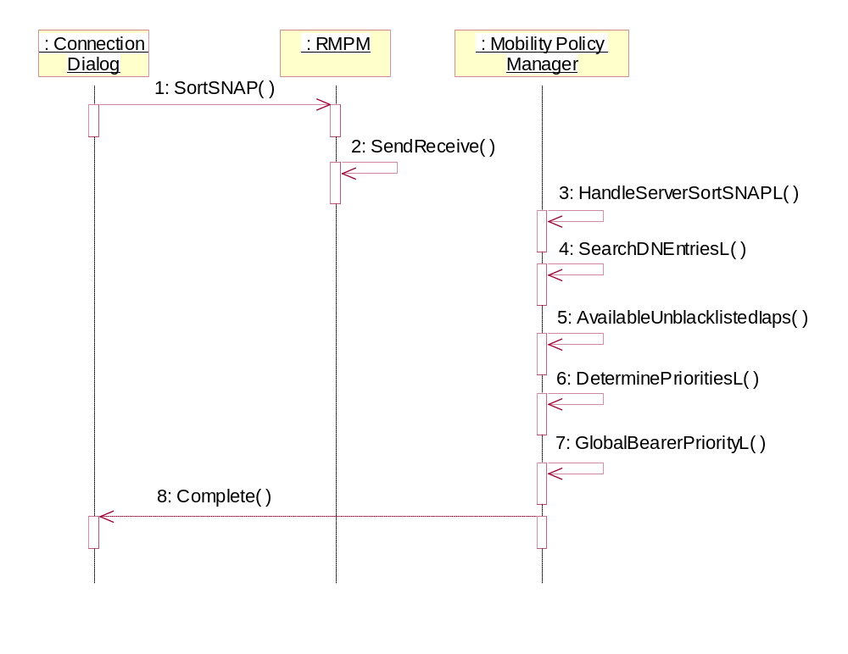
Figure 2.28 Sort IAPs of specific SNAP

Services required

From the Symbian OS subsystems
Services of Symbian OS infrastructure (including client-server framework, agent dialog API and CommsDat handling services) are required.

API | Description
Client-Server Framework | Service is required for client server implementation.
Agent Dialog Server API | Service is required for interaction with user dialog implementation.
CommsDat API | Service is required for doing communications’ DB queries.
Connection Monitor API | Service is required for receiving event notifications from Connection Monitor.
Disconnect Dialog Server API | Service is required for interaction with disconnect dialog implementation.
Feature Manager API | Service is required for checking whether off-line feature is supported by device.
Central Repository API | Service is required for checking whether off-line is activated.
ETel API | Service is required for connecting to ETel server.
Multimode ETel API | Service is required for checking if phone is in GSM mode.
Etel 3rd Party API | Service is required for voice call notifications.
ETel Multimode Packet Data API | Service is required for checking if phone supports Dual Transfer Mode.
Connection UI Utilities API | Service is required for displaying confirmation queries, wait notes, information notes and confirmation notes.
Connection Method Manager API | Service is required for accessing Bearer Management specific tables in CommsDat.

From the Domestic OS subsystems
This component does not have any direct interfaces to the Domestic OS side subsystems.

From HW
This component has no direct HW interfaces.

Services provided

UI
This component does not provide any UI.

SW IF
This component provides an API for Bearer Manager to select IAP and access network ID for the connection according to the used policy.
The API contains general client-server handling methods (such as Connect and Close) and the IAP selection method.

Provided Service | Description | Protected
LaunchServer() | Starts the MPM server. | Yes
ChooseBestIAP() | Initiates the IAP selection. See Sections 2.3.1 and 2.3.2. | Yes
RMPM() | Constructor for the client interface. | Yes
Connect() | Starting of a new server session | Yes
Close() | Closing of server session. | Yes
Cancel() | Canceling of the asynchronous IAP selection. | Yes
Version() | Returns the version information of the server. | Yes
ProcessError() | Error processing of connection initiation. | Yes
ApplicationLeaves  Connection() | Application leaves connection. | Yes
IAPConnectionStopped() | The whole IAP connection is stopped. | Yes
WaitNotification() | Bearer manager provides message buffer for MPM notifications, must be called before registering for notifications. | Yes
RegisterPrefIAPNotif() | Register for getting preferred IAP notifications. | Yes
UnregisterPrefIAPNotif() | Unregister preferred IAP notifications. | Yes
SortSNAP() | Sort available IAPs belonging to the specified SNAP. | Yes
ApplicationJoins  Connection() | Application joins connection. | Yes
IAPConnectionStarted() | The IAP connection is started. | Yes
ApplicationConnection  Ends() | Application connection ends. | Yes
ApplicationMigratesTo  Carrier() | Application migrates to carrier. | Yes
ApplicationIgnoredThe  Carrier() | Application ignored the carrier. | Yes
ApplicationAcceptedThe  Carrier() | Application accepted the carrier. | Yes
ApplicationRejectedThe  Carrier() | Application rejected the carrier. | Yes
IAPConnectionActivated() | The IAP connection is activated. | Yes
EasyWlanSsid() | Displays connecting wait note for Easy WLAN connection. | Yes

// CLASS DECLARATION
/**
* Mobility Policy Manager server client interface.
*
* @lib RMPM.lib
* @since 3.0
*/
class RMPM : public RSessionBase
{
public:
IMPORT_C RMPM();
IMPORT_C TInt LaunchServer();
IMPORT_C TInt Connect();
IMPORT_C void ChooseBestIAP(TConnPref& aConnPref,
const TUid aAppUid,
TConnPref& aPolicyPref,
TRequestStatus& aStatus);
IMPORT_C void ProcessError(TConnPref& aConnPref,
TInt& aError,
const TUid aAppUid,
TBMNeededAction& aNeededAction,
TRequestStatus& aStatus);
IMPORT_C TInt ApplicationLeavesConnection(const TUint32 aIapId,
const TUid aAppUid);
IMPORT_C TInt IAPConnectionStopped(const TUint32 aIapId);
IMPORT_C void WaitNotification(TMPMMessageBuffer& aMpmNotification,
TRequestStatus& aStatus);
IMPORT_C TInt RegisterPrefIAPNotif(TConnPref& aConnPref,
const TUid aAppUid);
IMPORT_C void UnregisterPrefIAPNotif(const TUid aAppUid);
IMPORT_C TInt SortSNAP(const TUint32 aSNAP,
TMpmSnapBuffer& aSortedList);
IMPORT_C TInt ApplicationJoinsConnection(const TUint32 aIapId,
const TUid aAppUid);
IMPORT_C TInt IAPConnectionActivated( const TUint32 aIapId,
const TConnectionId aConnId );
IMPORT_C TInt IAPConnectionStarted(const TUint32 aIapId);
IMPORT_C TInt ApplicationConnectionEnds(const TUid aAppUid);
IMPORT_C TInt ApplicationMigratesToCarrier(const TUint32 aIapId,
const TUid aAppUid);
IMPORT_C TInt ApplicationIgnoredTheCarrier(const TUint32 aIapId,
const TUid aAppUid);
IMPORT_C TInt ApplicationAcceptedTheCarrier(const TUint32 aIapId,
const TUid aAppUid);
IMPORT_C TInt ApplicationRejectedTheCarrier(const TUint32 aIapId,
const TUid aAppUid);
IMPORT_C TInt EasyWlanSsid(const TWlanSsid& aSSID);
IMPORT_C TVersion Version() const;
IMPORT_C void Cancel() const;
IMPORT_C void Close();
};
#endif // RMPM_H

UI control hierarchy
In the case of implicit connection setup MPM starts a user dialog for SNAP or IAP selection. The dialog is initiated through Connection Agent Dialog Server defined in reference document [2]. The dialog server and the actual UI are not implemented by this component.
In case the maximum number of contexts has been exceeded by network or phone MPM starts a disconnect dialog where user can select the connection to be disconnected. The dialog is initiated through Disconnect Dialog Server API defined in reference document [3]. The Disconnect Dialog server and the actual UI are not implemented by this component.
In case of explicit starting of SNAP, MPM starts a confirmation query. The query is initiated through Connection UI Utilities API defined in reference document [4]. The Connection UI Utilities server and the actual UI are not implemented by this component.
In case of application roaming, MPM starts a roaming dialog. The dialog is initiated through Connection UI Utilities API defined in reference document [4]. The Connection UI Utilities server and the actual UI are not implemented by this component.
In case of IAP connection activation, MPM starts displaying connecting wait note. The wait note is initiated through Connection UI Utilities API defined in reference document [4]. The Connection UI Utilities server and the actual UI are not implemented by this component.

Design
Mobility Policy Manager implementation is based on Symbian’s client-server framework that provides used base classes: RSessionBase for client interface and CServer2, CSession2 and CPolicyServer for the server. The user dialog is initiated via an active object (class CMPMDialog). The client interface provides a method for the server launching.

Class diagrams
Figure 4.29 and Figure 4.30 depict the client interface and server classes of Mobility Policy Manager. The number of concurrent server sessions is dependent on the amount of simultaneous client connections.

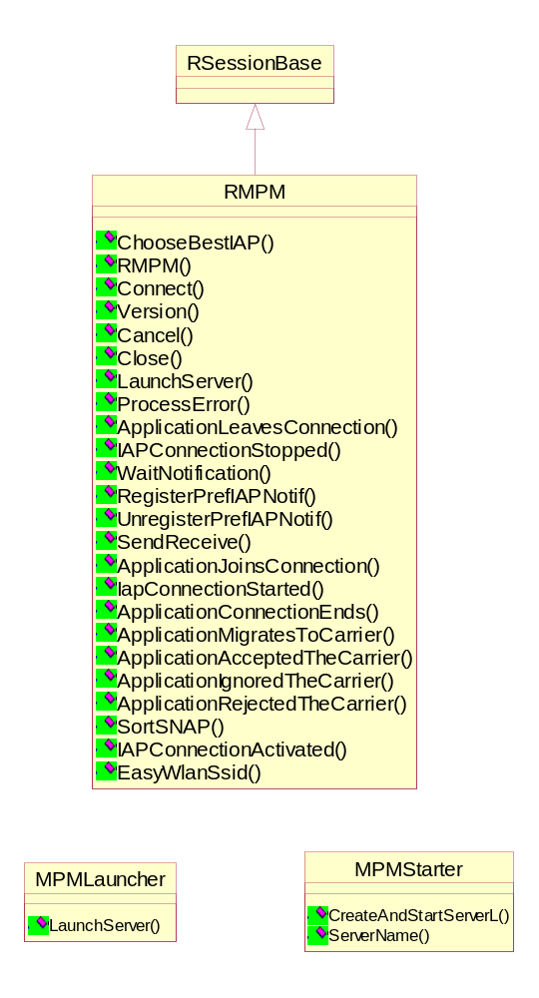
Figure 4.29 MPM Client class diagram

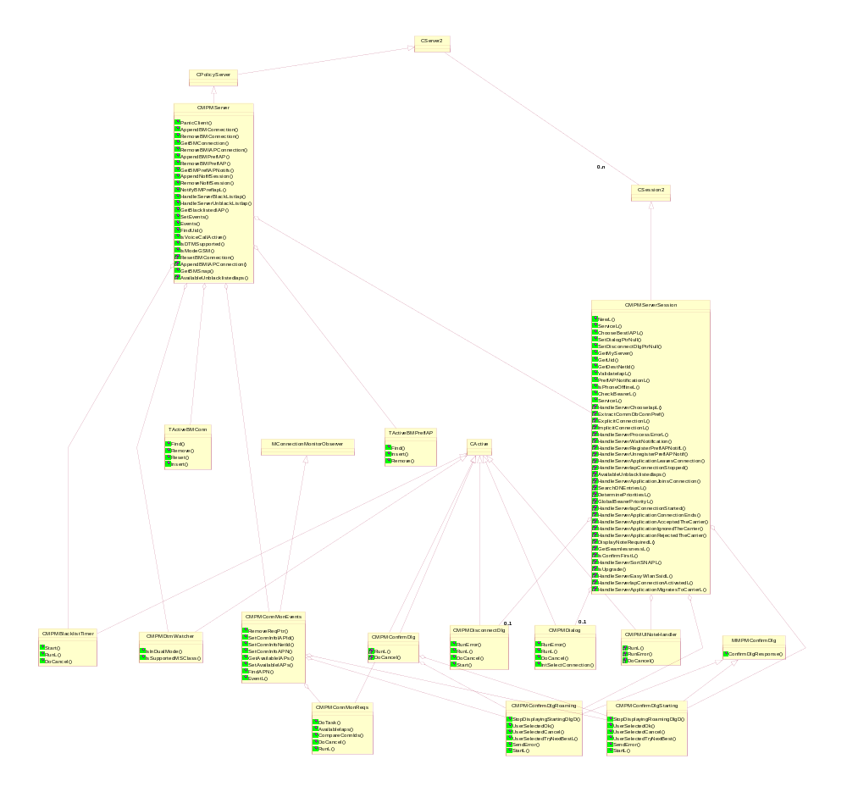
Figure 4.30 MPM Server class diagram

Class descriptions
Shorter form of class description: list of classes with a short description of each class. The descriptions of the methods are described in the C++ header files as comments.

Class | Description | Header file
RMPM | Client interface of MPM. | rmpm.h
CMPMServer | Server class of MPM. | mpmserver.h
CMPMServerSession | Server session class of MPM. | mpmserversession.h
CMPMDialog | Dialog handling. | mpmdialog.h
MPMLauncher | Server launching from client interface. | mpmlauncher.h
MPMStarter | Server starter code. | mpmstarter.h
CMPMConnMonEvents | ConnMon interface class definition. | mpmconnmonevents.h
CMPMConnMonReqs | Class definition for ConnMon requests. | mpmconnmonreqs.h
CMPMDisconnectDlg | Disconnect dialog initiation class definition. | mpmdisconnectdlg.h
MMPMConfirmDlg | Confirmation Dialog abstract base class. | mpmconfirmdlg.h
CMPMConfirmDlg | Confirmation Dialog base class. | mpmconfirmdlg.h
CMPMConfirmDlgStarting | Confirmation Dialog for establishing connection class. | mpmconfirmdlgstarting.h
CMPMConfirmDlgRoaming | Confirmation Dialog for roaming connection class. | mpmconfirmdlgroaming.h
CMPMUINoteHandler | UI Note Handler Class. | mpmuinotehandler.h
TConnInfo | Record for connection information storage. | mpmconnmonevents.h
TMPMBlackListConnId | Associates connection Id and the list of blacklisted IAPs. See Figure 4.31. | mpmserver.h
TAppInfo | Contains application information. | mpmserver.h
TActiveBMConn | Associates application information with IAP and connection state. | mpmserver.h
TPrefIapInfo | Contains information about registered application for preferred IAP notifications. | mpmserver.h
TActiveBMPrefIAP | Associates SNAP ID with the list of preferred notification information. | mpmserver.h
TNetIap | Record for CommsDat IAP table search storage. | mpmserversession.h

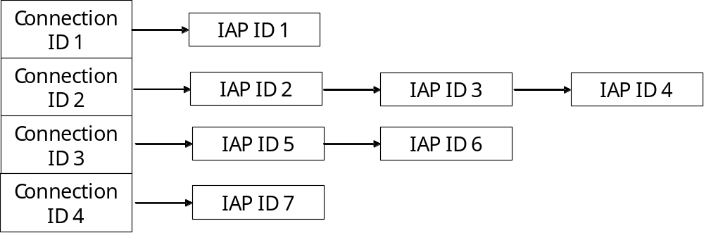

Figure 4.31 Connection Id is the key of the entry of the array, each entry contains IAP IDs

Structs, type definitions and enumerations

mpmcommon.h

Enumeration's name | Description
TMPMServerRequests | Opcodes used in IPC messaging.
TMPMPanic | Panic codes used for server and client.

mpmconnmonreqs.h

Enumeration's name | Description
TRequestState | Internal state types for state machine.

rmpm.h

Enumeration's name | Description
TMpmNotifications | Codes used for clients which have registered for getting preferred IAP notifications.
TMpmAsynchCodes | Codes used for canceling asynchronous requests.

Flag definitions

Flag | Description
MPM_LOGGING_METHOD | - Value 0 = No logging (if not _DEBUG build)  - Value 1 = Flogger (Logging in to file)  - Value 2 = RDebug (Logging e.g. to consol).

Operations

Choosing the best IAP from DB

Operation | Choosing the best IAP for the given SNAP.
Preconditions | Bearer Manager has requested IAP selection.
Description | Selects the best IAP according to the policy that is based on the ranking of the IAP.
Inputs | Connection preferences containing SNAP ID or user prompting activation information.
Modifies | Creates database queries for finding the highest ranked available IAP in given SNAP. Changes the SNAP ID to the access network ID of the IAP in the connection preferences.
Outputs | Selected IAP and corresponding access network ID.
Post conditions | Returns outputs to the Bearer Manager.
Related To | Use case 2.3.1.
Related Event
Exceptions | If database query fails, KErrNotFound is returned to Bearer Manager.

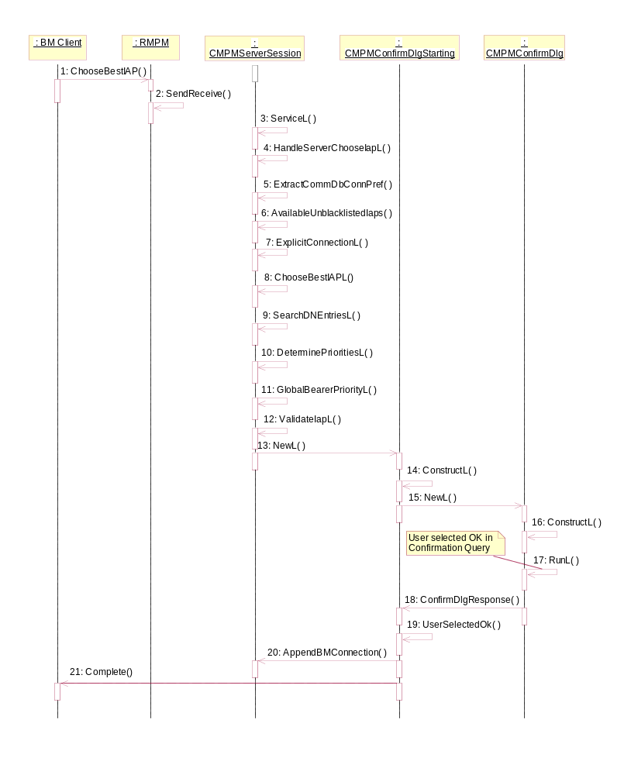
Figure 4.32 Choosing the best IAP

No. | Message | Description
1 | ChooseBestIAP | BM calls this asynchronous method to get the best -ranked IAP for the connection.
2 | SendReceive | The MPM client interface sends the request to the server by using the asynchronous version of SendReceive.
3 | ServiceL | This method gets called upon client interface’s SendReceive invocation.
4 | HandleServerChooseIAPL | Called by the ServiceL. Reads and starts checking client input parameters.
5 | ExtractCommDbConnPref | Checks connection preferences which in this case contain SNAP ID and user prompting is not set to ECommDbDialogPrefPrompt.
6 | AvailableUnblacklistedIapsL | Returns the list of available IAPs, where the blacklisted IAPs have already been removed.
7 | ExplicitConnectionL | Starts the selection of the best IAP and handles the message completion towards client in the end.
8 | ChooseBestIAPL | Compares the available IAPs with the sorted list of IAPs found from CommsDat defined for the SNAP.
9 | SearchDNEntriesL | Finds DN-IAP entries based on given SNAP Id
10 | DeterminePrioritiesL | Determine the priority for the IAP ID.
11 | GlobalBearerPriorityL | Finds the service type for the IAP and returns the global bearer priority for that service type.
12 | ValidateIapL | Validates the given IAP.
13 | NewL | The first phase of CMPMConfirmDlgStarting construction.
14 | ConstructL | The second phase of CMPMConfirmDlgStarting construction.
15 | NewL | The first phase of CMPMConfirmDlg construction.
16 | ConstructL | Displays the Confirmation Query.
17 | RunL | Gets user selection from the Confirmation Query.
18 | ConfirmDlgResponse | Checks the user selection and calls appropriate method.
19 | UserSelectedOK | Implements the actions when user selected OK in the Confirmation Query.
20 | AppendBMConnection | Adding info about active BM connection.
21 | Complete | Completes the request to the client with return code.

User dialog initiation

Operation | User dialog initiation.
Preconditions | Bearer Manager has requested implicit IAP connection selection. See Section 2.3.2.
Description | Starts an AgentDialog server session for user interaction via UI.
Inputs | Connection preference information with dialog prompting specified.
Modifies | Creates an instance of CMPMDialog that connects to RgenConAgentDialogServer and initiates the UI dialog with IapConnection method. Then waits for user response completion.
Outputs | If user selects SNAP ID then proceed as in Section 4.3.1. If user selects a specific IAP ID then return it to BM.
Post conditions | Completes outputs to the Bearer Manager.
Related To | Use case 2.3.2.
Related Event
Exceptions | If connection to the dialog server fails or user cancels selection, returned error code is passed forward to Bearer Manager within message completion.

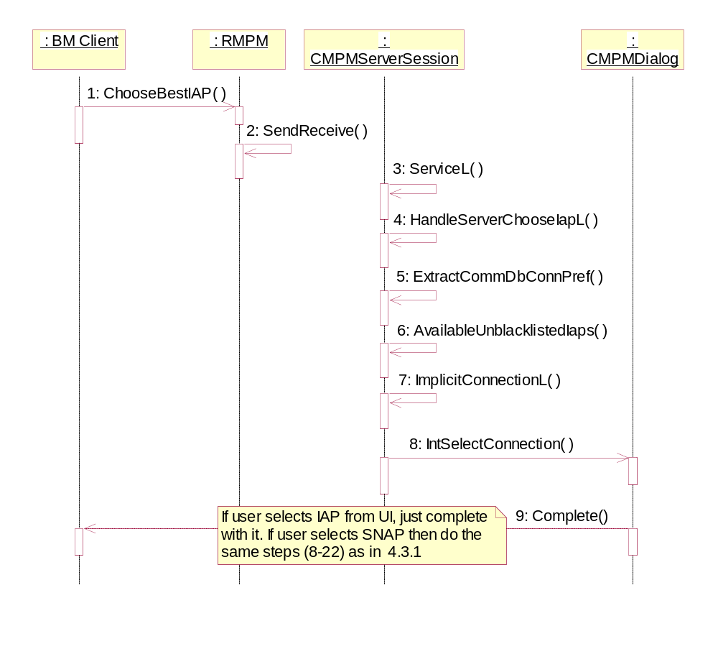
Figure 4.33 User dialog initiation

No. | Message | Description
1 | ChooseBestIAP | BM calls this asynchronous method to get the best -ranked IAP for the connection.
2 | SendReceive | The MPM client interface sends the request to the server by using the asynchronous version of SendReceive.
3 | ServiceL | This method gets called upon client interface’s SendReceive invocation.
4 | HandleServerChooseIAPL | Called by the ServiceL. Reads and starts checking client input parameters.
5 | ExtractCommDbConnPref | Checks connection preferences. In this case the user dialog prompting is set to ECommDbDialogPrefPrompt.
6 | AvailableUnblacklistedIaps | Returns the list of available IAPs, where the blacklisted IAPs have already been removed.
7 | ImplicitConnectionL | Creates CMPMDialog object and activates it.
8 | IntSelectConnection | Initiates the user dialog UI prompting via Agent Dialog Server.
9 | Complete | Completes the request to the client with return code.

Support of using existing PDP context per APN

Operation | Support of using existing PDP context per APN.
Preconditions | Bearer manager gets indication for connection setup.
Description | In case of one IAP is active and another one with the same APN is started, Bearer Manager attaches the RConnection to the existing connection.
Inputs | Connection preferences containing SNAP ID or user prompting activation information.
Modifies | Checks if connection to APN already exists. Changes the SNAP ID to the access network ID of the IAP in the connection preferences.
Outputs | Selected IAP and corresponding access network ID.
Post conditions | The access network ID and IAP ID are valid for BM use.
Related To | Use case 2.3.4.
Related Event
Exceptions | [KErrNotFound] indicates that no suitable IAP was found.

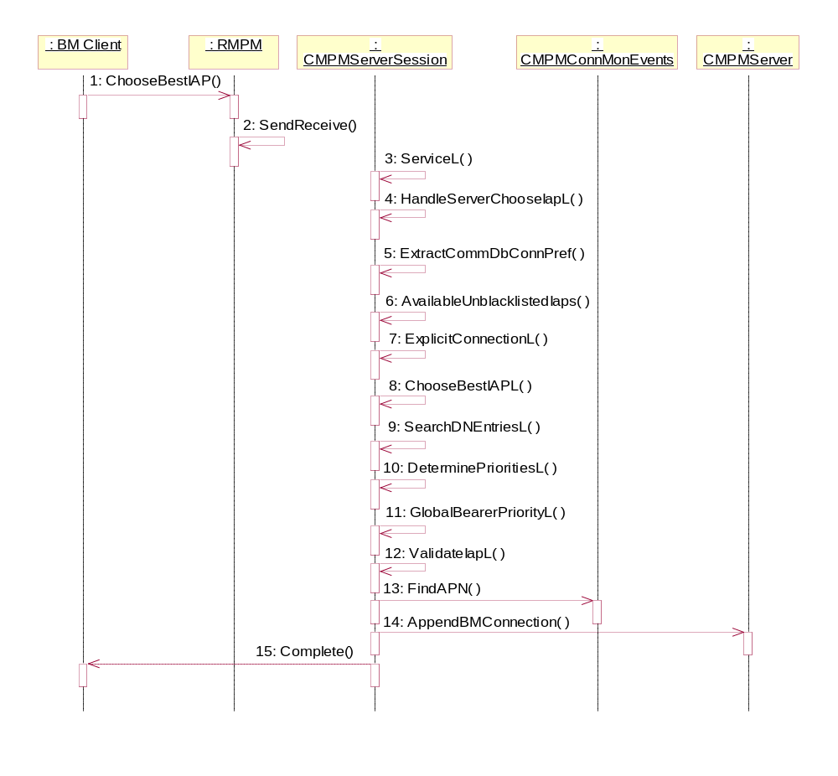
Figure 4.34 Support of using existing PDP context per APN

No. | Message | Description
1 | ChooseBestIAP | BM calls this asynchronous method to get the best -ranked IAP for the connection.
2 | SendReceive | The MPM client interface sends the request to the server by using the asynchronous version of SendReceive.
3 | ServiceL | This method gets called upon client interface’s SendReceive invocation.
4 | HandleServerChoose  IAPL | Called by the ServiceL. Reads and starts checking client input parameters.
5 | ExtractCommDbConn  Pref | Checks connection preferences.
6 | Available  UnblacklistedIaps | Returns the list of available IAPs, where the blacklisted IAPs have already been removed.
7 | ExplicitConnectionL | Starts the selection of the best IAP and handles the message completion towards client in the end.
8 | ChooseBestIAPL | Compares the available IAPs with the sorted list of IAPs found from CommsDat defined for the SNAP.
9 | SearchDNEntriesL | Finds DN-IAP entries based on given SNAP Id
10 | DeterminePrioritiesL | Determine the priority for the IAP ID.
11 | GlobalBearer  PriorityL | Finds the service type for the IAP and returns the global bearer priority for that service type.
12 | ValidateIapL | Validates the given IAP.
13 | FindAPN | Checks if connection to APN already exists.
14 | AppendBMConnection | Adds information about active BM connection.
15 | Complete | Completes the request to the client with return code.

Off-line mode

Operation | Off-line mode.
Preconditions | Bearer Manager has requested IAP selection.
Description | Describes GPRS/UMTS -connection activation when the phone is in off-line mode.
Inputs | Connection preferences containing SNAP ID or user prompting activation information.
Modifies | Checks the bearer type and is the phone in off-line mode or not. Changes the SNAP ID to the access network ID of the IAP in the connection preferences.
Outputs | [KErrGsmOfflineOpNotAllowed] is returned to Bearer Manager.
Post conditions | GPRS/UMTS -connection is not established.
Related To | Use case 2.3.5.
Related Event
Exceptions | [KErrNone] indicates that WLAN/LAN-connection was attempted in off-line mode.

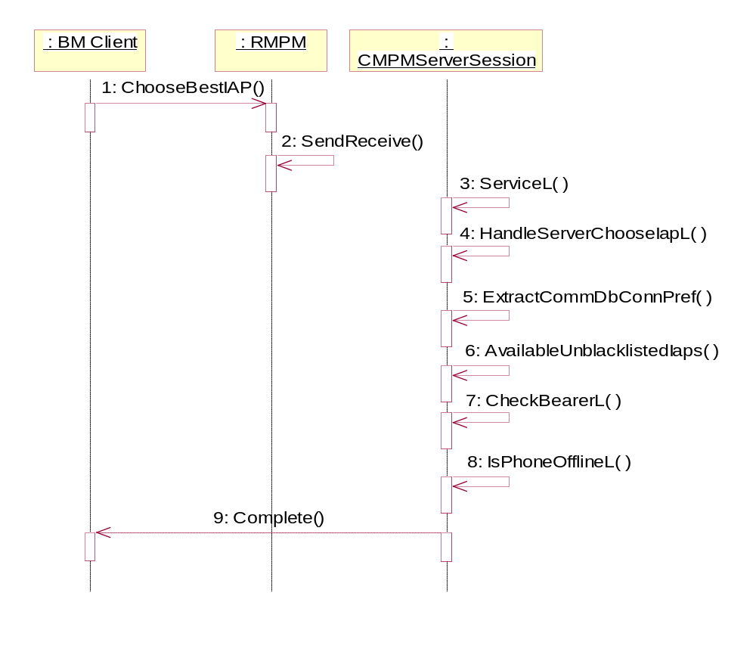
Figure 4.35 Off-line mode

No. | Message | Description
1 | ChooseBestIAP | BM calls this asynchronous method to get the best -ranked IAP for the connection.
2 | SendReceive | The MPM client interface sends the request to the server by using the asynchronous version of SendReceive.
3 | ServiceL | This method gets called upon client interface’s SendReceive invocation.
4 | HandleServerChooseIAPL | Called by the ServiceL. Reads and starts checking client input parameters.
5 | ExtractCommDbConnPref | Checks connection preferences.
6 | AvailableUnblacklistedIaps | Returns the list of available IAPs, where the blacklisted IAPs have already been removed.
7 | CheckBearerL | Checks the bearer type of given IAP.
8 | IsPhoneOfflineL | Checks if phone is in offline mode or not.
9 | Complete | Completes the request to the client with return code.

Maximum number of contexts exceeded

Operation | Propagating the error.
Preconditions | Bearer manager has detected an error in connection initiation.
Description | Describes connection termination when the maximum number of contexts has been exceeded by network or phone.
Inputs | Connection preferences, error code and application UID.
Modifies | Initiates the Disconnect Dialog UI, where user can select the connection to be closed.
Outputs | MPM tells Bearer Manager to end the client connection with the appropriate error code (EPropagateError).
Post conditions | The IAP ID of the closed connection is returned to Bearer Manager.
Related To | Use case 2.3.6.
Related Event
Exceptions | If connection to the disconnect dialog server fails or user cancels selection, returned error code is passed to Bearer Manager.

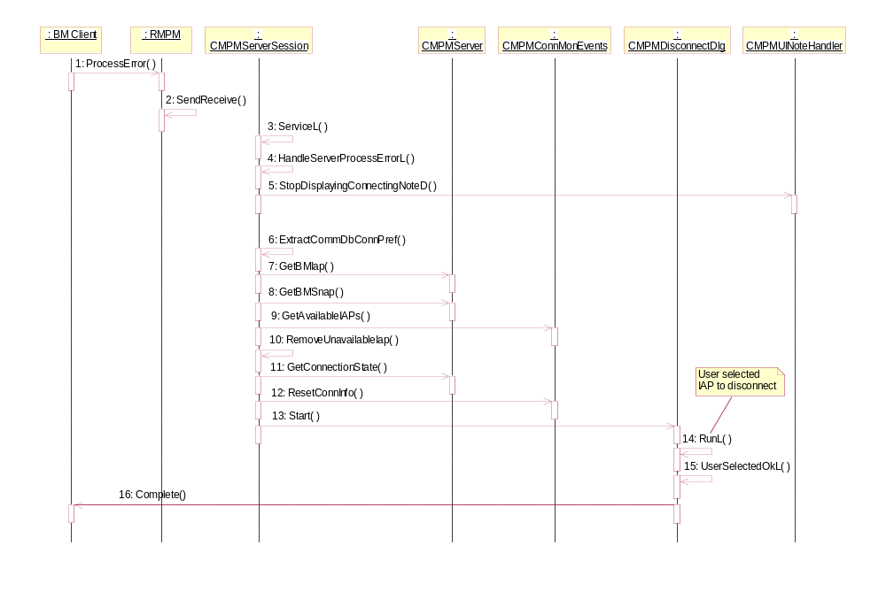
Figure 4.36 Maximum number of contexts exceeded

No. | Message | Description
1 | ProcessError | BM calls this asynchronous method to handle the error processing of connection initiation.
2 | SendReceive | The MPM client interface sends the request to the server by using the asynchronous version of SendReceive.
3 | ServiceL | This method gets called upon client interface’s SendReceive invocation.
4 | HandleServerProcess  ErrorL | Called by the ServiceL. Handles error processing.
5 | StopDisplayingConnectingNoteD | MPM cancels displaying the wait note.
6 | ExtractCommDbConnPref | Checks connection preferences.
7 | GetBMIap | Get the current Iap Id for this connection.
8 | GetBMSnap | Get the current SNAP for this connection.
9 | GetAvailableIAPs | MPM gets the IDs of available IAPs.
10 | RemoveUnavailableIap | MPM removes unavailable Iap Id.
11 | GetConnectionState | MPM gets the state of the connection for this Iap Id.
12 | ResetConnInfo | MPM resets connection info for all connections using given Iap.
13 | Start | Initiates the Disconnect Dialog UI via Disconnect Dialog Server.
14 | RunL | Checks the user selection and calls appropriate method.
15 | UserSelectedOkL | Implements the actions when user selected OK in the Disconnect Dialog UI.
16 | Complete | Completes the request to the client with return code.

Ignoring the error

Operation | Ignoring the error.
Preconditions | A connection has been started.
Description | Describes error processing for a connection which has already been started.
Inputs | Connection preferences, error code and application UID.
Modifies | Blacklists the erroneous IAP, sends preferred IAP notifications and then unblacklists the IAP.
Outputs | MPM tells Bearer Manager to ignore the error and let MPM notify the application about a new preferred IAP (EIgnoreError).
Post conditions | Applications have been notified of a new preferred IAP.
Related To | Use case 2.3.7.
Related Event
Exceptions | If the error to be processed was [KErrTimedOut], then operation 4.3.7 is the correct one.

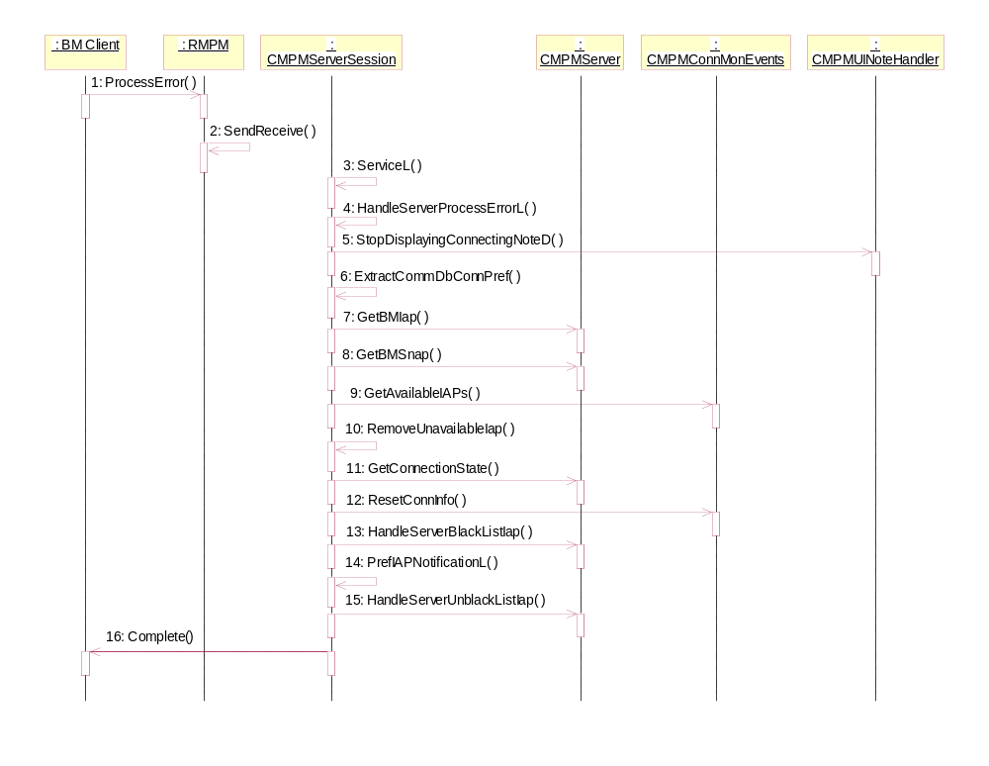
Figure 4.37 Ignoring the error

No. | Message | Description
1 | ProcessError | BM calls this asynchronous method to handle the error processing of connection initiation.
2 | SendReceive | The MPM client interface sends the request to the server by using the asynchronous version of SendReceive.
3 | ServiceL | This method gets called upon client interface’s SendReceive invocation.
4 | HandleServerProcess  ErrorL | Called by the ServiceL. Handles error processing.
5 | StopDisplayingConnectingNoteD | MPM cancels displaying the wait note.
6 | ExtractCommDbConnPref | Checks connection preferences.
7 | GetBMIap | Get the current Iap Id for this connection.
8 | GetBMSnap | Get the current SNAP for this connection.
9 | GetAvailableIAPs | MPM gets the IDs of available IAPs.
10 | RemoveUnavailableIap | MPM removes unavailable Iap Id.
11 | GetConnectionState | MPM gets the state of the connection for this Iap Id.
12 | ResetConnInfo | MPM resets connection info for all connections using given Iap.
13 | HandleServerBlackList  Iap | MPM blacklists the IAP which had the error.
14 | PrefIAPNotificationL | MPM checks if there are preferred IAPs to be notified to applications.
15 | HandleServer  UnblackListIap | MPM unblacklists the IAP which had the error.
16 | Complete | Completes the request to the client with return code.

Propagating the error

Operation | Propagating the error.
Preconditions | A connection has been started.
Description | Describes error processing for a connection which has already been started.
Inputs | Connection preferences, error code and application UID.
Modifies
Outputs | MPM tells Bearer Manager to ignore the error and do a reselection (EDoReselection).
Post conditions | Bearer Manager has been informed about appropriate action.
Related To | Use case 2.3.8.
Related Event
Exceptions

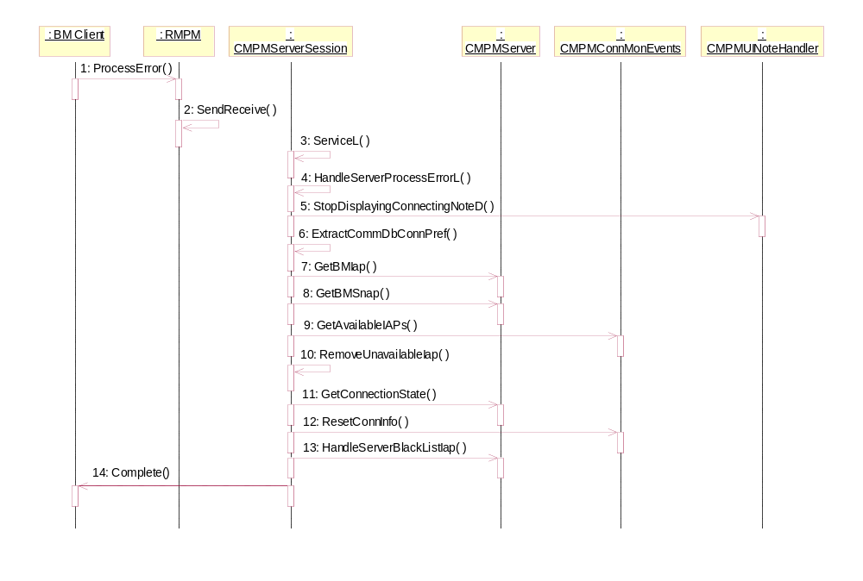
Figure 4.38 Propagating the error

No. | Message | Description
1 | ProcessError | BM calls this asynchronous method to handle the error processing of connection initiation.
2 | SendReceive | The MPM client interface sends the request to the server by using the asynchronous version of SendReceive.
3 | ServiceL | This method gets called upon client interface’s SendReceive invocation.
4 | HandleServerProcessErrorL | Called by the ServiceL. Handles error processing.
5 | StopDisplayingConnectingNoteD | MPM cancels displaying the wait note.
6 | ExtractCommDbConnPref | Checks connection preferences.
7 | GetBMIap | Get the current Iap Id for this connection.
8 | GetBMSnap | Get the current SNAP for this connection.
9 | GetAvailableIAPs | MPM gets the IDs of available IAPs.
10 | RemoveUnavailableIap | MPM removes unavailable Iap Id.
11 | GetConnectionState | MPM gets the state of the connection for this Iap Id.
12 | ResetConnInfo | MPM resets connection info for all connections using given Iap.
13 | HandleServerBlackList  Iap | MPM blacklists the IAP which had the error.
14 | Complete | Completes the request to the client with return code.

Connection request during a voice call

Operation | Connection request during a voice call.
Preconditions | Bearer Manager has requested IAP selection. Phone is in GSM mode but doesn’t support dual transfer mode.
Description | Describes connection activation when voice call is active.
Inputs | Connection preferences containing SNAP ID or user prompting activation information.
Modifies | Checks whether voice call is active, whether phone is in GSM mode and whether dual transfer mode is supported. Checks also the bearer type.
Outputs | [KErrGprsServicesNotAllowed] indicates that GPRS-connection was attempted but phone didn’t support dual transfer mode.
Post conditions | The voice call is active.
Related To | Use case 2.3.9.
Related Event
Exceptions | [KerrNotFound] indicates that no suitable IAP was found.

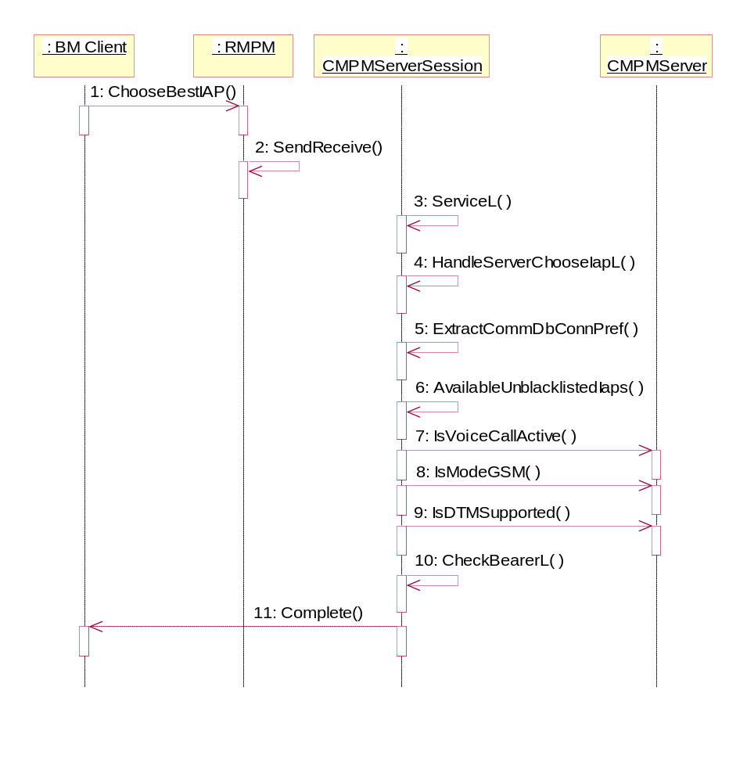
Figure 4.39 Connection request during a voice call

No. | Message | Description
1 | ChooseBestIAP | BM calls this asynchronous method to get the best -ranked IAP for the connection.
2 | SendReceive | The MPM client interface sends the request to the server by using the asynchronous version of SendReceive.
3 | ServiceL | This method gets called upon client interface’s SendReceive invocation.
4 | HandleServerChoose  IAPL | Called by the ServiceL. Reads and starts checking client input parameters.
5 | ExtractCommDbConnPref | Checks connection preferences.
6 | Available  UnblacklistedIaps | Returns the list of available IAPs, where the blacklisted IAPs have already been removed.
7 | IsVoiceCallActive | Checks if voice call is active or not.
8 | IsModeGSM | Checks if mode is GSM or not.
9 | IsDTMSupported | Checks if phone supports Dual Transfer Mode or not.
10 | CheckBearerL | Checks the bearer type of given IAP.
11 | Complete | Completes the request to the client with return code.

Initialize message buffer for IAP notifications

Operation | Initialize message buffer for IAP notifications.
Preconditions | A connection has been started.
Description | Describes initialization of message buffer for IAP notifications.
Inputs | MPM message buffer.
Modifies | Adds a notification session pointer and enables notification requested flag.
Outputs | Initialized message buffer.
Post conditions
Related To | Use case 2.3.10.
Related Event
Exceptions | [KErrServerBusy] indicates that there was already outstanding notification request activity.

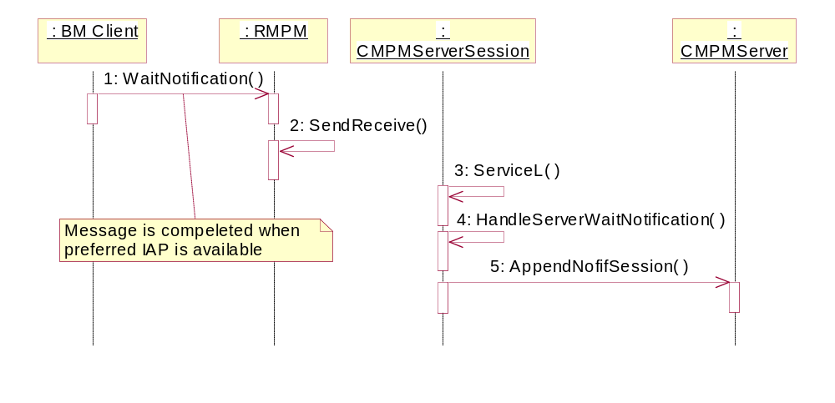
Figure 4.40 Initialize message buffer for IAP notifications

No. | Message | Description
1 | WaitNotification | BM calls this asynchronous method to initialize the message buffer for IAP notifications.
2 | SendReceive | The MPM client interface sends the request to the server by using the asynchronous version of SendReceive.
3 | ServiceL | This method gets called upon client interface’s SendReceive invocation.
4 | HandleServerWaitNotification | Called by the ServiceL. Starts a notification request activity.
5 | AppendNofifSession | MPM adds a notification session pointer to the array of notification sessions.

Preferred IAP registration

Operation | Preferred IAP registration.
Preconditions | A connection has been started. Message buffer has been initialized (see Section 4.3.9).
Description | Describes registering for receiving preferred IAP notifications.
Inputs | Connection preferences containing application UID.
Modifies | Adds information about active BM preferred IAP notification registration.
Outputs | Application has registered for receiving preferred notifications.
Post conditions | The status of the operation is returned to Bearer Manager.
Related To | Use case 2.3.11.
Related Event
Exceptions | [KErrArgument] indicates that BM provided unrecognized connection preference type.

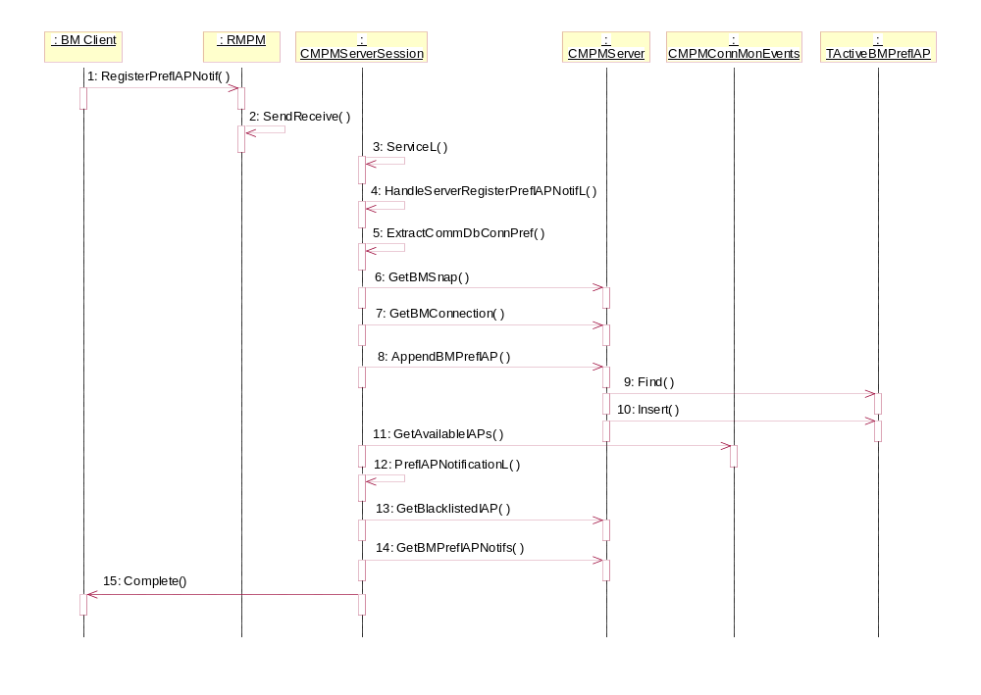
Figure 4.41 Preferred IAP registration

No. | Message | Description
1 | RegisterPrefIAPNotif | BM calls this synchronous method to register for getting preferred IAP notifications.
2 | SendReceive | The MPM client interface sends the request to the server by using the synchronous version of SendReceive.
3 | ServiceL | This method gets called upon client interface’s SendReceive invocation.
4 | HandleServerRegisterPrefIAP  NotifL | Called by the ServiceL. Reads and starts checking client input parameters.
5 | ExtractCommDbConnPref | Checks connection preferences.
6 | GetBMNetId | MPM gets the network ID of an active BM connection.
7 | GetBMConnection | MPM gets the IAP ID of an active BM connection.
8 | AppendBMPrefIAP | MPM adds information about active BM preferred IAP notification registration.
9 | Find | MPM finds preferred notification information which matches SNAP ID.
10 | Insert | If such a record is not found, then inserts new record.
11 | GetAvailableIAPs | MPM gets the IDs of available IAPs.
12 | PrefIAPNotificationL | MPM checks the need for preferred IAP notification.
13 | AvailableUnblacklistedIaps | MPM gets the list of available IAPs, where the blacklisted IAPs have already been removed.
14 | GetBMPrefIAPNotifs | MPM gets the reference to active preferred IAP notifications.
15 | Complete | If there are no preferred IAPs available, then request returns to the client.

Preferred IAP notification

Operation | Preferred IAP notification.
Preconditions | - Registration to preferred IAP notifications has been completed (see Section 4.3.10).  - A preferred IAP has become available.
Description | Describes sending preferred IAP notifications.
Inputs | Connection Monitor sends an IAP Availability change event.
Modifies | Adds information about active BM preferred IAP notification registration. Selects the best IAP for the connection and validates it.
Outputs | The preferred IAP is valid for BM further use.
Post conditions | The status of the operation is returned to Bearer Manager.
Related To | Use case 2.3.12.
Related Event
Exceptions

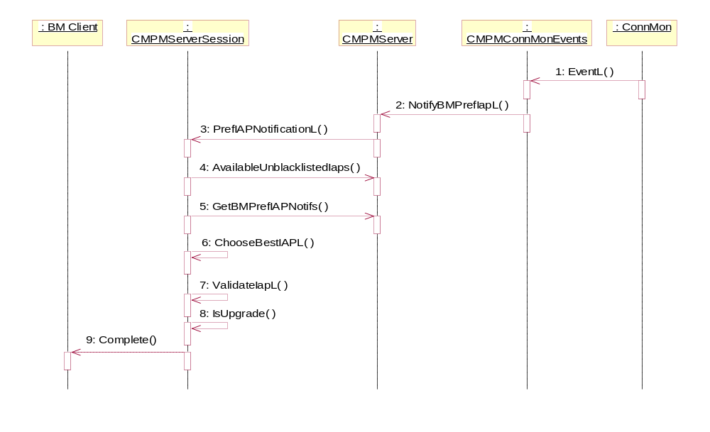
Figure 4.42 Preferred IAP notification

No. | Message | Description
1 | EventL | Connection Monitor informs that preferred IAP has become available.
2 | NotifyBMPrefIapL | MPM gets the IDs of available IAPs.
3 | PrefIAPNotificationL | MPM checks the need for preferred IAP notification.
4 | AvailableUnblacklistedIaps | MPM gets the list of available IAPs, where the blacklisted IAPs have already been removed.
5 | GetBMPrefIAPNotifs | MPM gets the reference to active preferred IAP notifications.
6 | ChooseBestIAPL | MPM selects the best IAP for the connection.
7 | ValidateIapL | MPM validates the preferred IAP.
8 | IsUpgrade | MPM checks whether the preferred IAP is either an upgrade or a downgrade.
9 | Complete | MPM notifies BM of preferred IAP.

Unregister preferred IAP notifications

Operation | Unregister preferred IAP notifications.
Preconditions | - A connection has been started. Message buffer has been initialized (see Section 4.3.9).  - Bearer Manager has registered for getting preferred IAP notifications (see Section 4.3.10).
Description | Describes unregistering the preferred IAP notifications.
Inputs | Application UID.
Modifies | Removes information about active BM preferred IAP notification registration.
Outputs | Registration for preferred IAP notifications has been removed.
Post conditions | The status of the operation is returned to Bearer Manager.
Related To | Use case 2.3.13.
Related Event
Exceptions

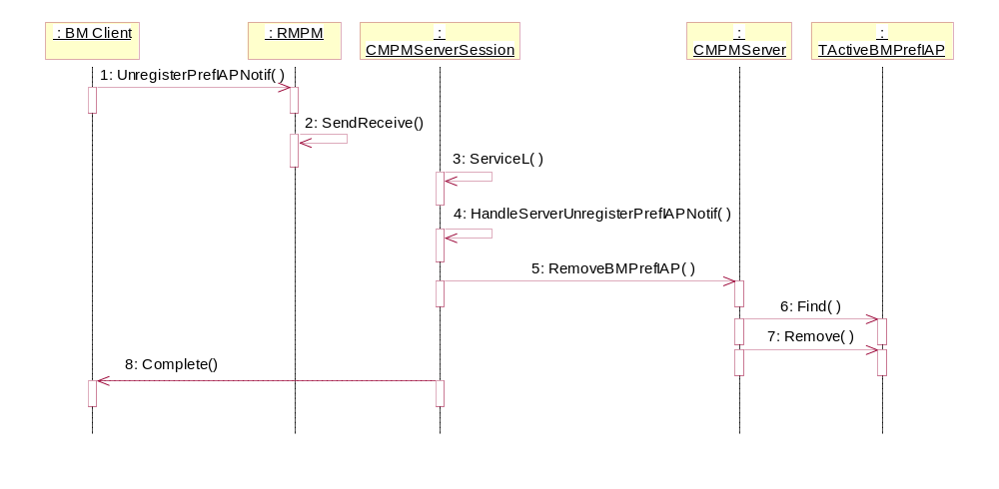
Figure 4.43 Unregister preferred IAP notifications

No. | Message | Description
1 | UnregisterPrefIAPNotif | BM calls this synchronous method to unregister the preferred IAP notifications.
2 | SendReceive | The MPM client interface sends the request to the server by using the synchronous version of SendReceive.
3 | ServiceL | This method gets called upon client interface’s SendReceive invocation.
4 | HandleServerUnregisterPrefIAP  NotifL | Called by the ServiceL. Reads and starts checking client input parameters.
5 | RemoveBMPrefIAP | Removes information about active BM preferred IAP notification registration.
6 | Find | Finds information about active BM preferred IAP notification registration which matches the SNAP ID.
7 | Remove | Removes information about active BM preferred IAP notification registration related to specific SNAP ID.
8 | Complete | Completes the request to the client with return code.

Application leaves connection

Operation | Application leaves connection.
Preconditions | A connection has been started.
Description | Describes MPM functionality when application leaves connection.
Inputs | Application UID and IAP ID.
Modifies | Resets information about an active BM connection.
Outputs | Information about an active BM connection has been reset.
Post conditions | The status of the operation is returned to Bearer Manager.
Related To | Use case 2.3.14.
Related Event
Exceptions

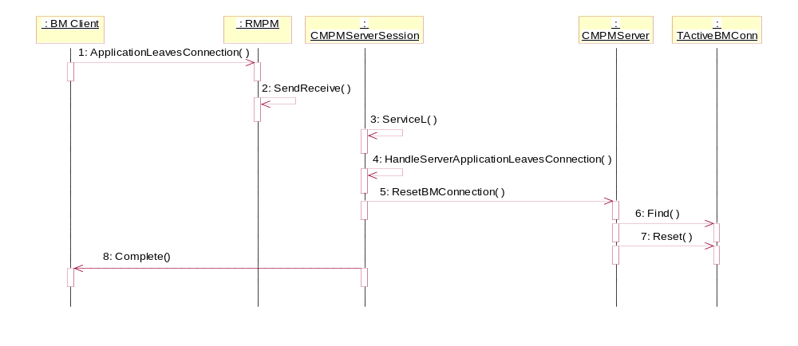
Figure 4.44 Application leaves connection

No. | Message | Description
1 | ApplicationLeavesConnection | BM calls this synchronous method to inform MPM that application is leaving connection.
2 | SendReceive | The MPM client interface sends the request to the server by using the synchronous version of SendReceive.
3 | ServiceL | This method gets called upon client interface’s SendReceive invocation.
4 | HandleServerApplicationLeaves  Connection | Called by the ServiceL. Reads and starts checking client input parameters.
5 | ResetBMConnection | Resets information about an active BM connection.
6 | Find | Finds information about an active BM connection which matches the IAP Id.
7 | Reset | Resets information about an active BM connection related to specific IAP Id.
8 | Complete | Completes the request to the client with return code.

IAP connection is stopped

Operation | The whole IAP connection is stopped.
Preconditions | A connection has been started.
Description | Describes MPM functionality when the whole IAP connection is stopped.
Inputs | IAP ID.
Modifies | Removes the whole IAP information about an active BM connection.
Outputs | The whole IAP information about an active BM connection has been removed.
Post conditions | The status of the operation is returned to Bearer Manager.
Related To | Use case 2.3.15.
Related Event
Exceptions

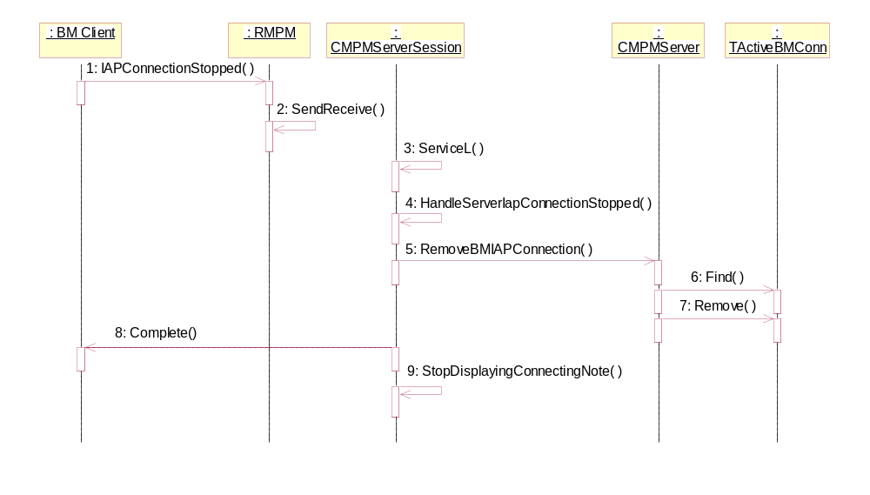
Figure 4.45 IAP connection is stopped

No. | Message | Description
1 | IAPConnectionStopped | BM calls this synchronous method to inform MPM that the whole IAP connection is stopped.
2 | SendReceive | The MPM client interface sends the request to the server by using the synchronous version of SendReceive.
3 | ServiceL | This method gets called upon client interface’s SendReceive invocation.
4 | HandleServerIapConnectionStopped | Called by the ServiceL. Reads and starts checking client input parameters.
5 | RemoveBMIAPConnection | Removes the whole IAP information about an active BM connection.
6 | Find | Finds information about active BM connections which match the IAP ID.
7 | Remove | Removes information about all active BM connections related to specific IAP ID.
8 | Complete | Completes the request to the client with return code.
9 | StopDisplayingConnectingNote | MPM cancels displaying the wait note.

Application joins connection

Operation | Application joins connection.
Preconditions | A connection has been started.
Description | Describes MPM functionality when application joins connection.
Inputs | Application UID and IAP ID.
Modifies | Updates information about an active BM connection.
Outputs | Information about an active BM connection has been updated.
Post conditions | The status of the operation is returned to Bearer Manager.
Related To | Use case 2.3.16.
Related Event
Exceptions

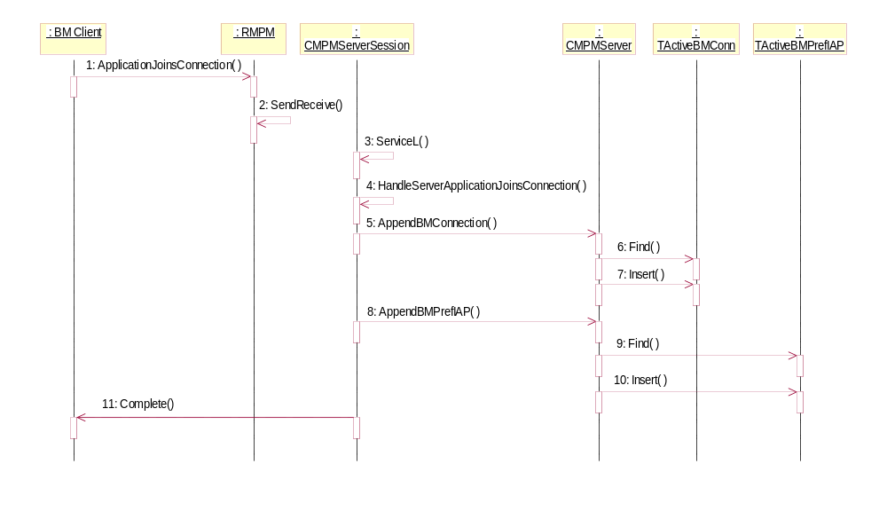
Figure 4.46 Application joins connection

No. | Message | Description
1 | ApplicationJoinsConnection | BM calls this synchronous method to inform MPM that application is joining connection.
2 | SendReceive | The MPM client interface sends the request to the server by using the synchronous version of SendReceive.
3 | ServiceL | This method gets called upon client interface’s SendReceive invocation.
4 | HandleServerApplicationJoins  Connection | Called by the ServiceL. Reads and starts checking client input parameters.
5 | AppendBMConnection | Adds information about active BM connection.
6 | Find | Finds information about an active BM connection which matches the IAP Id.
7 | Insert | If such a record is not found, then inserts new record.
8 | AppendBMPrefIAP | MPM adds information about active BM preferred IAP notification registration.
9 | Find | MPM finds preferred notification information which matches SNAP ID.
10 | Insert | If such a record is not found, then inserts new record.
11 | Complete | Completes the request to the client with return code.

IAP connection is activated

Operation | IAP connection is activated.
Preconditions | An IAP has been selected (see Section 4.3.1)
Description | Describes MPM functionality when the IAP connection is activated.
Inputs | Iap Id and connection Id.
Modifies
Outputs | Connecting wait note is displayed.
Post conditions | The status of the operation is returned to Bearer Manager.
Related To | Use case 2.3.17.
Related Event
Exceptions | If user has selected Easy WLAN, then see Section 4.3.17.

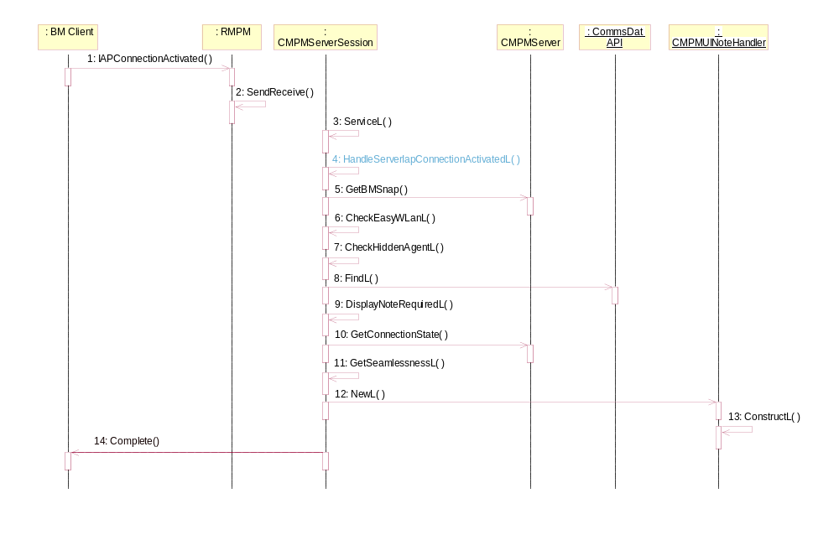
Figure 4.47 IAP connection is activated

No. | Message | Description
1 | IapConnectionActivated | BM calls this synchronous method to inform MPM that IAP connection is activated.
2 | SendReceive | The MPM client interface sends the request to the server by using the synchronous version of SendReceive.
3 | ServiceL | This method gets called upon client interface’s SendReceive invocation.
4 | HandleServerIapConnectionActivated | Called by the ServiceL. Reads and starts checking client input parameters.
5 | GetBMSnap | Gets SNAP of an active BM connection.
6 | CheckEasyWLanL | Checks if given Iap Id is Easy WLAN.
7 | CheckHiddenAgentL | Checks if the HiddenAgent metadata is set for this Iap Id.
8 | FindL | Checks if the metadata entry exists.
9 | DisplayNoteRequiredL | Checks what type of note needs to be displayed.
10 | GetConnectionState | MPM gets the state of the connection for this Iap Id.
11 | GetSeamlessnessL | Finds the seamlessness value of Iap Id.
12 | NewL | The first phase of CMPMUINoteHandler construction.
13 | ConstructL | Displays the wait note.
14 | Complete | Completes the request to the client with return code.

User selects Easy WLAN

Operation | Implicit connection activation (no destination network or IAP specified) and the phone user selects Easy WLAN from the UI.
Preconditions | User prompting defined in connection preferences passed to MPM.
Description | Describes MPM functionality when the user selects Easy WLAN.
Inputs | SSID of the WLAN access point selected by user.
Modifies
Outputs | Connecting wait note is displayed.
Post conditions | The status of the operation is returned to Bearer Manager.
Related To | Use case 2.3.18.
Related Event
Exceptions

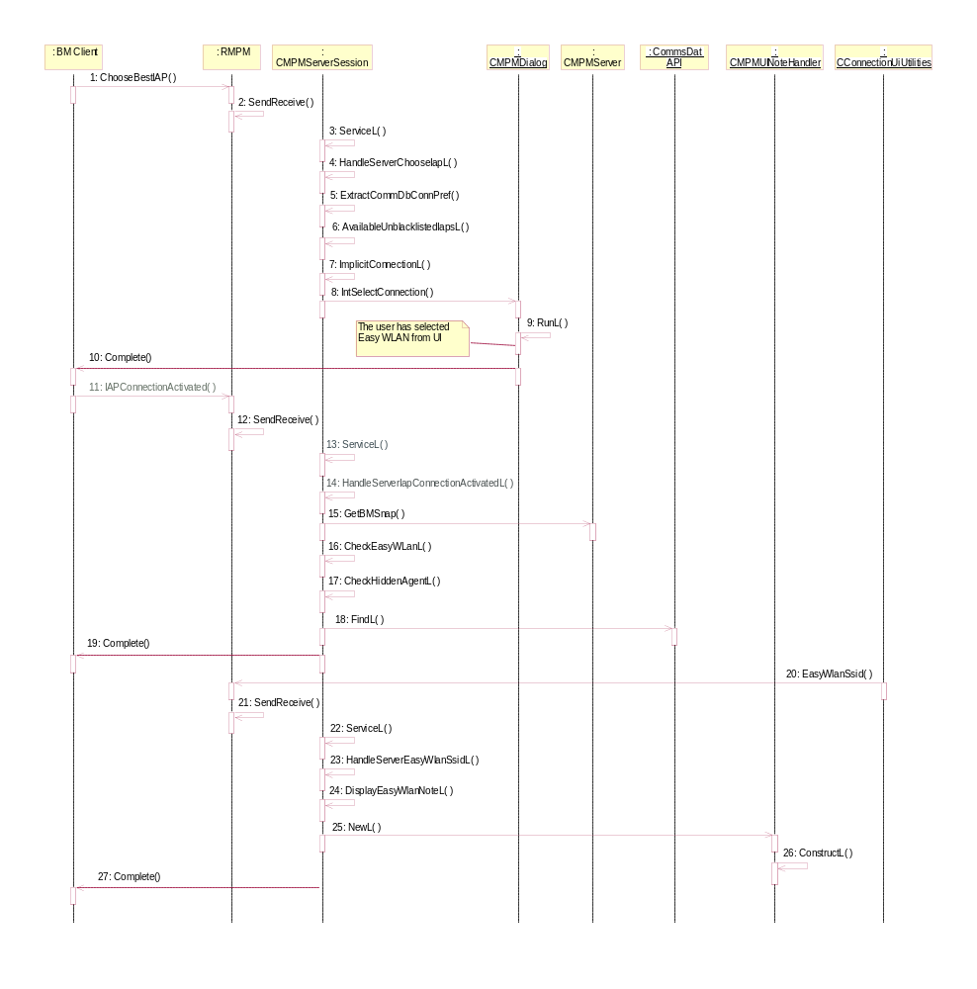
Figure 4.48 User selects Easy WLAN

No. | Message | Description
1 | ChooseBestIAP | BM calls this asynchronous method to get the best -ranked IAP for the connection.
2 | SendReceive | The MPM client interface sends the request to the server by using the asynchronous version of SendReceive.
3 | ServiceL | This method gets called upon client interface’s SendReceive invocation.
4 | HandleServerChooseIAPL | Called by the ServiceL. Reads and starts checking client input parameters.
5 | ExtractCommDbConnPref | Checks connection preferences. In this case the user dialog prompting is set to ECommDbDialogPrefPrompt.
6 | AvailableUnblacklistedIaps | Returns the list of available IAPs, where the blacklisted IAPs have already been removed.
7 | ImplicitConnectionL | Creates CMPMDialog object and activates it.
8 | IntSelectConnection | Initiates the user dialog UI prompting via Agent Dialog Server.
9 | RunL | Gets user selection from the Connection Dialog.
10 | Complete | Completes the request to the client with return code.
11 | IapConnectionActivated | BM calls this synchronous method to inform MPM that IAP connection is activated.
12 | SendReceive | The MPM client interface sends the request to the server by using the synchronous version of SendReceive.
13 | ServiceL | This method gets called upon client interface’s SendReceive invocation.
14 | HandleServerIapConnectionActivated | Called by the ServiceL. Reads and starts checking client input parameters.
15 | GetBMSnap | Gets SNAP of an active BM connection.
16 | CheckEasyWLanL | Checks if given Iap Id is Easy WLAN.
17 | CheckHiddenAgentL | Checks if the HiddenAgent metadata is set for this Iap Id.
18 | FindL | Checks if the metadata entry exists.
19 | Complete | Completes the request to the client with return code.
20 | EasyWlanSsid
21 | SendReceive | The MPM client interface sends the request to the server by using the synchronous version of SendReceive.
22 | ServiceL | This method gets called upon client interface’s SendReceive invocation.
23 | HandleServerEasyWlanSsidL | Called by the ServiceL. Reads and starts checking client input parameters.
24 | DisplayEasyWlanNoteL | Displays connecting wait note for Easy WLAN connection.
25 | NewL | The first phase of CMPMUINoteHandler construction.
26 | ConstructL | Displays the wait note.
27 | Complete | Completes the request to the client with return code.

IAP connection is started

Operation | IAP connection is started.
Preconditions | A connection has been started.
Description | Describes MPM functionality when the IAP connection is started.
Inputs | IAP ID.
Modifies | Updates information about an active BM connection.
Outputs | The IAP information about an active BM connection has been inserted.
Post conditions | The status of the operation is returned to Bearer Manager.
Related To | Use case 2.3.17.
Related Event
Exceptions

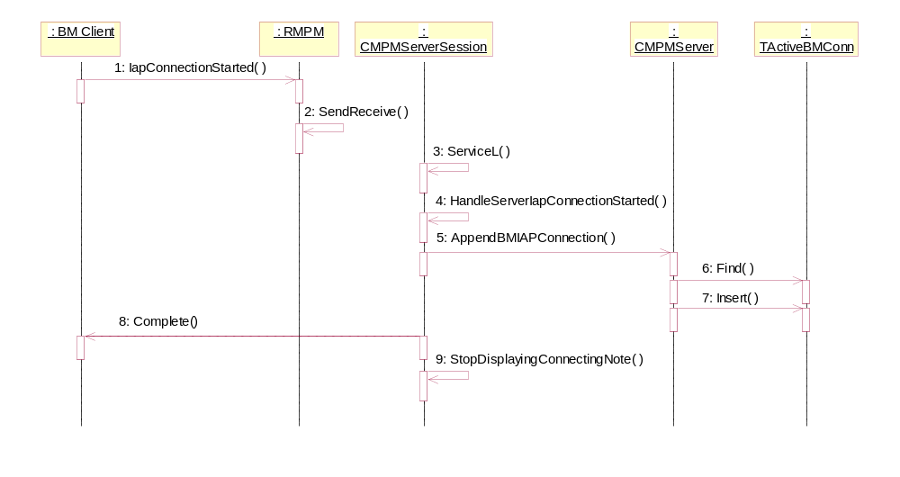
Figure 4.49 IAP connection is started

No. | Message | Description
1 | IapConnectionStarted | BM calls this synchronous method to inform MPM that IAP connection is started.
2 | SendReceive | The MPM client interface sends the request to the server by using the synchronous version of SendReceive.
3 | ServiceL | This method gets called upon client interface’s SendReceive invocation.
4 | HandleServerIapConnectionStarted | Called by the ServiceL. Reads and starts checking client input parameters.
5 | AppendBMIAPConnection | Appending the whole IAP info about an active BM connection.
6 | Find | Finds information about an active BM connection which matches the IAP ID.
7 | Insert | If such a record is not found, then inserts new record.
8 | Complete | Completes the request to the client with return code.
9 | StopDisplayingConnectingNote | MPM cancels displaying the wait note.

Application ends connection

Operation | Application ends connection.
Preconditions | - A connection has been started. Message buffer has been initialized (see Section 4.3.9).  - Bearer Manager has registered for getting preferred IAP notifications (see Section 4.3.10).
Description | Describes MPM functionality when application ends connection.
Inputs | Application UID.
Modifies | Updates internal database TActiveBMConn which associates application information with the IAP Id and connection state.
Outputs | Information about an active BM connection has been removed.
Post conditions | The status of the operation is returned to Bearer Manager.
Related To | Use case 2.3.20.
Related Event
Exceptions

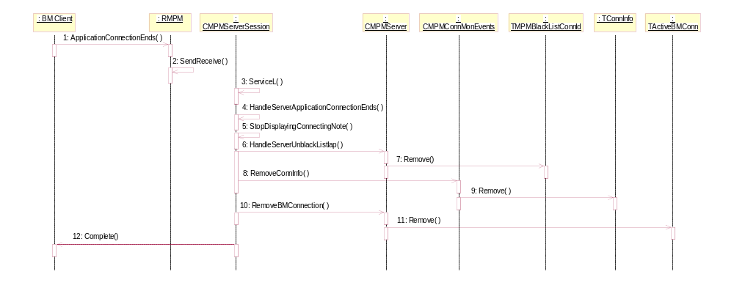
Figure 4.50 Application ends connection

No. | Message | Description
1 | ApplicationConnectionEnds | BM calls this synchronous method to inform MPM that application is ending connection.
2 | SendReceive | The MPM client interface sends the request to the server by using the synchronous version of SendReceive.
3 | ServiceL | This method gets called upon client interface’s SendReceive invocation.
4 | HandleServerApplicationConnectionEnds | Called by the ServiceL. Reads and starts checking client input parameters.
5 | StopDisplayingConnectingNote | MPM cancels displaying the wait note.
6 | HandleServerUnblackListIap | MPM unblacklists the IAP which had the error.
7 | Remove | Removes the IAP from the blacklist.
8 | RemoveConnInfo | Removing connection info.
9 | Remove | Removes information from connection information storage.
10 | RemoveBMConnection | Removing info about an active BM connection.
11 | Remove | MPM removes information about an active BM connection.
12 | Complete | Completes the request to the client with return code.

Application migrates to carrier

Operation | Application migrates to carrier.
Preconditions | - A connection has been started. Message buffer has been initialized (see Section 4.3.9).  - Bearer Manager has registered for getting preferred IAP notifications (see Section 4.3.10).
Description | Describes MPM functionality when application migrates to carrier.
Inputs | Application UID and IAP ID.
Modifies | Updates internal databases TActiveBMConn and TActiveBMPrefIAP.
Outputs | Information about an active BM connection and preferred IAP notification has been updated.
Post conditions | The status of the operation is returned to Bearer Manager.
Related To | Use case 2.3.21.
Related Event
Exceptions

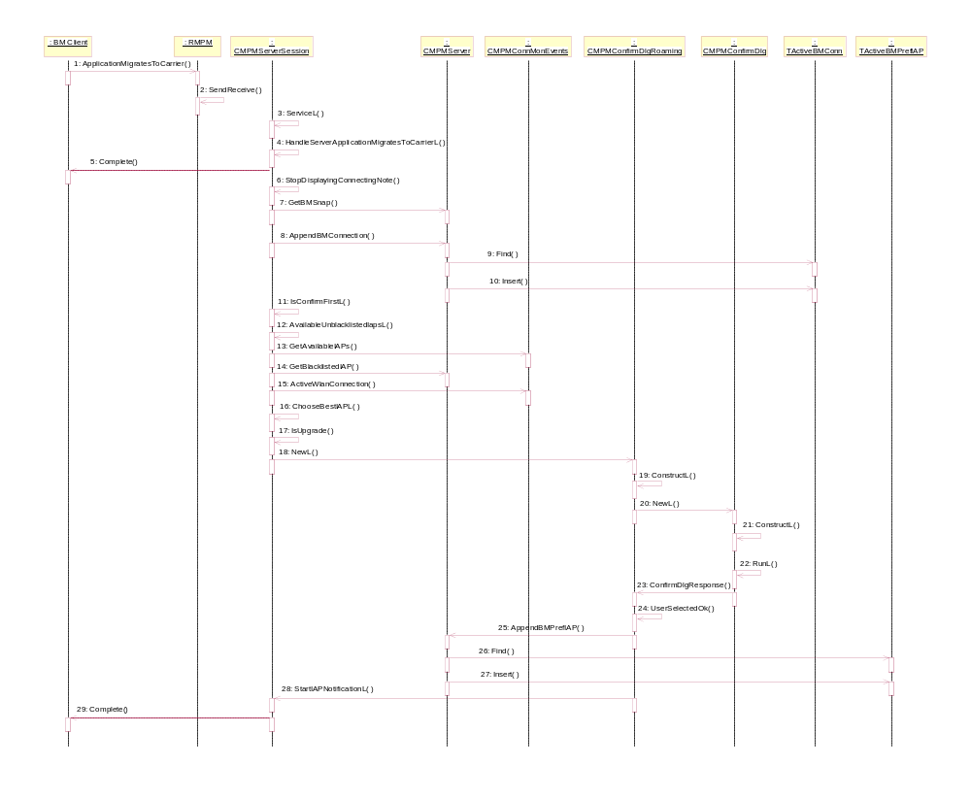
Figure 4.51 Application migrates to carrier

No. | Message | Description
1 | ApplicationMigratesToCarrier | BM calls this synchronous method to inform MPM that application is migrating to carrier.
2 | SendReceive | The MPM client interface sends the request to the server by using the synchronous version of SendReceive.
3 | ServiceL | This method gets called upon client interface’s SendReceive invocation.
4 | HandleServerApplicationMigratesToCarrier | Called by the ServiceL. Reads and starts checking client input parameters.
5 | Complete | Completes the request to the client with return code.
6 | StopDisplayingConnectingNote | MPM cancels displaying the wait note.
7 | GetBMSnap | Gets SNAP of an active BM connection.
8 | AppendBMConnection | Adds information about active BM connection.
9 | Find | Finds information about an active BM connection which matches the IAP ID.
10 | Insert | If such a record is not found, then inserts new record.
11 | IsConfirmFirstL | Checks whether it is required to display a confirmation dialog or not.
12 | AvailableUnblacklistedIapsL | Returns the list of available IAPs, where the blacklisted IAPs have already been removed.
13 | GetAvailableIAPs | MPM gets the IDs of available IAPs.
14 | GetBlacklistedIAP | Get list of blacklisted IAPs.
15 | ActiveWlanConnection | Checks if there is active WLAN connection.
16 | ChooseBestIAPL | MPM selects the best IAP for the connection.
17 | IsUpgrade | MPM checks whether the preferred IAP is either an upgrade or a downgrade.
18 | NewL | The first phase of CMPMConfirmDlgRoaming construction.
19 | ConstructL | The second phase of CMPMConfirmDlgRoaming construction.
20 | NewL | The first phase of CMPMConfirmDlg construction.
21 | ConstructL | Displays the Roaming Dialog.
22 | RunL | Gets user selection from the Roaming Dialog.
23 | ConfirmDlgResponse | Checks the user selection and calls appropriate method.
24 | UserSelectedOK | Implements the actions when user selected OK in the Roaming Dialog.
25 | AppendBMPrefIAP | Adds information about active BM preferred IAP notification registration.
26 | Find | Finds preferred notification information which matches SNAP ID.
27 | Insert | If such a record is not found, then inserts new record.
28 | StartIAPNotificationL | Sends start IAP notifications.
29 | Complete | Completes the request to the client with return code.

Application accepted the carrier

Operation | Application accepted the carrier.
Preconditions | - A connection has been started. Message buffer has been initialized (see Section 4.3.9).  - Bearer Manager has registered for getting preferred IAP notifications (see Section 4.3.10).
Description | Describes MPM functionality when application accepted the carrier.
Inputs | Application UID and IAP ID.
Modifies | Updates internal databases TActiveBMConn and TActiveBMPrefIAP.
Outputs | Information about an active BM connection and preferred IAP notification have been updated.
Post conditions | The status of the operation is returned to Bearer Manager.
Related To | Use case 2.3.22.
Related Event
Exceptions

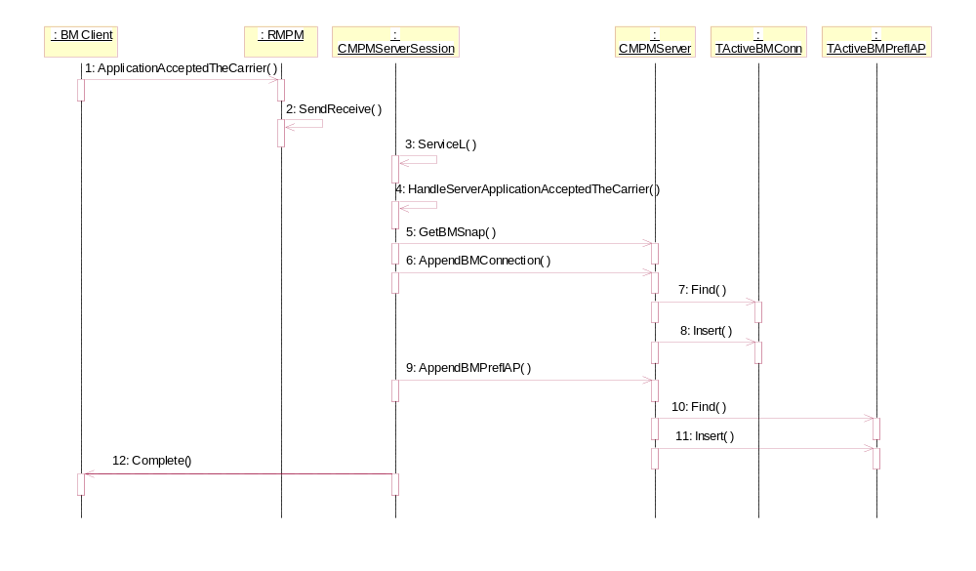
Figure 4.52 Application accepted the carrier

No. | Message | Description
1 | ApplicationAcceptedTheCarrier | BM calls this synchronous method to inform MPM that application has accepted the carrier.
2 | SendReceive | The MPM client interface sends the request to the server by using the synchronous version of SendReceive.
3 | ServiceL | This method gets called upon client interface’s SendReceive invocation.
4 | HandleServerApplicationAccepted  TheCarrier | Called by the ServiceL. Reads and starts checking client input parameters.
5 | GetBMSnap | Gets SNAP of an active BM connection.
6 | AppendBMConnection | Adds information about active BM connection.
7 | Find | Finds information about an active BM connection which matches the IAP ID.
8 | Insert | If such a record is not found, then inserts new record.
9 | AppendBMPrefIAP | Adds information about active BM preferred IAP notification registration.
10 | Find | Finds preferred notification information which matches SNAP ID.
11 | Insert | If such a record is not found, then inserts new record.
12 | Complete | Completes the request to the client with return code.

Application ignored the carrier

Operation | Application ignored the carrier.
Preconditions | - A connection has been started. Message buffer has been initialized (see Section 4.3.9).  - Bearer Manager has registered for getting preferred IAP notifications (see Section 4.3.10).
Description | Describes MPM functionality when application ignored the carrier.
Inputs | Application UID and IAP ID.
Modifies | Updates internal databases TActiveBMConn and TActiveBMPrefIAP.
Outputs | Information about an active BM connection has been reset.
Post conditions | The status of the operation is returned to Bearer Manager.
Related To | Use case 2.3.23.
Related Event
Exceptions

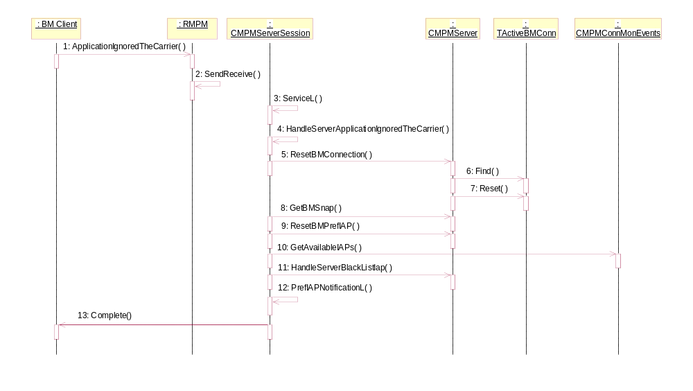
Figure 4.53 Application ignored the carrier

No. | Message | Description
1 | ApplicationIgnoredTheCarrier | BM calls this synchronous method to inform MPM that application has ignored the carrier.
2 | SendReceive | The MPM client interface sends the request to the server by using the synchronous version of SendReceive.
3 | ServiceL | This method gets called upon client interface’s SendReceive invocation.
4 | HandleServerApplicationIgnoredTheCarrier | Called by the ServiceL. Reads and starts checking client input parameters.
5 | ResetBMConnection | Resets information about an active BM connection.
6 | Find | Finds information about an active BM connection which matches the IAP ID.
7 | Reset | Resets information about an active BM connection related to specific IAP ID.
8 | GetBMSnap | Get the current SNAP for this connection.
9 | ResetBMPrefIAP | Resets current IAP Id info of an active BM preferred IAP notification registration.
10 | GetAvailableIAPs | MPM gets the IDs of available IAPs.
11 | HandleServerBlackListIap | MPM blacklists certain IAP for the certain application.
12 | PrefIAPNotificationL | MPM checks if there are preferred IAPs to be notified to applications.
13 | Complete | Completes the request to the client with return code.

Application rejected the carrier

Operation | Application rejected the carrier.
Preconditions | - A connection has been started. Message buffer has been initialized (see Section 4.3.9).  - Bearer Manager has registered for getting preferred IAP notifications (see Section 4.3.10).
Description | Describes MPM functionality when application rejected the carrier.
Inputs | Application UID and IAP ID.
Modifies | Updates internal databases TActiveBMConn and TActiveBMPrefIAP.
Outputs | Information about an active BM connection has been reset.
Post conditions | The status of the operation is returned to Bearer Manager.
Related To | Use case 2.3.24.
Related Event
Exceptions

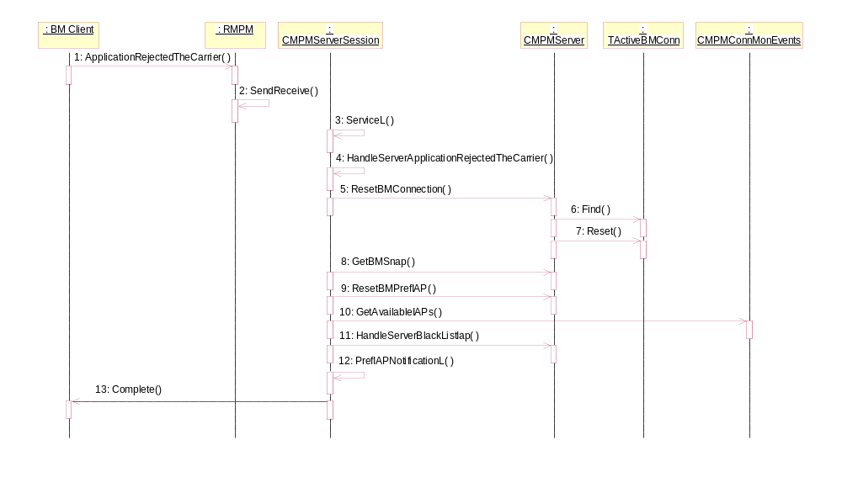
Figure 4.54 Application rejected the carrier

No. | Message | Description
1 | ApplicationRejectedTheCarrier | BM calls this synchronous method to inform MPM that application has rejected the carrier.
2 | SendReceive | The MPM client interface sends the request to the server by using the synchronous version of SendReceive.
3 | ServiceL | This method gets called upon client interface’s SendReceive invocation.
4 | HandleServerApplicationRejectedTheCarrier | Called by the ServiceL. Reads and starts checking client input parameters.
5 | ResetBMConnection | Resets information about an active BM connection.
6 | Find | Finds information about an active BM connection which matches the IAP ID.
7 | Reset | Resets information about an active BM connection related to specific IAP ID.
8 | GetBMSnap | Get the current SNAP for this connection.
9 | ResetBMPrefIAP | Resets current IAP Id info of an active BM preferred IAP notification registration.
10 | GetAvailableIAPs | MPM gets the IDs of available IAPs.
11 | HandleServerBlackListIap | MPM blacklists certain IAP for the certain application.
12 | PrefIAPNotificationL | MPM checks if there are preferred IAPs to be notified to applications.
13 | Complete | Completes the request to the client with return code.

Sort IAPs of specific SNAP

Operation | Sort IAPs of specific SNAP.
Preconditions | User prompting defined in connection preferences passed to MPM.
Description | Sort available IAPs belonging to the specified SNAP.
Inputs | SNAP ID.
Modifies
Outputs | Connection Dialog (CConnDlg) has received TMpmSnapBuffer-type list which contains sorted IAPs.
Post conditions | The status of the operation is returned to CConnDlg.
Related To | Use case 2.3.25.
Related Event
Exceptions

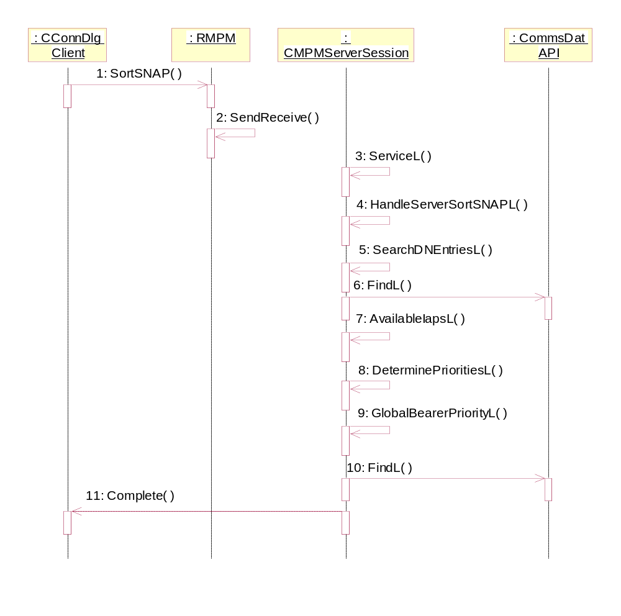
Figure 4.55 Sort IAPs of specific SNAP

No. | Message | Description
1 | SortSNAP | CConnDlg calls this synchronous method to get the list which contains sorted IAPs.
2 | SendReceive | The MPM client interface sends the request to the server by using the synchronous version of SendReceive.
3 | ServiceL | This method gets called upon client interface’s SendReceive invocation.
4 | HandleServerSortSNAPL | Called by the ServiceL. Reads and starts checking client input parameters.
5 | SearchDNEntriesL | Gets DN-IAP entries based on given SNAP ID.
6 | FindL | Find the DN-IAP records from CommsDat
7 | AvailableIapsL | Returns the list of available IAPs.
8 | DeterminePrioritiesL | Determine the priority for the IAP ID.
9 | GlobalBearerPriorityL | Gets the service type for the IAP and returns the global bearer priority for that service type.
10 | FindL | Find the priority of specified service type from CommsDat.
11 | Complete | Completes the request to the client with return code.

Backup and Restore
This component does not participate in backup and restore.

Variation
No variation is done.

System resource usage

Files
This component does not use any files.

Other data

Databases

Database | Performance goal | Estimate
CommsDat | As fast as possible. | None.

Database is used via CommsDat API. New tables “Data Mobility Selection Policy Table”, “Global Bearer Type Prioritization Table”, “SNAP Metadata Table” and “IAP Metadata Table” have been added into the database for this component’s usage. The new database table columns and their types are presented below:

Data Mobility Selection Policy Table
This table indicates which IAPs belong to a SNAP. For each IAP under a SNAP there is an entry that contains a link to the destination network, link to the IAP and the priority of the IAP within the destination network.
CommsDat repository
SNAP | Element ID of the SNAP. | TUint32
IAP | Element ID of the IAP entry. | TUint32
EmbeddedSNAP | Element ID of embedded SNAP. | TUint32
Priority | Priority of the IAP within this SNAP. The wildcard priority is not a valid priority value. | TUint32

Global Bearer Type Prioritization Table
This table is used to define generic priority for different types of IAPs. It lists IAP types as service table names and identifies unique priority for each. When determining a priority for a virtual IAP the underlying IAP is determined and its service type priority in this table is used.
CommsDat repository
ServiceType | Name of the service table to identify type of bearer. | Text
Priority | Priority of the bearer. | TUint32
UIPriority | Priority of this bearer type when shown in UI for configuring a new IAP. | TUint32

SNAP Metadata Table
This table defines additional data for destination networks. The table may have one entry where SNAP field is not defined. This entry is used for defining default icon for all destination networks that do not have an icon defined in this table.
CommsDat repository
SNAP | Element ID of SNAP. If value is NULL this is default icon for networks that have no Icon specified. | TUint32
Metadata | Additional metadata for a SNAP. This field is interpreted as a bit map according to bit masks defined in header datamobilitycommsdattypes.h. | TUint32
Icon | Identifier representing the icon file. | TUint32

IAP Metadata Table
This table contains metadata for an IAP. The metadata field is similar to that of the SNAP Metadata table. The seamlessness value describes if and how roaming should be performed to the IAP. All IAPs may not have an entry defined in this table.
CommsDat repository
IAP | Element ID of the IAP entry. | TUint32
Metadata | Additional metadata for IAP. This field is interpreted as a bit map according to bit masks defined in datamobilitycommsdattypes.h. | TUint32
Seamlessness | Defines whether an IAP can be roamed to. With “Confirm first” a confirmation is required from user. With “Show progress” progress of connection creation is shown to user. | TUint32

Central Repository
This component accesses Central Repository to check if phone is in offline mode or not.

Publish and Subscribe
This component does not use Publish and Subscribe.

Memory consumption

Memory/Build | Consumption
User data area | None.
WINSCW Udeb | 199 KB / 902 KB (MPM client IF/ MPM server).
WINSCW Urel | 61 KB / 127 KB (MPM client IF/ MPM server).
ARMV5 Urel | 1.6 KB / 21 KB (MPM client IF / MPM server).

Task allocation
This server runs in its own process launched by Bearer Manager.

Performance
Not measured.

Timers
This component does not use any timers.

Security

Capabilities of this component
The capabilities defined in the MMP file. File defaultcaps.HRH lists all default capabilities to be used in MMP files. Capabilities for MPM.dll are defined using macro CAP_CLIENT_DLL. Capabilities for MPMServer.exe are defined using macro CAP_SERVER and in addition capability NetworkControl.

Capability | Justification
CAP_CLIENT_DLL | ALL –TCB.
CAP_SERVER | ProtServ, ReadDeviceData, WriteDeviceData, SwEvent, Location, NetworkServices, ReadUserData, WriteUserData, LocalServices, UserEnvironment.

Input and output validation
This component does not require or make any validation for data.

Environmental assumptions
This component does not make any assumptions about its environment.

Additional enforcements
MPM API method calls will fail if the client doesn’t have capability NetworkControl.

Exception handling
The leave mechanism of Symbian OS environment is used to handle memory exhaustion. MPM is not allowed to panic because otherwise the phone is unable to make a connection. The client is panicked in case of unsupported request. TRAP is only used in active scheduler instance creation.

Usage

Building
To build both the MPM server and the client interface type following commands in the group directory of MPM (i.e. \MPM\group)
- bldmake bldfiles
- abld build

User's Guide
This component is used via MPM Control API (see Section 2.5.2). Here are the instructions for taking Bearer Management into use:

- Check ip.providers.esk in directory \epoc32\data\z\private\101F7989\esock:
Make sure that following line exists in the file:

connprov= BearerManProviderFactory,IpConnectionFactoryShim

- Check that following lines are found in file S60.iby in directory \epoc32\rom\include:

#include <bearerman.iby>
#include <mpm.iby>
#include <mpmserver.iby>

