S60 3.1
Network Positioning Proxy
Design Document

Team name | Author
Core BS / Location CF | Honglei Zhang

Change history:

Version | Date | Status | Comments
2.0 | 05.09.2007 | Approved | Added feature:  NPP PSY validates NPP PSY setting list during construction. If the key value in ROM contains different PSY list, the dynamic value will be discarded.
1.0 | 26.04.2006 | Approved

Table of contents:
1. Document control 5
1.1 References 5
1.2 Documentation conventions 5
1.3 Abbreviations 5
1.4 Definitions 5
2. General 6
2.1 Introduction 6
2.2 Subsystem environment 6
2.3 Services required 7
2.3.1 From the Location Framework subsystems 7
2.3.2 From the Generic Positioning Plug-ins subsystem 7
2.3.3 From the Application User Interfaces subsystems 7
2.3.4 From the Symbian OS subsystems 7
2.3.5 From the Domestic OS subsystems 7
2.3.6 From HW 7
2.3.7 Services provided 7
2.3.7.1 SW IF 7
3. Subsystem overview 8
3.1 Design 8
3.1.1 Architectural requirements 8
3.1.2 Component diagrams 8
3.1.2.1 Subsystem 8
3.1.3 Component descriptions 8
3.1.3.1 NPP PSY 8
3.1.3.2 Positioning Plug-in API 9
3.1.3.3 NPP PSY Information API 9
3.1.3.4 NP Proxy Configuration API 9
3.1.4 State diagrams 9
3.1.5 Variability 10
3.1.6 Flag definitions 10
3.1.7 Operations 11
3.1.7.1 NPP PSY loading 11
3.1.7.2 NPP PSY unloading 11
3.1.7.3 Requesting location 12
3.1.7.4 Canceling a location request 13
3.2 System resource usage 14
3.2.1 Files 14
3.2.2 Databases 14
3.2.3 Memory consumption 14
3.2.4 Task allocation 14
3.2.5 Timers 14
3.3 Security 15
3.3.1 Capabilities of this component 15
3.3.2 Input and output validation 15
3.3.3 Environmental assumptions 15
3.3.4 Additional enforcements 15
3.4 Exception handling 15
4. Subsystem usage 16
4.1 Building 16
4.1.1 Variation and feature flags 16
4.1.2 Localization 16
4.2 User's guide 16
4.2.1 Developers 16
4.2.1.1 Debugging 16
4.2.2 End users 17
5. NPP PSY component 18
5.1 Design 18
5.1.1 Class descriptions 18
5.1.2 Operations 19
5.1.2.1 PSY loading 19
5.1.2.2 PSY unloading 19
5.1.2.3 Making a location request while only SUPL PSY is present 20
5.1.2.4 Location request fallback 21
5.1.2.5 Canceling a location request 22
5.1.3 File structures 23
5.1.4 Database structures 23
5.1.5 Timers and active objects 23
5.2 Exception handling 23
Appendix: PSY Properties 25

Document control

References

- S60 Location Framework Subsystem Design Document
- S60 Positioning Plug-in API Specification Document
- S60 Generic Positioning Plug-ins Subsystem Architecture Description
- S60 Network Positioning Proxy User’s Guide

Documentation conventions
Code is shown with the Courier New font.

Abbreviations

FW | Framework
NPP | Network Positioning Proxy
OEM | Original Equipment Manufacturer
PSY | Positioning System (In the context of this document, also means a Positioning Plug-in to Location Framework.)
ROM | Read-Only Memory
SUPL | Secure User Plane Location

Definitions

ECom | Symbian OS framework for plug-in DLLs.
Fix | Information received from a location technology adaptation subsystem (PSY) about the current location.
Hidden PSY | Hidden PSY in this document refers to those PSYs that implement network base location technology, and hidden behind NPP PSY. Those PSYs are not visible from Location FW and to the end users.
Max age | The maximum age of the fix that can be delivered to the requestor.
Request bundling | The method for serving multiple simultaneous location requests. All the simultaneous requests are completed with the same fix.
Tracking | The process of delivering location fixes to the client continuously at a given interval.

General

Introduction
In some terminal configurations, there might be multiple PSYs that implement similar network-based positioning technologies from the end user’s point of view. End users see those as similar functions, even though PSYs use different protocols or techniques to obtain the position information. For example, SUPL PSY makes use of user plane protocols to obtain location, and licensees can implement similar functions by using control plane protocols. What is common for these plug-ins is that they have similar performance parameters like time to first fix and time to next fix. The Network Position Proxy (NPP PSY) can hide these similar PSYs and show those as one common PSY. The PSY that needs to be hidden by this proxy needs to list its UID to central repository defined by Network Positioning Proxy, and switch on hidden property from its own central repository file defined by location FW in Positioning Plug-in Information API. The Proxy is loaded and it tries each PSY in the order predefined in Central Repository, until it times out or all PSYs give failure. All communication between the PSY and this proxy is handled via Positioning Plug-in API defined by Location Framework.
From the Location FW perspective, NPP PSY is a normal PSY which implements network-based positioning technology. This is different from Default Proxy PSY, which is defined as a hidden proxy PSY. See reference document [1] for information on the detailed implementation of Default Proxy PSY.
This document describes the design of NPP PSY. It is valid from S60 release 3.1 onwards.

Subsystem environment
The subsystem environment is shown in Figure 2.1. The NPP PSY belongs to the Generic Positioning Plug-ins subsystem.
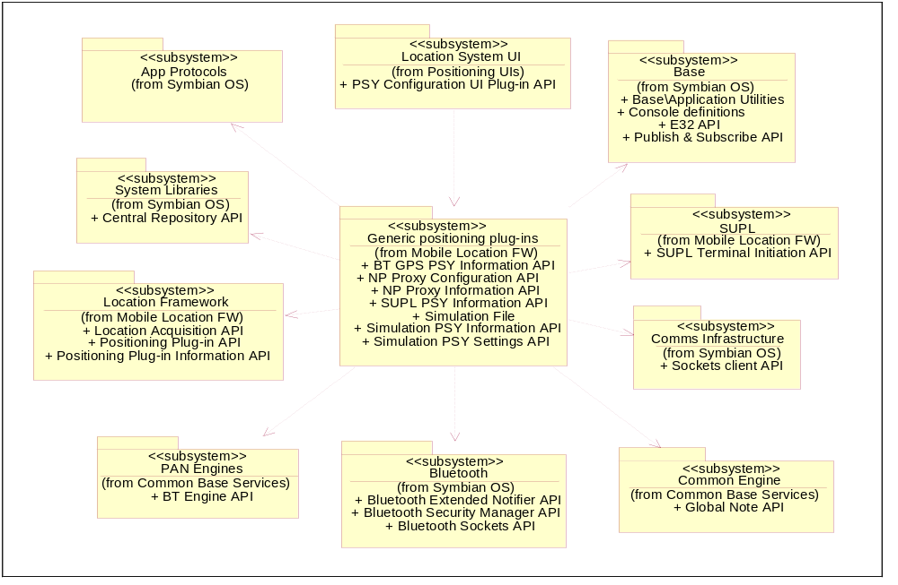
Figure 2.1 Subsystem environment of Generic Positioning Plug-ins Subsystem

Services required

From the Location Framework subsystems
NPP PSY uses the Positioning Plug-in API (see reference document [2]), which is exported by the Location Framework subsystem, as a base for its implementation. This enables the Location FW to detect and communicate with NPP PSY. The same API is also used by NPP PSY for detecting and using other hidden PSY that implement network-based location technologies.
NPP PSY publishes its static information through Positioning Plug-in Information API (Central Repository).

From the Generic Positioning Plug-ins subsystem
NPP PSY will use other hidden PSYs that implement network positioning technology, for example SUPL PSY from the Generic Positioning Plug-ins subsystem.
The configuration of NPP PSY is done through NP Proxy Configuration API (Central Repository). See reference document [4] for more information. This API can configure the availability status and the priority of hidden network positioning PSYs.

From the Application User Interfaces subsystems
There is no direct connection to the Application User Interfaces subsystems.

From the Symbian OS subsystems
There are dependencies to the following subsystems:

Base | Symbian Base is used for basic Symbian OS functionality support.
System Libraries | NPP PSY uses Central Repository API to store static information and configuration information.
ECom | ECom is used to load the PSY which is hidden behind NPP PSY.

From the Domestic OS subsystems
This component has no direct interfaces to the Domestic OS side subsystems.

From HW
This component has no direct HW interfaces.

Services provided

SW IF
NPP PSY implements the Positioning Plug-in API and Positioning Plug-in Information API (see reference document [2]). It reads configuration information from NP Proxy Configuration API.

Subsystem overview

Design

Architectural requirements
Some important architectural considerations for the NPP PSY are the following:
- NPP PSY is implemented as an ECom plug-in. This is required, so that NPP PSY can be detected and used by Location Framework.
- NPP PSY must be implemented as a proxy PSY. Thus varied PSYs that implement different network positioning technology can be hidden behind NPP PSY. The end user will see only the network-based positioning method and does not need to understand technical details behind each specific PSY.
- NPP PSY must report the device status and data quality.

Component diagrams

Subsystem
The component diagram for the NPP PSY is shown in Figure 3.2.
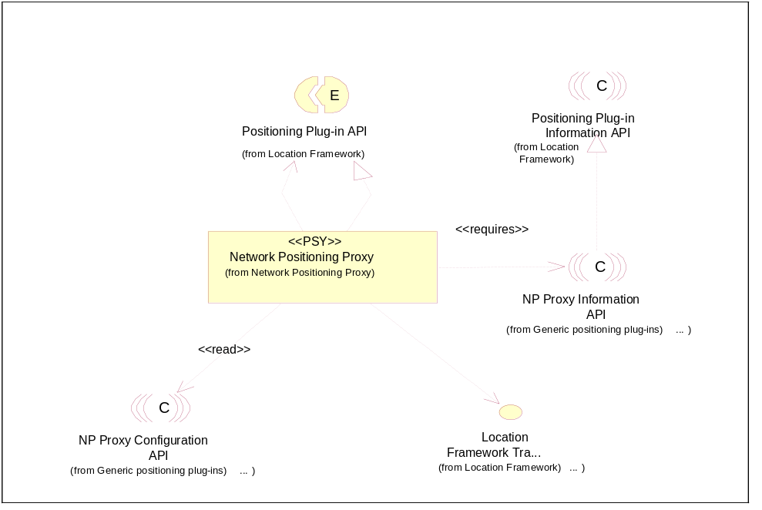
Figure 3.2 NPP PSY component diagram

Component descriptions

NPP PSY
NPP PSY does not provide location information itself, but behaves as a proxy to hide multiple PSYs that implement network-based position technologies, e.g. user plane and control plane based technologies.
The PSY properties are listed in Appendix.

Positioning Plug-in API
The Positioning Plug-in API defines the framework classes needed for implementing PSYs for the Location Framework. See reference document [2].

NPP PSY Information API
The NPP PSY publishes its static properties in Central Repository, as defined by Positioning Plug-in Information API. See reference document [2].

NP Proxy Configuration API
The NP Proxy Configuration API defines the data keys for listing PSY UIDs to be used by a proxy. The key data is stored into Central Repository.
NPP PSY does not update the PSY list in case of PSY installation. The installed hidden PSY must add its UID to the PSY list defined by NP Proxy Configuration API. The updated PSY list will be used without reloading NPP PSY, but the on-going Location Request will not be affected.
The PSY list can be frozen. If the list is frozen, PSYs will not be reordered if location requests fail by a PSY.

State diagrams
NPP PSY maintains its own state internally. It will report the device status and data quality to Location FW. The device status report is given according to the state chart in Figure 3.3.
Location request fallback has no effect on the device status report. If one hidden PSY fails to make a fix and not all the PSYs have been tried, the device status remains in EDeviceActive. If all PSYs fail to make a fix, the location request will be completed with the error code from the last used PSY and EDeviceReady is reported to Location FW. See Section 3.1.7.3 for a detailed description on the location request procedure.
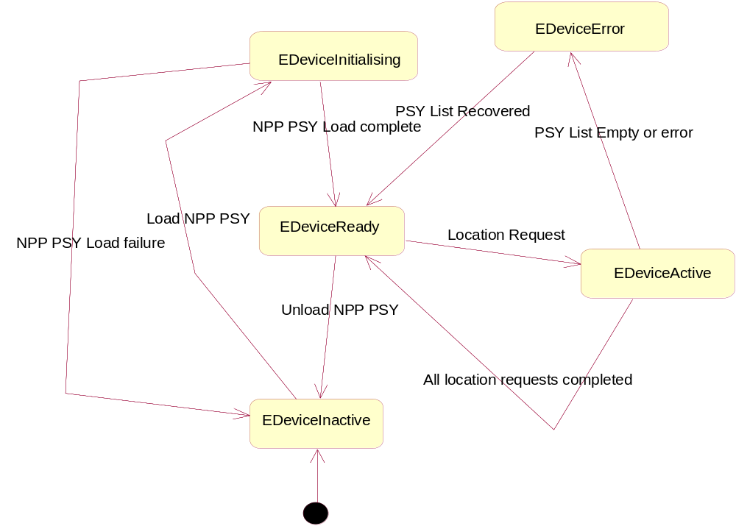
Figure 3.3 NPP PSY device status report
The data quality report is given according to the following table:

State | Condition
EDataQualityUnknown | This data quality is reported only when PSY is unloaded.
EDataQualityLoss | Not reported
EDataQualityPartial | Not reported.
EDataQualityNormal | Default value reported.

Variability
NPP PSY can be included during ROM image creation time by adding the feature flag __NPP_PSY.

Flag definitions
The table below specifies the R&D flags (debug flags etc.) used by the subsystem. Feature flags related to the subsystem are specified in Section 4.1.1.

Flag | Description
__WINS__ | The flag is used for controlling different implementation of the WINS/WINSCW platform and the HW platform. Differences are required in some cases to enable the testing on WINS/WINSCW.
_DEBUG | The flag is used for separating the code that is used only in the internal debug build. This concerns the logging for debug purposes.

Operations
The NPP PSY includes only one module and the operations of the module are described in detail in Chapter 5. This section includes only high-level descriptions of the operations.

NPP PSY loading
NPP PSY loading is shown in Figure 3.4. It can be loaded either via Location Acquisition API by specifying NPP PSY implementation UID or loaded by Default Proxy PSY. See reference document [1] for a detailed description. When NPP PSY is loaded the first time, it will construct a singleton object for device status and data quality report. The singleton is also responsible for reading and updating the PSY list via NP Proxy Configuration API. After the PSY list is received from Central Repository, NPP PSY will reset the key and read the key value stored in ROM. Then NPP PSY compares the ROM key value with the dynamic key value, if two lists have different frozen flag or contain different PSY list, the dynamic key will be discarded. This is required when phone restore to an old version of backup. The new firmware might contain different PSY in PSY list. For a detailed description, see Chapter 5.
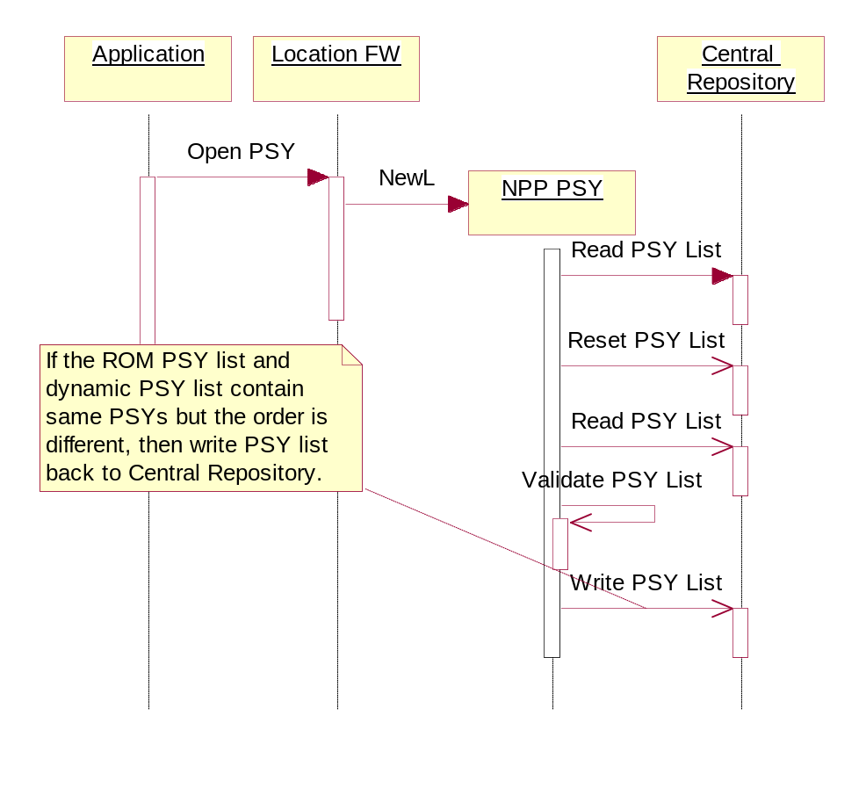
Figure 3.4 NPP PSY loading

NPP PSY unloading
The last unloading of a PSY instance unloads the whole PSY. This includes deleting the singleton Cconstructed when PSY was loaded the first time.
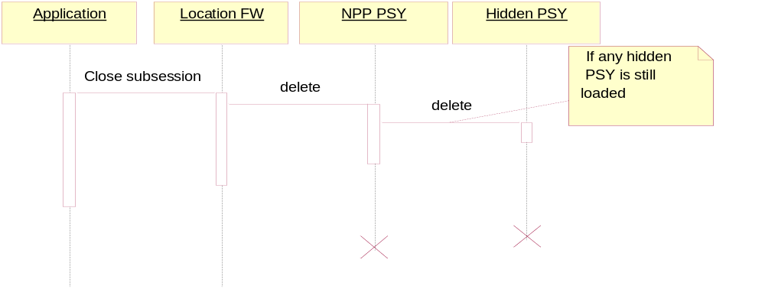
Figure 3.5 NPP PSY unloading

Requesting location
Figure 3.6 shows the location request and fix is retrieved successfully. NPP PSY will make a location request to the first PSY on the PSY list.
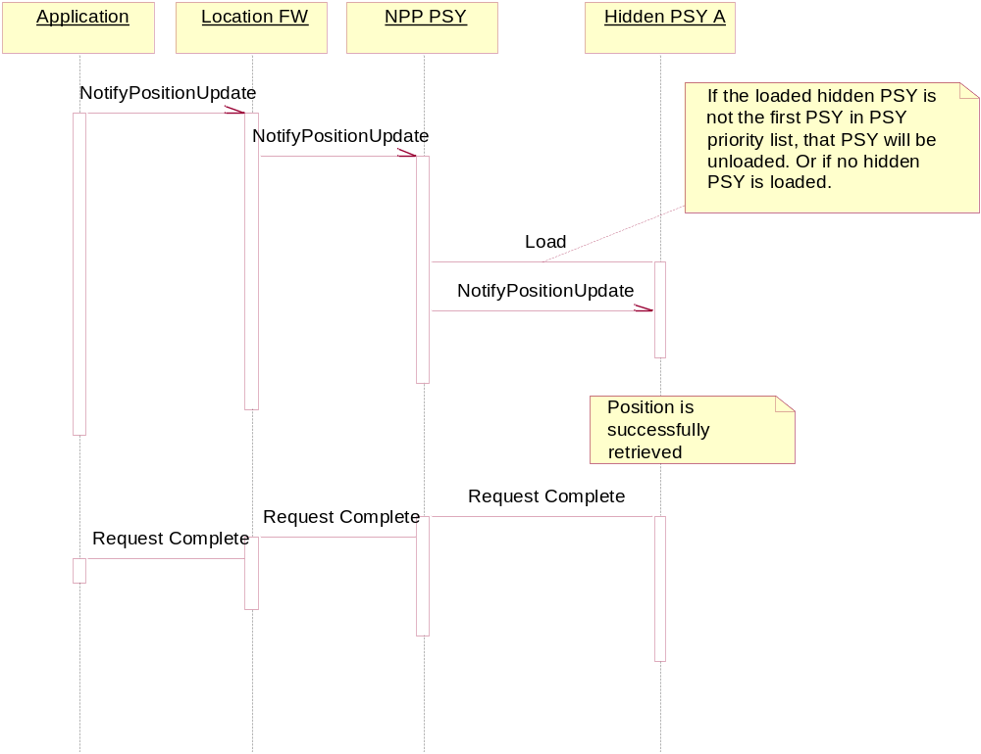
Figure 3.6 Requesting location and fix is retrieved successfully.
Figure 3.7 shows a location request and fallback diagram when the PSY list is not frozen. If a hidden PSY fails to return a location estimate, it is moved to the end of the PSY list. If all the listed PSYs have not yet been tried, the first PSY on the PSY list will be tried, otherwise the information returned by the last tried PSY is forwarded to Location Framework.
If the location request is reported failed by a hidden PSY, NPP PSY will check if this hidden PSY is in the end of the PSY list. If it is not the last one, the PSY will be moved to the end and a new PSY list and a new setting is stored to Central Repository.
When the PSY list is frozen, NPP PSY will not change the PSY order, if the location request is reported as failed by a hidden PSY. NPP PSY will load the PSY next to the failing PSY if it is not the last one on the list.
The PSY list can be set as frozen with no fallback. In this case, only the first PSY on PSY list will be tried. The PSY list will not be updated, if the first PSY fails to give a location estimation.
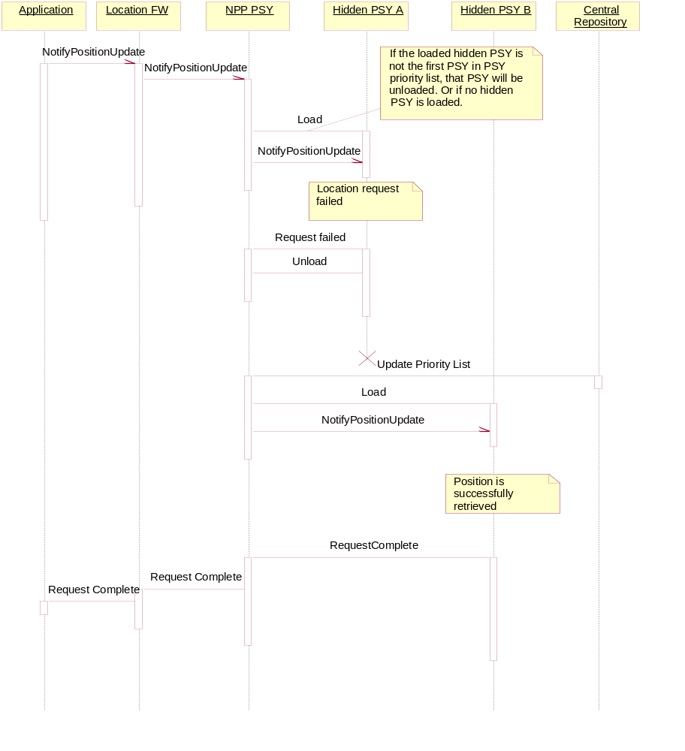
Figure 3.7 Requesting location and fallback when PSY list is not frozen

Canceling a location request
The canceling of the location request will cancel the location request that is currently ongoing by the loaded hidden PSY.
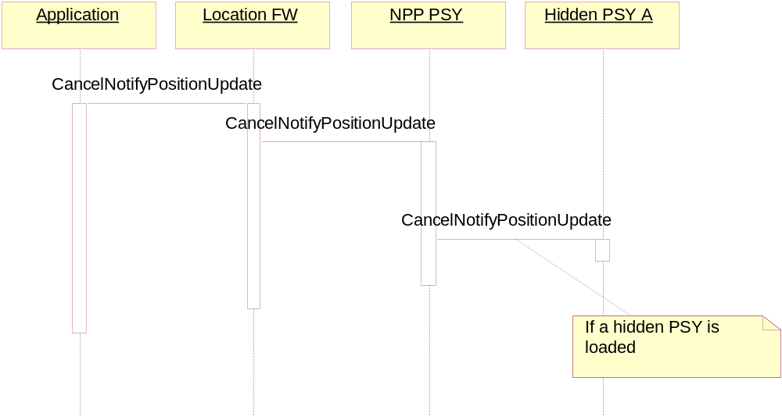
Figure 3.8 Canceling the location request

System resource usage

Files

Filename | Size | Description
nlanpplpsy.rsc | 80 bytes | Defines the ECom plug-in resource file.
nlanpppsy_name.rsc | 20 bytes | This resource file contains the localizable PSY name.
10206915.txt | 2050 bytes | This file is a Central Repository text file defining static information of NPP PSY

Databases
NPP PSY does not utilize any databases.

Memory consumption
The ROM usage of this component is 5 KB in the ARMV5 release. The estimated RAM usage of the PSY is 3 KB. Additional connections are estimated to increase the heap usage by 1 KB per connection.

Task allocation
NPP PSY runs in the Location Server thread and does not allocate any new threads.

Timers
Timers are presented in Chapter 5.

Security

Capabilities of this component
This component is an ECom Plug-in, and the capabilities describe its level of trust. The capabilities assigned to NPP PSY are defined in macro CAP_ECOM_PLUGIN.

Input and output validation
This component does not require or make any validation for data.

Environmental assumptions
This component does not make any assumptions about its environment.

Additional enforcements
This component does not have any additional security enforcements.

Exception handling
Exception handling is documented in Chapter 5.

Subsystem usage
This section describes component building and the different configuration options.

Building
The table below shows how components are mapped to DLLs and where in the source code tree the project definitions and the source code for different DLLs are located.

Component name | Directory | MMP file name | DLL name
NPP PSY | LocationNppPsy | group\nla_npppsy.mmp | nlanpppsy.dll

The building is done by running the following commands in the \group subdirectory of the directory listed in the table:
bldmake bldfiles
abld build <TARGET>

Where <TARGET> is one of winscw or armv5.

To build a SIS file for ARMV5, use the following command in the Install directory:
makesis nla_npppsy.pkg

To sign the SIS file, use the following command in the Install directory:
signsis nla_npppsy.pkg nla_npppsy.sisx rd.cer rd-key.pem

NPP PSY is not upgradeable. If there is NPP PSY in ROM, it is not possible to install a signed SIS package on the device.

Variation and feature flags
NPP PSY can be included during the ROM image creation time by enabling the feature flag __NP_PROXY.

Localization
The PSY name defined is localizable. The name is defined in nla_npppsy.loc.

User's guide

Developers

Debugging
The tracing log of the debug builds of the NPP PSY is generated in the directory C:\logs\npppsy\log.txt. The tracing can be switched on and off by creating the directory and removing it, respectively.

End users
The end user can enable/disable NPP PSY via Location Settings UI. None of the hidden PSYs behind NPP PSY will be used for location retrieving, if NPP PSY is disabled from Location UI. The end user cannot change the priority of hidden PSYs via the phone UI.

NPP PSY component

Design
This section describes the design of the NPP PSY.
Figure 5.9 shows the class diagram of the NPP PSY component and its dependencies of Positioning Plug-in API, etc. NPP PSY does not have a direct dependency to any specific PSY. The hidden PSYs are on the PSY list (CenRep key) and loaded via ECom plug-in. A detailed description of the classes is presented in Section 5.1.1.
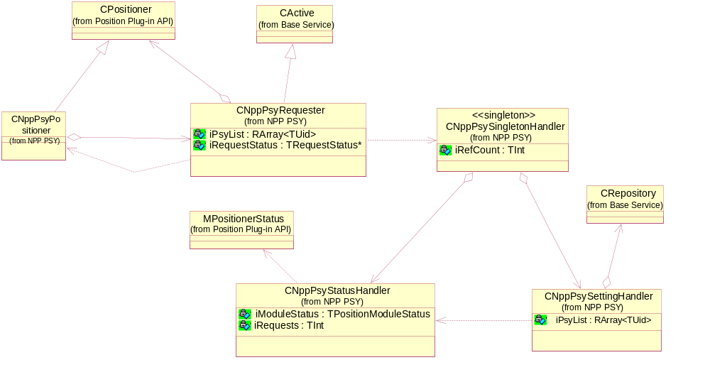
Figure 5.9 Class diagram of the NPP PSY component

Class descriptions

Class | Description
CNppPsyPositioner | Provides the interface to Location Framework as specified by Positioning Plug-in API. Each client connection to NPP PSY makes an instance of this class.
CNppPsyRequester | Implements the position requester. The position requester is responsible for loading appropriate PSY via ECom plug-in and forwarding the location request to the loaded PSY.
CNppPsySingletonHandler | Implements the handler for a singleton object. The singleton contains PSY status handler (CNppPsySettingHandler) and setting handler (CNppPsyStatusHandler).
CNppPsySettingHandler | Implements the handler that is responsible for reading/writing the PSY list from/to Central Repository.
CNppPsyStatusHandler | Implements the handler that is responsible for the device status and data quality report.

Operations

PSY loading

Operation | PSY loading.
Preconditions | NPP PSY is enabled by the end user with Location Settings UI.
Description | Location FW loads NPP PSY via ECom plug-in. NPP PSY then constructs the required objects and reads the PSY list from Central Repository. NPP PSY will also update the module status via the module status report interface provided by Positioning Plug-in.
Inputs
Modifies | Module status.
Outputs
Postconditions | The PSY is loaded and connected to Central Repository for getting the changes of the PSY list.
Related to | Section 5.1.2.2.
Related event
Exceptions | Out of memory.

The first PSY loading constructs the CNppPsySingletonHandler singleton object. CNppPsySingletonHandler object will then construct CNppPsySettingHandler and CNppPsyStatusHandler objects. CNppPsySettingHandler, then connect to Central Repository to get the PSY list and set the observer to get the changes of the PSY list.
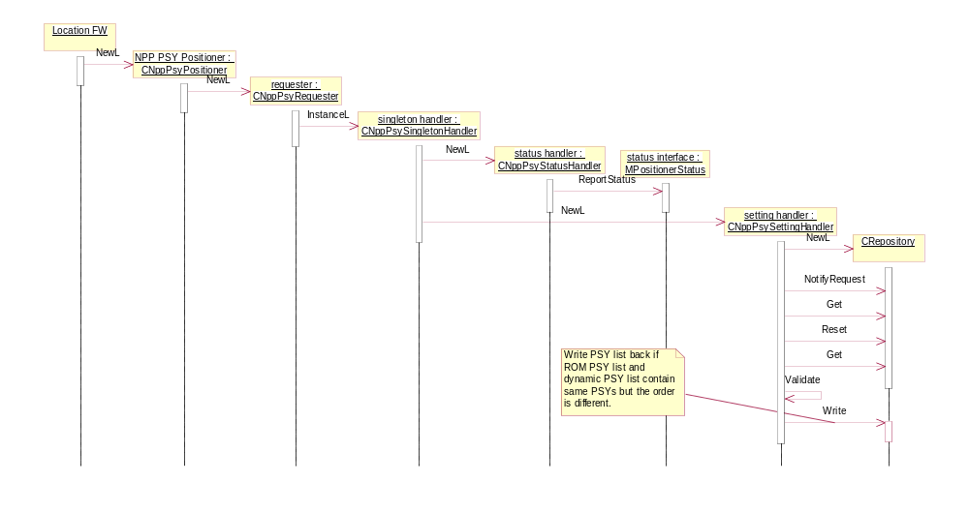
Figure 5.10 PSY loading

PSY unloading

Operation | PSY unloading.
Preconditions | An instance of PSY exists.
Description | Location FW unloads NPP PSY. If the last instance of CNppPsyPositioner is closed, the singleton object CNppPsySingletonHandler will be deleted. Thus CNppPsySettingHandler and CNppPsyStatusHandler will be deleted. The connection to Central Repository will be closed. NPP PSY will update its status via the module status report interface.
Inputs
Modifies | The module status.
Outputs
Postconditions | The PSY is unloaded and the connection to Central Repository is closed.
Related to | Section 5.1.2.1
Related event
Exceptions

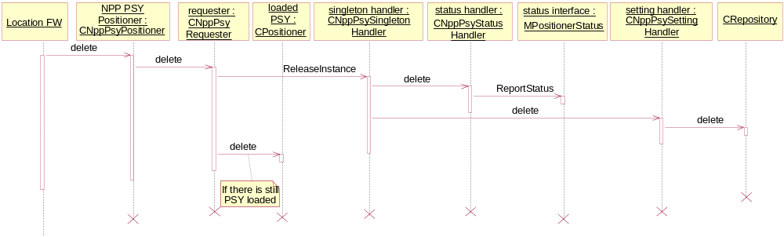
Figure 5.11 PSY unloading

Making a location request while only SUPL PSY is present

Operation | Making a location request while only SUPL PSY is present.
Preconditions | The PSY is loaded. SUPL PSY is present in the system and appears as the only PSY on the PSY list.
Description | Location FW makes a location request to NPP PSY. NPP PSY will first update the module status (EDeviceActive and EDataQualityNormal) via the module status report interface, then read the PSY list and load the first PSY on the list if it is not loaded. If SUPL PSY is the only hidden PSY in the system and its UID is on the PSY list, SUPL PSY will be loaded. NPP PSY forwards this location request to SUPL PSY.  After SUPL PSY makes the fix, it will notify NPP PSY. NPP PSY then forwards the fix to Location FW and updates its status (EdeviceReady and EDataQualityNormal). SUPL PSY will not be unloaded immediately, so that the next location request can be handled fast.  See Section 3.1.4 for further information on how the device status and data quality is reported.  Note: NPP PSY does not cache the fix. NPP PSY does not bundle the request either.
Inputs | Location request.
Modifies | Module status.
Outputs | The request result and location fix if possible. The module status.
Postconditions
Related to | Sections 5.1.2.5 and 5.1.2.4.
Related event
Exceptions | Out of memory.

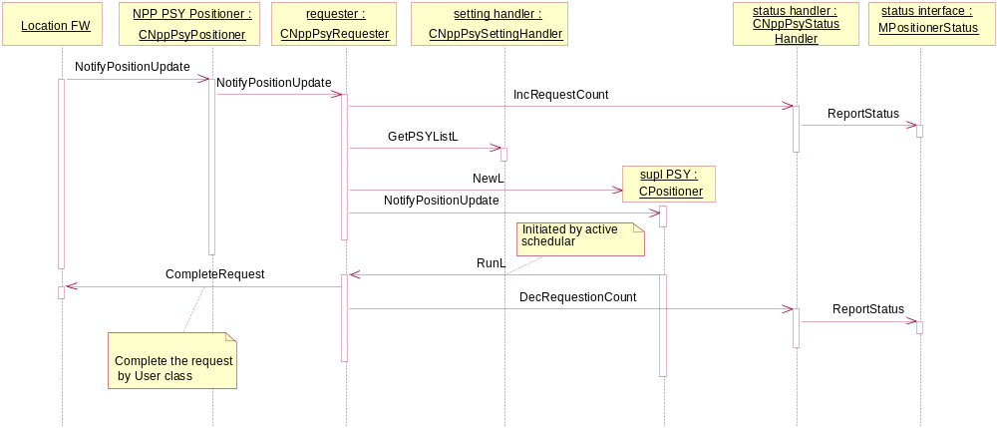
Figure 5.12 Making a location request while only SUPL PSY is present.

Location request fallback

Operation | Location request fallback.
Preconditions | NPP PSY is loaded. More than one hidden PSYs are present in the system. Their UIDs are listed on the PSY list. The PSY list is not frozen.
Description | Location FW makes a location request to NPP PSY. NPP PSY will first read the PSY list and load the first PSY in the list, if it is not loaded yet. NPP PSY then updates the module status via the module status report interface. NPP PSY forwards this location request to the loaded PSY.  If the loaded PSY fails to make a fix and returns an error code to NPP PSY, NPP PSY fill move the current loaded PSY to the last on the PSY list, if the list is not frozen. NPP PSY will check if there is still a PSY that has not been tried. If yes, NPP PSY will unload the current PSY and load the next one on the PSY list. Then it forwards the location request to the new loaded PSY.  If the loaded PSY gives a fix, NPP PSY will return to fix back to Location FW and update the module status.  If all PSYs on the list are tried and none can give a fix, NPP PSY will return the error code from the last loaded PSY to location FW, and update the module status.  See Section 3.1.4 for further information on how the device status and data quality is reported.  Note: NPP PSY does not cache the fix. and NPP PSY will not unload the PSY when the location request is completed. NPP PSY does not bundle request either.
Inputs | The PSY list.
Modifies | The module status.
Outputs | The request result and location fix if possible. The module status.
Postconditions
Related to | Section 5.1.2.3.
Related event
Exceptions

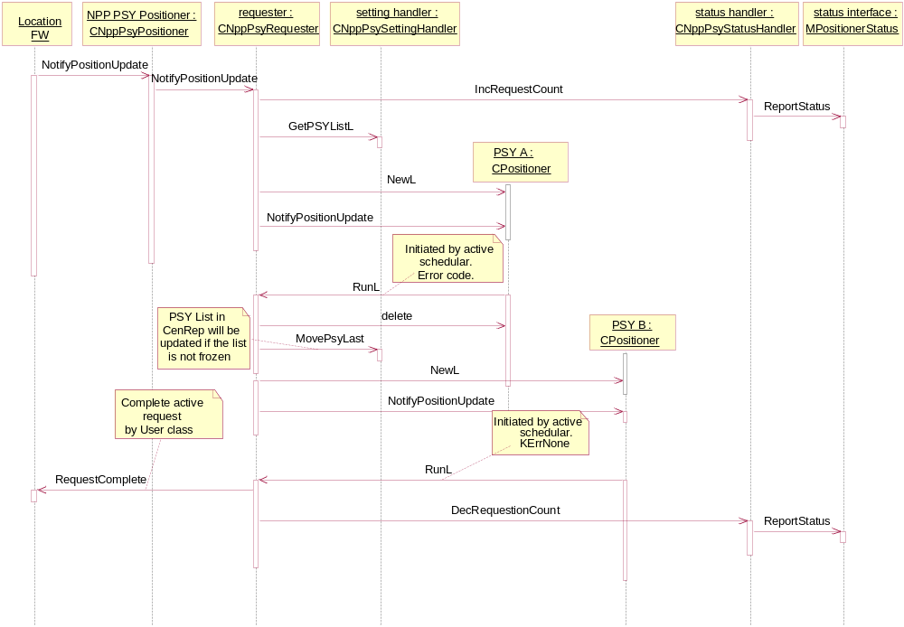
Figure 5.13 Sequence diagram on location request fallback

Canceling a location request

Operation | Canceling a location request.
Preconditions | PSY is loaded and a location request is pending.
Description | A previously initiated location request is canceled.
Inputs
Modifies | Internal request status
Outputs | The request is completed with KErrCancel.
Postconditions | No location request is pending from a client.
Related to | Section 5.1.2.3 and 5.1.2.4
Related event
Exceptions
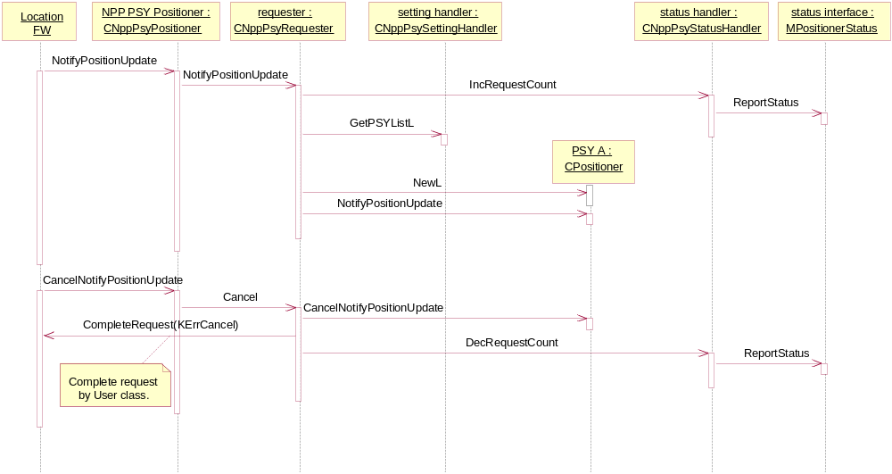
Figure 5.14 Canceling a location request.

File structures
The Central Repository initial value file 10206915.txt contains the NPP PSY static information (see reference document [2]). Appendix describes the properties that have been set in Central Repository initialization file.
nlanpppsy_name.rsc is the resource file that contains the localizable name for NPP PSY.

Database structures
This component uses no databases.

Timers and active objects

Active objects / Timers
CNppPsyRequester | Derived from CActive.
CNppPsySettingHandler | Derived from CActive.

Exception handling
NPP PSY will generate panics if it is used incorrectly. The following panic code has been defined. These panics happen only if there is programming bug in Location FW or NPP PSY.

Panic Reason
EPanicPositionRequestOngoing | NPP PSY receives a location request while there is already a location request ongoing.

The following table lists error codes that are returned by NPP PSY when making a location request.

Error code
KErrNoMemory | If the system is out of memory when NPP PSY is performing the operation.
KPositionQualityLoss | If the PSY list is empty.
KErrCancel | If the location request is canceled.
KErrNotFound | If the PSY is on the PSY list but cannot be found in the system.

Appendix: PSY Properties

Property | NPP PSY
Implementation UID | 0x10206915
Interface version | 1.0
PSY Priority | Auto
PSY Status | Available
Time to first fix (s) | 12
Time to next fix (s) | 12
Horizontal accuracy (m) | 200
Vertical accuracy (m) | 0
Cost | Possible
Power consumption | Low
Technology type | Network
Device location | Internal
Capabilities | Horizontal
Classes supported | TPositionInfo  HPositionGenericInfo
Visibility | Visible
Tracking supported | No
Displayable name | \\resource\nlanpppsy_name.rsc

