S60 3.2

SUPL PSY

Design Document

Team name | Author
Location Technology Team | Marko A. Alanen

Change history:
Version | Date | Status | Comments
3.0 | 01.06.2007 | Approved | Incorporated review comments, changes to add filter for accuracy received in the position information.
2.0 | 21.04.2006 | Approved
1.0 | 20.01.2006 | Approved | Initial version

Table of contents:

1. Document control 5
1.1 References 5
1.2 Documentation conventions 5
1.3 Abbreviations 5
1.4 Definitions 6
2. General 7
2.1 Introduction 7
2.2 Subsystem environment 7
2.3 Services required 8
2.3.1 From the Location Framework subsystems 8
2.3.2 From the Generic Positioning Plug-ins subsystem 8
2.3.3 From the application user interfaces subsystems 8
2.3.4 From the Symbian OS subsystems 8
2.3.5 From the Domestic OS subsystems 9
2.3.6 From HW 9
2.4 Services provided 9
2.4.1 SW IF 9
3. Subsystem overview 10
3.1 Design 10
3.1.1 Architectural requirements 10
3.1.2 Component diagrams 10
3.1.2.1 Subsystem 10
3.1.3 Component descriptions 11
3.1.3.1 SUPL PSY 11
3.1.3.2 Positioning Plug-in API 11
3.1.3.3 SUPL PSY Information API 11
3.1.3.4 SUPL Terminal Initiation API 11
3.1.4 State diagrams 11
3.1.5 Variability 11
3.1.6 Flag definitions 11
3.1.7 Operations 12
3.1.7.1 PSY loading 12
3.1.7.2 PSY unloading 12
3.1.7.3 Requesting location 13
3.1.7.4 Canceling a location request 15
3.2 System resource usage 16
3.2.1 Files 16
3.2.2 Databases 16
3.2.3 Memory consumption 16
3.2.4 Task allocation 16
3.2.5 Timers 16
3.3 Security 16
3.3.1 Capabilities of this component 16
3.3.2 Input and output validation 16
3.3.3 Environmental assumptions 16
3.3.4 Additional enforcements 16
3.4 Exception handling 16
4. Subsystem Usage 17
4.1 Building 17
4.1.1 Variation and feature flags 17
4.1.2 Localization 17
4.2 User's guide 17
4.2.1 Developers 17
4.2.1.1 Debugging 17
4.2.2 End users 17
5. SUPL PSY component 18
5.1 Design 18
5.1.1 Class descriptions 19
5.1.2 Operations 20
5.1.2.1 PSY loading 20
5.1.2.2 PSY unloading 21
5.1.2.3 Location request 22
5.1.2.4 Canceling a location request 24
5.2 System resource usage 25
5.2.1 File structures 25
5.2.2 Database structures 25
5.2.3 Timers and active objects 26
5.3 Exception handling 26
Appendix A: Location request error code 27

Document control

References

- S60 Location Framework Subsystem Design Document
- S60 Positioning Plug-in API Specification Document
- S60 Generic Positioning Plug-ins Subsystem Architecture Description
- S60 SUPL Subsystem Design Document
- S60 SUPL Terminal Initiation API Specification Document
- S60 Network Positioning Proxy Design Document

Documentation conventions
Code is shown with the Courier New font.

Abbreviations

FW | Framework
MLFW | Mobile Location Framework
OEM | Original Equipment Manufacturer
PSY | Positioning System (In the context of this document, also means a Positioning Plug-in to MLFW.)
ROM | Read-Only Memory
SET | SUPL Enabled Terminal
SLC | SUPL Location Center
SLP | SUPL Location Platform
SPC | SUPL Positioning Center
SUPL | Secure User Plane Location

Definitions

ECom | Symbian OS framework for plug-in DLLs.
Fix | Information received from SUPL subsystem about the current location.
Max age | The maximum age of the fix that can be delivered to the requestor.
Request bundling | The method for serving multiple simultaneous location requests. All the simultaneous requests are completed with the same fix.
Request handler | The singleton that routes the location requests from multiple clients (multiple PSY instances) to the single SUPL subsystem session.
Request handling | The process of handling multiple location requests from a single SUPL subsystem session.
Tracking | The process of delivering location fixes to the client continuously at a given interval.

General

Introduction
SUPL PSY is a positioning technology plug-in for Location FW. It uses services provided by SUPL subsystem (see reference document [4]) The SUPL subsystem offers general service to use different user plane location protocols defined by different standardization bodies The SUPL subsystem behaves like umbrella that hides differences between SUPL implementations. Note that SUPL PSY is hidden from the clients and system UI, and it is meant to be used only via Network Positioning Proxy (see reference document [6]). The main task of SUPL PSY is to forward a request from the Location FW and Network Positioning Proxy to the SUPL system to obtain location and forward response back to the requestor. The SUPL PSY does filtering of the location fix returned by SUPL system if the accuracy is present in the location fix. If the horizontal accuracy in the location fix is worse than the configured accuracy, SUPL PSY will returns error and fix is ignored. With this feature, SUPL PSY will filter the position fix which may be inaccurate. For ex., in case of Cell ID based positioning, if the fix is received based on country code instead of cell info with large horizontal accuracy value, this can be filtered in the SUPL PSY.

This document describes the design of SUPL PSY. It is valid from S60 3.1u onwards.

Subsystem environment
The subsystem environment is shown in Figure 2.1. The SUPL PSY belongs to the Generic Positioning Plug-ins subsystem.

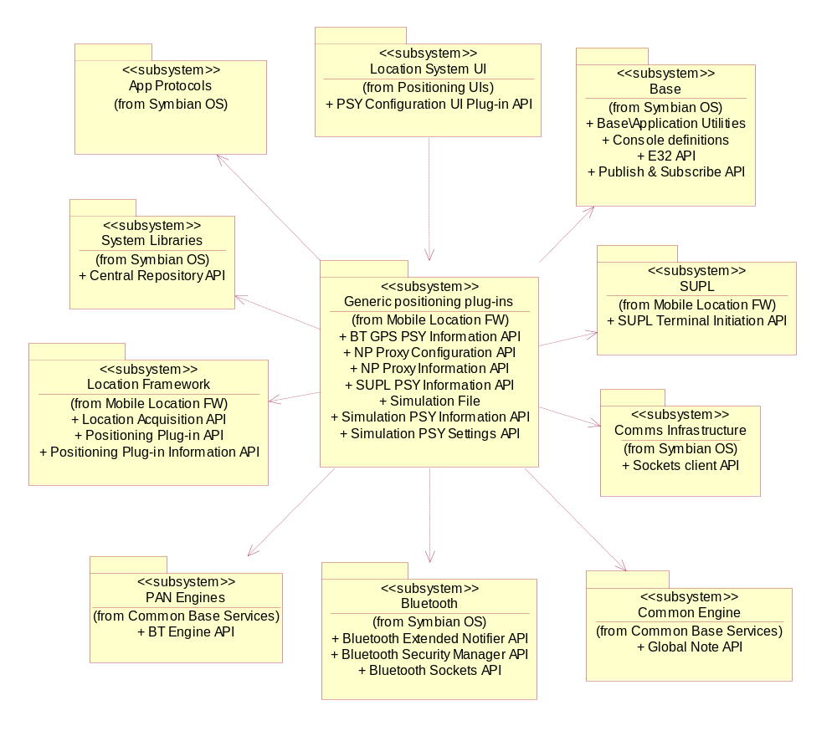
Figure 2.1 Subsystem environment of Generic Positioning Plug-ins subsystem

Services required

From the Location Framework subsystems
SUPL PSY uses the Positioning Plug-in API (see reference document [2]), which is exported by the Location Framework subsystem, as a base for its implementation. This enables Network Positioning Proxy to detect and communicate with SUPL PSY.
SUPL PSY publishes its static information through Positioning Plug-in Information API (Central Repository).

From the Generic Positioning Plug-ins subsystem
SUPL PSY is hidden from the clients and system UI. Only Network Positioning Proxy can use it. Location requests are received via Network Positioning Proxy.

From the application user interfaces subsystems
There is no direct connection to the application user interfaces subsystems.

From the Symbian OS subsystems
There are dependencies to the following subsystems:

Base | Symbian Base is used for basic Symbian OS functionality support.
System Libraries | SUPL PSY uses Central Repository API to store static information of SUPL PSY.

From the Domestic OS subsystems
This component has no direct interfaces to the Domestic OS side subsystems.

From HW
This component has no direct HW interfaces.

Services provided

SW IF
The PSY implements the Positioning Plug-in API and Positioning Plug-in Information API (see reference document [2]).

Subsystem overview

Design

Architectural requirements
Some important architectural considerations for the SUPL PSY are:
- SUPL PSY is implemented as an ECom plug-in. This is required so that SUPL PSY can be detected and used by Network Positioning Proxy.
- SUPL PSY must be defined as hidden PSY. So end user will see only network based positioning method and does not need to understand technique details behind each specific method.
- SUPL PSY must utilize the maximum age parameter related to location requests. The maximum age parameter is used to reuse a previously retrieved fix if the fix is within the maximum age time limit.
- SUPL PSY must support multiple simultaneous client sessions, which means that a position request may be received before the previous one has completed. Request bundling is to be used to deliver the result to the clients when the acquisition is complete.

Component diagrams

Subsystem
The component diagram for the SUPL PSY is shown in Figure 3.2.

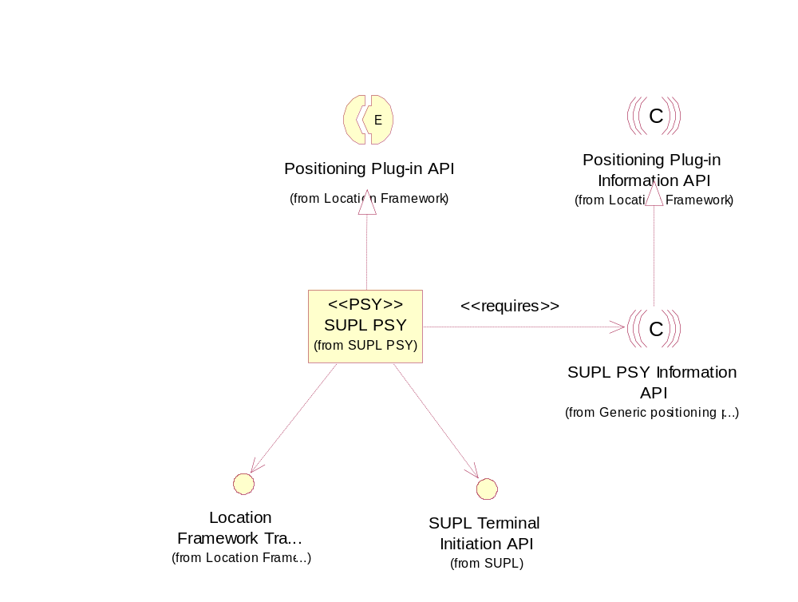
Figure 3.2 SUPL PSY component diagram

Component descriptions

SUPL PSY
The SUPL PSY is a positioning plug-in for Location Framework that enables the usage of SUPL subsystem as a location information provider. Location Framework utilizes SUPL PSY via Network Positioning Proxy. PSY properties are listed in Section 5.2.1.

Positioning Plug-in API
The Positioning Plug-in API defines the framework classes needed to implement PSYs for the Location Framework. See reference document [2]

SUPL PSY Information API
The SUPL PSY publishes its static properties in Central Repository, as defined by Positioning Plug-in Information API. See reference document [2].

SUPL Terminal Initiation API
SUPL PSY uses SUPL Subsystem to retrieve current location information via SUPL Terminal Initiation API. See reference document [5].

State diagrams
SUPL PSY maintains its state internally. It will not report device status and data quality to any other component.

Variability
There are no variability flags.

Flag definitions
The table below specifies the R&D flags (debug etc. flags) used by the subsystem. Feature flags related to the subsystem are specified in Section 4.1.1.

Flag | Description
__WINS__ | The flag is used to control different implementations of WINS/WINSCW platform and HW platform. Differences are required in some case to make testing on WINS/WINSCW possible.
_DEBUG | The flag is used to separate code that is used only in the internal debug build. This concerns the logging for debug purposes.

Operations
The SUPL PSY includes only one module and the operations of the module are described in detail in Chapter 5. This section includes only high-level descriptions of the operations.

PSY loading
Loading SUPL PSY for the first time will initiate connection to SUPL subsystem.
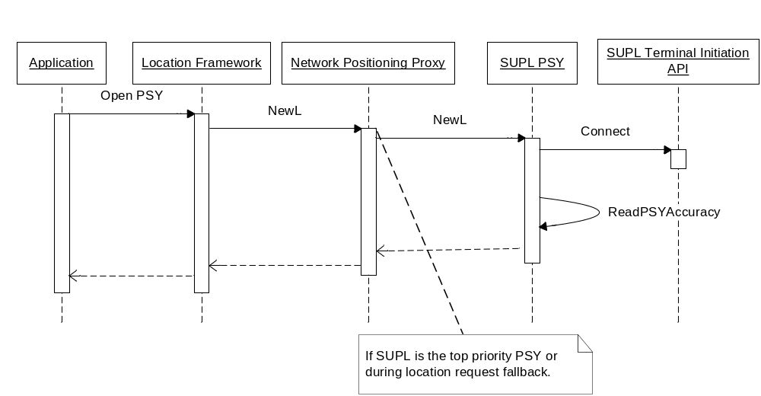
Figure 3.3 PSY loading

PSY unloading
The last PSY instance unloading unloads the whole PSY. This includes the closing the SUPL Terminal Initiation API connection.
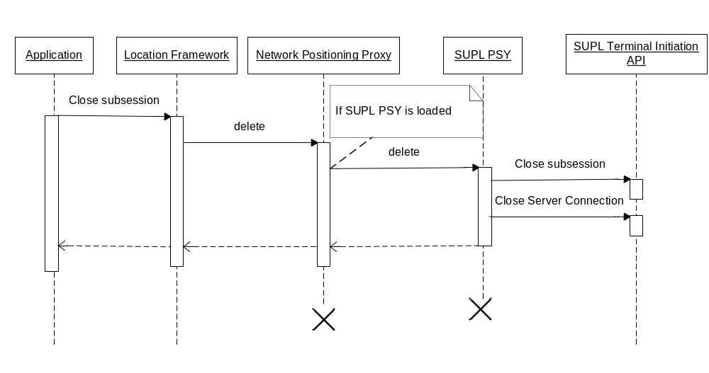
Figure 3.4 PSY unloading

Requesting location
If the location request cannot be satisfied using a cached fix, SUPL PSY starts requesting location from SUPL subsystem via SUPL Terminal Initiation API. When the fix is received, it then collects the required information and completes the location request.
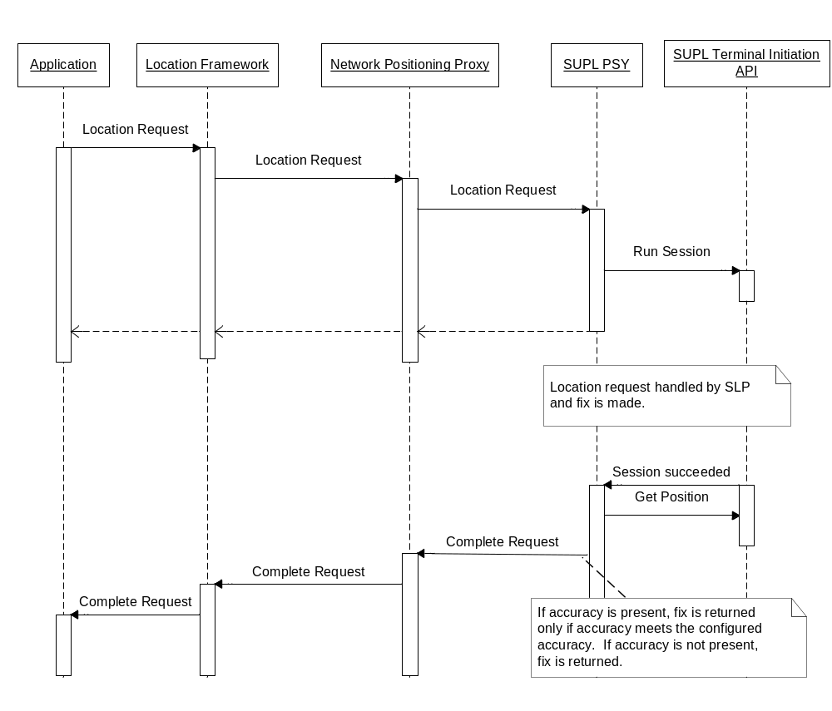
Figure 3.5 Requesting location

Canceling a location request
The canceling of the location request will cancel location request process between SUPL SET and SUPL SLP (see reference document [4]) via SUPL Terminal Initiation API.

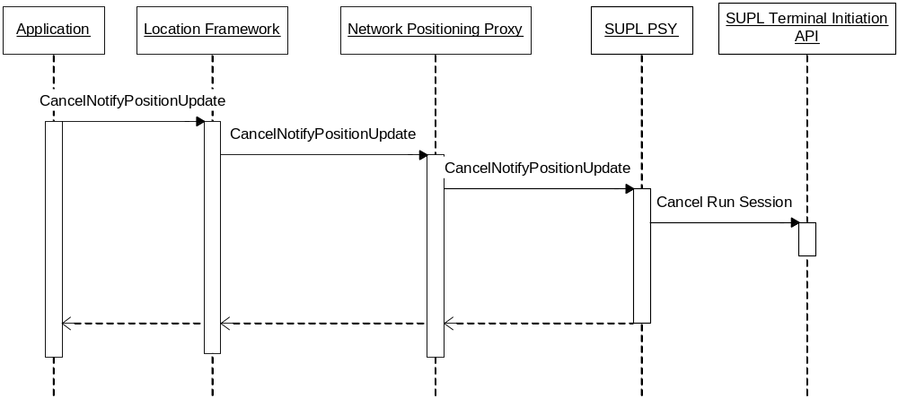
Figure 3.6 Canceling of the location request

System resource usage

Files

Filename | Size | Description
nlasuplpsy.rsc | 80 bytes | Defines ECom plug-in resource file.
10206913.txt | 2050 bytes. | This file is a Central Repository text file defining static information of SUPL PSY

Databases
SUPL PSY does not utilize any databases.

Memory consumption
The ROM usage of this component is 3231B in ARMV5 release. The estimated RAM usage of the PSY is 3 KB. Additional connections are estimated to increase the heap usage by 0.5KB per connection.

Task allocation
SUPL PSY runs in the Location Server thread and does not allocate any new threads.

Timers
Timers are presented in Chapter 5.

Security

Capabilities of this component
This component is an ECom plug-in, the capabilities describe its level of trust. Capabilities assigned to SUPL PSY are defined in the macro CAP_ECOM_PLUGIN.

Input and output validation
This component does not require or make any validation for data.

Environmental assumptions
This component does not make any assumptions about its environment.

Additional enforcements
This component does not have any additional security enforcements.

Exception handling
Exception handling is documented in Chapter 5.

Subsystem Usage

Building
The table below shows how components map to DLLs and where in the source code tree the project definitions and source code for the different DLLs are located.

Component name | Directory | MMP file name | DLL name
SUPL PSY | LocationSuplPsy | group\  nla_suplpsy.MMP | nlasuplpsy.dll

Building is done by running the following commands in the \group subdirectory of the directory listed in the table:
- bldmake bldfiles
- abld build <TARGET>

Where <TARGET> is one of WINSCW or ARMV5.
To build a SIS-file forARMV5, use the following command in the Install directory:
- makesis nla_suplpsy.pkg

To sign the SIS-file, use the following command in the Install directory:
- signsis nla_suplpsy.pkg nla_suplpsy.sisx rd.cer rd-key.pem

SUPL PSY is not upgradeable. If there is SUPL PSY in ROM, it is not possible to install a signed .sis package on the device.

Variation and feature flags
SUPL PSY can be included during ROM image creation time by enabling the feature flags __SUPL_FRAMEWORK and __NP_PROXY.

Localization
This component does not contain any localizable string.

User's guide

Developers

Debugging
The tracing log of debug builds of the SUPL PSY is generated in the directory C:\logs\suplpsy\log.TXT. Tracing can be switched on and off by creating the directory and removing it, respectively.

End users
This component is not visible to end-users.

SUPL PSY component

Design
This section describes the design of the SUPL PSY.
Figure 5.7 shows the class diagram of SUPL PSY component and its dependencies of Positioning Plug-in API, SUPL Terminal Initiation API, etc. Detailed description of classes is represented in the class descriptions.

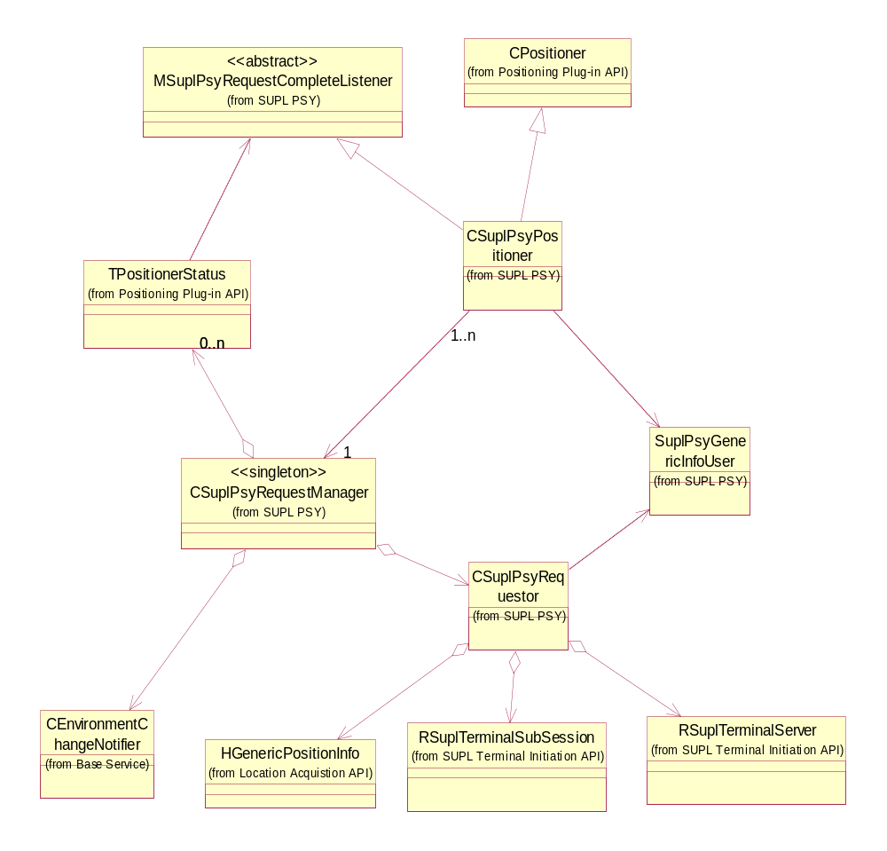
Figure 5.7 Class diagram of the SUPL PSY component

Class descriptions

Class | Description
CSuplPsyPositioner | This class provides the interface to Location Framework as specified by Positioning Plug-in API. Each client connection to SUPL PSY makes an instance of this class.
CSuplPsyRequestManager | This class provides function to instance a singleton object of SUPL PSY. This class manages all client connections and location requests.
CSuplPsyRequestor | This class implements position requestor of SUPL PSY.
SuplPsyGenericInfoUser | This is a user class that provides function to handle HPositionGenericInfo.
MSuplPsyRequestComplete  Listener | This class is request complete listener interface. This class provides the interface for listener to get request complete events.

Operations

PSY loading

Operation | PSY loading.
Preconditions
Description | The Network Positioning Proxy decides to use SUPL PSY and loads the first instance of the PSY.
Inputs
Modifies
Outputs
Postconditions | The PSY is loaded and a connection SUPL Terminal Initiation API is made. Accuracy value is read from the central repository for filtering.
Related to | Section 5.1.2.2.
Related event
Exceptions | Out of memory.

The first PSY loading constructs the CSuplPsyRequestManager singleton object. CSuplPsyRequestManager will then construct CSuplPsyRequestor. CSuplPsyRequestor then connects to SUPL FW through SUPL Terminal Initiation API. CSuplPsyRequestor constructs the CRepository object and reads allowed accuracy from the central repository. After reading CRepository object is destroyed.
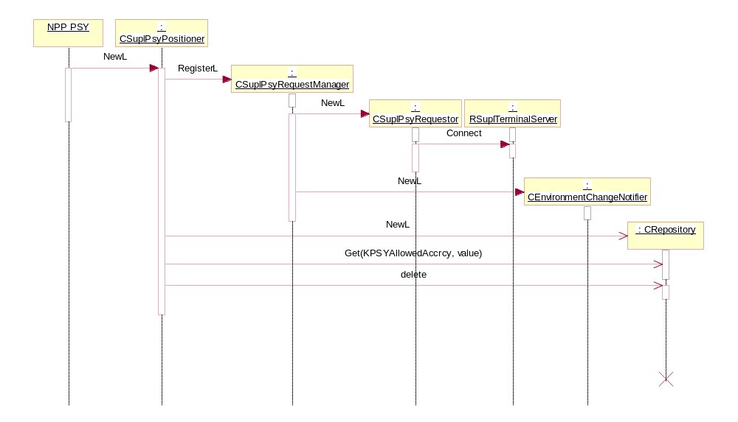
Figure 5.8 PSY loading

PSY unloading

Operation | PSY unloading.
Preconditions | Instance of PSY exists.
Description | The NPP PSY decides to unload SUPL PSY. If the last instance of CSuplPsyPoistioner is closed, the singleton object CSuplPsyRequestManager will be deleted. Thus, all connections to SUPL FW will be closed.
Inputs
Modifies
Outputs
Postconditions | The PSY is unloaded and connection to SUPL FW is closed.
Related to | Section 5.1.2.1.
Related event
Exceptions

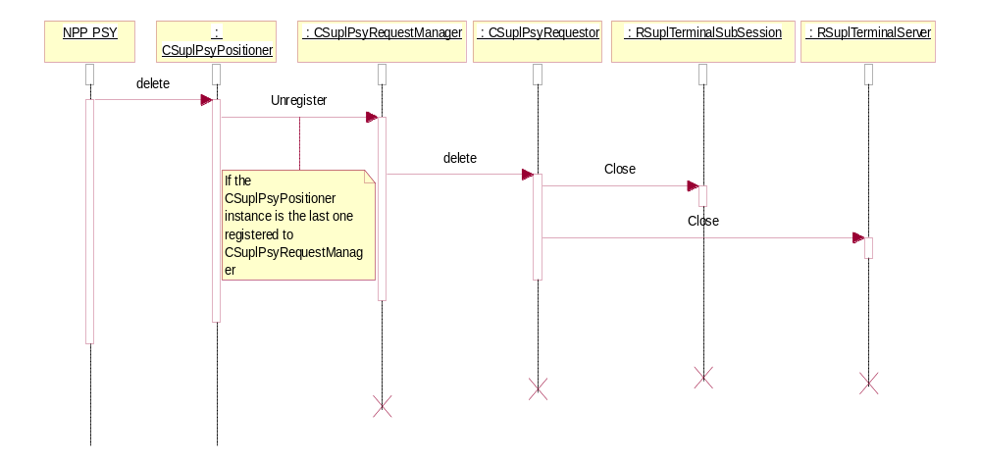
Figure 5.9 Sequence diagram of PSY unloading when the instance is the only one loaded

Location request

Operation | Location request.
Preconditions | The PSY is loaded.
Description | NPP PSY makes a location request to SUPL PSY. SUPL PSY forwards this location request to SUPL FW if there is not location request currently ongoing.  - The information from a cached fix is used if the maximum age parameter allows this.  - If the cached fix cannot be used, the new location request is issued to SUPL FW.
Inputs | Location request.
Modifies | Internal location request status.
Outputs | The request result. If the accuracy is present in the location fix, then fix is returned only if the accuracy is within the configured accuracy. If accuracy is not present, fix is returned.
Postconditions
Related to | Section 5.1.2.4.
Related event
Exceptions | Out of memory.

SUPL PSY requests HPositionGenericInfo from SUPL FW. In addition to normal position information (as TPositionInfo), the following fields, which are supported by SUPL Terminal Initiation API (as defined in reference document [5]), are requested:
- EPositionFieldHorizontalSpeed
- EPositionFieldHorizontalSpeedError
- EPositionFieldVerticalSpeed
- EPositionFieldVerticalSpeedError

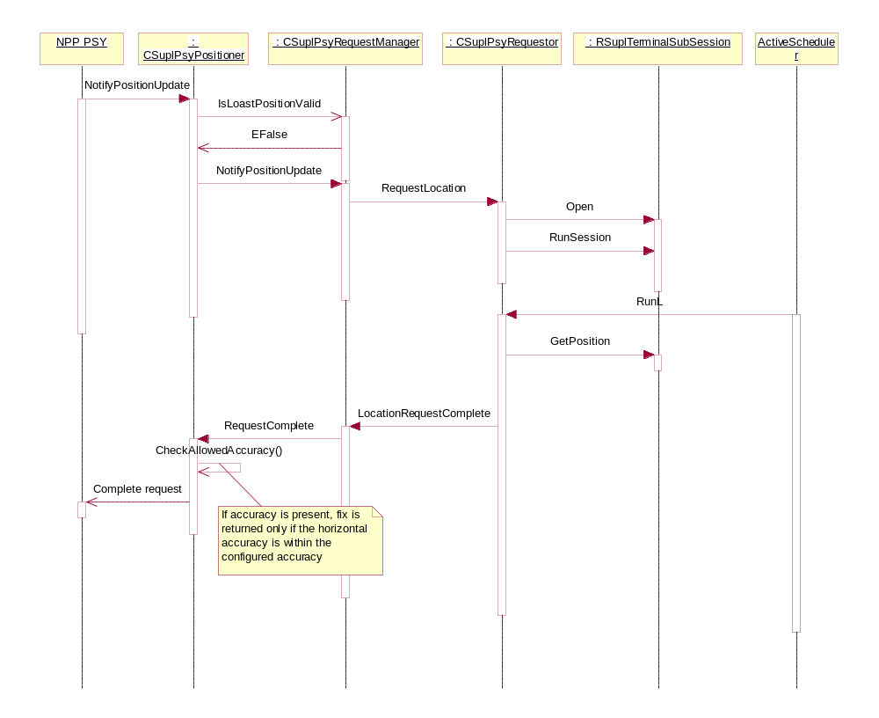
Figure 5.10 Sequence diagram for the location request when cached fix could not be returned
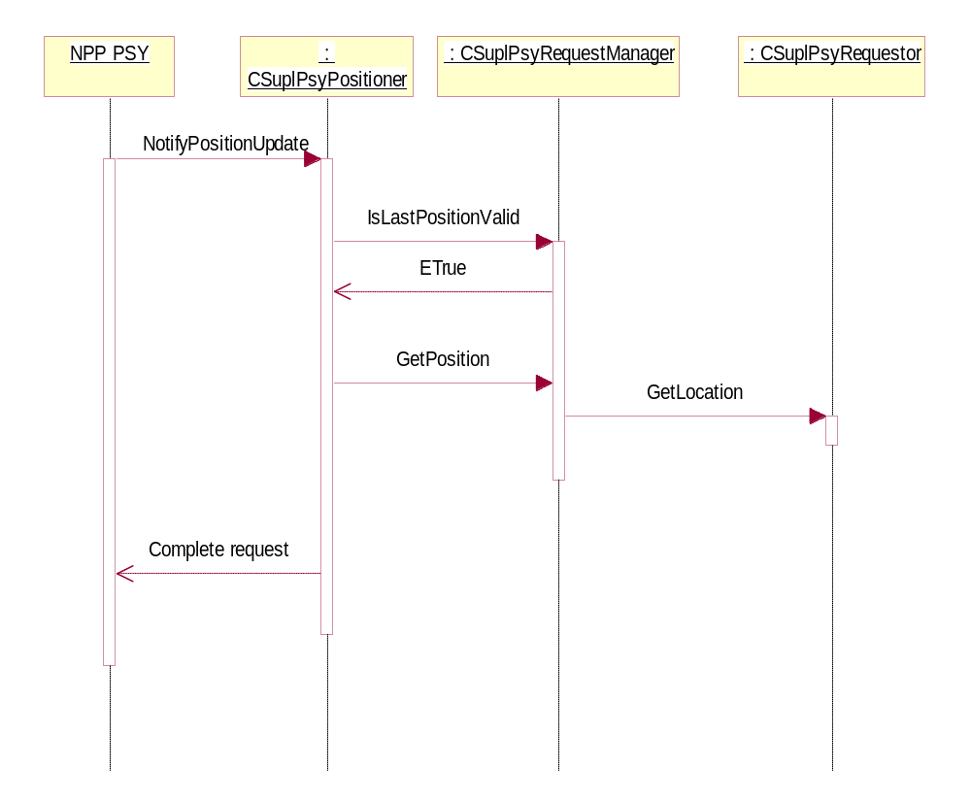
Figure 5.11 Sequence diagram for the location request when the cached fix could be returned

Canceling a location request

Operation | Canceling a location request.
Preconditions | PSY is loaded and a location request is pending.
Description | A previously initiated location request is canceled.
Inputs
Modifies | Internal request status.
Outputs | The request is completed with KErrCancel.
Postconditions | No location request is pending from a client.
Related to | Section 5.1.2.3.
Related event
Exceptions

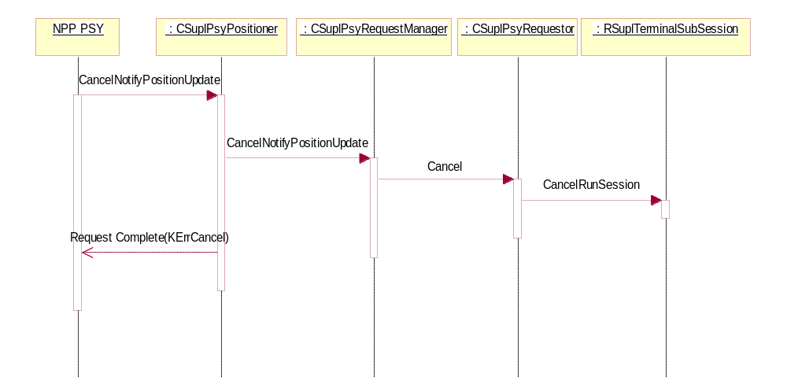
Figure 5.12 Sequence diagram for the canceling of a location request when the canceled location request is the only one

System resource usage

File structures
The Central Repository initial value file 10206913.txt contains the SUPL PSY static information (see reference document [2]). Table 5.1 describes the properties that have been set in Central Repository init file.

Tag | Value
timetofirstfix | 12.0 (in seconds)
timetonextfix | 12.0 (in seconds)
horizaccuracy | 200.0 (in meters)
vertaccuracy | 0 (in meters)
costindicator | ECostPossible
powerconsumption | EPowerLow
technologytype | KTechnologyNetwork
devicelocation | KDeviceInternal
capabilities | KCapabilitiesHorizontal
classessupported | KPositionClassInfo | KPositionClassGenericInfo
allowedaccuracy | 40000 (in meters)
Table 5.1 PSY properties in 10206913.txt
SUPL PSY is a hidden PSY and does not have a localizable display name.

Database structures
This component uses no databases.

Timers and active objects

Active objects / Timers
CSuplPsyPositioner | Derived from CActive.

Exception handling
SUPL PSY will generate panics if it is used incorrectly. The following panic code has been defined. These panics happen only if there is programming bug in Location FW or NPP PSY.

Panic Reason
EPanicPositionRequest  Ongoing | SUPL positioner received location request while there is already a location request ongoing.
EPanicPositionerAlready  Registered | SUPL positioner has been registered to request manager and try to register to it again.
EPanicUnknownPositioning  Class | SUPL positioner receive a location request but the positioning class is unknown.

Refer to Appendix A for a description of error codes of location requests.

Appendix A: Location request error code

Error code | Description
KErrArgument | If class type is not supported.
KErrCancel | If location request is canceled successfully.
KErrPositionBufferOverflow | If client does not allocate enough buffer to hold the fix. This happens when clients request HPositionGenericInfo.
Other system wide error code | If location request is rejected by SUPL FW.

