S60 5.x
Landmarks Content Format Recognizer
Design Document

Team name | Author
Location CF/TietoEnator | Stefan Folkesson
 | Magnus Gustafson
 | Katharina Augustsson
SP SWD SSW Location | Sergey Burnevsky

Change history:

Version | Date | Status | Comments
1.0 | 12.07.2005 | Approved
2.0 | 10.05.2007 | Approved | Added support for GPX format recognition

Table of contents:

1. Document control 4
1.1 References 4
1.2 Documentation conventions 4
1.3 Abbreviations 4
1.4 Definitions 4
2. General 5
2.1 Introduction 5
2.2 Component environment 5
2.3 Services required 6
2.3.1 From the Symbian OS subsystems 6
2.3.2 From the Domestic OS subsystems 6
2.3.3 From HW 6
2.4 Services provided 6
2.4.1 UI 6
2.4.2 SW IF 6
3. Design 7
3.1 Class diagrams 7
3.1.1 Component 7
3.2 Class descriptions 7
3.2.1 Structs, type definitions and enumerations 7
3.3 Operations 8
3.3.1 Recognizing landmark content 8
3.4 Backup and Restore 9
4. Variation 10
5. System resource usage 11
5.1 File structures 11
5.2 Database structures 11
5.3 Timers and active objects 11
6. Security 12
6.1 Capabilities of this component 12
6.2 Input and output validation 12
6.3 Environmental assumptions 12
6.4 Additional enforcements 12
7. Exception handling 13
8. Usage 14

Document control

References
- Series 60 3.0 Landmarks Subsystem Architecture Description
- Series 60 Landmarks Subsystem Design Document
- Series 60 Landmarks Exchange Format Specification Document
- GPX format specification
http://www.topografix.com/GPX/1/1/
http://www.topografix.com/gpx_manual.asp

Documentation conventions
Code is shown with the Courier New font.

Abbreviations
API | Application Programming Interface
GPS | Global Positioning System
GPX | GPS Exchange (format)
DBMS | Database Management System
DLL | Dynamic Link Library
LMX | Landmark Exchange (format)
MBM | Multiple Bitmap file format
MIME | Multipurpose Internet Mail Extensions
MLFW | Mobile Location Framework
OS | Operating System
XML | Extensible Markup Language

Definitions
Corrupt database | A database that has become invalid and cannot be opened.
Damaged database | A database may be damaged when a transaction fails or is cancelled. A damaged database can be recovered by initialization.
DBMS | Database Management System. A commonly used term for the Symbian OS database engine.
ECom | Symbian OS framework for plug-in DLLs.
Framework | Usually denotes the collection of an engine and associated programming interfaces. This document mentions the Mobile Location Framework and the Symbian OS ECom Framework. There is also a subsystem in Symbian OS called Application Framework.
Landmark | A landmark is a named object that contains a location. The location can be defined by various attributes, e.g. WGS84 coordinates or a textual address.
Landmark category | A landmark can be categorized by assigning a landmark category to it. A typical landmark category is “Restaurant”. A landmark category is often referred to as “category”.
Landmark collection | A group of landmarks encoded according to reference document [3].
Landmark database | Persistent storage of a collection of landmarks and landmark categories.
Platform Security | Definition for the security design principles and features in Symbian OS.
Recognizer | Plug-in code that can examine sample data. If the data is recognized, its data type is returned. A data type is also commonly known as a MIME type.

General
This document describes the Landmarks Content Format Recognizer component in the Landmarks subsystem. The Landmarks subsystem design including general design guidelines for Landmark components is described in reference document [2]. The architecture is described in reference document [1].
Landmarks Content Format Recognizer is available from S60 3.0 onwards. Recognition of GPS Exchange (GPX) format is available from S60 5.0 onwards.

Introduction
This component is a recognizer that can identify data encoded in the Landmarks Exchange format (see reference document [3]) and in the GPS Exchange format (see reference document [4]).
The responsibilities and additional requirements of Landmarks Content Format Recognizer are the following:
- Examines data to identify if it is in the Landmarks Exchange format (application/vnd.nokia.landmarkcollection+xml)
- Examines data to identify if it is in the GPX format (application/gps+xml)

Component environment
Figure 2.1 and Figure 2.2 show the components in the Landmarks subsystem.
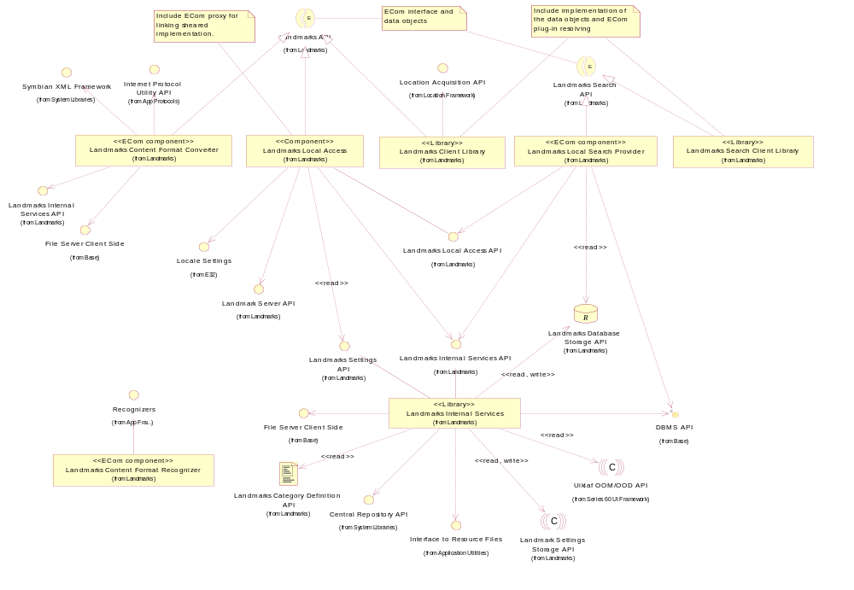
Figure 2.1 Basic Landmarks component diagram
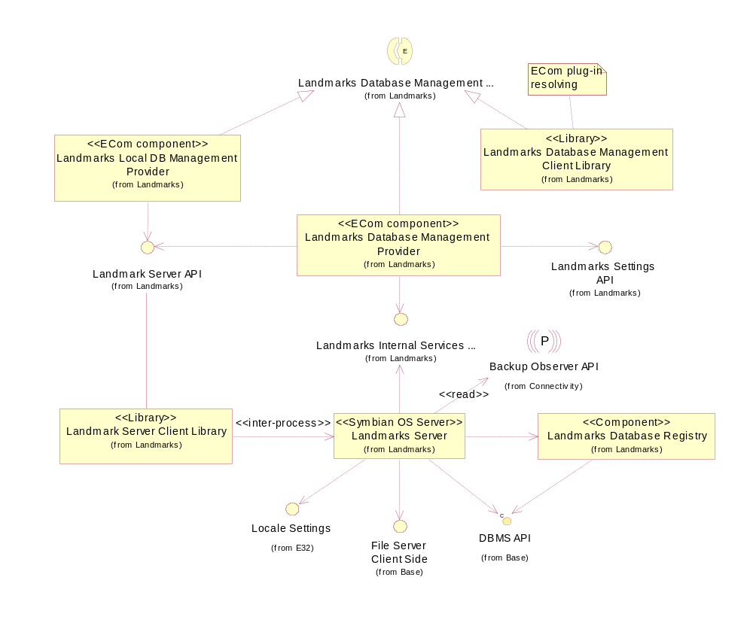
Figure 2.2 Database management component diagram

Services required

From the Symbian OS subsystems
API | Description
Recognizers | Landmarks Content Format Recognizer plugs into the Recognizer Framework through this API.

From the Domestic OS subsystems
This component does not have any direct interfaces to the Domestic OS side subsystems.

From HW
This component has no direct HW interfaces.

Services provided

UI
This component does not provide any UI.

SW IF
This component does not provide any APIs.

Design

Class diagrams

Component
This section describes the design of the Landmarks Content Format Recognizer component.
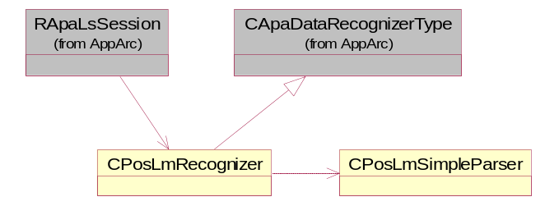
Figure 3.3 Landmarks Content Format Recognizer component class diagram

Class descriptions
Class | Description | Header file
CPosLmRecognizer | Plug-in code that implements the CApaDataRecognizerType interface used to recognize a specified data format. Can examine sample data supplied in a buffer and return the data type of that data if recognized. A data type is also commonly known as a MIME type. | EPos_CPosLmRecognizer.H
CPosLmSimpleParser | Simple XML parser, used to examine starting part of a document in order to identify if it is a XML document, does it use known namespace and root tag. | EPos_CPosLmSimpleParser.h

Structs, type definitions and enumerations
This component does not define any structs, type definitions or enumerations.

Operations

Recognizing landmark content
Operation | Recognizing landmark content.
Preconditions
Description | Examines the beginning of the data supplied in a buffer or file and returns the data type (MIME type) and confidence level if the data is recognized.  The operation is invoked through an instance of RApaLsSession by calling RecognizeData(). Recognition sequence is following:  - Checks if the input data is a XML document, by looking for “<?xml” at the very beginning of the data. If this pattern (XML prolog) is not found, then result will be ENotRecognised. This ensures that the recognizer does not affect recognition performance by reading clearly foreign data.  - Searches for LMX or GPX root tag (<lmx> and <gpx> respectively). If neither is found then result is ENotRecognised. If either is found then result is EProbable and next check is performed.  - Checks if LMX or GPX namespace string is found (depending on the result at step 2) (“http://www.nokia.com/schemas/location/landmarks/” and “http://www.topografix.com/GPX/” respectively). If found, then result is ECertain.  Based on the result on step 2, recognition returns appropriate MIME type:  - For LMX: application/vnd.nokia.landmarkcollection+xml  - For GPX: application/gps+xml
Inputs | The name of the file containing the data. This is not used by the Landmarks Content Format Recognizer component and will be ignored. A buffer containing the data taken from the specified file; typically the data is read from the beginning of the file. The preferred size of the data is 250 characters.
Modifies
Outputs | ENotRecognized, EProbable or ECertain depending on the format of the provided data buffer. If EProbable or ECertain, the recognized MIME type can be found in the recognition result, which was sent as parameter to the RecognizeData() function.
Postconditions | The result is returned to the client.
Related To | CPosLmRecognizer
Related Event
Exceptions

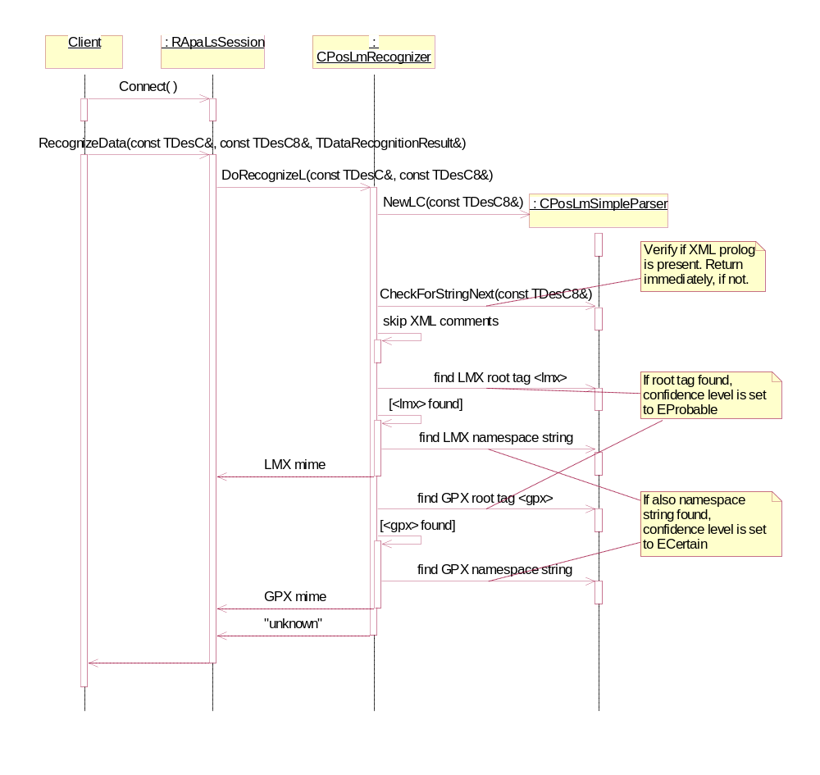
Figure 3.4 Recognizing landmark content

Backup and Restore
The policies for backup and restore are described in reference document [2].

Variation
Variation for the Landmarks subsystem is described in reference document [2].

System resource usage

File structures
Landmarks Content Format Recognizer does not use any files.

Database structures
Landmarks Content Format Recognizer does not use any databases.

Timers and active objects
Landmarks Content Format Recognizer does not use any timers or active objects.

Security

Capabilities of this component
Capability | Justification
CAP_RECOGNISER | All recognizers are assigned this group of capabilities.

Input and output validation
Landmarks Content Format Recognizer validates all input data.

Environmental assumptions
This component does not make any assumptions about its environment.

Additional enforcements
This component does not have any additional security enforcements.

Exception handling
The Symbian OS panic and leave mechanism are used to handle memory exhaustion and other system-wide error codes that appear upon execution.

Usage
Usage is described at the subsystem level in reference document [2].

