S60 5.x

Landmarks Subsystem

Design Document

Team name | Author
Location CF/TietoEnator | Stefan Folkesson
 | Magnus Gustafson
 | Katharina Augustsson
SP SWD SSW Location | Sergey Burnevsky

Change history:

Version | Date | Status | Comments
1.0 | 29.07.2005 | Approved
2.0 | 10.05.2007 | Approved | Updates related to GPX format support addition

Table of contents:

1. Document control 5
1.1 References 5
1.2 Documentation conventions 5
1.3 Abbreviations 5
1.4 Definitions 6
2. General 7
2.1 Introduction 7
2.1.1 Landmarks 7
2.1.2 Landmark categories 7
2.1.3 Landmark databases 8
2.1.4 Searching for landmarks 8
2.1.5 Exchanging landmarks 8
2.1.6 Managing landmark databases 9
2.2 Subsystem environment 9
2.3 Services required 9
2.3.1 From the Symbian OS subsystems 9
2.3.2 From the Domestic OS subsystems 10
2.3.3 From HW 10
2.4 Services provided 10
2.4.1 UI 10
2.4.2 SW IF 10
2.4.2.1 Landmarks API 10
2.4.2.2 Landmarks Search API 11
2.4.2.3 Landmarks Database Management API 11
2.4.2.4 Landmarks Category Definition API 11
2.4.2.5 Landmarks Internal Services API 11
2.4.2.6 Landmarks Settings API 11
2.4.2.7 Landmarks Local Access API 11
2.4.2.8 Landmarks Database Storage API 11
2.4.2.9 Landmarks Settings Storage API 12
2.4.2.10 Landmarks Server API 12
3. Subsystem overview 13
3.1 Design 13
3.1.1 Architectural requirements 13
3.1.2 Component diagrams 13
3.1.2.1 Subsystem 13
3.1.3 Component descriptions 15
3.1.3.1 Landmarks Client Library 15
3.1.3.2 Landmarks Local Access 16
3.1.3.3 Landmarks Search Client Library 16
3.1.3.4 Landmarks Local Search Provider 16
3.1.3.5 Landmarks Server 17
3.1.3.6 Landmarks Internal Services 17
3.1.3.7 Landmarks Content Format Converter 18
3.1.3.8 Landmarks Content Format Recognizer 18
3.1.3.9 Landmarks Database Management Client Library 18
3.1.3.10 Landmarks Local DB Management Provider 18
3.1.3.11 Landmarks Database Registry 19
3.1.3.12 Landmarks Server Client Library 19
3.1.3.13 Landmarks Database Management Provider 19
3.1.4 State diagrams 20
3.1.4.1 Landmark database initialization states 20
3.1.4.2 Landmark database operation states 20
3.1.5 Variability 21
3.1.6 Flag definitions 21
3.1.7 Operations 21
3.1.7.1 Opening a local landmark database 21
3.1.7.2 Modifying a local landmark database 23
3.1.7.3 Searching a local landmark database 24
3.1.7.4 Searching several landmark databases 25
3.1.7.5 Recognizing landmark content 26
3.1.7.6 Importing landmarks 27
3.1.7.7 Exporting landmarks 29
3.1.7.8 Managing local landmark databases 29
3.1.7.9 Changing the default database URI 30
3.1.7.10 Local landmark database management event listening 31
3.1.7.11 Backup and restore 32
3.2 System resource usage 32
3.2.1 Files 32
3.2.2 Databases 32
3.2.3 Central Repository 34
3.2.4 Publish and Subscribe 34
3.2.5 Memory consumption 35
3.2.6 Task allocation 35
3.2.7 Performance 35
3.2.8 Timers 35
3.3 Exception handling 36
4. Security 37
5. Usage 38
5.1 Building 38
5.2 User's guide 39
5.2.1 Resources 39
5.2.2 Trace points 42

Document control

References
- Series 60 3.0 Landmarks Subsystem Architecture Description
- Series 60 Location Acquisition API Specification Document
- Series 60 Landmarks API Specification Document
- Series 60 Landmarks Search API Specification Document
- Series 60 Landmarks Category Definition API Specification Document
- Series 60 Landmarks Exchange Format Specification Document
- Series 60 Landmarks Database Management API Specification Document
- Series 60 Landmarks Internal Services Design Document
- Series 60 Landmarks Client Library Design Document
- Series 60 Landmarks Local Access Design Document
- Series 60 Landmarks Search Client Library Design Document
- Series 60 Landmarks Local Search Provider Design Document
- Series 60 Landmarks Server Design Document
- Series 60 Landmarks Content Format Converter Design Document
- Series 60 Landmarks Content Format Recognizer Design Document
- Series 60 Landmarks Database Management Client Library Design Document
- Series 60 Landmarks Local DB Management Provider Design Document
- Series 60 Landmarks Database Management Provider Design Document
- Series 60 Landmarks Server Client Library Design Document
- Series 60 Landmarks Database Registry Design Document
- GPX format specification
http://www.topografix.com/GPX/1/1/
http://www.topografix.com/gpx_manual.asp

Documentation conventions
Code is shown with the Courier New font.

Abbreviations
API | Application Programming Interface
DBMS | Database Management System
DLL | Dynamic Link Library
MBM | Multiple Bitmap file format
MIME | Multipurpose Internet Mail Extensions
MLFW | Mobile Location Framework
OS | Operating System
XML | Extensible Markup Language

Definitions
Corrupt database | A database that has become invalid and cannot be opened.
Damaged database | A database may be damaged when a transaction fails or is cancelled. A damaged database can be recovered by initialization.
DBMS | Database Management System. A commonly used term for the Symbian OS database engine.
ECom | Symbian OS framework for plug-in DLLs.
Framework | Usually denotes the collection of an engine and associated programming interfaces. This document mentions the Mobile Location Framework and the Symbian OS ECom Framework. There is also a subsystem in Symbian OS called Application Framework.
Landmark | A landmark is a named object that contains a location. The location can be defined by various attributes, e.g. WGS84 coordinates or a textual address.
Landmark category | A landmark can be categorized by assigning a landmark category to it. A typical landmark category is “Restaurant”. A landmark category is often referred to as “category”.
Landmark collection | A group of landmarks encoded according to reference document [6].
Landmark database | Persistent storage of a collection of landmarks and landmark categories.
Mobile Location Framework | A high-level subsystem containing engines for location services, e.g. Landmarks.
Platform Security | Definition for the security design principles and features in Symbian OS.
Recognizer | Plug-in code that can examine sample data. If the data is recognized, its data type is returned. A data type is also commonly known as a MIME type.

General

Introduction
This document describes the Landmarks subsystem. The main responsibility of this subsystem is to enable landmark management in the terminal. A landmark is basically a location with a name and extended information, such as an address and a displayable icon.
A user interface (a Landmarks application) is required to make landmark management visible to the end-user, but user interfaces are not part of this subsystem. The Landmarks subsystem contains only engine functionality.
The main characteristics of the Landmarks subsystem are:
- Pluggable architecture for landmarks management. The Landmarks subsystem is built up by ECom components that can be added and removed dynamically from the system during run-time.
- Sophisticated SQL database structure that enables fast search of landmarks and landmark categories. The Landmarks subsystem uses a default database to store landmarks and landmark categories.
- Simultaneous access from multiple clients. There are no restrictions regarding how many clients can execute read or search operations simultaneously. A write operation can be done only if no other operation is currently in progress.
- Position, address fields and calculation methods are accessed from Location Acquisition API (see reference document [2]).
- Conforms to the Symbian OS Platform Security architecture.

Landmarks is available from Series 60 Platform release 3.0 onwards.

Landmarks
A landmark is essentially a location with a name. It can contain a variety of information, such as a position, name, description, address information, and displayable icon. The landmark name is defined as a Unicode string. WGS 84 coordinates specify the latitude, longitude and altitude of the landmark.
Generic text strings can contain textual information about the landmark, such as address information or a URL. The generic text strings are based upon the generic text fields in Location Acquisition API (see TPositionFieldId in reference document [2]).
A coverage radius can be specified if the landmark stretches over a larger area. An example of this is if a landmark is defined for a city.
A landmark can belong to a landmark category. See Section 2.1.2.
A landmark can be associated with a displayable icon for graphical user interface interaction. The icon is represented as a path and an index to an MBM file.

Landmark categories
A landmark can be categorized by assigning a landmark category to it. A landmark category is identified either by a name or a globally defined ID.
A typical named landmark category is “Restaurant”. If the category is identified by a name, the category has only meaning for the entity that defined it. A category can therefore also be identified by a 16-bit global ID. For instance, the global ID 12 could be defined to indicate “Church”. A set of global IDs can be predefined for this purpose.
In addition to the ID, a landmark category can be associated with a displayable icon.
The Landmarks subsystem contains support for localizing category names for the global category IDs.
The icons and names of global categories are defined in a resource file.

Landmark databases
In the terminal, landmarks and landmark categories are stored in SQL databases called landmark databases. Generally, the term landmark database does not imply that it resides in the terminal storage. A landmark database can just as well reside in a remote landmarks server.
A landmarks database file name always has the extension LDB.
A landmark database that resides in the terminal storage is identified by a combination of its file name extension and access policy UID. Such landmark databases are stored in the DBMS private data cage.
The Landmarks subsystem also supports storing databases on memory cards.

Searching for landmarks
The Landmarks subsystem contains functionality for searching landmarks or landmark categories that match a certain criterion. The search criterion can be:
- Landmarks that contain a certain text.
- Landmarks that belong to a certain landmark category.
- Landmarks that reside in a certain area.
- Landmarks nearest to a specified location.
- Any combinations of criteria 1-4. Can also be combined with a search among a set of landmarks.
- Landmark categories with a certain name.

The Landmarks subsystem also allows making refined searches on previous search results. This is useful when a search returns too many matches. A previous search result can be used to build search chains where the results from each search are combined by an AND condition. The result from such a search chain satisfies all the criteria in that search.
Wild card search for landmarks and landmark categories is enabled for text-based searches.
Searching for landmarks in multiple databases differs somewhat from searching in a single database. The main differences are that the client must specify a list of databases to search and that not all criteria are supported. The search result will also be specified on database IDs from the specified list of databases and landmark IDs for each database respectively.
Note: Searching for landmarks belonging to a category specified by its local ID and landmarks among a set of landmarks cannot be done in multiple database searches.

Exchanging landmarks
The Landmarks subsystem optionally supports exchanging landmarks between terminals. Landmarks and landmark collections encoded according to Landmarks Exchange (LMX) format (defined in reference document [6] ) can be imported to a landmark database. Landmark collections can be exported from a landmark database.
The Landmarks subsystem supports XML-encoded landmark data specified according to reference document [6]. The Landmarks subsystem supports the MIME type application/vnd.nokia.landmarkcollection+xml.
The Landmarks subsystem also supports partial importing of landmark data encoded in GPS Exchange (GPX) format (as defined in reference document [21]) identified by MIME type application/gps+xml.
Any landmark data encoded according to LMX or GPX format can be identified by Landmarks Content Format Recognizer.

Managing landmark databases
Several landmark databases can co-exist in a terminal. A client can create, delete, copy and list landmark databases through the support of landmark database management in the Landmarks subsystem.

Subsystem environment
The Landmarks subsystem is a part of the Mobile Location FW, which consists of engines and plug-ins for location services. The Landmarks subsystem within MLFW is shown in Figure 2.1. The high-level design of the Landmarks subsystem is described in reference document [1].
The Landmarks subsystem has a dependency to Location Acquisition API (see reference document [2]) within the Location Framework subsystem.
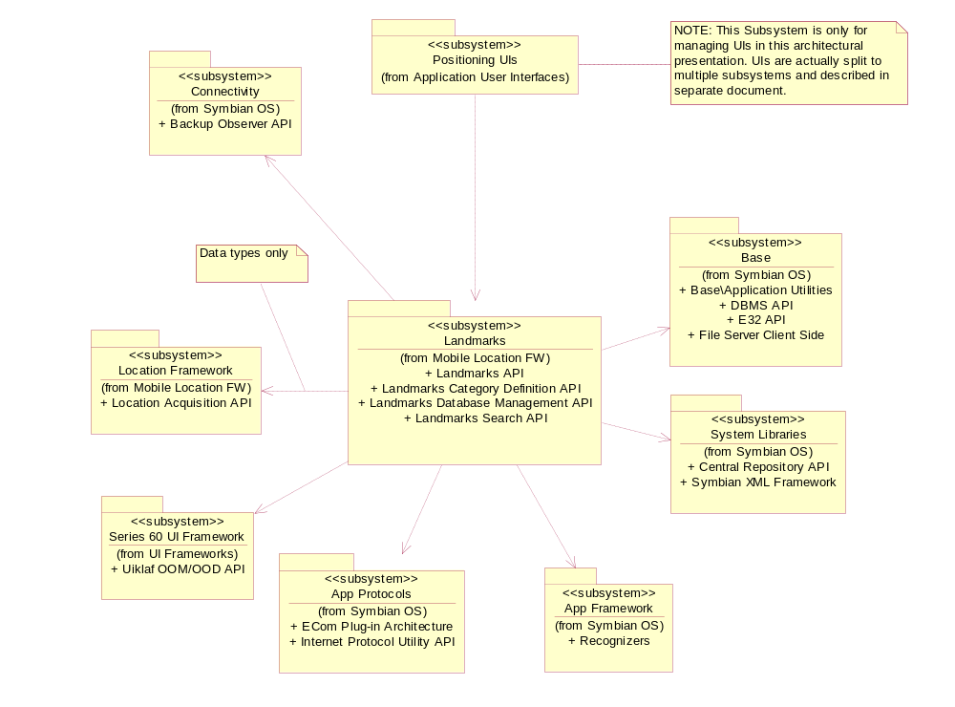
Figure 2.1 Landmarks subsystem

Services required

From the Symbian OS subsystems
API | Description
Backup Observer API | Landmarks uses Publish and Subscribe to listen to backup-related events.
Central Repository API | Landmark settings are stored in Central Repository.
DBMS API | Landmark databases are DBMS databases.
ECom Plug-In Architecture | Different implementations for the Landmark APIs are provided as ECom plug-ins.
File Server Client Side | Landmark content can be imported into landmark databases from a file. Landmarks can also be exported to a file.
Internet Protocol Utility API | Used to validate URIs.
Recognizers | There is a recognizer for Landmark content.
Symbian XML Framework | Used to read XML-coded landmark content.

From the Domestic OS subsystems
This component does not have any direct interfaces to the Domestic OS side subsystems.

From HW
This component has no direct HW interfaces.

Services provided

UI
This subsystem does not provide any UI.

SW IF
The Landmarks subsystem is responsible for the following interfaces:
- Landmarks API
- Landmarks Search API
- Landmarks Database Management API
- Landmarks Category Definition API
- Landmarks Internal Services API
- Landmarks Settings API
- Landmarks Local Access API
- Landmarks Database Storage API
- Landmarks Settings Storage API
- Landmarks Server API

Each of the APIs are described shortly in the following sections.

Landmarks API
Landmarks API is published in the SDK.
Landmarks API provides basic landmark functionality. It enables opening the default landmark database and performing operations on it. This includes listing, reading, creating, updating and deleting landmarks, managing landmark categories and listening for landmark database events.
The API is defined as an ECom interface so that the functionality can be dynamically configured, i.e. the implementation is provided as polymorphic plug-ins.
For more information, see reference document [3].

Landmarks Search API
Landmarks Search API is published in the SDK.
Landmarks Search API enables searching for landmarks. Searching is performed according to the criteria defined by the client. The criteria can be based on position, landmark category or other landmark content.
Searches are always handled asynchronously since these operations normally take some time. It is also possible to perform a new search based on previously found matches.
The API is defined as an ECom interface so that the functionality can be dynamically configured, i.e. the implementation is provided as polymorphic plug-ins.
For more information, see reference document [4].

Landmarks Database Management API
Landmarks Database Management API is published in the SDK.
Landmarks Database Management API extends Landmarks API to enable managing and accessing landmark databases. This includes listing, creating, deleting and copying landmark databases.
The API is defined as an ECom interface so that the functionality can be dynamically configured, i.e. the implementation is provided as polymorphic plug-ins.
For more information, see reference document [7].

Landmarks Category Definition API
Landmarks Category Definition API is an internal API.
This API is used to define localizable data, i.e. the category name, for predefined global landmark categories.
For more information, see reference document [5].

Landmarks Internal Services API
This is a private API, which:
- Defines the table structure in a local landmark database and provides operations for reading and editing the content.
- Provides a service for checking the available memory on disk.
- Simplifies the reading of parameters from resource files.

Landmarks Settings API
This is a private API for accessing the Landmarks system settings.

Landmarks Local Access API
Landmarks Local Access API is a private API. It provides an extension point so that local implementation can access the open database handle.

Landmarks Database Storage API
Landmarks Database Storage API is a private API. It defines the table structure as well as the security policy for creating and deleting of landmark databases.

Landmarks Settings Storage API
Landmarks Settings Storage API is a private API. It contains Central Repository key definitions for landmark settings (e.g. the default database URI).

Landmarks Server API
Landmarks Server API is a private API. It is used for accessing services provided by Landmarks Server (e.g. registering/unregistering databases, listing databases and reporting database events).

Subsystem overview

Design

Architectural requirements
There are a number of important architecture goals for the Landmarks subsystem:
- The Landmarks subsystem should consist of public APIs, which are always supported by the system. However, landmark features are implemented as ECom plug-ins so that they can be variated at run-time.
- There should be one basic API supporting the use of landmark databases. The API enables basic landmark management operations such as creating, updating, and deleting landmarks from the database as well as reading landmarks. It also supports landmark category management.
- There should also be a number of additional APIs, which enable other landmark features, such as searching or managing landmark databases.
- If a landmark feature is not enabled in the platform, the client application must be able to detect this at run-time.
- The landmark data is based on the position types and generic field data types in Location Acquisition API (see reference document [2]).
- It must be possible to use global landmark categories, which are recognized across different platforms.
- It must be possible to install internationalization data, i.e. a category name and icon, for global landmark categories. Global category names and the default landmark database name are changed when the language is switched.
- The Landmarks subsystem must conform to the Platform Security design principles.

Component diagrams

Subsystem
The basic Landmarks APIs provide efficient services for accessing landmark databases. Some clients require more high-level support for landmark management. Such services are provided by a separate landmarks component, which uses the basic landmarks services.
The component diagrams for the Landmarks subsystem are shown in Figure 3.2 and Figure 3.3 below.
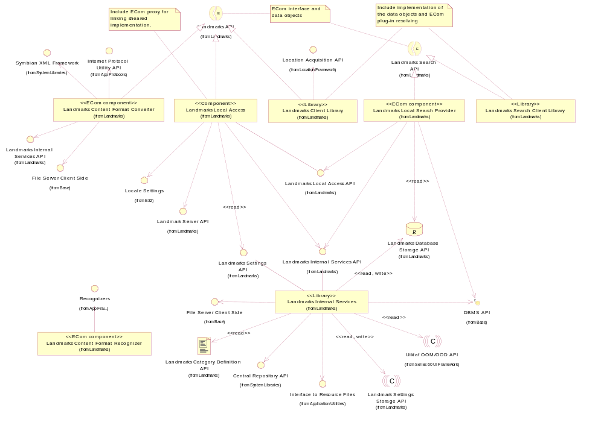
Figure 3.2 Basic Landmarks component diagram
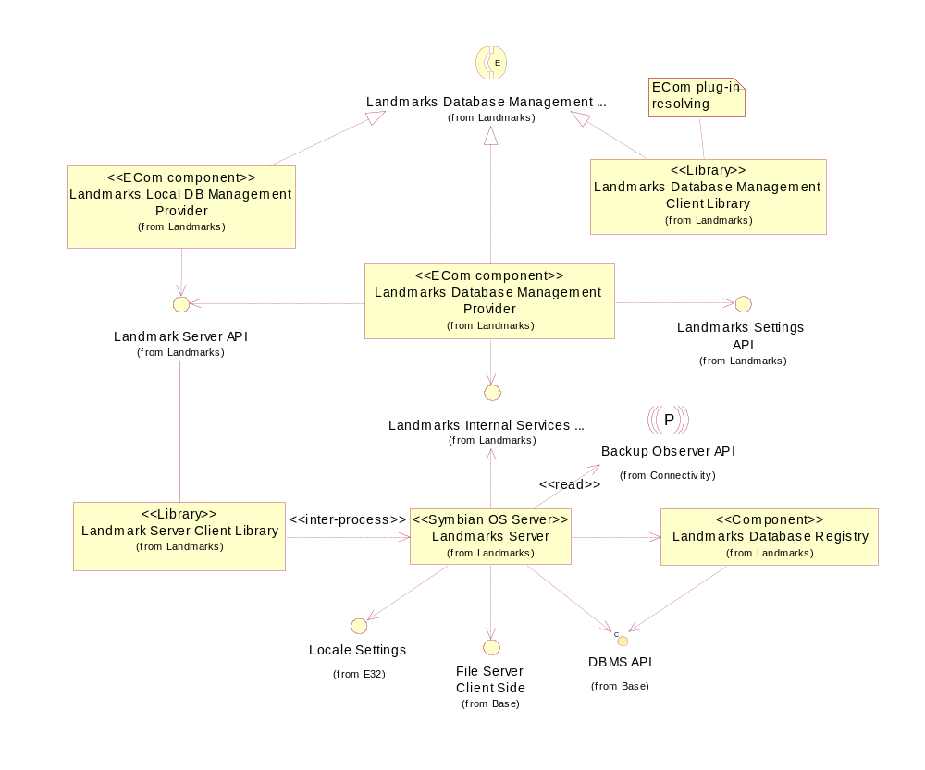
Figure 3.3 Database management component diagram

Component descriptions

Landmarks Client Library
Landmarks Client Library publishes the interfaces needed to access landmark databases. The actual implementation is provided by ECom plug-ins, which implement the database access. The effect is that the Landmarks Client Library is relatively small and functionality can be added or removed at run-time.
The responsibilities and additional requirements of Landmarks Client Library are the following:
- Defines the basic data classes needed for landmark management.
- Loads the components that realize the services defined by Landmarks API.
- A landmark can contain generic position text fields.

The design of the Landmarks Client Library component is described in reference document [9].

Landmarks Local Access
Landmarks Local Access provides an implementation of Landmarks API for local landmark databases and functionality for accessing local landmark databases.
The responsibilities and additional requirements of Landmarks Local Access are the following:
- The local database implementation is loaded at run-time to handle requests from a client.
- Implements the database access functionality of Landmarks API.
- It must be possible to add Landmarks components that extend the functionality. This means that the open database handle must be exported.
- The path of the default landmark database is configurable and is read from the landmark settings.
- When a client opens the default landmark database, it is created if it does not already exist.
- Long-running operations such as removing a set of landmarks from a database are handled incrementally so that they can be run in the background.
- Writing to a database is not accepted if the amount of free memory on disk is too low.
- Uses locale settings to check if the language changes. If the language changes, the database must be re-initialized to update the names of the global categories.
- Multi-item write operations have different strategies for transaction and compacting. Parameters for this are read from a resource file.
- Provides a channel for communication with Landmarks Server.

The design of the Landmarks Local Access component is described in reference document [10].

Landmarks Search Client Library
Landmarks Search Client Library publishes the interfaces needed to search landmark databases. The actual implementation is provided by ECom plug-ins, which realize the services defined by Landmarks Search API. The effect is that Landmarks Search Client Library is relatively small and functionality can be added or removed at run-time.
The responsibilities and additional requirements of Landmarks Search Client Library are the following:
- Defines the basic classes (e.g. the search criteria classes) needed for landmark searches.
- Loads the ECom plug-in, which provides the requested search functionality.
- Provides functionality for searching multiple databases. This functionality is not provided by an ECom plug-in, but by Landmarks Search Client Library.

The design of the Landmarks Search Client Library component is described in reference document [11].

Landmarks Local Search Provider
Landmarks Local Search Provider provides functionality for searching in local landmark databases.
The responsibilities and additional requirements of Landmarks Local Search Provider are the following:
- Defines the database queries to be used for searching local landmark databases. DBMS API is used to execute the database queries.
- Searches are handled incrementally.

The design of the Landmarks Local Search Provider component is described in reference document [12].

Landmarks Server
Some operations cannot be allowed to be run simultaneously by different clients, for example landmark database creation and initialization. If two clients try to initialize the same database, there is a risk of corrupting the database. Instead, these operations must be run by a single instance, Landmarks Server. All database file operations such as creating and deleting are controlled and processed by Landmarks Server.
The responsibilities and additional requirements of Landmarks Server are the following:
- Used to control access to landmarks resources.
- Creates the predefined global categories in the landmark database during initialization.
- The names and icons for the global categories are read from a resource file when the database is created. The names are also read again if the language has changed since last using the database.
- Handles the distribution of landmarks related events.
- Creating, deleting, and copying the database files.
- Creates the table structure into the databases.
- Handles compactization in the background when needed.
- Manages read and write locks for landmark databases.
- Backup of landmark database registries.

Landmarks Server provides functionality for locking local landmark databases. Locks are used to stop several clients from concurrently writing to the database. Only one client may write to the database at a time. All clients trying to access the database during this time will receive KErrLocked. Several clients can read simultaneously, but a client cannot start a write operation during this time.
Two kinds of locks are available: read lock and write lock. A client acquires a read lock on the database when it performs an operation that only reads from the database. A write lock is acquired when performing write or read/write operations. The client does not release the lock until the operation is completed.
Operations on databases (e.g. creating, deleting, and copying databases) also go through Landmarks Server. The database scheme requires device data capabilities for these operations and they need to be implemented in a process separate from the client application process since the client will typically not have system capabilities.
The design of the Landmarks Server component is described in reference document [13].

Landmarks Internal Services
Landmarks Internal Services defines the table structure in a local landmark database and provides operations for reading and editing the content. It also provides general services needed within the Landmarks subsystem.
The responsibilities and additional requirements of Landmarks Internal Services are the following:
- Implements the storage strategy of a local landmark database.
- Exports functions for accessing a local landmark database.
- A landmark can contain generic position text fields. These position fields are stored in the database in the landmark item.
- Writing to a database is not accepted if the amount of free memory on disk is too low.
- This component defines an API for writing category definition resource files.
- Provides a service for reading parameters from a resource files. This also includes reading the category definition resource file.
- Provides a service for checking the memory available on disk.
- Provides a service for accessing landmark settings.

The design of the Landmarks Internal Services component is described in reference document[8].

Landmarks Content Format Converter
Landmarks Content Format Converter is a plug-in, which provides functionality for converting landmarks from and to the XML-based landmarks content formats. It supports parsing and encoding for Landmarks Exchange Format (LMX) defined in reference document [6] and GPS Exchange Format (GPX) defined in reference document [21].
The responsibilities and additional requirements of Landmarks Content Format Converter are the following:
- Converts native landmark objects to the LMX content.
- Converts the LMX content to native landmark objects.
- Converts the GPX content to native landmark objects.

The design of the Landmarks Content Format Converter component is described in reference document [14].

Landmarks Content Format Recognizer
Landmarks Content Format Recognizer is a Recognizer Framework plug-in that can identify the landmark content formats.
The responsibilities and additional requirements of Landmarks Content Format Recognizer are the following:
- Examines data to identify if it is in the Landmarks Exchange format (application/vnd.nokia.landmarkcollection+xml)
- Examines data to identify if it is in the GPX format (application/gps+xml)

The design of the Landmarks Content Format Recognizer component is described in reference document [15].

Landmarks Database Management Client Library
Landmarks Database Management Client Library publishes the interfaces needed to manage landmark databases. The actual implementation is provided by ECom plug-ins, which realize the services defined by Landmarks Database Management API. The effect is that Landmarks Database Management Client Library is relatively small and functionality can be added or removed at run-time.
The responsibilities and additional requirements of Landmarks Database Management Client Library are the following:
- Defines the basic data classes needed for landmark database management.
- Loads the ECom plug-in, which provides the services defined by this client library.

The design of the Landmarks Database Management Client Library component is described in reference document [16].

Landmarks Local DB Management Provider
Landmarks Local DB Management Provider provides functionality for managing multiple local landmark databases.
Landmarks Local DB Management Provider is an ECom plug-in providing functionality for managing local landmark databases according to Landmarks Database Management API.
The responsibilities and additional requirements of Landmarks Local DB Management Provider are the following:
- Uses Landmark Server API to establish a communication channel to Landmarks Server.
- Enables creating, deleting, and copying landmark databases. A private sub-session interface to Landmarks Server is used for this.
- Enables listing of databases using Landmarks Server API.
- Registers and unregisters databases as they are created using Landmarks Server API.
- Events are reported to Landmarks Server, which distributes them to the interested clients.

The design of the Landmarks Local DB Management Provider component is described in reference document [17].

Landmarks Database Registry
Landmarks Database Registry keeps track of the landmarks databases created by Landmarks Server as well as references to landmarks databases residing in the network.
The responsibilities and additional requirements of Landmarks Database Registry are the following:
- Handles access to the landmarks database registry.
- Each drive has its own registry database, which contains a list of the landmark databases in that drive.
- Stores the display names for landmark databases.

The design of the Landmarks Database Registry component is described in reference document [20].

Landmarks Server Client Library
Landmarks Server Client Library publishes the interfaces needed to access services provided by Landmarks Server. The interfaces contain functionality for registering, unregistering and listing databases and for reporting database events.
The responsibilities and additional requirements of Landmarks Server Client Library are the following:
- Defines the basic data classes.
- Implements a connection to Landmarks Server.
- Interfaces for listing, registering, and unregistering all kinds of databases.
- An interface for reporting database events.

The design of the Landmarks Server Client Library component is described in reference document [19].

Landmarks Database Management Provider
Landmarks Database Management Provider provides functionality for managing multiple landmark databases using any defined protocol. Some of the functionality is handled by this component itself, and some uses the protocol-specific provider plug-ins.
The responsibilities and additional requirements of Landmarks Database Management Provider are the following:
- Uses Landmarks Server API to establish a communication channel to Landmarks Server.
- Enables listing, registering, unregistering, creating, deleting and copying landmark databases, and setting/retrieving database settings and properties. This component delegates the operations to the database manager plug-in that is responsible for handling the specific database protocol.
- Events are reported to Landmarks Server (using Landmarks Server API), which distributes them to the interested clients.
- Enables listening for database events. A private sub-session interface to Landmarks Server is used for this.

The design of the Landmarks Database Management Provider component is described in reference document [18].

State diagrams

Landmark database initialization states
The landmark database initialization state diagram is shown in Figure 3.4 below.
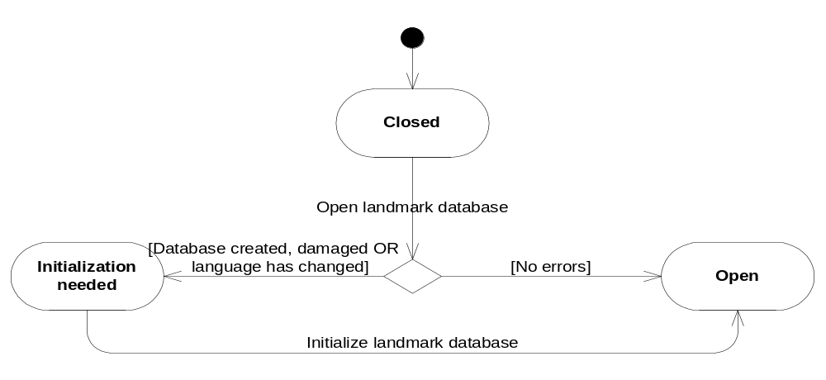
Figure 3.4 Landmark database initialization state diagram

Landmark database operation states
The landmark database operation state diagram is shown in Figure 3.5 below.
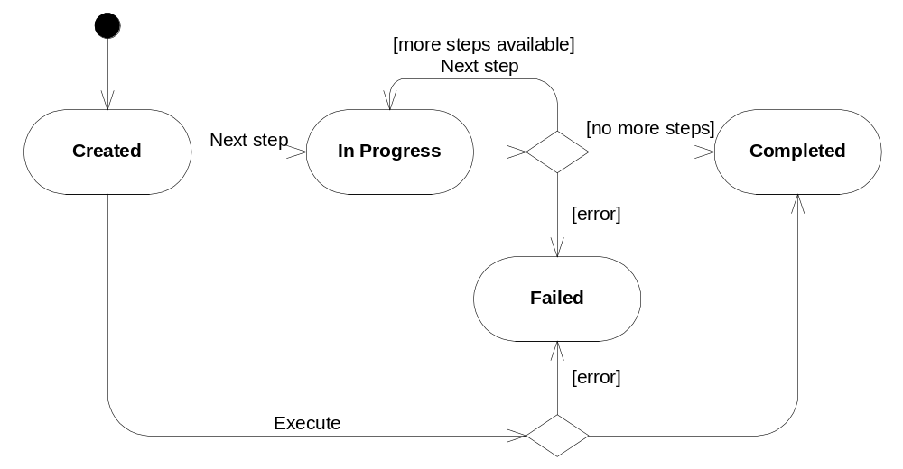
Figure 3.5 Landmarks operation state diagram

Variability
The Landmarks subsystem is optional and is defined by the following feature flag:
- __LANDMARKS defines that the Landmarks functionality is included. Image creation variation is used to select whether the Landmarks functionality is included or not.
- __LANDMARKS_CONVERTER defines that landmarks content format recognition and conversion functionality are included. Image creation variation is used to select whether landmarks content format recognition and conversion functionality are included or not.

There is no link time variation. Components are variated during run-time using ECom plug-ins.
Client libraries are not under any variation flags.

Flag definitions
The table below specifies the flags (feature, debug, etc.) used by the subsystem.

Flag | Description
__LANDMARKS | Defines that the Landmarks functionality is included.
__LANDMARKS_CONVERTER | Defines that landmarks content format recognition and conversion functionality are included.

Operations

Opening a local landmark database
Operation | Opening a local landmark database.
Preconditions
Description | The client uses Landmarks API to open a landmark database. If the default landmark database is opened, the database is created if it does not exist. If another landmark database is opened and it does not exist, an error code will be returned to the client.
Inputs
Modifies | If the default database does not exist when it is opened, it is created.
Outputs | A handle to the opened local landmark database.
Postconditions | The client has a handle to the open landmark database.
Related to | See Figure 3.6 and Figure 3.7.
Related event
Exceptions | If Landmarks Local Access is not installed, this operation fails with an error code.

In Figure 3.6, all communication between the client and Landmarks Client Library is made through Landmarks API.
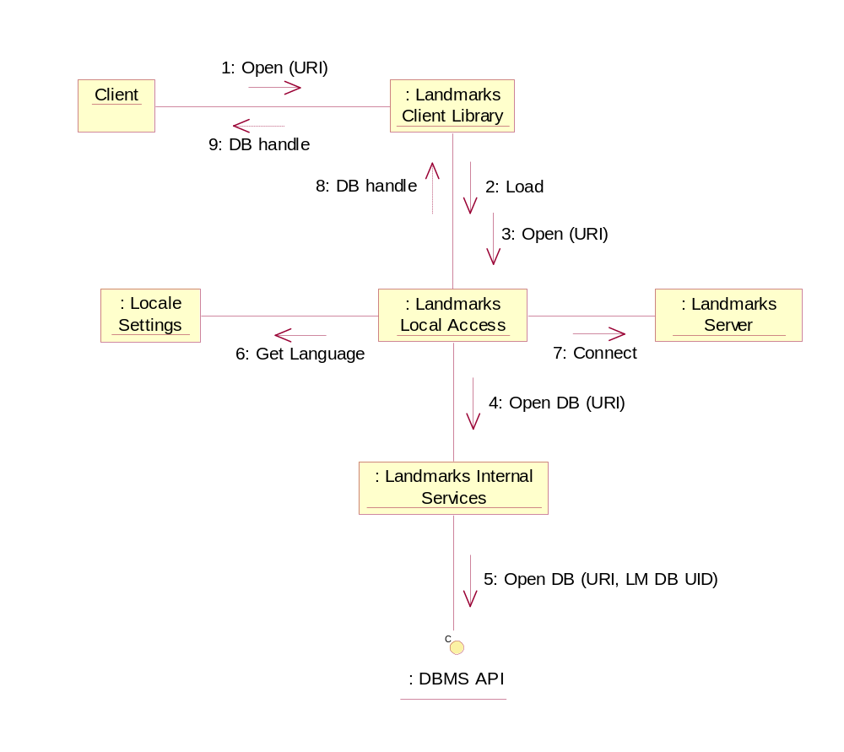
Figure 3.6 Opening a local landmark database
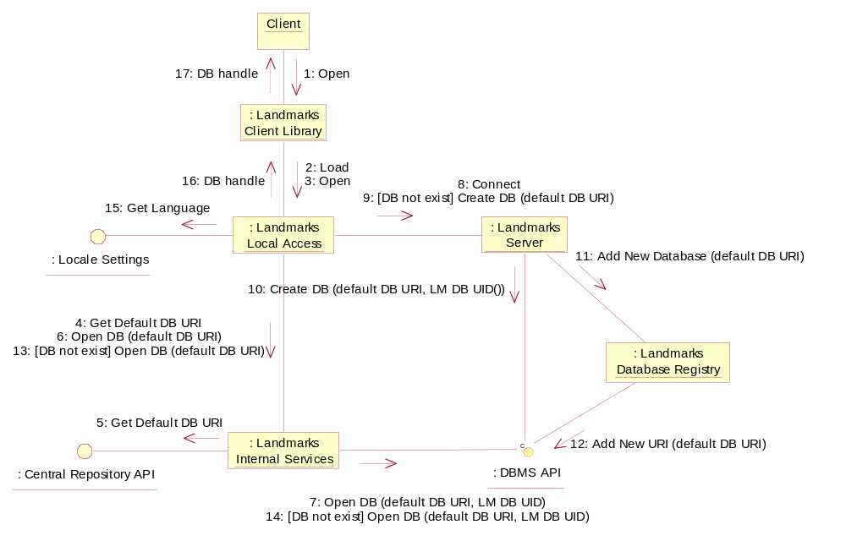
Figure 3.7 Opening the default landmark database
When a Landmark database has been opened, the client must check if it needs to be initialized. If initialization is needed, the client must start it. If initialization is not performed, it may not be possible to access the database.
Initialization consists of the following three actions:
- Adding global categories to the database. This is only needed once, right after the landmark database is first created.
- Recovering the database may be needed if the database has been damaged.
- Updating the names of global categories if the language has been changed since the database was last used.

Figure 3.8 shows the use case where initialization is needed.
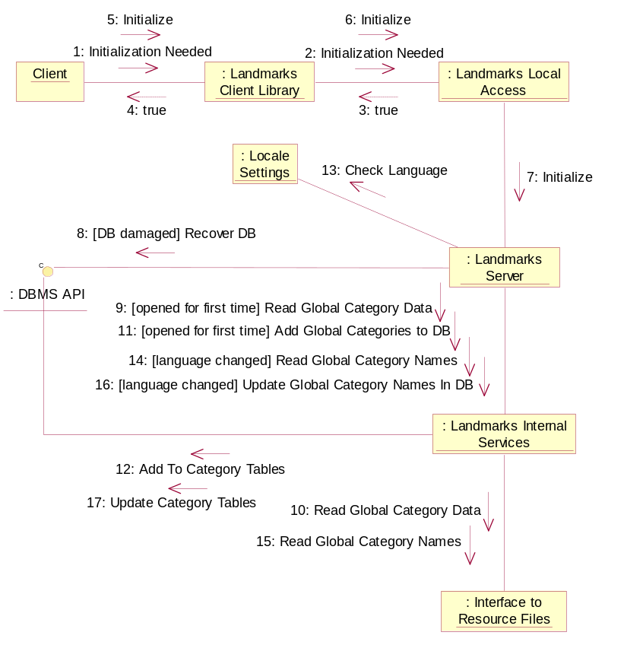
Figure 3.8 Landmark database initialization

Modifying a local landmark database
Operation | Modifying a local landmark database.
Preconditions | A client is connected to a landmark database.
Description | The client uses Landmarks API to modify (add, update or remove landmarks and categories) a landmark database. Another client is listening for the event created by the landmark database operation.
Inputs
Modifies | The landmark database.
Outputs | The listening client receives the event generated by the landmark database operation.
Postconditions | The database is modified. The listening clients have been notified.
Related to | Landmarks Local Access, Landmarks Internal Services, Landmarks Server.
Related event | See Section 3.1.7.1.
Exceptions | If the database is read-only, an error code is returned.

In Figure 3.9, all communication between the client and Landmarks Client Library is made through Landmarks API.
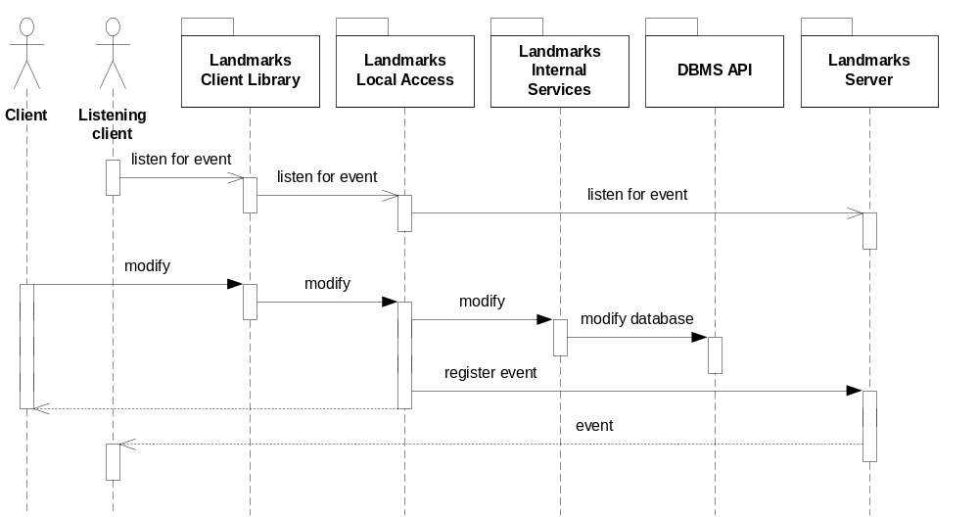
Figure 3.9 Modifying a local landmark database

Searching a local landmark database
Operation | Searching a local landmark database.
Preconditions | A client is connected to a landmark database.
Description | The client uses Landmarks Search API to search a landmark database.
Inputs | The search criterion.
Modifies
Outputs | The s result.
Postconditions | The client has received the search result.
Related to | Landmarks Client Library, Landmarks Search Client Library, Landmarks Local Search Provider.
Related event | See Section 3.1.7.1.
Exceptions

In Figure 3.10, all communication between the client and Landmarks Search Client Library is made through Landmarks Search API.
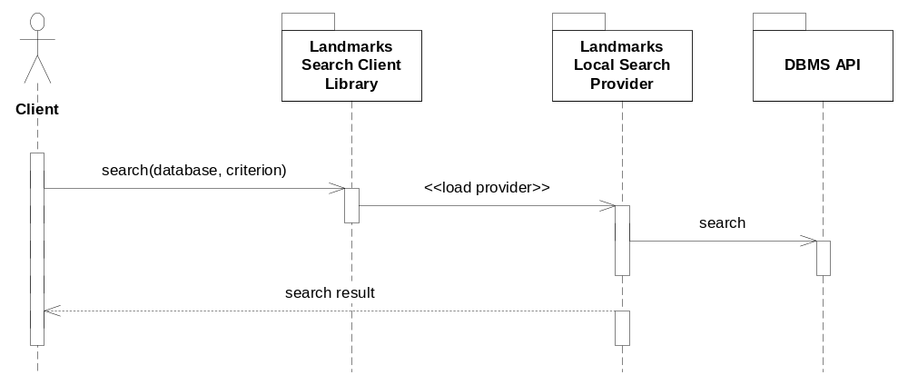
Figure 3.10 Searching a local landmark database

Searching several landmark databases
Operation | Searching several landmark databases.
Preconditions
Description | The client uses Landmarks Search API to search several landmark databases. The databases included in the search are opened and initialized if necessary. A multi search is based on several single searches. If the client specifies a sort preference, the matches in each database are sorted.
Inputs | A list of the landmark database URIs and the search criterion.
Modifies
Outputs | The search result for each database.
Postconditions | The client has received the search result.
Related to | Landmarks Client Library, Landmarks Search Client Library, Landmark Search Providers.
Related event | See Sections 3.1.7.1 and 3.1.7.3.
Exceptions

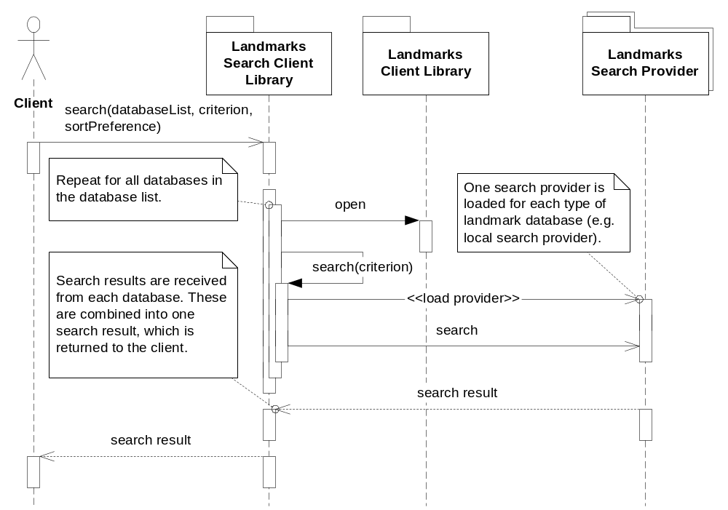
Figure 3.11 Searching several landmark databases

Recognizing landmark content
Operation | Recognizing landmark content.
Preconditions | The client has received a file possibly containing landmark data.
Description | Recognizes the landmark content in the received file and returns the MIME type if the data is specified according to reference document [6]. An error code is returned if the file does not contain any landmark data.
Inputs | A memory buffer containing data from the beginning of the file.
Modifies
Outputs | The MIME type.
Postconditions | The file has been identified to include landmark data. The client has received the MIME type representing the landmark data.
Related to | Recognizer Framework, Landmarks Content Format Recognizer.
Related event
Exceptions

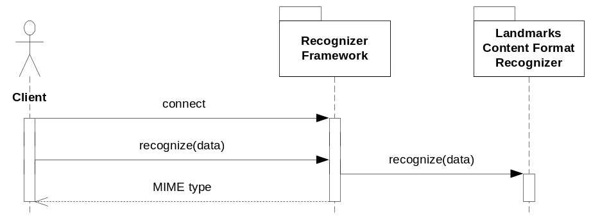
Figure 3.12 Recognizing landmark content

Importing landmarks
Operation | Importing landmarks.
Preconditions | The client has received a file or buffer containing landmark data. The client is connected to a landmark database.
Description | The client uses Landmarks API to import the landmarks to the landmark database.
Inputs | The MIME type, the file or buffer, and transfer options.
Modifies | The landmark database.
Outputs
Postconditions | The landmarks and landmark categories have been added to the landmark database. The listening clients have been notified about the changes.
Related to | Landmarks Client Library, Landmarks Content Format Converter, Landmarks Local Access.
Related event | See Sections 3.1.7.1 and 3.1.7.5.
Exceptions

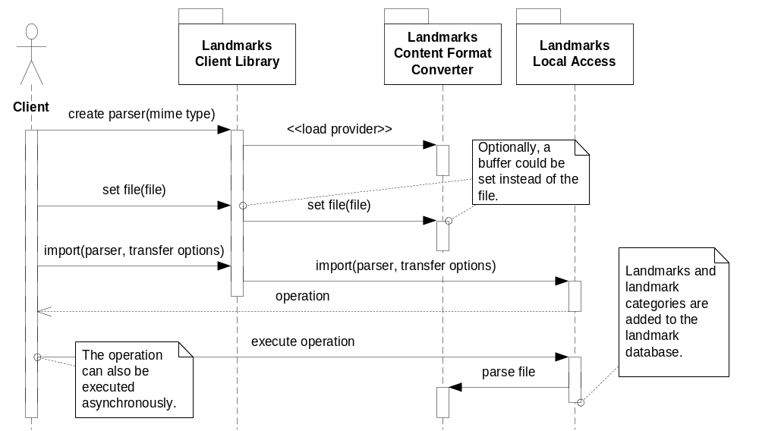
Figure 3.13 Importing landmarks
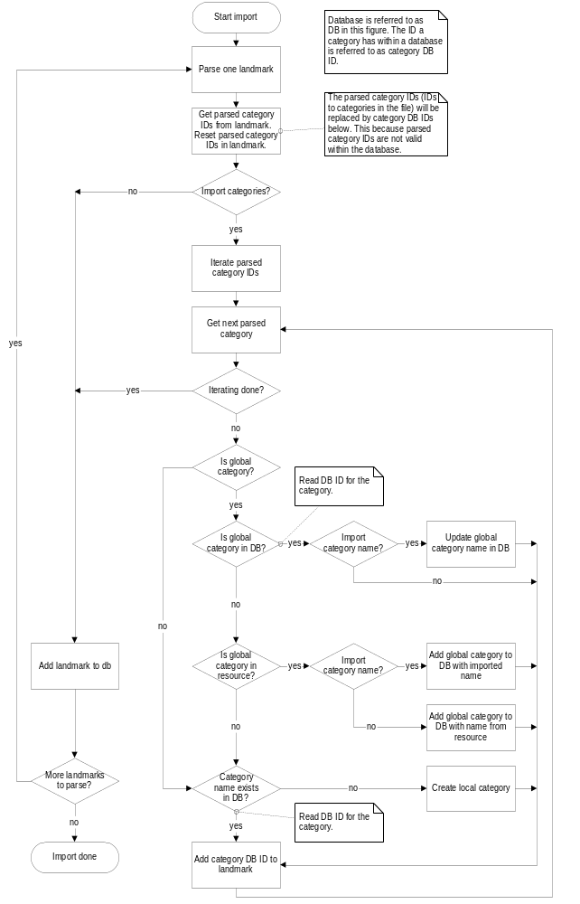
Figure 3.14 Importing landmarks flowchart

Exporting landmarks
Operation | Exporting landmarks.
Preconditions | The client is connected to a landmark database.
Description | The client uses Landmarks API to export landmarks from the landmark database.
Inputs | The MIME type, the file or buffer, an array with the landmark IDs to export, and transfer options.
Modifies
Outputs | A file or buffer containing the landmark data.
Postconditions | The landmarks and landmark categories have been exported to the specified file or buffer.
Related to | Landmarks Client Library, Landmarks Content Format Converter, Landmarks Local Access
Related event | See Section 3.1.7.1.
Exceptions

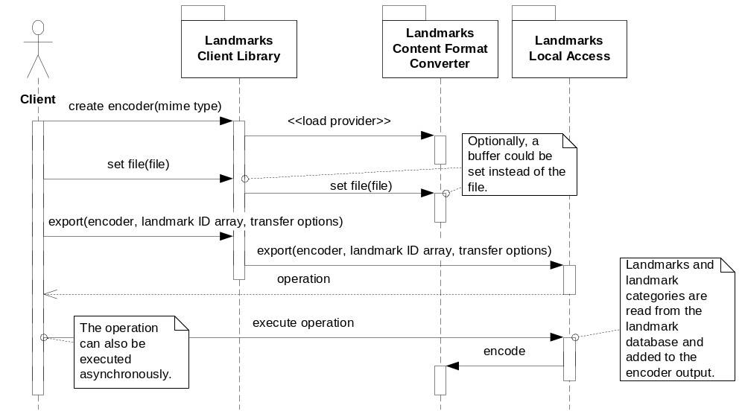
Figure 3.15 Exporting landmarks

Managing local landmark databases
Operation | Managing local landmark databases.
Preconditions
Description | The client uses Landmarks Database Management API to manage landmark databases. This example shows how a database is copied.
Inputs | The source URI and the destination URI.
Modifies
Outputs | The copied landmark database.
Postconditions | The source landmark database has been copied to the destination URI.
Related to | Landmarks Database Management Client Library, Landmarks DB Management Provider, Landmarks Local DB Management Provider (may be several implementations), Landmarks Server
Related event
Exceptions

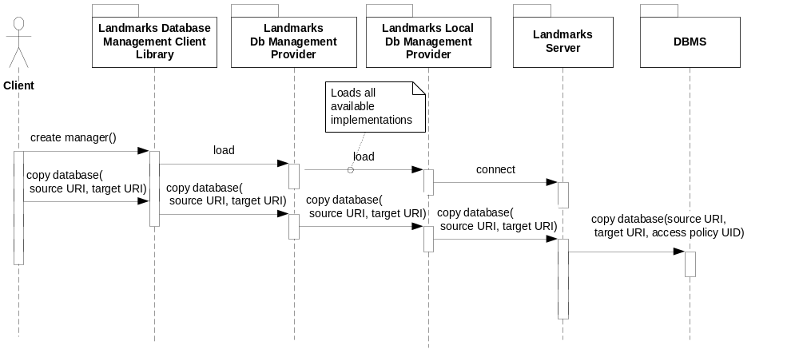
Figure 3.16 Managing local landmark databases

Changing the default database URI
Operation | Changing the default database URI.
Preconditions
Description | The client uses Landmarks Database Management API to change the default database URI.
Inputs | The new default database URI.
Modifies | The default database URI setting.
Outputs
Postconditions | The default landmark database URI has been changed.
Related to | Landmarks Database Management Client Library, Landmarks Local DB Management Provider
Related event
Exceptions | Leaves if the database to be set as default does not exist.

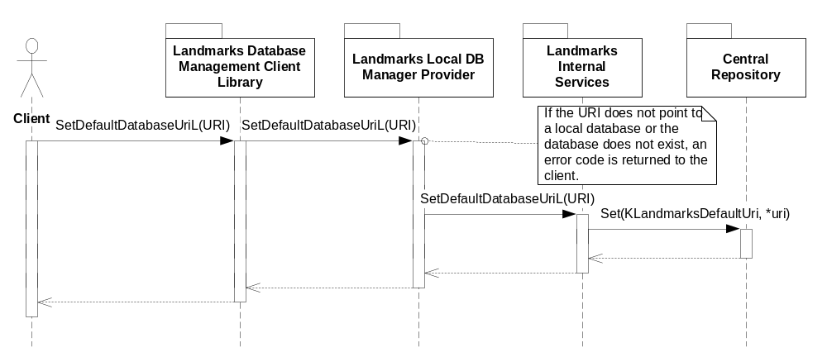
Figure 3.17 Changing the default database URI

Local landmark database management event listening
Operation | Local landmark database management event listening.
Preconditions
Description | The client uses Landmarks Database Management API to listen for landmark database management events.
Inputs | The client requests landmark database management event notifications.
Modifies
Outputs | Landmark database management events are reported to the client.
Postconditions
Related to | Landmarks Database Management Client Library, Landmarks DB Management Provider, Landmarks Local DB Management Provider (may be several implementations), Landmarks Server.
Related event
Exceptions

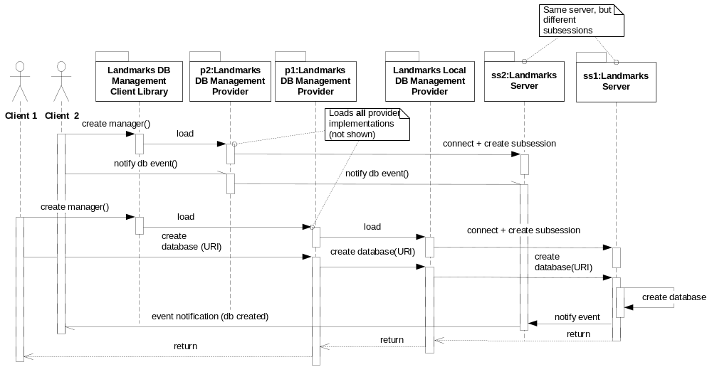
Figure 3.18 Local landmark database management event listening

Backup and restore
In backup and restore, the Landmarks subsystem makes a distinction between files accessed in the client’s process and files not accessed in the client’s process.
A landmark database is accessed in the client’s process to speed up access. The client is therefore responsible for releasing the database during backup and restore. If all clients have released their handles to a database, then the Landmarks subsystem must not have any internal handles to the database.
Landmark database registries are only accessed through Landmarks Server. The Landmarks subsystem is therefore completely responsible for releasing handles to database registries during backup and restore.

System resource usage
This section summarizes the system resource usage for the Landmarks subsystem. The names and usage descriptions of the databases and files used by the subsystem can also be found here.

Files
No files are used by the Landmarks subsystem, except for resource files (see Section 5.2) and landmark databases (see Section 3.2.2).

Databases
The Landmarks subsystem uses landmark databases and owns the default landmark database (see the table below).
A local landmark database is identified by the file extension LDB and an access policy UID. Hence, listing all the available databases will hide any databases created with the landmarks access policy UID but with an extension another than LDB, or vice versa.
Landmark databases use transactions to enable atomicity of write operations. If a transaction fails, it is automatically rolled-back. This means that any changes to the database are abandoned since the beginning of the transaction. Note: Some database operations are performed in several steps, where each step is one transaction. If one step fails, all the previous steps cannot be undone due to DBMS limitations.
If the default landmark database does not exist in the system from the start, it is created when a client tries to open it. This also means that if a database is removed by accident, a new database is automatically created when the client tries to open the default database. If the default landmark database is corrupt, it is replaced with an empty one.
After a client has opened a landmark database, it must be initialized if necessary. Initialization is needed when the landmark database is damaged, the language in the phone has changed and the default landmark database has been created. If the landmark database is damaged, it is recovered upon initialization. If the language has changed, global categories are updated according to that language.
The file names and locations of the databases are always read from resource files, see Section 5.2. For further information about the landmark database structure, see reference document [8].

Database | Owning component | Type | Overhead | Size per item | Total size | Comment
Local landmark database | Landmarks Internal Services | DBMS | 3000 bytes | 250 bytes | 30000 bytes | A landmark database has a variable size.  The figures are based on estimates of landmarks with three fields, one category, no description, ten characters name and fields. All landmarks belong to the same category and use the same icon MBM file.  The total size includes a database with 100 landmarks.  The overhead is an estimation of an empty landmark database, which depends on the amount of predefined global categories.

Database | Local landmark database
Performance goal | It is especially important that listing and reading landmarks is fast to minimize delays in the UI when browsing landmarks.
Estimate | Based on 1000 landmarks in the database. ARMV5  Reading one landmark: 35 ms  Listing 1000 landmark IDs: 850 ms (0.85 ms/landmark)  Updating one landmark: 50 ms
Schema policy | Schema name | Read policy | Write policy
 | Landmark database schema | ReadUserData | WriteDeviceData
Table policy | Table name | Read policy | Write policy
 | All tables | ReadUserData | WriteUserData

The Landmarks subsystem also uses registry databases to keep track of landmark databases. The registry databases can hold a displayable name for each landmark database.

Database | Owning component | Type | Overhead | Size per item | Total size | Comment
Landmark database registry | Landmarks Database Registry | DBMS | 325 bytes | 100  bytes | ~1.5KB | A landmark database registry has a variable size.  The figures are based on estimated that the databases have URIs with the average length of 40 characters and displayable names of 10 characters. The total size is based on there being 10 landmark databases in the registry.

Database | Landmark database registry
Performance goal | It is especially important that listing and reading landmarks is fast to minimize delays in the UI when browsing landmark databases. It must also be fast to retrieve all databases accessed through a specific protocol.
Estimate | The registry databases will be small and therefore accessing content will be fast.
Schema policy | Schema name | Read policy | Write policy
 | Landmark database registry schema. | The database resides in Landmarks Server’s data cage and clients will not be able to access the schema. | The database resides in Landmarks Server’s data cage and clients will not be able to access the schema.
Table policy | Table name | Read Policy | Write policy
 | All tables. | The database resides in Landmarks Server’s data cage and clients will not be able to access the content directly. | The database resides in Landmarks Server’s data cage and clients will not be able to access the content directly.

Central Repository
The Landmarks subsystem publishes landmark settings in Central Repository. The API is defined in reference document [1].
The Landmarks subsystem uses Central Repository to read the critical disc level in the terminal. Landmarks should not allow adding landmark data if it means passing this limit.

Publish and Subscribe
The Landmarks subsystem uses Publish and Subscribe to listen for backup events.

Memory consumption
The following table shows the ROM estimates for the Landmarks components in ARMv5 release.

Component | ROM estimate (KB)
Landmarks Client Library | 6.0
Landmarks Local Access | 13.0
Landmarks Search Client Library | 4.5
Landmarks Local Search Provider | 11.0
Landmarks Database Registry | 3.5
Landmarks Server | 15.0
Landmarks Internal Services | 13.0 (32.0 with icons)
Landmarks Content Format Converter | 15.0
Landmarks Content Format Recognizer | 2.5
Landmarks Database Management Client Library | 2.0
Landmarks Local DB Management Provider | 3.0
Landmarks Database Management Provider | 3.5
Landmarks Server Client Library | 2.0
Total: | ~120

Task allocation
The Landmarks subsystem allocates a thread for Landmarks Server. Landmarks Server is up as long as at least one landmark database is opened.
All the other landmark operations run in the client thread.

Performance
The landmark database operations are the most critical tasks from the performance point of view. All transaction-based operations, such as adding, updating and removing landmarks and landmark categories, have a long execution time. As a database grows larger, the execution time increases for all transaction-based operations. It is considered to be more important that read operations are faster than write operations. The database design reflects this.

Timers
There is a timer for the shutdown of Landmarks Server. Landmarks Server is shut down two seconds after the last client has closed its handle to a landmark database.

Exception handling
As a general rule, panics are used for programming errors. Leaving functions and return codes are used for run-time errors. Errors are considered as programming errors if they are independent of the run-time state of the system and could have been foreseen by the programmer. The following are examples of programming errors:
- Arguments are out of range. If an argument has a clearly defined value range and the client application programmer uses a value outside the range, a panic is usually generated. This is considered to be an error in the client application and it should be fixed. In some cases, a more forgiving strategy is used and methods leave instead of a panic. This approach is used when errors cannot be predicted during development. For example, if the client first reads some information and tries to use it, but e.g. database changes have occurred so the information is no longer valid.
- Calling methods in a client API without being connected to the server.

Security
Landmarks are deemed to be sensitive information because they may contain information about the phone user’s life, e.g. where the user lives or works or what the user’s favorite restaurants are. It is therefore important to minimize the risk of leaking this information to other parties. For instance, malicious software should not be able to access landmark information through the APIs or by copying a database from the file system.
Landmarks are also of some value to the phone user and it can be a problem if the landmark information is lost. The phone user does not want to enter all the information again. Landmarks can be lost in a number of ways and some must be considered in the Landmarks architecture. For instance, landmarks can be lost in the following ways:
- A bug in the Landmarks subsystem causing a landmark database to become corrupt. This must be considered in the architecture but it is more of an implementation issue.
- Malicious software deletes landmark information. The landmarks architecture must deal with protecting the landmark information from unauthorized software. This concerns both protecting the Landmarks APIs and protecting the landmark databases from being tampered with through File Server.
- The user accidentally removes a landmark or a landmark database. This threat must be dealt with in the UI design, but it does not affect the Landmarks subsystem.

The security aspects for individual components are described in their respective design documents.

Usage
This chapter describes how to build the components and the different configuration options.

Building
The table below shows how the Landmarks components map to binaries and where in the source code tree the project definitions and source code for the different binaries are located.

Component name | Directory (relative to \S60\LocationLandmarks) | MMP file name | DLL name
Landmarks Client Library | ClientLib | EPos_LandmarksClientLibrary.  MMP | eposlandmarks.DLL
Landmarks Local Access | LocalAccess | EPos_LandmarksLocalAccess.  MMP | eposlmlocalaccess.DLL
Landmarks Local Access | LocalAccessProv | EPos_LandmarksLocalAccessProvider.MMP | eposlmlocalaccessprovider.DLL
Landmarks Search Client Library | SearchClientLib | EPos_LandmarksSearchClientLibrary.MMP | eposlmsearchlib.DLL
Landmarks Search Client Library | MultiDbSearch | EPos_LandmarksMultiDbSearch.MMP | eposlmmultidbsearch.DLL
Landmarks Local Search Provider | LocalSearchProv | EPos_LmLocalSearchProvider.  MMP | eposlmlocalsearchprovider.DLL
Landmarks Server | Server | EPos_LandmarksServer.MMP | eposlmserver.EXE
Landmarks Database Registry | DbReg | EPos_LmDbReg.MMP | eposlmdbreg.DLL
Landmarks Internal Services | InternalServices | EPos_LmInternalServices.MMP | eposlmintservices.DLL
Landmarks Content Format Converter | Converter | EPos_LmContentFormatConverter.MMP | eposlmconverter.DLL
Landmarks Content Format Recognizer | Recognizer | EPos_LmRecognizer.MMP | eposlmrecognizer.DLL
Landmarks Database Management Client Library | DbManClientLib | EPos_LmDbManClientLibrary.  MMP | eposlmdbmanlib.DLL
Landmarks Local DB Management Provider | LocalDbManProv | EPos_LmLocalDbManProv.MMP | eposlmlocaldbmanprovider.DLL
Landmarks Database Management Provider | DbManProv | EPos_LmDbManProv.MMP | eposlmdbmanprovider.DLL

Building is done by running the following commands in the \group subdirectory of the directory listed in the table:
bldmake bldfiles
abld build <TARGET>
where <TARGET> is one of winscw or armv5.
It is also possible to build the whole Landmarks subsystem from the Landmarks root \group directory.

User's guide
This section describes the different configuration options that are possible for the subsystem.

Resources
The Landmarks subsystem contains a number of adjustable parameters defined in resource files. The resource files are found in the resource subdirectory of the component directory (see Section 5.1 above).

Resource name | Purpose | Default value
Component: Landmarks Local Access Provider
Resource file: 101fdf89.RSS
r_pos_lm_local_access_  provider_reg_info | ECom registry information. | dll_uid = 0x101fdf89  interface_uid = 0x101fdf77  implementation_uid = 0x101fdf7a  version_no = 1  display_name = "Landmarks Local Database"  default_data = "file"  interface_uid = 0x101fdf78  implementation_uid = 0x101fdf7b  version_no = 1  display_name = "Landmarks Local Category Manager"  default_data = "[101fdf7a]"
Component: Landmarks Local Search Provider
Resource file: 101fdf86.RSS
r_lmlocalsearch | ECom registry information. | dll_uid = 0x101fdf86  interface_uid = 0x101fdf7d  implementation_uid = 0x101fdf80  version_no = 1  display_name = "Landmarks Local Search"  default_data = "[101fdf7a]"
Component: Landmarks Internal Services
Resource file: eposlmglobalcategories.RSS
glcategories | Default global categories. | Localized global category information. For each specified language, a resource file will be generated as  eposlmglobalcategories.rXX  where XX is a language code.
Component: Landmarks Local Access
Resource file: eposlmasyncops.RSS
r_pos_lm_local_add_cat_  to_lms_op | Number of landmarks to change (a category is added to each landmark) in each step of the CPosLmLocalCategoryManager::  AddCategoryTo  LandmarksL operation. | 5  Limits: value > 0  This value is estimated and can be changed to increase or decrease execution time for each step.
r_pos_lm_local_remove_  lms_op | Number of landmarks to remove in each step of the CPosLmLocalDatabase::RemoveLandmarksL operation. | 5  Limits: value > 0  This value is estimated and can be changed to increase or decrease execution time for each step.
r_pos_lm_local_remove_  all_lms_op | Number of landmarks to remove in each step of the CPosLmLocalDatabase::RemoveAllLandmarksL operation. | 5  Limits: value > 0  This value is estimated and can be changed to increase or decrease execution time for each step.
r_pos_lm_local_remove_  cats_op | Number of categories to remove in each step of the CPosLmLocalCategoryManager::Remove  CategoriesL operation. | 1  Limits: value > 0  This value is estimated and can be changed to increase or decrease execution time for each step.
r_pos_lm_local_remove_  cat_from_lms_op | Number of landmarks to change (a category is removed from each landmark) in each step of the CPosLmLocalCategoryManager::Remove  CategoryFrom  LandmarksL operation. | 1  Limits: value > 0  This value is estimated and can be changed to increase or decrease execution time for each step.
r_pos_lm_local_read_  partial_lms_op | Number of partial landmarks to read in each step of the CPosLmLocalDatabase::PreparePartial  LandmarksL operation. | 5  Limits: value > 0  This value is estimated and can be changed to increase or decrease execution time for each step.
r_pos_lm_local_reset_  global_categories_op | Number of global categories to reset in each step of the CPosLmLocalCategoryManager::Reset  GlobalCategoriesL operation. | 1  Limits: value > 0  This value is estimated and can be changed to increase or decrease execution time for each step.
r_pos_lm_local_export_  lms_op | Number of landmark categories to export in each step of the CPosLmLocalDatabase::ExportLandmarksL operation. | 1  Limits: value > 0  This value is estimated and can be changed to increase or decrease execution time of each step.
r_pos_lm_local_import_  lms_op | Number of landmark categories to import in each step of the CPosLmLocalDatabase::ImportLandmarksL operation. | 1  Limits: value > 0  This value is estimated and can be changed to increase or decrease execution time of each step.
Component: Landmarks Internal Services
Resource file: eposlmcompactdblevel.RSS
r_pos_lm_local_compact_  db_usage_level | If the database usage percentage gets lower than this specified value during an operation that modifies the database, compact is performed. | 75
Component: Landmarks Server
Resource file: eposlmserver.RSS
r_pos_lm_server_shutdown_delay | Microseconds before Landmarks Server shuts down. | 2000000
Component: Landmarks Content Format Converter
Resource file: 101fdf85.RSS
r_  lmcontentformatconverter | ECom registry information. | dll_uid = 0x101fdf85  interface_uid = 0x101fe990  implementation_uid = 0x101fe992  version_no = 1  display_name = "Landmarks Content Format Encoder"  default_data = "application/vnd.nokia.landmarkcollection+xml"  interface_uid = 0x101fe991  implementation_uid = 0x101fe993  version_no = 1  display_name = "Landmarks Content Format Parser"  default_data = "application/vnd.nokia.landmarkcollection+xml"
Component: Landmarks Database Management Provider
Resource file: eposlmdefaultdbname.RSS
r_pos_lm_default_db_  display_name | The default database name. | Localized default database name. For each specific language, a resource file will be generated as eposlmdefaultdbname.rXX where XX is a language code.
Component: Landmarks Local DB Management Provider
Resource file: 101fe977.RSS
r_lmlocaldbmanager | ECom registry information. | dll_uid = 0x101fe977  interface_uid = 0x101fe975  implementation_uid = 0x101fe976  version_no = 1  display_name = "Landmarks Local Database Manager"  default_data = ""

Trace points
This component has no trace points.

