S60 3.x
Landmarks Category Definition API
Specification Document

Team name | Author
TP SP SWD SSW Location | Sergey Burnevsky

Change history:

Version | Date | Status | Comments
2.0 | 28.08.2007 | Approved | Editorial changes.
1.0 | 11.07.2005 | Approved

Table of contents:

1. Document control 4
1.1 References 4
1.2 Documentation conventions 4
1.3 Abbreviations 4
1.4 Definitions 4
2. Purpose 5
2.1 List of the required interfaces 5
2.2 Constraints 5
3. Technical specification 6
3.1 Type of the interface 6
3.2 Interface class structure 6
3.3 Usage 7
3.3.1 Protocol 7
3.3.1.1 Global category ID enumeration 7
3.3.1.2 Localization files 7
3.3.1.3 Localization file selection 7
3.3.1.4 Global category resource file 8
3.3.1.5 Resource compilation 8
3.3.1.6 Resource file installation 8
3.3.2 Error handling 8
3.3.3 Memory overhead 8
3.3.4 Extensions to the API 8
3.4 Example 8
3.4.1 Global category ID enumeration 9
3.4.2 Localization files 9
3.4.3 Localization file selection 9
3.4.4 Global category resource file 9
3.4.5 Resource compilation 10
3.4.6 Resource file installation 11
3.5 Detailed description 11
3.5.1 Code architecture 11

Document control

References

- S60 Landmarks API Specification Document
- Symbian Developer Library | http://www.symbian.com
- S60 Global Landmarks Categories Specification Document

Documentation conventions
Code is shown with the Courier New font.

Abbreviations

API | Application Programming Interface

Definitions

Global landmark category | Normally a landmark category is defined in a landmark database. Global categories are categories, which are defined outside the context of a landmark database. This means that these categories can be referenced in multiple landmark databases.
HRH | Symbian OS header file, which may be included both in resource files and source code files.
Landmark | A landmark is a named object that contains a location. The location can be defined by various attributes, for example WGS84 coordinates or a textual address.
Landmark category | A landmark can be categorized by assigning a landmark category to it. A typical landmark category is “Restaurant”.
Landmark database | Persistent storage of a collection of landmarks and landmark categories.
LOC | Symbian OS localization file.
MMP | Symbian OS project definition file.

Purpose
Landmarks API (see reference document [1]) enables clients to create landmark categories in a landmark database and to assign categories to the landmarks in the database. Such a category is only defined in the context of a landmark database, which means that the category cannot be used for landmarks that are not in the database where the category is defined. These categories are “local”.
To enable globally defined categories, it is possible to define a set of categories outside the context of a landmark database. Each of these global categories has a unique ID number. This ID number can be stored in a “local” category to give it a meaning outside the database where it is stored.
Landmarks Category Definition API is used to define global categories. These global categories exist by default in all landmark databases in the terminal. Landmarks Category Definition API is also used to provide localized names for the global categories.
The predefined global landmark categories are listed in reference document [3].
Landmarks Category Definition API is available from S60 release 3.0 onwards.

List of the required interfaces
No other interfaces are required.

Constraints
Landmarks Category Definition API is valid for all platforms running on Symbian OS 9.1 or later.

Technical specification

Type of the interface
Landmarks Category Definition API is not a method-call interface. It consists of structure definitions and guidelines for creating a localized resource file containing the predefined global landmark categories.
The Landmarks subsystem uses the resource file to populate the landmark databases in the terminal with globally defined categories.

Interface class structure
There is no regular class structure for this type of interface. Instead, this section describes the layout of the global category resource file.
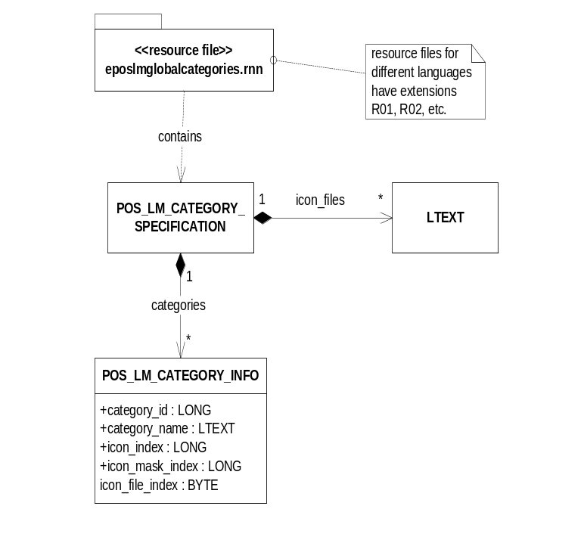
Figure 3.1 Composition of global category resource files
A global category resource file contains only one instance of the POS_LM_CATEGORY_SPECIFICATION structure. This structure consists of a list of icon file names and a list of global categories.
The attribute set for global categories is defined by the POS_LM_CATEGORY_INFO structure. The attributes are:
- Global Category ID: This ID must be unique for each global category. This ID is used in landmark databases to identify a global category.
- Category name: Each category must have a unique name. The name cannot be an empty string.
- Icon index: Refers to an icon in an icon file. If no icon is specified, this attribute is set to KPosLMCategoryNoIcon.
- Mask index: Refers to an icon mask in an icon file. An icon mask enables transparent backgrounds for icons. If no icon mask is specified, this attribute is set to KPosLMCategoryNoMask. It is not allowed to specify an icon mask index without specifying an icon index. The icon mask index will then be ignored.
- Icon file index: Refers to the list of icon file names defined in the resource file. Zero represents the first icon file in the list.

Usage

Protocol
This section describes how to use Landmarks Category Definition API to define global categories for the Landmarks subsystem.
To define global categories the developer has to produce the following items:
- An HRH file containing an enumeration for the global category IDs.
- LOC files for each language that is supported.
- An HRH file, which checks the compiler flags to control which LOC file is included.
- eposlmglobalcategories.rss, which contains the global category structures.

Each of these items is discussed in the sections below.
Sections are also dedicated to resource compilation and installation issues.

Global category ID enumeration
The Landmarks API clients must be able to recognize the global categories. To enable this, an HRH file must be published in the SDK where constants for the available global category IDs are defined.
The HRH file only has to define an enumeration, which lists the global categories. The enumeration values must be unique within the category enumeration.
Note: The global ID must always be a non-zero positive number.
Landmarks Category Definition API does not set a requirement for the name of the HRH file.

Localization files
For each supported language, a localization file must be created. A localization file defines constants for the attributes that should be localized. The same constants must be defined in all the LOC files, but the values of the constants are adapted for each LOC file.
In the global category resource file, category names can be localized.
Landmarks Category Definition API does not set a requirement for the names of the LOC files.

Localization file selection
Compiler flags control which LOC file to use. The compiler flags for the different languages are defined in Symbian OS.
Pre-compilation macros must be used to include the correct LOC file. This logic should be set in a separate HRH file.
Landmarks Category Definition API does not set a requirement for the name of the HRH file.

Global category resource file
The global category resource file must contain a POS_LM_CATEGORY_SPECIFICATION resource and nothing else, see Section 3.2.
The resource file includes the category enumeration HRH file (see Section 3.3.1.1) and uses the enumeration values to specify global category IDs.
The resource file includes the LOC file selection HRH file (see Section 3.3.1.3) and uses the constants defined in the LOC files to specify the names for the global categories.
The global category resource file must have the name eposlmglobalcategories.rss.

Resource compilation
The preferred way to compile the global category resource files is to define an MMP file and then use the Symbian OS project build tools. In the MMP file, the supported languages can be specified using the lang statement. See reference document [2] for further MMP file syntax description.
One resource file is generated for each supported language. They have RNN extensions, where NN is a two-digit number representing the language.
Note: An MMP file must define a target. It is therefore necessary to use some dummy source code to be able to compile the resource files.

Resource file installation
The compiled resource files must be installed under \Resource\ on the device. The drive does not matter, but drives will be searched by the system in the following order: Z:, then C:, D: and so on up to Y: as defined in reference document [2].

Error handling
If the definition of the global category resource file does not follow the rules in this document, the Landmarks subsystem may not start. Take special care to follow the rules below:
- The global IDs must be unique non-zero positive numbers.
- Within one language, global category names must be unique. The name cannot be an empty string.
- The icon file index must point to an item in the icon file list; that is, it must be larger than or equal to 0 and strictly less than the number of icon files in the list.

Memory overhead
Runtime memory is not an issue for resource files but the files are installed on the device and have a memory footprint. Also, it is important to realize that the contents are copied into the landmark databases in the terminal and add to their footprint.

Extensions to the API
Landmarks Category Definition API does not have any extension points.

Example
This section shows how to define localized global categories. The example defines three categories: Restaurant, Gas station and Hotel. English and German languages are supported.

Global category ID enumeration
First, IDs for the categories must be defined. The following enumeration is defined in eposlmcategories.hrh. The file name does not matter.

enum TPosLmCategories
{
EPosLmCatRestaurant = 1, // ID cannot be zero
EPosLmCatGasStation,
EPosLmCatHotel
};

Localization files
Next, the localized data must be defined. Constants are defined for the category names. One LOC file is created for the English language and one is created for the German language:
eposlmcategories_uk.loc

#define qtn_poslm_restaurant "Restaurant"

#define qtn_poslm_gasstation "Gas station"

#define qtn_poslm_hotel "Hotel"

eposlmcategories_ge.loc

#define qtn_poslm_restaurant "Gaststätte"

#define qtn_poslm_gasstation "Tankstelle"

#define qtn_poslm_hotel "Hotel"

Localization file selection
An HRH file is needed where the language pre-compilation flags are checked:
eposlmcatlanguages.hrh:

#ifdef LANGUAGE_01 // UK English - 01
#include "eposlmcategories_uk.loc"
#elif LANGUAGE_03 // German - 03
#include "eposlmcategories_ge.loc"
#endif

Global category resource file
Now, the resource file can be created. This file must have the name eposlmglobalcategories.rss:

#include <uikon.rh>
#include <epos_lmcatdef.rh>
#include "eposlmcatlanguages.hrh"
#include "eposlmcategories.hrh"

RESOURCE POS_LM_CATEGORY_SPECIFICATION glcategories
{
icon_files =
{
"c:\\resource\\lmcaticons.mbm"
};

categories =
{
POS_LM_CATEGORY_INFO
{
category_id = EPosLmCatRestaurant;
category_name = qtn_poslm_restaurant;
icon_index = 2;
icon_mask_index = 3;
icon_file_index = 0;
},
POS_LM_CATEGORY_INFO
{
category_id = EPosLmCatGasStation;
category_name = qtn_poslm_gasstation;
icon_index = 4;
icon_file_index = 0;
},
POS_LM_CATEGORY_INFO
{
category_id = EPosLmCatHotel;
category_name = qtn_poslm_hotel;
icon_index = 1;
icon_file_index = 0;
}
};
}

Resource compilation
To compile the resource file, a project is needed. An MMP file is created:

TARGET dummy.dll
TARGETTYPE dll
UID 0x1000008d 0x01abcdef

CAPABILITY NONE

// We need a dummy main source to be able to create a DLL.
SOURCE DummyMain.cpp

START RESOURCE eposlmglobalcategories.rss
TARGETPATH \Resource
END

USERINCLUDE .

SYSTEMINCLUDE \Epoc32\Include
SYSTEMINCLUDE \Epoc32\Include\Oem

LIBRARY euser.lib

// Supported languages.
LANG 01 03

LANG 01 03 specifies that the languages, UK English and German are compiled.
Some dummy code is needed to be able to compile the project, DummyMain.cpp:

#include <e32std.h>

EXPORT_C void Dummy() {}

When the project is built, the resource files eposlmglobalcategories.r01 and eposlmglobalcategories.r03 are created.
dummy.dll should be removed since it is not needed.

Resource file installation
See Section 3.3.1.6. dummy.dll should not be installed.

Detailed description

Code architecture
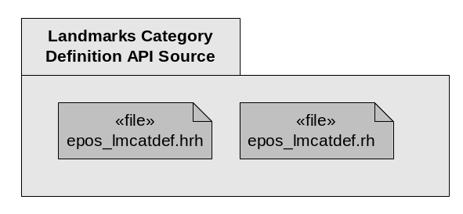
Figure 3.2 Files needed by the Landmarks Category Definition API user
The necessary structures for defining a global category resource file are defined in epos_lmcatdef.hrh and epos_lmcatdef.rh.

