S60 3.x
Landmarks Client Library
Design Document

Team name | Author
Location | Sergey Burnevsky

Change history:

Version | Date | Status | Comments
3.0 | 27.08.2007 | Approved | Editorial changes.
2.0 | 18.11.2005 | Approved | Serialization support information added.
1.0 | 12.07.2005 | Approved

Table of contents:

1. Document control 4
1.1 References 4
1.2 Documentation conventions 4
1.3 Abbreviations 4
1.4 Definitions 4
2. General 6
2.1 Introduction 6
2.2 Component environment 6
2.3 Services required 8
2.3.1 From the Symbian OS subsystems 8
2.3.2 From the Domestic OS subsystems 8
2.3.3 From HW 8
2.4 Services provided 8
2.4.1 UI 8
2.4.2 SW IF 9
3. Design 10
3.1 Class diagrams 10
3.1.1 Component 10
3.2 Class descriptions 11
3.2.1 Structs, type definitions and enumerations 12
3.2.1.1 epos_landmarks.h 12
3.2.1.2 epos_landmarkserrors.h 13
3.2.1.3 epos_cposlandmark.h 13
3.2.1.4 epos_cposlandmarkcategory.h 13
3.2.1.5 epos_cposlandmarkdatabase.h 13
3.2.1.6 epos_tposlmsortpref.h 13
3.2.1.7 epos_cposlmcategorymanager.h 14
3.3 Operations 14
3.3.1 Opening the default landmark database 14
3.3.2 Opening a landmark database by URI 14
3.3.3 Creating a category manager 15
3.3.4 Creating a landmark encoder 16
3.3.5 Creating a landmark parser 17
3.3.6 Packing a landmark 17
3.3.7 Unpacking a landmark 18
3.3.8 Packing a landmark category 19
3.3.9 Unpacking a landmark category 19
3.4 Backup and Restore 20
4. Variation 21
5. System resource usage 22
5.1 File structures 22
5.2 Database structures 22
5.3 Timers and active objects 22
6. Security 23
6.1 Capabilities of this component 23
6.2 Input and output validation 23
6.3 Environmental assumptions 23
6.4 Additional enforcements 23
7. Exception handling 24
8. Usage 25

Document control

References
- S60 3.0 Landmarks Subsystem Architecture Description
- S60 Landmarks Subsystem Design Document
- S60 Landmarks Exchange Format Specification Document
- S60 Landmarks API Specification Document
- S60 Landmarks Search API Specification Document

Documentation conventions
Code is shown with the Courier New font.

Abbreviations
API | Application Programming Interface
DBMS | Database Management System
DLL | Dynamic Link Library
MBM | Multiple Bitmap file format
MIME | Multipurpose Internet Mail Extensions
MLFW | Mobile Location Framework
OS | Operating System
XML | Extensible Markup Language

Definitions
Corrupt database | A database that has become invalid and cannot be opened.
Damaged database | A database may be damaged when a transaction fails or is canceled. A damaged database can be recovered by initialization.
DBMS | Database Management System. A commonly used term for the Symbian OS database engine.
ECom | Symbian OS framework for plug-in DLLs.
Framework | Usually denotes the collection of an engine and associated programming interfaces. This document mentions the Mobile Location Framework and the Symbian OS ECom Framework. There is also a subsystem in Symbian OS called Application Framework.
Landmark | A landmark is a named object that contains a location. The location can be defined by various attributes, for example WGS84 coordinates or a textual address.
Landmark category | A landmark can be categorized by assigning a landmark category to it. A typical landmark category is “Restaurant”. A landmark category is often referred to as “category”.
Landmark collection | A group of landmarks encoded according to reference document [3].
Landmark database | Persistent storage of a collection of landmarks and landmark categories.
Platform Security | Definition for security design principles and features in Symbian OS.
Recognizer | Plug-in code that can examine sample data. If the data is recognized, its data type is returned. A data type is also commonly known as a MIME type.

General
This document describes the Landmarks Client Library component in the Landmarks subsystem. The Landmarks subsystem design including general design guidelines for Landmark components is described in reference document [2]. The architecture is described in reference document [1].
Landmarks Client Library is available from S60 release 3.0 onwards.

Introduction
Landmarks Client Library publishes the interfaces needed to access landmark databases. The actual implementation is provided by ECom plug-ins, which implement the database access. The effect is that Landmarks Client Library is relatively small and functionality can be added or removed at run-time.
The responsibilities and additional requirements of Landmarks Client Library are the following:
- Defines the basic data classes needed for landmark management.
- Loads the components, which realize the services defined by Landmarks API (see reference document [4]).
- A landmark can contain generic position text fields.

Component environment
Figure 2.1 and Figure 2.2 show the components in the Landmarks subsystem.
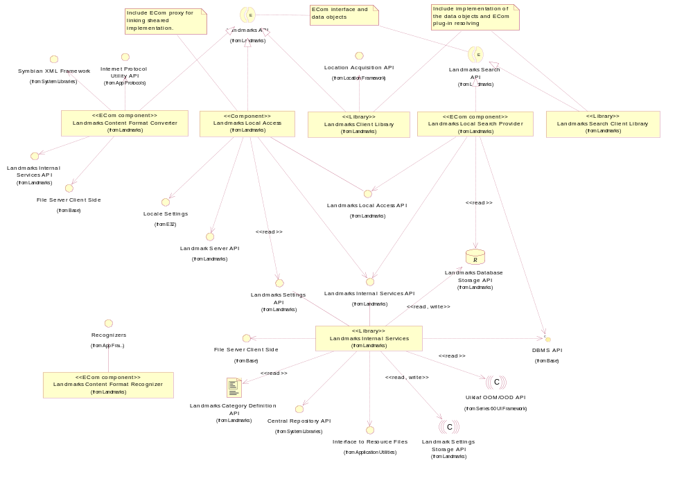
Figure 2.1 Basic Landmarks component diagram
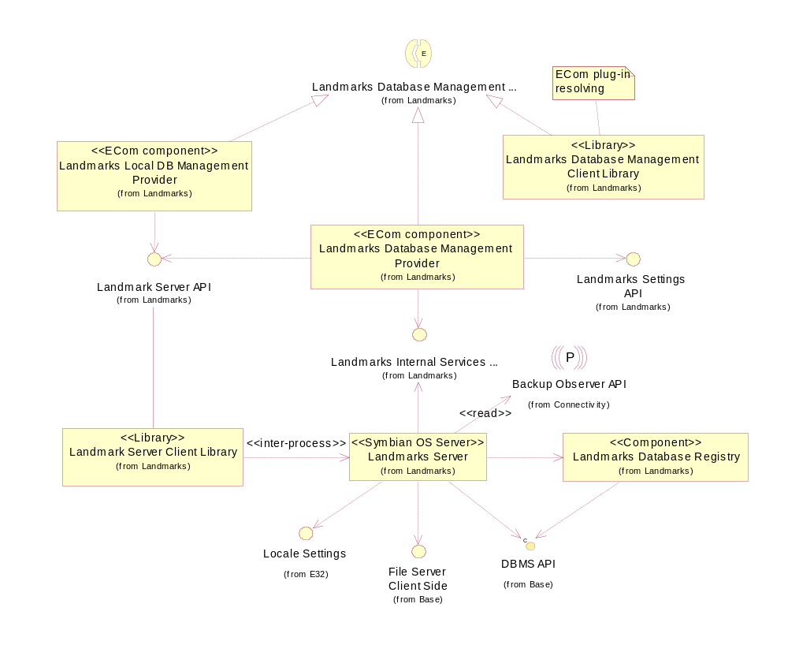
Figure 2.2 Database management component diagram

Services required

From the Symbian OS subsystems
API | Description
ECom Plug-in Architecture | Used to load Landmarks API implementations, e.g. Landmarks Local Access and Landmarks Content Format Converter.

From the Domestic OS subsystems
This component does not have any direct interfaces to the Domestic OS side subsystems.

From HW
This component has no direct HW interfaces.

Services provided

UI
This component does not provide any UI.

SW IF
Provided Service | Description | Protected
Landmarks API. | Landmarks Client Library provides Landmarks API. | Yes.

Design

Class diagrams

Component
This section describes the design of the Landmarks Client Library component.
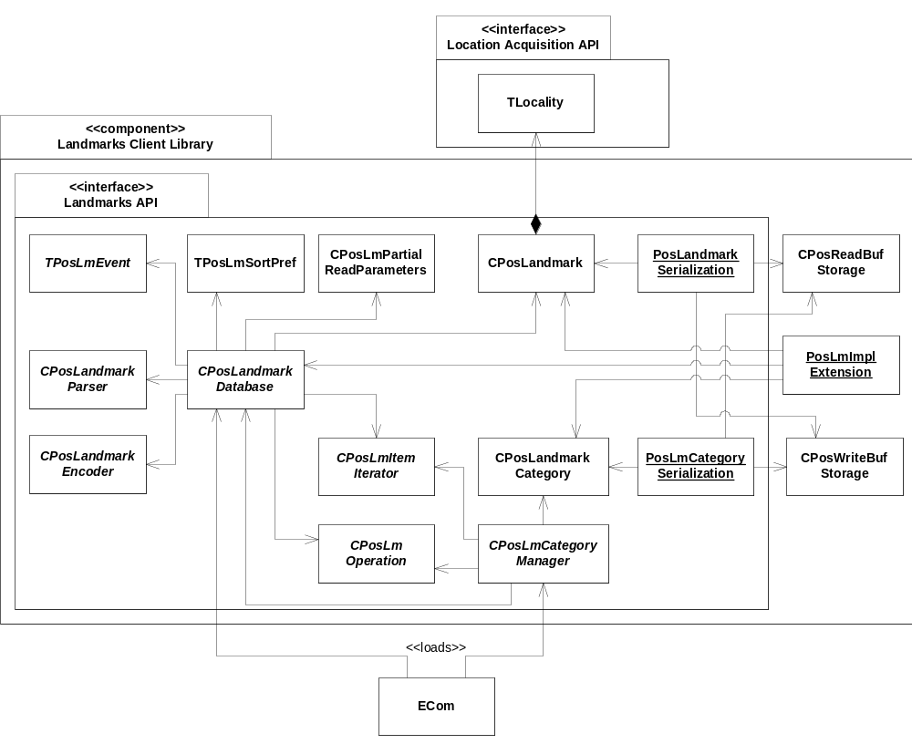
Figure 3.3 Landmarks Client Library component class diagram

Class descriptions
Class | Description | Header file
CPosLandmark | A part of Landmarks API.  This container class contains information about a landmark. It can either be created by clients or retrieved from CPosLandmarkDatabase.  The position of the landmark is stored in TLocality. | EPos_CPosLandmark.h
CPosLandmark  Category | A part of Landmarks API.  This container class contains information about a landmark category. It can either be created by clients or retrieved from CPosLmCategoryManager. | EPos_CPosLandmarkCategory.h
CPosLmPartialReadParameters | A part of Landmarks API.  This container class contains information about partial landmark settings. Partial settings are used to define which landmark data should be returned when calling CPosLandmarkDatabase::ReadPartialLandmarkLC(). | EPos_CPosLmPartialReadParameters.h
TPosLmSortPref | A part of Landmarks API.  This container class specifies sort preference. A sort preference object can be passed to CPosLandmarkDatabase::LandmarkIteratorL() to specify a sort order for the returned landmark iterator. Landmark sorting is not case sensitive. | EPos_TPosLmSortPref.h
CPosLmCategory  Manager | A part of Landmarks API.  This abstract base class enables category management for a landmark database.  An implementation of this class is loaded by ECom Framework. | EPos_CPosLmCategoryManager.h
CPosLandmark  Database | A part of Landmarks API.  This abstract base class provides a handle to a landmark database and enables landmark management.  An implementation of this class is loaded by ECom Framework.  Note: The database class is used as input to other classes (e.g. CPosLmCategory  Manager). An instance of this class should therefore not be deleted until all the dependent objects of this class have been deleted. | EPos_CPosLandmarkDatabase.h
TPosLmEvent | A part of Landmarks API.  TPosLmEvent is a struct for landmark database event details. Consists of an event type describing what database change occurred and optionally an item ID, describing which item (landmark or category) was changed. | EPos_Landmarks.h
CPosLmOperation | A part of Landmarks API.  This abstract base class provides a handle to a long running landmark operation that can be run either synchronously or asynchronously. | EPos_CPosLmOperation.h
CPosLmItem  Iterator | A part of Landmarks API.  This is an abstract base class for objects, which iterate a set of database items in a single database. | EPos_CPosLmItemIterator.h
PosLmImpl  Extension | A Landmarks subsystem internal class.  A class containing static exported functions needed by the implementation of components in the Landmarks subsystem. | EPos_PosLmImplExtension.h
CPosLandmark  Encoder | A part of Landmarks API.  This abstract base class provides a handle to a landmark encoder and enables conversion of landmarks and landmark categories into an exchange format (see reference document [3]).  An implementation of this class is loaded by the ECom Framework. | EPos_CPosLandmarkEncoder.h
CPosLandmark  Parser | A part of Landmarks API.  This abstract base class provides a handle to a landmark parser and enables decoding of landmarks and landmark categories from an exchange format (see reference document [3]).  An implementation of this class is loaded by ECom Framework. | EPos_CPosLandmarkParser.h
PosLandmark  Serialization | A part of Landmarks API since S60 3.1.  This class contains helper methods for landmark serialization. A landmark can be packed into a buffer and unpacked back. | EPos_PosLandmarkSerialization.h
PosLmCategory  Serialization | A part of Landmarks API since S60 3.1.  This class contains helper methods for category serialization. A landmark can be packed into a buffer and unpacked back. | EPos_PosLmCategorySerialization.h
CPosReadBuf  Storage | Supports reading data elements from fixed-size buffer. Its methods check for boundaries of source and destination and leave if boundaries may be violated.  (since S60 3.1.) | EPos_CPosReadBufStorage.h
CPosWriteBuf  Storage | Supports writing data elements to fixed-size buffer. Its methods check for boundaries of source and destination and leave if boundaries may be violated.  (since S60 3.1.) | EPos_CPosWriteBufStorage.h

Structs, type definitions and enumerations

epos_landmarks.h
Definition name | Description
TPosLmItemId | Identifies landmarks and landmark categories in a landmark database.
TPosLmGlobalCategory | Identifies global categories.
Enumeration name | Description
TPosLmCollectionDataId | Identifies landmark collection attributes. Used in landmark messaging.
TPosLmEventType | Specifies what type of event has occurred.
Struct name | Description
TPosLmEvent | A struct for landmark database change event details.

epos_landmarkserrors.h
Enumeration name | Description
TPositionLandmarksClientPanic | Landmarks panic codes.

epos_cposlandmark.h
Definition name | Description
CPosLandmark::TAttributes | This type definition is used to specify one or several landmark attributes.
Enumeration name | Description
CPosLandmark::_TAttributes | Enumerates the available landmark attributes, e.g. landmark name, position, description, etc.

epos_cposlandmarkcategory.h
Definition name | Description
CPosLandmarkCategory::TAttributes | This type definition is used to specify one or several landmark category attributes.
Enumeration name | Description
CPosLandmarkCategory::_TAttributes | Enumerates the available landmark category attributes, e.g. category name and category icon.

epos_cposlandmarkdatabase.h
Definition name | Description
CPosLandmarkDatabase::TTransferOptions | Used to specify a number of options for importing and exporting landmarks.
Enumeration name | Description
CPosLandmarkDatabase::_TTransferOptions | Enumerates options for importing and exporting landmarks.
Struct name | Description
CPosLandmarkDatabase::TSize | Encapsulates size information for a landmark database.

epos_tposlmsortpref.h
Enumeration name | Description
TPosLmSortPref::TPosLmSortPref | Specifies the sort order, i.e. ascending and descending.

epos_cposlmcategorymanager.h
Enumeration name | Description
CPosLmCategoryManager::TCategorySortPref | Specifies the sort preference for landmark categories, i.e. ascending, descending or no sort.

Operations

Opening the default landmark database
Operation | Opening the default landmark database.
Preconditions
Description | Opens the default database by using ECom to load the proper implementation of the landmark database (ECom plug-in).
Inputs
Modifies | Creates the default landmark database if it does not exist.
Outputs | A handle to the open database.
Postconditions | The default database is opened. If it did not exist, it has been created.
Related To | CPosLandmarkDatabase.
Related Event
Exceptions | If the proper implementation of the landmark database (ECom plug-in) is not installed, this operation leaves with KErrNotSupported.

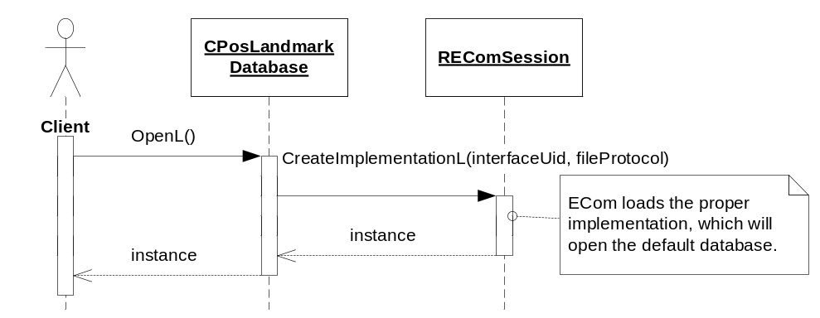
Figure 3.4 Opening the default landmark database

Opening a landmark database by URI
Operation | Opening a landmark database by URI.
Preconditions | The landmark database exists.
Description | Opens a landmark database by using ECom to load the proper implementation of the landmark database (ECom plug-in).
Inputs
Modifies
Outputs | A handle to the open database.
Postconditions | The database is opened.
Related To | CPosLandmarkDatabase.
Related Event
Exceptions | If the proper implementation of the landmark database (ECom plug-in) is not installed, this operation leaves with KErrNotSupported.

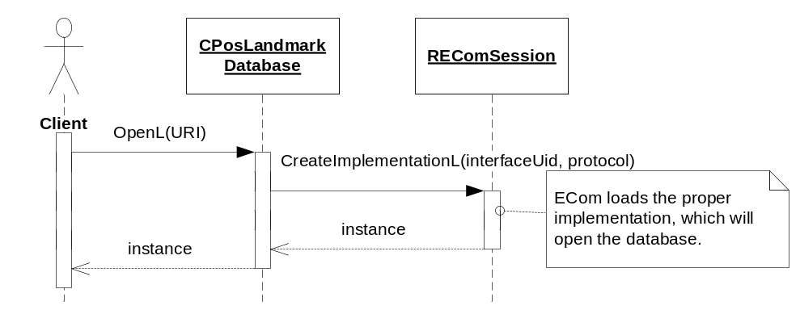
Figure 3.5 Opening a landmark database by URI

Creating a category manager
Operation | Creating a category manager.
Preconditions | A landmark database is opened.
Description | Creates a category manager that can be used for managing categories in a landmark database.
Inputs | A landmark database.
Modifies
Outputs | A handle to the category manager.
Postconditions
Related To | CPosLmCategoryManager.
Related Event
Exceptions | If the proper implementation of the landmark category manager (ECom plug-in) is not found, this operation leaves with KErrNotFound.

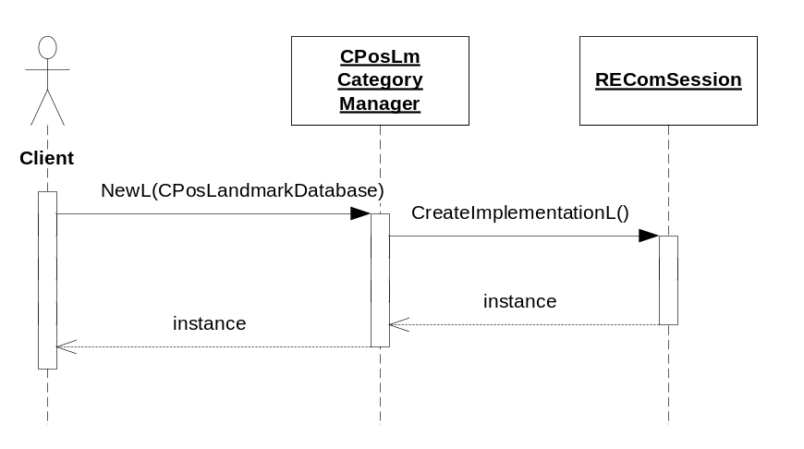
Figure 3.6 Creating a category manager

Creating a landmark encoder
Operation | Creating a landmark encoder.
Preconditions
Description | Creates a landmark encoder that can be used for encoding landmarks and landmark categories into an exchangeable format.
Inputs | A MIME type that specifies the format.
Modifies
Outputs | A handle to the landmark encoder.
Postconditions
Related To | CPosLandmarkEncoder.
Related Event
Exceptions | If the implementation of the landmark encoder (ECom plug-in) is not found, this operation leaves with KErrNotFound.

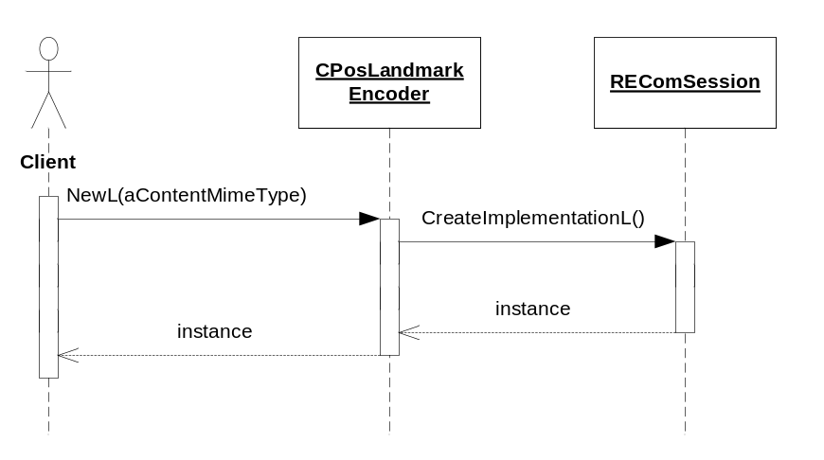
Figure 3.7 Creating a landmark encoder

Creating a landmark parser
Operation | Creating a landmark parser.
Preconditions
Description | Creates a landmark parser that can be used for decoding landmarks and landmark categories from an exchangeable format.
Inputs | A MIME type that specifies the format.
Modifies
Outputs | A handle to the landmark parser.
Postconditions
Related To | CPosLandmarkParser.
Related Event
Exceptions | If the implementation of the landmark parser (ECom plug-in) is not found, this operation leaves with KErrNotFound.

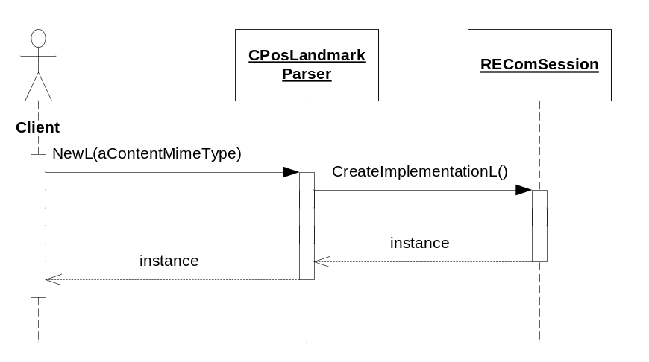
Figure 3.8 Creating a landmark parser

Packing a landmark
Operation | Packing a landmark into buffer.
Preconditions
Description | Packs landmark’s data into flat buffer for further serialization.
Inputs | A landmark.
Modifies
Outputs | A pointer to buffer.
Postconditions
Related To | CPosLandmark, PosLandmarkSerialization, CPosBufWriteStorage.
Related Event
Exceptions

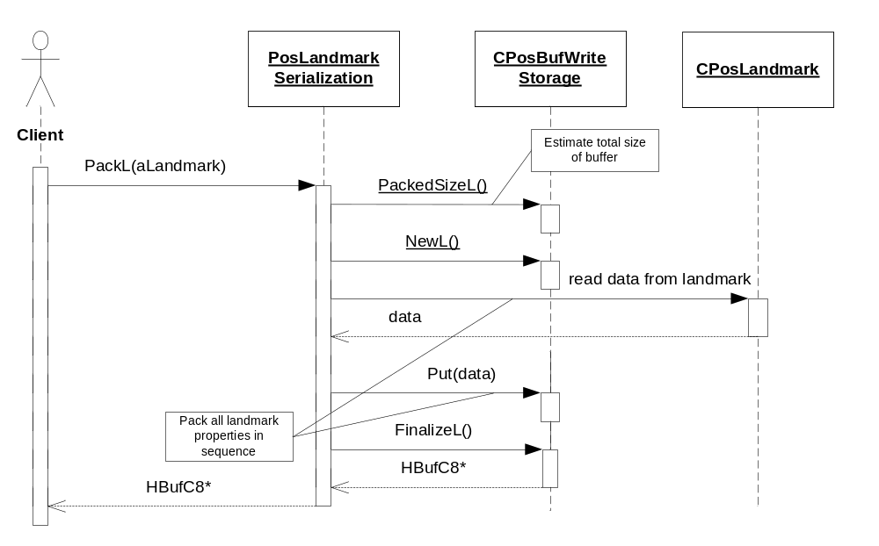
Figure 3.9 Packing a landmark

Unpacking a landmark
Operation | Unpacking a landmark from buffer.
Preconditions
Description | Unpacks landmark’s data from flat buffer and creates new CPosLandmark instance.
Inputs | A buffer descriptor.
Modifies
Outputs | A landmark.
Postconditions
Related To | CPosLandmark, PosLandmarkSerialization, CPosBufReadStorage.
Related Event
Exceptions

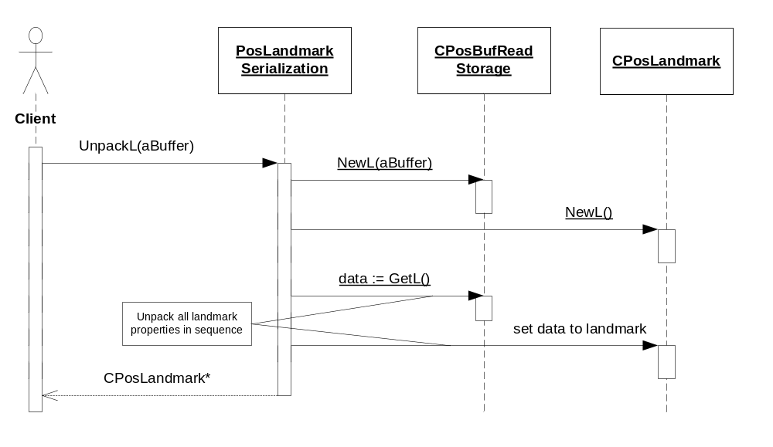
Figure 3.10 Packing a landmark

Packing a landmark category
Operation | Packing a landmark category into buffer.
Preconditions
Description | Packs landmark category data into flat buffer for further serialization. The sequence diagram for the operation is similar to that of Packing a landmark.
Inputs | A landmark category.
Modifies
Outputs | A pointer to buffer.
Postconditions
Related To | CPosLandmarkCategory, PosLandmarkSerialization, CPosBufWriteStorage.
Related Event
Exceptions

Unpacking a landmark category
Operation | Unpacking a landmark category from buffer.
Preconditions
Description | Unpacks landmark category data from flat buffer and creates new CPosLandmarkCategory instance. The sequence diagram for the operation is similar to that of Unpacking a landmark.
Inputs | A buffer descriptor.
Modifies
Outputs | A landmark category.
Postconditions
Related To | CPosLandmarkCategory, PosLandmarkSerialization, CPosBufReadStorage.
Related Event
Exceptions

Backup and Restore
The policies for Backup and Restore are described in reference document [2].

Variation
Variation for the Landmarks subsystem is described in reference document [2].

System resource usage

File structures
Landmarks Client Library does not use any files.

Database structures
Landmarks Client Library does not use any databases.

Timers and active objects
Landmarks Client Library does not use any timers or active objects.

Security

Capabilities of this component
Capability | Justification
CAP_CLIENT_DLL | The DLL is a client side library and it must have all the capabilities that a potential client may have.

Input and output validation
This component performs input data checking as protection from client bugs, but since it is purely done on the client side, it is not protection against malicious clients. This protection must be provided at process borders where the data is used, but this is not the responsibility of this component.

Environmental assumptions
This component does not make any assumptions about its environment.

Additional enforcements
This component does not have any additional security enforcements.

Exception handling
The Symbian OS panic and leave mechanism are used to handle memory exhaustion and other system-wide error codes that appear upon execution. The leave mechanism is also used for telling whether implementations loaded by ECom Framework are present or not.

Panics | Description
EPosInvalidPositionFieldId | This panic is raised if a client has specified a position field ID that is invalid for the landmark.
EPosNoneOrMultipleLandmark  AttributeSet | This panic is raised if a client has specified none or multiple landmark attributes.
EPosSpecifiedIntervalLies  OutsideIteratedSet | This panic is raised if a client has specified an interval that lies partially outside the iterated set.
EPosNaNCoordinate | This panic is raised if a client has specified a coordinate with latitude and/or longitude set to NaN.
EPosInvalidLandmarkAttribute | This panic is raised if a client has specified a landmark attribute that is invalid.
EPosInvalidValueSpecifiedIn  ResourceFile | This panic is raised if an invalid value has been detected in a resource file.
EPosInvalidPartialRead  Parameters | This panic is raised if the partial landmark parameters are invalid.
EPosInvalidRequestedPositionFields | This panic is raised if the requested position fields are invalid.
EPosNegativeValue | This panic is raised when a negative value has been detected when not allowed.
EPosInvalidOperationMode | This panic is raised if a client has made an invalid operation call. This is caused by mixed calls to NextStep() or ExecuteL() for a CPosLmOperation object, or subsequent calls to NextStep() if the previous call was not completed.
EPosInvalidEnumValue | This panic is raised when an invalid enumeration value has been detected.
EPosLmProtocolBreak | This panic is raised when the protocol of CPosLandmarkEncoder/CPosLandmarkParser is not followed.
EPosLmInvalidArgument | This panic is raised when an invalid argument has been detected.
EPosInvalidIndex | This panic is raised if a client has specified an invalid index.
EPosInvalidItemType | This panic is raised if a client has specified an invalid item type.
EPosSearchOperationInUse | This panic is raised if a client tries to set/unset display data during an ongoing search. Used by Landmarks Search API (see reference document [5]).

Usage
Usage is described at the subsystem level in reference document [2].

