S60 5.x
Landmarks Content Format Converter
Design Document

Team name | Author
Location CF/TietoEnator | Stefan Folkesson
 | Magnus Gustafson
 | Katharina Augustsson
SP SWD SSW Location | Sergey Burnevsky

Change history:

Version | Date | Status | Comments
4.0 | 10.06.2009 | Approved | Added support for URL parsing & encoding
3.0 | 26.09.2008 | Approved | Added Support for KML/KMZ format
2.0 | 10.05.2007 | Approved | Added support for GPX format
1.0 | 12.07.2005 | Approved

Table of contents:

1. Document control 4
1.1 References 4
1.2 Documentation conventions 4
1.3 Abbreviations 4
1.4 Definitions 4
2. General 6
2.1 Introduction 6
2.2 Component environment 9
2.3 Services required 10
2.3.1 From the Symbian OS subsystems 10
2.3.2 From the Domestic OS subsystems 10
2.3.3 From HW 10
2.4 Services provided 10
2.4.1 UI 10
2.4.2 SW IF 11
3. Design 12
3.1 Class diagrams 12
3.1.1 Component 12
3.2 Class descriptions 12
3.2.1 Structs, type definitions and enumerations 15
3.2.1.1 epos_tposlmconvoperationstatus.H 15
3.2.1.2 epos_cposlmxmlparser.H 15
3.3 Operations 15
3.3.1 Encoding a landmark to a file 15
3.3.2 Encoding a landmark and a category to a buffer 17
3.3.3 Encoding a landmark to an URL using File Output 19
3.3.4 Encoding a landmark & category to an URL using Buffer Output 21
3.3.5 Parsing landmarks 23
3.4 Backup and Restore 25
4. Variation 26
5. System resource usage 27
5.1 File structures 27
5.2 Database structures 27
5.3 Timers and active objects 27
6. Security 28
6.1 Capabilities of this component 28
6.2 Input and output validation 28
6.3 Environmental assumptions 28
6.4 Additional enforcements 28
7. Exception handling 29
8. Usage 30

Document control

References
- S60 5.0 Landmarks Subsystem Architecture Description
- S60 Landmarks Subsystem Design Document
- S60 Landmarks Exchange Format Specification Document
- GPX format specification | http://www.topografix.com/GPX/1/1/  http://www.topografix.com/gpx_manual.asp
- KML format Specification | http://code.google.com/apis/kml/documentation/kmlreference.html
- Landmarks URL format Specification | Landmarks API Specification – Grammar Definition

Documentation conventions
Code is shown with the Courier New font.

Abbreviations
API | Application Programming Interface
DBMS | Database Management System
DLL | Dynamic Link Library
GPX | GPS Exchange Format
KML | Google Exchange Format
KMZ | Compressed KML file format
MBM | Multiple Bitmap file format
MIME | Multipurpose Internet Mail Extensions
MLFW | Mobile Location Framework
OS | Operating System
XML | Extensible Markup Language
URL | Uniform Resource Locator

Definitions
Corrupt database | A database that has become invalid and cannot be opened.
Damaged database | A database may be damaged when a transaction fails or is cancelled. A damaged database can be recovered by initialization.
DBMS | Database Management System. A commonly used term for the Symbian OS database engine.
ECom | Symbian OS framework for plug-in DLLs.
Framework | Usually denotes the collection of an engine and associated programming interfaces. This document mentions the Mobile Location Framework and the Symbian OS ECom Framework. There is also a subsystem in Symbian OS called Application Framework.
Landmark | A landmark is a named object that contains a location. The location can be defined by various attributes, e.g. WGS84 coordinates or a textual address.
Landmark category | A landmark can be categorized by assigning a landmark category to it. A typical landmark category is “Restaurant”. A landmark category is often referred to as “category”.
Landmark collection | A group of landmarks encoded according to reference document [3].
Landmark database | Persistent storage of a collection of landmarks and landmark categories.
Platform Security | Definition for the security design principles and features in Symbian OS.
Recognizer | Plug-in code that can examine sample data. If the data is recognized, its data type is returned. A data type is also commonly known as a MIME type.
Landmark URL | A URL containing location information. For Eg: “http://www.maps.ovi.com/?la=23.134&lo=120.22&pid=12&n=Placemark”

General
This document describes the Landmarks Content Format Converter component in the Landmarks subsystem. The Landmarks subsystem design including general design guidelines for Landmark components is described in reference document [2]. The architecture is described in reference document [1].
Landmarks Content Format Converter is available from S60 release 3.0 onwards.

Introduction
Landmarks Content Format Converter is an ECom plug-in providing functionality for exchanging landmark content between entities. It features an encoder that converts landmarks and landmark categories into the landmarks exchange format (see reference document [3]) data. A parser also exists to decode landmarks exchange format (further LMX) data into landmarks and landmark categories. Since S60 5.0 it also features parser to decode landmark data encoded in GPX format ( see reference document [4]).
Since S60 release 5.1 it also features parser to decode landmark data encoded in KML/KMZ format ( see reference document [4]).
Since S60 XX there is support to encode a landmark in to an URL and parse an URL to decode it into a landmark.
The Landmarks Content Format Converter component uses the Symbian XML Framework to decode XML files based on the LMX, GPX and KML. A client can therefore receive error codes from this framework if the errors are XML-specific and not associated with the landmarks exchange format.
The following rules are applied when LMX format is handled:
- The coordinatesType/timeStamp and mediaLinkType/name XML tags from the landmarks exchange format are ignored by the Landmarks Content Format Converter component because they are not supported by landmark databases.
- Any content-specific collection meta data added to an encoder is ignored if it is not supported by the landmarks exchange format.
- The encoder always uses the landmarkCollection tag, even if only one landmark was added to it. Hence, the single landmark tag is not used when encoding.
- Position fields from TPositionFieldId that cannot be mapped to a tag in the landmarks exchange format are ignored by the encoder.
- Only media links specified in the format <mime type>/<URL> or <URL> will be encoded (e.g. text/html/http://www.nokia.com or http://www.nokia.com). The MIME type is defined as [string]/[string] and is allowed to be empty.
- Only country codes with a length of two characters will be encoded.
- Decoded strings that exceed the maximum number of allowed characters for the Landmarks subsystem are truncated.
- During parsing, any position containing a longitude or latitude set to NaN will be ignored. NaN is not valid in the Landmarks subsystem.
- Invalid data content will be rejected (e.g. the parser expects a real number, but receives a string).
- Landmarks Content Format Converter supports encoding to vnd.nokia.landmarkcollection+xml only. For parsing, also vnd.nokia.landmark+xml is supported.
The following rules are applied when GPX format is handled:
- Only parser for the format exists.
- The parser does not verify the overall validity of a GPX document: it only checks the hierarchy and correctness of values for supported elements (listed below).
- Versions 1.0 and 1.1 of GPX schema are supported. However the parser does not use all the data from GPX documents. GPX elements are matched to landmark data as listed in the table below. Other elements are ignored.

GPX 1.0 | GPX 1.1 | Description of matching landmark’s data
gpx/name | gpx/metadata/name | landmarks collection name
gpx/desc | gpx/metadata/desc | landmarks collection description
gpx/wpt | gpx/wpt | a landmark
wpt/lat attribute | wpt/lat attribute | latitude part of the landmark’s coordinate
wpt/lon attribute | wpt/lon attribute | – longitude part of the landmark’s coordinate
wpt/ele | wpt/ele | altitude part of the landmark’s coordinate
wpt/name | wpt/name | name of the landmark
wpt/desc | wpt/desc | description of the landmark
wpt/cmt | wpt/cmt | comment standard field EPositioningFieldComment
wpt/url | wpt/link | media links associated with the landmark.  link/href and link/type are combined as described above for LMX format.
wpt/urlname | wpt/link/text | displayable name of the media link
wpt/type | wpt/type | category of the landmark. Used only if importing of categories is enabled by client and creation of new categories is not suppressed.
wpt/hdop | wpt/hdop | Used to estimate horizontal accuracy of the landmark’s coordinate
wpt/vdop | wpt/vdop | Used to estimate vertical accuracy of the landmark’s coordinate

- GPX parser is tied to application/gps+xml MIME type.

The following rules are applied when KML/KMZ format is handled:
- Only parser for the format exists.
- The parser does not verify the overall validity of a KML document: it only checks the hierarchy and correctness of values for supported elements (listed below).
- Versions 2.2 KML schema are supported. However the parser does not use all the data from KML documents. KML elements are matched to landmark data as listed in the table below. Other elements are ignored.
- Landmark name is mandatory field.
- Parsing of the KML/KMZ file will be done only when the file is in the format as defined in document [5]. All the tags in the file should follow syntax defined in the KML reference document.

KML 2.0 | Description of matching landmark’s data
Folder/name Or Document/name | Category of the landmark.  If there is nested folder/document in the KML document, then immediate folder/document name which contains the landmark will be treated as category name.  Used only if importing of categories is enabled by client and creation of new categories is not suppressed.
Placemark | a landmark
Placemark/Point/ coordinates | Comma separated values in order of Latitude, longitude and altitude respectively
Placemark/name | name of the landmark
Placemark/description | description of the landmark
Placemark/phoneNumber | Phone Number
Placemark /Address | Address of the landmark. Comma separated values in order of street, city, postal code/State and country.
Horizontal accuracy | 0
Vertical accuracy | 0

- KML parser is tied to application/vnd.google-earth.kml+xml MIME type.

The following rules are applied for handling of URL format :

- There exists an encoder & a parser for URL format handling.
- The URL has to conform to the grammar as specified in the Landmarks API Specification document under the section URL format specification.[6].
- The latitude & longitude parameters are mandatory location information to be present in the URL.
- Except the cat ( category ) parameter none of the parameters should be repeated in the URL.If repetition occurs then only the first occurrence will be considered.
- The URL can contain the following location parameters :

Location Parameters | Description of matching landmark’s data
pid | Place id for any location as specified by the client.
la | Latitude ( mandatory )
lo | Longitude ( mandatory)
n | Name of landmark
s | Street
sn | House Number
pz | Postal/zip code
c | City
sp | State/province
cr | Country/region
t | Telephone number
w | Web address
cat | Category ( can be repeated to allow a landmark to contain multiple categories)
d | Description
pa | Position accuracy
a | Altitude
aa | Altitude accuracy
v | Speed
h | Heading
ts | timestamp

- The timestamp field should be of the format YYYYMMDD:HHMMSS.MMMMMM indicating the date,time & microseconds(optional).If date field is not present then the timestamp is neither encoded nor parsed whereas if the time is not specified then default value assumed is 0.
- The URL to be parsed can be specified as input in the form of a buffer or file.The file should be a text file containing only the URL.
- The encoded URL can be in the form of an output buffer or an output file containing the encoded URL.
- The Mime type to be used for URL parsing or encoding is the hostname of the URL.Currently there is support only for the host – “ maps.ovi.com”
- Currently there is support for only single landmark encoding & parsing.KErrNotSupported is returned in case of trying to add multiple landmarks during encoding process.During the parsing,if the URL contains multiple landmarks information then the URL is parsed to obtain only a single landmark information & the rest are ignored.

Component environment
Figure 2.1 and Figure 2.2 show the components in the Landmarks subsystem.
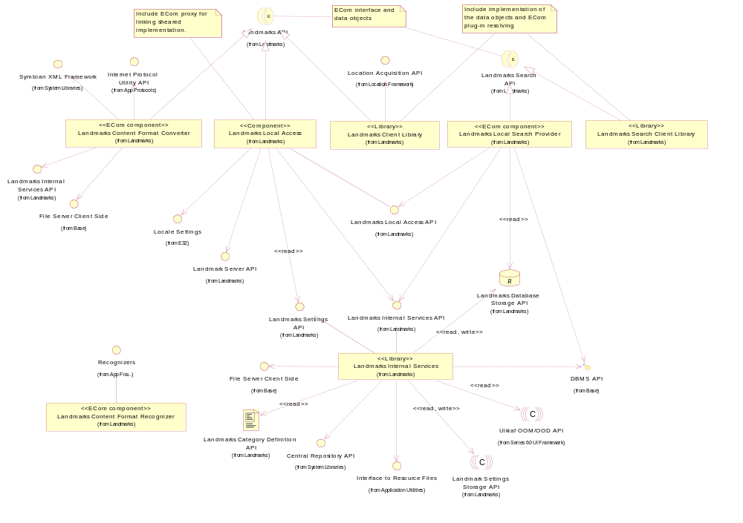
Figure 2.1 Basic Landmarks component diagram
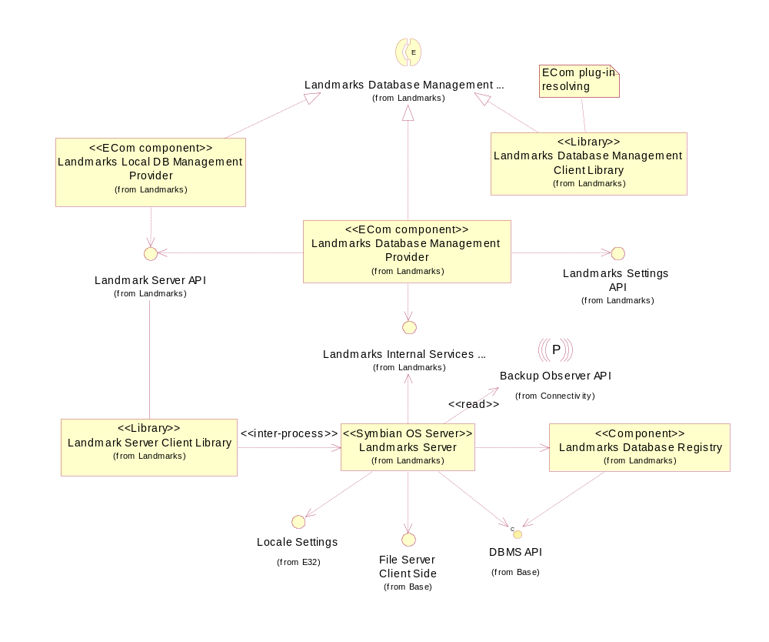
Figure 2.2 Database management component diagram

Services required

From the Symbian OS subsystems
API | Description
ECom Plug-In Architecture | Landmarks Content Format Converter is an ECom component.
File Server Client Side | Used to write to and read from a landmark content file.
Internet Protocol Utility | Used to validate URIs in landmark content.
Symbian XML Framework | Used to read XML-coded landmark content.

From the Domestic OS subsystems
This component does not have any direct interfaces to the Domestic OS side subsystems.

From HW
This component has no direct HW interfaces.

Services provided

UI
This component does not provide any UI.

SW IF
Provided Service | Description | Protected
Landmarks API | Landmarks Content Format Converter implements the conversion base classes in Landmarks API. | Yes, but not the part implemented by this component

Design

Class diagrams

Component
This section describes the design of the Landmarks Content Format Converter component.
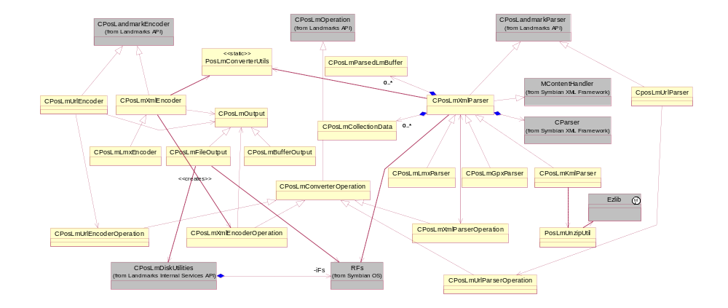
Figure 3.3 Landmarks Content Format Converter component class diagram

Class descriptions
Class | Description | Header file
CPosLmXmlEncoder | This subclass to CPosLandmarkEncoder is used for encoding XML landmark content. It implements format-independent encoding functionality and leaves format-dependent operations on its subclasses.  CPosLmXmlEncoder uses the helper class PosLmConverterUtils to write the landmark content to a CPosLmOutput subclass.  CPosLmXmlEncoderOperation is used for finalizing the encoding. | EPos_CPosLmXmlEncoder.H
CPosLmLmxEncoder | This subclass to CPosLmXmlEncoder is responsible specifically for Landmark Exchange Format (LMX) XML mark-up. It implements format-dependent functionality of its parent. | epos_cposlmlmxencoder.h
CPosLmOutput | This abstract base class provides a handle to RWriteStream and is used to write the encoder output. | EPos_CPosLmOutput.H
CPosLmFileOutput | This CPosLmOutput subclass is used to write encoder output to a file.  CPosLmFileOutput uses RFs and RFileWriteStream for creating the output file.  CPosLmFileOutput uses CPosLmDiskUtilities to handle a low disk situation. If such a situation appears, the class member functions will leave with KErrDiskFull. | EPos_CPosLmFileOutput.H
CPosLmBuffer  Output | This CPosLmOutput subclass is used to write encoder output to a buffer.  CPosLmBufferOutput uses CBufBase and RBufWriteStream for creating the output buffer. | EPos_CPosLmBufferOutput.H
CPosLmConverter  Operation | An abstract subclass to CPosLmOperation from Landmarks API.  This class implements the virtual functions of its base class. The code for these functions is the same for all operations that can be executed in small synchronous steps.  A subclass to CPosLmConverterOperation needs to implement a synchronous NextStepL() function, which performs one small synchronous step of the operation.  A client using an operation can execute it either synchronously or asynchronously. | EPos_CPosLmConverterOperation.H
CPosLmXmlEncoder  Operation | A subclass to CPosLmConverterOperation that provides functionality for finalizing an encoder.  When CPosLmXmlEncoderOperation is created, it takes ownership of CPosLmOutput. | EPos_CPosLmXmlEncoderOperation.H
CPosLmXmlParser  Operation | A subclass to CPosLmConverterOperation that provides functionality for parsing an XML file with landmarks content format.  CPosLmXmlParserOperation uses CPosLmXmlParser to parse the content stepwise. | EPos_CPosLmXmlParserOperation.H
CPosLmXmlParser | This subclass to CPosLandmarkParser is used for parsing XML landmark content. It implements format-independent parsing functionality and leaves format-dependent operations on its subclasses.  CPosLmXmlParser uses the Symbian XML Framework to parse XML files by implementing the Xml::MContentHandler interface and by using Xml::CParser.  This class also uses the helper class PosLmConverterUtils and the container classes CPosLmCollectionData and CPosLmParsedLmBuffer.  CPosLmXmlParser uses RFs and RFile (not shown) for handling the input file. | EPos_CPosLmXmlParser.H
CPosLmLmxParser | This subclass to CPosLmXmlParser is responsible specifically for Landmark Exchange Format (LMX) XML mark-up. It implements format-dependent parsing functionality of its parent. | epos_cposlmlmxparser.h
CPosLmGpxParser | This subclass to CPosLmXmlParser is responsible specifically for GPS Exchange format (GPX) XML mark-up. It implements format-dependent parsing functionality of its parent. | epos_cposlmgpxparser.h
CPosLmKmlParser | This subclass to CPosLmXmlParser is responsible specifically for Goolge Exchange format (KML/KMZ) XML mark-up. It implements format-dependent parsing functionality of its parent. | epos_cposlmkmlparser.h
PosLmConverter  Utils | This class defines helper methods for using strings/URIs, Unicode conversions, etc. | EPos_PosLmConverterUtils.H
CPosLmCollection  Data | This class is used for holding collection data information while parsing a Landmark XML file to a landmark(s). | EPos_CPosLmCollectionData.H
CPosLmParsedLm  Buffer | This class is used for holding landmarks and landmark categories while parsing a Landmark XML file to a landmark(s). | EPos_CPosLmParsedLmBuffer.H
PosLmUnzipUtil | This class defines helper methods for extracting data from compressed(zip) file. | Epos_CposLmUnzipUtil.h
CPosLmUrlEncoder | This is derived from CPosLandmarkEncoder and is used for encoding landmark content to an URL.  CPosLmUrlEncoder uses CPosLmOutput subclass to write the encoded output.  CPosLmUrlEncoderOperation is used for finalizing the encoding. | epos_cposlmurlencoder.h
CPosLmUrlEncoderOperation | This is derived from CPosLmConverterOperation and provides functionality for finalizing encoding of an URL.  When CPosLmUrlEncoderOperation is created, it takes ownership of CPosLmOutput | epos_cposlmurlencoderoperation.h
CPosLmUrlParser | This is derived from CPosLandmarkParser and is used for parsing an URL and decoding it to a landmark.  CPosLmUrlParser uses CPosLmUrlParserOperation to execute the parsing operation. | epos_cposlmurlparser.h
CPosLmUrlParserOperation | This is derived from CPosLmConverterOperation and provides functionality for executing the parsing of an URL. | Epos_cposlmurlparseroperation.h

Structs, type definitions and enumerations

epos_tposlmconvoperationstatus.H
Enumeration name | Description
TPosLmConvOperationStatus | Enumerates the different states of the parser and encoder operations.

epos_cposlmxmlparser.H
Enumeration name | Description
TLmXmlParserState | Enumerates the states of the landmarks format parser.
TXmlParserElementState | Enumerates the states of reading an element in the landmarks format parser.

Operations

Encoding a landmark to a file
Operation | Encoding a landmark to a xml based file.
Preconditions
Description | Creates an encoder, writes the landmark content to the encoder and finalizes the encoder.  Encoding is done incrementally so that each landmark is directly written to the output file (or buffer). When all the landmarks have been added, the client calls FinalizeEncodingL to close all the XML tags.
Inputs | The name of the file, a landmark object.
Modifies
Outputs | A file containing the encoded content.
Postconditions | The chosen landmark has been written to the encoder file.
Related to | CPosLmXmlEncoder, CPosLmFileOutput, RFileWriteStream, CPosLmXmlEncoderOperation, CPosLmDiskUtilities
Related event
Exceptions | Leaves with KErrAlreadyExists if there already is a file with the specified name and KErrDiskFull if the operation is estimated to go below the critical disk level. Panics with EPosLmProtocolBreak if the call sequence specified in the API is not followed.

Instead of CPosLmXmlEncoder object shown on the diagram below, one of its derivatives is instantiated based on the exact format type. In S60 5.0 it is always CPosLmLmxEncoder, which handles Landmarks Exchange format mark-up.
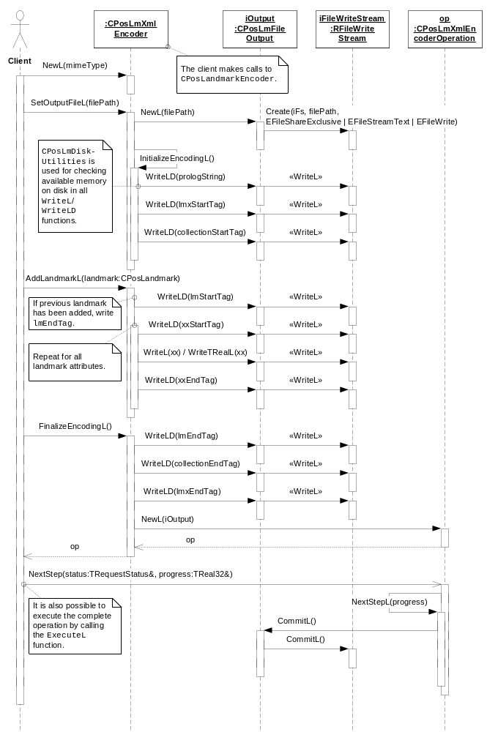
Figure 3.4 Encoding a landmark to a file

Encoding a landmark and a category to a buffer
Operation | Encoding a landmark and a category to a buffer in the xml format.
Preconditions
Description | Creates an encoder, writes the landmark and category content to the encoder and finalizes the encoder.
Inputs | A landmark object, a category object.
Modifies
Outputs | A buffer containing the encoded content.
Postconditions | The chosen landmark and category has been written to the encoder buffer.
Related to | CPosLmXmlEncoder, CPosLmBufferOutput, CBufSeg, RBufWriteStream, CPosLmXmlEncoderOperation
Related event
Exceptions | Leaves with EPosLmProtocolBreak if the specified protocol order is not followed.

Instead of CPosLmXmlParser object shown on the diagram below, one of its derivatives is instantiated based on the exact format type. In S60 5.0 it is either CPosLmLmxParser (which handles Landmarks Exchange format mark-up) or CPosLmGpxParser(which handles GPS Exchange format mark-up). In S60 release 5.1 CPosLmKmlParser (which handles KML/KMZ format mark-up) is also supported. The choice is based on input data MIME type specified by client.

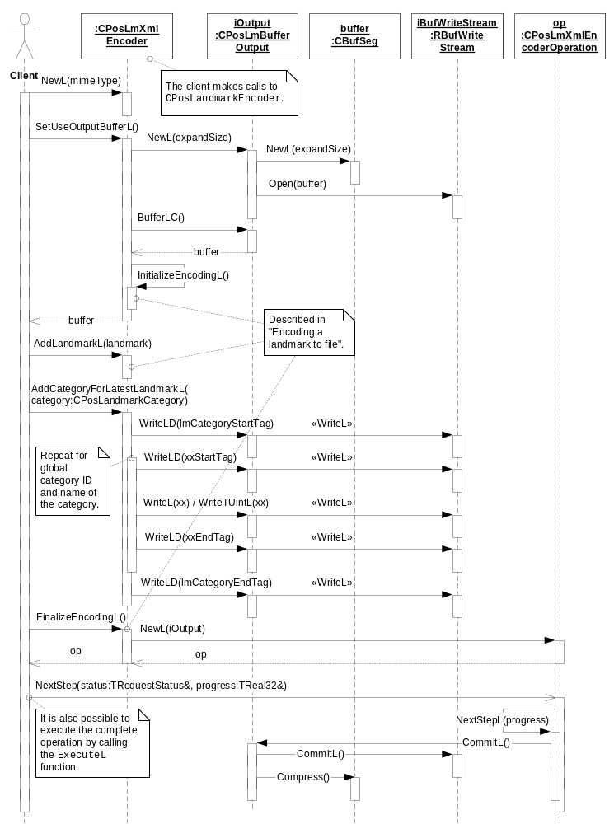
Figure 3.5 Encoding a landmark and a category to a buffer

Encoding a landmark to an URL using File Output
Operation | Encoding a landmark to an URL using file output.
Preconditions
Description | Creates an encoder, writes the landmark content to the encoder and finalizes the encoder.
Inputs | The name of the file, a landmark object.
Modifies
Outputs | A file containing the encoded URL.
Postconditions | The chosen landmark has been encoded to an URL which is written into the output file.
Related to | CPosLmUrlEncoder, CPosLmFileOutput, RFileWriteStream, CPosLmUrlEncoderOperation, CPosLmDiskUtilities
Related event
Exceptions | Leaves with KErrAlreadyExists if there already is a file with the specified name and KErrDiskFull if the operation is estimated to go below the critical disk level. Panics with EPosLmProtocolBreak if the call sequence specified in the API is not followed.Also leaves with KErrNotSupported if AddLandmarkL method is called more than once( in order to encode more than one landmark ) during the encoding process.

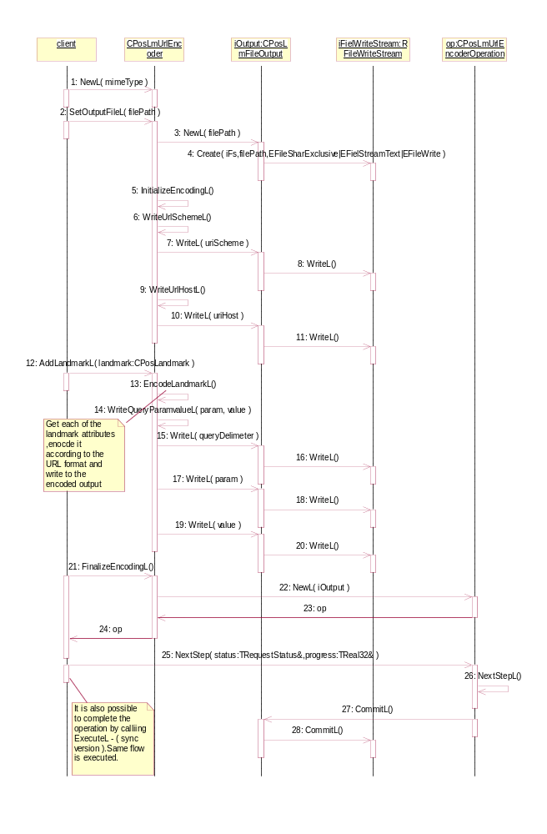
Figure 3.6 Encoding a landmark to an URL using File output.

Encoding a landmark & category to an URL using Buffer Output
Operation | Encoding a landmark to an URL using buffer output.
Preconditions
Description | Creates an encoder, writes the landmark and category content to the encoder and finalizes the encoder.
Inputs | A landmark object, a category object.
Modifies
Outputs | A buffer containing the encoded URL.
Postconditions | The chosen landmark and category has been encoded to the URL and written to the buffer.
Related to | CPosLmUrlEncoder, CPosLmBufferOutput, CBufSeg, RBufWriteStream, CPosLmUrlEncoderOperation
Related event
Exceptions | Leaves with EPosLmProtocolBreak if the specified protocol order is not followed. Also leaves with KErrNotSupported if AddLandmarkL method is called more than once( in order to encode more than one landmark ) during the encoding process.

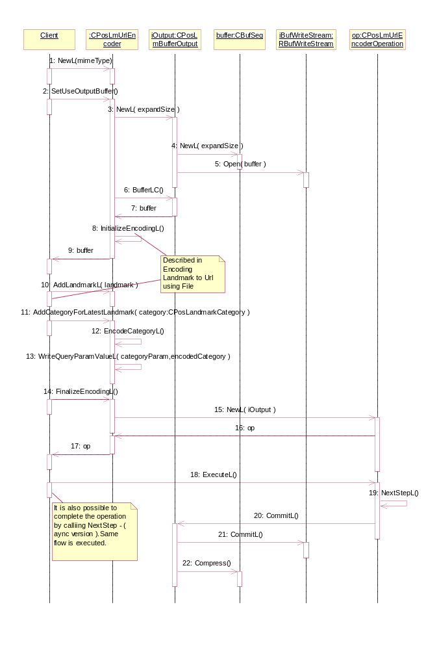

Figure 3.7 Encoding a landmark and a category to an URL using buffer output.

Parsing landmarks from a XML based file

Operation | Parsing landmarks from a XML based file.
Preconditions | A file (or buffer) containing the encoded content exists.
Description | Creates a parser, parses the landmark content from the file (or buffer) and retrieves the landmarks and categories from the parser. The client can specify the file either by name or by passing an open file handle.
Inputs | The name of the file, an open file handle or a buffer.
Modifies
Outputs | The landmark objects and landmark category objects.
Postconditions
Related to | CPosLmXmlParser, RFile, Xml::CParser, CPosLmXmlParserOperation
Related event
Exceptions | Leaves with KErrPosLmUnknownFormat if the content is unrecognized. KErrNotSupported if the client specifies that the parser should build an index.  Error codes from Symbian XML Framework are possible.

Instead of CPosLmXmlParser object shown on the diagram below, one of its derivatives is instantiated based on the exact format type. In S60 5.0 it is either CPosLmLmxParser (which handles Landmarks Exchange format mark-up) or CPosLmGpxParser(which handles GPS Exchange format mark-up). In S60 release 5.1, CPosLmKmlParser (which handles KML/KMZ format mark-up) is also supported. The choice is based on input data MIME type specified by client.

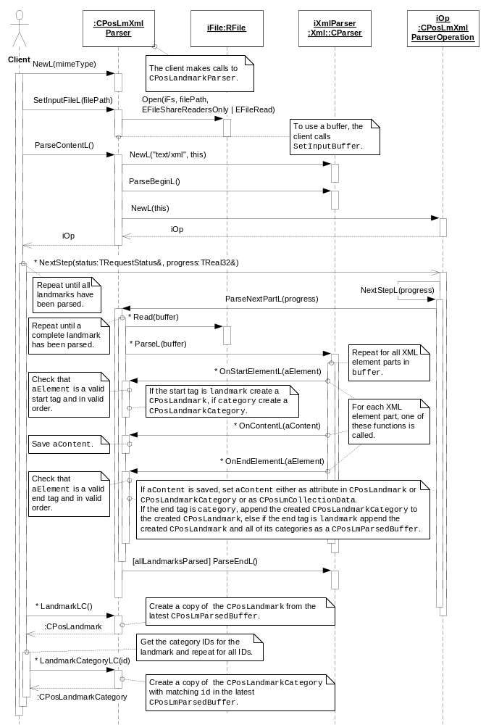
Figure 3.8 Parsing landmarks. This figure shows how the client specifies the file name and Landmarks opens the file for reading. The client can also pass an already open file handle.

Parsing landmark from an URL

Operation | Parsing landmarks from an URL containing location information
Preconditions | A file (or buffer) containing the encoded URL
Description | Creates an URL parser based on the mime type which is host name of the URL( maps.ovi.com), parses the landmark content from the file (or buffer) and retrieves the landmark and categories from the parser. The client can specify the file either by name or by passing an open file handle.
Inputs | The name of the file, an open file handle or a buffer.
Modifies
Outputs | The landmark object and landmark category object.
Postconditions
Related to | CPosLmUrlParser, RFile, CPosLmUrlParserOperation
Related event
Exceptions | Leaves with KErrPosLmUnknownFormat if the content is unrecognized. KErrNotSupported if the client specifies that the parser should build an index.  Error codes from Symbian XML Framework are possible.

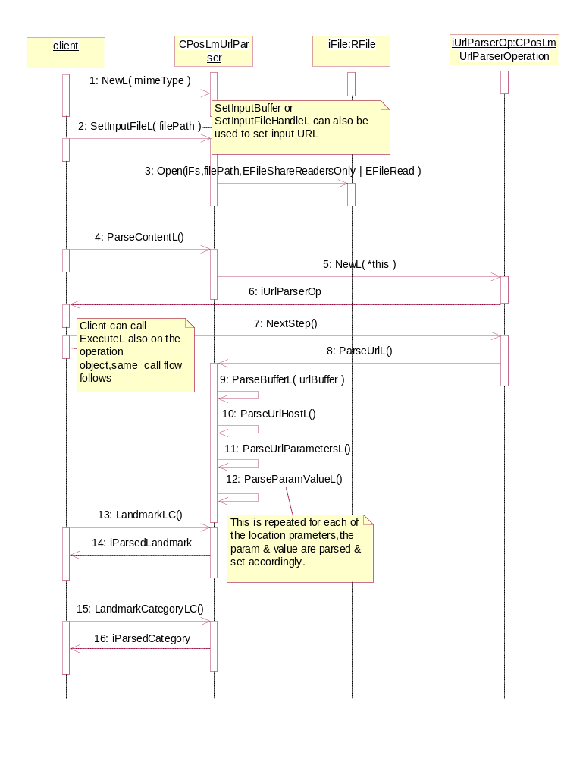
Figure 3.9 Parsing landmarks from an URL.

Backup and Restore
The policies for backup and restore are described in reference document [2].

Variation
Variation for the Landmarks subsystem is described in reference document [2].

System resource usage

File structures
Landmarks Content Format Converter uses no other files than the encoder output file and the parser input file. The path and name of these files are specified by the client.

Database structures
Landmarks Content Format Converter does not use any databases.

Timers and active objects
Landmarks Content Format Converter does not use any timers or active objects.

Security

Capabilities of this component
Capability | Justification
CAP_CLIENT_DLL | The DLL is a client side plug-in and it must have all the capabilities that a potential client may have.

Input and output validation
Landmarks Content Format Converter validates all input data.

Environmental assumptions
This component does not make any assumptions about its environment.

Additional enforcements
This component does not have any additional security enforcements.

Exception handling
The Symbian OS panic and leave mechanism are used to handle memory exhaustion and other system-wide error codes that appear upon execution.

Usage
Usage is described at the subsystem level in reference document [2].

