S60 3.x
Landmarks Database Management Client Library
Design Document

Team name | Author
TD Software Platforms | Sergey Burnevsky

Change history:

Version | Date | Status | Comments
2.0 | 28.08.2007 | Approved | Whole document revised.
1.0 | 12.07.2005 | Approved

Table of contents:

1. Document control 4
1.1 References 4
1.2 Documentation conventions 4
1.3 Abbreviations 4
1.4 Definitions 4
2. General 5
2.1 Introduction 5
2.2 Component environment 5
2.3 Services required 6
2.3.1 From the Symbian OS subsystems 6
2.3.2 From the Domestic OS subsystems 6
2.3.3 From HW 6
2.4 Services provided 6
2.4.1 UI 6
2.4.2 SW IF 7
3. Design 8
3.1 Class diagrams 8
3.1.1 Component 8
3.2 Class descriptions 9
3.2.1 Structs, type definitions and enumerations 9
3.2.1.1 epos_tposlmdatabasesettings.H 9
3.2.1.2 epos_tposlmdatabaseevent.H 9
3.3 Operations 10
3.3.1 Creating a landmark database manager 10
3.4 Backup and Restore 10
4. Variation 11
5. System resource usage 12
5.1 File structures 12
5.2 Database structures 12
5.3 Timers and active objects 12
6. Security 13
6.1 Capabilities of this component 13
6.2 Input and output validation 13
6.3 Environmental assumptions 13
6.4 Additional enforcements 13
7. Exception handling 14
8. Usage 15

Document control

References
- S60 3.0 Landmarks Subsystem Architecture Description
- S60 Landmarks Subsystem Design Document
- S60 Landmarks Exchange Format Specification Document

Documentation conventions
Code is shown with the Courier New font.

Abbreviations
API | Application Programming Interface
DBMS | Database Management System
DLL | Dynamic Link Library
MBM | Multiple Bitmap file format
MIME | Multipurpose Internet Mail Extensions
MLFW | Mobile Location Framework
OS | Operating System
XML | Extensible Markup Language

Definitions
Corrupt database | A database that has become invalid and cannot be opened.
Damaged database | A database may be damaged when a transaction fails or is cancelled. A damaged database can be recovered by initialization.
DBMS | Database Management System. A commonly used term for the Symbian OS database engine.
ECom | Symbian OS framework for plug-in DLLs.
Framework | Usually denotes the collection of an engine and associated programming interfaces. This document mentions the Mobile Location Framework and the Symbian OS ECom Framework. There is also a subsystem in Symbian OS called Application Framework.
Landmark | A landmark is a named object that contains a location. The location can be defined by various attributes, e.g. WGS 84 coordinates or a textual address.
Landmark category | A landmark can be categorized by assigning a landmark category to it. A typical landmark category is “Restaurant”. A landmark category is often referred to as “category”.
Landmark collection | A group of landmarks encoded according to reference document [3].
Landmark database | Persistent storage of a collection of landmarks and landmark categories.
Platform Security | Definition for the security design principles and features in Symbian OS.
Recognizer | Plug-in code that can examine sample data. If the data is recognized, its data type is returned. A data type is also commonly known as a MIME type.

General
This document describes the Landmarks Database Management Client Library component in the Landmarks subsystem. The Landmarks subsystem design including general design guidelines for Landmark components is described in reference document [2]. The architecture is described in reference document [1].
Landmarks Database Management Client Library is available from S60 release 3.0 onwards.

Introduction
Landmarks Database Management Client Library publishes the interfaces needed to manage landmark databases. The actual implementation is provided by ECom plug-ins, which realize the services defined by Landmarks Database Management API. The effect is that Landmarks Database Management Client Library is relatively small and functionality can be added or removed at run-time.
The responsibilities and additional requirements of Landmarks Database Management Client Library are the following:
- Defines the basic data classes needed for landmark database management.
- Loads the ECom plug-in, which provides the services defined by Landmarks Database Management Client Library.

Component environment
Figure 2.1 and Figure 2.2 show the components in the Landmarks subsystem.
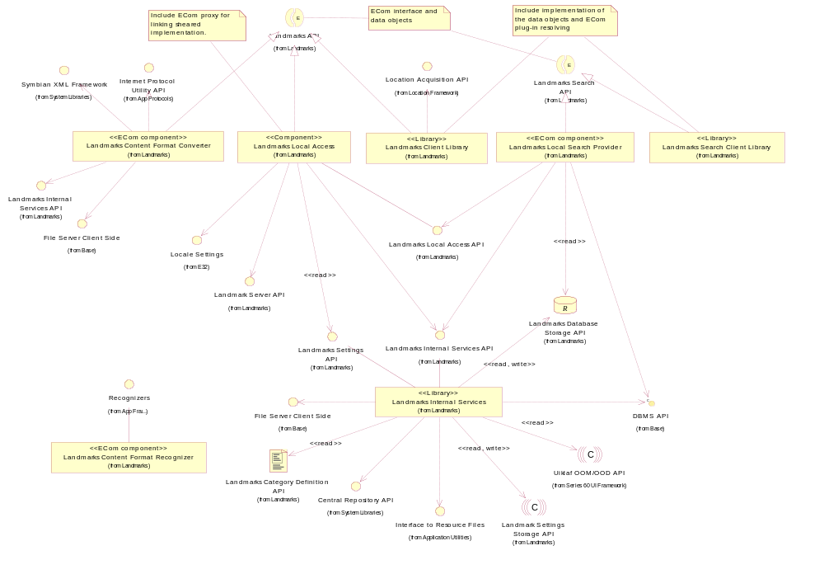
Figure 2.1 Basic Landmarks component diagram
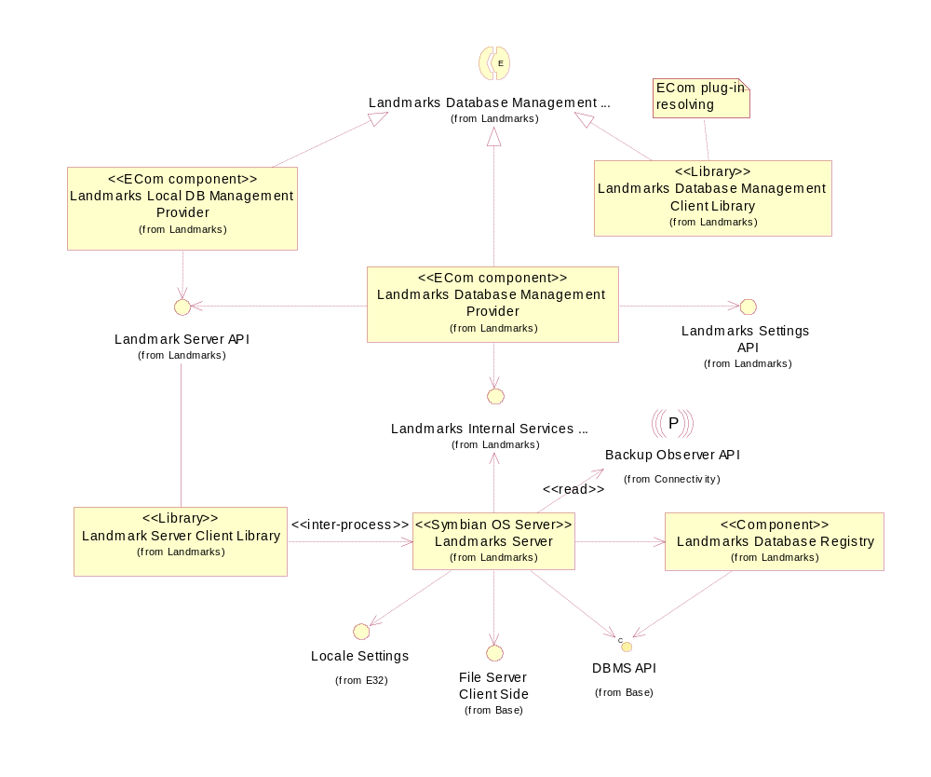
Figure 2.2 Database management component diagram

Services required

From the Symbian OS subsystems

API | Description
ECom Plug-in Architecture | Used to load Landmarks Database Management Provider.

From the Domestic OS subsystems
This component does not have any direct interfaces to the Domestic OS side subsystems.

From HW
This component has no direct HW interfaces.

Services provided

UI
This component does not provide any UI.

SW IF

Provided Service | Description | Protected
Landmarks Database Management API | Landmarks Database Management API extends Landmarks API to enable managing and accessing landmark databases. This includes listing, creating, deleting and copying landmark databases. | Yes

Design

Class diagrams

Component
This section describes the design of the Landmarks Database Management Client Library component.
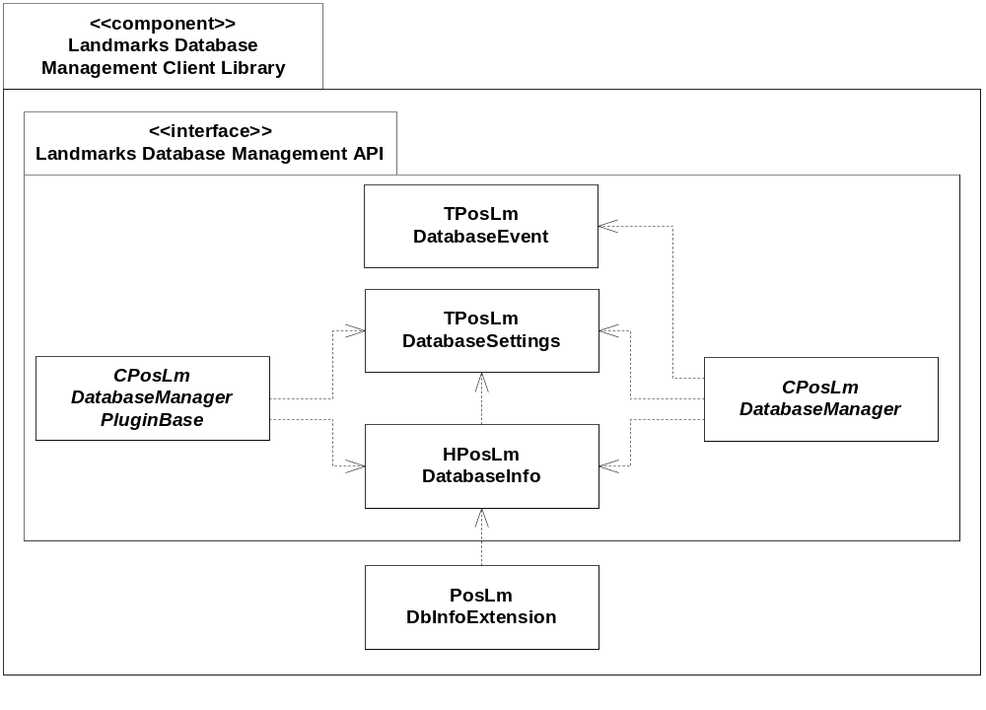
Figure 3.3 Landmarks Database Management Client Library component class diagram

Class descriptions

Class | Description | Header file
CPosLandmark  DatabaseManager | This class is used by clients to manage landmark databases. The management functions are abstract and implemented by an ECom plug-in, which is loaded when the client calls CPosLmDatabaseManager::NewL(). | EPos_CPosLmDatabaseManager.H
CPosLandmark  DatabaseManager  PluginBase | This abstract base class is inherited by protocol-specific database management provider classes that implement database management operations for specific database types (protocols). They are all loaded by the CPosLandmarkDatabaseManager implementation.  The implementations of this class are loaded using the ECom Framework. | EPos_CPosLmDatabaseManagerPluginBase.H
TPosLmDatabase  Settings | A container class for database settings, such as database display name. | EPos_TPosLmDatabaseSettings.H
HPosLmDatabase  Info | A container class for information related to a landmarks database, e.g. where the database is located. | EPos_HPosLmDatabaseInfo.H
PosLmDbInfo  Extension | A Landmarks subsystem internal class.  A class containing static exported functions needed by the implementation of components in the Landmarks subsystem. | EPos_PosLmDbInfoExtension.H
TPosLmDatabase  Event | A container class for database management events, such as registering/unregistering of databases. | EPos_TPosLmDatabaseEvent.H

Structs, type definitions and enumerations

epos_tposlmdatabasesettings.H

Definition name | Description
TPosLmDatabaseName | A descriptor containing a displayable name for a landmark database.
Enumeration name | Description
TPos_LmDatabaseSettings::  TAttribute | An enumeration of the attributes that can be set for a landmark database.

epos_tposlmdatabaseevent.H

Enumeration name | Description
TPosLmDatabaseEventType | Specifies what type of event has occurred.
Struct name | Description
TPosLmDatabaseEvent | A struct for landmark database events.

Operations

Creating a landmark database manager

Operation | Creating a landmark database manager.
Preconditions
Description | Creates a landmark database manager to manage and access a landmark database.
Inputs
Modifies
Outputs | A handle to the landmark database manager.
Postconditions
Related to | CPosLmDatabaseManager
Related event
Exceptions | If the proper implementation of the landmark database manager (ECom plug-in) is not found, this operation fails with KErrNotFound.

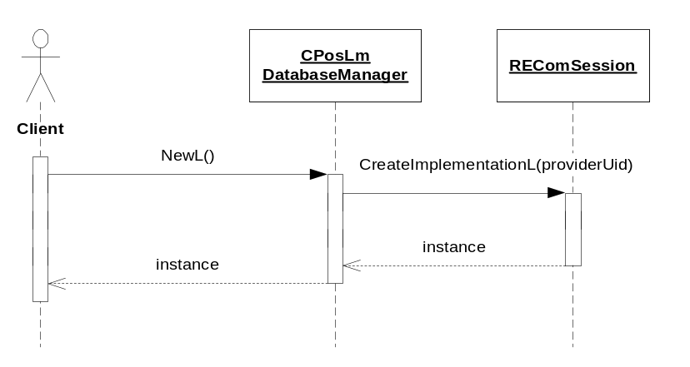
Figure 3.4 Creating a landmark database manager

Backup and Restore
The policies for backup and restore are described in reference document [2].

Variation
Variation for the Landmarks subsystem is described in reference document [2].

System resource usage

File structures
Landmarks Database Management Client Library does not use any files.

Database structures
Landmarks Database Management Client Library does not use any databases.

Timers and active objects
Landmarks Database Management Client Library does not use any timers or active objects.

Security

Capabilities of this component

Capability | Justification
CAP_CLIENT_DLL | The DLL is a client side library and it must have all the capabilities that a potential client may have.

Input and output validation
This component performs input data checking as protection from client bugs, but since it is purely done at the client side, it is not protection against malicious clients. This protection must be provided at process borders where the data is used, but this is not the responsibility of this component.

Environmental assumptions
This component does not make any assumptions about its environment.

Additional enforcements
This component does not have any additional security enforcements.

Exception handling
The Symbian OS panic and leave mechanism are used to handle memory exhaustion and other system-wide error codes that appear upon execution. The leave mechanism is also used for telling whether implementations loaded by the ECom Framework are present or not.

Usage
Usage is described at the subsystem level in reference document [2].

