S60 3.x
Landmarks Database Management Provider
Design Document

Team name | Author
TD Software Platforms | Sergey Burnevsky

Change history:

Version | Date | Status | Comments
2.0 | 28.08.2007 | Approved | Whole document revised.
1.0 | 12.07.2005 | Approved

Table of contents:

1. Document control 4
1.1 References 4
1.2 Documentation conventions 4
1.3 Abbreviations 4
1.4 Definitions 5
2. General 6
2.1 Introduction 6
2.2 Component environment 6
2.3 Services required 7
2.3.1 From the Symbian OS subsystems 7
2.3.2 From the Domestic OS subsystems 7
2.3.3 From HW 7
2.4 Services provided 7
2.4.1 UI 7
2.4.2 SW IF 8
3. Design 9
3.1 Class diagrams 9
3.1.1 Component 9
3.2 Class descriptions 10
3.2.1 Structs, type definitions and enumerations 10
3.3 Operations 10
3.3.1.1 Creating Landmarks Database Management Provider 10
3.3.1.2 Creating a landmark database 11
3.3.1.3 Listing landmark databases 12
3.3.1.4 Retrieving the URI of the default landmark database 13
3.3.1.5 Setting a landmark database as default 14
3.3.1.6 Listening to a database management event 15
3.3.1.7 Canceling listening to a database management event 16
3.3.1.8 Retrieving the database URI associated with the last event 17
3.4 Backup and Restore 18
4. Variation 19
5. System resource usage 20
5.1 File structures 20
5.2 Database structures 20
5.3 Timers and active objects 20
6. Security 21
6.1 Capabilities of this component 21
6.2 Input and output validation 21
6.3 Environmental assumptions 21
6.4 Additional enforcements 21
7. Exception handling 22
8. Usage 23

Document control

References

- S60 3.0 Landmarks Subsystem Architecture Description
- S60 Landmarks Subsystem Design Document
- S60 Landmarks Database Management API Specification Document
- S60 Landmarks Server Client Library Design Document
- S60 Landmarks Exchange Format Specification Document

Documentation conventions
Code is shown with the Courier New font.

Abbreviations

API | Application Programming Interface
DBMS | Database Management System
DLL | Dynamic Link Library
MBM | Multiple Bitmap file format
MIME | Multipurpose Internet Mail Extensions
MLFW | Mobile Location Framework
OS | Operating System
XML | Extensible Markup Language

Definitions

Corrupt database | A database that has become invalid and cannot be opened.
Damaged database | A database may be damaged when a transaction fails or is cancelled. A damaged database can be recovered by initialization.
DBMS | Database Management System. A commonly used term for the Symbian OS database engine.
ECom | Symbian OS framework for plug-in DLLs.
Framework | Usually denotes the collection of an engine and associated programming interfaces. This document mentions the Mobile Location Framework and the Symbian OS ECom Framework. There is also a subsystem in Symbian OS called Application Framework.
Landmark | A landmark is a named object that contains a location. The location can be defined by various attributes, e.g. WGS84 coordinates or a textual address.
Landmark category | A landmark can be categorized by assigning a landmark category to it. A typical landmark category is “Restaurant”. A landmark category is often referred to as “category”.
Landmark collection | A group of landmarks encoded according to reference document [5].
Landmark database | Persistent storage of a collection of landmarks and landmark categories.
Platform Security | Definition for the security design principles and features in Symbian OS.
Recognizer | Plug-in code that can examine sample data. If the data is recognized, its data type is returned. A data type is also commonly known as a MIME type.

General
This document describes the Landmarks Database Management Provider component in the Landmarks subsystem. The Landmarks subsystem design including general design guidelines for Landmark components is described in reference document [2]. The architecture is described in reference document [1].
Landmarks Database Management Provider is available from S60 release 3.0 onwards.

Introduction
The Landmarks Database Management Provider component is an ECom implementation that implements the interface from Landmarks Database Management Client Library. For some of the functionality, it loads protocol specific provider implementations as ECom plug-ins. The interface for protocol specific provider implementations is defined in Landmarks Database Management Client Library. Operations for listening to database management events and setting/retrieving the default database URI are implemented by this component. Other operations, such as creating, deleting, copying, registering, unregistering databases and changing database settings are directly forwarded to the protocol specific provider plug-in.

Component environment
Figure 2.1 and Figure 2.2 show the components in the Landmarks subsystem.
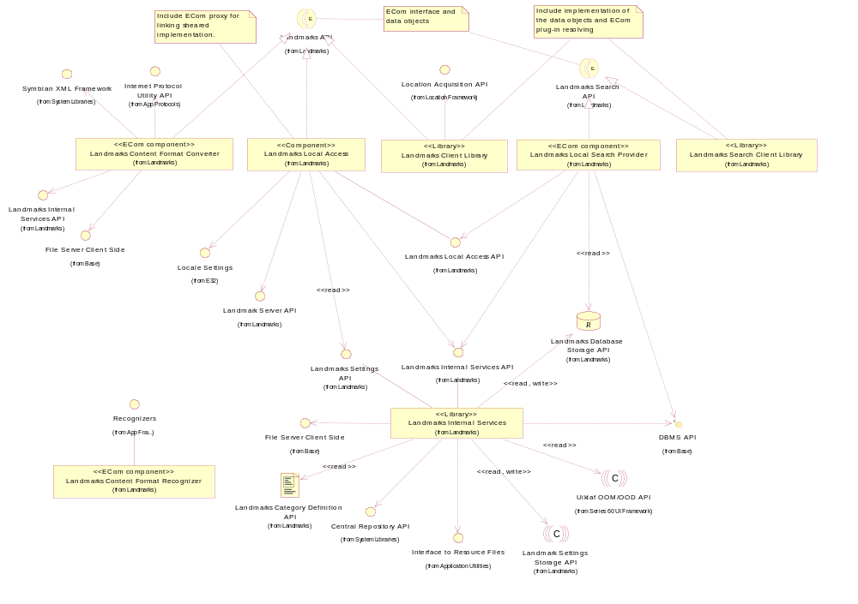
Figure 2.1 Basic Landmarks component diagram
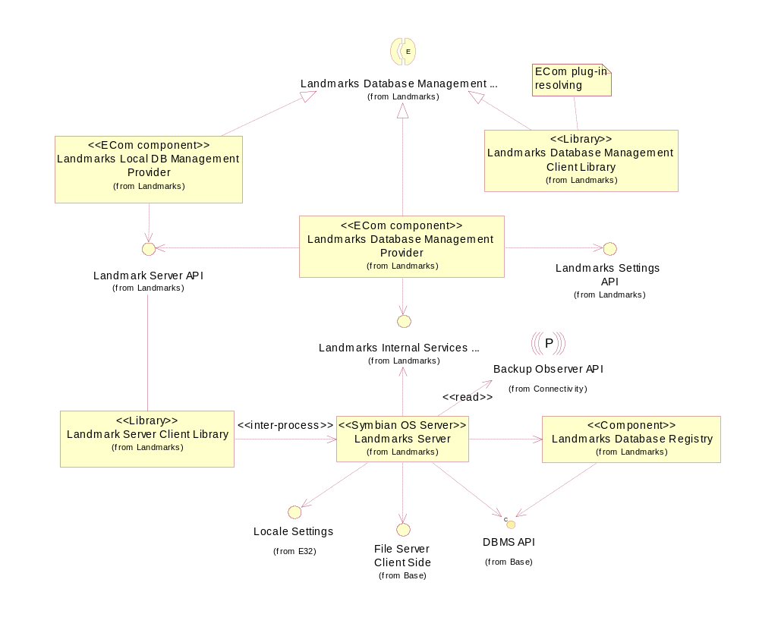
Figure 2.2 Database management component diagram

Services required

From the Symbian OS subsystems

API | Description
ECom Plugin Architecture | Used to load database management plug-ins such as Landmarks Local Database Management Provider.

From the Domestic OS subsystems
This component does not have any direct interfaces to the Domestic OS side subsystems.

From HW
This component has no direct HW interfaces.

Services provided

UI
This component does not provide any UI.

SW IF

Provided Service | Description | Protected
Landmarks Database Management API | Implements the ECom interface in Landmarks Database Management API. Landmarks Database Management API extends Landmarks API to enable managing and accessing landmark databases. This includes listing, creating, deleting and copying landmark databases. | Yes

Design
The Landmarks Database Management Provider component is an ECom implementation that implements the interface from Landmarks Database Management Client Library.
If the client requests that all types of databases should be listed, it is the responsibility of this component to list each type of database using the protocol-specific provider implementation and to merge the result before it is returned to the client.

Class diagrams

Component
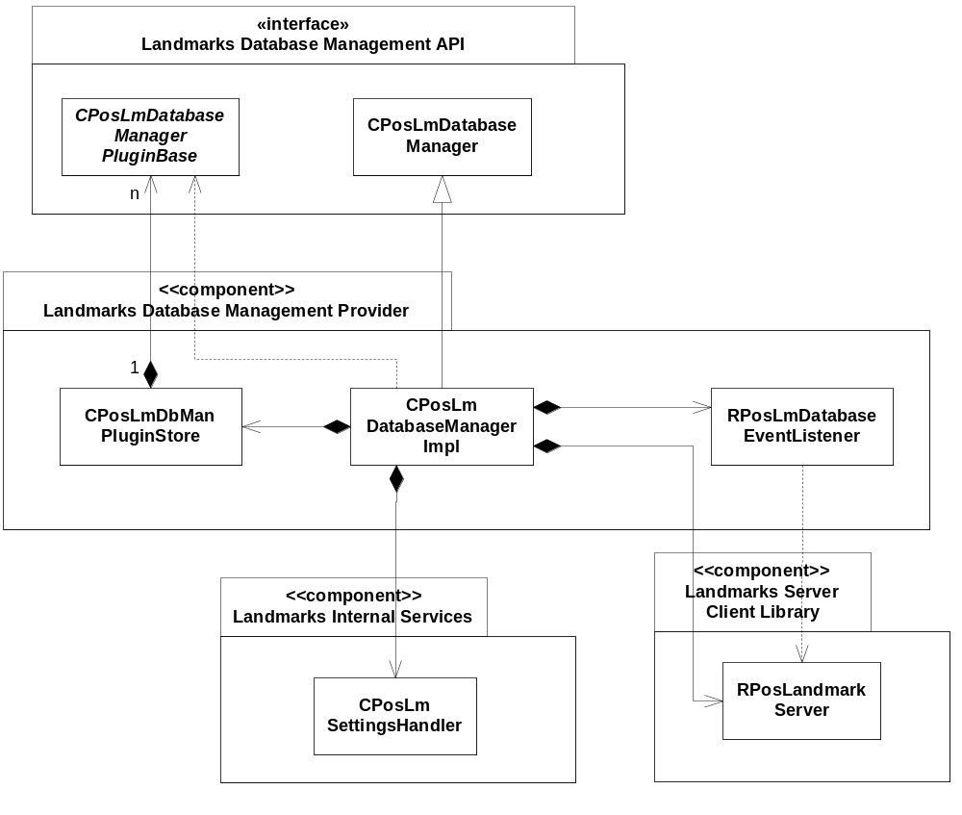
Figure 3.3 Landmarks Database Management Provider component class diagram

Class descriptions
Class | Description | Header file
CPosLmDatabase  ManagerImpl | This is the implementation of CPosLmDatabaseManager. It handles database management events and setting/retrieving the default database URI itself, and forwards other operations to protocol-specific plug-ins via the CPosLmDbManPluginStore class.  CPosLmSettingsHandler is used to read and change the URI of the default landmark database.  RPosLmDatabaseEventListener is the Landmarks Server sub-session handle used to listen for database management events.  RPosLandmarkServer is the session handle to Landmarks Server (see reference document [4]). | EPos_CPosLmDatabase  ManagerImpl.H
CPosLmDbManPlugInStore | A container class for protocol-specific database management provider plug-ins. This class is responsible for the loading/unloading of plug-ins, and contains methods for traversing the list of the available plug-ins and for obtaining the plug-in handle based on the protocol descriptor. | EPos_CPosLmDbManPlugin  Store.H
RPosLmDatabase  EventListener | A sub-session handle for listening to database management events. | EPos_RPosLmDatabaseEventListener.H

Structs, type definitions and enumerations
This component does not define any structs, type definitions or enumerations.

Operations

Creating Landmarks Database Management Provider
Operation | Creating Landmarks Database Management Provider.
Preconditions
Description | Creates Landmarks Database Management Provider. CPosLmSettingsHandler, RPosLandmarkServer, RPosLmDatabaseEventListener are instantiated.
Inputs
Modifies
Outputs | A new instance of Landmarks Database Management Provider.
Postconditions
Related to | CPosLmDatabaseManagerImpl, CPosLmSettingsHandler, RPosLandmarkServer, RPosLmDatabaseEventListener, CPosLmDatabaseManagerPluginBase, CPosLmDbManPluginStore
Related event
Exceptions

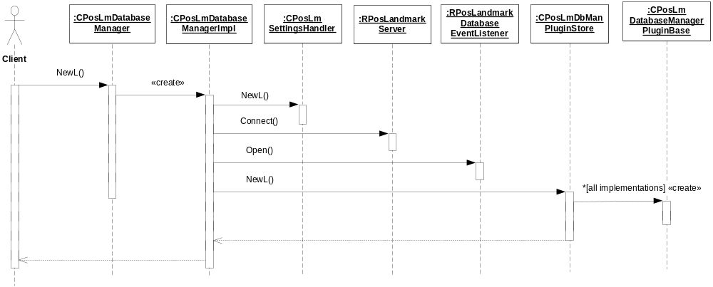
Figure 3.4 Creating Landmarks Database Management Provider

Creating a landmark database
The following example describes the method flow when the client requests that a database should be created. Exactly the same flow applies to the following operations, which all makes use of protocol-specific provider plug-ins:
- Deleting a database
- Copying a database
- Registering a database, unregistering a database, unregistering all databases
- Modifying database settings, retrieving database information
- Checking if a database exists

Operation | Creating a landmark database.
Preconditions
Description | Creates a landmark database. The database to create is specified by passing a URI to this function. The URI must point to a database, which is handled by this database manager, i.e. not a remote location.
Inputs | The URI of the new database.
Modifies
Outputs
Postconditions | The landmark database is created.
Related to | CPosLmDatabaseManagerImpl, CPosLmDatabaseManagerPluginBase, CPosLmDbManPluginStore
Related event
Exceptions | Leaves with KErrArgument if the URI is incorrect or not recognized by the database manager, KErrNotSupported if there is no provider plug-in that supports the specified protocol, other error codes depending on the operation, e.g. KErrNotFound when accessing or deleting resources that do not exist, or KErrAlreadyExists when creating resources that already exist.

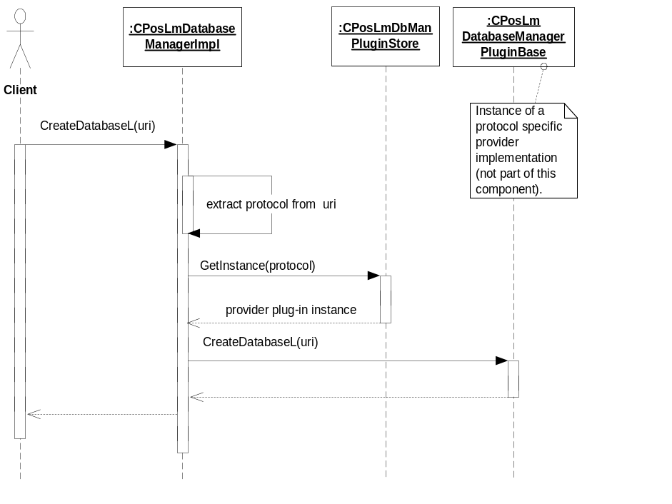
Figure 3.5 Creating a landmark database

Listing landmark databases
Operation | Listing landmark databases.
Preconditions
Description | A list containing the URIs of all the landmark databases (supporting any protocol) known by the database manager is returned to the client.
Inputs
Modifies
Outputs | A list containing the URIs of the landmark databases.
Postconditions | The client takes ownership of the URI list.
Related to | CPosLmDatabaseManagerImpl, CPosLmDatabaseManagerPluginBase, CPosLmDbManPluginStore, CDesCArrayFlat
Related event | The client can choose to list databases supporting a specific protocol (a simplified version of this operation).
Exceptions

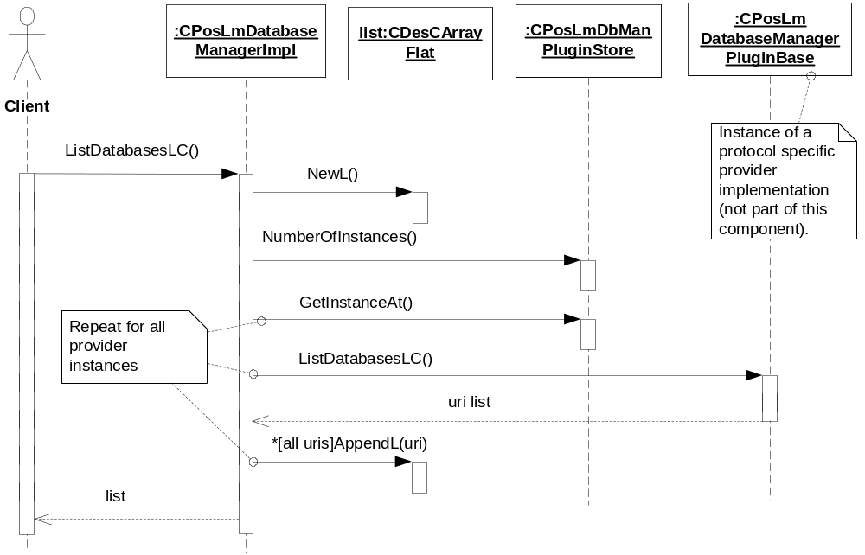
Figure 3.6 Listing landmark databases

Retrieving the URI of the default landmark database
Operation | Retrieving the URI of the default landmark database.
Preconditions
Description | Retrieves the URI of the default landmark database.
Inputs
Modifies
Outputs | The URI of the default landmark database.
Postconditions
Related to | CPosLmDatabaseManagerImpl, CPosLmSettingsHandler
Related event
Exceptions

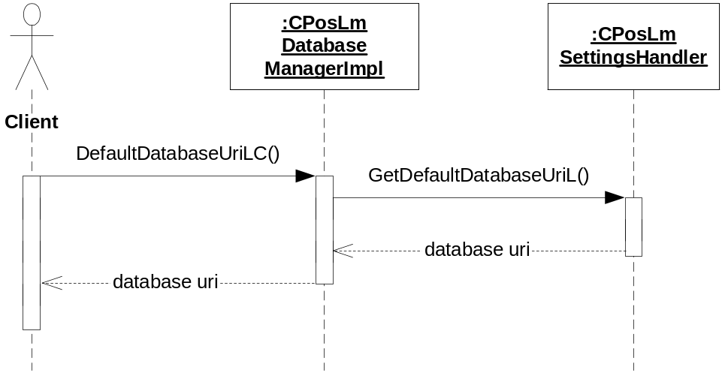
Figure 3.7 Retrieving the URI of the default landmark database

Setting a landmark database as default
Operation | Setting a landmark database as default.
Preconditions
Description | Sets a landmark database as default.
Inputs | The URI of the database that should be set as default. Only “file” databases are allowed as default.
Modifies
Outputs
Postconditions
Related to | CPosLmDatabaseManagerImpl, CPosLmDatabaseManagerPluginBase, CPosLmSettingsHandler, CPosLmDbManPluginStore
Related event
Exceptions | Leaves with KErrNotFound if the landmark database to be set as default does not exist.

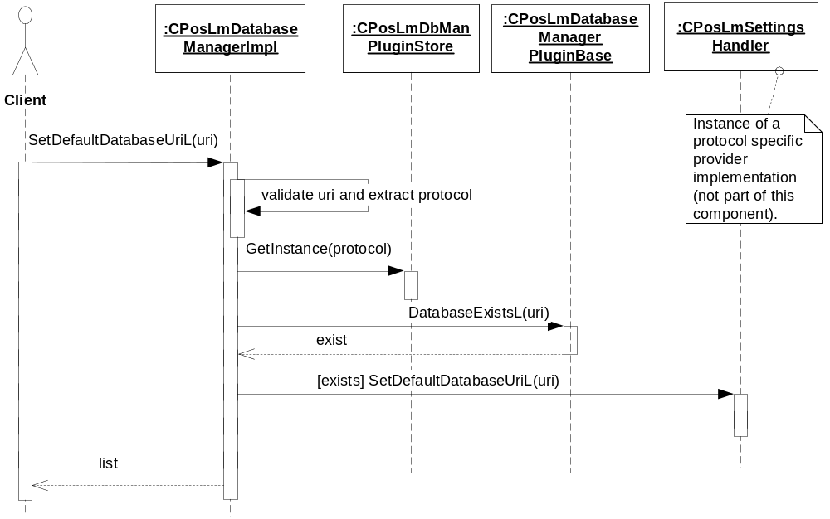
Figure 3.8 Setting a landmark database as default

Listening to a database management event
Operation | Listening to a database management event.
Preconditions
Description | Listens to a database management event. This function is asynchronous and it completes the request status when an event occurs. At this time, the client can read event information from the retrieved event object.
Inputs
Modifies
Outputs | An event.
Postconditions | The client is notified of the database event.
Related to | CPosLmDatabaseManagerImpl, RPosLmDatabaseEventListener
Related event
Exceptions

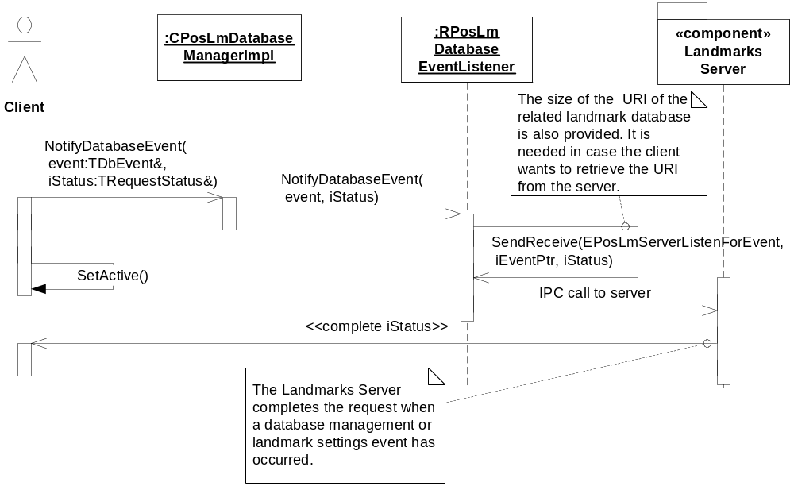
Figure 3.9 Listening to a database management event

Canceling listening to a database management event
Operation | Canceling listening to a database management event.
Preconditions | A client has made a request to be notified of a database management event.
Description | Cancels the listening to a database management event.
Inputs
Modifies
Outputs | KErrNone if the request was successfully cancelled, otherwise a system wide error code.
Postconditions | The outstanding request is cancelled.
Related to | CPosLmDatabaseManagerImpl, RPosLmDatabaseEventListener
Related event | See Section 3.3.1.6.
Exceptions

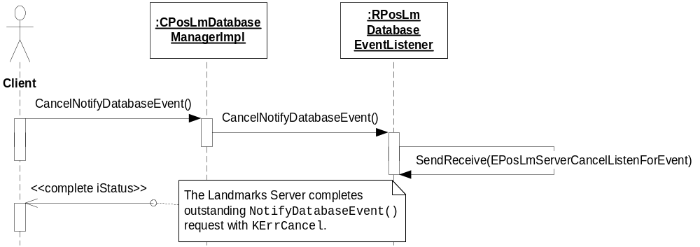
Figure 3.10 Canceling listening to a database management event

Retrieving the database URI associated with the last event
Operation | Retrieving the database URI associated with the last event.
Preconditions | The client has been notified of a database management event.
Description | The client retrieves the database URI associated with the last event. The database URI can be retrieved for the following events: ENewDefaultDbLocation, EDatabaseRegistered, EDatabaseUnregistered and EPosLmDbSettingsModified.
Inputs
Modifies
Outputs | The database URI.
Postconditions | The client has taken ownership of the URI.
Related to | CPosLmDatabaseManagerImpl, RPosLmDatabaseEventListener
Related event | See Section 3.3.1.6.
Exceptions | Leaves with KErrNotFound if there is no database URI associated with the event.

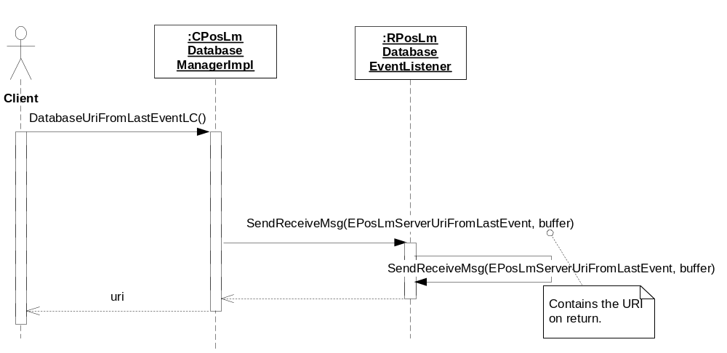
Figure 3.11 Retrieving the database URI associated with the last event

Backup and Restore
The policies for backup and restore are described in reference document [2].

Variation
Variation for the Landmarks subsystem is described in reference document [2].

System resource usage

File structures
Landmarks Database Management Provider component uses the resource files described in reference document [2].

Database structures
Landmark Database Management Provider component does not own any databases.

Timers and active objects
Landmarks Database Management Provider does not use any timers or active objects.

Security

Capabilities of this component

Capability | Justification
CAP_CLIENT_DLL | The DLL is a client side plug-in and it must have all the capabilities that a potential client may have.

Input and output validation
This component performs input data checking as protection from client bugs, but since it is purely done in the client side, it is not protection against malicious clients. This protection must be provided at process borders where the data is used, but this is not the responsibility of this component.

Environmental assumptions
This component does not make any assumptions about its environment.

Additional enforcements
This component does not have any additional security enforcements.

Exception handling
The Symbian OS panic and leave mechanism are used to handle memory exhaustion and other system-wide error codes that appear upon execution. The leave mechanism is also used for telling whether implementations loaded by the ECom Framework are present or not.

Usage
Usage is described at the subsystem level in reference document [2].

