S60 3.x
Landmarks Database Registry
Design Document

Team name | Author
Location CF/TietoEnator | Stefan Folkesson
 | Magnus Gustafson
 | Katharina Augustsson
 | Sergey Burnevsky

Change history:

Version | Date | Status | Comments
2.0 | 28.08.2007 | Approved | Editorial changes
1.0 | 13.07.2005 | Approved

Table of contents:

1. Document control 4
1.1 References 4
1.2 Documentation conventions 4
1.3 Abbreviations 4
1.4 Definitions 4
2. General 5
2.1 Introduction 5
2.2 Component environment 5
2.3 Services required 7
2.3.1 From the Symbian OS subsystems 7
2.3.2 From the Domestic OS subsystems 7
2.3.3 From HW 7
2.4 Services provided 7
2.4.1 UI 7
2.4.2 SW IF 7
3. Design 8
3.1 Class diagrams 8
3.1.1 Component 8
3.2 Class descriptions 9
3.2.1 Structs, type definitions and enumerations 9
3.3 Operations 9
3.3.1 Creating a database registry 9
3.3.2 Opening a database registry 10
3.3.3 Registering a landmark database 11
3.3.4 Unregistering a database 12
3.3.5 Unregistering all databases with a certain protocol 13
3.3.6 Retrieving database settings 14
3.3.7 Modifying database settings 15
3.3.8 Listing databases with a specific protocol 16
3.4 Backup and Restore 17
4. Variation 18
5. System resource usage 19
5.1 File structures 19
5.2 Database structures 19
5.3 Timers and active objects 19
6. Security 20
6.1 Capabilities of this component 20
6.2 Input and output validation 20
6.3 Environmental assumptions 20
6.4 Additional enforcements 20
7. Exception handling 21
8. Usage 22

Document control

References
- S60 3.2 Landmarks Subsystem Architecture Description
- S60 Landmarks Subsystem Design Document
- S60 Landmarks Exchange Format Specification Document

Documentation conventions
Code is shown with the Courier New font.

Abbreviations
API | Application Programming Interface
DBMS | Database Management System
DLL | Dynamic Link Library
MBM | Multiple Bitmap file format
MIME | Multipurpose Internet Mail Extensions
MLFW | Mobile Location Framework
OS | Operating System
XML | Extensible Markup Language

Definitions
Corrupt database | A database that has become invalid and cannot be opened.
Damaged database | A database may be damaged when a transaction fails or is cancelled. A damaged database can be recovered by initialization.
DBMS | Database Management System. A commonly used term for the Symbian OS database engine.
ECom | Symbian OS framework for plug-in DLLs.
Framework | Usually denotes the collection of an engine and associated programming interfaces. This document mentions the Mobile Location Framework and the Symbian OS ECom Framework. There is also a subsystem in Symbian OS called Application Framework.
Landmark | A landmark is a named object that contains a location. The location can be defined by various attributes, e.g. WGS84 coordinates or a textual address.
Landmark category | A landmark can be categorized by assigning a landmark category to it. A typical landmark category is “Restaurant”. A landmark category is often referred to as “category”.
Landmark collection | A group of landmarks encoded according to reference document [3].
Landmark database | Persistent storage of a collection of landmarks and landmark categories.
Platform Security | Definition for the security design principles and features in Symbian OS.
Recognizer | Plug-in code that can examine sample data. If the data is recognized, its data type is returned. A data type is also commonly known as a MIME type.

General
This document describes the Landmarks Database Registry component in the Landmarks subsystem. The Landmarks subsystem design including general design guidelines for Landmark components is described in reference document [2]. The architecture is described in reference document [1].
Landmarks Database Registry is available from S60 release 3.0 onwards.

Introduction
Landmarks Database Registry keeps track of landmarks databases created by Landmarks Server as well as references to the landmarks databases residing in the network.
The responsibilities and additional requirements of Landmarks Database Registry are the following:
- Handles access to the landmarks database registry.
- Each drive has its own registry database, which contains a list of the landmark databases in that drive. The registry on the c: drive can also contain information about remote landmark databases.
- Stores the display names for landmark databases.

Component environment
Figure 2.1 and Figure 2.2 show the components in the Landmarks subsystem.
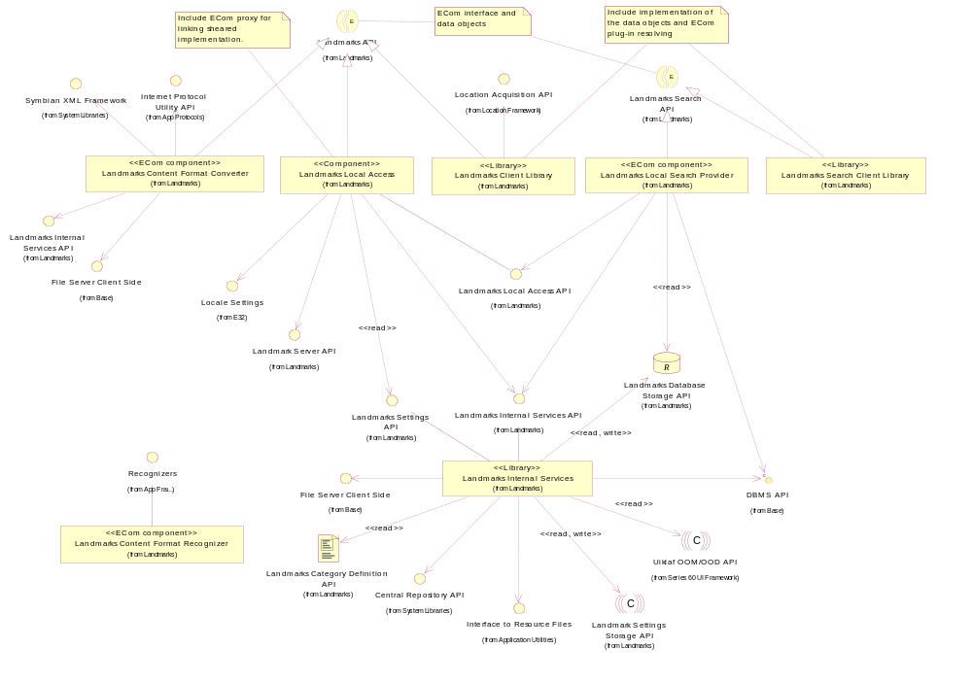
Figure 2.1 Basic Landmarks component diagram
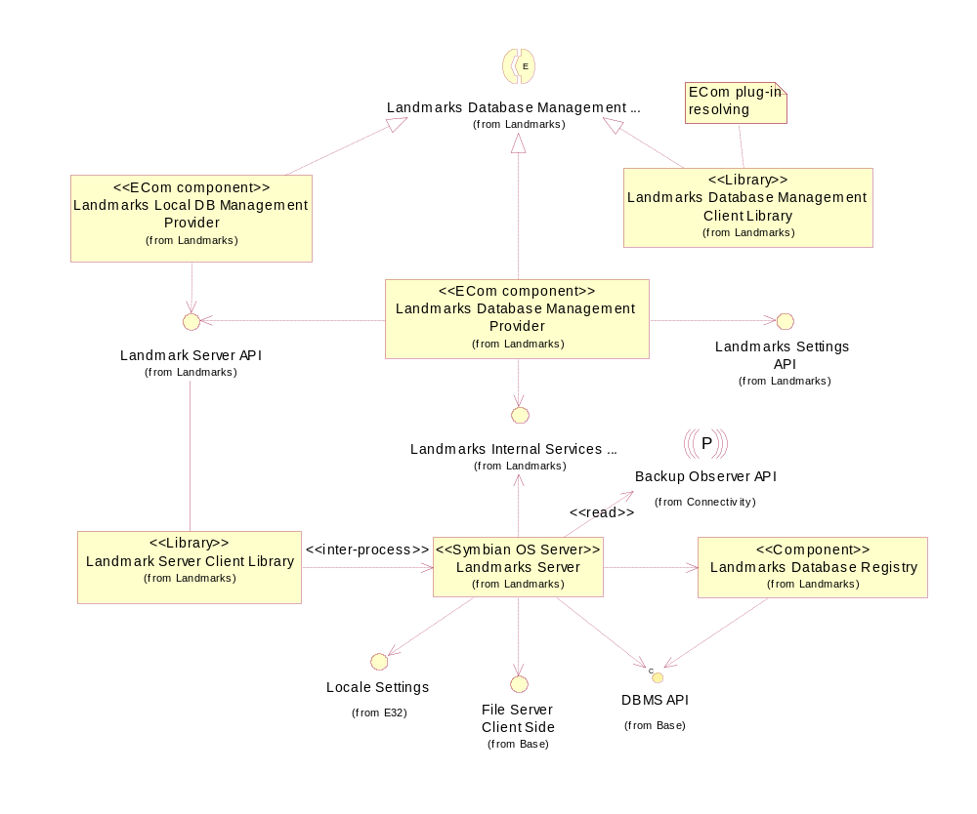
Figure 2.2 Database management component diagram

Services required

From the Symbian OS subsystems
API | Description
DBMS API | Registry databases are DBMS databases.
File Server Client Side | Landmarks Database Registry uses client side access to the databases.

From the Domestic OS subsystems
This component does not have any direct interfaces to the Domestic OS side subsystems.

From HW
This component has no direct HW interfaces.

Services provided

UI
This component does not provide any UI.

SW IF
This component does not provide any APIs.

Design

Class diagrams

Component
This section describes the design of the Landmarks Database Registry component.
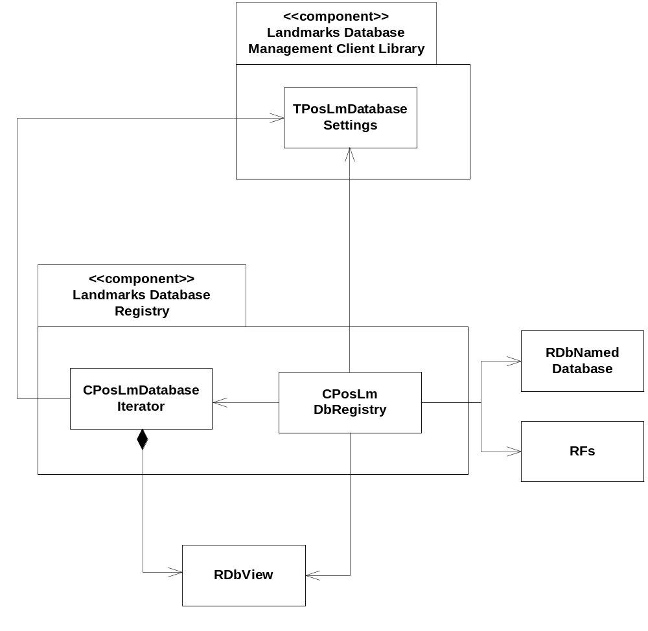
Figure 3.3 Landmarks Database Registry class diagram

Class descriptions
Class | Description | Header file
CPosLmDbRegistry | A class used for storing landmark database information.  The supported functionalities are the following: creating a database registry and registering, modifying, finding and listing database information.  Note: This class provides also a compact operation for compacting the registry. Landmarks Server is responsible for this.  RDbNamedDatabase is used to create the database registry.  RDbNamedDatabase uses RFs to create and open the registry.  TPosLmDatabaseSettings from Landmarks Database Management Client Library contains database settings information.  CPosLmDatabaseIterator is returned to a client when database information is requested.  PosDbRegistryConstants stores constants used by this class.  RDbView is used for querying the registry. | EPos_CPosLmDbRegistry.h
CPosLmDatabase  Iterator | Encapsulates RDbView.  Provides functionality for the client to iterate RDbView and to extract information about registered databases. RDbView holds the search results from the client request.  It uses constants stored in PosDbRegistryConstants. | EPos_CPosLmDatabaseIterator.h

Structs, type definitions and enumerations
This component does not define any structs, type definitions or enumerations.

Operations

Creating a database registry
Operation | Creating a database registry.
Preconditions
Description | Creates a database registry. A database is created. The protocol field is indexed. See Section 5.2 for detailed database information.
Inputs | A File Server session and the name of the database to create.
Modifies
Outputs
Postconditions | The database registry is created and opened.
Related to | CPosLmDbRegistry, RDbNamedDatabase, CDbColSet
Related event
Exceptions | Leaves with KErrAlreadyExists if the registry already exists.

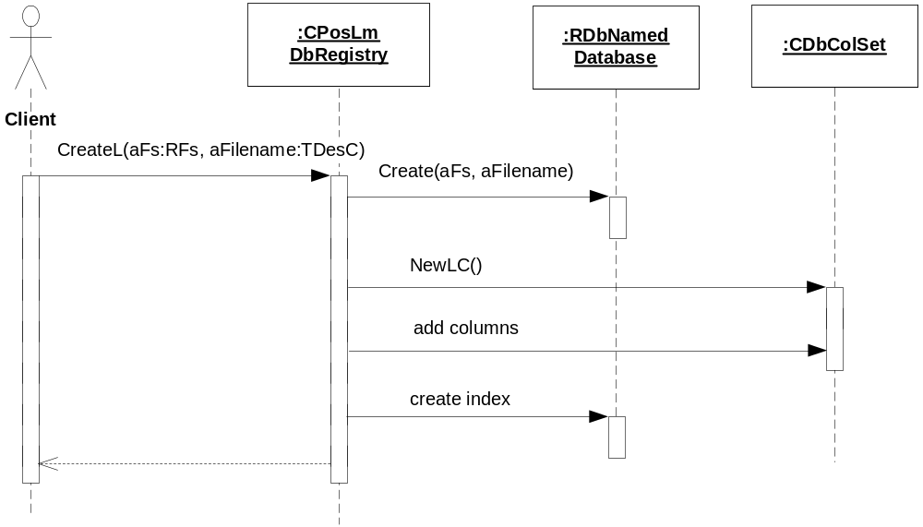
Figure 3.4 Creating a database registry

Opening a database registry
Operation | Opening a database registry.
Preconditions
Description | Opens a database registry.
Inputs | A File Server session and the name of the database to open.
Modifies
Outputs | KErrNone if the operation was successful; otherwise a system-wide error code.
Postconditions | The database registry is opened.
Related to | CPosLmDbRegistry, RDbNamedDatabase
Related event
Exceptions

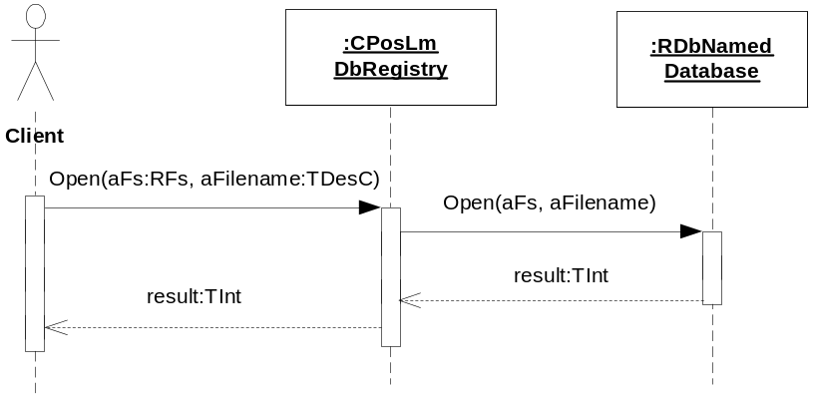
Figure 3.5 Opening a database registry

Registering a landmark database
Operation | Registering a landmark database.
Preconditions | The database registry is open.
Description | Registers a landmark database to the registry. The protocol, file name and database settings are stored in the registry.
Inputs | The database URI and the settings.
Modifies | The registry.
Outputs
Postconditions | The landmark database is registered in the registry.
Related to | CPosLmDbRegistry, RDbView, RDbColWriteStream, RDbNamedDatabase
Related event
Exceptions | Leaves with KErrAlreadyExists if the database is already registered.

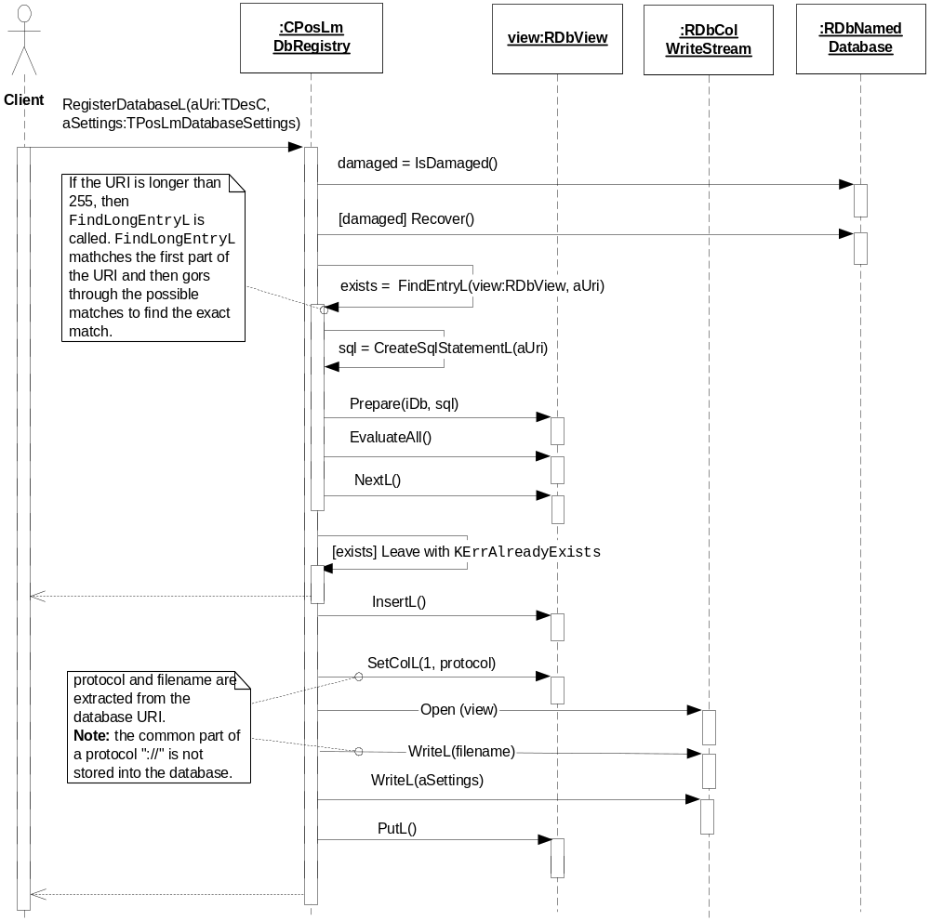
Figure 3.6 Registering a database

Unregistering a database
Operation | Unregistering a database.
Preconditions | The database registry is open.
Description | Unregisters a database in the registry using an SQL query.
Inputs | The URI of the database to unregister.
Modifies | The registry.
Outputs
Postconditions | The database is removed from the registry.
Related to | CPosLmDbRegistry, RDbNamedDatabase
Related event
Exceptions

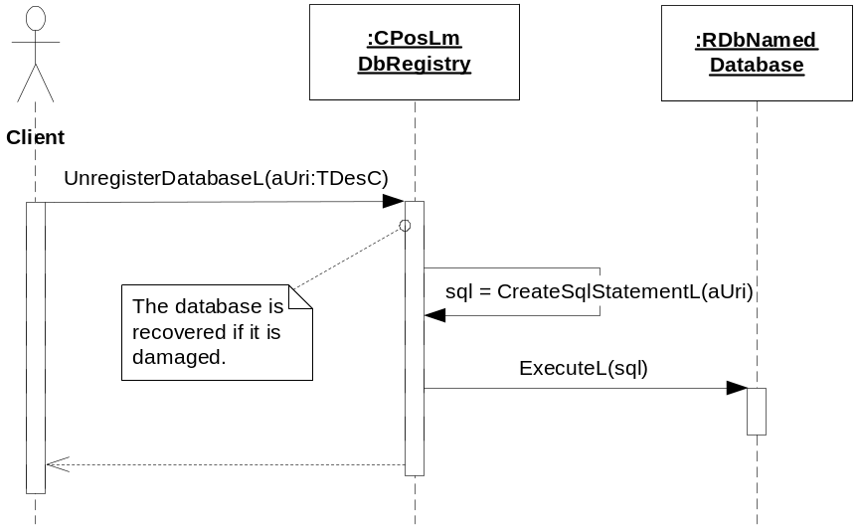
Figure 3.7 Unregistering a database

Unregistering all databases with a certain protocol
Operation | Unregistering all databases with a certain protocol.
Preconditions | The database registry is open.
Description | Unregisters all databases in the registry with a certain protocol, using an SQL query.
Inputs | The protocol for which to unregister all databases.
Modifies | The registry.
Outputs
Postconditions | All the databases with the specified protocol are removed from the registry.
Related to | CPosLmDbRegistry, RDbNamedDatabase
Related event
Exceptions

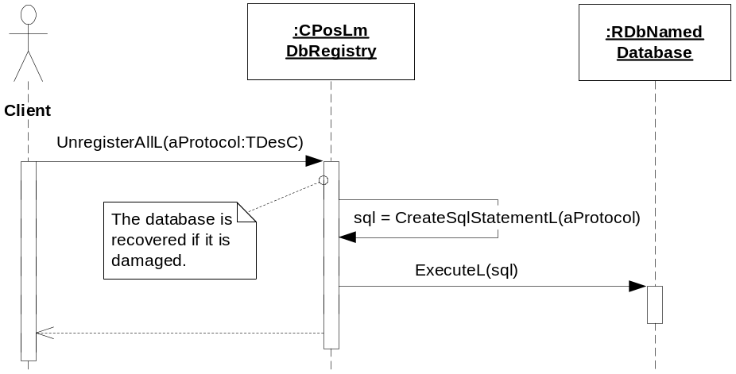
Figure 3.8 Unregistering all databases with a certain protocol

Retrieving database settings
Operation | Retrieving database settings.
Preconditions | The database registry is open.
Description | Retrieves the database settings for the database URI supplied by the client.
Inputs | The URI of the database for which to read the settings.
Modifies
Outputs | The database settings.
Postconditions | The client has received the database settings.
Related to | CPosLmDbRegistry, RDbView, RDbColReadStream
Related event
Exceptions | Leaves with KErrNotFound if the database does not exist in the registry.

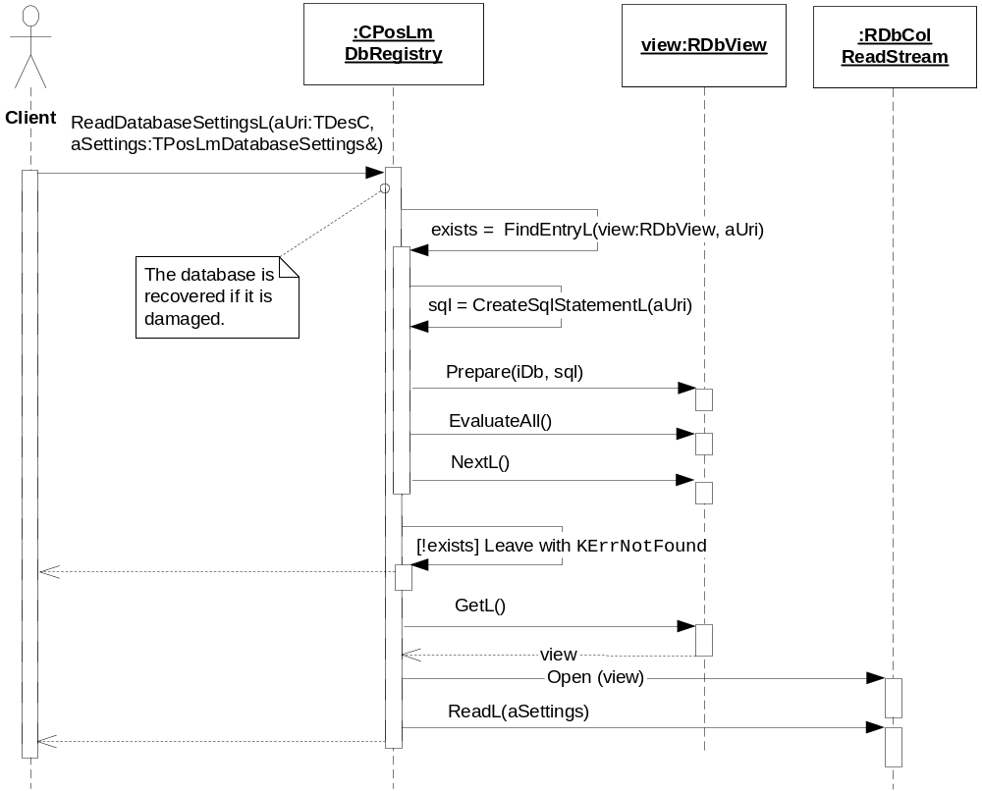
Figure 3.9 Retrieving database settings

Modifying database settings
Operation | Modifying database settings.
Preconditions | The database registry is open.
Description | Modifies the settings for a landmark database in the registry.
Inputs | The URI of the database for which to modify the settings and the new database settings.
Modifies | The settings for the landmark database.
Outputs
Postconditions | The settings for the specified database URI are updated in the registry.
Related to | CPosLmDbRegistry, RDbView, RDbColWriteStream
Related event
Exceptions | Leaves with KErrNotFound if the database does not exist in the registry.

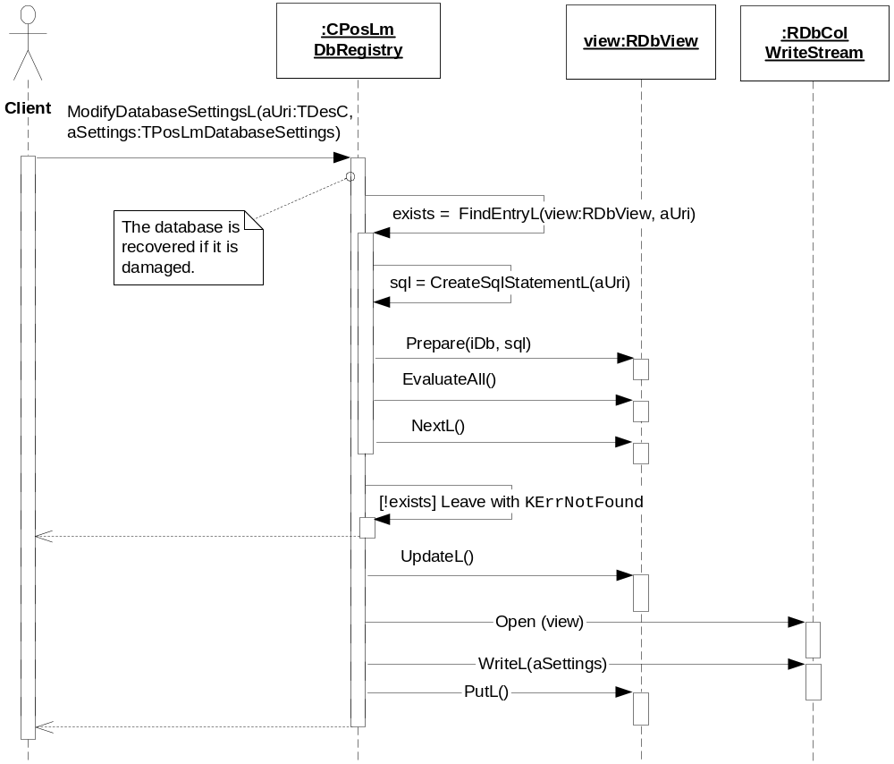
Figure 3.10 Modifying database settings

Listing databases with a specific protocol
Operation | Listing databases with a certain protocol.
Preconditions | The database registry is open.
Description | Lists all the databases with a certain protocol in the registry.
Inputs | The protocol for which to list the databases.
Modifies
Outputs | An iterator containing the databases.
Postconditions | The client has received an iterator with the search result. The client takes ownership of the iterator.
Related to | CPosLmDbRegistry, RDbView, CPosLmDatabaseIterator
Related event
Exceptions

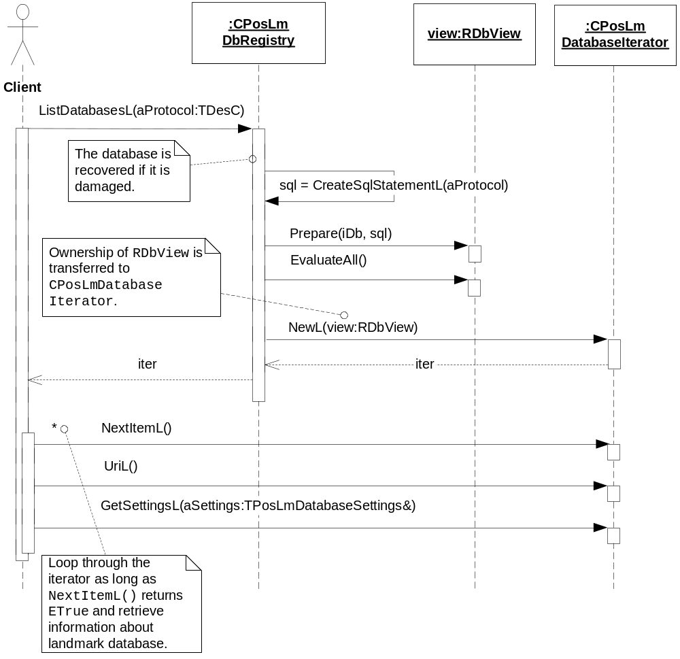
Figure 3.11 Listing databases with a specific protocol

Backup and Restore
The policies for backup and restore are described in reference document [2].

Variation
Variation for the Landmarks subsystem is described in reference document [2].

System resource usage

File structures
Landmarks Database Registry does not use any files.

Database structures
The registry database is an SQL database created with DBMS. It is a non-shared database only to be used by Landmarks Server.
The registry database contains one table with three fields. The internal database structure is created in CPosLmDbRegistry. The table and the column names are stored internally in EPos_PosDbRegistryConstants.h.
The table design is as follows:

Table name: dbreg
Column name | Type | Data size | Index | Description
prot | EDbColText | 0-33 bytes | Yes | Protocol. The maximum of 16 characters.
name | EDbColLongText | 0-2 Gbytes |  | File name.
dbset | EDbColLongText | 176 bytes |  | Database settings.

Timers and active objects
Landmarks Database Registry does not use any timers or active objects.

Security

Capabilities of this component
Capability | Justification
CAP_CLIENT_DLL | The DLL is a shared library and it will have the standard set of capabilities for shared libraries.

Input and output validation
This component performs input data checking as protection from client bugs, but since it is purely done in the client side, it is not protection against malicious clients. This protection must be provided at process borders where the data is used, but this is not the responsibility of this component.

Environmental assumptions
This component does not make any assumptions about its environment.

Additional enforcements
This component does not have any additional security enforcements.

Exception handling
The Symbian OS panic and leave mechanism are used to handle memory exhaustion and other system-wide error codes that appear upon execution.

Usage
Usage is described at the subsystem level in reference document [2].

