S60 3.x
Landmarks Internal Services
Design Document

Team name | Author
TD Software Platforms | Sergey Burnevsky

Change history:

Version | Date | Status | Comments
2.0 | 28.08.2007 | Approved | Whole document revised.
1.0 | 14.07.2005 | Approved

Table of contents:

1. Document control 4
1.1 References 4
1.2 Documentation conventions 4
1.3 Abbreviations 4
1.4 Definitions 5
2. General 6
2.1 Introduction 6
2.2 Component environment 6
2.3 Services required 8
2.3.1 From the Symbian OS subsystems 8
2.3.2 From the Domestic OS subsystems 8
2.3.3 From HW 8
2.4 Services provided 8
2.4.1 UI 8
2.4.2 SW IF 8
3. Design 9
3.1 Class diagrams 9
3.1.1 Component 9
3.2 Class descriptions 10
3.2.1 Structs, type definitions and enumerations 12
3.2.1.1 epos_cposlmdblocalaccess.h 12
3.2.1.2 epos_cposlmdiscutilities.h 12
3.2.1.3 epos_poslmcategoryhandler.h 12
3.2.1.4 epos_landmarksinternalservicespanic.h 12
3.2.1.5 epos_landmarkdatabasestructure.h 12
3.3 Operations 13
3.3.1 Adding a landmark to a landmark database 13
3.3.2 Checking if disk space is below the critical level 15
3.3.3 Estimating disk size for a landmark operation 16
3.3.4 Reading global categories from a resource file 17
3.3.5 Reading landmark settings 18
3.3.6 Changing landmark settings 19
3.3.7 Listening to a landmark settings event 20
3.3.8 Canceling listening to a landmark settings event 20
3.4 Backup and Restore 21
4. Variation 22
5. System resource usage 23
5.1 File structures 23
5.2 Database structures 23
5.2.1 Indexing strategy 25
5.3 Timers and active objects 25
6. Security 26
6.1 Capabilities of this component 26
6.2 Input and output validation 26
6.3 Environmental assumptions 26
6.4 Additional enforcements 26
7. Exception handling 27
8. Usage 28

Document control

References

- S60 3.0 Landmarks Subsystem Architecture Description
- S60 Landmarks Subsystem Design Document
- S60 Landmarks Category Definition API Specification Document
- S60 Landmarks Exchange Format Specification Document

Documentation conventions
Code is shown with the Courier New font.

Abbreviations

API | Application Programming Interface
DBMS | Database Management System
DLL | Dynamic Link Library
MBM | Multiple Bitmap file format
MIME | Multipurpose Internet Mail Extensions
MLFW | Mobile Location Framework
OS | Operating System
XML | Extensible Markup Language

Definitions

Corrupt database | A database that has become invalid and cannot be opened.
Damaged database | A database may be damaged when a transaction fails or is cancelled. A damaged database can be recovered by initialization.
DBMS | Database Management System. A commonly used term for the Symbian OS database engine.
ECom | Symbian OS framework for plug-in DLLs.
Framework | Usually denotes the collection of an engine and associated programming interfaces. This document mentions the Mobile Location Framework and the Symbian OS ECom Framework. There is also a subsystem in Symbian OS called Application Framework.
Landmark | A landmark is a named object that contains a location. The location can be defined by various attributes, e.g. WGS84 coordinates or a textual address.
Landmark category | A landmark can be categorized by assigning a landmark category to it. A typical landmark category is “Restaurant”. A landmark category is often referred to as “category”.
Landmark collection | A group of landmarks encoded according to reference document [4].
Landmark database | Persistent storage of a collection of landmarks and landmark categories.
Platform Security | Definition for the security design principles and features in Symbian OS.
Recognizer | Plug-in code that can examine sample data. If the data is recognized, its data type is returned. A data type is also commonly known as a MIME type.

General
This document describes the Landmarks Internal Services component in the Landmarks subsystem. The Landmarks subsystem design including general design guidelines for Landmark components is described in reference document [2]. The architecture is described in reference document [1].
Landmarks Internal Services is available from S60 release 3.0 onwards.

Introduction
Landmarks Internal Services defines the table structure in a local landmark database and provides operations for reading and editing the content. It also provides general services needed within the Landmarks subsystem.
The responsibilities and additional requirements of Landmarks Internal Services are the following:
- Implements the storage strategy of a local landmark database.
- Exports functions for accessing a local landmark database.
- A landmark can contain generic position text fields. These position fields are stored in the database in the landmark item.
- Writing to a database is not accepted if the amount of free memory on disk is too low.
- This component defines an API for writing category definition resource files.
- Provides a service for reading parameters from a resource files. This also includes reading the category definition resource file.
- Provides a service for checking the memory available on disk.
- Provides a service for accessing landmark settings, e.g. the default landmark database.

Component environment
Figure 2.1 and Figure 2.2 show the components in the Landmarks subsystem.
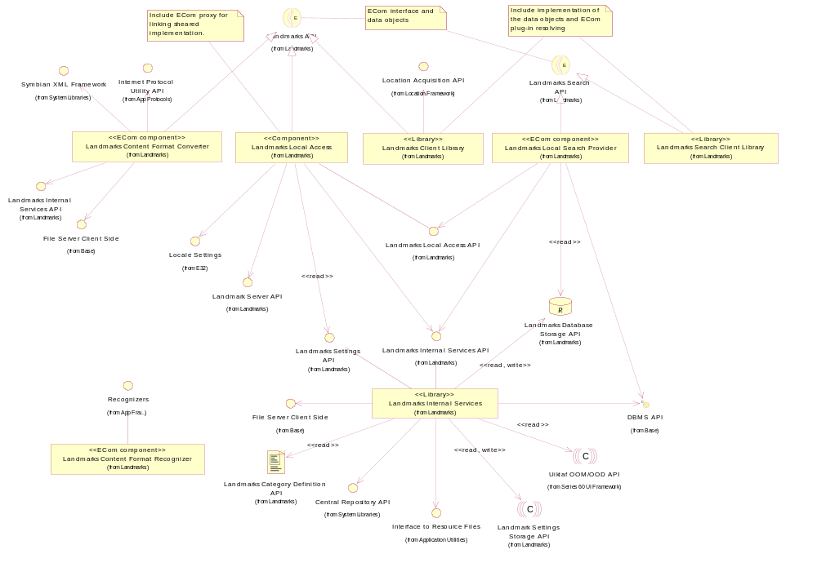
Figure 2.1 Basic Landmarks component diagram
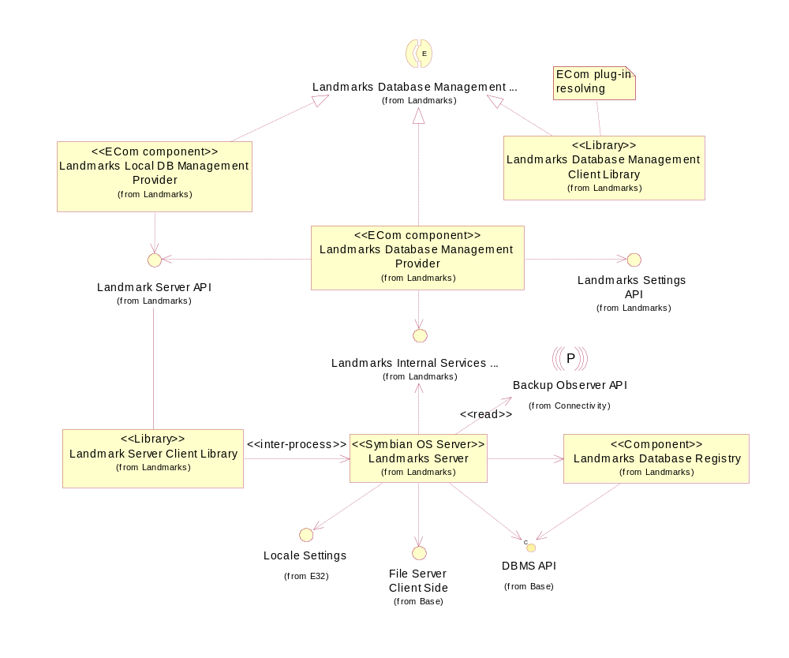
Figure 2.2 Database management component diagram

Services required

From the Symbian OS subsystems

API | Description
Central Repository API | Landmarks settings are stored in Central Repository.
DBMS API | Landmarks databases are DBMS databases.
File Server Client Side | Landmark content can be imported into landmark databases from a file. Landmarks can also be exported to a file.
Interface to resource files | Used to read the global category definition file.

From the Domestic OS subsystems
This component does not have any direct interfaces to the Domestic OS side subsystems.

From HW
This component has no direct HW interfaces.

Services provided

UI
This component does not provide any UI.

SW IF

Provided service | Description | Protected
Landmarks Internal Services API | Landmarks Internal Services is a private API, which  - Defines the table structure in a local landmark database and provides operations for reading and editing the content.  - Provides a service for checking the available memory on disk.  - Simplifies the reading of parameters from resource files. | Yes (DBMS policing)
Landmarks Settings API | A private API for accessing Landmarks system settings. | Yes (Central Repository policing)

Design

Class diagrams

Component
This section describes the design of the Landmarks Internal Services component.
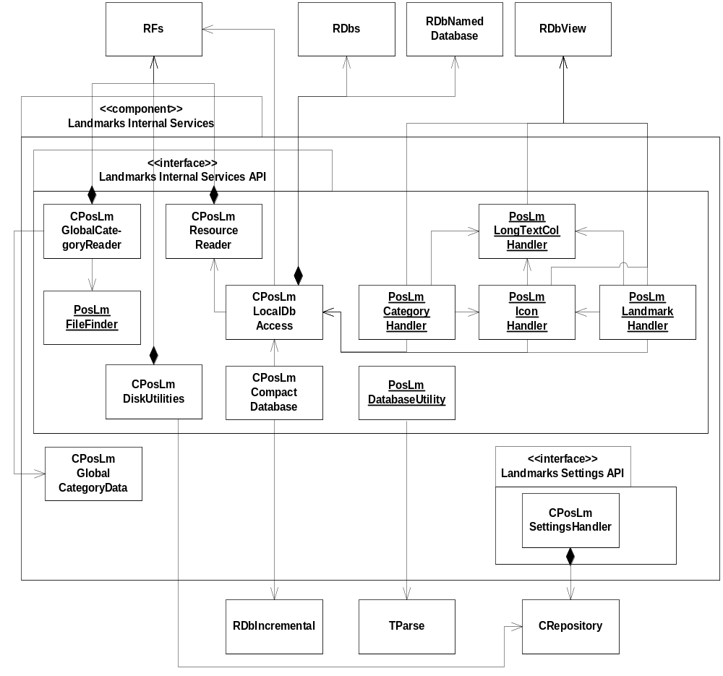
Figure 3.3 Landmarks Internal Services component class diagram

Class descriptions
Class | Description | Header file
CPosLmDisk  Utilities | A part of Landmarks Internal Services API.  Defines helper methods for handling out of disk space situations that can be used by other Landmarks components.  The critical memory level is read from Central Repository. | EPos_CPosLmDiskUtilities.h
CPosLmGlobal  CategoryReader | A part of Landmarks Internal Services API.  CPosLmGlobalCategoryReader reads global categories from a resource file and uses CPosLmGlobalCategoryData to store information about the global categories.  The static class PosLmFileFinder is used for finding the resource file and RFs is used to read from the resource file. | EPos_CPosLmGlobalCategoryReader.h
CPosLmGlobal  CategoryData | A data class holding information about a global category. | EPos_CPosLmGlobalCategoryData.h
CPosLmResource  Reader | A part of Landmarks Internal Services API.  CPosLmResourceReader reads properties from a resource file. It uses RFs to read from the resource file. | EPos_CPosLmResourceReader.h
CPosLmLocalDb  Access | This class is responsible for creating and opening landmark databases. It also provides transaction handling and a database handle to allow other classes to operate on the database.  If the default landmark database cannot be opened, e.g. if it is corrupt, it is replaced by an empty database.  Landmark databases are shared, so RDbs is used for creating and accessing the databases.  CPosLmLocalDbAccess uses RDbNamedDatabase to connect to a local landmark database. It is also used for creating tables and indexes.  CPosLmResourceReader is used for reading the database compact level from a resource file.  CPosLmLocalDbAccess provides transaction handling functions. It may also push a rollback function on the cleanup stack to automatically roll back if errors occur while making updates or committing a transaction. The rollback is popped if the transaction is completed correctly. | EPos_CPosLmLocalDbAccess.h
PosLmLongTextCol  Handler | Provides functions to read from and write to long text columns in a database. RDbView is used for accessing the current view of the database. | EPos_PosLmLongTextColHandler.h
PosLmIconHandler | Manages icon paths within a local landmark database.  PosLmIconHandler uses PosLmLongTextColHandler to read and write icon paths. It uses CPosLmLocalDbAccess to access a landmark database and RDbView to create views on it. | EPos_PosLmIconHandler.h
PosLmLandmark  Handler | Manages landmark operations on a local landmark database.  PosLmLandmarkHandler uses PosLmLongTextColHandler to read and write long text columns and PosLmIconHandler to manage icon paths within a local landmark database. It uses CPosLmLocalDbAccess to access a landmark database and RDbView to create views on it. | EPos_PosLmLandmark  Handler.h
PosLmCategory  Handler | Manages category operations on a local landmark database.  PosLmCategoryHandler uses PosLmLongTextColHandler to read and write long text columns and PosLmIconHandler to manage icon paths within a local landmark database. It uses CPosLmLocalDbAccess to access a landmark database and RDbView to create views on it. | EPos_PosLmCategoryHandler.h
PosLmDatabase  Utility | A class that has utility functions for landmark database handling.  PosLmDatabaseUtility uses TParse to parse file names. | EPos_PosLmDatabaseUtility.h
CPosLmCompact  Database | A class that compacts a local landmark database.  It uses CPosLmLocalDbAccess to access a landmark database and RDbIncremental to compact it in small steps. | EPos_CPosLmCompactDatabase.h
PosLmFileFinder | A static class, which provides an exported function for finding a resource file in the file system. | EPos_PosLmFileFinder.h
CPosLmSettings  Handler | CPosLmSettingsHandler uses CRepository to read and change landmark settings and also to listen to changes in Central Repository. | EPos_CPosLmSettingsHandler.h

Structs, type definitions and enumerations

epos_cposlmdblocalaccess.h

Enumeration name | Description
TPosLmInitParams | Enumerates the different reasons for landmark initialization.
CPosLmLocalDbAccess::  TPreparationType | Specifies whether a database view should be opened in updatable mode or in insert only mode.
CPosLmLocalDbAccess::  TCompactLevelType | Specifies whether compacting should be done using the client side strategy or the server side strategy.

epos_cposlmdiscutilities.h

Enumeration name | Description
CPosLmDiskUtilities::  TLmOperation | Enumerates all the operations that modify a landmark database.
CPosLmLocalDbAccess::  TCompactLevelType | Specifies whether compacting should be done using the client side strategy or the server side strategy.

epos_poslmcategoryhandler.h

Enumeration name | Description
PosLmCategoryHandler::  TCheckCategoryType | Specifies what kind of operation is checking for duplicated category names. If a category is added, there should not be a category with the same name. If a category is updated, there should not be another category with the same name.

epos_landmarksinternalservicespanic.h

Enumeration name | Description
TPosLandmarkInternalServices  DebugPanic | Enumerates the debug panic codes used in Landmarks Internal Services.

epos_landmarkdatabasestructure.h
Enumeration name | Description
TPosLmDatabaseTables | Enumerates the tables in a landmark database.
TPosLmLandmarkCols | Enumerates the columns in the landmark table.
TPosLmLandmarkFieldCols | Enumerates the columns in the landmark field table.
TPosLmLandmarkFieldCols | Enumerates the columns in the landmark field table.
TPosLmCategoryCols | Enumerates the columns in the category table.
TPosLmLandmarkCategoryCols | Enumerates the columns in the landmark category table.
TPosLmIconCols | Enumerates the columns in the icon table.
TPosLmSettingsCols | Enumerates the columns in the settings table.

Operations

Adding a landmark to a landmark database

Operation | Adding a landmark to a landmark database.
Preconditions | A landmark database is open.
Description | This operation shows how Landmarks Local Access uses Landmarks Internal Services to add a landmark to the landmark database. Landmarks Internal Services knows the table structures and writes to them using RDbView.
Inputs | A landmark object.
Modifies | The landmark data is added to the landmark database.
Outputs | The landmark ID is written to the landmark object.
Postconditions | The landmark exists in the landmark database.
Related to | Landmarks Local Access, PosLmLandmarkHandler, PosLmIconHandler, PosLmCategoryHandler, CPosLmLocalAccess
Related event
Exceptions | Leaves with KErrDiskFull if disk space decreases below the critical level.  Leaves if exceptions occur during operations against RFs.

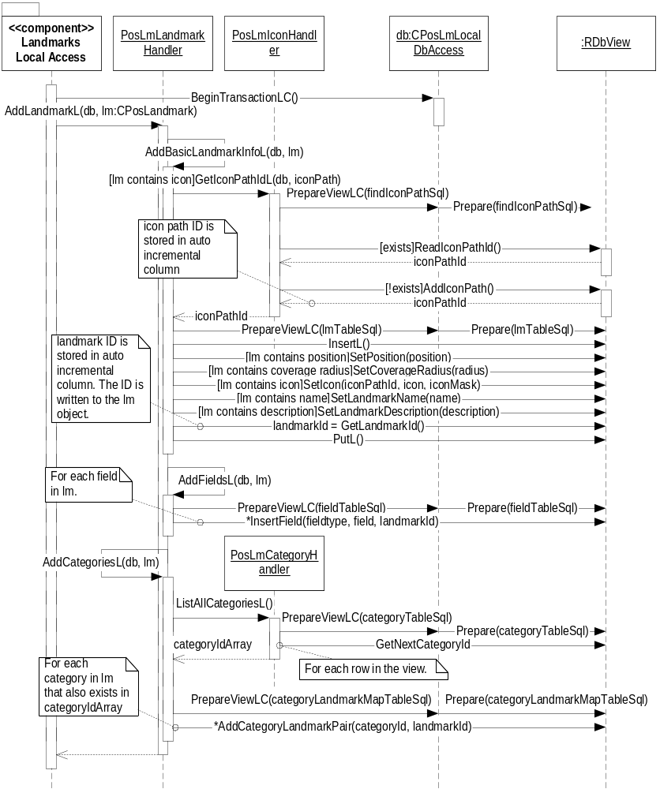
Figure 3.4 Adding a landmark to a landmark database

Checking if disk space is below the critical level

Operation | Checking if disk space is below the critical level.
Preconditions
Description | Checks the current free disk space on the defined drive. Checks if an operation causes the free disk space to decrease below the defined critical level. The critical level is defined in Central Repository.
Inputs | The estimated size in bytes that an operation should take on disk space. Which drive unit the operation should consume disk space on.  Note: The calculations are based on a disk cluster size of 2048 bytes. This means that files always have the size of n*2048 bytes even if the data in the file is less. This is taken into account when checking whether the critical level is reached or not (e.g. the estimated size is 3045 bytes, which will be evaluated to 4096 bytes).
Modifies
Outputs
Postconditions
Related to | CPosLmDiskUtilities
Related event
Exceptions | Leaves with KErrDiskFull if disk space decreases below the critical level.  Leaves if exceptions occur during operations against RFs.

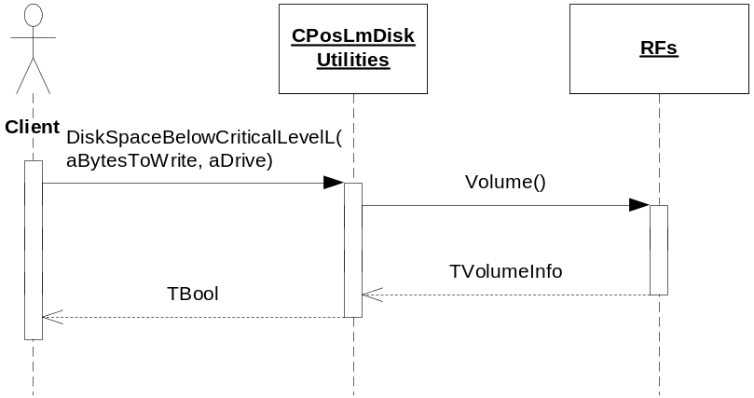
Figure 3.5 Checking if disk space is below the critical level

Estimating disk size for a landmark operation

Operation | Estimating disk size for a landmark operation.
Preconditions
Description | The disk impact estimation for a landmark operation is calculated differently depending on the type of operation. An estimation strategy has been created to make future changes easy to implement.  The estimation for landmark operations is done as follows:  - The estimation for adding a landmark is based on class member variables.  - The estimation for updating a landmark is based on class member variables minus a constant for removing a mean sized landmark.  - The estimation for removing landmarks is based on a constant for removing a mean sized landmark multiplied with the number of landmarks to remove.  The estimation for category operations is done as follows:  - The estimation for adding a category is based on class member variables.  - The estimation for updating a category is based on class member variables minus a constant for removing a mean sized category.  - The estimation for removing a category is based on a constant for removing a mean sized category multiplied with the number of categories to remove.  The estimation for adding or removing categories to/from a landmark is done as follows.  - The estimation for adding a category to a landmark is based on a constant.  - The estimation for removing a category from a landmark is based on a constant.  The estimation for creating a landmark database is done by checking the number of bytes an empty database takes on disk.  The calculations are based on a disk cluster size of 2048 bytes. Hence, if estimating disk impact to 100 bytes, the actual size needed above the limit is 2048 bytes.
Inputs | The landmark to be added or updated, the landmark item ID(s) that should be removed, the landmark category to be added or updated, the landmark category item ID(s) that should be removed.
Modifies
Outputs | The number of bytes the operation would take on disk.
Postconditions
Related to | CPosLmDiskUtilities
Related event
Exceptions

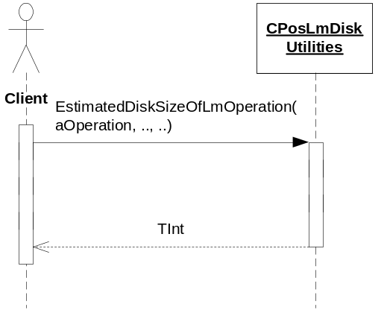
Figure 3.6 Estimating disk size for a landmark operation
Disk size usage of a mean size landmark is a landmark with a name of 15 characters, a description of 25 characters, three position fields with a total of 50 characters, and coverage radius and position set. The evaluated disk size for such a mean size landmark is approximately 1250 bytes.
Disk size usage of a mean landmark category is evaluated using a landmark category with a name of 15 characters. The evaluated disk size for such a landmark category is approximately 1250 bytes. The reason why the disk usage for a category is approximately the same as for a landmark is that the category is more indexed than the landmark. For instance, the category name is indexed.
Disk size usage for adding a landmark category to a landmark is approximately 250 bytes.
Disk size usage for removing a landmark category from a landmark is 100 bytes.

Reading global categories from a resource file

Operation | Reading global categories from a resource file.
Preconditions
Description | Reads global categories from a resource file. The resource file must be created according to Landmarks Category Definition API (see reference document [3]).  If the file is not found on any drive, no error is generated, but there are no global categories available.
Inputs
Modifies
Outputs | The global categories.
Postconditions | The global categories have been read from the resource file.
Related to | CPosLmGlobalCategoryReader, CPosLmGlobalCategoryData, PosLmFileFinder
Related event
Exceptions

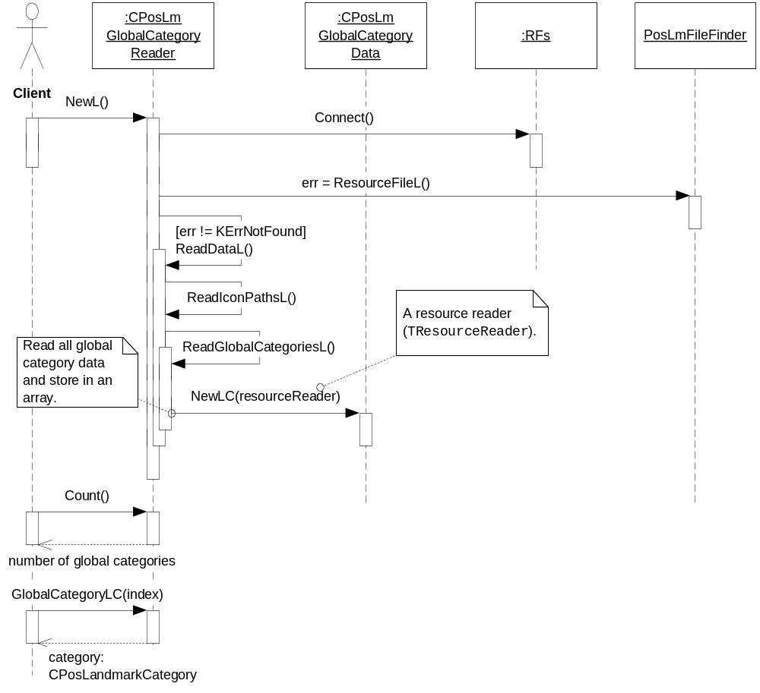
Figure 3.7 Reading global categories from a resource file

Reading landmark settings

Operation | Reading landmark settings.
Preconditions | The landmark settings file is available either in ROM or on the C: drive.
Description | Reads the landmark settings from Central Repository. This example shows how the default landmark database URI is fetched.
Inputs
Modifies
Outputs | The landmark settings.
Postconditions | The client has received the landmark settings.
Related to | CPosLmSettingsHandler, CRepository
Related event
Exceptions

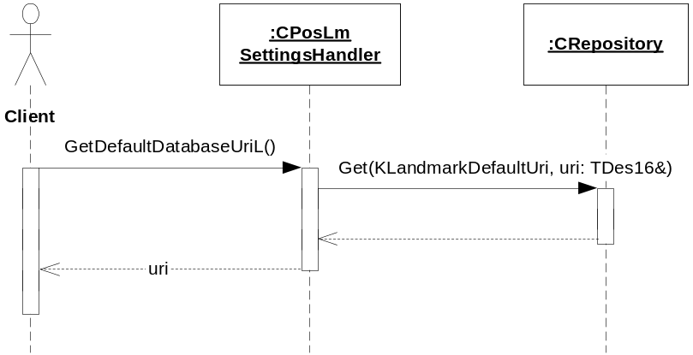
Figure 3.8 Reading landmark settings

Changing landmark settings

Operation | Changing landmark settings.
Preconditions | The landmark settings file is available either in ROM or on the C: drive.
Description | Changing landmark settings in Central Repository. This example shows how to set the default landmark database URI.
Inputs
Modifies | The landmark settings in Central Repository.
Outputs
Postconditions | The landmark settings are updated.
Related to | CPosLmSettingsHandler, CRepository
Related event
Exceptions

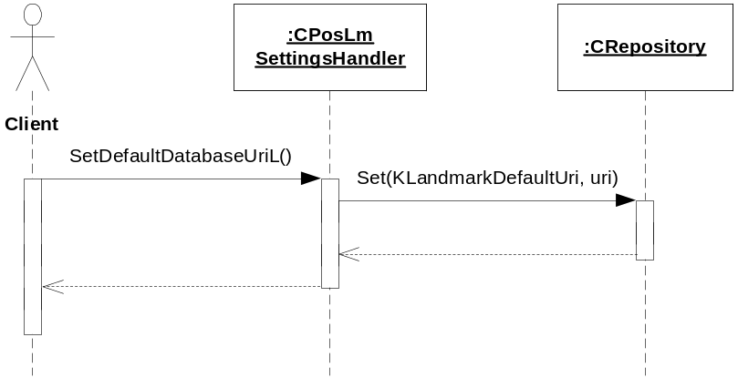
Figure 3.9 Changing landmark settings

Listening to a landmark settings event

Operation | Listening to a landmark settings event.
Preconditions
Description | The client makes a request to be notified of a landmark settings event. The request is asynchronous and completes when a change in the landmark settings has occurred.
Inputs | The request status.
Modifies
Outputs
Postconditions | The client is notified of the change in the landmark settings.
Related to | CPosLmSettingsHandler, CRepository
Related event
Exceptions

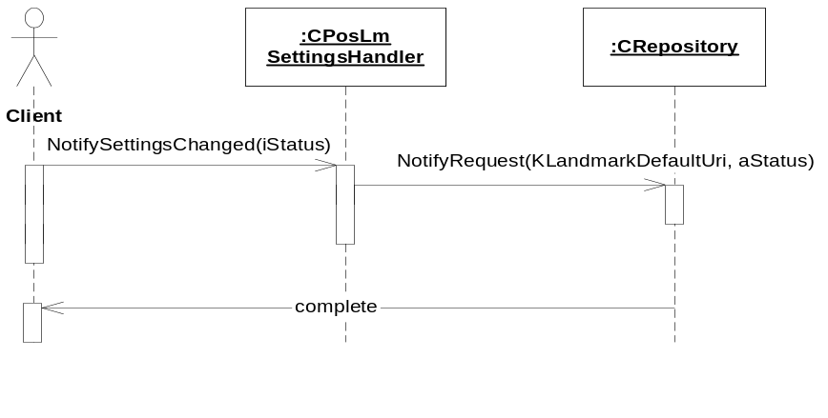
Figure 3.10 Listening to a landmark settings event

Canceling listening to a landmark settings event

Operation | Canceling listening to a landmark settings event.
Preconditions | A client has made a request to be notified of a landmark settings event.
Description | The client cancels the outstanding request in order to not to be notified of a landmark settings event.
Inputs
Modifies
Outputs | KErrNone if the operation was successful or any system wide error code.
Postconditions | The request is cancelled.
Related to | CPosLmSettingsHandler, CRepository
Related event | See Section 3.3.7.
Exceptions

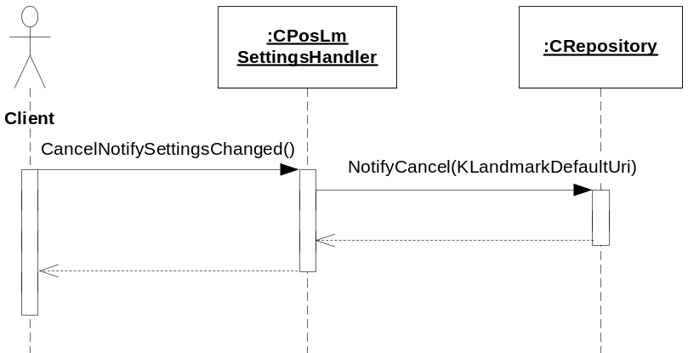
Figure 3.11 Canceling listening to a landmark settings event

Backup and Restore
The policies for backup and restore are described in reference document [2].

Variation
Variation for the Landmarks subsystem is described in reference document [2].

System resource usage

File structures
Landmarks Internal Services uses a resource file to specify the database usage level where compacting should be started, compactdblevel.RSS. This resource file is described in detail in reference document [2].
Landmark settings are stored in a Central Repository definition file, 101FE99B.TXT. This file contains settings for the URI of the default landmark database. The default landmark database key is defined by the constant KLandmarksDefaultUri.

Database structures
The landmark database is an SQL database created with DBMS. It contains seven tables with several fields.
The internal database structure is created in CPosLmLocalDbAccess. The table and column names are stored internally in EPos_LandmarkDatabaseStructure.h.
The table designs are as follows:

Table name: lmt_landmark
Column name | Type | Data size | Index | Description
lmc_lmid | EDbColUint32 | 4 bytes | Primary key | Landmark ID. Represented as a counter, which starts counting at 1.
lmc_lat | EDbColReal64 | 8 bytes |  | Latitude.
lmc_long | EDbColReal64 | 8 bytes |  | Longitude.
lmc_alt | EDbColReal32 | 4 bytes |  | Altitude.
lmc_hacc | EDbColReal32 | 4 bytes |  | Horizontal accuracy.
lmc_vacc | EDbColReal32 | 4 bytes |  | Vertical accuracy.
lmc_covrad | EDbColReal32 | 4 bytes |  | Coverage radius.
lmc_iconid | EDbColUint32 | 4 bytes | Foreign key to table lmt_icon | Icon ID (representing a path in the lmt_icon table).
lmc_iconnr | EDbColInt32 | 4 bytes |  | Icon index (the icon index within the icon file).
lmc_masknr | EDbColInt32 | 4 bytes |  | Mask index (the icon index within the icon file).
lmc_name | EDbColLongText | 0-511 bytes |  | Landmark name. The maximum of 255 characters.
lmc_desc | EDbColLongText | 0-8191 bytes |  | Landmark description. The maximum of 4095 characters.

Table name: lmt_lmfield
Column name | Type | Data size | Index | Description
lmc_lmid | EDbColUint32 | 4 bytes | Foreign key to table lmt_  landmark | Landmark ID.
lmc_fieldtype | EDbColUint16 | 2 bytes |  | Field type. TPositionFieldId (from Location Client API) is stored here.
lmc_fieldstr | EDbColLongText | 0-511 bytes |  | Field text. The maximum of 255 characters.

Table name: lmt_cat
Column name | Type | Data size | Index | Description
lmc_catid | EDbColUint32 | 4 bytes | Primary key | Category ID. Represented as a counter, which starts counting at 1.
lmc_glcatid | EDbColUint16 | 2 bytes | Yes | Global category ID.  This column is checked to be unique, but it cannot have a unique index because several categories may not be global categories, so a NULL value may be used by several categories.
lmc_iconid | EDbColUint32 | 4 bytes | Foreign key to table lmt_icon | Icon ID (representing a path in the lmt_icon table).
lmc_iconnr | EDbColInt32 | 4 bytes |  | Icon index (the icon index within the icon file).
lmc_masknr | EDbColInt32 | 4 bytes |  | Mask index (the icon index within the icon file).
lmc_catname | EDbColText | 0-249 bytes | Unique | Category name. The maximum of 124 characters.
lmc_namemod | EDbColBit | 1 bit |  | Set to 1 if the category name has been modified. Only used for global categories to distinguish between user-modified and original global category names.

Table name: lmt_lmcat
Column name | Type | Data size | Index | Description
lmc_lmid | EDbColUint32 | 4 bytes | Foreign key to table lmt_  landmark | Landmark ID.
lmc_catid | EDbColUint32 | 4 bytes | Foreign key to table lmt_cat | Category ID.

Table name: lmt_icon
Column name | Type | Data size | Index | Description
lmc_iconid | EDbColUint32 | 4 bytes | Primary key | Icon ID. Represented as a counter, which starts counting at 0.
lmc_iconpath | EDbColLongText | 0-513 bytes |  | Icon path. File names cannot be longer than 256 characters. In practice, this column has therefore the maximum data size of 513 bytes.

Table name: lmt_settings
Column name | Type | Data size | Index | Description
lmc_language | EDbColInt32 | 4 bytes |  | Contains the language associated with the current global categories within the database.
lmc_init | EDbColInt32 | 4 bytes |  | Contains initialization settings used by Landmarks Server when initializing the database.

Indexing strategy
Database indexing is used to speed up database operations. The main strategy is to use indexes on primary keys to enable fast look-up. Indexes are used on other non-text fields that are used in single column search operations. This means that if a search operation is performed on two columns at the same time, there is no gain in performance using indexes in most cases.
Indexes are also used on text fields where searches are performed on the whole string. Searching for strings with wild cards does not take advantage of indexes within DBMS. It is also used whenever column uniqueness needs to be guaranteed.

Timers and active objects
Landmarks Internal Services does not use any timers or active objects.

Security

Capabilities of this component

Capability | Justification
CAP_CLIENT_DLL | The DLL is a client side shared library and it must have all the capabilities that a potential client may have.

Input and output validation
This component does not require or make any validation for data.

Environmental assumptions
This component does not make any assumptions about its environment.

Additional enforcements
This component does not have any additional security enforcements.

Exception handling
The Symbian OS panic and leave mechanism are used to handle memory exhaustion and other system-wide error codes that appear upon execution.

Usage
Usage is described at the subsystem level in reference document [2].

