S60 3.x
Landmarks Local DB Management Provider
Design Document

Team name | Author
TD Software Platforms | Sergey Burnevsky

Change history:

Version | Date | Status | Comments
2.0 | 28.08.2007 | Approved | Whole document revised.
1.0 | 15.07.2005 | Approved

Table of contents:

1. Document control 4
1.1 References 4
1.2 Documentation conventions 4
1.3 Abbreviations 4
1.4 Definitions 4
2. General 5
2.1 Introduction 5
2.2 Component environment 5
2.3 Services required 7
2.3.1 From the Symbian OS subsystems 7
2.3.2 From the Domestic OS subsystems 7
2.3.3 From HW 7
2.4 Services provided 7
2.4.1 UI 7
2.4.2 SW IF 7
3. Design 8
3.1 Class diagrams 8
3.1.1 Component 8
3.2 Class descriptions 9
3.2.1 Structs, type definitions and enumerations 9
3.2.1.1 epos_cposlmlocaldatabasemanager.h 9
3.3 Operations 10
3.3.1 Creating a local database manager 10
3.3.2 Checking if a specified landmark database exists 11
3.3.3 Creating a landmark database 12
3.3.4 Deleting a landmark database 13
3.3.5 Copying a landmark database 14
3.3.6 Listing landmark database names 15
3.3.7 Listing landmark database information 16
3.3.8 Retrieving landmarks database information 18
3.3.9 Modifying landmark database settings 19
3.4 Backup and Restore 20
4. Variation 21
5. System resource usage 22
5.1 File structures 22
5.2 Database structures 22
5.3 Timers and active objects 22
6. Security 23
6.1 Capabilities of this component 23
6.2 Input and output validation 23
6.3 Environmental assumptions 23
6.4 Additional enforcements 23
7. Exception handling 24
8. Usage 25

Document control

References
- S60 3.0 Landmarks Subsystem Architecture Description
- S60 Landmarks Subsystem Design Document
- S60 Landmarks Exchange Format Specification Document

Documentation conventions
Code is shown with the Courier New font.

Abbreviations
API | Application Programming Interface
DLL | Dynamic Link Library
MBM | Multiple Bitmap file format
MIME | Multipurpose Internet Mail Extensions
MLFW | Mobile Location Framework
OS | Operating System
XML | Extensible Markup Language

Definitions
Corrupt database | A database that has become invalid and cannot be opened.
Damaged database | A database may be damaged when a transaction fails or is cancelled. A damaged database can be recovered by initialization.
DBMS | Database Management System. A commonly used term for the Symbian OS database engine.
ECom | Symbian OS framework for plug-in DLLs.
Framework | Usually denotes the collection of an engine and associated programming interfaces. This document mentions the Mobile Location Framework and the Symbian OS ECom Framework. There is also a subsystem in Symbian OS called Application Framework.
Landmark | A landmark is a named object that contains a location. The location can be defined by various attributes, e.g. WGS84 coordinates or a textual address.
Landmark category | A landmark can be categorized by assigning a landmark category to it. A typical landmark category is “Restaurant”. A landmark category is often referred to as “category”.
Landmark collection | A group of landmarks encoded according to reference document [3].
Landmark database | Persistent storage of a collection of landmarks and landmark categories.
Platform Security | Definition for the security design principles and features in Symbian OS.
Recognizer | Plug-in code that can examine sample data. If the data is recognized, its data type is returned. A data type is also commonly known as a MIME type.

General
This document describes the Landmarks Local DB Management Provider component in the Landmarks subsystem. The Landmarks subsystem design including general design guidelines for Landmark components is described in reference document [2]. The architecture is described in reference document [1].
Landmarks Local DB Management Provider is available from S60 release 3.0 onwards.

Introduction
The Landmarks Local DB Management Provider component provides functionality for managing multiple local landmark databases.
The responsibilities and additional requirements of Landmarks Local DB Management Provider are the following:
- Uses Landmark Server API to establish a communication channel to Landmarks Server.
- Enables creating, deleting and copying landmark databases. A private sub-session interface to Landmarks Server is used for this.
- Enables listing of databases using Landmarks Server API.
- Registers and unregisters databases as they are created using Landmarks Server API.
- Events are reported to Landmarks Server, which distributes them to the interested clients.

Landmarks Local DB Management Provider is an ECom plug-in providing functionality for managing local landmark databases according to Landmarks Database Management API.

Component environment
Figure 2.1 and Figure 2.2 show the components in the Landmarks subsystem.
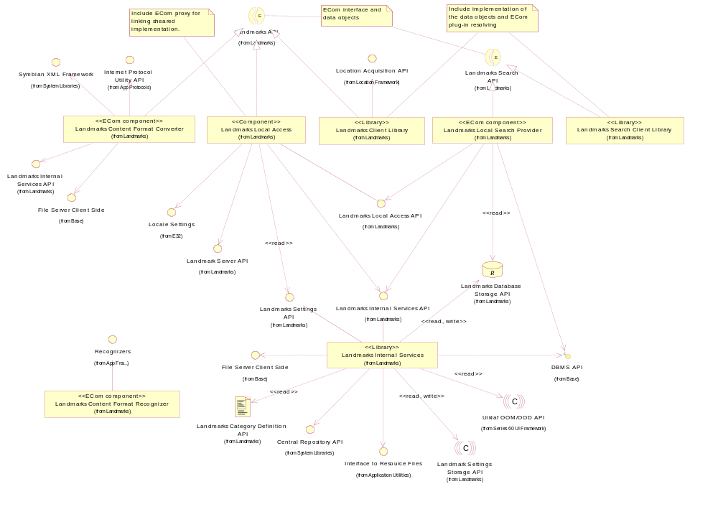
Figure 2.1 Basic Landmarks component diagram
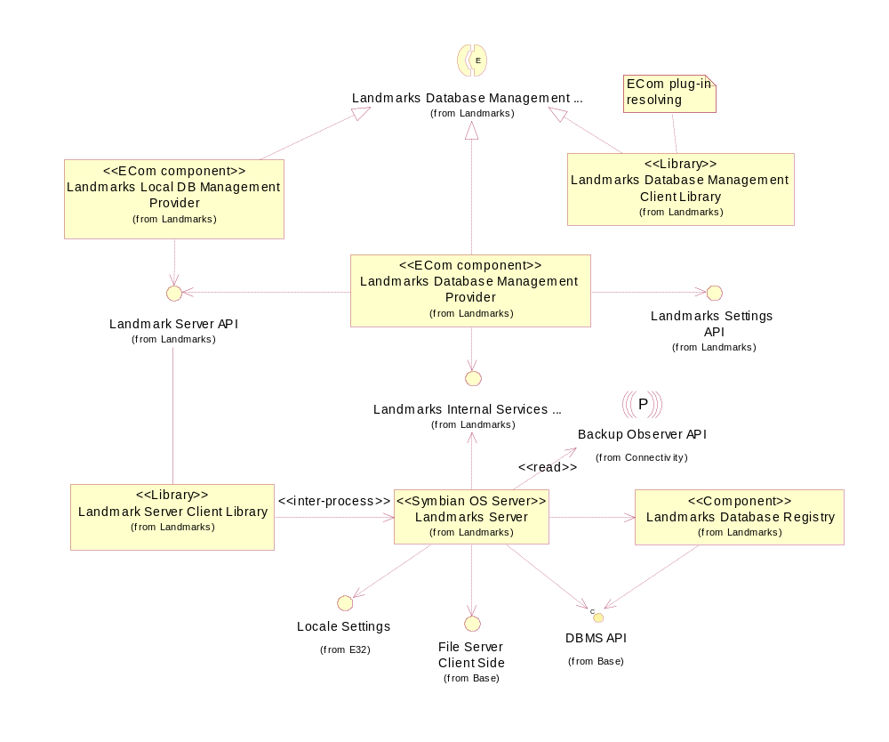
Figure 2.2 Database management component diagram

Services required

From the Symbian OS subsystems

API | Description
DBMS API | Landmark databases are DBMS databases.
ECom Plug-in Architecture | Different implementations for Landmark APIs are provided as ECom plug-ins.

From the Domestic OS subsystems
This component does not have any direct interfaces to the Domestic OS side subsystems.

From HW
This component has no direct HW interfaces.

Services provided

UI
This component does not provide any UI.

SW IF

Provided service | Description | Protected
Landmarks Database Management API | Landmarks Local DB Management Provider is a plug-in, which implements database management of local landmark databases for Landmarks Database Management API. | Yes

Design

Class diagrams

Component
This section describes the design of the Landmarks Local DB Management Provider component.
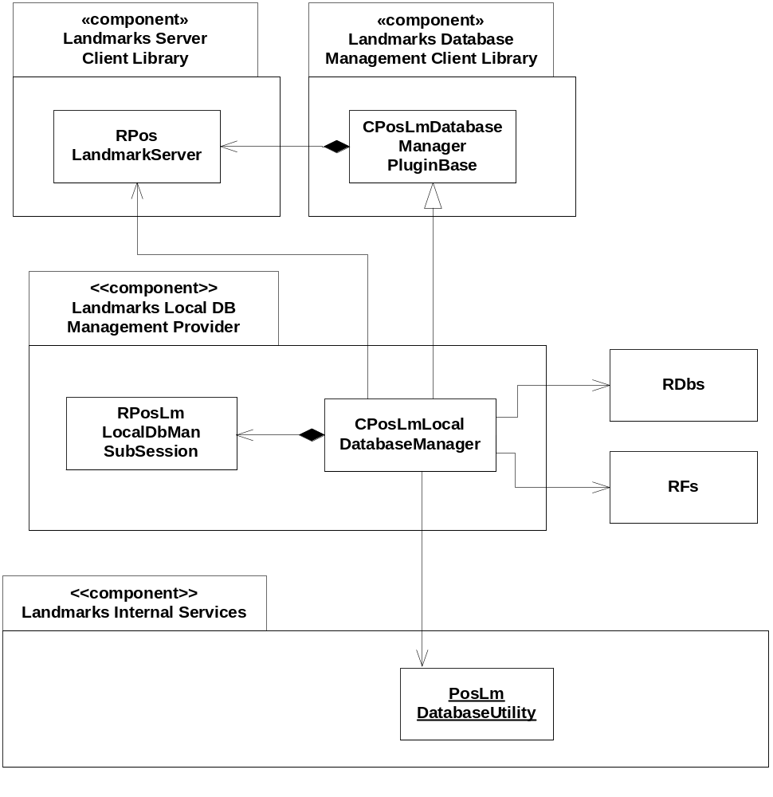
Figure 3.3 Landmarks Local DB Management Provider component class diagram

Class descriptions
Class | Description | Header file
CPosLmLocal  DatabaseManager | This subclass to CPosLmDatabaseManagerPluginBase is used to manage and access landmark databases.  RDbs is used to retrieve database names from the file system.  RPosLmLocalDbManSubsession is used for certain operations (for creating, deleting and copying a database) since these operations require the ReadDeviceData and WriteDeviceData capabilities. Landmarks Server has these capabilities, while it is generally expected that client processes only have user capabilities.  PosLmDatabaseUtility is used to verify that a database URI is correct. It is also used to remove the “file” protocol from the URI.  RPosLandmarkServer is used to connect to Landmarks Server and attach a sub-session.  RFs is used to find out about the available drives where landmark databases may reside. | EPos_CPosLmLocalDatabaseManager.h
RPosLmLocalDbMan  Subsession | RPosLmLocalDbManSubsession handles the communication with Landmarks Server and contains methods for creating, copying and deleting local landmark databases. | EPos_RPosLmLocalDbMan  Subsession.h

Structs, type definitions and enumerations

epos_cposlmlocaldatabasemanager.h

Struct name | Description
TMediaInfo | A struct for media information, i.e. drive letter and media type.

Operations

Creating a local database manager

Operation | Creating a local database manager.
Preconditions
Description | Creates a local database manager. RPosLmLocalDbManSubsession is instantiated.
Inputs
Modifies
Outputs | A new instance of a local database manager.
Postconditions
Related to | CPosLmLocalDatabaseManager, RPosLandmarkServer, RPosLmLocalDbManSubsession
Related event
Exceptions

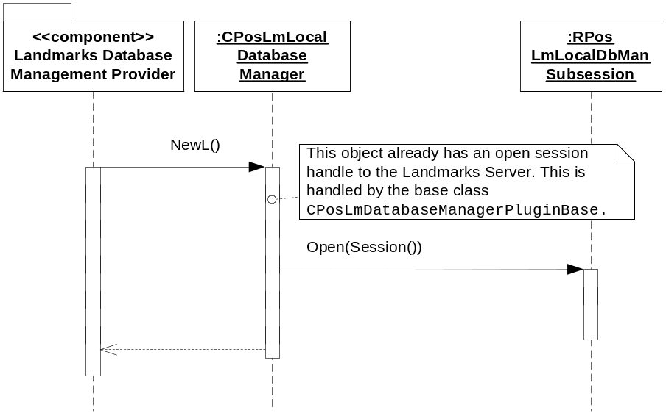
Figure 3.4 Creating a local database manager

Checking if a specified landmark database exists

Operation | Checking if a specified landmark database exists.
Preconditions
Description | Checks if the specified landmark database exists. The database to check is specified by passing a URI to this function. The URI must point to a database, which is handled by this database manager, i.e. “file” protocol.
Inputs | The URI of the database, which should be checked for existence.
Modifies
Outputs | ETrue if the database exists, otherwise EFalse.
Postconditions
Related to | CPosLmLocalDatabaseManager, PosLmDatabaseUtility, RDbs
Related event
Exceptions | Leaves with KErrArgument if the URI is incorrect or not recognized by the database manager.

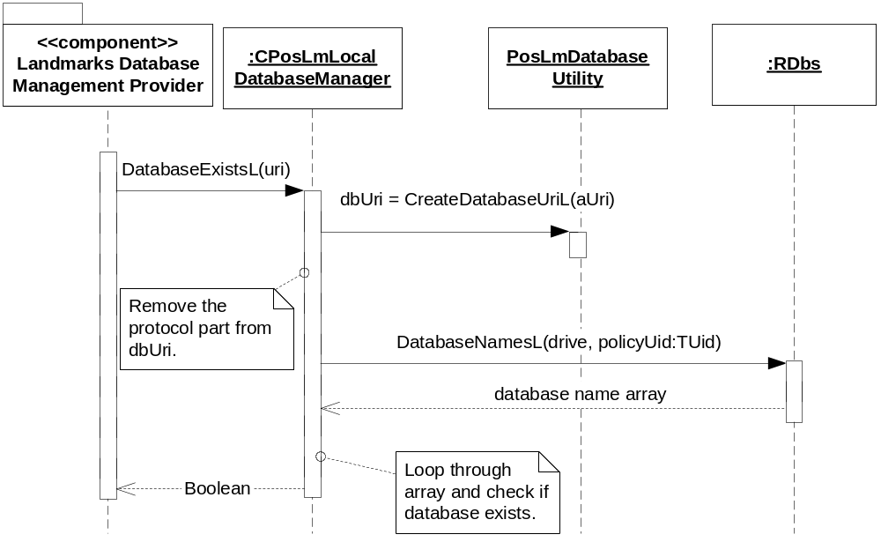
Figure 3.5 Checking if a specified landmark database exists

Creating a landmark database

Operation | Creating a landmark database.
Preconditions
Description | Creates a landmark database. The database to create is specified by passing a URI to this function. The URI must point to a database, which is handled by this database manager, i.e. “file” protocol.
Inputs | The URI of the new database.
Modifies
Outputs
Postconditions | The landmark database is created.
Related to | CPosLmLocalDatabaseManager, RPosLmLocalDbManSubsession
Related event
Exceptions | Leaves with KErrArgument if the URI is incorrect or not recognized by the database manager, KErrAlreadyExists if there is already a database at the URI.

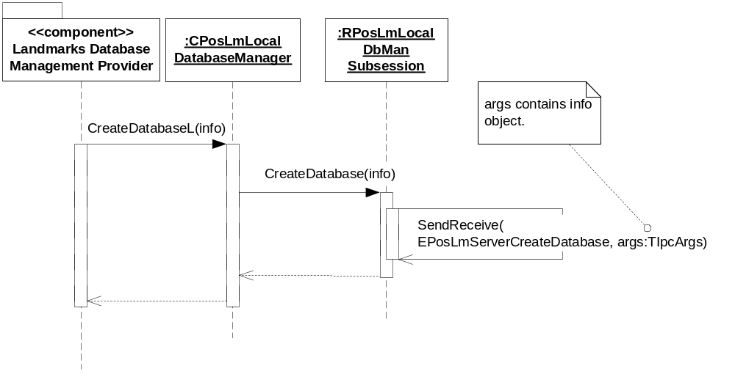
Figure 3.6 Creating a landmark database

Deleting a landmark database

Operation | Deleting a landmark database.
Preconditions
Description | Deletes a landmark database. The database to delete is specified by passing a URI to this function. The URI must point to a database, which is handled by this database manager, i.e. not a remote location.
Inputs | The URI of the database to delete.
Modifies
Outputs
Postconditions | The landmark database is deleted.
Related to | CPosLmLocalDatabaseManager, RPosLmLocalDbManSubsession, HPosLmDatabaseInfo
Related event
Exceptions | Leaves with KErrArgument if the URI is incorrect or not recognized by the database manager, KErrInUse if the database is in use by some client, KErrAccessDenied if the database is read-only.

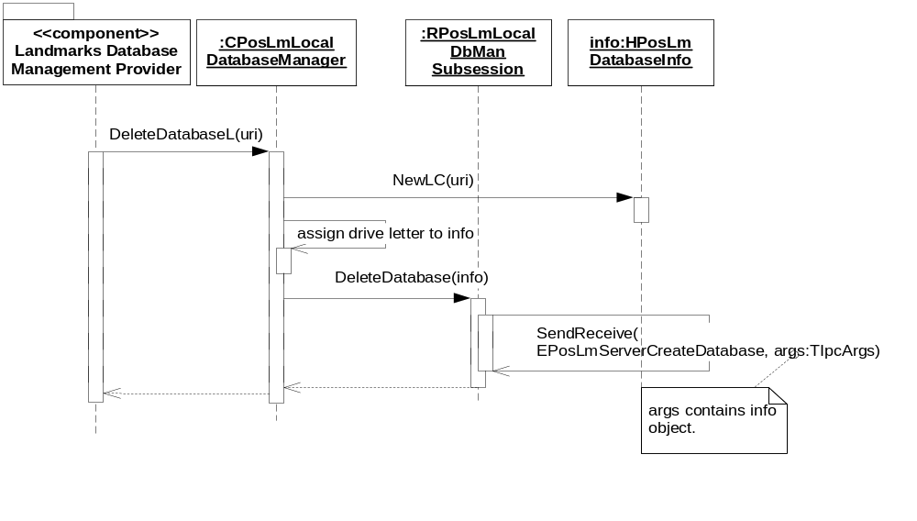
Figure 3.7 Deleting a landmark database

Copying a landmark database

Operation | Copying a landmark database.
Preconditions | A client has requested that a landmarks database should be copied.
Description | Copies a local database.
Inputs | The source and destination database URIs.
Modifies | Creates the new database copy.
Outputs
Postconditions | A copy of the database has been created.
Related to | CPosLmLocalDatabaseManager, RPosLmLocalDbManSubsession
Related event
Exceptions | Leaves with an error code if the destination already exists, the source cannot be found, or if there are other errors in the source and target URI descriptors.

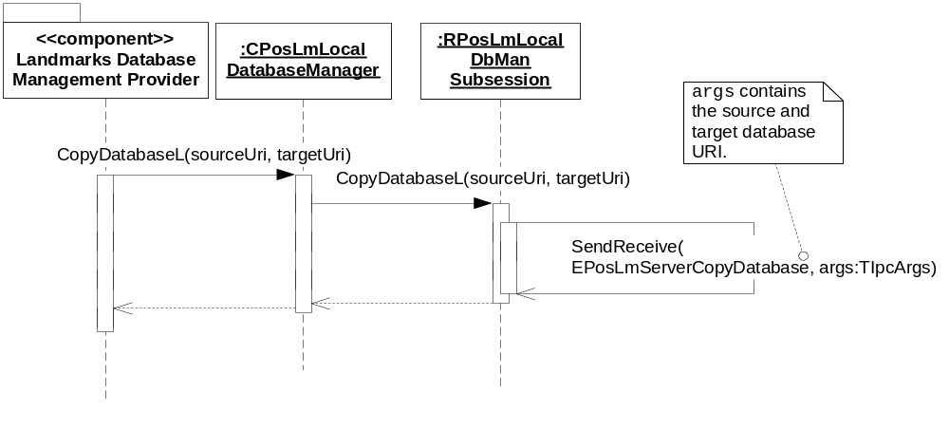
Figure 3.8 Copying a landmark database.

Listing landmark database names

Operation | Listing landmark database names.
Preconditions
Description | A list containing the URIs of the landmark databases known by the local database manager is returned to the client. The list includes the default landmark database.
Inputs
Modifies
Outputs | A list containing the URIs of the landmark databases.
Postconditions | The client takes ownership of the URI list.
Related to | CPosLmLocalDatabaseManager, CDesCArrayFlat, RDbs.
Related event | See Section 3.3.7.
Exceptions

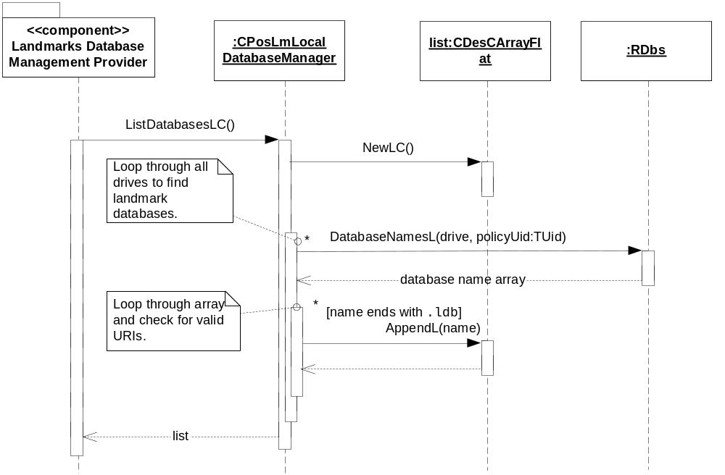
Figure 3.9 Listing landmark database names

Listing landmark database information

Operation | Listing landmark database information.
Preconditions
Description | A list containing the information about all the databases known by the local database manager is returned to the client.
Inputs
Modifies
Outputs | A list containing the properties of the landmark databases (owned by the client).
Postconditions
Related to | CPosLmLocalDatabaseManager, RPointerArray, HPosLmDatabaseInfo, RPosLandmarkServer
Related event | See Section 3.3.6.
Exceptions

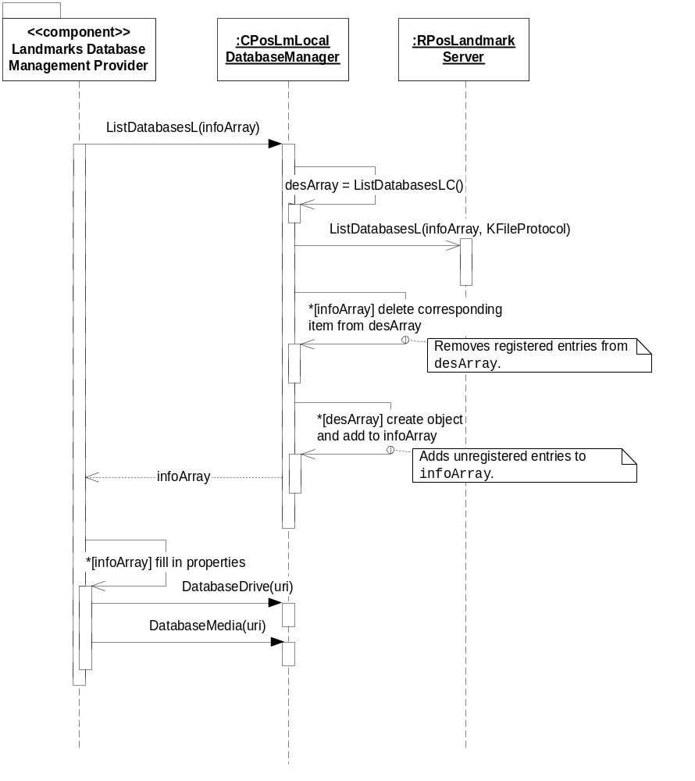
Figure 3.10 Listing landmark database information

Retrieving landmarks database information

Operation | Retrieving landmarks database information.
Preconditions
Description | The client retrieves information about a local landmarks database, such as the database URI, database drive, database media type and display name.
Inputs
Modifies
Outputs | Information about the landmarks database.
Postconditions
Related to | CPosLmLocalDatabaseManager, HPosLmDatabaseInfo, RPosLandmarkServer, PosLmDatabaseUtility
Related event
Exceptions

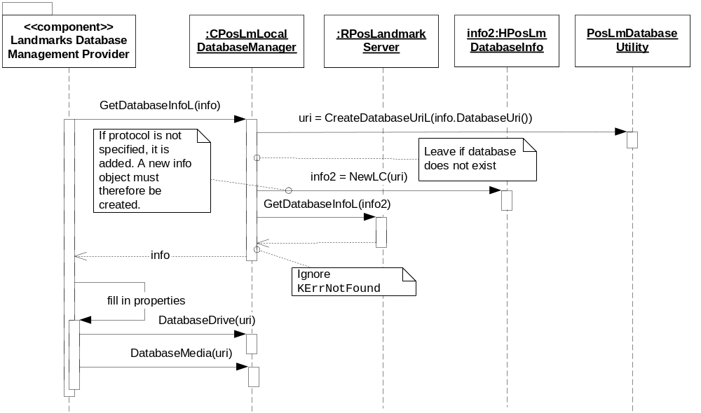
Figure 3.11 Retrieving landmarks database information

Modifying landmark database settings

Operation | Modifying landmark database settings.
Preconditions
Description | The client modifies the settings (the display name) of a local landmark database.
Inputs | The new settings of the database.
Modifies | The settings of the database.
Outputs
Postconditions
Related to | CPosLmLocalDatabaseManager, TPosLmDatabaseSettings, RPosLandmarkServer, PosLmDatabaseUtility
Related event
Exceptions

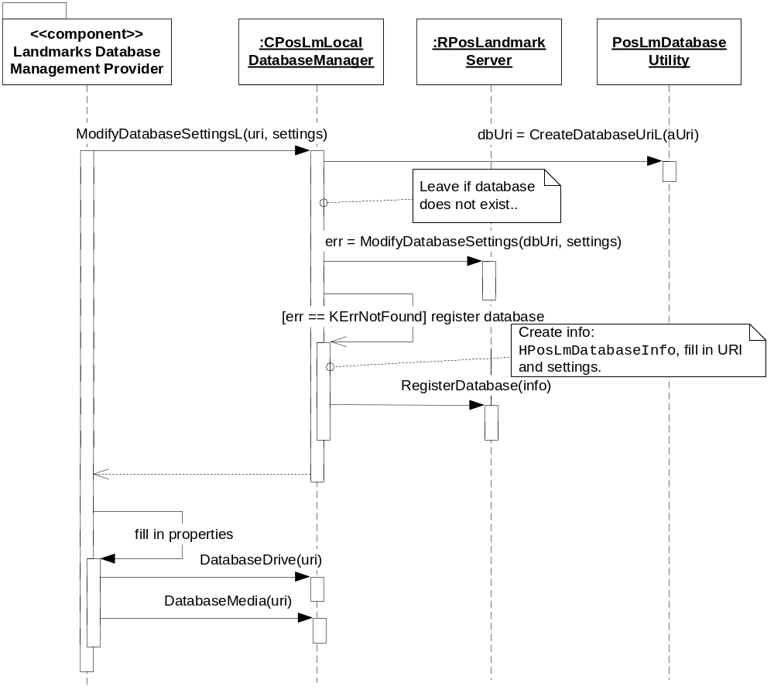
Figure 3.12 Modifying landmark database settings

Backup and Restore
The policies for backup and restore are described in reference document [2].

Variation
Variation for the Landmarks subsystem is described in reference document [2].

System resource usage

File structures
Landmarks Local DB Management Provider does not own any files.

Database structures
Landmarks Local DB Management Provider uses the database defined in the Landmarks Local Access component.

Timers and active objects
Landmarks Local DB Management Provider does not use any timers or active objects.

Security

Capabilities of this component

Capability | Justification
CAP_CLIENT_DLL | The DLL is a client side plug-in and it must have all the capabilities that a potential client may have.

Input and output validation
This component performs input data checking as protection from client bugs, but since it is purely done in the client side, it is not protection against malicious clients. This protection must be provided at process borders where the data is used, but this is not the responsibility of this component.

Environmental assumptions
This component does not make any assumptions about its environment.

Additional enforcements
This component does not have any additional security enforcements.

Exception handling
The Symbian OS panic and leave mechanism are used to handle memory exhaustion and other system-wide error codes that appear upon execution. The leave mechanism is also used for telling whether implementations loaded by the ECom Framework are present or not.

Usage
Usage is described at the subsystem level in reference document [2].

