S60 3.x
Landmarks Local Search Provider
Design Document

Team name | Author
TD Software Platforms | Sergey Burnevsky

Change history:

Version | Date | Status | Comments
2.0 | 28.08.2007 | Approved | Whole document revised.
1.0 | 15.07.2005 | Approved

Table of contents:

1. Document control 4
1.1 References 4
1.2 Documentation conventions 4
1.3 Abbreviations 4
1.4 Definitions 5
2. General 6
2.1 Introduction 6
2.2 Component environment 6
2.3 Services required 7
2.3.1 From the Symbian OS subsystems 7
2.3.2 From the Domestic OS subsystems 7
2.3.3 From HW 7
2.4 Services provided 7
2.4.1 UI 7
2.4.2 SW IF 7
3. Design 8
3.1 Class diagrams 8
3.1.1 Component 8
3.2 Class descriptions 9
3.2.1 Structs, type definitions and enumerations 11
3.2.1.1 epos_tposlmlocalsortpref.h 11
3.2.1.2 epos_landmarkslocalsearchproviderpanic.h 11
3.3 Operations 12
3.3.1 Searching for landmarks 12
3.3.2 Searching for landmark categories sorted by preference 17
3.3.3 Retrieving a search result 19
3.3.4 Using display data 20
3.4 Backup and Restore 23
4. Variation 24
5. System resource usage 25
5.1 File structures 25
5.2 Database structures 25
5.3 Timers and active objects 25
6. Security 26
6.1 Capabilities of this component 26
6.2 Input and output validation 26
6.3 Environmental assumptions 26
6.4 Additional enforcements 26
7. Exception handling 27
8. Usage 28

Document control

References

- S60 3.0 Landmarks Subsystem Architecture Description
- S60 Landmarks Subsystem Design Document
- S60 Landmarks Internal Services Design Document
- S60 Landmarks Search Client Library Design Document
- S60 Landmarks Exchange Format Specification Document

Documentation conventions
Code is shown with the Courier New font.

Abbreviations

API | Application Programming Interface
DLL | Dynamic Link Library
MBM | Multiple Bitmap file format
MIME | Multipurpose Internet Mail Extensions
MLFW | Mobile Location Framework
OS | Operating System
XML | Extensible Markup Language

Definitions

Corrupt database | A database that has become invalid and cannot be opened.
Damaged database | A database may be damaged when a transaction fails or is cancelled. A damaged database can be recovered by initialization.
DBMS | Database Management System. A commonly used term for the Symbian OS database engine.
ECom | Symbian OS framework for plug-in DLLs.
Framework | Usually denotes the collection of an engine and associated programming interfaces. This document mentions the Mobile Location Framework and the Symbian OS ECom Framework. There is also a subsystem in Symbian OS called Application Framework.
Landmark | A landmark is a named object that contains a location. The location can be defined by various attributes, e.g. WGS84 coordinates or a textual address.
Landmark category | A landmark can be categorized by assigning a landmark category to it. A typical landmark category is “Restaurant”. A landmark category is often referred to as “category”.
Landmark collection | A group of landmarks encoded according to reference document [5].
Landmark database | Persistent storage of a collection of landmarks and landmark categories.
Platform Security | Definition for the security design principles and features in Symbian OS.
Recognizer | Plug-in code that can examine sample data. If the data is recognized, its data type is returned. A data type is also commonly known as a MIME type.

General
This document describes the Landmarks Local Search Provider component in the Landmarks subsystem. The Landmarks subsystem design including general design guidelines for Landmark components is described in reference document [2]. The architecture is described in reference document [1].
Landmarks Local Search Provider is available from S60 release 3.0 onwards.

Introduction
Landmarks Local Search Provider provides functionality for searching in local landmark databases.
The responsibilities and additional requirements of Landmarks Local Search Provider are the following:
- Defines the database queries to be used for searching local landmark databases. DBMS API is used to execute the database queries.
- Searches are handled incrementally.

Component environment
Figure 2.1 and Figure 2.2 show the components in the Landmarks subsystem.
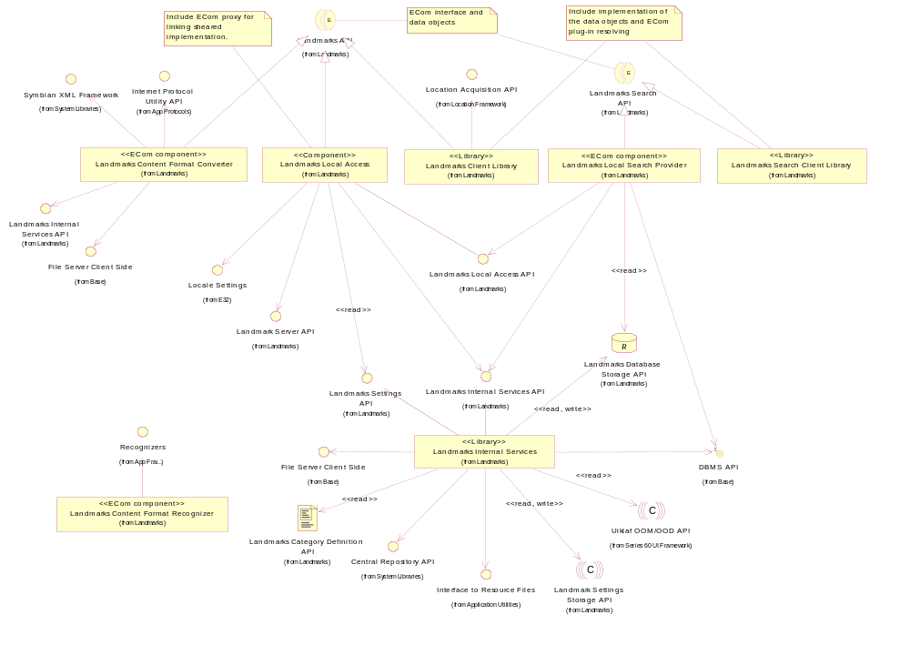
Figure 2.1 Basic Landmarks component diagram
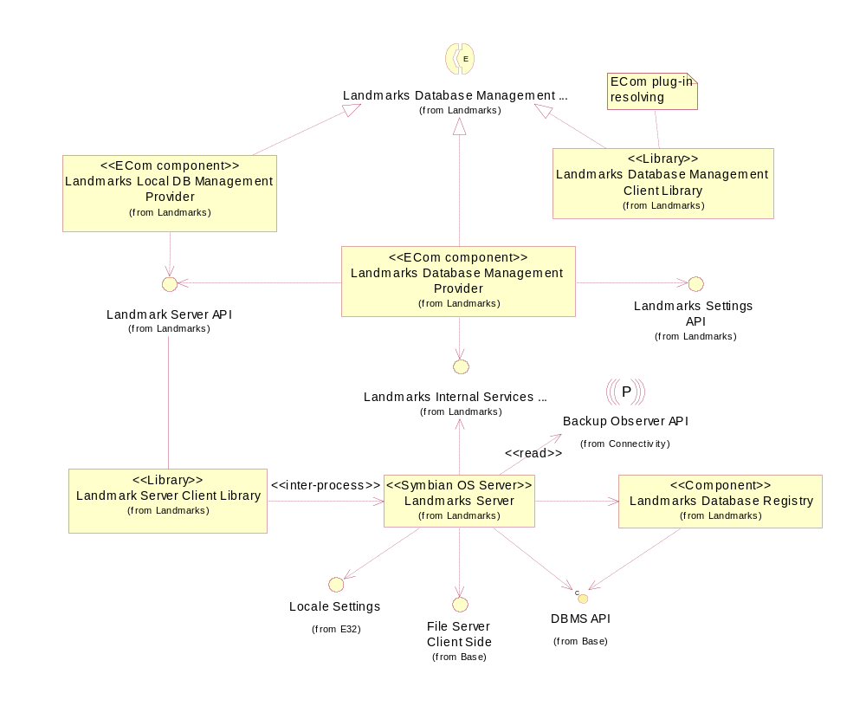
Figure 2.2 Database management component diagram

Services required

From the Symbian OS subsystems
API | Description
DBMS API | Landmark databases are DBMS databases.

From the Domestic OS subsystems
This component does not have any direct interfaces to the Domestic OS side subsystems.

From HW
This component has no direct HW interfaces.

Services provided

UI
This component does not provide any UI.

SW IF
Provided service | Description | Protected
Landmarks Search API | Landmarks Local Search Provider implements Landmarks Search API for local landmark databases. | Yes

Design

Class diagrams

Component
This section describes the design of the Landmarks Local Search Provider component.
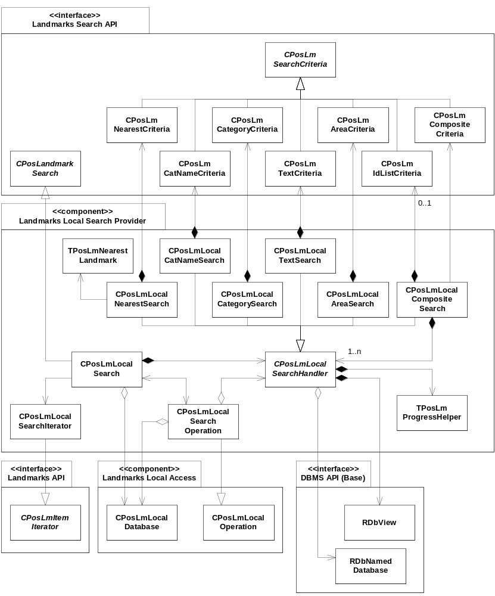
Figure 3.3 Landmarks Local Search Provider component class diagram

Class descriptions
Class | Description | Header file
CPosLmLocalSearch | This subclass to CPosLandmarkSearch is used to search for landmarks or landmark categories in a local database.  The database to search is accessed through the CPosLmLocalDatabase class.  When the client starts a search, CPosLmLocalSearch creates the proper CPosLmLocalSearchHandler subclass corresponding to the search criterion. CPosLmLocalSearch also creates CPosLmLocalSearchOperation that is returned to the client. The client can execute the search operation either in synchronous or asynchronous mode. | EPos_CPosLmLocalSearch.h
CPosLmLocalSearchIterator | This subclass to CPosLmItemIterator is an iterator for the search result. | EPos_CPosLmLocalSearch  Iterator.h
CPosLmLocalSearchOperation | This class inherits CPosLmLocalOperation and is the operation that is returned to the client when a search is started in CPosLmLocalSearch.  The database to search is accessed through the CPosLmLocalDatabase class.  When the client executes the search operation, CPosLmLocalSearchOperation uses its CPosLmLocalSearchHandler to perform the search. | EPos_CPosLmLocalSearch  Operation.h
CPosLmLocalSearchHandler | An abstract base class for landmark search handlers.  The database to search is accessed through the RDbNamedDatabase class and by using RDbView.  TPosLmProgressHelper is used to calculate the progress during the search operation. | EPos_CPosLmLocalSearch  Handler.h
CPosLmLocalText  Search | This subclass to CPosLmLocalSearchHandler is used to search for landmarks, which contain a certain text. It is possible to use wild cards, such as “?” and “*” in the search. All searching and sorting is case insensitive and done using the text comparison type collation (TDbTextComparison::EDbCompare  Collated).  CPosLmTextCriteria is used to set the text criterion and is required by CPosLmLocalTextSearch in the search.  See reference document [4] for more information about CPosLmTextCriteria. | EPos_CPosLmLocalText  Search.h
CPosLmLocal  CategorySearch | This subclass to CPosLmLocalSearchHandler is used to search for landmarks, which belong to a certain category.  CPosLmCategoryCriteria is used to set the category criterion and is required by CPosLmLocalCategorySearch in the search. All searching and sorting is case sensitive and done using the text comparison type normal (TDbTextComparison::  EDbCompareNormal).  See reference document [4] for more information about CPosLmCategoryCriteria. | EPos_CPosLmLocalCategorySearch.h
CPosLmLocalCat  NameSearch | This subclass to CPosLmLocalSearchHandler is used to search for landmark categories, the name of which matches the search text supplied by the client. It is possible to use wild cards, such as “?” and “*” in the search. All searching and sorting is case insensitive and done using the text comparison type collation (TDbTextComparison::EDbCompare  Collated).  CPosLmCatNameCriteria is used to set the category name criterion and is required by CPosLmLocalCatNameSearch in the search.  See reference document [4] for more information about CPosLmCatNameCriteria. | EPos_CPosLmLocalCatNameSearch.h
CPosLmLocalArea  Search | This subclass to CPosLmLocalSearchHandler is used to search for landmarks in a specified area.  CPosLmAreaCriteria is used to set the area criterion and is required by CPosLmLocalAreaSearch.  See reference document [4] for more information about CPosLmAreaCriteria. | EPos_CPosLmLocalArea  Search.h
CPosLmLocal  NearestSearch | This subclass to CPosLmLocalSearchHandler is used to search for landmarks nearest a specified coordinate.  TPosLmNearestLandmark is used to sort the landmarks in ascending distance.  CPosLmNearestCriteria is used to set the nearest criteria and is required by CPosLmLocalNearestSearch.  See reference document [4] for more information about CPosLmNearestCriteria | EPos_CPosLmLocalNearest  Search.h
TPosLmNearest  Landmark | This helper class for CPosLmLocalNearestSearch is used to compare landmarks by distance. | EPos_TPosLmNearest  Landmark.h
CPosLmLocal  CompositeSearch | This subclass to CPosLmLocalSearchHandler is used to search for landmarks using a combination of search handlers.  CPosLmCompositeCriteria is used to set the combination of criteria and is required by CPosLmLocalCompositeSearch.  See reference document [4] for more information about CPosLmCompositeCriteria.  If CPosLmCompositeCriteria includes CPosLmIdListCriteria, the landmark IDs of that list are set as previous matches for the other criteria searches.  For all the other criteria included in CPosLmCompositeCriteria, the corresponding CPosLmLocalSearchHandler performs the search for that criterion.  In order to get the best performance, nearest landmark search is always done after the other searches. Nearest search is considered to be slow, but this way the implementation only has to consider the matches from the other criteria. | EPos_CPosLmLocal  CompositeSearch.h
TPosLmProgress  Helper | This is a helper class for calculating the progress during a search operation. | EPos_TPosLmProgress  Helper.h
PosLmSqlQuery  Helper | This is a helper class for creating SQL queries. For simplicity, this class is not shown in Figure 3.3. | EPos_PosLmSqlQuery  Helper.h

Structs, type definitions and enumerations

epos_tposlmlocalsortpref.h

Enumeration name | Description
TPosLmLocalSortPref::TSortType | Specifies the sort preference type.
TPosLmLocalSortPref::TSortOrder | Specifies the sort order, i.e. ascending or descending.

epos_landmarkslocalsearchproviderpanic.h

Enumeration name | Description
TPosLandmarksLocalSearch  ProviderPanic | Enumerates the debug panics for Landmarks Local Search Provider.

Operations

Searching for landmarks

Operation | Searching for landmarks.
Preconditions | A local landmark database is opened.
Description | Searches for landmarks matching the specified search criterion. Optionally, the result is sorted according to a specified sort preference.  The search operation can be run in either synchronous or asynchronous mode.
Inputs | The search criterion, the local landmark database to search, and optionally a landmark sort preference.
Modifies
Outputs | A handle to an operation object. During an asynchronous search, the status and progress are available after each step.
Postconditions | When a search has completed or during an asynchronous search, the matching landmarks can be retrieved from CPosLmLocalSearch.
Related to | CPosLmLocalSearch, CPosLmLocalDatabase, CPosLmLocalDbAccess, CPosLmLocalSearchHandler, CPosLmLocalCompositeSearch, CPosLmLocalSearchOperation
Related event | See Sections 3.3.3 and 3.3.4.
Exceptions | Leaves with KErrNotSupported if the passed search criteria object is not supported, KErrArgument if any part of the search criteria is invalid, and KErrInUse if a search is already running.

A landmark sort preference can be specified when a landmark search is started. If display data has been set before the landmark search is started, the contents of the display data (i.e. the matching landmarks) are sorted according to the specified sort preference both during the search and when the search is completed. The matching landmarks are also stored in a landmark ID iterator and the contents are sometimes not sorted until the search is completed.
If the client is using display data, the contents of the landmark ID iterator are sorted in the same order as the display data; a matching landmark is first inserted in sort order into the display data and then added to the iterator in the same position as in the display data. Thus the landmark IDs in the iterator are always sorted according to the sort preference during the search.
If the client is not using display data, the contents of the landmark ID iterator are sorted using RDbView. If possible, the SQL query with the WHERE clause (the search condition) includes also an ORDER BY clause (the sort order). In this case, the landmark IDs in the iterator are sorted according to the sort preference also during the search. However, for some search criteria, the SQL query with the WHERE clause must be requested from one table while the SQL query with the ORDER BY clause must be requested from another table. In this case, all matching landmarks will be added to the iterator in unsorted order during the search phase and the last step(s) of the asynchronous search will re-sort the existing matches in the iterator.
When searching using a default nearest criterion, all landmarks with coordinates are returned as matches. In CPosLmLocalNearestSearch, the SQL query selects all the landmarks and calculates the distance to each of them. The client can also specify a maximum distance to narrow down the search. In this case, the SQL query includes a WHERE clause to exclude those landmarks, which are too far away from the search center. The formulas for the landmarks to include are as follows:
- search center = lat, lon
- max distance is the radius of the search area.
- dlat and dlon are the angles that should be added/subtracted from the search center to get the envelope coordinates.

The search area restrictions for nearest criterion are shown in Figure 3.4.
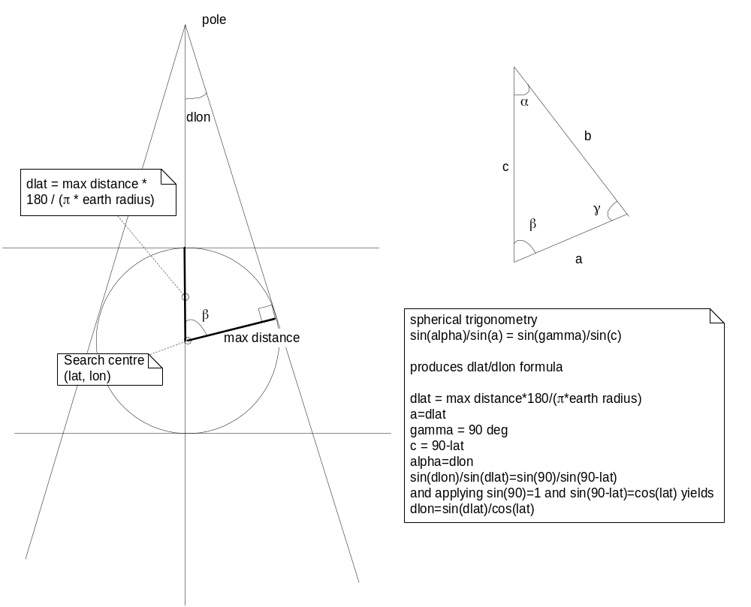
Figure 3.4 Search area restrictions for nearest criterion
The formula for dlat is dlat = max distance*180/(π*earth radius).
The formula for dlon is dlon = asin(sin(dlat)/cos(lat)) and can be reformulated as atan2(sin(dlat)/squareroot(square(cos(lat))-square(sin(dlat)))).
These formulas are true as long as a pole is not included in the envelope coordinates. If a pole is included, the formula instead includes all the coordinates within a circle with the pole as its center point.
This gives the following pseudo code:

dlat = max distance*180/(π*earth radius)
lat_max = lat+dlat
lat_min = lat-dlat
if (lat_max>90)
{
lat_max=90
}
if (lat_min<-90)
{
lat_max=-90
}
if (abs(lat)+dlat<90)
{
dlon = asin atan2(sin(dlat)/squareroot(square(cos(lat))-square(sin(dlat))))
lon_max = normalize(lon+dlon)
lon_min = normalize(lon-dlon)
}
else
{
lon_max = 180
lon_min = -180
}

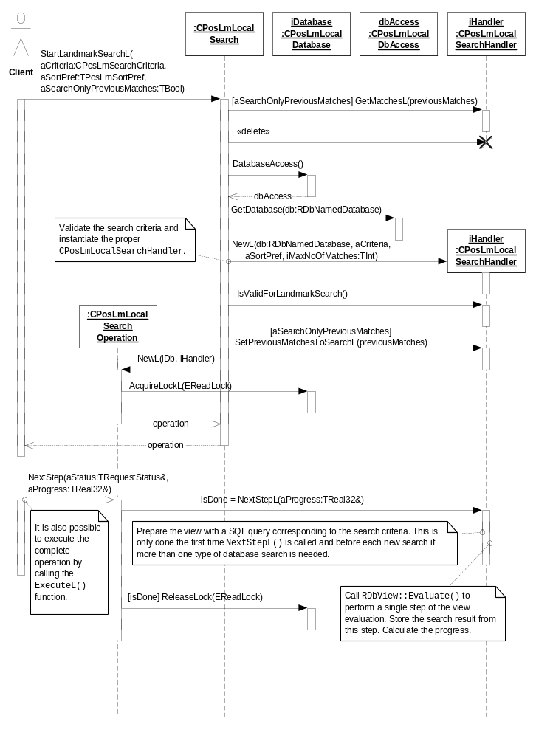
Figure 3.5 Searching for landmarks
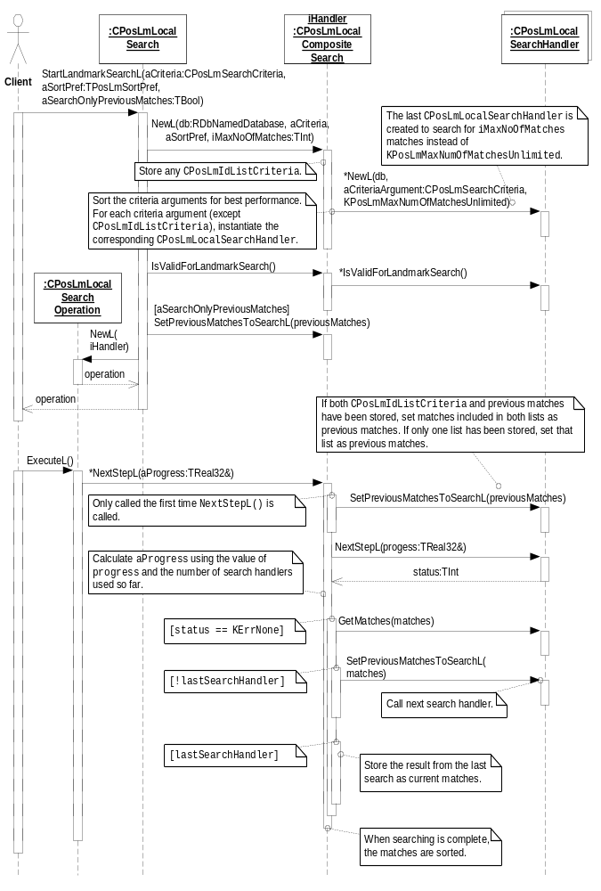
Figure 3.6 Searching for landmarks using a composite criterion

Searching for landmark categories sorted by preference

Operation | Searching for landmark categories sorted by preference.
Preconditions | A local landmark database is opened.
Description | Searches for landmark categories matching the specified search criterion. The result is sorted according to the specified sort preference.  The search operation can be run in either synchronous or asynchronous mode.
Inputs | The search criterion, the local landmark database to search, and a category sort preference.
Modifies
Outputs | A handle to an operation object. During an asynchronous search, the status and progress are available after each step.
Postconditions | When a search has completed or during an asynchronous search, the matching landmark categories can be retrieved from CPosLmLocalSearch.
Related to | CPosLmLocalSearch, CPosLmLocalDatabase, CPosLmLocalDbAccess, CPosLmLocalSearchHandler, CPosLmLocalSearchOperation
Related event | See Sections 3.3.3 and 3.3.4.
Exceptions | Leaves with KErrNotSupported if the passed search criteria object is not supported, KErrArgument if any part of the search criteria is invalid, and KErrInUse if a search is already running.

A category sort preference is specified when a category search is started. If display data has been set before the category search is started, the contents of the display data (i.e. the matching categories) are sorted according to the specified sort preference both during the search and when the search is completed. The matching categories are also stored in a category ID iterator.
If the client is using display data, the contents of the category ID iterator are sorted in the same order as the display data; a matching category is first inserted in sort order into the display data and then added to the iterator in the same position as in the display data.
If the client is not using display data, the contents of the category ID iterator are sorted using RDbView. The SQL query with the WHERE clause (the search condition) includes also an ORDER BY clause (the sort order).
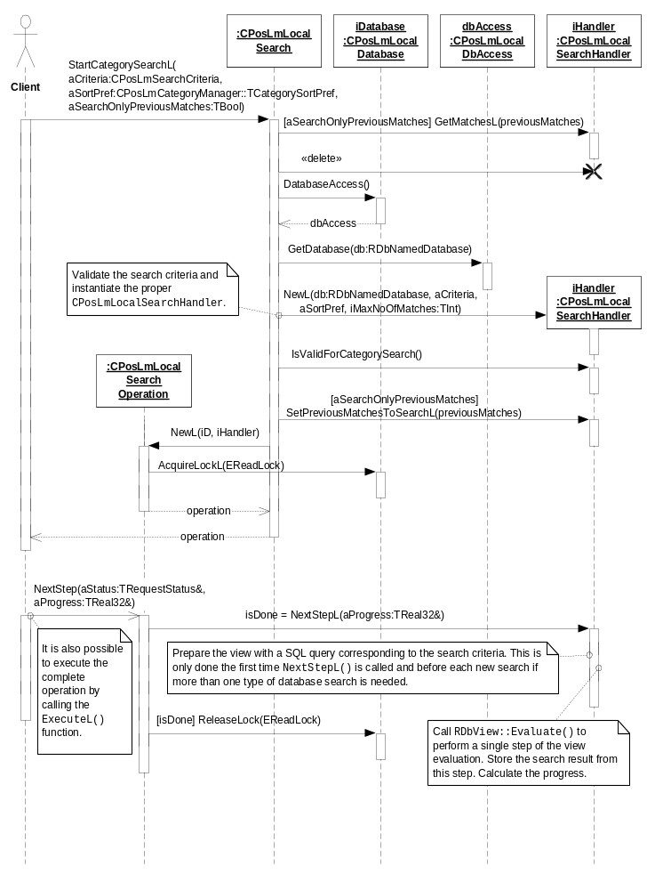
Figure 3.7 Searching for landmark categories sorted by preference

Retrieving a search result

Operation | Retrieving a search result.
Preconditions | A local landmark database is opened and a search for landmarks or landmark categories is in progress or has completed.
Description | Retrieves the current result of a search for landmarks or landmark categories. The search can be in progress or be completed (successfully or with an error).
Inputs
Modifies
Outputs | An iterator for the current search result. This operation will return an empty iterator if no search has been started.
Postconditions
Related to | CPosLmLocalSearch, CPosLmLocalSearchHandler, CPosLmLocalSearchIterator
Related event
Exceptions

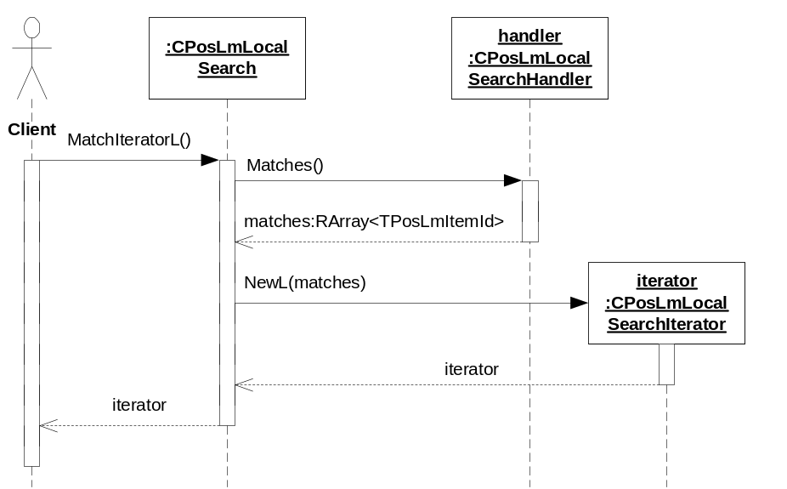
Figure 3.8 Retrieving a search result

Using display data

Operation | Using display data.
Preconditions
Description | Display data can be used as an alternative to get results from a database search. Landmarks or categories are added to the display data collection during a search depending on the search type. This function may replace the combination of using MatchIteratorL and reading landmark or category data. The result data is read already during the search and no duplicate access to the database is needed. The display data object is reset each time a new search is started. During the search no items are removed from the collection. New found matches can be added every time the next search step is completed. The client can stop using display data by calling UnsetDisplayData().
Inputs | A display data object.
Modifies | The display data object.
Outputs
Postconditions | When this operation has been called, display data is in use for search operations that are started after this call. During the search, matches have been added to the display data.
Related to | CPosLmLocalSearch, CPosLmLocalSearchHandler, CPosLmLocalCompositeSearch, CPosLmLocalSearchOperation, CPosLmDisplayData
Related event | See Sections 3.3.1 and 3.3.2.
Exceptions | Panics with EPosSearchOperationInUse if the client tries to set/unset display data during an ongoing search.

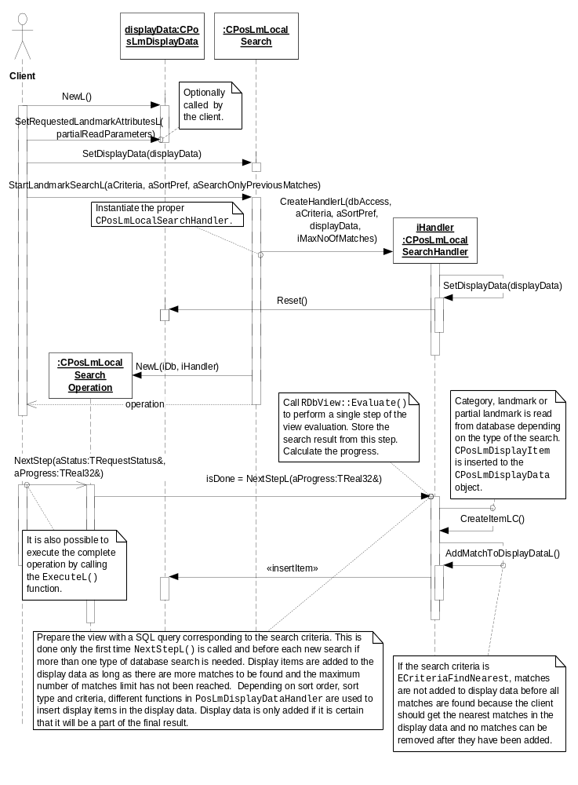
Figure 3.9 Using display data
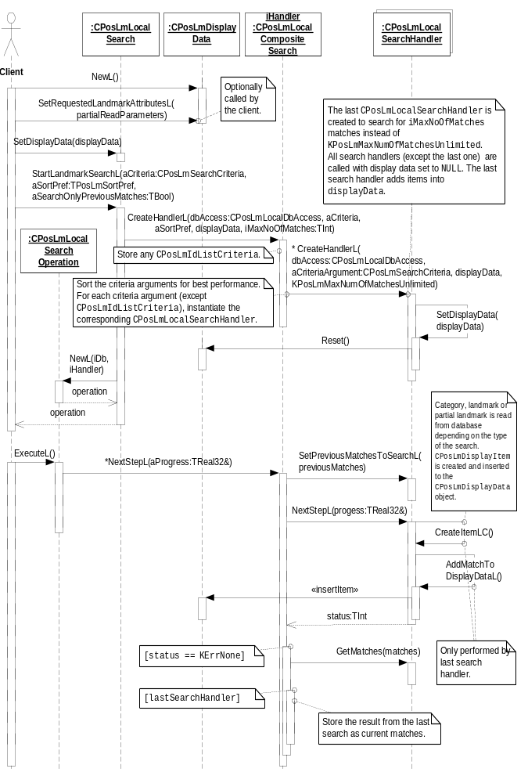
Figure 3.10 Using display data using a composite criterion

Backup and Restore
The policies for backup and restore are described in reference document [2].

Variation
Variation for the Landmarks subsystem is described in reference document [2].

System resource usage

File structures
Landmarks Local Search Provider does not use any files.

Database structures
Landmarks Local Search Provider uses the database defined in the Landmarks Internal Services component.

Timers and active objects
Landmarks Local Search Provider does not use any timers or active objects.

Security

Capabilities of this component

Capability | Justification
CAP_CLIENT_DLL | The DLL is a client side shared library and it must have all the capabilities that a potential client may have.

Input and output validation
This component performs input data checking as protection from client bugs, but since it is purely done in the client side, it is not protection against malicious clients. This protection must be provided at process borders where the data is used, but this is not the responsibility of this component.

Environmental assumptions
This component does not make any assumptions about its environment.

Additional enforcements
This component does not have any additional security enforcements.

Exception handling
The Symbian OS panic and leave mechanism are used to handle memory exhaustion and other system-wide error codes that appear upon execution.

Usage
Usage is described at the subsystem level in reference document [2].

