S60 3.x
Landmarks Search Client Library
Design Document

Team name | Author
TD Software Platforms | Sergey Burnevsky

Change history:

Version | Date | Status | Comments
3.0 | 25.08.08 | Approved | Document Revised
2.0 | 28.08.2007 | Approved | Whole document revised.
1.0 | 28.07.2005 | Approved

Table of contents:

1. Document control 4
1.1 References 4
1.2 Documentation conventions 4
1.3 Abbreviations 4
1.4 Definitions 4
2. General 5
2.1 Introduction 5
2.2 Component environment 5
2.3 Services required 6
2.3.1 From the Symbian OS subsystems 6
2.3.2 From the Domestic OS subsystems 6
2.3.3 From HW 6
2.4 Services provided 6
2.4.1 UI 6
2.4.2 SW IF 7
3. Design 8
3.1 Class diagrams 8
3.1.1 Component 8
3.2 Class descriptions 11
3.2.1 Structs, type definitions and enumerations 14
3.2.1.1 epos_cposlmsearchcriteria.h 14
3.2.1.2 epos_cposlmdisplaydata.h 14
3.2.1.3 epos_cposlmcompositecriteria.h 14
3.2.1.4 epos_cposlmmultidbsortpref.h 14
3.2.1.5 epos_cposlmmultidbsearchoperation.h 14
3.2.1.6 epos_cposlmmultidbsearch.h 15
3.3 Operations 15
3.3.1 Creating a landmark searcher 15
3.3.2 Searching for landmarks in multiple databases 16
3.3.3 Searching for categories in multiple databases 21
3.3.4 Retrieving a multiple database search result as an iterator 21
3.3.5 Retrieving a multiple database search result from display data 22
3.4 Backup and Restore 23
4. Variation 24
5. System resource usage 25
5.1 File structures 25
5.2 Database structures 25
5.3 Timers and active objects 25
6. Security 26
6.1 Capabilities of this component 26
6.2 Input and output validation 26
6.3 Environmental assumptions 26
6.4 Additional enforcements 26
7. Exception handling 27
8. Usage 28

Document control

References
- S60 Landmarks Subsystem Architecture Description
- S60 Landmarks Subsystem Design Document
- S60 Landmarks Exchange Format Specification Document

Documentation conventions
Code is shown with the Courier New font.

Abbreviations
API | Application Programming Interface
DBMS | Database Management System
DLL | Dynamic Link Library
MBM | Multiple Bitmap file format
MIME | Multipurpose Internet Mail Extensions
MLFW | Mobile Location Framework
OS | Operating System
XML | Extensible Markup Language

Definitions
Corrupt database | A database that has become invalid and cannot be opened.
Damaged database | A database may be damaged when a transaction fails or is cancelled. A damaged database can be recovered by initialization.
DBMS | Database Management System. A commonly used term for the Symbian OS database engine.
ECom | Symbian OS framework for plug-in DLLs.
Framework | Usually denotes the collection of an engine and associated programming interfaces. This document mentions the Mobile Location Framework and the Symbian OS ECom Framework. There is also a subsystem in Symbian OS called Application Framework.
Landmark | A landmark is a named object that contains a location. The location can be defined by various attributes, e.g. WGS84 coordinates or a textual address.
Landmark category | A landmark can be categorized by assigning a landmark category to it. A typical landmark category is “Restaurant”. A landmark category is often referred to as “category”.
Landmark collection | A group of landmarks encoded according to reference document [3].
Landmark database | Persistent storage of a collection of landmarks and landmark categories.
Platform Security | Definition for the security design principles and features in Symbian OS.
Recognizer | Plug-in code that can examine sample data. If the data is recognized, its data type is returned. A data type is also commonly known as a MIME type.

General
This document describes the Landmarks Search Client Library component in the Landmarks subsystem. The Landmarks subsystem design including general design guidelines for Landmark components is described in reference document [2]. The architecture is described in reference document [1].
Landmarks Search Client Library is available from S60 release 3.0 onwards.

Introduction
Landmarks Search Client Library publishes the interfaces needed to search landmark databases. The actual implementation is provided by ECom plug-ins, which realize the services defined by Landmarks Search API. The effect is that Landmarks Search Client Library is relatively small and functionality can be added to or removed from it at run-time.
The responsibilities and additional requirements of Landmarks Search Client Library are the following:
- Defines the basic classes, for example the search criteria classes, needed for landmark searches.
- Loads the ECom plug-in, which provides the requested search functionality.
- Provides functionality for searching multiple databases. This functionality is not provided by an ECom plug-in, but by Landmarks Search Client Library.

Component environment
Figure 2.1 and Figure 2.2 show the components in the Landmarks subsystem.
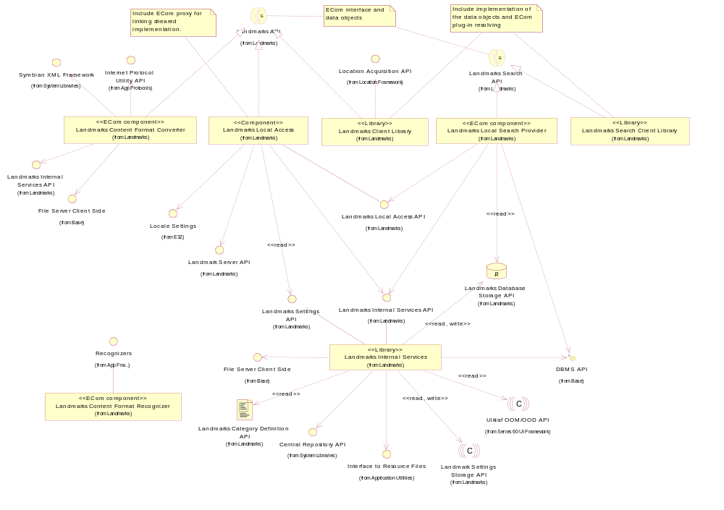
Figure 2.1 Basic Landmarks component diagram
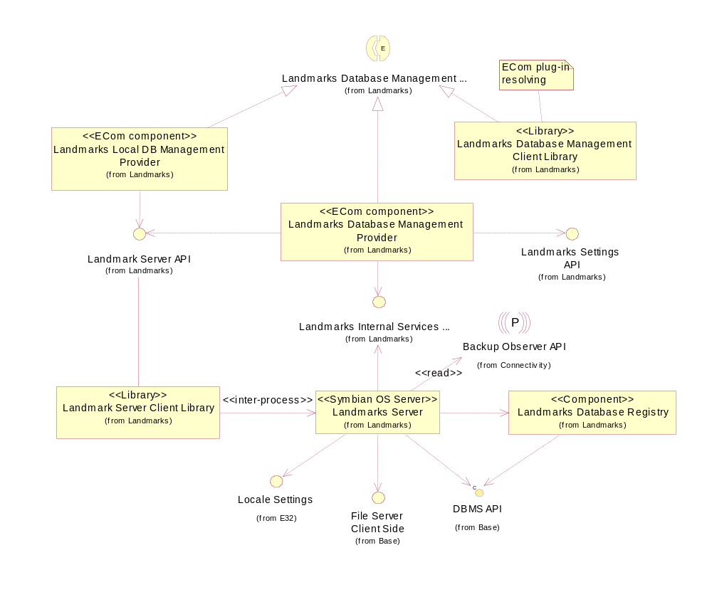
Figure 2.2 Database management component diagram

Services required

From the Symbian OS subsystems

API | Description
ECom Plugin Architecture | Different implementations for the Landmark APIs are provided as ECom plug-ins.

From the Domestic OS subsystems
This component does not have any direct interfaces to the Domestic OS side subsystems.

From HW
This component has no direct HW interfaces.

Services provided

UI
This component does not provide any UI.

SW IF

Provided service | Description | Protected
Landmarks Search API | Landmarks Search API enables searching for landmarks. Searching is performed according to the criteria defined by the client. The criteria can be based on position, landmark category or other landmark content. | Yes

Design

Class diagrams

Component
This section describes the design of the Landmarks Search Client Library component.
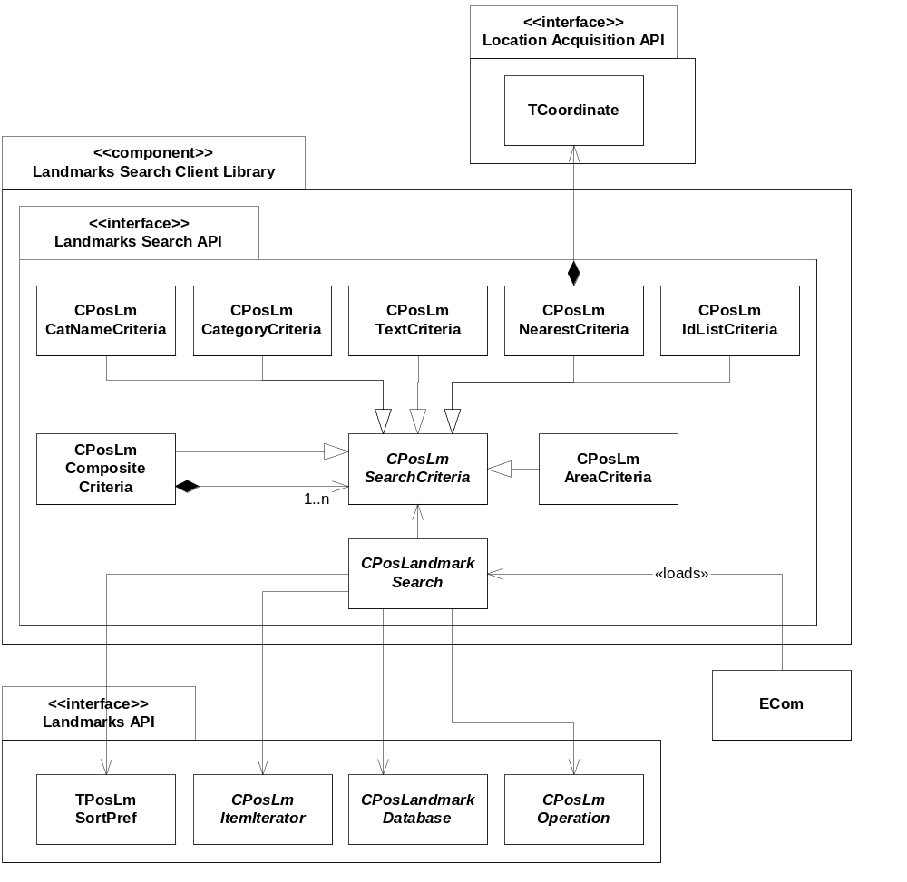
Figure 3.3 Landmarks Search Client Library component main class diagram
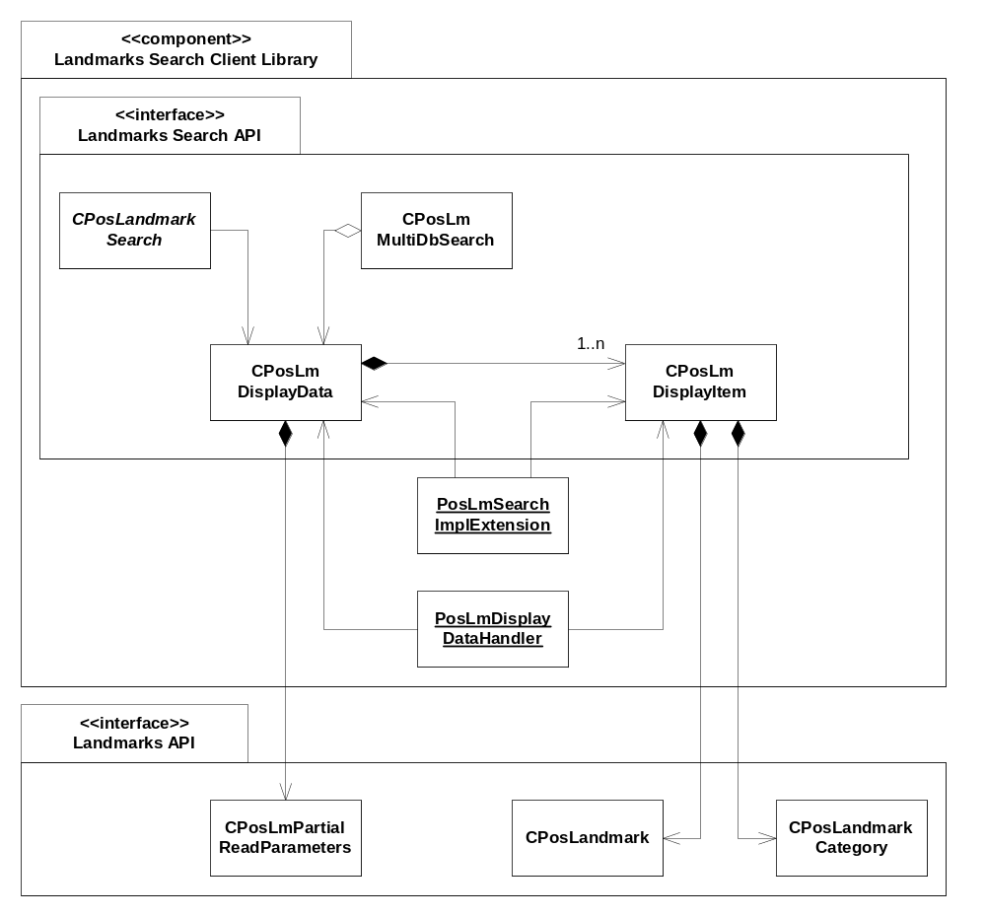
Figure 3.4 Landmarks Search Client Library component display data class diagram
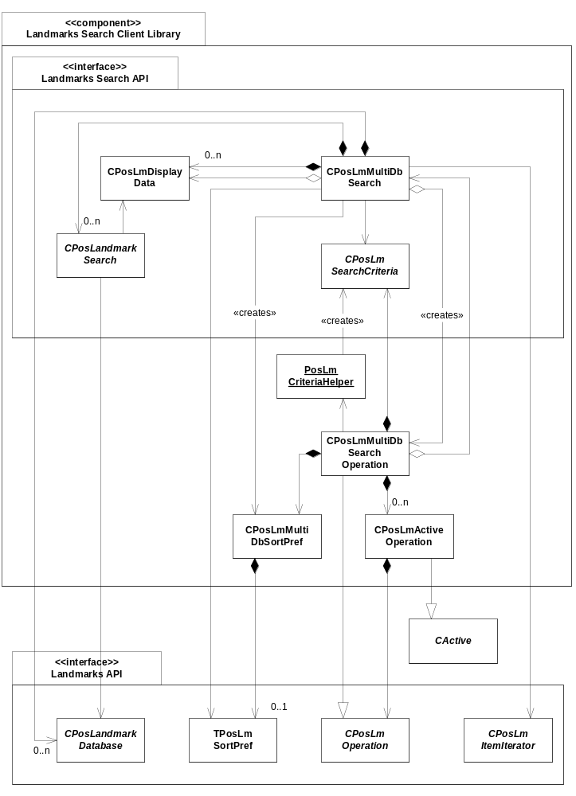
Figure 3.5 Landmarks Search Client Library component multiple database search class diagram

Class descriptions

Class | Description | Header file
CPosLandmark  Search | A part of Landmarks Search API.  This abstract base class is used to perform searches for landmarks or landmark categories in a specified landmark database (CPosLandmarkDatabase).  Before the search is started, the client can specify CPosLmDisplayData to which the search matches are added during the search. Search matches can also be retrieved as CPosLmItemIterator.  The client specifies CPosLmSearchCriteria and optionally a sort preference object, TPosLmSortPref, when a search is started and CPosLmOperation is returned to the client.  An implementation of this class is loaded by the ECom Framework. | EPos_CPosLandmark  Search.h
CPosLmSearch  Criteria | A part of Landmarks Search API.  An abstract base class for landmark search criteria classes.  The criteria classes are used in CPosLandmarkSearch to specify what to search for. | EPos_CPosLmSearch  Criteria.h
CPosLmComposite  Criteria | A part of Landmarks Search API.  A criteria class used for combining multiple search criteria. | EPos_CPosLmComposite  Criteria.h
CPosLmCatName  Criteria | A part of Landmarks Search API.  A criteria class for searching for landmark categories with a certain name. | EPos_CPosLmCatName  Criteria.h
CPosLmCategory  Criteria | A part of Landmarks Search API.  A criteria class for searching for landmarks that belong to a certain category or do not belong to any categories. | EPos_CPosLmCategory  Criteria.h
CPosLmText  Criteria | A part of Landmarks Search API.  A criteria class for searching for landmarks that contain a certain text. | EPos_CPosLmTextCriteria.h
CPosLmNearest  Criteria | A part of Landmarks Search API.  A criteria class for finding the landmarks that are closest to a certain coordinate. | EPos_CPosLmNearest  Criteria.h
CPosLmArea  Criteria | A part of Landmarks Search API.  A criteria class for searching for landmarks that reside in a certain area. | EPos_CPosLmAreaCriteria.h
CPosLmIdList  Criteria | A part of Landmarks Search API.  A criteria class for searching a specific set of landmarks. Must be combined by CPosLmCompositeCriteria with at least one other criterion in a composite search, except CPosLmIdListCriteria. | EPos_CPosLmIdListCriteria.h
CPosLmDisplayData | A part of Landmarks Search API.  This is a class for a displayable data collection. A displayable data collection consists of displayable items (CPosLmDisplayItem) that are fetched during a search.  CPosLmPartialReadParameters can be used to specify which landmark data that is read from the database during a landmark search. | EPos_CPosLmDisplayData.h
CPosLmDisplayItem | A part of Landmarks Search API.  This is a class for a displayable data item. A displayable item consists of a database index and a displayable object (CPosLandmark or CPosLandmarkCategory).  The database index is 0 if running a single database search. In case of a multiple database search, it is used to specify what database a displayable data item belongs to, the index is in the range [0, the number of databases involved in the search -1]. | EPos_CPosLmDisplayItem.h
PosLmSearchImpl  Extension | A Landmarks subsystem internal class.  A class containing static exported functions for calling non-exported functions in CPosLmDisplayData and CPosLmDisplayItem. | EPos_PosLmSearchImpl  Extension.h
PosLmDisplayData  Handler | A Landmarks subsystem internal class.  A class containing static exported functions for inserting/removing CPosLmDisplayItem to/from CPosLmDisplayData. | EPos_PosLmDisplayData  Handler.h
CPosLmMultiDb  Search | A part of Landmarks Search API.  This class is used to search for landmarks or categories in multiple databases.  Before the search is started, the client can specify CPosLmDisplayData to which the search matches are added during the search. Search matches per database can also be retrieved as a CPosLmItemIterator.  The client specifies CPosLmSearchCriteria and optionally a sort preference object, TPosLmSortPref, when a search is started. CPosLmMultiDbSearch then creates CPosLmMultiDbSearchOperation that performs the search. CPosLmMultiDbSortPref, optionally wrapping TPosLmSortPref, is created and passed to the constructor of CPosLmMultiDbSearchOperation.  During the search, landmark databases (CPosLandmarkDatabase) is opened and single database search classes (CPosLandmarkSearch) is created. If the client has specified display data, a new CPosLmDisplayData is created for each CPosLandmarkSearch.  CPosLmMultiDbSearch also uses two helper classes that are not shown in the sequence and class diagrams for simplicity: CPosLmMultiDbSearchItem is used to hold together CPosLandmarkDatabase and its corresponding CPosLandmarkSearch and CPosLmDisplayData. CPosLmEmptyIterator is used if the client asks for a match iterator but no CPosLandmarkSearch has been created yet. | EPos_CPosLmMultiDb  Search.h
CPosLmMultiDb  SearchItem | This is a helper class for CPosLmMultiDbSearch.  It holds a pointer to CPosLandmarkDatabase and its corresponding CPosLandmarkSearch and CPosLmDisplayData. It also holds the URI of the database. | EPos_CPosLmMultiDbSearch  Item.h
CPosLmEmpty  Iterator | This is a helper class for CPosLmMultiDbSearch.  It inherits CPosLmItemIterator and implements an empty iterator. | EPos_CPosLmEmptyIterator.h
CPosLmMultiDbSortPref | This is a helper class for CPosLmMultiDbSearch and CPosLmMultiDbSearchOperation.  It knows which type of sorting is used for a search operation: category sorting, landmark attribute sorting, landmark distance sorting or landmark without sorting. In case of landmark sorting, it holds TPosLmSortPref. | EPos_CPosLmMultiDbSort  Pref.h
CPosLmMultiDb  SearchOperation | This class inherits CPosLmOperation and is the operation that is returned to the client when a search is started in CPosLmMultiDbSearch.  When created, this class uses PosLmCriteriaHelper to validate and create a copy of CPosLmSearchCriteria specified by the client. It also takes ownership of CPosLmMultiDbSortPref created by CPosLmMultiDbSearch.  During the search, this class creates initialization operations for the databases that need initialization and it creates search operations for all the single database search classes. For an asynchronous search, both types of operations are wrapped by CPosLmActiveOperation in order to execute all operations (of the same type) in parallel. | EPos_CPosLmMultiDbSearchOperation.h
PosLmCriteria  Helper | This is a helper class for CPosLmMultiDbSearchOperation.  The class validates CPosLmSearchCriteria according to the validations rules of CPosLmMultiDbSearch and the criteria classes and creates a copy of the criteria. | EPos_PosLmCriteriaHelper.h
CPosLmActive  Operation | This class inherits CActive and is an active object wrapper for CPosLmOperation. | EPos_CPosLmActive  Operation.h

Structs, type definitions and enumerations

epos_cposlmsearchcriteria.h

Enumeration name | Description
CPosLmSearchCriteria::  CPosLmSearchCriteria | Enumerates the search criteria subclasses.

epos_cposlmdisplaydata.h

Enumeration name | Description
CPosLmDisplayItem::  TDisplayItemType | Enumerates the types of display data, i.e. a landmark item or a category item.

epos_cposlmcompositecriteria.h

Enumeration name | Description
CPosLmCompositeCriteria::  TCompositionType | Specifies the type of the composite criterion. i.e ECompositionAnd or ECompositionOR.  ECompositionAND, which means the Boolean operator AND is used to combine the search criteria.  ECompostionOR, which means the Boolean operator OR is used to combine the search criteria. This type is valid only to combine CPosLmTextCriteria. Other criterias can not be combined using ECompostionOR type.

epos_cposlmmultidbsortpref.h

Enumeration name | Description
CPosLmMultiDbSortPref::  TSortType | Enumerates the sort preferences used when searching multiple landmark databases.

epos_cposlmmultidbsearchoperation.h

Enumeration name | Description
CPosLmMultiDbSearchOperation::TPosLmOperationStatus | Enumerates the states of the multiple database search operation.

epos_cposlmmultidbsearch.h

Struct name | Description
CPosLmMultiDbSearch::  TSearchError | A struct containing a search error.

Operations

Creating a landmark searcher

Operation | Creating a landmark searcher.
Preconditions | A landmark database is opened.
Description | Creates a landmark searcher that can be used to perform searches for landmarks or landmark categories in the landmark database.
Inputs | The landmark database.
Modifies
Outputs | A handle to the landmark searcher.
Postconditions
Related to | CPosLandmarkSearch
Related event
Exceptions | If the proper implementation of the landmark searcher (ECom plug-in) is not found, this operation fails with KErrNotFound.

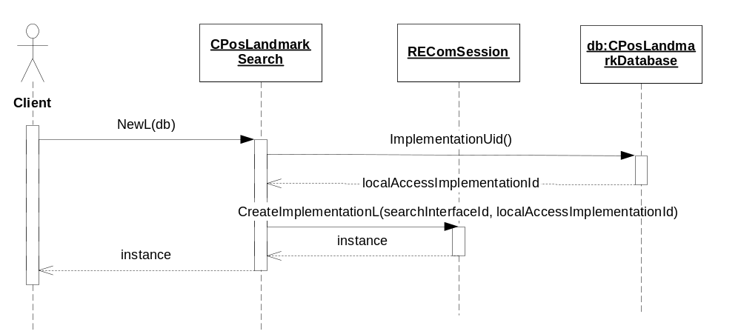
Figure 3.6 Creating a landmark searcher

Searching for landmarks in multiple databases

Operation | Searching for landmarks in multiple databases.
Preconditions
Description | Searches the specified set of landmark databases for landmarks matching the specified search criterion. Optionally, the result is sorted according to the specified sort preference.  Note that it is the client’s responsibility to make sure that each database is only specified once. If a database is specified more than once, the search returns duplicated matches.  The client can specify the display data to which the search matches are added.  The search operation can be run in either incremental mode or in one batch.
Inputs | A list of database URIs and a search criterion. Optionally a landmark sort preference and display data.
Modifies | If display data is specified, matches are added to it during the search.
Outputs | A handle to the operation object. During an incremental search, the status and progress are available after each step.
Postconditions | When a search has completed or during an asynchronous search, the matching landmarks per database can be retrieved from CPosLmMultiDbSearch. If display data is specified, matches can be retrieved from it.
Related to | CPosLmMultiDbSearch, CPosLmMultiDbSearchOperation, CPosLandmarkDatabase, CPosLandmarkSearch, CPosLmActiveOperation, CPosLmOperation, CPosLmDisplayData, CPosLmDisplayItem
Related event | See Sections 3.3.4 and 3.3.5.
Exceptions | Leaves with KErrNotSupported if the passed search criteria object is not supported, KErrArgument if any part of the search criteria is invalid, and KErrInUse if a multiple database search is already running in this instance of CPosLmMultiDbSearch.

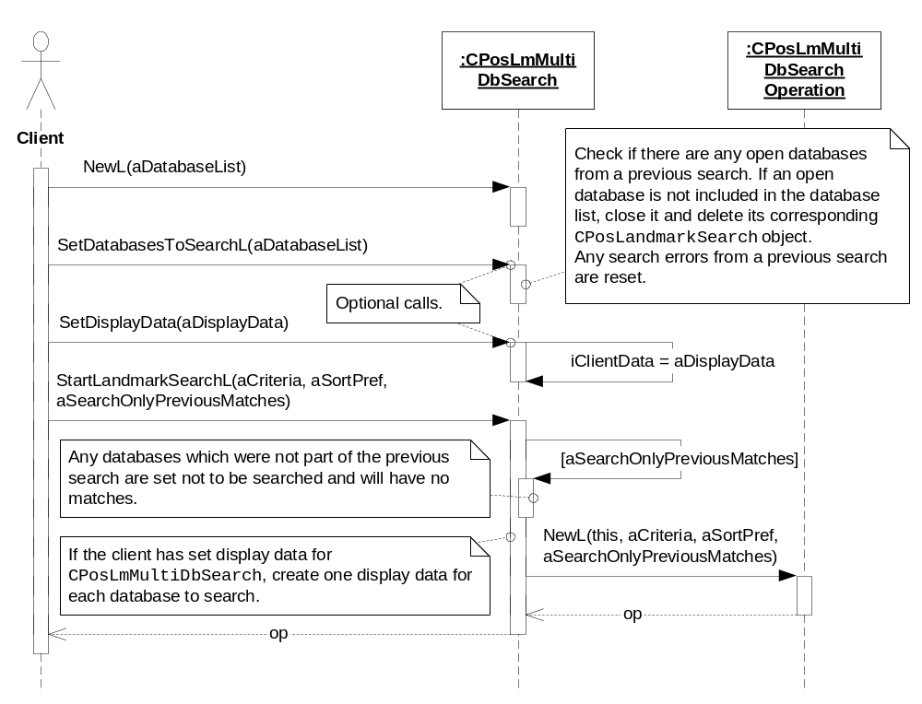
Figure 3.7 Searching for landmarks in multiple databases – creation of search operation
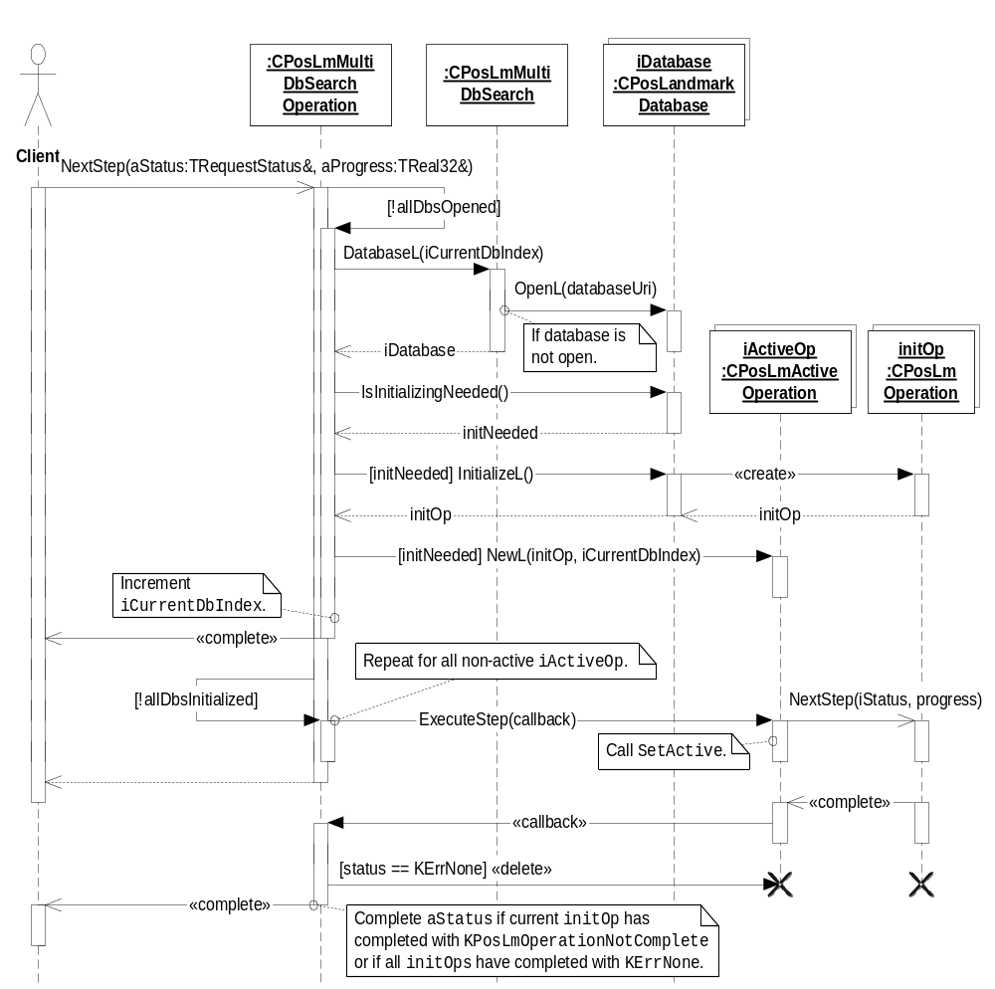
Figure 3.8 Searching for landmarks in multiple databases – asynchronous search, part 1, initialization of databases
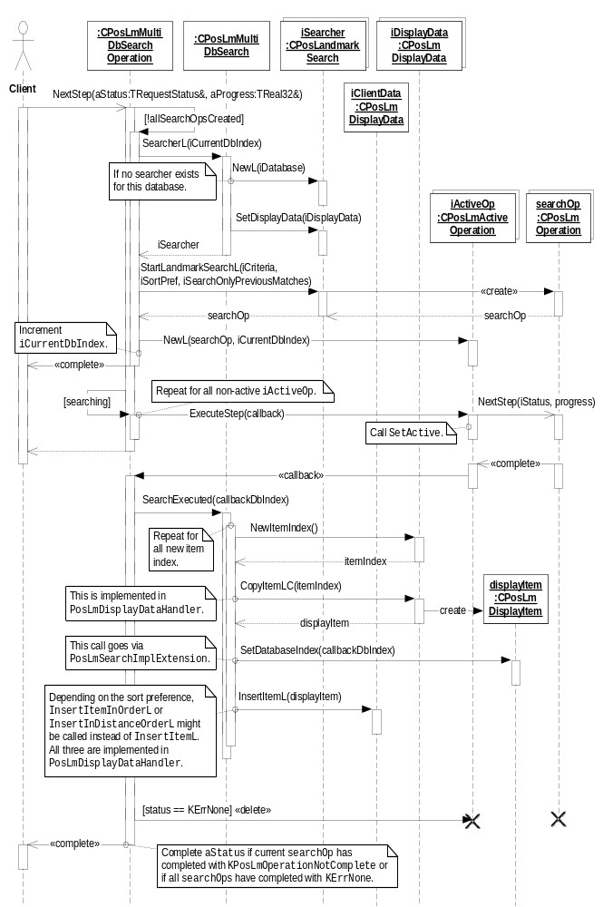
Figure 3.9 Searching for landmarks in multiple databases – asynchronous search, part 2, searching databases
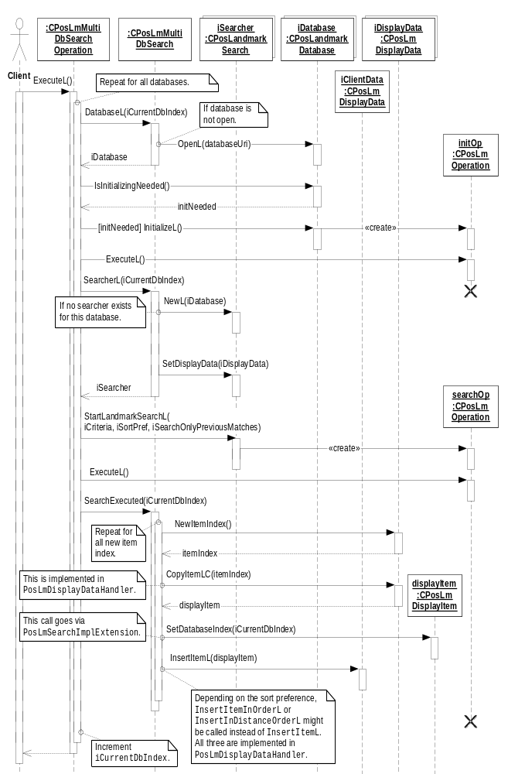
Figure 3.10 Searching for landmarks in multiple databases – synchronous search

Searching for categories in multiple databases

Operation | Searching for categories in multiple databases.
Preconditions
Description | Searches the specified set of landmark databases for categories matching the specified search criterion. Optionally, the result is sorted according to the specified sort preference.  The client can specify the display data to which the search matches are added.  The search operation can be run in either incremental mode or in one batch.
Inputs | A list of database URIs, a category search criterion and a category sort preference. Optionally display data.
Modifies | If display data is specified, matches will be added to it during the search.
Outputs | A handle to the operation object. During an incremental search, the status and progress are available after each step.
Postconditions | When a search has completed or during an asynchronous search, the matching categories per database can be retrieved from CPosLmMultiDbSearch. If display data is specified, matches can be retrieved from it.
Related to | CPosLmMultiDbSearch, CPosLmMultiDbSearchOperation, CPosLandmarkDatabase, CPosLandmarkSearch, CPosLmActiveOperation, CPosLmOperation, CPosLmDisplayData, CPosLmDisplayItem
Related event | See Sections 3.3.4 and 3.3.5.
Exceptions | Leaves with KErrNotSupported if the passed search criteria object is not supported, KErrArgument if any part of the search criteria is invalid, and KErrInUse if a multiple database search is already running in this instance of CPosLmMultiDbSearch.

The sequence diagrams for searching categories are very similar to those for searching landmarks. With the replacement of the StartLandmarkSearchL() calls with StartCategorySearchL() calls, Figure 3.7, Figure 3.8, Figure 3.9 and Figure 3.10 apply also to this operation.

Retrieving a multiple database search result as an iterator

Operation | Retrieving a multiple database search result as an iterator.
Preconditions | A multiple database search for landmarks or categories is in progress or has completed.
Description | Retrieves the current result of a multiple database search for landmarks or categories. The search can be in progress or be completed (successfully or with an error).
Inputs | The index of the database for which to retrieve the result.
Modifies
Outputs | An iterator with the landmark or category IDs.
Postconditions
Related to | CPosLmMultiDbSearch, CPosLandmarkSearch
Related event
Exceptions

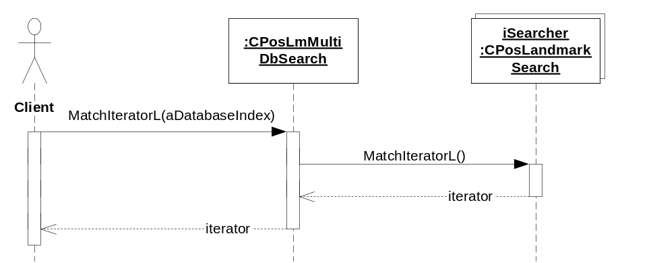
Figure 3.11 Retrieving a multiple database search result as an iterator

Retrieving a multiple database search result from display data

Operation | Retrieving a multiple database search result from display data.
Preconditions | A multiple database search for landmarks or categories is in progress or has completed. The client has set the display data for the search.
Description | Retrieves the current result of a multiple database search for landmarks or categories. The search can be in progress or be completed (successfully or with an error). New display items from the display data can be fetched when NextStep of the search operation completes.
Inputs
Modifies
Outputs | Indexes for the new display items. The display items contain the index of the database where the match was found and either a landmark or a category.
Postconditions
Related to | CPosLmDisplayData, CPosLmDisplayItem
Related event
Exceptions | Panics with EPosInvalidItemType if the client calls CPosLmDisplayItem::Category() after a landmark search and vice versa.

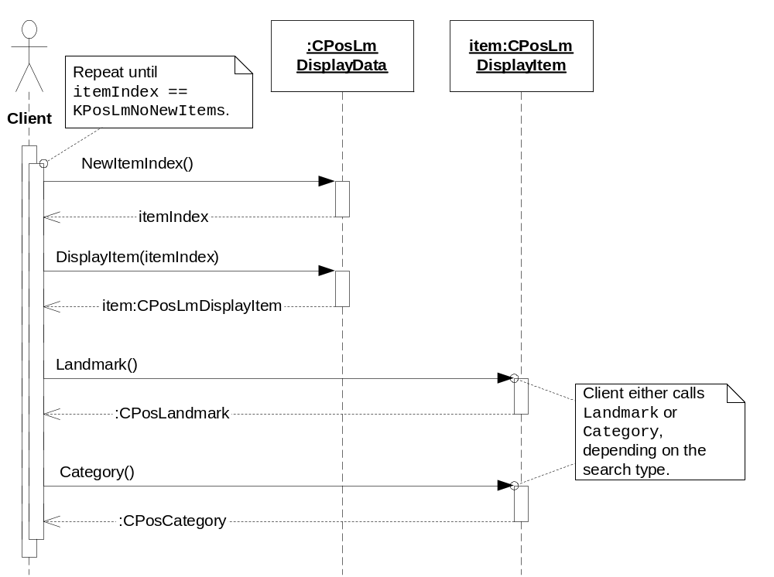
Figure 3.12 Retrieving a multiple database search result from display data

Backup and Restore
The policies for backup and restore are described in reference document [2].

Variation
Variation for the Landmarks subsystem is described in reference document [2].

System resource usage

File structures
Landmarks Search Client Library does not use any files.

Database structures
Landmarks Search Client Library does not use any databases.

Timers and active objects

Active objects / Timers | Description
CPosLmActiveOperation | Used to run the search in each landmark database.

Security

Capabilities of this component

Capability | Justification
CAP_CLIENT_DLL | The DLL is a client side library and it must have all the capabilities that a potential client may have.

Input and output validation
This component performs input data checking as protection from client bugs, but since it is purely done in the client side, it is not protection against malicious clients. This protection must be provided at process borders where the data is used, but this is not the responsibility of this component.

Environmental assumptions
This component does not make any assumptions about its environment.

Additional enforcements
This component does not have any additional security enforcements.

Exception handling
The Symbian OS panic and leave mechanism are used to handle memory exhaustion and other system-wide error codes that appear upon execution. The leave mechanism is also used for telling whether implementations loaded by the ECom Framework are present or not.

Usage
Usage is described at the subsystem level in reference document [2].

