S60 3.x
Landmarks Server Client Library
Design Document

Team name | Author
Location CF/TietoEnator | Stefan Folkesson
 | Magnus Gustafson
 | Katharina Augustsson
 | Sergey Burnevsky

Change history:

Version | Date | Status | Comments
2.0 | 28.08.2007 | Approved | Editorial changes
1.0 | 29.07.2005 | Approved

Table of contents:

1. Document control 4
1.1 References 4
1.2 Documentation conventions 4
1.3 Abbreviations 4
1.4 Definitions 4
2. General 6
2.1 Introduction 6
2.2 Component environment 6
2.3 Services required 7
2.3.1 From the Symbian OS subsystems 7
2.3.2 From the Domestic OS subsystems 7
2.3.3 From HW 7
2.4 Services provided 7
2.4.1 UI 7
2.4.2 SW IF 7
3. Design 8
3.1 Class diagrams 8
3.1.1 Component 8
3.2 Class descriptions 8
3.3 Operations 9
3.3.1 Registering a database 9
3.3.2 Unregistering a database 9
3.3.3 Unregistering all databases with a certain protocol 10
3.3.4 Retrieving database information 11
3.3.5 Modifying database settings 11
3.3.6 Listing the database URIs with a certain protocol 12
3.3.7 Listing the database information with a certain protocol 13
3.4 Backup and Restore 14
4. Variation 15
5. System resource usage 16
5.1 File structures 16
5.2 Database structures 16
5.3 Timers and active objects 16
6. Security 17
6.1 Capabilities of this component 17
6.2 Input and output validation 17
6.3 Environmental assumptions 17
6.4 Additional enforcements 17
7. Exception handling 18
8. Usage 19

Document control

References
- S60 3.2 Landmarks Subsystem Architecture Description
- S60 Landmarks Subsystem Design Document
- S60 Landmarks Server Design Document
- S60 Landmarks Exchange Format Specification Document

Documentation conventions
Code is shown with the Courier New font.

Abbreviations
API | Application Programming Interface
DBMS | Database Management System
DLL | Dynamic Link Library
MBM | Multiple Bitmap file format
MIME | Multipurpose Internet Mail Extensions
MLFW | Mobile Location Framework
OS | Operating System
XML | Extensible Markup Language

Definitions
Corrupt database | A database that has become invalid and cannot be opened.
Damaged database | A database may be damaged when a transaction fails or is cancelled. A damaged database can be recovered by initialization.
DBMS | Database Management System. A commonly used term for the Symbian OS database engine.
ECom | Symbian OS framework for plug-in DLLs.
Framework | Usually denotes the collection of an engine and associated programming interfaces. This document mentions the Mobile Location Framework and the Symbian OS ECom Framework. There is also a subsystem in Symbian OS called Application Framework.
Landmark | A landmark is a named object that contains a location. The location can be defined by various attributes, e.g. WGS84 coordinates or a textual address.
Landmark category | A landmark can be categorized by assigning a landmark category to it. A typical landmark category is “Restaurant”. A landmark category is often referred to as “category”.
Landmark collection | A group of landmarks encoded according to reference document [4].
Landmark database | Persistent storage of a collection of landmarks and landmark categories.
Platform Security | Definition for the security design principles and features in Symbian OS.
Recognizer | Plug-in code that can examine sample data. If the data is recognized, its data type is returned. A data type is also commonly known as a MIME type.

General
This document describes the Landmarks Server Client Library component in the Landmarks subsystem. The Landmarks subsystem design including general design guidelines for Landmark components is described in reference document [2]. The architecture is described in reference document [1].
Landmarks Server Client Library is available from S60 release 3.0 onwards.

Introduction
Landmarks Server Client Library publishes the interfaces needed to access services provided by Landmarks Server. The interfaces contain functionality for registering, unregistering and listing databases, and for reporting database events.
The responsibilities and additional requirements of Landmarks Server Client Library are the following:
- Implements a connection to Landmarks Server.
- Interfaces for listing, registering and unregistering all kinds of databases.
- An interface for reporting database events.

Component environment
Figure 2.1 and Figure 2.2 show the components in the Landmarks subsystem.
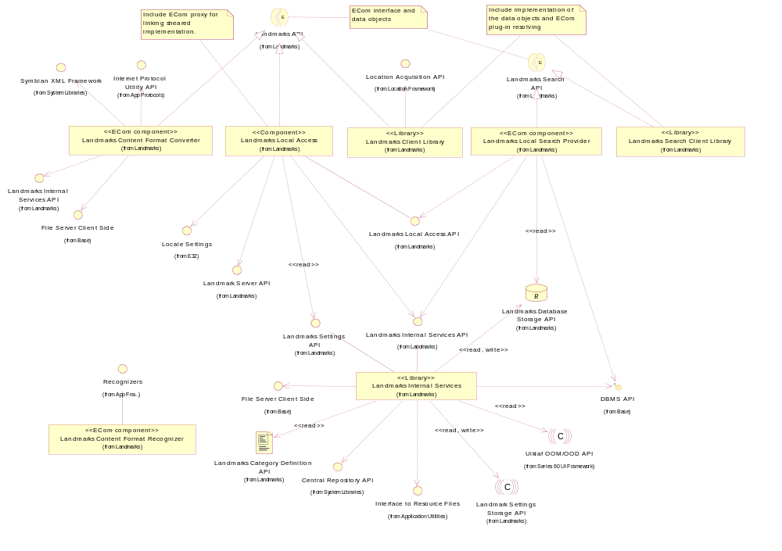
Figure 2.1 Basic Landmarks component diagram
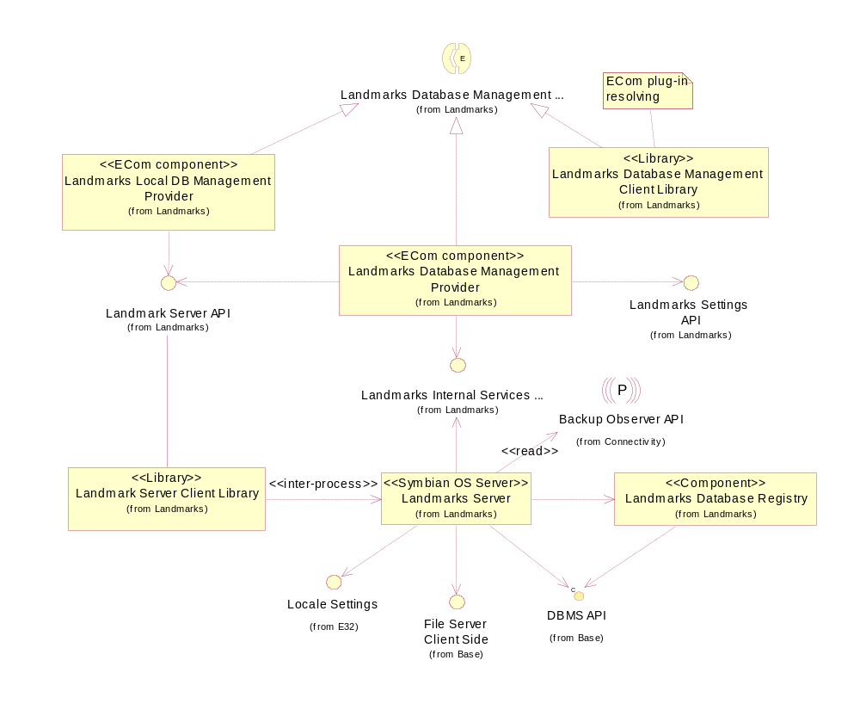
Figure 2.2 Database management component diagram

Services required

From the Symbian OS subsystems
Landmarks Server Client Library does not use any services. All the requests are sent to Landmarks Server.

From the Domestic OS subsystems
This component does not have any direct interfaces to the Domestic OS side subsystems.

From HW
This component has no direct HW interfaces.

Services provided

UI
This component does not provide any UI.

SW IF
Provided service | Description | Protected
Landmarks Server API | Landmarks Server API is a private API. It is used for accessing services provided by Landmarks Server, such as registering/unregistering databases, listing databases and reporting database events. | Yes

Design

Class diagrams

Component
This section describes the design of the Landmarks Server Client Library component.
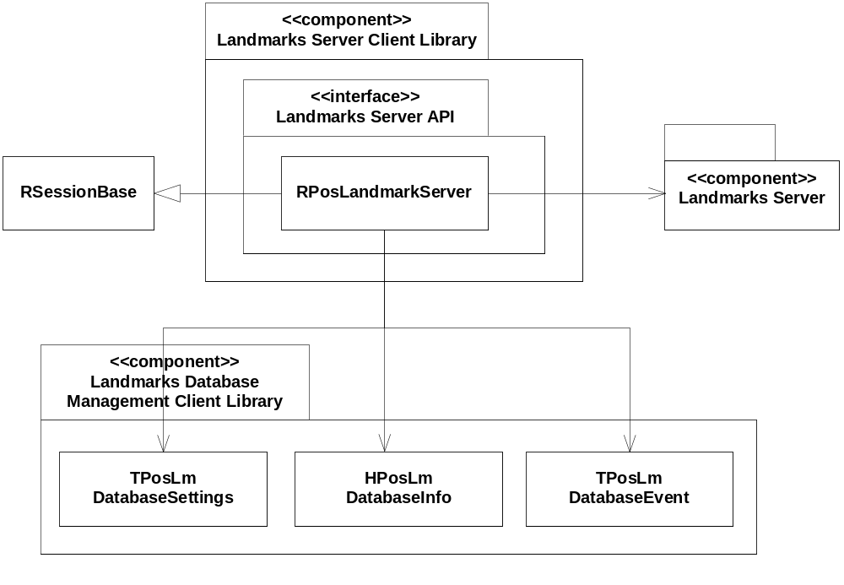
Figure 3.3 Landmarks Server Client Library component class diagram

Class descriptions
Class | Description | Header file
RPosLandmark  Server | Landmarks Server API.  RPosLandmarkServer is the client-side interface to Landmarks Server. It inherits RSessionBase.  TPosLmDatabaseSettings from Landmarks Database Management Client Library contains database settings information.  HPosLmDatabaseInfo from Landmarks Database Management Client Library contains information about the landmark database and database settings.  TPosLmDatabaseEvent contains event information and is used when a client wants to report a database management event. | EPos_RPosLandmarkServer.h

Operations

Registering a database
Operation | Registering a database.
Preconditions | The client has an open connection to Landmarks Server.
Description | Registers a landmark database.  The client supplies an HPosLmDatabaseInfo object, which contains the database URI to register. The object can also contain database settings information, such as the display name for the database.
Inputs | An HPosLmDatabaseInfo object.
Modifies | The database information is added to the registry.
Outputs | KErrNone if the operation was successful, KErrAlreadyExists if the database is already registered, KErrArgument if the URI is incorrect or any other system-wide error code.
Postconditions | The database is registered.
Related to | RPosLandmarkServer
Related event
Exceptions

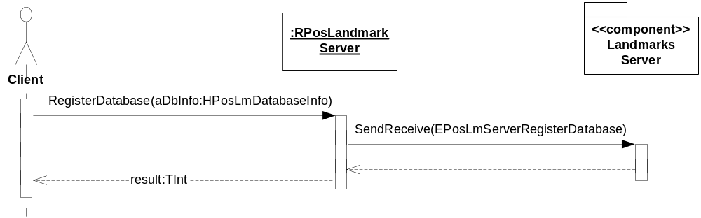
Figure 3.4 Registering a database

Unregistering a database
Operation | Unregistering a database.
Preconditions | The client has an open connection to Landmarks Server.
Description | Unregisters a database.
Inputs | The URI of the database to unregister and the drive letter.
Modifies | The database entry is removed from the registry.
Outputs | KErrNone if the operation was successful, KErrArgument if the URI is incorrect or any other system-wide error code.
Postconditions | The database is unregistered.
Related to | RPosLandmarkServer
Related event
Exceptions

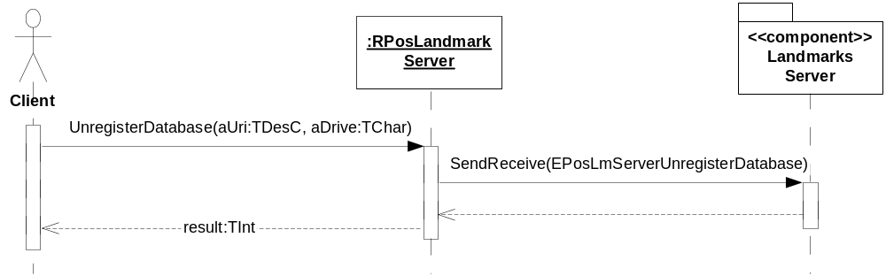
Figure 3.5 Unregistering a database

Unregistering all databases with a certain protocol
Operation | Unregistering all databases with a certain protocol.
Preconditions | The client has an open connection to Landmarks Server.
Description | Unregisters all databases with a certain protocol.
Inputs | The protocol for which to unregister all databases.
Modifies | Removes all the databases with the protocol from the registry.
Outputs | KErrNone if the operation was successful, otherwise a system-wide error code.
Postconditions | All the databases with the specified protocol are unregistered.
Related to | RPosLandmarkServer
Related event
Exceptions

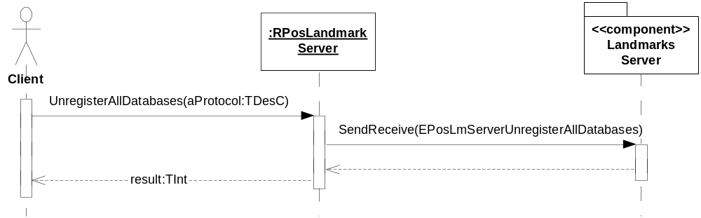
Figure 3.6 Unregistering all databases with a certain protocol

Retrieving database information
Operation | Retrieving database information.
Preconditions | The client has an open connection to Landmarks Server.
Description | Retrieves the database settings for the database URI supplied by the client.
Inputs | An HPosLmDatabaseInfo object containing the URI of the database for which to read the database information.
Modifies
Outputs | KErrNone if the operation was successful, KErrNotFound if the URI does not exist, KErrArgument if the URI is incorrect or any other system-wide error code.  The database information is written to the HPosLmDatabaseInfo object.
Postconditions | The HPosLmDatabaseInfo object contains the database information.
Related to | RPosLandmarkServer
Related event
Exceptions

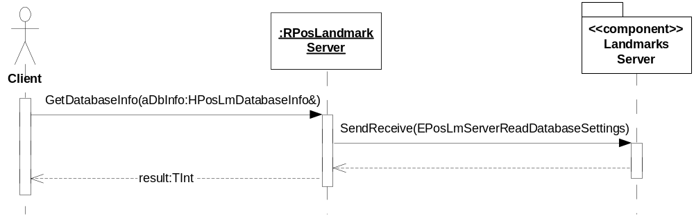
Figure 3.7 Retrieving database information

Modifying database settings
Operation | Modifying database settings.
Preconditions | The client has an open connection to Landmarks Server.
Description | Modifies the settings for a landmark database.
Inputs | The URI of the database for which to modify the settings and the new settings for the database. The drive telling where the database is located.
Modifies | The settings for the landmark database.
Outputs | KErrNone if the operation was successful, KErrNotFound if the URI does not exist, KErrArgument if the URI is incorrect or any other system-wide error code.
Postconditions | The settings for the specified database URI are updated.
Related to | RPosLandmarkServer
Related event
Exceptions

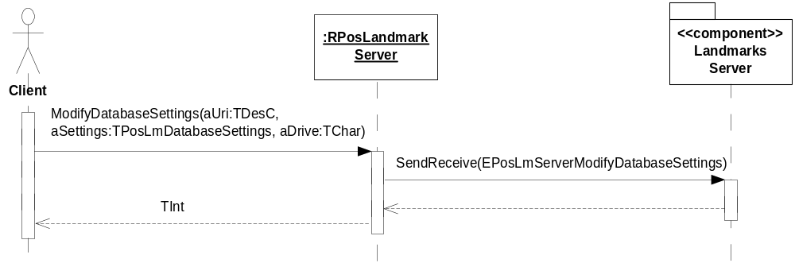
Figure 3.8 Modifying database settings

Listing the database URIs with a certain protocol
Operation | Listing the database URIs with a certain protocol.
Preconditions | The client has an open connection to Landmarks Server.
Description | Lists the URIs of the databases with a certain protocol.
Inputs | The protocol for which to list the databases.
Modifies
Outputs | A list of the database URIs.
Postconditions | The client has received a list of the database URIs. The client takes ownership of the array.
Related to | RPosLandmarkServer
Related event
Exceptions | If any code between the first and the second SendReceive leaves, the resources used for storing the remaining result in Landmarks Server will be destroyed.

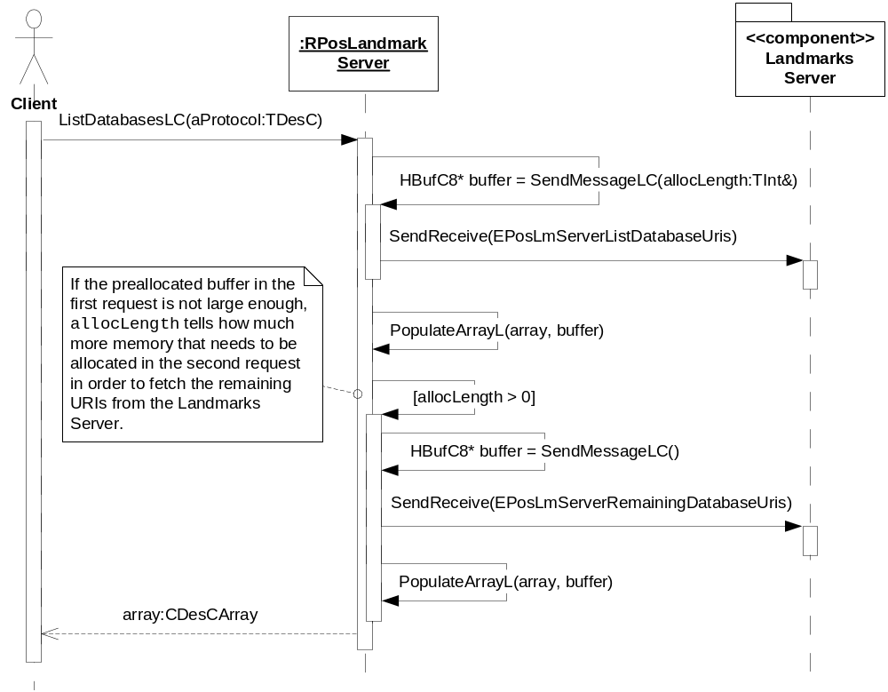
Figure 3.9 Listing the database URIs with a certain protocol

Listing the database information with a certain protocol
Operation | Listing the database information with a certain protocol.
Preconditions | The client has an open connection to Landmarks Server.
Description | Lists the database information with a certain protocol.
Inputs | The protocol for which to list the databases. An array that will contain the database information on return.
Modifies
Outputs
Postconditions | The array supplied by the client contains information about the landmark databases. The client takes ownership of all the information objects in the array.
Related to | RPosLandmarkServer
Related event
Exceptions | If any code between the first and the second SendReceive leaves, the resources used for storing the remaining result in Landmarks Server will be destroyed.

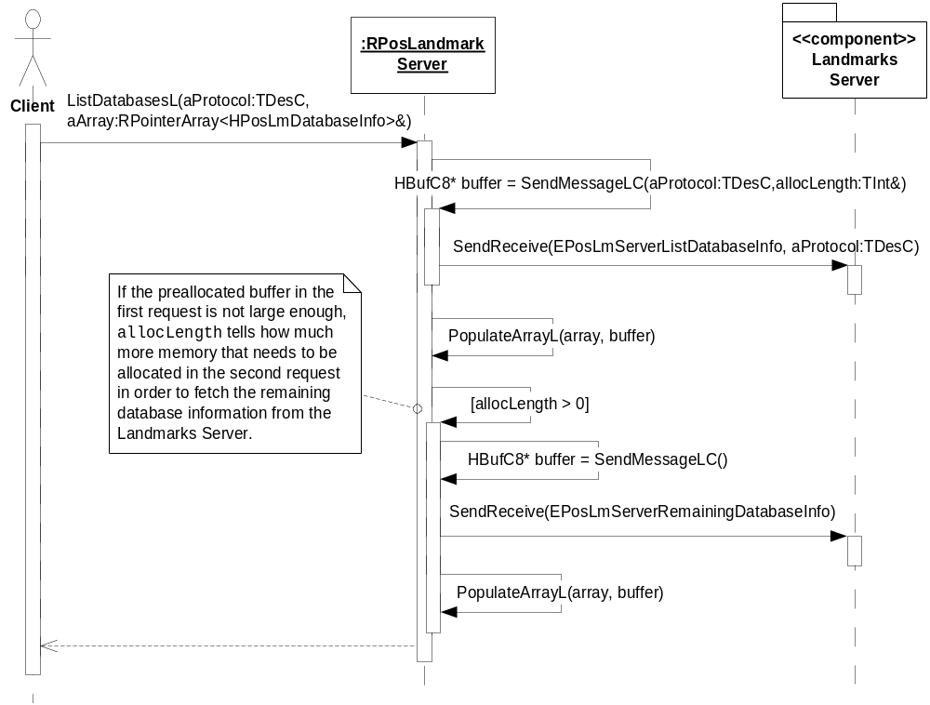
Figure 3.10 Listing the database information with a certain protocol

Backup and Restore
The policies for backup and restore are described in reference document [2].

Variation
Variation for the Landmarks subsystem is described in reference document [2].

System resource usage

File structures
Landmarks Server Client Library does not use any files.

Database structures
Landmarks Server Client Library does not use any databases.

Timers and active objects
Landmarks Server Client Library does not use any timers or active objects.

Security

Capabilities of this component
Capability | Justification
CAP_CLIENT_DLL | The DLL is a client side shared library and it must have all the capabilities that a potential client may have.

Input and output validation
Input and output validation is done in Landmarks Server, see reference document [3].

Environmental assumptions
This component does not make any assumptions about its environment.

Additional enforcements
This component does not have any additional security enforcements.

Exception handling
All input data is validated by Landmarks Server. Leaves and error codes are used to handle memory exhaustion and other system-wide error codes that appear upon execution. Panics are used when the client does something wrong.

Usage
Usage is described at the subsystem level in reference document [2].

