S60 3.x
Map and Navigation Framework
Design Document

Team name | Author
S60 Location | Sergey Burnevsky

Change history:

Version | Date | Status | Comments
3.0 | 30.01.2007 | Approved | Changed file names for localizable resources in chapter 6.1  Changed folder names for subsystem’s source tree in chapter 9.1
2.0 | 31.10.2006 | Approved | Provider application exit observer added
1.0 | 02.05.2006 | Approved

Table of contents:

1. Document control 5
1.1 References 5
1.2 Documentation conventions 5
1.3 Abbreviations 5
1.4 Definitions 6
2. General 7
2.1 Introduction 7
2.2 Component environment 7
2.3 Use cases 8
2.3.1 Using the framework 8
2.3.1.1 Execute Map and Navigation service via AIW 9
2.3.1.2 Execute Map and Navigation service via client APIs 9
2.3.1.3 Find Provider applications 10
2.3.2 Services 10
2.3.2.1 Show map 10
2.3.2.2 Navigate to 10
2.3.2.3 Select from map 11
2.3.2.4 Fetch address by coordinates (reverse geocoding) 11
2.3.2.5 Fetch coordinates by address (geocoding) 12
2.4 Services required 12
2.4.1 From the Symbian OS subsystems 12
2.4.2 From the Domestic OS subsystems 12
2.4.3 From HW 12
2.5 Services provided 13
2.5.1 UI 13
2.5.2 SW IF 13
2.6 Subsystem overview 13
2.6.1 Component diagrams 13
2.6.1.1 Subsystem 13
2.6.2 Component descriptions 14
2.6.2.1 Map and Navigation Library 14
2.6.2.2 Map and Navigation AIW Provider 14
3. UI control hierarchy 15
3.1 Provider application selection query 15
4. Design 16
4.1 Class diagrams 16
4.1.1 Map and Navigation Library 16
4.1.2 Map and Navigation AIW Provider 17
4.2 Class descriptions 18
4.2.1 Map and Navigation Library 18
4.2.2 Map and Navigation AIW Provider 19
4.2.3 Structs, type definitions and enumerations 20
4.2.3.1 mnaiwservices.h structs and enumerations 20
4.2.3.2 mnserviceinfo.rh structs 21
4.2.3.3 mnappserviceuids.hrh definitions 21
4.2.3.4 mnappservices.hrh definitions 21
4.2.4 Flag definitions 21
4.2.5 State diagrams 22
4.3 Operations 22
4.3.1 Overview 22
4.3.1.1 Using subsystem via AIW 22
4.3.1.2 Selecting the preferred Provider application 25
4.3.1.3 Using client APIs 26
4.3.1.4 Provider applications discovery 27
4.3.2 Map and Navigation Library 28
4.3.2.1 Finding Provider applications 28
4.3.2.2 Connecting Provider application 31
4.3.2.3 Disconnecting Provider application 33
4.3.2.4 Listening for exit of Provider application 34
4.3.2.5 Resolving address by coordinates 35
4.3.2.6 Resolving coordinates by address 37
4.3.2.7 Retrieving geocoding result 37
4.3.2.8 Starting navigation 38
4.3.2.9 Changing map view options 39
4.3.2.10 Adding landmarks to be shown on map view 40
4.3.2.11 Launching map view 42
4.3.2.12 Launching selection from map view 44
4.3.2.13 Retrieving result of selection from map view 46
4.3.2.14 Resetting landmarks to be shown on map view 48
4.3.3 Map and Navigation AIW Provider 49
4.3.3.1 Retrieving available AIW menu commands 49
4.3.3.2 Executing AIW service command 50
4.4 Backup and Restore 56
5. Variation 57
5.1 Map and Navigation AIW Provider 57
6. System resource usage 58
6.1 Files 58
6.2 Other data 59
6.2.1 Databases 59
6.2.2 Central Repository 59
6.2.3 Publish and Subscribe 59
6.3 Memory consumption 59
6.4 Task allocation 59
6.5 Performance 59
6.6 Timers 59
7. Security 60
7.1 Capabilities of this component 60
7.2 Input and output validation 60
7.3 Environmental assumptions 60
7.4 Additional enforcements 60
8. Exception handling 61
9. Usage 62
9.1 Building 62
9.2 User's guide 62

Document control

References

- S60 3.1 Map and Navigation Framework Subsystem Architecture Description
- S60 Map and Navigation API
- S60 Geocoding API
- S60 Map and Navigation Provider API
- S60 Map and Navigation Provider Discovery API
- S60 Map and Navigation AIW API
- S60 Location Acquisition API
- S60 Landmarks API
- S60 AIW API
- S60 Map and Navigation FW UI Specification

Documentation conventions
Code is shown with the Courier New font. Filenames and command line commands are shown in italics font decoration.

Abbreviations

API | Application Programming Interface
AIW | Application Interworking
DLL | Dynamic Link Library
FW | Framework
OS | Operating System
UI | User Interface

Definitions

ECom | Symbian OS framework for plug-in DLLs.
Framework | Usually denotes the collection of an engine and associated programming interfaces. This document mentions the Mobile Location Framework and the Symbian OS ECom Framework. There is also a subsystem in Symbian OS called Application Framework.
Landmark | A named location with coordinates and additional information, such as address, media links and category.
Mobile Location Framework | A high-level subsystem containing engines for location services, e.g. Map and Navigation Framework.
Platform Security | Definition for the security design principles and features in Symbian OS.
Provider application | An application, which serves requests from Map and Navigation Framework. Typically single Provider application contains map and navigation features and supports geocoding requests.
Geocoding | Geocoding is a process of translating street address to geographic coordinates. Also known Reverse Geocoding, which is a process of translating geographic coordinates to address information.

General

Introduction
This document describes the design of Map and Navigation Framework.
This subsystem is aimed to allow access to map and navigation features provided by already existing 3rd party applications. These applications are called Provider applications, and this subsystem defines the way these applications may provide such access. The framework itself does not have a direct access to map and navigation content, and thus, DRM issues are not the responsibility of this system. Content may be local or remote, but it is totally hidden by the Provider applications, which are also responsible for DRM aspects.
This subsystem allows for easy integration of Map and Navigation features into an existing system and other 3rd party applications. This is achieved by using AIW mechanisms.
More than one Provider application is allowed to be installed on a terminal at the same time, and the user can select which one to use, case by case.
The system also supports Geocoding features with the help of the Provider applications.
Map and Navigation Framework is available from S60 Platform release 3.1 onwards. It is compatible with S60 Platform release 3.0.

Component environment
The Map and Navigation subsystem is a part of Mobile Location Framework. The Map and Navigation subsystem’s environment is shown in Figure 2.1. The high-level design of the Map and Navigation subsystem is described in reference document [1].
The Map and Navigation subsystem has a dependency to Location Acquisition API (see reference document [7]) and Landmarks API (see reference document [8]). Only data types are used from these APIs.
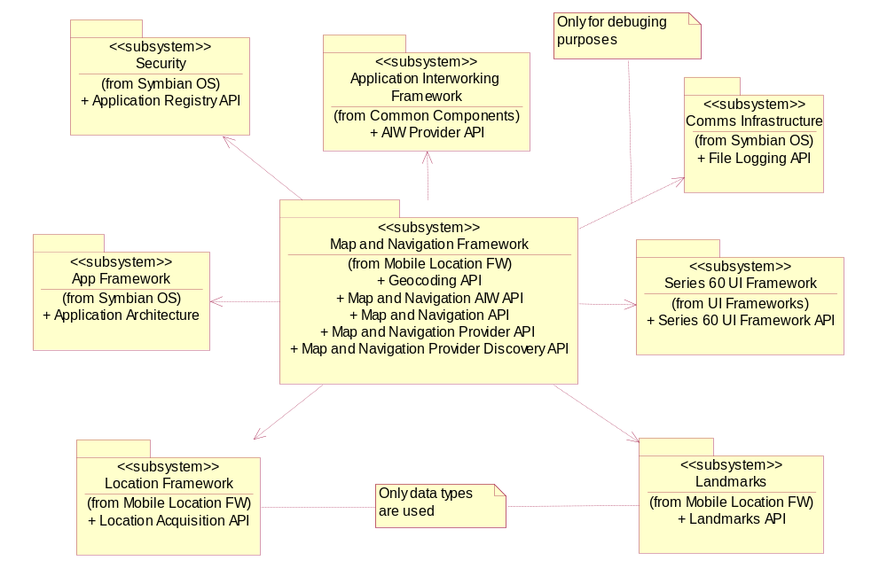
Figure 2.1 Map and Navigation Framework

Use cases

Using the framework
Reference document [1] describes the two major use cases of the system: request via AIW FW and direct request via APIs. These uses cases show the flow of data and control between components of this subsystem and other subsystems.

Execute Map and Navigation service via AIW

Summary | The client uses Map and Navigation Framework via AIW FW.
Actor(s) | AIW client.
Frequency | Low.
Preconditions
Description | - The client application uses AIW FW to find out what Map and Navigation AIW Services are available; it forms and sends the request via AIW FW.  - Map and Navigation AIW Provider selects the Provider application:  - If there is only one Provider application available for the request, it is selected.  - If there are more than one Provider applications available, then Map and Navigation AIW Provider shows a list of available Provider applications and asks the user to select the preferred one.  - Map and Navigation AIW Provider connects to the selected Provider application and forwards the request to the Map and Navigation library.  - The library sends the request further to the Provider application for handling.
Exceptions | - The Provider application selected by the user fails to serve the request – the use case is repeated from step 2.b without the failed Provider application in the list.  - There are no Provider applications or no Provider applications were able to serve the request – the client’s request will be rejected by Map and Navigation AIW Provider and an error is retuned to the client.
Postconditions | The client’s request is served.
Illustrations | See Sections 4.3.1.1 and 4.3.1.2.

Execute Map and Navigation service via client APIs

Summary | The client uses Map and Navigation Framework via APIs.
Actor(s) | Client.
Frequency | Low.
Preconditions | The client has specified a Provider application to use (see Section 2.3.1.3).
Description | The client application uses Map and Navigation APIs to issue requests directly via the Map and Navigation library, which sends the request further to the specified Provider application for handling.
Exceptions | The Provider application cannot serve the issued request – an error is returned to the client.
Postconditions | The client’s request is served.
Illustrations | See Section 4.3.1.3.

Find Provider applications

Summary | The client finds the available Provider applications.
Actor(s) | Client.
Frequency | Low.
Preconditions
Description | The client requests to find all the Provider applications installed, or just those that implement certain services.
Exceptions
Postconditions | A list of the available Provider applications is returned to the client.
Illustrations | See Section 4.3.1.4.

Services
The following use cases define the exact services that may be requested by clients both via AIW and client APIs.

Show map

Summary | The client requests to show a map on the screen.
Actor(s) | Client, AIW client.
Frequency | Low.
Preconditions
Description | Actor specifies (optionally) a landmark or a set of landmarks, map area, whether current location shall be shown or not, and uses Map and Navigation API or Map and Navigation AIW services, as described in Section 2.3.1, to request to show map on the screen.
Exceptions | The Provider application cannot serve the issued request – an error is returned to the client.
Postconditions | The map is shown on the screen.
Illustrations

Navigate to

Summary | The client requests to launch the navigation application.
Actor(s) | Client, AIW client.
Frequency | Low.
Preconditions
Description | Actor specifies a destination landmark and uses Map and Navigation API, or Map and Navigation AIW services, as described in Section 2.3.1, to launch the navigation application.
Exceptions | The Provider application cannot serve the issued request – an error is returned to the client.
Postconditions | The navigation application is launched.
Illustrations

Select from map

Summary | The client requests the user to select a location on the map.
Actor(s) | Client, AIW client.
Frequency | Low.
Preconditions
Description | Actor specifies that the user should select a location on the map and uses Map and Navigation API, or Map and Navigation AIW services, as described in Section 2.3.1, to launch a query dialog. The Provider application shows the query dialog to the user. The user selects a location.
Exceptions | The Provider application cannot serve the issued request – an error is returned to the client.  The user dismisses the query dialog – an error (“cancelled”) is returned.
Postconditions | Location selected by the user is returned to actor.
Illustrations

Fetch address by coordinates (reverse geocoding)

Summary | The client requests an address for coordinates.
Actor(s) | Client, AIW client.
Frequency | Low.
Preconditions
Description | Actor specifies coordinates and asks for a corresponding address using Map and Navigation API, or Map and Navigation AIW services, as described in Section 2.3.1. The Provider application performs calculations and returns the address to actor.
Exceptions | The Provider application cannot serve the issued request – an error is returned to the client.
Postconditions | The address is returned to actor.
Illustrations

Fetch coordinates by address (geocoding)

Summary | The client requests coordinates for an address.
Actor(s) | Client, AIW client.
Frequency | Low.
Preconditions
Description | Actor specifies address and asks for corresponding coordinates using Map and Navigation API, or Map and Navigation AIW services, as described in Section 2.3.1. The Provider application performs calculations and returns coordinates to actor.
Exceptions | The Provider application cannot serve the issued request – an error is returned to the client.  If the given address cannot be unambiguously resolved to coordinates, the Provider application may issue a request to the user to select from possible choices. This behavior may be disabled by the client, in which case only an error will be returned.
Postconditions | Coordinates are returned to actor.
Illustrations

Services required

From the Symbian OS subsystems
Services of AIW FW, S60 UI FW, App Framework, Security, Location FW (only datatypes) and Landmarks FW (only datatypes) are required for this subsystem. File Logging API of Comms Infrastructure is only used in debug builds for tracing purposes.

API / FW | Description
AIW FW | Map and Navigation framework contains the Map and Navigation AIW Provider component, which implements AIW Service Interface Base API and AIW Service Interface Menu API.
S60 UI Framework | Used to show the Provider application selection dialog to user.
Application Architecture | Used to get information about the installed Provider applications (servers) and implement application services.
Application Registry API | Used to get extended information about Provider applications: version, vendor name, trust status.
Location Acquisition API | This subsystem uses datatypes defined in Location Acquisition API.
Landmarks API | This subsystem uses datatypes defined in Landmarks API.

From the Domestic OS subsystems
This component does not have any direct interfaces to the Domestic OS side subsystems.

From HW
This component has no direct HW interfaces.

Services provided

UI
Map and Navigation Framework does not provide any UI services a client can explicitly utilize. Map and Navigation AIW Provider shows Provider application selection dialog for a user, when several Provider applications are available. This dialog serves the subsystem’s needs (the user is responsible to select the preferred Provider application, not subsystem itself), but is also a service for the user: it allows users to control what Provider application is used for a particular request. Note: this dialog is only shown if the request comes from AIW Client, API clients have to specify the needed Provider application explicitly. For more information, see Section 3.1.
This subsystem allows a user an access to Map and Navigation related UI from Provider applications.

SW IF

Provided Service | Description | Protected
Map and Navigation AIW API | Defines map and navigation related AIW service commands and their parameters. | No
Map and Navigation API | This API enables the client to access map and navigation features of a Provider application. The most important use cases are: showing map, showing landmarks on map, selecting a location from map, and engaging navigation. | No
Geocoding API | This API provides interfaces for geocoding and reverse geocoding features, such as conversion address information to coordinates and vice versa. | No
Map and Navigation Provider API | This API provides an interface that a Provider application (server) implements. Framework uses this API to send requests to Provider applications over process boundaries. This API also defines how the Provider application registers its map and navigation services within the platform, and what information about the Provider application shall be published. | No
Map and Navigation Provider Discovery API | This API allows client applications to find out what Provider applications are available, and to retrieve their detailed information related to this subsystem. | No

Subsystem overview

Component diagrams

Subsystem
Map and Navigation framework consists of two main components: Map and Navigation Library and Map and Navigation AIW Provider. Their mutual relationships and dependencies to other subsystems are shown in Figure 2.2.
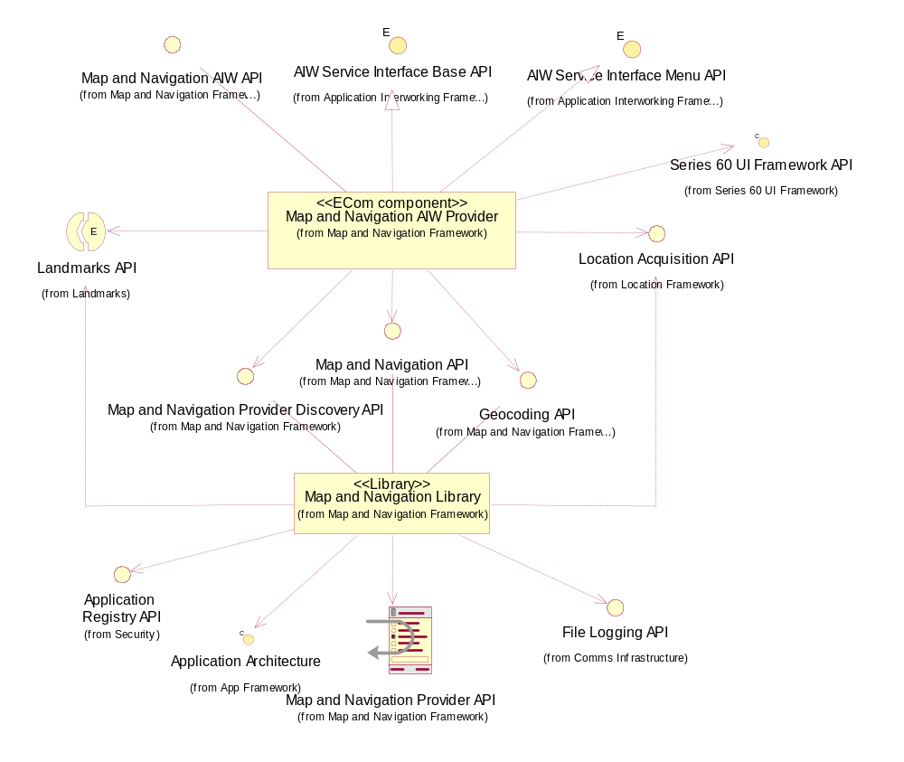
Figure 2.2 Map and Navigation component diagram

Component descriptions

Map and Navigation Library
This component publishes interfaces needed to access Map and Navigation features. Its main responsibilities and additional requirements are:
- Exposes and implements the following APIs: Map and Navigation API, Geocoding API and Map and Navigation Provider Discovery API.
- Exposes Map and Navigation Provider API, which should be implemented by Provider applications.
- Finds available Provider applications and information about them.
- Wraps communications between the client and the Provider application.

Map and Navigation AIW Provider
This is an AIW plug-in, which serves as a gateway from client UI applications to Map and Navigation APIs. Its main responsibilities and additional requirements are:
- Builds AIW menus on runtime based information about available providers.
- Wraps client calls to requests to Map and Navigation API and Geocoding API.
- Exposes Map and Navigation AIW API
- Shows the Provider application selection dialog, if multiple applications are available.

This component uses the Map and Navigation Library component.

UI control hierarchy

Provider application selection query
The Map and Navigation AIW Provider component shows the Provider application query dialog whenever several Provider applications, that are able to serve the client’s request, exist. This query dialog and various error messages used by this component are described in reference document [10]. This component does not define any new UI controls or classes, but instead uses CAknListQueryDialog from S60 UI FW directly.

Design

Class diagrams

Map and Navigation Library

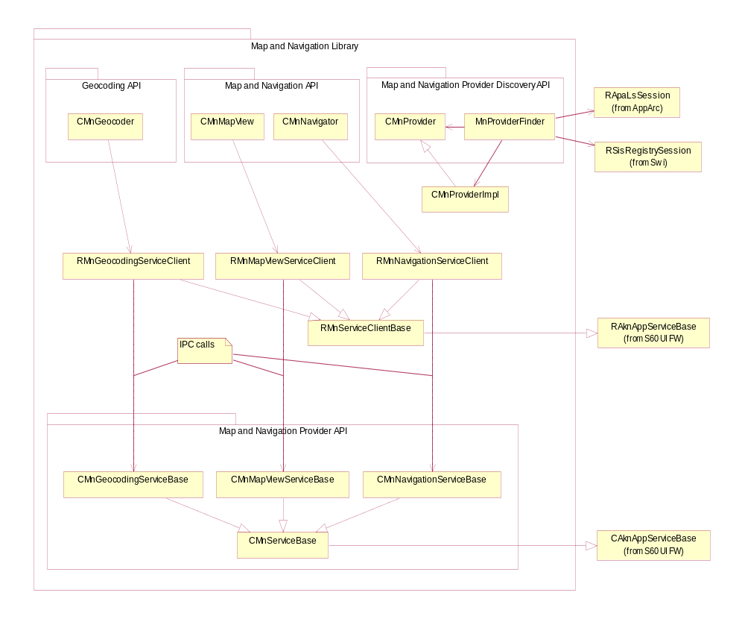
Figure 4.3 Class diagram of the Map and Navigation Library component
Figure 4.3 shows the Map and Navigation Library component of the subsystem. This component implements client APIs, server API, and client-server IPC communications.

Map and Navigation AIW Provider

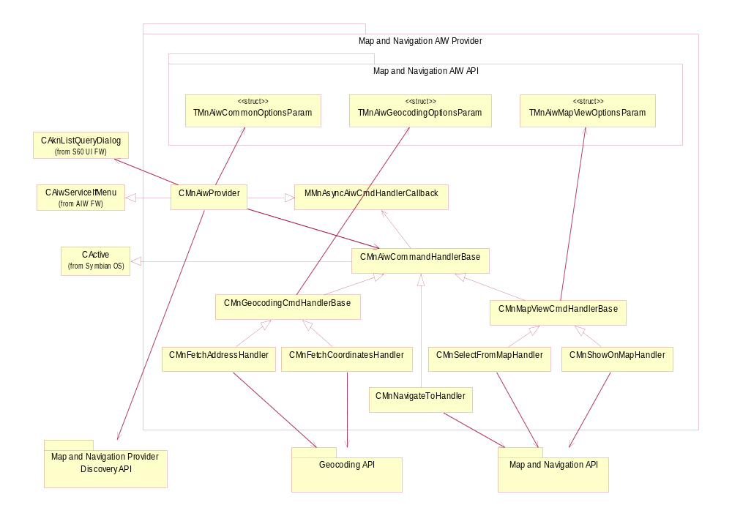
Figure 4.4 Class diagram of the Map and Navigation AIW Provider component
Figure 4.4 shows the Map and Navigation AIW Provider component of the subsystem. This component is used by UI applications that access Map and Navigation Framework via AIW FW.

Class descriptions

Map and Navigation Library

Class | Description | Header file
CMnMapView | This class allows the client to issue map view requests: show map, show current location, and select from map. It checks input parameters and utilizes RMnMapViewServiceClient to send requests to Provider application server.  It is a part of Map and Navigation API. | mnmapview.h
CMnNavigator | This class allows client to issue navigation requests. It checks input parameters and utilizes RMnNavigationServiceClient to send requests to Provider application server.  It is a part of Map and Navigation API. | mnnavigator.h
CMnGeocoder | This class allows client to issue geocoding requests: convert address to coordinates and backwards. It checks input parameters and utilizes RMnGeocodingServiceClient to send requests to Provider application server.  It is a part of Geocoding API. | mngeocoder.h
CMnProvider | This class gives read access to Provider application’s detailed information.  It is a part of Map and Navigation Provider Discovery API. | mnprovider.h
CMnProviderImpl | This class gives write access to CMnProvider class. It is internal class derived from CMnProvider and is used by MnProviderFinder. | mnproviderimpl.h
MnProviderFinder | This is static class, which provides facilities to search for Provider applications available in the system. It returns results in form of array of CMnProvider pointers.  It is a part of Map and Navigation Provider Discovery API. | mnproviderfinder.h
RMnClientServiceBase | This is base class for this component’s client-side IPC parties. | mnclientservicebase.h
RMnMapViewServiceClient | This class is derived from RMnClientServiceBase and implements map view related IPC with Provider application. | mnmapviewserviceclient.h
RMnNavigationServiceClient | This class is derived from RMnClientServiceBase and implements navigation related IPC with Provider application. | mnnavigationserviceclient.h
RMnGeocodingServiceClient | This class is derived from RMnClientServiceBase and implements geocoding related IPC with Provider application. | mngeocodingserviceclient.h
CMnServiceBase | This is base class for component’s server side of IPC.  It is a part of Map and Navigation Provider API. | mnservicebase.h
CMnMapViewServiceBase | This is server side of map view related IPC and is base class for Provider application’s implementation of map view services.  It is a part of Map and Navigation Provider API. | mnmapviewservicebase.h
CMnNavigationServiceBase | This is server side of navigation related IPC and is base class for Provider application’s implementation of navigation services.  It is a part of Map and Navigation Provider API. | mnnavigationservicebase.h
CMnGeocodingServiceBase | This is server side of geocoding related IPC and is base class for Provider application’s implementation of geocoding services.  It is a part of Map and Navigation Provider API. | mngeocodingservicebase.h

Map and Navigation AIW Provider

Class | Description | Header file
CMnAiwProvider | Implementation of CAiwServiceIfMenu interface from AIW FW. This class receives Map and Navigation AIW requests from AIW FW and forwards them to Map and Navigation Library component.  This class uses CAknListQueryDialog to show list popup and let user choose preferred Provider application, if several existing Provider applications can serve client’s request.  This class uses CMnAiwCommandHandlerBase derived classes to handle AIW commands. | mnaiwprovider.h
CMnAiwCommandHandlerBase | Base class for Map and Navigation AIW command handlers. It is derived from CActive to make possible asynchronous execution of AIW commands. It defines common functionality for handlers. | Mnaiwcommandhandler  base.h
MMnAsyncAiwCmd  HandlerCallback | Abstract class, which defines callback function for notifying observer about completion of asynchronous AIW command. It is used by CMnAiwProvider. | Mnaiwcommandhandler  base.h
CMnMapViewCmdHandlerBase | Base class for Map View-related AIW command handlers. It is derived from CMnAiwCommandHandlerBase and provides base methods for parsing appropriate AIW parameters. | mnmapviewcmdhandlerbase.h
CMnShowOnMapHandler | Handler for KAiwCmdMnShowMap AIW command. This class parses input parameters as defined in reference document [6] and forwards them to Map and Navigation API to launch map view. This is synchronous handler. | mnshowonmaphandler.h
CMnSelectFromMap  Handler | Handler for KAiwCmdMnSelectFromMap AIW command. This class parses input parameters as defined in reference document [6] and forwards them to Map and Navigation API to launch selection of a location from map view. This is asynchronous handler. | mnselectfrommaphandler.h
CMnGeocodingCmd  HandlerBase | Base class for Geocoding-related AIW command handlers. It is derived from CMnAiwCommandHandlerBase and provides base methods for parsing appropriate AIW parameters. | mngeocodingcmdhandlerbase.h
CMnFetchAddress  Handler | Handler for KAiwCmdMnAddrByCoord AIW command. This class parses input parameters as defined in reference document [6] and forwards them to Geocoding API to perform translation of given coordinates to address. This is an asynchronous handler. | mnfetchaddresshandler.h
CMnFetchCoordinates  Handler | Handler for KAiwCmdMnCoordByAddr AIW command. This class parses input parameters as defined in reference document [6] and forwards them to Geocoding API to perform translation of given coordinates to coordinates. This is an asynchronous handler. | mnfetchcoordinateshandler.h
CMnNavigateToHandler | Handler for KAiwCmdMnNavigateTo AIW command. It is derived from CMnAiwCommandHandlerBase. It parses input parameters as defined in reference document [6] and forwards them to Map and Navigation API to launch map view. This is a synchronous handler. | mnnavigatetohandler.h

Constants for AIW commands listed in the table above are defined in the aiwcommon.hrh file, part of AIW FW (see reference document [9]).
Asynchronous command handlers reports completion via the callback class MMnAsyncAiwCmdHandlerCallback.

Structs, type definitions and enumerations

mnaiwservices.h structs and enumerations

Struct | Description
TMnAiwCommonOptionsParam | Common options for map and navigation AIW services.  It is the part of Map and Navigation AIW API.
TMnAiwMapViewOptionsParam | Contains additional parameters for KAiwCmdMnShowMap and KAiwCmdMnSelectFromMap AIW service commands.  It is the part of Map and Navigation AIW API.
TMnAiwGeocodingOptionsParam | Contains geocoding parameters for KAiwCmdMnAddrByCoord and KAiwCmdMnCoordByAddr AIW service commands.  It is the part of Map and Navigation AIW API.

See reference document [6] for details on these structures.

mnserviceinfo.rh structs

Struct | Description
MN_SERVICE_INFO | Defines Map and Navigation Provider application’s extension information for SERVICE_INFO structure defined by S60 UI FW.  It is the part of Map and Navigation Provider API.
See reference documents [4] and [5] for details on these structures.

mnappserviceuids.hrh definitions

Struct and enumeration's name | Description
KMnAppMapViewService | MapView application service UID.
KMnAppNavigationService | Navigation application service UID.
KMnAppGeocodingService | Geocoding application service UID.

See reference document [4] for details on these definitions. These values are part of Map and Navigation Provider API.

mnappservices.hrh definitions
This file defines the constants used in the MN_SERVICE_INFO structure: Map and Navigation application service features.

Enumeration | Description
MapView service features
KMnSvcFeatureShowMap | Defines support for map displaying.
KMnSvcFeatureSelectFromMap | Defines support for selecting from map .
Navigation service features
KMnSvcFeatureNavigateTo | Defines support for simple navigating requests.
Geocoding service features
KMnSvcFeatureCoordToAddr | Defines support for translating coordinates to address.
KMnSvcFeatureAddrToCoord | Defines support for translating address to coordinates.
KMnSvcFeaturePlainAddrTo  Coord | Defines support for translating plain-string address to coordinates.

See reference document [4] for details on these definitions. These values are part of Map and Navigation Provider API.

Flag definitions
This Section specifies the flags used by the component and clarify their usage. Variation flags are defined in Chapter 5.

Flag | Description
_DEBUG | Standard flag for debug builds. It is used to remove debug-related code (checks, traces, etc.) from release builds.

State diagrams
This subsystem has no state diagrams.

Operations

Overview

Using subsystem via AIW

Operation | Using subsystem via AIW.
Preconditions | Map and Navigation AIW Provider installed. At least one Provider application installed.
Description | The client application uses Map and Navigation FW via AIW FW. Synchronous and asynchronous requests are possible.
Inputs | Service command ID.
Modifies
Outputs
Postconditions | Client’s request is served.
Related To | 2.3.1.2, 4.3.1.4, 4.3.1.2.
Related Event | The user selects one Map and Navigation command from a menu.
Exceptions | Error is returned to the client if the Provider application cannot serve the issued request, or the connection to the Provider application fails.

The following diagrams show a case when only one Provider application that can serve the client’s request is found. In case there are many such Provider applications found, the user will be asked to select the preferred one. See Section 4.3.1.2 for details on how this operation will be extended if many Provider applications are found. See Section 4.3.1.4 for details on how Map and Navigation AIW Provider finds Provider applications.
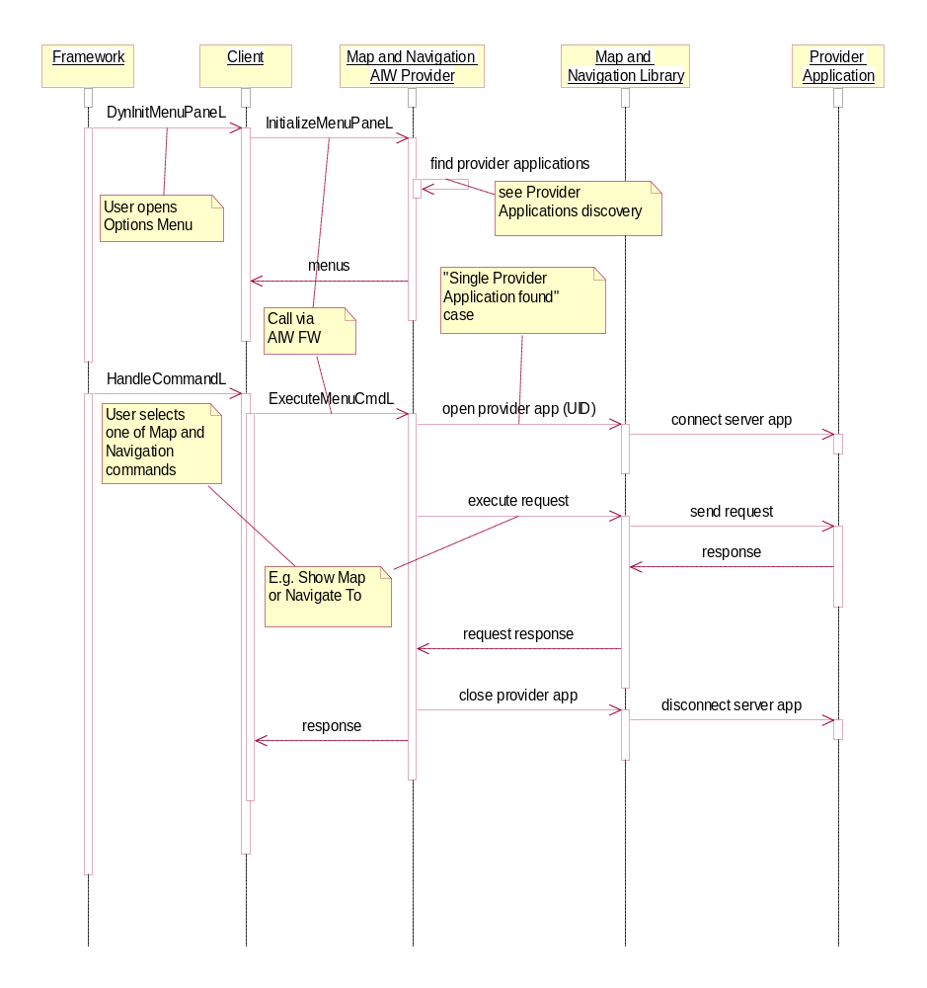
Figure 4.5 Synchronous AIW request with a single Provider application
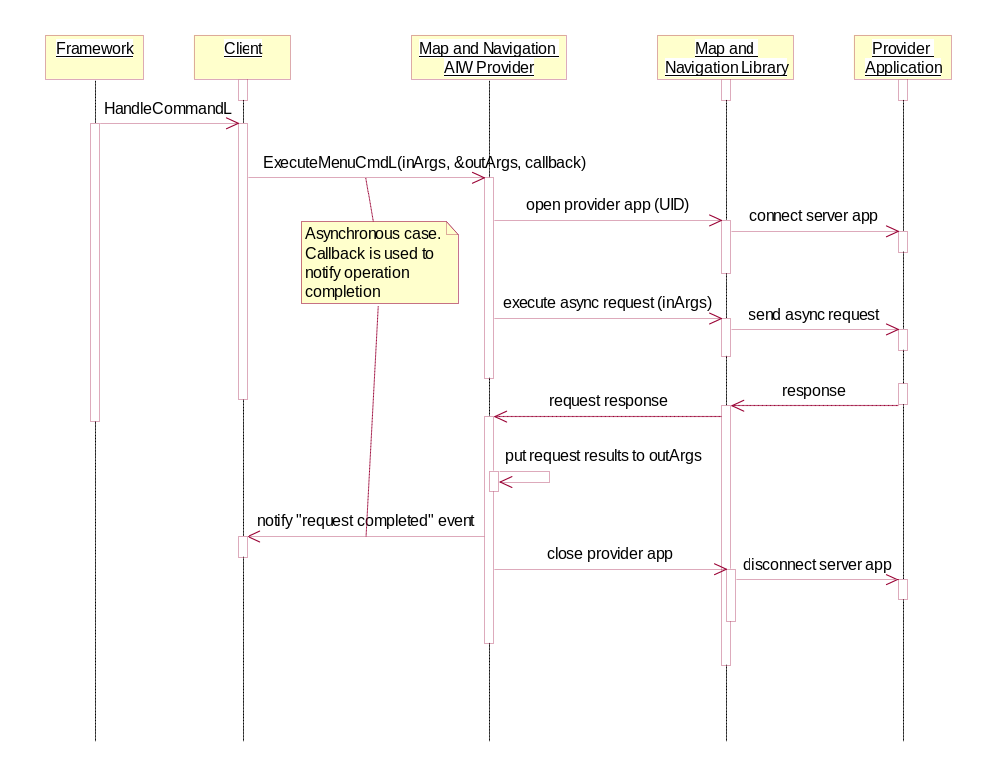
Figure 4.6 Asynchronous AIW request with a single Provider application

Selecting the preferred Provider application

Operation | Selecting the preferred Provider application.
Preconditions | Multiple Provider applications installed, which can provide the requested service.
Description | The client application uses Map and Navigation FW via AIW FW. The user is asked to select one Provider application from a list.
Inputs | Service command ID.
Modifies
Outputs
Postconditions | The client’s request is served.
Related To | 2.3.1.2, 4.3.1.1.
Related Event | The user selects one Map and Navigation command from a menu.
Exceptions | The user refuses to select a Provider application – an error is returned to the client.

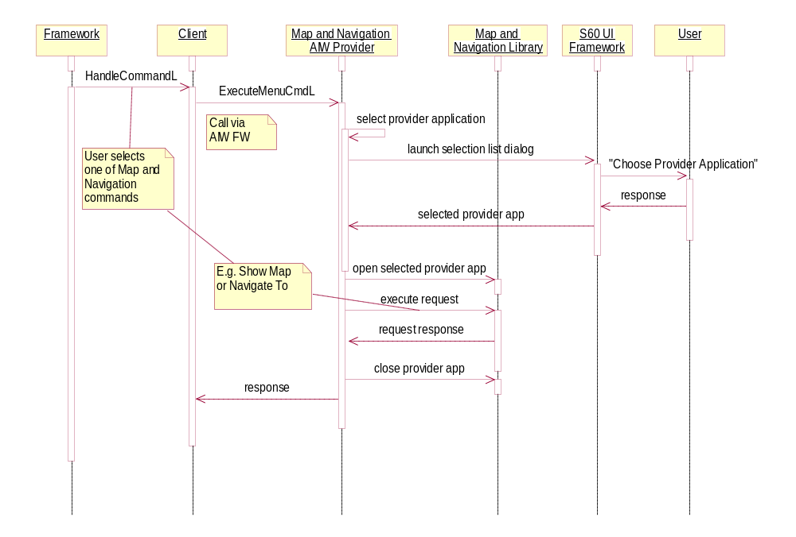
Figure 4.7 Selecting the preferred Provider application when many are available

Using client APIs

Operation | Using client APIs.
Preconditions | The client has selected a Provider application.
Description | The client uses native APIs to access Map and Navigation functionality: Map and Navigation API (see reference document [2]), Geocoding API (see reference document [3]). The client uses Map and Navigation Provider Discovery API (see reference document [5]) to select a Provider application.
Inputs
Modifies
Outputs
Postconditions | The client’s request is served.
Related To | 2.3.1.1, 4.3.1.4.
Related Event
Exceptions | An error is returned to the client if the Provider application cannot serve the issued request, or the connection to the Provider application fails.

See Section 4.3.1.4 for details on how the client finds Provider applications.

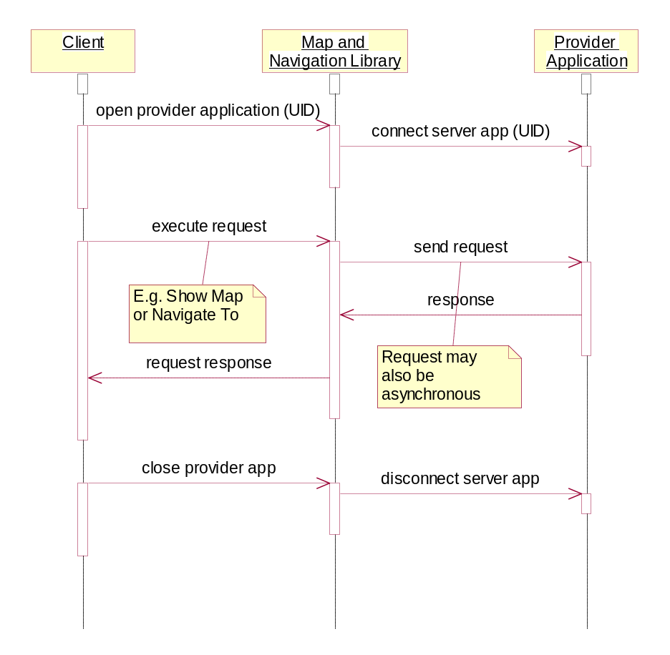
Figure 4.8 Using client APIs

Provider applications discovery

Operation | Provider applications discovery.
Preconditions
Description | The client uses Map and Navigation Provider Discovery API (see reference document [5]) to find available Provider applications. Map and Navigation Library uses AppArc and SWI to get needed information.
Inputs
Modifies
Outputs | List of available Provider applications, if any.
Postconditions
Related To | 4.3.2.1.
Related Event
Exceptions

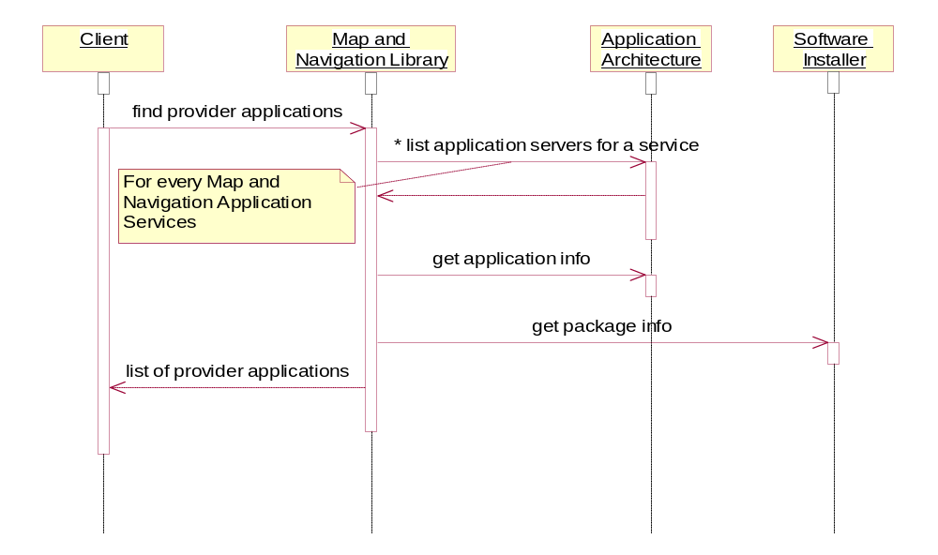
Figure 4.9 Provider applications discovery

Map and Navigation Library

Finding Provider applications

Operation | Finding Provider applications.
Preconditions
Description | The client uses Map and Navigation Provider Discovery API (see reference document [5]) to find available Provider applications.
Inputs | Optional: list of Map and Navigation application services (bitmap of CMnProvider::TService values).
Modifies
Outputs | An array of all available Provider applications, or only those which support specified services, if optional input parameter is given.
Postconditions
Related To | MnProviderFinder, CMnProviderImpl.
Related Event
Exceptions

In the case the client supplies an optional parameter, the operation only returns those Provider applications that support services specified by this parameter, and implementation does not query RApaLsSession (AppArc) for servers of other services.
Map and Navigation Library does not return applications that claim support for Map and Navigation application services (see Section 4.2.3.3), but cannot be trusted. Trust status is verified by calling Swi::RSisRegistryEntry::TrustStatusL() and checking validation status. Application is considered trusted if its package validation status is at least Swi::TValidationStatus::EValidatedToAnchor (one or more certificate chains were validated to an issuer certificate in the certificates store). Rom-based packages have higher validation status and thus will be trusted as well.
This means that application must have its installation package (stub or real) on the device available for SWI subsystem. However in order to ease developing applications with emulator, installation information is only checked on hardware and in __WINS__ environment all Provider applications are trusted. This also means that vendor name and application version information is not available on __WINS__ environment.
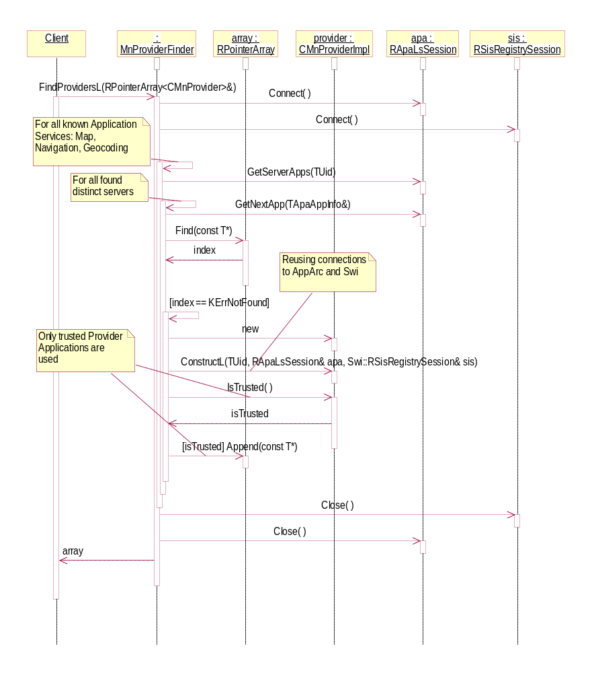
Figure 4.10 Finding Provider applications
A call to CMnProviderImpl::ConstructL issues a procedure of retrieving detailed information about Provider applications. One part of it is a connecting to SWI and checking trust level of found application server shown on the diagram below. If this part fails (e.g. because there is no installation package found for the server) or package cannot be trusted then IsTrusted() property of CMnProviderImpl class will return EFalse and this server will not be used as Provider application.
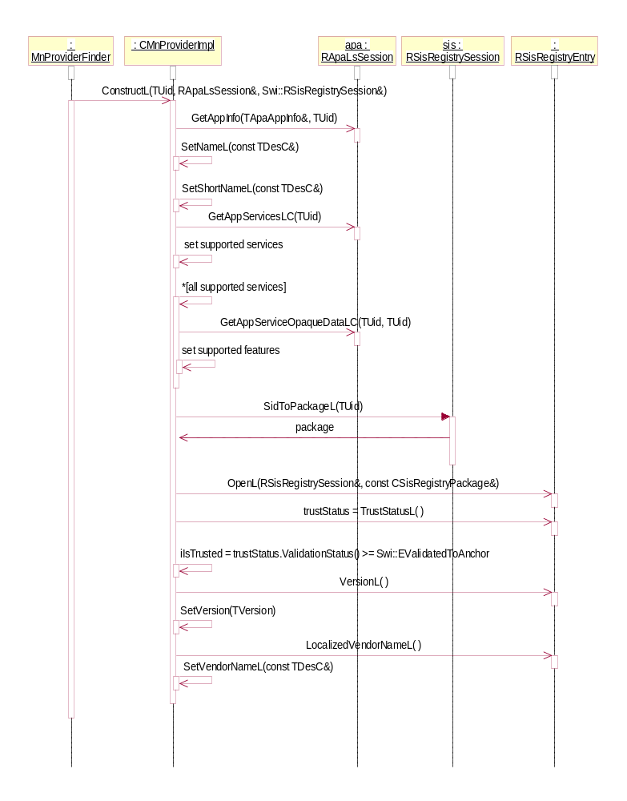
Figure 4.11 Retrieving information about Provider application
On __WINS__ environment installation packages are not checked and all Provider applications are trusted.

Connecting Provider application

Operation | Connecting Provider application.
Preconditions
Description | The client uses Map and Navigation API (see reference document [2]) or Geocoding API (see reference document [3]) to connect to the Provider application. The client specifies the services needed from the Provider application by using one of the CMnGeocoder or CMnMapView or CMnNavigator classes.
Inputs | Provider application (CMnProvider).
Modifies
Outputs
Postconditions | Connection established to Provider application.
Related To | CMnGeocoder or CMnMapView or CMnNavigator, CMnProvider, RMnGeocodingServiceClient or RMnMapViewServiceClient or RMnNavigationServiceClient respectively.
Related Event
Exceptions | KErrNotFound if specified provider does not exist.  KErrNotSupported if specified provider does not support the requested service.

CMnNavigator is shown on this diagram for example purposes only. The same approach is used with CMnGeocoder and CMnMapView.
Establishing connection to a Provider application may involve its start-up, if it is not started yet.
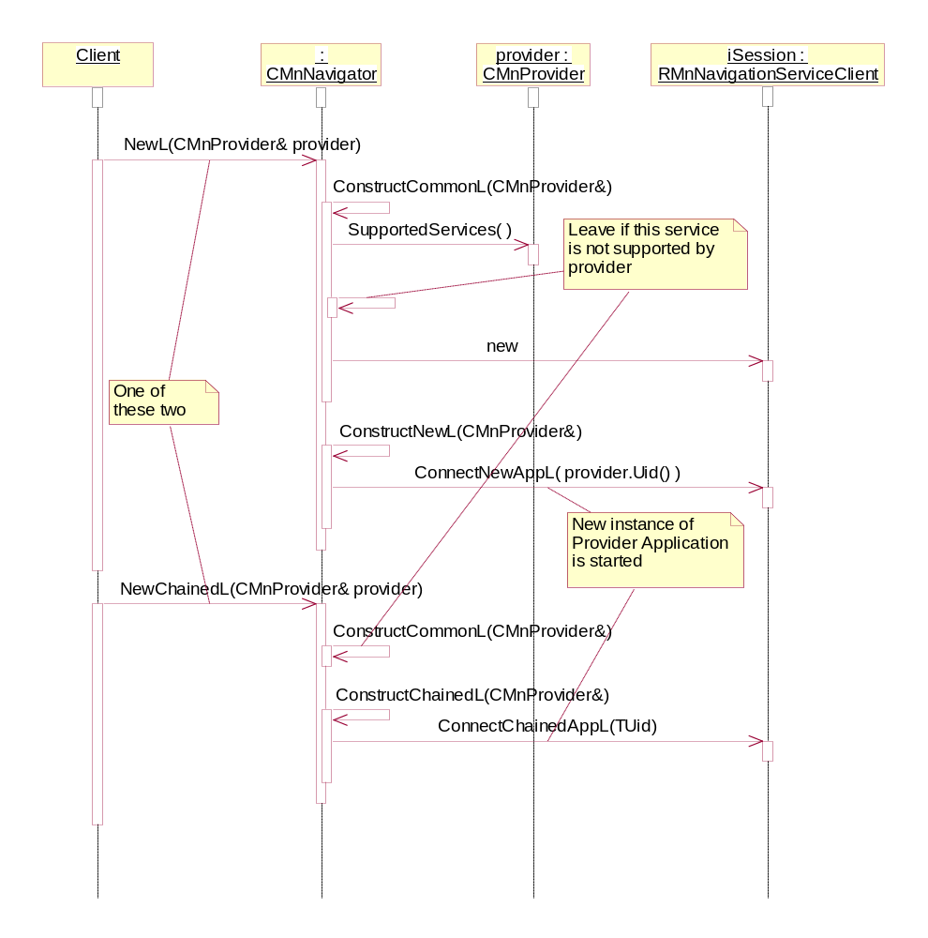
Figure 4.12 Connecting Provider application

Disconnecting Provider application

Operation | Disconnecting Provider application.
Preconditions | Provider application is connected.
Description | The client closes the connection to the Provider application.
Inputs
Modifies
Outputs
Postconditions | Connection to the Provider application is closed.
Related To | CMnGeocoder or CMnMapView or CMnNavigator, CMnProvider, RMnGeocodingServiceClient or RMnMapViewServiceClient or RMnNavigationServiceClient respectively.
Related Event
Exceptions

CMnNavigator is shown on this diagram for example purposes only. The same approach is used with CMnGeocoder and CMnMapView.
Closing the connection to a Provider application may involve its shutdown, if it has no more connections or active views open. This is up to the Provider application.

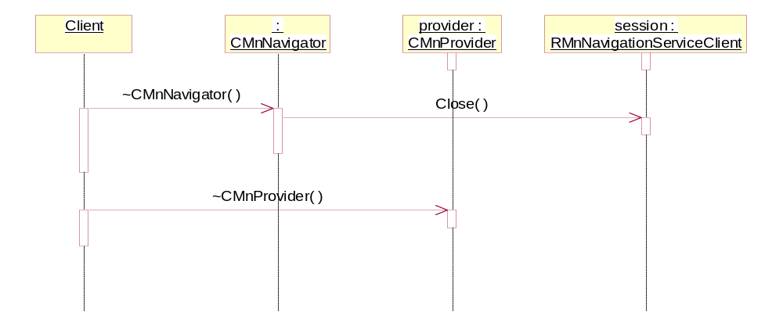
Figure 4.13 Disconnecting Provider application

Listening for exit of Provider application
Operation | Listening for Provider application exit
Preconditions | Provider application is connected.
Description | The client specifies observer for Provider application exit. When Provider application is closed (by user or other reasons) observer is notified with exit code of Provider application.
Inputs | Observer object
Modifies
Outputs
Postconditions | Exit monitor is created
Related To | CMnGeocoder or CMnMapView or CMnNavigator, RMnGeocodingServiceClient or RMnMapViewServiceClient or RMnNavigationServiceClient respectively.
Related Event
Exceptions

Provider application may be closed by user before client has disconnected. In that case client needs to close connection and reopen it again, if it still needs services of Provider application. This is achieved by specifying observer object, which will be informed about provider’s exit.
Observer object must be derived from MAknServerAppObserver class. This class contains default S60 implementation for handling server (provider) application exit: if provider was closed by EAknCmdExit command, client application will be closed too. It is recommended for clients to base call this implementation if provider was executed in chained mode. This allows to implement default S60 behavior where client application is closed if embedded (chained, in this case) application has been closed by user by “Exit” command.
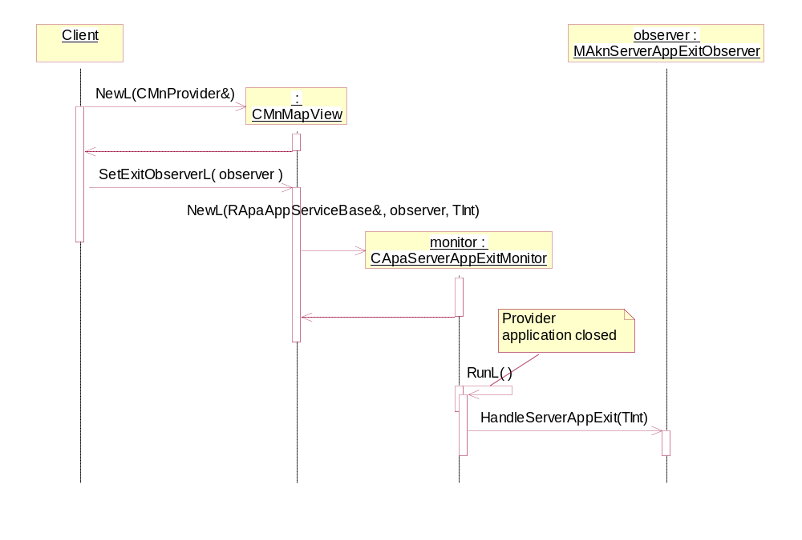
Figure 4.14 Listening for provider application exit

Resolving address by coordinates

Operation | Resolving address by coordinates.
Preconditions | Provider application is connected.
Description | The client uses Geocoding API (see reference document [3]) to resolve coordinates to a street address. Asynchronous request is forwarded to the Provider application, which performs calculations and informs the client about completion.
Inputs | CPosLandmark.
Modifies
Outputs
Postconditions | The client’s request is successfully completed (KErrNone) and the client may retrieve the result.
Related To | CMnGeocoder, RMnGeocodingServiceClient, CMnGeocodingService.
Related Event
Exceptions | The request is completed with an error code if any error occurs.

Note: on completion of this request, the client’s data is not updated. The client has to explicitly ask for a conversion result. This allows the client to use different instances of CPosLandmark for input and output. See Section 4.3.2.7 for details on how to retrieve a geocoding result.
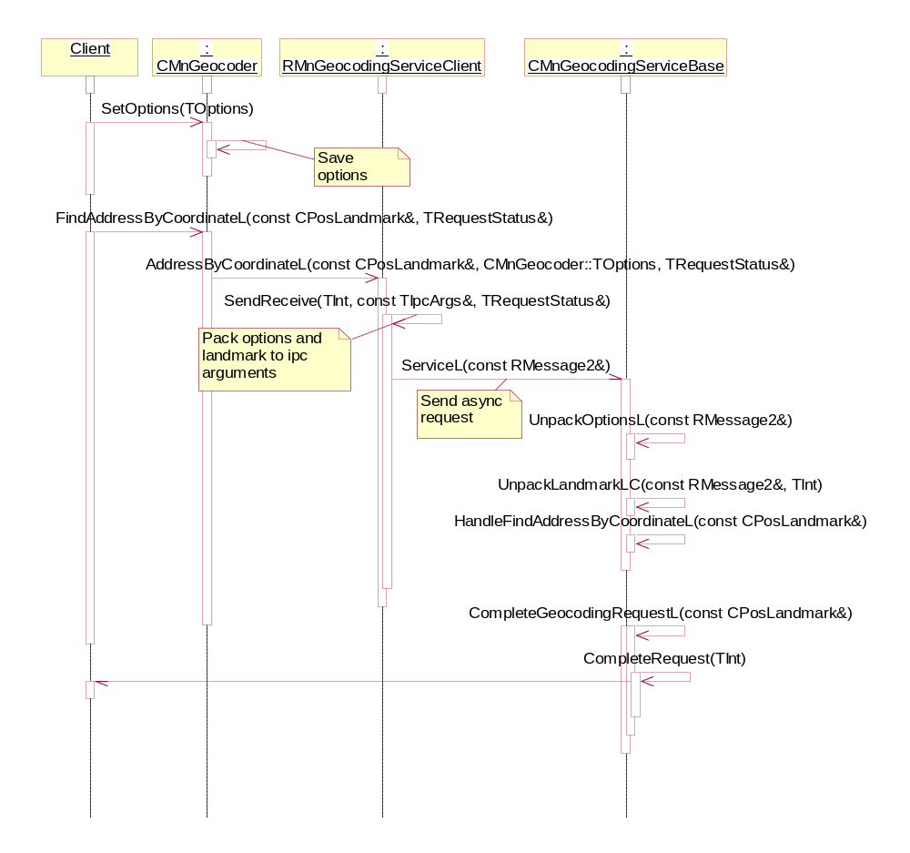
Figure 4.15 Resolving address by coordinates
The client’s IPC arguments have a room to receive the size of a landmark, which contains geocoding results. During completion of the client’s request, this information is sent back to the client. It is then reused when the client asks for a geocoding result: a buffer big enough to receive the resulting landmark is allocated on the client side, and filled as in Section 4.3.2.7.

Resolving coordinates by address

Operation | Resolving coordinates by address.
Preconditions | Provider application is connected.
Description | The client uses Geocoding API (see reference document [3]) to resolve a street address to coordinates. Asynchronous request is forwarded to the Provider application, which performs calculations and informs the client about completion.
Inputs | CPosLandmark or plain string.
Modifies
Outputs
Postconditions | The client’s request is successfully completed (KErrNone) and the client may retrieve the result.
Related To | CMnGeocoder, RMnGeocodingServiceClient, CMnGeocodingServiceBase.
Related Event
Exceptions | The request is completed with an error code if any error occurs.

The flow of this operation is the same as that for 4.3.2.4, with the exception to methods called from RMnGeocodingServiceClient.

Retrieving geocoding result

Operation | Retrieving geocoding result.
Preconditions | 4.3.2.4 or 4.3.2.6 has been successfully completed.
Description | The client uses Geocoding API (see reference document [3]) to retrieve results of a previous geocoding operation: resolving street address to coordinates or vice versa. Using a synchronous request to server side, Map and Navigation Library receives a geocoding result and updates the client’s parameter.
Inputs | A landmark.
Modifies | Input parameter.
Outputs
Postconditions | The client’s input parameter is updated with results of a previous geocoding operation.
Related To | CMnGeocoder, RMnGeocodingServiceClient, CMnGeocodingServiceBase.
Related Event
Exceptions | An error code is returned if any error occurs.  KErrNotFound if no result available, i.e. Preconditions are not fulfilled.

The client’s input parameter (CPosLandmark) gets updated with a result of a previous geocoding operation. It means that if the previous request was for finding an address, then all address fields (EPositionFieldAddressCapabilitiesBegin area and EPositionFieldBuildingCapabilitiesBegin area) in input landmark object are updated with values sent by the Provider application. If the previous request was for finding coordinate information, the location information (position and coverage radius) in the client’s landmark is updated.
A request for geocoding result requires only one IPC call to the server because the size of the result is sent back to the client side, when appropriate geocoding request is completed, and at this phase client side just allocates buffer of already known size to receive actual data.
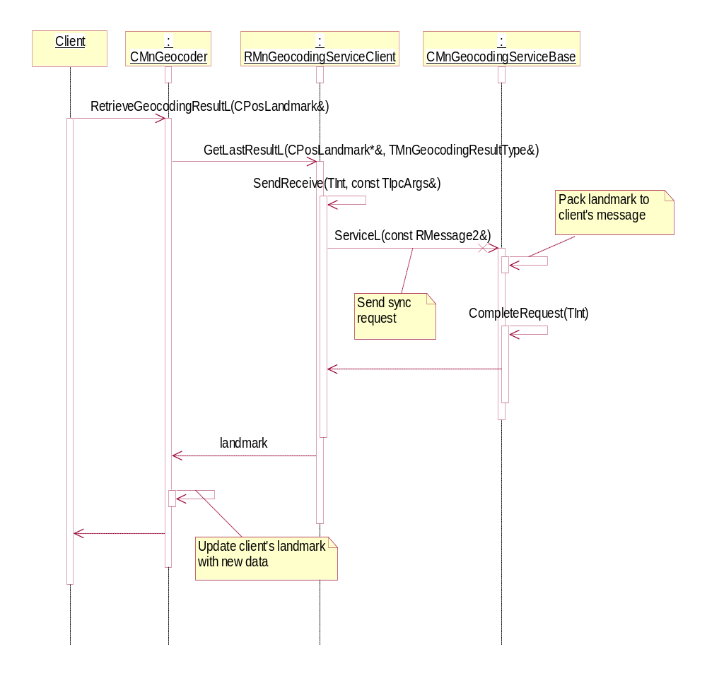
Figure 4.16 Retrieving geocoding result

Starting navigation

Operation | Starting navigation.
Preconditions | The Provider application is connected.
Description | The client uses Map and Navigation API (see reference document [3]) to start navigation. Request is forwarded to the Provider application, which performs navigation.
Inputs | A destination landmark.
Modifies
Outputs
Postconditions | Navigation view is shown to the user and navigation is started.
Related To | CMnNavigator, RMnNavigationServiceClient, CMnNavigationServiceBase.
Related Event
Exceptions | An error code is returned if any error occurs.
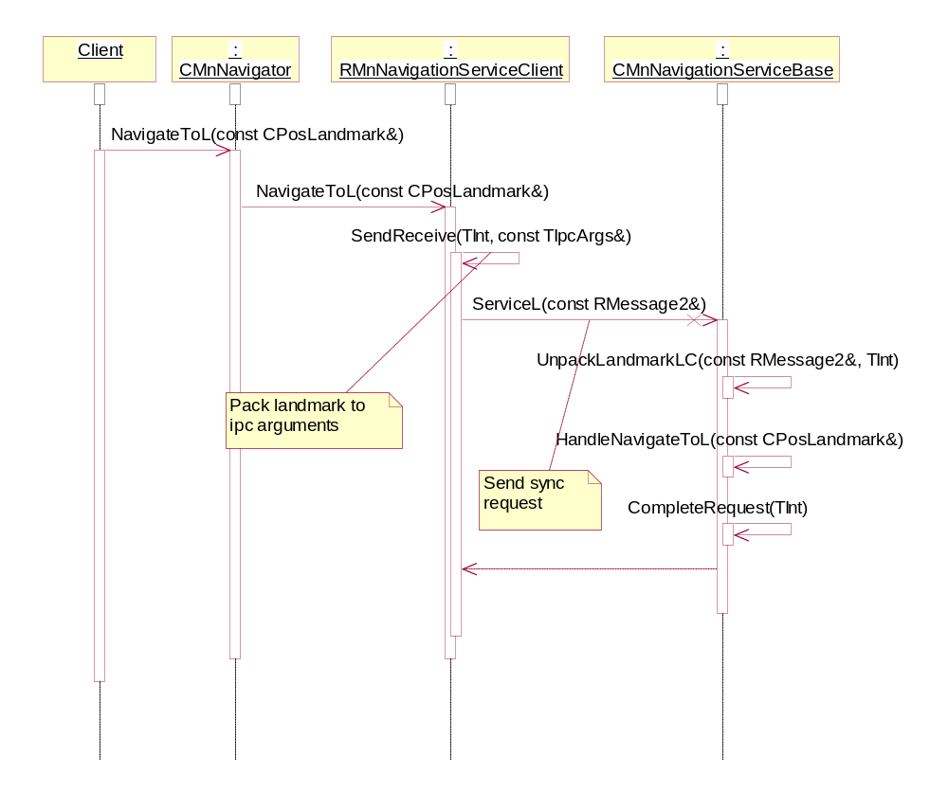
Figure 4.17 Starting navigation

Changing map view options

Operation | Changing map view options.
Preconditions | The Provider application is connected.
Description | The client uses Map and Navigation API (see reference document [3]) to set map view options.
Inputs | Map view options: central point, view area radius, current location display option, selection request text, various flags. See CMnMapView in reference document [3] for details.
Modifies | CMnMapView instance.
Outputs
Postconditions | New options are saved in CMnMapView instance.
Related To | CMnMapView
Related Event
Exceptions

This operation consists of several optional method calls, one for each option. See CMnMapView in reference document [3] for details on available options and methods.
Note that options are not sent to the Provider application at this phase. It is done only at the phase when the actual request is issued, such as 4.3.2.11 or 4.3.2.12. Within this operation, options are only saved in the current instance of the CMnMapView class.

Adding landmarks to be shown on map view

Operation | Adding landmarks to be shown on map view.
Preconditions | The Provider application is connected.
Description | The client uses Map and Navigation API (see reference document [3]) to specify what landmarks are shown.
Inputs | Landmarks: an array of CPosLandmark instances, database URI, and list of landmark IDs from this database, or an array of pointers to packed CPosLandmark instances
Modifies
Outputs
Postconditions | Landmarks are added to the internal list of landmarks in CMnMapViewServiceBase and made available for the Provider application.
Related To | CMnMapView, RMnMapViewServiceClient, CMnMapViewServiceBase.
Related Event
Exceptions

The following diagrams describe how landmarks are sent to the Provider application. Two different cases exist: sending linked landmarks (as database URI and list of IDs from this database) and sending “free” landmarks (as array of instances or as array of pointers to packed instances). Packed instance is the buffer, containing landmark object packed with packing methods from Landmarks API (see reference document [8]). This option exists to reduce memory consumption in AIW Provider component, which receives parameters from AIW client in packed form.
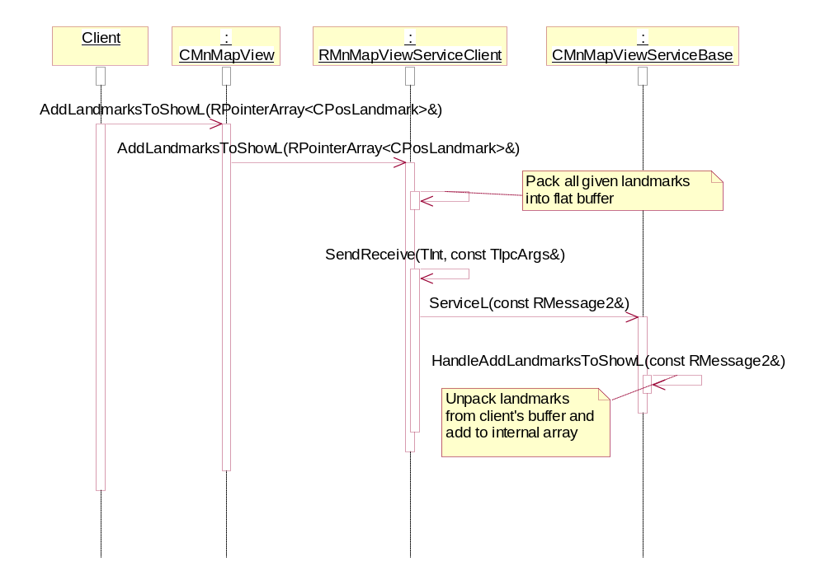
Figure 4.18 Adding landmarks to be shown on map view
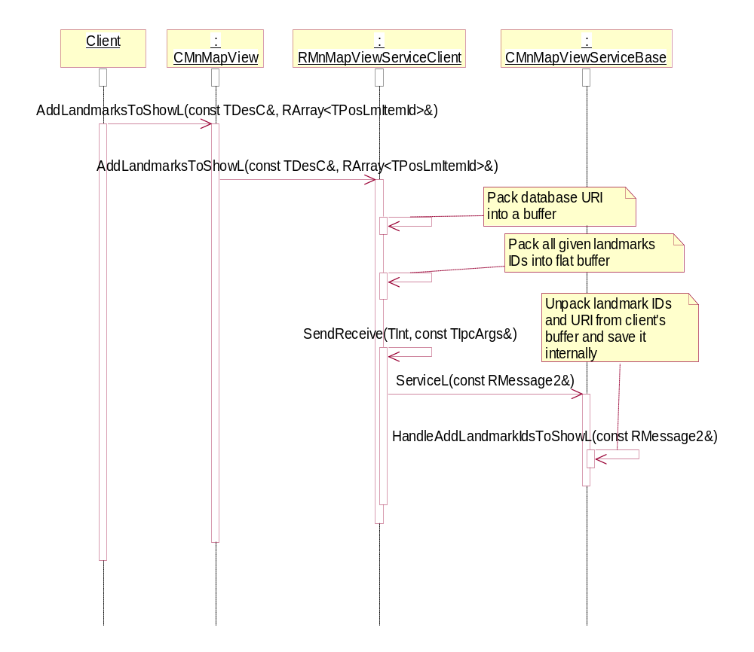
Figure 4.19 Adding linked landmarks to be shown on map view

Launching map view

Operation | Launching map view.
Preconditions | The Provider application is connected.
Description | The client uses Map and Navigation API (see reference document [3]) to launch map view. Request is forwarded to the Provider application, which opens map view.
Inputs
Modifies
Outputs
Postconditions | Map view is shown to the user.
Related To | CMnMapView, RMnMapViewServiceClient, CMnMapViewServiceBase.
Related Event
Exceptions | An error code is returned if any error occurs.

Options set in 4.3.2.9 are sent to the Provider application when this request is issued.
On this diagram is shown how during the HandleShowMapL method, implementation (Provider application) retrieves information about landmarks, which are to be shown on map view. Other options are retrieved in similar way, see reference document [4].

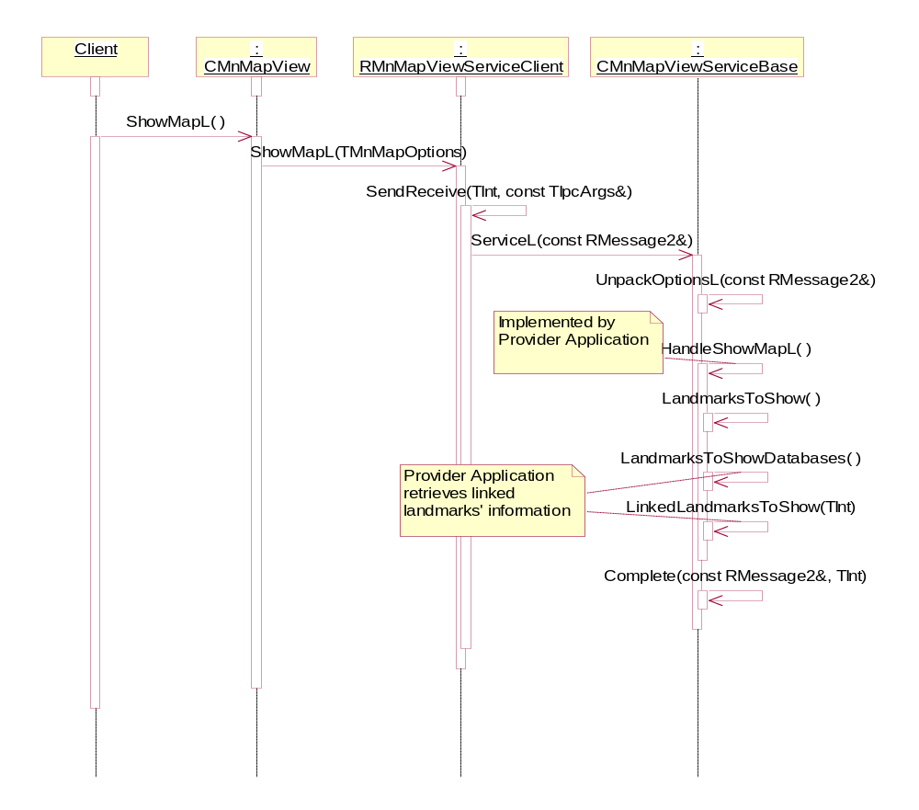
Figure 4.20 Launching map view

Launching selection from map view

Operation | Launching selection from map view.
Preconditions | The Provider application is connected.
Description | The client uses Map and Navigation API (see reference document [3]) to launch selection from map view. Request is forwarded to the Provider application, which opens map view, asks user to select a location from map and returns result to client.
Inputs
Modifies
Outputs
Postconditions | The user-selected location is returned to the client.
Related To | CMnMapView, RMnMapViewServiceClient, CMnMapViewServiceBase.
Related Event
Exceptions | An error code is returned if any error occurs. KErrCancel if the user dismisses the selection view.

Note that during completion of the client’s request, some information about the selection result is sent back to client side and stored by RMnMapViewServiceClient. This includes selection result type (see CMnMapView::TSelectionResultType) and any other data of constant size data type (landmark ID or index, size of variable-sized parameters: landmark data or database URI). The information, which size is not known to client at the time when selection request is issued, is retrieved during the operation 4.3.2.13.
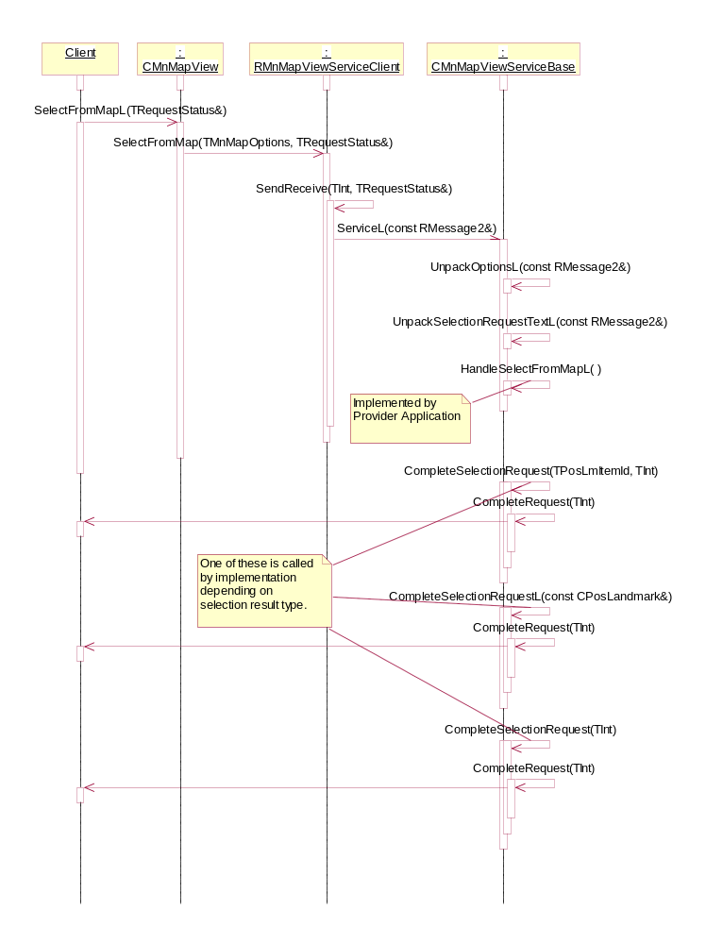
Figure 4.21 Launching selection from map view

Retrieving result of selection from map view

Operation | Retrieving result of selection from map view.
Preconditions | Selection from map view successfully completed.
Description | The client uses Map and Navigation API (see reference document [3]) to request result of selection from map view operation. Request is forwarded to the Provider application, which returns the result of the last selection operation.
Inputs
Modifies
Outputs | Landmark, describing the result of the last selection operation.
Postconditions | The user-selected location is returned to the client.
Related To | CMnMapView, RMnMapViewServiceClient, CMnMapViewServiceBase.
Related Event
Exceptions | An error code is returned if any error occurs. KErrCancel if the user dismisses selection view.

Depending on the result type (see CMnMapView::TSelectionResultType), the client calls one of three retrieval methods. Some information is already on client side, but some is on server side yet and only size of this information is known to RMnMapViewServiceClient. Therefore to retrieve landmark data and database URI, another request is made to server side to retrieve this data. It is fully handled by Library without involving the Provider application.
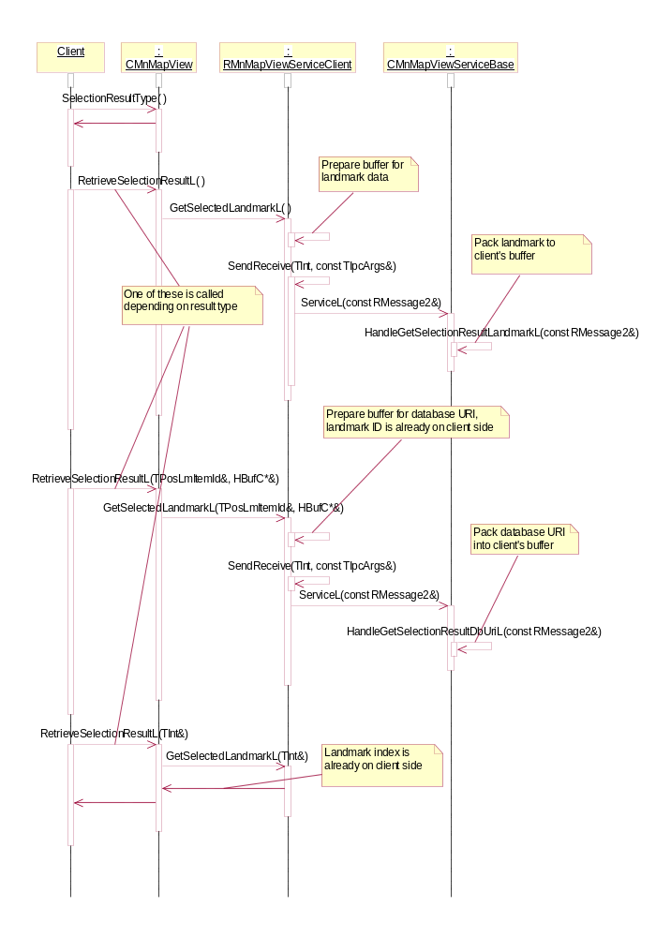
Figure 4.22 Retrieving result of selection from map view

Resetting landmarks to be shown on map view

Operation | Resetting landmarks to be shown on map view.
Preconditions | The Provider application is connected.
Description | The client uses Map and Navigation API (see reference document [3]) to reset list of landmarks to be shown on map view.
Inputs
Modifies
Outputs
Postconditions | Internal list of landmarks to be shown on map view in CMnMapViewServiceBase is empty.
Related To | CMnMapView, RMnMapViewServiceClient, CMnMapViewServiceBase.
Related Event
Exceptions

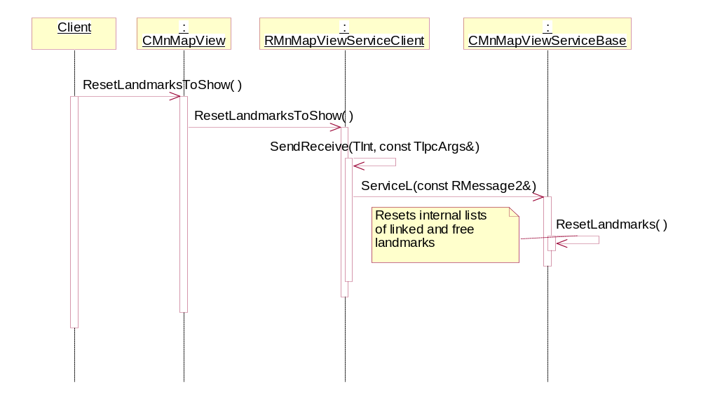
Figure 4.23 Resetting landmarks to be shown on map view

Map and Navigation AIW Provider

Retrieving available AIW menu commands

Operation | Retrieving available AIW menu commands.
Preconditions
Description | The client requests AIW FW for Map and Navigation AIW commands. Map and Navigation AIW Provider receives request to fill client’s menu with Map and Navigation commands. It identifies available Provider applications for each command. If there is at least one Provider application, which can serve Map and Navigation requests for given AIW command, this command is added to client’s menu, otherwise command is skipped.
Inputs
Modifies | Fills the client’s menu pane AIW object with available Map and Navigation AIW commands.
Outputs
Postconditions | Available Map and Navigation AIW command menus are added to the client’s menu pane.
Related To
Related Event
Exceptions | No Provider applications found – nothing is added to the client menu pane.

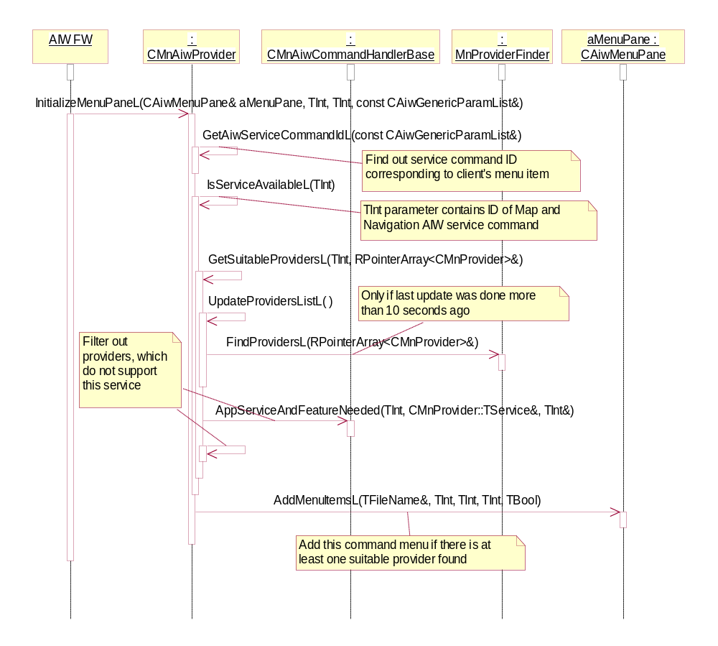
Figure 4.24 Initializing client menu pane with AIW command menus

Executing AIW service command
Operation | Executing AIW service command.
Preconditions
Description | Map and Navigation AIW Provider receives request to handle Map and Navigation AIW service (see reference document [6]) from AIW FW. It uses Map and Navigation APIs (see reference documents [2], [3], and [5]) to handle the request.
Inputs | AIW parameters (from the client).
Modifies
Outputs
Postconditions | Command is served and execution is returned to the client.
Related To | CMnAiwProvider, command handlers: CMnShowOnMapHandler or CMnSelectFromMapHandler or CMnNavigatoToHandler or CMnFetchAddressHandler or CMnFetchCoordinatesHandler, CMnMapView or CMnNavigator or CMnGeocoder, MnProviderFinder.
Related Event
Exceptions | No Provider application was able to serve the request. Error note is shown to user and error is reported to client.

Implementation of Map and Navigation AIW Provider is based on using helper classes: AIW command handlers, each of which is responsible for handling of a single Map and Navigation AIW command.
Map and Navigation AIW API (see reference document [6]) defines some commands as synchronous, for which control flow is returned from AIW FW back to client as soon as command execution is completed. Other commands are asynchronous. Those imply some result returned to client and completion is reported via the MAiwNotifyCallback class.
These handlers perform execution in accordance with definition of appropriate commands and are listed in table below:

Handler class | AIW command | Execution type
CMnShowOnMapHandler | KAiwCmdMnShowMap | Synchronous
CMnSelectFromMapHandler | KAiwCmdMnSelectFromMap | Asynchronous
CMnNavigatoToHandler | KAiwCmdMnNavigateTo | Synchronous
CMnFetchAddressHandler | KAiwCmdMnAddrByCoord | Asynchronous
CMnFetchCoordinatesHandler | KAiwCmdMnCoordByAddr | Asynchronous

Execution of AIW commands only differs in the execution type: synchronously or asynchronously, therefore only these two different approaches are shown below on diagrams using “Show On Map” and “Select From Map” commands as examples.
For every service command, AIW Provider selects Provider application to use to handle it using following algorithm.
- If there is no one found, then error is returned from this operation and handled in ProcessAiwCommandResultL by showing error note to the user.
- If there is only one found, it is tried and if error happens, error note is shown and operation is completed with error code.
- If there is more that one found, then selection dialog is shown. User chooses preferred Provider application. It is tried and if error happens, error note is shown and selection dialog is shown again. If user dismisses selection dialog, operation is cancelled and client receives appropriate error code (KErrCancel).
- If selected Provider application successfully serves AIW command, completion code and possible result is silently returned to the client.

This is shown on a separate diagram Figure 4.28 for clarity purposes.
Map and Navigation AIW Provider supports menu commands as well as service commands. All functionality is implemented for CAiwServiceIfBase::HandleServiceCmdL call. Whenever menu call is made (via CAiwServiceIfMenu::HandleMenuCmdL) this component converts client’s menu command ID to Map and Navigation AIW service command ID (those defined in aiwcommon.hrh and named as KAiwCmdMn) and executes it as service command.
This component handles event of Provider application exit in standard S60 way, by calling MAknServerAppExitObserver::HandleServerAppExit(), if Provider application was executed in chained mode. This shuts down client application if Provider was closed by EAknCmdExit command (usually “Exit” command). See Figure 4.29.

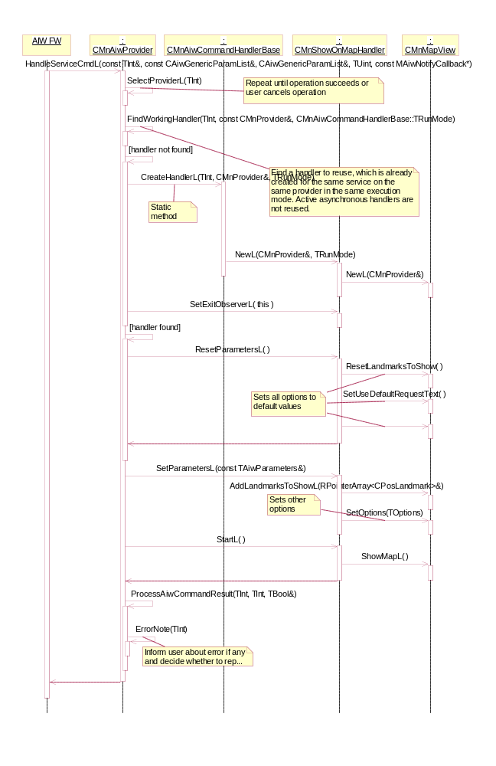
Figure 4.25 Handling synchronous AIW service command
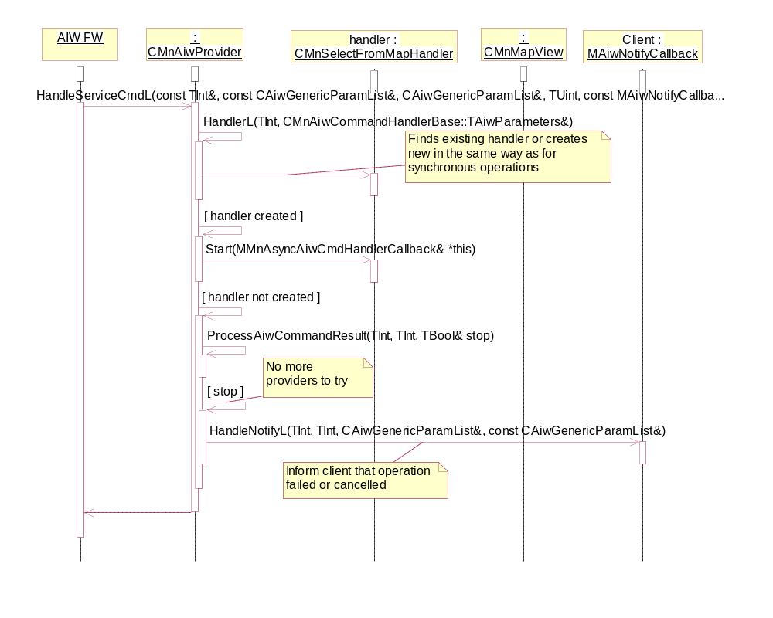
Figure 4.26 Handling asynchronous AIW service command – Part 1, Starting
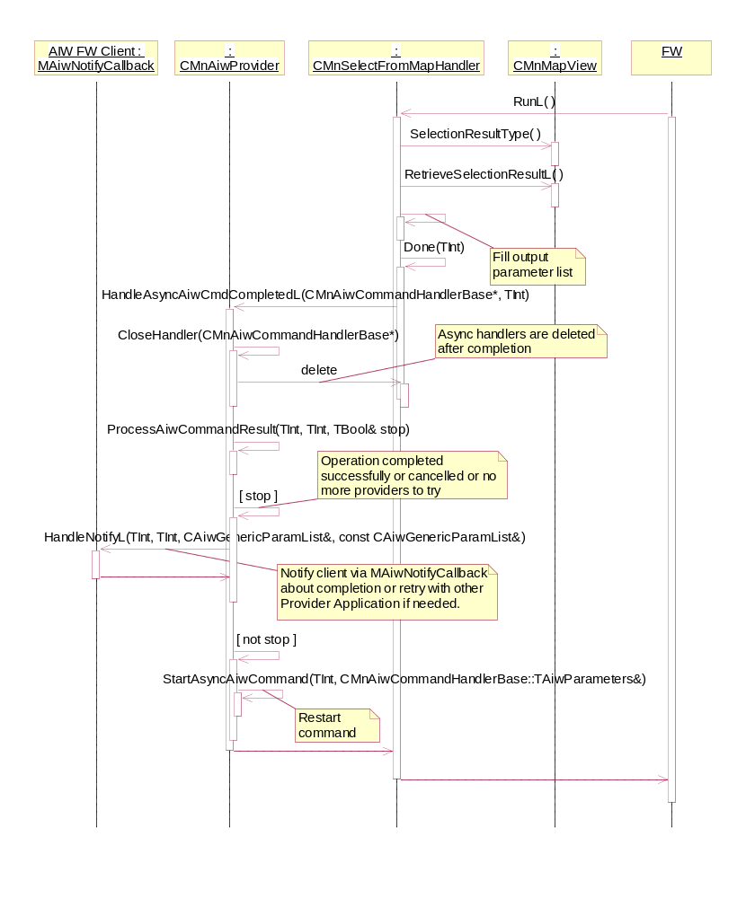
Figure 4.27 Handling asynchronous AIW service command – Part 2, Completion
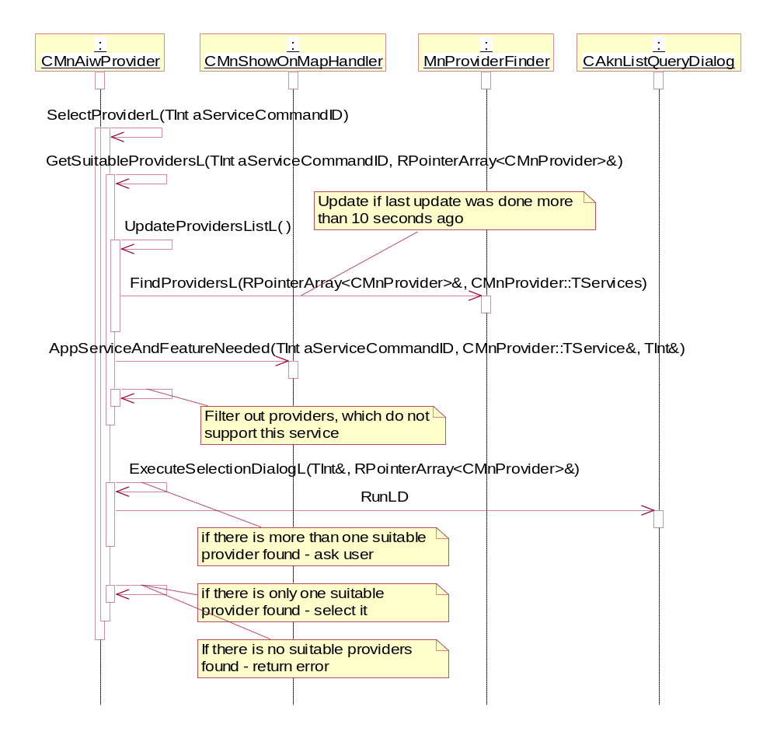
Figure 4.28 Selecting Provider application
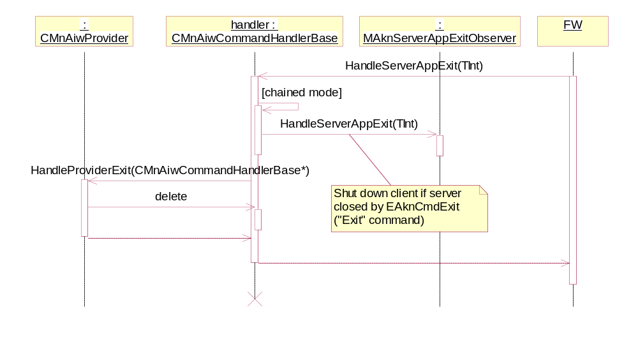
Figure 4.29 Handling Provider application exit

Backup and Restore
This component does not participate in backup and restore.

Variation
Map and Navigation subsystem contains both necessary and optional parts.
Map and Navigation Library exposes interfaces, which are planned to be SDK APIs in future releases. SDK APIs shall always be available, which means that Map and Navigation Library component cannot be under variation flags.
Map and Navigation AIW Provider is optional component and can be included to or excluded from a ROM image.

Map and Navigation AIW Provider

Flag | Description
__MAP_AND_NAVIGATION_AIW_PROVIDER | Defines whether Map and Navigation AIW Provider is included to ROM.

System resource usage
This subsystem does not use any storage except for localization resource files.

Files
This subsystem uses resource files to store localized strings.

File | mnaiwproviderres.rsc
Type | Private
Location | ROM / removable media
Format | Resource file
Sharing | Not shared
Encryption | Not encrypted
Size estimate | 0.5 kilobytes per language
Clean up | Persistent
Description | This resource file contains localized strings used by Map and Navigation AIW Provider component.

File | mnclientlib.rsc
Type | Private
Location | ROM / removable media
Format | Resource file
Sharing | Not shared
Encryption | Not encrypted
Size estimate | 0.1 kilobytes per language
Clean up | Persistent
Description | This resource file contains localized strings used by Map and Navigation Library component.

Map and Navigation AIW Provider component defines ECom resource file:

File | mnaiwprovider.rsc
Type | ECom
Location | ROM / removable media
Format | Resource file
Sharing | Shared for ECom server
Encryption | Not encrypted
Size estimate | 0.1 kilobytes
Clean up | Persistent
Description | This resource file contains ECom registration of Map and Navigation AIW Provider component.

Other data

Databases
This subsystem does not use any databases.

Central Repository
This subsystem does not use Central Repository.

Publish and Subscribe
This subsystem does not use Publish and Subscribe.

Memory consumption
This subsystem does not consume disk space and generally has no unusual demand on heap and stack. One case, which should be noted is when client supplies many landmarks instances as input parameter to Map and Navigation API. Map and Navigation Library packs supplied landmarks to a buffer in order to send them to Provider application. This involves increased memory usage. Thus, sending many landmarks as instances requires higher RAM consumption. However, the client will rarely send many landmarks as instances, only a few in most cases, and can avoid high memory usage by sending landmark IDs and references to landmark databases. See reference documents [2] and [6] for details.

Memory/Build | Consumption by component
 | Map and Navigation Library | Map and Navigation AIW Provider
User data area | 0 KB | 0 KB
ARMV5 URel | 10 KB | 6 KB

Task allocation
This subsystem uses Provider applications to handle client’s requests. These are Application Servers, which are executed in their own processes. One instance of a Provider application is launched for every connection requested by client. This subsystem does not know or specify what processes or threads are started by Provider applications.

Performance
Main performance-critical area of the subsystem is client-server communication in Map and Navigation Library component: clients’ requests should reach Provider application (Server) as soon as possible. Whenever such request imply sending of large amount of data or request completion notification from server is needed, this component allows clients to use asynchronous operations to avoid blocking.

Timers
This subsystem does not use timers.

Security

Capabilities of this component
Map and Navigation Library has CAP_GENERAL_DLL set of capabilities.
Map and Navigation AIW Provider has CAP_ECOM_PLUGIN set of capabilities.
It is necessary that CAP_GENERAL_DLL set has at least all capabilities defined in CAP_ECOM_PLUGIN, because Map and Navigation AIW Provider loads Map and Navigation Library.

Input and output validation
This component performs input data checking as protection from client bugs. Also, validation is made at process borders (on server side) to provide protection from malicious clients. On the server side, only those Provider application are used, which are trusted, and data is only checked to identify errors in implementation’s behavior (for debug builds).

Environmental assumptions
This component does not make any assumptions about its environment.

Additional enforcements
This subsystem This subsystem requires that Provider application are properly installed in the terminal. This imply existence of stub installation package for preinstalled application or normal installation info for postinstalled applications. This subsystem checks trust level for application servers, which implement Map and Navigation application services and only uses trusted application servers as Provider applications.

Exception handling
Panics are used to inform clients of misusage of the APIs. Leaves are used to report run-time errors. Error codes are used to report result of asynchronous operations.
All errors are forwarded to client, with one exception: Map and Navigation AIW Provider component, if informed that user-selected Provider application cannot serve current request, may try another Provider application (if the user allows). Error will be returned to the client if no Provider application were able to serve the request.
This subsystem does not make any security-related checks.
The following table shows the panic codes defined.

Exception | Description
KMnPanicDuplicateRequest | Raised if client issues new asynchronous request before previous one is completed or cancelled.
KMnPanicArrayIndex  OutOfBounds | Raised if array index is out of bounds.
KMnPanicAttemptToComplete  NoRequest | Raised if a CMnServiceBase-derived class attempts to complete asynchronous request, when there is no outstanding one.

Usage
This Chapter describes how to build the subsystem components.

Building
The table below shows how the Map and Navigation components map to binaries and where in the source code tree the project definitions and source code for the different binaries are located.

Component name | Directories  (relative to project root LocationMapNavFW) | MMP file name | DLL name
Map and Navigation AIW Provider | aiwprovider | mnaiwprovider.mmp | mnaiwprovider.dll
Map and Navigation Library | library | mnclientlib.mmp | mnclientlib.dll
Map and Navigation Library | library | mnservicelib.mmp | mnservicelib.dll

Building is done by running the following commands in the \group subdirectory of the subsystem’s source tree root:
- bldmake bldfiles
- abld build <TARGET>
- where <TARGET> is one of WINSCW or ARMV5.

User's guide
See examples of usage of this subsystem in reference documents [2], [3], [4], [5], [6], and [9].

