LBT Input Specification for CFW Plugin
Version | Date | Status | Comments
1.0 | 13.05.2009 | Initial Draft
1.1 | 07.08.2009 | Under review
1.2 | 21.08.2009 | Pending Review
TABLE OF CONTENTS
1. Introduction 3
1.1 Scope of this document 3
1.2 References 3
2. Input Specifications 3
2.1 Defining a trigger using an XML file as Input to CFW Plugin 3
2.2 Behaviour of the plugin 6
2.2.1 Context Definition 6
2.2.2 Saving a Setting file 6
2.2.3 Delete functionality 7
2.2.4 Upgrade of Setting files 7
2.2.5 RAM and ROM storage 7
3. Restrictions 7

Introduction

Scope of this document
This document specifies how the user may write an Input file for the Location Triggering Context Framework plugin. The CFW Plugin picks up data from this file and creates triggers as per the user’s specifications. This document uses the Context Framework Context Source Settings Definition as baseline for the definition of a trigger using CFW. The document also specifies the behaviour of the plugin in various usage scenarios.

References
[1] S60 5.0 Context Source API Specification
[2] S60 5.0 Context Framework Client API Specification

Input Specifications

Defining a trigger using an XML file as Input to CFW Plugin
The user needs to define triggers through an XML setting file. The schema definition for the trigger setting XML file for LBT can be described as :

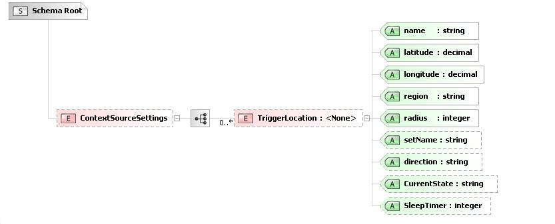
Fig 1.1 XML Schema definition
The “ContextSourceSettings” node is the root tag for the XML. CFW requires that this tag be defined in each setting file as an identifier that the current file is a settings file for the CFW plugin. Only one “ContextSourceSettings” definition is allowed per file. In case more than one “ContextSourceSettings” node is defined, only the contents of the first node will be read.
The rest of the file structure is specific to our LBT Plugin.
Description of XML schema :
XML tag | Mandatory | Description
ContextSourceSettings | Yes | Root tag for the XML setting file.
TriggerLocation | No | Child node for “ContextSourceSettings“ element. This is the opening tag which specifies the elements for creating a trigger in a particular location. User must define the latitude, longitude, and the shape of the area to be monitored.  Any number of “TriggerLocation” nodes may be defined.
Name = “Value” | Yes | Name of the Trigger. The context will be published with this value if the trigger is fired.  The length of the name should be less than or equal to 256 characters,if not it will be truncated upto 256 characters.  For eg. We can have multiple trigger locations for branches of “Nokia Care Centres”. By defining the Trigger name as “Nokia Care Centres” for all these locations, we publish a single context everytime a Care centre is within the triggering region. This gives us a mechanism to generalize our searches and trigger alerts.
Latitude = “Value” | Yes | Attribute that specifies the Latitude of the point where a trigger is required.  Definition :  MinInclusive value="-90"  MaxInclusive value="90"  fractionDigits value='6'
Longitude = “Value” | Yes | Attribute that specifies the Longitude of the point where a trigger is required.  Definition :  Min Inclusive value="-180"  MaxInclusive value="180"  fractionDigits value='6'
Region = “Value” | Yes | Attribute that defines the monitoring region. Permisible values : “Circle”  Currently, only a circular monitoring region is permissible in the triggering engine.  For “Circle”, the attribute “Radius” needs to be specified.
Radius = “Value” | Yes | The radius of the trigger monitoring area in meters.  Only positive values for radius will be considered.  If the radius is less than 100m then the default value is taken as 100.
SetName = “Value” | No | Attribute that specifies the name of the Context Source you wish to define.  The length of the name should be less than or equal to 256 characters,if not it will be truncated upto 256 characters.  The user has the option to setup a rule for a particular set or triggers, and not for all the triggers. This gives the action plugin more control over its triggers. The listener can be alerted when one of a particular ‘set’ of triggers is called.  If not defined by the user, the default value is taken as “Location”.
Direction = “Value” | No | Specifies when the trigger is fired, upon entering the region, or on exiting the region.  Permisible values : “OnExit”  “OnEntry”  If not specified, “OnEntry” will be taken as the fire criteria.
CurrentState = “Value” | No | Specifies whether to actively monitor this Trigger or not.  Permisible values : “On”  “Off”  If not specified, “On” will be taken as the Trigger State.

The schema makes the provision to have multiple trigger points with the same context name. This allows us to provide the option of the user’s script being able to recognize multiple outlets of the same resource under a single heading.

An example context source settings file -
<ContextSourceSettings>

<TriggerLocation name = "Office"
latitude="38.567346"
longitude="-142.361454"
region="circle" radius="15"
setName="Location"
direction="OnEntry"
CurrentState="On" />

<TriggerLocation name = "Office"
latitude="83.394573"
longitude="-28.324323"
region="circle" radius="15"
setName="Location"
direction="OnEntry"
CurrentState="On" />

<TriggerLocation name = "Pickup Point" latitude="73.781645" longitude="-178.879505" region="circle" radius="7" setName="MySetA" />

<TriggerLocation name = "Office" latitude="38.567346" longitude="-122.356835" region="circle" radius="10" />

</ContextSourceSettings>

Sample XML input file

Behaviour of the plugin

Context Definition
The plugin is responsible for monitoring triggers and publishing the context name and value in the event of a trigger being fired.
The set of triggers created via setting files is monitored by the source plugin. When a trigger is fired, the Context (defined by the user using the “setName” attribute, or taken as “Location” if not defined) is published along with the name of the Trigger ( defined by the “name” attribute. eg. “Pickup Point”).

This context information can be monitored and used by the corresponding Action plugins. Action Plugins must be written by the user. We only provide a mechanism to publish the state of the trigger.

Saving a Setting file
Context Framework reads all its settings from a pre-defined folder in the RAM and ROM. Please refer the Context Framework Settings File definition for more details. The XML setting files for use in our plugin must be saved in this directory under a folder with folder name as the UID of our plugin. The UID allotted for the LBTContextSource plugin is 200267F3.

The user may use the CFW Client API call ( SaveContextSourceSetting() ) to save the settings file onto the correct folder. If the corresponding folder for our plugin does not exist, it will be created by this function call. CFW Client API calls however, operate only on the RAM. Hence, all setting files saved using the client call will be saved only to the RAM.

Delete functionality
The user may stop the plugin from creating triggers from the specified setting files in the following ways :
- Using CFW Client API call (DeleteContextSourceSetting() ) : The plugin deletes all existing triggers and recreates triggers from the new set of trigger setting files now present in the phone. The API call also deletes the file from the device. The device always retains the latest version of settings present in the device.
- Delete all triggers through the Settings UI (Location ->Positioning -> Reminder Settings -> Delete All Triggers ): In this scenario, all the trigger setting files in the RAM will be deleted permanently, and all triggers present in the system will be removed. The user will need to reinstall the setting file to create triggers.
- Remove the setting file from the phone manually : The user needs to reboot the device to have the plugin recognize the new set of setting files.

Upgrade of Setting files
A installed setting file may be updated by simply ensuring that the new file retains the same name as the previous version. A file installed through a certain application can only be upgraded through the same application.

RAM and ROM storage
Context Framework picks up setting files from the RAM and ROM directories allotted to our plugin. All setting files stored or deleted through Client API calls will operate only on RAM files. If the user stores a file on the ROM, the file will be of a persistent nature, and will never be removed. Hence, the triggers created using ROM setting files will always be present on the device, until the user removes the file from the device image.

Restrictions
The setting file needs to follow the CFW guidelines for proper parsing. The following points must be observed while writing the setting file :
- “ContextSourceSettings” must be the first node entry in the setting file. If any nodes or comments are present before this tag, the setting file will be considered to be invalid.
- Settings stored onto the ROM will be parsed and the corresponding triggers will be created. However, the LBT ContextSource plugin is not responsible for deleting or updating the triggers created from these setting files. The user must take care of this situation, as CFW does not provide any functionality to operate on ROM files.

