S60 3.2
Location OMA SUPL POS Tester
Design Document

Team name | Author
Location Technology Team | Gaurav Chaurasia

Change history:

Version | Date | Status | Comments
1.0 | 07.06.2006 | Approved

Table of contents:

1. Document control 5
1.1 References 5
1.2 Documentation conventions 5
1.3 Abbreviations 5
1.4 Definitions 5
2. General 6
2.1 Introduction 6
2.2 Subsystem environment 6
2.3 Services required 7
2.3.1 From the STIF Framework subsystem 7
2.3.2 From the Symbian OS subsystem 7
2.3.3 From HW 7
2.3.4 From Location SUPL Framework 7
2.4 Services provided 8
2.4.1 UI 8
2.4.2 SW IF 8
3. UI Control Hierarchy 9
4. Design 10
4.1 Component diagram 10
4.2 Class diagram 11
4.3 Class descriptions 12
4.3.1 Structs, type definitions and enumerations 14
4.3.2 Flag definitions 14
4.4 Operations 15
4.4.1 Execution of tests 15
4.4.2 Canceling tests 16
4.4.3 UID ECom Test 17
4.4.4 POS Handler creation test 18
4.4.5 POS Session creation test 19
4.4.6 GetSuplInfo test 20
4.4.7 Canceling the GetSuplInfo test 21
4.4.8 Testing the cancellation of the initialization of POS Handler 22
4.4.9 Testing the cancellation of the initialization of POS Session 23
4.4.10 Position test 23
4.4.11 Session test 24
4.4.12 File reader test 26
4.4.13 Position velocity test 27
4.4.14 Position cancellation test 28
4.4.15 Multiple session test 29
4.4.16 Thread and process test 30
4.4.17 Platform security capability test 31
5. Variation 32
6. System resource usage 33
6.1 Files 33
6.1.1 Output file 33
6.1.2 Message file 33
6.1.3 Resource file 33
6.2 Databases 33
6.3 Memory consumption 34
6.4 Task allocation 34
6.5 Performance 34
6.6 Timers and active objects 34
7. Exception handling 35
8. Usage 36
8.1 Building 36
8.2 User's guide 36

Document control

References
- S60 SUPL POS Message Plug-in API Specification
- S60 STIF Test Framework User’s Guide
- S60 3.2 Location OMA SUPL POS Tester User’s Guide

Documentation conventions
Code is written in the Courier New font.

Abbreviations
API | Application Programming Interface
FW | Framework
GW | Gateway
HW | Hardware
OMA | Open Mobile Alliance
OS | Operating System
PKG | Package
SID | SecureID of an application
STIF | System Testing Integration factory
SUPL | Secure User Plane Location
SW | Software
UI | User Interface
UID | Unique Identifier

Definitions
ECom | Framework defined in Symbian OS for realizing plug-in architectures.
POS | POS refers to the control plane positioning protocol that provides messages to be tunneled over the TLS connection established by SUPL Framework.
POS Module/ POS message plug-in | The licensee component that interacts with SUPL Framework as well as control plane positioning protocol that resides in the Domestic OS. It is an ECom plug-in which implements SUPL POS Message plug-in API.
SIS-file | Symbian OS installation file.
SISX-file | Signed SIS-file.
STIF Testclass | In STIF the test module template type testclass creates a test class for Test Scripter usage.
STIF Logger | A module of STIF Test Framework that offers logging services.
Test scripter | A program of STIF Test Framework for executing test cases from a test case file.

General

Introduction
This document describes the Location OMA SUPL POS Tester subsystem. The general purpose of Location OMA SUPL POS Tester is to simplify the testing of the SUPL POS Message plug-ins. POS Tester is intended to be used by POS message plug-in developers for testing POS message plug-in for correct behavior. The user must ensure that SUPL Framework is not running when Location OMA SUPL POS Tester is started.
The responsibility of Location OMA SUPL POS Tester is to ensure that the POS Message plug-in has implemented POS Message plug-in API as per the guidelines provided in reference document [1]. Location OMA SUPL POS Tester instantiates the classes implemented by the SUPL POS Message plug-in, invokes all the API methods exported by the SUPL POS Message plug-in and logs values provided by the plug-in. However, it does not test the SUPL POS Message plug-in for its functionality.
Location OMA SUPL POS Tester is a test module of STIF Framework. For more details about STIF Framework, please see reference document [2].
The POS Tester DLL name is configured along with the POS Tester test cases in the STIF configuration file. When the user selects any of the POS Tester test cases for execution, STIF Framework loads the POS Tester DLL.
POS Tester is available from S60 release 3.2 onwards.

Subsystem environment
The component environment is shown in Figure 2.1. The Location OMA SUPL POS Tester subsystem is a test module of STIF Framework (see reference document [2]).
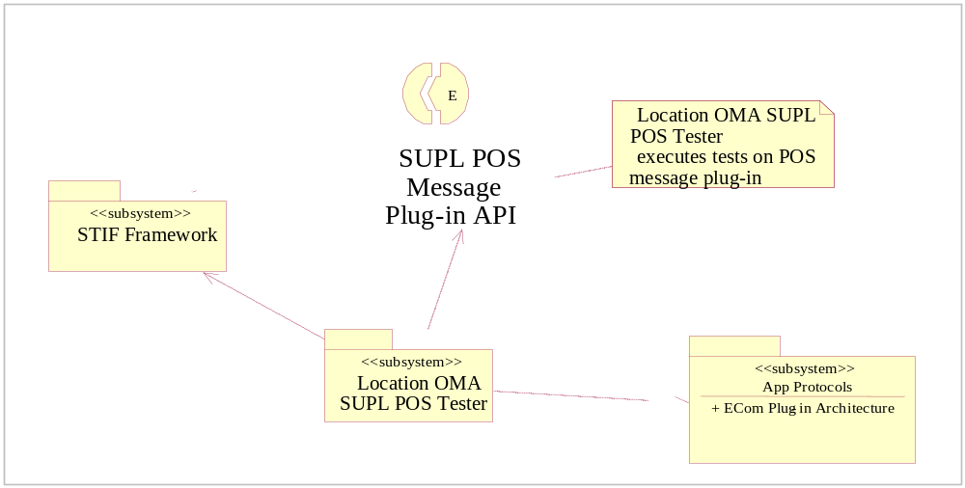
Figure 2.1 Subsystem environment

Services required

From the STIF Framework subsystem
STIF provides the basic framework within which Location OMA SUPL POS Tester is executed. The different STIF modules that POS Tester is dependent on are described below:

Module | Purpose
Logger | STIF logger is used by POS Tester to log the results of all the tests that are performed by POS Tester.
Console UI | Console UI of STIF is used for selecting test case, aborting test case and view the results of test cases that are executed on a POS message plug-in.
Test Module | POS Tester is a test module of STIF and is of type, Test Scripter. Test Module of STIF provides POS Tester with the ability to control the execution sequence of tests in a test case through configuration file.
Caps Modifier | Caps Modifier of STIF is used by POS Tester to specify the capabilities required to load the POS Tester DLL.

From the Symbian OS subsystem
The following table shows the dependencies that the Location OMA SUPL POS Tester component has to Symbian OS subsystems.

Subsystem | Purpose
Base | Base provides the programming framework for all the other components of Symbian OS. The Location OMA SUPL POS Tester component uses the Base for the basic data types, such as buffers, descriptors and arrays, active objects, process related calls, file server client calls, etc.
App Protocols | The Application Protocols subsystem provides various application level utilities such as the ECom plug-in architecture providing a generalized mechanism to plug-in different DLLs.  Location OMA SUPL POS Tester makes use of ECom Plug-in API to load and unload the POS Message plug-in.

From HW
This subsystem has no direct HW interfaces.

From Location SUPL Framework
Subsystem | Purpose
POS Message Plug-in API | POS Message Plug-in API is used by POS Tester for performing different tests on the POS Message plug-in.

Services provided

UI
Location OMA SUPL POS Tester provides a console based UI to the user for selecting a POS Message plug-in. STIF provides a console based UI for selecting the test case. Please see reference document [2] for more details about STIF Framework.

SW IF
This subsystem does not provide services for other subsystems.

UI Control Hierarchy
The Location OMA SUPL POS Tester subsystem does not contain any GUI or GUI controls. It provides a console based UI that can be used to select and execute tests on the POS Message plug-in.

Design

Component diagram
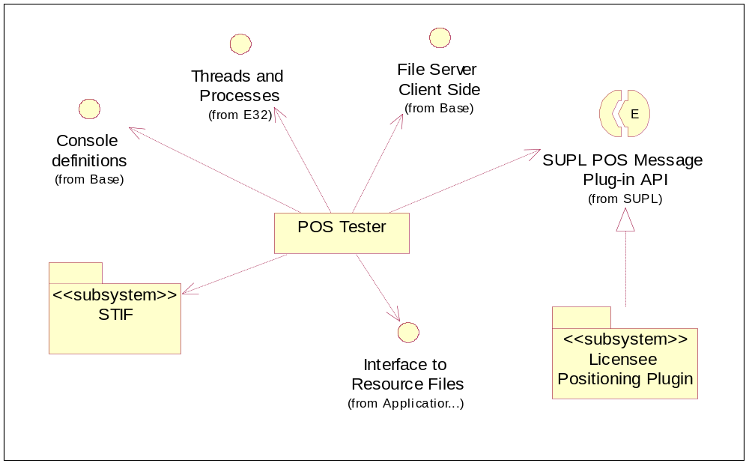
Figure 4.2 Location OMA SUPL POS Tester component diagram

Class diagram
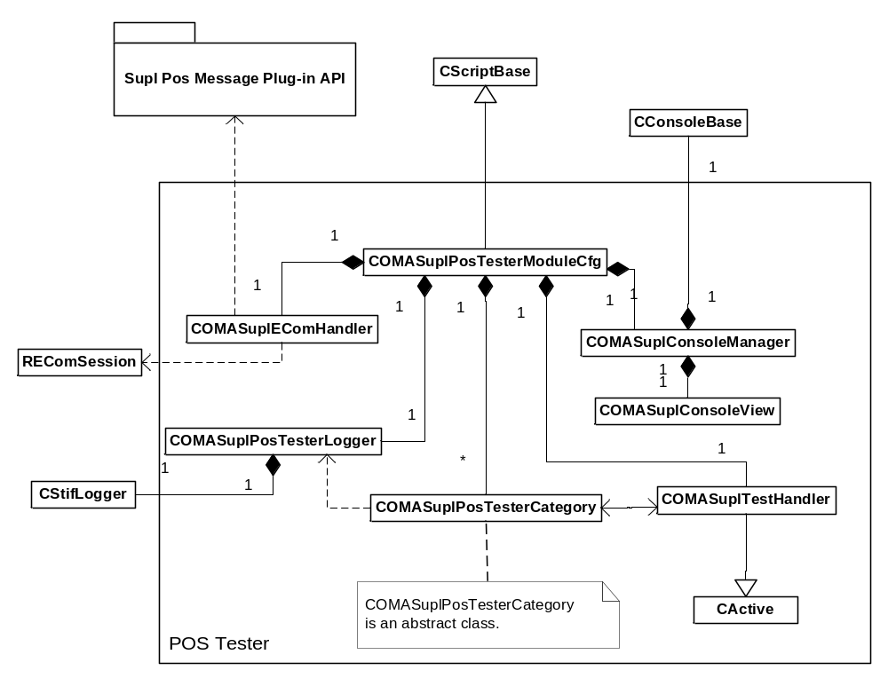
Figure 4.3 Class diagram for Location OMA SUPL POS Tester
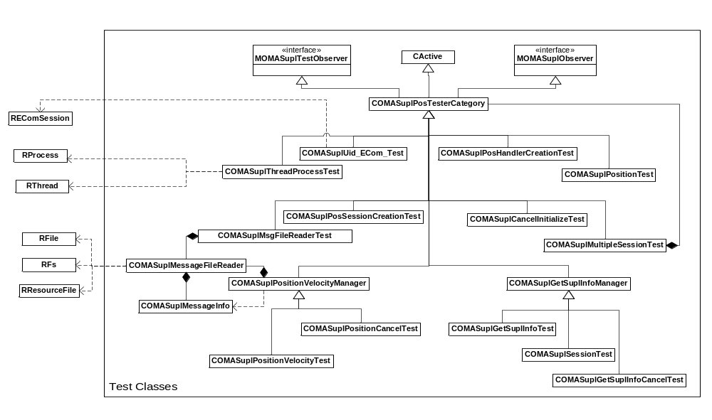
Figure 4.4 Hierarchy of test classes

Class descriptions
Class | Description | Header file
COMASuplPosTesterModuleCfg | Test module created by STIF Framework.  - COMASuplPosTesterModuleCfg ensures that SUPL Gateway is not running.  - COMASuplPosTesterModuleCfg contains various test methods which carry out specific tests on the POS Message plug-in.  - When the POS Message plug-in to be tested is identified, COMASuplPosTesterModuleCfg prepares the name of the log file for logging test information. | epos_comasuplpostester  modulecfg.h
COMASuplECom  Handler | Retrieves the list of all POS Message plug-ins for a particular Interface UID using REComSession. | epos_comasuplecomhandler.h
COMASuplPosTesterLogger | Logger for POS Tester.  COMASuplPosTesterLogger provides functionality necessary for:  - Writing info/warning/error messages and test results for the tests performed by POS Tester.  - Calculating and logging execution time of a synchronous function.  - Provides methods for logging values of data members of the object of the different data types defined in POS Message plug-in API.  - Logging implementation details like display name, implementation UID and version of POS Message plug-in selected for testing. | epos_comasuplpostester  logger.h
COMASuplTest  Handler | A class derived from CActive and listens to the user request for cancellation of tests (Keyboard input). | epos_comasupltesthandler.h
COMASuplConsole  Manager | Provides the console for the user selection and display of POS Message plug-ins.  If there is only one POS Message plug-in present, COMASuplConsoleManager selects the plug-in automatically for testing. | epos_comasuplconsole  manager.h
COMASuplConsole  View | Lists all POS Message plug-ins and allows the user to select one of them so that tests can be performed on the selected POS Message plug-in. | epos_comasuplconsoleview.h
COMASuplPosTesterCategory | The parent class of all test case classes. It is derived from CActive and implements MOMASuplTestObserver.  - Provides the framework for the different test classes to invoke the asynchronous calls in POS Message Plug-in API.  - Count number of info, warning and error messages.  - Provides methods for COMASuplTestHandler to start, cancel and abort test cases.  - Provides callback methods for the multiple session test to indicate the completion of the test. | epos_comasuplpostester  category.h
MOMASuplTest  Observer | The observer class for starting, canceling, aborting and completing test case. | epos_momasupltestobserver.h
COMASuplPos  SessionCreation  Test | Tests Loading of POS Handler, creation and initialization of POS session. | epos_comasuplpossession  creationtest.h
COMASuplUid_ECom_Test | Tests whether the POS Message plug-in selected for testing is the one that is actually loaded. | epos_comasupluid_ecom_test.h
COMASuplPos  HandlerCreation  Test | Tests the creation and initialization of POS Handler. | epos_comasuplposhandler  creationtest.h
COMASuplGetSupl  InfoTest | This class tests GetSuplInfoL() on a POS Session under the following conditions:  - POS Session not initialized.  - POS Session initialized.  - POS Session ended. | epos_comasuplgetsuplinfotest.h
COMASuplGetSupl  InfoCancelTest | This class tests CancelInfoRequest() on a POS Session under the following conditions:  - POS Session not initialized.  - POS Session initialized.  - After invoking GetSuplInfoL().  - POS Session ended. | epos_ comasuplgetsuplinfocanceltest.h
COMASuplSession  Test | This class tests GetSuplInfoL() and GetPositionL() on a POS Session under the following conditions:  - POS Session not initialized.  - POS Session initialized.  - POS Session ended. | epos_comasuplsessiontest.h
COMASuplMsgFile  ReaderTest | Tests the format of the POS Tester Message file and sends POS Payload data read from the file to POS Message plug-in. | epos_comasuplmsgfilereadertest.h
TOMASuplMatchDataTypes | This class is responsible to ensure the POS Message plug-in maintains the same position information once all the POS Payload messages have been exchanged between POS Tester and POS Message plug-in. | epos_tomasuplmatchdatatypes.h
COMASuplMessage  Info | COMASuplMessageInfo holds the instructions from the POS Tester Message file. | epos_comasuplmessageinfo.h
COMASuplMessage  FileReader | Reads POS Message from POS Tester Message file and constructs an array of COMASuplMessageInfo objects from the data read. | epos_comasuplmessagefilereader.h
COMASuplCancel  InitializeTest | Tests the behavior CancelInitialize on both POS Handler and POS Session of the POS Message plug-in under consideration. | epos_comasuplcancelinitializetest.h
COMASuplGetSupl  InfoManager | Base class of test classes testing GetSuplInfoL() | epos_comasuplgetsuplinfomanager.h
COMASuplPosition  Test | This class tests GetPositionL() on a POS Session under the following conditions:  - POS Session not initialized.  - POS Session initialized.  - POS Session ended. | epos_comasuplpositiontest.h
COMASuplPositionVelocityTest | This class tests retrieval of Position and Velocity from the POS Message plug-in based on the messages provided in the POS Tester Message file. | epos_comasuplpositionvelocitytest.h
COMASuplPositionCancelTest | This class tests cancellation of Position request to the POS Message plug-in after executing message instructions provided in the POS Tester Message file. | epos_comasuplpositioncanceltest.h
COMASuplPositionVelocityManager | Base class of COMASuplPositionVelocityTest and COMASuplPositionCancelTest | epos_comasuplpositionvelocitymanager.h
COMASuplMultiple  SessionTest | Runs tests in parallel sessions. | epos_comasuplmultiplesessiontest.h
COMASuplThread  ProcessTest | Tests the number of threads and priority of process are the same before loading and after unloading the POS Message plug-in. | epos_comasuplthreadprocesstest.h

Structs, type definitions and enumerations
Struct/Definition/Enumeration's name | Description
TTestingStatus | Enum that provides values for status of tests. The values in this enum are:  - Aborted.  - Canceled by user.  - Completed successfully.
TOMASuplOperationType | Identifies the instruction type in POS Tester Message file. The values are  - Send  - Wait
TSessionState | Identifies the state of POS session in Session test. The values are:  - Initialized.  - Uninitialized.  - Session ended.
TExecutionSequence | Controls the sequence of operations in a given test.

Flag definitions
No compile time flags are used by the components in this subsystem.

Operations

Execution of tests
Operation | Execution of a test.
Preconditions | The user has launched Location OMA SUPL POS Tester and has selected a POS Message plug-in for testing.
Description | This operation describes the basic flow of execution of tests in any test class. The test class that is actually instantiated for a particular test is described in the later sections of this document.
Inputs | The user selects the POS Message plug-in for testing.
Modifies
Outputs | A log file per POS Message plug-in is selected for testing. The log file contains the test result and summary for the tests performed on the POS Message plug-in.
Postconditions | Tests are performed.
Related To
Related Event | Canceling tests.
Exceptions | - If no POS message plug-in is installed, testing fails with error code KErrNotFound.  - If SUPL Framework is running, testing fails with error code KErrAlreadyExists.  - If POS Tester Message file does not exist, testing fails with KErrNotFound.  - If there is no memory available to perform the tests, POS Tester leaves with error code KErrNoMemory and further tests are aborted.

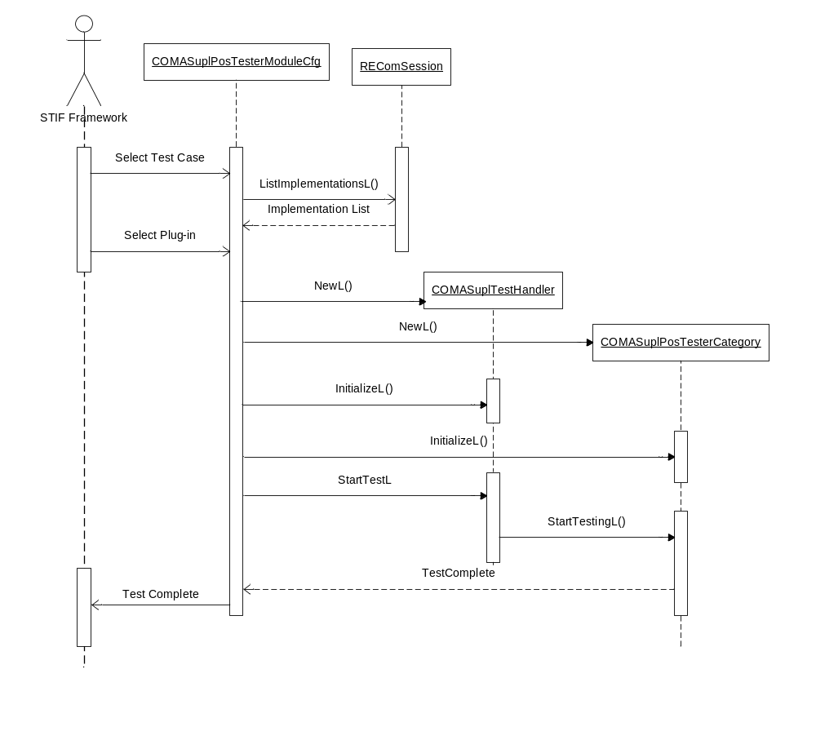
Figure 4.5 Execution of tests

Canceling tests
Operation | Canceling tests.
Preconditions | Tests are executed through Location OMA SUPL POS Tester.
Description | The execution of test cases is aborted and this is logged in the log file.
Inputs | Selection of cancellation of tests by user.
Modifies
Outputs | Entry in log file.
Postconditions | Tests are canceled.
Related To
Related Event
Exceptions | If there is no memory available to perform the tests, POS Tester leaves with error code KErrNoMemory and further tests are aborted.
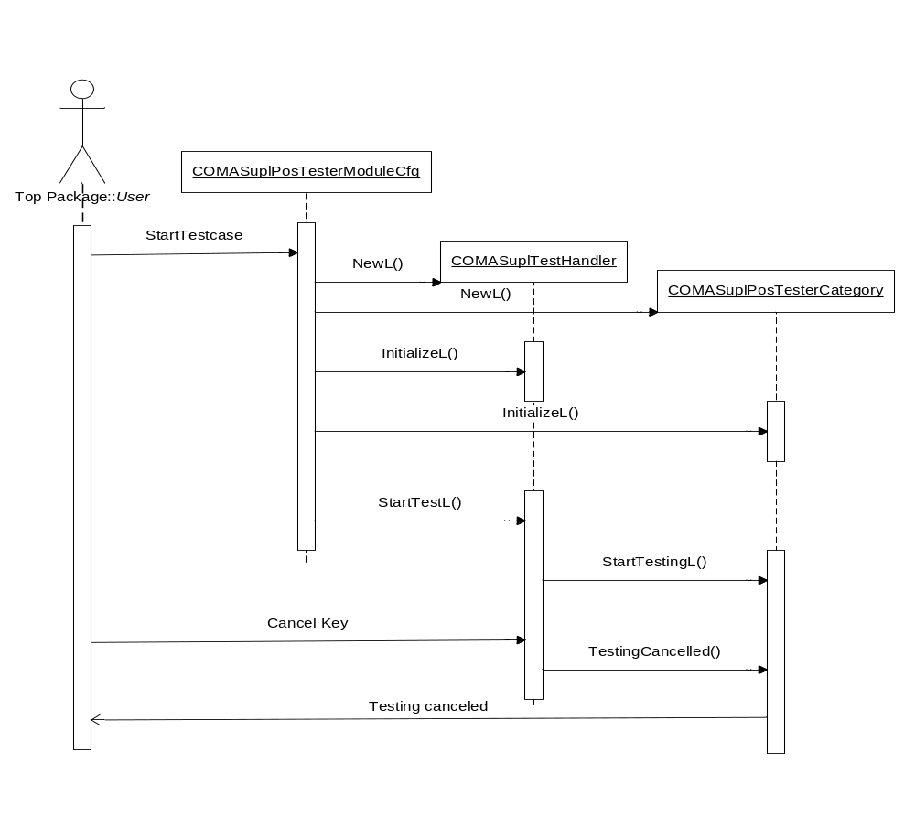
Figure 4.6 Canceling tests

UID ECom Test
Operation | UID ECom Test.
Preconditions | The POS Message plug-in is successfully loaded.
Description | Compares the Implementation UID of the loaded POS Message plug-in with the selected Implementation UID.  An error is generated when:  - Implementation UID of plug-in loaded is not the same as the implementation UID of plug-in selected.  Info is generated when:  - Implementation UID of plug-in loaded is the same as the implementation UID of plug-in selected.
Inputs | Implementation UID of the selected POS Message plug-in.
Modifies | Info, warning and error count of Location OMA SUPL POS Tester.
Outputs | Test result that is appended in the log file:  c:\logs\postester\<DisplayName>_<UID>.txt
Postconditions | If the test passes, further tests are conducted. Otherwise testing is aborted.
Related To | COMASuplUid_ECom_Test
Related Event
Exceptions | If there is no memory available to perform the tests, Location OMA SUPL POS Tester leaves with error code KErrNoMemory and further tests are aborted.

POS Handler creation test
Operation | Testing creation and initialization of POS Handler.
Preconditions | User selects a test case and selects a POS Message plug-in for testing.
Description | POS Handler creation and initialization test ensures that the POS Handler under consideration can be successfully loaded and initialized.  - POS Handler is created.  - POS Handler is initialized  An error is generated when:  - The creation of POS Handler fails. In this case testing is aborted.  - Initialization of POS Handler does not complete with status KErrNone.  Info is generated when:  - POS Handler is created and initialized successfully.
Inputs | Implementation UID of POS Message plug-in.
Modifies | Info, warning and error count of Location OMA SUPL POS Tester.
Outputs | Test result that is appended in the log file:  c:\logs\postester\<DisplayName>_<UID>.txt
Postconditions | If the test passes, further tests are conducted. Otherwise testing is aborted.
Related To | COMASuplPosHandlerCreationTest.
Related Event
Exceptions | If there is no memory available to perform the tests, Location OMA SUPL POS Tester leaves with error code KErrNoMemory and further tests are aborted.

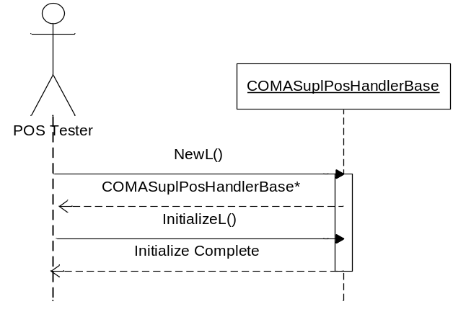
Figure 4.7 Creating and initializing POS Handler

POS Session creation test
Operation | Testing creation and initialization of POS Session.
Preconditions | POS Handler is created and initialized.
Description | POS Session creation and initialization test ensures that POS Session can be successfully loaded and initialized for the POS Message plug-in under consideration.  - POS Session is created.  Error is generated when:  - The creation of POS Session fails. In this case testing is aborted.  Info is generated when:  - POS Session is created successfully.  - POS Session is initialized  Error is generated when:  - Initialization of POS Session completes with status other than KErrNone. In this case testing is aborted.  Info is generated when:  - POS Session is initialized successfully.
Inputs | A reference to POS Handler that is created.
Modifies | Info, warning and error count of POS Tester.
Outputs | Test result that is appended in the log file:  c:\logs\postester\<DisplayName>_<UID>.txt
Postconditions | If the test passes, further tests are conducted. Otherwise testing is aborted.
Related To | COMASuplPosSessionCreationTest
Related Event
Exceptions | If there is no memory available to perform the tests, Location OMA SUPL POS Tester leaves with error code KErrNoMemory and further tests are aborted.

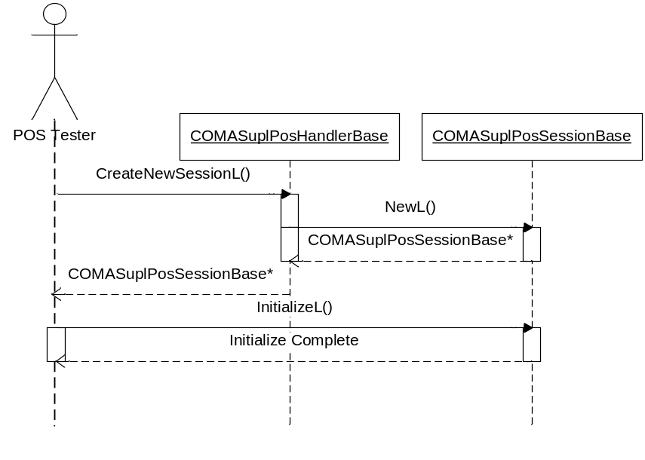
Figure 4.8 Creating and initializing POS Session

GetSuplInfo test
Operation | Retrieving data types from the POS Message plug-in.
Preconditions | POS Session is created.
Description | The GetSuplInfo test ensures that GetSuplInfoL() on a POS Session completes with the expected status code. This test is performed under different POS Session states.  - The request list is prepared using one instance each of COMASuplSETCapabilities, COMASuplRequestAsstData, COMASuplPosPayload, COMASuplPosition and COMASuplVelocity.  - GetSuplInfoL() is invoked and request list (created in step 1 above) is passed as an argument.  Warning is generated when:  - GetSuplInfoL() completes with status other than KErrOMASuplPosInActive.  Info is generated when:  - GetSuplInfoL() completes with status KErrOMASuplPosInActive.  - POS session is initialized.  - GetSuplInfoL() is invoked.  Warning is generated when:  - GetSuplInfoL() completes with status other than KErrNone.  Info is generated when:  - GetSuplInfoL() completes with status KErrNone.  Error is generated when:  - GetSuplInfoL() leaves. Testing is aborted.  - POS Session is ended using the SessionEnd method.  - GetSuplInfoL() is invoked.  Warning is generated when:  - GetSuplInfoL() completes with status other than KErrOMASuplPosInActive.  Info is generated when:  - GetSuplInfoL() completes with status KErrOMASuplPosInActive.  Error is generated when:  - GetSuplInfoL() leaves. Testing is aborted.
Inputs | Reference to POS Session.
Modifies | Info, warning and error count of POS Tester.
Outputs | The test result that is appended in the log file:  c:\logs\postester\<DisplayName>_<UID>.txt
Postconditions | If the test passes, further tests are conducted. Otherwise testing is aborted.
Related To | COMASuplGetSuplInfoTest.
Related Event
Exceptions | If there is no memory available to perform the tests, POS Tester leaves with error code KErrNoMemory and further tests are aborted.

Canceling the GetSuplInfo test
Operation | Canceling the test of retrieving different data types defined by POS Message Plug-in API.
Preconditions | POS Session is created.
Description | The cancel data types test ensures that CancelSuplInfoRequest() is able to cancel GetSuplInfoL() for the given POS Session.  - CancelSuplInfoRequest() is invoked even before the initialization of POS Session.  - Session is initialized.  - CancelSuplInfoRequest() is invoked. An info is logged about the cancellation of GetSuplInfoL() being invoked.  - The request list is prepared using one instance each of COMASuplSETCapabilities, COMASuplRequestAsstData, COMASuplPosPayload and COMASuplPosition.  - GetSuplInfoL() is invoked and the request list (created in step 4 above) is passed as an argument.  - CancelSuplInfoRequest() is invoked.  Warning is generated when:  - GetSuplInfoL() completes with status other than KErrCancel.  Info is generated when:  - GetSuplInfoL() completes with status KErrCancel.  - POS Session is ended using the SessionEnd method.  - CancelSuplInfoRequest() is invoked. An info is logged about the cancellation of GetSuplInfoL() being invoked.
Inputs | Reference to POS Session.
Modifies | Info, warning and error count of Location OMA SUPL POS Tester.
Outputs | The test result that is appended in the log file:  c:\logs\postester\<DisplayName>_<UID>.txt
Postconditions | If the test passes, further tests are conducted. Otherwise testing is aborted.
Related To | COMASuplGetSuplInfoCancelTest
Related Event
Exceptions | If there is no memory available to perform the tests, Location OMA SUPL POS Tester leaves with error code KErrNoMemory and further tests are aborted.

Testing the cancellation of the initialization of POS Handler
Operation | Testing the cancellation of the initialization of POS Handler.
Preconditions | POS Handler is created.
Description | Testing the cancellation of the initialization of POS Handler ensures that CancelInitialize() of POS Handler is able to cancel the initialization of POS Handler for the POS Message plug-in under consideration.  - CancelInitialize() of POS Handler is invoked even before Initializing POS Handler.  - Invokes InitializeL() on POS Handler.  - Invokes CancelInitialize() on POS Handler.  Warning is generated when:  - The initialization of POS Handler completes with status other than KErrCancel.  Info is generated when:  - The initialization of POS Handler completes with status KErrCancel.
Inputs | Implementation UID of the POS Message plug-in selected for testing.
Modifies | Info, warning and error count of Location OMA SUPL POS Tester.
Outputs | The test result that is appended in the log file:  c:\logs\postester\<DisplayName>_<UID>.txt
Postconditions | If the test passes, further tests are conducted. Otherwise testing is aborted.
Related To | COMASuplCancelInitializeTest
Related Event
Exceptions | If there is no memory available to perform the tests, Location OMA SUPL POS Tester leaves with error code KErrNoMemory and further tests are aborted.

Testing the cancellation of the initialization of POS Session
Operation | Testing the cancellation of the initialization of POS Session.
Preconditions | POS Session is created.
Description | Testing the cancellation of the initialization of POS Session ensures that CancelInitialize() of POS Session is able to cancel the initialization of POS session for the POS Message plug-in under consideration.  - CancelInitialize() is invoked on POS Session even before Initializing the POS Session.  - Invoke InitializeL() on POS Session.  - Invoke CancelInitialize() on POS Session.  Warning is generated when:  - Initialization of POS Session completes with status other than KErrCancel.  Info is generated when:  - Initialization of POS Session completes with status KErrCancel.
Inputs | Reference to POS Session.
Modifies | Info, warning and error count of Location OMA SUPL POS Tester.
Outputs | The test result that is appended in the log file:  c:\logs\postester\<DisplayName>_<UID>.txt
Postconditions | If the test passes, further tests are conducted. Otherwise testing is aborted.
Related To | COMASuplCancelInitializeTest.
Related Event
Exceptions | If there is no memory available to perform the tests, Location OMA SUPL POS Tester leaves with error code KErrNoMemory and further tests are aborted.

Position test
Operation | Testing GetPositionL() under different scenarios.
Preconditions | POS Session in created.
Description | The position test ensures that GetPositionL() completes with expected status code for the POS Message plug-in under consideration, under different POS Session states.  - Create an object of COMASuplPosition. Invoke GetPositionL()  Warning is generated when:  - GetPositionL() completes with status other than KErrOMASuplPosInActive  Info is generated when:  - GetPositionL() completes with status KErrOMASuplPosInActive.  - POS Session is initialized.  - Invoke GetPositionL()  Warning is generated when:  - GetPositionL() completes with status other than KErrNone.  Info is generated when:  - GetPositionL() completes with status KErrNone.  - End the session by invoking SessionEnd()  - Invoke GetPositionL()  Warning is generated when:  - GetPositionL() completes with status other than KErrOMASuplPosInActive  Info is generated when:  - GetPositionL() completes with status KErrOMASuplPosInActive
Inputs | Reference to POS Session.
Modifies | Info, warning and error count of Location OMA SUPL POS Tester.
Outputs | The test result that is appended in the log file:  c:\logs\postester\<DisplayName>_<UID>.txt
Postconditions | If the test passes, further tests are conducted. Otherwise testing is aborted.
Related To | COMASuplPositionTest
Related Event
Exceptions | If there is no memory available to perform the tests, Location OMA SUPL POS Tester leaves with error code KErrNoMemory and further tests are aborted.

Session test
Operation | Testing GetSuplInfoL and GetPositionL on POS Session.
Preconditions | POS Session is created and successfully initialized.
Description | The position test ensures that GetSuplInfoL() and GetPositionL() complete with expected status code for the POS Message plug-in under consideration, under different POS Session states.  - The request list is prepared using one instance each of COMASuplSETCapabilities, COMASuplRequestAsstData, COMASuplPosPayload, COMASuplPosition and COMASuplVelocity  - GetSuplInfoL() is invoked and the request list (created in step 1 above) is passed as an argument.  Warning is generated when:  - GetSuplInfoL() completes with status other than KErrOMASuplPosInActive  Info is generated when:  GetSuplInfoL() completes with status KErrOMASuplPosInActive  - Create an object of COMASuplPosition. Invoke GetPositionL()  Warning is generated when:  - GetPositionL() completes with status other than KErrNone  Info is generated when:  GetPositionL() completes with status KErrNone  - Initialize the POS Session  - GetSuplInfoL() is invoked and request list (created in step 1 above) is passed as an argument.  Warning is generated when:  - GetSuplInfoL() completes with status other than KErrNone  Info is generated when:  GetSuplInfoL() completes with status KErrNone  - Create an object of COMASuplPosition. Invoke GetPositionL()  Warning is generated when:  - GetPositionL() completes with status other than KErrOMASuplPosInActive  Info is generated when:  GetPositionL() completes with status KErrOMASuplPosInActive  - POS Session is ended using the SessionEnd method  - GetSuplInfoL() is invoked  Warning is generated when:  - GetSuplInfoL() completes with status other than KErrOMASuplPosInActive.  Info is generated when:  GetSuplInfoL() completes with status KErrOMASuplPosInActive.  - Invoke GetPositionL()  Warning is generated when:  - GetPositionL() completes with status other than KErrOMASuplPosInActive  Info is generated when:  GetPositionL() completes with status KErrOMASuplPosInActive
Inputs | Reference to POS Session.
Modifies | Info, warning and error count of POS Tester.
Outputs | Test result that will be appended in the log file:  c:\logs\postester\<DisplayName>_<UID>.txt
Postconditions | If the test passes, further tests are conducted. Otherwise testing is aborted.
Related To | COMASuplSessionTest
Related Event
Exceptions | If there is no memory available to perform the tests, Location OMA SUPL POS Tester leaves with error code KErrNoMemory and further tests are aborted.

File reader test
Operation | Testing whether the message file is present and the instructions are in proper format.
Preconditions | POS Session is created and initialized.
Description | File reader test verifies the format of POS Tester message file.  - Create a File session.  An error is generated when:  - The file session is not created successfully.  - The file is opened  An error is generated when:  - The file could not be opened successfully.  Info is generated when:  - The file is opened successfully.  - Message segments are read one by one.  - Each message segment is parsed.  Error is generated when:  - Format of message segment is not correct.
Inputs | Reference to POS Session. Name of message file with absolute path.
Modifies | Info, warning and error count of Location OMA SUPL POS Tester.
Outputs | Test result that is appended in the log file:  c:\logs\postester\<DisplayName>_<UID>.txt
Postconditions | If the test passes, further tests are conducted. Otherwise testing is aborted.
Related To | COMASuplMsgFileReaderTest
Related Event
Exceptions | - If the message file does not exist, testing fails with KErrNotFound.  - If parsing of the message file fails, leave occurs with error code KErrNotFound and testing is aborted.  - If there is no memory available to perform the tests, Location OMA SUPL POS Tester leaves with error code KErrNoMemory and further tests are aborted.

Position velocity test
Operation | Testing the handling of a positioning message by the POS Message plug-in.
Preconditions | POS Session is created and initialized. The POS Tester message file is parsed successfully.
Description | The position velocity test ensures that the POS Message plug-in under consideration is able to handle messages from network. It also ensures that the POS Message plug-in is able to send messages to the network.  - Read the message file and get instructions from it.  - If the instruction is send, use COMASuplPosSessionBase::HandleSuplPosMessageL() for sending the POS payload to the POS Message plug-in. This POS payload is attached with the instruction in the array.  - If the instruction is wait, prepare a request list with one object each of COMASuplPosition, COMASuplVelocity and COMASuplPosPayload. Invoke COMASuplPosSessionBase::GetSuplInfoL().  - If last instruction in the message file is wait, COMASuplPosSessionBase::GetSuplInfoL() should complete with status KErrNone and iRreqStatus in COMASuplInfoRequest of POS payload should be set to KErrOMASuplLastPosMsg  An error is generated when:  - COMASuplPosSessionBase::GetSuplInfoL() does not complete with the status KErrNone or iRreqStatus in COMASuplInfoRequest of POS payload is not set to KErrOMASuplLastPosMsg. Testing is aborted.  - Create an object of COMASuplPosition. Invoke COMASuplPosSessionBase::GetPositionL().  Warning is generated when:  - GetPositionL() completes with status other than KErrNone.  Info is generated when:  - GetPositionL() completes with status KErrNone.  - End the POS Session by invoking SessionEnd.  - Initialize POS Session.  - Repeat from steps 1 to step 4 after initialization.
Inputs | Reference to POS Session.
Modifies | Info, warning and error count of Location OMA SUPL POS Tester.
Outputs | Test result that is appended in the log file:  c:\logs\postester\<DisplayName>_<UID>.txt
Postconditions | If the test passes, further tests are conducted. Otherwise testing is aborted.
Related To | COMASuplPositionVelocityTest
Related Event
Exceptions | If there is no memory available to perform the tests, Location OMA SUPL POS Tester leaves with error code KErrNoMemory and further tests are aborted.

Position cancellation test
Operation | Testing the cancellation of position request while handling a positioning message.
Preconditions | The user selects a test case and selects a POS Message plug-in for testing.  The UID ECom test, creation of POS Handler test and the creation of POS Session test are done.
Description | The position cancellation test verifies that GetPositionL() can be cancelled successfully after message transaction between Location OMA SUPL POS Tester and POS Message plug-in under consideration.  - Read message file and get instructions from it.  - If the instruction is send, use COMASuplPosSessionBase::HandleSuplPosMessageL() for sending the POS payload to POS Message plug-in. This POS payload is attached with the instruction in the array.  - If the instruction is wait, prepare a request list with one object each of COMASuplPosition, COMASuplVelocity and COMASuplPosPayload. Invoke COMASuplPosSessionBase::GetSuplInfoL().  - If the last instruction in the message file is wait, COMASuplPosSessionBase::GetSuplInfoL() should complete with status KErrNone and iRreqStatus in COMASuplInfoRequest of POS payload should be set to KErrOMASuplLastPosMsg.  Error is generated when:  - COMASuplPosSessionBase::GetSuplInfoL() does not complete with status KErrNone or iRreqStatus in COMASuplInfoRequest of POS payload is not set to KErrOMASuplLastPosMsg. Testing is aborted.  - Create an object of COMASuplPosition. Invoke COMASuplPosSessionBase::GetPositionL()  - Invoke CancelGetPosition() on POS Session.  Warning is generated when:  - GetPositionL() completes with status other than KErrCancel  Info is generated when:  - GetPositionL() completes with status KErrCancel.
Inputs | Reference to POS Session.
Modifies | Info, warning and error count of Location OMA SUPL POS Tester.
Outputs | Test result that is appended in the log file:  c:\logs\postester\<DisplayName>_<UID>.txt
Postconditions | If the test passes, further tests are conducted. Otherwise testing is aborted.
Related To | The COMASuplPositionCancelTest class.
Related Event
Exceptions | If there is no memory available to perform the tests, Location OMA SUPL POS Tester leaves with error code KErrNoMemory and further tests are aborted.

Multiple session test
Operation | Running several tests in parallel sessions.
Preconditions | POS Handler is loaded and initialized
Description | The multiple session test ensures that the POS Message plug-in supports multiple sessions.  In the multiple session tests, multiple POS Sessions are created and the following tests are executed on all the session at the same time.  - PosSessionCreationTest  - CancelInitializeTest  - PositionTest  - GetSuplInfoTest  - GetSuplInfoCancelTest  - MsgFileReaderTest  - SessionTest  - PositionVelocityTest  - PositionCancelTest  The following are not executed as part of the multiple session test:  - Uid_ECom test  - POS Handler creation test  - Thread and process test  When the multiple session test is executed, all info, warnings and errors provide the session number of the test. If a test is aborted, the multiple session test logs that the test has been aborted along with the session ID and continues with other tests.  If the user selects to cancel the testing (the user presses the softkey Cancel), all the tests running in the multiple session test are canceled.  - The multiple session test is executed as follows:  - An array of objects of test classes which are to be executed in multiple session test is created.  - Each test object is initialized  - Testing is started by invoking StartTestingL() method on the test object.  - The multiple session test completes when tests on all the test object are completed or aborted.  Warning is generated when:  - Any test logs a warning.  Info is generated when:  - Any test logs Info.  Error is generated when:  - Any test logs an error.
Inputs | Reference to POS Handler, number of sessions.
Modifies | Info, warning and error count of Location OMA SUPL POS Tester.
Outputs | Test result that is appended in the log file:  c:\logs\postester\<DisplayName>_<UID>.txt
Postconditions | If test passes, further tests are conducted. Otherwise testing is aborted.
Related To | COMASuplMultipleSessionTest
Related Event
Exceptions | - If the message file does not exist, testing fails with KErrNotFound.  - If parsing of the message file fails. Leave occurs with error code KErrNotFound and testing is aborted.  - If there is no memory available to perform the tests, Location OMA SUPL POS Tester leaves with error code KErrNoMemory and further tests are aborted.

Thread and process test
Operation | Thread and process test.
Preconditions | The user selects a test case and selects a POS Message plug-in for testing.
Description | Tests whether the number of threads and priority of the process before loading and after unloading the POS Message plug-in are the same or not. The test class records the number of threads and priority of the process before loading the plug-in.  The following tests are performed on the POS Message plug-in:  - PosSessionCreationTest  - CancelInitializeTest  - PositionTest  - GetSuplInfoTest  - GetSuplInfoCancelTest  - MsgFileReaderTest  - SessionTest  - PositionVelocityTest  - PositionCancelTest  - Uid_ECom test  - POS Handler creation test  After all tests are done, the test class records the number of threads and priority of the process and matches them.  Info is generated when:  - The number of threads recorded before testing equals the number of threads recorded after testing.  - The priority of process before testing is the same as the priority of process after testing.  Error is generated when:  - The number of threads recorded before testing is not equal to the number of threads recorded after testing.  - The priority of process before testing is not the same as the priority of process after testing.
Inputs
Modifies | Info, warning and error count of Location OMA SUPL POS Tester.
Outputs | Test result that is appended in the log file:  c:\logs\postester\<DisplayName>_<UID>.txt
Postconditions | The test summary is logged in log file.
Related To | COMASuplThreadProcessTest
Related Event
Exceptions | If there is no memory available to perform the tests, Location OMA SUPL POS Tester leaves with error code KErrNoMemory and further tests are aborted.

Platform security capability test
Operation | Platform security capability test.
Preconditions | The user selects a test case.
Description | This test ensures that only those POS message plug-ins whose capability is more than or equal to the capability of POS Tester are listed and loaded  To load DLL of Location OMA SUPL POS Tester, STIF uses epos_comasuplpostestermodulecfg_exe which is module of type capsmodifier. It determines the capability of the process with which Location OMA SUPL POS Tester is executed.  A POS Message plug-in is listed in the list of installed POS Message plug-ins if it has at least the following six capabilities:  1) Location  2) NetworkServices  3) ReadDeviceData  4) WriteDeviceData  5) CommDD  6) ProtServ  Otherwise it is not listed.
Inputs
Modifies
Outputs
Postconditions | POS Message plug-ins with the above six capabilities are displayed. Others are not displayed or loaded.
Related To | epos_comasuplpostestermodulecfg_exe and STIF FW.
Related Event
Exceptions

Variation
There are no variation or feature flags defined for this subsystem.

System resource usage

Files

Output file
Location OMA SUPL POS Tester generates one log file per POS Message plug-in. The name of the log file is <DisplayName>_<UID>.txt. This file contains the results of all the tests that Location OMA SUPL POS Tester has performed. <DisplayName> is the display name of the POS Message plug-in that was tested with Location OMA SUPL POS Tester and <UID> is the implementation UID of the POS Message plug-in. If any of the following characters is present in the <DisplayName>, it is removed in the generation of the log file name:
" &^+-@$%*()|\\/[]{}<>?;:,\"'"
The log file is stored under c:\logs\postester. If this directory structure for the log file is not present, it is created by Location OMA SUPL POS Tester. If the tests are performed on the same POS Message plug-in for a second time, the results are appended to the existing log file.
Please see reference document [3] for more details about the log file.

Message file
The Location OMA SUPL POS Tester message file is used to provide control plane positioning protocol messages to the POS Message plug-in. Location OMA SUPL POS Tester reads the POS payload messages from the message file and sends the messages to the POS Message plug-in. The message file also provides the facility for Location OMA SUPL POS Tester to listen to messages from the POS Message plug-in. This helps in emulating send and receive of POS payload to/from the network.
The POS Tester Message file contains the messages to be sent to the POS Message plug-in as POS payload. For more details about the POS Tester Message file and its format please see reference document [3].

Resource file
Location OMA SUPL POS Tester contains the name and path of the message file defined in the resource file postester.rss. Location OMA SUPL POS Tester reads the instructions from the sample message file. Parameters in postester.rss are listed in the table below.

Resource name | Purpose | Default value
Component: POS Tester Resource file: postester.rss
r_default_pos_message_file_name | Name of the file that contains the POS message. | \postester\postestermessagefile.txt

Databases
This component does not use any databases.

Memory consumption
Memory/Build | Consumption
User data area | N/A
WINS UDeb | 814 KB
WINSCW URel | 176 KB
ARMV5 URel | 27 KB
ARMV5 UDeb | 31 KB

Task allocation
A separate thread is created by STIF for POS Tester. epos_comasuplpostestermodulecfg.exe is a caps modifier module of Location OMA SUPL POS Tester that provides the capabilities to be used by STIF when Location OMA SUPL POS Tester is loaded. Please see reference document [2] for more details about the caps modifier.

Performance
This component does not have any performance related issues.

Timers and active objects
No Timers are used.

Active objects
COMASuplPosTesterCategory | The COMASuplPosTesterCategory class is implemented as an active object because it has to call asynchronous APIs for testing the POS Message plug-in.
COMASuplTestHandler | It listens to key inputs for the cancellation of tests.

Exception handling
The leave mechanism of the Symbian OS environment is used to handle memory exhaustion. Leave in functions is handled as follows:

Exception | Description
KErrAlreadyExists | SUPL Framework is running.
KErrNotFound | - No POS Message plug-in installed.  - Message file not found in the specified path.  - Parsing of message file fails due to wrong file format.
KErrNoMemory | The system is running out of memory.

Location OMA SUPL POS Tester panics if there is a panic in any method of POS Message plug-in, selected for testing.

Usage

Building
Location OMA SUPL POS Tester has depends on the following components:
- locationsuplfw
- locationomasuplprotocolhandler
Location OMA SUPL POS Tester can be built by the following process.
Change the directory to s60/mw/locationservices/supl/locationomasuplpostester\group. Now run the following commands:
bldmake bldfiles
abld build
This builds epos_comasuplpostestermodulecfg.dll and epos_comasuplpostestermodulecfg.exe.
The build process exports all files required along with the configuration file, default message file and testframework.ini required for Location OMA SUPL POS Tester.

User's guide
A user’s guide for Location OMA SUPL POS Tester is in reference document [3].

