S60 3.2
OMA SUPL ASN Converter
Design Document

Team name | Author
Location Technology Team | Tina Tibrewal

Change history:

Version | Date | Status | Comments
1.0 | 22.05.2006 | Approved

Table of contents:

1. Document control 4
1.1 References 4
1.2 Documentation conventions 4
1.3 Abbreviations 4
1.4 Definitions 4
2. General 5
2.1 Introduction 5
2.2 Component environment 5
2.3 Services required 6
2.3.1 From the Symbian OS subsystems 6
2.3.2 From Mobile Location FrameWork 6
2.3.3 From POS Message Plugin API 6
2.3.4 From the Domestic OS subsystems 7
2.3.5 From HW 7
2.3.6 From CASN 7
2.4 Services provided 8
2.4.1 UI 8
2.4.2 SW IF 8
3. UI control hierarchy 9
4. Design 10
4.1 Class diagrams 10
4.2 Class descriptions 12
4.2.1 Structs, type definitions and enumerations 13
4.3 Operations 15
4.3.1 Encoding a SUPL message 15
4.3.2 Decoding a SUPL message 17
5. Variation 18
6. System resource usage 19
6.1 Database structures 19
6.2 Memory consumption 19
7. Security 20
7.1 Capabilities of this component 20
7.2 Input and output validation 20
7.3 Environmental assumptions 20
7.4 Additional enforcements 20
8. Exception handling 21
9. Usage 22
9.1 Building 22

Document control

References
- S60 SUPL Subsystem Design Document
- S60 3.1 SUPL Subsystem Architecture Description
- Secure User Plane Location Technical Specification | http://www.openmobilealliance.org/

Documentation conventions
Code is shown with the Courier New font.

Abbreviations
API | Application Programming Interface
ASN.1 | Abstract Syntax Notation One
FW | Framework
HW | Hardware
OMA | Open Mobile Alliance
OS | Operating System
RTS | Run Time System
SET | SUPL Enabled Terminal
SLP | SUPL Location Platform
SUPL | Secure User Plane Location
SW | Software
UI | User Interface

Definitions
CASN | Compiler for ASN.1. This tool parses a collection of ASN.1 modules and then generates a binary representation of the modules for the backend tools.
Cell ID | Coarse position of the mobile user can be estimated by knowing the current cell in which the mobile terminal is located.
Network Initiated Location Request | A location request that originates in the network.
Terminal Initiated Location Request | A location request that originates in the SET.

General
This document describes the OMA SUPL ASN Converter component of SUPL Framework. The SUPL FW subsystem design is described in reference document [1]. The architecture is described in reference document [2].

Introduction
SUPL messages defined by OMA are encoded using the ASN.1 standard. OMA SUPL ASN Converter is the encoding and decoding entity of SUPL Framework. The main responsibility of OMA SUPL ASN Converter is to encode and decode the SUPL protocol messages received and sent out to SLP.
The ASN.1 component of the SUPL subsystem consists of Run Time System of the CASN tool and the C++ wrappers. CASN is an ASN.1 tool that can generate C code for the SUPL ASN gammar. It provides encoding/decoding functions for different SUPL messages. For these functions to be used in the Symbian environment, C++ wrappers have to be defined encapsulating C functions that are generated for encoding and decoding SUPL messages.
Responsibilities and additional requirements:
- Implements methods for handling SUPL ASN.1 messages.
- Does trace logging in debug mode.
- Returns error to protocol handler in case of problems with encoding and decoding.
- Encodes the following SUPL messages:
- SUPL_START
- SUPL_POS_INIT
- SUPL_POS
- SUPL_END
- Decodes the following SUPL Messages:
- SUPL_INIT
- SUPL_START
- SUPL_RESPONSE
- SUPL_POS_INIT
- SUPL_POS
- SUPL_END
- For SUPL POS only the SUPL messaging frame is removed (when receiving) or added (when sending). The payload (other protocols tunneled inside SUPL) is left as it is.

Component environment
Figure 2.1 shows the components and their relations in SUPL Framework.
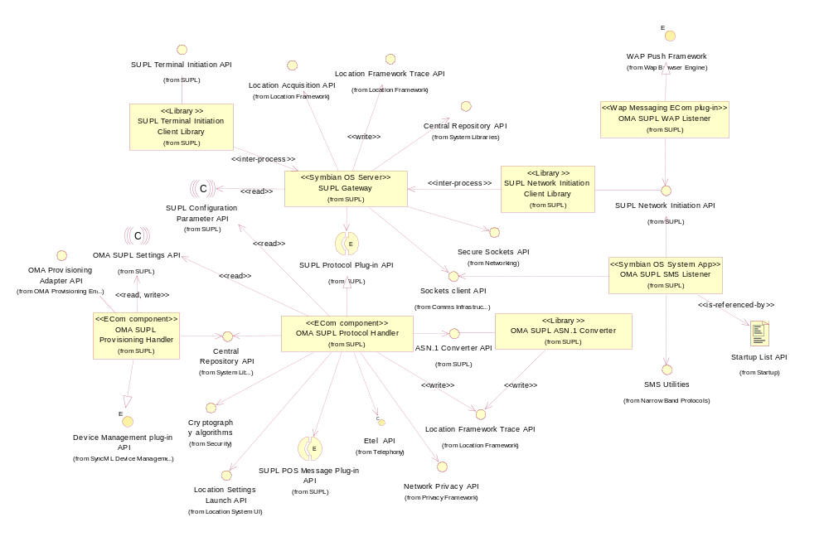
Figure 2.1 OMA SUPL Protocol Handler component diagram

Services required

From the Symbian OS subsystems
The following table shows the dependencies that the OMA SUPL ASN Converter component has to the Symbian OS subsystems.

SubSystem | Purpose
Base | Base provides the programming framework for all the components of Symbian OS. The OMA ASN Converter component uses Base for the basic data types buffers, descriptors and arrays, etc.

From Mobile Location FrameWork
SubSystem | Purpose
Location Framework | The following subcomponents of Location Framework are used by the SUPL subsystem.  - Location Framework Trace API to enable tracing in debug builds

From POS Message Plugin API
SubSystem | Purpose
SUPL POS Message Plug-in | The POS Message plug-in data types are used by the ASN Converter for the SUPL messages such as COMASuplSETCapabilities, etc.

From the Domestic OS subsystems
This component does not have any direct interfaces to the Domestic OS side subsystems.

From HW
This component does not have any direct interfaces to HW.

From CASN
The CASN tool is used for generating C-language datatypes and corresponding encoding and decoding functions that implement the Packed Encoding Rules for the supplied ASN.1 datatype definitions. The input to the CASN tool is the ASN grammar for the SUPL messages defined in reference document [3].The command line options used for generating the encoding and decoding functions and the C datatypes with CASN for SUPL messages are:

$ mkprefil -A=asn -option-file=prefix.opt top mid bot
$ casn +prefix.opt -A=asn top mid bot
$ asn2c +prefix.opt top mid bot
$ asn2per.exe +opt.fil -percod=1:1 -encoding-variant=basic-unaligned top mid bot

Top, mid and bot are the example files containing the ASN grammar. Only if the ASN.1 grammar is changed there is a need to regenerate the C datatypes and functions from the CASN tool.
The generated C functions are used by the C++ wrapper for encoding and decoding the corresponding SUPL messages. To use the generated C functions first the memory is allocated to the generated C data structures using createHandle().CASN RTS is initialized using a call to asnPerInit(), so that the generated functions can be called. The arguments to asnPerInit() specify the frame buffer to be used when a value is encoded or decoded and the buffer for error recovery. If the asnPerInit() function is called for encoding, the encoded octets are added into the beginning of the frame buffer. If the asnPerInit() function is called for decoding, the decoded octets are removed from the beginning of this frame. A frame buffer is regarded as an abstract data type that is capable of storing (virtually) unlimited number of bytes.
The generated C data structures are initialized and then the generated encoding and decoding functions are called which fill the encoded data in frame buffers. The frame buffer is converted into a byte array using copyBytesToArray() and the byte array is converted to a frame buffer using putnFirstBytes(). The byte array can then be copied into Symbian descriptors.
The configurations with which the CASN tool is used in SUPL are:

Macro | Value
CVOPS_MAIN_CONFIGURATION | 3
KEYBOARD_USED | 0
TERM_OUTPUT_USED | 0
ASN_REENTRANT | 1
ASN_PER_BASIC_ALIGNED_SUPPORT | 0
ASNBER_MODULE | 0
ASN_NO_WEXIT_IN_FATAL_ERROR | 1
ASN_MEMORY | 1
STAND_ALONE_ASN | 1

All modifications to the configuration options should be made into the extdefs.h file to enable maintainability for the libraries.

Services provided

UI
This component does not provide any UI services.

SW IF
OMA SUPL ASN Converter is a private API. It is responsible for providing the encoding and decoding functionality to OMA SUPL Protocol Handler. The classes involved are:

Class Name | Description
TOMASuplVersion | Exports methods to get and set the version of the ULP protocol, in the form major, minor, service indicator.
COMASuplAsnMessageBase | Exports methods to get and set parameters that are present in all ULP messages i.e. Version, Session ID and Message Type.
COMASuplEnd | Exports methods to get and set SUPL END message parameters. Creating a clone of the received SUPL END message.  Exports method to Encode the SUPL END message.
COMASuplInit | Exports methods to get and set SUPL INIT message parameters. Creating a clone of the received SUPL INIT message.
COMASuplPos | Exports methods to get and set SUPL POS message parameters. Creating a clone of the received SUPL POS message.  Exports method to Encode the SUPL POS message.
COMASuplPosInit | Exports methods to get and set SUPL POS INIT message parameters.  Exports method to Encode the SUPL POS INIT message.
COMASuplResponse | Exports methods to get and set SUPL RESPONSE message parameters. Creating a clone of the received SUPL RESPONSE message.
COMASuplStart | Exports methods to get and set methods for SUPL START message parameters.  Exports method to Encode the SUPL START message.
COMASuplCellInfo | Exports methods to get and set WCDMA network information.
COMASuplGSMCellInfo | Exports methods to get and set GSM network information.
COMASuplNotification | Exports methods to get and set privacy notification information.

UI control hierarchy
This component does not contain any UI or UI controls.

Design

Class diagrams
The OMA SUPL ASN Converter class diagrams:
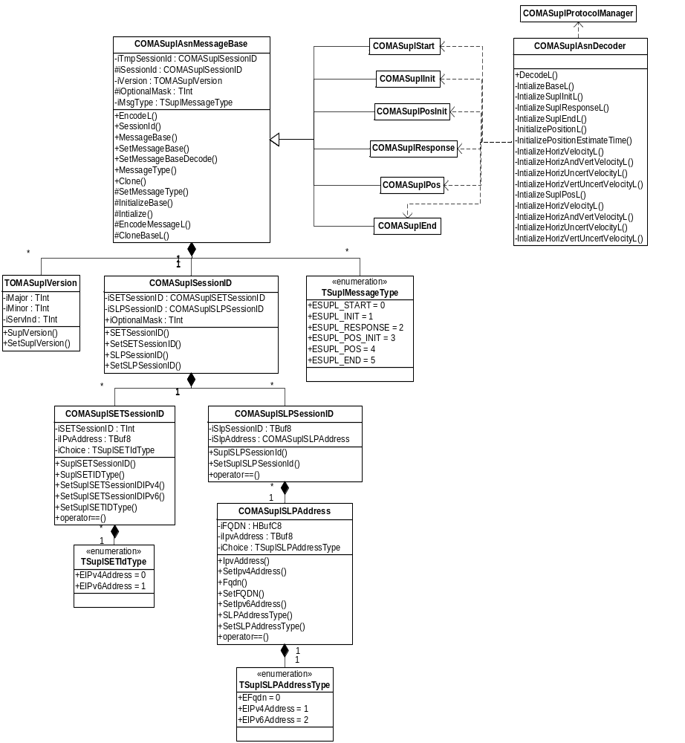
Figure 4.2 OMA SUPL ASN Converter class diagram
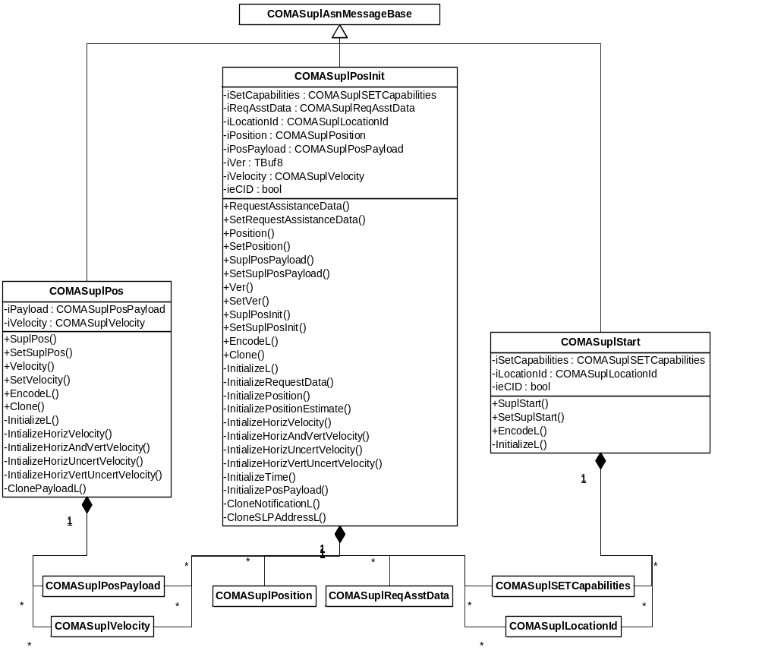
Figure 4.3 OMA SUPL ASN Converter class diagram
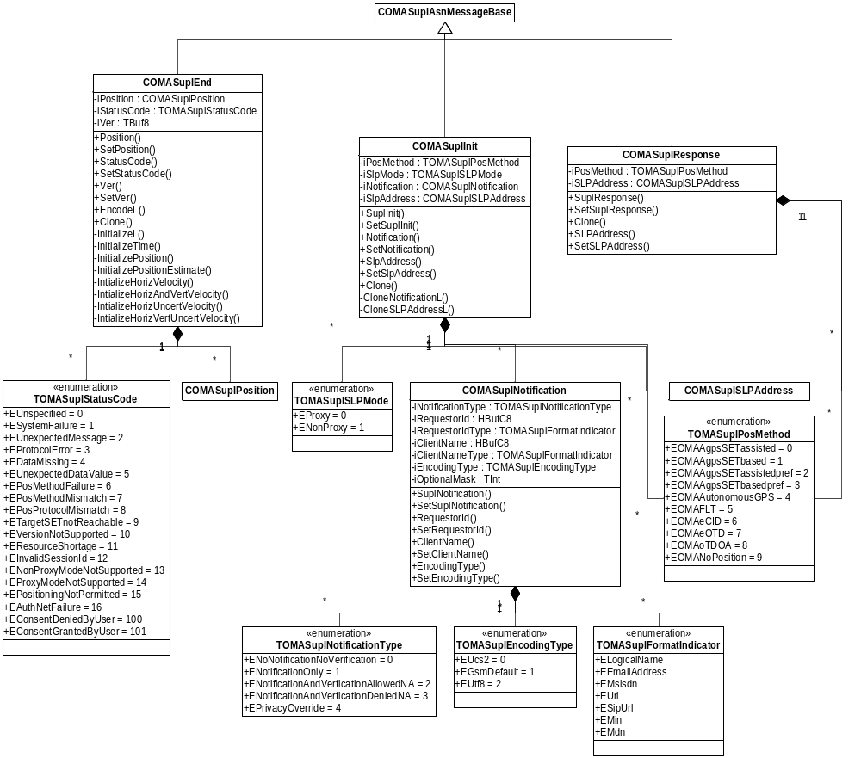
Figure 4.4 OMA SUPL ASN Converter class diagram

Class descriptions

Class | Description | Header file
COMASuplAsnMessageBase | Provides a base class for all SUPL messages. This class is responsible for encoding of the packets. | epos_comasuplasnmessagebase.h
COMASuplAsnDecoder | Class for decoding the received SUPL Packets. Returns an object of COMASuplAsnMessageBase. | epos_comasuplasndecoder.h
COMASuplStart | The implementation class for OMA SUPL START Message. This class is responsible for:  - Encoding of the SUPL START Message. | epos_comasuplstart.h
COMASuplInit | The implementation class for OMA SUPL INIT Message. | epos_comasuplinit.h
COMASuplPosInit | The implementation class for OMA SUPL POS INIT Message. This class is responsible for:  - Encoding of the SUPL POS INIT Message. | epos_comasuplposinit.h
COMASuplResponse | The implementation class for OMA SUPL RESPONSE Message. | epos_comasuplresponse.h
COMASuplPos | The implementation class for OMA SUPL POS Message. This class is responsible for:  - Encoding of the SUPL Pos Message | epos_comasuplpos.h
COMASuplEnd | The implementation class for OMA SUPL End Message. This class is responsible for:  - Encoding of the SUPL End Message | epos_comasuplend.h
COMASuplSessionID | The unique Session ID for a SUPL Session. There are two components for Session ID:  - SET Session ID  - SLP Session ID | epos_comasuplsessionid.h
COMASuplSETSessionID | Class for holding the SET part of the unique session ID. SET Session ID consists of  - A unique identification number.  - SET Address, which can be in the form of IPv4 or IPv6. | epos_comasuplsessionid.h
COMASuplSLPSessionID | Class for holding the SLP Part of the unique session id. It consists of  - Unique SLP ID  - SLP Address which can be in the form of IPv4, IPv6 or FQDN. | epos_comasuplsessionid.h
COMASuplSLPAddress | Class for holding SLP Address which can be in the form of IPv4,IPv6 or FQDN | epos_comasuplsessionid.h
COMASuplNotification | Class that holds Notification and Verification fields sent in SUPL INIT | epos_comasuplnotification.h

Structs, type definitions and enumerations
Class | Description | Header file
TSuplSETIDType | Enums for SETID Type, which can be in the form of:  - EIPv4Address  - EIPv6Address | epos_comasuplsessionid.h
TOMASuplVersion | Class for holding the version of SUPL messages. Version consists of major version, minor version, and service indicator. | epos_comasuplasnmessagebase.h
TSuplMessageType | Enums for type of SUPL message, which can be:  - ESUPL_INIT  - ESUPL_START  - ESUPL_RESPONSE  - ESUPL_POSINIT  - ESUPL_POS  - ESUPL_END | epos_comasuplasnmessagebase.h
TSuplSLPAddressType | Enums for SLP address type, which can be:  - EIPv4Address  - EIPv6Address  - EFqdn | epos_tomasuplsessionid.h
TOMASuplPosMethod | Enum for holding the pos methods which can be:  - EOMAAgpsSETAssisted  - EOMAAgpsSETBased  - EOMAAgpsSETAssistedPref  - EOMAAgpsSETBasedPref  - EOMAAutonomousGps  - EOMAFLT  - EOMAeCID  - EOMAeOTD  - EOMAoTDOA  - EOMANoPosition | epos_tomasuplposmethod.h
TOMASuplSLPMode | Enum of SLP mode which can be:  - EProxy  - ENonProxy | epos_comasuplinit.h
TOMASuplStatusCode | Enum for the status of position information, which can be:  - EUnspecified  - ESystemFailure  - EUnexpectedMessage  - EProtocolError  - EDataMissing  - EUnexpectedDataValue  - EPosMethodFailure  - EPosMethodMismatch  - EPosProtocolMismatch  - ETargetSETnotReachable  - EVersionNotSupported  - EResourceShortage  - EInvalidSessionId  - ENonProxyModeNotSupported  - EProxyModeNotSupported  - EPositioningNotPermitted  - EAuthNetFailure  - EConsentDeniedByUser  - EConsentGrantedByUser | epos_comasuplend.h
TOMASuplNotificationType | Enum for the type of notification  - ENoNotificationNoVerification  - ENotificationOnly  - ENotificationAndVerficationAllowedNA  - ENotificationAndVerficationDeniedNA  - EPrivacyOverride | epos_comasuplnotification.h
TOMASuplEncodingType | Enum for the type of encoding of location requestor and client in privacy  - EUCS2  - EGsmDefault  - EUtf8 | epos_comasuplnotification.h
TOMASuplFormat  Indicator | Enum for the type of requestor and client in privacy  - ELogicalName  - EEMailAddress  - EMsisdn  - EUrl  - ESipUrl  - EMin  - EMdn  - EIMSPublicIdentity | epos_comasuplnotification.h

Operations

Encoding a SUPL message
Operation | Encoding SUPL a message.
Preconditions | A SUPL message to be encoded is created and initialized. For example COMASuplStart.
Description | The CASN data structures are allocated memory. A validation of the data given for encoding is done in the classes implementing the SUPL message against the grammar before assigning them to the CASN data structures. Then the CASN tool is initialized using a call asnPerInit().The CASN data structure is given for encoding, which returns the encoded buffer. The encoded buffer is then converted to a descriptor and returned to the protocol handler. The ownership of the encoded buffer is transferred to the protocol handler.
Inputs | Depending on the packet type the input parameters vary. For example for SUPL START the input parameters are SET Capabilities and Location ID.
Modifies
Outputs | Encoded SUPL Packet, error code in case of encoding failure.
Postconditions | SUPL Message has been encoded.
Related To | Generation of SUPL Message.
Related Event
Exceptions | The encoding returns with the following error codes:  - KErrNoMemory – when the system runs out off memory.  - KErrArgument –when the parameter doesn’t lie in the constraint.  - KErrOMASuplManParamMissing – when mandatory parameter is missing in the message.

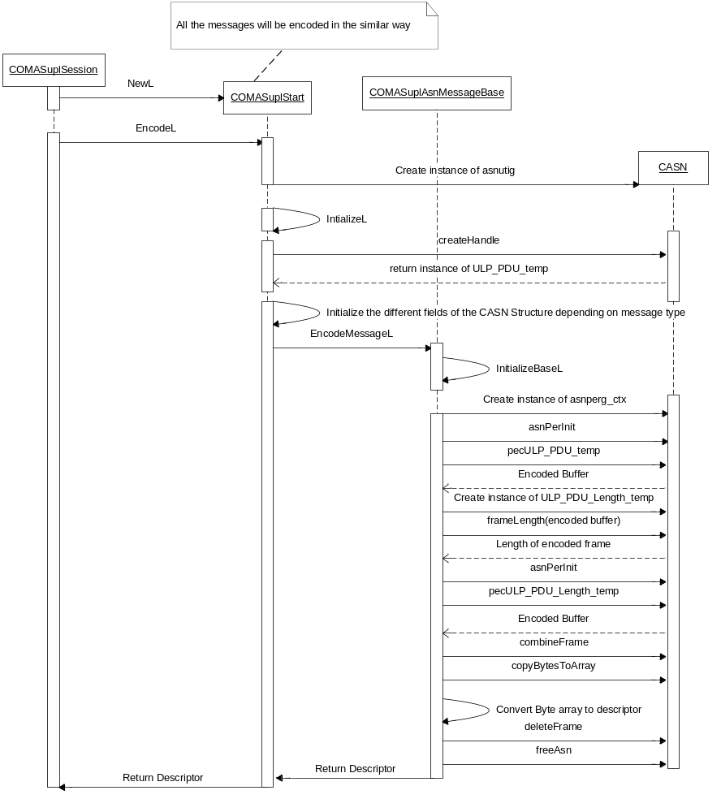
Figure 4.5 Encoding of SUPL message

Decoding a SUPL message
Operation | Decoding SUPL Init.
Preconditions | An encoded message is received from the network.
Description | The memory is allocated to the CASN data structures and then the CASN module is initialized using a call to asnPerInit(). The error recovery buffer is set to catch any decoding errors in the CASN module during decoding. After the decoding ID completed by the CASN module the wrapper initializes the C++ data structures with the corresponding CASN structures. The decoded message is returned to the protocol handler. The ownership of the decoded message is transferred to the protocol handler after decoding is completed. The complete packet given for decoding may not be consumed. The number of unconsumed bytes or the numbers of bytes which are not decoded are returned to the protocol handler.
Inputs | Encoded SUPL Packet.
Modifies
Outputs | Decoded SUPL message, error code in case of error, the number of unconsumed bytes.
Postconditions | Decoded SUPL message.
Related To | Receiving a message from network.
Related Event
Exceptions | Decoding can fail with the following error codes:  - KErrOMASuplInvalidMessage - when an invalid message is received from network.  - KErrNoMemory - when the system runs out off memory.  - KErrCompletion – for general decoding error.  - KErrOMASuplDecodeSessionFailed – when decoding of Session ID fails.

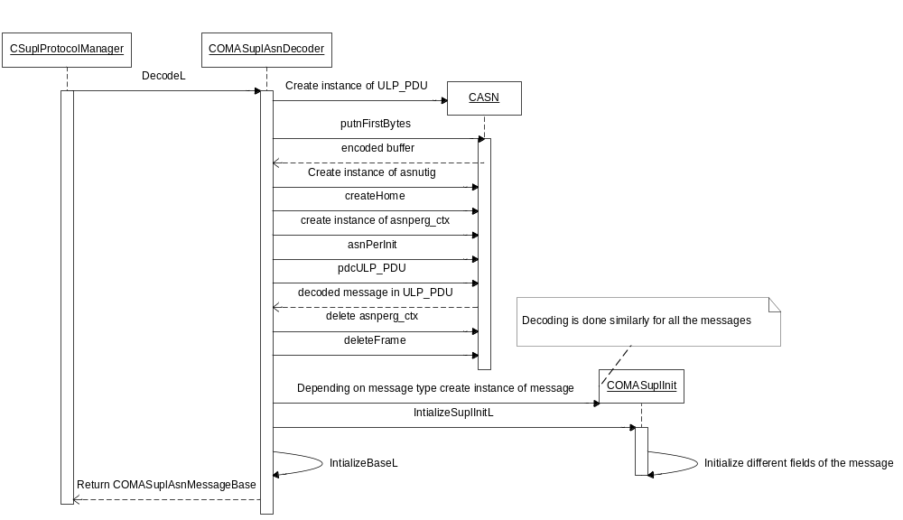
Figure 4.6 Decoding of a SUPL message

Variation
OMA SUPL ASN Converter does not support any variation mechanism other than application wide image creation time variation defined in reference document [1].
OMA SUPL ASN Converter is included in image creation only if __OMA_SUPL_PLUGINS is defined.

System resource usage

Database structures
OMA SUPL ASN Converter defines no database structures.

Memory consumption
The memory consumption for the WINSCW UDeb build.

Component | Consumption
eposomasuplasnconverter.dll | 679 KB
eposomasuplposmessageplugin.dll | 273 KB

The following table shows the component-wise memory consumption for the ARMV5 URel build.

Component | Consumption
eposomasuplasnconverter.dll | 35 KB
eposomasuplposmessageplugin.dll | 5 KB

Security

Capabilities of this component
Capability | Justification
CAP_GENERAL_DLL | Capability required by any S60 DLL.

Input and output validation
The CASN tool does not validate the ASN grammar while encoding. The C++ wrapper takes care of validating the data against the grammar before giving it for encoding. The CASN tool takes care of validating the data while decoding the message.

Environmental assumptions
This component does not make any assumptions about its environment.

Additional enforcements
This component does not have any additional security enforcements.

Exception handling
The CASN raises encoding and decoding errors and the C++ wrappers classes can handle these errors using the following mechanism:
- The decoding errors are handled using the longjmp –mechanism. In order to use this mechanism, the C++ wrapper classes first call setjmp for the buf-component of the ERR_RET error-handling buffer. The ERR_RET structure contains the buffer for error recovery. After that the error-handling buffer must be given as an argument to the asnPerInit()function that is called to initialize the CASN RTS for encoding/decoding. This enables the decoding functions to return to the wrapper code using longjmp when a decoding error occurs.
- The encoding errors are handled in a similar way. The application initializes an ERR_RET buffer with setjmp and passes the buffer to the asnSetFatalErrorHandler() function. The CASN RTS then calls longjmp when encountering a fatal error.

On encountering any errors from the CASN the ASN Converter can return with the following error codes:

Exception | Description
KErrArgument | ASN Converter was unable to encode due to an argument being out of range or invalid.
KErrNoMemory | The system was running out of memory.
KErrOMASuplInvalidMessage | An unexpected message received for decoding.
KErrCompletion | Decoding was aborted due to internal error.
KErrOMASuplDecodeSession  Failed | Decoding of session id failed.
KErrOMASuplManParamMissing | Mandatory parameter is missing in the message to be encoded.

Usage

Building
This section explains the components that are related to OMA SUPL ASN Converter. The directory paths are relative to /S60/locationomasuplprotocolhandler/.

Component name | Directory | MMP file name | DLL or EXE name
OMA SUPL ASN Converter | /asnconverter | epos_comaasnconverter.mmp | eposomasuplasnconverter.dll

Building is done by running the following commands in the \group subdirectory of the directory listed in the table:
bldmake bldfiles
abld build <TARGET>
where <TARGET> is one of winscw, or armv5

