S60 3.2
OMA SUPL Listener
Design Document

Team name | Author
Location Team | Sridhar Krishna, Venkatesh Sathyanarayana

Change history:

Version | Date | Status | Comments
1.0 | 08.05.2006 | Approved
2.0 | 21.08.2006 | Approved | Incorporated review comments

Table of contents:

1. Document control 4
1.1 References 4
1.2 Documentation conventions 4
1.3 Abbreviations 4
1.4 Definitions 4
2. General 6
2.1 Introduction 6
2.2 Component environment 6
2.3 Services required 7
2.3.1 From the Symbian OS subsystems 7
2.3.2 From Mobile Location Framework 7
2.3.3 From the Domestic OS subsystems 7
2.3.4 From HW 7
3. UI control hierarchy 8
4. Design 9
4.1 Class diagram 9
4.2 Class descriptions 9
4.2.1 State diagrams 10
4.2.1.1 OMA SUPL Listener 10
4.3 Operations 11
4.3.1 Initializing SUPL Listener 14
4.3.2 Initializing IMSI Observer 14
4.3.3 Handling IMSI Change 14
4.3.4 Listening for SMS 15
4.3.5 Processing Message 16
5. Variation 17
6. System resource usage 18
6.1 Files 18
6.2 Databases 18
6.3 Memory consumption 18
6.4 Task allocation 18
6.5 Performance 18
6.6 Timers 18
7. Security 19
7.1 Capabilities of this component 19
7.2 Input and output validation 19
7.3 Environmental assumptions 19
7.4 Additional enforcements 19
8. Exception handling 20
9. Usage 21
9.1 Building 21
9.2 User's guide 21

Document control

References
- S60 3.1 SUPL Subsystem Architecture Description
- S60 SUPL Subsystem Design Document
- S60 SUPL Network Initiation API Specification
- S60 SUPL Settings API Specification
- OMA SUPL TS | http://www.openmobilealliance.org
- OMA SUPL AD | http://www.openmobilealliance.org

Documentation conventions
Code is shown with the Courier New font.

Abbreviations
API | Application Programming Interface
CDMA | Code Division Multiple Access
FW | Framework
GSM | Global System for Mobile Communications
HW | Hardware
IPC | Inter-Process Communication
NW | Network
OMA | Open Mobile Alliance
OS | Operating System
SMS | Short Message Service
SLP | SUPL Location Platform
SUPL | Secure User Plane Location
SET | SUPL Enabled Terminal
UI | User Interface
UID | Unique Identifier
WCDMA | Wide-band CDMA
WDP | Wireless Datagram Protocol

Definitions
Framework | Usually denotes the collection of an engine and associated programming interfaces. This document mentions SUPL Framework and Symbian OS ECom Framework. There is also a subsystem in Symbian OS called Application Frameworks.
Platform Security | Definition for security design principles and features in Symbian OS.
Network Initiated Request | A Location Request originated by the SLP.
SUPL Enabled Terminal | A device that is capable of communicating with a SUPL network. Examples of this are UE in UMTS, MS in GSM or IS95.

General
This document describes the OMA SUPL Listener component of SUPL Framework. The SUPL Framework subsystem design is described in reference document [2] and the architecture is described in reference document [1].

Introduction
OMA SUPL Listener is a component responsible for forwarding SUPL INIT (see reference document[5]) requests received as SMS messages to SUPL Framework. These messages are received via the SMS system. The following points list the responsibilities of this component:
- During startup, SUPL Listener checks whether SUPL Feature is enabled or not in the terminal using Feature Manager API. If SUPL feature is not enabled, SUPL listener exits.
- Listens to incoming messages from WDP port as defined in reference document[5].
- Creates an IPC connection with the SUPL Server to forward received messages using SUPL Network Initiation API (see reference document [3]) and then terminates the connection.
- Reads IMSI changes that occur only as part of SIM change events. The SIM Utils APIs provide the necessary interfaces to access SIM information. The SUPL Listener component uses the KPSUidSimChanged key of the SIM Utils API to read the SIM change status
- Upon notification of a SIM change event this component checks for IMSI changes in the Central Repository using SUPL Settings API [4].
- Generates HSLP address from IMSI and updates Central Repository using SUPL Settings API when IMSI changes are detected.
- This component is started during device boot.

Component environment
Figure 2.1 shows the component and its relations in the SUPL Framework subsystem.
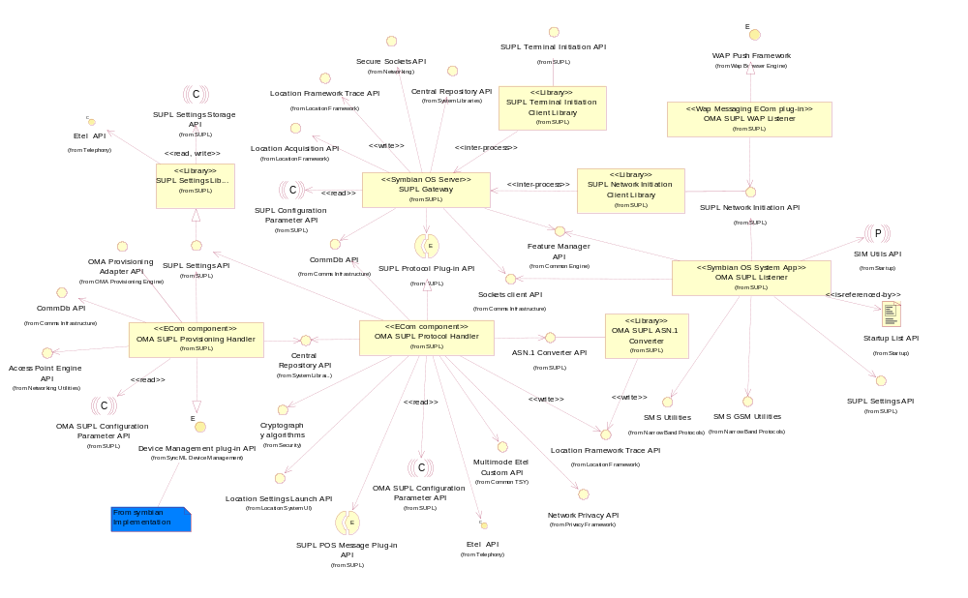
Figure 2.1 SUPL Framework component diagram

Services required

From the Symbian OS subsystems
SubSystem | Purpose
Base | Base provides the programming framework for all the other components of the Symbian OS. The SUPL subsystem uses Base for the basic data types, e.g. buffers, descriptors and arrays, active objects, process related calls, etc.  SUPL subsystem uses publish and subscribe API is used to listen to SIM change events.
SMS Utilities | The GSM and CDMA SMS utility provides the framework for sending and receiving SMS messages using the SMS stack respectively on GSM and CDMA networks. This framework provides necessary APIs for use with GSM and CDMA SMS stack.
Startup | The Startup subsystem is responsible for controlling the boot of a S60 device.  The SUPL subsystem makes use of the Startup subsystem to bring up the SMS listener process. The SMS Listener is listening to a standard WDP port, defined in the SUPL standard, for SUPL INIT messages from the network. It runs in an independent thread and has been started during the system boot-up.

From S60
SubSystem | Purpose
Location Framework | The Location Framework Trace API is used by the SUPL Listener to enable tracing in debug builds.

From the Domestic OS subsystems
This component does not have any direct interfaces to the Domestic OS side subsystems.

From HW
This component has no direct HW interfaces.

UI control hierarchy
The component does not contain any UI or UI controls design.

Design

Class diagram
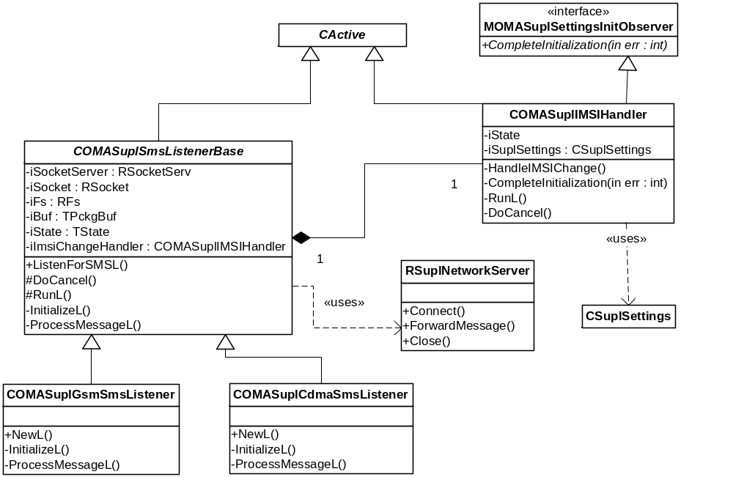
Figure 4.2 OMA SUPL Listener class diagram

Class descriptions
Class | Description | Header file
COMASUPLSms  ListenerBase | - This is the base class for SMS listener implementations for GSM and CDMA networks.  - This class provides implementations for the common functionalities required by both variants of SMS listener (CDMA and GSM).  - This class uses the RSocket class to read SMS packets arriving on the specific WDP port and performs the task of sending acknowledgements to the protocol upon successful receiving of a SMS message.  - This class uses NW Initiation API to forward SUPL INIT requests to the SUPL FW. | epos_comasuplsmslistenerbase.h
COMASuplGsmSmsListener | - This class specializes COMASUPLSmsListenerBase in providing functionalities pertaining to receive SMS messages on a GSM network.  - The functionalities provided are pertaining to set up socket client and process a message received on the GSM SMS stack. | epos_comasuplgsmsms  listener.h
COMASuplCdma  SmsListener | - This class specializes COMASUPLSmsListenerBase in providing functionalities pertaining to receive SMS messages on a CDMA network.  - The functionalities provided are pertaining to set up a socket client and process a message received on the CDMA SMS stack. | epos_comasuplcdmasms  listener.h
COMASuplIMSIObserver | - This class handles SIM Change events based on the notifications provided by the SIM Utils APIs.  - The functionality of this class involves reading the key KPSUidSimChangedValue to determine a SIM change status. In the event of a SIM change an instance of this class performs the following operations  - Subscribes to notifications provided to determine the completion of phone boot-up. This is done by using the Publish and Subscribe key KPSGlobalSystemState provided by the SIM Utils APIs  - Upon notification of the above mentioned event the instance of COMASuplSettings is created to update the SUPL Settings information.  - This class provides the functionality of verifying IMSI change, generating HSLP address based on the new IMSI value and updating the Central Repository with the new settings information.  - This class uses the COMASuplSettings class of the SUPL Settings API to perform the tasks mentioned above. | epos_comasuplimsiobserver.h

State diagrams

OMA SUPL Listener
Figure 4.3 depicts the states of OMA SUPL Listener on both GSM and CDMA networks.
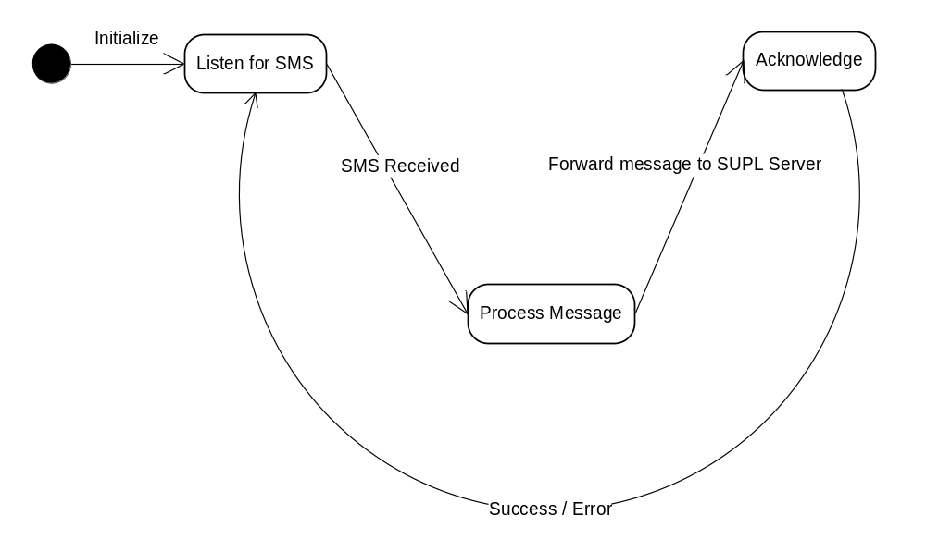
Figure 4.3 State machine describing the dynamic behavior of OMA SUPL Listener

The following diagram depicts the states of OMA SUPL Listener when handling SIM Change notifications on both GSM and CDMA networks

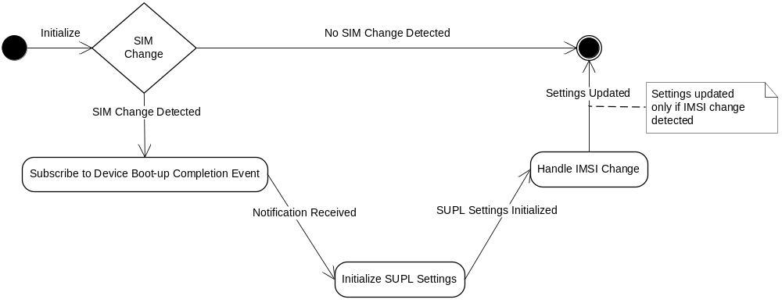
Figure 4.4 A state machine describing the dynamic behaviour of OMA SUPL Listener when handling SIM Change notifications

Operations
Figure 4.5 lists the operations of the OMA SUPL Listener component on both GSM and CDMA networks.
This component is started by the S60 Starter application during terminal boot-up. It is registered with the S60 Starter application in order to be launched during device boot. This is done by providing an entry in the Starter’s resource file Starter_Arm.rss. This entry in the resource file is described below:

APP_ITEM
{
path = supllistener;
type = EExecutableType;
monitored = EMonRestart;
}

- Path is the absolute path to the SUPL Listener executable. This path is specified by the supllistener macro which is defined as z:\sys\bin\epos_omasupllistener.exe.
- Type is the type of item registered with the starter.
- Monitored is the type of monitoring performed by the starter.

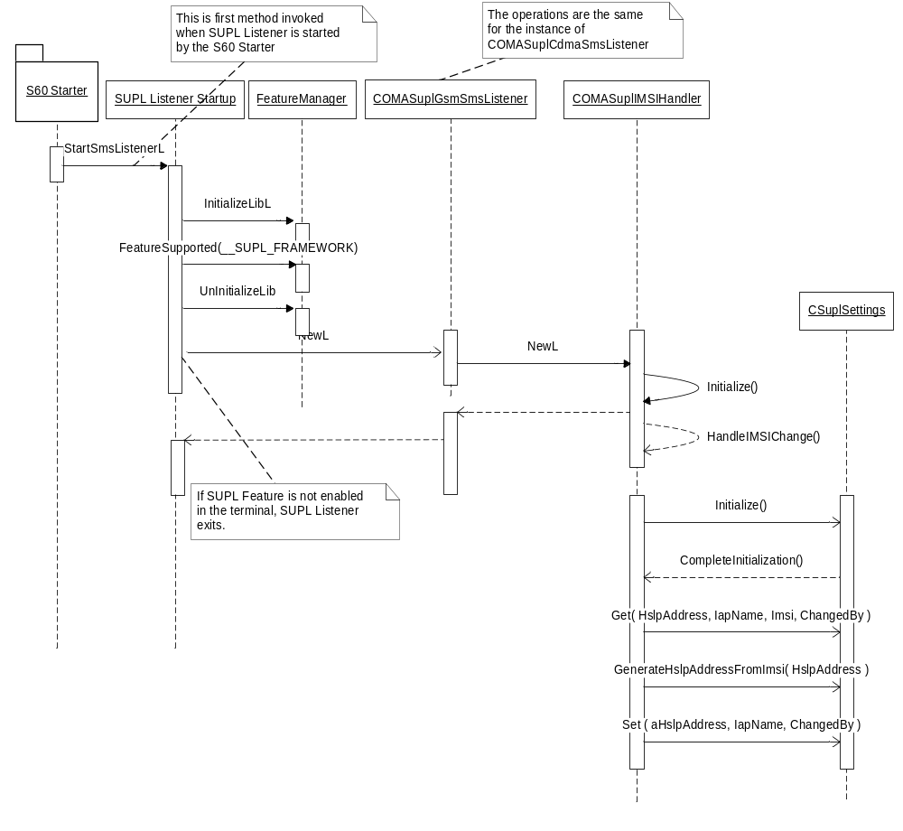
Figure 4.5 Operation of OMA SUPL Listener on GSM / CDMA networks

Initializing SUPL Listener
Operation | Initializing SUPL Listener
Preconditions | The SUPL Listener component is started by the S60 Starter application during device boot.
Description | During startup, SUPL Listener checks whether SUPL feature is enabled or not in the terminal using Feature Manager API.  During initialization SUPL Listener initializes the end point address of the socket by creating an instance of TSMSAddr (GSM) or TCdmaSmsAddr (CDMA) and setting the SMS address family for the socket to ESmsAddrApplication16BitPort (GSM) or ECdmaSmsAddrWdp (CDMA) respectively. It sets the port to the designated WDP port number as specified in reference document [5] and binds the socket to the address.
Inputs
Modifies
Outputs
Postconditions | The socket is bound to the designated WDP port 7275 and is ready to receive messages arriving on this port.
Related To
Related Event | Listening for SMS.
Exceptions | One of the system wide error codes – if binding of the socket to the specified WDP port fails.  If SUPL feature is not enabled in the terminal, SUPL Listener exits.

Initializing IMSI Observer
Operation | Initializing IMSI Observer
Preconditions | The SUPL Listener component is started by the S60 Starter application during device boot.
Description | This operation performs the task of reading the KPSUidSimChangedValue API of SIM Utils to determine SIM change status. If a change in SIM is detected then the operation sends a subscription for phone boot-up completation event. The operation issues an asynchronous request to be notified when the boot-up is completed. Upon notification of the above mentioned event, the operation sends a request to initialize an instance of CSuplSettings class to update the SUPL Settings information in the Central Repository.
Inputs | -
Modifies | -
Outputs | -
Postconditions | An instance of CSuplSettings class is initialized based on the SIM change status
Related To
Related Event | Handling SIM Change
Exceptions | One of the system wide error codes – if reading SIM Change status fails, if subscribing to phone boot-up completion event fails or when initializing CSuplSettings object fails

Handling IMSI Change
Operation | Handling IMSI Change
Preconditions | The SUPL Listener component is started by the S60 Starter application during device boot.
Description | This operation is triggered by a SIM Change event. This operation uses the instance of COMASuplSettings class to verify the IMSI change based on the SIM change, generate the HSLP address from the IMSI value and reset the SUPL settings information stored in the Central Repository. SUPL Settings information is updated only if IMSI change is detected.
Inputs | -
Modifies | Supl Settings information stored in the Central Repository  Internal state of COMASuplIMSIObserver. This internal state is read by the instance of COMASuplGsmSmsListener which accordingly terminates the active instance of COMASuplIMSIObserver when state is mentioned as EComplete
Outputs
Postconditions | The SUPL Settings information is updated
Related To | -
Related Event | -
Exceptions | -

Listening for SMS
Operation | Listening for SMS.
Preconditions | The SMS Listener component is initialized with the socket bound to a specific WDP port as specified in reference document [5].
Description | Waits for the event of a message to be available on the socket.
Inputs
Modifies | SUPL SMS Listener state.
Outputs
Postconditions | The SMS message is available on the socket to be processed.
Related To
Related Event
Exceptions

Processing Message
Operation | Processing Message
Preconditions | Message is available on the socket to be read
Description | Creates a buffer to contain the data read from the socket. Creates a stream to read the data into the buffer. It then creates an IPC connection with the SUPL server using the NW Initiation API and forwards the message to SUPL server. The IPC connection is closed once the message has been delivered to the SUPL Server.  The protocol is then acknowledged with KIoctlReadMessageSucceeded which indicates that the client received the messages. This causes the socket server to remove the message from the socket’s message stack thus allowing access to subsequent messages. Any errors caused during acknowledgement are ignored by the SUPL Listener component. Also, this acknowledgement to the socket server is sent even if the operation of forwarding the SUPL INIT request to the SUPL Server fails.
Inputs | An instance of the CSMSMessage class containing the data to be processed.
Modifies | SUPL SMS listener state.
Outputs
Postconditions | The payload information (SUPL INIT) is extracted from the SMS message and forwarded to SUPL Server.
Related To
Related Event
Exceptions | - KErrNoMemory in case of an error in creating the buffer for receiving the SMS message.  - Errors returned by NW Initiation API calls.

Variation
OMA SUPL Listener does not support any variation mechanism other than application wide image creation time variation defined in reference document [2].

System resource usage

Files
OMA SUPL Listener does not use any files.

Databases
This component does not use any databases.

Memory consumption
Memory/Build | Consumption
WINSW UDeb | 224 KB
ARMV5 URel | 2 KB

Task allocation
This component runs in the thread in which it is launched.

Performance
There is no significant performance impact on the SUPL subsystem due to this component.

Timers
This component does not make use of any timers.

Security

Capabilities of this component
Capability | Justification
ALL –Tcb | This component requires this capability in order to use SUPL NW Initiation API.
CommDD | This component requires this capability in order to use SUPL NW Initiation API.

Input and output validation
This component does not perform any input or output validations.

Environmental assumptions
This component does not make any assumptions about its environment.

Additional enforcements
This component does not have any additional security enforcements.

Exception handling
The leave mechanism of the Symbian OS environment is used to handle memory exhaustion. All errors encountered are logged and the component resumes normal operation.

Usage

Building
This section explains the components that are related to OMA SUPL Listener. The directory paths are relative to /S60/mw/locationservices/supl.

Component name | Directory | MMP file name | DLL or EXE name
supllistener | /locationomasuplprotocolhandler/supllistener | epos_omasupllistener.mmp | epos_omasupllistener.exe

Building is done by running the following commands in the \group subdirectory of the directory listed in the table:

bldmake bldfiles
abld build <TARGET> <BUILD>

where <TARGET> is one of winscw, or armv5 and <BUILD> could be one of UDeb or URel.

User's guide
This component is not used by other components.

