S60 3.2
OMA SUPL WAP Listener
Design Document

Team name | Author
 | Suprabha Mysore

Change history:

Version | Date | Status | Comments
1.0 | 02.05.2006 | Approved

Table of contents:

1. Document control 4
1.1 References 4
1.2 Documentation conventions 4
1.3 Abbreviations 4
1.4 Definitions 4
2. General 5
2.1 Introduction 5
2.2 Component environment 5
2.3 Services required 6
2.3.1 From the Symbian OS subsystems 6
2.3.2 From the Domestic OS subsystems 6
2.3.3 From HW 6
3. UI control hierarchy 7
4. Design 8
4.1 Class diagram 8
4.2 Class descriptions 8
4.2.1 State diagrams 9
4.2.1.1 COMASuplWapListener 9
4.3 Operations 9
4.3.1 Loading of OMA SUPL WAP Listener 10
4.3.2 Handle WAP Push Message 11
4.3.3 Process Push Message 11
4.3.4 Forward SUPL Request 11
5. Variation 13
6. System resource usage 14
6.1 Files 14
6.2 Databases 14
6.3 Memory consumption 14
6.4 Task allocation 14
6.5 Performance 14
6.6 Timers 14
7. Security 15
7.1 Capabilities of this component 15
7.2 Environmental assumptions 15
7.3 Additional enforcements 15
8. Exception handling 16
9. Usage 17
9.1 Building 17
9.2 User's guide 17

Document control

References
- S60 3.1 SUPL Subsystem Architecture Description
- S60 SUPL Subsystem Design Document
- OMA SUPL TS v1.0 (http://www.openmobilealliance.org/)

Documentation conventions
Code is shown with the Courier New font.

Abbreviations
API | Application Programming Interface
FW | Framework
HW | Hardware
IPC | Inter Process Communication
NW | Network
OMA | Open Mobile Alliance
OS | Operating System
SET | SUPL Enabled Terminal
SLP | SUPL Location Platform
SUPL | Secure User Plane Location
SW | Software
UI | User Interface
UID | Unique Identifier
URI | Uniform Resource Identifier
WAP | Wireless Application Protocol

Definitions
ECom | Framework defined in Symbian OS for realizing plug-in architectures.
Framework | Usually denotes the collection of an engine and associated programming interfaces. This document mentions the SUPL Framework and the Symbian OS ECom Framework. There is also a subsystem in Symbian OS called Application Frameworks.
Platform Security | Definition for security design principles and features in Symbian OS.
Terminal Initiated Request | A Location Request originated by the SUPL Enabled Terminal.
Network Initiated Request | A Location Request originated by SLP.

General
This document describes the OMA SUPL WAP Listener component of SUPL Framework. The SUPL Framework subsystem design is described in reference document [2] and the architecture is described in reference document [1].

Introduction
OMA SUPL WAP Listener is an ECom plug-in that is mainly responsible for forwarding SUPL INIT messages (see reference document [3]) received as WAP Push messages to SUPL Gateway. Other responsibilities include:
- Register for listening WAP Push messages identified by the OMA specified application ID:
x-oma-application:ulp.ua.
- Create IPC connection with SUPL Gateway to forward received messages using SUPL Network Initiation API.

Component environment
Figure 2.1 shows the components and their relations in the SUPL Framework subsystem.
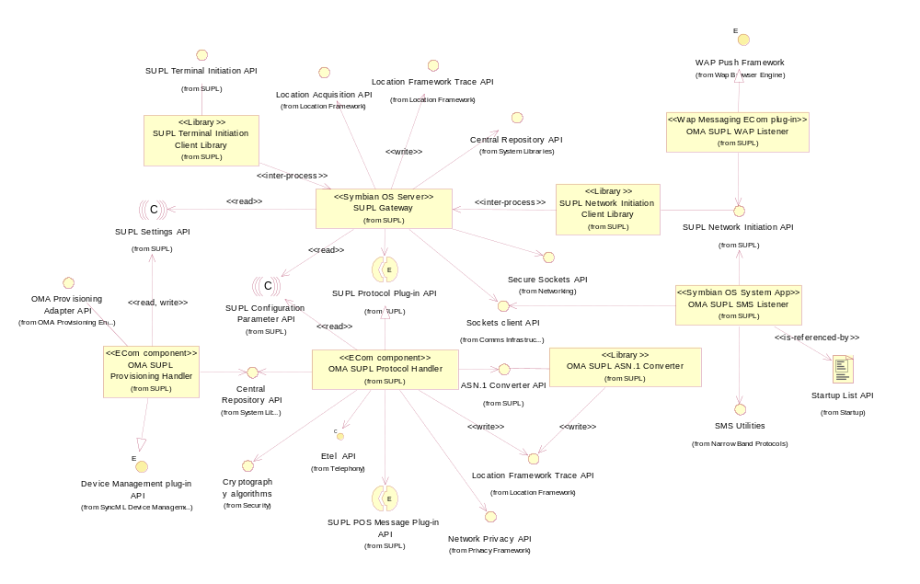
Figure 2.1 SUPL Framework component diagram

Services required

From the Symbian OS subsystems
SubSystem | Purpose
Base | Base provides the programming framework for all the other components of the Symbian OS. The SUPL subsystem uses the Base for the basic data types, e.g. buffers, descriptors and arrays, active objects, process related calls, etc.
App Protocols | The Application Protocols subsystem provides various application level utilities such as the ECom plug-in architecture providing a generalized mechanism to plug-in different DLLs.
WAP Push Framework | WAP Push Framework provides the necessary interfaces for handling Wap Push messages containing SUPL INIT messages from the network.

From the Domestic OS subsystems
This component does not have any direct interfaces to the Domestic OS side subsystems.

From HW
This component has no direct HW interfaces.

UI control hierarchy
The component does not contain any UI or UI controls design.

Design

Class diagram
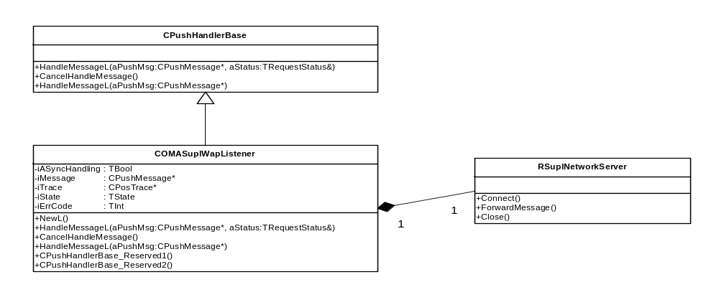
Figure 4.2 OMA SUPL Wap Listener class diagram

Class descriptions
Class | Description | Header file
CPushHandlerBase | - This is an abstract base class for WAP Push plug-ins provided by Symbian WAP Push Framework.  - This class provides the necessary interfaces to handle WAP push messages. | CPushHandlerBase.h
COMASuplWap  Listener | This class implements a WAP Push plug-in. The following points show the responsibilities:  - It registers for listening WAP PUSH messages identified by the application ID  x-oma-application:ulp.ua.  - Extracts the SUPL INIT message.  - Creates an IPC connection with the SUPL server, forwards the message and closes the IPC connection. | epos_comasuplwaplistener.h

State diagrams

COMASuplWapListener
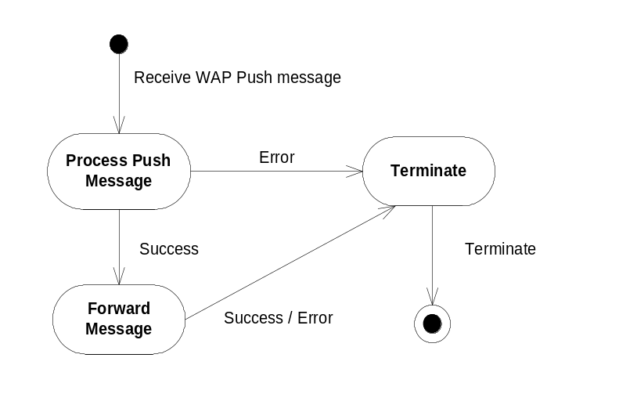
Figure 4.3 State machine describing the dynamic behavior of COMASuplWapListener.

Operations
Figure 4.4 shows the working of the WAP Listener plug-in.
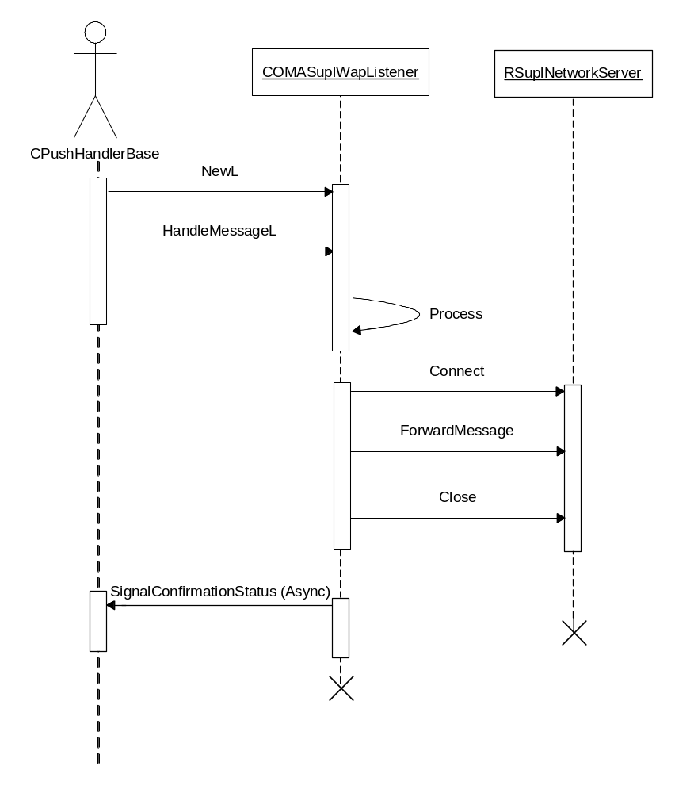
Figure 4.4 Operation of OMA SUPL WAP Listener plug-in

Loading OMA SUPL WAP Listener
Operation | Loading the WAP Listener plug-in.
Preconditions | The WAP Push FW is initialized
Description | The registry file of the SUPL WAP Listener plug-in specifies the application ID for which the Push messages are to be handled. This value is specified in the default_data field of IMPLEMENTATION_INFO. When the WAP Push framework receives a PUSH message, it examines the application ID and then loads the plug-in by using its factory method NewL.
Inputs
Modifies
Outputs
Postconditions | WAP Push Framework has loaded the SUPL WAP Push Listener plug-in and passed the Push message.
Related To
Related Event | A WAP Push message with the application ID x-oma-application:ulp.ua is received by the WAP Push Framework.
Exceptions

Handling WAP Push Message
Operation | Handling WAP Push Message.
Preconditions | The OMA SUPL WAP Listener plug-in is loaded by WAP Push Framework of Symbian.
Description | Stores Request Status is passed (only in case of asynchronous call) and initializes to Request Pending. Takes ownership of the push message and initiates processing of the message.
Inputs | Push Message, Request Status (only in case of asynchronous call).
Modifies | SUPL Wap listener state.
Outputs
Postconditions | The WAP message is stored internally by the plug-in.
Related To
Related Event | The WAP message received is passed to the plugin to handle the specific content.
Exceptions | A panic occurs with KPushMsgNull if in case of invalid argument.

Processing Push Message
Operation | Processing Push Message.
Preconditions | WAP Push framework has passed the WAP payload.
Description | Extracts the payload information sent as a WAP Push message. It then invokes the send method to forward the payload information to the SUPL Server.
Inputs | Extracted SUPL INIT request.
Modifies | SUPL Wap listener state.
Outputs
Postconditions | The payload information, if present, is extracted and forwarded to SUPL server using the NW Initiation API. Otherwise the error code KErrNotFound is set and the WAP message is discarded.
Related To
Related Event | A WAP message is available for the plug-in to process.
Exceptions | If in case of an empty payload an error is logged and the plug-in terminated.

Forwarding SUPL Request
Operation | Forwarding SUPL Request.
Preconditions | The SUPL payload information is extracted from the Push message.
Description | Creates an IPC session with the SUPL Server and forwards the payload information. A connection to the SUPL Server is established, the payload forwarded and the connection closed using the Connect, ForwardMessage and Close methods of the RSuplNetworkServer class of NW Initiation API.
Inputs | SUPL payload.
Modifies
Outputs
Postconditions | An IPC connection is established and the payload is delivered to the SUPL Server. The session is closed immediately after the SUPL INIT message is forwarded to the SUPL Server.
Related To
Related Event | The SUPL INIT request is extracted from the WAP message.
Exceptions | Error code returned by SUPL NW Initiation API.

Variation
OMA SUPL Wap Listener does not support any variation mechanism other than application wide image creation time variation defined in reference document [2].

System resource usage

Files
OMA SUPL WAP Listener provides a resource file containing the ECom registration information. The format of the resource file is as follows:

Resource name | Purpose | Default value
Component: OMA SUPL WAP Listener
Resource file: 102073D3.rss
interface_uid | Provides the interface UID reserved for WAP Push Framework. | 0x102073D3
implementation_uid | Provides the implementation UID of the ECom plug-in. | 0x1027509F
Version | Provides version information. | 1.0
Display Name | A string that identifies the plug-in. | OMA SUPL Wap Listener

Databases
This component does not use any databases.

Memory consumption
Memory/Build | Consumption
WINSW UDeb | 197,849 bytes
ARMV5 URel | 1,998 bytes

Task allocation
This component runs in the thread in which it is launched.

Performance
There is no significant performance impact on the SUPL subsystem due to this component.

Timers
This component does not make use of any timers.

Security

Capabilities of this component
Capability | Justification
CAP_ECOM_PLUGIN | {ALL –Tcb} All capabilities granted except Tcb.

Environmental assumptions
This component does not make any assumptions about its environment.

Additional enforcements
This component does not have any additional security enforcements.

Exception handling
The leave mechanism of Symbian OS environment is used to handle memory exhaustion:

Exception | Description
KErrNotFound | SUPL WAP Listener was unable to extract the payload information.
KPushMsgNull | Panics when an invalid argument is passed to HandleMessageL by WAP Push Framework.

Usage

Building
This section explains the components that are related to OMA SUPL WAP Listener. The directory paths are relative to /s60/mw/locationservices/supl/locationomasuplprotocolhandler.

Component name | Directory | MMP file name | DLL or EXE name
OMA SUPL WAP Listener | /locationomasuplprotocol  handler/waplistener | epos_omasuplwaplistener.mmp | epos_omasuplwap  listener.dll

Building is done by running the following commands in the /group subdirectory of the directory listed in the table:
bldmake bldfiles
abld build <TARGET>
where <TARGET> is one of winscw, or armv5.

User's guide
This application is not used by other components.

