S60 5.2
OMA SUPL Provisioning and
SyncML DM Handler
Design Document

Team name | Author
Location Technology Team | Suprabha Mysore

Change history:

Version | Date | Status | Comments
1.0 | 01.06.2006 | Approved
2.0 | 04.08.2009 | Approved | Changes for CMCC New MO.

Table of contents:

1. Document control 4
1.1 References 4
1.2 Documentation conventions 4
1.3 Abbreviations 4
1.4 Definitions 5
2. General 6
2.1 Introduction 6
2.2 Component environment 7
2.3 Services required 8
2.3.1 From the Symbian OS subsystems 8
2.3.2 From the S60 Provisioning subsystem 8
2.3.3 From the Domestic OS subsystems 8
2.3.4 From HW 8
2.4 Services provided 8
2.4.1 UI 8
2.4.2 SW IF 8
3. UI control hierarchy 9
4. Design 10
4.1 Class diagram 10
4.2 Class descriptions 12
4.3 Operations 14
4.3.1 Importing data to SUPL Provisioning Handler 14
4.3.2 Retrieving summaries from SUPL Provisioning Handler 15
4.3.3 Saving data in SUPL Provisioning Handler 17
4.3.4 Filling the DDF structure 19
4.3.5 Version query 20
4.3.6 Fetching the URI list 21
4.3.7 Fetching a settings value 22
4.3.8 Updating a settings value – non atomic 23
4.3.9 Updating a settings value – atomic 25
5. Variation 27
6. System resource usage 28
6.1 Files 28
6.2 Databases 29
6.2.1 Central Repository 29
6.3 Memory consumption 29
6.4 Task allocation 29
6.5 Performance 29
6.6 Timers 29
7. Security 30
7.1 Capabilities of this component 30
7.2 Environmental assumptions 30
7.3 Additional enforcements 30
8. Exception handling 31
9. Usage 32
9.1 Building 32
9.2 User's guide 32

Document control

References

- S60 SUPL Subsystem Architecture Description
- S60 SUPL Subsystem Design Document
- S60 OMA Provisioning Design Document
- OMA SUPL Client Provisioning TS | http://www.openmobilealliance.org/release_program/supl_v1_0.html
- SyncML Device Management Standardised Objects | http://www.openmobilealliance.org/tech/affiliates/syncml/syncml_dm_std_obj_v11_20020215.pdf
- SyncML Representation Protocol Device Management Usage Version 1.1.2 | http://www.openmobilealliance.org/release_program/docs/CopyrightClick.asp?pck=DM&file=V1_1_2-20040113-A/OMA-SyncML-DMRepPro-V1_1_2-20030613-A.pdf

Documentation conventions
Code is shown with the Courier New font. Emphasized body text is underlined.

Abbreviations

API | Application Programming Interface
APN | Access Point Name
DDF | SyncML Device Description Framework (see reference document [5])
DM | Device Management
FW | Framework
HSLP | Home SLP
HW | Hardware
IAP | Internet Access Point
IPC | Inter Process Communication
NW | Network
OMA | Open Mobile Alliance
OS | Operating System
SET | SUPL Enabled Terminal
SLP | SUPL Location Platform
SUPL | Secure User Plane Location
SW | Software
SyncML | Synchronization Markup Language
UI | User Interface
UID | Unique Identifier
URI | Uniform Resource Identifier
WAP | Wireless Application Protocol

Definitions

ECom | Framework defined in Symbian OS for realizing plug-in architectures
Framework | Usually denotes the collection of an engine and associated programming interfaces. This document mentions the SUPL framework and the Symbian OS ECom framework. There is also a subsystem in Symbian OS called Application Frameworks
Platform Security | Definition for security design principles and features in Symbian OS
Client Provisioning | An act of acquiring service or configuring it for use
Device Management | Device management i.e. a framework through which mobile application settings can be added, deleted and updated

General
This document describes OMA SUPL Provisioning and the SyncML DM components of the SUPL framework. The SUPL framework subsystem design is described in reference document [2] and architecture is described in reference document [1].

Introduction
The SUPL subsystem may be remotely configured by the operator in one of two ways. These are
- Sending a SUPL Provisioning message containing the settings parameters
- Sending the SUPL settings using SyncML DM

A SUPL provisioning message contains the HSLP address and / or the corresponding APN reference to be used by the SUPL subsystem.
A SUPL DM message contains one of the settings mentioned in the table below.
The OMA SUPL Provisioning handler and the OMA SUPL SyncML DM handler are two components responsible for handling SUPL Provisioning messages (see reference document [4]) and DM settings, respectively.
The SUPL Provisioning handler is an ECom plug-in that implements the S60 Provisioning Adapter interface (see reference document [3]). The OMA SUPL SyncML DM Handler is also an ECom plug-in that implements the SyncML DM adapter interface. These adapters use the SUPL settings API to save the settings information into the SUPL Settings Database.
The OMA SUPL provisioning message (see reference document [4]) containing the SUPL settings information is received as a configuration message in the Inbox of the device which is saved explicitly by the user. In case of DM, a DM server provides the SUPL settings to be stored on the client device. In order to do this the client device exposes its internal data to the DM server by providing a hierarchical tree structure of the objects to be managed. These objects are uniquely addressed by the URI. The management objects that are provided by the OMA SUPL SyncML DM handler are

Name of the parameter | URI
AGPS server ID | ./Supl/ProviderID
AGPS server name | ./Supl/Name
Default APN | ./Supl/PrefConRef
Other APN | ./Supl/ToConRef
Other APN | ./Supl/ConRef
Address Type | ./Supl/AddrType
AGPS Server Addres | ./Supl/SLP

The structure of the DM tree is shown below.

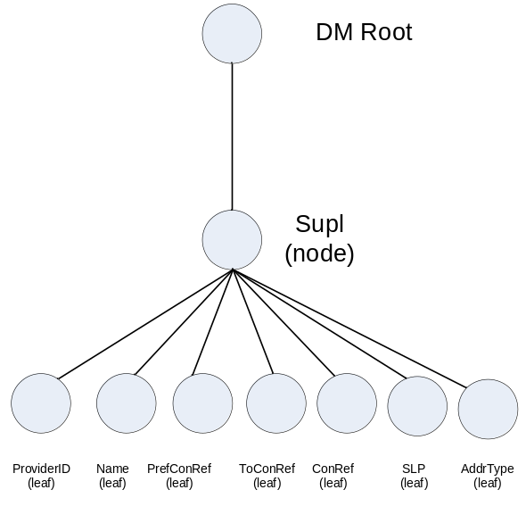
Figure 2.1 SUPL DM tree structure

Component environment
Figure 2.2 shows the components and their relations in the SUPL FW subsystem.

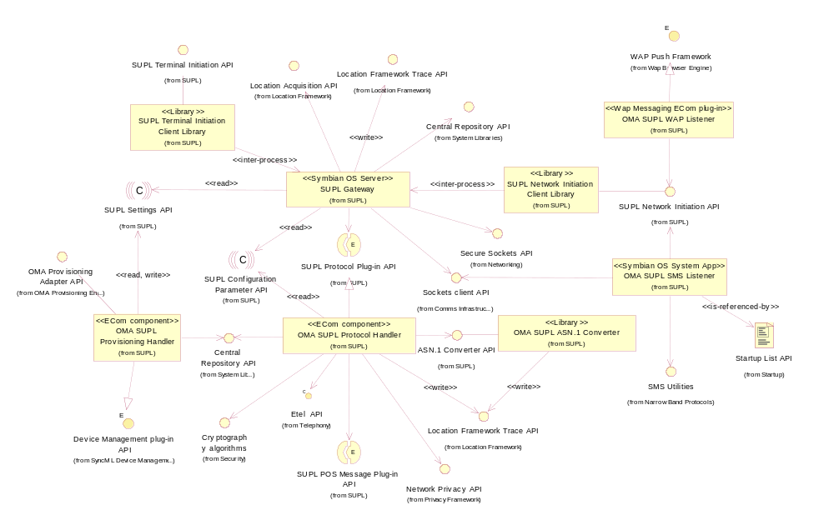
Figure 2.2 SUPL FW component diagram

Services required

From the Symbian OS subsystems

SubSystem | Purpose
Base | Base provides the programming framework for all the other components of the Symbian OS. The SUPL subsystem uses the Base for the basic data types like buffers, descriptors and arrays, active objects, process related calls etc.
App Protocols | The Application Protocols subsystem provides various application level utilities such as the ECom plug-in architecture providing a generalized mechanism to plug-in different DLLs.
System Libraries | The OMA SUPL Provisioning Handler uses SQL APIs to store the settings information which are SLP Address and APN.
SyncML Client FW | Provides the necessary interfaces to implement Device Management adapter plug-ins.

From the S60 Provisioning subsystem
The S60 Provisioning subsystem provides the necessary interface for the implementation of Provisioning adapters. The OMA SUPL Provisioning hander uses the Provisioning Engine for accessing the characteristic and parameter data containing the SUPL settings that form the provisioning message (see reference document [4]).

From the Domestic OS subsystems
OMA SUPL Provisioning and SyncML DM components do not have any direct interfaces to the Domestic OS side subsystems.

From HW
OMA SUPL Provisioning and SyncML DM components have no direct HW interfaces.

Services provided

UI
The OMA SUPL Provisioning Handler and OMA SUPL SyncML DM handler components do not provide any UI services.

SW IF
The OMA SUPL Provisioning Handler and OMA SUPL SyncML DM handler components do not provide services for other components.

UI control hierarchy
The OMA SUPL Provisioning and SyncML DM components do not contain any UI or UI controls design

Design

Class diagram

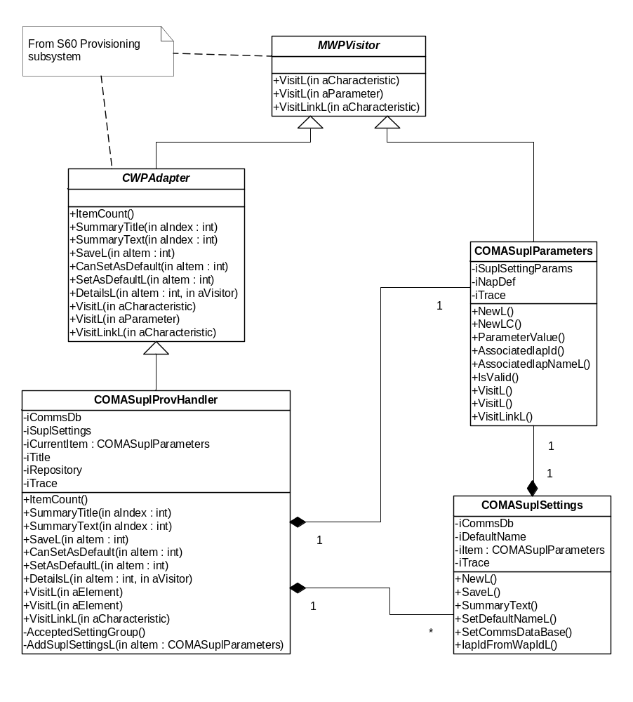
Figure 4.3 OMA SUPL Provisioning handler class diagram
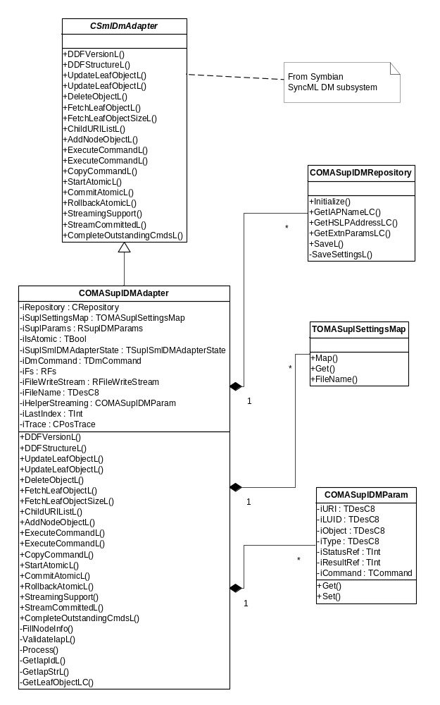
Figure 4.4 OMA SUPL SyncML DM handler class diagram

Class descriptions
Class descriptions for OMA SUPL Provisioning handler

Class | Description | Header file
COMASuplProvHandler | - This is the main adapter class that handles SUPL provisioning settings  - This class implements CWPAdapter which is the interface class for all OMA Provisioning adapter implementations.  - This class contains an array of instances of COMASuplSettings class each of which representing one complete provisioning message. | epos_comasuplprovhandler.h
COMASuplParameters | - This class represents the SUPL settings information provided in a provisioning message.  - The characteristic and contained parameter values are stored by the instance of this class. | epos_comasuplparameters.h
COMASuplSettings | - This is a container class for an instance of COMASuplParameters.  - This class also maintains house keeping information such as the Summary Text and the default name of the provisioned setting which are retrieved by the Provisioning engine. | epos_comasuplsettings.h

Class descriptions for OMA SUPL SyncML DM handler

Class | Description | Header file
COMASuplDMAdapter | An instance of this class is used by the SyncML framework to handle operations related to Supl settings update in SUPL Settings Database when SUPL DM settings are provided by the operator.  This class implements the CSmlDmAdapter which is the main interface class for all implementations of SyncML DM adapters.  There are two modes of operation which are  - Atomic in which case the updates to SUPL settings are transaction based. This is used when the command ‘Atomic’ (see reference document [6]) is specified in the DM setting message.  - Non-atomic where updates to SUPL Settings are not transaction based. | epos_comasupldmadapter.h
TOMASuplSettingsMap | This class provides the implementations to map the URI provided in a DM command sent from SyncML DM framework to the object in the DDF structure hierarchy. This class is utilized by the COMASuplDMAdapter adapter class to access the leaf objects specified in a DM command. | epos_tomasuplsettingsmap.h
COMASuplDMRepository | - Performs buffering of settings until Server Name parameter is received.  - Writes settings to the settings using Settings API. | epos_comasupldmrespository.h
COMASuplDMParam | This class stores commands (see reference document [6]) and inputs to be used in atomic mode only. When atomic mode is on then all the DM commands received in the DM settings message provided by the operator are buffered and processed inside CompleteOutstandingCmdsL() of COMASuplDMAdapter one at a time. | epos_comasupldmparam.h

Operations
OMA SUPL Provisioning Handler
The operations of OMA SUPL Provisioning handler are listed below. The sequence diagrams shown for each of the operations depict the APIs exposed by the CWPAdapter interface of S60 Provisioning Framework. The details of these APIs can be seen in reference document [3].

Importing data to SUPL Provisioning Handler

Operation | Importing data to SUPL Provisioning Handler.
Preconditions | Provisioning Engine has loaded SUPL Provisioning Handler by instantiating an instance of COMASuplProvHandler and starts to import data using the visitor pattern.
Description | The contents of the OMA Provisioning message provided by the operator is parsed by the Provisioning Engine and the SUPL setting information containing the APN and SLP address are imported to OMA SUPL Provisioning Handler. Importing of SUPL settings information uses the Visitor pattern, defined by the MWPVisitor interface class (see reference document [3]).  The SUPL Provisioning handler is concerned with only one type of characteristic: ULP as defined by the APPID parameter of the APPLICATION characteristic (see reference document [4]) mentioned in the provisioning message. For each characteristic APPLICATION containing the parameter APPID with the value “ULP” SUPL Provisioning Handler creates an instance of COMASuplParameters and further importing of data is done by this class. SUPL Provisioning Handler also creates an instance of the corresponding container class COMASuplSettings for each instance of COMASuplParameters. The array of COMASuplSettings representing each APPLICATION characteristic is stored in the array by the provisioning handler.
Inputs | Instance of the CWPCharacteristic class.
Modifies | COMASuplParameters, COMASuplSettings.
Outputs
Postconditions | An array of COMASuplSettings is created.
Related To | The classes CWPCharacteristic and CWPParameter.
Related Event | 4.3.3.
Exceptions | Leaves with one of the system wide error codes - all errors occurring are propagated to the Provisioning engine.

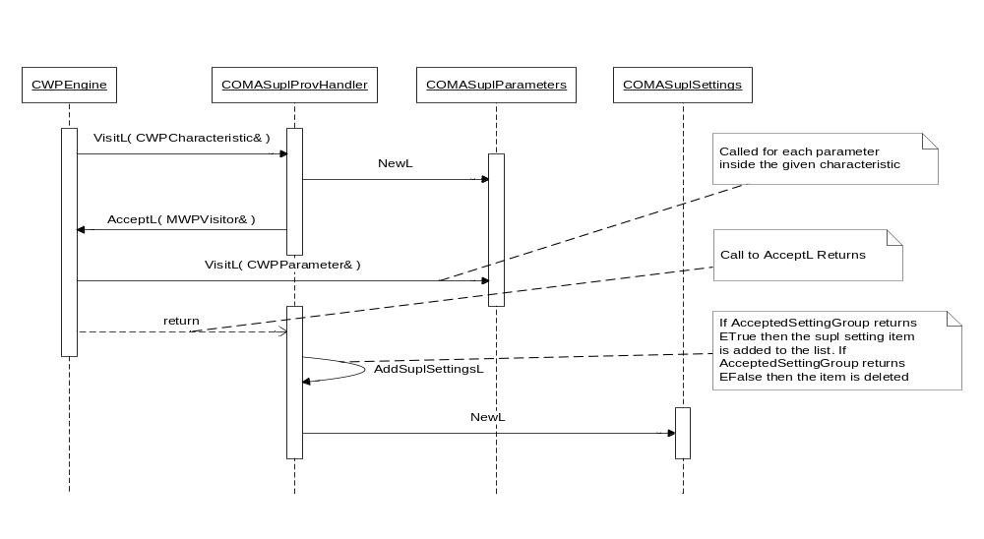
Figure 4.5 Importing data to SUPL Provisioning Handler

Retrieving summaries from SUPL Provisioning Handler

Operation | Retrieving summaries from SUPL Provisioning Handler.
Preconditions | Data has been imported to SUPL Provisioning Handler.
Description | When the user chooses to open a SUPL Provisioning message provided by the operator, the Provisioning engine requests the Provisioning message’s summary from SUPL Provisioning Handler. This summary describes the provider details as mentioned in the Provisioning message.  CWPEngine of the client Provisioning engine FW requests the item count from SUPL Provisioning Handler. It then requests the summary title and text for each item.
Inputs
Modifies
Outputs | The summary title and summary text for each SUPL setting provided in the Provisioning message.
Postconditions | Summary is seen on the UI.
Related To
Related Event | 4.3.3.
Exceptions

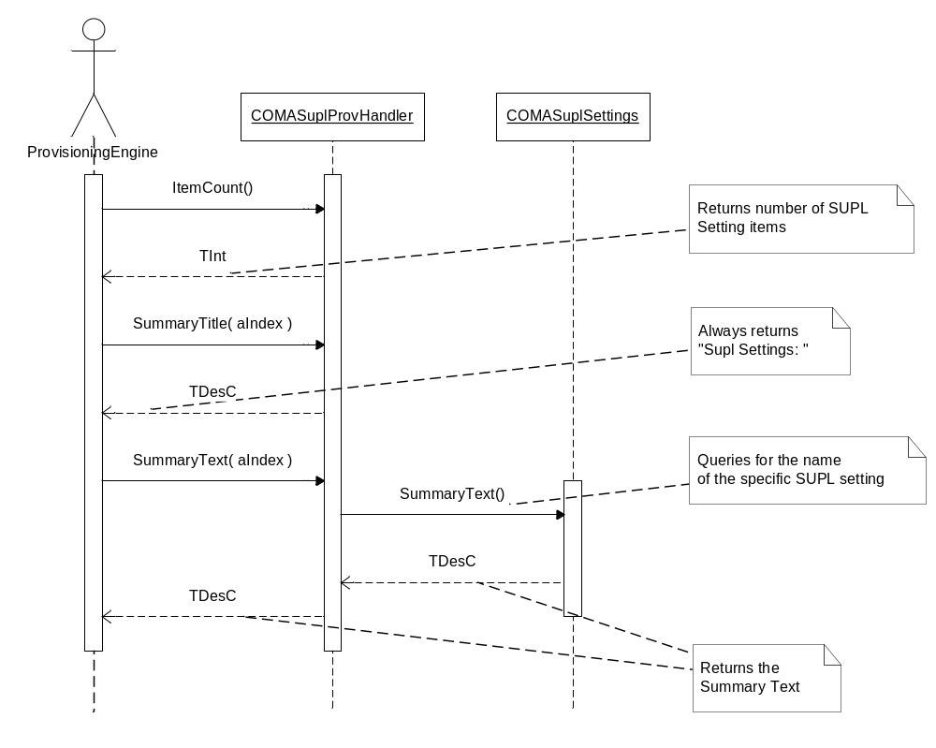

Figure 4.6 Retrieving summaries from SUPL Provisioning Handler

Saving data in SUPL Provisioning Handler

Operation | Saving data in SUPL Provisioning Handler.
Preconditions | Data has been imported successfully and SUPL Provisioning Handler contains items to be saved. The Access Point items provisioned along with the SUPL settings are saved in the Comms DB by the S60 Access Point adapter.
Description | CWPEngine calls the SaveL method for each setting item in the SUPL Provisioning message times. SaveL has an integer parameter that indicates that the adapter should store that particular item. SUPL Provisioning Handler then calls the COMASuplSettings SaveL method. This method retrieves the IAP ID as stored in the Comms database for the access point setting provisioned along with the SUPL settings and retrieves the associated IAP name. It then stores the SLP address and the associated IAP name into SUPL Settings Database.
Inputs
Modifies | SUPL settings.
Outputs
Postconditions | The updated SUPL settings are stored in SUPL Settings Database.
Related To
Related Event | 4.3.1.
Exceptions | KErrNotFound in case of an error while retrieving the IAP ID from the Comms database, the SaveL method leaves with this error code.  Leaves with one of the system wide error codes in case of errors while saving settings into SUPL Settings Database.  All errors are propagated to the Provisioning engine.

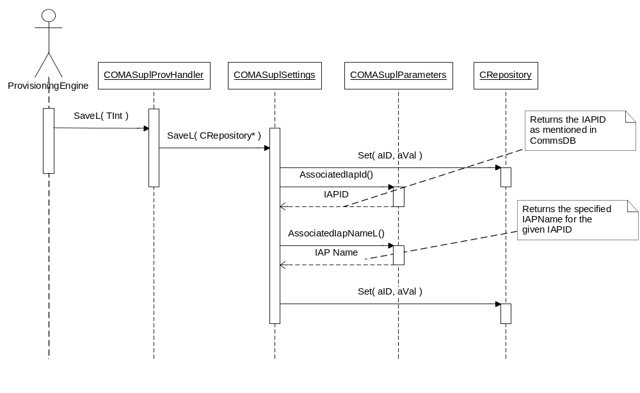
Figure 4.7 Saving data in SUPL Provisioning adapter
OMA SUPL SyncML DM Handler
The operations of OMA SUPL SyncML DM handler are listed below. The DM commands that can be provided as part of a DM message can be a combination of Get, Add, Delete, Replace, Exec and Copy (see reference document [6]). Of these listed commands, only the Get and Replace commands are applicable to the SUPL SyncML DM handler component.
When SUPL DM settings are provisioned by the operator, the SyncML DM framework queries the DDF structure of the adapter to retrieve the structure of the DM tree (see Section 2.4). This operation is called only once after the SUPL SyncML DM adapter is created. The DM framework then queries the adapter to retrieve the version of the DDF. Retrieving version information from the adapter allows the DM FW to control possible changes in the data structure and send the changed description to a DM server with the operator. The URI information provided along with the Get command identifies the node for which the data needs to be retrieved. The DM framework uses the UpdateLeafObjectL() method of the SUPL SyncML DM adapter to update the settings at a specified leaf object. This operation is carried out when a Replace command is provisioned from the operator. As with the Get command, the URI information contained in the Replace command identifies the node whose data needs to be updated.
These operations are explained below in further detail.

Filling the DDF structure

Operation | Filling the DDF structure.
Preconditions | OMA SUPL SyncML DM Handler is loaded.
Description | This operation is performed as soon as the SUPL SyncML adapter is created. This function is invoked by the DM FW to retrieve the DDF structure of the SUPL SyncML DM adapter.  When the function DDFStructureL() of SUPL SyncML DM Handler is called, the DDF structure of adapter is filled by starting from the root level. In the function DDFStructureL(), the adapter gets the reference to MSmlDmDDFObject, which is the root level object. The filling of the DDF structure is started by creating the next level by calling the MSmlDmDDFObject::AddChildObjectL.
Inputs | Reference to MSmlDmDDFObject.
Modifies | DDF object parameters by using methods in the class MSmlDmDDFObject.
Outputs | The DDF structure of Device Management SUPL Handler.
Postconditions | The adapter plug-in informs the device management framework about its own DM tree and its own version information.
Related to
Related event | 4.3.5.
Exceptions | Leaves with one of the system-wide error codes  All errors occurring are propagated to the SyncML DM engine.

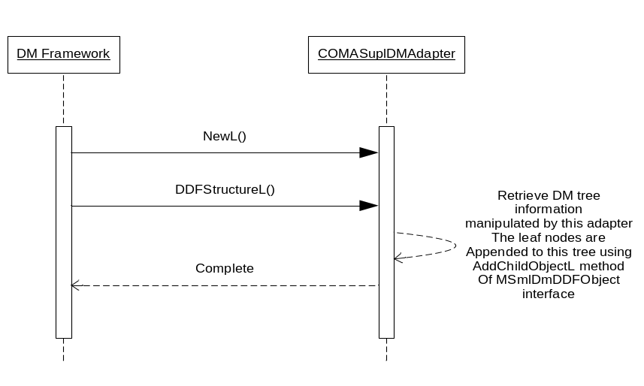
Figure 4.8 Filling the DDF structure

Version query

Operation | Version query.
Preconditions | OMA SUPL SyncML DM Handler is loaded.
Description | This operation is initiated by the DM FW soon after the DDF structure is filled by the SUPL SyncML DM adapter.  When the function DDFVersionL() of the SUPL SyncML DM Handler is called, the DDF version of the adapter is returned by filling the version information to aDDFVersion reference. The version information is maintained internally by the OMA SUPL SyncML DM adapter.  The DM FW deletes the instance of COMASuplDMAdapter once this operation is complete.
Inputs
Modifies
Outputs | The DDF version of SUPL SyncML DM Handler.
Postconditions | The DDF version is filled and SUPL SyncML DM adapter is ready to accept other commands.
Related To
Related Event | 4.3.4.
Exceptions

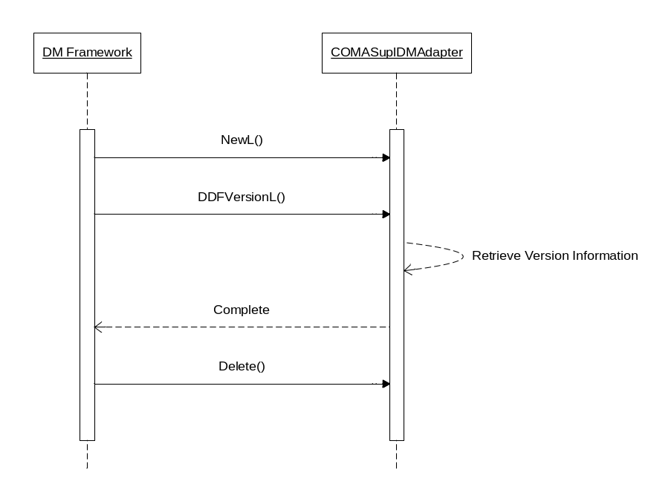
Figure 4.9 Version query

Fetching the URI list

Operation | Fetching the URI list.
Preconditions | OMA SUPL SyncML DM Handler is loaded.
Description | This operation is performed when a Get command is provisioned in the SUPL SyncML DM settings message. The URI information set in the Get command identifies the root node whose child node list needs to be retrieved (see Section 2.4).  The operation is executed, when the function ChildURIListL of SUPL SyncML DM Handler is called. The adapter returns a list of URI segments under the given URI separated with a slash /. The list is returned by calling the function SetResultsL of the callback interface MSmlCallback. The URIs returned for the root node /Supl are  /Supl/Name, /Supl/ProviderId, /Supl/PrefConRef, /Supl/ToConRef, ,/SuplConRef, /Supl/SLP and /Supl/AddrType
Inputs | URI of the root node.
Modifies
Outputs | The status codes in accordance to CSmlDmAdapter::TError are returned using the callback function MSmlDmCallback::SetStatusL(), and the URI list is returned by calling the function MSmlDmCallback::SetResultsL().
Postconditions | The adapter plug-in informs the SyncML DM framework about the child URIs of the root node /Supl separated by a “/”.
Related to
Related event | 4.3.7.
Exceptions | Leaves with one of the system-wide error codes  All errors occurring are propagated to the SyncML DM engine.

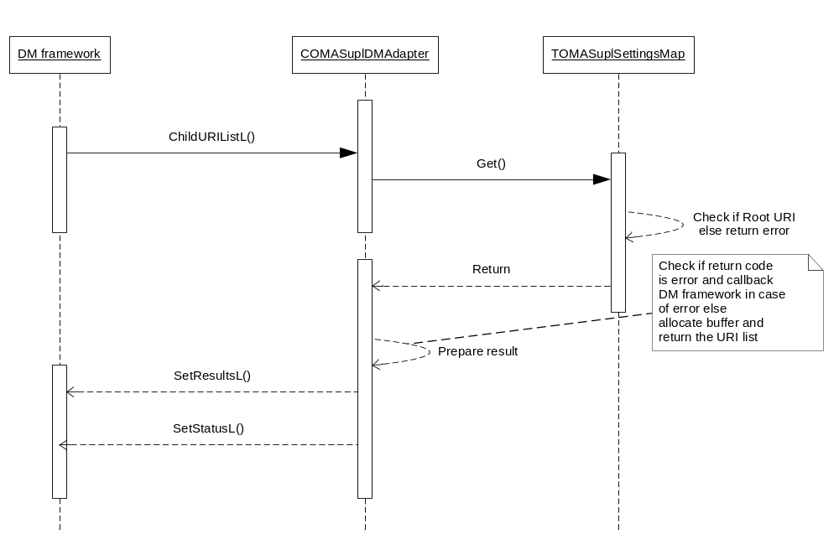
Figure 4.10 Fetching the URI list

Fetching a settings value

Operation | Fetching a settings value.
Preconditions | OMA SUPL SyncML DM Handler is loaded.
Description | This operation is performed when a Get command is provisioned in the SUPL SyncML DM settings message. The URI information set in the Get command identifies the leaf object whose value needs to be retrieved.  The operation is executed, when the function FetchLeafObjectL of SUPL SyncML DM adapter is called. The correct setting is recognized from the aURI argument. The result of the fetch is returned by calling the function MSmlDmCallback::SetResultsL().
Inputs | URI of the leaf object whose value needs to be retrieved.
Modifies | Status codes according to CSmlDmAdapter::TError, and the fetched value is returned by calling the function MSmlDmCallback::SetResultsL().
Outputs | The status codes in accordance to CSmlDmAdapter::TError are returned using the callback function MSmlDmCallback::SetStatusL().
Postconditions | The object value identified by the aURI argument is returned.
Related to
Related event
Exceptions | ENotFound if in case the URI provided is incorrect.  Leaves with one of the system-wide error codes.  All errors occurring are propagated to the SyncML DM engine.

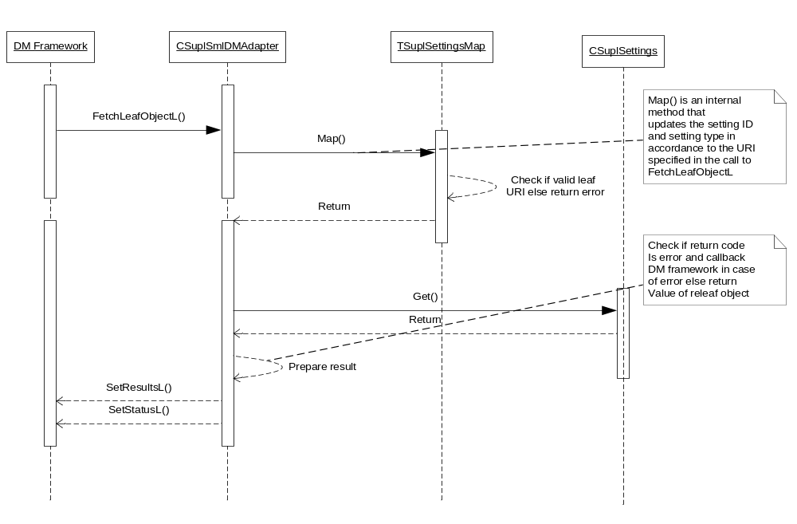
Figure 4.11 Fetching a settings value

Updating a settings value – non atomic

Operation | Updating a settings value – non atomic.
Preconditions | OMA SUPL SyncML DM Handler is loaded.
Description | DM client application sends the Replace command on any leaf node.  The operation is executed, when the function UpdateLeafObjectL() of SUPL SyncML DM Handler is called. The correct setting is recognized from the aURI argument and the new value comes in the aObject argument. This value is written to SUPL Settings Database. The status code CSmlDmAdapter::EOk is returned by calling the function MSmlDmCallback::SetStatusL(). If in case of an error writing into SUPL Settings, an error code is retuned by using the same method.
Inputs | URI of the leaf object whose value needs to be updated with a settings value.
Modifies | The value of the leaf object corresponding to aURI and parent LUID.
Outputs | The status codes in accordance to CSmlDmAdapter::TError are returned using the callback function MSmlDmCallback::SetStatusL().
Postconditions | The adapter plug-in should update the values of these leafs and inform the DM framework about the result in terms of an error code specific to the device management framework.
Related to
Related event
Exceptions | ENotFound if in case the URI provided is incorrect.  EError in case of internal errors such as data conversion from utf8 to Unicode.  Leaves with one of the system-wide error codes.  All errors occurring are propagated to the SyncML DM engine.

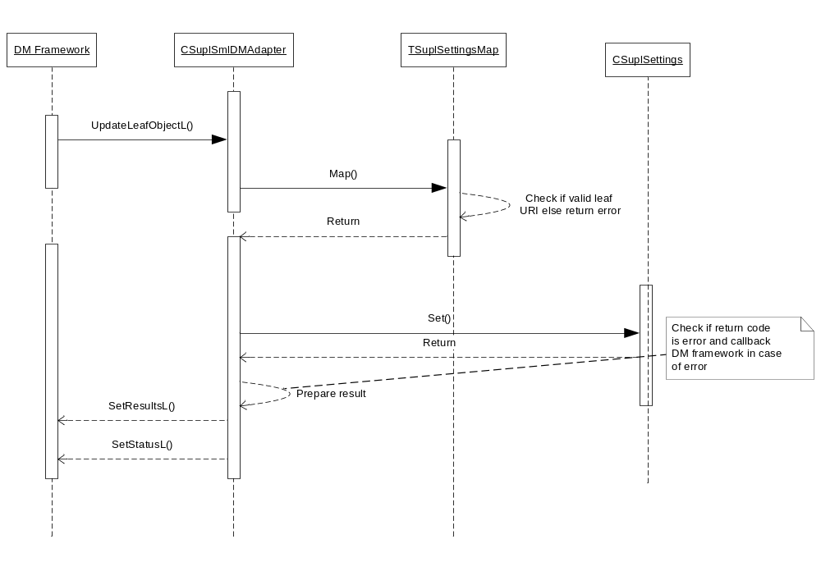
Figure 4.12 Updating a settings value – non atomic

Updating a settings value – atomic

Operation | Updating a settings value in atomic mode.
Preconditions | OMA SUPL SyncML DM Handler is loaded.
Description | DM client application sends the Replace command on any leaf node.  The operation is executed, when the function UpdateLeafObjectL() of SUPL SyncML DM Handler is called. The atomic mode of this operation is initiated by the DM FW by invoking the method StartAtomicL() before calling UpdateLeafObjectL(). Errors are returned to the DM FW using the callback method MSmlDmCallback::SetStatusL(). If in case of errors the DM FW may rollback the updates by invoking the RollbackAtomicL() method.
Inputs | URI of the leaf object whose value needs to be updated with a settings value.
Modifies | The value of the leaf object corresponding to aURI and parent LUID.
Outputs | The status codes in accordance to CSmlDmAdapter::TError are returned using the callback function MSmlDmCallback::SetStatusL().
Postconditions | The adapter plug-in updates the values of these leafs and informs the DM framework about the result in terms of error code specific to the device management framework. If there is any error DM framework calls RollBack and in case of success the DM framework calls Commit and the result is rolled back or committed accordingly.
Related to
Related event
Exceptions | ENotFound if in case the URI provided is incorrect.  EError in case of internal errors such as data conversion from UTF8 to Unicode.  Leaves with one of the system-wide error codes.  All errors occurring are propagated to the SyncML DM engine.

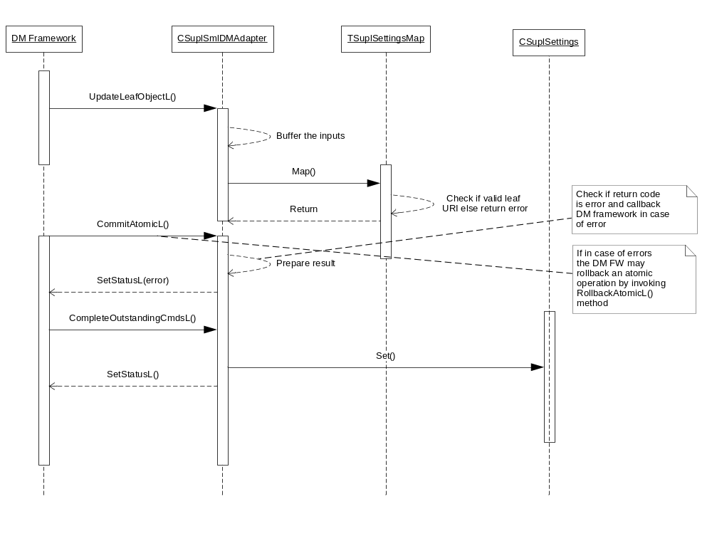
Figure 4.13 Updating a settings value – atomic

Variation
The OMA SUPL Provisioning and SyncML DM handler components do not support any variation mechanism other than application wide image creation time variation defined in reference document [2].

System resource usage

Files
OMA SUPL Provisioning Handler provides a resource file containing the ECom registration information. The format of the resource file is as follows:

Resource name | Purpose | Default value
Component: OMA SUPL Provisioning Handler
Resource file: 1027509B.rss
interface_uid | Provides the interface UID reserved for S60 Provisioning Adapter interface. | 0x101F84D5
implementation_uid | Provides the implementation UID of the ECom plug-in. | 0x102818E3
Version | Provides version information. | 1.0
Display Name | A string that identifies the plug-in. | SUPL Provisioning || Implements a WAP Provisioning Adapter || Copyright © 2006 Nokia Corporation.

OMA SUPL Provisioning Handler provides a resource file to store localized strings. The format of the resource file is as follows:

Resource name | Purpose | Default value
Component: OMA SUPL Provisioning Handler
Resource file: epos_omasuplprovhandlerres.rss
qtn_sm_suplsetting | Provides local SUPL Settings name | "SUPL settings:"
qtn_sm_remote_settings_name | Provides name for the SUPL Settings provisioned | "New SUPL Settings"

OMA SUPL SyncML DM Handler provides a resource file containing the ECom registration information. The format of the resource file is as follows:

Resource name | Purpose | Default value
Component: OMA SUPL SyncML DM Handler
Resource file: 102818E4.rss
interface_uid | Provides the interface UID reserved for SyncML DM Adapters. | 0x102018B4
Implementation_uid | Provides the implementation UID of the ECom plug-in. | 0x102818E5
Version | Provides version information. | 1.0
Display Name | A string that identifies the plug-in. | OMA SUPL SyncML DM Handler

Databases

Central Repository
The OMA SUPL Provisioning and SyncML DM Handler components store some SUPL Settings related information in the Central Repository file with the UID 0x102073D6.

Memory consumption
OMA SUPL Provisioning Handler

Memory/Build | Consumption
[WINSCW UDeb] | 248 KB
[ARMV5 URel] | 3 KB

OMA SUPL SyncML DM Handler

Memory/Build | Consumption
[WINSCW UDeb] | 298 KB
[ARMV5 URel] | 9 KB

Task allocation
The OMA SUPL Provisioning and SyncML DM handlers run in the threads in which they are launched.

Performance
There is no significant performance impact on the SUPL subsystem due to either OMA SUPL Provisioning or SyncML DM handler

Timers
The OMA SUPL Provisioning and SyncML DM handlers do not make use of any timers.

Security

Capabilities of this component

Capability | Justification
CAP_ECOM_PLUGIN | {ALL –Tcb} Default capabilities required by all ECom plug-in implementations are provided.

Environmental assumptions
The OMA SUPL Provisioning and SyncML DM handlers do not make any assumptions about their environment.

Additional enforcements
The OMA SUPL Provisioning and SyncML DM handlers do not have any additional security enforcements.

Exception handling
The leave mechanism of Symbian OS environment is used to handle memory exhaustion. All errors occurring are propagated to the S60 OMA Provisioning engine.
Any error in normal operation of SUPL SyncML DM Handler is reported to the DM framework using the pre-defined error codes mentioned in the smldmadapter.h file of the DM framework.

Usage

Building
This Section explains the components that are related to OMA SUPL Provisioning and SyncML DM Handlers. The directory paths are relative to /sf/mw/locationsrv/sup/locationomasuplprotocolhandler.

Component name | Directory | MMP file name | DLL or EXE name
OMA SUPL Provisioning Handler | /provisioninghandler | epos_omasuplprov  handler.mmp | epos_omasuplprov  handler.dll

Component name | Directory | MMP file name | DLL or EXE name
OMA SUPL SyncML DM Handler | /syncmlprovhandler | epos_omasupldmadapter.mmp | epos_omasuplsyncmldm.dll

Building is done by running the following commands in the /group subdirectory of the directory listed in the table:
- bldmake bldfiles
- abld build <TARGET> <BUILD>
- where <TARGET> is one of winscw, or armv5 and
- <BUILD> is one of udeb or urel

User's guide
OMA SUPL Provisioning and SyncML DM Handlers are not used by other components.

