S60 3.2
SUPL Settings Library
Design Document

Team name | Author
Location Technology Team | Venkatesh Sathyanarayana

Change history:

Version | Date | Status | Comments
2.0 | 12.10.2007 | Approved
1.0 | 23.05.2006 | Approved

Table of contents:
1. Document control 4
1.1 References 4
1.2 Documentation conventions 4
1.3 Abbreviations 4
1.4 Definitions 4
2. General 5
2.1 Introduction 5
2.2 Component environment 5
2.3 Services required 6
2.3.1 From the Symbian OS subsystems 6
2.3.2 From the Domestic OS subsystems 6
2.3.3 From HW 6
2.4 Services provided 7
2.4.1 UI 7
2.4.2 SW IF 7
3. UI control hierarchy 8
4. Design 9
4.1 Class diagram 9
4.2 Class descriptions 9
4.2.1 Structs, type definitions and enumerations 10
4.3 Operations 10
4.3.1 Creating SUPL Settings 10
4.3.2 Initializing SUPL Settings 10
4.3.3 Retrieving Communication Parameters from SUPL Settings 11
4.3.4 Retrieving SUPL Usage from SUPL Settings 12
4.3.5 Changing SUPL Usage in SUPL Settings 13
4.3.6 Changing Communication Parameters in SUPL Settings 14
4.3.7 Generating the HSLP address 15
4.3.8 Getting IMSI 16
4.3.9 Checking whether IMSI has changed 16
4.3.10 Starting the listening of SUPL Settings changes 17
4.3.11 Receiving the SUPL Settings change event 18
4.3.12 Stop listening to SUPL Settings changes 19
4.3.13 Canceling initialization 19
5. Variation 21
6. System resource usage 22
6.1 Files 22
6.2 Other data 22
6.2.1 Databases 22
6.2.2 Central Repository 22
6.3 Memory consumption 22
6.4 Task allocation 22
6.5 Performance 22
6.6 Timers 22
7. Security 23
7.1 Capabilities of this component 23
7.2 Input and output validation 23
7.3 Environmental assumptions 23
7.4 Additional enforcements 23
8. Exception handling 24
9. Usage 25
9.1 Building 25
9.2 User's guide 25

Document control

References
- S60 3.1 SUPL Subsystem Architecture Description
- S60 SUPL Subsystem Design Document
- S60 SUPL Settings API Specification

Documentation conventions
Code is shown with the Courier New font.

Abbreviations
AP | Access Point
API | Application Programming Interface
ETel | ETelephony
FQDN | Fully Qualified Domain Name
FW | Framework
HSLP | Home SUPL Location Platform
HW | Hardware
IAP | Internet Access Point
IMSI | International Mobile Subscriber Identity
OS | Operating System
ROM | Read-Only Memory
SET | SUPL Enabled Terminal
SLP | SUPL Location Platform
SUPL | Secure User Plane Location Protocol
SW | Software
UI | User Interface

Definitions
Framework | Denotes the collection of an engine and associated programming interfaces.
Platform Security | Definition for security design principles and features in Symbian OS.
SUPL Enabled Terminal | A device that is capable of communicating with a SUPL network. Examples of this are UE in UMTS, MS in GSM or IS95.
SUPL Location Platform (SLP) | Entity responsible for Service management and Position determination.

General

Introduction
Secure User Plane Location (SUPL) defines how location related information is transferred and how already existing control plane positioning protocols can be tunneled over user plane between the terminal and the network server.
SUPL Enabled Terminal (SET) and SUPL Location Platform (SLP) are the two important entities of the SUPL system. SET establishes a secure IP connection with SLP. This secure IP connection is used to exchange SUPL messages between SET and SLP. SUPL Settings contains information required to establish this secure IP connection between SET and SLP.
SUPL Settings Library is part of the SUPL subsystem. The purpose of SUPL Settings Library is to enable client applications to retrieve and change SUPL Settings in Central Repository. In addition, this can be used to generate HSLP address from IMSI, to get IMSI and to check whether IMSI has changed or not. The IMSI value is obtained during initialization from ETEL.
The SUPL setting storage contains information such as Home SUPL Location Platform (HSLP) address, Internet Access Point (IAP) name, IMSI, ChangedBy and SUPL usage fields. The HSLP address and the IAP name are used to establish a secure IP connection. The HSLP address is in the form of Fully Qualified Domain Name (FQDN). The IAP name refers to the Access Point, the terminal of which can be used to access HSLP over the Internet. IMSI is the mobile subscriber identity and ChangedBy is used for storing information about the client, which last changed SUPL Settings. The ChangedBy field is an enumerated value that specifies the client category. The client has to select one of the values from this enumeration corresponding to its identity when changing SUPL Settings. For example, if SUPL Settings UI is changing SUPL Settings, it has to select EUserInterface. This is required for the client to decide whether it can overwrite the settings or not.
Whenever the client changes communication parameters in SUPL Settings, the IMSI obtained during initialization is written to SUPL Settings Storage. When changing SUPL Settings, the client has to explicitly lock SUPL Settings and unlock SUPL Settings immediately after the changes are made. Locking is required to avoid multiple clients changing SUPL Settings at the same time. Only after unlocking SUPL Settings, changes are committed to SUPL Settings Storage.
The IMSI value stored in SUPL Settings can be used by the client to check whether IMSI has changed and to verify whether SUPL Settings are pertaining to the current IMSI value or not. The IMSI obtained during initialization can also be used to generate the HSLP address. For example, the HSLP address can be generated from IMSI if the HSLP address read from SUPL Settings is empty or not valid.
The SUPL Usage value controls the different level of user notification or intervention while using SUPL. By default SUPL Usage is set to "Always ask". If SUPL Usage has a value indicating automatic, SUPL can be used to make location request or to get assistance data. If SUPL Usage has value indicating automatic in home network, a confirmation dialog is shown before using SUPL when the terminal is roaming. If SUPL Usage has value indicating always ask, a confirmation dialog is shown before using SUPL. If SUPL Usage has value indicating disabled, SUPL cannot be used at all.
The architecture for SUPL FW is described in reference document [1] and the design is described in reference document [2]. SUPL Settings Library is a part of Domain API.

Component environment
Figure 2.1 below shows the components and their relations in SUPL Framework.
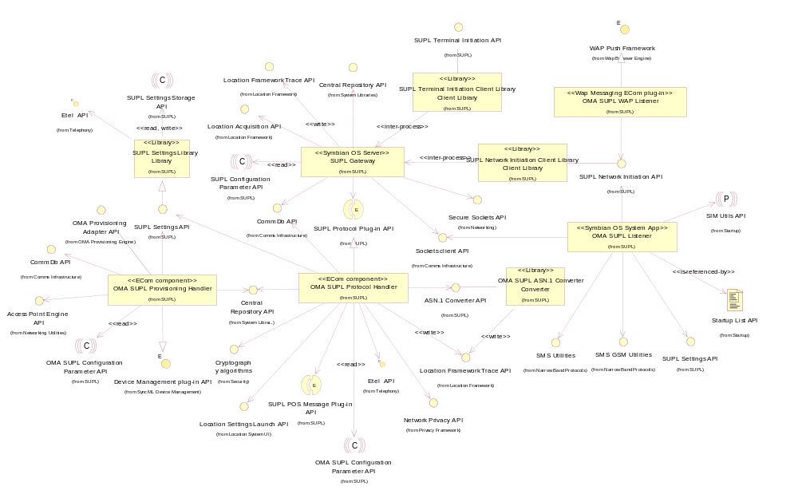
Figure 2.1 Component environment

Services required

From the Symbian OS subsystems
This component uses Central Repository from the Symbian OS subsystems in order to perform its operations.

API | Description
Central Repository API | This API is used to access and modify SUPL Settings and to listen to SUPL Settings change events.
ETEL API | This API is used to retrieve the currently active IMSI.

From the Domestic OS subsystems
This component does not have any direct interfaces to the Domestic OS side subsystems.

From HW
This component has no direct hardware interfaces.

Services provided

UI
This component does not provide any UI services.

SW IF
Provided Service | Description
SUPL Settings API | SUPL Settings API is a Domain API. It is used to:  - Retrieve communication parameters from SUPL Settings.  - Lock SUPL Settings.  - Unlock SUPL Settings.  - Change communication parameters in SUPL Settings.  - Listen to SUPL Settings change events.  - Generate the HSLP address from the IMSI value retrieved during initialization.  - Get the IMSI value retrieved during initialization.  - Check whether the IMSI value retrieved during initialization is different from the IMSI stored in SUPL Settings Storage.

UI control hierarchy
The component does not contain any UI or UI controls.

Design

Class diagram
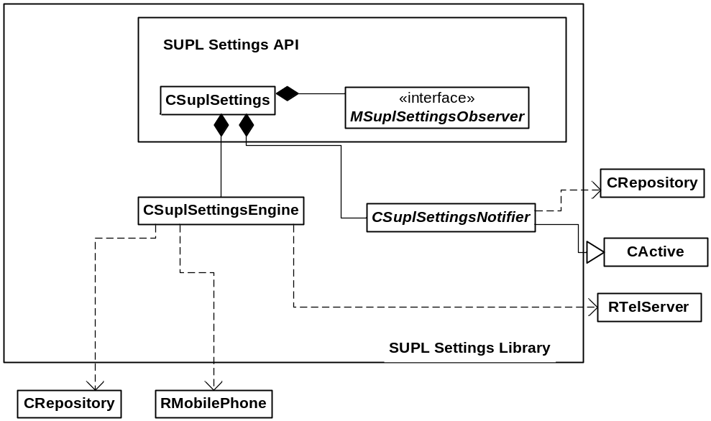
Figure 4.2 Class diagram

Class descriptions
Class | Description | Header file
CSuplSettings | CSuplSettings is the main class for serving the SUPL Settings API clients. The class handles all requests from the client side.  CSuplSettings uses CSuplSettingsEngine class to serve most of the client request and uses CSuplSettingsNotifier class to notify client about changes in SUPL Settings. | epos_csuplsettings.h
CSuplSettingsEngine | The CSuplSettingsEngine class handles all changes to SUPL Settings. The class utilizes Central Repository to manage the settings using CRepository class. This class uses ETEL API to retrieve the IMSI value from ETEL during initialization using RTelServer and RMobilePhone class. | epos_csuplsettings  engine.h
CSuplSettingsNotifier | The CSuplSettingsNotifier class is responsible for observing the change in SUPL Settings Central Repository. The class issues a callback to the client observer. This class uses CRepository class to receive Central Repository change events. | epos_csuplsettings  notifier.h
MSuplSettingsObserver | MSuplSettingsObserver is the callback interface for the SUPL Settings observer. Every SUPL Settings observer has to implement the interface to get the SUPL Settings change event. This is an abstract class. | epos_msuplsettings  observer.h

Structs, type definitions and enumerations

Enumeration name | Description
TSuplSettingsEventType | Enumerations for possible events in SUPL Settings changes.
TSuplSettingsChangedBy | Enumeration to indicate which client has changed SUPL Settings last.
TSuplSettingsUsage | Enumeration to indicate how/when the user should be notified while using SUPL.

Operations

Creating SUPL Settings
Operation | Creating SUPL Settings.
Preconditions
Description | The SUPL Settings client invokes the NewL method in SUPL Settings API. SUPL Settings API instantiates the Settings Engine object and Central Repository object.
Inputs
Modifies
Outputs
Postconditions | The SUPL Settings object is created.
Related To | Section 4.3.2.
Related Event
Exceptions | If there is not enough memory, the NewL method leaves with KErrNoMemory.

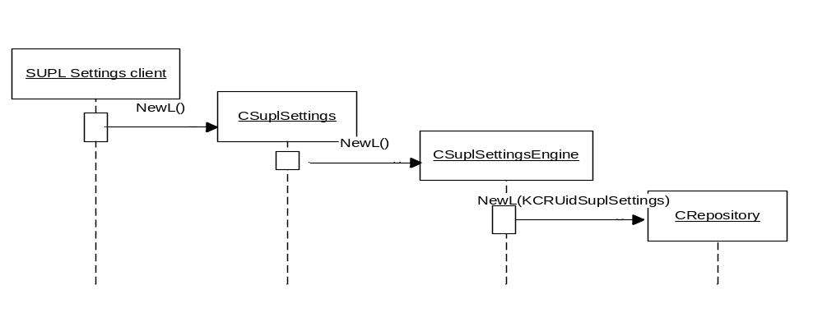
Figure 4.3 Creating SUPL Settings object

Initializing SUPL Settings
Operation | Initializing SUPL Settings.
Preconditions
Description | The SUPL Settings client invokes the Initialize method in SUPL Settings API. This is an asynchronous call. SUPL Settings API connects to ETEL Server and issues a request to ETEL to retrieve IMSI. After the request to retrieve IMSI is completed, a request is issued to retrieve network information. MCC and MNC retrieved from the network information are used to generate the HSLP address from IMSI. After the request is completed, the connection to ETEL Server is closed. Initialization of SUPL Settings is an asynchronous call for the client, but in Settings Library the asynchronous call to ETEL is used with wait for request as these requests gets completed very fast.
Inputs | Status.
Modifies
Outputs
Postconditions | IMSI and Network information (MCC and MNC) is retrieved from ETEL.
Related To | Sections 4.3.1, 4.3.4, 4.3.8, 4.3.9 and 4.3.13.
Related Event
Exceptions | After completion, the status has one of the following values:  - KErrNone if initialization is successful.  - KErrGeneral if initialization has failed.

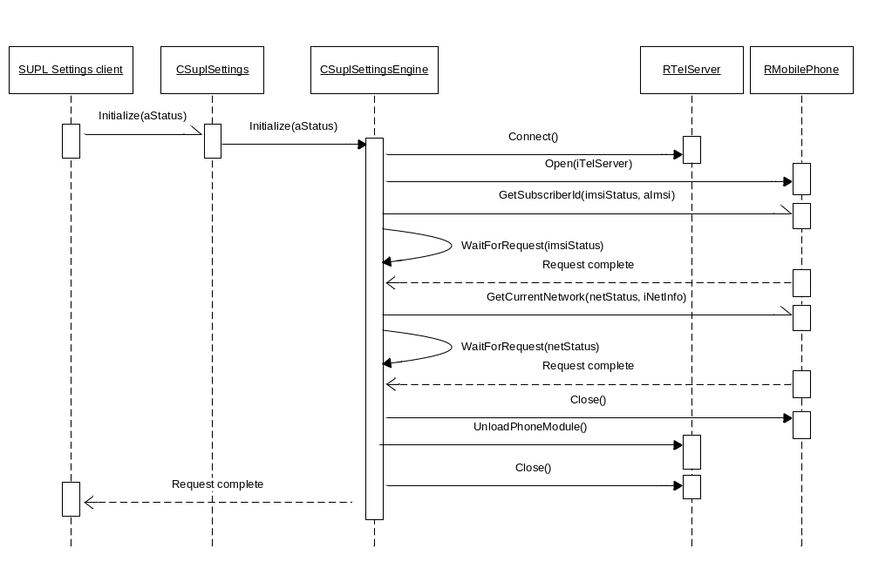
Figure 4.4 Initializing SUPL Settings

Retrieving Communication Parameters from SUPL Settings
Operation | Retrieving Communication Parameters From SUPL Settings.
Preconditions | The SUPL Settings object is created.
Description | The client invokes the Get method in SUPL Settings API to retrieve communication parameters from SUPL Settings Storage.
Inputs | Parameters to hold settings.
Modifies | Parameters passed.
Outputs
Postconditions | The values for communication parameters from SUPL Settings Storage are retrieved.
Related To | Section 4.3.1.
Related Event
Exceptions | One of the following error codes is returned:  - KErrNone if SUPL Settings are retrieved successfully.  - KErrOverFlow if the descriptor is too small to receive the value.  - KErrGeneral if the settings are not valid.  - KErrArgument if any of the arguments passed is of zero length.

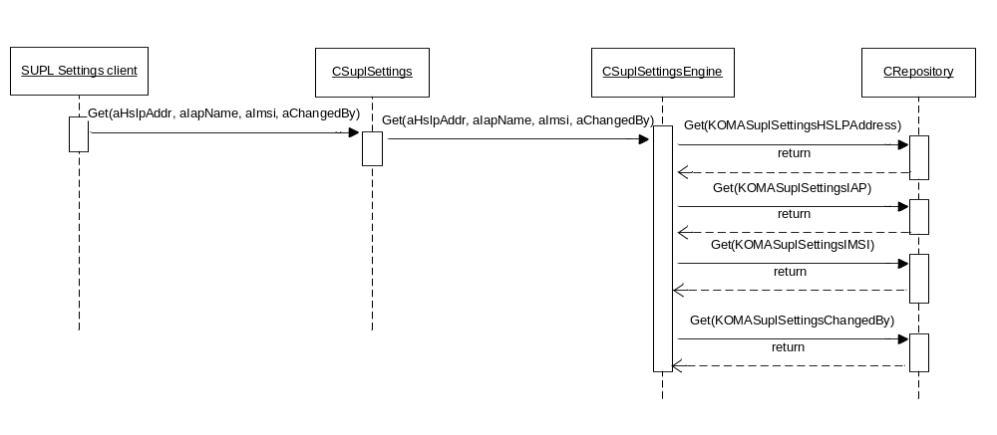
Figure 4.5 Retrieving SUPL Settings

Retrieving SUPL Usage from SUPL Settings
Operation | Retrieving SUPL Usage From SUPL Settings.
Preconditions | The SUPL Settings object is created.
Description | The client invokes the GetSuplUsage method in SUPL Settings API to retrieve SUPL usage from SUPL Settings Storage.
Inputs | Parameters to hold SUPL usage.
Modifies | Parameters passed.
Outputs
Postconditions | The SUPL usage is retrieved from SUPL Settings Storage.
Related To | Sections 4.3.1, 4.3.5.
Related Event
Exceptions | One of the following error code is returned:  - KErrNone if SUPL usage is retrieved successfully.  - KErrNotFound if the SUPL usage is not found in SUPL Settings.  - KErrUnknown if retrieving SUPL usage from Settings Storage failed.

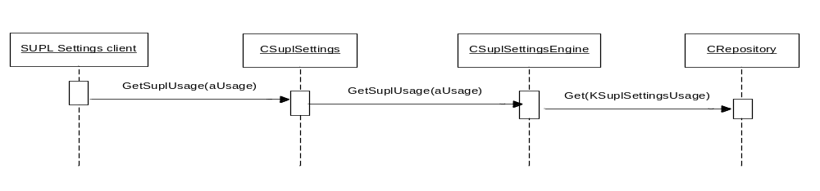
Figure 4.6 Retrieving SUPL Usage from SUPL Settings

Changing SUPL Usage in SUPL Settings
Operation | Changing SUPL Usage In SUPL Settings.
Preconditions | The SUPL Settings object is created.
Description | The client invokes the LockSettingsL method in SUPL Settings API to lock and change SUPL usage in SUPL Settings. After changing SUPL Settings, the client invokes the UnlockSettings method to commit the changes made. For Central Repository transactions, pessimistic transaction is used to make sure only one client changes the SUPL Settings.
Inputs | New values to be written to SUPL usage in SUPL Settings Storage.
Modifies | SUPL Settings in Central Repository.
Outputs
Postconditions | SUPL usage is changed and change is committed to SUPL Settings Storage.
Related To | Sections 4.3.1, 4.3.2.
Related Event
Exceptions | One of the following error codes is returned to the client.  - KErrNone if SUPL Usage is changed successfully.  - KErrArgument if aUsage field is not in range.  - KErrLocked if SUPL Settings is locked by some other client.  - KErrNotReady if the SetSuplUsage method is called before locking SUPL Settings.  - KErrUnknown if changing SUPL usage in Settings Storage has failed.

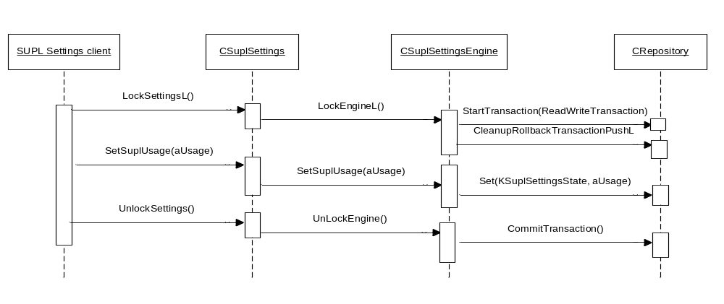
Figure 4.7 Changing SUPL Usage in SUPL Settings

Changing Communication Parameters in SUPL Settings
Operation | Changing Communication Parameters in SUPL Settings.
Preconditions | The SUPL Settings object is created and initialized.
Description | The client invokes the LockSettingsL method in SUPL Settings API to lock and change SUPL Settings. After changing SUPL Settings, the client invokes the UnlockSettings method to commit the changes made.
Inputs | New values to be written to SUPL Settings Storage.
Modifies | SUPL Settings in Central Repository.
Outputs
Postconditions | SUPL Settings are changed and changes are committed to SUPL Settings Storage.
Related To | Sections 4.3.1, 4.3.2.
Related Event
Exceptions | One of the following error codes is returned to the client.  - KErrNone if SUPL Settings are changed successfully.  - KErrArgument if there is an error in the arguments passed.  - KErrLocked if SUPL Settings is locked by some other client.  - KErrNotReady if the Set method is called before Initialization or if initialization has not completed with KErrNone.

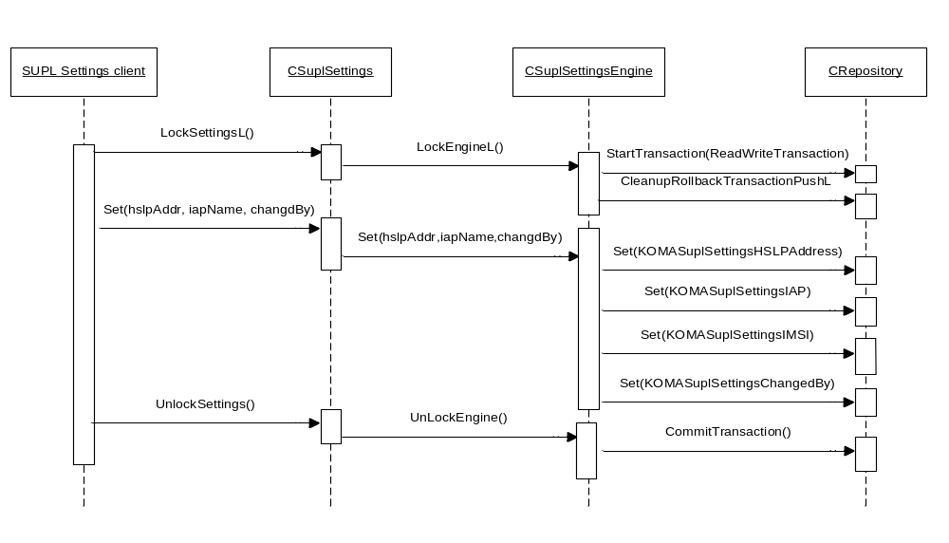
Figure 4.8 Changing SUPL Settings

Generating the HSLP address
Operation | Generating the HSLP address.
Preconditions | The SUPL Settings object is created and initialized.
Description | The client invokes the GenerateHslpAddressFromImsi method in SUPL Settings API to generate the HSLP address from IMSI. The HSLP address is generated from the IMSI obtained during initialization. The client can generate the HSLP address if the HSLP address is not valid, for example, if the HSLP address stored in the SUPL Settings Storage is empty or with the HSLP address present in the SUPL Settings connection could not be established.
Inputs
Modifies
Outputs | The HSLP address.
Postconditions | The HSLP address is generated from IMSI obtained during initialization.
Related To | Sections 4.3.1, 4.3.2 and 4.3.4.
Related Event
Exceptions | One of the following error codes is returned to the client.  - KErrNone if the HSLP address is generated successfully.  - KErrOverflow if the descriptor is too small to hold the HSLP address.  - KErrArgument if the argument passed is of zero length.  - KErrNotReady if the generation of the HSLP address is attempted before Initialization or if initialization has not completed with KErrNone.

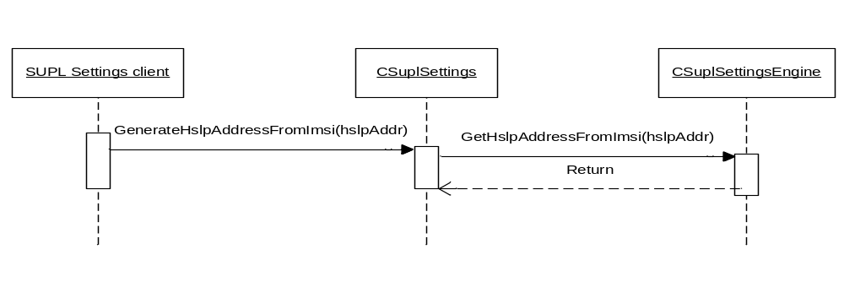
Figure 4.9 Generating the HSLP address and setting SUPL Settings

Getting IMSI
Operation | Getting IMSI.
Preconditions | The SUPL Settings object is created and initialized.
Description | The client invokes the GetImsi method in SUPL Settings API to retrieve the IMSI value obtained during initialization.
Inputs
Modifies
Outputs | The IMSI value.
Postconditions | The IMSI value obtained during initialization is returned.
Related To | Sections 4.3.1 and 4.3.2.
Related Event
Exceptions | One of the following error codes is returned to the client.  - KErrNone if IMSI is returned successfully.  - KErrNotReady if the client tries to get IMSI before Initialization or if initialization has not completed with KErrNone.

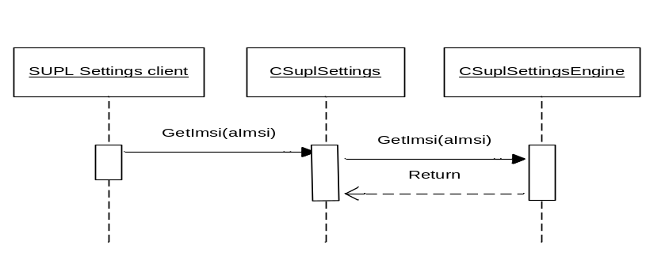
Figure 4.10 Getting IMSI

Checking whether IMSI has changed
Operation | Checking whether IMSI has changed.
Preconditions | The SUPL Settings object is created and initialized.
Description | The client invokes the IsImsiChanged method to check whether the IMSI obtained during initialization and the IMSI present in SUPL Settings Storage are the same or not. Client can use this to verify whether SUPL Settings are pertaining to the current IMSI value or not. For example, if the client receives an event that SUPL Settings have changed (see Section 4.3.10), then the client can verify whether the SUPL Settings are pertaining to currently active IMSI or not.
Inputs
Modifies
Outputs | TRUE or FALSE.
Postconditions | If the IMSI value obtained during initialization and the IMSI value present in SUPL Settings Storage are the same, returns TRUE or FALSE.
Related To | Sections 4.3.1 and 4.3.2.
Related Event
Exceptions | One of the following error codes is returned to the client.  - KErrNone if the IMSI change check is successful.  - KErrNotReady if the client tries to check IMSI change before Initialization or if initialization has not completed with KErrNone.

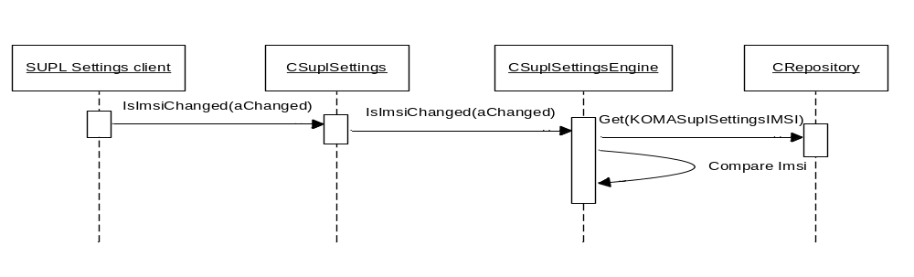
Figure 4.11 Checking whether IMSI has changed

Starting the listening of SUPL Settings changes
Operation | Starting the listening of SUPL Settings changes.
Preconditions | The SUPL Settings object is created.
Description | The client invokes the SetObserverL method in SUPL Settings API to start listening to the SUPL Settings change event. The client has to implement MSuplSettingsObserver to receive the SUPL Settings change events.
Inputs | Reference to Event Listener.
Modifies
Outputs
Postconditions | Listening to Central Repository events has started.
Related To | Sections 4.3.1 and 4.3.12.
Related Event
Exceptions | One of the following error codes is returned to client:  - KErrNone if setting observer is successful.  - KErrAlreadyExists if observer is already set.  - KErrArgument if the parameter passed is NULL.

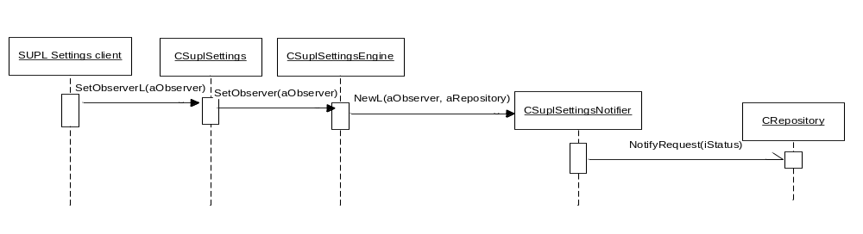
Figure 4.12 Start listening to SUPL Settings changes

Receiving the SUPL Settings change event
Operation | Receiving the SUPL Settings change event.
Preconditions | The SUPL Settings object is created and the observer is set to receive SUPL Settings change event.
Description | A client changes SUPL Settings in Central Repository, which triggers an event.  CSuplSettingsNotifier reissues the notify request and sends the event to the SUPL Settings client in the HandleSuplSettingsChangeL method. Depending on the key changed in SUPL Settings, either communication parameter change event or SUPL usage change event is sent to client in HandleSuplSettingsChangeL method.
Inputs
Modifies
Outputs | The event to the SUPL Settings client. If the communication parameter is changed, client receives ESuplSettingsEventCommParameterChange event and if SUPL usage has changed the client receives ESuplSettingsEventSuplUsageChange event.
Postconditions | The SUPL Settings client handles the delivered event.
Related To | Section 4.3.10 and 4.3.12.
Related Event
Exceptions

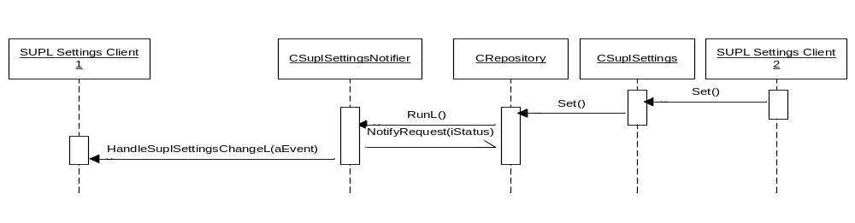
Figure 4.13 Receiving SUPL Settings change event

Stop listening to SUPL Settings changes
Operation | Stop listening to SUPL Settings changes.
Preconditions | The observer to listen to SUPL Settings changes is set.
Description | The client invokes the RemoveObserver method in SUPL Settings API to stop listening to SUPL Settings changes.
Inputs
Modifies
Outputs
Postconditions | Observing is stopped. SUPL Settings is no longer listening to Central Repository events.
Related To | Section 4.3.10.
Related Event
Exceptions

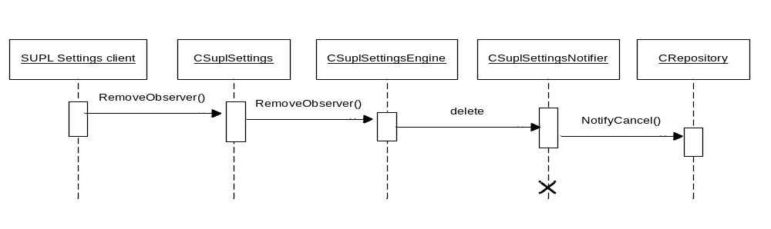
Figure 4.14 Stop listening to SUPL Settings changes

Canceling initialization
Operation | Canceling initialization.
Preconditions | The initialization request is pending.
Description | The client invokes the CancelInitialize method in SUPL Settings API to cancel the pending initialization request.
Inputs
Modifies
Outputs
Postconditions | The initialization request is canceled.
Related To | Section 4.3.2.
Related Event
Exceptions | If there is no pending initialization request, the cancel request is ignored.

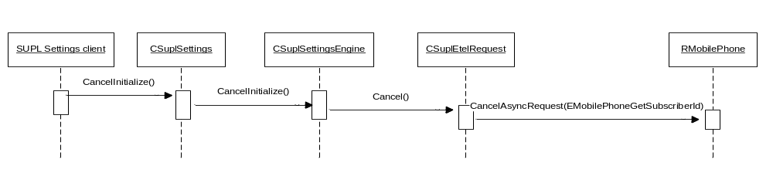
Figure 4.15 Cancel initialization

Variation
SUPL Settings API does not support any other variation mechanism than the SUPL Framework wide image creation time variation, i.e., the SUPL Framework can be included in or excluded from a ROM image. The flags for SUPL Framework can be found in reference document [2].
SUPL Settings Library is included in image creation only if __SUPL_FRAMEWORK is defined.

System resource usage

Files
SUPL Settings Library does not use any files.

Other data

Databases
SUPL Settings Library does not define any databases.

Central Repository
SUPL Settings Library uses Central Repository for reading and storing SUPL Settings which consists of the HSLP address, the IAP name, the IMSI value, ChangedBy field and SUPL Usage.

Central Repository UID | Key Value | Purpose
KCRUidSuplSettings | KSuplSettingsHSLP  Address | IP Address or FQDN of HSLP.
 | KSuplSettingsIAP | Access Point Name for SUPL Connections.
 | KSuplSettingsIMSI | IMSI Value to check whether settings are pertaining to current IMSI value or not.
 | KSuplSettings  ChangedBy | ChangedBy to reflect which application has changed settings last.
 | KSuplSettingsUsage | SUPL Usage indicates how and when user should be notified about the SUPL usage.

Memory consumption

Component | ROM estimate on Emulator(KB) | ROM estimate on HW(KB)
SUPL Settings Library | 233 | 5

Task allocation
SUPL Settings Library runs in the client application thread.

Performance
Only performance critical issue in SUPL Settings Library is the Initialization of SUPL settings which is an asynchronous call to client. In Settings Library asynchronous call to ETEL is used with wait for request and this might block client. The ETEL method completes very fast and does not affect the client very much.

Timers
SUPL Settings Library does not define any timers.

Security

Capabilities of this component
Capability | Justification
CAP_GENERAL_DLL | Required to be successfully loaded by other processes.

Input and output validation
This component validates the ChangedBy field specified when changing SUPL Settings. This component validates the length of the parameters passed for the HSLP address, the IAP name and IMSI. This component validates for range for all the enums.

Environmental assumptions
This component’s Central Repository files are created and are present in the following directory for SUPL Settings Library:
- \epoc32\data\Z\private\\10202be9 for ARMV5
- \epoc32\RELEASE\winscw\UDEB\Z\private\10202be9 for emulator

Additional enforcements
The capability requirements for the client application using the SUPL Settings Library are as follows:
- The following operations require the ReadDeviceData capability:
- Initializing SUPL Settings.
- Generating the HSLP address from IMSI.
- Retrieving IMSI obtained during initialization.
- To check whether IMSI has changed or not.
- The following method requires the WriteDeviceData capability:
- To change communication parameters.
- To change SUPL usage.
- All other operations do not require any capability.

Exception handling
The following are the error codes returned by SUPL Settings API.
KErrLocked | If client tries to lock SUPL settings using LockSettingsL() and settings are locked by another client.
KErrNotReady | This error code is returned in the following cases:  - If the settings object is not initialized before calling the Set method.  - If the settings object is not initialized before calling the method to get IMSI.  - If the settings object is not initialized before calling the method to check whether IMSI has changed or not.
KErrGeneral | If the settings unlock method is called without calling the lock method or if unlock is called multiple times or if initialization fails.
KErrPermissionDenied | If the client does not have the WriteDeviceData capability when changing SUPL Settings or if the client does not have the ReadDeviceData capability when initializing the SUPL Settings object.
KErrArgument | If any of the arguments passed to SUPL Settings methods is not valid.
KErrNotFound | If the client tries to remove the observer without setting it.
KErrOverflow | If the descriptor passed as argument is too small to retrieve the value from SUPL Settings Storage.

Usage

Building
This Section describes the components which are related to SUPL Settings API. The directory paths are relative to /s60/mw/locationservices/locationsuplfw/
Component name | Directory | MMP file name | DLL or EXE name
SUPL Settings Library | /settingsapi | epos_suplsettings.mmp | epos_suplsettings.dll

Building is done by running the following commands in the \group subdirectory of the directory listed in the table:
- bldmake bldfiles.
- abld build <TARGET>.
- where <TARGET> is one of winscw, or ARMV5.

User's guide
User’s guide is described in reference document [3].

