S60 3.2
SUPL Terminal Initiation Client Library
Design Document

Team name | Author
Location Team | Venkatesh Sathyanarayana

Change history:

Version | Date | Status | Comments
2.0 | 18.09.2006 | Approved | Changes approved
1.0 | 08.05.2006 | Approved

Table of contents:

1. Document control 4
1.1 References 4
1.2 Documentation conventions 4
1.3 Abbreviations 4
1.4 Definitions 4
2. General 5
2.1 Introduction 5
2.2 Services required 5
2.2.1 From the Symbian OS subsystems 5
2.2.2 From the Domestic OS subsystems 5
2.2.3 From HW 5
2.3 Services provided 5
2.3.1 UI 5
2.3.2 SW IF 5
2.4 Component environment 6
3. UI control hierarchy 7
4. Design 8
4.1 Class diagrams 8
4.2 Class descriptions 8
4.3 Operations 9
4.3.1 Connecting to SUPL Server 9
4.3.2 Opening an IPC subsession to SUPL Server 10
4.3.3 Starting a synchronous SUPL session 11
4.3.4 Starting an asynchronous SUPL session 12
4.3.5 Retrieving position information 13
4.3.6 Canceling an asynchronous RunSession 14
4.3.7 Closing an IPC subsession to SUPL Server 15
4.3.8 Closing connection to SUPL Server 16
5. Variation 18
6. System resource usage 19
6.1 Files 19
6.2 Databases 19
6.3 Memory consumption 19
6.4 Task allocation 19
6.5 Performance 19
6.6 Timers 19
7. Exception handling 20
8. Usage 21

Document control

References
- S60 3.2 SUPL Subsystem Architecture Description
- S60 SUPL Subsystem Design Document
- S60 SUPL Subsystem Terminal Initiation API Specification

Documentation conventions
Code is shown with the Courier New font.

Abbreviations
API | Application Programming Interface
FW | Framework
HW | Hardware
IPC | Inter Process Communication
OS | Operating System
ROM | Read-Only Memory
SET | SUPL Enabled Terminal
SUPL | Secure User Plane Location Protocol
SW | Software
UI | User Interface

Definitions
Framework | Usually denotes the collection of an engine and associated programming interfaces. This document mentions SUPL Framework.
Terminal Initiated Location Request | Location request is issued by the mobile terminal to find out the current location of the terminal.
Platform Security | Definition for security design principles and features in Symbian OS.
SUPL Enabled Terminal | A device that is capable of communicating with a SUPL network. Examples of this are UE in UMTS, MS in GSM or IS95.
SUPL Location Platform (SLP) | Entity responsible for Service management and Position determination.

General

Introduction
SUPL Terminal Initiation Client Library is part of SUPL Framework subsystem. The purpose of SUPL Terminal Initiation Client Library is to enable client applications to retrieve terminal’s position information utilizing SUPL Server. In addition, this can be used to retrieve additional position calculation information such as assistance data to terminal utilizing SUPL protocol.
The architecture for SUPL FW is described in reference document [1] and the design is described in reference document [2]. SUPL Terminal Initiation Client Library is a part of Domain API.
SUPL Terminal Initiation Client Library consists of a server class and subsession class. The server class is used by client applications for connecting to SUPL Server and subsession class is used to open and close subsession with SUPL Server, to determining position information or to get assistance data using SUPL, to cancel the asynchronous request to determine the position information or to get assistance data and to get the position information obtained during SUPL session.

Services required

From the Symbian OS subsystems
This component uses client-server services from Symbian OS subsystems.

From the Domestic OS subsystems
This component does not have any direct interfaces to the Domestic OS side subsystems.

From HW
This component has no direct hardware interfaces.

Services provided

UI
This component does not provide any UI services.

SW IF
Provided Service | Description
SUPL Terminal Initiation API | SUPL Terminal Initiation API is a Domain API. Using this API, the licensee can write the client which can use SUPL to get location information. In addition, this API can also be used to retrieve additional positioning information such as assistance data for A-GPS by control plane protocols.

Component environment
Figure 2.1 shows the components and their relations in SUPL Framework.
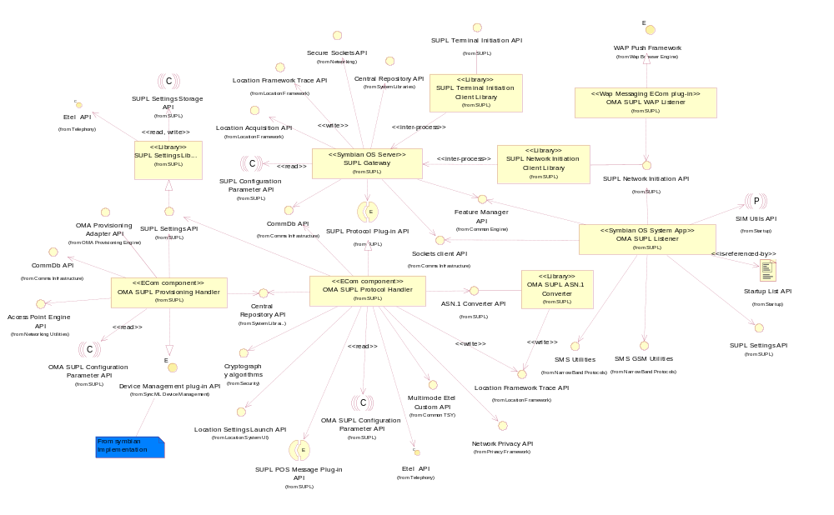
Figure 2.1 Component diagram

UI control hierarchy
The component does not contain any UI or UI controls.

Design

Class diagrams
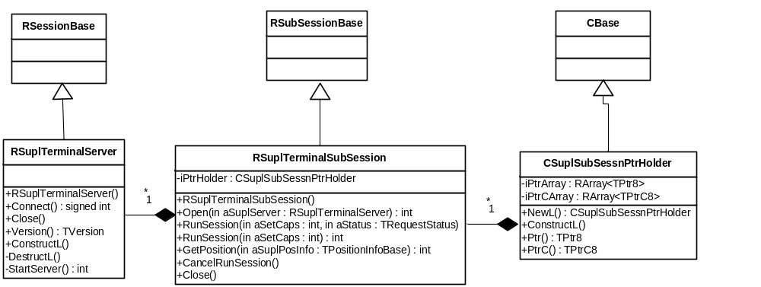
Figure 4.2 Class diagram

Class descriptions
Class | Description | Header file
RSuplTerminal  Server | The main client side class for SUPL Terminal Initiation Library. It handles establishing sessions for clients.  This class inherits from RSessionBase, so that it conforms to Symbian OS Client/Server Framework. | epos_suplterminal.h
RSuplTerminalSub  Session | This class handles opening and closing of IPC subsession with SUPL Server.  This class inherits from RSubSessionBase, so that it conforms to Symbian OS Client/Server Framework. | epos_suplterminal.h
CSuplsubSessnPtr  Holder | This holds the TPtr8 and TPtrC8 arrays for all position requests. | epos_suplterminalptrholder.h

Operations

Connecting to SUPL Server
Operation | Connecting to SUPL Server
Preconditions
Description | SUPL Terminal Initiation Client invokes the Connect method in SUPL Terminal Initiation API.  SUPL Terminal Initiation API starts the SUPL Server process if it is not already running. During startup, SUPL Server checks whether SUPL feature is enabled or not in the terminal. After the server is started, SUPL Terminal Initiation API creates an IPC session with SUPL Server.
Inputs
Modifies
Outputs
Postconditions | SUPL Server is up and running and the client has established a connection to SUPL Server.
Related to | See Section 4.3.8.
Related event
Exceptions | If the client tries to connect when the previous connection is not closed, it panics with panic code ESuplServerHandleNotClosed.  If connecting to SUPL Server fails, one of the following error codes is returned:  - KErrNotFound if server executable is not found to start SUPL Server.  - KErrNotSupported if the version of client API is not compatible with SUPL Server or if SUPL feature is not enabled in the terminal.  - KErrPermissionDenied if the client does not have CommDD capability

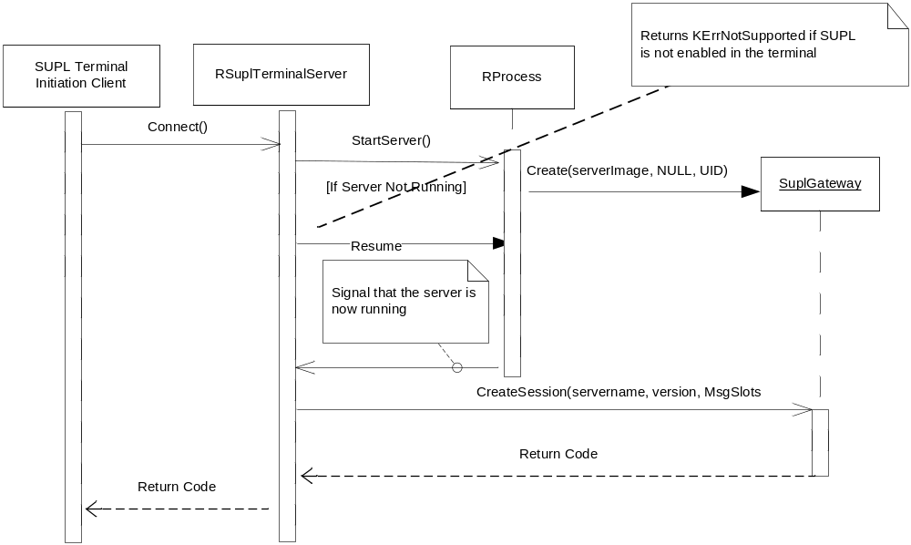
Figure 4.3 Connecting to SUPL server

Opening an IPC subsession to SUPL Server
Operation | Opening an IPC subsession to SUPL Server.
Preconditions | SUPL Server is up and running and the client has established an IPC session to SUPL Server.
Description | SUPL Terminal Initiation Client invokes the Open call in the SUPL Terminal Initiation API to open an IPC subsession to SUPL Server.
Inputs | IPC session object.
Modifies
Outputs
Postconditions | IPC subsession to SUPL Server is created.
Related to | See Sections 4.3.1, 4.3.8 and 4.3.7.
Related event
Exceptions | If an IPC session is not established and the client tries to open a subsession or if the parameter passed is NULL, the EsuplServerBadHandle panic is raised.  If the opening IPC subsession to SUPL Server fails, one of the following error codes is returned:  - KErrServerBusy if SUPL Server has taken too long to accept a request.  - KErrPermissionDenied if the client does not have CommDD capability.  - KErrNoMemory if there is no memory.

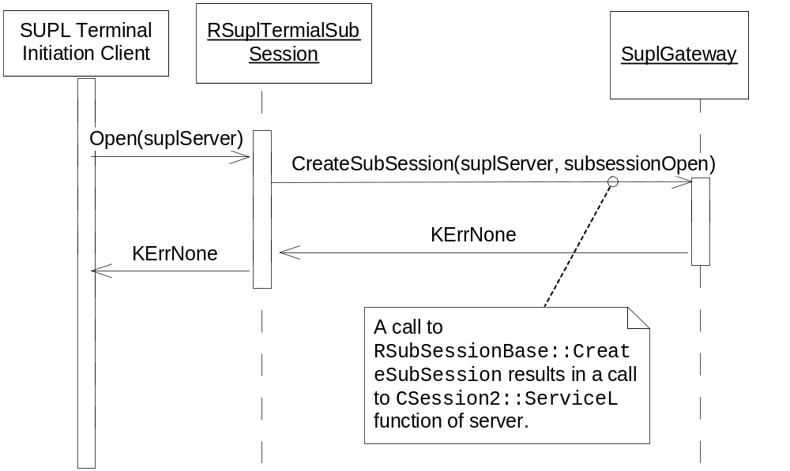
Figure 4.4 Opening a IPC subsession to SUPL Server

Starting a synchronous SUPL session
Operation | Starting a synchronous SUPL session.
Preconditions | SUPL Server is up and running and the client has established an IPC session to SUPL Server. The client has opened an IPC subsession to SUPL Server.
Description | SUPL Terminal Initiation Client invokes the synchronous RunSession call in SUPL Terminal Initiation API to start position determination using SUPL. Since this is a synchronous call, this call blocks until the SUPL session is completed.
Inputs | SUPL Terminal Capabilities which is used to restrict the positioning technologies to be used for positioning determination.
Modifies
Outputs
Postconditions | Position determination using SUPL is completed.
Related to | 4.3.1, 4.3.8, 4.3.2, 4.3.7 and 4.3.5.
Related event
Exceptions | If the subsession is not opened, the client panics with the panic code ESuplServerBadHandle.  If the runsession is not completed successfully, one of the following error codes is returned to client:  - KErrTimedOut in case of SUPL session timeout.  - KErrNoMemory if there is no memory.  - KErrArgument if there is error in the arguments passed.  - KErrCompletion if position determination cannot be completed successfully.  - KErrNotReady if SUPL Server is not ready to determine position information.  - KErrServerTerminated if the server got terminated due to some error.  - KErrGeneral for all other errors.  - KErrAlreadyExists if there is already an outstanding asynchronous RunSession request.

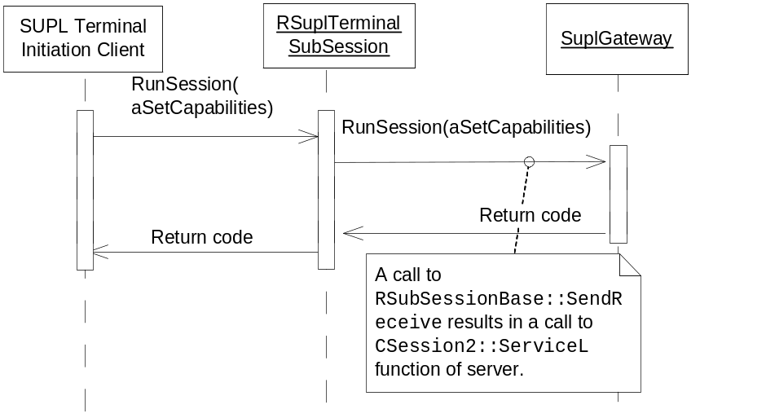
Figure 4.5 Starting synchronous SUPL session

Starting an asynchronous SUPL session
Operation | Starting an asynchronous SUPL session.
Preconditions | SUPL Server is up and running and the client has established an IPC session to the SUPL Server. The client has opened an IPC subsession to SUPL Server.
Description | SUPL Terminal Initiation Client invokes the asynchronous RunSession call in the SUPL Terminal Initiation API to determine position information using SUPL. After completing the request, server returns the status to the client.
Inputs | SUPL Terminal Capabilities which is used to restrict the positioning technologies to be used in positioning determination and status to be returned after position determination is completed.
Modifies
Outputs
Postconditions | SUPL session is started. After position determination is completed, the status is returned to indicate whether position determination is success or failure.
Related to | See Sections 4.3.1, 4.3.8, 4.3.2, 4.3.7, 4.3.6 and 4.3.5.
Related event
Exceptions | If the subsession is not opened, the client panics with the panic code ESuplServerBadHandle.  If the runsession is not completed successfully, one of the following error codes is returned to client.  - KErrTimedOut in case of SUPL session timeout.  - KErrNoMemory if there is no memory.  - KErrArgument if there is an error in the arguments passed.  - KErrCompletion if position determination cannot be completed successfully.  - KErrNotReady if SUPL Server is not ready to determine position information.  - KErrServerTerminated if server got terminated due to some error.  - KErrGeneral for all other errors.  - KErrAlreadyExists if there is already an outstanding RunSession request.

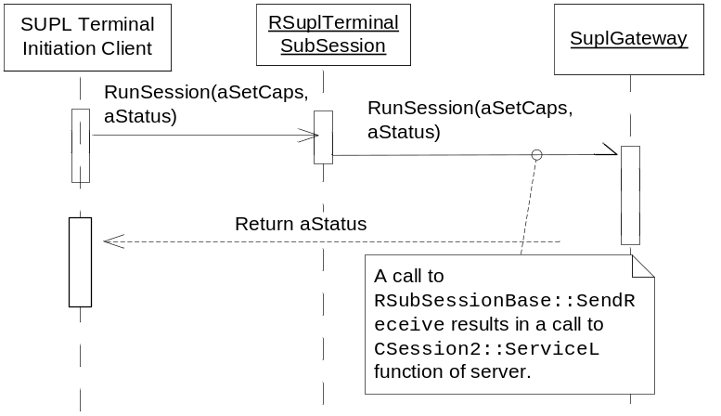
Figure 4.6 Starting an asynchronous SUPL session

Retrieving position information
Operation | Retrieving position information.
Preconditions | SUPL Server is up and running and the client has established an IPC session to SUPL Server. The client has opened an IPC subsession to SUPL Server and RunSession is completed with KErrNone.
Description | SUPL Terminal Initiation Client invokes the GetPosition call in SUPL Terminal Initiation API to get position info obtained during run session. The parameter aPositionInfo is of type TPositionInfoBase defined by Location Acquisition API. It is possible to pass any class that is derived from TPositionInfoBase. But class types supported are TPositionInfo and HPositionGenericInfo defined in Location Acquisition API. Using HPositionGenericInfo the client can specify and retrieve extended position information. The client can specify the field it wants to retrieve by setting identifiers of the requested fields in the HPositionGenericInfo object using HPositionGenericInfo::SetRequestedField method. Fields currently supported are:  - EPositionFieldHorizontalSpeed  - EPositionFieldHorizontalSpeedError  - EPositionFieldVerticalSpeed  - EPositionFieldVerticalSpeedError  If any other field other than the fields mentioned above is requested, the field is left empty.
Inputs | Reference to position information.
Modifies
Outputs | Position information.
Postconditions | Position information is obtained.
Related to | See Sections 4.3.1, 4.3.8, 4.3.2, 4.3.3, 4.3.4 and 4.3.7.
Related event
Exceptions | If subsession is not opened, the client panics with the panic code ESuplServerBadHandle.  If the server cannot write the position information to the parameter passed, the client panics with the panic code ESuplBadDescriptor.  If retrieving the position is not completed successfully, one of the following error codes is returned to the client.  - KErrNotFound for the following reasons:  - Position information is not available.  - GetPosition is called before RunSession().  - RunSession() is not completed with KErrNone.  - -KErrPositionBufferOverflow if memory allocated by client for the HPositionGenericInfo object is not enough to hold the requested fields.  - KErrNotSupported if any other class derived from TPositionInfoBase other than TPositionInfo and HPositionGenericInfo is used with this method.

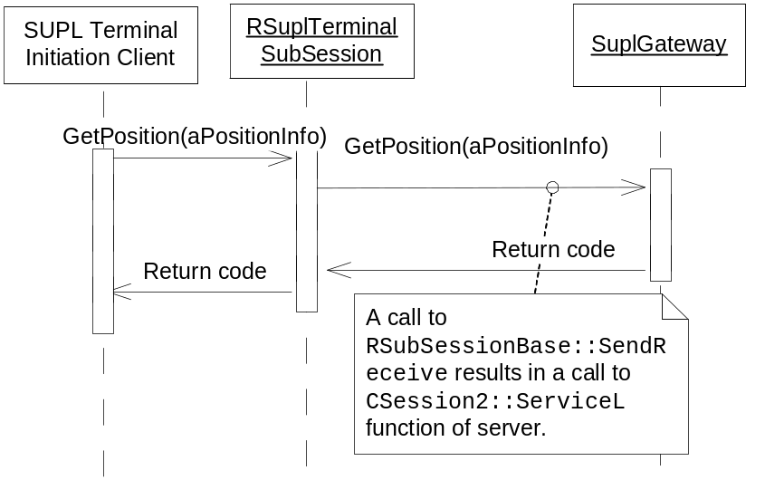
Figure 4.7 Retrieving position information

Canceling an asynchronous RunSession
Operation | Canceling an outstanding asynchronous RunSession.
Preconditions | SUPL Server is up and running and the client has established an IPC session to SUPL Server. The client has opened an IPC subsession to SUPL Server and the client has an outstanding asynchronous RunSession request.
Description | SUPL Terminal Initiation Client invokes the CancelRunsession to cancel the outstanding asynchronous RunSession.
Inputs
Modifies
Outputs
Postconditions | The outstanding asynchronous RunSession is cancelled and RunSession is completed with KErrCancel.
Related to | See Sections 4.3.1, 4.3.8, 4.3.2, 4.3.7 and 4.3.4.
Related event
Exceptions | If the subsession is not opened, the client panics with the panic code ESuplServerBadHandle.  If the request is not active, cancel is ignored.

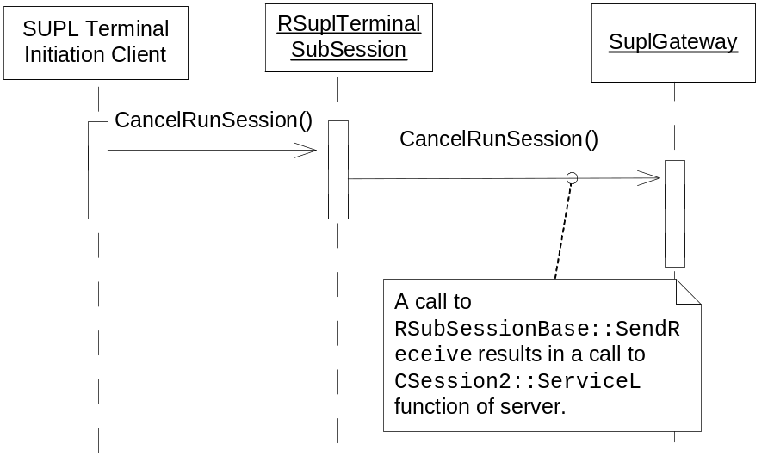
Figure 4.8 Canceling an asynchronous RunSession

Closing an IPC subsession to SUPL Server
Operation | Closing an IPC subsession to SUPL Server.
Preconditions | SUPL Server is up and running and the client has established an IPC session to SUPL Server. The client has opened an IPC subsession to SUPL Server.
Description | SUPL Terminal Initiation Client invokes the Close call in SUPL Terminal Initiation Library to close the IPC subsession to SUPL Server.
Inputs
Modifies
Outputs
Postconditions | The IPC subsession to SUPL Server is closed.
Related to | See Sections 4.3.1, 4.3.8 and 4.3.2.
Related event
Exceptions | If the subsession is not opened, the client panics with the panic code ESuplServerBadHandle.  The outstanding asynchronous request is cancelled.

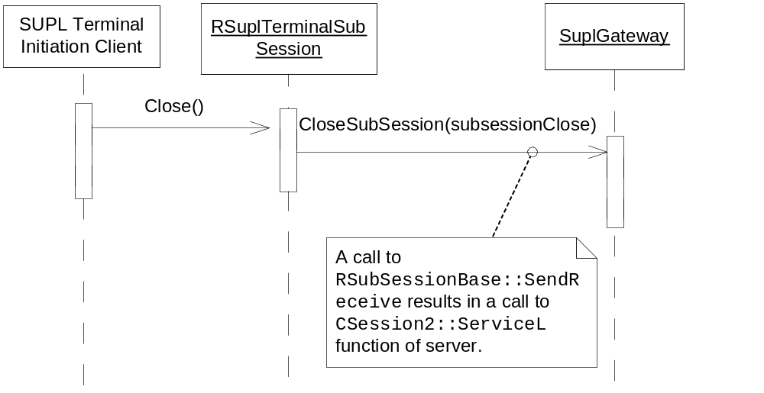
Figure 4.9 Closing a IPC subsession to SUPL Server

Closing connection to SUPL Server
Operation | Closing connection to SUPL Server.
Preconditions | SUPL Server is up and running and the client has established a connection to SUPL Server.
Description | The SUPL client invokes the close method in SUPL Terminal Initiation API.
Inputs
Modifies
Outputs
Postconditions | The IPC session to SUPL Server is closed.
Related to | See Section 4.3.1.
Related event
Exceptions | If there are any subsessions open, they are closed.

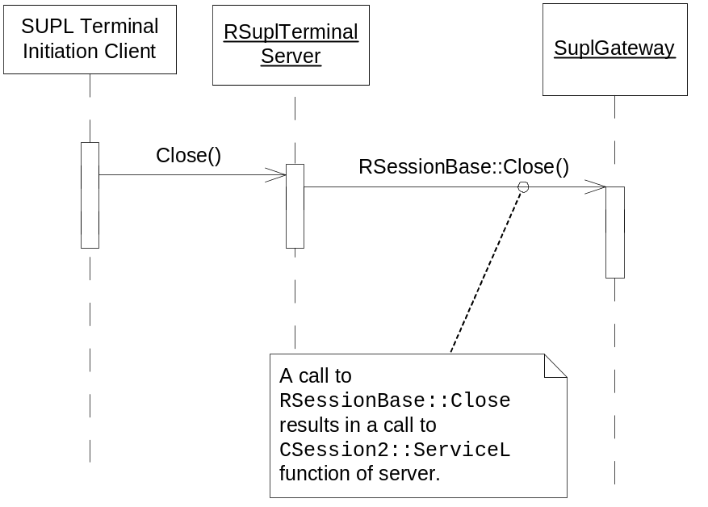
Figure 4.10 Closing connection to SUPL Server

Variation
SUPL Terminal Initiation API does not support any other variation mechanism than application wide image creation time variation, i.e. the application can be included in or excluded from a ROM image. The flags for SUPL Framework can be found from reference document [2].

System resource usage

Files
SUPL Terminal Initiation Client Library does not use any files.

Databases
SUPL Terminal Initiation Client Library does not define any databases.

Memory consumption
Memory consumption for the SUPL FW subsystem is illustrated in reference document [2].

Task allocation
SUPL Terminal Initiation API runs in the client application thread.

Performance
There are no performance critical issues in SUPL Terminal Initiation API.

Timers
SUPL Terminal Initiation API does not define any timers.

Exception handling
The following table lists the panic codes defined in SUPL Terminal Initiation API.

Exception | Description
ESuplBadDescriptor | A bad descriptor has been given to the server by the client.
ESuplServerHandleNotClosed | An attempt has been made to connect using and already open handle.
ESuplServerBadHandle | An attempt has been made to communicate though a non-connected handle.

Usage
Usage is described at subsystem level, see reference document [3].

