TMsvEntry - Use of flags

Status: | <Issued>
Version: | <0.2>
Team/Department : | <Application Technology/Messaging>

Contents
1 Introduction 3
1.1 Purpose and Scope 3
2 Overview 3
3 The TMsvEntry and derived classes 3
3.1 Predefined flags in TMsvEntry and derived classes 3
4 Implementation Considerations 5
5 Testing 5
6 Further Information 6
6.1 References 6

Introduction

Purpose and Scope
This document is intended to provide guidance on how to use the TMsvEntry class, its public members and the derived classes and gives an overview of the predefined flags. The document outlines the best practice approach to ensure maximal compatibility in the future.

Overview
The TMsvEntry and derived classes are part of the Messaging framework. An instance of the class represents an entry in the Message Server index, which contains the metadata (e.g. subject-line, date and flags) for a message regardless the type of message (Email, SMS, …). The class is extensively used in the messaging framework, MTM implementations and message client applications to access and manipulate index entry data. Because the class is used in so many places, it is important to have a set of guidelines to ensure that usage by multiple components don’t cause a conflict.

TMsvEntry and derived classes
As mentioned in the previous paragraph, the TMsvEntry class comprises the metadata for different message types. Most members of the class are public and directly accessible for reading and writing data. However, it is recommended to always use the predefined accessor-functions to ensure maximum compatibility in the future.
Further Symbian provides a class TMsvEmailEntry, derived from the class TMsvEntry as a placeholder for metadata for Emails. This class predefines some extra flags that have a meaning for Emails and can be reused by different Email MTMs.

Predefined flags in TMsvEntry and derived classes
Apart from metadata information like the subject line, the size and date, the TMsvEntry class is also a placeholder for a large set of predefined flags related to messages. The flags predefined by Symbian are stored in the data members iData, iMtmData1, iMtmData2 and iMtmData3.
As an illustration, the following tables give an overview of all currently predefined flags.
Although these flags can be accessed directly, it is very strongly recommended that the accessor functions provided by Symbian and used.
Further you should not use any of the bits marked as “Reserved for use by Symbian”.

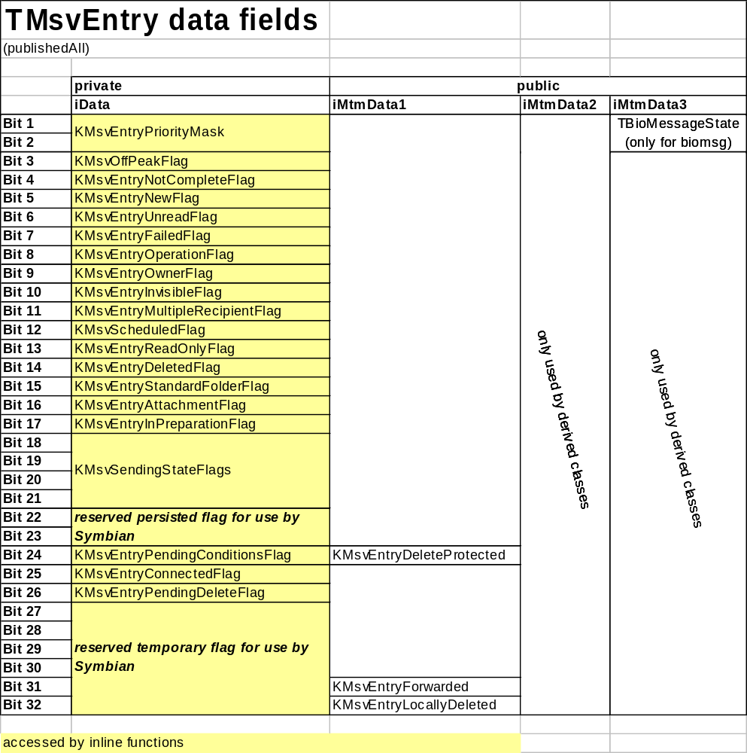
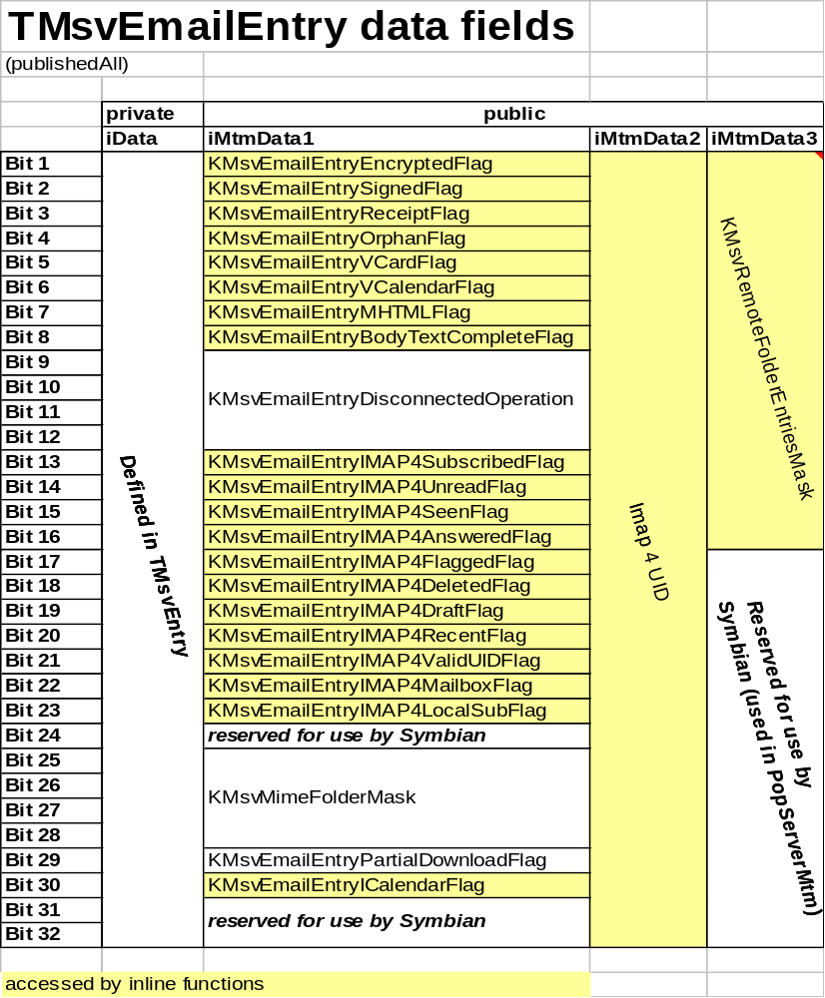

Implementation Considerations
Any third party implementer is free to use the predefined flags in TMsvEntry and derived classes for the purpose as specified by Symbian. However, it is strongly recommended that the flags marked as “reserved for use by Symbian” are not used as Symbian reserves the right to use these bits in the future.
Further it is recommended that for any predefined flags, the implementer using the TMsvEntry or derived classes should always use one of the provided accessor-functions. If extra flags or data is required, you must derive a new implementation from the TMsvEntry or TMsvEmailEntry class. For the derived class you can freely choose the usage of the members, or you can add extra data members.

Testing
Symbian does not provide any test code or application.

Further Information

References
No. | Document Reference | Version | Description

