Specifications for the WAP Access Point Parser

Version
Version 1.1
23 November 1999

Sources
We have five sources of information:

[1] The Nokia Document “Providing the Nokia 7110 with browser settings over the air”
Approved v.4.0 16-07-99
Uses the WBXML specification given in (2).

[2] The wapforum.org document “WAP Binary XML Content Format”
Version 30-Apr-1998
Version 1.0 of the WBXML specification.
(N.B. Not to be confused with the document dated 16-Jun-1999 that gives version 1.1 of the WBXML specification.)

[3] Sample WAP Settings messages from http://wfldemo.wirelessfuture.com/wap/wapdemos.asp.

[4] 03.01 Commdb Functional Spec.doc
Document code 00.23
Dated 05-Aug-1999

[5] Private communications between Julia Blumin and the Symbian Messaging Group.

From the third source, we may obtain sample messages in a number of ways. These include standard example messages pushed to the ‘phone and downloaded encoded versions of XML documents that we have previously uploaded.

The standard example messages may be transferred from the ‘phone to a PC. They appear to be garbled in the process. Of particular concern is the first number in the sequence: the version identifier. This would seem to be given a WBXML version number of 1.1 – not the version 1.0 that we expect.

Using [3] to encode XML examples from [2] is successful, giving WBXML that conforms to version 1.0 of the specification, although the encoding is not identical to that given in [2].

Using [3] to encode XML WAP settings examples from [1] is currently unsuccessful. We are trying to establish which of the differences between the examples in [1] and those in [2] are responsible for the lack of success.

Objective
To create a parser that can receive a WBXML document conforming to [1] and [2] that meets the specifications provided by [5]. The WAP Settings message will come in on port 49999. Later versions of the parser may be able to use messages that conform to version 1.1 of the WBXML standard. The parser extracts the information required for the WAP Settings Table, as given in [4]. The parser should expect messages to be encoded in the same manner as those received from [3].

There will also be a test harness for the WAP Parser. This takes an XML WAP Settings document that has been encoded as WBXML and places the binary data as the body of a message. It will then either place the message in the inbox or pass it directly to the parser.

WBXML Codes
Table 1: Global Tokens (from [2]):
Token Name | Token | Description
SWITCH_PAGE | 0 | Change the code page for the current token state. Followed by a single u_int8 indicating the new code page number.
END | 1 | Indicates the end of an attribute list or the end of an element.
ENTITY | 2 | A character entity. Followed by a mb_u_int32 encoding the character entity number.
STR_I | 3 | Inline string. Followed by a termstr.
LITERAL | 4 | An unknown tag or attribute name. Followed by an mb_u_int32 that encodes an offset into the string table.
EXT_I_0 | 40 | Inline string document-type-specific extension token. Token is followed by a termstr.
EXT_I_1 | 41 | Inline string document-type-specific extension token. Token is followed by a termstr.
EXT_I_2 | 42 | Inline string document-type-specific extension token. Token is followed by a termstr.
PI | 43 | Processing instruction.
LITERAL_C | 44 | Unknown tag, with content.
EXT_T_0 | 80 | Inline integer document-type-specific extension token. Token is followed by a mb_uint_32.
EXT_T_1 | 81 | Inline integer document-type-specific extension token. Token is followed by a mb_uint_32.
EXT_T_2 | 82 | Inline integer document-type-specific extension token. Token is followed by a mb_uint_32.
STR_T | 83 | String table reference. Followed by a mb_u_int32 encoding a byte offset from the beginning of the string table.
LITERAL_A | 84 | Unknown tag, with attributes.
EXT_0 | C0 | Single-byte document-type-specific extension token.
EXT_1 | C1 | Single-byte document-type-specific extension token.
EXT_2 | C2 | Single-byte document-type-specific extension token.
RESERVED_2 | C3 | Reserved for future use.
LITERAL_AC | C4 | Unknown tag, with content and attributes.

Table 2: Tag Tokens (from [1]):
Token name | Token value
CHARACTERISTIC-LIST | 0x05
CHARACTERISTIC | 0x06
PARM | 0x07

Table 3: Attribute Start Tokens (from [1] and [3] – see Notes 1 and 2):
Attribute name | Attribute value prefix | Attribute value
TYPE |  | 0x05
TYPE | ADDRESS | 0x06
TYPE | URL | 0x07
TYPE | NAME | 0x08
NAME |  | 0x10
VALUE |  | 0x11
NAME | BEARER | 0x12
NAME | PROXY | 0x13
NAME | PORT | 0x14
NAME | NAME | 0x15
NAME | SMS_SMSC_ADDRESS | 0x1A
NAME | CSD_DIALSTRING | 0x21
NAME | CSD_AUTHTYPE | 0x22
NAME | CSD_AUTHNAME | 0x23
NAME | CSD_AUTHSECRET | 0x24
NAME | CSD_CALLTYPE | 0x28
NAME | CSD_CALLSPEED | 0x29
VALUE | GSM/SMS | 0x41
VALUE | GSM/CSD | 0x45
VALUE | 9200 | 0x60
VALUE | 9201 | 0x61
VALUE | 9202 | 0x62
VALUE | 9203 | 0x63
VALUE | AUTO | 0x6A
VALUE | 9600 | 0x6B
VALUE | 14400 | 0x6C
VALUE | PAP | 0x70
VALUE | CHAP | 0x71
VALUE | ANALOGUE | 0x72
VALUE | ISDN | 0x73

Notes
- The code for TYPE (0x05) is not given in the tables in [1] but appears in messages encoded via [3].
- The code 0x41 is duplicated – it should be reserved for the global token. This conflict is resolved in later versions of [1] but does not lead to any ambiguity in messages currently being created.
- Attributes not assigned a token are encoded as inline strings.
- According to [5], the tags and attributes may be assumed to be given in the same order as they appear in the examples from [1]. There will always be two bearers (CSD and SMS) and the first set of values for each bearer is used. Additional sets of values for a given bearer are discarded.

DTD
WAP settings messages will conform to the DTD given in [1]:

<!ELEMENT CHARACTERISTIC-LIST (CHARACTERISTIC)+>
<!ELEMENT CHARACTERISTIC (PARM*)>
<!ATTLIST C
TYPE CDATA #REQUIRED
VALUE CDATA #IMPLIED
>
<!ELEMENT PARM EMPTY>
<!ATTLIST PARM
NAME CDATA #REQUIRED
VALUE CDATA #REQUIRED
>

This implies that the only tags to be used are “CHARACTERISTIC-LIST”, “CHARACTERISTIC” and “PARM”. These all have tokens as given in Table 2. N.B. Using [3] to encode XML with other tags gives WBXML with a string-table containing the tags. However, a WBXML message with other tags is not a valid WAP settings message.

Bits 6 and 7 of the tag code are used to indicate whether the tag has attributes and/or content, as per Section 5.7.2 of [2].

The “CHARACTERISTIC-LIST” has no attributes but must have content (i.e. one or more CHARACTERISTIC elements). Thus, it will be denoted by the token 45.

A “CHARACTERISTIC” must have attributes and may have content (zero or more PARM elements). Thus, it will be denoted by the token 86 or C6.

A “PARM” must have attributes but cannot have content. Thus, it will be denoted by the token 87.

7110 EXAMPLE 1
XML uploaded to website:
<?xml version="1.0"?>
<!DOCTYPE CHARACTERISTIC-LIST [
<!ELEMENT CHARACTERISTIC-LIST (CHARACTERISTIC+)>
<!ELEMENT CHARACTERISTIC (PARM*)>
<!ATTLIST CHARACTERISTIC
TYPE CDATA #REQUIRED
VALUE CDATA #IMPLIED
>
<!ELEMENT PARM EMPTY>
<!ATTLIST PARM
NAME CDATA #REQUIRED
VALUE CDATA #REQUIRED
>
]>
<CHARACTERISTIC-LIST>
<CHARACTERISTIC TYPE="ADDRESS">
<PARM NAME="BEARER" VALUE="GSM/CSD"/>
<PARM NAME="PROXY" VALUE="192.122.10.120"/>
<PARM NAME="CSD_DIALSTRING" VALUE="+358508124002"/>
<PARM NAME="CSD_AUTHTYPE" VALUE="PAP"/>
<PARM NAME="CSD_AUTHNAME" VALUE="wapuser"/>
<PARM NAME="CSD_AUTHSECRET" VALUE="wappassw"/>
<PARM NAME="CSD_CALLTYPE" VALUE="ANALOGUE"/>
<PARM NAME="CSD_CALLSPEED" VALUE="AUTO"/>
</CHARACTERISTIC>
<CHARACTERISTIC TYPE="ADDRESS">
<PARM NAME="BEARER" VALUE="GSM/SMS"/>
<PARM NAME="PROXY" VALUE="9400410"/>
<PARM NAME="SMS_SMSC_ADDRESS" VALUE="+36209400400"/>
</CHARACTERISTIC>
<CHARACTERISTIC TYPE="URL" VALUE="/startpage/index.wml"/>
<CHARACTERISTIC TYPE="NAME">
<PARM NAME="NAME" VALUE="Mobilbank"/>
</CHARACTERISTIC>
</CHARACTERISTIC-LIST>

Encoded version downloaded:
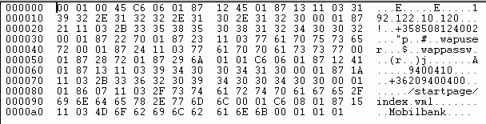

7110 EXAMPLE 2
XML uploaded to website:
<?xml version="1.0"?>
<!DOCTYPE CHARACTERISTIC-LIST [
<!ELEMENT CHARACTERISTIC-LIST (CHARACTERISTIC+)>
<!ELEMENT CHARACTERISTIC (PARM*)>
<!ATTLIST CHARACTERISTIC
TYPE CDATA #REQUIRED
VALUE CDATA #IMPLIED
>
<!ELEMENT PARM EMPTY>
<!ATTLIST PARM
NAME CDATA #REQUIRED
VALUE CDATA #REQUIRED
>
]><CHARACTERISTIC-LIST>
<CHARACTERISTIC TYPE="ADDRESS">
<PARM NAME="BEARER" VALUE="GSM/CSD"/>
<PARM NAME="PROXY" VALUE="192.122.10.120"/>
<PARM NAME="CSD_DIALSTRING" VALUE="+358508124002"/>
<PARM NAME="CSD_AUTHTYPE" VALUE="PAP"/>
<PARM NAME="CSD_AUTHNAME" VALUE="wapuser"/>
<PARM NAME="CSD_AUTHSECRET" VALUE="wappassw"/>
<PARM NAME="CSD_CALLTYPE" VALUE="ANALOGUE"/>
<PARM NAME="CSD_CALLSPEED" VALUE="AUTO"/>
<PARM NAME="PROXY_AUTHNAME" VALUE="pxauthname"/>
<PARM NAME="PROXY_AUTHSECRET" VALUE="pxauthsecret"/>
<PARM NAME="ISP_NAME" VALUE="World Access ISP"/>
</CHARACTERISTIC>
<CHARACTERISTIC TYPE="ADDRESS">
<PARM NAME="BEARER" VALUE="GSM/SMS"/>
<PARM NAME="PROXY" VALUE="9400410"/>
<PARM NAME="SMS_SMSC_ADDRESS" VALUE="+36209400400"/>
</CHARACTERISTIC>
<CHARACTERISTIC TYPE="BOOKMARK">
<PARM NAME="NAME" VALUE="My favorite page"/>
<PARM NAME="URL" VALUE="http://www.somewhere.com/index.wml"/>
<CHARACTERISTIC/>
<CHARACTERISTIC TYPE="URL" VALUE="/startpage/index.wml"/>
<CHARACTERISTIC TYPE="NAME">
<PARM NAME="NAME" VALUE="Mobilbank"/>
</CHARACTERISTIC>
</CHARACTERISTIC-LIST>
Encoded version downloaded:
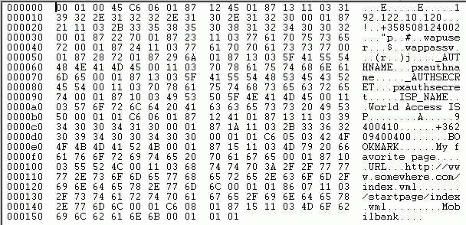

7110 EXAMPLE 3
Message generated by a form on the WAP coding web-site.

Encoded version downloaded:
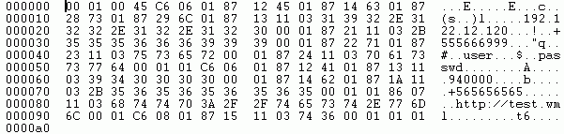

7110 EXAMPLE 4
XML uploaded to website:
<?xml version="1.0"?>
<!DOCTYPE CHARACTERISTIC-LIST [
<!ELEMENT CHARACTERISTIC-LIST (CHARACTERISTIC+)>
<!ELEMENT CHARACTERISTIC (PARM*)>
<!ATTLIST CHARACTERISTIC
TYPE CDATA #REQUIRED
VALUE CDATA #IMPLIED
>
<!ELEMENT PARM EMPTY>
<!ATTLIST PARM
NAME CDATA #REQUIRED
VALUE CDATA #REQUIRED
>
]>
<CHARACTERISTIC-LIST>
<CHARACTERISTIC TYPE="ADDRESS">
<PARM NAME="BEARER" VALUE="GSM/CSD"/>
<PARM NAME="PROXY" VALUE="192.122.10.120"/>
<PARM NAME="CSD_DIALSTRING" VALUE="+358508124002"/>
<PARM NAME="CSD_AUTHTYPE" VALUE="PAP"/>
<PARM NAME="CSD_AUTHNAME" VALUE="wapuser"/>
<PARM NAME="CSD_AUTHSECRET" VALUE="wappassw"/>
<PARM NAME="CSD_CALLTYPE" VALUE="ANALOGUE"/>
<PARM NAME="CSD_CALLSPEED" VALUE="AUTO"/>
<PARM NAME="PROXY_AUTHNAME" VALUE="pxauthname"/>
<PARM NAME="PROXY_AUTHSECRET" VALUE="pxauthsecret"/>
<PARM NAME="ISP_NAME" VALUE="World Access ISP"/>
<PARM NAME="WIBBLE_CODE" VALUE="sandwich"/>
</CHARACTERISTIC>
<CHARACTERISTIC TYPE="ADDRESS">
<PARM NAME="BEARER" VALUE="GSM/SMS"/>
<PARM NAME="PROXY" VALUE="9400410"/>
<PARM NAME="SMS_SMSC_ADDRESS" VALUE="+36209400400"/>
</CHARACTERISTIC>
<CHARACTERISTIC TYPE="BOOKMARK">
<PARM NAME="NAME" VALUE="My favorite page"/>
<PARM NAME="URL" VALUE="http://www.somewhere.com/index.wml"/>
</CHARACTERISTIC>
<CHARACTERISTIC TYPE="URL" VALUE="/startpage/index.wml"/>
<CHARACTERISTIC TYPE="NAME">
<PARM NAME="NAME" VALUE="Mobilbank"/>
</CHARACTERISTIC>
<CHARACTERISTIC TYPE="PENGUIN">
<PARM NAME="FISH" VALUE="mackerel"/>
<PARM NAME="FLIES" VALUE="not likely"/>
<PARM NAME="FLIP" VALUE="flop"/>
</CHARACTERISTIC>
</CHARACTERISTIC-LIST>

Encoded version downloaded:
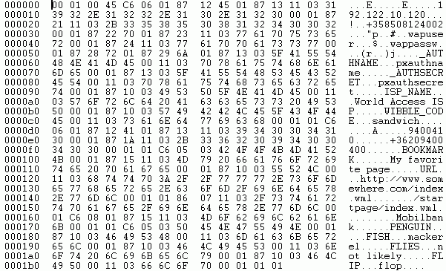

7110 EXAMPLE 5
XML uploaded to website:
<?xml version="1.0"?>
<!DOCTYPE FISH-LIST [
<!ELEMENT FISH-LIST (FISH+)>
<!ELEMENT FISH (PARM*)>
<!ATTLIST FISH
TYPE CDATA #REQUIRED
VALUE CDATA #IMPLIED
>
<!ELEMENT PARM EMPTY>
<!ATTLIST PARM
NAME CDATA #REQUIRED
VALUE CDATA #REQUIRED
>
]>
<FISH-LIST>
<FISH TYPE="ADDRESS">
<PARM NAME="BEARER" VALUE="GSM/CSD"/>
<PARM NAME="PROXY" VALUE="192.122.10.120"/>
<PARM NAME="CSD_DIALSTRING" VALUE="+358508124002"/>
<PARM NAME="CSD_AUTHTYPE" VALUE="PAP"/>
<PARM NAME="CSD_AUTHNAME" VALUE="wapuser"/>
<PARM NAME="CSD_AUTHSECRET" VALUE="wappassw"/>
<PARM NAME="CSD_CALLTYPE" VALUE="ANALOGUE"/>
<PARM NAME="CSD_CALLSPEED" VALUE="AUTO"/>
<PARM NAME="PROXY_AUTHNAME" VALUE="pxauthname"/>
<PARM NAME="PROXY_AUTHSECRET" VALUE="pxauthsecret"/>
<PARM NAME="ISP_NAME" VALUE="World Access ISP"/>
<PARM NAME="WIBBLE_CODE" VALUE="sandwich"/>
</FISH>
<FISH TYPE="ADDRESS">
<PARM NAME="BEARER" VALUE="GSM/SMS"/>
<PARM NAME="PROXY" VALUE="9400410"/>
<PARM NAME="SMS_SMSC_ADDRESS" VALUE="+36209400400"/>
</FISH>
<FISH TYPE="BOOKMARK">
<PARM NAME="NAME" VALUE="My favorite page"/>
<PARM NAME="URL" VALUE="http://www.somewhere.com/index.wml"/>
</FISH>
<FISH TYPE="URL" VALUE="/startpage/index.wml"/>
<FISH TYPE="NAME">
<PARM NAME="NAME" VALUE="Mobilbank"/>
</FISH>
<FISH TYPE="PENGUIN">
<PARM NAME="FISH" VALUE="mackerel"/>
<PARM NAME="FLIES" VALUE="not likely"/>
<PARM NAME="FLIP" VALUE="flop"/>
</FISH>
</FISH-LIST>
Encoded version downloaded:
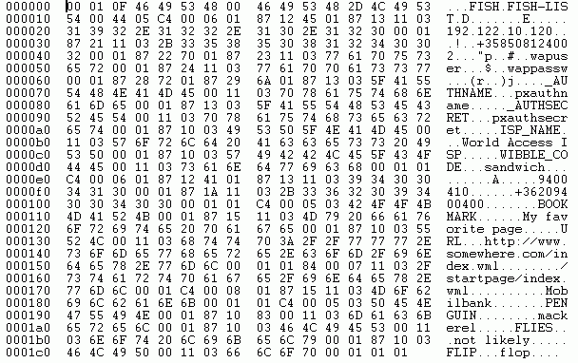

7110 EXAMPLE 7
XML uploaded to website:
<?xml version="1.0"?>
<!DOCTYPE CHARACTERISTIC-LIST [
<!ELEMENT CHARACTERISTIC-LIST (CHARACTERISTIC+)>
<!ELEMENT CHARACTERISTIC (PARM*)>
<!ATTLIST CHARACTERISTIC
TYPE CDATA #REQUIRED
VALUE CDATA #IMPLIED
>
<!ELEMENT PARM EMPTY>
<!ATTLIST PARM
NAME CDATA #REQUIRED
VALUE CDATA #REQUIRED
>
]>
<CHARACTERISTIC-LIST>
<CHARACTERISTIC TYPE="ADDRESS">
<PARM NAME="BEARER" VALUE="GSM/CSD"/>
<PARM NAME="PROXY" VALUE="192.122.10.120"/>
<PARM NAME="PORT" VALUE="9202"/>
<PARM NAME="CSD_DIALSTRING" VALUE="+358508124002"/>
<PARM NAME="CSD_AUTHTYPE" VALUE="CHAP"/>
<PARM NAME="CSD_AUTHNAME" VALUE="wapuser"/>
<PARM NAME="CSD_AUTHSECRET" VALUE="wappassw"/>
<PARM NAME="CSD_CALLTYPE" VALUE="ISDN"/>
<PARM NAME="CSD_CALLSPEED" VALUE="14400"/>
</CHARACTERISTIC>
<CHARACTERISTIC TYPE="ADDRESS">
<PARM NAME="BEARER" VALUE="GSM/SMS"/>
<PARM NAME="PROXY" VALUE="9400410"/>
<PARM NAME="SMS_SMSC_ADDRESS" VALUE="+36209400400"/>
</CHARACTERISTIC>
<CHARACTERISTIC TYPE="URL" VALUE="/index.wml"/>
<CHARACTERISTIC TYPE="NAME">
<PARM NAME="NAME" VALUE="Penguin"/>
</CHARACTERISTIC>
</CHARACTERISTIC-LIST>

Encoded version downloaded:
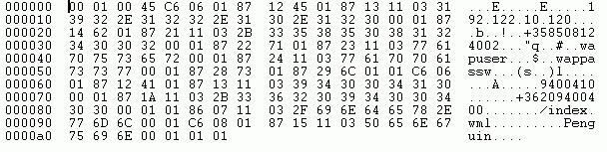

7110 EXAMPLE 8
XML uploaded to website:
<?xml version="1.0"?>
<!DOCTYPE CHARACTERISTIC-LIST [
<!ELEMENT CHARACTERISTIC-LIST (CHARACTERISTIC+)>
<!ELEMENT CHARACTERISTIC (PARM*)>
<!ATTLIST CHARACTERISTIC
TYPE CDATA #REQUIRED
VALUE CDATA #IMPLIED
>
<!ELEMENT PARM EMPTY>
<!ATTLIST PARM
NAME CDATA #REQUIRED
VALUE CDATA #REQUIRED
>
]>
<CHARACTERISTIC-LIST>
<CHARACTERISTIC TYPE="ADDRESS">
<PARM NAME="BEARER" VALUE="GSM/CSD"/>
<PARM NAME="PROXY" VALUE="195.134.226.28"/>
<PARM NAME="PORT" VALUE="9201"/>
<PARM NAME="CSD_DIALSTRING" VALUE="+358331520666"/>
<PARM NAME="CSD_AUTHTYPE" VALUE="PAP"/>
<PARM NAME="CSD_AUTHNAME" VALUE="tstuser"/>
<PARM NAME="CSD_AUTHSECRET" VALUE="pw4tstu"/>
<PARM NAME="CSD_CALLTYPE" VALUE="ANALOGUE"/>
<PARM NAME="CSD_CALLSPEED" VALUE="AUTO"/>
</CHARACTERISTIC>
<CHARACTERISTIC TYPE="ADDRESS">
<PARM NAME="BEARER" VALUE="GSM/SMS"/>
<PARM NAME="PROXY" VALUE="1065504"/>
<PARM NAME="PORT" VALUE="9200"/>
<PARM NAME="SMS_SMSC_ADDRESS" VALUE="+358508771019"/>
</CHARACTERISTIC>
<CHARACTERISTIC TYPE="URL" VALUE="http://mmm.wirelessfuture.com/extindex11.wml"/>
<CHARACTERISTIC TYPE="NAME">
<PARM NAME="NAME" VALUE="WFL wapgw1"/>
</CHARACTERISTIC>
</CHARACTERISTIC-LIST>

Encoded version downloaded:
