S60 3.1
FOTA Engine
Design Document

Team name | Author
Sync & Provisioning | Pekka Paadar

Change history:

Version | Date | Status | Comments
2.0 | 20.11.2006 | Approved | Reminder, flexible memory handling.
1.0 | 17.03.2006 | Approved

Table of contents:

1. Document control 4
1.1 References 4
1.2 Documentation conventions 4
1.3 Abbreviations 4
1.4 Definitions 4
2. General 5
2.1 Introduction 5
2.2 Component environment 5
2.3 Use cases 5
2.4 Services required 6
2.4.1 From Symbian OS subsystems 6
2.5 Services provided 7
2.5.1 UI 7
2.5.2 SW IF 7
3. UI control hierarchy 8
4. Design 9
4.1 Class diagrams 9
4.1.1 Framework 9
4.1.2 Component 10
4.2 Class descriptions 10
4.2.1 Structs, type definitions and enumerations 11
4.2.2 Flag definitions 11
4.2.3 State diagrams 12
4.3 Operations 12
4.3.1 Download 12
4.3.2 Update 13
4.3.3 Scheduled Update 14
4.3.4 DownloadAndUpdate 14
4.3.5 Result to server after reboot 14
4.3.6 Reserve disk space 15
4.4 Backup and Restore 16
5. Variation 17
6. System resource usage 18
6.1 Files 18
6.2 Other Data 18
6.2.1 Databases 18
6.2.2 Central Repository 18
6.3 Memory consumption 19
6.4 Task allocation 19
6.5 Performance 19
6.6 Timers 19
7. Security 20
7.1 Capabilities of this component 20
7.2 Input and output validation 20
7.3 Environmental assumptions 20
7.4 Additional enforcements 20
8. Exception handling 21
9. Usage 22
9.1 Building 22
9.2 User's Guide 22

Document control

References
- Firmware Update Management Object | http://www.openmobilealliance.org
- S60 Device Manager UI Specification
- S60 Content Download UI Specification
- Generic Content Download Over The Air Specification | http://www.openmobilealliance.org

Documentation conventions
Code is shown with the Courier New font.

Abbreviations
API | Application programming interface.
DD | OMA download descriptor. File containing the details of the file to be downloaded.
DM | SyncML Device Management protocol.
DP2 | Obsolete (see SWUPD)
FOTA | Firmware update Over The Air
FUMO | Firmware Update Management Object. Media object handled by the SyncML Device Management protocol.
FW | Firmware software of the device.
OMA | Open Mobile Alliance.
OS | Operating System.
RFS | Restore Factory Settings means formatting the user area.
SID | Secure IDentifier identifies the applications on Symbian OS.
SWUPD | Firmware package file. Device firmware is updated with this file.
UI | User interface

Definitions
OMA download | OMA’s download mechanism, which uses a special download descriptor (DD) to execute the download (see reference document [4]).
Download manager | S60 application, which can be used to download files via the HTTP protocol.
Package | Object describing a firmware update. FOTA DM Adapter stores the packages, in the format of DM Update Management Object (see reference document [1]).  FOTA Engine stores the actual payload (.swupd files) of the packages, and maintains the state associated with each package in the database.
Update agent | Engine which takes care of flashing the device with the downloaded SWUPD package. Runs in the mini-OS context.

General

Introduction
FOTA Server is a server application coordinating the firmware update functionality. Clients of FOTA Server use FOTA Engine to access the functionality.

Component environment
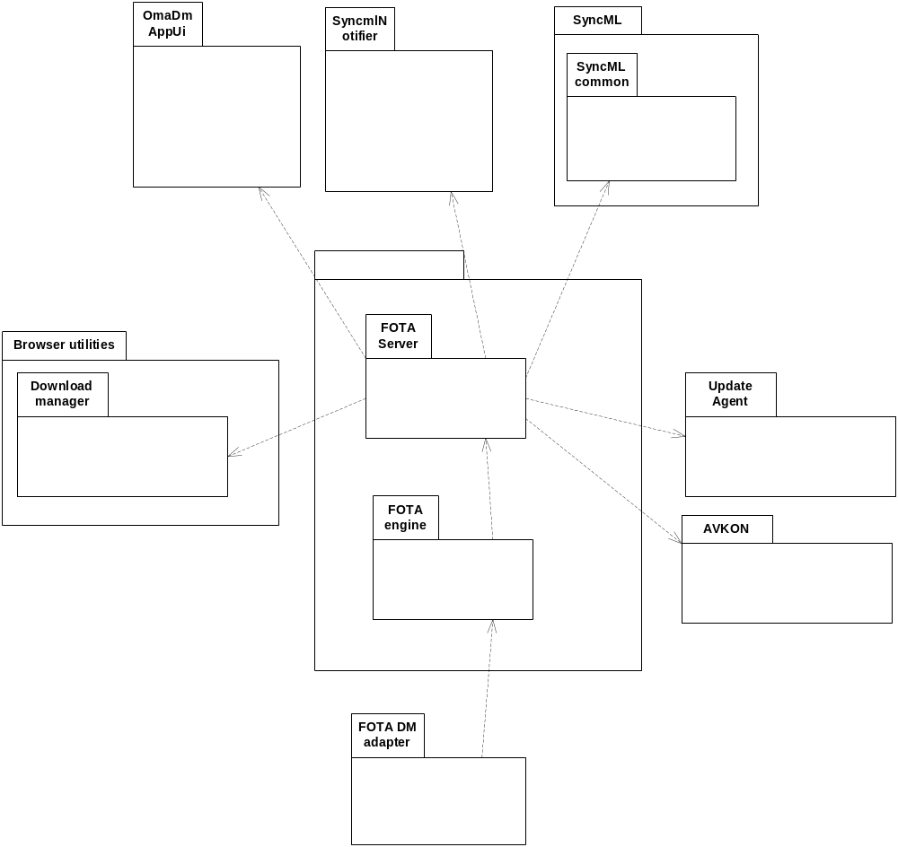
Figure 2.1 Component environment

Use cases
Some basic use cases are displayed in the following image.
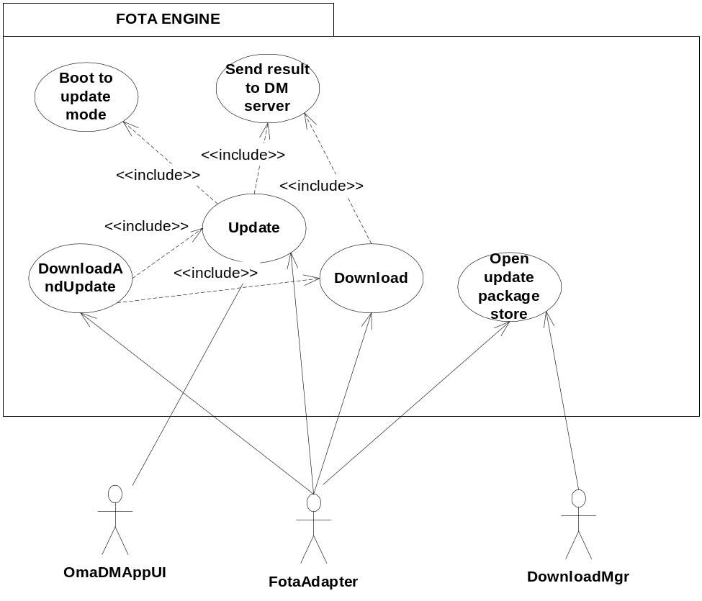
Figure 2.2 FOTA Engine use cases

Services required

From Symbian OS subsystems
Required Service | Description
Edbms | Database functionality.
Downloadmgr | Download manager is used for downloading files via HTTP.
SysUtil | This is used for booting to the update mode.
SyncMLClientAPI | Used for establishing the initial DM session, which sends the generic alert to DM server.
ECom | Used for loading FOTA disk storage, which saves the SWUPD package.
BITGDI | Used for writing graphics for the update agent.
FBScli | Used for writing graphics for the update agent.
gdi | Used for writing graphics for the update agent.
NSmlTreeDbClient | For deleting FUMO tree after state has bee reset back to 10.

Services provided

UI
Download, Update and DownloadAndUpdate operations cause UI activity. During download, FOTA Server shows a progress dialog (see reference document [2]). When the download progresses, DD is shown by Download Manager (see reference document [3]). The Restart notification and Download notifications are shown via SyncML Notifier (see reference document [2]).

SW IF
Provided Service | Description
Download | Downloads the SWUPD file from a specified URI.
Update | Updates the device firmware with the designated SWUPD file.
DownloadAndUpdate | Downloads a SWUPD and updates the device with it.
Open update package store | Creates a stream to update the package store, for the client to write the SWUPD.
Get State of package | Gets the FUMO state for the update package.
Get Result of package | Gets the FUMO result for the update package.
Delete | Deletes the SWUPD package.
Get last update time | Gets the time of the last update.

UI control hierarchy
The component does not contain any UI or UI controls.

Design

Class diagrams
Static object model of the components.

Framework
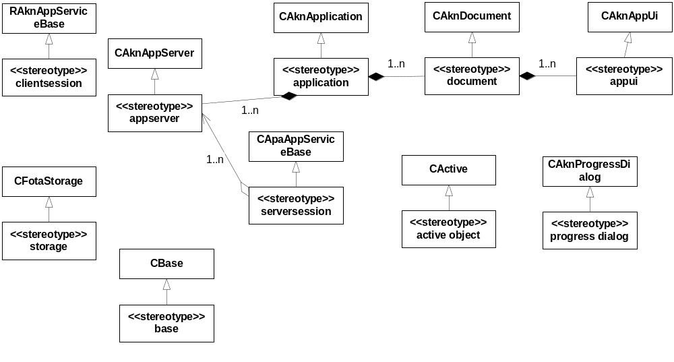
Figure 4.3 FOTA Server stereotypes

Component
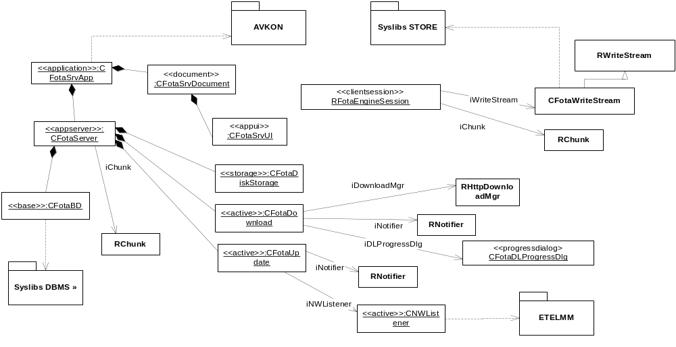
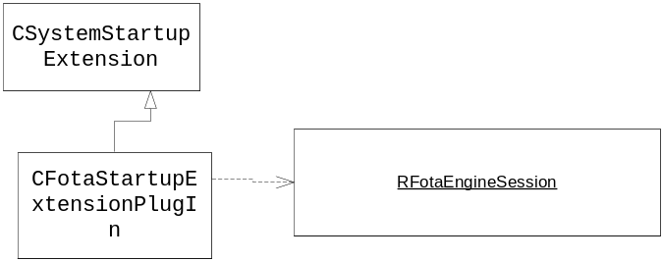

Figure 4.4 Fotaserver components

The interface of FOTA Server is provided via the RFotaEngineSession class.

Class descriptions
Class | Description | Header file
RFotaEngineSession | FOTA Engine API. | FotaEngClient.h
RFotaWriteStream | Stream to write the SWUPD package to the server. | FotaEngStream.h
CFotaSession | Server side session object. | FotaSession.h
CFotaServer | Server class. | FotaServer.h
CFotaDB | Stores the FOTA package states. | FotaDB.h
CFotaSrvApp | FOTA Server application. | Fotasrvapp.h
CFotaSrvDocument | FOTA Server document class. | Fotasrcdocument.h
CFotaSrvUi | FOTA Server UI. | Fotasrvui.h
CFotaDownload | Download active object. Used for downloading. | Fotadownload.h
CFotaUpdate | Updater active object. Used for initiating a firmware update. | Fotaupdate.h
CFotaDLProgressDlg | Progress dialog for download. | FotaDLProgressDlg.h
CFotaNWListener | This is used for observing the network. | Updater.h
CFotaStartupExtensionPlugin | Starts fotaserver in new start up scenario. | Fotastartupextensionplugin.h

Structs, type definitions and enumerations

Fotaengine.h
Name | Description
enum TFotaIPCCmds | Message types sent from the client to the server.
enum RFotaEngineSession::TState | Package states as in the FUMO Specification, see reference document [1].
enum RFotaEngineSession::TResult | Result of download/update operation as specified in the FUMO Specification, see reference document [1].

Flag definitions
Flag | Description
_FOTA_DEBUG | Specifies whether or not FOTA logs to c:\logs\fota. If _FOTA_DEBUG_RDEBUG is additionally defined, it is logged to the rdebug stream. The flag is individually defined for each component.
_FOTA_DEBUG_RDEBUG | Specifies whether or not FOTA logs to the tracing stream. The flag is individually defined for each component.

State diagrams

CFotaDownload
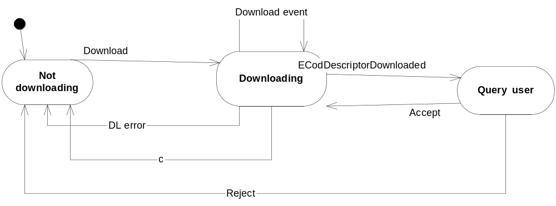
Figure 4.5 A state machine describing the dynamic behavior of CFotaDownload

CFotaUpdate
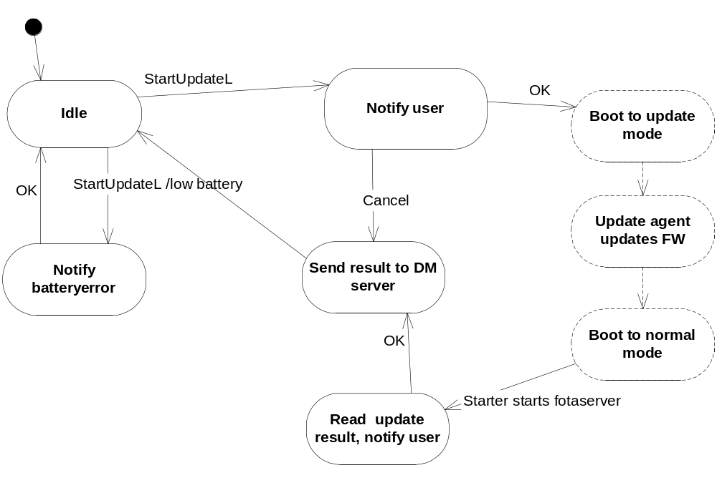
Figure 4.6 A state machine describing the dynamic behavior of CFotaUpdate

Operations

Download
Operation | Download.
Preconditions | Network is available, a DM profile exists.
Description | Depending on the DM profile’s auto-accepted value (whether or not the DM session is visible), the download is started in the visible mode or the invisible mode. There is one exception to this: If the user manually starts a DM session, the resulting download should be visible, even if the profile is auto-accepted.  a) Visible mode: Download is started using Download Manager. FOTA Server turns visible, and a progress dialog is shown. After the download of the descriptor is complete, the Descriptor view is shown. The user may accept or reject the download. After the download has been accepted, the download process continues and the progress dialog is shown again. The download ends and FOTA Server is turned invisible.  If package doesn’t fit to space reservation, reservation is increased to hold the package.  If package doesn’t fit to filesystem (space reservation + free space), user is presented with a popup telling him to free some disk space.  b) Invisible mode: Download is started using Download Manager. The download ends. When the download completes (with or without an error), a DM session is established to report the result back to the server, in a generic alert.
Inputs | PackageID, PackageURL, SyncMLProfileID, PackageName, PackageVersion
Modifies | The downloaded file is written to the file system via the FOTA storage.
Outputs | Immediate result of the download command (TError).
Postconditions | SWUPD file is downloaded to the system.
Related To | Classes CFotaServer, CFotaDownload, CfotaStorage.
Related Event | The Exec command received by the SyncML framework.
Exceptions | If the user clicks cancel in the progress dialog, the download is cancelled and the status is reported to the DM server. If the user rejects the descriptor, the download is cancelled and the status is reported. If a download error occurs, a popup is shown and the status is reported. If an OMA install notification is defined in the descriptor and it fails, the package is deleted.

Update
Operation | Update of the system firmware.
Preconditions | SWUPD is stored in the device.
Description | The battery power is checked. The update query dialog is shown to the user via SyncMLNotifier. If the user accepts the update, the update request file and the update graphics are written for the update agent. The device is booted to the update mode. If user cancels update, he is asked to set a update timer. (1 hour, 1 day etc).
Inputs | PackageID, SyncMLProfileID.
Modifies | All data in the phone addressed by the SWUPD package is overwritten.  If user sets reminder, an update is scheduled using scheduleserver. See Scheduled update.
Outputs | Immediate result of the update command (TError).
Postconditions | Device firmware is updated. The result is sent to the server after reboot.
Related To | Classes CFotaServer, CFotaUpdate.
Related Event | The Exec command received by the SyncML framework. User interaction in OmaDMAppUI.
Exceptions | If the battery is low, the user is notified about that. The result is reported to the DM server.

Scheduled Update
Operation | Schedule update
Preconditions | SWUPD is stored in the device, user has choosed “Later” option when asked to update firmware.
Description | Schedule server finds fota entry in it’s database. Fotaschedulehandler.exe is called, and passed with schedule data (schedule id and firmware package id). Fotaschedulehandler calls Fota engines ScheduledUpdate() method.
Inputs | ScheduleId, PackageID.
Modifies | -
Outputs | -
Postconditions | Update process is started. See update.
Related To | Fotaschedulehandler.cpp,.
Related Event | Scheduleserver triggers an event, set earlier by fotaserver
Exceptions | If process is forced to be cancelled, schedule entry will prevail, and will be triggered later.

DownloadAndUpdate
Operation | Download of SWUPD and firmware update.
Preconditions | Network is available.
Description | The download is started using Download Manager, and it proceeds as described in Section 4.3.1 with the exception that the result is not reported to the DM server after a successful download. When the download completes successfully, the update is initiated. The update proceeds as described in Section 4.3.2.
Inputs | PackageID, PackageURL, SyncMLProfileID, PackageName, PackageVersion.
Modifies | SWUPD is written to fotadiskstorage. All data in phone addressed by SWUPD package is overwritten.
Outputs | Immediate result of the update (TError).
Postconditions | Device firmware is updated and SWUPD is deleted. The result is sent to the server after reboot.
Related To | Classes CFotaServer, CFotaDownload, CFotaUpdate.
Related Event | The Exec command received by the SyncML framework.
Exceptions | Download exceptions are the same as in Section 4.3.1.

Result to server after reboot
Operation | Status of the firmware update is sent to the server after reboot.
Preconditions | FW has been updated. There is update result file.
Description | When phone is booted up from update mode, fotaserver is started by fotastartupextplugin. Whenever fotaserver start’s up, it checks for update result file and FUMO states which need to reported. Update result code is read from result file. Code is mapped to the FUMO result. A timestamp indicating the last successful update is written to the file system. A DM session is established to send the FUMO result code to the DM server. The user is notified about the outcome of the update.  When generic alert has been sent, dmhostserver calls back fotaserver via fotaengine’s method GenericAlertSentL(). Fota server resets FUMO state back to 10 and deletes FUMO tree.
Inputs | Network state. Update result file.
Modifies | Deletes the SWUPD file and the result file.
Outputs | Mapping of the result code. Updating the time stamp.
Postconditions | A DM session is established. FUMO state back to 10. Update package and FUMO tree deleted.
Related To | Classes CFotaServer, CfotaUpdate, SyncMLClientAPI.
Related Event | Boot from the update mode to the normal mode.
Exceptions | If a network not available, keep listening to the network. If one does not become available, another attempt to start the operation is made at the next FOTA Server startup.

When the update has finished, the update agent has written the result code into the result file. The result is mapped to the corresponding value in reference document [1] according to the following table:
Integer | Update agent value name | State | Result
0 | OK. | EUpdateSuccessNoData | Success
1 | Install request is invalid. | EUpdateFailedNoData | UpdateFailed
2 | SWUPD package is absent. | EUpdateFailedNoData | UpdateFailed
3 | SWUPD is corrupted. | EUpdateFailedNoData | CorruptedFWUPD
4 | SWUPD contents are invalid. | EUpdateFailedNoData | CorruptedFWUPD
5 | SWUPD is not compatible with the current mobile device. | EUpdateFailedNoData | PackageMismatch
FFFFFFFF | Fatal error | Cannot be seen by FOTA Server since the phone is now dead.

Reserve disk space
Operation | Disk space is reserved on the initial boot.
Preconditions | RFS has been done and the next boot-up of the device is of the first boot type. The FOTA space reservation has been defined, and other RFS plug-ins leave enough space for the FOTA space reservation.
Description | When the device boots up, RFSServer runs RFSFotaPlugin. RFSFotaPlugin loads the FOTA disk storage, and through the storage, creates a space reservation file.
Inputs | The RFSBoot flag indicating the first boot. Central Repository key dedicating the size of the space reservation file (KFotaDiskSpaceReservationKey). Central Repository key dedicating the chunk size, which is used when creating the dummy file (KFotaDiskSpaceReservationChunkKey).
Modifies | Creates a space reservation file.
Outputs
Postconditions | Space reservation file is created and its size is set to the value defined by the Central Repository key.
Related To | Classes CRfsFotaPlugin, CFotaDiskStorage.
Related Event | First boot.
Exceptions

Backup and Restore
This component does not participate in backup and restore.

Variation
FOTA Server is variated by the __SYNCML_DM_FOTA flag (bldvariant). If the flag is not defined, FOTA Server components are not built and are not included in the image.
See Section 6.3 for the FOTA space reservation variation.

System resource usage

Files
All files used by FOTA Server are in its private directory. In the following, the sum of x and y is constant (space reservation defined by KFotaDiskSpaceReservationKey, see Section 6.3).
File | Format | Size estimate | Description
FotaState | Database | 500B | FOTA package states.
update.req | Internal | 30B | Request for the update agent to execute the update.
update.resp | Internal | 20B | Response to the update operation, from the update agent.
updatebitmap.bmp | Mbm | 5KB | Bitmap that update agent is supposed to show when updating (qtn_fota_wait_installing).
Reserved | Internal | 0MB-x MB | FOTA disk storage’s disk space reservation file. Size depends on the FOTA disk storage (0x102072C6) Central Repository key.
i.swupd | SWUPD file | 0MB-y MB | Downloaded SWUPD package.

Other Data

Databases
The FOTA state database is in FOTA Server’s private directory.
Database | Schema | Description
FOTA state | Table STATE: | Contains package states.
  ID | COUNTER
  PkgID | SMALLINT
  Result | SMALLINT
  State | SMALLINT
  ProfileID | SMALLINT
  PkgURL | CHAR(150)
  PkgName | CHAR(30)
  Version | CHAR(30)

Central Repository
FOTA disk storage (0x102072C6) has the key for configuring disk space reservation:
Key | Default value | Description
KfotaDiskSpaceReservationKey | 5000000 | Space in bytes that is reserved from the disk.
KFotaDiskSpaceReservationChunkKey | 120000 | Dummy and SWUPD file copying is conducted by copying one chunk at a time. This defines the chunk size in bytes.

Memory consumption
The SWUPD package file and the space reservation file require a lot of space.
Memory/Build | Consumption
User data area | FOTA space reservation plus 10KB (see Section 6.1]).
WINS UDEB | 1141124
ARMV5 UREL | 32084

Task allocation
When a session to FOTA Server is opened for the first time, a new FOTA Server instance is launched. Consecutive connections from clients do not launch new FOTA Server instances. However, during download, CodEngine opens a session to FOTA Server, which starts a new FOTA Server instance to receive the packet.

Performance
As FOTA Server is an application server, its startup is rather time-consuming. For this reason, unnecessary startups are avoided.

Timers
Timer | Purpose | Interval | Lifetime
IDownloadFinalizer | Allows the call stack to empty for deleting CFotaDownload. CFotaDownload makes a decision on its own destruction, but it cannot destroy itself because it is being executed. For this reason, the destruction must be scheduled to a particular time in the future. | 1s | 1s
IUpdateFinalizer | Allows the call stack to empty for deleting CfotaUpdate. | 1s | 1s
iTimedExecuteResultFile | Executes the result file (triggers post boot functionality). | 1s | 1s
iAppShutter | After the last client disconnects FOTA Server, this timer periodically checks whether FOTA Server is in middle of an operation or whether it can be shut down. | 10s | ∞

Security

Capabilities of this component
FOTA Server’s capabilities: CAP_SERVER.
FOTA Engine’s capabilities: CAP_GENERAL_DLL.

Input and output validation
FOTA Server uses a fixed list of allowed clients. The allowed clients are: FOTA Server, OMA DM Application UI, Download Manager and SyncML Host Server.

Environmental assumptions
It is assumed that the C drive is non-removable, and thus subject to platform security

Additional enforcements
FOTA Server stores SWUPD to its private directory (via the fotadiskstorage plug-in). The update package is passed by Download Manager via in-memory route, rather than via a public directory. In addition, the package is not included in backup.

Exception handling
The leave mechanism of Symbian OS environment is used for handling exceptions.
ASSERTs are scarcely used. The FUMO state is used for indicating error conditions.

Usage

Building
The components which FOTA Server is dependent on should be built first. FOTA Server is built with the following commands:
- cd \s60\fotaserver\group
- bldmake bldfiles
- abld build

User's Guide
Using FOTA Engine is simple and straightforward. The basic operation flow is as follows:
RfotaEngineSession s;
s. OpenL();
// do some operations, e.g.
// s.LastUpdate( time );
s.Close();

FOTA Engine does not offer any asynchronous operations, which are used in a client-aware manner (e.g. FOTA Engine does not report the outcome of the operations by the TStatus object). Therefore, an active object is not needed for using FOTA Engine functionality. Download and update methods cause lengthy operations to be executed.
Only the applications (clients) mentioned in Chapter 7 can use FOTA Engine.

