S60 3.1
Mini OS
Guide

Change history:

Version | Date | Status | Comments
1.0 | 12.01.2006 | Approved

Table of contents:

1. Introduction 4
2. Document control 5
2.1 Documentation conventions 5
2.2 Abbreviations 5
3. Background 6
3.1 What is MiniOS? 6
3.2 Where can MiniOS be used? 6
3.3 How is MiniOS used? 6
4. MiniOS design 7
4.1 Binaries in the MiniOS ROM image 7
4.1.1 Symbian OS related binaries 7
4.1.2 Base port specific binaries 7
4.2 Build files for the MiniOS 8
4.2.1 Main OBY and IBY files 8
4.3 Booting from CoreOS to MiniOS 9
4.4 Booting from MiniOS to CoreOS 9
4.5 Building the MiniOS ROM image 9
5. MiniOS use case, FOTA update 11
5.1 Access to ROM media, e.g. NAND flash 11
5.1.1 ROM access by default 11
5.1.2 Full ROM access provided by file system 13
5.1.3 Full ROM access provided by a media driver 14
5.1.4 User data area access 15
5.2 Raw file system 15
5.2.1 C++ class inheritance in the raw file system 15
5.2.2 Mapping a drive letter for the raw file system 16
5.2.3 Accessing the media via the raw file system 17

Introduction
The purpose of this document is to give answers for the following questions:
- What is a MiniOS?
- Where can it be used?
- How it is used?
- How it was designed?
- How it is built?

Document control

Documentation conventions
Code is shown with the Courier New font.

Abbreviations
ARM | Acorn/Advanced RISC Machine
ASIC | Application Specific Integrated Circuit
ASSP | Application Specific Standard Product
EKA2 | Epoc/Enhanced Kernel Architecture 2
FOTA | Firmware Over The Air
HAL | Hardware Abstraction Layer
LCD | Liquid Crystal Display
NAND | Not AND
OS | Operating System
ROFS | Read Only File System
ROM | Read Only Memory
UI | User Interface

Background

What is MiniOS?
MiniOS is a lighter variation of the Symbian OS version 9.x (EKA2 based). It is a subset of Symbian OS baseport (base port is a.k.a. a hardware adaptation). In this document, the full version of the Symbian OS is called CoreOS. Both MiniOS and CoreOS are ROM images, stored on the ROM media.
MiniOS includes primitive EKA2 base port and some other important drivers to support, e.g. Symbian OS – Modem software communication. Typically, the S60 UI is not included in MiniOS. The S60 UI is not included in MiniOS in order to save space on the media where OS images are stored. Technically there are no restrictions of adding more software modules into the MiniOS image. The software modules included in MiniOS are described in Section 4.1.
Typically, MiniOS is based on the same EKA2 version as the actual CoreOS in the device, thus it can be built from the same source code tree as CoreOS. However, it can also be made from a different version. In this document, the MiniOS build examples are based on the same version as CoreOS. Example of how MiniOS can be built is shown in Section 4.5.
MiniOS is not run simultaneously with CoreOS. Thus, either CoreOS (normal case) or MiniOS is run. To run MiniOS, the system needs to be (re)booted so that the boot loader will boot MiniOS instead of CoreOS. The reboot mechanism is a hardware dependent feature. In addition, the boot loader must have a feature to select which ROM image is booted (e.g. a selection between MiniOS and CoreOS). Such a feature is not built in the Symbian boot loader.
MiniOS (as CoreOS) runs on ARM processor, which is embedded in ASIC. The mobile device can be a single chip or dual chip device.

Where can MiniOS be used?
MiniOS can be used in FOTA update process, i.e. it can provide the working environment where the FOTA update software can be executed. The MiniOS image is also located in ROM (e.g. on the NAND device) together with other images, e.g. CoreOS, and ROFS image in NAND based systems. This document uses the FOTA feature as an example use case for MiniOS.
Before the firmware update begins in a FOTA device, MiniOS is booted up. Thus the actual firmware update happens while MiniOS is up and running. MiniOS can be used for any other purposes, too. However, limitation of what can be done with MiniOS depends on what software modules are included in the ROM image of MiniOS.

How is MiniOS used?
While CoreOS, i.e. the actual EKA2 based Symbian OS with S60, is active, the device can be rebooted so that MiniOS is booted up instead of CoreOS. (Note that the reboot feature is not built-in on S60, neither on Symbian OS, as a default, and it may also be a hardware dependent feature.)
Typically this reboot cannot be utilized by the end user, but only by a certain application that is part of the FOTA feature, e.g. by a “Download Agent” software (in S60 it is called FOTA Engine), which downloads the software update package over the air and then reboots the system to MiniOS.
While MiniOS is active, there has to be a feature built-in to the MiniOS that enables the system to be rebooted back to CoreOS. (Note that the reboot feature is not built-in the Symbian OS as a default, and it may also be a hardware dependent feature.)
Typically in MiniOS, there is no UI to be used by the end user. Thus in the FOTA case, the media update and a reboot after that is utilized by the FOTA software application.

MiniOS design
The MiniOS image is a reduced variation of CoreOS. In other words, in the MiniOS image, there are reduced amount of binaries included in to the image compared to CoreOS. Typically the reduction is made to save the ROM space. It is recommended that MiniOS is built from the same release as the actual CoreOS by using build flags.

Binaries in the MiniOS ROM image
In this section is listed the binaries that can be taken into the MiniOS image. Some of the binaries are mandatory, e.g. the kernel, ekern.exe, and some are optional. These optional files may vary a lot between different base ports (e.g. based in different hardware platform).

Symbian OS related binaries
The following Symbian OS binaries can be included in the MiniOS ROM image (notice that filenames for some compiler related files may differ between different Symbian OS releases):

Binary name | File type | Description
_My_Ekern.exe | Primary | EKA2 kernel, always HW dependent.
Exstart.dll | Extension | Creates a File Server process.
Ewsrv.exe | File | Text based window server (optional).
Edisp.dll | File | Display driver for text shell (optional).
Drtaeabi.dll | File
Dfpaeabi.dll | File
Drtrvct2_1.dll | File
Dfprvct2_1.dll | File
dfprvct2_1-thunk.dll | File
Euser.dll | File | EUSER library.
Ektran.dll | File
Elocd.dll | Extension | Local media device driver.
Efile.exe | Secondary | File server.
Efsrv.dll | File
Elocal.fsy | File
Domainsrv.exe | File
Domaincli.dll | File
Domainpolicy.dll | File
Eshell.exe | File | Text shell application (optional).

Base port specific binaries
The following base port specific binaries can be included in the MiniOS ROM image (notice that the binary name will vary in different base ports; thus the binary names given here are only examples):

Binary name | File type | Description
Bootrom.bin | Bootbinary | Bootstrap.
Kaomap.dll | Extension | ASSP.
Dma.dll | Extension | DMA controller.
Ecust.dll | Variant | Variant.
Power.dll | Extension | Power (Management) Controller.
Ekeyb.dll | Extension | Keypad device driver.
Medint.pdd | Extension | RAM drive.
Lcd.ldd | Device | LCD device driver.
vserialkb.dll | Extension | Serial keyboard driver (optional, used with text shell only, e.g. in testing phase).
mednand.pdd | Extension | NAND device driver (only in case, where the media is NAND based).
Erawfs.fsy | File | Raw (a.k.a. Direct) file system (optional, in case e.g. where the media is accessed for FOTA update purposes).
Hal.dll | File | HAL interface library.
Ekdata.dll | File | Defines keyboard map (optional, used with text shell only, e.g. in testing phase).
Estart.exe | File | ESTART (this may need to be modified, e.g. to load only necessary components).
Estart.txt | Data | ESTART’s definition file, where e.g. driver letters are mapped.
Autoexec.bat | Data | Optional, can be used with text shell to start applications automatically.

In addition to the binaries shown above, the user has to add any binaries that are mandatory to keep the system running correctly. Typical examples of such binaries are device drivers for internal buses (e.g. I²C device driver), and any driver taking care of Symbian OS and modem software inter-communication.
Typically serial port based text shell and window server could be included in the MiniOS image also in the testing phase.

Build files for the MiniOS
There are several ways of building MiniOS from the same source code as the actual CoreOS (e.g. using a separate build flag, or using a separate OBY or IBY file(s) to define binaries etc.). In this section, only one example is shown, i.e. using the separate build flag.
ROM image can be created using different ROM image build tools, e.g. ROM.bat and BUILDROM.cmd. They may also need different OBY or IBY files. In this document, examples are shown using the BUILDROM build tool.
Sometimes some files that are taken into both MiniOS and CoreOS images need to be different versions, i.e. having different features. Typical example of such files is source code files for media driver. E.g. in the NAND driver, a unique build flag can be used in its source code to build a different variation of the NAND driver, which can then be taken only into the MiniOS image (a separate MMP file is also needed).

Main OBY and IBY files
The product could have one, the “main” OBY file, which could then include other OBY or IBY files, or just list the binaries taken into the ROM image.
The use of OBY files is not described in this document. Instead, only one IBY file is used and it is called base_myproduct.iby, which is located in the \myproduct\rom\ directory and is exported to the \epoc32\rom\include\ directory. The same base_myproduct.iby file is, and can be, used to define files for the CoreOS as well.
When using the BUILDROM build tool, one can use build time flag(s) as a command line parameter. Thus there is no need to define a build flag for MiniOS inside the IBY file. In this example, a __MINIOS__ build flag is used. In the base_myproduct.iby file, inside the __MINIOS__ flag one can list the binaries that will be included into the MiniOS ROM image.
Below is shown one example of the base_myproduct.iby file. Other definitions that are needed, as well as the CoreOS part, are omitted from this example:

// List the files that are taken into the MiniOS:
#ifdef __MINIOS__
bootbinary=\epoc32\release\ARMV5\_myproduct_bootrom.bin
primary[0x09080004]=\epoc32\release\ARMV5\udeb\_myproduct_ekern.exe "Sys\Bin\ekern.exe"
// all the rest of the needed binaries should be listed here
...

// List the files taken to CoreOS here:
#else
bootbinary=\epoc32\release\ARMV5\_myproduct_bootrom.bin
primary[0x09080004]=\epoc32\release\ARMV5\udeb\_myproduct_ekern.exe "Sys\Bin\ekern.exe"
// all the rest of the needed binaries should be listed here
...

#endif // __MINIOS__

Buiding the MiniOS ROM image is described in Section 4.5.

Booting from CoreOS to MiniOS
There are different ways of booting up MiniOS instead of CoreOS. One such mechanism is to reboot the system from CoreOS. However, all the mechanisms are hardware dependent.
The FOTA Engine of S60 has an API for calling the system reboot. This API takes care of shutting down all the applications etc. and then calls the actual reboot function (actual implementation is then needed in the hardware adaptation). Executing the restart function from the Symbian OS may not be enough (the Kern::Restart() function provided by the Symbian OS).
The reboot feature is not enough either. The boot loader (i.e. a piece of software, which is run before bootstrap) would need to have a feature to select which ROM image is booted up, .e.g. either CoreOS or MiniOS. Such a feature is platform dependent and does not exist on Symbian made software.

Booting from MiniOS to CoreOS
See Section 4.3.

Building the MiniOS ROM image
MiniOS is built in the same way as the CoreOS ROM image. In the ROM build phase, the user needs to specify a different name for MiniOS. In the MiniOS build phase, either a different IBY file or a separate build flag could be used.
In this document, the ROM images are built using BUILDROM build tool. In Section 4.2.1, in the description of the base_myproduct.iby file, rounded by the __MINIOS__ build flag, there is a list of the files that were taken into MiniOS (and others to CoreOS).
Type the following command to command line prompt in order to build the MiniOS ROM image:
BUILDROM -oMYPRODUCT_minios.img base_myproduct.iby -D__MINIOS__

The myproduct_minios.oby and myproduct_minios.log files are also created. They show the contents of the MiniOS ROM image.
To build the CoreOS ROM image, the same command line is used without the –D__MINIOS__ parameter. It is also a good idea to give a different name for the output file (i.e. the ROM image filename, e.g. myproduct_coreos.img):
BUILDROM -oMYPRODUCT_coreos.img base_myproduct.iby

The myproduct_coreos.oby and myproduct_coreos.log files are also created. They show the contents of the CoreOS ROM image.
After the images have been made, they can be downloaded to the ROM (e.g. NOR or NAND flash) of the mobile device. Downloading the images to ROM is hardware dependent and thus is omitted from this document.

MiniOS use case, FOTA update
As described in Section 3.2, MiniOS can be used to provide the working environment for some particular use case. The FOTA update use case is described in this chapter.
In this document, the FOTA update means a way of update the ROM media on the fly, e.g. NAND flash. As a summary, the execution flow of the FOTA update could be the following:
- S60 application, ‘Download Agent’ (in CoreOS), downloads the FOTA SW package over the air.
- After downloading, ‘Download Agent’ (in CoreOS) reboots the system to MiniOS.
- In the reboot phase, the bootloader boots up the MiniOS ROM image.
- When MiniOS has booted up and is active, the ‘FOTA update’ application starts patching ROM (e.g. NAND media). New information, which is used in update process, is provided in the FOTA SW package.
- After the ‘FOTA update’ application has finished the patching, it reboots the system.
- In the reboot phase, the bootloader boots up the CoreOS ROM image, i.e. S60.

Access to ROM media, e.g. NAND flash
In the example shown above, the ‘FOTA update’ application’s accessing the ROM media (see step 4) may require changes either to file system (e.g. a raw file system and its extension), or the media driver (e.g. NAND media driver), or both. In other words, the decision (and its implementation) regarding which part of the ROM media can be accessed for reading and writing can be done in file system level or in media driver level. Typically, without any of these changes, most of the locations in the ROM media cannot be accessed by default for writing (nor for reading), e.g from the beginning of the media. The following figures show both cases (ROM in these examples is NAND-media): default cases without NAND driver changes, as well as the user data area access.

ROM access by default
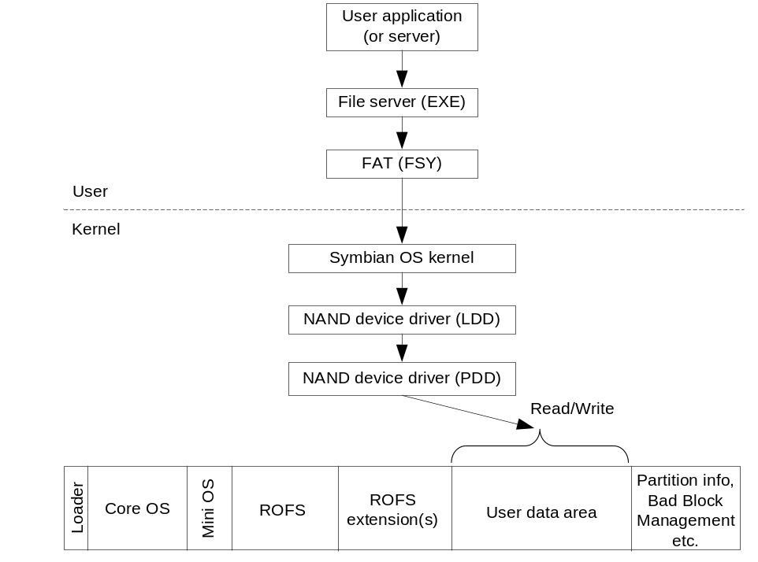
Figure 4.1 ROM access by default
In Figure 4.1 the ROM access is typically controlled, e.g. by the media driver (PDD), so that the read commands cannot access ROFS and its extension images, whereas read and write commands work through FAT32 file system to user data area.
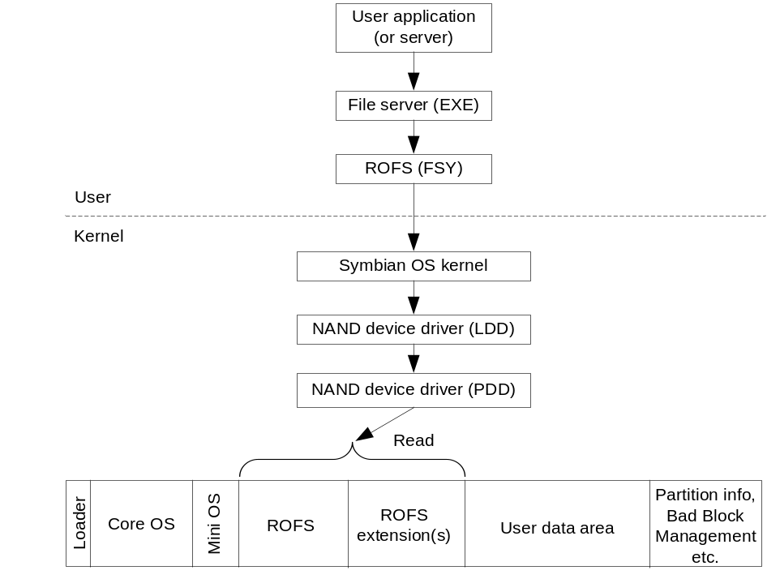
Figure 4.2 ROFS access
Figure 4.2 shows a typical way of accessing ROFS and its extension images in case where the file system or media driver do not allow it (default use case). Note also the usage of different file systems.

Full ROM access provided by file system
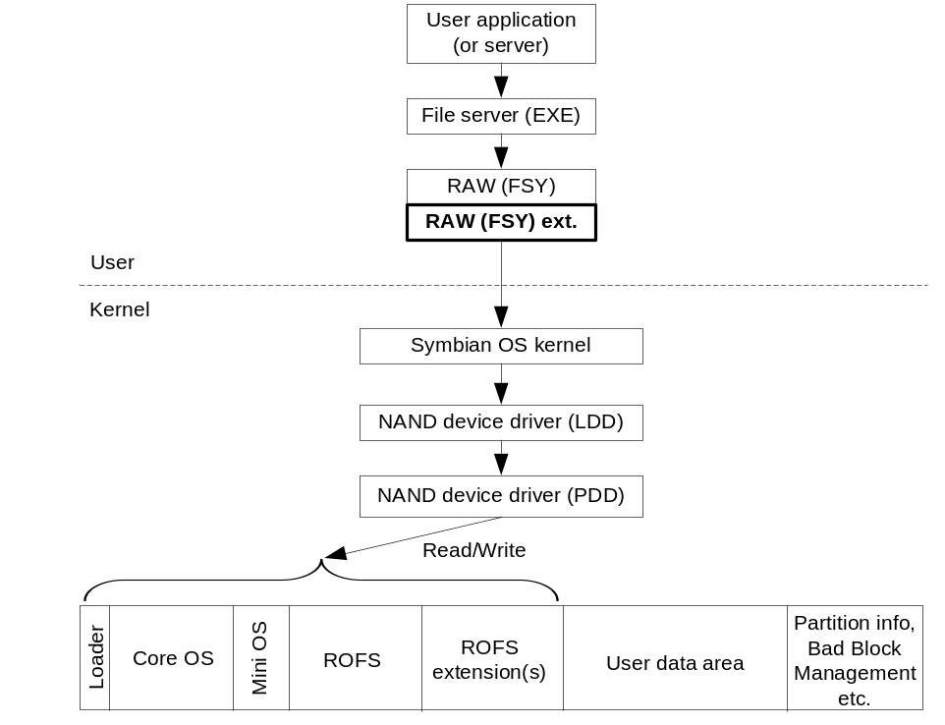
Figure 4.3 Full ROM access provided by file system
In Figure 4.3 the media access is controlled in the file system and its extension level (i.e. raw file system and its extension). In other words, file system controls which area in the ROM can be accessed. Note: The raw file system is not provided as a part of Symbian OS.

Full ROM access provided by a media driver
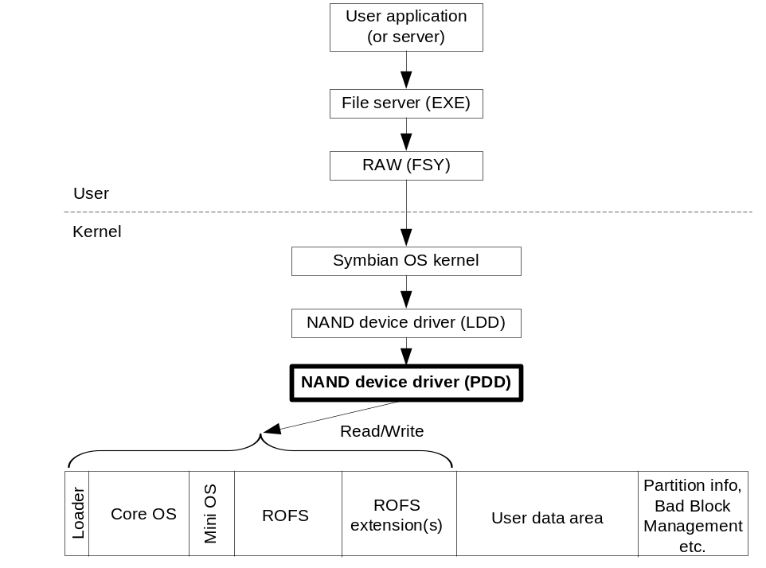
Figure 4.4 Full ROM access provided by Media Driver
In Figure 4.4 the ROM access is controlled in the media driver level (e.g. NAND driver, PDD). In other words, media driver (PDD) controls which areas in the ROM can be accessed. Note: The raw file system is not provided as a part of Symbian OS.

User data area access
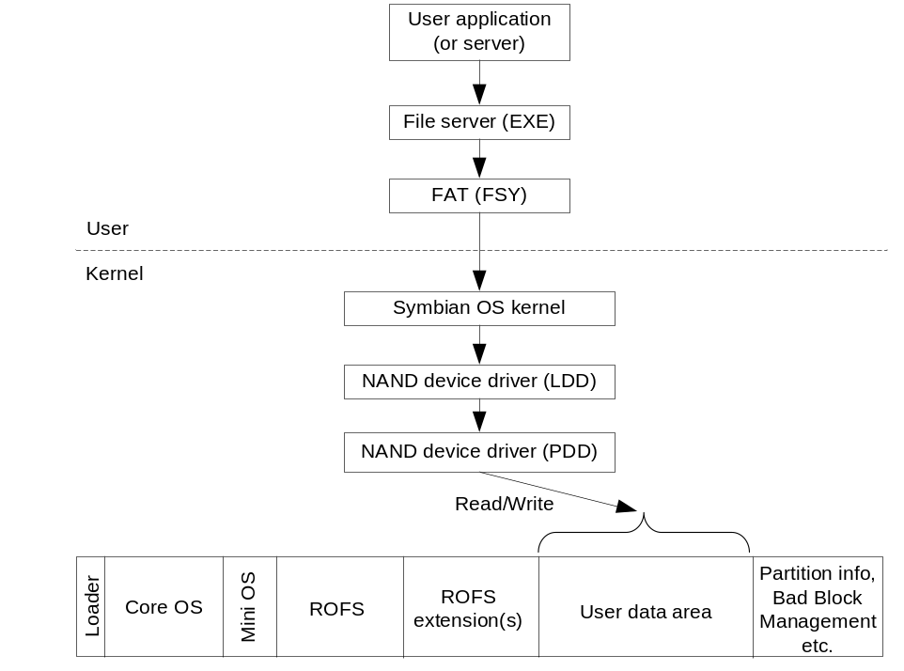
Figure 4.5 user data area access
As can be seen in Figure 4.5, the user data area is typically accessed through the FAT(32) file system.

Raw file system
This section describes briefly how the raw file system can be created and used (note that the raw file system is not provided as a part of Symbian OS).

C++ class inheritance in the raw file system
The new file system in Symbian OS can be created by inheriting one own C++ classes from the following Symbian Os C++ classes and implementing their pure virtual functions:
- CFileSystem
- CLocDrvMountCB
- CFileCB
- CDirCB

When built, the raw file system is one binary file, RAWFS.fsy. It is a user side software module. The source code consists of an entry point function and the following inherited C++ classes (shown in red):
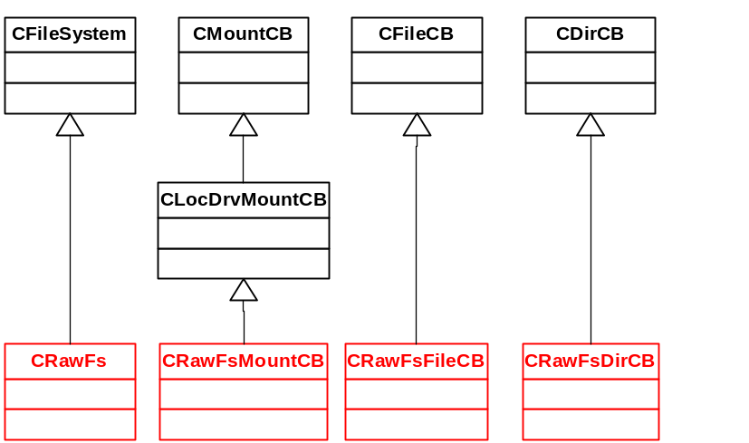
Figure 4.6 C++ class inheritance in the raw file system
If the full ROM access to be used is based on the media driver architecture as shown in Section 5.1.3, then the user needs to implement only the following functions while creating the raw file system:
- class C_YOUR_CLASS_FILE_SYSTEM (inherited from the class CFileSystem)
- ::Install()
- ::DriveInfo()
- ::New()
- class C_YOUR_CLASS_MOUNT (inherited from the class CLocDrvMountCB)
- ::Mount()
- ::RawReadL()
- ::RawWriteL()
- Entry point
- CreateFileSystem()

Mapping a drive letter for the raw file system
In Symbian OS the drive letter mappings are done in the base port, specifically in the ESTART. This example shows how to map a drive letter for the raw file system.
E.g. in \estart\estartforrawfsy.txt (in the base port’s directory), the following type of line should be added:
S: 7 ERAWFS RAWFS 0 FS_DISMNT_CORRUPT

In the example above, the raw file system is mapped as an “S:” drive. The definitions of the line are the following:
- S: Drive letter.
- 7 Drive number (this must also be defined in the media driver).
- ERAWFS Filename (without .FSY).
- RAWFS Object name.
- 0 Filename of the file system extension, 0 if no extension.
- FS_DISMNT_CORRUPT Mounts flag(s), in this case dismounts if drive is corrupted.

Accessing the media via the raw file system
Before being able to read or write to the media via the raw file system, the user needs to create a connection between the application and the file server (created connection is called a session), and to open a connection between the application and raw file system as well (this created connection is called a sub-session). After sub-session creation, no other instance can access the raw file system simultaneously. Access is allowed after the (sub-)session is closed.
To create a connection (i.e. a session) to the file server, the class RFs needs to be used, e.g. in the application:
RFs TheFs; // create a file server object
TInt r = TheFs.Connect(); // create a connection (a session) to the file server
if (r!=KErrNone) // check if the creation of the connection succeeded
//fail somehow if it failed, otherwise continue

To create a connection (i.e. a sub-session) to the raw file system, the class RRawDisk needs to be used, e.g. in the application:
RRawDisk rd; // create a raw file system object

// create a connection (a subsession) to the raw file system
// This example uses S: drive, i.e. application must use the same drive letter
// that was defined in the ESTART’s .txt file
TInt r = rd.Open(TheFs,EDriveS);
if (r!=KErrNone) // check if the creation of the connection succeeded
//fail somehow if it failed, otherwise continue

To use the raw file system from the application, the user needs to use the class RRawDisk’s functions to read and write to the media, e.g. in the application:
// read from the position where “start” points to, to the buffer called “buf”.
// The amount of the data to be read is the size of the buffer called “buf”.
// The “buf” buffer must exist before one can read data into it
TInt r = rd.Read(start,buf);
if (r!=KErrNone) // check if the read succeeded
//fail somehow if it failed, otherwise continue

// write from the buffer called “buf” (of the size of the “buf”) to the position
// where “start” points to in the media
TInt r = rd.Write(start,buf);
if (r!=KErrNone) // check if the write succeeded
//fail somehow if it failed, otherwise continue

After all reads and writes have been finished, connections (session and sub-session) can be closed, e.g. in the application:
rd.Close(); // close the connection (subsession) to the raw file system
TheFs.Close(); // close the connection (session) to the file server

