S60 3.x
OMA Provisioning
Design Document

Team name | Author
D RD S60 CSU OS Service Mgmt IN | Sriramulu Appana

Change history:

Version | Date | Status | Comments
2.0 | 14.11.2008 | Approved | New sections:  3.1.14 Provisioning Authentication type plug-in  3.2.14 Provisioning Authentication type plug-in  Modified sections:  4.1 Provisioning feature
1.0 | 05.04.2006 | Approved

Table of contents:

1. Document control 6
1.1 References 6
1.2 Documentation conventions 6
1.3 Abbreviations 6
1.4 Definitions 7
2. General 8
2.1 Introduction 8
2.2 Component environment 8
2.2.1 Provisioning BIO Control 8
2.2.2 Provisioning Handler 9
2.2.3 Provisioning Engine 10
2.2.4 Provisioning Parser 11
2.2.5 Provisioning Access Point Adapter 11
2.2.6 Provisioning WAP Adapter 12
2.2.7 Provisioning Wireless Village Adapter 13
2.2.8 Provisioning Email Adapter 13
2.2.9 Provisioning Streaming Adapter 14
2.2.10 Provisioning SIP Adapter 14
2.2.11 Provisioning VoIP Adapter 14
2.2.12 Provisioning Authentication type plug-in 15
2.3 Use cases 16
2.3.1 Receiving Provisioning settings to the device 16
2.3.2 Viewing configuration contexts in the device 16
2.4 Services required 16
2.4.1 From the Symbian OS subsystems 16
2.4.1.1 Provisioning Access Point Adapter 16
2.4.1.2 Provisioning Email Adapter 16
2.4.1.3 Provisioning Wireless Village Adapter 17
2.4.1.4 Provisioning BIO Controller 17
2.4.1.5 Configuration Context application 18
2.4.1.6 Provisioning Engine 18
2.4.1.7 Provisioning Parser 19
2.4.1.8 Smart Card Provisioning 19
2.4.1.9 Provisioning SIP Adapter 19
2.4.1.10 Provisioning Streaming Adapter 19
2.4.1.11 Provisioning VoIP Adapter 20
2.4.1.12 Provisioning WAP Adapter 20
2.4.1.13 Provisioning Authentication type plug-in 20
2.4.2 From Domestic OS subsystems 21
2.4.3 From HW 21
2.5 Services provided 21
2.5.1 UI 21
2.5.2 SW IF 21
2.5.3 UI 21
3. Design 22
3.1 Class diagrams 22
3.1.1 Provisioning BIO Control 22
3.1.2 ProvisioningCx 22
3.1.3 Provisioning Handler 24
3.1.4 Provisioning Engine 24
3.1.4.1 Core 25
3.1.4.2 Adapter interface 25
3.1.4.3 Configuration context 26
3.1.4.4 Data model 26
3.1.4.5 Message 27
3.1.5 Provisioning Parser 28
3.1.6 Provisioning Access Point Adapter 28
3.1.7 Provisioning WAP Adapter 30
3.1.8 Provisioning Wireless Village Adapter 32
3.1.9 Provisioning Email Adapter 32
3.1.10 Provisioning Streaming Adapter 33
3.1.11 Provisioning SIP Adapter 34
3.1.12 Provisioning VoIP Adapter 36
3.1.13 Provisioning SC 38
3.1.14 Provisioning Authentication type plug-in 38
3.2 Class descriptions 39
3.2.1 Provisioning Access Point Adapter 39
3.2.2 Provisioning Email Adapter 39
3.2.3 Provisioning Wireless Village Adapter 40
3.2.4 Provisioning BIO Controller 40
3.2.5 Configuration Context application 40
3.2.6 Provisioning Engine 40
3.2.7 Provisioning Handler 41
3.2.8 Provisioning Parser 42
3.2.9 Smart Card Provisioning 42
3.2.10 Provisioning SIP Adapter 42
3.2.11 Provisioning Streaming Adapter 43
3.2.12 Provisioning WAP Adapter 43
3.2.13 Provisioning VoIP Adapter 43
3.2.14 Provisioning Authentication type Plugin 43
3.2.15 Structs, type definitions and enumerations 44
3.2.15.1 Provisioning Access Point Adapter 44
3.2.15.1.1 WPAPDefs.h 44
3.2.15.1.2 CWPAPItemBase.h 44
3.2.15.1.3 CWPAPPhysicalProxy.h 44
3.2.15.2 Provisioning Email Adapter 44
3.2.15.2.1 CWPEmailSaveItem.h 44
3.2.15.3 Provisioning BIO Controller 44
3.2.15.3.1 CWPBioControl.h 44
3.2.15.4 Provisioning Engine 44
3.2.15.4.1 CWPValidator.h 44
3.2.15.4.2 CWPAdapter.h 44
3.2.15.4.3 CWPBootstrap.h 45
3.2.15.4.4 CWPParameter.h 45
3.2.15.4.5 CWPElement.h 45
3.2.15.5 Provisioning Handler 45
3.2.15.5.1 CWPHandler.h 45
3.2.15.5.2 CWPMessage.h 45
3.2.15.6 Provisioning Parser 45
3.2.15.6.1 CWPWbxmlParser.h 45
3.2.15.7 Provisioning SC 46
3.2.15.7.1 CWPWimHandler.h 46
3.2.15.8 Provisioning Streaming Adapter 46
3.2.15.8.1 StreamingAdapter.h 46
3.2.15.9 Provisioning VoIP Adapter 46
3.2.15.9.1 CWPVoIPCodec.h 46
3.2.15.10 Provisioning WAP Adapter 46
3.2.15.10.1 MWPWAPItemBase.h 46
3.2.16 Flag definitions 46
3.3 Operations 47
3.3.1 Receiving an OMA Provisioning message 47
3.3.2 Opening an OMA Provisioning message 48
3.3.3 Bootstrapping with a received message 49
3.3.4 Retrieving a list of configuration contexts 50
3.3.5 Deleting a configuration context 51
3.3.6 Importing data to Provisioning Access Point Adapter 52
3.3.7 Retrieving summaries from Provisioning Access Point Adapter 54
3.3.8 Importing data to the Browser adapter 55
3.3.9 Importing data to the MMS adapter 56
3.3.10 Retrieving summaries from the Browser and MMS adapters 57
3.3.11 Saving the settings in an OMA Provisioning message 58
3.3.12 Saving data in Provisioning Access Point Adapter 59
3.3.13 Saving WLAN data 60
3.3.14 Saving data in the Browser adapter 61
3.3.15 Saving data in the MMS adapter 63
3.3.16 Importing data to Provisioning Wireless Village Adapter 64
3.3.17 Retrieving summaries from Provisioning Wireless Village Adapter 65
3.3.18 Saving data in Provisioning Wireless Village Adapter 66
3.3.19 Importing data to Provisioning Email Adapter 68
3.3.20 Retrieving summaries from Provisioning Email Adapter 69
3.3.21 Saving data in Provisioning Email Adapter 70
3.3.22 Importing data to Provisioning Streaming Adapter 72
3.3.23 Retrieving summaries from Provisioning Streaming Adapter 73
3.3.24 Saving data in Provisioning Streaming Adapter 74
3.3.25 Reading settings from a SIM card 75
3.4 Backup and Restore 76
4. Variation 77
4.1 Provisioning feature 77
5. System resource usage 78
5.1 Files 78
5.2 Other data 78
5.2.1 Databases 78
5.2.2 Central Repository 78
5.2.3 Publish and Subscribe 78
5.3 Memory consumption 78
5.4 Task allocation 79
5.5 Timers 79
6. Security 80
6.1 Capabilities of this component 80
6.1.1 Provisioning Access Point Adapter 80
6.1.2 Provisioning Email Adapter 80
6.1.3 Provisioning Wireless Village Adapter 80
6.1.4 Provisioning Bio Controller 80
6.1.5 Provisioning Configuration Context application 80
6.1.6 Provisioning Engine 80
6.1.7 Provisioning Handler 80
6.1.8 Provisioning Parser 80
6.1.9 Provisioning Smart Card application 81
6.1.10 Provisioning SIP Adapter 81
6.1.11 Provisioning Streaming Adapter 81
6.1.12 Provisioning WAP Adapter 81
6.1.13 Provisioning VoIP Adapter 81
6.1.14 Provisioning Authentication type Plugin 81
6.2 Input and output validation 81
6.3 Environmental assumptions 81
6.4 Additional enforcements 81
7. Exception handling 82
8. Usage 83
8.1 Building 83

Document control

References
- Provisioning Architecture Overview | http://www.openmobilealliance.com/
- Provisioning Bootstrap | http://www.openmobilealliance.com/
- S60 OMA Provisioning UI Specification
- S60 Plugin BIO Controls Design Document
- Binary XML Content Format Specification | http://www.openmobilealliance.com/

Documentation conventions
Code is shown with the Courier New font.

Abbreviations
BIO | Bearer-Independent Object
BIODB | Bearer-Independent Object Data Base
DLL | Dynamic Link Library
DOM | Document Object Model
ETelMM | Multimode ETel
IMAP | Internet Message Access Protocol
IMSI | International Mobile Subscriber Identity
MIME | Multi-purpose Internet Mail Extensions
MMS | Multimedia Messaging Service
MTM | Message Type Module
OMA | Open Mobile Alliance
PIN | Personal Identification Number
POP3 | Post Office Protocol, version 3
RCSE | Rich Call Settings Engine
SAP | Service Access Point
SIP | Session Initiation Protocol
SMCM | SMS Client MTM
SMS | Short Message Service
SMTP | Simple Mail Transfer Protocol
TPS | Trusted Provisioning Server
UI | User Interface
URI | Uniform Resource Identifier
URL | Uniform Resource Locator
VoIP | Voice over IP (Internet Protocol)
WAP | Wireless Access Protocol
WBXML | WAP Binary XML
WIM | Wireless Identity Module
WLAN | Wireless local area network
WSP | Wireless Session Protocol
WV | Wireless Village
XML | Extensible Markup Language

Definitions
CONE | Control Environment, graphical UI framework for Symbian OS.
ECom | A generic plug-in framework from Symbian.
OMA Provisioning | A method of receiving settings via WAP Push.
Trusted provisioning server | A server that is trusted to send valid provisioning documents.

General
This document describes the design of the S60 OMA Provisioning feature as described in reference document [1].

Introduction
OMA Provisioning settings arrive as WAP Push messages. They are saved as BIO messages and viewed with a BIO control (see reference document [4] for further information on the BIO controls). OMA Provisioning must first be bootstrapped to establish trust between the terminal and the TPS (see reference document [2]) and after that continuous provisioning is started. Trust can be established between the terminal and multiple TPSs.

Component environment
OMA Provisioning consists of the following components: Provisioning BIO Control, Provisioning Handler, Provisioning Engine, ProvisioningCx, Provisioning Parser and the adapters. ProvisioningCx provides a UI for deleting existing contexts and adding new contexts if necessary. The adapters are components that are responsible for handling a specific set of data. The following adapters are described in this design document:
- Provisioning Access Point Adapter, which is responsible for the Access Point data.
- Provisioning WAP Adapter, which is responsible for the MMS and Browser data.
- Provisioning Email Adapter, which is responsible for the mail settings.
- Provisioning Wireless Village Adapter, which is responsible for the Wireless Village settings.
- Provisioning Streaming Adapter, which is responsible for handling RealOne Player streaming settings.
- Provisioning SIP Adapter, which is responsible for the SIP settings.
- Provisioning VoIP Adapter, which is responsible for the VoIP settings.

The subsystem environments for each of these adapters are presented in separate sections.

Provisioning BIO Control
Provisioning BIO Control is provided in a polymorphic DLL as are all BIO controls. It displays the settings of the received OMA Provisioning message to the user. The user can then save the settings or delete the message. Provisioning BIO Control uses the following components:
- MsgEditorUtils as the generic BIO control framework.
- RichBio and CONE for displaying the contents of a message.
- Msgs.dll for reading the message from Messaging Server.
- Provisioning Engine for handling the contents of the OMA Provisioning message.
- Common Engine’s String Loader to load resource strings.

The main dependencies are depicted in Figure 2.1.
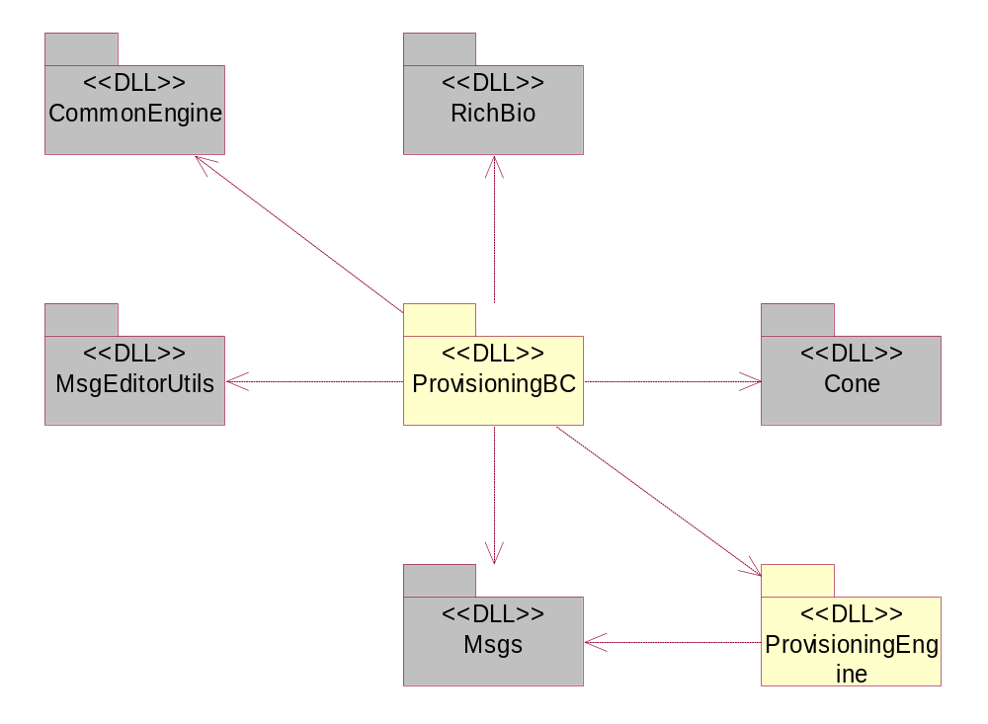
Figure 2.1 Provisioning BIO Control subsystem environment

Provisioning Handler
Provisioning Handler implements an ECom plug-in to Push Watcher. Its function is to store the OMA Provisioning message into Messaging Server once it is received from the network. It also authenticates bootstrap messages and stores the bootstrap data. It uses the following components:
- WAPPushUtils to retrieve information from the Push message.
- Provisioning Engine to parse the WAP Push message.
- BioDB for finding the BIO message type of OMA Provisioning messages.
- Msgs for storing the message into Messaging Server.
- SMCM for formatting an SMS message for saving.

The dependencies are depicted in Figure 2.2.
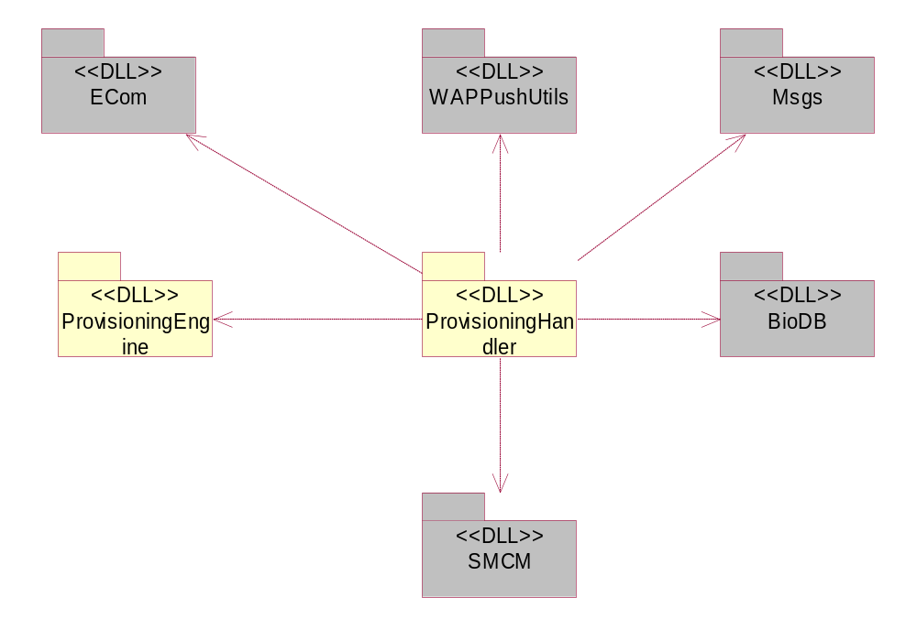
Figure 2.2 Provisioning Handler subsystem environment

Provisioning Engine
Provisioning Engine is a DLL that provides common functionality to all OMA Provisioning components, such as intermediate storage of the OMA Provisioning message contents. It uses the following components:
- Provisioning Parser for parsing the XML content.
- ECom for loading the adapters.
- Msgs for interfacing with Messaging Server.
- Multimode ETel for retrieving the IMSI number used for authenticating OMA Provisioning bootstrap messages.
- Hash for creating the authentication code.
- Central Repository to save the bootstrap data.
- HTTPResponse for parsing WSP headers.
- INetProtUtil for parsing URIs.

The dependencies are depicted in Figure 2.3.
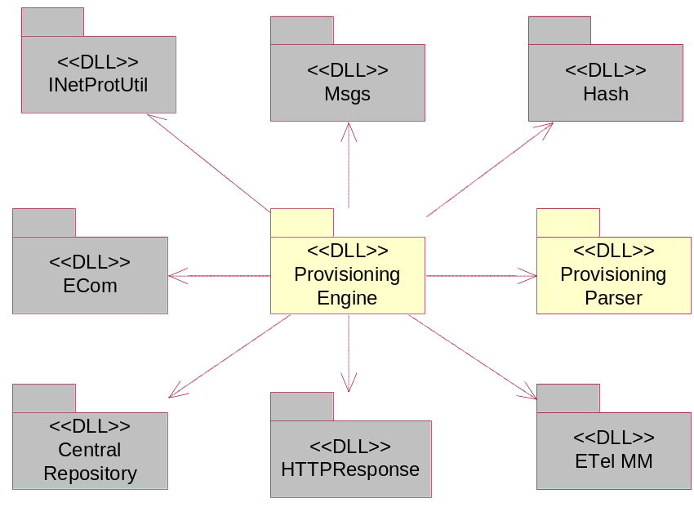
Figure 2.3 Provisioning Engine subsystem environment

Provisioning Parser
Provisioning Parser is a DLL that handles the parsing of OMA Provisioning message contents and headers. It uses XML Parser for parsing the WBXML contents. The contents of the binary encoded provisioning message are stored into Provisioning Engine using a builder provided by the engine. The format used for storing this information includes binary tag tokens and strings containing the actual attribute values.
The dependencies are depicted in Figure 2.4.
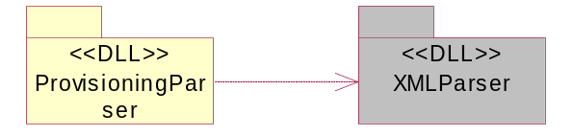
Figure 2.4 Provisioning Parser subsystem environment

Provisioning Access Point Adapter
Provisioning Access Point Adapter (WPAPAdapter.dll) handles the Access Point and Proxy related content. It uses the following components:
- Access Point Engine for storing the Access Point data to the Comms database.
- Provisioning Engine for accessing the characteristic and parameter data.
- Comms database for storing the Access Point data.

The Provisioning Access Point Adapter dependencies are depicted in Figure 2.5.
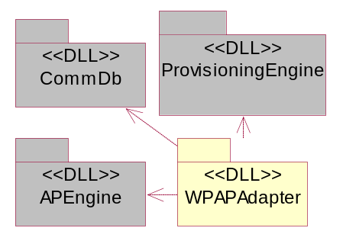
Figure 2.5 Provisioning Access Point Adapter subsystem

Provisioning WAP Adapter
Provisioning WAP Adapter (WPWAPAdapter.dll) handles the MMS and Browser related content. It uses the following components:
- MsgEditorUtils for MsgBioUtils, which offers URL checking.
- Access Point Engine for storing the Access Point data to the Comms database.
- Provisioning Engine for accessing characteristic and parameter data.
- Comms database for storing the Access Point data.
- Favourites Engine for storing the Browser bookmarks.
- Msgs for saving the MMS settings.

The Provisioning WAP Adapter dependencies are depicted in Figure 2.6.
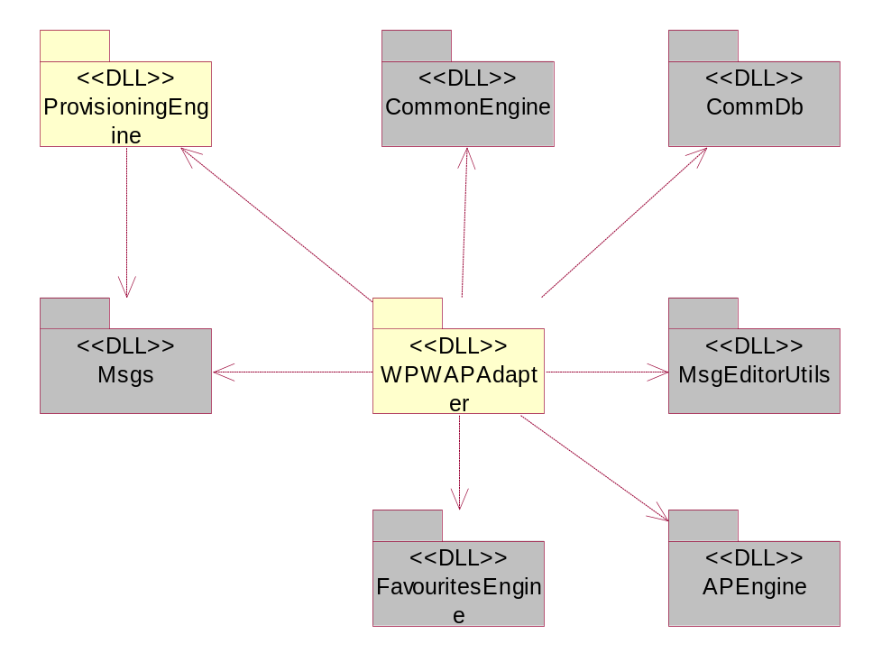
Figure 2.6 Provisioning WAP Adapter subsystem

Provisioning Wireless Village Adapter
Provisioning Wireless Village Adapter (WPWVAdapter.dll) handles Wireless Village related content. It uses the following components:
- MsgEditorUtils for MsgBioUtils, which offers URL checking.
- WVSapSettingsStore for storing the Wireless Village settings data.
- Provisioning Engine for accessing the characteristic and parameter data.

The Provisioning Wireless Village Adapter dependencies are depicted in Figure 2.7.
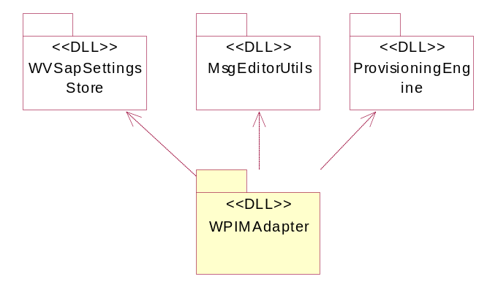
Figure 2.7 Provisioning Wireless Village Adapter subsystem

Provisioning Email Adapter
Provisioning Email Adapter handles the received email settings. Email settings are stored into the root folder of the Messaging system (Msgs).
Provisioning Email Adapter uses the following components:
- MsgEditorUtils for common utilities.
- Provisioning Engine for accessing characteristic and parameter data.
- Msgs for saving email settings.

The dependencies are depicted in Figure 2.8.
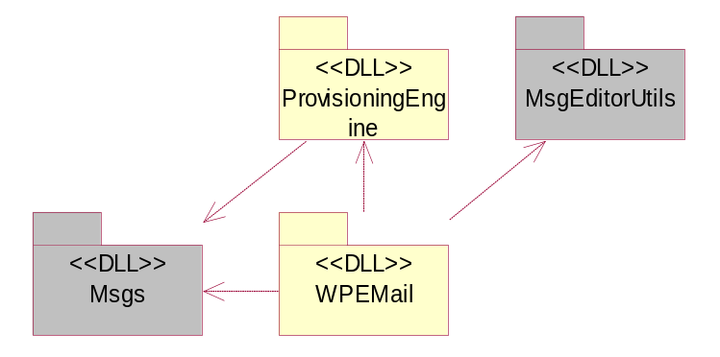
Figure 2.8 Provisioning Email Adapter subsystem

Provisioning Streaming Adapter
Provisioning Streaming Adapter handles the streaming settings for RealOne Player. The processed settings are stored into the media settings.
Provisioning Streaming adapter uses the following components:
- Provisioning Engine for accessing characteristic and parameter data.
- Comms database for accessing the Internet Access Point database.
- Access Point Engine for handling the Access Point data item.
- Media settings for storing the settings.

The dependencies are depicted in Figure 2.9.
EMBED Visio.Drawing.6 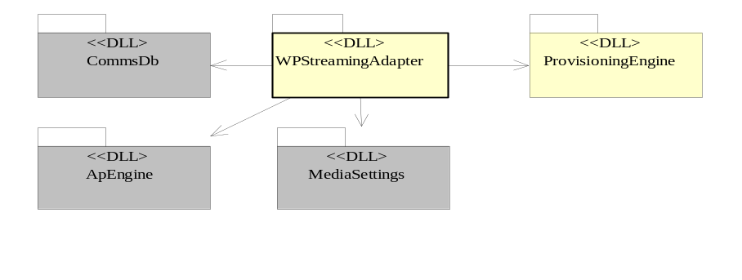
Figure 2.9 Provisioning Streaming Adapter subsystem

Provisioning SIP Adapter
Provisioning SIP Adapter handles the settings for SIP. The settings are stored via the SIP Profile interface provided by SIPPROFILECLI. Provisioning SIP Adapter uses the following components:
- Provisioning Engine for accessing characteristic and parameter data. Provisioning Engine controls the life cycle of Provisioning SIP Adapter.
- SIPProfileCli for saving the SIP settings.

The dependencies are depicted in Figure 2.10.
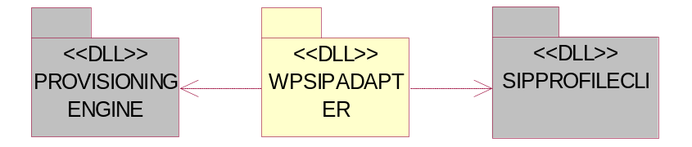
Figure 2.10 Provisioning SIP Adapter subsystem

Provisioning VoIP Adapter
Provisioning VoIP Adapter handles the settings for VoIP. The settings are stored via the RCSE interface provided by RCSE.
- Provisioning Engine for accessing characteristic and parameter data. Provisioning Engine controls the life cycle of Provisioning VoIP Adapter.
- RCSE for saving the SIP settings.

The dependencies are depicted in Figure 2.11.
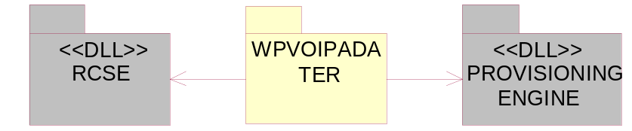
Figure 2.11 Provisioning VoIP Adapter subsystem

Provisioning Authentication type plug-in
Authentication type plug-in is provided as an ECom plug-in to General settings. This plug-in enables the user to change the authentication method.
The following authentication methods are supported:
- NetworkPin.
- Network or User Pin.
- All methods supported.

Authentication type plug-in uses the following components:
- CRepository to get and set the Central Repository key to support various authentication methods in OMA CP.

The following key values are set for KOMAProvAuthenticationLV to support authentication method:
- Value 1 indicates only that Network Pin is supported and the message sent with any other authentication type of configuration message is deleted and an information note is put into INBOX.
- Value 3 indicates that Network Pin or User Pin are supported. A message sent with either Network Pin or User Pin is authenticated and a configuration message with no security is not authenticated and is deleted. An information note is shown either in form of Class 0 or Class 2 behavior.
- Value 15 indicates all methods are supported.

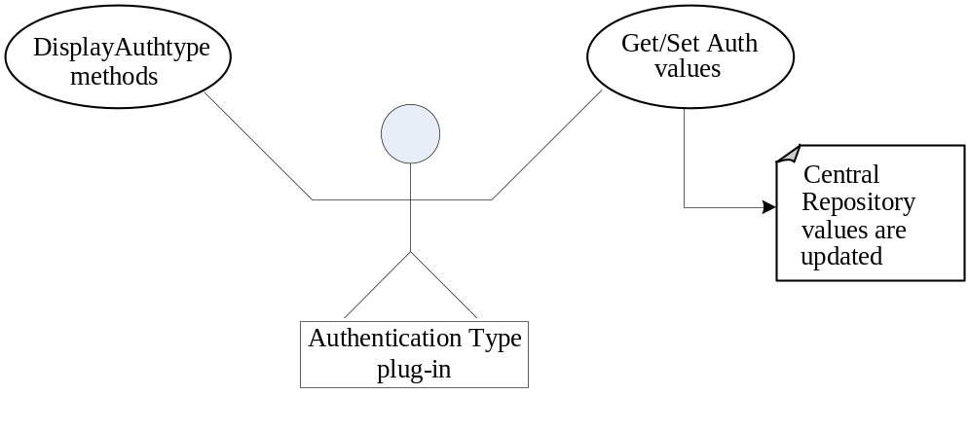
Figure 2.12 Authentication Type plug-in

Use cases

Receiving Provisioning settings to the device
Summary | A configuration settings message is sent to the device or read from a smart card and the OMA Provisioning component processes the message and stores it.
Actor(s) | Message store or a smart card with a configuration message.
Frequency | Low.
Preconditions | The OMA Provisioning framework is up and running.
Description | The settings are received via WAP Push or from a smart card. The settings are properly handled and valid settings are saved to the correct applications.
Exceptions | OOM or OOD situations lead to discarding of the settings. If the message is corrupted, only the valid settings are saved.
Postconditions | The settings are saved to the proper applications.

Viewing configuration contexts in the device
Summary | The user can view configuration settings by launching the Configuration Context application from General Settings.
Actor(s) | General Settings.
Frequency | Low.
Preconditions
Description | The user opens the Configuration Context application from General Settings.
Exceptions | A corrupted configuration context database leads to discarding of the context.
Postconditions | The settings are shown properly on the UI. If no settings exist, the UI shows an empty list.

Services required

From the Symbian OS subsystems

Provisioning Access Point Adapter
Library | Description
apengine | Access Point Engine.
commdb | Comms database.
euser | Symbian OS Base class.
FeatMgr | Feature Manager.
flogger | Logging tools.
ProvisioningEngine | Provisioning Engine.

Provisioning Email Adapter
Library | Description
apengine | Access Point Engine.
bafl | Basic Application Framework Library.
commdb | Comms database.
etext | Text formatting.
euser | Symbian OS Base class.
imcm | Email client MTMs (SMTP, POP3, IMAP4) and email client-side utilities.
MsgEditorUtils | Message editing tools.
msgs | Messaging system.
muiu | Messaging UI Utilities DLL.
ProvisioningEngine | Provisioning Engine.

Provisioning Wireless Village Adapter
Library | Description
apengine | Access Point Engine.
commdb | Comms database.
euser | Symbian OS Base class.
flogger | Logging tools.
MsgEditorUtils | Message editing tools.
ProvisioningEngine | Provisioning Engine.
wvsapsettingsstore | SAP Settings container.

Provisioning BIO Controller
Library | Description
apengine | Access Point Engine.
bafl | Basic Application Framework Library.
CommonEngine | Text Resolver.
Cone | Control environment.
eikcore | Shared application environment.
euser | Symbian OS Base class.
favouritesengine | Favourites Engine.
featmgr | Feature Manager.
MsgEditorUtils | Message editing tools.
Msgs | Messaging system.
provisioningengine | Provisioning Engine.
richBio | A UI control used by Smart Messaging viewers.
sysutil | System utilities.

Configuration Context application
Library | Description
apengine | Access Point Engine.
apparc | Application architecture.
bafl | Basic Application Framework Library.
commonengine | Text Resolver.
cone | Control environment.
eikcore | Shared application environment.
euser | Symbian OS Base class.
favouritesengine | Favourites Engine.
featmgr | Feature Manager.
provisioningengine | Provisioning Engine.

Provisioning Engine
Library | Description
bafl | Basic Application Framework Library.
centralrepository | Central Repository.
commonengine | Text Resolver.
ecom | A Symbian OS framework, enabling runtime detection and dynamic loading of components.
edbms | Database management - client and server.
efsrv | File Server.
estor | Symbian OS Base class.
etel | Telephony server and core API.
etelmm | Telephony Multimode API.
euser | Symbian OS Base class.
flogger | Logging tools.
hash | Hash functions such as MD5, SHA1 and HMAC.
httpresponse | Header codec for WSP.
inetprotutil | Utilities for Internet clients.
msgs | Messaging system.
ProvisioningParser | XML Parser.
sysutil | System utilities.

Provisioning Parser
Library | Description
cxmlparser | XML Parser
estlib | Control for multi-thread and multi-process operations.
euser | Symbian OS Base class.

Smart Card Provisioning
Library | Description
bifu | BIO utilities used by BIO database to read BIF files.
biodb | BIO database.
edbms | Database management - client and server.
efsrv | File Server.
etext | Text formatting.
flogger | Logging tools.
msgs | Messaging system.
provisioningengine | Provisioning Engine.
smcm | SMS client MTM.
sysutil | System utilities.
wappushutils | WAP Push tools.
wimclient | WIM Client.

Provisioning SIP Adapter
Library | Description
bafl | Basic Application Framework Library.
charconv | Character conversions.
euser | Symbian OS Base class.
provisioningengine | Provisioning Engine.
sipprofilecli | SIP Profile Client.

Provisioning Streaming Adapter
Library | Description
apengine | Access Point Engine.
commdb | Comms database.
euser | Symbian OS Base class.
flogger | Logging tools.
MPSettEngine | Media Settings Engine.
provisioningengine | Provisioning Engine.

Provisioning VoIP Adapter
Library | Description
bafl | Basic Application Framework Library.
charconv | Character conversions.
euser | Symbian OS Base class.
provisioningengine | Provisioning Engine.
RCSE | Rich Call Settings Engine.

Provisioning WAP Adapter
Library | Description
apengine | Access Point Engine.
centralrepository | Central Repository.
commdb | Comms database.
commonengine | Text Resolver.
euser | Symbian OS Base class.
favouritesengine | Favourites Engine.
flogger | Logging tools.
msgs | Messaging system.
provisioningengine | Provisioning Engine.

Provisioning Authentication type plug-in
The Configuration message authentication plug-in depends on the following libraries:
- aknskins.lib
- apgrfx.lib
- apparc.lib
- bafl.lib
- centralrepository.lib
- commonengine.lib
- cone.lib
- ecom.lib
- efsrv.lib
- egul.lib
- eikcore.lib
- euser.lib
- FeatMgr.lib
- flogger.lib
- GSEcomPlugin.lib
- GSFramework.lib
- GSListBox.lib
- ws32.lib
- provisioningengine.lib
- akncapserverclient.lib

From Domestic OS subsystems
This component does not have any direct interfaces to the Domestic OS side subsystems.

From HW
This component has no direct HW interfaces.

Services provided

UI
Provided Service | Description
Configuration Context application | Provides a list view of configuration contexts. The user interface is described in reference document [3].

SW IF
Provided Service | Description | Protected
Provisioning Engine | Provides tools for Provisioning adapters. | No
Provisioning Adapter framework | Provides a Provisioning framework for adapters. | No

UI
Provided Service | Description
Authentication Type plug-in | Provides a list of authentication methods the user can select and update the Central Repository information.

Design

Class diagrams

Provisioning BIO Control
Provisioning BIO Control CWPBioControl uses Provisioning Engine to handle the OMA Provisioning message. CWPSaver provides the saving functionality with a Progress note. CMsgNameValue implements a name-value pair, which is used for sorting the items shown to the user. CWPBioControl implements the BIO Control Framework CMsgBioControl. The class diagram is in shown Figure 3.13.
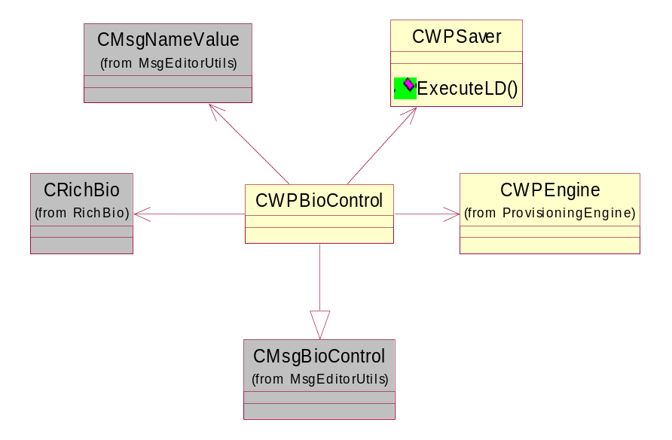
Figure 3.13 Provisioning BIO Control class diagram

ProvisioningCx
ProvisioningCx implements a list of configuration contexts. The user can delete a configuration context in this list with the help of CWPCxDeleter, which is invoked by the view class. CWPCxApp, CWPCxDocument, CWPCxAppUi and CWPCxView implement the typical application structure. CWPCxContainer implements a listbox with a list of the contexts. The class diagram is shown in Figure 3.14.
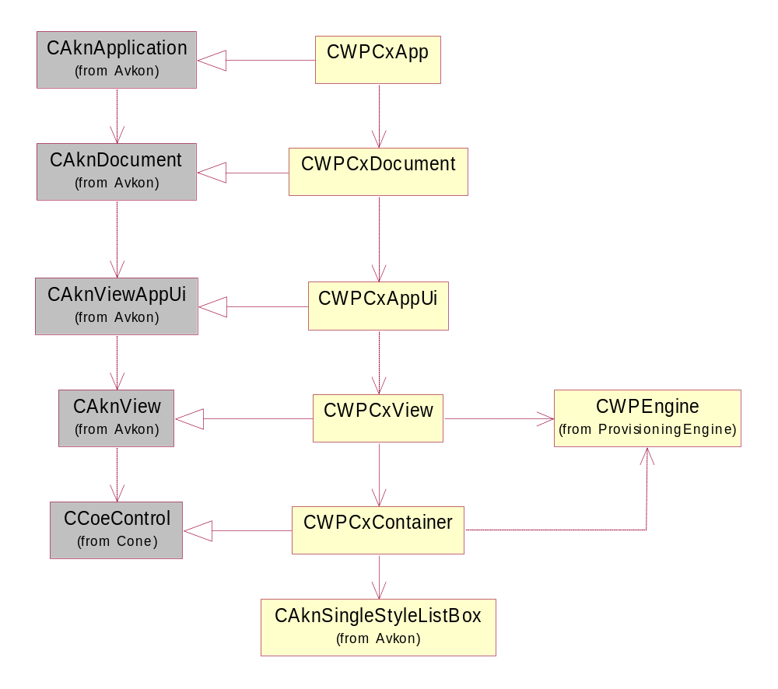
Figure 3.14 ProvisioningCx class diagram

Provisioning Handler
Provisioning Handler consists of the main class, CWPHandler, which implements the plug-in interface CContentHandlerBase. It uses CWPMessage for handling the message. CWPMessage uses CWPPushMessage for storing the WAP Push message to Messaging Server and parsing the WSP headers. WPPhoneFactory creates an instance of MWPPhone, which is implemented by CWPPhone and CWPPhoneEmul in the Provisioning Engine part. They implement retrieving the IMSI code from the SIM card and emulating an IMSI code. The class diagram is shown in Figure 3.15.
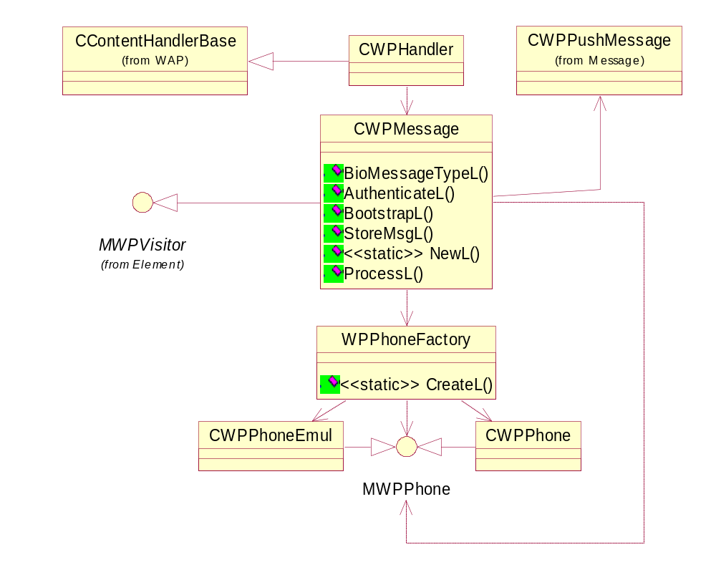
Figure 3.15 Provisioning Handler class diagram

Provisioning Engine
Provisioning Engine has several parts: core, adapter interface, configuration context, message and data model. They are described in their own sections below.

Core
The core consists of the class CWPEngine. It owns the data model via CWPRoot and the adapters via CWPAdapterManager. It can be used for importing an OMA Provisioning XML document and it uses CWPWbxmlParser to parse the contents. CWPValidator checks that the received document is valid. Configuration contexts are handled via the MWPContextManager interface. The class diagram is shown in Figure 3.16.
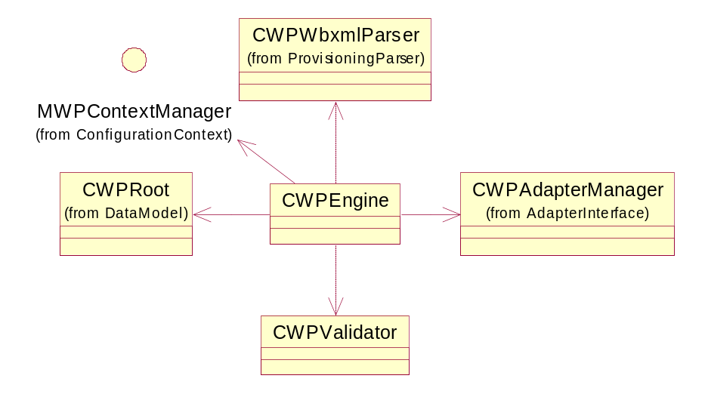
Figure 3.16 Provisioning Engine core class diagram

Adapter interface
WPAdapterFactory is responsible for creating the adapters. It creates the CWPAdapter objects via their factory methods, which use ECom to load the actual adapter. MWPPairVisitor is used for retrieving the details of a single setting entry. CWPAdapterManager owns the created adapters. The class diagram is shown in Figure 3.17.
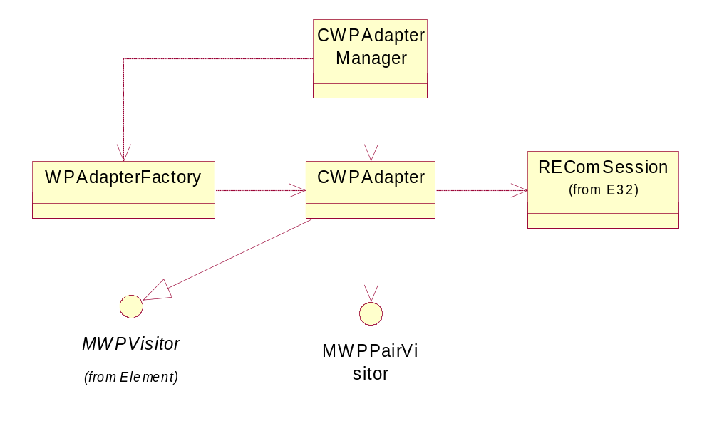
Figure 3.17 Provisioning Engine adapter interface class diagram

Configuration context
WPContextManagerFactory creates an instance of CWPMultiContextManager or CWPBindingContextManager, depending on the compilation option. They both implement the MWPContextManager interface, which is used by CWPEngine to create, switch between and delete contexts. CWPSingleContextManager is deprecated and similar functionality is implemented by CWPBindingContextManager.
The class diagram is shown in Figure 3.18.
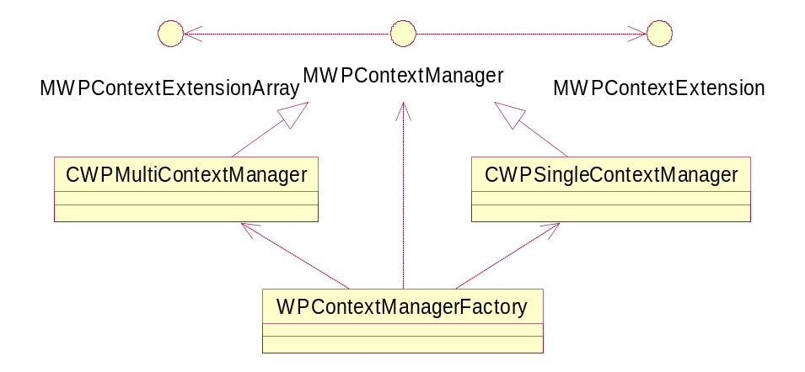
Figure 3.18 Provisioning Engine configuration context class diagram

Data model
The data model stores the information in an OMA Provisioning document and allows the adapters and Provisioning Engine to access and modify it. CWPRoot owns all the elements in the data model. It implements MWPBuilder, which can be used for building the data model. MWPVisitor can be used for browsing through the data model. The data model consists of objects of the types CWPCharacteristic and CWPParameter. The former can contain other CWPCharacteristic and CWPParameter objects and the latter contains only a value for a single parameter. MWPElement is implemented by both CWPCharacteristic and CWPParameter. WPElementFactory contains the exported methods for creating objects of the data model.
The class diagram is shown in Figure 3.19.
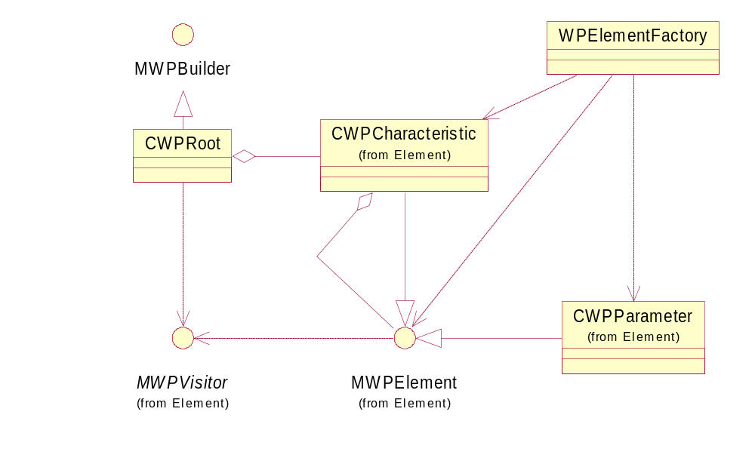
Figure 3.19 Provisioning Engine data model class diagram

Message
CWPBootstrap handles data in CWPPushMessage and uses CWPEngine to create or modify the context information.
Push message information and its parsing are implemented in CWPPushMessage. It handles the storing and restoring of a message from Messaging Server as well as parsing the fields of WSP headers. It uses CHTTPResponse for finding the correct fields in the WSP headers and CMsvStore for storing and restoring the message.
The class diagram is shown in Figure 3.20.
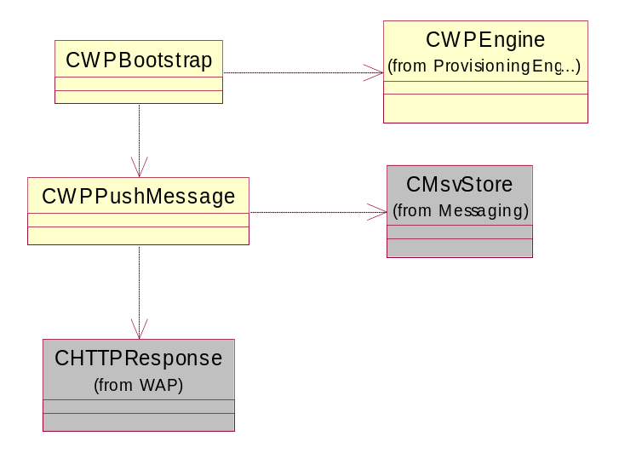
Figure 3.20 Provisioning Engine message class diagram

Provisioning Parser
Provisioning Parser provides a C++ wrapper class (CWPWbxmlParser) for using the external cXML parser written in the C programming language. The wrapper uses the C-based parser to build an XML DOM tree and to read the contents of the received WBXML message. The DOM tree is iterated and a data model is built using MWPBuilder that is passed as an argument by Provisioning Engine. CWPWbxmlParser provides a dictionary to the external parser for decoding numerical WBXML tokens into strings.
Figure 3.21 depicts the wrapper class interfacing code written in the C language contained in an XML Parser DLL.
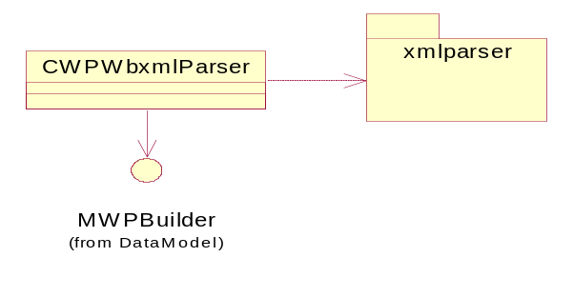
Figure 3.21 Provisioning Parser interface class diagram

Provisioning Access Point Adapter
The Provisioning Access Point Adapter main class CWPAPAdapter inherits from the adapter base class CWPAdapter. It has one array for the Access Point items and one array for the items deriving from CWPAPItemBase.
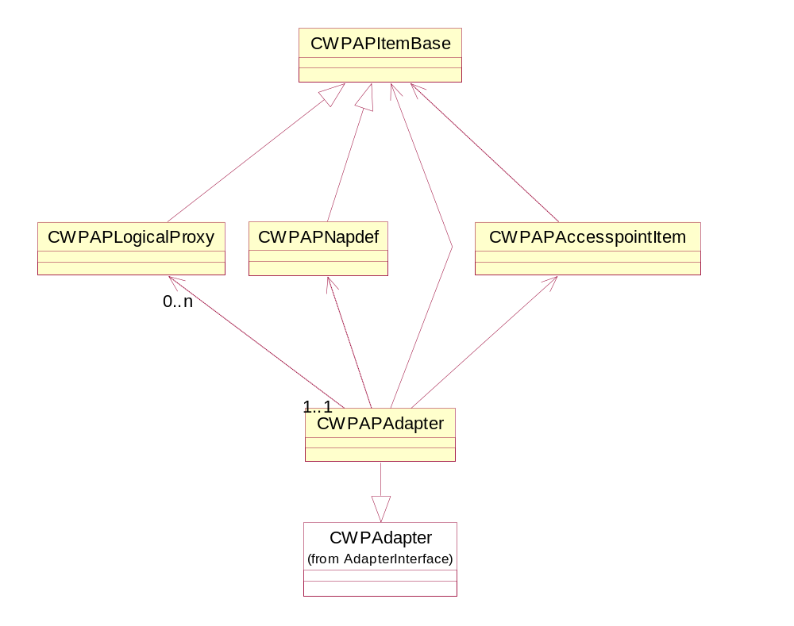
Figure 3.22 Provisioning Access Point Adapter design
Inside Provisioning Access Point Adapter, four classes are defined, which roughly correspond to the characteristic elements in the Provisioning data model. All of the classes are inherited from a common base class, which implements the MWPVisitor interface and offers default implementations for the visitor methods. For each valid NAPDEF, also an Access Point item is created. Figure 3.23 depicts the item’s derivation and shows the relationships between the items.
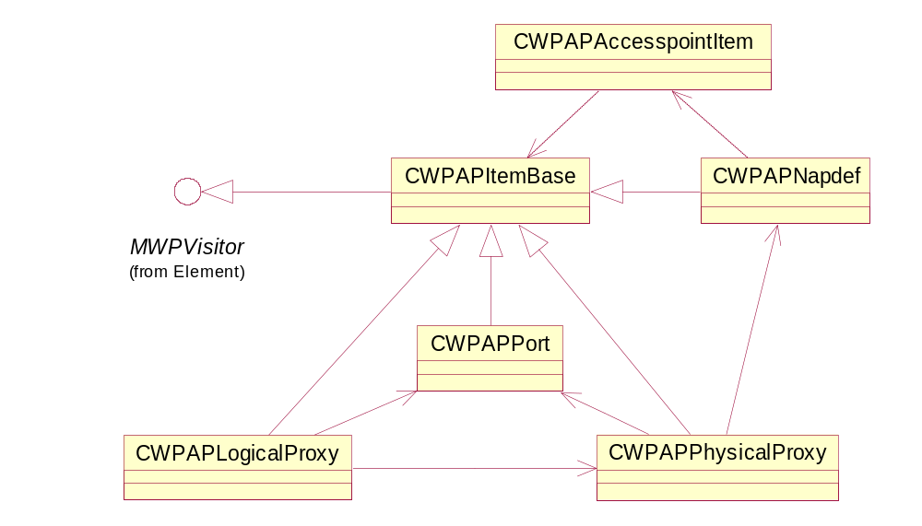
Figure 3.23 Provisioning Access Point Adapter item derivation
When saving, CWPAPAccesspointItem uses Access Point Engine to perform the creation of Access Points, and saves the unique identifiers to the Access Points in CWPCharacteristic. See Figure 3.24 for a class diagram.
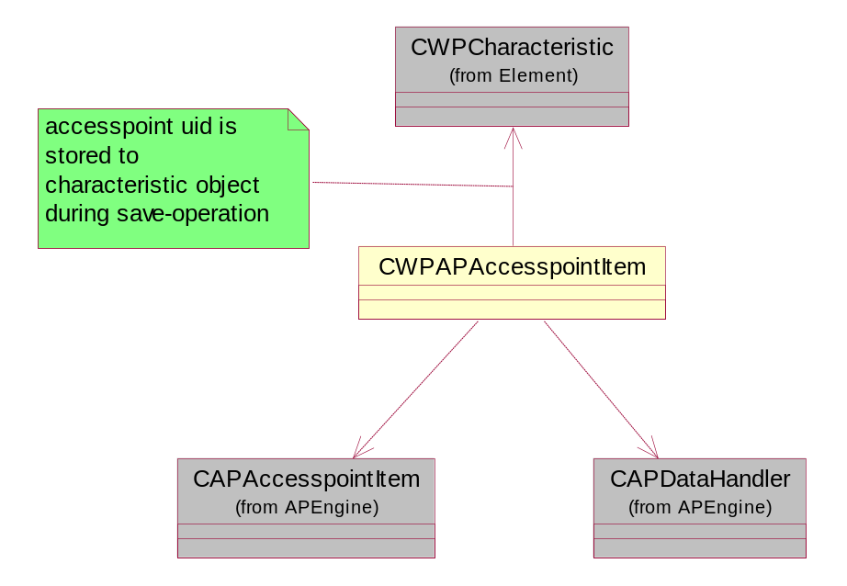
Figure 3.24 Dependencies during the saving of an Access Point

Provisioning WAP Adapter
Provisioning WAP Adapter actually consists of two adapters: the Browser adapter and the MMS adapter. They both use the same base classes, the WAP base classes.
CWPWAPAdapterBase acts as the base class for the two adapter classes. It creates instances of CCommsDatabase and CAPDataHandler. CWPWAPAdapterBase also owns an array of MWPWAPItemBase objects and implements most of the abstract methods in CWPAdapter by relaying them to the corresponding MWPWAPItemBase methods.
MWPWAPItemBase is the base class for the individual settings classes. WPWAPItemFactory acts as a factory class for the classes derived from MWPWAPItemBase. CWPWAPItemBase provides the common implementation for both Browser and MMS setting items. It looks for the actual settings in the Provisioning data model.
See Figure 3.25 for a class diagram.
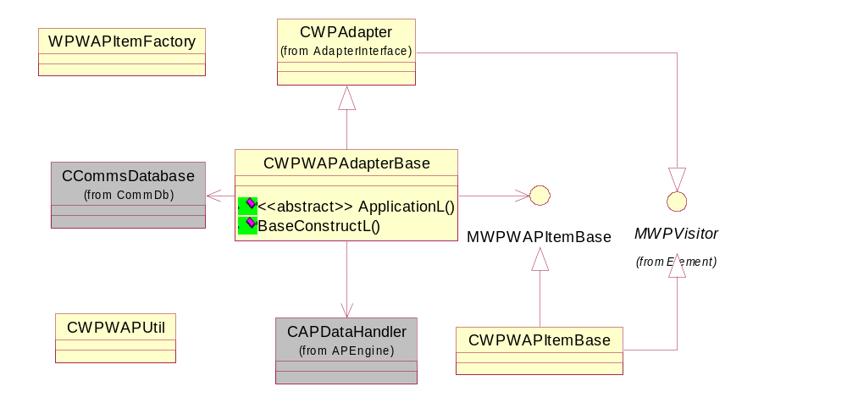
Figure 3.25 Provisioning WAP Adapter base classes
The Browser adapter is implemented in CWPWAPBrowserAdapter, which derives from the Provisioning WAP Adapter base class. The Browser settings are embedded in the CWPWAPBrowserItem class and the CWPWAPBookmarkItem objects represent bookmarks. CWPWAPBrowserItem looks for the bookmarks in the Browser section of the Provisioning data model and creates CWPWAPBookmarkItem for each bookmark. See Figure 3.26 for a class diagram.
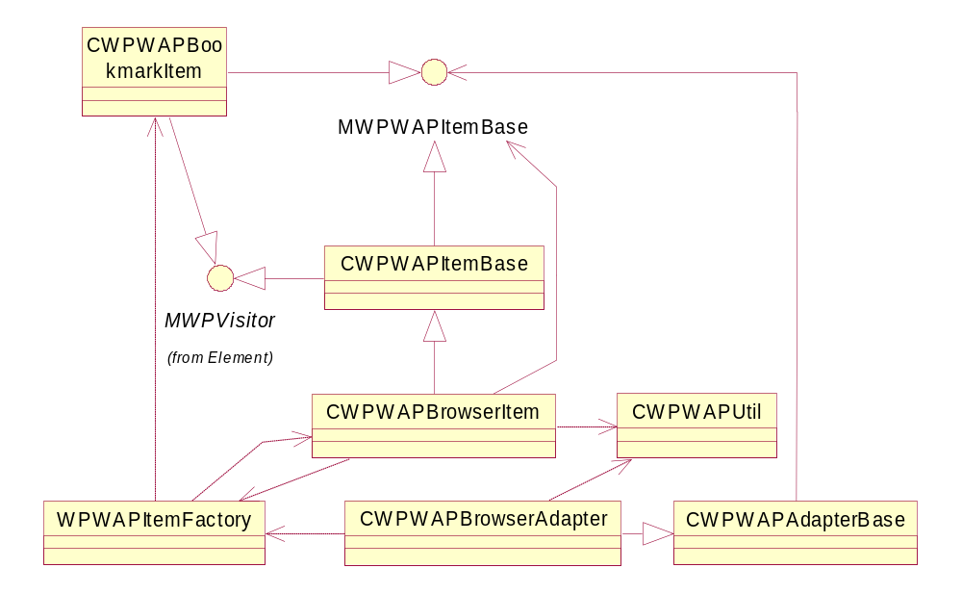
Figure 3.26 Browser adapter classes
The MMS adapter is implemented in CWPWAPMMSAdapter. It creates one CWPWAPMMSItem for each MMS setting section. See Figure 3.27 for a class diagram.
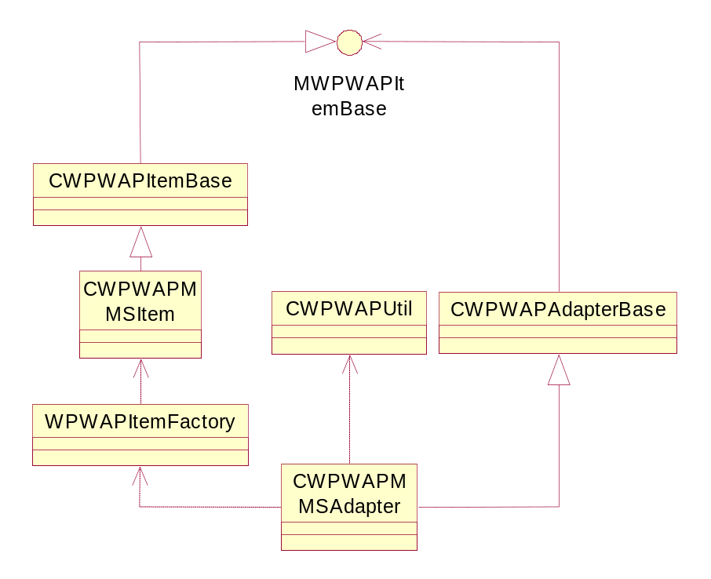
Figure 3.27 MMS adapter class diagram

Provisioning Wireless Village Adapter
The Provisioning Wireless Village Adapter main class CWPIMAdapter inherits from the adapter base class CWPAdapter. It has an array for the Wireless Village settings that are stored in the TData class. The TWPIMVisitor class is used for getting the Internet Access Point link from the provisioned data. The WPIMUtil class does the loading of localized strings from the resource file. The CWPIMSAPItem class has all the functionality for storing the Wireless Village settings to the SAPSettingsStore database. The class diagram is illustrated in Figure 3.28.
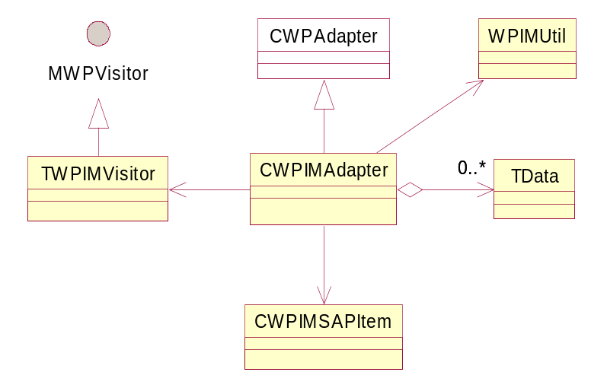
Figure 3.28 Provisioning Wireless Village Adapter class diagram

Provisioning Email Adapter
The Provisioning Email Adapter main class CWPEmailAdapter inherits from the adapter base class CWPAdapter. It stores the email related settings in an array of CWPEmailItem objects. From that array, Provisioning Email Adapter creates two different kinds of Save items, CWPSaveSmtpImapItem or CWPSaveSmtpPopItem, depending on the setting type. The complete Save items are stored in another array and are used later on when validating and saving the settings. The CWPSaveSmtpImapItem and CWPSaveSmtpPopItem classes are derived from CSaveItem that has the functionality for storing the settings to the message store. The class diagram is illustrated in Figure 3.29.
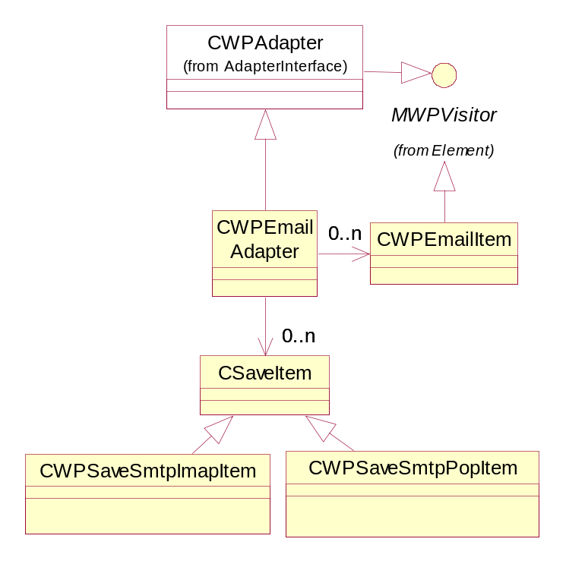
Figure 3.29 Provisioning Email Adapter class diagram

Provisioning Streaming Adapter
The class CStreamingAdapter is inherited from CWPAdapter and it forms the public API for this component. The class uses WPAdapterUtil for handling Access Point data. The settings read from a Provisioning message concerning this adapter are stored in the class TStreaminAdapterData. When the processing is complete, the settings are stored into CMPSettingsModel in MediaSettings.dll. CApDataHandler is used for getting the UIDs corresponding to the Access Point item (CApAccessPointItem) from CCommsDatabase. The item is used for retrieving Proxy information to be stored with the other streaming settings.
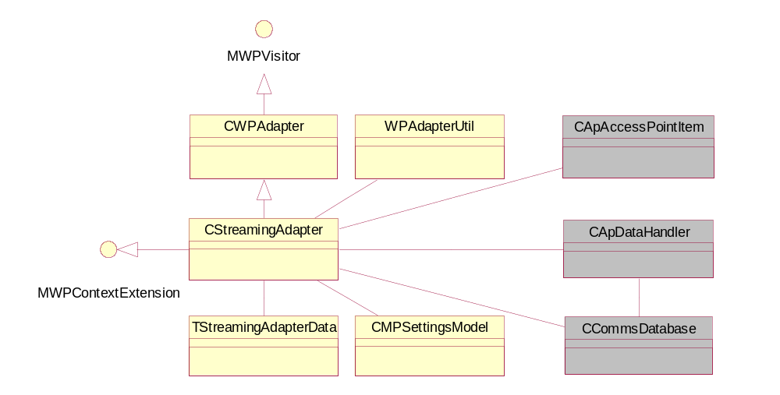
Figure 3.30 Provisioning Streaming Adapter class diagram

Provisioning SIP Adapter
The class CWPSIPAdapter inherits the OMA Client Framework class CWPAdapter (an abstract class), which is inherited by all the adapters of the framework. It provides the basic functionality of the adapter. CWPAdapter provides the capabilities of visit and adapter design pattern. The framework (Provisioning Engine) and adapter communicate through the visitor pattern. See Figure 3.31 for a class diagram.
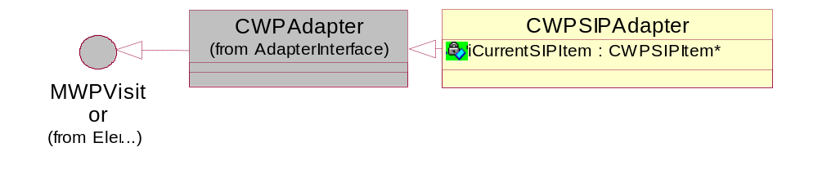
Figure 3.31 Provisioning SIP Adapter base classes
The classes and dependencies of Provisioning SIP Adapter can be broken down to two groups by their nature. First there is a group of classes that are used to interface with the S60 OMA Client Provisioning framework (CWPAdapter, CWPSIPAdapter, CWPCharacteristic). The second group makes use of SIP specific classes (MSIPProfileRegistryObserver, CSIPProfileRegistryObserver, CSIPManagedProfileRegistry, CSIPManagedProfile). CWPParameter and utility classes are not shown. CWPParameter objects are used to carry setting values of a SIP profile one by one from the OMA Client Provisioning framework to Provisioning SIP Adapter.
Provisioning SIP Adapter contains the following classes:
- CWPSIPAdapter inherits the CWPAdapter class (provided by the Provisioning framework) and is the controlling part of the Provisioning SIP Adapter plug-in component. CWPSIPAdapter has a reference to an iCurrentSIPItem::CWPSIPItem object, which is used to hold the parameter values of the present SIP profile and the Comms database ID of the Access Point bound to the profile. The CWPSIPAdapter object has a reference to iNapDef:CWPCharacteristic, which includes information about the Access Point.
- CWPSIPItem is a concrete class, which carries the values of the new SIP profile. The class uses the SIP Profile and SIP Profile Admin interfaces to store the received new SIP profile(s).
- Individual SIP settings belonging to the same context (i.e. received in the same Provisioning document) are stored in iDatas:RPointerArray, which is owned by CWPSIPAdapter.
- iCSIPObserver:CSIPObserver is used for handling notifications received from the SIP stack.
- iCSIPProfileRegistryObserver:CSIPProfileRegistryObserver is created to get events concerning profiles. The class implements the interface MSIPProfileRegistryObserver provided by SIP Profile API.
- iCSIPManagedProfileRegistry:CSIPManagedProfileRegistry is created to save (the method SaveL) a new managed profile object.
- iCSIPManagedProfile:CSIPManagedProfile is used to set the values of the new profile.

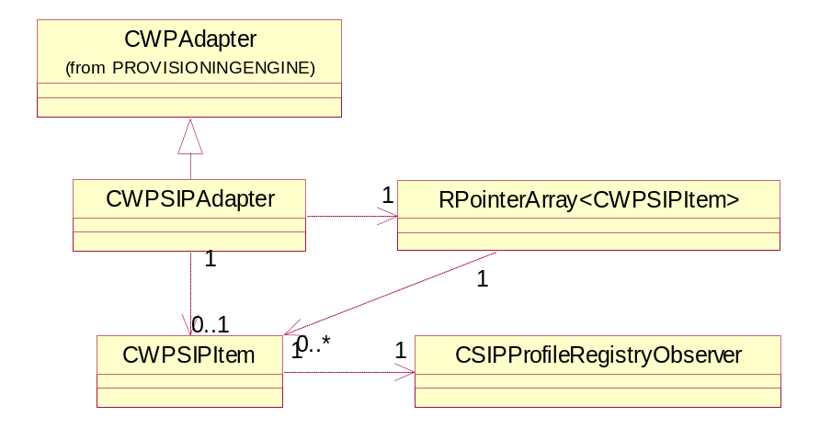
Figure 3.32 Provisioning SIP Adapter design. RPointerArray is used to hold one or more CWPSIPItem instances.
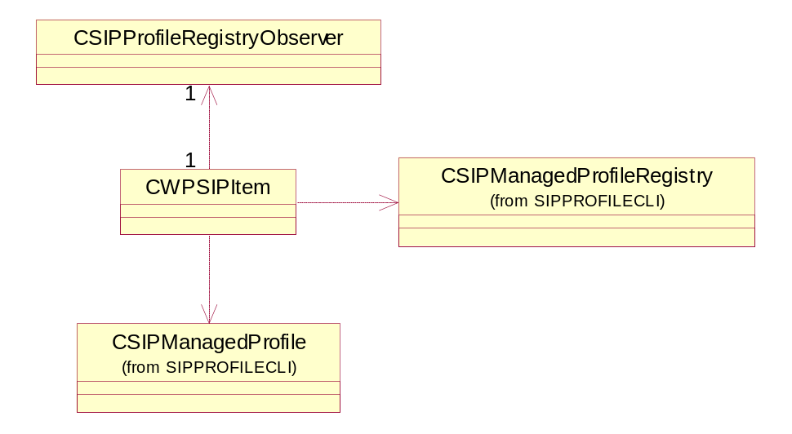
Figure 3.33 SIP item design. CWPSIPItem is the class that holds and stores one set of SIP profile settings.

Provisioning VoIP Adapter
The class CWPVoIPAdapter inherits the OMA Client Framework class CWPAdapter (an abstract class), which is inherited by all the adapters of the framework. It provides the basic functionality of the adapter. CWPAdapter provides the capabilities of the visit and adapter design pattern. The framework (Provisioning Engine) and adapter communicate through the visitor pattern. See Figure 3.31 for a class diagram.
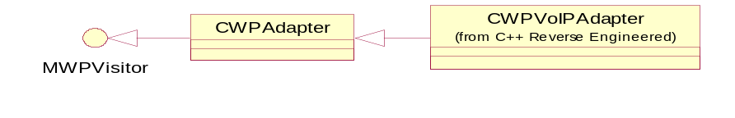
Figure 3.34 Provisioning VoIP Adapter base classes
The classes and dependencies of Provisioning VoIP Adapter can be broken down to two groups by their nature. The first group of classes is used to interface with the S60 OMA Client Provisioning framework (CWPAdapter, CWPVoIPAdapter, CWPCharacteristic, CWPParameter). The second group makes use of VoIP specific classes (CRCSEProfileRegistry). CWPParameter and utility classes are not shown. CWPParameter objects are used to carry setting values of a VoIP profile one by one from the OMA Client Provisioning framework to Provisioning VoIP Adapter.
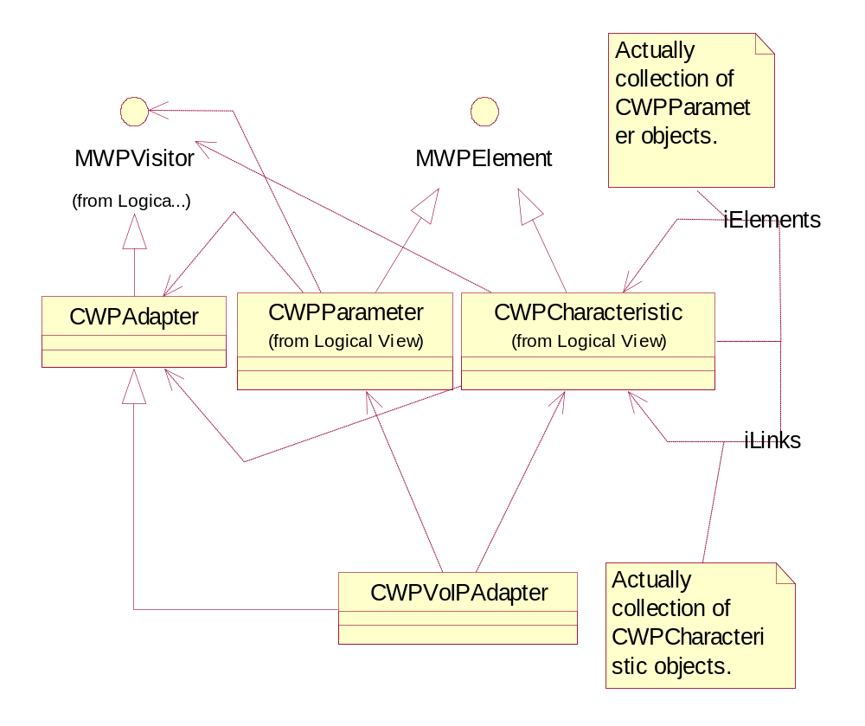
Figure 3.35 CWPVoIPAdapter and the Provisioning framework
Provisioning VoIP Adapter contains the following classes:
- CWPVoIPAdapter inherits the CWPAdapter class (provided by the Provisioning framework) and is the controlling part of the Provisioning VoIP Adapter plug-in component. CWPVoIPAdapter has a reference to an iCurrentVoIPItem::CWPVoIPItem object, which is used to hold the parameter values of the present VoIP profile (VoIP, links to SIP profile and links to IAPs). The CWPVoIPAdapter object has a reference to iNapDef:CWPCharacteristic, which includes information about the Access Point.
- CWPVoIPItem is a concrete class, which carries the values of the VoIP profile. The class uses the VoIP Profile and VoIP Profile Admin interfaces to store the received new VoIP profile(s).
- Individual VoIP settings belonging to the same context (i.e. received in the same Provisioning document) are stored in iDatas:RPointerArray, which is owned by CWPVoIPAdapter.

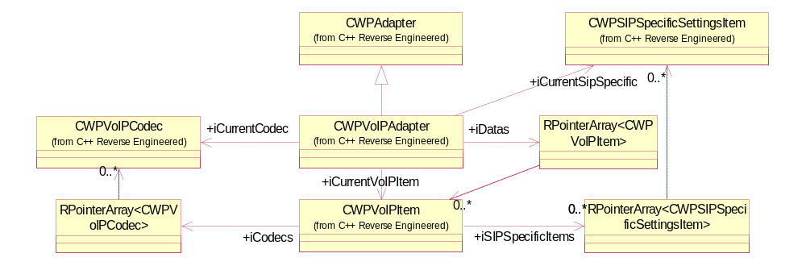
Figure 3.36 Provisioning VoIP Adapter design. RPointerArray is used to hold one or more CWPVoIPItem instances.
CWPVoIPAdapter owns and controls the data structure of multiple VoIP settings items. CWPVoIPAdapter owns an array of CWPVoIPItems called iDatas, where the individual VoIP settings items are kept transiently before saving them via the RCSE interface.
CWPVoIPItem is a place where the central VoIP settings are stored transiently before saving them via the RCSE interface (CRCSEProfileHandler). CWPVoIPItem owns arrays for:
- Audio codecs (iCodecs); CWPVoIPCodec items.
- SIP URIs related to the known (by storage ID) SIP profiles (SIP URIs); CWPSIPSpecifiSettingsItem objects.
- SCCP IDs are kept in their own array. SCCP settings are handled by the SCCP dedicated adapter. The IDs of the saved SCCP settings are received via enhanced linking mechanism (the message SettingsSavedL).
- TO-APPREF parameters (to know which SIP settings in the same Provisioning context/document the VoIP settings must refer to), SIP identities (by which the SIP profile is known in SIP Profile Registry). At the time of saving the VoIP settings, the SIP identities are not necessarily known because of the order of execution of the component’s methods. SIP identities are received also via enhanced linking mechanism (the message SettingsSavedL).

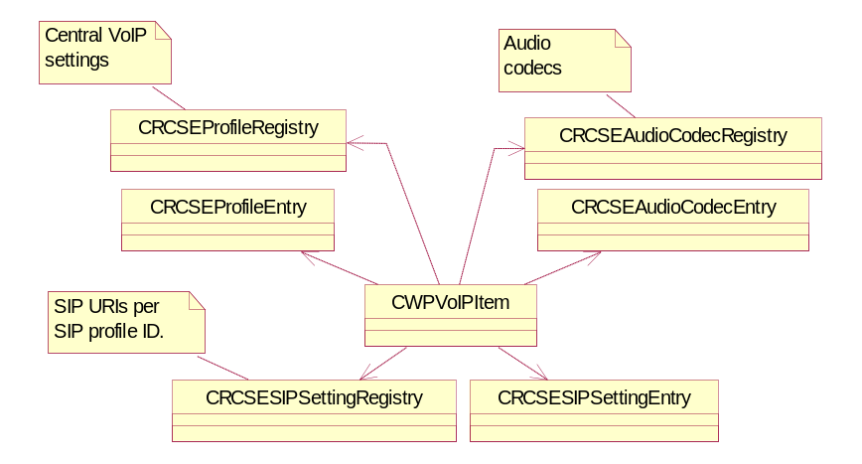
Figure 3.37 VoIP item’s relations to the classes of the RCSE storage interface. RCSE is used for saving the settings. CWPVoIPItem acts as controller in the roles of the data structure manager and saving manager, so it does make use of different storage interfaces of RCSE to save and update (update is done by Provisioning VoIP Adapter after SavingFinalizedL is called by the framework) VoIP profile, audio codec, SIP specific and SCCP settings (only the ID of the SCCP profile[s]).

Provisioning SC
Provisioning SC, CWPProvisioningSC, uses the WIM library to read OMA Provisioning messages from a new inserted SIM card. The process is initiated by S60 Starter at system startup. This should take place only after displaying global notes is allowed in the system startup sequence. CWPImsiDbHandler manages a database of previously read SIM cards in order to avoid reading the same settings twice. CWPBioMsgHandler stores the read settings into the Inbox or directly into Provisioning Engine.

Provisioning Authentication type plug-in
The Authentication type plug-in class CAuthtypePlugin is inherited from the General settings plug-in Interface base class CGSPluginInterface and MAknServerAppExitOnbserver.
The CAuthtypePlugin class has all the functionality for retrieving and storing repository values based on selection of Item from List dialog popped to user.
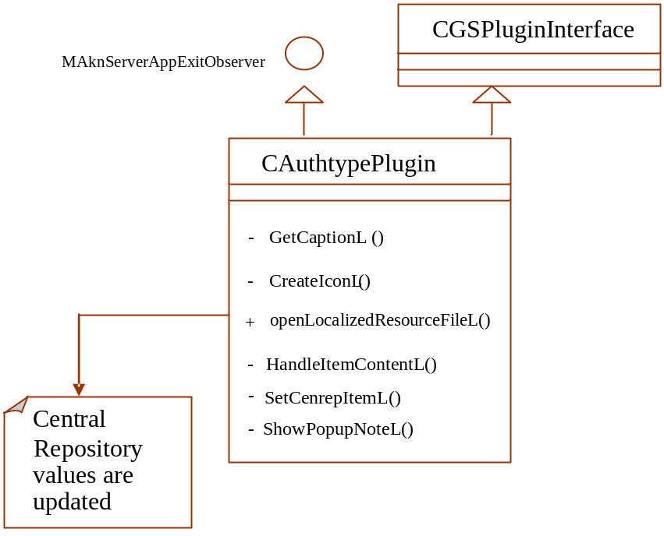
Figure 3.38 Provisioning Authentication plug-in

Class descriptions

Provisioning Access Point Adapter
Class | Description | Header file
CWPAPAccesspointItem | Handles Access Point settings. | CWPAPAccesspointItem.h
CWPAPAdapter | Handles Access Point settings. | CWPAPAdapter.h
CWPAPItemBase | The base class for all the items in WPAPAdapter. | CWPAPItemBase.h
CWPAPLogicalProxy | Contains logical Proxy data. | CWPAPLogicalProxy.h
CWPAPNapdef | Handles NAPDEF characteristics. | CWPAPNapdef.h
CWPAPPhysicalProxy | Contains physical Proxy information. | CWPAPPhysicalProxy.h
CWPAPPort | Contains port information. | CWPAPPort.h
WPAPUtil | Offers common helper methods. | WPAPUtil.h
Log | Offers logging functionality. | CWPLog.h

Provisioning Email Adapter
Class | Description | Header file
CWPEmailAdapter | Handles email provisioning settings. | CWPEmailAdapter.h
CWPEmailItem | Handles email settings. | CWPEmailItem.h
CWPEmailSaveItem | Email saving settings base class. | CWPEmailSaveItem.h
CSaveSmtpImapItem | Saves SMTP/IMAP settings. | CWPEmailSaveSmtpImapItem.h
CSaveSmtpPopItem | Saves SMTP-POP settings. | CWPEmailSaveSmtpPopItem.h
Log | Offers logging functionality. | CWPEmailLog

Provisioning Wireless Village Adapter
Class | Description | Header file
CWPIMAdapter | Handles Wireless Village settings. | CWPIMAdapter.h
CWPIMSAPItem | Handles the saving of a Wireless Village settings item. | CWPIMSAPItem.h
CWPPecAdapter | Handles PEC settings. | CWPPecAdapter.h
TWPIMVisitor | Crawls through a logical proxy and finds the corresponding NAPDEF. | TWPIMVisitor.h
TData | Stores settings. | WPIMUtil.h
WPIMUtil | A utility class for reading resource strings. | WPIMUtil.h

Provisioning BIO Controller
Class | Description | Header file
CWPBioControl | The BIO control for OMA Provisioning messages. | CWPBioControl.
CWPCodeQueryDialog | The PIN code query dialog. | CWPCodeQueryDialog.h
CWPSaver | A helper class for saving Provisioning settings. Provides a progress note. | CWPSaver.h
CWPStringPair | A sortable string pair. | CWPStringPair.h

Configuration Context application
Class | Description | Header file
CWPCxApp | Provides a factory for creating the concrete document object. | CWPCxApp.h
CWPCxAppUi | The application UI class. | CWPCxAppUi.h
CWPCxContainer | The CWPCxDocument container control class. | CWPCxContainer.h
CWPCxDeleter | A helper class for deleting Provisioning settings. | CWPCxDeleter.h
CWPCxDocument | The document class. | CWPCxDocument.h
CWPCxView | The view class. | CWPCxView.h

Provisioning Engine
Class | Description | Header file
CWPAdapter | The base class that has to be implemented by each adapter. | CWPAdapter.h
CWPAdapterManager | Owns and controls all the adapters. | CWPAdapterManager.h
CWPBindingContextManager | Handles data in contexts. | CWPBindingContextManager.h
CWPBootstrap | Handles bootstrap information. | CWPBootstrap.h
CWPCharacteristic | Contains one characteristic. | CWPCharacteristic.h
CWPEngine | The engine class used by the Provisioning components. | CWPEngine.h
CWPMultiContextManager | Handles data in contexts. | CWPMultiContextManager.h
CWPParameter | Contains one parameter. | CWPParameter.h
CWPPhone | Reads IMSI from a SIM card. | CWPPhone.h
CWPPhoneEmul | The emulator for CWPPhone. | CWPPhoneEmul.h
CWPPushMessage | Helps in saving/restoring a Push message. | CWPPushMessage.h
CWPRoot | The root for the contents of a WAP Provisioning document. | CWPRoot.h
CWPValidator | A document structure validator. | CWPValidator.h
MWPBuilder | Used by Provisioning Parser to pass data to Provisioning Engine. | MWPBuilder.h
MWPContextExtension | Declares an extension interface for adapters. | MWPContextExtension.h
MWPContextExtensionArray | Declares an extension interface for adapters. | MWPContextExtensionArray.h
MWPContextManager | Declares an interface to be implemented by context managers. | MWPContextManager.h
MWPContextObserver | Declares an extension interface for adapters. | MWPContextObserver.h
MWPElement | An abstract base class for the contents of a WAP Provisioning document. | MWPElement.h
MWPPairVisitor | Has to be implemented by details visitors. | MWPPairVisitor.h
MWPPhone | An interface to telephony functionality. | MWPPhone.h
MWPVisitor | Has to be implemented by visitors. | MWPVisitor.h
TWPFindAccesspoint | Crawls a logical proxy and finds the corresponding Access Point. | TWPFindAccesspoint.h
WPAdapterFactory | A factory class for adapters. | WPAdapterFactory.h
WPAdapterUtil | A utility class for reading resource strings. | WPAdapterUtil.h
WPContextManagerFactory | A factory class for Context Manager. | WPContextManagerFactory.h
WPElementFactory | A factory class for CWProvisiong elements. | WPElementFactory.h
WPPhoneFactory | A factory class for the Phone interface. | WPPhoneFactory.h

Provisioning Handler
Class | Description | Header file
CWPHandler | Handles provisioning documents. | CWPHandler.h
CWPMessage | Handles a provisioning message. | CWPMessage.h
WPHandlerUtil | A utility class for Provisioning Handler. | WPHandlerUtil.h

Provisioning Parser
Class | Description | Header file
CWPNameValuePair | A class for passing the attribute name and value. | CWPWbxmlParser.h
CWPWbxmlParser | Parses WBXML data received from Provisioning Engine. The parsed data is built back into Provisioning Engine. | CWPWbxmlParser.h

Smart Card Provisioning
Class | Description | Header file
CWPBioMsgHandler | Manages the storage of the IMSI numbers of processed SIM cards. | CWPBioMsgHandler.h
CWPImsiDbHandler | Manages the storage of the IMSI numbers of processed SIM cards. | CWPImsiDbHandler.h
CWPProvisioningSC | Detects a new SIM and handles the contained OMA Provisioning document. | CWPProvisioningSC.h
CWPWimHandler | WIM card handler. | CWPWimHandler.h
MWPWimObserver | An observer for Provisioning SC to be notified about read events. | MWPWimObserver.h

Provisioning SIP Adapter
Class | Description | Header file
CSIPProfileRegistry  Observer | Implements the MSIPProfile  RegistryObserver interface. Observes changes in the SIP profile registry. | CSIPProfileRegistryObserver.h
CWPSIPAdapter | Handles SIP settings. | CWPSIPAdapter.h
CWPSIPItem | Handles the saving of a SIP settings item. | CWPSIPItem.h

Provisioning Streaming Adapter
Class | Description | Header file
CStreamingAdapter | Handles streaming Access Point settings. | CStreamingAdapter.h

Provisioning WAP Adapter
Class | Description | Header file
CWPWAPAdapterBase | Base for WAP adapters. | CWPWAPAdapterBase.h
CWPWAPBookmarkItem | Handles one bookmark item in Browser settings. | CWPWAPBookmarkItem.h
CWPWAPBrowserAdapter | Handles Browser settings. | CWPWAPBrowserAdapter.h
CWPWAPBrowserItem | Handles one Browser setting. | CWPWAPBrowserItem.h
CWPWAPItemBase | The base class for WAP settings. | CWPWAPItemBase.h
CWPWAPMMSAdapter | Handles MMS settings. | CWPWAPMMSAdapter.h
CWPWAPMMSItem | Contains one MMS setting. | CWPWAPMMSItem.h
MWPWAPItemBase | The base class for WAP settings. | MWPWAPItemBase.h
WPWAPItemFactory | A factory for all WAP items. | WPWAPItemFactory.h
WPWAPUtil | A utility class for reading resource strings. | WPWAPUtil.h

Provisioning VoIP Adapter
Class | Description | Header file
CWPSIPSpecificSettings  Item | This class keeps the VoIP codec data transiently and stores the codec via an interface provided by RCSE. | CWPSIPSpecificSettingsItem.h
CWPVoIPAdapter | Handles VoIP settings and stores them via RCSE.dll. | CWPVoIPAdapter.h
CWPVoIPCodec | Keeps the VoIP codec data transiently and stores the codec via an interface provided by RCSE. | CWPVoIPCodec.h
CWPVoIPItem | Keeps the VoIP setting values transiently and stores the values via an interface provided by RCSE. | CWPVoIPItem.h

Provisioning Authentication type Plugin
Class | Description | Header file
CAuthtypePlugin | Handles the selection of Authentication methods. | AuthtypePlugin.h

Structs, type definitions and enumerations

Provisioning Access Point Adapter

WPAPDefs.h
Struct's name | Description
TWep | Data structure for storing a WEP key.
TWpaPsk | Data structure for storing a WPA Pre-Shared key.

Enumeration's name | Description
TWEPAuthentication | Authentication type.

CWPAPItemBase.h
Enumeration's name | Description
TMarkedField | Field types that can be marked received.

CWPAPPhysicalProxy.h
Enumeration's name | Description
TWPAPPxAddrType | Address type.

Provisioning Email Adapter

CWPEmailSaveItem.h
Struct's name | Description
TSettingId | Setting IDs.

Provisioning BIO Controller

CWPBioControl.h
Enumeration's name | Description
TMenuCommands | Menu commands.

Provisioning Engine

CWPValidator.h
Struct's name | Description
TMapping | The currently possible mappings.

CWPAdapter.h
Enumeration's name | Description
TWPSaveLeaveCode | Database leave codes.

CWPBootstrap.h
Enumeration's name | Description
TBootstrapResult | Bootstrap result.

CWPParameter.h
Enumeration's name | Description
TWPParameterID | Parameter IDs that follow the WBXML specification.

CWPElement.h
Enumeration's name | Description
TWPElementTypes | Element types.

Provisioning Handler

CWPHandler.h
Enumeration's name | Description
TProvState | Provisioning state.

CWPMessage.h
Enumeration's name | Description
TAuthResult | Authentication result.

Provisioning Parser

CWPWbxmlParser.h
Struct's name | Description
NW_TinyTree_Node_s NW_TinyTree_Node_t | Provisioning Parser attributes.
NW_DOM_AttributeHandle_s NW_DOM_AttributeHandle_t | Provisioning Parser attributes.
NW_TinyDom_Handle_s NW_TinyDom_Handle_t | Provisioning Parser attributes.
NW_String_String_s NW_String_String_t | Provisioning Parser attributes.
NW_String_String_s NW_String_t | Provisioning Parser attributes.
NW_String_UCS2Buff_s NW_String_UCS2Buff_t | Provisioning Parser attributes.
NW_WBXML_Dictionary_s NW_WBXML_Dictionary_t | Provisioning Parser attributes.

Type definition's name | Description
NW_TinyTree_Node_s NW_TinyTree_Node_t | Provisioning Parser attributes.
NW_TinyTree_Node_t NW_DOM_DocumentNode_t | Provisioning Parser attributes.
NW_TinyTree_Node_t NW_DOM_Node_t | Provisioning Parser attributes.
NW_DOM_Node_t NW_DOM_ElementNode_t | Provisioning Parser attributes.
NW_DOM_AttributeHandle_s NW_DOM_AttributeHandle_t | Provisioning Parser attributes.
struct NW_TinyDom_Handle_s NW_TinyDom_Handle_t | Provisioning Parser attributes.
NW_String_String_s NW_String_String_t | Provisioning Parser attributes.
NW_String_String_s NW_String_t | Provisioning Parser attributes.
NW_String_UCS2Buff_s NW_String_UCS2Buff_t | Provisioning Parser attributes.
NW_Uint32 | Provisioning Parser attributes.
NW_Int32 | Provisioning Parser attributes.
NW_Uint16 | Provisioning Parser attributes.
NW_Byte | Provisioning Parser attributes.
NW_Ucs2 | Provisioning Parser attributes.
NW_WBXML_Dictionary_s NW_WBXML_Dictionary_t | Provisioning Parser attributes.
NW_TinyTree_Node_t NW_DOM_DocumentNode_t | Provisioning Parser attributes.

Provisioning SC

CWPWimHandler.h
Enumeration's name | Description
TOMAPhase | Progress information.

Provisioning Streaming Adapter

StreamingAdapter.h
Struct's name | Description
TStreamingAdapterData | Provisioning Streaming Adapter data.

Provisioning VoIP Adapter

CWPVoIPCodec.h
Enumeration's name | Description
TAudioCodecs | Audio codecs.

Provisioning WAP Adapter

MWPWAPItemBase.h
Struct's name | Description
TWPWAPSaveItem | Saving item data.

Flag definitions
Flags are used to enable debugging.

Operations

Receiving an OMA Provisioning message
Operation | Receiving an OMA Provisioning message.
Preconditions | Push Watcher is running. A bootstrap has been received earlier.
Description | An OMA Provisioning message is received via WAP Push. Push Watcher calls Provisioning Handler. Push Handler authenticates the message by checking its sender and stores the message into Messaging Server. If the message contains a bootstrap, the bootstrap settings are stored. The user receives a soft notification about a new message.
Inputs | An OMA Provisioning message.
Modifies | The Inbox of the message store.
Outputs | The soft notification New message received.
Postconditions | The message is stored in the Inbox.
Related to | The classes CWPHandler, CWPMessage, CWPPushMessage and CWPBootstrap.
Related event | Receiving a WAP Push message with the MIME type OMA Provisioning message.
Exceptions | In case of out of disk space, the message is dropped. If authentication could not be performed, the message is dropped.

See Figure 3.39 for a sequence diagram.
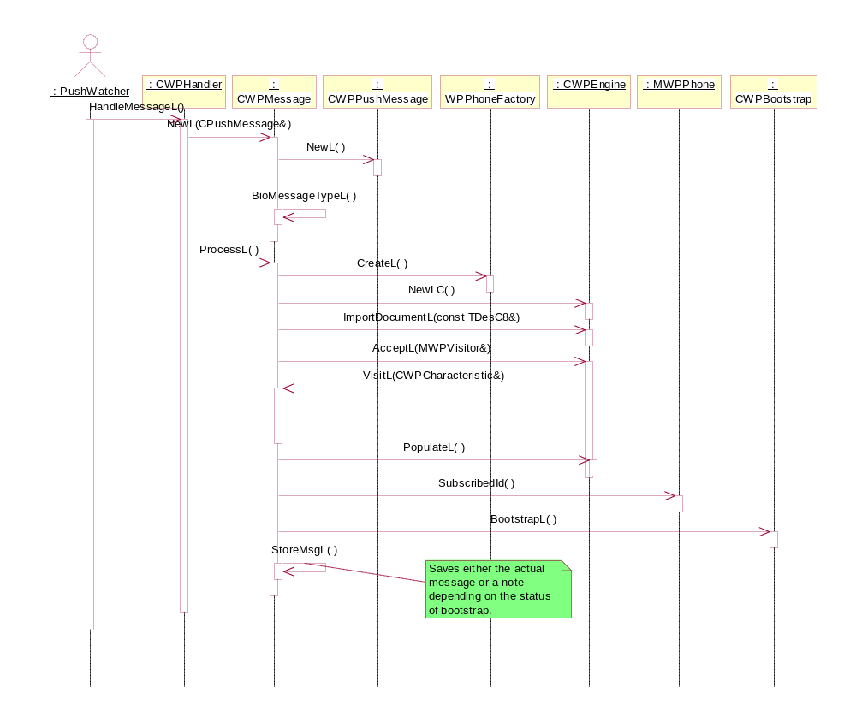
Figure 3.39 Receiving an OMA Provisioning message

Opening an OMA Provisioning message
Operation | Opening an OMA Provisioning message.
Preconditions | A message has been received.
Description | The user opens an OMA Provisioning message in the Inbox. Provisioning BIO Control is launched and it loads the message. The message is passed to Provisioning Engine. Provisioning Engine parses the message with Provisioning Parser and passes the data to the adapters. After that, Provisioning Engine extracts summaries from the adapters.
Inputs | An OMA Provisioning message.
Modifies
Outputs | The message summary on the screen.
Postconditions | The message is opened.
Related to | The classes CProvisioningBioControl, CWPEngine, CWPPushMessage and CWPAdapter.
Related event | The user opens an OMA Provisioning message in the Inbox.
Exceptions | Out of memory.

See Figure 3.40 for a sequence diagram.
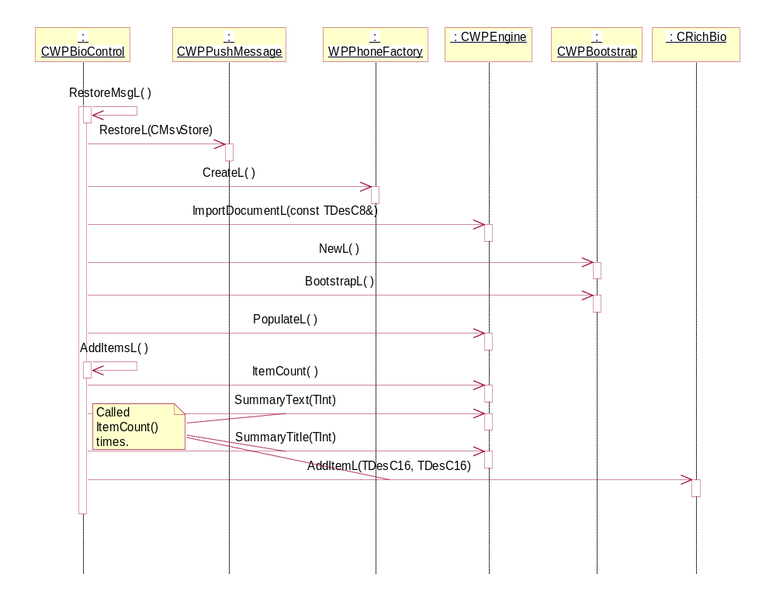
Figure 3.40 Opening an OMA Provisioning message

Bootstrapping with a received message
Operation | Bootstrapping with a received message.
Preconditions | A message has been received from the network or the user is opening a message in the Inbox. A bootstrap needs to be done.
Description | CWPBootstrap first tries to authenticate the message. If it succeeds, a new context is created with the help of WPContextManagerFactory and MWPContextManager.
Inputs | Instances of the CWPPushMessage and CWPEngine classes.
Modifies | The context store.
Outputs
Postconditions | Bootstrapping has been successfully done.
Related to | The classes CWPCharacteristic, CWPParameter, CWPPushMessage, WPContextManagerFactory and MWPContextMAnager.
Related event | The user opens an OMA Provisioning message in the Inbox with PIN authentication or a message arrives to the terminal with NETWPIN authentication.
Exceptions | Out of memory.

Figure 3.41 shows how bootstrap is performed.
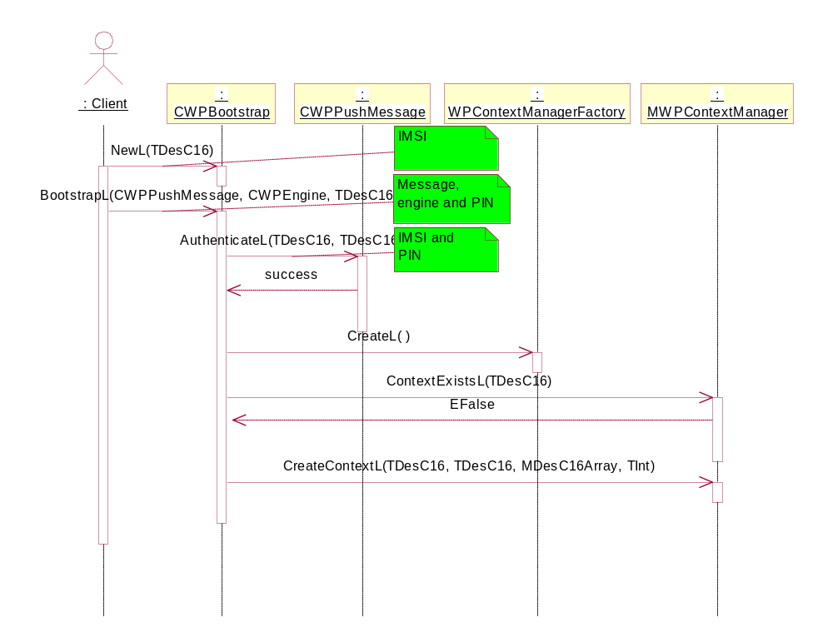
Figure 3.41 Bootstrapping with a received message

Retrieving a list of configuration contexts
Operation | Retrieving a list of configuration contexts.
Preconditions | A context manager has been created.
Description | CWPCxContainer requests a list of the context UIDs. For each UID, CWPCxContainer requests its name.
Inputs | Instances of the CWPEngine class.
Modifies
Outputs | A list of the contexts for the user.
Postconditions | A list of the configuration contexts has been retrieved.
Related to | MWPContextManager
Related event | The user opens a list of the configuration contexts.
Exceptions | Out of memory.

Figure 3.42 shows how a list of contexts is retrieved by the Provisioning Cx component.
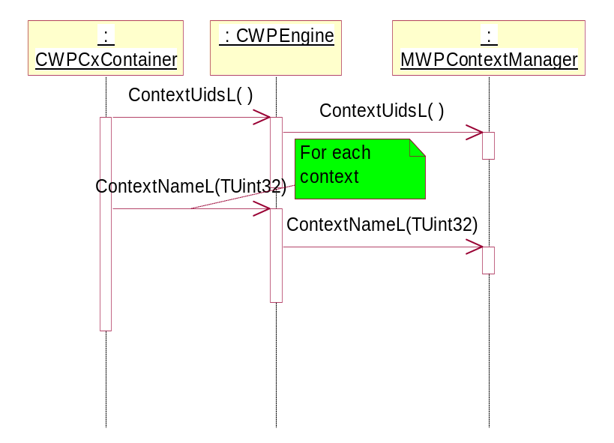
Figure 3.42 Retrieving a list of configuration contexts

Deleting a configuration context
Operation | Deleting a configuration context.
Preconditions | A context manager has been created.
Description | CWPCxView requests the current context UID from CWPCxContainer. After that, the context is deleted with CWPEngine.
Inputs | Instances of the CWPEngine class.
Modifies | The configuration context is deleted.
Outputs
Postconditions | The configuration context has been deleted.
Related to | The MWPContextManager class.
Related event | The user chooses Delete in Provisioning Cx.
Exceptions | Out of memory.

Figure 3.43 shows how a configuration context is deleted by the Provisioning Cx component.
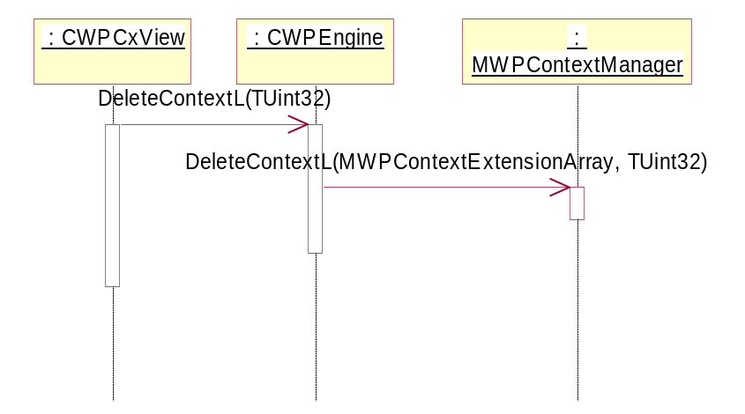
Figure 3.43 Deleting a configuration context

Importing data to Provisioning Access Point Adapter
Operation | Importing data to Provisioning Access Point Adapter.
Preconditions | Provisioning Engine has loaded Provisioning Access Point Adapter and starts to import data to it using the visitor pattern.
Description | Provisioning Access Point Adapter is interested in two types of characteristics: NAPDEF and PXLOGICAL. Depending on the characteristic type, either a CWPAPAccesspointItem or CWPProxyData instance is created and further data importing is done by it.
Inputs | Instances of the CWPCharacteristic class.
Modifies
Outputs
Postconditions | The Access Point data is available to Provisioning Access Point Adapter.
Related to | The classes CWPCharacteristic and CWPParameter.
Related event | The user opens an OMA Provisioning message in the Inbox.
Exceptions | Out of memory.

Figure 3.44 shows how the NAPDEF characteristic data is imported to Provisioning Access Point Adapter.
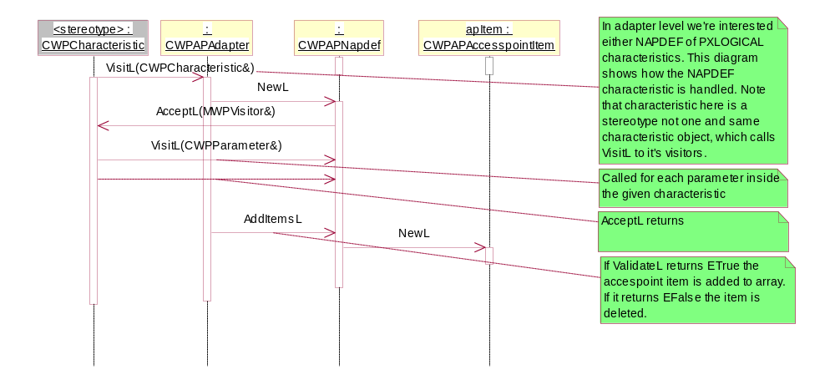
Figure 3.44 Importing the NAPDEF characteristic
Figure 3.45 shows how the PXLOGICAL characteristic data is imported to Provisioning Access Point Adapter. Importing of PXPHYSICAL is shown in Figure 3.46.
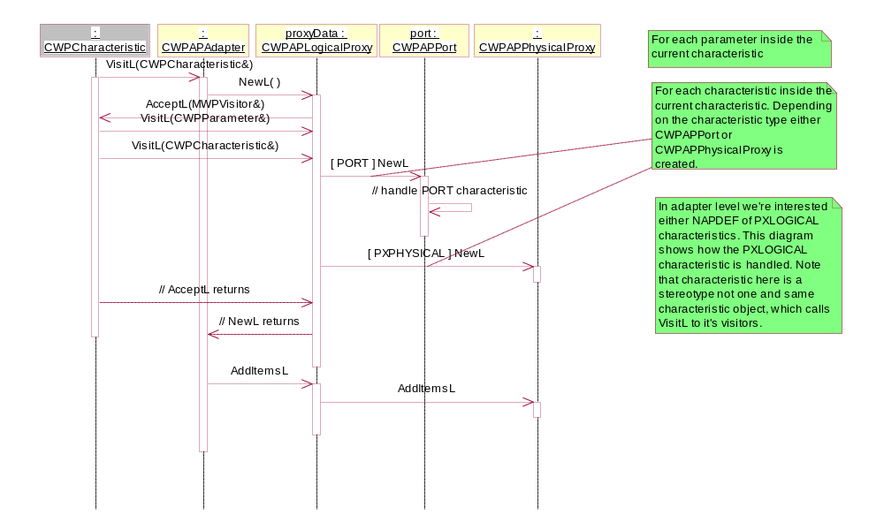
Figure 3.45 Importing the PXLOGICAL characteristic
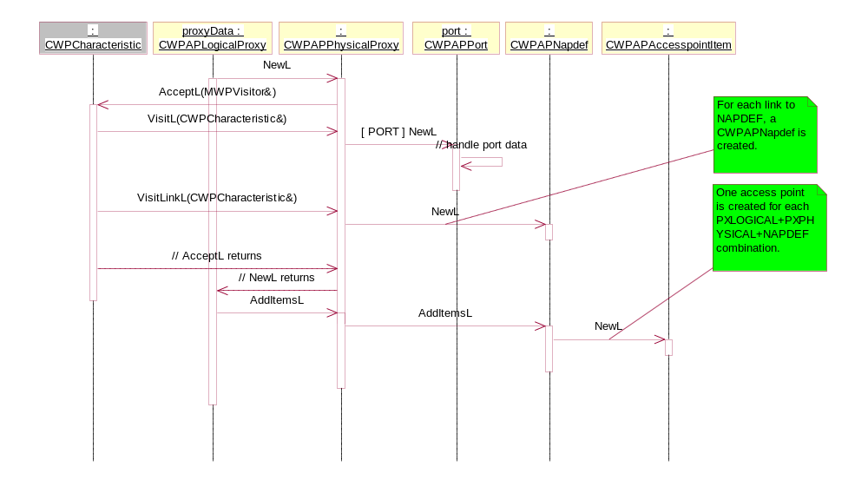
Figure 3.46 Importing the PXPHYSICAL characteristic

Retrieving summaries from Provisioning Access Point Adapter
Operation | Retrieving summaries from Provisioning Access Point Adapter.
Preconditions | Data has been imported to Provisioning Access Point Adapter successfully.
Description | CWPEngine requests an item count from Provisioning Access Point Adapter and then requests the summary title and text for each item.
Inputs
Modifies
Outputs | The summary title and text values.
Postconditions | The summary text is shown on the UI.
Related to
Related event | The user opens an OMA Provisioning message in the Inbox.
Exceptions

Figure 3.47 shows how the summaries are retrieved from Provisioning Access Point Adapter.
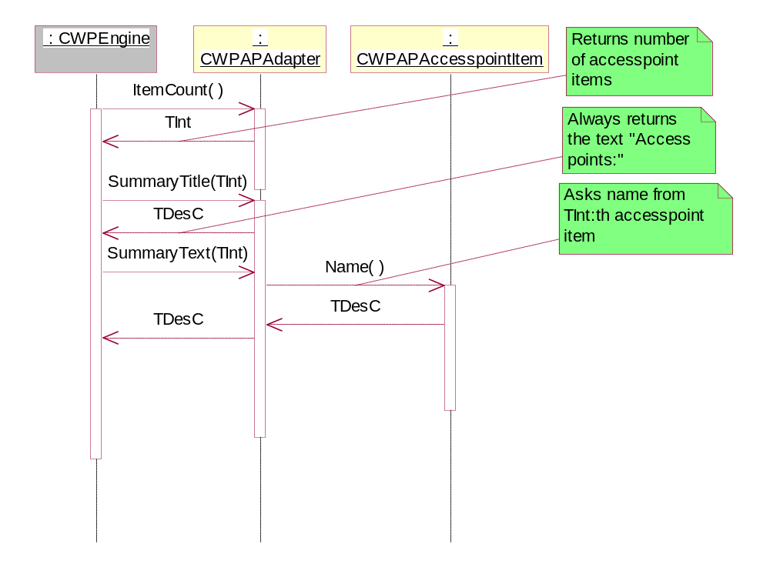
Figure 3.47 Retrieving summaries from Provisioning Access Point Adapter

Importing data to the Browser adapter
Operation | Importing data to the Browser adapter.
Preconditions | Provisioning Engine has loaded the Browser adapter and starts to import data to it using the visitor pattern.
Description | The Browser adapter is interested in the APPLICATION and RESOURCE characteristics. For each APPLICATION with the parameter APPID containing the value w4, a CWPWAPBrowserItem instance is created and further data importing is done by it. CWPWAPBrowserItem creates one CWPWAPBookmarkItem per RESOURCE characteristic. At the end, the adapter calls CWPWAPBrowserItem::AddL() to add the item to the array of items. CWPWAPBrowserItem passes this call on to the CWPWAPBookmarkItem objects if any exist.
Inputs | Instances of the CWPCharacteristic class.
Modifies
Outputs
Postconditions | The data is available to the Browser adapter.
Related to | The classes CWPCharacteristic and CWPParameter.
Related event | The user opens an OMA Provisioning message in the Inbox.
Exceptions | Out of memory.

See Figure 3.48 for a sequence diagram.
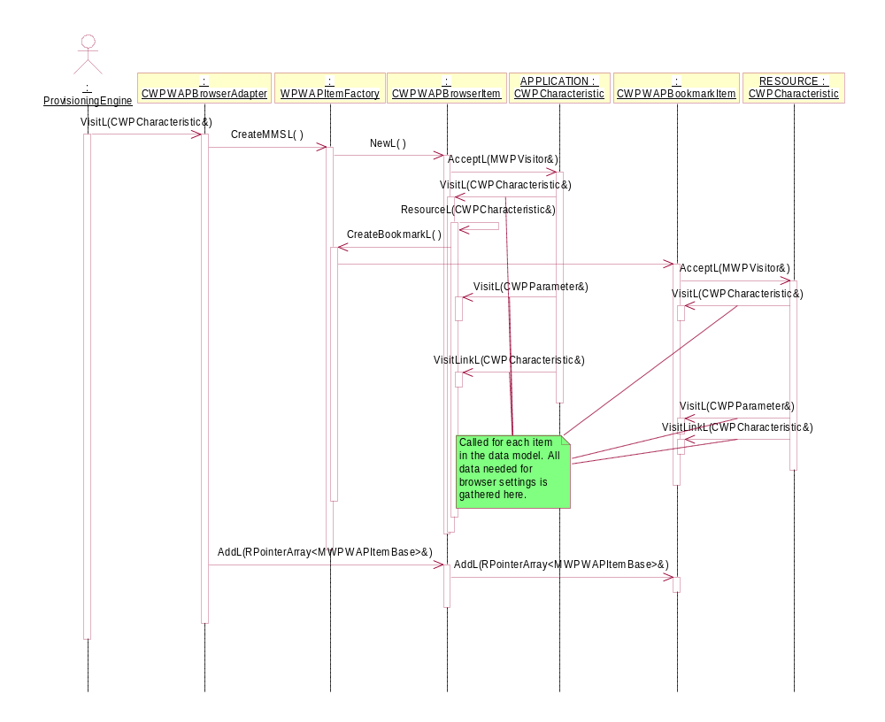
Figure 3.48 Importing data to the Browser adapter

Importing data to the MMS adapter
Operation | Importing data to the MMS adapter.
Preconditions | Provisioning Engine has loaded the MMS adapter and starts to import data to it using the visitor pattern.
Description | The MMS adapter is interested in the APPLICATION characteristic. For each APPLICATION with the parameter APPID containing the value w4, a CWPWAPMMSItem instance is created and further data importing is done by it. At the end, the MMS adapter calls CWPWAPMMSItem::AddL() to add the item to the array of items.
Inputs | Instances of the CWPCharacteristic class.
Modifies
Outputs
Postconditions | The data is available to the MMS adapter.
Related to | The classes CWPCharacteristic and CWPParameter.
Related event | The user opens an OMA Provisioning message in the Inbox.
Exceptions | Out of memory.

See Figure 3.49 for a sequence diagram.
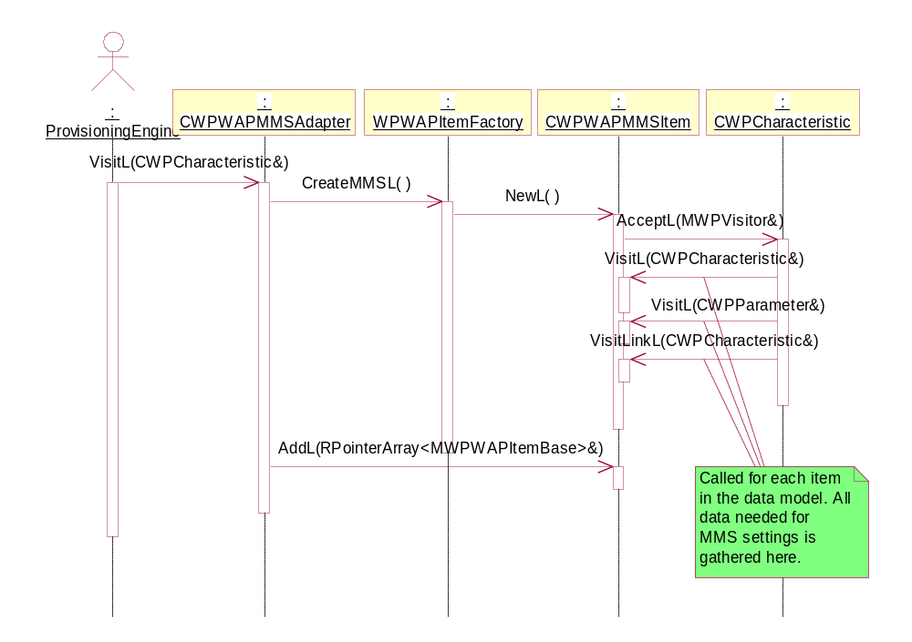
Figure 3.49 Importing data to the MMS adapter

Retrieving summaries from the Browser and MMS adapters
Operation | Retrieving summaries from the Browser and MMS adapters.
Preconditions | Data is successfully imported to the Browser or MMS adapter.
Description | CWPEngine requests the item count from the adapter and then requests the summary title and text for each item.
Inputs
Modifies
Outputs | The summary title and text values.
Postconditions | The summary is shown on the UI.
Related to
Related event | The user opens an OMA Provisioning message in the Inbox.
Exceptions

See Figure 3.50 for a sequence diagram.
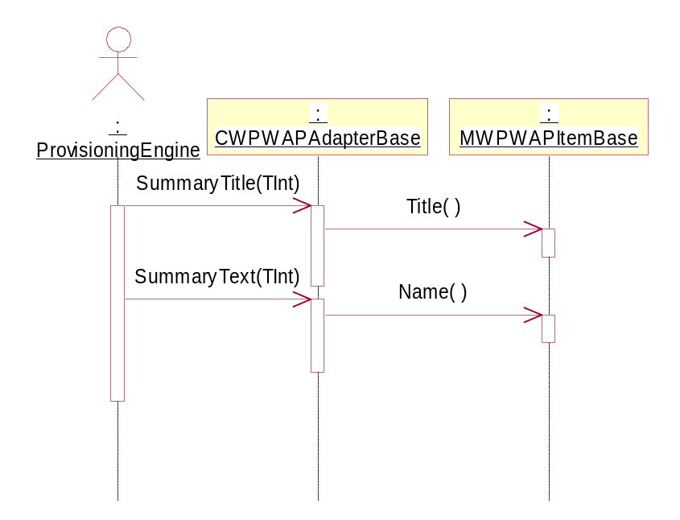
Figure 3.50 Retrieving summaries from the Browser and MMS adapters

Saving the settings in an OMA Provisioning message
Operation | Saving the settings in an OMA Provisioning message.
Preconditions | A message has been opened in Provisioning BIO Control.
Description | The user chooses to save the settings in Provisioning BIO Control. CWPSaver is used as a saver with a Progress note; it calls Provisioning Engine to perform the saving. Provisioning Engine delegates each saving operation to the correct adapter.
Inputs | The opened message.
Modifies | The settings received in the message.
Outputs | The settings in their respective databases.
Postconditions | The data is saved via adapters.
Related to | The classes CWPBioControl, CWPSaver, CWPEngine and CWPAdapter.
Related event | The user chooses to save the settings in Provisioning BIO Control.
Exceptions | Out of memory.

See Figure 3.51 for a sequence diagram.
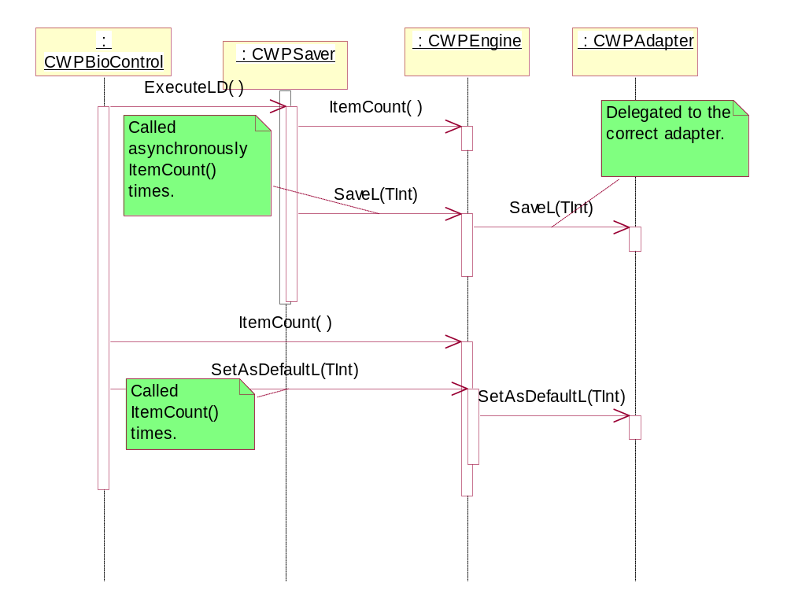
Figure 3.51 Saving the settings in an OMA Provisioning message

Saving data in Provisioning Access Point Adapter
Operation | Saving data in Provisioning Access Point Adapter.
Preconditions | Data has been imported successfully and Provisioning Access Point Adapter contains items to be saved. Note that in case the Provisioning document does not contain any application characteristics referring to a Proxy or a NAP and if the NAP definition does not have an Internet parameter, then there are no items to be saved.
Description | CWPEngine calls the SaveL method CWPAdapter::ItemCount() times. SaveL has an integer parameter that indicates that Provisioning Access Point Adapter should store that particular item. Provisioning Access Point Adapter adapter calls SaveL to its CWPAPAccesspointItem instance. CWPAPAccesspointItem first creates an instance of CApAccessPointItem (a class defined in Access Point Engine) and adds the data to it.
Inputs
Modifies | The Comms database and the NAPDEF characteristic.
Outputs | The data is saved via Provisioning Access Point Adapter.
Postconditions | The data stored in CApAccesspointItem is stored in the Comms database. After that, CApAccessPointItem is deleted.
Related to | The CWPCharacteristic class.
Related event | The user chooses to save the settings in Provisioning BIO Control.
Exceptions | OOM, a protected Access Point table.

Figure 3.52 shows how the data in one Access Point item is saved in Provisioning Access Point Adapter.
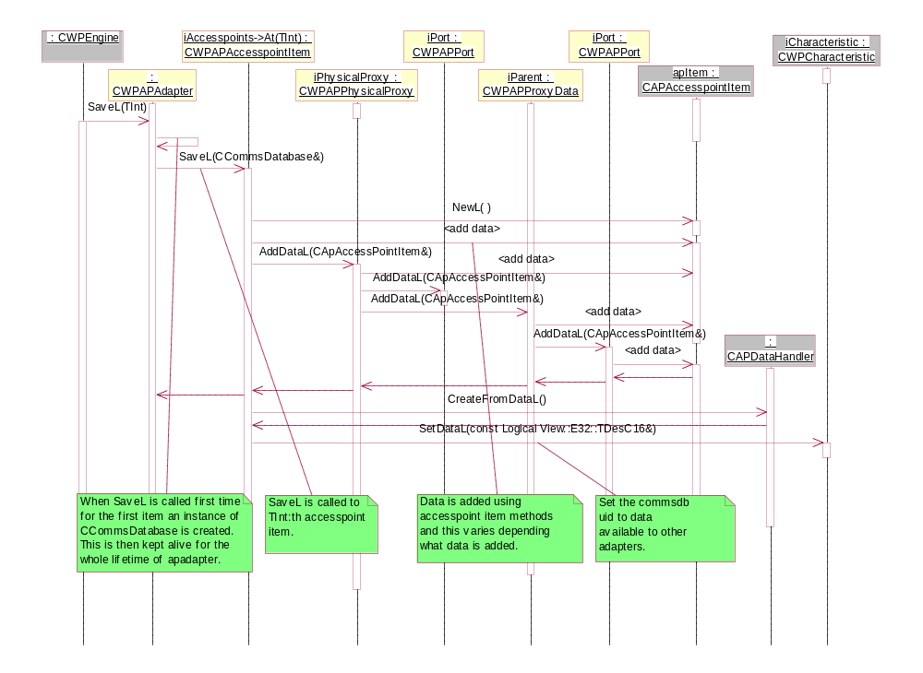
Figure 3.52 Saving data in Provisioning Access Point Adapter r

Saving WLAN data
Operation | Saving WLAN data in Provisioning Access Point Adapter.
Preconditions | Data has been imported successfully and Provisioning Access Point Adapter contains items to be saved.
Description | CWPEngine calls the SaveL method CWPAdapter::ItemCount() times. SaveL has an integer parameter that indicates that Provisioning Access Point Adapter should store that particular item. Provisioning Access Point Adapter calls SaveL to its CWPAPAccesspointItem instance. CWPAPAccesspointItem first creates an instance of CApAccessPointItem (a class defined in Access Point Engine) and adds the data to it.
Inputs
Modifies | The Comms database.
Outputs
Postconditions | The data stored in CApAccesspointItem is stored in the Comms database. After that, CApAccessPointItem is deleted.
Related to | The CWPCharacteristic class.
Related event | The user chooses to save the WLAN settings in Provisioning BIO Control.
Exceptions | OOM, a protected Access Point table.

Receiving and saving WLAN settings is very similar to normal Access Point setting handling. WLAN settings handling is built inside Provisioning Access Point Adapter and it activates if an Access Point setting message contains WLAN as a bearer information.
The received parameters are handled in the same way as with any other Access Point. The only difference is the location where the settings are stored. See Figure 3.53 for a sequence diagram of saving the WLAN settings.
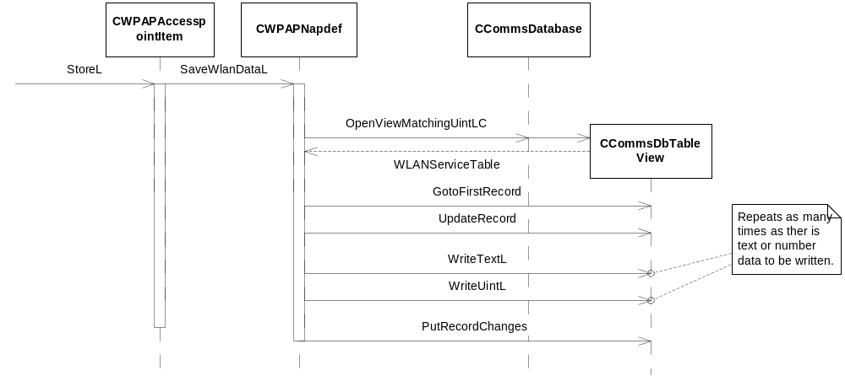
Figure 3.53 Saving WLAN settings

Saving data in the Browser adapter
Operation | Saving data in the Browser adapter.
Preconditions | Data has been imported successfully and the Browser adapter contains items to be saved.
Description | CWPEngine calls the SaveL method CWPAdapter::ItemCount() times. SaveL has an integer parameter that indicates that the Browser adapter should store that particular item. The Browser adapter calls SaveL() for the particular MWPWAPItemBase instance. The Browser settings are saved with CAPDataHandler and bookmarks with RFavouritesDb.
Inputs
Modifies | The Comms database and Access Point Engine.
Outputs
Postconditions | The data stored in CApAccesspointItem is stored in the Comms database. After that, CApAccessPointItem is deleted.
Related to | The CWPCharacteristic class.
Related event | The user chooses to save settings in Provisioning BIO Control.
Exceptions | OOM, a protected Access Point table.

See Figure 3.54 and Figure 3.55 for sequence diagrams.
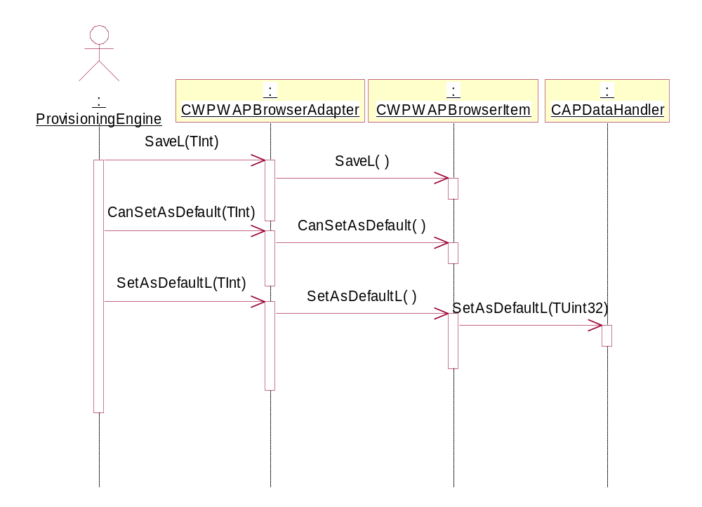
Figure 3.54 Saving Browser settings
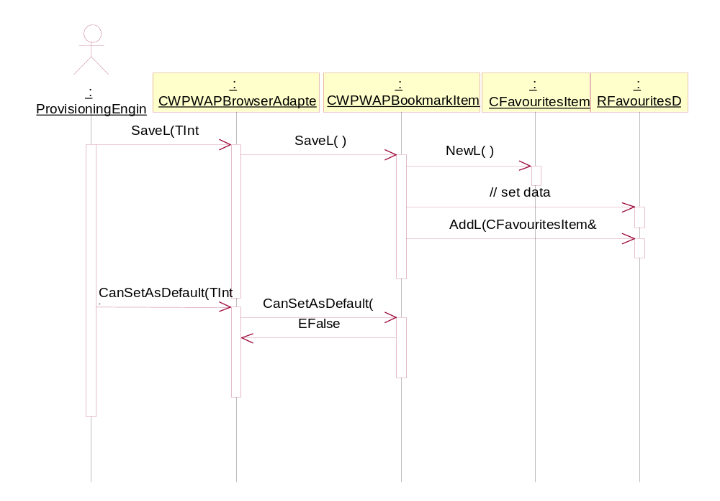
Figure 3.55 Saving bookmarks

Saving data in the MMS adapter
Operation | Saving data in the MMS adapter.
Preconditions | Data has been imported successfully and the MMS adapter contains items to be saved.
Description | CWPEngine calls the SaveL method CWPAdapter::ItemCount() times. SaveL has an integer parameter that indicates that the MMS adapter should store that particular item. The MMS adapter calls SaveL() for the particular MWPWAPItemBase instance. The settings are saved with CAPDataHandler.
Inputs
Modifies | The Comms database and Access Point Engine.
Outputs
Postconditions | The data stored in CApAccesspointItem is stored in the Comms database. After that, CApAccessPointItem is deleted.
Related to | The CWPCharacteristic class.
Related event | The user chooses to save the settings in Provisioning BIO Control.
Exceptions | OOM, a protected Access Point table.

See Figure 3.56 for a sequence diagram.
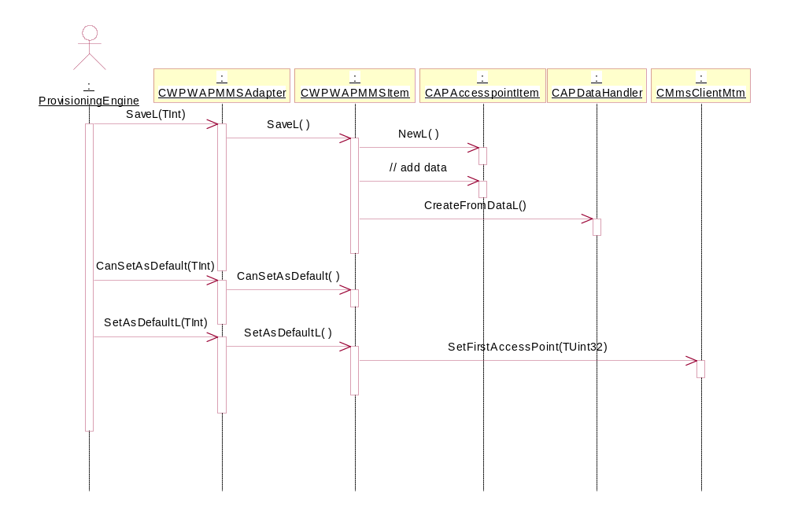
Figure 3.56 Saving MMS settings

Importing data to Provisioning Wireless Village Adapter
Operation | Importing data to Provisioning Wireless Village Adapter.
Preconditions | Provisioning Engine has loaded Provisioning Wireless Village Adapter and starts to import data to it using the visitor pattern.
Description | Provisioning Wireless Village Adapter is interested in the APPLICATION characteristic. For each APPLICATION with the parameter APPID containing the value wA, a TData instance is created and the data is stored to it. The TWPIMVisitor class is used for getting the IAP characteristic from the Provisioning data. At the end, Provisioning Wireless Village Adapter validates the settings data and sets the data item to the array.
Inputs | Instances of the CWPCharacteristic class.
Modifies
Outputs
Postconditions | The data is available to Provisioning Wireless Village Adapter.
Related to | The classes CWPCharacteristic and CWPParameter.
Related event | The user opens an OMA Provisioning message in the Inbox.
Exceptions | Out of memory.

See Figure 3.57 for a sequence diagram.
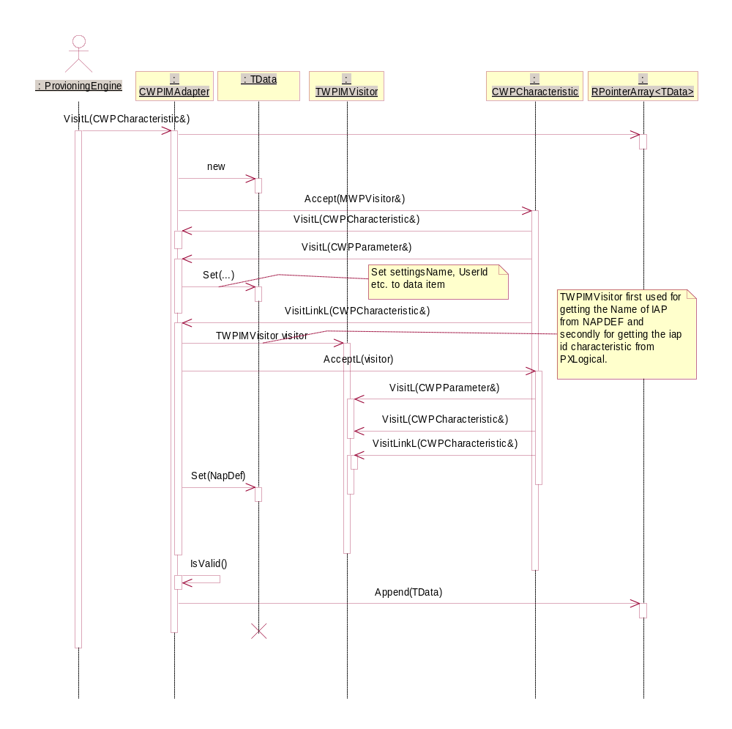
Figure 3.57 Importing data to Provisioning Wireless Village Adapter

Retrieving summaries from Provisioning Wireless Village Adapter
Operation | Retrieving summaries from Provisioning Wireless Village Adapter.
Preconditions | Data has been successfully imported to Provisioning Wireless Village Adapter.
Description | CWPEngine requests the item count from Provisioning Wireless Village Adapter and then requests the summary title and text for each item.
Inputs
Modifies
Outputs | The summary title and text values.
Postconditions | The summary is seen on the UI.
Related to
Related event | The user opens an OMA Provisioning message in the Inbox.
Exceptions

See Figure 3.58 for a sequence diagram.
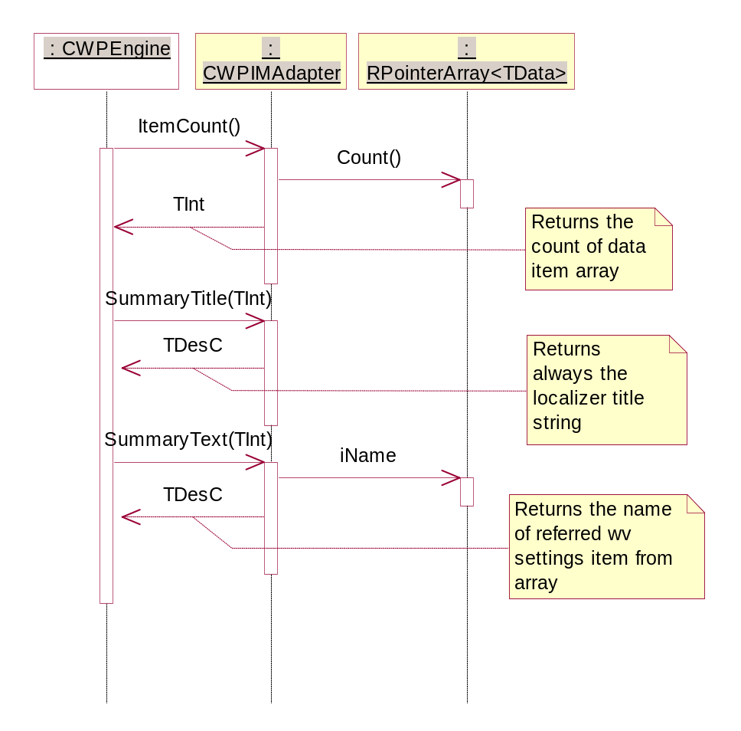
Figure 3.58 Retrieving summaries from Provisioning Wireless Village Adapter

Saving data in Provisioning Wireless Village Adapter
Operation | Saving data in Provisioning Wireless Village Adapter.
Preconditions | Data has been imported successfully and Provisioning Wireless Village Adapter contains items to be saved.
Description | CWPEngine calls the SaveL method CWPAdapter::ItemCount() times. SaveL has an integer parameter that indicates that Provisioning Wireless Village Adapter should store that particular item. Provisioning Wireless Village Adapter creates an instance of CWPIMSAPItem, sets the Save item data from TData to CWPIMSAPItem’s CWVSAPSettings item and calls CWPIMSAPItem’s StoreL method.
Inputs
Modifies | WVSapSettingsStore.
Outputs
Postconditions | The data has been stored to the SAP Settings database. After that, CWPIMSAPItem is deleted.
Related to | The CWPCharacteristic class.
Related event | The user chooses to save settings in Provisioning BIO Control.
Exceptions | Out of memory.

See Figure 3.59 and Figure 3.60 for the sequence diagrams.
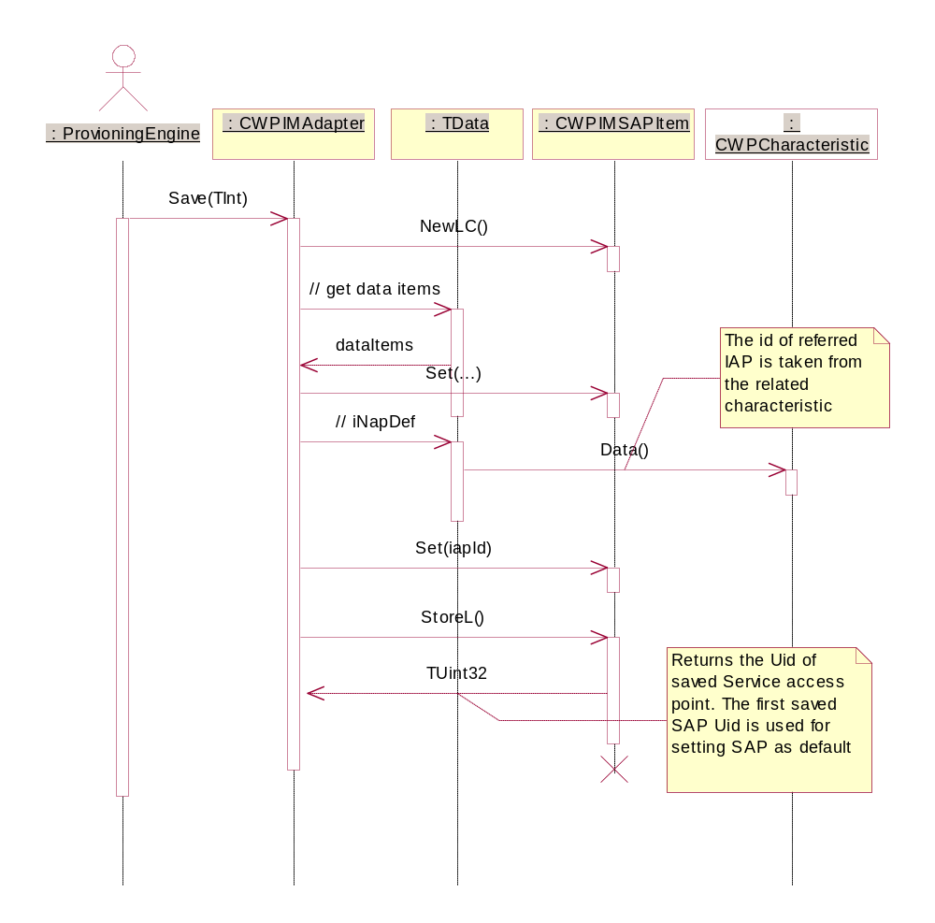
Figure 3.59 Saving Wireless Village settings
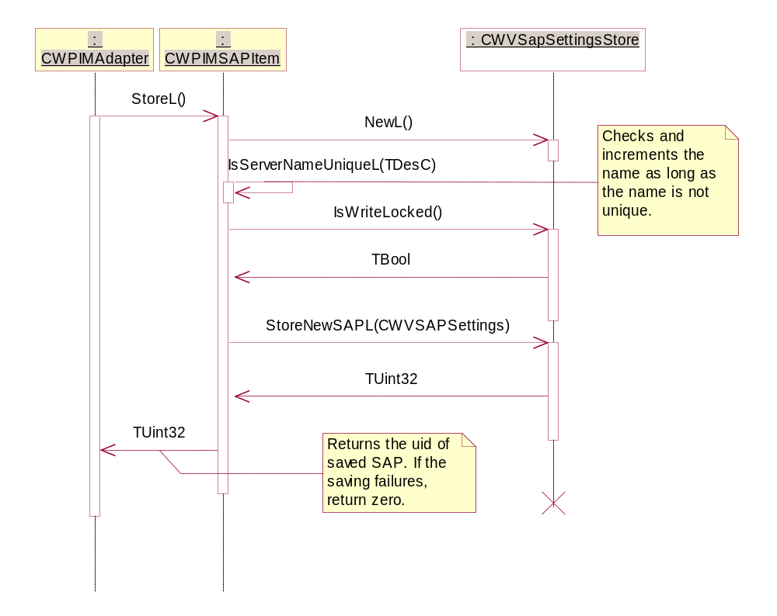
Figure 3.60 Saving Wireless Village settings in detail
Wireless Village settings have been divided into two parts. The first part handles Presence settings and the second handles Instant Messaging settings. Sections 3.3.16, 3.3.17 and 3.3.18 describe how settings are stored using Instant Messaging Adapter.
Presence settings handling is similar to Instant Messaging. The only difference is that the settings are saved to the SAP store using a different parameter.

Importing data to Provisioning Email Adapter
Operation | Importing data to Provisioning Email Adapter.
Preconditions | Provisioning Engine has loaded Provisioning Email Adapter and starts to import data to it using the visitor pattern.
Description | Provisioning Email Adapter is interested in the APPLICATION characteristic. For each APPLICATION containing the parameter APPID with the value 100, 143 or 25, Provisioning Email Adapter creates an instance of CWPEmailItem and the data is stored to it. At the end, Provisioning Email Adapter validates the settings data and sets the CSaveItem inherited item to the array.
Inputs | Instances of the CWPCharacteristic class.
Modifies | CWPEmailItem, CSaveItem.
Outputs
Postconditions | An array of CSaveItem inherited items is created.
Related to | The classes CWPCharacteristic and CWPParameter.
Related event | The user opens an OMA Provisioning message in the Inbox.
Exceptions | Out of memory.

See Figure 3.61 for a sequence diagram.
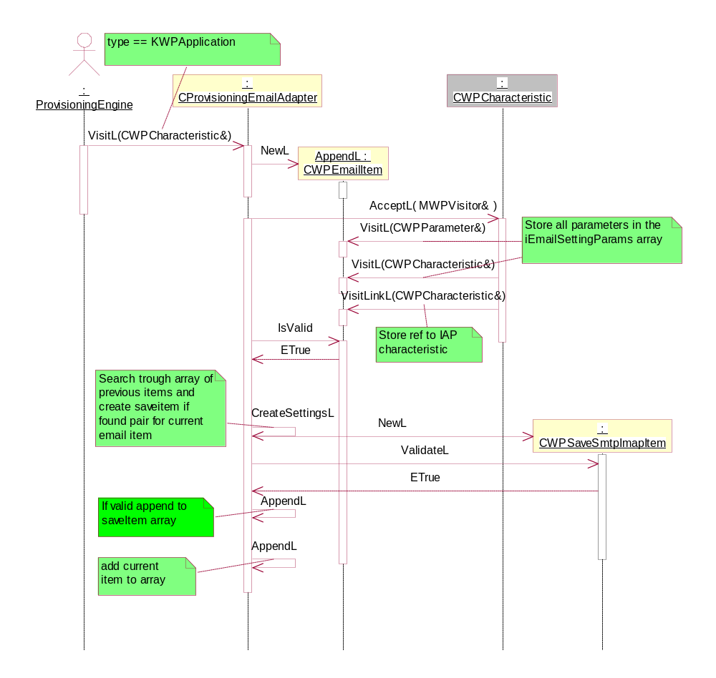
Figure 3.61 Importing data to Provisioning Email Adapter

Retrieving summaries from Provisioning Email Adapter
Operation | Retrieving summaries from Provisioning Email Adapter.
Preconditions | Data has been imported to Provisioning Email Adapter successfully.
Description | CWPEngine requests the item count from Provisioning Email Adapter and then requests the summary title and text for each item.
Inputs
Modifies
Outputs | The summary title and text values.
Postconditions | The summary is seen on the UI.
Related to
Related event | The user opens an OMA Provisioning message in the Inbox.
Exceptions

See Figure 3.62 for a sequence diagram.
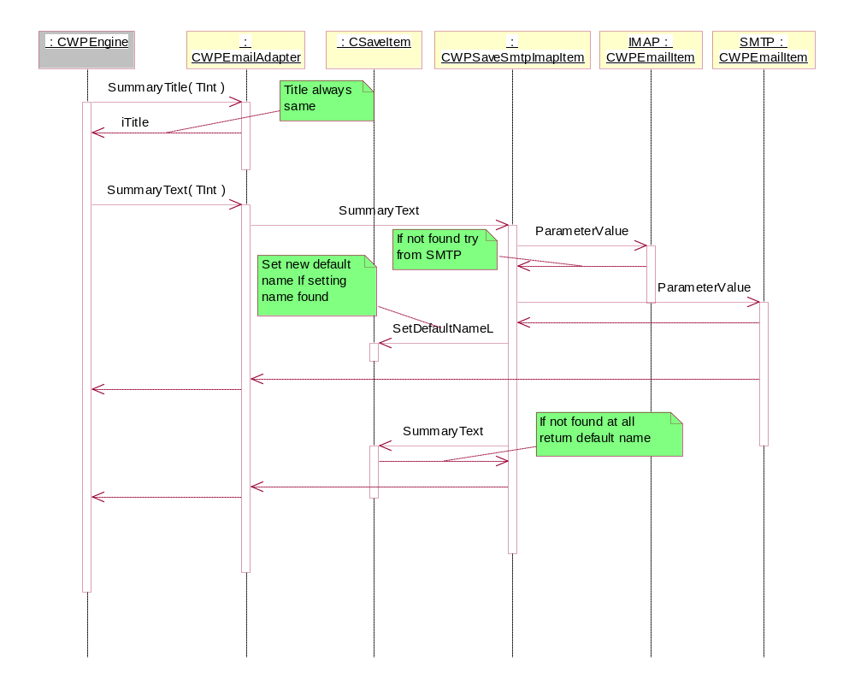
Figure 3.62 Retrieving summaries from Provisioning Email Adapter

Saving data in Provisioning Email Adapter
Operation | Saving data in Provisioning Email Adapter.
Preconditions | Data has been imported successfully and Provisioning Email Adapter contains items to be saved. The Access Point items referred to by the email settings have been saved to the Comms database.
Description | CWPEngine calls the SaveL method CWPAdapter::ItemCount() times. SaveL has an integer parameter that indicates that Provisioning Email Adapter should store that particular item. Provisioning Email Adapter calls CSaveItem’s SaveL method.
Inputs
Modifies | CMsvEntry.
Outputs
Postconditions | The Access Point items referred to by the email settings have been saved to the Comms database.
Related to
Related event | The user chooses to save the settings in Provisioning BIO Control.
Exceptions | Out of memory.

See Figure 3.63 and Figure 3.64 for a sequence diagram.
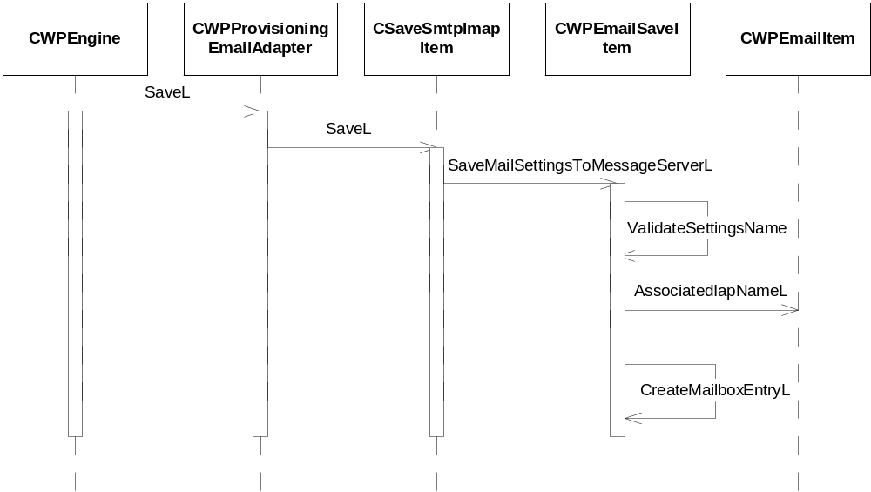
Figure 3.63 Saving email settings
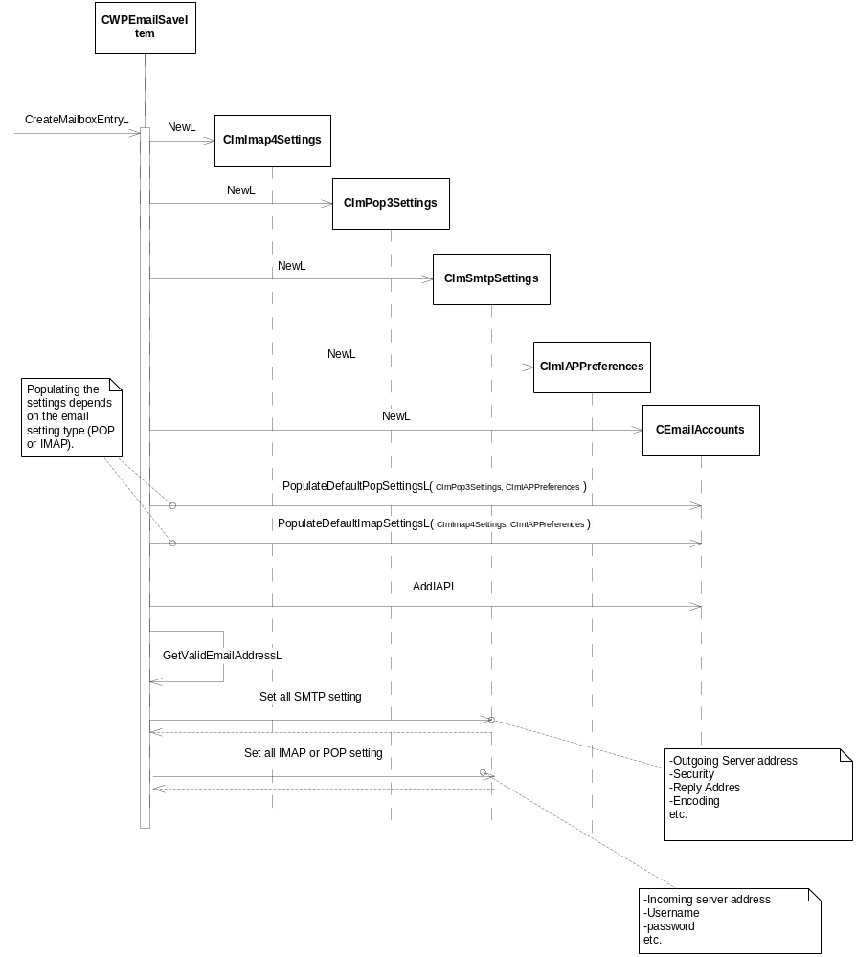
Figure 3.64 Creating a mailbox

Importing data to Provisioning Streaming Adapter
Operation | Importing data to Provisioning Streaming Adapter.
Preconditions | Provisioning Engine has loaded Provisioning Streaming Adapter and starts to import data to it using the visitor pattern.
Description | Provisioning Streaming Adapter is interested in the APPLICATION characteristic. For APPLICATION containing the parameter APPID with the value 554, Provisioning Streaming Adapter first creates the class TStreamingAdapterData and stores the data into it. After all the settings have been stored, Provisioning Streaming Adapter validates the settings.
Inputs | Instances of the CWPCharacteristic class.
Modifies | TStreamingAdapterData for storing the settings locally.
Outputs
Postconditions | The correct settings in TStreamingAdapterData.
Related to | The classes CWPCharacteristic and CWPParameter.
Related event | The user opens an OMA Provisioning message in the Inbox.
Exceptions | Out of memory.

See Figure 3.65 for a sequence diagram.
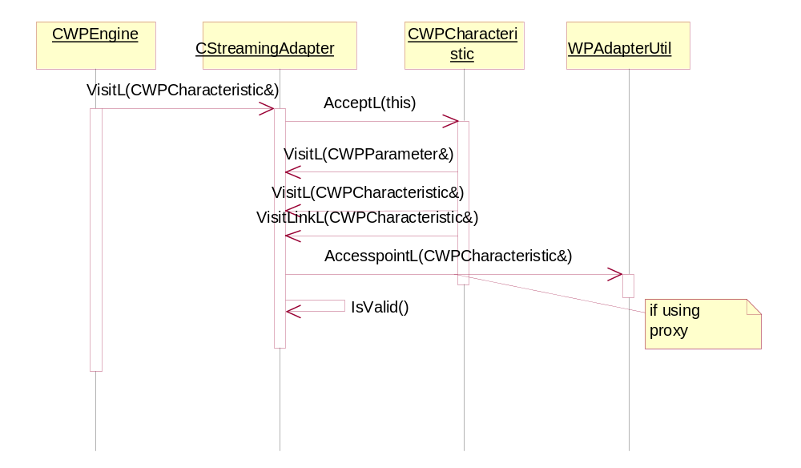
Figure 3.65 Importing data to Provisioning Streaming Adapter

Retrieving summaries from Provisioning Streaming Adapter
Operation | Retrieving summaries from Provisioning Streaming Adapter.
Preconditions | Data has been imported to Provisioning Streaming Adapter (TStreamingAdapterData) successfully.
Description | CWPEngine requests the item count from Provisioning Streaming Adapter and then requests the summary title and text for each item.
Inputs | The item number.
Modifies
Outputs | The summary title and text values.
Postconditions | The summary is seen on the UI.
Related to
Related event | The user opens an OMA Provisioning message in the Inbox.
Exceptions

See Figure 3.66 for a sequence diagram.
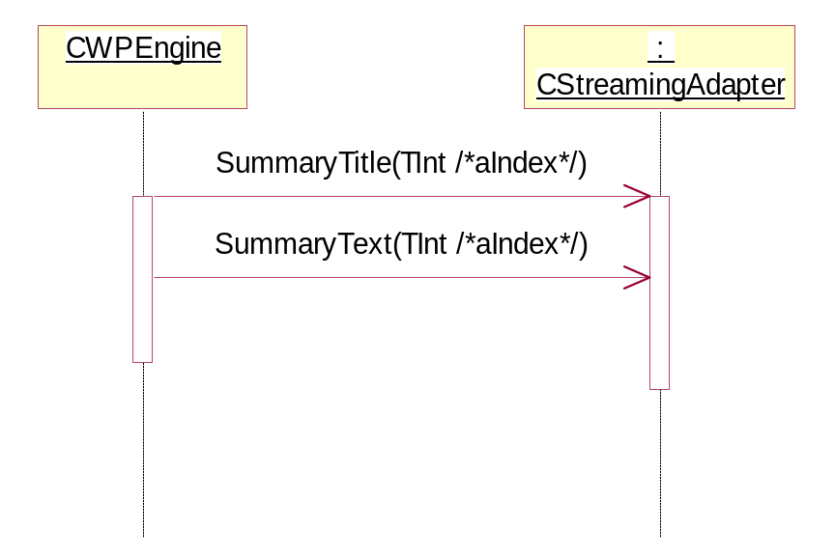
Figure 3.66 Retrieving summaries from Provisioning Streaming Adapter

Saving data in Provisioning Streaming Adapter
Operation | Saving data in Provisioning Streaming Adapter.
Preconditions | Data has been imported successfully and Provisioning Streaming Adapter contains items to be saved. Additionally, Provisioning Access Point Adapter has been populated for being able to store a link to an Access Point or a Proxy.
Description | CWPEngine calls the SaveL method CWPAdapter::ItemCount() times. SaveL has an integer parameter that indicates that Provisioning Streaming Adapter should store that particular item.
Inputs
Modifies | The media settings.
Outputs
Postconditions | The settings are stored into the media settings.
Related to
Related event | The user chooses to save the settings in Provisioning BIO Control.
Exceptions | Out of memory.

Figure 3.67 shows the sequence chart of saving streaming settings.
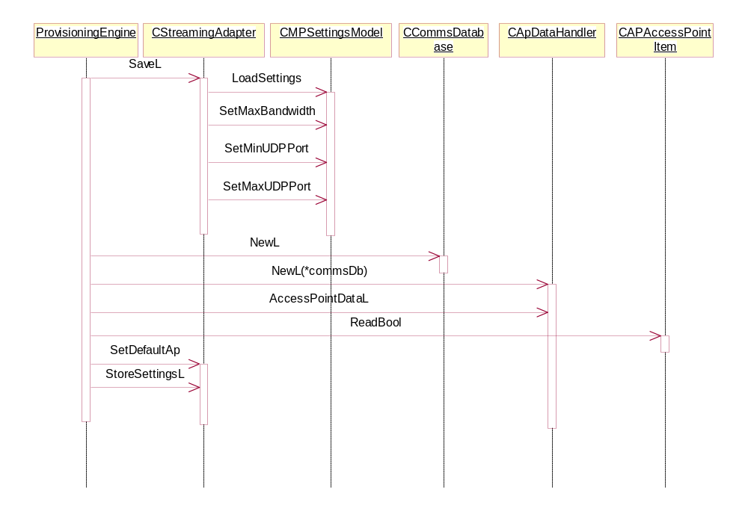
Figure 3.67 Saving data in Provisioning Streaming Adapter

Reading settings from a SIM card
Operation | Reading settings from a SIM card.
Preconditions | S60 Starter allows displaying global notes and has started Provisioning SC during its startup sequence.
Description | The IMSI number of the inserted SIM card is checked. If the SIM is new to the device, the settings are read from the card. The settings are validated and put into the Inbox. The contained bootstrap may be stored directly and an Information note is put into the Inbox.
Inputs | Starter calls ProvisioningSC NewL.
Modifies | The Inbox of the message store.
Outputs | Notification if persistent storage space is too low.
Postconditions | The message is stored in the Inbox.
Related to | The classes CWPWimHandler, CWPBioMsgHandler, CWPImsiDbHandler and CWPBootstrap.
Related event | A SIM card is inserted into the phone and the phone is powered on.
Exceptions | In case of running out of disk space, the message is dropped.

Figure 3.68 describes how Provisioning information is read from the data that is received from a Smart Card.
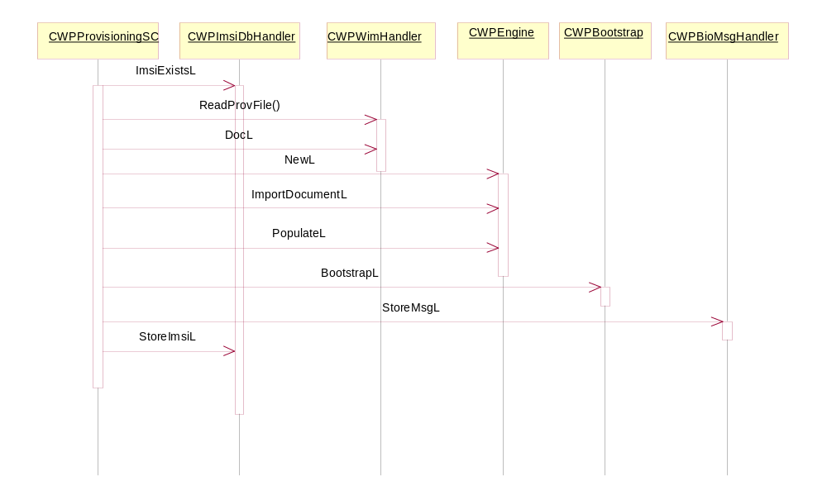
Figure 3.68 Smart card provisioning

Backup and Restore
This component owns the DBMS database wpcontext.db. It is registered as a part of the Backup and restore. Passive backup is used.

Variation

Provisioning feature
This feature can be left out by removing Provisioning Parser, Provisioning Engine, Provisioning BIO Control, Provisioning Handler and all the adapters. Individual setting types can be variated by leaving out or adding an adapter.
The following flags are used for variation:
- __EMAIL_UI
- __MULTIPLE_PROV_CTX
- __SMART_CARD_PROV
- __IM
- FF_PROV_AUTHTYPE_PLUGIN

Configuration context support is compile-time variated. The support for multiple contexts can be enabled with the Central Repository variation flag KOMAProvisioningLVFlag.

System resource usage

Files
File | wpsimcard.db
Type | private
Location | RAM
Format | Database
Sharing | No
Encryption | No
Size estimate | <1kb
Clean up | N/A
Description | The IMSI numbers of the processed SIM cards are stored into this local database.

Other data

Databases
Database | wpcontext.db
Performance goal | -
Estimate | -
Schema policy | Schema name | Read Policy | Write policy
 | wpcontext | ReadDeviceData | WriteDeviceData
Table policy | Table name | Read Policy | Write policy
 | A | ReadDeviceData | WriteDeviceData

Central Repository
Central Repository is used only for local variation.

Publish and Subscribe
This component does not use Publish and Subscribe.

Memory consumption
Provisioning Engine holds a copy of all the received settings. In addition to this, the adapters hold a copy of the data relevant to them, so when a message is open, some settings items are in memory twice.
Provisioning Parser constructs a DOM tree of the binary Provisioning message. This tree is used for constructing the internal data model. Therefore, during parsing, memory is allocated for both the DOM tree and the internal data model. The DOM tree resides in memory only during the tree traversal. When the internal data model is complete, the tree is deleted.

Task allocation
Provisioning Handler runs in the thread of Push Watcher. Provisioning BIO Control runs in the thread of the calling application, usually Messaging Centre. Provisioning CX and Provisioning SC run in their own process.

Timers
No persistent timers are used.

Security

Capabilities of this component

Provisioning Access Point Adapter
Capability | Justification
CAP_ECOM_PLUGIN | This component is an ECom plug-in.

Provisioning Email Adapter
Capability | Justification
CAP_ECOM_PLUGIN | This component is an ECom plug-in.

Provisioning Wireless Village Adapter
Capability | Justification
CAP_ECOM_PLUGIN | This component is an ECom plug-in.

Provisioning Bio Controller
Capability | Justification
CAP_GENERAL_DLL | Default DLL capabilities.

Provisioning Configuration Context application
Capability | Justification
CAP_APPLICATION | Default application capabilities.

Provisioning Engine
Capability | Justification
CAP_GENERAL_DLL | Default DLL capabilities.

Provisioning Handler
Capability | Justification
CAP_ECOM_PLUGIN | This component is an ECom plug-in.

Provisioning Parser
Capability | Justification
CAP_GENERAL_DLL | Default DLL capabilities.

Provisioning Smart Card application
Capability | Justification
CAP_APPLICATION | Default application capabilities.

Provisioning SIP Adapter
Capability | Justification
CAP_ECOM_PLUGIN | This component is an ECom plug-in.

Provisioning Streaming Adapter
Capability | Justification
CAP_ECOM_PLUGIN | This component is an ECom plug-in.

Provisioning WAP Adapter
Capability | Justification
CAP_ECOM_PLUGIN | This component is an ECom plug-in.

Provisioning VoIP Adapter
Capability | Justification
CAP_ECOM_PLUGIN | This component is an ECom plug-in.

Provisioning Authentication type Plugin
Capability | Justification
CAP_ECOM_PLUGIN | This component is an ECom plug-in.

Input and output validation
Received settings are validated using PIN code or user acceptance query. Provisioning Parser validates the received XML data and rejects it if it is not valid.
The validitation of the data that is provided to other applications is on their responsibility.

Environmental assumptions
This component does not make any assumptions about its environment.

Additional enforcements
This component does not have any additional security enforcements.

Exception handling
OMA Provisioning makes sure that the received messages are valid OMA Provisioning documents before saving them. Invalid messages are discarded without user interaction. OOD and OOM situations cause discarding of the message.
In Provisioning BIO Control, the leave mechanism is used for reporting the exceptions to the user.
If the Access Point table is protected, the Provisioning Access Point Adapter SaveL operation leaves with EWPAccessPointsProtected (defined in CWPAdapter.h).

Usage

Building
cd \s60\provisioning\group
bldmake bldfiles
abld build

