S60 3.1
SyncML Device Management Agent
Design Document

Team name | Author
Core BS Synch & Provisioning | Tiina Vuoniemi

Change history:

Version | Date | Status | Comments
1.0 | 13.04.2006 | Approved
0.1 | 1.2.2005 | Draft | First draft.
0.2 | 10.3.2005 | Draft | Inspected
0.3 | 12.5.2005 | Draft | Changes due to addition of Generic Alert and correlator -field in the exec -command.
0.4 | 01.09.2005 | Draft | Remove threat analysis
0.5 | 11.10.2005 | Draft | Settings enforcement changes.

Table of contents:

1. Document control 5
1.1 References 5
1.2 Documentation conventions 5
1.3 Abbreviations 5
1.4 Definitions 6
2. General 7
2.1 Introduction 7
2.2 Component environment 7
2.3 Use cases 8
2.4 Services required 8
2.4.1 From the Symbian OS subsystems 8
2.4.2 From the Domestic OS subsystems 8
2.4.3 From HW 8
2.5 Services provided 8
2.5.1 UI 8
2.5.2 SW IF 8
3. UI control hierarchy 9
4. Design 10
4.1 Class diagrams 10
4.1.1 Framework 10
4.1.2 Component 10
4.2 Class descriptions 11
4.2.1 CNSmlDMAgent 12
4.2.2 CNSmlDMCmds 16
4.2.3 TNSmlDMError 18
4.2.4 CNSmlDMGenericAlert 19
4.2.5 CNSmlAgentNotifierObserver 20
4.2.6 CNSmlAgentNotifierTimeOut 20
4.2.7 Structs, type definitions and enumerations 20
4.2.7.1 NSmlDMError.h 20
4.2.7.2 NSmlDMAgConstants.h 21
4.2.8 Flag definitions 21
4.2.9 State diagrams 21
4.3 Operations 23
4.3.1 Beginning 23
4.3.2 Client initialization 23
4.3.3 Server modifications 24
4.3.4 Data update status 24
4.3.5 Client next alerting 24
4.3.6 Server next alerting 25
4.3.7 Result alerting 26
4.3.8 Sending 26
4.3.9 Receiving 27
4.3.10 Finishing 27
4.3.11 Sending large object 28
4.3.12 Receiving large object 28
4.3.13 Adding and resetting Generic Alert 29
4.3.14 Adding and resetting Generic User Alert 30
4.4 Backup and Restore 30
5. Variation 31
6. System resource usage 32
6.1 Files 32
6.2 Other data 32
6.2.1 Databases 32
6.2.2 Central Repository 32
6.2.3 Publish and Subscribe 32
6.3 Memory consumption 32
6.4 Task allocation 32
6.5 Performance 32
6.6 Timers 33
7. Security 34
7.1 Capabilities of this component 34
7.2 Input and output validation 34
7.3 Environmental assumptions 34
7.4 Additional enforcements 34
8. Exception handling 35
9. Usage 36
9.1 Building 36
9.2 User's guide 36

Document control

References

- S60 Common Agent Design Document
- SyncML Representation Protocol, version 1.1.2 | http://www.openmobilealliance.org/release_program/dm_v112.html
- SyncML Device Management Protocol 1.1.2 | http://www.openmobilealliance.org/release_program/dm_v112.html
- SyncML Sync Protocol, version 1.1.2 | http://www.openmobilealliance.org/release_program/dm_v112.html
- SyncML Device Management Tree And Description, version 1.1.2 | http://www.openmobilealliance.org/release_program/dm_v112.html
- SyncML Notification Initiated Session, version 1.1.2 | http://www.openmobilealliance.org/release_program/dm_v112.html
- SyncML Device Management Standardised Objects, version 1.1.2 | http://www.openmobilealliance.org/release_program/dm_v112.html
- Extensible Markup Language | http://www.w3.org/
- WAP Binary XML Content Format Specification | http://www.wapforum.org/
- MD5 Message-Digest Algorithm | http://www.ietf.org/
- UNICODE | http://www.unicode.org/
- Symbian Home Pages | http://www.symbian.com/
- S60 SyncML SOS Server Design document
- S60 SyncML Device Management Functional Description Document
- S60 SyncML Device Management Subsystem Architecture Description Document

Documentation conventions
Code is shown with the Courier New font.

Abbreviations

Conf | Configuration.
DevInfo | Device Information. See Chapter DevInfo Object in reference document [7].
DLL | Dynamic Link Library.
DM | Device Management. See reference document [3].
DM Tree Module | A module that handles SyncML Device Management Tree. See reference document [5].
FOTA | Firmware Update Over The Air.
MD5 | Message Digest Authentication. See reference documents [2] and [10].
SOS | Symbian Operating System. See reference document [12].
UNICODE | Universal character set, see reference document [11].
WBXML | WAP Binary XML Content Format. See reference document [9].
XML | eXtensible Markup Language. See reference document [8].

Definitions

Generic User Alert | In case of Client Initiated Firmware Update, DM Engine adds Generic Alert command to the initialization package to identify for the DM Server that user wants to update device’s firmware. For the detailed description how the generic user alert is handled in DM Synchronisation Agent (see Section 6.2.2).  This generic alert use must not be confused with other way of using generic alert, where the alert is used for reporting the firmware update status to remote server.
Message | A SyncML message contains SyncML commands in addition to related data and meta-information. It is an XML document.
Package | A SyncML package is a complete set of commands and related data elements. One package consists of one or more SyncML messages.

General

Introduction
Device Management Agent (DM Agent) implements the DM protocol. There are two classes in DM Agent that are inherited from the classes of Common Agent. Part of the SyncML DM Protocol (see reference document [3]) and SyncML Representation Protocol (see reference document [2]) is implemented in Common Agent.
The DM Agent can serve only one management request at time. Proper delivery of management session requests is handled by the SOS Server (see reference document [13]).
The __POLICY_MANAGEMENT feature flag is used to enable settings enforcement. When enabled, certificate of a session is checked, if checking is enforced (checked from Central Repository). User is notified of a certificate using RNotifier.

Component environment
The key relationships between the DM Agent and its surrounding components are presented in Figure 2.1. The DM Agent relies heavily to services provided by the Common Agent (see reference document [6]) and its underlying components. These components provide services like transport services over different media (SyncML Transport), DM Tree module, WXBML generation/parsing (SyncML WBXML Framework) and logging (SyncML History Log).

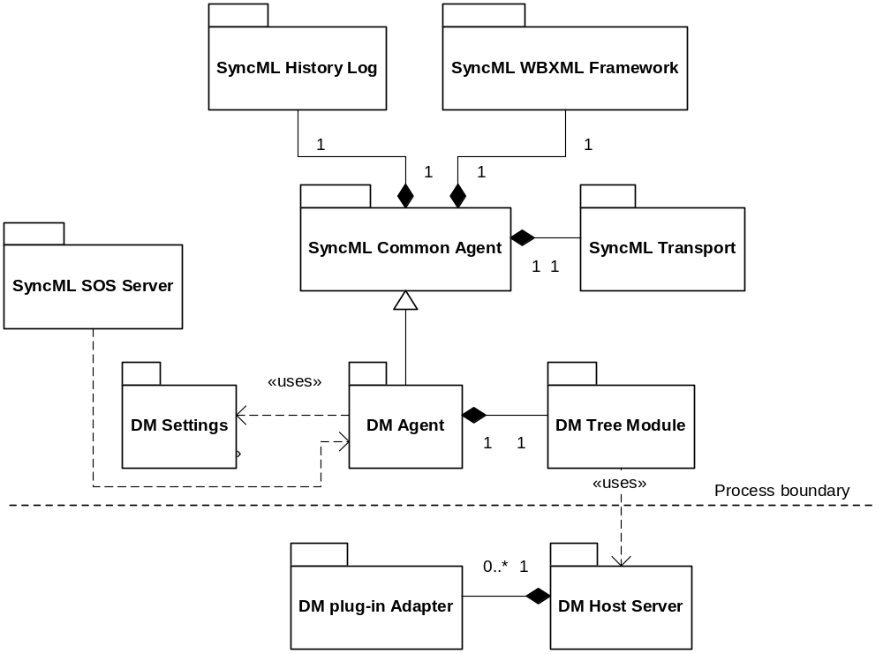
Figure 2.1 DM Agent component environment

Use cases
DM Agent can be used to start DM sessions. By default, parameters are defined in Device Management Settings Database. Alternatively, the transport ID can be overridden, when the different internet access point is used in case of remote configuration.

Services required

From the Symbian OS subsystems
Services of Symbian OS infrastructure are required.

API | Description
Central Repository | Central Repository is needed to provide Device Management Configuration API
Feature Manager | Feature Manager is used for inquiring whether DM FOTA is supported
Notifier | RNotifier is used to query the user whether or not to accept a certificate.

From the Domestic OS subsystems
This component does not have any direct interfaces to the Domestic OS side subsystems.

From HW
This component has no direct HW interfaces.

Services provided

UI
This component does not provide any UI.

SW IF
The DM Agent component provides a method to start a Device Management session with a remote or a local server.

Provided Service | Description | Protected
Start DM session | Device management session is started via DM Agent. | No
Device Management Configuration API | Central Repository Keys used to configure behavior of DM Agent (see Section 6.2.2 ). | Yes

UI control hierarchy
The component does not contain any UI or UI controls.

Design

Class diagrams
This Chapter introduces the class diagram of the DM Agent component. Also, individual classes are discussed.

Framework
This component does not implement any common framework.

Component
Figure 4.2 illustrates the class diagram of the DM Agent component. Short description of each class is provided in the next section.

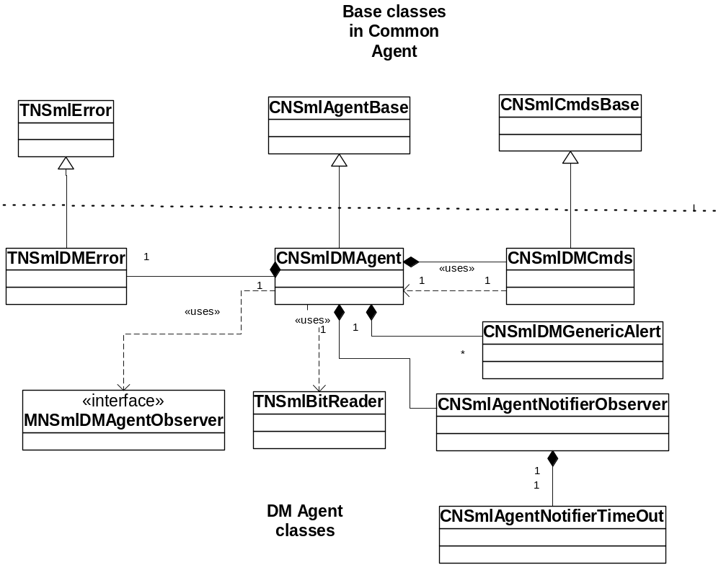
Figure 4.2 DM Agent class diagram

Class descriptions
The DM Agent component contains several classes. These classes are listed and shortly described in the table below. More detailed descriptions can be found from following sections.

Class | Description | Header file
CNSmlDMAgent | Handles DM specific parts of the session flow control. Rest of the session flow control is implemented in CNSmlAgentBase class that resides in the Common Agent component (see reference document [1]). | NSmlDMAgent.h
CNSmlDMCmds | Contains handling of DM specific SyncML commands. Command handling routines shared with the SyncML Data Synchronisation Agent are implemented in the CNSmlCmdsBase class of the Common Agent component (see reference document [1]). | NSmlDMCmds.h
TNSmlDMError | Error code converter. This converts system wide error codes to a smaller subset of errors. | NSmlDMError.h
CNSmlDMGenericAlert | Possesses all the needed fields to generate a generic alert structure to the client init package. | NSmlDMGenericAlert.h
CNSmlAgentNotifierObserver | This active object class is used to query the user whether or not the session’s certificate should be accepted. This class and its usage is included in builds only if __POLICY_MANAGEMENT is defined. | NSmlDMAgent.h
CNSmlAgentNotifierTimeOut | Timeout notifier (active object) used by CNSmlAgentNotifierObserver. This class and its usage is included in builds only if __POLICY_MANAGEMENT is defined. | NSmlDMAgent.h

CNSmlDMAgent

CNSmlDMAgent | Base class for session flow.
// exported creation
IMPORT_C CNSmlDMAgent* CreateDMAgentL( MSyncMLProgressObserver* aDMObserver ); | Creates the CNSmlDMAgent instance. The only function which is exported in the DLL.
// construction and destruction
static CNSmlDMAgent* NewL( MSyncMLProgressObserver* aObserver = NULL ); | Construction, in internal use, called by CreateDMAgentL() function.
virtual ~CNSmlDMAgent(); | Destructor
void ConstructL( MSyncMLProgressObserver* aObserver ); | Second phase in two-phase construction. Also CNSmlAgentBase::ConstructL() is called inside this function.
CNSmlDMAgent(); | Default constructor (private)
// public interface
virtual void Configure( TRequestStatus& aStatus, TInt aSettingsID,TInt aTransportId,TNSmlSyncInitiation aSyncInitiation=EClientInitiated); | Starts configuration session. aSettingsID is ID for the profile in DM sync settings. aSyncInitiation defines, is the conf session server alerted or client initiated .aTransportId is for overriding the transport ID in DM settings profile.
virtual void SetGenericAlertL ( const TDesC8& aFwMgmtUri, const TDesC8& aMetaType, const TDesC8& aMetaFormat, TInt aFinalResult, const TDesC8& aFwCorrelator ) | Appends a Generic Alert to the internal list. The alert itself is sent in the later phase of the dm session.
// private functions
TBool SupportedAlert( const TDesC8& aAlertCode ) const; | Returns true if alert code is supported by the DM Agent.
void ServerModificationsStateL(); | Calls reset function of the Generic Alert and the Generic User Alert, if those were sent in the client init package and the remote server has not issued an authentication request. The reset functions are called in order to prevent erroneous re-sending of the alerts in next dm session.  Calls ProcessReceivedDataL() until message from a server is processed. At end of the message NextMainStateL() is called.
void ServerModGetCmdStateL( SmlGet_t* aContent ); | Receives server’s Get command, passes Get command’s content to CNSmlCmds instance.
void ServerModStartAtomicStateL( SmlAtomic_t* aContent ); | Receives server’s Atomic command, passes Atomic command’s content to CNSmlCmds instance. Controls that nested Atomic commands are not handled.
void ServerModEndAtomicStateL(); | Receives server’s end of Atomic element, passes end of Atomic to CNSmlCmds instance.
void ServerModStartSequenceStateL( SmlSequence_t* aContent ); | Receives server’s Sequence command, passes Sequence command’s content to CNSmlCmds instance.
void ServerModEndSequenceStateL(); | Receives server’s end of Sequence element, passes end of Sequence to CNSmlCmds instance.
void FinishingStateL(); | Calls the FinishL() function.
void ReadSettingsL(); | Reads data from DM Settings with given profile ID.
void InitSyncLogL(); | Initialization of Sync Log.
TInt GetSessionIDL(); | Reads last used session ID from DM settings
void UpdateSessionIDL( TInt aSessionIDL ); | Updates given session ID to DM settings.
void FinishL(); | Observes EDisconnecting state. Calls User::RequestComplete() with caller’s status.
TBool InterruptedImmediately();
TBool CheckCertificateL(); | If certificate checking is enforced, fetches the certificate from Central Repository and returns should the connection be continued or not. This method is included in builds only if __POLICY_MANAGEMENT is defined.
void UserConfirmateConnection(): | Sends user confirmation notification using CNSmlAgentNotifierObserver. This method is included in builds only if __POLICY_MANAGEMENT is defined.
void CheckForcedCertificateCheckStateL (); | Fetches whether or not certificate checking is enforced from Central Repository. This method is included in builds only if __POLICY_MANAGEMENT is defined.
//from MWBXMLSyncMLCallbacks | SyncML parser callbacks
Ret_t smlAlertCmdFuncL( SmlAlertPtr_t aContent); | Alert code check. Passes Alert command’s content to CNSmlCmdsBase::ServerAlertNextAlertCmdStateL() or CNSmlCmdsBase::ServerModAlertCmdStateL() function depending on the current state.
Ret_t smlExecCmdFuncL( SmlExecPtr_t aContent ); | Passes Exec command’s content to ServerModUpdatesStateL () function. The current state must be EServerModifications.
Ret_t smlCopyCmdFuncL( SmlCopyPtr_t aContent ); | Passes Copy command’s content to ServerModUpdatesStateL() function. The current state must be EServerModifications.
Ret_t smlGetCmdFuncL( SmlGetPtr_t aContent ); | Passes Get command’s content to ServerModGetCmdStateL() function. The current state must be EServerModifications.
Ret_t smlPutCmdFuncL( SmlPutPtr_t aContent ); | Put command is not processed. CNSmlCmdsBase:: StatusToUnsupportedCommandL() is called.
Ret_t smlResultsCmdFuncL( SmlResultsPtr_t aContent ); | Results command is not processed. CNSmlCmdsBase:: StatusToUnsupportedCommandL() is called.
Ret_t smlStatusCmdFuncL( SmlStatusPtr_t aContent ); | Passes Status command’s content to CNSmlCmdsBase::ServerModStatusCmdStateL () or CNSmlCmdsBase::ServerModAlertCmdStateL() function depending on the current state.
Ret_t smlStartMessageFuncL( SmlSyncHdrPtr_t aContent ); | Passes SyncHdr command’s content to CNSmlCmdsBase:: ServerModStartMessageStateL () or CNSmlCmdsBase:: ServerAlertNextStartMessageStateL () function depending on the current state.
Ret_t smlEndMessageFuncL( Boolean_t final ); | Calls ServerModEndMessageStateL or ServerAlertNextEndMessageStateL.
Ret_t smlStartSyncFuncL( SmlSyncPtr_t aContent ); | Sync command is not processed. CNSmlCmdsBase:: StatusToUnsupportedCommandL() is called.
Ret_t smlEndSyncFuncL(); | End of Sync flag is not processed.
Ret_t smlStartAtomicFuncL( SmlAtomicPtr_t aContent ); | Passes Atomic command’s content to the ServerModStartAtomicStateL() function. The current state must be EServerModifications.
Ret_t smlEndAtomicFuncL(); | ServerModEndAtomicStateL() function is called;
Ret_t smlStartSequenceFuncL( SmlSequencePtr_t aContent ); | Passes Sequence command’s content to ServerModStartSequenceStateL() function. The current state must be EServerModifications.
Ret_t smlEndSequenceFuncL(); | ServerModEndSequenceStateL() function is called.
//from CNSmlAgentBase
void NavigateMainStateL(); | Switching to a function depending on the current state. This function is often called (from Runl()), because asynchronous conf session is performed in chunks().
void NextMainStateL(); | This function changes the current main state. The current state and some flags determine the next state. Also InitialiseSubStates() is called;
void InitialiseSubStates(); | Set sub-states to their init value.
void BeginStateL(); | The first state function called by CNSmlAgentBase. Sync Log initiation and conf settings reading functions are called. In case of server alerting ParseTriggerMessageL() is called. Sub state is changed to EBeginConnectingToServer. Next state is implemented in the base class.
InitStartingMessageStateL(); | There is not specific implementation. Only CNSmlAgentBase::InitStartingMessageStateBaseL() function is called;
void InitAlertingStateL(); | If conf session has not been interrupted, Alert code is set (server alert or client initiated) and CNSmlDMCmds::DoAlertL() function is called. Additionally checks if there is a need to send a Generic Alert and/or a Generic User Alert.
void InitDeviceInfoStateL(); | If conf session has not been interrupted CNSmlDMCmds::DoAddOrReplaceOrDelete() function is called.
void ServerModUpdatesStateL( const TDesC8& aCmd, SmlGenericCmd_t* aContent ); | If sub-state is EServerModWaitingCommands, CNSmlDMCmds::ProcessUpdates() function is called, command parameter(Add, Replace, Delete) and content are passed.
void ServerModUpdatesStateL( SmlExec_t* aContent ) | Issues a process request for the arrived exec command.
void DataUpdateStatusStartingMessageStateL(); | There is not specific implementation. Only CNSmlAgentBase:: DataUpdateStatusStartingMessageStateBaseL() function is called;
void DataUpdateStatusMakingResultsStateL(); | If there are any Results in the buffer iStatusPackage switch is set to true. CNSmlDMCmds::DoResults() function is called. If all Results did not fit to a message, iBufferFull switch is set to true.
HBufC* NonceL() const; | Nonce value (which client use and was received in server’s challenge) is read from DM settings.
void SetNonceL( const TDesC& aNonce ) const; | Nonce value (which client use and was received in server’s challenge) is updated to DM settings.
TPtrC ServerUserName() const; | Server ID is returned from an attribute.
TPtrC ServerPassword() const; | Server password is returned from an attribute.
HBufC* ServerNonceAllocL()const; | Nonce value (which the server uses and was sent to aserver by the client) is read from DM settings.
void SetServerNonceL( const TDesC& aNonce ) const; | Nonce value (which the server uses and was sent to aserver by the client) is updated to DM settings.
void FinalizeSyncLog(); | The current time is set to end time in Sync Log.
void CreateSyncmlCmdsInstanceL(); | An instance of CNSmlDMCmds class is created and initiated.
void CheckCommandsAreReceivedL(); | Empty implementation.
void SetAuthTypeL( CNSmlAgentBase::TAuthenticationType aAuthType ) const; | Authentication type (Basic, MD5) is updated to DM settings.
CNSmlAgentBase::TAuthenticationType AuthTypeL() const; | Authentication type (Basic, MD5) is read from DM settings.
void FreeResources(); | All resources allocated by the class are released.
void FinaliseWhenErrorL(); | Empty implementation.
TBool Interrupted(); | Returns iDMInterrupted flag value.
void Interrupt( TInt aErrorCode, TBool aImmediatelyInterruption, TBool aStatusError ); | Writes error message to Sync Log. Set iDMInterrupted to true. Set iSessionAbortAlertRequest to true, that abort Alert will be written in the client’s message.
void InterruptL( TInt appIndex, TInt aErrorCode, TBool aImmediatelyInterruption, TBool aStatusError ); | Calls the Interrupt() function without the appIndex parameter (see above). There are some routines in Common Agent when session level interruption is done by this function with -1 value in appIndex.
void WriteWarningL( TNSmlError::TNSmlAgentErrorCode aWarningCode ); | Adds informational message to Sync Log.
void WriteWarningL( TInt appIndex, TNSmlError::TNSmlAgentErrorCode aWarningCode ); | WriteWarningL() function without the appIndex parameter (see above). There are some routines in Common Agent when session level interruption is done by this function with -1 value in appIndex.
void WriteWarningL( TInt appIndex, TNSmlError::TNSmlSyncMLStatusCode aWarningCode ); | Same functionality than in the function above. TNSmlSyncMLStatusCode type is cast to TNSmlAgentErrorCode type.
void CheckServerStatusCodeL( TInt aEntryID ); | Handling of Status element from a server. Status codes 212, 401 and 407 which are related to an authentication are processed. CNSmlAgentBase:: AuthenticationRequirementL() function (which includes challenge handling) is called. Also possible nonce from a server is stored with SaveIfNonceL() function.

CNSmlDMAgent controls the DM session flow. The class contains state machine for controlling session. The states are grouped to main states and sub-states. The main state chart is in Figure 4.3. The functionality inside states is described in Section 4.3.

CNSmlDMCmds

CNSmlDMCmds
// construction and destruction
static CNSmlDMCmds* NewL( CNSmlAgentBase* aAgent, const TDesC8& aSessionID, const TDesC8& aVerProto, const HBufC& aSyncMLUserName, CNSmlURI* aSyncServer, const TDesC& aDMServerId, MSyncMLProgressObserver* aDMObserver ); | Static construction. Creates new instance and calls ConstructL() function.
void ConstructL( CNSmlAgentBase* aAgent, const TDesC8& aSessionID, const TDesC8& aVerProto, const HBufC& aSyncMLUserName, CNSmlURI* aSyncServer, const TDesC& aDMServerId, MSyncMLProgressObserver* aDMObserver ); | Second phase in two-phase construction. iDMServerID is allocated from a parameter and pointer of DM observer is set. Other parameters are passed to base class calling CNSmlCmdsBase::ConstructL() function.  Asks from the FeatureManager if the SyncML FOTA feature is supported by the platform. If it is, opens the Central Repository object with the KDevManClientInitiatedFwUpdateId key.
~CNSmlDMCmds(); | Destruction.
// private new functions
void DoDevInfoItemsL( const TDesC& aURISegment ); | Recursive called function, which asks DevInfo items from DevInfo adapter through DM Tree Module. The leaf objects of DevInfo are written as Item elements in the data structure of Replace command.
void FreeDMDevinfo(); | Releases allocated data in structure used generating DevInfo.
TInt AlertParameter ( const SmlPcdata_t* aData, const TDesC8& aParamID ) const; | Parses minimal or maximum duration time for display or confirmation Alert from PCDATA structure. The function returns duration time as integer value.
HBufC8* AlertDataLC( const SmlItemList_t* aItemList ) const; | Takes data of second item from SmlItemList_t* and makes UNICODE conversion for the data.
TInt InitStatusToAtomicOrSequenceL( const TDesC8& aCmd, SmlAtomic_t* aAtomic ) const; | Initiates Status command to Status buffer.
// from CNSmlCmdsBase
void DoAlertL( const TDesC8& aAlertCode, TTime* aLastSyncAnchor = NULL, TTime* aNextSyncAnchor = NULL ); | Builds structure for initialization Alert command and calls SyncML generator.
void DoPutL(); | Empty implementation.
CNSmlCmdsBase::TReturnValue DoResultsL(); | Reads Results commands from buffer, adds cmdID element to them and calls SyncML generator.
void DoGetL(); | Empty implementation.
CNSmlCmdsBase::TReturnValue DoStartSyncL(); | Empty implementation.
void DoEndSyncL(); | Empty implementation.
CNSmlCmdsBase::TReturnValue DoAddOrReplaceOrDeleteL(); | Builds structure for Replace command. Calls DoDevInfoItemsL() function, which generates Device Info data. Calls SyncML generator.
CNSmlCmdsBase::TReturnValue DoMapL(); | Empty implementation.
TReturnValue DoReplaceOrDeleteL(); | Empty implementation.
void ProcessResultsCmdL( SmlResults_t* aResults ); | Empty implementation.
void ProcessPutCmdL( SmlPut_t* aPut ); | Empty implementation.
void ProcessGetCmdL( SmlGet_t* aGet ); | Handles Get command from a server. Initializes Results command for GET in the buffer. Get command is passed to DM Tree Module.
void ProcessAlertCmdL( SmlAlert_t* aAlert, TBool aNextAlert = EFalse, TBool aServerAlert = EFalse, TBool aDisplayAlert = EFalse ); | Handles Alert command from a server. DM observer is called if display or confirmation alert.
void ProcessSyncL( SmlSync_t* aSync ); | Empty implementation.
void ProcessUpdatesL( const TDesC8& aCmd, SmlGenericCmd_t* aContent ); | Handles Add, Replace, Delete and Copy commands from a server. Commands are passed to DM Tree Module.
void ProcessAtomicL( SmlAtomic_t* aAtomic ); | Handles Atomic command from a server.
void ProcessEndAtomicL(); | Handles end of Atomic element from a server.
void ProcessSequenceL( SmlSequence_t* aSequence ); | Handles Sequence command from a server.
void ProcessEndSequence(); | Handles end Sequence element from a server.
void ProcessEndSyncL(); | Generates end tag of SyncML element, SyncML generator is called.
void ProcessExecCmdL ( SmlExec_t* aExec ) | Process the exec structure sent by the remote server.
void DoGenericAlertL ( const TDesC8& aFwMgmtUri, const TDesC8& aMetaType, const TDesC8& aMetaFormat, TInt aFinalResult, const TDesC8& aFwCorrelator ) | Makes a generic alert element and calls WBXML generator.
TBool DoGenericUserAlertL ( TInt aProfileId ) | Makes a generic user alert element, if the correct update request can be found from the central repository for KDevManClientInitiatedFwUpdateId key.
void ResetGenericUserAlertL() | Resets the update request in the central repository by writing '-1' value.
void MarkGenAlertsSentL() | When the generic alerts are successfully sent to the remote server, DM Plug-in Adapter needs to be informed about this. This command is chained through the DM engine.
void DisconnectFromOtherServers() | Closes the connections to callback server and host servers. Separate function is needed, since the disconnecting cannot be made after the active scheduler of the thread is stopped.
void DoEndMessageL( TBool aFinal ); | Generates end tag of SyncML element and possible final flag in SyncBody
void EndOfServerMessageL() const; | Indicates DM Tree module about the message ending.
//from MNSmlDmModuleCallBack
void SetResultsL( TInt aResultsRef, const CBufBase& aObject, const TDesC8& aType, const TDesC8& aFormat, TInt aTotalSize); | This callback function is called by DM Tree module. Results for Get command from a server are added to Results buffer. Results for Device Info are added to TDMDevInfo structure.
void SetStatusL( TInt aStatusRef, TInt aStatusCode ); | This callback function is called by DM Tree module. Status code is set for Status element in the buffer.

TNSmlDMError

TNSmlDMError | Description
// construction and destruction
TNSmlDMError() | C++ constructor.
~TNSmlDMError() | Destructor.
// public methods
TInt SyncLogMessageCode() | Converts a system-wide error code to a smaller subset of error codes.
TInt SyncLogErrorCode() | Returns the non-converted error code.

CNSmlDMGenericAlert

CNSmlDMGenericAlert | Description
// construction and destruction
static CNSmlDMGenericAlert* NewL ( const TDesC8& aFwMgmtUri, const TDesC8& aMetaType, const TDesC8& aMetaFormat, TInt aFinalResult, const TDesC8& aFwCorrelator ) | Creates a new generic alert object.  - - aFwMgmtUri. The URI that has been used in the EXE command whose final result is about to be reported.  - - aMetaType. Meta/Type that should be used in the alert.  - - aMetaFormat. Meta/Format that should be used in the alert.  - - aFinalResult. The final result value which is reported to remote server.  - - aCorrelator. Correlator value used in the original exec command.
void ConstructL ( const TDesC8& aFwMgmtUri, const TDesC8& aMetaType, const TDesC8& aMetaFormat, TInt aFinalResult, const TDesC8& aFwCorrelator ) | Symbian 2nd phase constructor.
~CNSmlDMGenericAlert() | C++ destructor.
// public methods
inline HBufC8* FwMgmtUri() const | Inline function to retrieve a firmware management URI.
inline HBufC8* MetaType() const | Inline function to retrieve a meta type. E.g. org.openmobilealliance.firmwareupdate.update.
inline HBufC8* MetaFormat() const | Inline function to retrieve a meta format. E.g. "text/plain".
inline HBufC8* FwCorrelator() const | Inline function to retrieve a correlator of the exec command.
inline TInt FinalResult() const | Inline function to retrieve a final result.

CNSmlAgentNotifierObserver

CNSmlAgentNotifierObserver | Description
// construction and destruction
CNSmlAgentNotifierObserver( TRequestStatus& aStatus, TInt aCreatorId ); | Constructor. Adds this object to CActiveScheduler.
~CNSmlAgentNotifierObserver(); | Destructor. Closes notifier (RNotifier) and timeout object (CNSmlAgentNotifierTimeOut).
// public methods
void ConnectToNotifierL( CNSmlAgentBase * aNSmlAgentBase); | Connects to notifier and start timeout object..
void NotifierTimeOut(); | Called by CNSmlAgentNotifierTimeOut, when timeout has occurred. Cancels notifier.
// protected methods
void DoCancel(); | Empty implementation.
void RunL(); | Handles return values from notifier.

CNSmlAgentNotifierTimeOut

CNSmlAgentNotifierTimeOut | Description
// construction and destruction
CNSmlAgentNotifierTimeOut(); | Constructor. Adds this object to CActiveScheduler.
~CNSmlAgentNotifierTimeOut(); | Destructor.
// public methods
void LaunchNotifierTimer( CNSmlAgentNotifierObserver* aObserver ); | Starts timer (RTimer).
// protected methods
void DoCancel(); | Cancels timer.
void RunL(); | If iStatus is not KErrCancel, calls CNSmlAgentNotifierObserver:: NotifierTimeOut().

Structs, type definitions and enumerations

Enumeration’s name | Description
TNSmlDMAgentErrorCode | Synchronization session error codes.

NSmlDMError.h

Enumeration: TNSmlDMAgentErrorCode | Description
ESmlServerSessionAbort | Abort session

NSmlDMAgConstants.h

Constants | Description
_LIT8( KNSmlDMAgentServerInitAlert, "1200" ); | Server init alert code.
_LIT8( KNSmlDMAgentClientInitAlert, "1201" ); | Client init alert code.
_LIT8( KNSmlDMAgentResultAlert, "1221" ); | Result alert code.
_LIT8( KNSmlDMAgentNextMessage, "1222" ); | Next message alert code.
_LIT8( KNSmlDMAgentSessionAbortAlert, "1223" ); | Session abort alert code.
_LIT8( KNSmlDMAgentGenericAlert, "1226" ) | Generic alert code.
_LIT8( KNSmlDMAgentDisplayAlert, "1100" ); | Display alert code.
_LIT8( KNSmlDMAgentContinueOrAbortAlert, "1101" ); | Continue or abort alert code.
_LIT8( KNSmlDMAgentVerProto, "DM/1.1" ); | DM protocol version.
_LIT8( KNSmlDMAgentMIMEType, "application/vnd.syncml.dm+wbxml" ); | DM MIME type.
_LIT8( KNSmlDMAgentMINDT, "MINDT=" ); | MINDT definition.
_LIT8( KNSmlDMAgentMAXDT, "MAXDT=" ); | MAXDT definition.

Flag definitions
The following flags are used by the component.

Flag | Description
__NSML_DEBUG__ | Used to dump debug text into file. Flag is defined in common\inc\nsmldefines.h.
__POLICY_MANAGEMENT | If defined, settings enforcement is applied.

State diagrams
CNSmlDMAgent controls the DM session flow. The class contains state machine for controlling session. The states are grouped to main states and sub-states. The main state chart is in Figure 4.3 The functionality inside states is described in Section 4.3.
If the Beginning state has been completed without errors next state is Client Initialization, in case of error(s) Finishing state is performed. Next state after Client initialization is always the Sending state. After the Sending state is the Receiving state unless session is interrupted by client when control moves to the Finishing state. After the Receiving state follows the Server Modifications state if the client has sent complete package with Final element. If the client has not sent a complete package, the Server Next Alerting State is performed. After the Server Modifications state typically follows the Data Update Status state. If the server has challenged authentication credentials, the control returns to the Client Initialization state. If the server has sent an incomplete package without the final element, the next state is Client Next Alerting. If there is a busy status in SyncHdr, the next state is Result Alerting. After the Data Update Status state, the next state is Finishing if there is only Status to SyncHdr to send, otherwise conf session continues, and the next state is Sending.
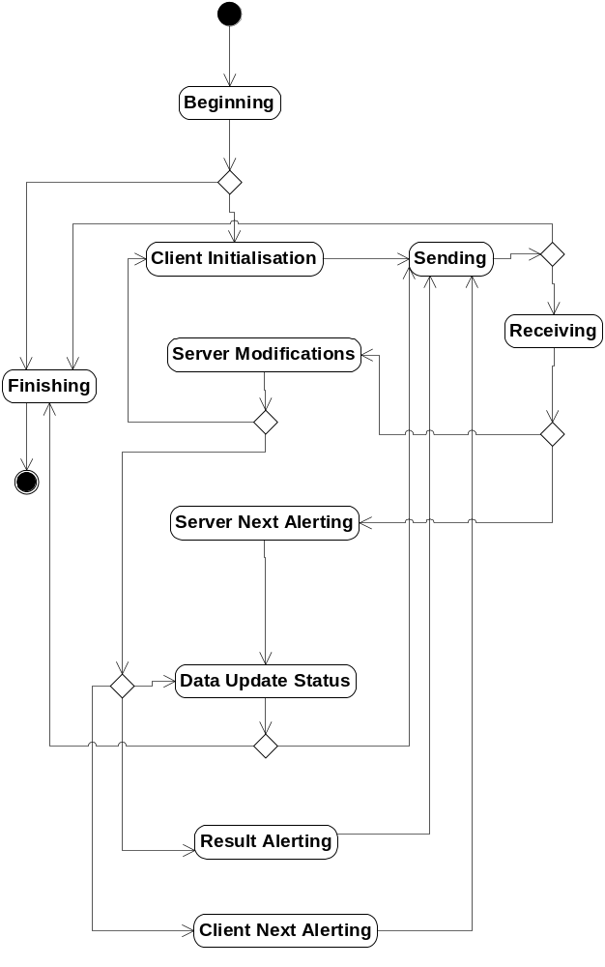
Figure 4.3 A state machine describing the run-time behavior of DM Agent

Operations

Beginning

Operation | Beginning of configuration session.
Preconditions | The conf session has been launched by Server Alert push message or by the user.
Description | Sync Log is initiated. If session is alerted by the server SyncML notification (Package 0) (see reference document [6]) is parsed. Settings are read by given profile ID. The instance of CNSmlCmds is created. The connection to the server is performed; this is implemented in Common Agent module. If __POLICY_MANAGEMENT is set, it is checked from Central Repository whether or not certificate checking is currently enforced. This information is used later in “sending” state.
Inputs | Parameters which are passed within CNSmlDMAgent::ConfigureL() function.
Modifies
Outputs
Postconditions | Needed initialization has been performed. Configuration session with the server is able to begin.
Related To
Related Event
Exceptions

Client initialization

Operation | Generating Initialization package (Package 1).
Preconditions | Beginning state has been completed successfully.
Description | Package 1: Initialization from client to server (see reference document [3]) is constructed. SyncHdr is generated in Common Agent. Initialization Alert and Replace command for DevInfo generations are implemented in this module.
Inputs | Sync Settings, DevInfo data from DM DevInfo Adapter through DM Tree module.
Modifies
Outputs | Package 1.
Postconditions | Package 1 is ready to send to the server.
Related To
Related Event
Exceptions

Server modifications

Operation | Processing of package from the server.
Preconditions | Receiving state has been completed successfully.
Description | Processing Package 2: Initialization from server to client or Package 4: Further server management operations (see reference document [3]).
Inputs | Package 2 or Package 4 from the server. SyncHdr is processed in Common Agent module. Other commands (Alert, Get, Atomic Sequence, Delete, Replace, Exec, Copy and Add) are handled in this module. Get, Add, Replace, Exec, Copy and Delete commands are passed to DM Tree module. UI alert commands are passed to RNotifier plug-in which shows them in UI. Status and Results commands are generated and buffered.
Modifies | No direct modifications to settings in this module. Management operations are passed to responsible adapters through DM Tree module.
Outputs | The buffers for Status and Results commands to the server, which are implemented in CNSmlStatusContainer and CNSmlResultsContainer in Common Agent.
Postconditions | Package 2 or 4 has been handled, ready to move to the next state.
Related To
Related Event
Exceptions

Data update status

Operation | Generating client’s response package (Package 3).
Preconditions | Server Modification state or Server Next Alerting state has been completed.
Description | Package 3: Client response sent to a server (see reference document [3]) is constructed. SyncHdr is generated in Common Agent. Already buffered Status and Results commands are generated.
Inputs | Instances of CNSmlStatusContainer and CNSmlResultsContainer.
Modifies
Outputs | Package 3.
Postconditions | Package 3 is ready to send to the server.
Related To
Related Event
Exceptions

Client next alerting

Operation | Generating one message of client’s response package (Package 3) with next alerting.
Preconditions | Server Modification state has been completed. Server has sent incomplete package without Final element.
Description | A message of Package 3: Client response sent to a server (see reference document [3]) is constructed. SyncHdr is generated in Common Agent. Already buffered Status and Results commands are generated. Next Alert is generated, see chapter Multiple Messages in Package in SyncML Sync Protocol (see reference document [10]).
Inputs | Status and Results buffers in instances of CNSmlStatusContainer and CNSmlResultsContainer.
Modifies
Outputs | A message of Package 3 including next Alert command.
Postconditions | A message of Package 3 is ready to send to the server.
Related To
Related Event
Exceptions

Server next alerting

Operation | Handling next alerting message in server’s package.
Preconditions | Receiving state has been completed successfully. Client’s last message to the server has been incomplete without Final element.
Description | Next alert message from as server is handled. See chapter Multiple Messages in Package in SyncML Sync Protocol (see reference document [10]). The commands are processed in Common Agent module.
Inputs | Next Alert message.
Modifies
Outputs | The buffer for Status commands to the server, which is implemented in CNSmlStatusContainer in Common Agent.
Postconditions | Next Alert message is ready to send to the server.
Related To
Related Event
Exceptions

Result alerting

Operation | Generating Result Alert message.
Preconditions | Server Modification has been completed. Server has sent incomplete package without Final element.
Description | Result Alert from Client message (see Chapter Result Alert from Client Package in reference document [10]) is constructed. The commands are generated in Common Agent module.
Inputs | Status buffer in an instance of CNSmlStatusContainer.
Modifies
Outputs | Result Alert message.
Postconditions | Result Alert message is ready to send to the server.
Related To
Related Event
Exceptions

Sending

Operation | Sending message.
Preconditions | Client Initialization, Data Update Status, Result Alerting or Client Next Alerting state has been completed.
Description | If __POLICY_MANAGEMENT is set and certificate checking is enforced, session’s certificate is first checked (only before first message). SyncML message is sent to the server. Common Agent module passes message to transport module.
Inputs | Generated SyncML message in WBXML format.
Modifies
Outputs | Generated SyncML message in WBXML format
Postconditions | SyncML message has been sent to the server.
Related To
Related Event
Exceptions

Receiving

Operation | Receiving message.
Preconditions | Sending state has been completed successfully.
Description | SyncML message is received from the server. Common Agent module gets received message from transport module.
Inputs | Received SyncML message in WBXML format.
Modifies
Outputs
Postconditions | SyncML message has been received from to the server.
Related To
Related Event
Exceptions

Finishing

Operation | Finishing the configuration session.
Preconditions | There were no more management commands from the server or session has interrupted with error.
Description | Notifies “disconnecting” with MSyncMLProgressObserver. User::RequestComplete() function is called.
Inputs
Modifies
Outputs
Postconditions | Session has been completed (or interrupted). DM Agent is ready for destruction. Control returns to RunL() function of calling active object.
Related To
Related Event
Exceptions

Sending large object

Operation | Sending large object
Preconditions | A response to Get command (Result) does not fit to one message.
Description | When the server has made a Get request and the response Result does not fit to one message, it is sent in multiple messages. The CNSmlDmCmds object gets the data from DM Tree module in SetResultsL function, where the data chunk and total size of data is provided. The CNSmlDmCmds object makes new result element and if there is still room in workspace, the object gets more data from DM Tree Module by calling MoreDataL(). This is done in loop as long as workspace buffer is full or all the data is got. If the workspace buffer is got full before getting all the data. The buffer is truncated and the rest of data is left to next message. When creating the next message, the truncated data is set first to workspace buffer, and the reading data from DM Tree Module is continued.
Inputs
Modifies
Outputs
Postconditions | All the data is read via DM Tree Module and sent to DM server.
Related To
Related Event
Exceptions

Receiving large object

Operation | Receiving large object.
Preconditions | Server sends an object, which does not fit to one message
Description | Server sends Add, Replace or Exec command, which contains large data object, which comes in multiple messages. The object is given to DM tree Module in parts, i.e. every time when new message arrives, AddObjectL, UpdateObjectL or ExecuteObjectL of DM Tree Module is called and it is also informed if more data is coming. When the message with final flag arrives, the DM Tree Module is informed that this is the last data chunk in this object.
Inputs
Modifies
Outputs
Postconditions | All the data received from DM server and provided to correct place via DM Tree Module.
Related To
Related Event
Exceptions

Adding and resetting Generic Alert

Operation | Generic Alert is added to the Client init package. After successful sending of this alert to remote server, the dm plug-in adapter is requested to mark this alert sent.
Preconditions | The dm plug-in adapter notices that there is unreported status which must be sent to remote server using Generic Alert. The adapter uses Private API to issue Generic Alert parameters to SOS Server. The SOS Server calls SetGenericAlertL function of DM Agent.
Description | SetGenericAlertL function creates a Generic Alert object and adds it to the internal list. List structure is used, so that DM Agent is able to insert many generic alerts to one SyncML message.  When composing the Client init package, DM Agent checks if there are generic alerts to be sent. If yes, DM Agent calls WBXML generator to insert these structures.  Resetting Generic Alert is done in the dm plug-in adapter. However, DM Agent is the originator for issuing an acknowledge call (via intermediary modules) to the adapter when the following conditions are met:  - Client has sent one or more generic alerts in the client init package.  - Response from remote server is got without problems.  - Remote server has authenticated the client without problems.
Inputs | For adding Generic Alert: the input is SetGenericAlertL function with parameters:  - - aFwMgmtUri. The URI which has been used in the exe command whose final result is about to be reported.  - - aMetaType. Meta/Type that should be used in the alert  - - aMetaFormat. Meta/Format that should be used in the alert.  - - aFinalResult. The final result value which is reported to remote server.  - - aCorrelator. Correlator value used in the original exec command.  For resetting Generic Alert: the input is ServerModificationsStateL function with the preconditions described above.
Modifies | Adding inserts Generic Alert first to the internal list (member variable) and later to the actual WBXML package (SyncML Client init package).  Resetting modifies only one Boolean type variable in DM Agent.
Outputs | Adding: Generic Alert -command is added to the WBXML -package.  Resetting: Calls the dm plug-in adapter (via intermediary modules) to reset generic alert.
Postconditions
Related To
Related Event
Exceptions | The normal leave mechanism of Symbian OS is used for exception handling. If the communication error prevents Generic Alert sending, the reset function of dm plug-in adapter is not called, and accordingly the unsent generic alert is included in next established DM session to the client init package.

Adding and resetting Generic User Alert

Operation | Generic User Alert is added to the client init package. After successful sending of this alert to remote server, the request is reset.
Preconditions | The central repository is used for activating a request for Client Initiated Firmware Update. When it is activated the actual value in the central repository shows Device Management profile id corresponding the device management server where firmware update request should be sent.  The central repository is opened with the internal key of device management, KCRUidDeviceManagementInternalKeys (this can be found using the API ‘Device Management Configuration API’) only if the static feature FOTA is defined in the platform. In other words, provided the FOTA feature is not defined in the platform, the Generic User Alert is not sent even though the request is activated in the central repository.
Description | DoGenericUserAlertL function makes the alert structure and calls WBXML generator if the correct firmware update request is present in the central repository. The value is read using the key KDevManClientInitiatedFwUpdateId. The word ‘correct’ means that the value read from Central Repository must be equal to the currently active profile Id. The default value, -1 means that there are no update requests for any remote server.  Resetting the Generic User Alert in DM Agent is done by writing the default value (= -1) to Central Repository. The actual moment when this reset is done is exactly the same as for Generic Alert (see Section ).
Inputs | For adding Generic User Alert: the input is DoGenericUserAlertL function with parameter:  - aProfileId. The profile ID of the current DM session.  Other parameters are not needed, since the content of the Generic User Alert is predefined (example in reference document [14]).  For resetting Generic Alert: the input is ServerModificationsStateL function with the preconditions described in Section .
Modifies | Adding inserts Generic User Alert to the actual WBXML package (SyncML client init package).  Resetting modifies one integer value in the central repository.
Outputs | Adding: Generic User Alert -command is added to the WBXML -package.  Resetting: Writes a default value to the central repository.
Postconditions
Related To | 4.3.13.
Related Event
Exceptions | The normal leave mechanism of Symbian OS is used for exception handling. If the communication error prevents Generic User Alert sending, the update request is not reset in the central repository, and accordingly the unsent Generic User Alert is included in next established dm session to client init package.

Backup and Restore
This component does not participate in backup and restore.

Variation
This component does not support any variation.

System resource usage

Files
This component does not use any files.

Other data

Databases
This component does not use any databases directly. However, both DM Settings database and DM Tree module database are accessed via their corresponding components (see reference documents [11] and [13]).

Central Repository
This module publishes and uses Device Management Configuration API, see reference document [15]. The API is used by this module for Client Initiated Firmware Update, defined by Central Repository key KDevManClientInitiatedFwUpdateId.
When the key is activated the actual value in the central repository shows Device Management profile id corresponding the device management server where firmware update request should be sent. The key is reset (set to default) by DM Agent after request has been successfully sent.
The Client Initiated Firmware Update request is expressed to remote server using Generic User Alert -command. For a detailed description of the command structure, see reference document [14].

Publish and Subscribe
This component does not use Publish and Subscribe.

Memory consumption
DM Agent component’s ROM and user area consumption are listed below.

Memory/Build | Consumption
User data area
WINSCW UDeb | 218292 bytes
ARMV5 | 145524 bytes
Heap size

Task allocation
This component runs in one thread which is the thread used to launch it.

Performance
No special performance issues are handled by this component.

Timers
CNSmlAgentNotifierTimeOut uses a timer for timeout purposes.

Timer | Purpose | Interval | Lifetime
RTimer | Timeout | 5 minutes | Timer starts before notifier service is called, and cancelled if notifier responds.

Security

Capabilities of this component

Capability | Justification
CAP_GENERAL_DLL | Default DLL capabilities defined by the platform.

Input and output validation
The DM Agent component performs validation for both incoming and outgoing protocol elements. DM Agent does not care about the contents of the actual payload i.e. the outgoing data received from DM plug-in adapters is assumed to be valid.
For incoming data more validations are done in order to ensure that the received data conforms with the currently used SyncML Representation and SyncML Sync Protocols both syntactically and semantically. Payload of the received synchronization items is not checked since the DM Agent does not understand how the item data should be encoded. Instead, the received item data is forwarded to the corresponding DM plug-in adapter that is assumed to handle it properly.
Performed validation operations include:
- For each received SyncML command the presence of all mandatory fields is checked. If a required field is missing or does not contain all necessary information then a proper error code is returned and the received command is not handled.
- For each sent SyncML command that requires a Status command in response the arrival of the Status is also checked. If an anticipated Status is not received or the received Status command’s CmdRef field is not correct then the ongoing session is terminated.

Environmental assumptions
This component does not make any assumptions about its environment.

Additional enforcements
This component does not have any additional security enforcements.

Exception handling
Every error that occurs during session causes an event to the MSyncMLProgressObserver:: OnSyncMLSyncError() callback given in the CNSmlDMAgent::NewL() function. This callback is used to inform the DM Agent’s user about the progress of the session. Protocol errors are delivered in SyncML Status messages.
There are two possible error types: fatal and non-fatal errors. If a fatal error occurs then the session is aborted. Otherwise, the error should be considered more like a warning. Fatal error code is also written to the SyncML History Log. Possible error codes are defined in three enumerations: TNSmlDMAgentErrorCode enumeration in addition to TNSmlSyncMLStatusCode and TNSmlAgentErrorCode enumerations from the Common Agent component (see reference document [1]).
If the management session is completed without leave errors the TRequestStatus given in the CNSmlDMAgent::Configure() function call will be signaled by this component. Possible statuses are described in following table.

Exception | Description
KErrNone | Session was completed without errors.
KErrGeneral | Session was aborted.

The handling of leave errors is implemented in the Common Agent component. For more information about leave errors, see reference document [1].

Usage

Building
The DM Agent module is built as any other module in the system. This component resides in the dm\syncagent directory under the SyncML component. As a result, the nsmldmagent.dll library is created.

User's guide
DM Agent is used by Client API.

