S60 3.1
SyncML Device Management
DevDetail Adapter
Design Document

Team name | Author
Core BS Synch & Provisioning | Tiina Vuoniemi

Change history:

Version | Date | Status | Comments
1.0 | 13.04.2006 | Approved
0.1 | 15.1.2005 | draft | Initial draft
0.2 | 21.06.2005 | draft | SwV and HwV changes.
0.3 | 30.06.2005 | draft | Inspection changes.
0.4 | 05.09.2005 | draft | Removed threat analysis and changed EInfo usage to SysUtil usage.

Table of contents:

1. Document control 5
1.1 References 5
1.2 Documentation conventions 5
1.3 Abbreviations 5
2. General 6
2.1 Introduction 6
2.2 Component environment 6
2.3 Use cases 7
2.4 Services required 7
2.4.1 From the Symbian OS subsystems 7
2.4.2 From the Domestic OS subsystems 8
2.4.3 From HW 8
2.5 Services provided 8
2.5.1 UI 8
2.5.2 SW IF 8
3. UI control hierarchy 9
4. Design 10
4.1 Class diagrams 10
4.1.1 Framework 10
4.1.2 Component 10
4.2 Class descriptions 10
4.2.1 CNSmlDevDetailAdapter 11
4.2.2 Structs, type definitions and enumerations 12
4.2.2.1 nsmldmdevdetailadapter.h 13
4.2.3 Flag definitions 13
4.2.4 State diagrams 13
4.3 Operations 13
4.3.1 Filling the DDF structure 13
4.3.2 Adding DevDetail settings 14
4.3.3 Updating a settings value 15
4.3.4 Deleting the settings 15
4.3.5 Copying a settings value 16
4.3.6 Executing a command 16
4.3.7 Fetching a settings value 17
4.4 Backup and Restore 17
5. Variation 18
6. System resource usage 19
6.1 Files 19
6.2 Other data 20
6.2.1 Databases 20
6.2.2 Central Repository 20
6.2.3 Publish and Subscribe 20
6.3 Memory consumption 20
6.4 Task allocation 20
6.5 Performance 20
6.6 Timers 20
7. Security 21
7.1 Capabilities of this component 21
7.2 Input and output validation 21
7.3 Environmental assumptions 21
7.4 Additional enforcements 21
8. Exception handling 22
9. Usage 23
9.1 Building 23
9.2 User's guide 23

Document control

References

- S60 SyncML How To Implement DM Plug-in Adapter
- SyncML Device Management Standardized Objects, version 1.1 | http://www.openmobilealliance.org/syncml/
- SyncML Device Management Protocol, version 1.1 | http://www.openmobilealliance.org/syncml/

Documentation conventions
The term Device Management DevDetail Adapter is later abbreviated to DevDetail Adapter, or just Adapter. Code is shown with the Courier New font.

Abbreviations

ACL | Access Control List
API | Application Programming Interface
DevDetail | General Device Information. See reference document [2] for further information.
DDF | Device Description Framework
DLL | Dynamic Link Library
DM | Device Management
ECom | Symbian OS plug-in framework
OEM | Original Equipment Manufacturer
OS | Operating system
SyncML | Synchronization Mark-up Language
UID | Unique Identifier
URI | Universal Resource Identifier

General
DevDetail Adapter is a Device Management Plug-in Adapter that retrieves device information of the device from its settings store, and returns it to the Device Management client. The adapter is used by the Device Management client application, and it is loaded via the ECom architecture. The adapter interface is described in reference document [1].
The adapter is used for retrieving the following fields:
- DevTyp - the type of the device.
- OEM - the Original Equipment Manufacturer.
- FwV - the firmware version.
- SwV - the software version.
- HwV - the Hardware version.
- MaxDepth - Specifies the maximum depth of the management tree supported by the device.
- MaxTotLen - Specifies the maximum total length of any URI used to address a management object or management object property.
- MaxSegLen - Specifies the maximum total length of any URI segment in a URI used to address a management object or management object property.
- LrgObj - Specifies whether or not large objects are supported in device management.

Introduction
DevDetail Adapter retrieves general device information of the device. The settings objects and formats are described in specification SyncML Device Management Standardized Objects (see reference document [2]. DevDetail Adapter only supports the Get operations. There is also Add, Replace, Copy, Execute and Delete support in the adapter interface, but in case of device information, they are not used. The SyncML Device Management protocol (see reference document [3]) requires that the DevDetail object is implemented. This means that DevDetail Adapter must always be installed in the device. although it is implemented as a plug-in.

Component environment
The adapter is owned by the Device Management client application and implemented as whole in the CNSmlDmDevDetailAdapter class. The CNSmlDmDevDetailAdapter class is inherited from the CSmlDmAdapter class which implements the MSmlDMCallback interface to Device Management client application. The MSmlDMCallback class is used to return the statuscodes and responses to Device Management client application. The CNSmlPhoneInfo class is needed for retrieving data for the OEM object; see specification SyncML Device Management Standardized Objects (see reference document [2]) for further information on the objects. Sysutil is used to fetch SwV –field information in ARM builds (HwV –field is left empty). In WINS builds the equivalent data is read from DevDetail_SwV.txt and DevDetail_HwV.txt files located in z:\Resource\DevMan. Figure 2.1 shows the dependencies to other modules.
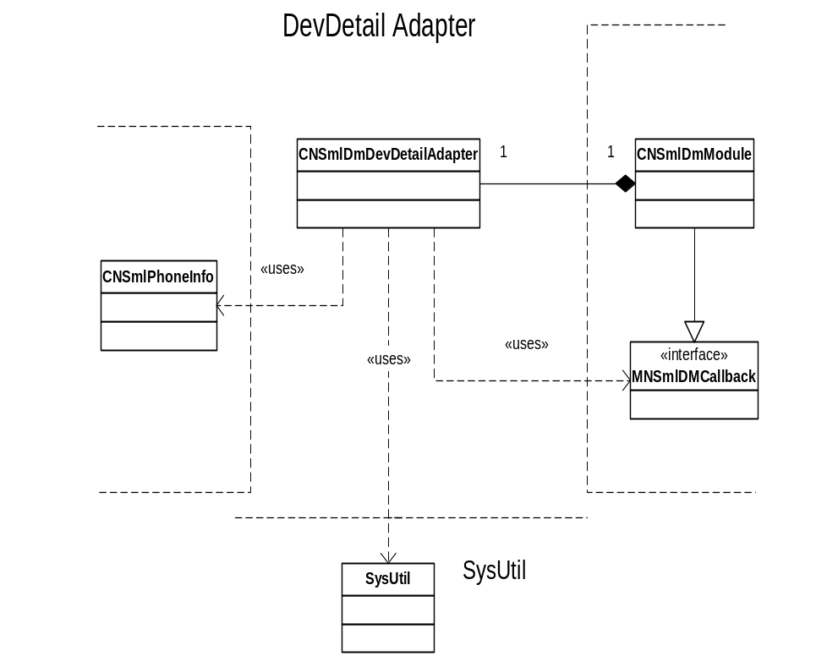
Figure 2.1 Dependencies to other components
The adapter is a Symbian plug-in module, i.e. it is loaded via ECom. For using the adapter, three ECom UIDs must be defined: interface UID, implementation UID and DLL UID. The interface UID is common for all plug-in modules that implement the same plug-in interface. The implementation UID and DLL UID are unique to one DLL. The UIDs of this module are as follows:

Interface UID | 0x102018B4
Implementation UID | 0x101F6DEF
DLL UID | 0x101F6DE9

Use cases
See the Section 4.3 to get information about usage.

Services required

From the Symbian OS subsystems

API | Description
DM Plug-in API | ECom plug-in API for adding new settings to be managed.
SysUtil | In ARM builds used for getting data for SwV -field.
File Server | In WINS builds used for getting data for SwV- and HwV -fields.

From the Domestic OS subsystems
This component does not have any direct interfaces to the Domestic OS side subsystems.

From HW
This component has no direct HW interfaces.

Services provided

UI
This component does not provide any UI.

SW IF
This component provides DevDetail settings retrieving for SyncML device management framework. For details, see Section 4.3.

Provided Service | Description | Protected
DevDetail settings retrieving | Fetching DevDetail settings to DM client application. Returning status codes and results via the MSmlDMCallback interface. | Yes

UI control hierarchy
The component does not contain any UI or UI controls.

Design

Class diagrams
The Device Management DevDetail Adapter is implemented in the CNSmlDMDevDetailAdapter class. The class implements the abstract CSmlDmAdapter interface. The CSmlDmAdapter interface is common for all the Device Management plug-in adapters and it is described in reference document [1]. In the CSmlDmAdapter interface, the common operations Add, Delete, Update, Copy, Execute and Fetch are described. Only support for Fetch is implemented. The interface also defines the methods for returning the DDF structure of the adapter to the Device Management client application. The DDF structure of the adapter is specified reference document [2].

Framework
The common Device Management framework is used in the adapter. For details, see reference document [1].

Component
Figure 4.2 illustrates the class diagram of the DM DevDetail component. The CNSmlDMDevDetailAdapter inherits the CSmlDmAdapter class which is a common base class for all DM adapters. A short description of CNSmlDMDevDetailAdapter class is in the next Section.

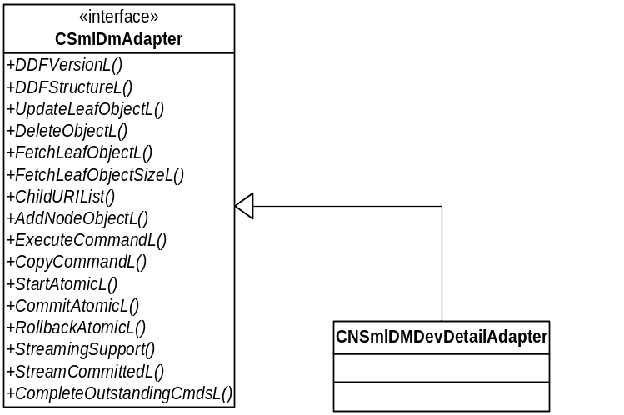
Figure 4.2 Class diagram of the CNSmlDmDevDetailAdapter class

Class descriptions
The module is implemented in one class:

Class | Description | Header file
CNSmlDevDetail  Adapter | The main class of the DevDetail adapter, which includes the whole implementation. | nsmldmdevdetailadapter.h

CNSmlDevDetailAdapter

CNSmlDevDetailAdapter | Description
// public
static CNSmlDevDetailAdapter* NewL(MSmlDmCallback* aCallBack) | Creates a new instance of the adapter and returns a pointer to it.
static CNSmlDevDetailAdapter* NewLC(MSmlDmCallback* aCallBack) | As the previous function but pushes the pointer to CleanupStack.
void DDFVersionL(CBufBase& aVersion) | Returns a DDF version of the adapter in aVersion.
void DDFStructureL(MSmlDmDDFObject& aDDF) | Fills the DDF of the adapter to aDDF.
void FetchLeafObjectL( const TDesC8& aURI, const TDesC8& aLUID, const TDesC8& aType, const TInt aResultsRef, const TInt aStatusRef ) | Fetches a leaf object from the adapter. The result of the command is returned by calling MSmlDmCallback::SetResults().
void FetchLeafObjectSizeL( const TDesC8& aURI, const TDesC8& aLUID, const TDesC8& aType, TInt aResultsRef, TInt aStatusRef ) | Fetches a leaf object size from the adapter. The result of the command is returned by calling MSmlDmCallback::SetResults().
void ChildURIListL( const TDesC8& aURI, const TDesC8& aLUID, const CArrayFix<TSmlDmMappingInfo>& aPreviousURISegmentList, const TInt aResultsRef, const TInt aStatusRef ) | Requests the list of children from the adapter. The result of the command is returned by calling MSmlDmCallback::SetResults().
TBool StreamingSupport( TInt& aItemSize ) | Returns EFalse since adapter does not support streaming.
void UpdateLeafObjectL( const TDesC8& aURI, const TDesC8& aLUID, const TDesC8& aObject, const TDesC8& aType, const TInt aStatusRef ) | The MSmlDmCallback::SetStatusL)() function is called with the CSmlDmAdapter::EError return code.
void UpdateLeafObjectL( const TDesC8& aURI, const TDesC8& aLUID, RWriteStream*& aStream, const TDesC8& aType, TInt aStatusRef ) | Updates the value, if the value is Stream. Not supported.
void DeleteObjectL( const TDesC8& aURI, const TDesC8& aLUID, const TInt aStatusRef ); | The MSmlDmCallback::SetStatusL)() function is called with the CSmlDmAdapter::EError return code.
void AddNodeObjectL( const TDesC8& aURI, const TDesC8& aParentLUID, const TInt aStatusRef ) | The MSmlDmCallback::SetStatusL)() function is called with the CSmlDmAdapter::EError return code.
void ExecuteCommandL( const TDesC8& aURI, const TDesC8& aLUID, const TDesC8& aArgument, const TDesC8& aType, TInt aStatusRef ) | Executes commands in adapter. Not supported. Returns its status using MSmlDmCallback::SetStatus() the status is always MSmlDmAdapter::EError.
void ExecuteCommandL( const TDesC8& aURI, const TDesC8& aLUID, RWriteStream*& aStream, const TDesC8& aType, TInt aStatusRef ) | Executes commands in adapter with streaming content. Not supported. Returns its status using MSmlDmCallback::SetStatus() the status is always MSmlDmAdapter::EError.
void CopyCommandL( const TDesC8& aTargetURI, const TDesC8& aTargetLUID, const TDesC8& aSourceURI, const TDesC8& aSourceLUID, const TDesC8& aType, TInt aStatusRef ) | Implements copy command. Not supported. Returns its status using MSmlDmCallback::SetStatus() the status is always MSmlDmAdapter::EError.
void SetResultsL( TInt aResultsRef, const CBufBase& aObject, const TDesC8& aType, const TDesC8& aFormat ) | Inherited from MSmlDmCallback. This tells the result of operations to framework.
void SetStatusL(TInt aStatusRef, TInt aStatusCode) | Inherited from MSmlDmCallback. This tells the status of operations to framework.
void StartAtomicL() | The function indicates start of Atomic command.
void CommitAtomicL() | The function indicates successful end of Atomic command.
void RollbackAtomicL() | The function indicates unsuccessful end of Atomic command.
void StreamCommittedL() | Called when stream returned from UpdateLeafObjectL or ExecuteCommandL has been written to and committed.
void CompleteOutstandingCmdsL() | The function tells the adapter that all the commands of the message that can be passed to the adapter have now been passed.
//private
void AddObjectToBufferL( CBufBase& aCrcBuf, const TDesC8& aURI ); | Adds the value of the object of a given URI to the buffer with the separator ‘:’.
CNSmlDmAdapter::TError FetchLeafObjectL( const TDesC8& aURI, CBufBase& aObject ); | Fetches the value of the leaf object. See Section 4.3.7 for details.
void SetLeafPropertiesL( MSmlDmDDFObject& aObject, const TSmlDmAccessTypes& aAccessTypes, const TDesC8& aDescription ) const; | Initializes the most used values to the given MNSmlDmDDFObject.
void SetLeafPropertiesL( MSmlDmDDFObject& aObject, const TSmlDmAccessTypes& aAccessTypes, const TDesC8& aDescription ) const; | Initializes the most used values to the given MSmlDmDDFObject.
void GetDevDetailDataL( CBufBase& aObject, TNSmlDevDetailData aElement ) const; | Method used for getting data defined by aElement (e.g. SwV). In ARM builds, fetches SwV- data using SysUtil, and in WINS builds, fetches SwV- and HwV data from files.  SwV data is concatenated in the following matter:  <Type_Designator_String><separator><SW_Version_String><separator><Variant_ID_String>  <Separator> equals to a ‘ ’ character (one space).

Structs, type definitions and enumerations

Enumeration's name | Description
TNSmlDevDetailData | Private enumeration for fields that can be fetched using CNSmlDevDetailAdapter::GetDevDetailDataL.

nsmldmdevdetailadapter.h
There are no structs or definitions in nsmldmdevdetailadapter.h. The only enumeration is the private TNSmlDevDetailData.

Enumeration: TNSmlDevDetailData | Description
ESwVersion | Software version of the device.
EHwVersion | Hardware version of the device.

Flag definitions
The DevDetail adapter does not have its own flag definitions. Its debug flag is defined in common\inc\nsmldebug.h under the SyncML component. This flag is common to all DM adapters.

Flag | Description
__NSML_DEBUG__ | Turns debug prints on/off. The debug prints appear in c:\nsmldebug.txt if flag is defined.

State diagrams
The adapter has no internal states. It performs all operations as they are received and independently of each other. No internal states are needed.

Operations
Operations performed by the DevDetail adapter during various phases of its progress are explained in the following sections.

Filling the DDF structure

Operation | Filling the DDF structure.
Preconditions
Description | When the DDFStructureL() of the adapter is called, the DDF structure of the adapter is filled starting from root level. In the DDFStructureL() function call, the adapter gets the reference to MSmlDmDDFObject, which is the root level object. The filling of the DDF structure is started by creating the next level by calling MSmlDmDDFObject::AddChildObjectL, which creates the next level and returns a reference to it.
Inputs | A reference to the root level MSmlDmDDFObject.
Modifies | Builds the DDF of the adapter.
Outputs
Postconditions | The DDF structure is generated.
Related To
Related Event | Creation of the instance of CNSmlDevDetailAdapter by the DM client framework.
Exceptions

The overall DDF structure of the DevDetail adapter is specified in reference document [2].
The field values in DDF are mapped as follows:

DevTyp | The value is hard coded in this module. The value is “phone”.
OEM | CNSmlPhoneInfo::PhoneDataL(). Implemented in Common Agent, the name of the manufacturer is returned.
FwV | A zero length string is returned.
SwV | In ARM builds returned string is concatenated using data enquired from SysUtil. In WINS the equivalent data is read from file.
HwV | In ARM builds returned string is left empty. In WINS the equivalent data is read from file.
MaxDepth | The value is hard coded in this module. The value is “0”.
MaxTotLen | The value is hard coded in this module. The value is “0”.
MaxSegLen | The value is hard coded in this module. The value is “9”.
LrgObj | The value is hard coded in this module. The value is “true”.

Adding DevDetail settings

Operation | Adding DevDetail settings.
Preconditions | The DDF structure has been generated correctly.
Description | This operation is not supported. Status code MSmlDmAdapter::EError is returned by calling the MSmlDmCallback::SetStatusL() function. The correct statusref must be used and it is taken from the aStatusRef argument of the AddNodeObjectL() function call.
Inputs | The inputs are specified in reference document [1].
Modifies
Outputs | Status of the operation using MSmlDmCallback::SetStatusL()function.
Postconditions
Related to
Related event
Exceptions

Updating a settings value

Operation | Updating a settings value.
Preconditions | The DDF structure has been generated correctly.
Description | This operation is not supported. Status code MSmlDmAdapter::EError is returned by calling the MSmlDmCallback::SetStatusL() function. The correct statusref must be used and it is taken from the aStatusRef argument of the UpdateLeafObjectL() function call.
Inputs | The inputs are specified in reference document [1].
Modifies
Outputs | Status of the operation using MSmlDmCallback::SetStatusL()function.
Postconditions
Related to
Related event
Exceptions

Deleting the settings

Operation | Deleting the settings.
Preconditions | The DDF structure has been generated correctly.
Description | This operation is not supported. Status code MSmlDmAdapter::EError is returned by calling the MSmlDmCallback::SetStatusL() function. The correct statusref must be used and it is taken from the aStatusRef argument of the DeleteObjectL() function call.
Inputs | The inputs are specified in reference document [1].
Modifies
Outputs | Status of the operation using MSmlDmCallback::SetStatusL()function.
Postconditions
Related to
Related event
Exceptions

Copying a settings value

Operation | Copies a settings value.
Preconditions | The DDF structure has been generated correctly.
Description | This operation is not supported. Status code MSmlDmAdapter::EError is returned by calling the MSmlDmCallback::SetStatusL() function. The correct statusref must be used and it is taken from the aStatusRef argument of the CopyCommandL() function call.
Inputs | The inputs are specified in reference document [1].
Modifies
Outputs | Status of the operation using MSmlDmCallback::SetStatusL()function.
Postconditions
Related To
Related Event
Exceptions

Executing a command

Operation | Executes a command.
Preconditions | The DDF structure has been generated correctly.
Description | This operation is not supported. Status code MSmlDmAdapter::EError is returned by calling the MSmlDmCallback::SetStatusL() function. The correct statusref must be used and it is taken from the aStatusRef argument of the ExecuteCommandL() function call.
Inputs | The inputs are specified in reference document [1].
Modifies
Outputs | Status of the operation using MSmlDmCallback::SetStatusL()function.
Postconditions
Related To
Related Event
Exceptions

Fetching a settings value

Operation | Fetching a settings value from settings store and retrieving the results to DM client.
Preconditions | The DDF structure has been generated correctly.
Description | The operation is executed when FetchLeafObjectL() of the adapter is called. As in the Update operation, the correct setting is recognized from the aURI argument. The result of the fetch is returned by calling the MSmlDmCallback::SetResultsL() function. In case of an interior node, the ChildURIListL() function of the adapter is called. In this case, the list of children is returned.
Inputs | The inputs are specified in reference document [1].
Modifies
Outputs | The value of the object or the list of child objects.
Postconditions | The status code and results of the operation is delivered to DM client.
Related to
Related event
Exceptions | If the status code is other than CSmlDmAdapter::EOk the operation is failed and results are not delivered.

Backup and Restore
This component does not participate in backup and restore.

Variation
DevDetail adapter is a DM plug-in module and does not support any other variation mechanism than application wide image creation time variation, i.e. the module can be included in or excluded from a ROM image

System resource usage

Files
This component uses two resource files described below.

File | NSmlDmDevDetailAdapter.rss.
Type | Resource file.
Location | Private directory.
Format | Text resource file.
Sharing
Encryption
Size estimate | 2 kB.
Clean up
Description | Provide DevDetail resources needed by the DevDetail adapter.

File | DevDetail_SwV.txt
Type | Text file.
Location | Resource directory, e.g. \epoc32\RELEASE\winscw\UDEB\z\Resource\DevMan\.
Format | Text file.
Sharing
Encryption
Size estimate | 20 bytes.
Clean up
Description | In WINS builds, the SwV string is read from this file. I.e. this file is convenient when testing in the emulator environment; one can easily change the SwV by modifying this file. DevDetail adapter reads all of the contents of this file (max. 2kB).

File | DevDetail_HwV.txt
Type | Text file.
Location | Resource directory, e.g. \epoc32\RELEASE\winscw\UDEB\z\Resource\DevMan\.
Format | Text file.
Sharing
Encryption
Size estimate | 5 bytes.
Clean up
Description | In WINS builds, the HwV string is read from this file. I.e. this file is convenient when testing in the emulator environment; one can easily change the HwV by modifying this file. DevDetail adapter reads all of the contents of this file (max. 2kB).

Other data

Databases
This component does not use any databases.

Central Repository
This component does not use Central Repository.

Publish and Subscribe
This component does not use Publish and Subscribe

Memory consumption

Memory/Build | Consumption
[User data area]
WINSCW UDeb | 87 948 bytes
ARMV5 | 3 286 bytes

Task allocation
The adapter does not launch any new threads; the operations are executed in the same thread as the calling application.

Performance
The adapter tries to execute all tasks as fast as possible within time limits given by DM server. The most performance critical task is querying of whole DDF structure using ChildURIListL function.

Timers
The adapter does not use any timers.

Security

Capabilities of this component

Capability | Justification
CAP_GENERAL_DLL | Default DLL capabilities defined by the platform.

Input and output validation
The adapter validates the input data on basis of the aURI parameter. The details of validation depend on operation context. In case of input operation it is first checked that the target which URI refers to exists before trying to write anything. In case of output when something is fetched, the adapter converts the value read from its data storage, to a format which can be used while settings the results of operation via Callback interface.

Environmental assumptions
This component does not make any assumptions about its environment.

Additional enforcements
This component does not have any additional security enforcements.

Exception handling
The leave mechanism of the Symbian OS environment is used to handle memory exhaustion and other system errors. No leave TRAPping is done within the module.

Usage

Building
DM DevDetail Settings Adapter module is built as any other module in the system. This component resides in the dm\adapters\devdetail directory, under the SyncML component. As a result, the nsmldmdevdetailadapter.dll library is created.

User's guide
This module is used only by DM framework.

