S60 3.1
SyncML Device Management
Host Server
Design Document

Team name | Author
Core BS Synch & Provisioning | Tiina Vuoniemi

Change history:

Version | Date | Status | Comments
1.0 | 18.04.2006 | Approved
0.1 | 09.02.2005 | Draft | Initial draft
0.2 | 25.02.2005 | Draft | Inspection changes made
0.3 | 05.04.2005 | Draft | Capability of DmHostServer1 changed
0.4 | 04.05.2005 | Draft | FOTA changes added
0.5 | 01.09.2005 | Draft | Remove threat analysis

Table of contents:

1. Document control 5
1.1 References 5
1.2 Documentation conventions 5
1.3 Abbreviations 5
1.4 Definitions 5
2. General 6
2.1 Introduction 6
2.2 Component environment 6
2.3 Use cases 7
2.4 Services required 7
2.4.1 From the Symbian OS subsystems 7
2.4.2 From the Domestic OS subsystems 7
2.4.3 From HW 8
2.5 Services provided 8
2.5.1 UI 8
2.5.2 SW IF 8
3. UI control hierarchy 9
4. Design 10
4.1 Class diagrams 10
4.1.1 Framework 10
4.1.2 Component 11
4.2 Class descriptions 12
4.2.1 CNSmlDMHostServer 12
4.2.2 CNSmlDMHostServer1 – 4 13
4.2.3 CNSmlDMHostSession 13
4.2.4 RNSmlDMFetchLink 15
4.2.5 Structs, type definitions and enumerations 15
4.2.5.1 Nsmldmhostsession.h 15
4.2.6 Flag definitions 16
4.3 Operations 17
4.3.1 Launching and connecting to servers 17
4.3.2 Receiving chunk handle 17
4.3.3 Getting DDF structure 18
4.3.4 Fetching leaf, child URI, or size 19
4.3.5 Adding or deleting node 20
4.3.6 Updating leaf or execute command 21
4.3.7 Fetching link - Internet adapter exists in server 22
4.3.8 Fetching link - Internet adapter exists in other server 23
4.3.9 Chunk is full condition - getting many normal results 24
4.3.10 Chunk is full condition - getting large object 25
4.3.11 Atomic command sequence 26
4.3.12 Marking generic alerts sent 27
4.4 Backup and Restore 27
5. Variation 28
6. System resource usage 29
6.1 Files 29
6.2 Other data 29
6.2.1 Databases 29
6.2.2 Central Repository 29
6.2.3 Publish and Subscribe 29
6.3 Memory consumption 29
6.4 Task allocation 29
6.5 Performance 29
6.6 Timers 30
7. Security 31
7.1 Capabilities of this component 31
7.2 Input and output validation 31
7.3 Environmental assumptions 31
7.4 Additional enforcements 31
8. Exception handling 32
9. Usage 33
9.1 Building 33
9.2 User's guide 33
Appendix A – IPC Commands 34

Document control

References

- S60 SyncML Symbian OS Server Design Document
- S60 SyncML Device Management Plug In Interface Specification Document
- S60 SyncML Device Management Tree Module Design Document
- S60 SyncML How to Implement Device Management Plug In Adapter

Documentation conventions
Code is shown with the Courier New font.

Abbreviations

Abbreviation | Description
DDF | Device Description Framework
DM | Device management
FOTA | Firmware Update Over The Air
IPC | Inter Process Communication
LUID | Local Unique Identifier
OS | Operating System
SyncML | Synchronization Markup Language
TCB | Trusted Computing Base, the most powerful capability
URI | Universal Resource Identifier
WAP | Wireless Application Protocol
WBXML | WAP Binary XML

Definitions

Definition | Description
AP adapter | Access point adapter, i.e. Internet adapter.
DM engine | Comprises the DM protocol engine and the most of the logic of Device Management.

General
SyncML DM Host Servers are server applications which are used by SyncML Symbian OS Server (see reference document [1]). The main purpose of SyncML DM Host Servers is to provide secure communication between DM Plug-in Adapters and SyncML Symbian OS Server (see reference document [2]). Because SyncML Symbian OS Server requires more capabilities than DM Plug-in Adapters, it is not able to load those. Therefore, DM Host Servers are needed in order to isolate DM Plug-in Adapters from SyncML Symbian OS Server to other processes.
DM Host servers are transient servers which mean that they are started when a client needs them and self terminated when they are no more used. SyncML Symbian OS Server uses SyncML DM Host Servers through SyncML DM Tree Module [3], which is the only allowed client for DM Host Servers. DM Plug-in Adapters are ECom plug-ins that can be used via the Symbian ECom Plug-in Architecture.
SyncML DM Host Servers load plug-in adapters for managing the real data in device. The capabilities of plug-in adapters may differ. That is why there are four separate SyncML DM Host Servers with different capabilities. The main functionality of all servers is the same and it is coded into one Dynamic Link Library that is used by all SyncML DM Host Servers.
SyncML DM Tree Module library can connect to all SyncML DM Host Servers. Using the ECom library DM Plug In Adapters can be created and be used on Host Servers. SyncML DM Host Servers can load only those DM Plug In Adapters that have enough capabilities, and client keeps track of which server created which DM Plug In Adapter and then communicates with that server.

Introduction
SyncML DM Host Servers are executables working as transient servers. They are used by SyncML Symbian OS Server via DM Tree Module.

Component environment
Figure 2.1 shows the component environment of SyncML DM Host Servers. All the servers are inherited from the DM Host Server Base component. Due to this, the majority of the content between servers is the same. Only the capabilities and the server names are different between DM Host Servers.
DM Plug In Adapters are not shown in the figure below because they are conceptually included to the different host servers. This means that the plug-in adapters are loaded and running in the same process as a particular DM Host Server. There is a logic built to DM Tree Module and to DM Host Servers which guarantees that an adapter is loaded only to one DM Host Server at a time.
DM Host Servers need services from the DM Callback Server and also - in a certain situation from each other. That is why the Figure 2.1 has IPC process boundaries described between these components.
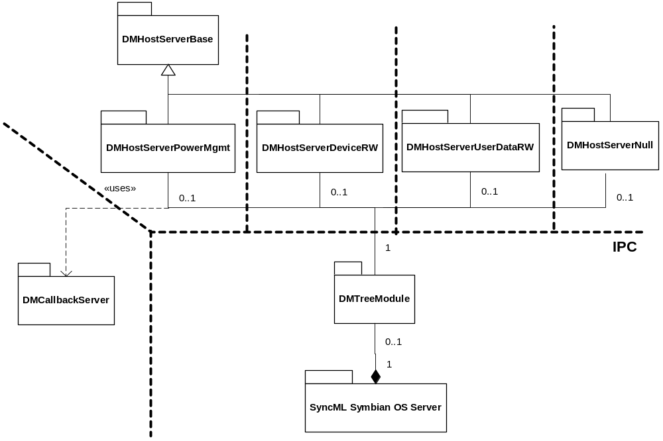
Figure 2.1 The component environment of SyncML DM Host Servers

Use cases
More detailed information about different use cases is presented in Section 4.3.

Services required

From the Symbian OS subsystems

API | Description
ECom Plug-in Architecture | DM Plug-in Adapters are searched, loaded and deleted using ECom API.
RChunk | RChunk provides a shared memory which is used for the data transfer between DM Tree Module and DM Host Servers.
CServer2 | Abstract base class for Symbian servers.
CSession2 | A session acts as a channel of communication between the client (DM Tree Module) and the server (DM Host Servers).
RReadStream | Streaming is used for reading data from the chunk or from the DM Plug-in Adapters.
RWriteStream | Streaming is used for writing data to the chunk or to the DM Plug-in Adapters.

From the Domestic OS subsystems
This component does not have any direct interfaces to the Domestic OS side subsystems.

From HW
This component has no direct HW interfaces.

Services provided

UI
This component does not provide any UI.

SW IF
This component provides services for SyncML DM Tree Module.

Provided Service | Description | Protected
Server services in client / server IPC | The IPC commands are described in detail in Appendix A – IPC Commands. | Yes
Search, Create and use DM Plug In Adapters | Access to DM Plug-in Adapters in a secure way. | Yes
Callback interface | Provides callback interface services for DM Plug-in Adapters (described in reference documents [2] and [4]). | Yes

UI control hierarchy
The component does not contain any UI or UI controls.

Design

Class diagrams
There are seven classes that co-operate and constitute the DM Host Server functionality. These classes are: CNSmlDMHostServer, CNSmlDMHostServer1, CNSmlDMHostServer2, CNSmlDMHostServer3, CNSmlDMHostServer4, CNSmlDMHostSession, and the auxiliary class RNSmlDMFetchLink.

Framework
DM Host Server provides a framework for DM Plug-in Adapters (see reference document [4]) by implementing the callback interface via which the adapters can return the results, the statuses, and the mappings of the DM commands (illustrated in Figure 4.3 ). In addition to this, DM Host Server takes care of searching and loading DM Plug-in Adapters like defined in the ECom framework.
Figure 4.2 below describes meanwhile the internal framework of SyncML DM Host Servers. As can be seen from the figure, the framework follows the Symbian Client - Server - architecture (version 2). DM Host Servers (CNSmlDMHostServer1-4) are named according to the actual implementation. The relationship with the capabilities is the following:
- CNSmlDMHostServer1 : CAP_GENERAL_DLL, i.e. all capabilities, excluding TCB capability
- CNSmlDMHostServer2 : Read and write rights to the device data
- CNSmlDMHostServer3 : Read and write rights to the user data
- CNSmlDMHostServer4 : NULL capabilities, i.e. no rights

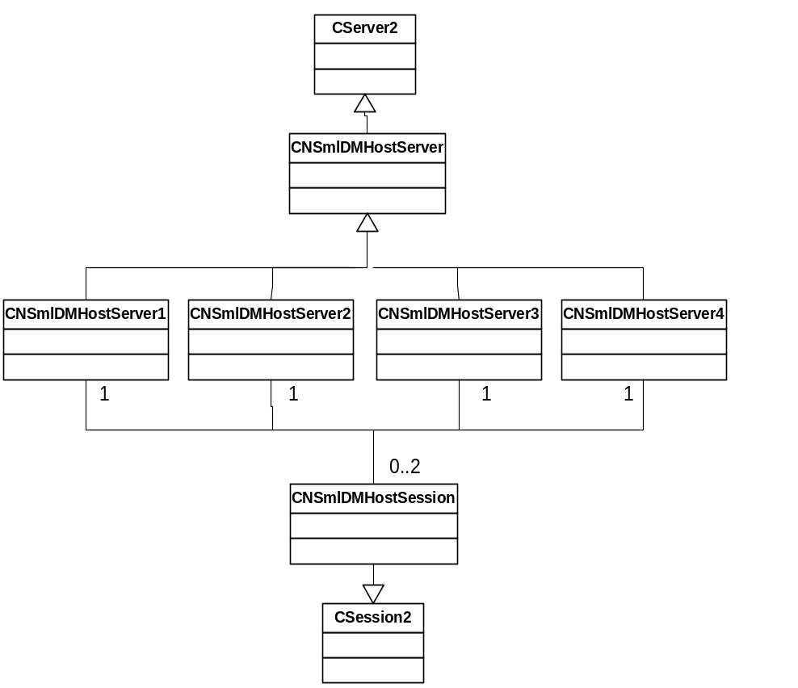
Figure 4.2 The internal framework of DM Host Server
Furthermore, the picture illustrates that one particular DM Host Server can have zero to two sessions. The limitation is built into the implementation of the server. The allowed clients are DM Tree Module and another DM Host Server - one at a time. Another DM Host Server may need a session in order to serve DM Plug-in Adapter during the FetchLink callback request.
From the implementation point of view the CNSmlDMHostSession class contains the majority of code. Accordingly, the next Section focuses on the structure of this component.

Component
Figure 4.3 below shows the class diagram of SyncML DM Host Server. The view focuses on the CNSmlDMHostSession class which is a major part of the DM Host Server implementation. Due to plug-in nature of the adapters, the amount of the loaded adapters per server varies.
DM Plug-in Adapters response to the CNSmlDMHostSession commands using the interface class MNSmlDmCallback. This way, the status and the result of the command is returned to the DM host session which buffers these and, when asked, transfers them further to the DM Tree Module. It is not required that DM Plug-in Adapters should immediately (i.e. synchronously) respond to the received commands. Accordingly, DM host session needs this kind of buffering mechanism.

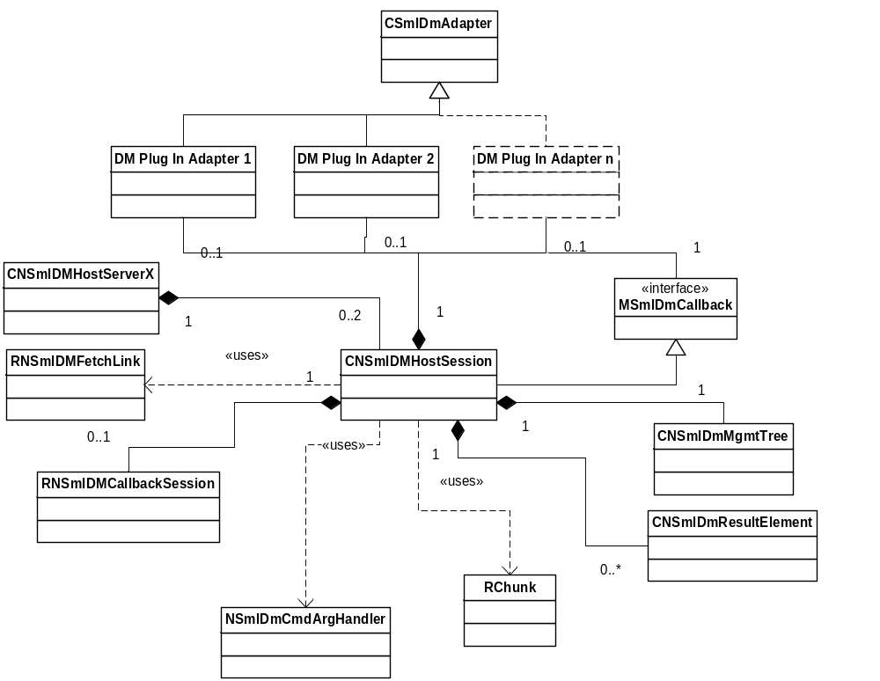
Figure 4.3 DM Host Server class diagram. Only CNSmlDMHostSession and RNSmlDMFecthLink are described in this document
The RChunk class offers a common data area for DM Tree Module and DM Host Server to read and write data. Briefly, DM Tree Module writes command parameters to the chunk and reads adapter responses from there. Correspondingly, DM Host Servers do the other way around. The chunk is created by the client (DM Tree Module ) and the server gets a handle to it at the beginning of the session.

Class descriptions
The following classes constitute the DM Host Server functionality (also shown in Figure 4.2 and in Figure 4.3 ).

Class | Description | Header file
CNSmlDMHostServer | Parent class of the actual DM Host Servers. Contains a common code for launching and initializing the servers. Additionally, takes care of creating new DM Host Server sessions. Checks the identity oh the calling process. | Nsmldmhostserver.h
CNSmlDMHostServer1  CNSmlDMHostServer2  CNSmlDMHostServer3  CNSmlDMHostServer4 | Inherited from CNSmlDMHostServer. Contains the server specific code like capabilities and naming of the DM Host Server. | Nsmldmhostserver1.h  Nsmldmhostserver2.h  Nsmldmhostserver3.h  Nsmldmhostserver4.h
CNSmlDMHostSession | Handles the communication with DM Tree Module (client). Transfer adapter commands to DM Plug In Adapters. Buffers the callback responses from the adapters. Serves adapters in special cases: a) Fetch Link request and b) Get LUID Alloc. | Nsmldmhostsession.h
RNSmlDMFetchLink | Acts as a client to the other DM Host Servers during the Fetch Link request. | Nsmldmhostsession.h

CNSmlDMHostServer

CNSmlDMHostServer
// construct/destruct
IMPORT_C ~CNSmlDMHostServer() | A C++ destructor of this class. Frees all the resources allocated by this instance.
protected:  IMPORT_C CNSmlDMHostServer() | A C++ constructor of this class. This method is protected to prevent a direct instantiation of the class.
// public methods
IMPORT_C void IncSessionCount() | Increases number of sessions at server.
IMPORT_C void DecSessionCount() | Decreases number of sessions at server. If the number of session goes to zero then server is shut down.

CNSmlDMHostServer1 – 4

CNSmlDMHostServer1 - 4
// public methods
IMPORT_C static TInt LaunchServer ( TAny* ) | First function that is called when the DM Host Server is launched.
static TInt ThreadFunction ( TAny* aStarted ) | Constructs the actual server and starts the active scheduler.
static CNSmlDMHostServer1* NewL ( const TDesC& aServerName ) | Starts a server with a given name and signals the semaphore which is waited by the client.
~CNSmlDMHostServer1() | Destructor. Empty function; no resources to be freed in this class.

CNSmlDMHostSession

CNSmlDMHostSession
// construct/destruct
static CNSmlDMHostSession* NewL ( CNSmlDMHostServer& aServer ) | Calls the constructor of CNSmlDmHostSession class. Server reference is used to increase or decrease session count, when DM Host Session is created or deleted.
~CNSmlDMHostSession() | A C++ destructor of this class. Frees all the resources allocated by this instance.
//public methods
void ServiceL ( const RMessage2 &aMessage ) | Entry point of handling the client request that has been passed to the server. This function must be implemented in a CSession2 derived class. All the possible leaves are caught in this function, and the leave code is transferred to the client as a return code for the IPC call. So, the server is not upset with the leaves happening in the message handling.
void DispatchMessageL ( const RMessage2 &aMessage ) | Recognizes the command from the received message and accordingly calls the right function for further command handling.
//public methods from MSmlDmCallback | This means that DM Plug-in Adapter calls these methods.
void SetResultsL ( TInt aResultsRef, CBufBase& aObject, const TDesC8& aType ) | The function is used to return the data in case of FetchLeafObjectL(), FetchLeafObjectSizeL() and ChildURIListL() functions. It should not be called where the DM command has failed, i.e. the error code returned in SetStatusL is something other than EOk.
void SetResultsL ( TInt aResultsRef, RReadStream*& aStream, const TDesC8& aType ) | The function is used to return the data in case of FetchLeafObjectL() and ChildURIListL() functions, where the size of the data being returned is large enough for the Adapter to stream it. This function should not be called when command was failed, i.e. the error code returned in SetStatusL is something other than EOk.
void SetStatusL ( TInt aStatusRef, MSmlDmAdapter::TError aErrorCode ) | The function returns information about the Add,Update,Delete and Fetch commands success to DM engine. The reference to correct command must be used when calling the SetStatusL function, the reference is got from the argument of the command functions. The SetStatusL function must be called separately for every single command.
void SetMappingL ( const TDesC8& aURI, const TDesC8& aLUID ) | The function passes map information to DM Module. This function is called for a new management object, both for node objects and for leaf objects. In addition if Child-URIListL() function has returned new objects a mapping information of the new objects must be passed. A mapping is treated as inheritable. If the mapping is not set with this function, the mapping LUID of the parent object is passed in following commands to the object.
void FetchLinkL ( const TDesC8& aURI, CBufBase& aData, MSmlDmAdapter::TError& aStatus ) | The function is used to make a fetch to other adapters. The most common use is to make a fetch to the AP adapter, because when managing the access points, the data comes as URI. For example, there are ToNAPId field in some adapters, and data to it can be something like AP/IAPidx, and then the link to AP adapter is needed. Using FetchLinkL causes the DM Host Server to make a Get request to the appropriate DM adapter. This may involve an IPC call to other adapter if the appropriate adapter is not found from the server. The receiving adapter must complete the Get request synchronously.
HBufC8* GetLuidAllocL ( const TDesC8& aURI ) | The function returns the LUID which is mapped to a URI. If LUID is not found, the function allocates a null length string, i.e. the function allocates memory in every case.  Basically, the LUID is asked from DM Callback Server using normal IPC client/server discussion.

RNSmlDMFetchLink

RNSmlDMFetchLink
// construct/destruct
RNSmlDMFetchLink() | Instantiates this class. There is no need for two phase construction, since this class does not allocate memory or open up resources at initialization.
//public methods
void OpenL ( const TDesC& aServer ) | Creates a session with the other DM Host Server. Typically this is the server containing the internet adapter, i.e. SyncML DM Host Server 2. Note: There is no need to launch the server, because it is already launched by the DM Tree Module.
void SendChunkHandleL ( TInt aHandle ) | Sends the chunk handle in order to get a common place for the Fetch Link result.
HBufC8* FetchL ( const TDesC8& aURI, RReadStream& aReadStream ) | Issues the Fetch Link IPC call to the other DM Host Server, and reads the result from the chunk.
void Close() | Closes the session with the other DM Host Server.

Structs, type definitions and enumerations

Nsmldmhostsession.h

Struct / Enumeration's name | Description
TNSmlDmResultAnalysis | Enumeration is used when DM Host Servers serves a Get Result IPC call. This enumeration is returned as an internal conclusion how the buffered results can be returned to the client via RChunk.
TNSmlDmAdapter | Struct TNSmlDmAdapter identifies the loaded adapters and partly the operations performed with them.

Enumeration: TNSmlDmResultAnalysis | Description
ENSmlDmAllWillFit | All the buffered results will fit to the chunk. So, no extra efforts needed.
ENSmlDmSomeWillFit | There are so many buffered results that only some of them will fit to the chunk at a time.
ENSmlDmStreamed | The result is a large object which does not fit into the chunk. The result is streamed by the dm adapter. So, in order to read next piece of the result, the saved RReadStream -pointer must be used.
ENSmlDmLargeDoesntFit | The result is a large object which does not fit into the chunk at a time. The result itself is fully stored in the memory of the DM Host Server, but is must be cut into suitable pieces (=size of the chunk) in order to return it to the client.

Struct: TNSmlDmAdapter | Description
CSmlDmAdapter* adapterPtr | Pointer to the DM Plug-in Adapter which this DM Host Server is capable of loading. It can be NULL if there has not yet been any commands to this adapter.
TUint32 adapterId | Implementation UID of the DM Plug In Adapter which uniquely identifies the adapter.
TBool startAtomicCalled | Stores the atomic command state of the particular DM Plug-in Adapter.
TBool commandsCalled | Informs if it is necessary to call CompleteOut-standingCmdsL function of the adapter or not.
TInt streamingLimit | Informs if the adapter supports a large object streaming and what is the size limit when the streaming should be used. The value -1 means ‘no streaming support’.

Flag definitions
The following flags are used by the component.

Flag | Description
__NSML_DEBUG__ | Used to dump debug text into file. The flag is defined in common\inc\nsmldefines.h.

Operations

Launching and connecting to servers

Operation | Launching and connecting to SyncML DM Host Servers.
Preconditions | All needed modules (.dll and .exe) are available in Symbian OS Environment.
Description | The servers are launched. After successful launching a client creates a session with the specified DM Host Server.
Inputs | The client needs to be running in the Symbian OS Server process, because DM Host Servers check the caller. In addition to this the client needs to know the server name (nsmldmhostserver1... nsmldmhostserver4), and the correct server version (1.0.0).
Modifies | Creates a new session to DM Host Server 1 - 4.
Outputs | The server will signal a semaphore when it has started. The Symbian OS CreateSession function call will return KErrNone when successful.
Postconditions | DM Host Servers are up and running. Additionally, there is one properly established session to each server.
Related To | CNSmlDMHostServer1 ... CNSmlDMHostServer4  CNSmlDMHostServer  CNSmlDMHostSession::NewL()
Related Event | Closing a session with DM Host Server.  (This has no separate description, since it is mainly handled by the kernel. The client needs only to call RSessionBase::Close() function. )
Exceptions | KErrCouldNotConnect if there are already maximum allowed number of sessions to one server (=2).  Diagnostic message for platform security violation, if the caller (i.e. the client) is running in the other process as Symbian OS Server.

Receiving chunk handle

Operation | Receives a chunk handle from DM Tree Module.
Preconditions | Servers are successfully launched. The session has been established between the client and the server.
Description | The client takes care of creating a global memory chunk. Then it sends the handle to the server. The chunk is used for data transfer between the client and the server.
Inputs | IPC command ENSmlDMChunkHandle with the parameters: a chunk handle and the server id. The server ID is in practice a number from one to four. It is needed because CNSmlDmHostSession class is a common for all the servers and thus could not hold information about the particular DM Host Server.
Modifies | The chunk handle and the server id are stored to the specific session.
Outputs | KErrNone if ok.
Postconditions | (A global memory chunk is allocated by the client).The chunk handle and the server ID are stored to the specific session.
Related To | CNSmlDMHostSession, RChunk (Symbian OS)
Related Event
Exceptions | KErrGeneral if the maximum size of the chunk is smaller than allowed by the server.

Getting DDF structure

Operation | Gets a DDF structure from the specific DM Host Server.
Preconditions | Servers are successfully launched. The session has been established between the client and the server. The chunk handle has been sent to the server. The DM adapters are built into the system.
Description | Depending on the capabilities of the server it can load a particular set of DM adapters. The client starts asking DDF from the server with the best rights. The returned DDF structure comprises a combination of the adapters which the server is capable of loading.
Inputs | IPC command ENSmlDMGetDDF. The command will take a UID list as a parameter. This list will tell to the server which adapters are already loaded and are thus prohibited to become reloaded.
Modifies | DM Host Server will store a list of the dm adapters it is capable of loading. The list will also hold additional information about the adapters, e.g. does the adapter support streaming and what is the streaming limit.  The combined DDF structure received from the loaded adapters is stored into the member variable of CNSmlDmMgmtTree type.
Outputs | - Writes the combined DDF structure to the chunk. It is in the WBXML format.  - Returns a checksum of the DDF structure to the client.  - Returns information about arrived callbacks, i.e. results, statuses, and mappings from the DM adapters. In practice, GetDDF always comes before any normal commands, so this always has a value ENSmlDmCallbackNone.
Postconditions | The adapter list and DDF structure are stored into the member variables. DM Host Servers are now ready to receive normal IPC commands.
Related To | CNSmlDMHostSession , CNSmlDmMgmtTree, Mem::Crc ( Symbian OS ), CSmlDmAdapter
Related Event
Exceptions | In unexpected error cases, the leave is TRAPped and the leave code is returned to the client.

Fetching leaf, child URI, or size

Operation | Fetches a leaf data, child URI list, or the size of the leaf data.
Preconditions | Servers are successfully launched. The session has been established between the client and the server. The chunk handle has been sent to the server. The DM adapters are built into the system. The DDF structure is successfully asked from the server.
Description | The client will issue a fetch request - of a certain type to the server. The parameters of the request are written to the chunk by the client. The server reads the parameters and forwards the command to the correct adapter. After receiving the response from the adapter (via SetResult callback) the server will buffer the result and inform the client that there are unread results.
Inputs | IPC commands are: ENSmlDMFetchLeaf, ENSmlDMChildUriList, and ENSmlDMFetchLeafSize. The input parameters are the same for all the commands.  - Adapter ID, status reference and result reference.  Furthermore, the client writes to the chunk the following parameters:  - LUID, URI, Type, and the previous URI segment list.
Modifies | If fetch is successful, the result is stored to the result list in the server. In any case the received status from the dm adapter is appended to the status list of the server.
Outputs | IPC command returns KErrNone if successful. Additionally, CallbackCalled parameter informs the client that there are unread results and statuses in the server.
Postconditions | The status lists is appended with the ‘ok’ status and the result list with the corresponding result value.
Related To | CNSmlDMHostSession , CSmlDmAdapter
Related Event
Exceptions | KErrNotFound if the given adapter was not found from this server.

Adding or deleting node

Operation | Adds a new node to the DM adapter, or deletes the existing one.
Preconditions | Servers are successfully launched. The session has been established between the client and the server. The chunk handle has been sent to the server. The DM adapters are built into the system. The DDF structure is successfully asked from the server.
Description | The client will issue an add interior node object or delete -request to DM Host Server. The parameters of the request are written to the chunk by the client. The server reads the parameters and forwards the command to the correct adapter. After receiving the status of the command from the adapter (via SetStatus callback) the server will buffer the status and inform the client that there are unread statuses.
Inputs | IPC commands are ENSmlDMAddNode and ENSmlDMDelete. The input parameters are the adapter ID, and the status reference.  Furthermore, the client writes to the chunk the following parameters:  - LUID, URI, Data, and Type.
Modifies | The received status from the dm adapter is appended to the status list of the server. Furthermore, in case of successful add, the DM adapter will issue a SetMapping callback in order to inform the DM framework (i.e. the client) about the reserved LUID of the new node. Accordingly, DM Host Server appends this new mapping info (LUID - URI pair) to its internal member variable list.
Outputs | IPC command returns KErrNone if successful. Additionally, CallbackCalled parameter informs the client that there are unread statuses (and also mappings) in the server.
Postconditions | The status list is appended with the ok status and the mapping list with the new mapping info.
Related To | CNSmlDMHostSession , CSmlDmAdapter
Related Event
Exceptions | KErrArgument if the given adapter was not found from this server.

Updating leaf or execute command

Operation | Updates the leaf data in the DM adapter, or calls the execute command.
Preconditions | Servers are successfully launched. The session has been established between the client and the server. The chunk handle has been sent to the server. The dm adapters are built into the system. The DDF structure is successfully asked from the server. (Additionally, a successful ‘Add node’ must be run before update, provided the updated leaf is under the dynamic interior node and interior node object is not yet added.)
Description | The client issues a ‘update leaf data’ or ‘execute’ -request to DM Host Server. The parameters of the request are written to the chunk by the client. The server reads the parameters and concludes whether the streaming should be used or not, and after that forwards the command to the correct adapter. After receiving the status of the command from the adapter (via SetStatus callback) the server will buffer the status and inform the client that there are unread statuses. (The DM adapter may also inform about new mappings, if the place of the leaf data in the settings database has been changed due to these commands. In that case the handling of the mappings is like presented in Section 4.3.5).  For the FOTA adapter there is an additional feature regarding the update command. Namely, if the size of the data is bigger than the streaming threshold the DM Host Server will call an overloaded function StreamingSupport. In this case, this function takes the size of the data as a parameter in order to the FOTA engine is able to detect does the data fit to a disk. Provided that the FOTA engine responses with KErrNoMemory, DM Host Server will complete the IPC call with the value KErrTooBig and no update takes place. However, if the data size is smaller than the streaming threshold the StreamingSupport function is not called, and the operation is like in any other DM adapter.
Inputs | IPC commands are: ENSmlDMUpdateLeaf and ENSmlDMExecute. The input parameters are the adapter ID, and the status reference.  Furthermore, the client writes the following parameters to the chunk:  LUID, URI, Data, and Type.  The streaming support has been asked from the DM adapter already during the Get DDF command by DM Host Server. So the server knows if the adapter supports streaming at all, and if it does, what is the data size limit when the streaming should be chosen by the server.
Modifies | The received status from the dm adapter is appended to the status list of the server. In case of new mappings they are also appended to the internal list.
Outputs | IPC command returns KErrNone if successful. Additionally, CallbackCalled parameter informs the client that there are unread statuses (and possibly also mappings) in the server.
Postconditions | The status list is appended with the ok status.
Related To | CNSmlDMHostSession , CSmlDmAdapter
Related Event
Exceptions | KErrArgument if the given adapter was not found from this server.

Fetching link - Internet adapter exists in server

Operation | Fetch link callback from DM Adapter. The cross-referenced adapter is loaded to the same DM Host Server.
Preconditions | Servers are successfully launched. The session has been established between the client and the server. The chunk handle has been sent to the server. The DM adapters are built into the system. The DDF structure is successfully asked from the server. A certain DM Adapter command is issued which causes the adapter to cross-reference other parts of the DM tree.
Description | A DM adapter might sometimes have the need to read data from other parts of the DM Tree. This is useful when one DM adapter implements a Management Object that contains a reference to a node in a different type of Management Object, one that is supported by a different DM adapter. To do this the dm adapter uses a FetchLink callback. If the supporting adapter is also loaded to the same server, serving the request is more straightforward, since DM Host Server can directly call a Fecth command of the supporting adapter, and return the result to the original adapter.
Inputs | The dm adapter which has a need to cross-reference will solely give a URI of the Management Object as a parameter.
Modifies | This operation does not change the internal data of DM Host Server. Although, the cross-referenced adapter will response normally using the SetResult and SetStatus callbacks, the server recognizes this as a fetch link -condition and does not append internal lists. However, if the cross-referenced adapter notices that mappings need updating, and accordingly calls the SetMapping callback, the server will not throw away this new mapping. Instead, it will forward this new mapping information to the callback server.
Outputs | The result is appended to the buffer given by the original adapter. In addition, the enumerated status is returned to the original adapter.
Postconditions
Related To | CNSmlDMHostSession , CSmlDmAdapter, MSmlDmAdapter::TError ( used for the returned status ).
Related Event | 4.3.8
Exceptions | MSmlDmAdapter::EError if the loading of the cross-referenced adapter was not successful.  MSmlDmAdapter::ENotFound if the requested Management Object was not found by the supporting adapter.

Fetching link - Internet adapter exists in other server

Operation | Fetch link callback from the DM Adapter. The cross-referenced adapter is not found from the same server. Instead, an IPC command must be issued to the other DM Host Server.
Preconditions | Servers are successfully launched. The session has been established between the client and the server. The chunk handle has been sent to the server. The DM adapters are built into the system. The DDF structure is successfully asked from the server. Then a certain DM Adapter command is issued which causes the adapter to cross-reference other parts of the DM tree.
Description | A DM Adapter might sometimes have the need to read data from other parts of the DM Tree. This is useful when one DM Adapter implements a Management Object that contains a reference to a node in a different type of Management Object, one that is supported by a different DM Adapter. To do this the dm adapter uses a FetchLink callback. If the cross-referenced adapter is not loaded to the same server, serving the request involves issuing an IPC command to the other DM Host Server. In other words, the server which received the fetch link callback has to act as a client to the other server.
Inputs | The dm adapter which has a need to cross-reference will solely give a URI of the Management Object as a parameter. This same URI is then forwarded to the other DM Host Server as a IPC call parameter.
Modifies | This operation does not change the internal data of DM Host Server.
Outputs | The result is appended to the buffer given by the original adapter. In addition, the enumerated status is returned to the original adapter.
Postconditions | The session with the other DM Host Server is closed.
Related To | CNSmlDMHostSession , CSmlDmAdapter, MSmlDmAdapter::TError ( used for the returned status ) , CNSmlDmCallbackServer
Related Event | 4.3.7
Exceptions | MSmlDmAdapter::EError if the loading of the cross-referenced adapter was not successful.  MSmlDmAdapter::ENotFound if the requested Management Object was not found by the supporting adapter.

Chunk is full condition - getting many normal results

Operation | Read DM Adapter results from DM Host Server. The amount of results is so big that the results do not fit into the memory chunk.
Preconditions | Servers are successfully launched. The session has been established between the client and the server. The chunk handle has been sent to the server. The DM adapters are built into the system. The DDF structure is successfully asked from the server.  A DM adapter has returned many results to DM Host Server, and the client (DM Tree Module) has not yet issued the Get result command in order to read these responses. The combined size of the results in the server exceeds the size of the global memory chunk.
Description | In practice, this operation is mostly academic, but it is reasonable that the server can handle the case where overfill of the chunk is expected.  When the server has received a ENSmlDMGetResults IPC call from the client, it will analyze the internal result list: Does it fit entirely to the chunk? If not, how many results from beginning of the list can be written? Then it will write those that fit to the chunk and after that remove them from the internal result list. Additionally, DM Host Server will inform the client that there are still unread results (by setting the IPC command parameter). The client can then issue another a ENSmlDMGetResults IPC call and read the rest of the results.
Inputs | There are no input parameters in the ENSmlDMGetResults IPC call.
Modifies | This operation shortens the internal result list, since a part of the results is written to the chunk, i.e. moved from DM Host Server to DM Tree Module.
Outputs | Results written to the chunk. Callback called IPC call parameter is set to ENSmlDmCallbackResults by the server. It tells the client that there are unread results.
Postconditions | The result list in the server is shortened.
Related To | CNSmlDMHostSession , RChunk (Symbian OS), CNSmlDmResultElement, NSmlDmCmdArgHandler
Related Event | 4.3.10
Exceptions | In unexpected error cases, the leave is TRAPped, and the leave code is returned to the client.

Chunk is full condition - getting large object

Operation | Read DM Adapter results from DM Host Server. The first result in the list is a large object that does not fit into the chunk at once.
Preconditions | Servers are successfully launched. The session has been established between the client and the server. The chunk handle has been sent to the server. The DM adapters are built into the system. The DDF structure is successfully asked from the server.  A DM adapter has returned a large object to DM Host Server as a result.
Description | If the DM adapter used streaming for returning the result, the server has read only one chunkfull to the internal memory space. Moreover, the server stores a pointer which points to the place from where it can read the next piece (one chunkfull) of the large object. On the contrary, if the adapter does not support streaming the large object is read fully to the internal memory space of the server.  When the server has received a ENSmlDMGetResults IPC call from the client, it will analyze the internal result list: It will detect that the first item in the result list is a large object. The server will write a chunkfull piece of the large object to the chunk. Additionally, DM Host Server will inform the client that data in the chunk is actually the large object. Moreover, the total size of the large object is returned to the client already when the first piece of the large object is written.
Inputs | There are no input parameters in the ENSmlDMGetResults IPC call.
Modifies | This operation cuts a chunkfull piece from the large object, after it is written to the chunk, i.e. moved from DM Host Server to DM Tree Module.
Outputs | Result is written to the chunk. Callback called IPC call parameter is set to ENSmlDmCallbackChunkFull by the server. It tells the client that the result is the large object. Furthermore, the total size of the large object is returned to the client.
Postconditions | The large object is slimmed.
Related To | CNSmlDMHostSession , RChunk (Symbian OS), CNSmlDmResultElement, NSmlDmCmdArgHandler, RReadStream (Symbian OS)
Related Event
Exceptions | In unexpected error cases, the leave is TRAPped, and the leave code is returned to the client.

Atomic command sequence

Operation | Carry out an atomic command sequence.
Preconditions | Servers are successfully launched. The session has been established between the client and the server. The chunk handle has been sent to the server. The DM adapters are built into the system. The DDF structure is successfully asked from the server.
Description | First, the client issues a ENSmlDMStartAtomic IPC call. Then the client will call some normal DM adapter commands. The server notices that there is an atomic command condition and before a normal DM adapter command is forwarded to the adapter, the server calls the StartAtomicL function for each called adapter. However, the start atomic function is called only once for each called adapter.  After that, the client issues a ENSmlDMCompleteCommands IPC call, which will oblige the DM adapters to run and response to the received atomic commands. The server sends this request only to those adapters that have performed some actions. Moreover, the server will collect and buffer the adapter responses normally.  The client will then read the responses by making ENSmlDMGetStatuses IPC call and after detecting that all commands were ok issue ENSmlDMCommitAtomic IPC command. The server forwards this command only to those adapters which have received the start atomic command.
Inputs | There are no input parameters in the ENSmlDMStartAtomic, ENSmlDMCompleteCommands, or in the ENSmlDMCommitAtomic IPC calls.
Modifies | The result, status, and possibly mapping lists are appended normally. The atomic condition is set after received start atomic IPC call. The commit atomic IPC call then resets this condition.
Outputs | All IPC command return KErrNone if they are successful.
Postconditions | The result, status, and possibly mapping lists are appended.
Related To | CNSmlDMHostSession, CSmlDmAdapter
Related Event | -
Exceptions | KErrArgument if the given adapter was not found from this server.

Marking generic alerts sent

Operation | The generic alerts are sent without problems to the remote server and the FOTA adapter needs to be informed about his. The FOTA adapter can then mark these alerts sent and thus prohibit unnecessary resending in the beginning of the next DM session.
Preconditions | Servers are successfully launched. The session has been established between the client and the server. The chunk handle has been sent to the server. The DM adapters are built into the system. The DDF structure is successfully asked from the server. If there were one or more generic alerts, which are successfully sent in the Client init package to the remote server.
Description | The client (DM Tree Module) issues an ENSmlDMGenericAlertsSent IPC call. The IPC call has no other parameters. After receiving this request the DM Host Server will search the FOTA adapter pointer from the internal list and load the adapter if it is not already loaded. The actual acknowledge request for the FOTA adapter is done by calling the overloaded function StreamingSupport with the parameter value: KNSmlDMResetGenAlerts (= −2). This function call will not generate any status, result nor mapping callback responses from the FOTA adapter.
Inputs | There are no input parameters in the ENSmlDMGenericAlertsSent IPC call.
Modifies | The FOTA adapter is loaded if it is not already done.
Outputs | Returns KErrNone.
Postconditions | The internal adapter list contains the FOTA adapter pointer.
Related To | CNSmlDMHostSession, CNSmlDmFotaAdapter
Related Event
Exceptions | KErrArgument if the loading of the FOTA adapter fails.  KErrNotFound if the FOTA adapter is not found from this server.

Backup and Restore
This component does not participate in backup and restore.

Variation
SyncML DM Host Servers do not support any variation.

System resource usage

Files
This component does not use any files.

Other data

Databases
This component uses a database NSmlDmTree.db via client-server framework. This database is owned by the CallbackServer module.

Central Repository
This component does not use Central Repository.

Publish and Subscribe
This component does not use Publish and Subscribe.

Memory consumption
SyncML DM Host Servers’ ROM and user data area consumption is the following:

Memory/Build | Consumption
User data area
WINSCW UDeb | Nsmldmhostserver1-4.exe 60 KB  Nsmldmhostserver.dll 182 KB
ARMV5 URel | Nsmldmhostserver1-4.exe 2 KB  Nsmldmhostserver.dll 10 KB

Task allocation
DM Tree Module running in SyncML Symbian OS Server starts SyncML DM Host server processes when needed and DM Host servers shut themselves down when all connections are closed. All DM Host Servers run in separate processes (see Figure 2.1 ) and each DM Plug-in Adapter in use is loaded to one of them.

Performance
IPC calls can be time consuming, therefore the IPC interface is designed so that the IPC traffic is minimized. For example, several result -, mapping - or status -items can be transferred as a result of one IPC call.
By using shared memory chunks between client and servers, dynamic memory consumption is reduced, which also improves the speed. The server saves dynamic memory also when it loads the dm adapter only as the need arises. On the other hand by keeping already loaded adapters in the memory speeds up the execution.

Timers
This component does not use timers.

Security

Capabilities of this component

Capability | Justification
CAP_GENERAL_DLL | Capabilities for SyncML DM Host Server 1.
ReadDeviceData WriteDeviceData | Capabilities for SyncML DM Host Server 2.
ReadUserData WriteUserData | Capabilities for SyncML DM Host Server 3.
NULL | Capabilities for SyncML DM Host Server 3. NULL = no capabilities.
CAP_GENERAL_DLL | Capability for SyncML DM Host Server DLL. Defined by platform.

Input and output validation
Inputs are only accepted from DM Tree Module or from the other DM Host Servers. This is checked by DM Host Servers during the session creation.
For IPC commands, DM Host Servers checks that the function the client requests is known. The enumerated list of the valid operation codes is defined in the file nsmldmclientandserver.h.
DM Host Servers assume also that the syntax of the IPC Commands is strictly according to specification presented in the Appendix A – IPC Commands. In practice, this kind of common agreement between the client and the server is achieved with the common library file nsmldmclientserverutils.dll loaded both by the server and the client. This library takes care of packing and parsing the data to the chunk and from the chunk.

Environmental assumptions
This component does not make any assumptions about its environment.

Additional enforcements
This component does not have any additional security enforcements.

Exception handling
All the leaves of the Symbian OS are captured (i.e. TRAPped) in the DM host session class. The panic mechanism is used only in the server if the startup fails. Servers panic the IPC client when IPC command operation code is out of range, which indicates a coding error or a severe program malfunction.
DM Host Server raises the following exceptions. The errors pass through IPC to the client. In addition to these, the exceptions from DM Plug-in Adapters are also transferred to the client.

Exception | Description
KErrCouldNotConnect | The session could not be created, because there are already a maximum amount of established sessions (=2).
KErrNotSupported | Wrong server version offered during the CreateSession function call.
KErrArgument | Given DM Plug-in Adapter could not be loaded by the server.
KErrArgument | During the large object update in the server, the client issues another large object update request for the other dm adapter.
KErrGeneral | The size of the global memory chunk is too small for the server.
KErrGeneral | Internal error in the server in handling the results.
KErrNotFound | There are no new mappings or statuses in the server, and the client has issued a get mappings or get status IPC calls.
Error codes returned by the CreateSession function call | Connection creation to other DM Host Server failed.

Usage

Building
SyncML DM Host Servers are built as any module in system. This component resides in the dm\hostserver directory under the SyncML component. The executable files which are to be generated from this module are: nsmldmhostserver1.exe, nsmldmhostserver2.exe, nsmldmhostserver3.exe, nsmldmhostserver4.exe, and nsmldmhostserver.dll.
In order to successfully build these files, some other modules must be built first. The overall build order is the following:
- common\debug
- common\inc\symbianheaders
- dm\dmutils
- dm\treedbhandler
- dm\callbackserver
- dm\treedbclient
- dm\hostserver\dmhostserverbase
- dm\hostserver\dmhostservers

User's guide
SyncML DM Host Servers are used by DM Tree Module, which is described in reference document [3]. Moreover, DM Host Servers offer a callback API for DM Plug-in Adapters. These interfaces are described in reference document [4].

Appendix A – IPC Commands
The following tables list the IPC commands used between SyncML DM Tree Module and – Server. In the tables service contains description of a command; Op Code its operation code, which is used in the implementation; IPC arg0 – arg3 lists how the four argument slots are used, and what they contain; Return value, value returned back after requesting a service; RChunk from client describes what the client puts to shared memory chunk for server side to read and RChunk to client, what the server puts to chunk for client to read.

Service |  | Get DDF from server
Op Code |  | ENSmlDMGetDDF
RChunk from client
RChunk to client |  | Combined DDF tree structure of the loaded DM adapters
IPC arg0 | IPC arg1 |  | IPC arg2 | IPC arg3 | Return value
Load except (TDesC8): [TUint8 nOfUids, TUint32 uid, TUint32 uid…] (read) |  |  | CheckSum (TUint16)  (write) |  | TInt [ out ]  Leave code

Service |  | Update the data of the leaf object.
Op Code |  | ENSmlDMUpdateLeaf
RChunk from client |  | LUID, data, URI, type.
RChunk to client
IPC arg0 | IPC arg1 |  | IPC arg2 | IPC arg3 | Return value
Adapter ID | Status ref |  |  | Callback called (write) | TInt [ out ]  Leave code

Service |  | Update the large object to the leaf.
Op Code |  | ENSmlDMUpdateLeafLarge
RChunk from client |  | LUID, data, URI, type.
RChunk to client
IPC arg0 | IPC arg1 |  | IPC arg2 | IPC arg3 | Return value
Adapter ID | Status ref |  | Last package (TBool)  (read) | Callback called (write) | TInt [ out ]  Leave code

Service |  | Add a interior node object.
Op Code |  | ENSmlDMAddNode
RChunk from client |  | LUID, data, URI, type.
RChunk to client
IPC arg0 | IPC arg1 |  | IPC arg2 | IPC arg3 | Return value
Adapter ID | Status ref |  |  | Callback called (write) | TInt [ out ]  Leave code

Service |  | Execute command.
Op Code |  | ENSmlDMExecute
RChunk from client |  | LUID, data, URI, type.
RChunk to client
IPC arg0 | IPC arg1 |  | IPC arg2 | IPC arg3 | Return value
Adapter ID | Status ref |  |  | Callback called (write) | TInt [ out ]  Leave code

Service |  | Execute command in multiple packages.
Op Code |  | ENSmlDMExecuteLarge
RChunk from client |  | LUID, data, URI, type.
RChunk to client
IPC arg0 | IPC arg1 |  | IPC arg2 | IPC arg3 | Return value
Adapter ID | Status ref |  | Last package (TBool)  (read) | Callback called (write) | TInt [ out ]  Leave code

Service |  | Delete object and its child objects.
Op Code |  | ENSmlDMDelete
RChunk from client |  | LUID, data, URI, type.
RChunk to client
IPC arg0 | IPC arg1 |  | IPC arg2 | IPC arg3 | Return value
Adapter ID | Status ref |  |  | Callback called (write) | TInt [ out ]  Leave code

Service |  | Copy command.
Op Code |  | ENSmlDMCopy
RChunk from client |  | New LUID, new URI, source LUID, source URI, type.
RChunk to client
IPC arg0 | IPC arg1 |  | IPC arg2 | IPC arg3 | Return value
Adapter ID | Status ref |  |  | Callback called (write) | TInt [ out ]  Leave code

Service |  | Start atomic command sequence.
Op Code |  | ENSmlDMStartAtomic
RChunk from client
RChunk to client
IPC arg0 | IPC arg1 |  | IPC arg2 | IPC arg3 | Return value
 |  |  |  | Callback called (write) | TInt [ out ]  Leave code

Service |  | Commit atomic command sequence.
Op Code |  | ENSmlDMCommitAtomic
RChunk from client
RChunk to client
IPC arg0 | IPC arg1 |  | IPC arg2 | IPC arg3 | Return value
 |  |  |  | Callback called (write) | TInt [ out ]  Leave code

Service |  | Rollback atomic commands.
Op Code |  | ENSmlDMRollbackAtomic
RChunk from client
RChunk to client
IPC arg0 | IPC arg1 |  | IPC arg2 | IPC arg3 | Return value
 |  |  |  | Callback called (write) | TInt [ out ]  Leave code

Service |  | Complete all outstanding commands.
Op Code |  | ENSmlDMCompleteCommands
RChunk from client
RChunk to client
IPC arg0 | IPC arg1 |  | IPC arg2 | IPC arg3 | Return value
 |  |  |  | Callback called (write) | TInt [ out ]  Leave code

Service |  | Fetch a data of the leaf object.
Op Code |  | ENSmlDMFetchLeaf
RChunk from client |  | LUID, data, URI, previousURISegmentList, type.
RChunk to client
IPC arg0 | IPC arg1 |  | IPC arg2 | IPC arg3 | Return value
Adapter ID | Status ref |  | Result ref | Callback called (write) | TInt [ out ]  Leave code

Service |  | Cross-reference an adapter in the different server (used only by the other DM Host Servers).
Op Code |  | ENSmlDMFetchLink
RChunk from client
RChunk to client |  | The result of the fetch command.
IPC arg0 | IPC arg1 |  | IPC arg2 | IPC arg3 | Return value
URI ( read ) |  |  |  |  | TInt [ out ]  Leave code

Service |  | Fetch the size of the leaf data.
Op Code |  | ENSmlDMFetchLeafSize
RChunk from client |  | LUID, data, URI, previousURISegmentList, type.
RChunk to client
IPC arg0 | IPC arg1 |  | IPC arg2 | IPC arg3 | Return value
Adapter ID | Status ref |  | Result ref | Callback called (write) | TInt [ out ]  Leave code

Service |  | Fetch the list of the child URIs under the given object.
Op Code |  | ENSmlDMChildUriList
RChunk from client |  | LUID, data, URI, previousURISegmentList, type.
RChunk to client
IPC arg0 | IPC arg1 |  | IPC arg2 | IPC arg3 | Return value
Adapter ID | Status ref |  | Result ref | Callback called (write) | TInt [ out ]  Leave code

Service |  | Send a chunk handle to the server.
Op Code |  | ENSmlDMChunkHandle
RChunk from client
RChunk to client
IPC arg0 | IPC arg1 |  | IPC arg2 | IPC arg3 | Return value
Chunk handle | serverId |  |  |  | TInt [ out ]  Leave code

Service |  | Get new mappings informed by the DM adapters.
Op Code |  | ENSmlDMGetMappings
RChunk from client
RChunk to client |  | Mappings (write).
IPC arg0 | IPC arg1 |  | IPC arg2 | IPC arg3 | Return value
 |  |  |  | Callback called (write) | TInt [ out ]  Leave code

Service |  | Get status list.
Op Code |  | ENSmlDMGetStatuses
RChunk from client
RChunk to client |  | Statuses (write).
IPC arg0 | IPC arg1 |  | IPC arg2 | IPC arg3 | Return value
 |  |  |  | Callback called (write) | TInt [ out ]  Leave code

Service |  | Get result s from the server.
Op Code |  | ENSmlDMGetResults
RChunk from client
RChunk to client |  | Results (write).
IPC arg0 | IPC arg1 |  | IPC arg2 | IPC arg3 | Return value
 |  |  | Data length (write)  - only in case the result is a large object. | Callback called (write) | TInt [ out ]  Leave code

Service |  | Get next piece of the large object.
Op Code |  | ENSmlDMGetMore
RChunk from client
RChunk to client |  | Next piece of result (write).
IPC arg0 | IPC arg1 |  | IPC arg2 | IPC arg3 | Return value
 |  |  |  | Callback called (write) | TInt [ out ]  Leave code

Service |  | Mark generic alerts sent (FOTA adapter specific IPC call).
Op Code |  | ENSmlDMGenericAlertsSent
RChunk from client
RChunk to client
IPC arg0 | IPC arg1 |  | IPC arg2 | IPC arg3 | Return value
TInt [ out ]
Leave code

