S60 3.1
SyncML Symbian OS Server
Design Document

Team name | Author
Core BS Synch & Provisioning | Tiina Vuoniemi

Change history:

Version | Date | Status | Comments
2.0 | 19.04.2006 | Approved
0.1 | 03.12.2004 | Draft
0.2 | 03.01.2005 | Draft | Added Private API and Alert queue.
0.3 | 20.01.2005 | Draft | DM Authentication Info added.
0.4 | 09.02.2005 | Draft | Filter support added.
0.5 | 24.02.2005 | Draft | Coding convention fixes updated to chapter 4.2.
0.6 | 29.03.2005 | Draft | Changed DM session to be run in own thread.
0.7 | 01.04.2005 | Draft | Generic Alert support added.
0.8 | 05.04.2005 | Draft | Changed required capabilities for profile handling and added capabilities for job creation.
0.9 | 24.05.2005 | Draft | Review changes: Corrected the term “General Alert” to “Generic Alert”.
1.0 | 07.06.2005 | Draft | Added active backup client feature.
1.1 | 05.09.2005 | Draft | Removed threat analysis.
1.2 | 07.10.2005 | Draft | Performance optimization, Job event buffering.
1.3 | 11.10.2005 | Draft | Tarm integration updates.
1.4 | 2.11.2005 | Draft | TARM review changes, Bearer type handling in alert updated.
1.5 | 14.12.2005 | Draft | Misc changes merged from 3.0.

Table of contents:

1. Document control 5
1.1 References 5
1.2 Documentation conventions 5
1.3 Abbreviations 5
1.4 Definitions 6
2. General 7
2.1 Introduction 8
2.2 Component environment 8
2.3 Use cases 8
2.4 Services required 9
2.4.1 From the Symbian OS subsystems 9
2.4.2 From the Domestic OS subsystems 9
2.4.3 From HW 9
2.5 Services provided 9
2.5.1 UI 9
2.5.2 SW IF 9
3. UI control hierarchy 10
4. Design 11
4.1 Class diagrams 11
4.1.1 Framework 11
4.1.2 Component 11
4.2 Class descriptions 14
4.2.1 CNSmlSOSServer 16
4.2.2 CNSmlSOSSession 17
4.2.3 CNSmlSOSHandler 18
4.2.4 CNSmlSOSBackup 19
4.2.5 CNSmlJob 20
4.2.6 CNSmlJobObject 21
4.2.7 CNSmlProfile 21
4.2.8 CNSmlTask 22
4.2.9 CNSmlConnection 23
4.2.10 CNSmlHistoryLog 23
4.2.11 CNSmlDataProvider 24
4.2.12 TNSmlThreadParams 24
4.2.13 CNSmlThreadEngine 25
4.2.14 CNSmlNotifierTimeOut 25
4.2.15 CNSmlCancelTimeOut 26
4.2.16 CNSmlThreadObserver 26
4.2.17 CNSmlNotifierObserver 26
4.2.18 TNSmlThreadLauncher 27
4.2.19 CNSmlMessageQueue 27
4.2.20 MSmlMessageHandler 28
4.2.21 CNSmlMessageItem 28
4.2.22 CNSmlParserFactory 28
4.2.23 CNSmlMessageParserBase 29
4.2.24 CNSmlDSAlertParser11 29
4.2.25 CNSmlDSAlertParser12 30
4.2.26 CNSmlDMAlertParser11 30
4.2.27 RNSmlPrivateAPI 31
4.2.28 CNSmlDMAuthInfo 31
4.2.29 Structs, type definitions and enumerations 32
4.2.29.1 nsmlsosserverdefs.h 32
4.2.29.2 syncmldef.h 33
4.2.29.3 syncmldatafilter.h 34
4.2.30 State diagrams 34
4.3 Operations 35
4.3.1 Creating profile 35
4.3.2 Opening profile 35
4.3.3 Getting profile 36
4.3.4 Updating profile 36
4.3.5 Deleting profile 37
4.3.6 Creating task 37
4.3.7 Opening task 38
4.3.8 Getting task 38
4.3.9 Updating task 39
4.3.10 Deleting task 39
4.3.11 Creating connection 39
4.3.12 Opening connection 40
4.3.13 Getting connection 40
4.3.14 Updating connection 41
4.3.15 Deleting connection 41
4.3.16 Opening history log 41
4.3.17 Getting history log 42
4.3.18 Resetting history log 42
4.3.19 Opening data provider 43
4.3.20 Getting data provider 43
4.3.21 Creating job 44
4.3.22 Opening job 44
4.3.23 Stopping job 45
4.3.24 Server alerted job 45
4.3.25 Send DM authentication info 46
4.3.26 Retrieve DM authentication info 46
4.3.27 Adding generic alert 47
4.3.28 Requesting event notification 47
4.3.29 Requesting progress event notification 48
4.4 Backup and Restore 48
5. Variation 49
6. System resource usage 50
6.1 Files 50
6.2 Other data 50
6.2.1 Databases 50
6.2.2 Central Repository 50
6.2.3 Publish and Subscribe 50
6.3 Memory consumption 50
6.4 Task allocation 50
6.5 Performance 50
6.6 Timers 51
7. Security 52
7.1 Capabilities of this component 52
7.2 Input and output validation 52
7.3 Environmental assumptions 52
7.4 Additional enforcements 52
8. Exception handling 53
9. Usage 54
9.1 Building 54
9.2 User's guide 54
Appendix A – IPC commands 55

Document control

References

- S60 SyncML Symbian OS Server Client Side Design Document
- S60 SyncML Data Synchronization Host Server Design Document
- S60 SyncML Data Synchronization Settings Database Design Document
- S60 SyncML Device Management Settings Database Design Document
- S60 SyncML Data Synchronization Agent Design Document
- S60 SyncML Device Management Agent Design Document
- S60 SyncML Data Synchronization WAP Push Alert Design Document
- S60 SyncML OBEX Data Synchronization Plugin Design Document
- S60 SyncML Device Management WAP Push Alert Design Document
- S60 SyncML Data Synchronization OMA Provisioning Adapter Design Document
- S60 SyncML Device Management DmSettings Adapter Design Document

Documentation conventions
Code is shown with the Courier New font.

Abbreviations

API | Application Programming Interface
DM | Device Management
DS | Data Synchronization
ECOM | Symbian OS plug-in framework. For resolving and loading implementations at run time.
IPC | Inter-Process Communication
SA message | SyncML 1.1 protocol server alerted message.
SAN message | SyncML 1.2 protocol server alerted notification message.
SID | Secure identifier of the process.
SOS | Symbian Operating System
SyncML | Synchronization Mark-up Language

Definitions

Alert message | Alert message definition is used in text to cover both SAN message and SA message abbreviations.
Connection | Connection encapsulates data needed to start session with SyncML remote server.
Job | Job is data synchronization or device management session with SyncML remote server.
Profile | A profile encapsulates a relationship with a single SyncML remote server, and contains a number of 'tasks' and 'connections'.
Task | Task represents a mapping between a local data store and a remote data store on SyncML remote server in the context of a profile.

General
SyncML Symbian OS Server is a server component used by Client API (see reference document [1]). The main purposes of the SyncML Symbian OS Server are hosting DS and DM synchronization sessions, job queuing and accessing to the DS and DM settings databases.
The server is a transient server, which means it is started when the client needs it, and self terminated when it is not used anymore. If there is a synchronization session running when starting a new job, the job will be queued and run after the ongoing job. Settings can be read or write at any time, regardless whether there is a synchronization session running. The server will terminate itself if there are no clients connected, and the queue of jobs is empty.
DS and DM sessions are run sequentially in SyncML Symbian OS Server, i.e. one queue may contain both DS and DM type synchronization jobs. Queued jobs can be removed from the queue by the client. Server alerted jobs are also added to the queue, and user will be notified of the job by the notifier service when the job is ready to start. New jobs are compared to queued jobs to find out if there is similar job already queued, which means that duplicate job will not be added to the queue. SyncML Symbian OS Server runs DM session in own thread and shares heap with thread allowing access to DM running DM Client Agent.
To observe progress and events client API maintains outstanding receive requests to SyncML Symbian OS Server.
The Private API module is used to transfer Alert messages from DS WAP Push Alert (see reference document [7]), OBEX Plug-in (see reference document [8]) and DM WAP Push Alert (see reference document [9]) modules and DM authentication info from DM Settings adapter (see reference document [11]) and DM OMA Provisioning adapter (see reference document [10]). It also provides means to add Generic Alerts to the initiation message of a DM session. Private API component connects to SyncML Symbian OS Server, launching it if it is not already running and creates a new session. If session is created successfully Alert message is transferred to SyncML Symbian OS Server which adds the Alert message into alert queue. Generic Alerts, on the other hand, are directly given to DM Agent if a DM session is currently running. DM Agent handles Generic Alert’s data from there.
The received alert message is added into alert queue, which is managed by SyncML Symbian OS Server. Alert queue handles the parsing of the Alert messages. Messages are retrieved from alert queue and parsed. After parsing alert history info is updated and the SyncML Symbian OS Server is called to create a new job, which is added to job queue. SyncML Symbian OS Server launches the progress notifier plug-in, which handles the server alert user interaction.
Data synchronization Alert message matching is performed with the following rule. Server ID from the alert message is matched to existing profiles’ Server ID. Also profiles’ server alert allowed flag must have been enabled. Remote database URI and MIME type is matched against found profiles’ enabled contents. If multiple profiles are found then profile with most matching contents is selected. SA message matching is performed in the same way, except that SyncML remote server URL is used instead of Server ID of the profile.
Device management server alert matching is performed with following rule. Server ID from the alert message is matched to existing profiles’ Server ID. Also profiles’ server alert allowed flag must have been enabled. If multiple matches are found then the first profile from the list is selected.
Common to all alert matching is the restriction of the bearer type. WAP Push alerts indicate remote connections and those are matched to profiles where bearer is Internet. Also if multiple profiles are found their selected access point is checked and those which have defined access point are selected.
The __POLICY_MANAGEMENT feature flag is used to enable settings enforcement. When enabled, updating, deleting and adding of DS and DM profiles is prohibited from all clients except DM host server. Check is performed using SID. DM job is run silent with specified server id value and certificate check is forced.

Introduction
SyncML Symbian OS Server component of S60 is an executable working as a transient server. SyncML Symbian OS Server is used by Client API and in server alert cases by Private API.

Component environment
Figure 2.1 illustrates the relationship between different modules. SyncML Symbian OS Server uses internal interfaces to provide services to the client. For data provider related information DS Host Client (reference document [2]) from DS Loader Framework is used. Settings databases are accessed via DS Settings API (reference document [3])and DM Settings API (reference document [4]). Data synchronization jobs are started from DS Sessions API (reference document [5]) and device management configurations are started from DM Agent (reference document [6]). Policy management engine is used to check whether current DM job is to be run as silent job.

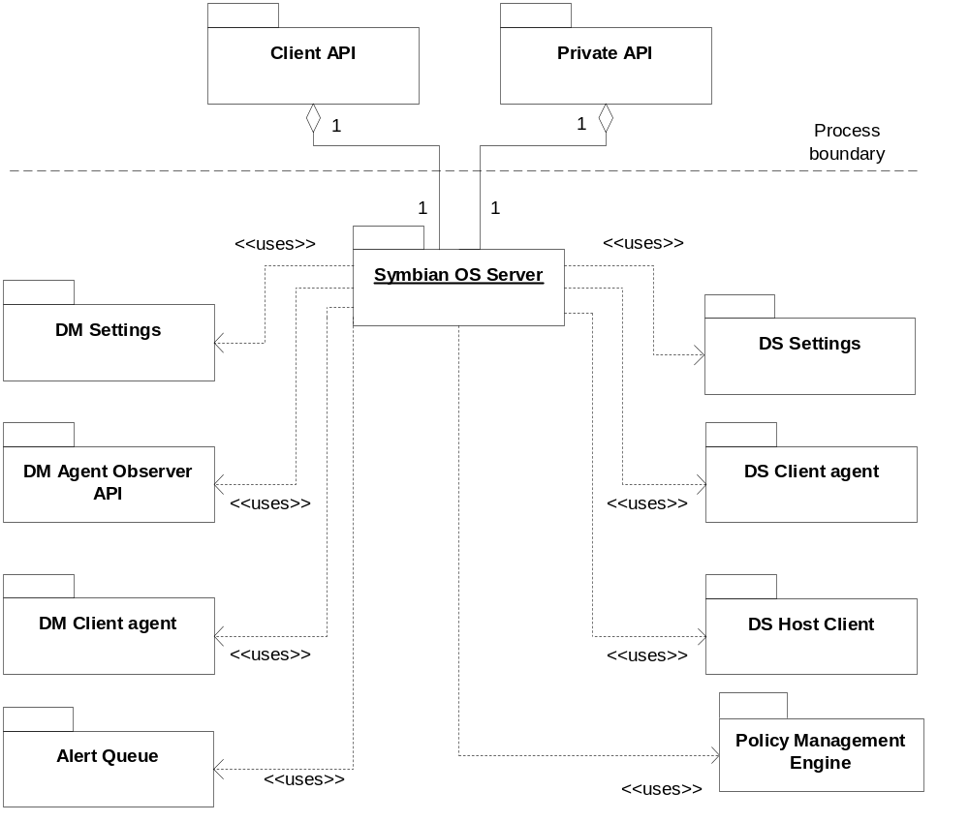
Figure 2.1 SyncML Symbian OS Server subsystem environment

Use cases
Via SyncML Symbian OS Server client can create, modify and delete data from DS and DM settings database. DS and DM jobs can be created and the originator of the job can observe and stop the job. Clients can also request events of their own actions or from the actions of other clients.
More detailed information about different use cases is presented in Section 4.3.

Services required

From the Symbian OS subsystems
Services of Symbian OS infrastructure including streams and the Client/Server framework are required. Also, the following services are used:

API | Description
ECom Plug-in Architecture | Data provider implementation ids are read from here.
Descriptor Arrays | To use descriptor arrays.
Publish & Subscribe Headers and Documentation API | This is used to listen to changes in backup or restore state.
Policy Management Engine API | API for making policy requests.
Settings Enforcement Info API | API for clients which wants to know is the specific setting set under enforcement.
TARM Policy Management Util Central Repository API | The internal central repository key collection for Policy Management DM Util.

From the Domestic OS subsystems
This component does not have any direct interfaces to the Domestic OS side subsystems.

From HW
This component has no direct HW interfaces.

Services provided

UI
This component does not provide any UI.

SW IF
SyncML Symbian OS Server provides services to modify Data Synchronization and Device Management databases and to create DS and DM jobs. Server does not provide any external services.

Provided Service | Description | Protected
Modify DS settings | DS Settings database is accessible only via SyncML Symbian OS Server. | Yes
Modify DM settings | DM Settings database is accessible only via SyncML Symbian OS Server. | Yes
Create DS job | DS jobs are created via SyncML Symbian OS Server. | No
Create DM job | DM jobs are created via SyncML Symbian OS Server. | No

UI control hierarchy
The component does not contain any UI or UI controls.

Design
CNSmlSOSServer is a server class, inherited from CServer2, which is created when the client starts the server. The server creates a new CNSmlSOSSession instance for every client to handle messages. Received messages are handled by the session class by calling appropriate methods from sub session classes or CNSmlSOSHandler class to process the wanted services. For every synchronization job a CNSmlJob class is created to store sync information. If there are multiple synchronization jobs at the same time, the jobs are queued and run sequentially after previous job has finished. CNSmlSOSBackup is used to listen publish and subscribe services to notice changes in backup and restore modes. It also connects to Secure Backup Engine as an active backup client and deletes Agent Log during restore state.
CNSmlSOSServer is alive while there is a client connected, i.e. at least one session class exists, or there is a synchronization job running or queued. When there are not any services needed, the server will be terminated.
CNSmlMessageQueue implements alert message queue to which the received alert notifications are added. Instance of CNSmlAlertHandler, which is derived from CActive, fetches the message from alert message queue, creates an appropriate parser using the CNSmlParserFactory instance and parses the message. Parser fills the CSmlAlertInfo instance and after successful parsing the CNSmlSOSHandler is called with parsed information to create a new job to add it to the job queue. CNSmlAlertHandler parses both DM and DS alert messages. For the DM SAN message is supported and for DS SA message and SAN message.
RNSmlPrivateAPI implements the Private API module, which is derived from RSessionBase class and it uses Client/Server framework to transfer Alert messages to SyncML Symbian OS Server.

Class diagrams

Framework
SyncML Symbian OS Server framework is based in Symbian Client-Server architecture containing one server class and one or more session classes. Session class may have one or more sub session classes. Server class also creates a handler class which is inherited from CActive.

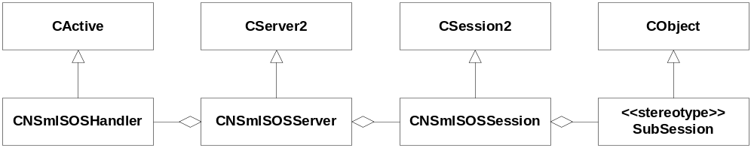
Figure 4.2 Metamodel definition of Symbian OS Server

Component
Figure 4.3 illustrates the relationship between SyncML Symbian OS Server classes and relations to internal interfaces. SyncML Symbian OS Server classes are marked to the figure with thicker outline.
Figure 4.4 illustrates the design of the Alert queue.
Figure 4.5 illustrates the design of the Private API.

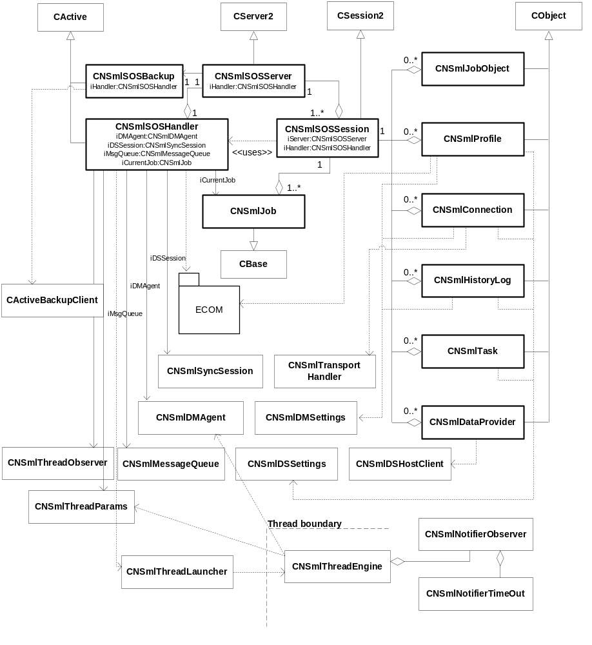
Figure 4.3 Symbian OS Server components
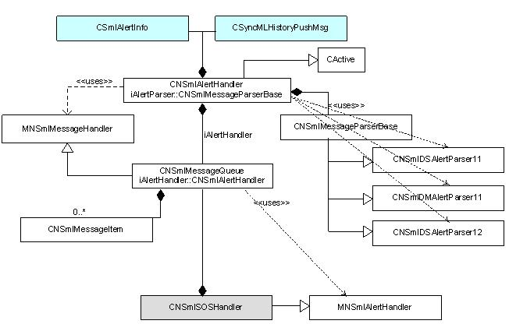
Figure 4.4 Alert queue component

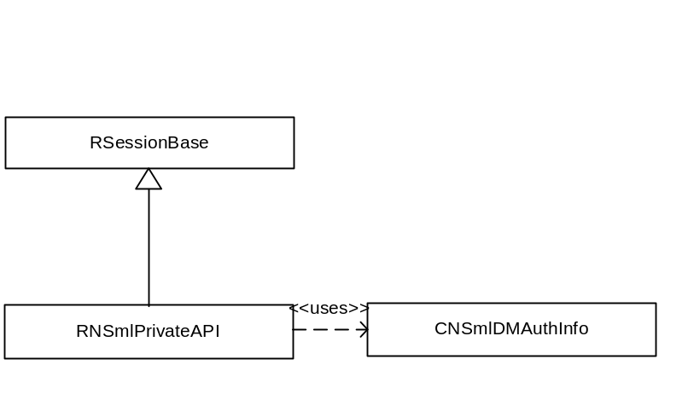
Figure 4.5 Private API component

Class descriptions
SyncML Symbian OS Server contains classes which are shortly described in this Section.

Class | Description | Header file
CNSmlSOSServer | The Symbian OS Server class. This class creates a handler class to take care of running and queuing synchronization jobs, and one session class for each client to process wanted services between client and server. | NSmlSOSServer.h
CNSmlSOSSession | The session class of the Symbian OS Server. Receives messages from the client, passes them to the sub session objects of to the handler class, process wanted services and replies to the client. | NSmlSOSServer.h
CNSmlSOSHandler | Handler class is inherited from CActive and it handles synchronization jobs. After starting a new job the class listens completion of request from the engine sync was started with. When sync job has been finished, handler starts the next job from queue if one exists. Handler also takes care of outstanding event requests and locking the profiles. | NSmlSOSServer.h
CNSmlSOSBackup | Backup class is inherited from CActive and it listens backup and restore states. When system starts backup or restore operation, backup class sets server in suspend mode. This class also ends suspend mode when backup or restore operation ends.  Agent log database is deleted during restore state. | NSmlSOSServer.h
CNSmlJob | This class stores parameters for the one sync job. Server reads parameters when stating a sync job and deletes job object after sync job is completed. Job object contains a pointer to the next object in the queue which is opened when current job has completed. | NSmlSOSServer.h
CNSmlJobObject | This module is a sub session object which links sub session to the CNSmlJob class to be able to read information about job. | NSmlSOSServer.h
CNSmlProfile | This module is a sub session object and it has methods to get, update and create profiles. | NSmlSOSServer.h
CNSmlTask | This module is a sub session object and it has methods to get, update and create tasks. | NSmlSOSServer.h
CNSmlConnection | This module is a sub session object and it has methods to get and update connections. | NSmlSOSServer.h
CNSmlHistoryLog | This module is a sub session object and it has methods to get and reset history logs. | NSmlSOSServer.h
CNSmlDataProvider | This module is a sub session object and it has methods to get data from data providers. | NSmlSOSServer.h
TNSmlThreadParams | Container for parameters needed to launch DM Session. | NSmlSOSThread.h
CNSmlThreadObserver | This module logs on to the DM Session thread and receives the status code of the session. Status code is returned when thread is exited. | NSmlSOSThread.h
CNSmlThreadEngine | This module starts and observers the DM Session. | NSmlSOSThread.h
CNSmlThreadLauncher | This module creates and launches a new thread. | NSmlSOSThread.h
CNSmlNotifierObserver | This module starts and observers notifier service.
CNSmlNotifierTimeOut | This module signals CNSmlNotifierObserver in case of time out.
CNSmlCancelTimeOut | This module performs job cancellation.
CNSmlMessageQueue | This class implements the queue for the SAN messages. Derived from MNSmlMessageHandler. | NSmlAlertQueue.h
MNSmlMessageHandler | MNSmlMessageHandler is an abstract interface containing methods for retrieving the message form alert queue and information about it. It must be implemented by derived classes. | NSmlAlertQueue.h
MNSmlAlertObserver | MNSmlAlertObserver is an abstract interface containing method to add a new job to server job queue. It must be implemented by derived classes. This is implemented in CNSmlSOSHandler | NSmlAlertQueueDefs.h
CNSmlAlertHandler | CNSmlAlertHandler is derived from CActive and it handles the SAN message parsing. A message is fetched from the alert queue and instance of CNSmlSOSHandler is called to create and add a new job to queue. | NSmlAlertQueue.h
CNSmlMessageItem | CNSmlMessageItem is a container for the received alert message containing the alert message, usage type and protocol version. It is a item of the alert queue. | NSmlAlertQueue.h
CNSmlParserFactory | CNSmlParserFactory creates an appropriate parser for the message to be parsed. Appropriate parser is decided based on the usage type and protocol version. | NSmlAlertQueue.h
CNSmlMessageParserBase | CNSmlMessageParserBase is a abstract base class for SAN message parser classes. This class must be implemented be the deriving classes. | NSmlAlertQueue.h
CNSmlDSAlertParser11 | CNSmlDSAlertParser11 class is derived from CNSmlMessageParserBase class. It implements the parsing of the SyncML protocol 1.1 version formatted messages. | NSmlAlertQueue.h
CNSmlDMAlertParser11 | CNSmlDMAlertParser11 class is derived from CNSmlMessageParserBase class. It implements the parsing of the SyncML protocol 1.2 version formatted alert messages. | NSmlAlertQueue.h
CNSmlDSAlertParser12 | CNSmlDSAlertParser12 class is derived from CNSmlMessageParserBase class. It implements the parsing of the SyncML protocol 1.2 version formatted alert messages. | NSmlAlertQueue.h
CNSmlAlertInfo | CNSmlAlertInfo class is a container for the profile id and matching data provider and sync type info. | NSmlAlertQueue.h
CNSmlAlertJobInfo | CNSmlAlertJobInfo is container for the information from which a new job is created. | NSmlAlertQueueDefs.h
RNSmlPrivateAPI | RNSmlPrivateAPI is used to transfer alert message. Derived from RSessionBase. | NSmlPrivateAPI.h
CNSmlDMAuthInfo | CNSmlDMAuthInfo is a container for DM authentication information. RNSmlPrivateAPI uses it to transfer DM authentication data to settings. | nsmldmauthinfo.h

CNSmlSOSServer

CNSmlSOSServer | Description
// construct/destruct
static CNSmlSOSServer* NewL() | Creates a new instance of Symbian OS Server.
~CNSmlSOSServer() | C++ destructor of this class. Frees all the resources allocated by this instance.
// public methods
CSession2* NewSessionL( const TVersion& aVersion, const RMessage2& aMessage ) const | The CServer2 base class calls this method. Creates a new instance of CNSmlSOSSession and returns it to the caller.
CObjectCon* NewContainerL() | This method creates new object container for sub sessions.
static void PanicServer( TNSmlSOSServerPanic aPanic ) | This method is used to panic server if the creation of the server fails in some point.
static TInt ThreadFunction( TAny* aStarted ) | This method is called when the thread is created. This method creates the CleanupStack, ActiveScheduler and the server class itself and releases the memory after ActiveScheduler is stopped.

CNSmlSOSSession

CNSmlSOSSession | Description
// construct/destruct
static CNSmlSOSSession* NewL( CNSmlSOSServer* aServer, CNSmlSOSHandler* aHandler ) | Creates a new instance of CNSmlSOSSession.
~CNSmlSOSSession() | C++ destructor of this class. Frees all the resources allocated by this instance.
// public methods
void ServiceL( const RMessage2& aMessage ) | The CServer2 base class calls ServiceL when the target for a message has been selected among the sessions. This method actually serves the request by calling the DispatchMessageL() method.
void DispatchMessageL( const RMessage2& aMessage ) | This method checks that a given request is a valid (i.e. the request is something that this session can serve), and then calls the appropriate method to do the actual task.  If command function in message is not valid, method panics whit error code KErrArgument.
void StoreToEventBuffer( MSyncMLEventObserver::TEvent aEvent, TInt aJobId, TInt aStatus ) | Stores EJobStart and EJobStop events to event buffer.
void StoreToProgessEventBuffer( const TNSmlProgressEvent& aProgressEventItem ) | Stores progress events to progress event buffer.
TBool ProgressEventsBuffered() | Returns ETrue if progress events are buffered.
CNSmlDSSettings& DSSettings() | This method returns reference to DS Settings database.
CNSmlDMSettings& DMSettings() | This method returns reference to DM Settings database.
CNSmlDSHostClient& HostClient() | This method returns reference to DS Host Client instance.

CNSmlSOSHandler

CNSmlSOSHandler | Description
// construct/destruct
CNSmlSOSHandler() | A C++ constructor for this class.
~CNSmlSOSHandler() | A destructor. Frees the resources allocated by this class.
// public methods
void LockProfile( const TInt aProfId ) | Adds the profile ID to the array of locked profiles.
void RemoveLock( const TInt aProfId ) | Removes profile ID from the array of locked profiles.
TBool IsLocked( const TInt aProfId ) | Returns ETrue if profile with given id is currently locked.
TInt AddJobL( CNSmlJob* aJob ) | Starts the job given as argument if no jobs currently running. Otherwise the job is added to queue and run when former jobs are handled.
CNSmlJob* FindJob( TInt aJobId ) | Fids the job with given ID from the queue.
TInt StopJob( const TInt aJobId, const TInt aCreatorId ) | Stops the job with the ID given as argument if currently running. If job is queued, it is removed from the queue.
void CurrentJob( TInt& aId, TSmlUsageType& aType ) | Returns the ID and usage type of the job currently running.
void QueuedJobsL( RArray<TInt>& aArray, const TSmlUsageType aType ) | Returns an id array of queued jobs of given usage type.
void AddProgressMsgL( const RMessage2& aMessage ) | Adds reference of RMessage2 from the session class to the array from which it is used when writing progress of a job to the client.
TBool CompleteBufProgressMsg( const TDesC8& aBuf, const CNSmlSOSSession* aSession ) | Writes progress info of a running job to the asynchronous progress message of the session which owns the running job.
void CancelProgressMsg( const CNSmlSOSSession* aSession ) | Removes the progress message from the message array and completes it.
void AddEventMsgL( const RMessage2& aMessagePtr ) | Adds reference of RMessage2 from the session class to the array from which it is used when event message is sent.
void CompleteEventMsgL( MSyncMLEventObserver::TEvent aEvent, TInt aId , TInt aError , TInt aAdditional ) | Writes event info and calls Complete() to all message references in event message array.
void CancelEventMsg( TInt aHandle ) | Removes the event message from the message array and completes it.
void ServerAlertL( TDesC8& aData, TSmlUsageType aType, TSmlProtocolVersion aVersion, TSmlTransportId aBearerType ) | Sends server alert message to the message queue in the ActiveAlert object.
void GenericAlertL( HBufC8* aMgmtUri, HBufC8* aMetaType, HBufC8* aMetaFormat, TInt aFinalResult, HBufC8* aCorrelator ) | Forwards the Generic Alert data to DM Agent, if it is created (i.e. if DM session is running). If DM Agent does not exist, leaves with KErrNotFound.
void IncreaseSessionCount() | Increments session count by one.
void DecreaseSessionCount() | Decrements session count by one. If session count decrement to zero and there is not a job running, the server is stopped.
void ServerSuspendedL( const TBool aSuspended ) | Backup class uses this method to set or unset server suspended.
TBool IsSuspended() | Returns ETrue if server is currently suspended.
void HandleEventMsgL( MSyncMLEventObserver::TEvent aEvent, TInt aStatus ) | Handles job associated events. Event is buffered to session requesting event notifications of events of the current job, if session exists.
void ClearSessionFromJob( const CNSmlSOSSession* aSession ) | Removes the referenced session from CNSmlJob instances. Called when active session is deleted.
HBufC8* WriteSyncErrorL( TErrorLevel aErrorLevel, TInt aError, TInt aTaskId, TInt aInfo1, TInt aInfo2 ) | Returns a pointer to streamed error event data.
HBufC8* WriteSyncProgressL( TStatus aStatus, TInt aInfo1, TInt aInfo2 ) | Returns a pointer to streamed progress event data.
HBufC8* WriteSyncModificationsL( TInt aTaskId, const TSyncMLDataSyncModifications& aClientMods, const TSyncMLDataSyncModifications& aServerMods ) | Returns a pointer to streamed modification event data.
// from MNSmlAlertObserver
void CreateJob( CNSmlAlertJobInfo& aJobInfo ) | Observer interface to server alert message queue to create jobs from server alerts.
// from MSyncMLProgressObserver
void OnSyncMLSyncError( TErrorLevel aErrorLevel, TInt aError, TInt aTaskId, TInt aInfo1, TInt aInfo2 ) | Observer interface to engine to receive synchronization error progress events.
void OnSyncMLSyncProgress( TStatus aStatus, TInt aInfo1, TInt aInfo2 ) | Observer interface to engine to receive synchronization progress events.
void OnSyncMLDataSyncModifications( TInt aTaskId, const TSyncMLDataSyncModifications& aClientMods, const TSyncMLDataSyncModifications& aServerMods ) | Observer interface to engine to receive synchronization modification progress events.

CNSmlSOSBackup

CNSmlSOSSession | Description
// construct/destruct
static CNSmlSOSBackup* NewL( CNSmlSOSHandler* aHandler ) | Creates a new instance of CNSmlSOSBackup.
~CNSmlSOSBackup() | C++ destructor of this class. Frees all the resources allocated by this instance.
// public methods
void Subscribe() | Subscribes this object to listen to changes in backup and restore modes.

CNSmlJob

CNSmlJob | Description
// construct/destruct
CNSmlJob() | A C++ constructor for this class.
~CNSmlJob() | A destructor. Frees the resources allocated by this class.
// public methods
TInt JobId() const | Returns the ID of the job.
TInt ProfileId() const | Returns the profile ID of the job.
TInt CreatorId() const | Returns the creator ID of the job.
TInt TransportId() const | Returns the transport ID of the job.
TSmlUsageType UsageType() const | Returns the usage type (DS/DM) of the job.
TNSmlJobType JobType() const | Returns the type of the job.
TSmlSyncType SyncType() const | Returns the sync type of the job.
RArray<TInt> TaskIds() const | Returns the array of task IDs of the job.
TBool JobRunning() const; | Returns whether job is running.
const CNSmlSOSSession* OwnerSession() const | Returns the owner session of the job.
CNSmlSOSSession* OwnerSessionNonConst() const | Returns the owner session of the job.
void SetJobId( const TInt aJobId ) | Sets the ID of the job.
void SetProfId( const TInt aProfId ) | Sets the profile ID of the job.
void SetCreatorId( const TInt aCreatorId ) | Sets the creator ID of the job.
void SetJobRunning( const TBool aRunning ) | Sets job running state depending on aRunning parameter.
void SetTransportId( const TInt aTransportId ) | Sets the transport ID of the job.
void SetUsageType( const TSmlUsageType aUsageType ) | Sets the usage type of the job.
void SetJobType( const TNSmlJobType aJobType ) | Sets the type of the job.
void SetSyncType( const TSmlSyncType aSyncType ) | Sets the sync type of the job.
void AddTaskId( const TInt aTaskId ) | Adds task ID to the job.
void SetOwnerSession( CNSmlSOSSession* aSession ) | Sets pointer of the owner session to the job.

CNSmlJobObject

CNSmlJobObject | Description
// construct/destruct
CNSmlJobObject() | A C++ constructor for this class.
~CNSmlJobObject() | A destructor. Frees the resources allocated by this class.
// public methods
TInt JobId() const | Returns the ID of the job this sub session object relates.
void SetJobId( const TInt aJobId ) | Sets the ID of the job this sub session object relates.

CNSmlProfile

CNSmlProfile | Description
// construct/destruct
CNSmlProfile(TSmlUsageType aUsageType, CNSmlSOSSession& aSession ) | A C++ constructor for this class: aUsageType defines the usage type of the profile (DM or DS), aSession is the reference to session.
~CNSmlProfile() | A destructor. Frees the resources allocated by this class.
// public methods
TInt ProfileId() const | Returns the ID of the profile.
void SetLocked() | Sets the profile locked for write mode.
TBool IsLocked() | Returns ETrue if the profile is locked.
void FetchDataL( const TInt aId ) | Fetches all the data of the profile from the database and packs it in a descriptor as a stream.
void ConnectionListL( RArray<TInt>& aArray ) | Returns a list of connections. Current implementation supports only one connection per profile.
void TaskListL( RArray<TInt>& aArray ) | Returns a list of tasks the profile owns.
TInt DataSize() | Returns the size of the profile data packed in a descriptor as a stream.
const TPtr8& ReadData() | Returns all the data of the profile packed in a buffer as a stream.
TInt UpdateDataL( TInt& aId, const TDesC8& aData ) | Writes the data of the profile to the database.
TBool DeleteTaskL( const TInt aId ) | Deletes task from the profile.
void SetCreatorId( const TInt aCreatorId ) | Sets the creator ID of the profile.
TSmlUsageType GetUsageType() | Returns the usage type of the profile (DS /DM).

CNSmlTask

CNSmlTask | Description
// construct/destruct
CNSmlTask( const TInt aProfId, TBool aNewTask, CNSmlSOSSession& aSession ) | A C++ constructor for this class: aProfId profile id, aNewTask whether task is new to profile or not, aSession is the reference to session.
~CNSmlTask() | A destructor. Frees the resources allocated by this class.
// public methods
void FetchDataL( const TInt aId ) | Fetches all the data of the task from the database and packs it in a descriptor as a stream.
TInt DataSize() | Returns the size of the task data packed in a descriptor as a stream.
const TPtr8& ReadData() | Returns all the data of the task packed in a buffer as a stream.
TInt UpdateDataL( TInt& aId, const TDesC8& aData ) | Writes the data of the task to the database.
void SetCreatorId( const TInt aCreatorId ) | Sets the creator ID of the task.
void SetDataProviderId( const TInt aTaskUID ) | Sets the implementation UID (data provider id) of the task.
TInt GetSupportedFiltersL() | Reads supported filters from DS Host Client.
TInt PrepareFilterBufferL( const TInt aTaskId ) | Reads supported filters from settings database or form DS Host Client if task is to be created.
TInt FilterSize() | Returns the size of the filter data packed in a descriptor as a stream.
const TPtr8& ReadFilter() | Returns filter data packed in a buffer as a stream.

CNSmlConnection

CNSmlConnection | Description
// construct/destruct
CNSmlConnection(const TInt aProfId, const TInt aTransId, CNSmlSOSSession& aSession ) | A C++ constructor for this class: aProfId is the profile identifier, aSession is the reference to session.
~CNSmlConnection() | A destructor. Frees the resources allocated by this class.
// public methods
TInt FetchDataL( const TInt aId ) | Fetches all the data of the connection from the database and packs it in a descriptor as a stream.
TInt DataSize() | Returns the size of the connection data packed in a descriptor as a stream.
const TPtr8& ReadData() | Returns all the data of the connection packed in a buffer as a stream.
TInt UpdateDataL( TInt& aId, const TDesC8& aData ) | Writes the data of the connection to the database.

CNSmlHistoryLog

CNSmlHistoryLog | Description
// construct/destruct
CNSmlHistoryLog(const TInt aProfId, CNSmlSOSSession& aSession ) | A C++ constructor for this class: aProfId is the profile identifier, aSession is the reference to session.
~CNSmlHistoryLog() | A destructor. Frees the resources allocated by this class.
// public methods
void FetchDataL() | Fetches the data of the history log from the database and packs it in a descriptor as a stream.
TInt DataSize() | Returns the size of the history log data packed in a descriptor as a stream.
const TPtr8& ReadData() | Returns the data of the history log packed in a buffer as a stream.
void UpdateDataL( const TDesC8& aData ) | Resets the history log data, i.e. removes all the data of the history log from the database.

CNSmlDataProvider

CNSmlDataProvider | Description
// construct/destruct
CNSmlDataProvider(const TInt aId, CNSmlSOSSession& aSession ) | A C++ constructor for this class: aId is the dataprovider identifier, aSession is the reference to session.
~CNSmlDataProvider() | A destructor. Frees the resources allocated by this class.
// public methods
void FetchDataL() | Fetches the data of the data provider and packs it in a descriptor as a stream.
TInt DataSize() | Returns the size of the data provider data packed in a descriptor as a stream.
const TPtr8& ReadData() | Returns the data of the data provider packed in a buffer as a stream.

TNSmlThreadParams

TNSmlThreadParams
// construct / destruct
CNSmlThreadParams(CNSmlJob& aJob, CNSmlDMAgent* aDMAgent, CNSmlDSAgent* aDSAgent ) | A C++ constructor for this class. aJob is a reference to current job data, aDMAgent is a pointer to DM Client Agent instance, . aDSAgent is a pointer to DM Client Agent instance.
~CNSmlThreadParams() | A C++ destructor for this class.

CNSmlThreadEngine

CNSmlThreadEngine
// construct/destruct
CNSmlThreadEngine( TNSmlThreadParams& aParams ) | A C++ constructor for this class. aParams is a reference to thread parameters that will be forwarded to DM Client Agent.
~CNSmlThreadEngine() | A destructor. Frees the resources allocated by this class.
// public methods
void StartJobSessionL() | Starts DM or DS job session.
TInt FinishedStatus() | Returns the status code of the finished DM session.
CNSmlDMAgent* DMAgentL() const | Returns pointer to dynamically loaded DM Agent.
CNSmlDSAgent* DSAgentL() const | Returns pointer to dynamically loaded DS Agent.
void CancelJob() | Cancel current job.
TInt VerifyJobFromNotifierL() | Launches notifier component to ask confirmation query from user.
TBool SilentModeL( const CNSmlThreadParams* aParams) | Check is current server ID mentioned to work in silent mode.
void SaveSessionInfoL() | Save session info which is needed later in DM agent to launch notifier.
void ForcedCertificateCheckL( TBool aForcedState) | Forces certificate check to be done.

CNSmlNotifierTimeOut

CNSmlNotifierTimeOut
// construct/destruct
CNSmlNotifierTimeOut() | A C++ constructor for this class
~ CNSmlNotifierTimeOut() | A destructor. Frees the resources allocated by this class.
// public methods
void LaunchNotifierTimer( CNSmlNotifierObserver* aObserver ) | Starts timer to signal time out. CNSmlNotifierObserver ::NotifierTimeOut() method is called.

CNSmlCancelTimeOut

CNSmlNotifierTimeOut
// construct/destruct
CNSmlCancelTimeOut( CNSmlDMAgent& iDMAgent, CNSmlDSAgent& iDSAgent ) | A C++ constructor for this class
~CNSmlCancelTimeOut() | A destructor. Frees the resources allocated by this class.
// public methods
void SetJobCancelled( TSmlUsageType aUsageType ) | Starts timer to signal job cancellation.

CNSmlThreadObserver

CNSmlThreadEngine
// construct/destruct
CNSmlThreadObserver ( TRequestStatus& aStatus ) | A C++ constructor for this class. aStatus is a reference to caller’s status member.
~CNSmlThreadObserver() | A destructor. Frees the resources allocated by this class.
// public methods
void LogonToThread( RThread& aThread ) | Logs on to the thread referenced by aThread parameter.

CNSmlNotifierObserver

CNSmlNotifierObserver
// construct/destruct
CNSmlNotifierObserver( TRequestStatus& aStatus, CNSmlThreadEngine* aEngine, CNSmlThreadParams& aParams ) | A C++ constructor for this class. aStatus is the reference to status of the caller, aParams is reference to CNSmlThreadParams instance.
~CNSmlNotifierObserver() | A destructor. Frees the resources allocated by this class.
// public methods
void ConnectToNotifierL( const TSyncMLAppLaunchNotifParams& aParam ) | Connects and launches notifier service to start a job.
void NotifierTimeOut() | Called by CNSmlNotifierTimeOut after set time limit.

TNSmlThreadLauncher

TNSmlThreadLauncher
// public methods
static TInt RunJobSession( TNSmlThreadParams& aParams, CNSmlThreadObserver& aObserver ) | Static method to run DM Session in new thread. aParams is reference to thread parameters that are passed to the thread to be launched. aObserver is a reference to the thread observer with is logged on to started thread.

CNSmlMessageQueue

CNSmlMessageQueue
// construct/destruct
static CNSmlMessageQueue* NewL( MNSmlAlertObserver* aObserver ) | Create a new instance of CNSmlMessageQueue. aObserver is a pointer to an instance of MNSmlAlertObserver.
virtual ~CNSmlMessageQueue() | A destructor. Frees the resources allocated by this class.
// public methods
void AddMessage( const TDesC8& aMessage, TSmlUsageType aType, TSmlProtocolVersion aVersion, TSmlTransportId aBearerType ) | Creates a new CNSmlMessageItem and adds it to the SAN message alert queue.
TBool IsEmpty() | Returns ETrue if the queue is empty.
void ServerSuspended( TBool aSuspend ) | Sets the suspend mode according to the value of aSuspend.
void CheckMessage( TBool& aMore, TSmlUsageType& aType, TSmlProtocolVersion& aVersion ); | Returns the type and version of the message stored in the alert queue. aMore is EFalse, if no messages are left in the queue. Method is derived from the base class.
TInt MessageSize() | Returns the size of the message stored in the alert queue.
void AlertMessage( TDes8& aMessage ) | Returns the message of the message stored in the queue.
void CreateJobL( CSmlAlertInfo& aInfo, TSmlUsageType aType, TBool& aQuit ) | Creates a job from CSmlAlertInfo and calls the instance of MNSmlAlertObserver.

MSmlMessageHandler

MNSmlMessageHandler
// construct/destruct
// public methods
void CheckMessage( TBool& aMore, TSmlUsageType& aType, TSmlProtocolVersion& aVersion ) = 0 | Checks if there is message in the queue and returns it’s the protocol version and usage type.
TInt MessageSize() = 0 | Returns the size of the queued SAN message
void AlertMessage( TDes8& aMessage ) = 0 | Makes a copy of the message and removes message item from the queue.
void CreateJobL( CSmlAlertInfo& aInfo, TSmlUsageType aType, TBool& aQuit ) = 0 | Gathers the parsed info to create a new job.

CNSmlMessageItem

CNSmlMessageItem
// construct/destruct
static CNSmlMessageItem* NewL( const TDesC8& aMessage, TSmlUsageType aType, TSmlProtocolVersion aVersion, TSmlTransportId aBearerType ) | Creates new instance of CNSmlMessageItem.
~CNSmlMessageItem() | Destructor.
// public methods
TDesC8& Message() | Returns a reference to message.

CNSmlParserFactory

CNSmlParserFactory
// construct/destruct
// public methods
CNSmlMessageParserBase* CreateAlertParserL( TSmlUsageType aType, TSmlProtocolVersion aVersion, CSmlAlertInfo& aAlertInfo, CSyncMLHistoryPushMsg& aHistoryInfo ) | Creates a new instance of a parser derived from CNSmlMessageParserBase.

CNSmlMessageParserBase

CNSmlMessageParserBase
// construct/destruct
CNSmlMessageParserBase( CSmlAlertInfo& aAlertInfo, CSyncMLHistoryPushMsg& aHistoryInfo ) | C++ constructor.
~CNSmlMessageParserBase(); | Destructor.
// public methods
virtual void ParseMessageL() = 0 | Pure virtual method to implement parsing.
void SearchProfileL( TDesC8& aServerUri ) = 0 | Pure virtual method to implement profile matching.
void MatchContentTypeL( TDesC8& aPath ) | Virtual method to implement Content type matching.
TPtr8& Message() | Returns a pointer to buffer used for parsing.
void CreateBufferL( TInt aSize ) | Creates a buffer of specified size.
void ResolveProfile( TInt aContentCount ) | Virtual method that resolves one profile from possible multiple matches.

CNSmlDSAlertParser11

CNSmlDSAlertParser11
// construct/destruct
CNSmlDSAlertParser11( CSmlAlertInfo& aAlertInfo, CSyncMLHistoryPushMsg& aHistoryInfo ) | C++ constructor.
virtual ~CNSmlDSAlertParser11() | Destructor.
// public methods
virtual void ParseMessageL() | Method to implement parsing.
void SearchProfileL( TDesC8& aServerUri ) | Pure virtual method to implement profile matching.
TBool SearchProfileURIL( CNSmlURI& aUri ) | Method to implement profile matching.
void PCDATAToUnicodeLC( const SmlPcdata_t& aPcdata, HBufC*& aUnicodeData ) const | Converts PCData to Unicode.
virtual void ResolveProfile( TInt aContentCount ) | Resolves one profile from possible multiple matches.
void MatchContentTypeL( TDesC8& aPath, TDesC8& aContentType, TInt aSyncType, TInt aProfileIndex ) | Implements Content type matching.
TBool ConvertContentTypeLC( TDesC& aMimeType, const TInt aDataProviderId ) | Checks alerted content type’s mime type against the supported mime types.

CNSmlDSAlertParser12

CNSmlDSAlertParser12
// construct/destruct
CNSmlDSAlertParser12( CSmlAlertInfo& aAlertInfo, CSyncMLHistoryPushMsg& aHistoryInfo ) | C++ constructor.
virtual ~CNSmlDSAlertParser12 () | Destructor.
// public methods
virtual void ParseMessageL() | Method to implement parsing.
void SearchProfileL( TDesC8& aServerUri ) | Pure virtual method to implement profile matching.
virtual void ResolveProfile( TInt aContentCount ) | Resolves one profile from possible multiple matches.
void MatchContentTypeL( TDesC8& aPath, TInt aContentType, TSmlSyncType aSyncType, TInt aProfileIndex ) | Resolves the alerted DS adapter plug-ins.

CNSmlDMAlertParser11

CNSmlDSAlertParser11
// construct/destruct
CNSmlDMAlertParser11( CSmlAlertInfo& aAlertInfo, CSyncMLHistoryPushMsg& aHistoryInfo ) | C++ constructor.
virtual ~CNSmlDMAlertParser11() | Destructor.
// public methods
virtual void ParseMessageL() | Method to implement parsing.
void SearchProfileL( TDesC8& aServerUri ) | Pure virtual method to implement profile matching.
virtual void ResolveProfile( TInt aContentCount ) | Resolves one profile from possible multiple matches.

RNSmlPrivateAPI

RNSmlPrivateAPI
// construct/destruct
RNSmlPrivateAPI() | C++ constructor.
~RNSmlPrivateAPI() | Destructor.
// public methods
void OpenL() | Creates session with SyncML Symbian OS Server and launches it necessary.
void SendL( const TDesC8& aData, TSmlUsageType aType, TSmlProtocolVersion aVersion, TUid aTransportId = KUidNSmlMediumTypeInternet ); | Transfers data from client to server. aData is a reference to data to be sent, aType specifies the usage type and aVersion specifies the used protocol version, aTransportId specifies the used transport medium.
void SetDMAuthInfoL( const CNSmlDMAuthInfo& aAuthInfo ) | Sends DM authentication info to server for saving.
void GetDMAuthInfo( CNSmlDMAuthInfo& aAuthInfo ) | Retrieves the DM authentication data from server.
TInt AddDMGenericAlertRequestL( const TDesC8& aMgmtUri, const TDesC8& aMetaType, const TDesC8& aMetaFormat, TInt aFinalResult, const TDesC8& aCorrelator ) const | Sends Generic Alert data to SOS Server, which forwards it to DM Agent, if it exists (i.e. DM session is currently running). Returns KErrNotFound, if DM Agent was not found in the server. aMgmtUri is the management URI used in the execute command, whose final result (aFinalResult) is about to be reported to remote server. aMetaType is the meta/type that should be used in the alert, aMetaFormat the meta/format that should be used in the alert, and aCorrelator the correlator that was received in the execute command.
void Close() | Closes session with SyncML Symbian OS Server.

CNSmlDMAuthInfo

CNSmlDMAuthInfo
// construct/destruct
CNSmlDMAuthInfo() | C++ constructor.
virtual ~CNSmlDMAuthInfo() | Destructor.
// public methods
virtual void InternalizeL( RReadStream& aStream ) | Reads data from given stream.
virtual void ExternalizeL( RWriteStream& aStream ) const | Writes data to given stream.
TInt DataSize() const | Returns the size of data.

Structs, type definitions and enumerations

Enumeration’s name | Description
TNSmlCommands | Commands for inter-process communication.
TNSmlRequestType | Type of outstanding receive request.
TNSmlProgressEventType | Type of progress event.
TNSmlJobType | Override type of the job.
TSmlUsageType | Protocol type (DS/DM).
TSmlSyncType | Synchronization type.
TSyncMLFilterMatchType | Filter match type.
TSyncMLFilterChangeInfo | Filter change info.

Struct name | Description
TNSmlJobEvent | Event buffer item.
TNSmlProgressEvent | Progress event buffer item.

nsmlsosserverdefs.h

Enumeration: TNSmlCommands | Description
Values of enumeration. | Commands for inter-process communication. See Appendix A – IPC commands.

Enumeration: TNSmlRequestType | Description
ENSmlTypeEvent | Outstanding event request type.
ENSmlTypeProgressEvent | Outstanding progress receive request type.

Enumeration: TNSmlProgressEventType | Description
ENSmlSyncError | Message includes error information. Used when outstanding progress receive request is processed.
ENSmlSyncProgress | Message includes session information. Used when outstanding progress receive request is processed.
ENSmlModifications | Message includes session information. Used when outstanding progress receive request is processed.

Enumeration: TNSmlJobType | Description
EDSJobProfile | Normal synchronization job. Profile settings are used.
EDSJobProfileST | Sync type override. Specified sync type is used instead of the profile’s sync type.
EDSJobTasks | Content type override. Tasks of the profile are overridden with specified tasks.
EDSJobTasksST | Content type and sync type override. Tasks of the profile and sync type are overridden with specified tasks.
EDSJobTransport | Used connection is overridden. Profile’s connection is overridden with specified connection identifier.
EDSJobTransportST | Used connection and sync type is overridden. Profile’s connection and sync type are overridden with specified connection.
EDSJobTaskTrans | Content type and connection override. Tasks of the profile and connection are overridden with specified tasks and connection id.
EDSJobTaskTransST | Content type, connection and sync type override. Tasks of the profile, connection and sync type are overridden with specified tasks, connection id and sync type.
EDMJobProfile | Normal device management job.
EDMJobTransport | Connection override. Profile’s connection is overridden with specified connection.

syncmldef.h

Enumeration: TSmlUsageType | Description
ESmlDataSync | Data synchronization.
ESmlDevMan | Device management.

Enumeration: TSmlSyncType | Description
ESmlTwoWay | Normal synchronization.
ESmlOneWayFromServer | Server sends its modifications to client, but client does not send its modifications back to server.
ESmlOneWayFromClient | Client sends its modifications to server, but server does not send its modifications back to client.
ESmlSlowSync | Client sends all its data to server and server
ESmlRefreshFromServer | Client data is replaced by server’s data.
ESmlRefreshFromClient | Server data is replaced by client’s data.

syncmldatafilter.h

Enumeration: TSyncMLFilterMatchType | Description
ESyncMLMatchDisabled | Match type cannot be changed.
ESyncMLMatchNotSelected | Match type value not set.
ESyncMLMatchAND | Match type value set as ‘AND’.
ESyncMLMatchOR | Match type value set as ‘OR’.

Enumeration: TSyncMLFilterChangeInfo | Description
ESyncMLDefault | Default value, no changes.
ESyncMLNoChanges | No changes made.
ESyncMLDynamicFiltersUpdated | Dynamic filters are updated.
ESyncMLFiltersMoreFiltersSupportedByServer | Filters added to server.
ESyncMLFiltersLessFiltersSupportedByServer | Filters removed from server.
ESyncMLFiltersUpdated | Many changes made to filters.

State diagrams
After the server has been started, it has two possible states: running and suspended. Server is subscribed to be informed when system backup and restore states changes. When backup or restore operation is performed, the server is suspended. Server is recovered after backup and restore operations are over.

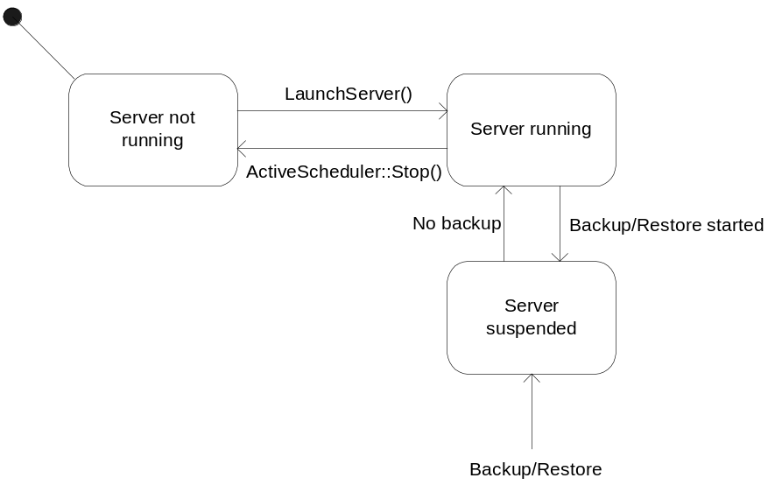
Figure 4.6 A state machine describing the behavior of Symbian OS Server

Operations
This is a description of the operations the server provides when running normally. In suspend mode, the server does not take any messages from the client, which means that none of these operations can be performed.
IPC commands and arguments used for operation inputs and outputs are listed in Appendix A.

Creating profile

Operation | Creating profile.
Preconditions | Server has been started and client has been successfully connected to the server.
Description | Client sends an IPC message to create sub session. Server creates a sub session object for the profile but does not make any modifications to the database.
Inputs | IPC call from client.
Modifies | Sub session object for the profile is created.
Outputs | Sub session handle is written into the IPC message.
Postconditions | Sub session object is ready to write data to the database.
Related To | CNSmlSOSServer, CNSmlSOSSession, CNSmlProfile
Related Event | 4.3.4.
Exceptions | Completes IPC message with a system-wide error code KErrPermissionDenied.

Opening profile

Operation | Opening profile.
Preconditions | Server has been started and the client has been successfully connected to the server.
Description | The client sends an IPC message with profile ID to create a sub session. The server creates a sub session object for the profile and reads all the profile data from the database. If the profile is opened in read-write mode, it is locked to prevent simultaneous access from another client to the same profile.
Inputs | IPC call from the client with profile ID and open mode info.
Modifies | Reads profile data from the database and stores it into sub session object.
Outputs | Size of the data and sub session handle is written into the IPC message.
Postconditions | Profile data is stored into the sub session object and profile is locked if opened in read-write mode.
Related To | CNSmlSOSServer, CNSmlSOSSession, CNSmlProfile.
Related Event | 4.3.3
Exceptions | Completes IPC message with system-wide error codes KErrLocked, and KErrPermissionDenied.

Getting profile

Operation | Getting profile.
Preconditions | Server has been started and the client has been successfully connected to the server. Profile has been opened.
Description | The client sends an IPC message with an allocated data buffer. Data from sub session object is written to the IPC message.
Inputs | IPC call from the client with an allocated data buffer.
Modifies | Reads profile data from the sub session object.
Outputs | Profile data is written into the IPC message.
Postconditions | If profile is opened in read-write mode, profile remains locked.
Related To | CNSmlSOSServer, CNSmlSOSSession, CNSmlProfile.
Related Event | 4.3.2
Exceptions | Completes IPC message with a system-wide error code KErrBadHandle.

Updating profile

Operation | Updating profile.
Preconditions | Server has been started and the client has been successfully connected to the server. Profile has been opened or created.
Description | The client sends an IPC message with a data buffer containing all the profile data. Data is read from the message and written into the database. If a new profile is created, it gets its ID which is written into the IPC message.
Inputs | IPC call from the client with a data buffer containing profile data.
Modifies | Writes all the data of the profile to the database.
Outputs | Profile id is written into the IPC message.
Postconditions | New profile is created into the database, or existing profile is updated.
Related To | CNSmlSOSServer, CNSmlSOSSession, CNSmlProfile.
Related Event | 4.3.1 and 4.3.2.
Exceptions | Completes IPC message with system-wide error codes KErrPermissionDenied, and KErrBadHandle.

Deleting profile

Operation | Deleting profile.
Preconditions | Server has been started and the client has been successfully connected to the server.
Description | The client sends an IPC message with profile ID. Profile is removed from the database and all the data is deleted.
Inputs | IPC call from client with profile ID.
Modifies | Removes the profile from the database.
Outputs | IPC message is completed.
Postconditions | Profile is removed from the database.
Related To | CNSmlSOSServer, CNSmlSOSSession, CNSmlProfile.
Related Event
Exceptions | Completes the IPC message with a system-wide error code KErrPermissionDenied.

Creating task

Operation | Creating task.
Preconditions | Server has been started and the client has been successfully connected to the server. Profile has been created and updated, or an existing profile has been opened.
Description | The client sends an IPC message with profile ID and data provider ID to create a sub session. The server creates a sub session object for the task, but does not make any modifications to the database.
Inputs | IPC call from the client with profile ID and data provider ID.
Modifies | Sub session object for the task is created.
Outputs | Sub session handle is written into the IPC message.
Postconditions | Sub session object is ready to write data to the database.
Related To | CNSmlSOSServer, CNSmlSOSSession, CNSmlTask.
Related Event | 4.3.9.
Exceptions | Completes the IPC message with a system-wide error code KErrAlreadyExists.

Opening task

Operation | Opening task.
Preconditions | Server has been started and the client has been successfully connected to the server. Profile has been created and updated or an existing profile has been opened.
Description | The client sends an IPC message with profile ID and task ID to create a sub session. Server creates a sub session object for the task and reads all the task data from the database.
Inputs | IPC call from client with profile ID and task ID.
Modifies | Reads task data from the database and stores it into sub session object.
Outputs | Size of the data and sub session handle is written into the IPC message.
Postconditions | Task data is stored into the sub session object.
Related To | CNSmlSOSServer, CNSmlSOSSession, CNSmlTask.
Related Event | 4.3.8.
Exceptions | Completes the IPC message with system-wide error codes KErrBadHandle, and KErrNotFound.

Getting task

Operation | Getting task.
Preconditions | Server has been started and the client has been successfully connected to the server. Task has been opened.
Description | The client sends an IPC message with an allocated data buffer. Data from sub session object is written to the IPC message.
Inputs | IPC call from the client with an allocated data buffer.
Modifies | Reads task data from the sub session object.
Outputs | Task data is written into the IPC message.
Postconditions
Related To | CNSmlSOSServer, CNSmlSOSSession, CNSmlTask.
Related Event | 4.3.7.
Exceptions | Completes the IPC message with a system-wide error code KErrBadHandle.

Updating task

Operation | Updating task.
Preconditions | Server has been started and the client has been successfully connected to the server. Task has been opened or created.
Description | The client sends an IPC message with a data buffer containing all the task data. Data is read from the message and written into the database.
Inputs | IPC call from the client with data buffer containing task data.
Modifies | Writes all the data of the task to the database.
Outputs | IPC message is completed.
Postconditions | New task is created into the database, or an existing task is updated.
Related To | CNSmlSOSServer, CNSmlSOSSession, CNSmlTask.
Related Event | 4.3.6 and 4.3.7.
Exceptions | Leaves with a system-wide error code KErrBadHandle.

Deleting task

Operation | Deleting task.
Preconditions | Server has been started and the client has been successfully connected to the server. Profile has been opened.
Description | The client sends an IPC message with profile ID and task ID. Task is removed from the database and all the data is deleted.
Inputs | IPC call from the client with profile ID and task ID.
Modifies | Removes the task from the specified profile from the database.
Outputs | IPC message is completed.
Postconditions | Task is removed from the profile.
Related To | CNSmlSOSServer, CNSmlSOSSession, CNSmlTask.
Related Event
Exceptions | Completes the IPC message with system-wide error codes KErrPermissionDenied, and KErrBadHandle.

Creating connection
Not supported. When the profile is created, the default value Internet is set as a connection value.

Opening connection

Operation | Opening connection.
Preconditions | Server has been started and the client has been successfully connected to the server. Profile has been created and updated, or an existing profile has been opened.
Description | The client sends an IPC message with profile ID and transport ID to create a sub session. Server creates a sub session object for the connection and reads all the connection data from the database.
Inputs | IPC call from the client with profile ID and transport ID.
Modifies | Reads connection data from the database and stores it into the sub session object.
Outputs | Size of the data and sub session handle are written into the IPC message.
Postconditions | Connection data is stored into the sub session object.
Related To | CNSmlSOSServer, CNSmlSOSSession, CNSmlConnection.
Related Event | 4.3.13.
Exceptions | Completes the IPC message with a system-wide error code KErrNotFound.

Getting connection

Operation | Getting connection.
Preconditions | Server has been started and the client has been successfully connected to the server. Connection has been opened.
Description | The client sends an IPC message with an allocated data buffer. Data from sub session object is written to the IPC message.
Inputs | IPC call from the client with an allocated data buffer.
Modifies | Reads connection data from the sub session object.
Outputs | Connection data is written into the IPC message.
Postconditions
Related To | CNSmlSOSServer, CNSmlSOSSession, CNSmlConnection.
Related Event | 4.3.12.
Exceptions | Completes the IPC message with a system-wide error code KErrBadHandle.

Updating connection

Operation | Updating connection.
Preconditions | Server has been started and the client has been successfully connected to the server. Connection has been opened or created.
Description | The client sends an IPC message with a data buffer containing all the connection data. Data is read from the message and written into the database.
Inputs | IPC call from the client with a data buffer containing connection data.
Modifies | Writes all the data of the connection to the database.
Outputs | IPC message is completed.
Postconditions | Connection is updated.
Related To | CNSmlSOSServer, CNSmlSOSSession, CNSmlConnection.
Related Event | 4.3.11 and 4.3.12.
Exceptions | Completes the IPC message with a system-wide error code KErrBadHandle.

Deleting connection
Not supported. Connection data can only be updated.

Opening history log

Operation | Opening history log.
Preconditions | Server has been started and the client has been successfully connected to the server. Profile has been created and updated, or an existing profile has been opened.
Description | The client sends an IPC message with a profile ID to create a sub session. Server creates a sub session object for the history log and reads all the history log data from the database.
Inputs | IPC call from the client with a profile ID.
Modifies | Reads history log data from the database and stores it into sub session object.
Outputs | Size of the data and sub session handle is written into the IPC message.
Postconditions | History log data is stored into the sub session object.
Related To | CNSmlSOSServer, CNSmlSOSSession, CNSmlHistoryLog.
Related Event | 4.3.17 and 4.3.18.
Exceptions | Completes the IPC message with system-wide error codes.

Getting history log

Operation | Getting history log.
Preconditions | Server has been started and the client has been successfully connected to the server. History log has been opened.
Description | The client sends an IPC message with an allocated data buffer. Data from sub session object is written to the IPC message.
Inputs | IPC call from client with allocated data buffer.
Modifies | Reads history log data from the sub session object.
Outputs | History log data is written into the IPC message.
Postconditions
Related To | CNSmlSOSServer, CNSmlSOSSession, CNSmlHistoryLog.
Related Event | 4.3.16.
Exceptions | Completes the IPC message with a system-wide error code KErrBadHandle.

Resetting history log

Operation | Resetting history log.
Preconditions | Server has been started and the client has been successfully connected to the server. History log has been opened.
Description | Data of the opened history log is removed from the database.
Inputs | IPC call from the client.
Modifies | Overwrites the profile history log with an empty stream.
Outputs | IPC message is competed.
Postconditions | Profile’s history log is removed from the database.
Related To | CNSmlSOSServer, CNSmlSOSSession, CNSmlHistoryLog.
Related Event | 4.3.16.
Exceptions | Completes the IPC message with a system-wide error code KErrBadHandle.

Opening data provider

Operation | Opening data provider.
Preconditions | Server has been started and the client has been successfully connected to the server.
Description | The client sends an IPC message with data provider ID to create a sub session. Server creates a sub session object for the data provider and reads all the data provider data from the database.
Inputs | IPC call from the client with data provider ID.
Modifies | Reads data provider data from the database and stores it into sub session object.
Outputs | Size of the data and sub session handle is written into the IPC message.
Postconditions | Data provider data is stored into the sub session object.
Related To | CNSmlSOSServer, CNSmlSOSSession, CNSmlDataProvider, CNSmlDSHostClient.
Related Event | 4.3.20.
Exceptions | Completes the IPC message with system-wide error codes.

Getting data provider

Operation | Getting data provider.
Preconditions | Server has been started and the client has been successfully connected to the server. Data provider has been opened.
Description | The client sends an IPC message with an allocated data buffer. Data from sub session object is written to the IPC message.
Inputs | IPC call from the client with an allocated data buffer.
Modifies | Reads data provider data from the sub session object.
Outputs | Data provider data is written into the IPC message.
Postconditions
Related To | CNSmlSOSServer, CNSmlSOSSession, CNSmlDataProvider, CNSmlDSHostClient.
Related Event | 4.3.19.
Exceptions | Completes the IPC message with a system-wide error code KErrBadHandle.

Creating job

Operation | Creating job.
Preconditions | Server has been started and the client has been successfully connected to the server.
Description | The client sends an IPC message containing all the arguments needed to create a new job. IPC command defines the job type and, based on the type, the data is read and written to the job object. When the job object is ready, the job is started. If there is another job running, the job is queued and run after the previous job has been finished.
Inputs | IPC message containing job data.
Modifies | Starts the job or adds the job to the queue if another job is running.
Outputs | IPC message is completed.
Postconditions | Job is started or added to job queue.
Related To | CNSmlSOSServer, CNSmlSOSSession, CNSmlJobObject, CNSmlJob, CNSmlSOSHandler.
Related Event | 4.3.23.
Exceptions | Completes the IPC message with system-wide error codes.

Opening job

Operation | Opening job.
Preconditions | Server has been started and the client has been successfully connected to the server. Job has been created.
Description | The client sends an IPC message with job ID. Server creates a sub session object for the job and links it to the job object with the given ID.
Inputs | IPC message containing job ID.
Modifies | Creates a new sub session object and links it to the job data.
Outputs | IPC message is completed.
Postconditions | Sub session object is ready for reading job data or to stop the job.
Related To | CNSmlSOSServer, CNSmlSOSSession, CNSmlJobObject, CNSmlJob, CNSmlSOSHandler.
Related Event | 4.3.23.
Exceptions | Completes the IPC message with a system-wide error code KErrNotFound.

Stopping job

Operation | Stopping job.
Preconditions | Server has been started and the client has been successfully connected to the server. Job has been opened.
Description | If a job is running, the cancel method from the engine is called. If the job is queued, the job object is removed from the queue and the next job takes its place.
Inputs | IPC call from the client.
Modifies | Stops the job or removes it from queue.
Outputs | IPC message is completed.
Postconditions | Job has been removed.
Related To | CNSmlSOSServer, CNSmlSOSSession, CNSmlJobObject, CNSmlJob, CNSmlSOSHandler.
Related Event | 4.3.22.
Exceptions | Completes the IPC message with system-wide error codes KErrBadHandle, and KErrNotFound.

Server alerted job

Operation | Server alerted job.
Preconditions | Server has been started and the client has been successfully connected to the server. Job has been opened.
Description | Server adds server alert message to the message queue where it is parsed. Message queue sends job parameters to the server handler, which creates a new job and adds it to the job queue.
Inputs | IPC call with server alert message.
Modifies | Adds a new job to the job queue.
Outputs | IPC message is completed.
Postconditions | When the server alerted job is next to run, the server send message to the notifier which sends a response to the server whether the job is going to be run or not. If notifier does not send a response, timeout rejects the job after five minutes.
Related To | CNSmlSOSServer, CNSmlSOSSession, CNSmlJob, CNSmlSOSHandler.
Related Event
Exceptions | Completes the IPC message with system-wide error codes.

Send DM authentication info

Operation | Save DM authentication info.
Preconditions | Server has been started and the client has been successfully connected to the server.
Description | DM authentication data is filled. Data is sent through Private API to SyncML Symbian OS Server. Server receives the data and saves it.
Inputs | IPC call with DM authentication info.
Modifies | Data is correctly saved to settings.
Outputs | IPC message is completed.
Postconditions | Data is correctly saved to settings.
Related To | CNSmlSOSServer, CNSmlSOSSession, CNSmlSOSHandler, CNSmlDMSettings, RNSmlPrivateAPI, CNSmlDMAuthInfo.
Related Event
Exceptions | Completes the IPC message with system-wide error codes.

Retrieve DM authentication info

Operation | Retrieve DM authentication info.
Preconditions | Server has been started and the client has been successfully connected to the server.
Description | Private API opens connection to server. DM authentication data is read from settings. Data is received through Private API.
Inputs | IPC call to get DM authentication info.
Modifies | Data is correctly read from settings.
Outputs | IPC message is completed.
Postconditions | Data is correctly read from settings.
Related To | CNSmlSOSServer, CNSmlSOSSession, CNSmlSOSHandler, CNSmlDMSettings, RNSmlPrivateAPI, CNSmlDMAuthInfo.
Related Event
Exceptions | Completes the IPC message with system-wide error codes.

Adding generic alert

Operation | Adding generic alert to DM session’s initiation message.
Preconditions | Server has been started and the client has been successfully connected to the server.
Description | Generic alert data is filled to a buffer, which is sent through Private API to SyncML Symbian OS Server. Server receives the data and forwards it to DM Agent.
Inputs | IPC call to add generic alert data.
Modifies | Data is correctly added to DM Agent.
Outputs | IPC message is completed.
Postconditions | Data is correctly added to DM Agent.
Related To | CNSmlSOSServer, CNSmlSOSSession, CNSmlSOSHandler, RNSmlPrivateAPI, CNSmlDMAgent.
Related Event
Exceptions | Completes the IPC message with a system-wide error code KErrNotFound, when DM session is not currently running, i.e. DM Agent has not been instantiated and therefore is not found.

Requesting event notification

Operation | Requesting event notification.
Preconditions | Server has been started and the client has been successfully connected to the server.
Description | The client requests event notifications by sending an outstanding asynchronous IPC message. When an event occurs on the server, all the event messages of the connected clients are completed with event info. The client may cancel requesting the event messages by sending an IPC message with a cancel command.  If a job is running and the owner session of the job is not found, then the EJobStart and EJobStop events are being buffered until the owner renews its request.
Inputs | Asynchronous IPC message from the client.
Modifies | Writes event info to the client’s IPC message.
Outputs | Event info is written to IPC message.
Postconditions | The client sends a new asynchronous IPC message which is added to the handler to wait for new event to occur.
Related To | CNSmlSOSServer, CNSmlSOSSession, CNSmlSOSHandler.
Related Event | Outstanding event request notification.
Exceptions | Completes the IPC message with a system-wide error code KErrCancel.

Requesting progress event notification

Operation | Requesting progress event notification.
Preconditions | Server has been started and the client has been successfully connected to the server.
Description | The client requests progress event notifications by sending an outstanding asynchronous IPC message. When a job is running, the progress event message of the client owning the job is completed with event info. The client may cancel requesting progress event messages by sending an IPC message with a cancel command.  If the owner session of the job is not found, the progress event is buffered until the owner renews its request.
Inputs | Asynchronous IPC message from the client.
Modifies | Writes progress event info to the client’s IPC message.
Outputs | Progress event info is written to IPC message.
Postconditions | The client sends a new asynchronous IPC message which is added to the handler to wait for new progress event to occur.
Related To | CNSmlSOSServer, CNSmlSOSSession, CNSmlSOSHandler.
Related Event | Outstanding progress event request notification.
Exceptions | Completes the IPC message with a system-wide error code KErrCancel.

Backup and Restore
SyncML Symbian OS Server takes part in backup and restore as an active and passive backup client. It listens publish and subscribe services to notice changes in backup and restore modes and connects to Secure Backup Engine. Backup data is not however transferred actively during backup operation.
Backup operation suspends server. If there is a job running, it is cancelled and removed from the queue. Also alert message queue is suspended and references to settings databases and DS host client are released. When server is suspended, all the messages for client are completed with error code KErrSuspended. Agent log database is deleted during restore operation.
After backup operation server recovers and starts the next job from the job queue if one exists. Client messages are received and handled normally.
Backup and Restore data is described in the backup_registration.xml file, which is exported into the private directory of SyncML Symbian OS Server. Below is the content of the backup registration file.

<?xml version="1.0" standalone="yes"?>
<!-- Copyright (c) 2004, Symbian Software Ltd. All Rights Reserved -->

<backup_registration version="1.0">

<active_backup process_name="nsmlsosserver" requires_delay_to_prepare_data="no" supports_selective="no" supports_incremental="no">
</active_backup>

<dbms_backup policy="101F99FB" />

<restore requires_reboot = "no"/>

</backup_registration>

Variation
SyncML Symbian OS Server itself does not support any variation. All the variation needed in the system is made in the client DLL. An exception is the __POLICY_MANAGEMENT feature flag, which is used to enable settings enforcement.

System resource usage

Files
This component does not use any files.

Other data

Databases
This component uses DS and DM settings databases via DS and DM settings modules, i.e. SyncML Symbian OS Server does not use databases directly.

Central Repository
This component uses TARM PolicyManagement Util Central Repository API. The API is used for Policy Management to force certificate check.

Publish and Subscribe
This component uses the Publish and Subscribe service to follow the start and end of backup and restore operations to set the server as suspended during backup or restore.

Memory consumption
This component’s ROM and user data area consumption is listed here.

Memory/Build | Consumption
User data area
WINSCW UDeb | 383 160 bytes.
ARMI URel | [TBD]
Heap size | 1 MB.

Task allocation
SyncML Symbian OS Server is running in its own process which is started and stopped within the server executable.

Performance
No special requirements for performance are needed, and no special performance solutions are provided by this component.

Timers
This component uses timer for timeout when contacting notification server to confirm start of server alerted job.

Timer | Purpose | Interval | Lifetime
RTimer | Timeout | 5 minutes | Timer starts just before notifier service is called, and is cancelled if notifier responses.

Security

Capabilities of this component

Capability | Justification
CAP_SERVER NetworkControl | Default server capabilities defined by platform and NetworkControl.

Input and output validation
This component does not require or make any validation for data.

Environmental assumptions
- The only API to access DS settings data is DS settings API and the only API to access DM settings data is DM settings API.
- Data that is stored in NSmlDSSettings.db and NSmlDMSettings.db is assumed to be writable only by this component.
- Notification service is needed for server alert handling.

Additional enforcements
This component does not have any additional security enforcements.

Exception handling
The leave mechanism of the Symbian OS environment is used to handle memory exhaustion and panic mechanism is used in server launch and in invalid IPC commands.
Exceptions are handled at the client side by completing IPC messages with appropriate error codes.

Exception | Description
KErrGeneral | Server launch has failed.
KErrNotSupported | Client tries to connect to the server with incompatible version.
KErrSuspended | Server is suspended.
KErrAlreadyExists | Created job already exists.
KErrNotFound | Job does not exist.
KErrNotFound | Can not open connection, transport id is not set for the profile.
KErrPermissionDenied | Client does not have capability to requested service.
KErrPermissionDenied | Job is tried to stop by client who does not own the job.
KErrCancel | Outstanding event request cancelled by client.
KErrAccessDenied | Deletion of the profile is not allowed.
KErrLocked | Profile is locked by another client.
KErrBadHandle | Sub session handle does not match with any of opened sub session.
KErrOverflow | All the data does not fit into the return message.
KErrArgument | IPC command is invalid, raises panic to the client.

Usage

Building
SyncML Symbian OS Server is built as any module in system.

User's guide
SyncML Symbian OS Server is used by Client API, which is described in reference document [1] and Private API described in Section 4.2.27.

Appendix A – IPC commands

IPC operation code | IPC arg0 | IPC arg1 | IPC arg2 | IPC arg3
ECmdEventRequest | TDes [ in ]  Event data
ECmdEventRequestCancel
ECmdProgressRequest | TDes [ in ]  Event data
ECmdProgressRequestCancel
ECmdJobListCurrent | TInt [ in ]  Job ID | TInt [ in ]  UsageType
ECmdJobListStart | TDes [ in ]  Job IDs | TInt [ out ]  UsageType
ECmdJobListNext | TDes [ in ]  Job IDs
ECmdProfileListStart | TDes [ in ]  Profile IDs | TInt [ out ]  UsageType
ECmdProfileListNext | TDes [ in ]  Profile IDs
ECmdProfileDelete | TInt [ out ]  Profile ID
ECmdConnList | TDes [ in ]  Connection IDs |  |  | *
ECmdProfileSet | TInt [ in ]  Profile ID | TDes [ out ]  Profile data |  | *
ECmdProfileClose |  |  |  | *
ECmdProfileCreateDS |  |  |  | *
ECmdProfileOpenDS | TInt [ in ]  Data size | TInt [ out ]  Profile ID | TInt [ out ]  Open mode | *
ECmdProfileGetDS | TDes [ in ]  Profile data |  |  | *
ECmdTaskListStart | TDes [ in ]  Task IDs |  |  | *
ECmdTaskListNext | TDes [ in ]  Task IDs |  |  | *
ECmdTaskDelete | TInt [ out ]  Task ID |  |  | *
ECmdProfileCreateDM | - |  |  | *
ECmdProfileOpenDM | TInt [ in ]  Data size | TInt [ out ]  Profile ID | TInt [ out ]  Open mode | *
ECmdProfileGetDM | TDes [ in ]  Profile data |  |  | *
ECmdConnOpen | TInt [ in ]  Data size | TInt [ out ]  Profile ID | TInt [ out ]  Transport ID | *
ECmdConnGet | TDes [ in ]  Connection data |  |  | *
ECmdConnSet | TDes [ out ]  Connection data |  |  | *
ECmdConnClose |  |  |  | *
ECmdCreateTask | TInt [ out ]  Profile ID | TInt [ out ]  Data provider ID |  | *
ECmdTaskOpen | TInt [ in ]  Data size | TInt [ out ]  Profile ID | TInt [ out ]  Task ID | *
ECmdTaskGet | TDes [ in ]  Task data |  |  | *
ECmdTaskFilterBufferSize | TInt [ in ]  Filter buffer size | TInt [ out ]  Task ID
ECmdTaskSupportedFilters |  |  |  | *
ECmdTaskSet | TInt [ in ]  Task ID | TDes [ out ]  Task data |  | *
ECmdTaskClose |  |  |  | *
ECmdJobClose |  |  |  | *
ECmdDataSyncJobCreateFor  Profile | TInt [ in ]  Job ID | TDes [ out ]  Job data |  | *
ECmdDataSyncJobCreateForTasks | TInt [ in ]  Job ID | TDes [ out ]  Job data |  | *
ECmdDataSyncJobCreateFor  Transport | TInt [ in ]  Job ID | TDes [ out ]  Job data |  | *
ECmdDataSyncJobCreateFor  TransportAndTasks | TInt [ in ]  Job ID | TDes [ out ]  Job data |  | *
ECmdDataSyncJobCreateFor  ProfileST | TInt [ in ]  Job ID | TDes [ out ]  Job data |  | *
ECmdDataSyncJobCreateForTasksST | TInt [ in ]  Job ID | TDes [ out ]  Job data |  | *
ECmdDataSyncJobCreateFor  TransportST | TInt [ in ]  Job ID | TDes [ out ]  Job data |  | *
ECmdDataSyncJobCreateFor  TransportAndTasksST | TInt [ in ]  Job ID | TDes [ out ]  Job data |  | *
ECmdJobOpen | TInt [ in ]  Data size | TInt [ out ]  Job ID |  | *
ECmdJobGet | TDes [ in ]  Job data |  |  | *
ECmdJobStop |  |  |  | *
ECmdDevManJobCreate | TInt [ in ]  Job ID | TInt [ out ]  Job data |  | *
ECmdDevManJobCreateForTransport | TInt [ in ]  Job ID | TInt [ out ]  Job data |  | *
ECmdJobOpen | TInt [ in ]  Data size | TInt [ out ]  Job ID |  | *
ECmdJobGet | TDes [ in ]  Job data |  |  | *
ECmdJobStop |  |  |  | *
ECmdDataProviderOpen | TInt [ in ]  Data size | TInt [ out ]  Data provider ID |  | *
ECmdDataProviderGet | TDes [ in ]  Data provider data |  |  | *
ECmdDataProviderClose |  |  |  | *
ECmdHistoryLogOpen | TInt [ in ]  Data size | TInt [ out ]  Profile ID |  | *
ECmdHistoryLogGet | TDes [ in ]  History log data |  |  | *
ECmdHistoryLogReset |  |  |  | *
ECmdHistoryLogClose |  |  |  | *
ECmdServerAlert | TDes [ out ]  Server alert data | TInt [ out ]  Usage type | TInt [ out ]  Protocol version
ECmdInitDMAuthInfo | TInt [ out ]  Profile ID | TInt [ in ]  Data size
ECmdGetDMAuthInfo | TDes [ in ]  Auth info data
ECmdSetDMAuthInfo | TInt [ out ]  Profile ID | TDes [ out ]  Auth info data
ECmdAddDMGenericAlert | TDes [ out ]  Generic alert data

Directions of the data:
[ in ] From server to client.
[out] From client to server.

IPC commands used with sub sessions reserve the fourth IPC argument (in the table marked with *) to the sub session handle.

