S60 3.1
TARM SCP Device Lock Enhancements
User’s Guide

Team name | Author
 | Rajesh Hegde

Change history:

Version | Date | Status | Comments
1.0 | 20.12.2006 | Approved

Table of contents:

1. General 4
1.1 Introduction 4
2. Description 5
2.1 SECUI 5
2.1.1 Checking the maximum Autolock period 5
2.1.2 Storing the new code changed by the user 6
2.1.3 Handling the code queries 7
2.1.4 Propagating the code change request to SCP Server 7
2.2 Security Observer 7
2.3 AutoLock 8
2.3.1 Allowing Autolock deactivation 8
2.3.2 Allowing Autolock activation when a call is in progress 9
2.3.3 Initiating SCP configuration check 9
2.4 General Settings 9
3. Variation 10

General
This document describes the changes made to S60 dependent components to allow changed functionality defined for the SCP module, which is a part of the TARM project. The following sections describe the changes for each component. This document assumes that the reader is familiar with the context in which these changes are required. Also, the semantics of the operations will be described in the document, while the actual detailed implementation is available in the provided source files, tagged with the variation flag __SAP_TERMINAL_CONTROL_FW. Implemented items are variated by including the flag __SAP_DEVICE_LOCK_ENHANCEMENTS. This flag controls the inclusion of the features, which implement the enhanced security code handling, and the new security code checking. The features that differ in these two cases will be indicated in the description of the feature. Otherwise the description applies for both cases, that is, whether or not the device lock enhancements are active.

Introduction
This document is not an introduction to a new component but a description of changes to be made in already existing components such as AutoLock, General Settings, Security Observer and SecUI, etc.

Description
The changes made to the components are discussed below.

SECUI
Four changes were required for the SecUI component.
- Checking the Autolock period set by the user through General Settings (SecUISecuritySettings.cpp)
- Storing the new security code to SCP Server, after the user has changed the code (SecUISecuritySettings.cpp) (not valid for Device Lock Enhancements)
- Propagating the code queries to SCP Server (SecUISecurityHandler.cpp) (Device Lock Enhancements only)
- Propagating the code change request to SCP Server (SecUISecuritySettings.cpp) (Device Lock Enhancements only)

The maximum period check requires also changes to SecUI.rss and in localization information. For this purpose a new file named SecUI_DIY.loc is added along SecUi.loc. These files include the buffer resources and the localization strings for the texts that are shown in the notes, which inform the user that the maximum Autolock period check has failed. Additionally the SecUI.mmp-file had to be modified to include the SCPClient.lib library.

Checking the maximum Autolock period
The maximum Autolock period checking is done in CSecuritySettings::ChangeAutoLockPeriodL. This is the method that is called when the user wishes to change the Autolock period. The added code block is entered after the user has entered the desired value. It first reads the maximum Autolock period from the server, and then checks if the value the user entered is allowed according to the maximum period. That is, if the maximum period is defined, the entered period cannot be zero, or larger than the maximum period. If the maximum period is zero, no restrictions are applied to the period the user has set.
If the check passes, no action is taken, and SecUI sets the period normally. If the check fails, however, an error note, which indicates the restriction (not allowed to disable Autolock, or the period is too long), is shown, and the user is prompted for a new value for the period. This sequence is shown in Figure 2.1.
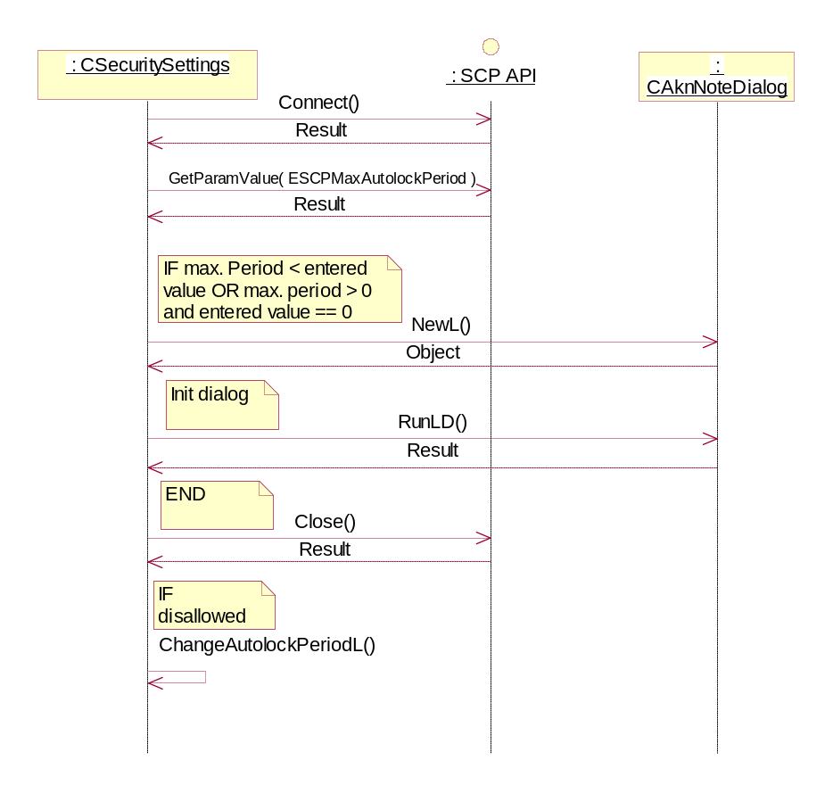
Figure 2.1 Checking the maximum Autolock period

Storing the new code changed by the user
Note: not valid for Device Lock Enhancements.
The storing code block is implemented in CSecuritySettings::ChangeSecCodeL. The implementation simply forwards the new code to SCP Server after showing the result note to the user. This sequence is illustrated in Figure 2.2.
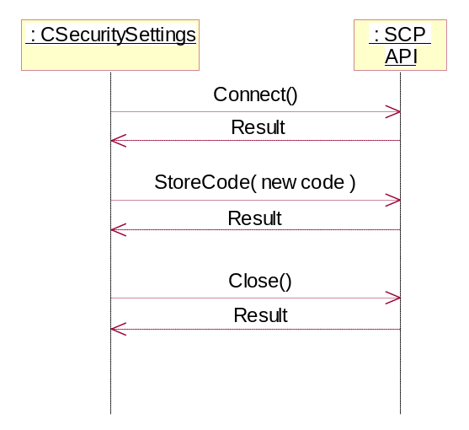
Figure 2.2 Storing the new code

Handling the code queries
SecUi checks the value of the TARM Admin flag (see Section 2.3) to see, if the Security Code query is related to SCP reconfiguration. If the flag is set, SecUi requests the code as it does on device startup (No cancel-possibility).
Valid only for Device Lock Enhancements:
The code was modified to forward the query to SCP Server by calling SCPClient::SecCodeQuery().The return value of the method is compatible with the original implementation, so the result checking for error reporting could be left intact. SCP Server handles the verification of the code from the DOS side, so this was removed from the original code. The changes were made to CSecurityHandler::AskSecCodeL(), CSecurityHandler::AskSecInAutolockL() and CSecurityHandler::PassPhraseRequiredL().

Propagating the code change request to SCP Server
Note: Valid only for Device Lock Enhancements
The change was made to CSecuritySettings::ChangeSecCodeL(). The modified code forwards the request for code change to SCP Server by calling SCPClient::ChangeCodeRequest(). The return value of the method is compatible with the original implementation, so the result checking error reporting could be left intact, while the ISA code handling part was discarded, since it is no longer required with the enhanced security code. SCP Server is responsible for all actual functionality related to changing the security code.

Security Observer
The Security Observer component had to be changed to check if a received security event resulted from a TARM administrator call. This is because security observer registers for security notifications, and it would normally prompt the user for the security code upon receiving a security code required –event.
The change was made in SecObsNotify.cpp. The code block was added in CSecObsNotify::StartNotifier. The implementation creates a connection to SCP Server, and queries the command status for ESCPCommandLockPhone. If this command is in progress, or SCP is waiting for an acknowledgement for this command, no further actions are needed in the method since SCP handles the call. Otherwise the sequence proceeds normally as described for Security Observer. This sequence is show in Figure 2.3.
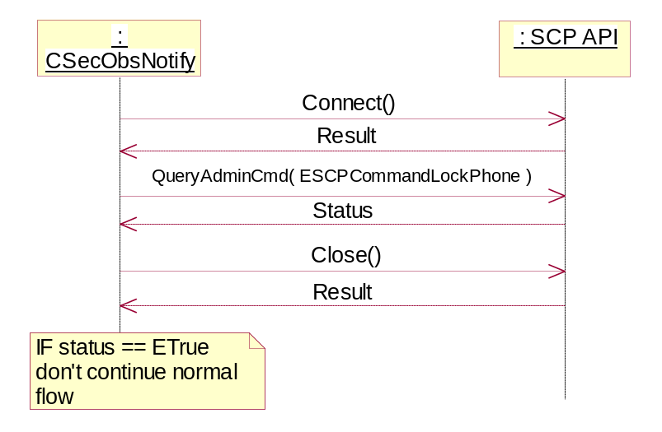
Figure 2.3 Checking the lock command status
In addition to the above change, the SecurityObserver.mmp file had to be changed to include the SCP client library, SCPClient.lib.

AutoLock
Changes were required to the Autolock application:
- to allow the TARM framework also to unlock the Symbian side of the phone
- to allow Autolock activation through TARM regardless of an ongoing call
- to allow SCP Server to configure itself on startup

These changes were implemented in AutolockAppUi.cpp, AutolockModel.cpp, AutolockAppUiPS.h and AutolockAppUi.h. In addition to this, the SCPClient library was added to the Autolock.mmp file.

Allowing Autolock deactivation
The unlocking feature was implemented by adding a message listener function to the AutolockAppUi class. The message handler function, HandleMessageL(), is a normal derived function for the application UI framework that was not used in Autolock before. The function only handles the unlock call from SCP, and propagates other calls to the framework default handler. The unlock message sent by SCP Server is identified by UID SCP_CMDUID_UNLOCK (=0x1020783D). Upon reception of the command, Autolock queries the status of the administrator command ESCPCommandUnlockPhone to make sure the call came from SCP Server. If the call is valid (the return value is ETrue), Autolock sends itself to the background, unlocking the phone. This procedure is done in a normal manner, as defined for the Autolock application. This sequence is shown in Figure 2.4.
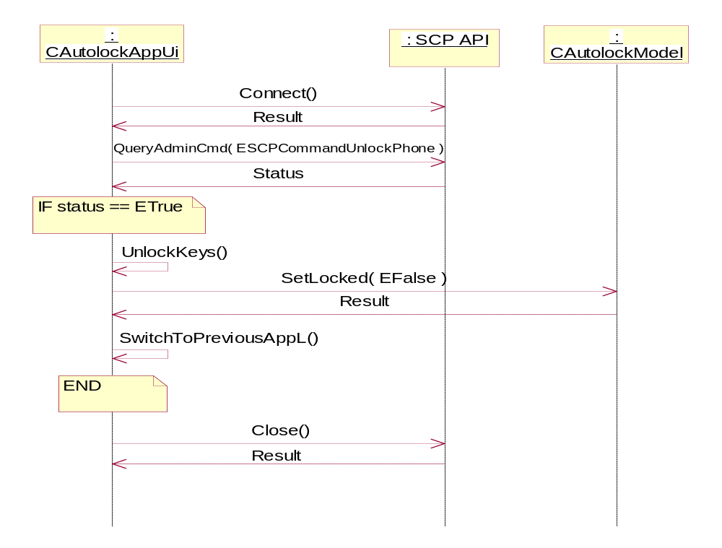
Figure 2.4 Checking the unlock message

Allowing Autolock activation when a call is in progress
To allow Autolock to be activated also when a call is in progress, Autolock was modified to register a PubSub variable (KSCPSIDAutolock, SCP_TARM_ADMIN_FLAG_UID), which allows TARM to set administrator flags. One of these flags is set when the TARM framework activates Autolock. Autolock then checks this flag, and if set, does not check if a call is in progress before activation. Normally, Autolock is not activated if a call is in progress. The admin flag is defined in AutolockAppUi.cpp, and the check is implemented in AutolockModel.cpp.

Initiating SCP configuration check
The third change to Autolock was to create a connection to SCP Server, and call the CheckConfiguration() method to allow SCP Server to configure itself on startup. If SCP Server signals that the configuration is not OK, Autolock initiates a code query, setting the KSCPFlagResyncQuery bit in the TARM admin flag (see Section 2.3.2). This bit is checked by SecUi when it queries the security code. This allows SCP to reconfigure the stored security code in case the configuration data has been lost.

General Settings
The General Settings application had to be modified to allow enabling/disabling the possibility for the user to change the security code. This was implemented by checking from SCP Server whether to show the security code setting item, when showing the device security settings menu.
The change was made to GSSettListSimSecurityContainer.cpp, and additionally the Gs.mmp file was modified to include the SCPClient library.
The query code block is implemented in CGSSettListSimSecurityContainer::MakeCodeItem. The block connects to SCP Server, and requests the value for the ESCPCodeChangePolicy parameter. If the value for these parameters is EFalse, the security code setting item is hidden. In error cases, or if the policy is ETrue, the code item is shown normally. This sequence is shown in Figure 2.5.
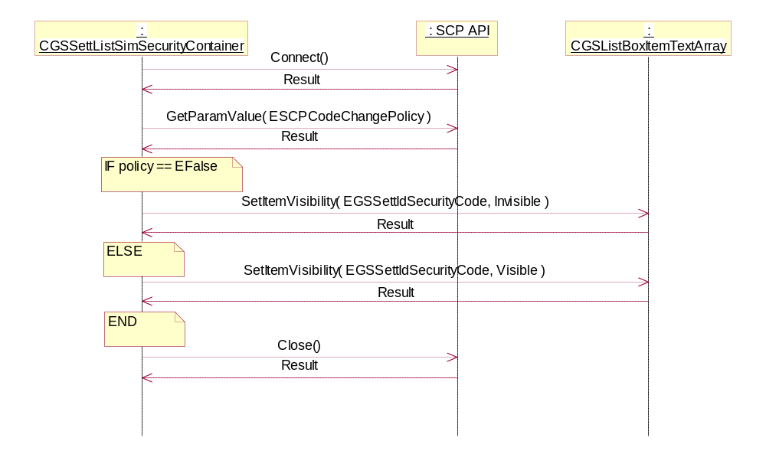
Figure 2.5 Checking the code change policy

Variation
Implemented items are variated by including the flag __SAP_DEVICE_LOCK_ENHANCEMENTS. This flag controls the inclusion of the features, which implement the enhanced security code handling, and the new security code checking. If this flag is included then all the enhanced features of device lock are available in the ROM Image.

