S60 3.1
Terminal Administrator Rights Model/
Security Code Proxy Server
Design Document

Team name | Author
Apollo SW Stream/DIY | Iisko Lappalainen

Change history:

Version | Date | Status | Comments
1.0 | 21.12.2006 | Approved

Table of contents:

1. Document control 5
1.1 References 5
1.2 Documentation conventions 5
1.3 Abbreviations 5
1.4 Definitions 5
2. General 6
2.1 Introduction 6
2.2 Component environment 6
2.2.1 SCP plugins 7
2.3 Use cases 8
2.3.1 Basic mode 8
2.3.1.1 Changing the security code 8
2.3.1.2 Setting the phone lock 8
2.3.1.3 Setting the Autolock period 9
2.3.1.4 Setting the maximum Autolock period 10
2.3.1.5 Fetching the code change policy 10
2.3.1.6 Querying the lock command status 10
2.3.1.7 Storing a new code 11
2.3.1.8 Fetching the maximum Autolock period 11
2.3.1.9 Getting the Autolock period 11
2.3.1.10 Getting the lock state 11
2.3.2 Advanced mode 12
2.3.2.1 Requesting the security code 12
2.3.2.2 Changing the security code 12
2.3.2.3 Changing the policy parameter value 13
2.3.2.4 Getting the policy parameter value 13
2.3.2.5 Validating the configuration 14
2.4 Services required 14
2.4.1 From Symbian OS subsystems 14
2.4.2 From Domestic OS subsystems 15
2.4.3 From HW 15
2.5 Services provided 15
2.5.1 UI 15
2.5.2 SW IF 16
3. UI control hierarchy 17
4. Design 18
4.1 Class diagrams 18
4.1.1 Framework 18
4.1.2 Component 18
4.2 Class descriptions 20
4.2.1 Structs, type definitions and enumerations 22
4.2.1.1 <SCPSession.h> enum TSCPLockCmdState 22
4.2.1.2 <SCPServerInterface.h> enum TSCPServRqst 22
4.2.1.3 <SCPServerInterface.h> enum TSCPAdminCommand 22
4.2.1.4 <SCPServerInterface.h> enum TSCPParameterID 22
4.2.1.5 <SCPLockNotificationEventHandler.h> enum TSCPLNQueryState 23
4.2.1.6 <SCPServer.h> enum TSCPServPanic 23
4.2.1.7 <SCPServer.h> enum TSCPButtonConfig 23
4.2.1.8 <SCPServer.h> enum TSCPParamType 23
4.2.2 Flag definitions 23
4.2.3 State diagrams 24
4.2.3.1 Processing the lock command 24
4.3 Operations 24
4.3.1 Creating a server connection 24
4.3.2 Changing the security code through TARM, Basic mode 25
4.3.3 Changing the security code through TARM, Advanced mode 26
4.3.4 Setting the phone lock state 27
4.3.5 Changing the DOS lock setting 28
4.3.6 Setting or retrieving a parameter value 29
4.3.7 Setting or getting a plugin parameter 31
4.3.8 Storing the new code (Basic mode only) 33
4.3.9 Getting the lock state 34
4.3.10 Fetching an administrator command status 35
5. Variation 37
6. System resource usage 38
6.1 Files 38
6.2 Databases 38
6.3 Memory consumption (Advanced mode) 38
6.4 Task allocation 39
6.5 Performance 39
6.6 Timers 39
7. Exception handling 40
8. Usage 41
8.1 Building 41
8.2 User's Guide 41

Document control

References
- S60 3.1 Policy Engine Design Document
- Series 60 General Settings Application Design Document
- S60 SIM and Device Security Design Document
- S60 3.1 TARM SCP Device Lock Enhancements User’s Guide

Documentation conventions
Code is shown with Courier New font.

Abbreviations
API | Application Programming Interface
DLL | Dynamic Link Library
DM | Device Management
ITC | Inter-Thread Communication
MM | Multi Mode
SCP | Security Code Proxy
TARM | Terminal Administrator Rights Model

Definitions
Autolock period | The time after which the Autolock application is activated, if the phone has been idle.
Enhanced security code | The code visible to the user while using SCP Advanced functionality. An up to 255-character alphanumeric code.
SCP Advanced functionality | The feature set in SCP, which allows the TARM server to use the capabilities in the Basic set plus password pattern checking functionality. The features also allow the user to use a 255-character alphanumeric password.
SCP Basic functionality | The feature set in SCP, which allows the TARM server to control the phone lock and the normal 5-digit password.
Security code | Used to unlock the phone when locked, and to provide access to certain guarded functionality.

General
This document describes the design of the SCP module, which is a part of the TARM package. The SCP module consists of a Symbian server component, a client library component and a set of plugins used for providing different password checking functions.
The functionality in the SCP module is divided into two feature sets, referred to as Basic and Advanced functionality in this document.
If configured to function in the Basic mode, the SCP module is used for providing access for TARM components to features locked by the phone security code. The module is also used for implementing other features relating to the policies enforced by TARM. Storing the current security code in the private storage of the server component forms the basis for the functionality in this module. This allows the features protected by the code to be accessed without prompting the user for the code.
If the Advanced functionality is enabled, the SCP server takes over the security code queries from the S60 components to allow the usage of a longer, alphanumeric, password. In addition the Advanced functionality allows the TARM or third party email administrator to restrict the possible passwords the user can use.

Introduction
SCPServer.exe is responsible for responding to requests received from the TARM Terminal Control server. These requests control security related issues such as phone locking and changing the security code, as well as updating the policy information regarding certain restrictions placed on user actions by the administrator using TARM. The component is also used by the actual components enforcing these policies for retrieving the current state of the policy. See reference document [1] for more information about the actual policies and their effects.
SCPClient.dll is used for providing inter-thread communication access to the server and for starting the server process, if necessary. For the Basic features, the client library contains no logical significance in the actual functionality of the module. For the Advanced functionality, the client DLL implements the password query dialogs, and is responsible for showing all the UI content used by the module.
SCPPatternPlugin.dll is used for providing pattern-based password checks such as password length, repeated characters and letters and numbers checks.
SCPHistoryPlugin.dll is used for providing password checking based on the previous passwords and passwords explicitly placed on the block list.
SCPTimestampPlugin.dll is used for implementing checks related to timed events, such as enforcing when the password can be changed and password expiration. The timestamp plugin is also responsible for checking the maximum consecutive authentication failures and the possible formatting of the device if configured.

Component environment
The key relationships between the SCP module and the components in its environment are shown in Figure 2.1. The image does not show the platform dependencies of the plugins to avoid cluttering the picture.
The SCP server is an executable, which is started when needed, and will close after a specified timeout once the final session is closed. The DLL is responsible for starting the component. The SCP server uses the ETel Multimode API to access the lock functionality on the DOS side, and the Autolock application to control the locking in Symbian OS. SCP server is also responsible for storing some TARM related policy parameters and for accessing the lock related items in the Central Repository and the Publish and Subscribe framework.
SCPClient.dll is the client library used for accessing the server and starting it. It also provides the UI required in the advanced features. The client library is also responsible for showing the UI responses from the plugins, either via the TARM notifier or passed directly from the server.
The plugin components, SCPPatternPlugin, SCPHistoryPlugin and SCPTimestampPlugin implement the password checks. These are ECom plugins, and are loaded by the server when needed. The server communicates with the plugins by passing them the events to which the plugins can react.
In the Basic model, SecUI is responsible for providing the new security code for storage in the SCP after the user has changed the code through the normal interface (General Settings), or has authenticated successfully. In the Advanced model, SecUi propagates all security code related calls to the SCPClient library.
Security Observer uses the SCP server to check if an incoming security code query originated from SCP, or should it display the code query dialog to the user.
SecurityNotifier uses SCPClient in the advanced feature set to display the UI required by the TARM notifier events.
NOTE: The ES/MDU modified versions of the S60 components SecUI, SecurityObserver, SecurityNotifier, General Settings, and Autolock are referred to in this document. See reference document Error: Reference source not found for more information about the changes to these components, and reference documents [2] and [3] for the implementation that forms the basis of their design.
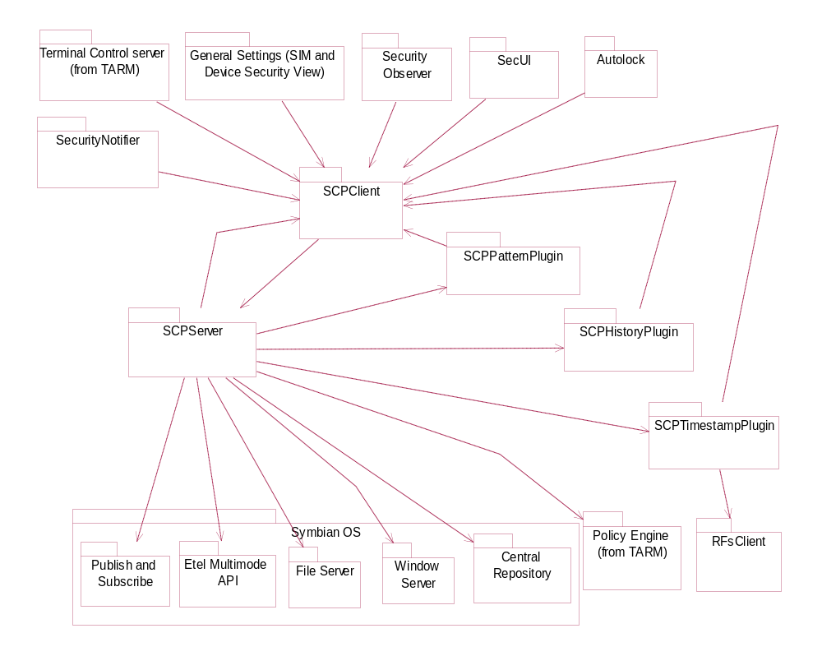
Figure 2.1 Component environment

SCP plugins
As mentioned, the SCP server allows plugins, which extend the server’s services, to be loaded. These plugins conform to the interface specified in the SCPPlugin class.

Use cases

Basic mode
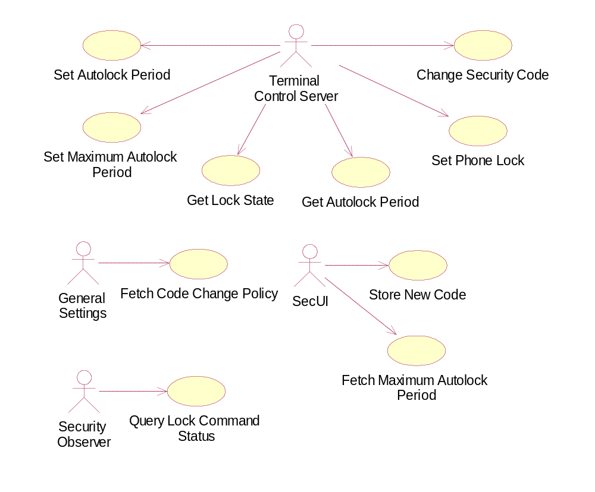
Figure 2.2 SCP use cases, Basic mode

Changing the security code
Summary | The administrator changes the security code on the phone.
Actor(s) | Terminal Control Server
Frequency | Low. When the administrator implicitly initiates a change security code message.
Preconditions | The current, valid, security code must be stored on the SCP server.
Description | The SCP server uses the ETel Multimode API to change the security code, giving the current code, which is stored on the server, and the new code, which is received along the command [Error result].
Exceptions | As an Error result, the error code is propagated backwards to the TARM framework for handling.
Postconditions | The security code in the terminal is changed to match the given parameter, and the new code is stored on SCP server.
Illustrations | See Figure 4.10.

Setting the phone lock
Summary | The administrator locks or unlocks the phone.
Actor(s) | Terminal Control Server
Frequency | Low. When the administrator implicitly initiates changing the setting.
Preconditions | The current, valid, security code must be stored on the SCP server.
Description | - The SCP server registers itself for notifications for security events using the ETel MM API. [Error result]  - The SCP server calls SetLockSetting from the ETel MM API to (un)lock the DOS side. [Error result]  - A request for the security code is received from the DOS. [Invalid event]  - The SCP server responds to the event using VerifySecurityCode ETel MM API call. [Error result]  - a) For locking: The SCP server uses the Publish and Subscribe system to set the KPSUidAutolockStatusValue property to EPSAutolockOn, to activate the Autolock application. [Error result]  b) For unlocking: The SCP server sends a message to the Autolock application to unlock the Symbian side. [Error result] The Autolock application requests confirmation for the message by requesting the status of the unlock command to authenticate the SCP server.
Exceptions | As an Error result, the error code is propagated backwards to the TARM framework for handling.  As an Invalid event, the SCP server sends a new notification request as in 1. and waits for a new event.
Postconditions | For locking: The DOS side is locked, and the Autolock application is brought to foreground, locking the Symbian OS side of the terminal.  For unlocking: The DOS side is unlocked, and the Autolock application is sent to the background, unlocking the Symbian OS side of the terminal. NOTE: If Autolock or SMS lock is still active in the terminal, the DOS lock setting is not disabled.
Illustrations | See Figure 4.12.

Setting the Autolock period
Summary | The administrator changes the Autolock period (the idle timeout).
Actor(s) | Terminal Control Server
Frequency | Low. When the administrator implicitly initiates a change in the Autolock period message.
Preconditions | None
Description | The SCP server sets the Central Repository key KSettingsAutoLockTime to the value given as a parameter. [Error result, invalid period]  If the new period is above zero (Autolock active) and the old period is zero (Autolock inactive), the DOS side lock setting is activated as described in Figure 4.13. The lock setting is also deactivated, if the new period is zero, while the old one is above zero. NOTE: If SMS lock is still active in the terminal, the DOS lock setting is not disabled.
Exceptions | As an Error result, the error code is propagated backwards to the TARM framework for handling.  As an Invalid period, KErrArgument is returned if the period value is invalid, or it does not comply with the current maximum Autolock period.
Postconditions | The Autolock period is set to the given value.
Illustrations | See Figure 4.14.

Setting the maximum Autolock period
Summary | The administrator changes the maximum Autolock period value.
Actor(s) | Terminal Control Server
Frequency | Low. When the administrator implicitly initiates a change in the max Autolock period –message.
Preconditions | None
Description | The SCP server sets the internal max. Autolock period parameter to the given value. [Error result] If the new maximum Autolock period is lower than the current Autolock period, the Autolock period is changed to match the new maximum Autolock period. This change is carried out as described in Section 2.3.1.3.
Exceptions | As an Error result, the error code is propagated backwards to the TARM framework for handling.
Postconditions | The internal max. period parameter is set to the given value.
Illustrations

Fetching the code change policy
Summary | General Settings inquires should the user be allowed to change the security code.
Actor(s) | General Settings
Frequency | Low. When the Security Settings view is shown in General Settings.
Preconditions | A valid policy must be available on the Policy Engine.
Description | - The SCP server fetches the relevant policy from the Policy Engine. [Error result]  - The result is checked and the status returned to General Settings.
Exceptions | As an Error result, ETrue is returned, thus no restrictions are applied.
Postconditions | The security code change item in the Security Settings view is either shown or hidden based on the policy.
Illustrations

Querying the lock command status
Summary | Security Observer has received an event requesting the security code, and inquires if the SCP server will handle the event.
Actor(s) | Security Observer
Frequency | Low. When a lock phone use case is in progress (see Section 2.3.1.2).
Preconditions | A lock phone process has been initiated and the SetLockSetting message sent.
Description | The SCP server checks if a lock command has been initiated, or if one has been completed and no query yet received. If so, it informs Security Observer that no action has to be taken for the event.
Exceptions | None
Postconditions | Security Observer acts in a normal manner if the query result is false, otherwise it does nothing.
Illustrations | See Figure 4.18.

Storing a new code
Summary | The user has changed the security code successfully, and the new code is stored to the SCP server.
Actor(s) | SecUI
Frequency | Low. When the user changes the security code.
Preconditions | None.
Description | SecUI sends the new security code to the SCP Server, which saves it to its internal storage.
Exceptions | None.
Postconditions | The new security code is stored.
Illustrations | See Figure 4.16.

Fetching the maximum Autolock period
Summary | SecUI fetches the maximum Autolock period value after the user has entered a desired value for the new period.
Actor(s) | SecUI
Frequency | Low. When the user changes the Autolock period.
Preconditions | None
Description | The SCP server fetches the max. period value from internal storage and sends it as a response.
Exceptions | None
Postconditions | SecUI checks the period, and acts accordingly.
Illustrations

Getting the Autolock period
Summary | Terminal Control Server gets the current Autolock period set in the terminal.
Actor(s) | Terminal Control Server
Frequency | Low. When the administrator specifically sends a Get Autolock Period message.
Preconditions | None
Description | The SCP server connects to the Central Repository. [Error] Then it fetches the value from the key KCRUidSecuritySettings /KSettingsAutoLockTime. [Error]
Exceptions | As an Error result, the error code is propagated backwards to the TARM framework.
Postconditions | The Autolock period is sent to the party who made the query by TARM.
Illustrations

Getting the lock state
Summary | Terminal Control Server gets the lock state of the terminal. This is the Autolock status in this context; it defines is the terminal concretely locked.
Actor(s) | Terminal Control Server
Frequency | Low. When the administrator specifically sends a Get Lock State message.
Preconditions | None
Description | The SCP server fetches the Autolock status from the Publish and Subscribe key KUidSystemCategory / KPSUidAutolockStatusValue. [Error] Then it inspects the value and returns the lock status.
Exceptions | As an Error result, the Error code is propagated backwards to the TARM framework.
Postconditions | The lock state is sent to the party who made the query by TARM.
Illustrations | See Figure 4.17.

Advanced mode
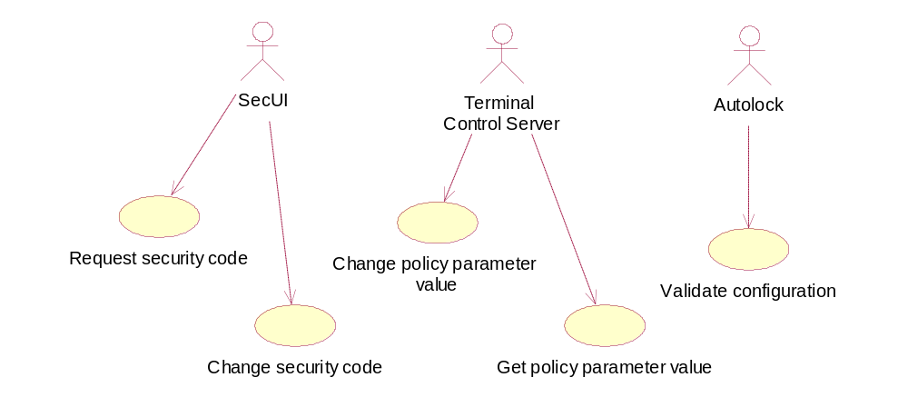
Figure 2.3 SCP use cases, Advanced mode

Requesting the security code
Summary | SecUi propagates the security code queries to SCP client, which shows the related UI and uses the server to authenticate the user.
Actor(s) | SecUi
Frequency | Low. When the user’s actions require the security code to be asked.
Preconditions | None
Description | - SecUi calls SCPClient’s SecCodeQuery method, which invokes the enhanced security code query dialog.  - After the user has input the code, it is sent to SCP server for authentication.  - SCP checks the code and reports the authentication result to the plugins. The result is then returned to the client.
Exceptions | All leaves and error situations are reported to the client. The user can in most cases cancel the query and/or exit the dialog by dialing an emergency call.
Postconditions | SecUi handles reporting the status to the initial client and showing the required notes.
Illustrations

Changing the security code
Summary | SecUi calls ChangeSecCode in SCPClient after the user has requested a code change. SCPClient shows the required dialogs and requests the code change from SCPServer. SCPServer checks the old code, and validates the new code by consulting the plugins.
Actor(s) | SecUi
Frequency | Low. When the user initiates a security code change.
Preconditions | None
Description | - SecUi calls ChangeSecCode.  - SCPClient checks from the SCP server if the code can be changed at this time. SCPServer forwards this query to the plugins and returns the result.  - If the code can be changed, SCPClient shows three dialogs: first the current security code query, then a query for the new code and a verification query.  - The old code, along with the new code candidate is sent to SCPServer.  - SCP server checks the code, and if correct, sends the new code to the plugins for verification.  - The plugins validate the code, each by its own criteria.  - The status is sent to SCP client, which propagates it to the caller.
Exceptions | All leaves and error situations are reported to the client. The user can in most cases cancel the query and/or exit the dialog by dialing an emergency call. The code query is retried if the new code and verification code do not match, or the given code was not accepted by the plugins.
Postconditions | The status of the change operation is forwarded to the caller, and if successful, the given code will be the new enhanced security code. The ISA code will, in this case, be changed to match the hash value of the new enhanced code.
Illustrations

Changing the policy parameter value
Summary | TC server sends a request to SCPClient to change password policy parameter value in response to a DM API or third party email API call. The parameter value is forwarded to SCP server and the plugin framework, where the corresponding plugin handles the value change.
Actor(s) | Terminal Control Server
Frequency | Low.
Preconditions | None
Description | - TC server calls SetParamValue in RSCPClient.  - SCPClient forwards the query to SCP server, which propagates the ID and value to the plugins.  - Each plugin checks if the ID is handled by it. If so, it first checks if the value is valid. Then it either saves the parameter value itself, or orders the server to save the value.  - The status value is returned to the caller.
Exceptions | All leaves and error situations are reported to the client. Most common errors are that the parameter ID is not recognized by any plugin, or that the value for the parameter is not valid.
Postconditions | After a successful call, the given parameter will have a new value as specified in the call.
Illustrations

Getting the policy parameter value
Summary | TC server sends a request to SCPClient to retrieve a value of a password policy parameter in response to a DM API or third party email API call. The parameter ID is forwarded to SCP server and the plugin framework, where the corresponding plugin handles the value retrieval.
Actor(s) | Terminal Control Server
Frequency | Low.
Preconditions | None
Description | - TC server calls SetParamValue from RSCPClient.  - SCPClient forwards the request to SCP server, which propagates the parameter ID to the plugin framework.  - The plugin responsible for the parameter either returns the value itself, or authenticates the server to return the value it has stored on behalf of the plugin.  - The value is returned along with a status code to the caller.
Exceptions | All leaves and error situations are reported to the client. Most common errors are that the parameter ID is not recognized by any plugin, or that the value for the given parameter is set-only and cannot be retrieved.
Postconditions | After a successful call, the caller will have a copy of the stored value.
Illustrations

Validating the configuration
Summary | Autolock validates the configuration of the SCP server on system startup by calling CheckConfiguration in RSCPClient. This allows the SCP server to check the stored security code configuration in relation to the DOS security code.
Actor(s) | Autolock
Frequency | Low.
Preconditions | None
Description | - Autolock calls CheckConfiguration in RSCPClient.  - SCP client forwards the request to SCP server.  - The server checks if the configuration has already been checked. If it has, the configuration is seen as valid, and will not be checked again.  - If the configuration is not checked, the server verifies the stored DOS password from DOS. If it is correct, the configuration is marked as checked. Otherwise it is marked as invalid and further code checks must be validated through DOS.  - The status is returned to Autolock. If the status indicates that the configuration is invalid, the security code is requested though SecUi to validate the configuration immediately.
Exceptions | All leaves and error situations are reported to the client.
Postconditions | After the check the configuration on the server is marked as valid or invalid.
Illustrations

Services required

From Symbian OS subsystems
The Symbian OS services the SCP module uses are listed in Table 2.1.
Table 2.1 Symbian OS services used by SCP server
Required Service | Description
Central Repository:  KCRUidSecuritySettings / KSettingsAutoLockTime | Read and write access to retrieve and store the value for the Autolock period.
Publish and Subscribe:  KUidSystemCategory / KPSUidAutolockStatusValue | Read and write access to retrieve and change the Autolock status (to lock the Symbian OS side).
File Server | File server is used to read and write to the configuration files stored in the private data path of the server. The file server is also required for many small tasks.
Policy Engine (from TARM) | Policy Engine is used to retrieve policy information about required user permissions. The SCP server uses it to retrieve the policy information for the security code changing.
Window Server | The Window server is used directly to send a message to the Autolock application while unlocking the terminal. Also the security code query dialogs utilize the windows server.
Remote Lock | The Remote Lock API is used for querying the status of the feature.
DMUtil Server (from TARM) | Used to set MMC wipe feature in SCPTimestampPlugin, and to follow the status of Restore Factory settings.
ECOM Framework | User to create and control the plugins.
Sysutil API | Used by SCPTimestampPlugin to restore factory settings and reboot the device.

From Domestic OS subsystems
The SCP server uses the ETel MM API to access the DOS services. The API calls used by this component are listed in Table 2.2.
Table 2.2 DOS services used by the SCP server
Required Service | Description
RMobilePhone::NotifySecurityEvent | Used for registering for notification for security events, namely for the EPhonePasswordRequired event, which is triggered, when the DOS lock setting is being changed.
RMobilePhone::CancelAsyncRequest | Used for canceling pending requests on erroneous operations.
RMobilePhone::ChangeSecurityCode | Used for changing the DOS side security code.
RMobilePhone::VerifySecurityCode | Used for answering to the code request generated when the phone is being locked.
RMobilePhone::SetLockSetting | Used for setting the DOS side lock setting.

From HW
This component has no direct HW interfaces.

Services provided

UI
This module provides a dialog, which can be parameterized to be used in different situations related to security code queries. The UI for this module is specified in reference document [2].
Provided Service | Description
Security code query | Allows the security code to be requested from the user. Can be specified to allow/disallow emergency calls and to be cancellable or not.
Security code change | Uses the security code query in sequence to first request the old code, then the new code twice. The results of the last two queries are required to match.

SW IF
The SCP server provides an API, implemented by SCPClient DLL, to the client components described in Figure 2.1. These services are described in more detail in Table 2.3.
Table 2.3 Services provided by the RSCPClient
Provided Service | Description
Set terminal lock state | Allows the terminal to be locked or unlocked. Only available for the Terminal Control Server.
Change lock code | Allows the terminal security code to be changed. Only available for the Terminal Control Server.
Store new code | Allows the new security code changed by the user to be stored. Only available for the General Settings application.
Get stored code | Allows the currently stored security code to be fetched. Only available for the Terminal Control Server.
Get lock state | Allows the terminal lock state to be fetched. Only available for the Terminal Control Server.
Fetch command status | Allows an administrator command status to be retrieved. Only available for the Security Observer and Autolock applications.
Set parameter value | Allows a parameter value to be changed. Only available for the Terminal Control Server.
Get parameter value | Allows retrieving a parameter value from the SCP server. Only available for the General Settings application.
Security Code Query | Allows the security code to the queried from the user.
Change Code Request | Allows the security code to be changed.
Validate Configuration | Allows the server configuration to be validated. Only available for the Autolock application.

In addition to the above interface, SCPClient provides a utility interface for using objects, which acts as parameter containers. This interface is described in Table 2.4.
Table 2.4 Utility functions provided by SCP client
Provided Service | Description
Create parameter-object | Used for initially creating a container object.
Set/Get parameter value | Used for setting values according to an ID, or to retrieve them.
Unset/Reset parameter/object | Used for removing a contained parameter or for resetting the whole object.
Parse buffer | Used for restoring the object contents from a previously compiled buffer representation.
Extract buffer | Used for creating a string buffer representation of the object’s contents.
Write/Read to/from file | Used for writing the object contents to a file in string buffer format, or for reading a previously written buffer and restoring the contents.

UI control hierarchy
The UI control hierarchy of the security code dialog screen is shown in Figure 3.4.
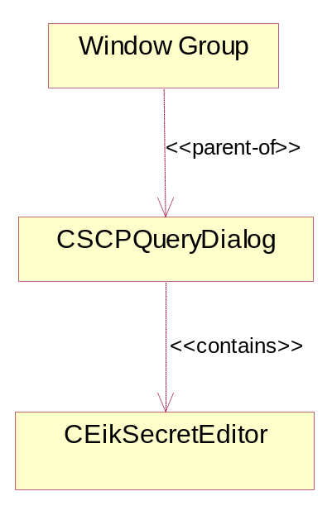
Figure 3.4 SCP query dialog hierarchy

Design

Class diagrams

Framework
The meta-model showing the class stereotypes used in SCP is shown in Figure 4.5. The module uses the Symbian client-server and active object concepts, and introduces the concept of an SCP plugin object.
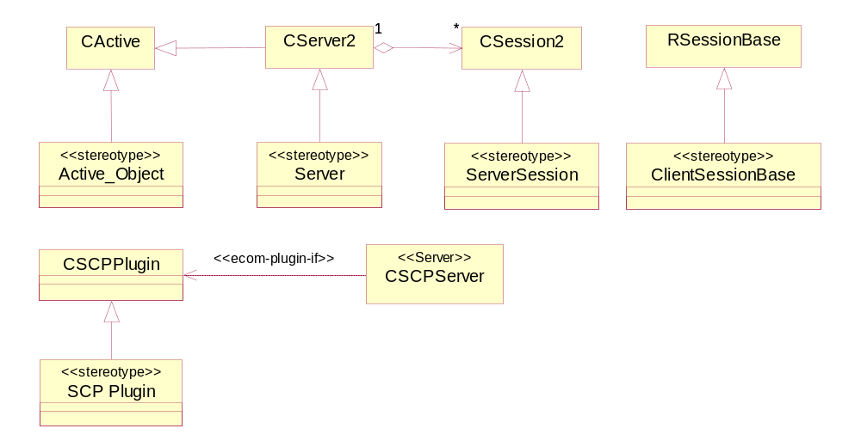
Figure 4.5 SCP class framework

Component
The class diagrams for the SCP module are depicted in Figure 4.6 and Figure 4.7. The figures show only a subset of the operations available in the classes: most of the relevant public methods and attributes are shown. The following section describes the existing classes in more detail. Basically, the CSCPClient, CSCPSession, and CSCPServer classes handle most of the functionality in the module. The other classes in the module handle auxiliary functionality. These include management of the configuration information (CSCPConfiguration), and handling the asynchronous calls related to locking and unlocking the phone (CSCPLockEventHandler, CSCPLockNotificationEventHandler, and CSCPLockSettingEventHandler). Also in Advanced mode the CSCPPluginEventHandler and CSCPPluginManager classes, and of course the plugin classes themselves, are responsible for the handling of plugin-related events.

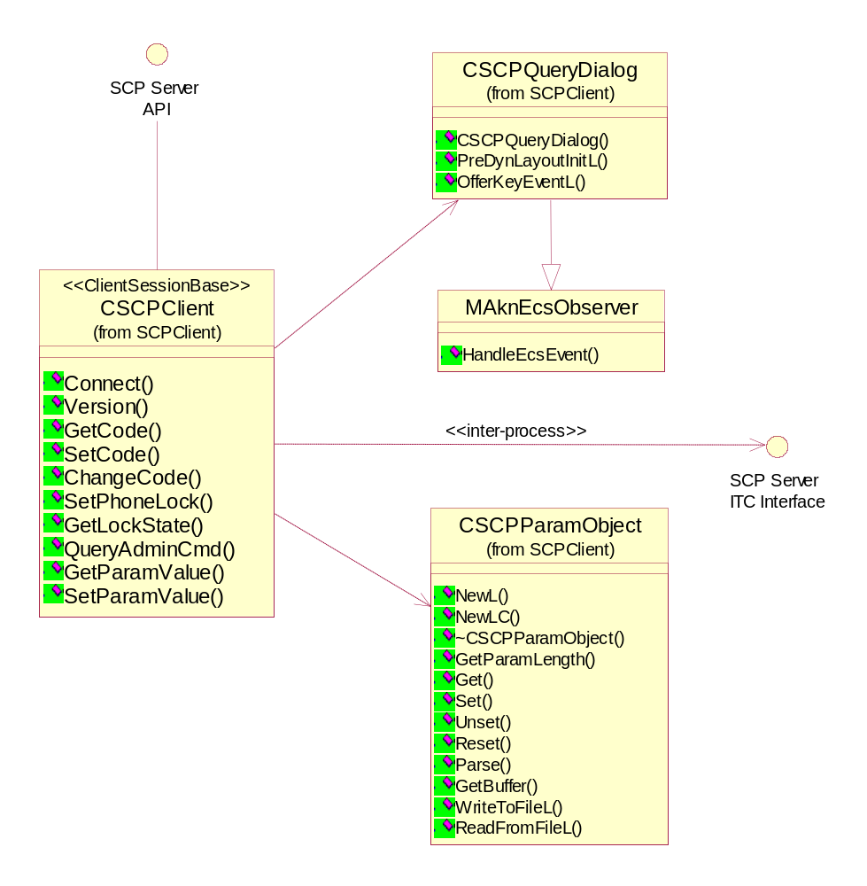
Figure 4.6 SCP structure, client side
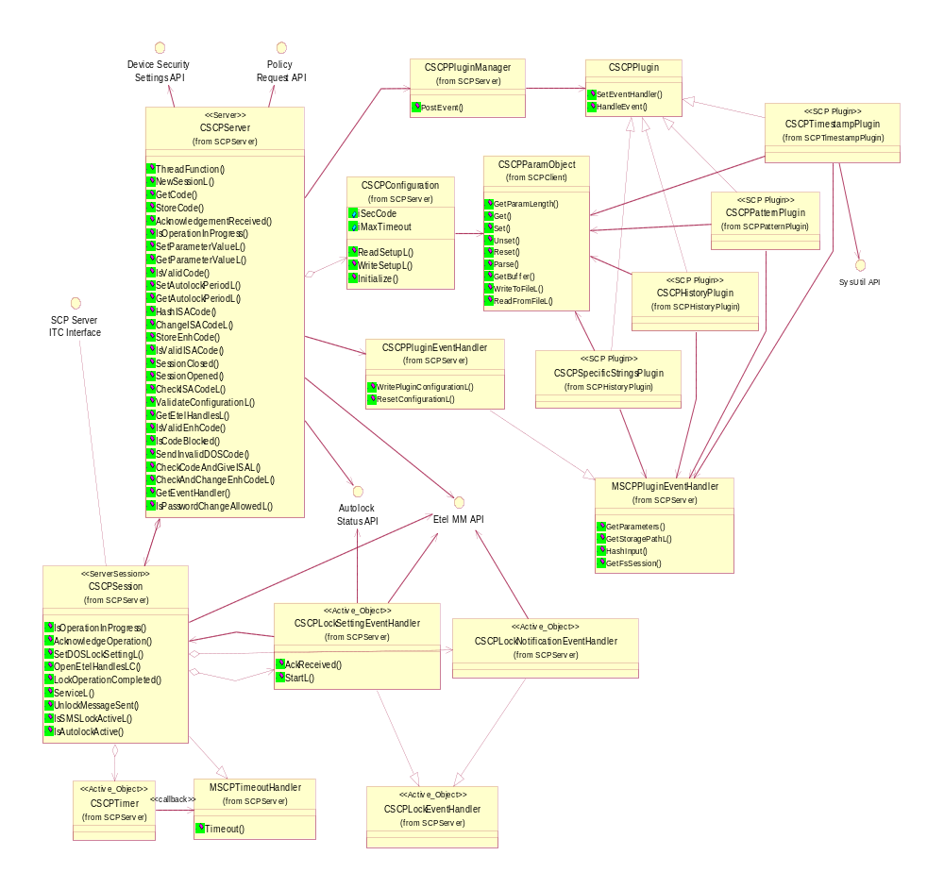
Figure 4.7 SCP structure, server side

Class descriptions
Class | Description | Header file
CSCPClient | The client-side interface class. Implements the functions, which allow clients to use the services of the SCP server through ITC. Handles the format conversion and message passing to and from the server. Also handles the showing of the password query dialogs before propagating the code query and code change requests to the server. | SCPClient.h
CSCPServer | The main server class. Implements control functionality for the session classes, and the parameter handling functions. In Advanced mode, handles all the code related conversion functions, checking and changing the code. | SCPServer.h
CSCPSession | The server session class. Has the main responsibility in handling incoming messages. Propagates the parameter related commands to CSCPServer and the DOS lock setting related commands to the CSCPLockEventHandler derived classes. | SCPSession.h
CSCPConfiguration | Handles storing the parameter information at run-time, and reading and writing the information to the flash memory. | SCPConfiguration.h
CSCPLockEventHandler | The abstract base class of the event handler classes. | SCPLockEventHandler.h
CSCPLockSettingEvent  Handler | Handles the actual setting of the DOS lock state, and the activation of Autolock. | SCPLockSettingEventHandler.h
CSCPLockNotification  EventHandler | Handles the registration of an event listener and the code verification related to locking. | SCPLockNotificationEventHandler.h
MSCPTimeoutHandler | An interface base class for classes that handle timeouts generated by CSCPTimer. | SCPTimer.h
CSCPTimer | A timer class, which is used for generating a callback when the timer elapses. Used for allowing timeouts for the Set Lock State operations, and the server inactivity timeout. | SCPTimer.h
CSCPQueryDialog | The dialog class, which is used for showing all the code queries to the user in Advanced mode. Allows only alphanumeric input and supports emergency calls if configured. | SCPQueryDialog.h
CSCPParamObject | A utility class, used to package parameter IDs and values. Allows these values to be packed into a string buffer and written to disk and retrieved. | SCPParamObject.h
CSCPPluginManager | Is responsible for creating the SCP plugin implementations and forwarding events to them. Creates all the plugin objects when the first event is received. | SCPPluginManager.h
CSCPPlugin | The base class for all SCP plugins. Contains ECom specific functionality and the plugin interface definition. | SCPPlugin.h
MSCPPluginEventHandler | The interface class for classes, which can handle events received from SCP plugins. | SCPPlugin.h
CSCPPluginEventHandler | The plugin event handler provided by SCP server. Mainly provides services to the plugins. Some of these services are also used by the server itself. | SCPPluginEventHandler.h
CSCPPatternPlugin | A plugin responsible for pattern-checking the new password. | SCPPatternPlugin.h
CSCPHistoryPlugin | A plugin responsible for keeping the password history and specifically restricted words in storage and checking them when the password is changed. | SCPHistoryPlugin.h
CSCPTimestampPlugin | A plugin responsible for checking the minimum change interval, maximum failed authentication attempts and password expiration. | SCPTimestampPlugin.h

Structs, type definitions and enumerations

<SCPSession.h> enum TSCPLockCmdState

TSCPLockCmdState | Identifies the lock command state for the current session.
ESCPLockCmdStateIdle | The session has not initiated a lock operation, and does not wait for an acknowledgement.
ESCPLockCmdStateInProgress | The session has initiated a lock operation, and it is in progress.
ESCPLockCmdStateInProgressAcknowledged | The session has initiated a lock operation, and it is in progress, this operation has already been acknowledged.
ESCPLockCmdStateFinishedAckPending | The session has already finished the lock operation, but is still waiting for an acknowledgement.

<SCPServerInterface.h> enum TSCPServRqst

TSCPServRqst | Identifies the server function ID.
ESCPServGetCode | Function ID for the Get code message.
ESCPServChangeCode | Function ID for the Change code message.
ESCPServSetPhoneLock | Function ID for the Set phone lock message.
ESCPServGetLockState | Function ID for the Get lock state message.
ESCPServSetParam | Function ID for the Set parameter message.
ESCPServSetCode | Function ID for the Set code message.
ESCPServQueryAdminCmd | Function ID for the Query admin command message.
ESCPServGetParam | Function ID for the Get parameter message.
ESCPServAuthenticateS60 | Function ID for the Authentication message.
ESCPServChangeEnhCode | Function ID for the Change Enhanced Code message.
ESCPServCodeChangeQuery | Function ID for determining if the code can be changed at this time.
ESCPServCheckConfig | Function ID for the Check Configuration message.

<SCPServerInterface.h> enum TSCPAdminCommand

TSCPAdminCommand | Identifies the administrator command ID.
ESCPCommandLockPhone | Command identifier for the lock phone command.
ESCPCommandUnlockPhone | Command identifier for the unlock phone command.

<SCPServerInterface.h> enum TSCPParameterID

TSCPParameterID | Identifies the parameter ID on the server.
ESCPAutolockPeriod | Parameter ID for the Autolock period.
ESCPMaxAutolockPeriod | Parameter ID for the Maximum Autolock period.
ESCPCodeChangePolicy | Parameter ID for the Code change policy.

<SCPLockNotificationEventHandler.h> enum TSCPLNQueryState

TSCPLNQueryState | Identifies the state of the notification process.
ESCPLNQueryStateNotification | The AO is in the notification state, i.e. the AO is waiting for an event from the DOS API.
ESCPLNQueryStateVerification | The AO is in the verification state, i.e. the AO has sent a verification request to the DOS API.

<SCPServer.h> enum TSCPServPanic

TSCPServPanic | Identifies a panic ID in the server or the client process.
ESvrCreateServer | A fatal error has occurred while creating the server process.
ESvrStartServer | A fatal error has occurred while starting the server.
ECreateTrapCleanup | A fatal error has occurred while creating the Cleanup Stack.
EBadRequest | The client has issued a request with an invalid function ID.

<SCPServer.h> enum TSCPButtonConfig

TSCPButtonConfig | Identifies the general code query dialog type to be shown.
SCP_OK | The dialog contains only the OK button, so it cannot be cancelled.
SCP_OK_CANCEL | The dialog contains both OK and Cancel buttons.
SCP_OK_ETEL | The dialog contains only the OK button, and it captures the special keys and discards them. Used in the startup code query.
SCP_OK_CANCEL_ETEL | The dialog contains both the OK and Cancel buttons, and it captures the special keys and discards them.

<SCPServer.h> enum TSCPParamType

TSCPParamType | Identifies the type of parameter stored in SCP server’s configuration file.
EParTypeInt | The parameter is an integer value.
EParTypeDesc | The parameter is a string.

Flag definitions

Flag | Description
__SCP_DEBUG | The debug flag, which controls output of debug strings. If this is set, debug information is printed. Implicitly set when _DEBUG is set.
__SCP_ENFORCE_SECURITY | A debug flag, which allows all the functionality to be used by any client. Normally set.
__SCP_USE_POLICY_ENGINE | A debug flag, which allows debugging without using the Policy Engine. Normally set.

State diagrams
The SCP module does not contain much state information in itself; the commands are processed entirely in a one-by-one manner.

Processing the lock command
The Lock phone operation is conducted using a simple state model, which is depicted in Figure 4.8.
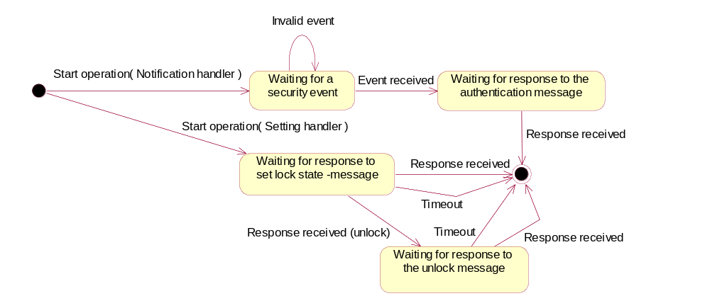
Figure 4.8 Processing the Lock Phone operation

Operations

Creating a server connection

Operation | A client connects to the server.
Preconditions | None.
Description | A client process creates a server connection by using the Client-Server framework provided by Symbian. The sequence describes the alternative when the server is not already running. If the server has already been started, the process creation will be skipped.
Inputs | None
Modifies | Creates a new session in the CSCPServer object.
Outputs | A system status code.
Postconditions | Possibly the server process has been created, and a session and a connection for the client have been established.
Related To | CSCPSession, CSCPServer, CSCPClient, CSCPConfiguration
Related Event | N/A
Exceptions | Fatal: Process creation failed, server initialization failed (NewL, StartL), Session creation failed (NewL). These conditions signal an error status to the client. If the session creation fails, no session will be created, but the server will be operational.  Non-fatal: Configuration reading failed (ReadSetupL), defaults will be used. This is normal on initial startup.
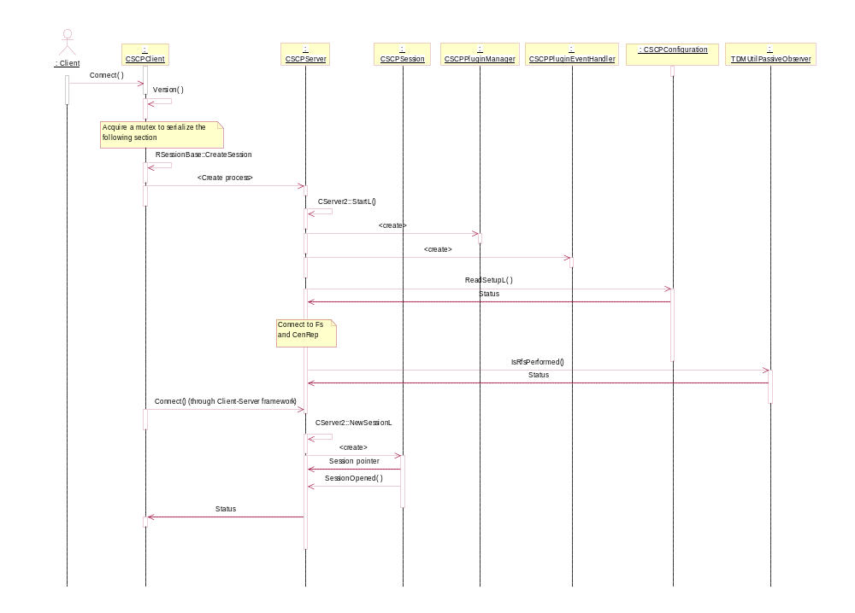
Figure 4.9 Creating a server connection

Changing the security code through TARM, Basic mode

Operation | The Terminal Control Server changes the security code.
Preconditions | The correct ISA security code is stored on the SCP server.
Description | The Terminal Control server sends a Change lock code message to SCP. SCP then calls the ETel MM API to change the code. If successful, the new code is stored on the server as the new security code.
Inputs | The new code from the client process.
Modifies | The new code is stored on the SCP server.
Outputs | A system status code. KErrArgument if the code is not valid, for other errors, the code received from the system.
Postconditions | The DOS security code is changed.
Related To | CSCPClient, CSCPServer, CSCPSession
Related Event | N/A
Exceptions | Fatal: Retrieving the code failed (GetCode), Code validation (IsValidCode), Reading the parameter info failed (ReadL), Storing the new code failed (StoreCode). An error value will be returned.
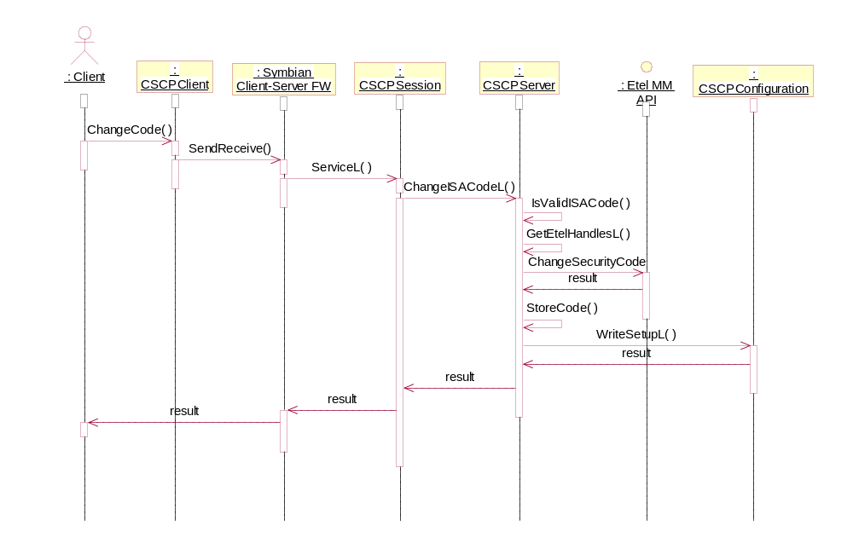
Figure 4.10 Changing the lock code

Changing the security code through TARM, Advanced mode

Operation | The Terminal Control Server changes the security code.
Preconditions | The correct DOS security code is stored on the SCP server.
Description | The Terminal Control server sends a Change lock code message to SCP. SCP then changes the enhanced code and calls the ETel MM API to change the DOS code to match the hash of the new enhanced code. If successful, the new codes are stored on the server.
Inputs | The new code from the client process.
Modifies | The new codes are stored on the SCP server.
Outputs | A system status code. KErrArgument if the code is not valid, for other errors, the code received from the system.
Postconditions | The DOS security code and the enhanced security code are changed.
Related To | CSCPClient, CSCPServer, CSCPSession
Related Event | N/A
Exceptions | Any errors in the actual processing of the call are propagated to the upper layers.
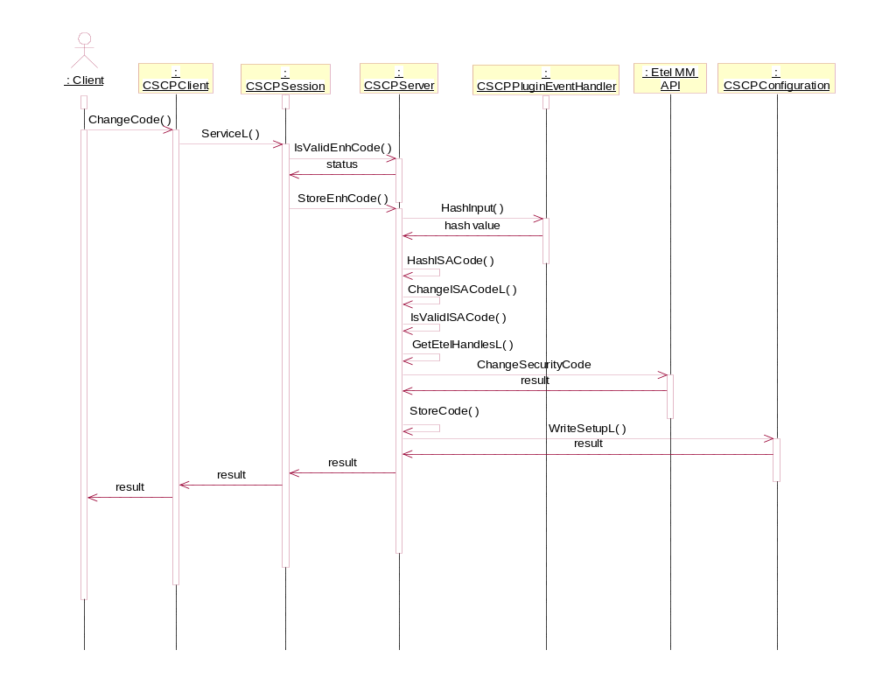
Figure 4.11 Changing the security code through TARM

Setting the phone lock state

Operation | The Terminal Control Server locks or unlocks the phone.
Preconditions | The correct security code is stored on the SCP server.
Description | The Terminal Control server sends a message to SCP to lock or unlock the phone. The DOS lock setting process is specified in more detail in the corresponding scenario. After the DOS lock has been enabled/ disabled, the Symbian side is locked by activating Autolock (also described in the lock scenario), or unlocked by sending the Autolock application a message to unlock itself. In the unlock case Autolock will query the state of a unlock command, to authenticate and acknowledge the message.
Inputs | None
Modifies | Nothing
Outputs | A system status code: the status code from SetDOSLockSetting.
Postconditions | The DOS lock setting is enabled/disabled, and Autolock is brought to the foreground/background.
Related To | CSCPClient, CSCPServer, CSCPSession
Related Event | See Section 4.3.5.
Exceptions | Fatal: Lock setting failed (SetDOSLockSetting), an error value will be returned.

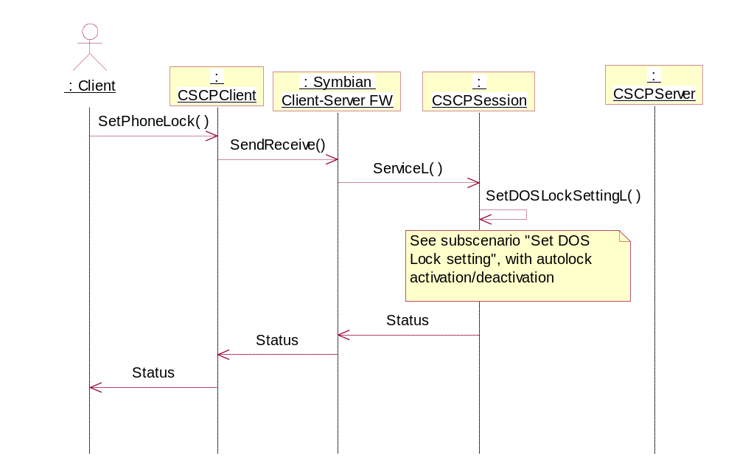
Figure 4.12 Locking the phone

Changing the DOS lock setting

Operation | SCP changes the DOS lock setting, along with activating or deactivating the Autolock application if desired.
Preconditions | The correct security code is stored on the SCP server.
Description | The session object first checks if another lock operation is in progress. Then it retrieves the stored code, and creates the AOs responsible for the lock operation. The AOs register for security events, verify the code, change the lock setting and possibly activate or deactivate Autolock.
Inputs | The new DOS lock state, and whether Autolock handling is desired as well.
Modifies | Nothing
Outputs | A system status code. KErrNone on success, KErrInUse if a lock operation is already in progress, otherwise a system error code.
Postconditions | The DOS lock setting, and possibly the state of the Autolock application, is changed.
Related To | CSCPClient, CSCPServer, CSCPSession, CSCPLockSettingEventHandler, CSCPLockNotificationEventHandler
Related Event | See Section 4.3.4.
Exceptions | Fatal: Operation in progress (IsOperationInProgress), failed to retrieve the code (GetCode), failed to open the handles (OpenEtelHandles), ETel API operations failed (VerifySecurityCode, NotifyOnSecurityEvent, SetLockSetting), Autolock activation failed (RProperty::Set): An error code is returned. Unlock message sending failed (Task::SendMessage): An error code is returned.  A timer is started when the changing operation is started to make sure the server does not stall, if the system fails to acknowledge the operations. If a timeout occurs, the call is completed with KErrTimedOut, and the server state is reset.
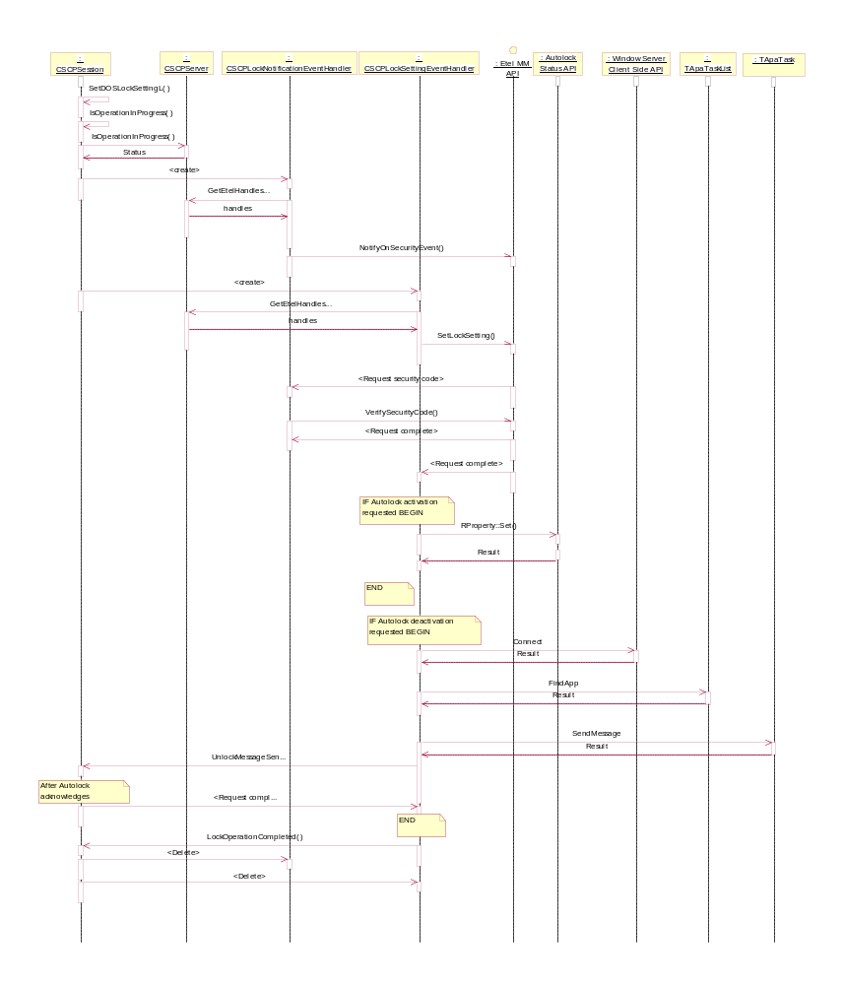
Figure 4.13 Setting the DOS lock setting

Setting or retrieving a parameter value

Operation | A client sets a new value for a parameter, or gets the value for one.
Preconditions | None.
Description | The SCP server handles the parameter setting in different ways depending on the ID. The parameters directly supported by the SCP server (and the only parameters supported in Basic mode) are the Autolock period, Max. Autolock period and Code Change Policy. Other parameters are supported by the plugins. This scenario is depicted in another sequence.  The Max. Autolock period setting is not described in the sequence. This parameter is stored in the server instance variable, and saved to disk while saving the settings.
Inputs | The ID of the parameter, for Set also the new value.
Modifies | In case of the internal parameters and the Set command the new value is stored in the configuration.
Outputs | A system status code, for the Get-command also the value.
Postconditions | The new value is stored.
Related To | CSCPClient, CSCPServer, CSCPSession, CSCPConfiguration
Related Event | See Section 4.3.7.
Exceptions | All error situations are reported to the client. The only specific exception for the internal parameters is if the value is not valid. This will return KErrArgument to the client.

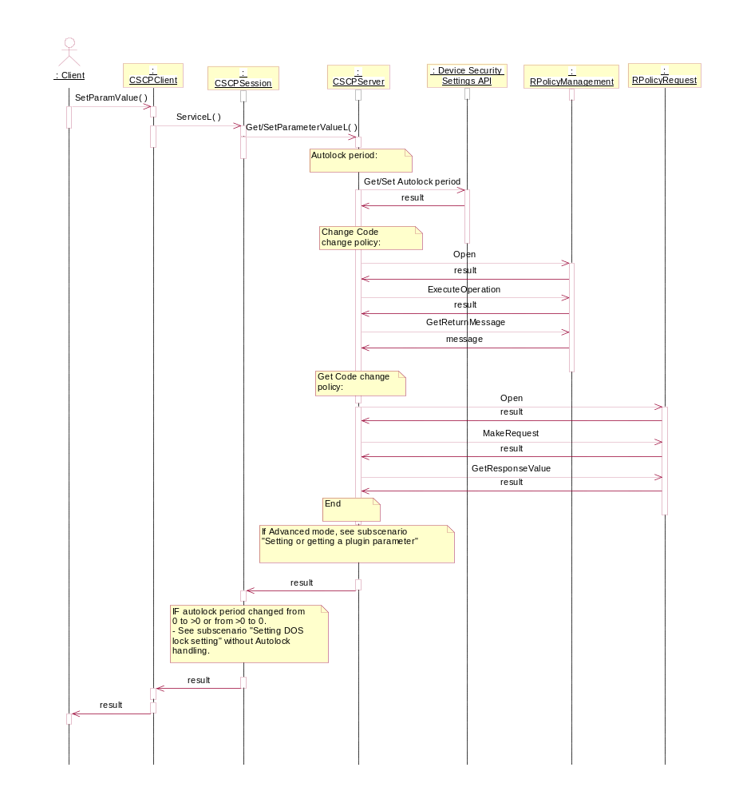
Figure 4.14 Setting or retrieving a parameter value

Setting or getting a plugin parameter

Operation | A client sets a new value for a parameter, or gets the value for one.
Preconditions | The sequence presented in Section 4.3.6 is run to the point where none of the internal parameters match the ID.
Description | The server first builds a parameter object, which identifies the caller (currently not used), the parameter ID and the value (Set call). This parameter object is posted to the plugins as an event parameter. The event posted depends on the call: KSCPEventConfigurationQuery (Set calls) or KSCPEventRetrieveConfiguration (Get calls). When receiving the event, a plugin checks the ID of the parameter. If the ID is on the plugin’s responsibility the following applies:  Set call:  - The plugin checks that the value is valid for the parameter.  - The plugin either saves the value in its private storage, or indicates that the value is OK to be stored by the server.  Get call:  - The plugin returns the value in the result object or indicates that the value can be sent to the client by the server from common storage.  - The plugin responds with a parameter object, which contains the above information set.
Inputs | The ID of the parameter, for Set also the new value.
Modifies | The Get calls do not modify anything. The Set calls can modify the internal storage of the plugin in question, or the common storage provided by the server.
Outputs | A system status code, for the Get command also the value.
Postconditions | The new value is possibly stored.
Related To | CSCPClient, CSCPServer, CSCPSession, CSCPConfiguration, plugin classes.
Related Event | See Section 4.3.6.
Exceptions | All error situations are reported to the client. The only specific exception for the internal parameters is if the value is not valid. This will return KErrArgument to the client.
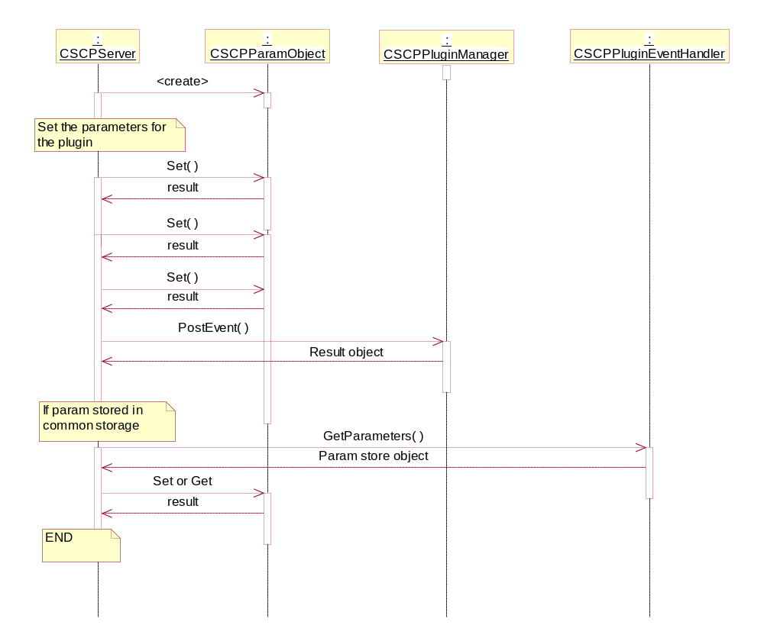
Figure 4.15 Setting or getting a plugin parameter

Storing the new code (Basic mode only)

Operation | The user has changed the security code or has verified the code correctly, and the code is sent to the SCP server.
Preconditions | None.
Description | The client calls the relevant function from the API, and after passing through the security checks the code is stored to the SCP server.
Inputs | The new code.
Modifies | The code is changed in the configuration.
Outputs | A system status code.
Postconditions | The new code is stored.
Related To | CSCPClient, CSCPServer, CSCPSession, CSCPConfiguration
Related Event | N/A
Exceptions | Fatal: Storing the code failed (StoreCode): an error value is returned.
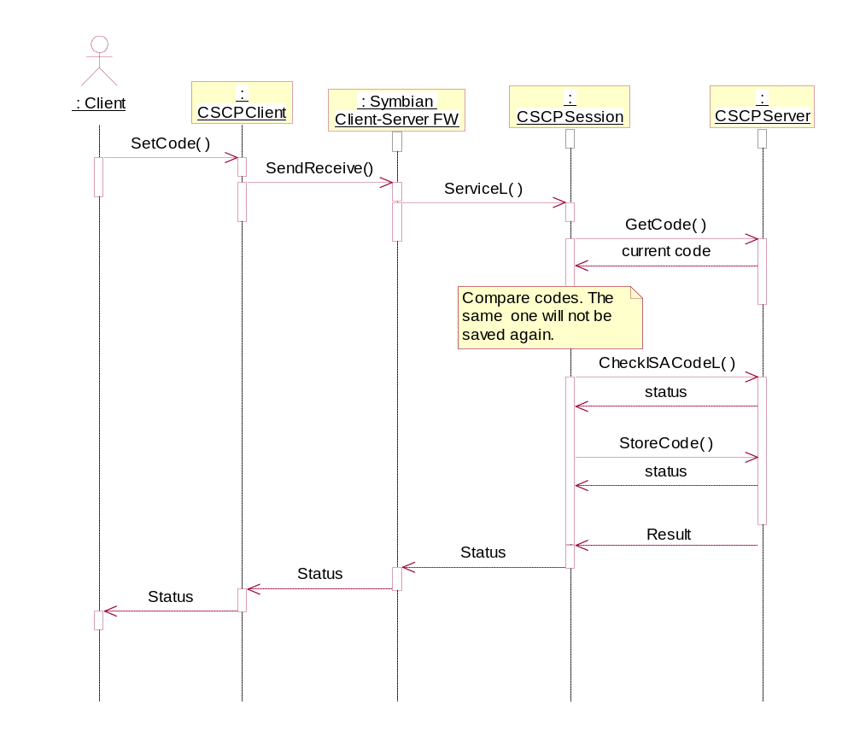
Figure 4.16 Storing the new code

Getting the lock state

Operation | The Terminal Control server retrieves the lock status.
Preconditions | None.
Description | The Terminal Control server calls the relevant function from the API, and the Autolock status value is retrieved from the Publish and Subscribe framework.
Inputs | None
Modifies | Nothing
Outputs | The Autolock status, it identifies the lock state for the Symbian side.
Postconditions | The lock state is returned.
Related To | CSCPClient, CSCPServer, CSCPSession
Related Event | N/A
Exceptions | Fatal: Failed to get the value from Publish and Subscribe (RProperty::Get): An error status is returned.
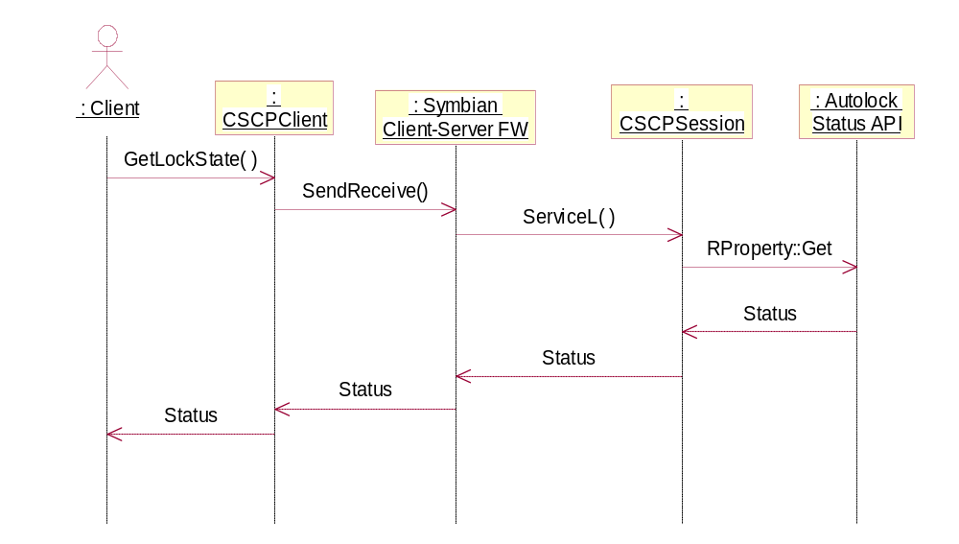
Figure 4.17 Getting the terminal lock state

Fetching an administrator command status

Operation | A Client requests a status for an administrator command.
Preconditions | None.
Description | The client requests the status for a command, and the request is propagated to the server. The query for a command status is converted into two calls, a request whether the operation is still in progress, and an acknowledgement notification, which also indicates whether a session was waiting for an acknowledgement. The acknowledgements can be used to “wait” for a required event.  NOTE: This flow is used, when Security Observer checks whether a security event resulted from an administrator command. The acknowledgement is needed, because the query for the administrator locking command must come in exactly once.
Inputs | The ID of the command.
Modifies | The acknowledgement status, if a session was waiting for an acknowledgement.
Outputs | The command status.
Postconditions | The status is returned.
Related To | CSCPClient, CSCPServer, CSCPSession
Related Event | N/A
Exceptions | Only system exceptions in the Client-Server FW.
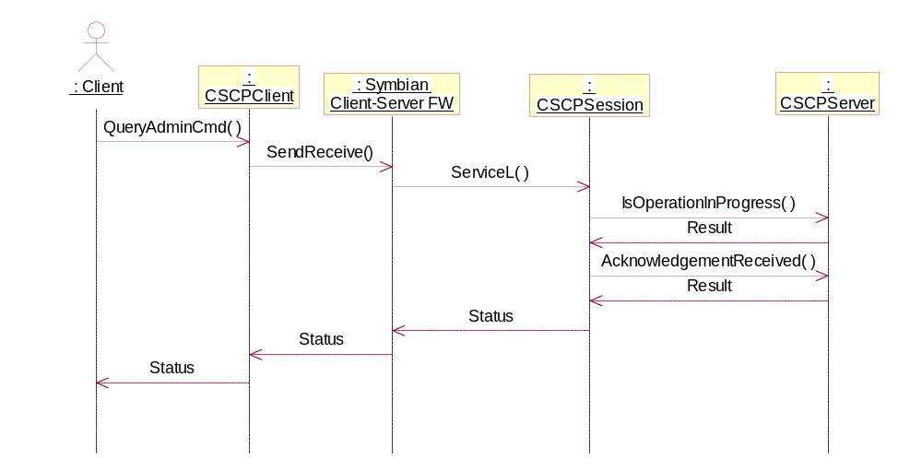
Figure 4.18 Fetching an administrator command status

Variation
The SCP module can be left out or included in an image at build time. The inclusion is controlled along the Terminal Control Framework, with the build flag __SAP_TERMINAL_CONTROL_FW.
SCP will use the Remote Lock API, when the Remote Lock component is included in a build, when the SCP_SMS_LOCK_AVAILABLE flag is defined.
The advanced mode in SCP is activated by the flag __SAP_DEVICE_LOCK_ENHANCEMENTS.

System resource usage

Files

File | Format | Size estimate | Description
config.ini | Binary | 150 bytes | Configuration: Security code, max. Autolock period and configuration flag. In the Advanced mode also the encrypted enhanced security code, the amount of consecutive failed attempts (for code blocking) and the possible code block start time.
plugincfg.bin | Binary | 100 bytes | Configuration: The configuration for the plugin parameters stored in the common storage. These include most of the “normal” configuration values. The history buffer and the specific words’ block list are stored in separate files.
SCPHistoryConfig.ini | Binary | 50 bytes – multiple kilobytes | Stores the password hashes in the history buffer and the passwords explicitly forbidden.
SCPTimestampPlugin.ini | Binary | 50 bytes. | Stores the state information for SCPTimestampPlugin: the last password change time, password change interval start time, used password change tolerance, consecutive failed attempts (for hard reset), and should the password expire explicitly after the next authentication.

Databases
This component does not use any databases.

Memory consumption (Advanced mode)

Memory/Build | Consumption
User data area | 350 bytes for files specified in Section 6.1, not including the history and specific words’ buffers.
WINSCW UDEB | SCPClient.dll: 894 KB  SCPServer.exe: 502 KB  SCPPatternPlugin.dll: 203 KB  SCPHistoryPlugin.dll: 261 KB  SCPTimeStampPlugin.dll: 454 KB  SCPNotifier.rsc: 1 KB  SCPPatternPluginLang.rsc: 1 KB  SCPPatternPlugin.rsc: 1 KB  SCPHistoryPluginLang.rsc: 1 KB  SCPHistoryPlugin.rsc: 1 KB  SCPTimestampPluginLang.rsc: 1 KB  SCPTimestampPlugin.rsc: 1 KB
ARMv5 UREL | SCPClient.dll: 10 KB  SCPServer.exe: 19 KB  SCPPatternPlugin.dll: 4 KB  SCPHistoryPlugin.dll: 8 KB  SCPTimeStampPlugin.dll: 5 KB  SCPNotifier.rsc: 1 KB  SCPPatternPluginLang.rsc: 1 KB  SCPPatternPlugin.rsc: 1 KB  SCPHistoryPluginLang.rsc: 1 KB  SCPHistoryPlugin.rsc: 1 KB  SCPTimestampPluginLang.rsc: 1 KB  SCPTimestampPlugin.rsc: 1 KB

Task allocation
The SCPClient library runs in the thread in which it is launched. The SCPServer runs in its own process, usually launched by the SCPClient library. All the plugins are loaded by SCPServer, and thus run in the SCPServer process.

Performance
This module has no performance-critical functionality.

Timers
Timer | Purpose | Interval | Lifetime
Lock timer | Make sure the lock operations do not lock up the server. | KSCPLockOperationTimeout microseconds (= 10sec). | Started when SetDOSLockSetting is activated, and stopped when the operation is complete (LockOperationCompleted) by CSCPSession.
Shutdown timer | Shut down the server if not used. | KSCPServerShutdownTimeout (=10sec). | Started when the last session on the server is closed (SessionClosed()). Stopped when a new session is opened (SessionOpened()). When the timer expires, the active scheduler is stopped and the server process closed.

Exception handling
The normal Symbian means for exception handling are used within the SCP module.
The code in the module rarely panics (the panics used are summarized in Table 7.5), and the API functions are designed to leave when a fatal error occurs, returning the status code back to the calling process.
Table 7.5 SCP panics
Exception | Description
Failed to initialize the Cleanup Stack. | The CleanupStack could not be created in the server process upon initial connection.
Failed to start the server. | The server could not be started upon initial connection.
Failed to create the server process. | The server process creation failed upon initial connection.
The client process sent an invalid message. | The server received a message from the Client-Server framework, which carries an unrecognized function ID.
The hash digest generated for an enhanced security code is not a valid MD5 digest. | The Symbian Crypto API is not outputting correct data.

Usage

Building
The components are contained in their individual subdirectories. To ease the building of the module a batch file exists, which allows building the whole module in the correct order.
The batch file is used as follows:
SCPBuild <platform> <target>.

For example, the following compiles the module for WINSCW UDEB.
- SCPBuild winscw udeb

The test application, SCPTest, must be built separately from its folder. For example:
- bldmake bldfiles
- abld build winscw udeb

User's Guide
The SCP server is used by including the SCP client library and creating an object of the type RSCPClient. This object is then used for creating a connection to the server, accessing the desired functions, and closing the connection. Note that the SCP module is of limited use to any other components than those mentioned as clients in this module because of the strict security checks.
The following is a practical example of using SCP.
Add the library definition to the MMP file of your application:
LIBRARY SCPClient.lib

Include the client header file, where you intend to use the client:
#include <SCPClient.h>

Use the client library:
RSCPClient scpClient;
User::LeaveIfError( scpClient.Connect() );
<use the functions..>
<..>
scpClient.Close();

