S60 3.1
Device Management Terminal Security Adapter
Design Document

Team name | Author

Change history:

Version | Date | Status | Comments
1.0 | 27.10.2006 | Approved

Table of contents:

1. Document control 5
1.1 References 5
1.2 Documentation conventions 5
1.3 Abbreviations 5
2. General 6
2.1 Introduction 6
2.2 Component environment 8
2.3 Use cases 9
2.3.1 Loading the adapter 10
2.3.2 Wiping the device 10
2.3.3 Restarting the device 11
2.3.4 Scanning the file system 11
2.3.5 Getting file system scan results 11
2.3.6 Setting the device lock state 12
2.3.7 Getting the device lock state 12
2.3.8 Setting the Autolock timeout 12
2.3.9 Getting the Autolock timeout 13
2.3.10 Setting the Autolock maximum timeout 13
2.3.11 Getting the Autolock maximum timeout 13
2.3.12 Setting the device lock code 14
2.3.13 Setting the lock code minimum length 14
2.3.14 Getting the lock code minimum length 14
2.3.15 Setting the lock code maximum length 15
2.3.16 Getting the lock code maximum length 15
2.3.17 Setting the lock code to require upper and lower 16
2.3.18 Getting the lock code to require upper and lower 16
2.3.19 Setting the lock code to require characters and numbers 16
2.3.20 Getting the lock code to require characters and numbers 17
2.3.21 Setting the lock code maximum repeated characters 17
2.3.22 Getting the lock code maximum repeated characters 17
2.3.23 Setting the lock code history buffer 18
2.3.24 Getting the lock code history buffer 18
2.3.25 Setting the lock code expiration 18
2.3.26 Getting the lock code expiration 19
2.3.27 Setting the lock code minimum change tolerance 19
2.3.28 Getting the lock code minimum change tolerance 20
2.3.29 Setting the lock code minimum change interval 20
2.3.30 Getting the lock code minimum change interval 20
2.3.31 Setting the lock code check specific strings 21
2.3.32 Getting the lock code check specific strings 21
2.3.33 Disallowing specific lock codes 21
2.3.34 Allowing specific lock codes 22
2.3.35 Clearing specific lock code strings 22
2.3.36 Setting the lock code maximum attempts 22
2.3.37 Getting the lock code maximum attempts 23
2.3.38 Setting the lock code consecutive numbers 23
2.3.39 Getting the lock code consecutive numbers 24
2.3.40 Deleting a file 24
2.3.41 Listing processes 24
2.3.42 Getting process data 25
2.3.43 Starting the process 25
2.3.44 Stopping the process 25
2.4 Services required 26
2.4.1 From the Symbian OS subsystems 26
2.4.2 From the Domestic OS subsystems 26
2.4.3 From HW 26
2.5 Services provided 26
2.5.1 UI 26
2.5.2 SW IF 26
3. UI control hierarchy 27
4. Design 28
4.1 Class diagrams 28
4.1.1 Framework 28
4.1.2 Component 29
4.2 Class descriptions 29
4.2.1 Structs, type definitions and enumerations 30
4.2.1.1 TcAdapter.h 30
4.2.2 Flag definitions 30
4.2.3 State diagrams 30
4.3 Operations 31
4.4 Backup and Restore 31
5. Variation 32
6. System resource usage 33
6.1 Files 33
6.2 Other data 33
6.2.1 Databases 33
6.2.2 Central Repository 33
6.2.3 Publish and Subscribe 33
6.3 Memory consumption 33
6.4 Task allocation 33
6.5 Performance 33
6.6 Timers 33
7. Security 34
7.1 Capabilities of this component 34
7.2 Input and output validation 34
7.3 Environmental assumptions 34
7.4 Additional enforcements 34
8. Exception handling 35
9. Usage 36
9.1 Building 36
9.2 User's guide 36

Document control

References
- S60 3.0 How To Implement The DM Plug-in Adapter
- Series 60 Developer Platform 2.0: ECom Plug-In | http://www.forum.nokia.com
- SyncML Device Management Tree and Description | http://www.openmobilealliance.org
- S60 3.1 Device Management Terminal Security Design Document

Documentation conventions
The name Device Management Terminal Security Adapter is also referenced as Terminal Security adapter and TS adapter.
Code is shown with Courier New font.

Abbreviations
ACL | Access Control List
API | Application Programming Interface
DDF | Device Description Framework
DM | Device management
ECom | Symbian OS plugin system
ID | Identifier
OS | Operating System
SID | Secure ID
SyncML | Synchronization Mark-up Language
TARM | Terminal Administration Rights Model
UI | User Interface
UID | Unique Identifier
URI | Uniform Resource Indicator

General
Terminal Security adapter is a Device Management adapter that provides the implementation of DM operations and handles certain settings of the device.
TS adapter is part of TARM subsystem and is used to access Terminal Security server. See reference document Error: Reference source not found.
Device Management adapters implement DM adapter interface and ECom plug-in interface. TS adapter is used by a SyncML Device Management client component and it is loaded via the ECom architecture. See reference documents [1] and [2].

Introduction
Terminal Security adapter introduces an interface to control the device with Terminal Security server’s features.
Server’s methods include control over device’s lock state, lock code and Autolock settings. It also includes features of file listing, file deletion, device restart, process listing, process start, process stop and device wipe (with memory card formatting and resetting the device to the factory settings).
The public methods of the adapter are provided in the implementation of the operations of Device Management. These operations include Get and Replace targeted for the nodes of the adapter’s Device Management tree.
The Device Management tree with a corresponding DDF structure is introduced and maintained by the adapter. See reference document [3].
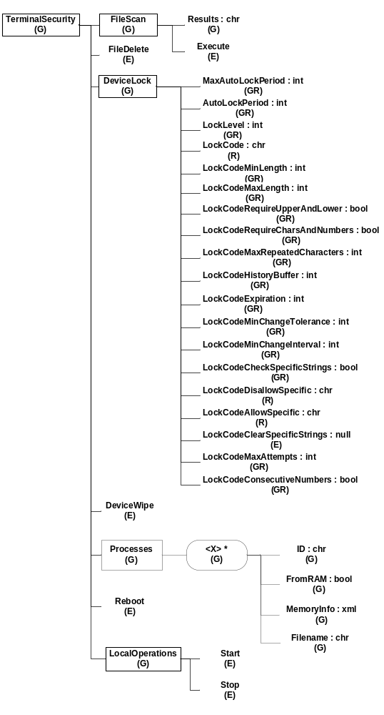
Figure 2.1 Device Management tree of Terminal Security

Component environment
TS adapter is used by the SyncML Device Management client component.
TS adapter uses the services of Terminal Security server.
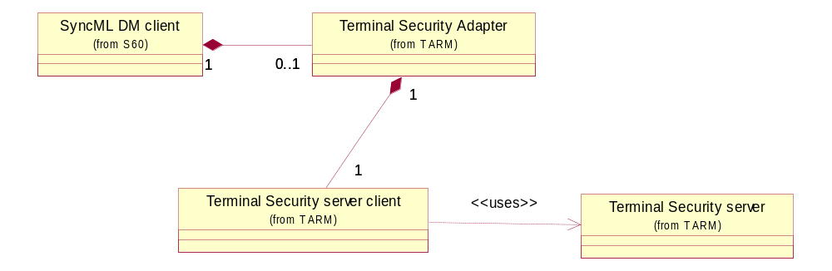
Figure 2.2 Dependencies to other modules
DM adapters have three unique identifiers: one for the ECom plug-in interface, one for the implementation and one for the DLL. The ECom plug-in interface identifier is common for all ECom plug-ins (and DM adapters.) The UID values used in adapter are listed in the table below.
Interface UID | 0x102018B4
Implementation UID | 0x10207824
DLL UID | 0x10207823

Use cases
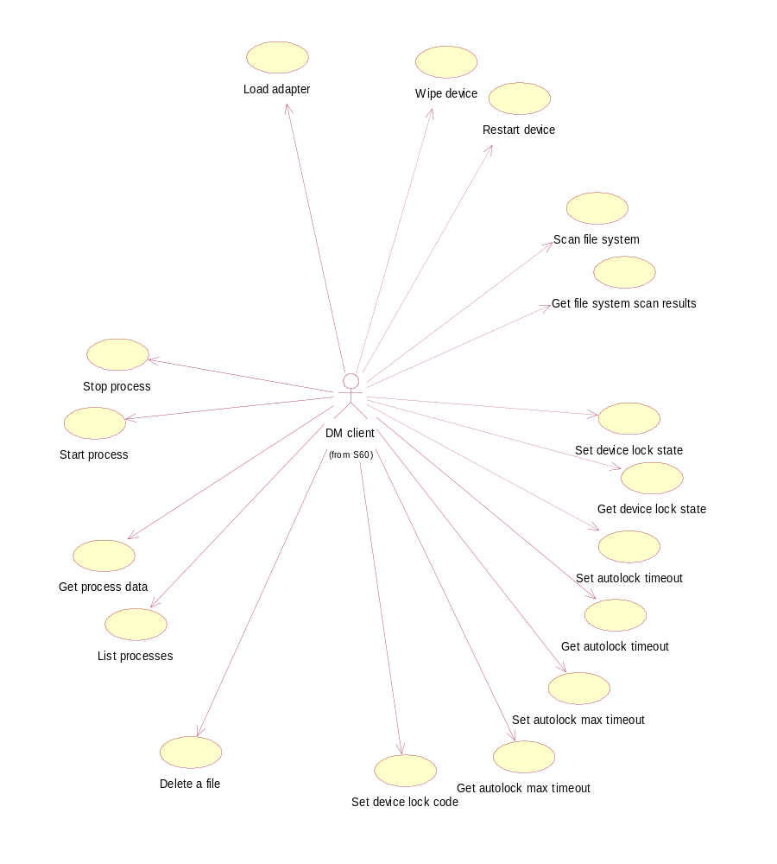
Figure 2.3 Use cases
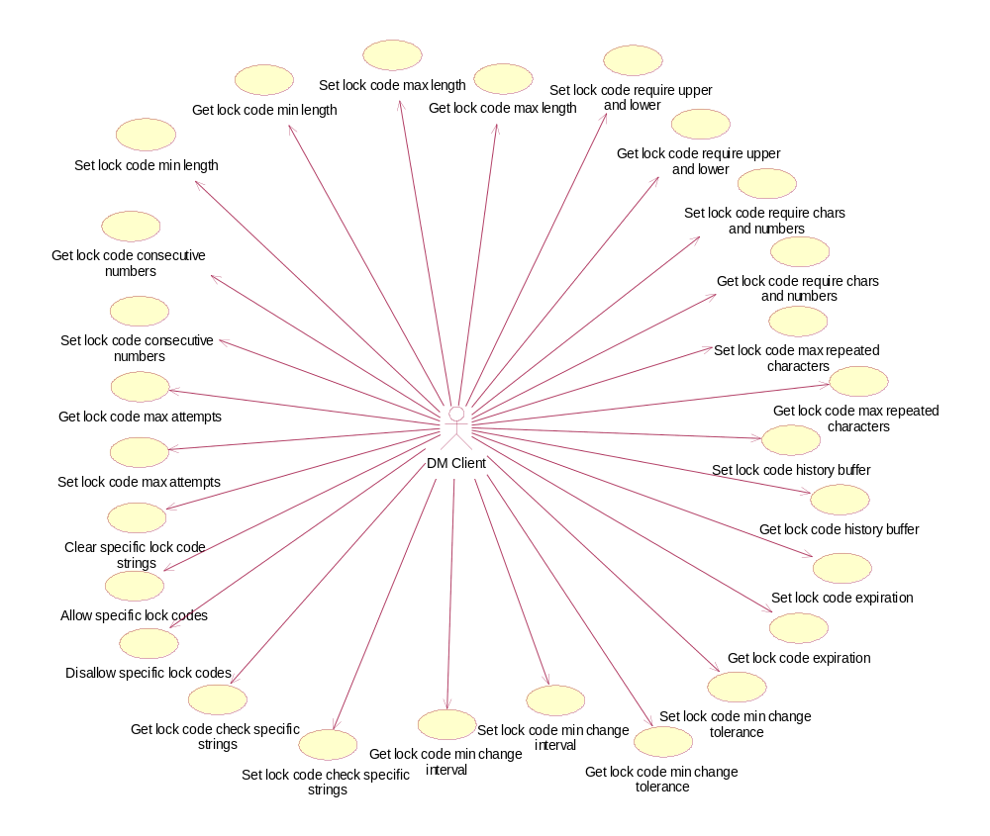
Figure 2.4 Enhanced features use cases

Loading the adapter
Summary | DM client loads the adapter.
Actor(s) | DM client
Frequency | Low
Preconditions | The adapter is installed in the device.
Description | The adapter is loaded when the DM client updates its DDF structures from the adapter (e.g. in client construction). It is also loaded whenever DM operations are targeted to the adapter. Adapter lifetime is equal to the execution time of operations in the DM session.
Exceptions | N/A
Postconditions | The adapter is loaded and ready to serve.
Illustrations | N/A

Wiping the device
Summary | EXEC ./TerminalSecurity/DeviceWipe
Actor(s) | DM client
Frequency | Low
Preconditions | Adapter is installed in the device.  Terminal Security server is available.
Description | DM adapter calls a Terminal Security server method to wipe the device.
Exceptions | N/A
Postconditions | Memory cards are formatted and the device is reset to factory settings.
Illustrations | N/A

Restarting the device
Summary | EXEC ./TerminalSecurity/Reboot
Actor(s) | DM client
Frequency | Low
Preconditions | Adapter is installed in the device.  Terminal Security server is available.
Description | DM adapter calls Terminal Security server method to restart the device.
Exceptions | N/A
Postconditions | Device is restarted (rebooted).
Illustrations | N/A

Scanning the file system
Summary | EXEC ./TerminalSecurity/FileScan/Execute  Input data: <path> [-r]
Actor(s) | DM client
Frequency | Low
Preconditions | Adapter is installed in the device.  Terminal Security server is available.
Description | DM adapter calls Terminal Security server method to scan the file system with specified parameters.  Parameters define recursion and the start path of the operation.
Exceptions | N/A
Postconditions | File system is scanned and results are available for fetching.
Illustrations | N/A

Getting file system scan results
Summary | GET ./TerminalSecurity/FileScan/Results  Output data: <scan results of this session>
Actor(s) | DM client
Frequency | Low
Preconditions | Adapter is installed in the device.  Terminal Security server is available.
Description | DM adapter calls Terminal Security server method to get the scan file system results.
Exceptions | N/A
Postconditions | File system scan results are returned.
Illustrations | N/A

Setting the device lock state
Summary | REPLACE ./TerminalSecurity/DeviceLock/LockLevel  Input data: {1 | 0}
Actor(s) | DM client
Frequency | Low
Preconditions | Adapter is installed in the device.  Terminal Security server is available.  SCP server is available.
Description | DM adapter calls Terminal Security server method to lock or unlock the device.  Operation result depends on the parameter of the command.
Exceptions | N/A
Postconditions | Device is locked or unlocked.
Illustrations | N/A

Getting the device lock state
Summary | GET ./TerminalSecurity/DeviceLock/LockLevel  Output data: {1 | 0}
Actor(s) | DM client
Frequency | Low
Preconditions | Adapter is installed in the device.  Terminal Security server is available.  SCP server is available.
Description | DM adapter calls Terminal Security server method to get the current device lock state.
Exceptions | N/A
Postconditions | Returns the state of the device lock (locked or not locked).
Illustrations | N/A

Setting the Autolock timeout
Summary | REPLACE ./TerminalSecurity/DeviceLock/AutolockPeriod  Input data: <value>
Actor(s) | DM client
Frequency | Low
Preconditions | Adapter is installed in the device.  Terminal Security server is available.  SCP server is available.
Description | DM adapter calls Terminal Security server method to set the timeout of Autolock.
Exceptions | N/A
Postconditions | Setting is updated and the adapter returns the status EOk.
Illustrations | N/A

Getting the Autolock timeout
Summary | GET ./TerminalSecurity/DeviceLock/AutolockPeriod  Output data: <value>
Actor(s) | DM client
Frequency | Low
Preconditions | Adapter is installed in the device.  Terminal Security server is available.  SCP server is available.
Description | DM adapter calls Terminal Security server method to get the timeout of Autolock.
Exceptions | N/A
Postconditions | Settings value is returned.
Illustrations | N/A

Setting the Autolock maximum timeout
Summary | REPLACE ./TerminalSecurity/DeviceLock/MaxAutolockPeriod  Input data: <value>
Actor(s) | DM client
Frequency | Low
Preconditions | Adapter is installed in the device.  Terminal Security server is available.  SCP server is available.
Description | DM adapter calls Terminal Security server method to set the maximum timeout of the Autolock.
Exceptions | N/A
Postconditions | Setting is updated and the adapter returns the status EOk.
Illustrations | N/A

Getting the Autolock maximum timeout
Summary | GET ./TerminalSecurity/DeviceLock/MaxAutolockPeriod  Output data: <value>
Actor(s) | DM client
Frequency | Low
Preconditions | Adapter is installed in the device.  Terminal Security server is available.  SCP server is available.
Description | DM adapter calls Terminal Security server method to get the maximum timeout of Autolock..
Exceptions | N/A
Postconditions | Settings value is returned.
Illustrations | N/A

Setting the device lock code
Summary | REPLACE ./TerminalSecurity/DeviceLock/LockCode  Input data: <string of digits e.g. 54321>
Actor(s) | DM client
Frequency | Low
Preconditions | Adapter is installed in the device.  Terminal Security server is available.  SCP server is available.
Description | DM adapter calls Terminal Security server method to set the device lock code.
Exceptions | N/A
Postconditions | Setting is updated and the adapter returns the status EOk.
Illustrations | N/A

Setting the lock code minimum length
Summary | REPLACE ./TerminalSecurity/DeviceLock/LockCodeMinLength  Input data: <string of digits e.g. 6>
Actor(s) | DM client
Frequency | Low
Preconditions | Adapter is installed in the device.  Terminal Security server is available.  SCP server is available.
Description | DM adapter calls Terminal Security server method to set the lock code minimum length.  Possible values: 4-256
Exceptions | N/A
Postconditions | Setting is updated and the adapter returns the status EOk.
Illustrations | N/A

Getting the lock code minimum length
Summary | GET ./TerminalSecurity/DeviceLock/LockCodeMinLength  Output data: <value>
Actor(s) | DM client
Frequency | Low
Preconditions | Adapter is installed in the device.  Terminal Security server is available.  SCP server is available.
Description | DM adapter calls Terminal Security server method to get the lock code minimum length.
Exceptions | N/A
Postconditions | Settings value is returned.
Illustrations | N/A

Setting the lock code maximum length
Summary | REPLACE ./TerminalSecurity/DeviceLock/LockCodeMaxLength  Input data: <string of digits e.g. 50>
Actor(s) | DM client
Frequency | Low
Preconditions | Adapter is installed in the device.  Terminal Security server is available.  SCP server is available.
Description | DM adapter calls Terminal Security server method to set the lock code maximum length.  Possible values: 4-256
Exceptions | N/A
Postconditions | Setting is updated and the adapter returns the status EOk.
Illustrations | N/A

Getting the lock code maximum length
Summary | GET ./TerminalSecurity/DeviceLock/LockCodeMaxLength  Output data: <value>
Actor(s) | DM client
Frequency | Low
Preconditions | Adapter is installed in the device.  Terminal Security server is available.  SCP server is available.
Description | DM adapter calls Terminal Security server method to get the lock code maximum length.
Exceptions | N/A
Postconditions | Settings value is returned.
Illustrations | N/A

Setting the lock code to require upper and lower
Summary | REPLACE ./TerminalSecurity/DeviceLock/LockCodeRequireUpperAndLower  Input data: <string of digits e.g. true>
Actor(s) | DM client
Frequency | Low
Preconditions | Adapter is installed in the device.  Terminal Security server is available.  SCP server is available.
Description | DM adapter calls Terminal Security server method to set the requirement as a Boolean value.  Possible values: true, false
Exceptions | N/A
Postconditions | Setting is updated and the adapter returns the status EOk.
Illustrations | N/A

Getting the lock code to require upper and lower
Summary | GET ./TerminalSecurity/DeviceLock/LockCodeRequireUpperAndLower  Output data: <value>
Actor(s) | DM client
Frequency | Low
Preconditions | Adapter is installed in the device.  Terminal Security server is available.  SCP server is available.
Description | DM adapter calls Terminal Security server method to get the Boolean value for the requirement.
Exceptions | N/A
Postconditions | Settings value is returned.
Illustrations | N/A

Setting the lock code to require characters and numbers
Summary | REPLACE ./TerminalSecurity/DeviceLock/LockCodeRequireCharsAndNumbers  Input data: <string of digits e.g. false>
Actor(s) | DM client
Frequency | Low
Preconditions | Adapter is installed in the device.  Terminal Security server is available.  SCP server is available.
Description | DM adapter calls Terminal Security server method to set the Boolean value for the requirement.  Possible values: true, false
Exceptions | N/A
Postconditions | Setting is updated and the adapter returns the status EOk.
Illustrations | N/A

Getting the lock code to require characters and numbers
Summary | GET ./TerminalSecurity/DeviceLock/LockCodeRequireCharsAndNumbers  Output data: <value>
Actor(s) | DM client
Frequency | Low
Preconditions | Adapter is installed in the device.  Terminal Security server is available.  SCP server is available.
Description | DM adapter calls Terminal Security server method to get the Boolean value for the requirement.
Exceptions | N/A
Postconditions | Settings value is returned.
Illustrations | N/A

Setting the lock code maximum repeated characters
Summary | REPLACE ./TerminalSecurity/DeviceLock/LockCodeMaxRepeatedCharacters  Input data: <string of digits e.g. 4>
Actor(s) | DM client
Frequency | Low
Preconditions | Adapter is installed in the device.  Terminal Security server is available.  SCP server is available.
Description | DM adapter calls Terminal Security server method to set the integral value for the maximum repeated characters.  Possible values: 0 = no restriction, 1-4 a single character cannot be used more than X times in the lock code.
Exceptions | N/A
Postconditions | Setting is updated and the adapter returns the status EOk.
Illustrations | N/A

Getting the lock code maximum repeated characters
Summary | GET ./TerminalSecurity/DeviceLock/LockCodeMaxRepeatedCharacters  Output data: <value>
Actor(s) | DM client
Frequency | Low
Preconditions | Adapter is installed in the device.  Terminal Security server is available.  SCP server is available.
Description | DM adapter calls Terminal Security server method get the value for the maximum repeated characters.
Exceptions | N/A
Postconditions | Settings value is returned.
Illustrations | N/A

Setting the lock code history buffer
Summary | REPLACE ./TerminalSecurity/DeviceLock/LockCodeHistoryBuffer  Input data: <string of digits e.g. 10>
Actor(s) | DM client
Frequency | Low
Preconditions | Adapter is installed in the device.  Terminal Security server is available.  SCP server is available.
Description | DM adapter calls Terminal Security server method to set the history buffer length.  Possible values: 0 = no restriction, 1-65535 the lock code cannot match the previous X lock codes.
Exceptions | N/A
Postconditions | Setting is updated and the adapter returns the status EOk.
Illustrations | N/A

Getting the lock code history buffer
Summary | GET ./TerminalSecurity/DeviceLock/LockCodeHistoryBuffer  Output data: <value>
Actor(s) | DM client
Frequency | Low
Preconditions | Adapter is installed in the device.  Terminal Security server is available.  SCP server is available.
Description | DM adapter calls Terminal Security server method to get the history buffer length.
Exceptions | N/A
Postconditions | Settings value is returned.
Illustrations | N/A

Setting the lock code expiration
Summary | REPLACE ./TerminalSecurity/DeviceLock/LockCodeExpiration  Input data: <string of digits e.g. 30>
Actor(s) | DM client
Frequency | Low
Preconditions | Adapter is installed in the device.  Terminal Security server is available.  SCP server is available.
Description | DM adapter calls Terminal Security server method to set the lock code expiration.  Possible values: 0 = no restriction, 1-365 the lock code expires after X days.
Exceptions | N/A
Postconditions | Setting is updated and the adapter returns the status EOk.
Illustrations | N/A

Getting the lock code expiration
Summary | GET ./TerminalSecurity/DeviceLock/LockCodeExpiration  Output data: <value>
Actor(s) | DM client
Frequency | Low
Preconditions | Adapter is installed in the device.  Terminal Security server is available.  SCP server is available.
Description | DM adapter calls Terminal Security server method to get the lock code expiration.
Exceptions | N/A
Postconditions | Settings value is returned.
Illustrations | N/A

Setting the lock code minimum change tolerance
Summary | REPLACE ./TerminalSecurity/DeviceLock/LockCodeMinChangeTolerance  Input data: <string of digits e.g. 5>
Actor(s) | DM client
Frequency | Low
Preconditions | Adapter is installed in the device.  Terminal Security server is available.  SCP server is available.
Description | DM adapter calls Terminal Security server method to set the minimum change tolerance for the lock code.  Possible values: 0-8 the user can change the lock code only X times before LockCodeMinChangeInterval hours has passed.
Exceptions | N/A
Postconditions | Setting is updated and the adapter returns the status EOk.
Illustrations | N/A

Getting the lock code minimum change tolerance
Summary | GET ./TerminalSecurity/DeviceLock/LockCodeMinChangeTolerance  Output data: <value>
Actor(s) | DM client
Frequency | Low
Preconditions | Adapter is installed in the device.  Terminal Security server is available.  SCP server is available.
Description | DM adapter calls Terminal Security server method to get the minimum change tolerance for the lock code.
Exceptions | N/A
Postconditions | Settings value is returned.
Illustrations | N/A

Setting the lock code minimum change interval
Summary | REPLACE ./TerminalSecurity/DeviceLock/LockCodeMinChangeInterval  Input data: <string of digits e.g. 100>
Actor(s) | DM client
Frequency | Low
Preconditions | Adapter is installed in the device.  Terminal Security server is available.  SCP server is available.
Description | DM adapter calls Terminal Security server method to set the minimum change interval for the lock code.  Possible values: 0 = no restriction, 1-1000 the user cannot change the lock code more that LockCodeMinChangeTolearance times before X hours has passed.
Exceptions | N/A
Postconditions | Setting is updated and the adapter returns the status EOk.
Illustrations | N/A

Getting the lock code minimum change interval
Summary | GET ./TerminalSecurity/DeviceLock/LockCodeMinChangeInterval  Output data: <value>
Actor(s) | DM client
Frequency | Low
Preconditions | Adapter is installed in the device.  Terminal Security server is available.  SCP server is available.
Description | DM adapter calls Terminal Security server method to get the minimum change interval for the lock code.
Exceptions | N/A
Postconditions | Settings value is returned.
Illustrations | N/A

Setting the lock code check specific strings
Summary | REPLACE ./TerminalSecurity/DeviceLock/LockCodeCheckSpecificStrings  Input data: <string of digits e.g. true>
Actor(s) | DM client
Frequency | Low
Preconditions | Adapter is installed in the device.  Terminal Security server is available.  SCP server is available.
Description | DM adapter calls Terminal Security server method to set the Boolean value whether to check the lock code specific strings.  Possible values: true, false
Exceptions | N/A
Postconditions | Setting is updated and the adapter returns the status EOk.
Illustrations | N/A

Getting the lock code check specific strings
Summary | GET ./TerminalSecurity/DeviceLock/LockCodeCheckSpecificStrings  Output data: <value>
Actor(s) | DM client
Frequency | Low
Preconditions | Adapter is installed in the device.  Terminal Security server is available.  SCP server is available.
Description | DM adapter calls Terminal Security server method to get the Boolean value whether to check the lock code specific strings.
Exceptions | N/A
Postconditions | Settings value is returned.
Illustrations | N/A

Disallowing specific lock codes
Summary | REPLACE ./TerminalSecurity/DeviceLock/LockCodeDisallowSpecific  Input data: <string of digits e.g. 12345;54321;pass>
Actor(s) | DM client
Frequency | Low
Preconditions | Adapter is installed in the device.  Terminal Security server is available.  SCP server is available.
Description | DM adapter calls Terminal Security server method to set the specific disallowed lock code strings.  Possible values: any string, multiple strings can be concatenated with the “;” mark.
Exceptions | N/A
Postconditions | Setting is updated and the adapter returns the status EOk.
Illustrations | N/A

Allowing specific lock codes
Summary | REPLACE ./TerminalSecurity/DeviceLock/LockCodeAllowSpecific  Input data: <string of digits e.g. 54321>
Actor(s) | DM client
Frequency | Low
Preconditions | Adapter is installed in the device.  Terminal Security server is available.  SCP server is available.
Description | DM adapter calls Terminal Security server method to set the specific allowed lock code strings.  Possible values: any string, multiple strings can be concatenated with “;” mark.
Exceptions | N/A
Postconditions | Setting is updated and the adapter returns the status EOk.
Illustrations | N/A

Clearing specific lock code strings
Summary | EXEC ./TerminalSecurity/DeviceLock/LockCodeClearSpecificStrings  Input data: Null
Actor(s) | DM client
Frequency | Low
Preconditions | Adapter is installed in the device.  Terminal Security server is available.  SCP server is available.
Description | DM adapter calls Terminal Security server method to clear all specific strings.
Exceptions | N/A
Postconditions | Settings value is returned.
Illustrations | N/A

Setting the lock code maximum attempts
Summary | REPLACE ./TerminalSecurity/DeviceLock/LockCodeMaxAttempts  Input data: <string of digits e.g. 20>
Actor(s) | DM client
Frequency | Low
Preconditions | Adapter is installed in the device.  Terminal Security server is available.  SCP server is available.
Description | DM adapter calls Terminal Security server method to set the lock code maximum attempts.  Possible values: 0 = no restriction, 3-100 the device is hard reset after the user has consecutively failed more than X times.
Exceptions | N/A
Postconditions | Setting is updated and the adapter returns the status EOk.
Illustrations | N/A

Getting the lock code maximum attempts
Summary | GET ./TerminalSecurity/DeviceLock/LockCodeMaxAttempts  Output data: <value>
Actor(s) | DM client
Frequency | Low
Preconditions | Adapter is installed in the device.  Terminal Security server is available.  SCP server is available.
Description | DM adapter calls Terminal Security server method to get the lock code maximum attempts.
Exceptions | N/A
Postconditions | Settings value is returned.
Illustrations | N/A

Setting the lock code consecutive numbers
Summary | REPLACE ./TerminalSecurity/DeviceLock/LockCodeConsecutiveNumbers  Input data: <string of digits e.g. “true”>
Actor(s) | DM client
Frequency | Low
Preconditions | Adapter is installed in the device.  Terminal Security server is available.  SCP server is available.
Description | DM adapter calls Terminal Security server method to set the lock code consecutive numbers.  Possible values: true, false
Exceptions | N/A
Postconditions | Setting is updated and the adapter returns the status EOk.
Illustrations | N/A

Getting the lock code consecutive numbers
Summary | GET ./TerminalSecurity/DeviceLock/ LockCodeConsecutiveNumbers  Output data: <value>
Actor(s) | DM client
Frequency | Low
Preconditions | Adapter is installed in the device.  Terminal Security server is available.  SCP server is available.
Description | DM adapter calls Terminal Security server method to get the lock code consecutive numbers.
Exceptions | N/A
Postconditions | Settings value is returned.
Illustrations | N/A

Deleting a file
Summary | EXEC ./TerminalSecurity/FileDelete  Input data: <filename with path e.g. C:\delete.txt>
Actor(s) | DM client
Frequency | Low
Preconditions | Adapter is installed in the device.  Terminal Security server is available.
Description | DM adapter calls Terminal Security server method to delete a single file.  Filename and path are defined in the command parameter.
Exceptions | N/A
Postconditions | File is deleted and the adapter returns EOk in SetStatusL.
Illustrations | N/A

Listing processes
Summary | GET ./TerminalSecurity/Processes  Output data: <list of processes as nodenames>
Actor(s) | DM client
Frequency | Low
Preconditions | Adapter is installed in the device.  Terminal Security server is available.
Description | DM adapter calls Terminal Security server method to list the processes.
Exceptions | N/A
Postconditions | Process list is returned.
Illustrations | N/A

Getting process data
Summary | GET ./TerminalSecurity/Processes/<ProcessName>/<Data>  Output data: <process data>
Actor(s) | DM client
Frequency | Low
Preconditions | Adapter is installed in the device.  Terminal Security server is available.
Description | DM adapter calls Terminal Security server method to get process data.  Process data is identified as a node name and return data that were valid at the previous process listing time. Process data node names are ID, FromRAM, MemoryInfo and Filename.
Exceptions | N/A
Postconditions | Process data is returned.
Illustrations | N/A

Starting the process
Summary | EXEC ./TerminalSecurity/LocalOperations/Start  Input data: <filename with path or DDF node path to an application management installed application>
Actor(s) | DM client
Frequency | Low
Preconditions | Adapter is installed in the device.  Terminal Security server is available.
Description | DM adapter calls Terminal Security server method to start the process.  Process name or reference to an installed application is given as a parameter. The application reference is a URI to the application management DDF tree.
Exceptions | N/A
Postconditions | Process is started.
Illustrations | N/A

Stopping the process
Summary | EXEC ./TerminalSecurity/LocalOperations/Stop  Input data: <filename with path or DDF node path to application management installed application>
Actor(s) | DM client
Frequency | Low
Preconditions | Adapter is installed in the device.  Terminal Security server is available.
Description | DM adapter calls Terminal Security server method to stop the process.  Process name or reference to an installed application is given as a parameter. The application reference is a URI to the application management DDF tree.
Exceptions | N/A
Postconditions | Process is stopped.
Illustrations | N/A

Services required

From the Symbian OS subsystems
This component does not have any direct interfaces to the Symbian OS side subsystems.

From the Domestic OS subsystems
This component does not have any direct interfaces to the Domestic OS side subsystems.

From HW
This component has no direct HW interfaces.

Services provided

UI
This component does not provide any UI.

SW IF
Provided Service | Description | Protected
Device Management API | This API provides access to Terminal Security server methods via a DM session.  See Section 2.3 for more information about available DM operations. | No

UI control hierarchy
The component does not contain any UI or UI controls.

Design

Class diagrams
TS adapter is implemented in the class CTcAdapter and it implements the adapter interface CSmlDmAdapter through the interface CTARMDmAdapter.
The CSmlDmAdapter interface is common for all the Device Management plug-in adapters and it is described in reference document [2].
The CSmlDmAdapter interface introduces methods that implement the common SyncML DM operations such as Add, Get, Replace and Delete. The interface also defines the methods for returning the DDF structure of the adapter to the Device Management client application. The DDF structure is specified in reference document [1].
CTARMDmAdapter is an interface common to all TARM DM adapters which need access to Policy Engine. CTARMDmAdapter implements policy requests to Policy Engine and prevents the usage of the adapter if the conditions of the policy are not fulfilled.
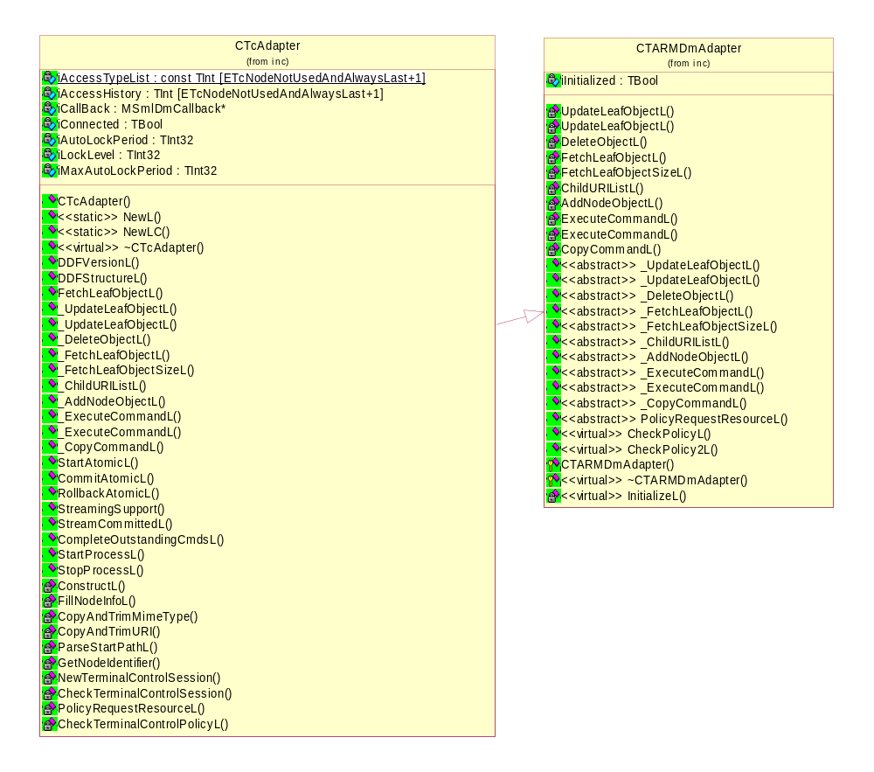
Figure 4.5 Class diagrams and relationships of CIsAdapter and CTARMDmAdapter

Framework
The framework is same for every ECom plug-in (that implements a DM adapter).

Component
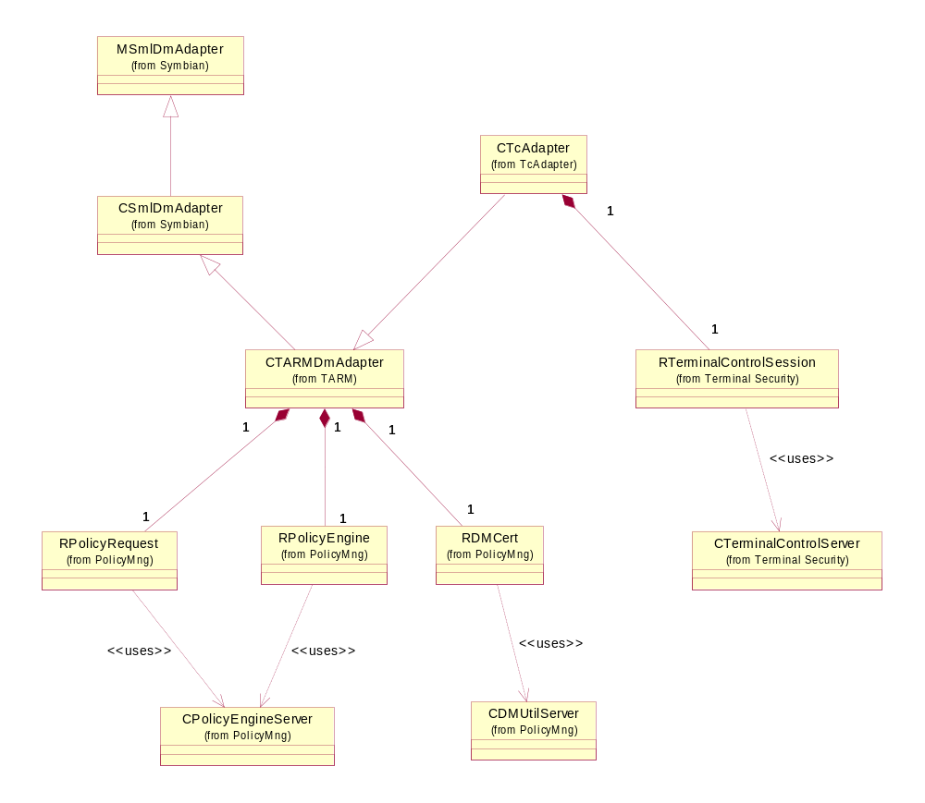
Figure 4.6 Components in the adapter execution environment

Class descriptions
Shorter form of class description: list of classes with a short description of each class. The descriptions of the methods are described in the C++ header files as comments.
Class | Description | Header file
CTcAdapter | TS adapter ECom plug-in DLL. | tcadapter.h
RTerminalControlSession | Terminal Security server client API. | TerminalControlClient.h
CTerminalControlServer | Terminal Security server. | TerminalControlServer.h
CTARMDMAdapter | Common TARM DM adapter parent class. | tarmdmadapter.h
CSmlDmAdapter | The class CSmlDmAdapter is an ECom interface for Device Management adapter plugins.  Copyright © Symbian Software Ltd. | SmlDmAdapter.h
MSmlDmAdapter | Abstract Device Management adapter.  Copyright © Symbian Software Ltd. | SmlDmAdapter.h
RPolicyEngine | RPolicyEngine class to establish Policy Engine server connection. | PolicyEngineClient.h
RPolicyRequest | RPolicyRequest class to handle policy request sessions. | PolicyEngineClient.h
CPolicyEngineServer | Policy Engine server. | PolicyEngineServer.h
RUISettingsSrv | TARM UI client. | UISettingsSrvClient.h
CUISettingsSrvServer | TARM UI server. | UISettingsSrv.h
RDMCert | Simple interface to get session certificate from Policy Management Utility Server. | DMCert.h
CDMUtilServer | Policy Management Utility Server. | DMUtilServer.h

Structs, type definitions and enumerations

TcAdapter.h
Enum’s name | Description
TTcNodeIdentifier | Private enumeration to identify a node with a number rather than with the URI.
TTcNodeAccessType | Private enumeration to identify node access types (Execute, Get, Replace).

Flag definitions
Flag | Description
__MYSERVER_NO_PROCESSES__ | Flag definition from EKA1 to EKA2 development.
__STIF_EMULATOR_TESTING__ | Flag for internal testing.
__WINS__ | Compiling target for emulator (WINS).
__WINS_DEBUG_TESTING__ | Flag for internal testing.
_DEBUG | Indicates compilation to debug target.
EKA2 | EKA2 kernel in use.
MAX_NUMBER_OF_DIGITS_IN_10BASE_INT64 | Defined as value 21.
TCADAPTER_FILESCAN_EXECUTE_LEAF | When activated, enables files can / execute leaf node.

State diagrams
All adapter methods are synchronic and block the execution of the hosting thread until the operation has finished.
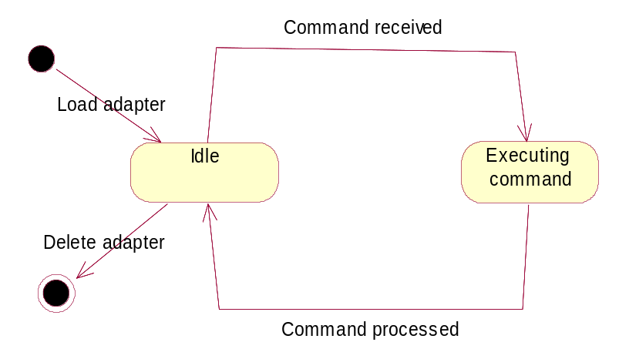
Figure 4.7 State diagram

Operations
All operations are defined in the use cases.

Backup and Restore
This component does not participate in Backup and Restore.

Variation
Application can be included in or excluded from a ROM image.
The variation is done according to the compilation flag __SAP_TERMINAL_CONTROL_FW. When the flag is defined, the adapter is included in a ROM image in an image creation IBY file.

System resource usage

Files
This component does not use any files.

Other data

Databases
This component does not use any databases.

Central Repository
This component does not use Central Repository.

Publish and Subscribe
This component does not use Publish and Subscribe.

Memory consumption
Memory/Build | Consumption
WINS UDEB | 253 700 bytes
ARMV5 UREL | 6979 bytes
Z\Resource\Plugins\tcadapter.rsc | 75 bytes

Task allocation
TS adapter runs in the SyncML DM client host process.
TS adapter starts a Terminal Security server process if it is needed.

Performance
In general, the adapter’s methods should be small in size and efficient in operation.
Overall performance is defined and limited by the hosting process and thread of the adapter DLL.
The transfer of large objects blocks the execution of the host thread and slows down the execution of the host process.

Timers
This component does not use timers.

Security

Capabilities of this component
Capability | Justification
CAP_ECOM_PLUGIN | Default ECom plug-in capabilities.

Input and output validation
Valid data types are defined in reference document [3].
Input and output data is UTF-8 text or Base64 binary data according to MIME type.
Adapter does not require or make any validation for data. Any invalid data must be detected and must cause an error in the host process or in S60 system services (in both directions of the data).

Environmental assumptions
This component does not make any assumptions about its environment.

Additional enforcements
Device Management operations are controlled with ACL values of DDF tree nodes. See reference document [3] for more information.
Adapter usage is controlled with policy management.
Each and every DM operation is permitted or denied by a policy request.

Exception handling
The leave mechanism of Symbian OS environment is used to handle memory exhaustion.
Any errors in the execution of operations will result in a SetStatusL call. DM adapter status code is used to characterize the error.
Exception | Description
Leave in operation | Adapter traps and leaves at the highest functional level and translates the error code to a suitable DM adapter status code.  Memory allocations are freed by Symbian OS leave handling.

Usage

Building
In directory \s60\tarm\group, run the following commands:
bldmake bldfiles
abld build tcadapter
To include the adapter in a target device, include the adapter’s IBY file in a configuration file (e.g. s60.iby) at image creation time.

User's guide
Refer to Device Management documentation [3] for instructions about DM operations.
To enable adapter operations in the target device, include the adapter’s IBY file in the image creation configuration file.

