S60 3.1
Device Management Terminal Security
Design Document

Team name | Author

Change history:

Version | Date | Status | Comments
1.0 | 24.10.2006 | Approved

Table of contents:

1. Document control 5
1.1 References 5
1.2 Documentation conventions 5
1.3 Abbreviations 5
2. General 6
2.1 Introduction 6
2.2 Component environment 6
2.3 Use cases 7
2.3.1 Setting the device lock code 8
2.3.2 Setting the device lock state 9
2.3.3 Getting the device lock state 9
2.3.4 Setting the Autolock timeout 9
2.3.5 Getting the Autolock timeout 10
2.3.6 Setting the Autolock maximum timeout 10
2.3.7 Getting the Autolock maximum timeout 10
2.3.8 Setting the lock code minimum length 11
2.3.9 Getting the lock code minimum length 11
2.3.10 Setting the lock code maximum length 11
2.3.11 Getting the lock code maximum length 12
2.3.12 Setting the lock code to require upper and lower 12
2.3.13 Getting the lock code to require upper and lower 12
2.3.14 Setting the lock code to require characters and numbers 13
2.3.15 Getting the lock code to require characters and numbers 13
2.3.16 Setting the lock code maximum repeated characters 13
2.3.17 Getting the lock code maximum repeated characters 14
2.3.18 Setting the lock code history buffer 14
2.3.19 Getting the lock code history buffer 14
2.3.20 Setting the lock code expiration 15
2.3.21 Getting the lock code expiration 15
2.3.22 Setting the lock code minimum change tolerance 15
2.3.23 Getting the lock code minimum change tolerance 16
2.3.24 Setting the lock code minimum change interval 16
2.3.25 Getting the lock code minimum change interval 16
2.3.26 Setting the lock code check specific strings 17
2.3.27 Getting the lock code check specific strings 17
2.3.28 Disallowing specific lock codes 17
2.3.29 Allowing specific lock codes 18
2.3.30 Clearing specific lock code strings 18
2.3.31 Setting the lock code maximum attempts 18
2.3.32 Getting the lock code maximum attempts 19
2.3.33 Setting the lock code consecutive numbers 19
2.3.34 Getting the lock code consecutive numbers 19
2.3.35 Wiping the device 20
2.3.36 Restarting the device 20
2.3.37 Scanning the file system 20
2.3.38 Getting file system scan results 20
2.3.39 Deleting a file 21
2.3.40 List processes 21
2.3.41 Getting process data 21
2.3.42 Starting the process 22
2.3.43 Stopping the process 22
2.4 Services required 22
2.4.1 From the Symbian OS subsystems 22
2.4.2 From the Domestic OS subsystems 22
2.4.3 From HW 23
2.5 Services provided 23
2.5.1 UI 23
2.5.2 SW IF 23
3. UI control hierarchy 24
4. Design 25
4.1 Class diagrams 25
4.1.1 Framework 27
4.1.2 Component 27
4.2 Class descriptions 27
4.2.1 Structs, type definitions and enumerations 28
4.2.1.1 TerminalControlServer.h 28
4.2.1.2 TcTrustedSession.h 28
4.2.1.3 TerminalControlthirdPartyAPI.h 28
4.2.1.4 TerminalControlClientServer.h 29
4.2.2 Flag definitions 30
4.2.3 State diagrams 30
4.3 Operations 31
4.4 Backup and Restore 31
5. Variation 32
6. System resource usage 33
6.1 Files 33
6.2 Other data 33
6.2.1 Databases 33
6.2.2 Central Repository 33
6.2.3 Publish and Subscribe 33
6.3 Memory consumption 33
6.4 Task allocation 33
6.5 Performance 33
6.6 Timers 33
7. Security 34
7.1 Capabilities of this component 34
7.2 Input and output validation 34
7.3 Environmental assumptions 34
7.4 Additional enforcements 34
8. Exception handling 35
9. Usage 36
9.1 Building 36
9.2 User's guide 36
9.2.1 How to use Third Party Application API 36
9.2.1.1 Building 36
9.2.1.2 Available functions 36
9.2.1.2.1 Open 36
9.2.1.2.2 Close 37
9.2.1.2.3 SetDeviceLockParameter 37
9.2.1.2.4 GetDeviceLockParameterSize 37
9.2.1.2.5 GetDeviceLockParameter 37

Document control

References
- OMA Device Management | http://www.openmobilealliance.org/
- S60 3.1 Policy Engine Design Document

Documentation conventions
Code is shown with Courier New font.

Abbreviations
API | Application Programming Interface
DM | Device management
ID | Identifier
OS | Operating System
SCP | Security Code Proxy
SID | Secure ID
TARM | Terminal Administration Rights Model
UI | User Interface
UID | Unique Identifier
URI | Uniform Resource Indicator

General
Terminal Security server is a TARM component offering control over the device via a DM session and with API for applications.
Server access is protected and clients are managed and controlled by the device administrating DM server.

Introduction
Terminal Security is a server that offers following services for its clients:
- File system scan
- Device restart
- Device wipe (formatting the memory card and resetting the device back to factory settings)
- Device lock features:
- Lock state
- Lock code
- Autolock period and its maximum value
- Process listing
- Process starting and killing
- File deletion

Terminal Security is a server with two types of clients. The client may be a DM adapter or an application.
The device lock and device wipe features are available for the application client. Adapter has access to all services.
Terminal Security server uses SCP server to modify device lock settings.

Component environment
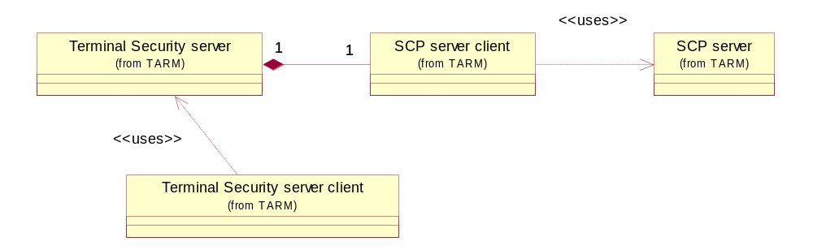
Figure 2.1 Dependencies to other modules
The UID values used in component are listed in the table below.
Terminal Security server | 0x10207825
Terminal Security client | 0x10207826
SCP server | 0x10207836
SCP server client | 0x10207837

Use cases
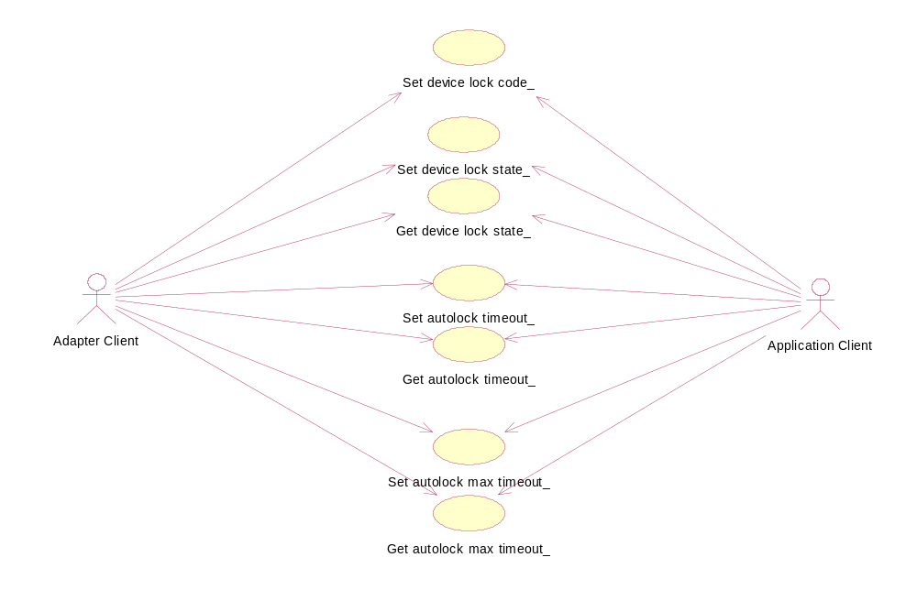
Figure 2.2 Use cases common to both types of clients
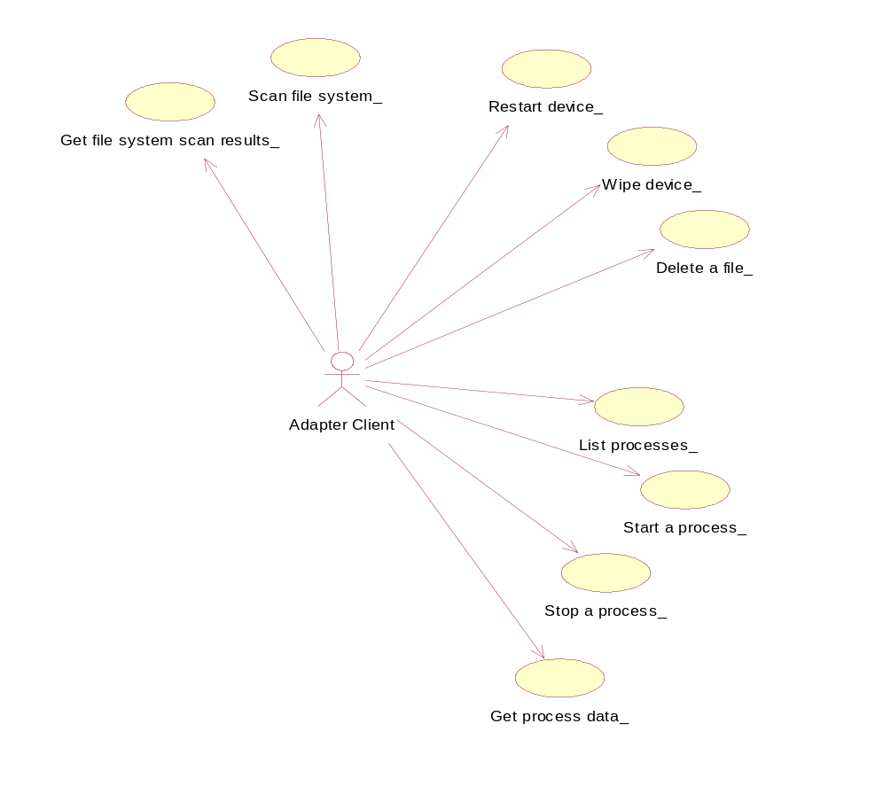
Figure 2.3 Use cases for DM client (adapter)
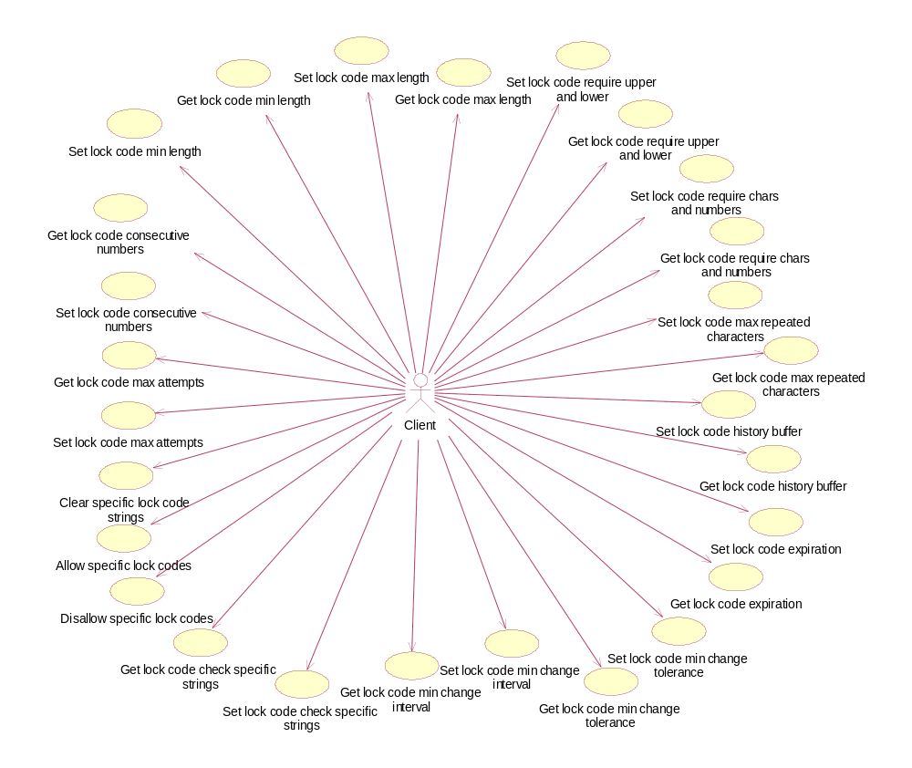
Figure 2.4 Use cases for enhanced features, the client can be DM or an application

Setting the device lock code
Summary | Setting the device lock code.
Actor(s) | Client
Frequency | Low
Preconditions | Terminal Security server is installed in the device.  SCP server is installed in the device
Description | - Client calls Terminal Security server method.  - Server checks client access rights (policy check).  - Server starts and completes the required operation.
Exceptions | If the policy check fails, the operation is aborted and the client panics.
Postconditions | Settings value is returned.
Illustrations | N/A

Setting the device lock state
Summary | Locking or unlocking the device.
Actor(s) | Client
Frequency | Low
Preconditions | Terminal Security server is installed in the device.  SCP server is installed in the device.
Description | - Client calls Terminal Security server method.  - Server checks client access rights (policy check).  - Server starts and completes the required operation.
Exceptions | If the policy check fails, the operation is aborted and the client panics.
Postconditions | Device is locked or unlocked.
Illustrations | N/A

Getting the device lock state
Summary | Getting the lock state.
Actor(s) | Client
Frequency | Low
Preconditions | Terminal Security server is installed in the device.  SCP server is installed in the device.
Description | - Client calls Terminal Security server method.  - Server checks client access rights (policy check).  - Server starts and completes the required operation.
Exceptions | If the policy check fails, the operation is aborted and the client panics.
Postconditions | Returns the state of the device lock (locked or not locked).
Illustrations | N/A

Setting the Autolock timeout
Summary | Setting timeout for the Autolock.
Actor(s) | Client
Frequency | Low
Preconditions | Terminal Security server is installed in the device.  SCP server is installed in the device.
Description | - Client calls Terminal Security server method.  - Server checks client access rights (policy check).  - Server starts and completes the required operation.
Exceptions | If the policy check fails, the operation is aborted and the client panics.
Postconditions | Setting is updated and the adapter returns the status EOk.
Illustrations | N/A

Getting the Autolock timeout
Summary | Getting timeout for the Autolock.
Actor(s) | Client
Frequency | Low
Preconditions | Terminal Security server is installed in the device.  SCP server is installed in the device.
Description | - Client calls Terminal Security server method.  - Server checks client access rights (policy check).  - Server starts and completes the required operation.
Exceptions | N/A
Postconditions | Settings value is returned.
Illustrations | N/A

Setting the Autolock maximum timeout
Summary | Setting the max timeout for the Autolock.
Actor(s) | Client
Frequency | Low
Preconditions | Terminal Security server is installed in the device.  SCP server is installed in the device.
Description | - Client calls Terminal Security server method.  - Server checks client access rights (policy check).  - Server starts and completes the required operation.
Exceptions | If the policy check fails, the operation is aborted and the client panics.
Postconditions | Setting is updated and adapter returns status EOk.
Illustrations | N/A

Getting the Autolock maximum timeout
Summary | Getting the timeout for the Autolock.
Actor(s) | Client
Frequency | Low
Preconditions | Terminal Security server is installed in the device.  SCP server is installed in the device.
Description | - Client calls Terminal Security server method.  - Server checks client access rights (policy check).  - Server starts and completes the required operation.
Exceptions | If the policy check fails, the operation is aborted and the client panics.
Postconditions | Settings value is returned.
Illustrations | N/A

Setting the lock code minimum length
Summary | Setting the lock code min length.
Actor(s) | DM client
Frequency | Low
Preconditions | Terminal Security server is available.  SCP server is available.
Description | - Client calls Terminal Security server method.  - Server checks client access rights (policy check).  - Server starts and completes the required operation.  Possible values: 4-256
Exceptions | If the policy check fails, the operation is aborted and the client panics.
Postconditions | Setting is updated and the adapter returns the status EOk.
Illustrations | N/A

Getting the lock code minimum length
Summary | Getting the lock code min length.
Actor(s) | DM client
Frequency | Low
Preconditions | Terminal Security server is available.  SCP server is available.
Description | - Client calls Terminal Security server method.  - Server checks client access rights (policy check).  - Server starts and completes the required operation.
Exceptions | If the policy check fails, the operation is aborted and the client panics.
Postconditions | Settings value is returned.
Illustrations | N/A

Setting the lock code maximum length
Summary | Setting the lock code max length.
Actor(s) | DM client
Frequency | Low
Preconditions | Terminal Security server is available.  SCP server is available.
Description | - Client calls Terminal Security server method.  - Server checks client access rights (policy check).  - Server starts and completes the required operation.  Possible values: 4-256
Exceptions | If the policy check fails, the operation is aborted and the client panics.
Postconditions | Setting is updated and the adapter returns the status EOk.
Illustrations | N/A

Getting the lock code maximum length
Summary | Getting the lock code max length.
Actor(s) | DM client
Frequency | Low
Preconditions | Terminal Security server is available.  SCP server is available.
Description | - Client calls Terminal Security server method.  - Server checks client access rights (policy check).  - Server starts and completes the required operation.
Exceptions | If the policy check fails, the operation is aborted and the client panics.
Postconditions | Settings value is returned.
Illustrations | N/A

Setting the lock code to require upper and lower
Summary | Setting the lock code to require upper and lower.
Actor(s) | DM client
Frequency | Low
Preconditions | Terminal Security server is available.  SCP server is available.
Description | - Client calls Terminal Security server method.  - Server checks client access rights (policy check).  - Server starts and completes the required operation.  Possible values: true, false
Exceptions | If the policy check fails, the operation is aborted and the client panics.
Postconditions | Setting is updated and the adapter returns the status EOk.
Illustrations | N/A

Getting the lock code to require upper and lower
Summary | Getting the lock code to require upper and lower.
Actor(s) | DM client
Frequency | Low
Preconditions | Terminal Security server is available.  SCP server is available.
Description | - Client calls Terminal Security server method.  - Server checks client access rights (policy check).  - Server starts and completes the required operation.
Exceptions | If the policy check fails, the operation is aborted and the client panics.
Postconditions | Settings value is returned.
Illustrations | N/A

Setting the lock code to require characters and numbers
Summary | Setting the lock code to require characters and numbers.
Actor(s) | DM client
Frequency | Low
Preconditions | Terminal Security server is available.  SCP server is available.
Description | - Client calls Terminal Security server method.  - Server checks client access rights (policy check).  - Server starts and completes the required operation.  Possible values: true, false
Exceptions | If the policy check fails, the operation is aborted and the client panics.
Postconditions | Setting is updated and the adapter returns the status EOk.
Illustrations | N/A

Getting the lock code to require characters and numbers
Summary | Getting the lock code to require characters and numbers.
Actor(s) | DM client
Frequency | Low
Preconditions | Terminal Security server is available.  SCP server is available.
Description | - Client calls Terminal Security server method.  - Server checks client access rights (policy check).  - Server starts and completes the required operation.
Exceptions | If the policy check fails, the operation is aborted and the client panics.
Postconditions | Settings value is returned.
Illustrations | N/A

Setting the lock code maximum repeated characters
Summary | Setting the lock code max repeated characters.
Actor(s) | DM client
Frequency | Low
Preconditions | Terminal Security server is available.  SCP server is available.
Description | - Client calls Terminal Security server method.  - Server checks client access rights (policy check).  - Server starts and completes the required operation.  Possible values: 0 = no restriction, 1-4 a single character cannot be used more than X times in the lock code.
Exceptions | If the policy check fails, the operation is aborted and the client panics.
Postconditions | Setting is updated and the adapter returns the status EOk.
Illustrations | N/A

Getting the lock code maximum repeated characters
Summary | Getting the lock code max repeated characters.
Actor(s) | DM client
Frequency | Low
Preconditions | Terminal Security server is available.  SCP server is available.
Description | - Client calls Terminal Security server method.  - Server checks client access rights (policy check).  - Server starts and completes the required operation
Exceptions | If the policy check fails, the operation is aborted and the client panics.
Postconditions | Settings value is returned.
Illustrations | N/A

Setting the lock code history buffer
Summary | Setting the lock code history buffer.
Actor(s) | DM client
Frequency | Low
Preconditions | Terminal Security server is available.  SCP server is available.
Description | - Client calls Terminal Security server method.  - Server checks client access rights (policy check).  - Server starts and completes the required operation.  Possible values: 0 = no restriction, 1-65535 the lock code cannot match the previous X lock codes.
Exceptions | If the policy check fails, the operation is aborted and the client panics.
Postconditions | Setting is updated and the adapter returns the status EOk.
Illustrations | N/A

Getting the lock code history buffer
Summary | Getting the lock code history buffer.
Actor(s) | DM client
Frequency | Low
Preconditions | Terminal Security server is available.  SCP server is available.
Description | - Client calls Terminal Security server method.  - Server checks client access rights (policy check).  - Server starts and completes the required operation.
Exceptions | If the policy check fails, the operation is aborted and the client panics.
Postconditions | Settings value is returned.
Illustrations | N/A

Setting the lock code expiration
Summary | Setting the lock code expiration.
Actor(s) | DM client
Frequency | Low
Preconditions | Terminal Security server is available.  SCP server is available.
Description | - Client calls Terminal Security server method.  - Server checks client access rights (policy check).  - Server starts and completes the required operation.  Possible values: 0 = no restriction, 1-365 the lock code expires after X days.
Exceptions | If the policy check fails, the operation is aborted and the client panics.
Postconditions | Setting is updated and the adapter returns the status EOk.
Illustrations | N/A

Getting the lock code expiration
Summary | Getting the lock code expiration.
Actor(s) | DM client
Frequency | Low
Preconditions | Terminal Security server is available.  SCP server is available.
Description | - Client calls Terminal Security server method.  - Server checks client access rights (policy check).  - Server starts and completes the required operation.
Exceptions | If the policy check fails, the operation is aborted and the client panics.
Postconditions | Settings value is returned.
Illustrations | N/A

Setting the lock code minimum change tolerance
Summary | Setting the lock code min change tolerance.
Actor(s) | DM client
Frequency | Low
Preconditions | Terminal Security server is available.  SCP server is available.
Description | - Client calls Terminal Security server method.  - Server checks client access rights (policy check).  - Server starts and completes the required operation.  Possible values: 0-8 the user can change the lock code only X times before LockCodeMinChangeInterval hours has passed.
Exceptions | If the policy check fails, the operation is aborted and the client panics.
Postconditions | Setting is updated and the adapter returns the status EOk.
Illustrations | N/A

Getting the lock code minimum change tolerance
Summary | Getting the lock code min change tolerance.
Actor(s) | DM client
Frequency | Low
Preconditions | Terminal Security server is available.  SCP server is available.
Description | - Client calls Terminal Security server method.  - Server checks client access rights (policy check).  - Server starts and completes the required operation.
Exceptions | If the policy check fails, the operation is aborted and the client panics.
Postconditions | Settings value is returned.
Illustrations | N/A

Setting the lock code minimum change interval
Summary | Setting the lock code min change interval.
Actor(s) | DM client
Frequency | Low
Preconditions | Terminal Security server is available.  SCP server is available.
Description | - Client calls Terminal Security server method.  - Server checks client access rights (policy check).  - Server starts and completes the required operation.  Possible values: 0 = no restriction, 1-1000 the user cannot change the lock code more that LockCodeMinChangeTolearance times before X hours has passed.
Exceptions | If the policy check fails, the operation is aborted and the client panics.
Postconditions | Setting is updated and the adapter returns the status EOk.
Illustrations | N/A

Getting the lock code minimum change interval
Summary | Getting the lock code min change interval.
Actor(s) | DM client
Frequency | Low
Preconditions | Terminal Security server is available.  SCP server is available.
Description | - Client calls Terminal Security server method.  - Server checks client access rights (policy check).  - Server starts and completes the required operation.
Exceptions | If the policy check fails, the operation is aborted and the client panics.
Postconditions | Settings value is returned.
Illustrations | N/A

Setting the lock code check specific strings
Summary | Setting the lock code check specific strings.
Actor(s) | DM client
Frequency | Low
Preconditions | Terminal Security server is available.  SCP server is available.
Description | - Client calls Terminal Security server method.  - Server checks client access rights (policy check).  - Server starts and completes the required operation.  Possible values: true, false.
Exceptions | If the policy check fails, the operation is aborted and the client panics.
Postconditions | Setting is updated and the adapter returns the status EOk.
Illustrations | N/A

Getting the lock code check specific strings
Summary | Getting the lock code check specific strings.
Actor(s) | DM client
Frequency | Low
Preconditions | Terminal Security server is available.  SCP server is available.
Description | - Client calls Terminal Security server method.  - Server checks client access rights (policy check).  - Server starts and completes the required operation.
Exceptions | If the policy check fails, the operation is aborted and the client panics.
Postconditions | Settings value is returned.
Illustrations | N/A

Disallowing specific lock codes
Summary | Disallowing specific lock code strings.
Actor(s) | DM client
Frequency | Low
Preconditions | Terminal Security server is available.  SCP server is available.
Description | - Client calls Terminal Security server method.  - Server checks client access rights (policy check).  - Server starts and completes the required operation.  Possible values: any string, multiple strings can be concatenated with the “;” mark.
Exceptions | If the policy check fails, the operation is aborted and the client panics.
Postconditions | Setting is updated and the adapter returns the status EOk.
Illustrations | N/A

Allowing specific lock codes
Summary | Allowing specific lock code strings.
Actor(s) | DM client
Frequency | Low
Preconditions | Terminal Security server is available.  SCP server is available.
Description | - Client calls Terminal Security server method.  - Server checks client access rights (policy check).  - Server starts and completes the required operation.  Possible values: any string, multiple strings can be concatenated with the “;” mark.
Exceptions | If the policy check fails, the operation is aborted and the client panics.
Postconditions | Setting is updated and the adapter returns the status EOk.
Illustrations | N/A

Clearing specific lock code strings
Summary | Clearing specific lock code strings.
Actor(s) | DM client
Frequency | Low
Preconditions | Terminal Security server is available.  SCP server is available.
Description | - Client calls Terminal Security server method.  - Server checks client access rights (policy check).  - Server starts and completes the required operation.
Exceptions | If the policy check fails, the operation is aborted and the client panics.
Postconditions | Settings value is returned.
Illustrations | N/A

Setting the lock code maximum attempts
Summary | Setting the lock code max attempts.
Actor(s) | DM client
Frequency | Low
Preconditions | Terminal Security server is available.  SCP server is available.
Description | - Client calls Terminal Security server method.  - Server checks client access rights (policy check).  - Server starts and completes the required operation.  Possible values: 0 = no restriction, 3-100 the device is hard reset after the user has consecutively failed more than X times.
Exceptions | If the policy check fails, the operation is aborted and the client panics.
Postconditions | Setting is updated and the adapter returns the status EOk.
Illustrations | N/A

Getting the lock code maximum attempts
Summary | Getting the lock code max attempts.
Actor(s) | DM client
Frequency | Low
Preconditions | Terminal Security server is available.  SCP server is available.
Description | - Client calls Terminal Security server method.  - Server checks client access rights (policy check).  - Server starts and completes the required operation.
Exceptions | If the policy check fails, the operation is aborted and the client panics.
Postconditions | Settings value is returned.
Illustrations | N/A

Setting the lock code consecutive numbers
Summary | Setting the lock code consecutive numbers.
Actor(s) | DM client
Frequency | Low
Preconditions | Terminal Security server is available.  SCP server is available.
Description | - Client calls Terminal Security server method.  - Server checks client access rights (policy check).  - Server starts and completes the required operation.  Possible values: true, false.
Exceptions | If the policy check fails, the operation is aborted and the client panics.
Postconditions | Setting is updated and the adapter returns the status EOk.
Illustrations | N/A

Getting the lock code consecutive numbers
Summary | Getting the lock code consecutive numbers.
Actor(s) | DM client
Frequency | Low
Preconditions | Terminal Security server is available.  SCP server is available.
Description | - Client calls Terminal Security server method.  - Server checks client access rights (policy check).  - Server starts and completes the required operation.
Exceptions | If the policy check fails, the operation is aborted and the client panics.
Postconditions | Settings value is returned.
Illustrations | N/A

Wiping the device
Summary | Device wipe
Actor(s) | DM client
Frequency | Low
Preconditions | Terminal Security server is installed in the device.
Description | - Client calls Terminal Security server method.  - Server checks client access rights (policy check).  - Server starts and completes the required operation.
Exceptions | If the policy check fails, the operation is aborted and the client panics.
Postconditions | Memory cards are formatted and the device is reset to factory settings.
Illustrations | N/A

Restarting the device
Summary | Restarting the device.
Actor(s) | DM client
Frequency | Low
Preconditions | Terminal Security server is installed in the device.
Description | - Client calls Terminal Security server method.  - Server checks client access rights (policy check).  - Server starts and completes the required operation.
Exceptions | If the policy check fails, the operation is aborted and the client panics.
Postconditions | Device is restarted (reboot).
Illustrations | N/A

Scanning the file system
Summary | Scanning the file system.
Actor(s) | DM client
Frequency | Low
Preconditions | Terminal Security server is installed in the device.
Description | - Client calls Terminal Security server method.  - Server checks client access rights (policy check).  - Server starts and completes the required operation.
Exceptions | If the policy check fails, the operation is aborted and the client panics.
Postconditions | File system is scanned and the results are available for fetching.
Illustrations | N/A

Getting file system scan results
Summary | Getting the scan results.
Actor(s) | DM client
Frequency | Low
Preconditions | Terminal Security server is installed in the device.
Description | - Client calls Terminal Security server method.  - Server checks client access rights (policy check).  - Server starts and completes the required operation.
Exceptions | If the policy check fails, the operation is aborted and the client panics.
Postconditions | File system scan results are returned.
Illustrations | N/A

Deleting a file
Summary | Deleting a file.
Actor(s) | DM client
Frequency | Low
Preconditions | Terminal Security server is installed in the device.
Description | - Client calls Terminal Security server method.  - Server checks client access rights (policy check).  - Server starts and completes the required operation.
Exceptions | If the policy check fails, the operation is aborted and the client panics.
Postconditions | File is deleted and the adapter returns EOk in SetStatusL.
Illustrations | N/A

List processes
Summary | Getting the process list.
Actor(s) | DM client
Frequency | Low
Preconditions | Terminal Security server is installed in the device.
Description | - Client calls Terminal Security server method.  - Server checks client access rights (policy check).  - Server starts and completes the required operation.
Exceptions | If the policy check fails, the operation is aborted and the client panics.
Postconditions | Process list is returned.
Illustrations | N/A

Getting process data
Summary | Getting process data.
Actor(s) | DM client
Frequency | Low
Preconditions | Terminal Security server is installed in the device.
Description | - Client calls Terminal Security server method.  - Server checks client access rights (policy check).  - Server starts and completes the required operation.
Exceptions | If the policy check fails, the operation is aborted and the client panics.
Postconditions | Process data is returned.
Illustrations | N/A

Starting the process
Summary | Starting the process.
Actor(s) | DM client
Frequency | Low
Preconditions | Terminal Security server is installed in the device.
Description | - Client calls Terminal Security server method.  - Server checks client access rights (policy check).  - Server starts and completes the required operation.
Exceptions | If the policy check fails, the operation is aborted and the client panics.
Postconditions | Process is started.
Illustrations | N/A

Stopping the process
Summary | Stopping the process.
Actor(s) | DM client
Frequency | Low
Preconditions | Terminal Security server is installed in the device.
Description | - Client calls Terminal Security server method.  - Server checks client access rights (policy check).  - Server starts and completes the required operation.
Exceptions | If the policy check fails, the operation is aborted and the client panics.
Postconditions | Process is killed.
Illustrations | N/A

Services required

From the Symbian OS subsystems
API | Description
Base / E32 API | Methods for base system services.
Base / File server client side | Methods for file system scan.
Application framework / Application Architecture | Methods for process management.

From the Domestic OS subsystems
This component does not have any direct interfaces to the Domestic OS side subsystems.

From HW
This component has no direct HW interfaces.

Services provided

UI
This component does not provide any UI.

SW IF
Provided Service | Description | Protected
Terminal Security DM adapter API | This API provides server methods to DM clients, see Section 2.3 for more information about services. | Yes
Terminal Security Third Party Application API | This API provides server methods to application clients, see Section 2.3 for more information about services. | Yes

UI control hierarchy
The component does not contain any UI or UI controls.

Design

Class diagrams
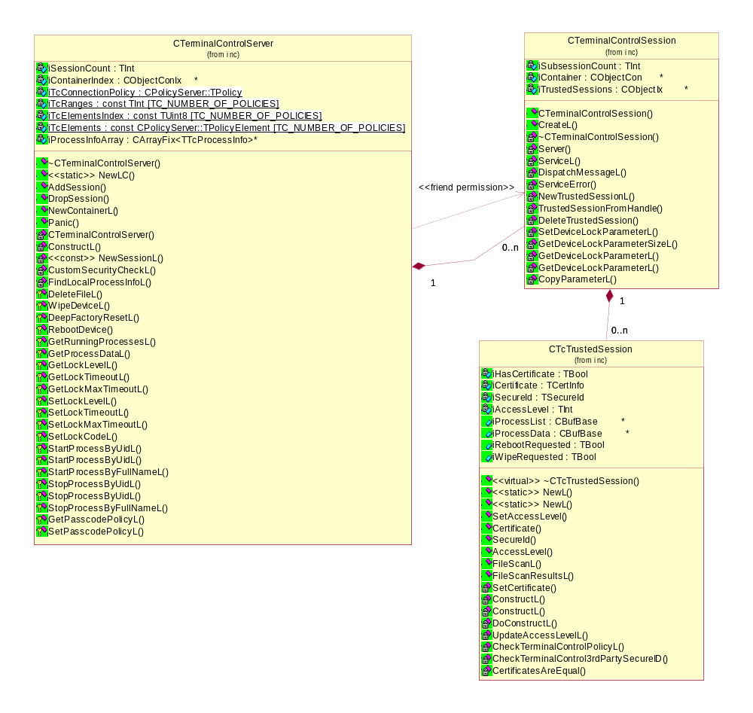
Figure 4.5 Class diagrams and relationships of server, session and subsession classes on server side
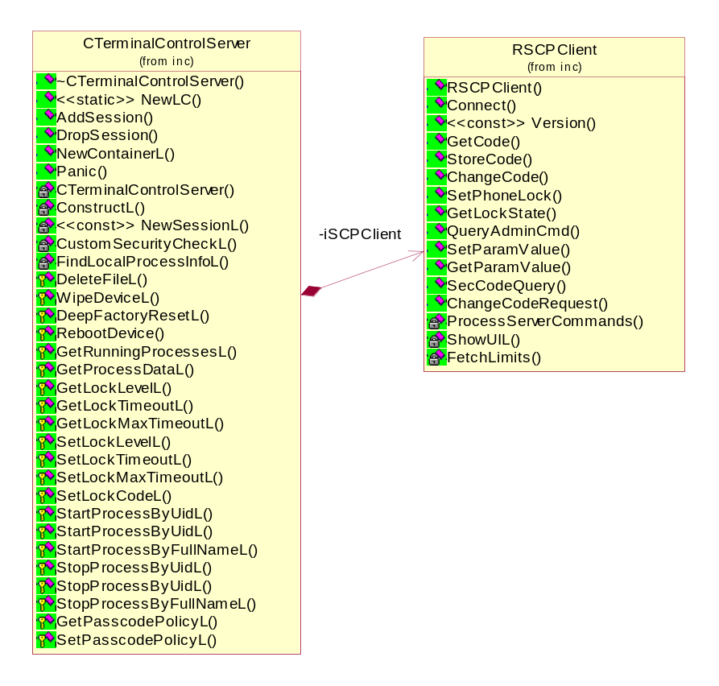
Figure 4.6 Class diagrams and relationships of CTerminalControlServer and RSCPClient
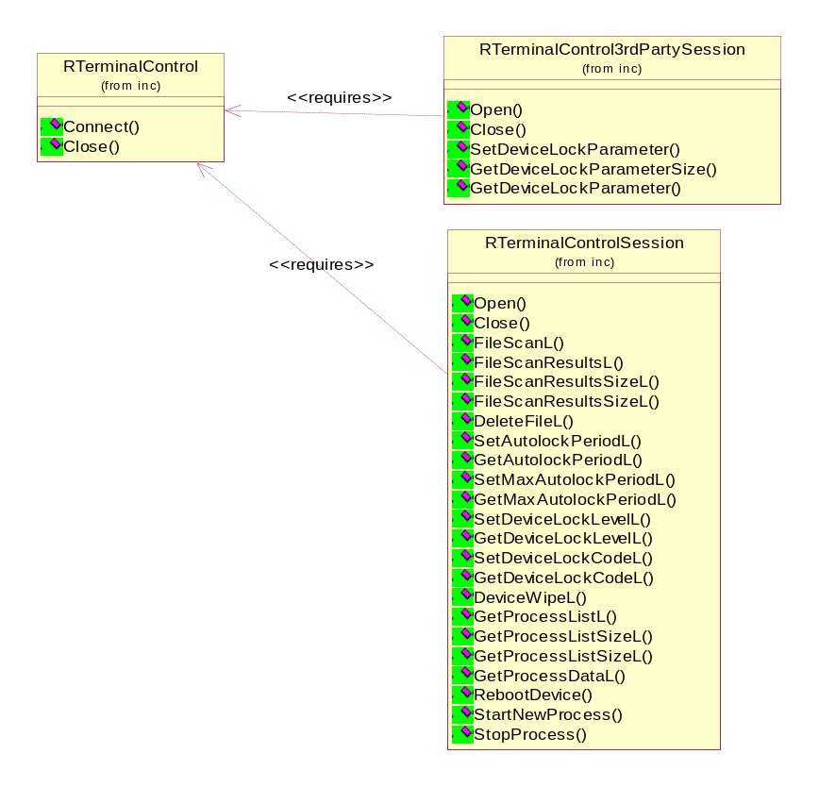
Figure 4.7 Class diagrams of client side classes, subsessions require a session

Framework
Terminal Security server component works in the framework of Symbian Client-Server architecture.

Component
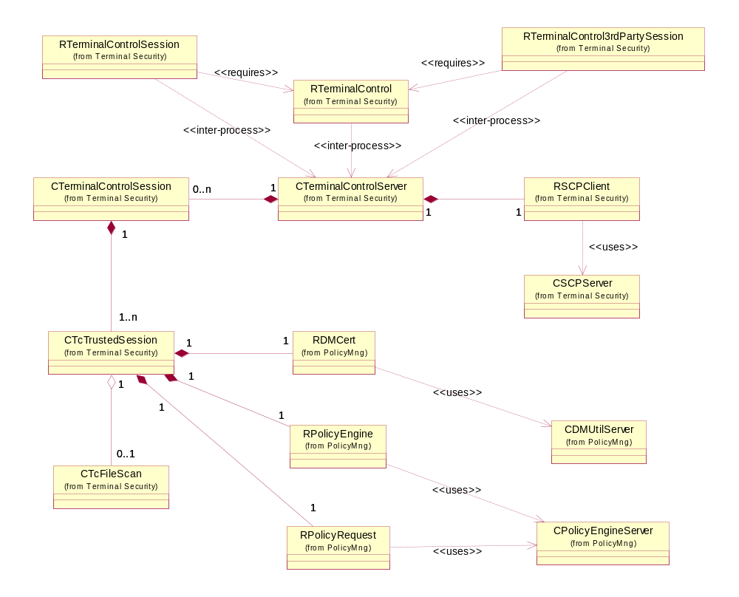
Figure 4.8 Components in the adapter execution environment

Class descriptions
The descriptions of the methods are described in the C++ header files as comments.
Class | Description | Header file
RTerminalControlthirdPartySession | A terminal Security server client API | TerminalControlthirdPartyClient.h
RTerminalControlSession | A terminal Security server client API | TerminalControlClient.h
CTerminalControlSession | Terminal Security server session | TerminalControlSession.h
CTcTrustedSession | Terminal Security server subsession | TcTrustedSession.h
CTcFileScan | File scan utility class | TcFileScan.h
CTerminalControlServer | Terminal Security server | TerminalControlServer.h
RSCPClient | Security Code Proxy client | SCPClient.h
CSCPServer | Security Code Proxy server | SCPServer.h
RPolicyEngine | RPolicyEngine class to establish Policy Engine server connection | PolicyEngineClient.h
RPolicyRequest | RPolicyRequest class to handle policy request sessions | PolicyEngineClient.h
CPolicyEngineServer | Policy Engine server | PolicyEngineServer.h
RUISettingsSrv | TARM UI client | UISettingsSrvClient.h
CUISettingsSrvServer | TARM UI server | UISettingsSrv.h
RDMCert | Simple interface to get session certificate from Policy Management Utility Server | DMCert.h
CDMUtilServer | Policy Management Utility Server | DMUtilServer.h

Structs, type definitions and enumerations

TerminalControlServer.h
Enumerations:
TTerminalControlPanic | Description
EPanicGeneral | General panic code.
EBadSubsessionHandle | Indicates invalid session handle.
EPanicIllegalFunction | Indicates illegal or unknown function.
EBadDescriptor | Indicates invalid descriptor and most probably bad usage of a method.

TcTrustedSession.h
Enumerations:
TTcAccessLevel | Description
EAccessLevelNone | Indicates no access to server.
EAccessLevelApplication | Indicates access to application services.
EAccessLevelDMAdapter | Indicates access to adapter services.

TerminalControlthirdPartyAPI.h
Enumerations:
TTerminalControlthirdPartyMessages | Description
ETimeout | Autolock timeout. Values in minutes. When != 0 the lock is enabled, when = 0 the lock is off.
EMaxTimeout | Maximum Autolock timeout value.
EPasscode | Passcode. Return value not supported.
EPasscodePolicy | 0 = passcode free. When != 0 the passcode cannot be changed.
ELock | Locks the terminal immediately. Return value not supported.
EDeviceWipe | When != 0 the device is wiped.
The following enumerations only exist in the Enhanced version of Third Party API
EPasscodeMinLength | 4-256 characters
EPasscodeMaxLength | 4-256 characters
EPasscodeRequireUpperAndLower | 0 = No restriction, 1 = Both upper and lower case letters are required in the password.
EPasscodeRequireCharsAndNumbers | 0 = No restriction, 1 = Both characters and numbers are required in the password.
EPasscodeMaxRepeatedCharacters | 0 = No restriction, 1-4 = A single character cannot be used more than X times in the password.
EPasscodeHistoryBuffer | 0 = No restriction, 1-X = The new password cannot match the previous X passwords.
EPasscodeExpiration | 0 = No restriction, 1-365 = The password expires after X days, and must be changed by the user.
EPasscodeMinChangeTolerance | 0-HistoryBuffer = The user can change the password only X times before EPasscodeMinChangeInterval hours have passed (default 0).
EPasscodeMinChangeInterval | 0 = No restriction, 1-1000 = The user cannot change the password more than EPasscodeMinChangeTolerance times before X hours have passed since the previous change.
EPasscodeCheckSpecificStrings | 0 = No restriction, 1 = The password cannot match a string in the set of strings given by the next three calls.
EPasscodeDisallowSpecific | Disallows the specific string/strings given. Individual strings can be separated with ";".
EPasscodeAllowSpecific | Re-allows the specific string/strings given. Individual strings can be separated with ";".
EPasscodeClearSpecificStrings | Clears the specific string buffer.
EPasscodeMaxAttempts | 0 = No restriction, 3-100 = The device is hard reset after the user has consecutively failed X times to answer the password query.

TerminalControlClientServer.h
Enumerations:
TTerminalControlMessages | Description
ECreateSubSession | Creates a new subsession.
ECloseSubSession | Closes a subsession.
EFileScan | Scans the file system, with folder and recursion indicator.
EFileScanResults | Gets file system scan results.
EFileScanResultsSize | Gets the size of results in bytes.
EFileDelete | Deletes a file given as an IPC parameter.
EDeviceLock_AutoLockPeriod_Set | Sets Autolock timeout period.
EDeviceLock_AutoLockPeriod_Get | Gets Autolock timeout period.
EDeviceLock_MaxAutoLockPeriod_Set | Sets Autolock timeout period maximum value.
EDeviceLock_MaxAutoLockPeriod_Get | Gets Autolock timeout period maximum value.
EDeviceLock_LockLevel_Set | Sets the device’s lock level (locked or not locked).
EDeviceLock_LockLevel_Get | Gets the device’s lock level.
EDeviceLock_LockCode_Set | Sets a new lock code.
EDeviceLock_LockCode_Get | Gets the lock code, not supported.
EDeviceWipe | Wipes the device (formats all memory cards and resets the device to factory settings).
EProcesses | Lists processes.
EProcessesSize | Gets process list size.
EProcessData | Gets process data (ID, FromRAM, MemoryInfo, Filename).
EReboot | Restarts the device.
ELocalOperation_Start | Starts a process, parameter is a SID or a filename with full path.
ELocalOperation_Stop | Stops a process, parameter is a SID or a filename with full path.
EthirdPartySetterGet | Third party application API common getter method.
EthirdPartySetterGetSize | Third party application API common get size method.
EthirdPartySetterSet | Third party application API common setter method.

Flag definitions
Flag | Description
__MYSERVER_NO_PROCESSES__ | EKA1 to EKA2 process flag.
__WINS__ | Indicates compiling for emulator (WINS).
_DEBUG | Indicates compiling for debugging purposes
EKA2 | Indicates compiling for EKA2 kernel.
MAX_NUMBER_OF_DIGITS_IN_10BASE_INT64 | 21

State diagrams
All services are handled synchronously and messages are completed only after message handling completes.
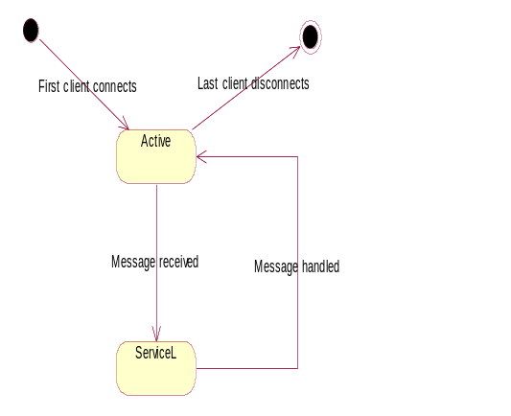
Figure 4.9 State transitions in Terminal Security server

Operations
All operations are described in Section 2.3.

Backup and Restore
This component does not participate in Backup and Restore.

Variation
An application can be included in or excluded from a ROM image.
The variation is done according to compilation flag __SAP_TERMINAL_CONTROL_FW.
When the flag is defined, server and client files are included in the ROM image in the image creation IBY file.

System resource usage

Files
This component does not use any files.

Other data

Databases
This component does not use any databases.

Central Repository
This component does not use Central Repository.

Publish and Subscribe
This component does not use Publish and Subscribe.

Memory consumption
Memory/Build | Consumption
WINS UDEB | TerminalControl.dll: 110 036 bytes  TerminalControl.exe: 296 116 bytes  Total: 406152 bytes
ARMV5 UREL | TerminalControl.dll: 1775 bytes  TerminalControl.exe: 8942 bytes  Total: 10717 bytes

Task allocation
Terminal Security server runs in its own process and in one thread.
Client DLL runs in the host process and thread.

Performance
Server performance is not measured. When the server works in the background, the processing speed of the device slows down.

Timers
This component does not use timers.

Security

Capabilities of this component
Server EXE:
Capability | Justification
CAP_SERVER | Default server capabilities
PowerMgmt | Process killing
DiskAdmin | Reset factory settings
AllFiles | File system scan

Client DLL:
Capability | Justification
CAP_CLIENT_DLL | Default client DLL capabilities

Input and output validation
There is no data validation in this component.

Environmental assumptions
This component does not make any assumptions about its environment.

Additional enforcements
The use of the DM adapter API requires PowerMgmt and DiskAdmin capabilities.
The use of Third Party Application API requires ReadDeviceData and DiskAdmin capabilities.
Connecting to server does not require any capabilities.

Exception handling
The leave mechanism of Symbian OS environment is used for handling memory exhaustion.
Any errors in the execution of operations result in an IPC error at the client thread.
Exception | Description
Leave in operation | Memory allocations are freed by Symbian OS leave handling.  Client receives leave code as IPC error code.

Usage

Building
In directory \s60\tarm\group, run the following commands:
bldmake bldfiles
abld export
abld build terminalcontrolserver
abld build terminalcontrolclient
To include components in the target device, include the IBY file in a configuration file (e.g. s60.iby) at image creation time.

User's guide
The use of Terminal Security server is limited by a DM server with administrator privileges to the device.
Refer to OMA Device Management [1] for information about the DM operations in general, and to Chapter 5 as well as reference document [2] for information about Policy Management and learning how to enable the Terminal Security feature.
This document explains the usage of Third Party Application API of the Terminal Security.

How to use Third Party Application API

Building
To build applications that use this API, you need the following files in your build environment:
- TerminalControl.h
- TerminalControlthirdPartyAPI.h
- TerminalControl.lib

Include the library file in your MMP file.
To test and use your application, include TerminalControl.dll in the target system.

Available functions
The API has following methods:
- Open
- Close
- SetDeviceLockParameter
- GetDeviceLockParameterSize
- GetDeviceLockParameter

The first two methods are used to open and close a session to the Terminal Security server.
The three last methods are used to run the services of this API.

Open
Use this method to open a session with the server.
RTerminalControl tc;
User::LeaveIfError( tc.Connect() );
CleanupClosePushL( tc );

RTerminalControlthirdPartySession ts;
User::LeaveIfError( ts.Open( tc ) );
CleanupClosePushL( ts );

Close
Use this method to close a session.
CleanupStack::PopAndDestroy( &ts );
CleanupStack::PopAndDestroy( &tc );

SetDeviceLockParameter
Use this method to set the device lock setting value.
For example, to set the Autolock timeout period value, look at the following code:
TBuf8<21> setValue;
setValue.Num( 10 );
User::LeaveIfError( ts.SetDeviceLockParameter( RTerminalControlthirdPartySession::ETimeout, setValue) );

GetDeviceLockParameterSize
Use this method to get the actual size of the descriptor data that would be returned by GetDeviceLockParameter.
For example, to get the Autolock timeout period value size, look at the following code:
TInt size = User::LeaveIfError( ts.GetDeviceLockParameterSize( RTerminalControlthirdPartySession::ETimeout ) );

GetDeviceLockParameter
Use this method to get the value of a setting.
For example, to get the Autolock timeout period value, look at the following code:
TInt size = User::LeaveIfError( ts.GetDeviceLockParameterSize( RTerminalControlthirdPartySession::ETimeout ) );

// Have some space
HBufC8* buf = HBufC8::NewL( size );
CleanupStack::PushL( buf );

// Make a writable descriptor
TPtr8 ptr( (unsigned char*)buf->Ptr(), buf->Length() );

// Get the timeout
User::LeaveIfError( ts.GetDeviceLockParameter( RTerminalControlthirdPartySession::ETimeout, ptr ) );

// Do something with data before destroying buffer
CleanupStack::PopAndDestroy( buf );

