AlfExAnalogDialer Description

Alf Analog Dialer Example Description 1
1. Features 1
1.1 Hitchcock features that the AlfExStickers is supposed to demonstrate 1
1.2 Application main features 1
1.2.1 Number display 2
1.2.2. Dialer 2
2. Prerequisites and dependencies 2
3. Architecture and design 2
3.1 Display Pane Area 3
3.2 Dialer Area 3
3.1 Graphics 4

1. Features
Analog Dialer example application imitates a telephone from old good days with rotating dial plate. It is not, however, stuck only with old days but can offer a digital display of newer times to show dialed number.

Although it imitates old phone in appearance in details it demonstrates power of ALF programming environment.

Hitchcock features that the AlfExAnalog Dialer is supposed to demonstrate
TODO: this is more a list of current list implemented feature than planned ones.
Effects
- Shadow
  - Shadow border shadow border of number display
- Transparency
  - Feature of Alf not used. Property of graphic images used by the application only.
- Opacity
  - Property of shadow border
- Transitions
  - Plate is rotated back to idle position with a fixed angle speed.

Media
- Animated gif
  - Not used.
- Release / restore of images / textures in FG/BG
  - Not implemented.

L10n / I18n/text
- BiDi
  - Not implemented.
- Mirroring
  - Not implemented.
- l10n resources
  - Not implemented.
- Font sizing, different fonts
  - Certain font is selected number display numbers. Their size do not change at run time.
- Text styling
  - Used for selecting text type for dialed numbers

Touch / tactile
- Drag / drop
  - Dragging is implemented for rotating image. Drop is not implemented.
- Tapping
  - Normal short tapping on Clear key is used clearing number display. Long taps clear whole number display. Tapping down initiates both plate rotation and clear key functionality. Lifting stylus up finishes these actions.

Themes / skins /misc
- Skin color
  - Not implemented.
- BG image
  - Background image is loaded for application. Implemented as CAlfImageBrush.
- Highlight/ 9 piece frame
  - Not implemented.

Layouts / Visuals / Brushes
- Viewport
  - Not implemented.
- Anchor layout
  - Not implemented
- Curve path layout
  - Planned for moving selected number from dialer pane to number display
- Deck Layout
  - Used both for display and dialer panes. Especially dialer needs, it because it has several image with same positioning.
- Text Visual
  - Number display is implemented as text visual.
- Image Brush
  - Background image is loaded for application.
- Drop Shadow Brush
  - Not implemented

1.2 Application main features
- Application is divided into two panes: number display and dialer
- In portrait mode, number display is topmost pane and dialer below it
- In landscape mode, dialer is leftmost pane and number display to the right of it
- Has common background image
- Support layout switch and different resolutions on fly

1.2.1 Number display

- It uses application screen area, which is left from dialer, see below
- Number display shows series of dialed number
- New dialed number is appended to the existing series of numbers
- Number display can be cleared by Clear key of dialer

1.2.2. Dialer

- Dialer pane must be an exact square. Length of its sides are smaller extent of application rectangular
- Dialer graphics consists of three images:
1) Background for dialer, which includes numbers
2) Plate, which contains holes that underlying numbers become visible. Technically holes are transparent areas on plate image. Plate rotates.
3) Stopper image, which includes Clear key and stopper.
- User rotates plate by dragging area which is between Clear key and edges of plate. When rotated, maximum angle of rotation is determined by stopper. Plate does not rotate counter clockwise (except when it is returning to idle position) or beyond stopper. Plate returns to idle position, when user lifts up the stylus.
Note! Technically rotating plate is implementing by changing angle of plate image. Idle position stands for angle 0. Clockwise rotation of the image stands for negative angles. Counter clockwise rotation of the image stands for positive angles.
- When dragging moves outside area which is between Clear key and edges of plate, plate returns automatically
- When plate starts to return, selected number appears to number display
- Normal tap to Clear key area clears last selected number of phone display. Long tap clears whole display. If stylus is lifted up outside Clear key area, Clear key has no affect

2. Prerequisites and dependencies
- Needs ALF environment on the phone
- Needs touch enabled phone to work

3. Architecture and design
Analog Dialer follows ALF adaptation of model-view-controller paradigma. User interface component is divided into control element (CAlfExAnalogDialerControl) and graphical elements called visuals. The control element owns the visuals. The control does not involve in creating graphics onto to the screen. It is visuals’ tasks. Visuals are grouped to layouts.

Classes are
- CAlfExAnalogDialerApplication. Class enforced by application framework. It creates CAlfExAnalogDialerDocument class.
- CAlfExAnalogDialerAppUi. Puts things rolling and creates basic objects, which every Alf applications need to work
  - Creates Alf environment CAlfEnv
  - Creates display CAlfDisplay
  - Create control group CAlfControlGroup
  - Creates control CAlfExAnalogDialerControl
  - Puts everything onto screen using roster
  - Additionally catches events of layout or resolution mode change and notifies control about needed changes
- CAlfExAnalogDialerDocument. Class enforced by application framework. It creates CAlfExAnalogDialerAppUi class.
- CAlfExAnalogDialerControl.
  - Contains most of the application logic. Creates layouts and visuals. Implements interaction with user.

Control class needs number of layouts and visual to perform the job. The following picture shows hierarchical structure of layout and visuals and brushes attached to them.

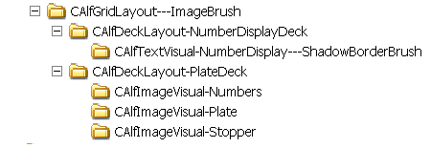

3.1 Graphics

Following picture shows graphics image, which dialer consists of . The background image is not shown in this figure.

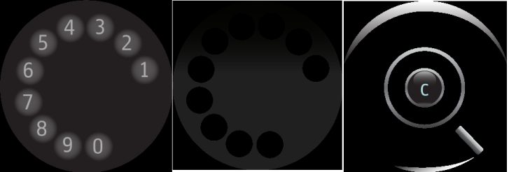

Appearance of analog dialer when application is running

