Hitchcock Example Application: AlfExStickers Description

1. Features 1
1.1 Hitchcock features that the AlfExStickers is supposed to demonstrate 1
1.2 Application main features 3
2. Prerequisites and dependencies 4
3. Architecture and design 5
3.1 Graphics 6
4. Application Logic 7

! Note that this documentation is only used by the technical writer to create the actual documentation for the project. Information provided here is by no means productized.

Features

Hitchcock features that the AlfExStickers is supposed to demonstrate

Effects
- Shadow
  - This is implemented as drop shadow brush for the stickers.
- Transparency
  - This is planned to be implemented for stickers that are being dragged.
- Opacity
  - This effect needs clarification, what actually is wanted to be demonstrated?
- Transitions
  - Scaling transition is implemented for the stickers when they are zoomed in or out.

Media
- Animated gif
  - Animated GIF was found to affect performance quite badly.
- Release / restore of images / textures in FG/BG
  - This is implemented for the AlfExStickers application.

L10n / I18n/text
- BiDi
  - Feature is not yet planned.
- Mirroring
  - Feature is not yet planned.
- l10n resources
  - Feature is not yet planned.
- Font sizing, different fonts
  - Feature is not yet planned.
- Text styling
  - Feature is not yet planned.

Touch / tactile
- Drag / drop
  - This is implemented for both stickers and viewport.
- Tapping
  - Touch interaction is used to interact with the application.

Themes / skins /misc
- Skin color
  - Feature is not yet planned.
- BG image
  - Background image is loaded for both stickers and application.
- Highlight/ 9 piece frame
  - Feature is not yet planned.

Layouts / Visuals / Brushes
- Viewport
  - This is implemented in the application.
- Anchor layout
  - This is planned to be implemented for scaled up stickers as default position on screen.
- Deck Layout
  - Stickers are implemented using deck layouts.
- Text Visual
  - Textual content in Sticker is created with text visual.
- Image Brush
  - Sticker background is drawn using image brush into the deck layout.
- Drop Shadow Brush
  - Drop shadow brush is used to create shadows on stickers.

Application main features

- Application has virtual screen that is sized bigger than the actual device screen.
- Viewport is the same size of the devices physical screen, the viewport can be scrolled by dragging the application background.
- Stickers are shown as small icon size on the application background, using drag and drop user can freely move them around.
- Tapping in the small size sticker zooms it to full screen and tapping on a full screen sticker causes it to scale back to icon size.
- Currently sticker contains text and background.

Prerequisites and dependencies

- Touch capable 5.0 phone hardware required.
- Normal Hitchcock dependencies

Architecture and design

- CAlfExStickers
  - Default Symbian class, no modification
- CAlfExStickersApplication
  - Default Symbian class, no modification
- CAlfExStickersAppUi
  - Default Symbian class, no modification
- CAlfExStickersDocument
  - Default Symbian class, no modification
- CAlfExStickerLayout
  - Is the base class for sticker objects
  - Inherited from CAlfDeckLayout
- CAlfExStickersControl
  - Control class for the stickers, inherited from the CAlfControl
  - Handles application logic

Graphics

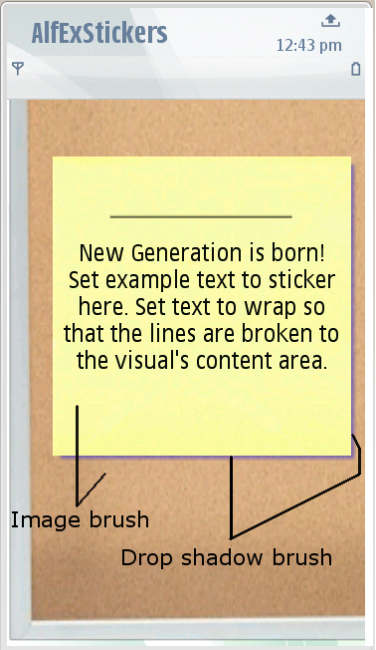
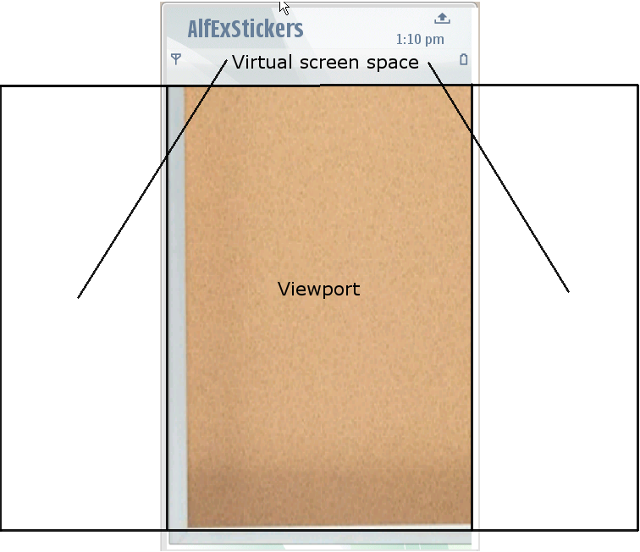 Picture 1 Demonstrating using Viewport on Virtual Screen
Picture 2 Showing usage of
different Brushes

Application Logic

This application is very simple. It is based on the Symbian project templates and we have only added two additional classes besides the default Symbian classes (like Document, View and AppUi).

Our control class (AlfExStickersControl) is inherited from CAlfControl class and thus acts as control for all of the visuals in the application. It also handles reacting to user events by OfferEventL() function.

We also have a wrapper class (CAlfExStickerLayout) that creates the Sticker object. The class itself is inherited from CAlfDeckLayout as the Sticker is created using Deck layout which contains a text visual and few brushes.

