S60 5.0
UI Accelerator Toolkit
Design Document

Hitchcock Taco ED | Pekka.E Jokela

Change history:

Version | Date | Status | Comments
1.0 | 04.05.2007 | Approved

Table of contents:

1. Document control 5
1.1 References 5
1.2 Documentation conventions 5
1.3 Abbreviations 5
1.4 Definitions 5
2. General 6
2.1 Introduction 6
2.2 Component environment 6
2.3 Use cases 7
2.3.1 Create custom controls 7
2.3.2 Create and observe events 7
2.4 Services required 8
2.4.1 From the Symbian OS subsystems 8
2.4.2 From the Domestic OS subsystems 8
2.4.3 From HW 8
2.5 Services provided 8
2.5.1 UI 8
2.5.2 SW IF 8
3. Design 11
3.1 Class diagrams 11
3.1.1 Framework 11
3.1.2 ALF client 12
3.1.3 ALF Server 13
3.1.4 Extensions 14
3.1.4.1 Extension client 14
3.1.4.2 Server side extension 15
3.1.5 Pointer events 17
3.1.6 Scheduler management 17
3.1.7 LCT Classes 17
3.1.8 Transition effect framework 18
3.2 Class descriptions 18
3.2.1 Structs, type definitions and enumerations 18
3.2.1.1 AlfAppServer.h structs 18
3.2.2 Flag definitions 18
3.3 Operations 19
3.3.1 Creating CAlfEnv for the first time 19
3.3.2 Allocating a control group 19
3.4 Backup and Restore 20
4. Variation 21
5. System resource usage 22
5.1 Files 22
5.2 Other data 22
5.2.1 Databases 22
5.2.2 Central Repository 22
5.2.3 Publish and Subscribe 22
5.3 Memory consumption 22
5.3.1 ALF Server exe 22
5.3.2 ALF Server Core 23
5.3.3 ALF client 23
5.3.4 Core toolkit 23
5.3.5 Total 23
5.4 Task allocation 23
5.5 Performance 23
5.6 Timers 23
6. Security 24
6.1 Capabilities of this component 24
6.2 Input and output validation 24
6.3 Environmental assumptions 24
6.4 Additional enforcements 24
7. Exception handling 25
8. Usage 26
8.1 Building 26
8.2 User's guide 26

Document control

References
- S60 AVKON Layout System Design Document

Documentation conventions
Code is shown with the Courier New font.

Abbreviations
AppServer | Application Server
ALF | Accelerated Look and Feel, a short name for UI Accelerator Toolkit
AVKON | S60 classic UI framework and control library
HUIToolkit | Core toolkit library
LCT | Layout Creation Tool

Definitions
Application Server | Server application. Server which also creates CoeEnv, AppUi, window groups, etc. as a normal S60 application.
Core toolkit | Toolkit which controls the visual trees and draws them.

General

Introduction
ALF is a wrapper around HUIToolkit for the S60 applications. HUIToolkit is a library which is used to create rich user interface visualization. ALF consists of a client and an application server.

Component environment
The key relationships between ALF and the components in its environment are shown in Figure 2.1:
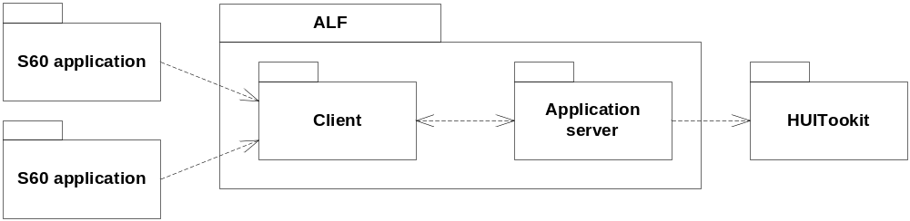
Figure 2.1 Component environment
The S60 applications use ALF Client to draw their screens. The client passes the information to the ALF Server application, which utilizes HUIToolkit. The toolkit then uses the selected renderer (BitGDI, OpenGL) to draw onto the screen.

Use cases
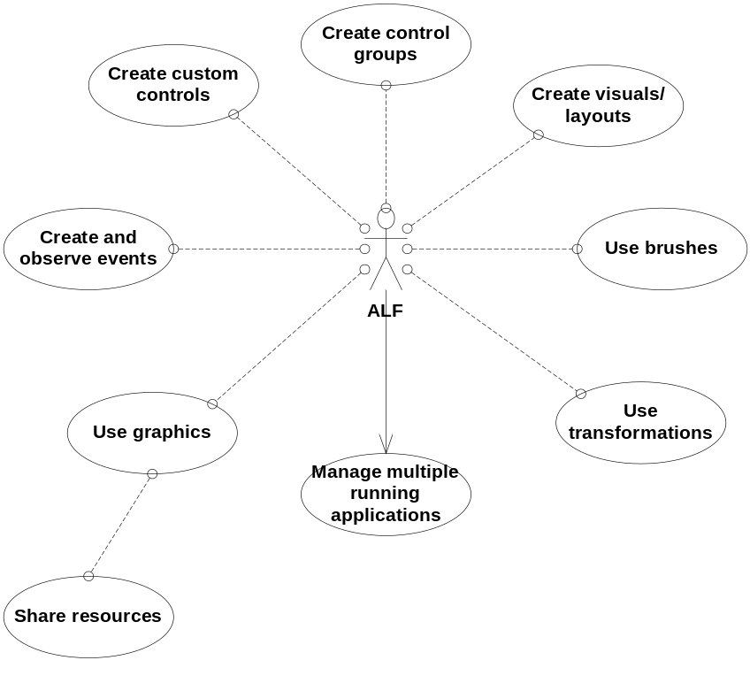
Figure 2.2 ALF use cases

Create custom controls
Summary | S60 applications must be able to create their own controls. ALF needs to create an easy-to-use framework to support this.
Actor(s) | ALF, the S60 application.
Frequency | Low. Typically one or more controls are created when a view is opened or a state of the UI is changed.
Preconditions | ALF has been set up successfully.
Description | The S60 application creates a custom control by deriving a control base class from ALF. The implementation overrides the needed function. The system has to ensure that these functions are called instead of the default implementation. The application must be able to instantiate and delete the custom control object.
Exceptions | Out of memory during construction.
Postconditions | The custom control has been instantiated. The application and ALF can utilize its functions.
Illustrations | None.

Create and observe events
Summary | ALF schedules an event.
Actor(s) | The S60 application.
Frequency | Low. Usually one per user key press.
Preconditions | ALF has been set up successfully.
Description | After used command, the S60 application sends a timed message to the ALF system. When the event is scheduled to be executed, the event is passed to the correct object and the event is handled.
Exceptions | Unknown commands, OOM.
Postconditions | The event is handled.
Illustrations | None.

Services required

From the Symbian OS subsystems
Services of the Symbian OS infrastructure (including client-server framework, CONE and timer service) and S60 UI Application Framework are required.

API | Description
AppArc | Application architecture for server launch.
AknLayout2 | S60 scalable layout system.
AVKON | S60 application framework.
CONE | Control environment.
ECom | ECom plug-ins for extensions.
EUser | User library for all the basic types.
FLogger | For file logging.
WS32 | Window Server session, window group and drawable window.

From the Domestic OS subsystems
This component does not have any direct interfaces to the Domestic OS side subsystems.

From HW
This component has no direct HW interfaces.

Services provided

UI
This component does not have an UI. All the user interaction and business logic is inside the client side application.

SW IF
The software interface is a subset of the HUIToolkit interface. Instead of using the full HUIToolkit interface, the S60 application uses the ALF Client interfaces, which provide all the needed functions for applications to create a rich HUIToolkit based visualization.

Provided Service | Description | Protected
CAlfAnchorLayout | An interface for anchor layout. Derived from CAlfLayout. | No
CAlfBorderBrush | An interface for border brush. Derived from CAlfBrush. | No
CAlfBrush | A base class for all brushes. | No
CAlfBrushArray | An array which holds the brushes. | No
RAlfClientBase | A server client base class available for deriving. | No
RAlfClient | A private server client used by CAlfEnv. | Yes
TAlfCommand | A base class for all commands. | No.
CAlfCommandSchduler | A scheduler for commands on the client side. | Yes
CAlfControl | A base class for all controls. | No
CAlfControlGroup | Groups a set of controls. | No
RAlfControlGroupSubsession | A subsession for all the control group operations. | Yes
CAlfCurvePath | Curve path definition. | No
CAlfCurvePathLayout | A layout where the items map via the defined curve. | No
CAlfDeckLayout | A layout where the items are stacked like a deck of cards. | No
CAlfDisplay | An interface for display. | No
RAlfDisplaySubsession | A subsession for all the display operations. | Yes
CAlfDropShadowBrush | A brush with drop shadow. | No
CAlfFrameBrush | A brush which draws a frame. | No
CAlfEnv | Interface for the environment. | No
TAlfEvent | An event structure. | No
MAlfEventHandler | An event hander interface for custom commands. | No
CAlfFlowLayout | A layout where the items are placed next to each other. | No
CAlfGenComponent | A generic communications component for client messages | No
CAlfGradientBrush | A brush with gradient color drawing. | No
CAlfGridLayout | An interface for grid layout. Derived from CAlfLayout. | No
TAlfImage | A struct for holding information relevant to an image. | No
CAlfimageBrush | A brush which draws an image. | No
CAlfImageLoaderUtil | A utility class to create images from the system skin. | No
CAlfImageVisual | An interface for image visual. Derived from CAlfVisual. | No
CAlfLCTAnchorLayout | An interface for the LCT specific anchor layout. Derived from CAlfAnchorLayout. | No
CAlfLCTGridLayout | An interface for the LCT specific grid layout. Derived from CAlfGridLayout. | No
CAlfLCTTextVisual | An interface for the LCT specific text visual. Derived from CAlfTextVisual. | No
CAlfLayout | An interface for layout. Derived from CAlfVisual. | No
CAlfLineVisual | A visual which draws a (curved) line. | No
CAlfMesh | Implementation of the 3D triangle mesh. | Yes
CAlfMeshVisual | A visual that displays a 3D triangle mesh. This implementation only supports OpenGL ES as the renderer. | Yes
MAlfMappingFunction | An interface for mapping functions. | No
CAlfPlainTextEditorControl | Provides un-marked up text editing. | No
CAlfRoster | An interface for the roster. | No
CAlfShadowBorderBrush | A brush which draws shadow on the border. | No
CAlfSkinnedImage | An internal class that provides texturing for a skinned TAlfImage. | Yes
CAlfStatic | Miscellaneous globally used functions, and thread local storage space. | No
CAlfTextEditorVisualization | A class performing the main editor functionality. | No
CAlfTexture | An interface for handling a texture. | Yes
CAlfTextureManager | An interface for loading textures. | No
CAlfTextureProcessor | CAlfTextureProcessor is a collection of texture filters. | No
CAlfTextStyle | Encapsulation of a particular text style. | No
CAlfTextStyleManager | Provides means to create and query text styles that will be used to render text. | No
CAlfTextVisual | An interface for text visual. Derived from CAlfVisual. | No
TAlfTimedValue | Timed value type. | No
CAlfTransformation | An interface for transformation. | No
RAlfTranformationSubsession | A subsession for all the transformation operations. | Yes
AlfUtil | A utility class. | No
CAlfViewPortLayout | An interface for viewport layout. | No
CAlfVisual | A base class for all visuals and layouts. | No
CAlfVisualization | A base class for visualizations. | Yes
AlfVisualFactory | A static factory class. | No

Design

Class diagrams

Framework
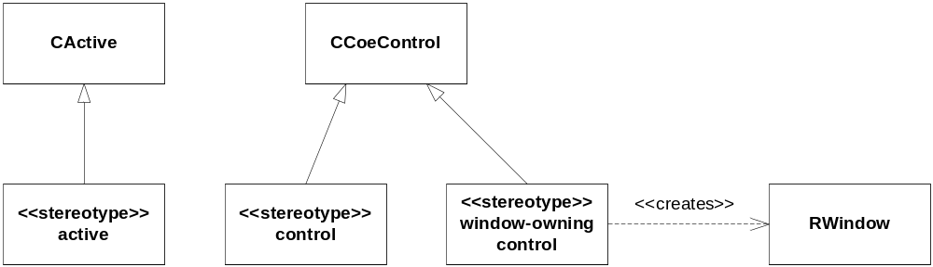

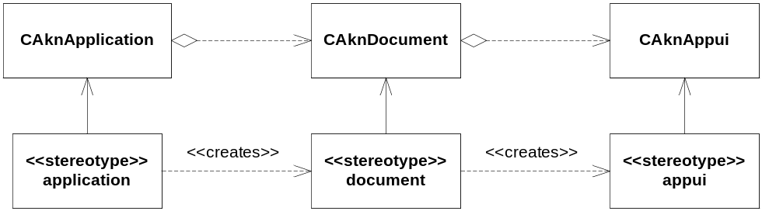
Figure 3.3 Metamodel definition

ALF client
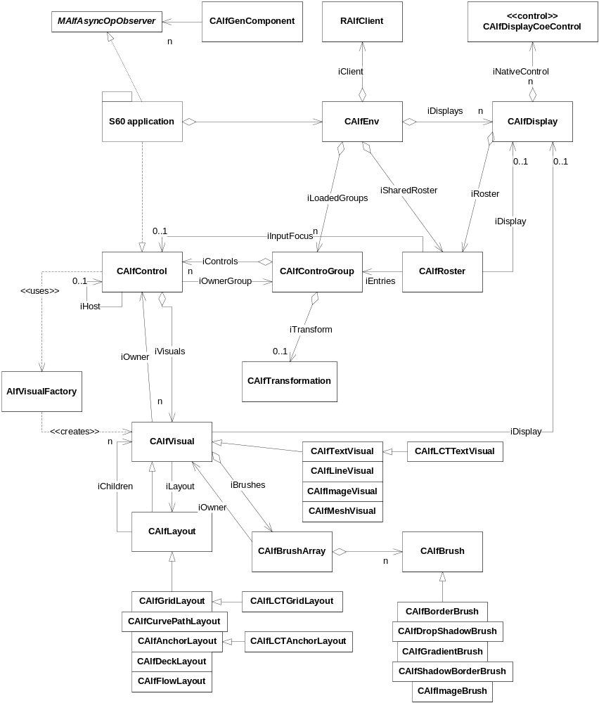
Figure 3.4 Client side class diagram
Figure 3.4 shows the ALF Client class diagram. The application creates an instance of CAlfEnv, which opens a server connection. The application can create any of the objects when needed and can access them later on. The objects are owned by the subsystem, so the application is only responsible for deleting the environment object on exit – of course single objects can be de-allocated run-time if not needed, but it must be done via the subsystem.
The application is responsible for creating the controls that it wants to show. This is done by deriving the CAlfControl class.

ALF Server
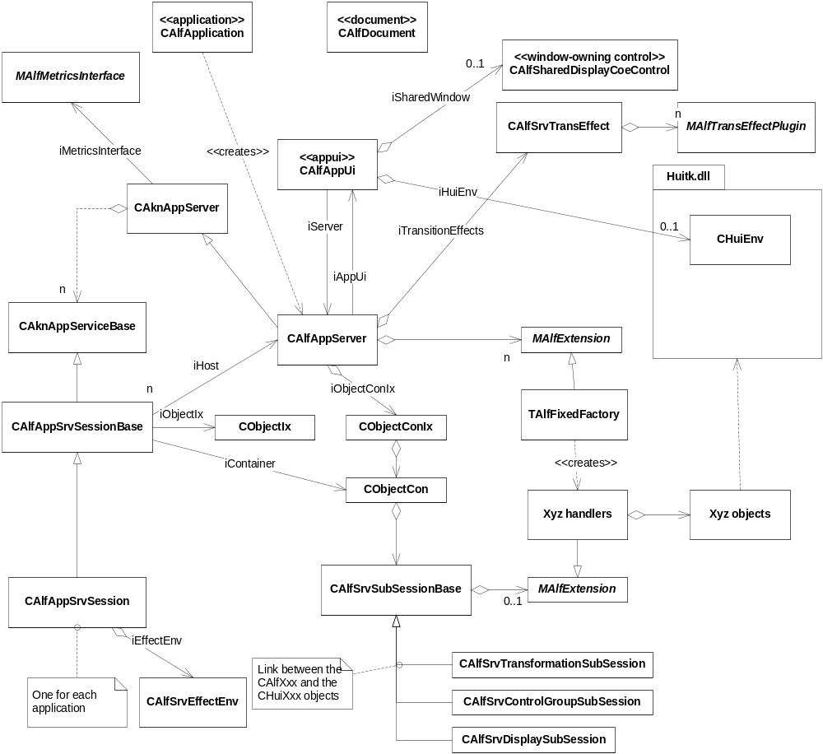
Figure 3.5 Classes of ALF Server
Figure 3.5 illustrates the server side. The AppUi creates an instance of CHuiEnv. The used window is shared from the AppUi class. CAlfAppSevSession and the corresponding sub sessions handle all the client requests. They call the HUIToolkit functions as the client commands.
When an item is allocated on the client side, a server side instance is created on a corresponding sub session. The subsession can be dedicated for the type if the concrete Hui class is not meant for deriving. There are dedicated subsessions for control group, display and transformation. The derived types (brushes, controls and visuals/layouts) have a generic subsession object and a corresponding handler. These are implemented with extensions. See Section 3.1.4 for more detailed information.

Client class | Has handle to server class
CAlfBrush | CAlfSrvSubSessionBase / CAlfBrushHandler / CHuiBrush
CAlfControl | CAlfSrvSubSessionBase / CAlfControlHandler / CHuiControl
CAlfControlGroup / RAlfControlGroupSubsession | CAlfSrvControlGroupSubsession / CHuiControlGroup
CAlfDisplay / RAlfDisplaySubsession | CAlfSrvDisplaySubsession / CHuiDisplay
CAlfTransformation / RAlfTransformationSubsession | CAlfSrvTransformationSubsession / CHuiTransformation
CAlfVisual | CAlfSrvSubSessionBase / CAlfVisualHandler / CHuiVisual

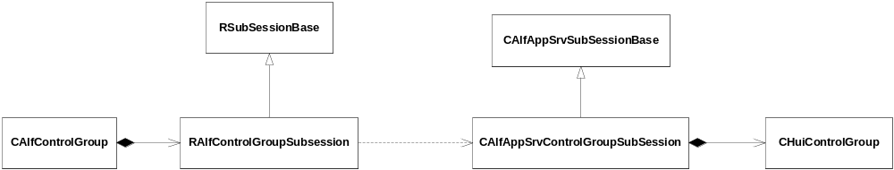
Figure 3.6 Classes associated with control group
To illustrate the subsessions, Figure 3.6 shows the classes associated with the control group. The user application allocates CAlfControlGroup, which opens a subsession on RAflClient. On the server side, the corresponding session creates a new subsession object, CAlfSrvControlGroupSubSession. For a sequence diagram, see Section 3.3.2.

Extensions
The extension mechanism is meant for applications to create their own brushes, layouts, visuals and mapping functions that need to run on the server side. The applications use ECom plug-ins to do this.

Extension client
The client side is responsible for offering an easy-to-use API for the application. It needs to open the subsession with an implementation ID of the ECom plug-in which implements the API on the server side. The custom functions need to be serialized for one in and one out buffer.
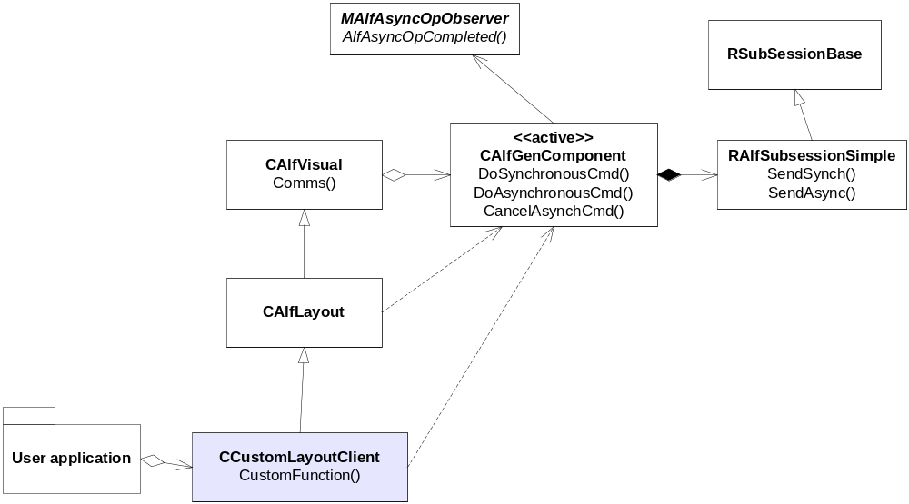
Figure 3.7 Client side of a layout extension
Figure 3.7 shows an example how to create a custom layout.

Server side extension
The server side needs three kinds of objects:
- Factory, which can allocate the handler
- Handler, which can allocate the actual implementation. The handler also interprets the custom messages into function calls.
- Actual implementation, which is derived usually from some Hui classes.

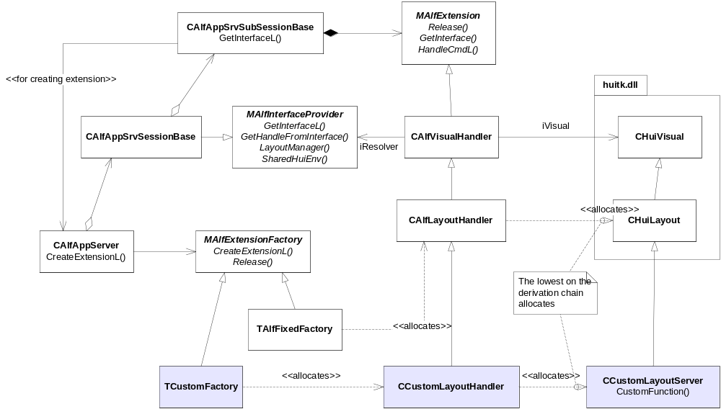
Figure 3.8 Server side example of a custom layout

Pointer events
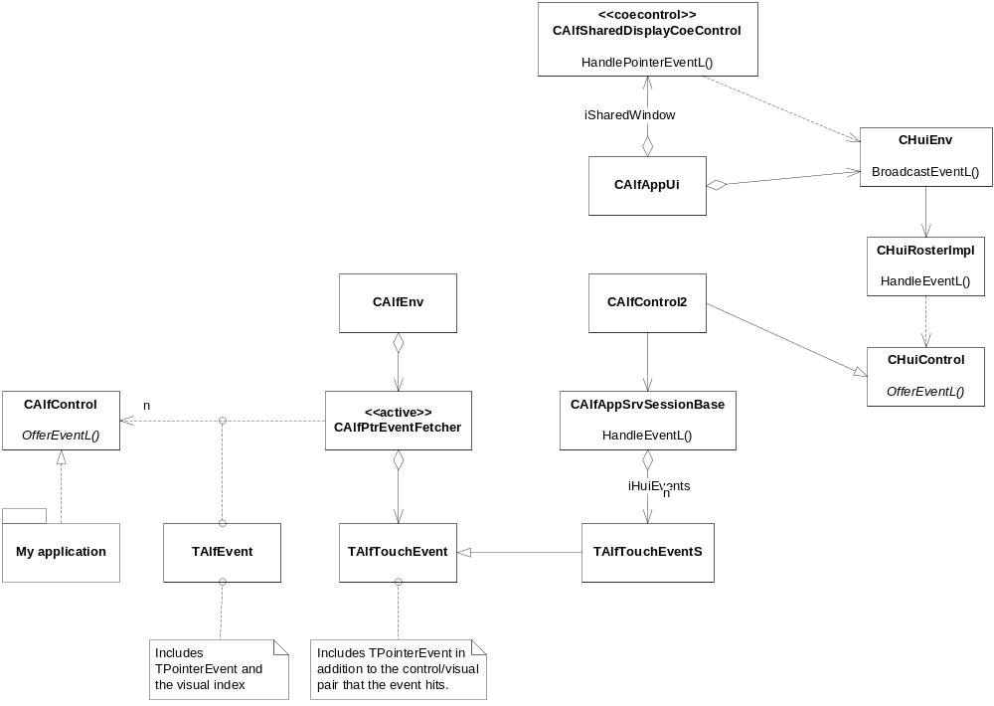
Figure 3.9 Pointer handling system
Figure 3.9 shows the classes which are involved with the pointer event handling. The CAlfSharedDisplayCoeControl object receives the pointer event from Window Server. The roster finds the controls which the pointer event hit in. The CAlfControl2 finds the leaf visual which the pointer event hits in. The session base passes the event to the client side which finds corresponding ALF controls and visuals. Eventually, the CAlfControl derived object receives the pointer event.

Scheduler management
In order to minimize power consumption ALF Server has an automatic mechanism to pause animations and timers when the device display lights go off or when there are no more applications in the foreground using ALF services. The mechanism in the server side is mainly implemented in the CAlfSrvResourceManager class. In the client side, command scheduling in CAlfCommandScheduler gets paused when it is not needed.

LCT Classes
There are specialized derived classes for specific types of visual, which can be used in the case of components whose layout is specified using S60 LCT (Layout Creation Tool). They provide additional means to set the layout sizes and positions of the visuals.
The layout data is provided through the S60 scalable layout system (as implemented in AknLayout2), which provides interfaces that enable the access to the layout data. The AVKON UI framework classes configure the layout system to runtime according to the current screen size, orientation, UI language direction, and the zoom factor. For more information, see reference document [1].
Each item of layout data specified in Layout Creation Tool is described as a layout component (with its own identifier) which can be of type pane, text, or graphic. Pane components can have multiple rows and columns, which correspond closely to the core toolkit’s grid layout, otherwise a single pane corresponds well to a core toolkit’s anchor layout. Text and graphic components correspond to the text and image visuals respectively.
Visualization provides the layout component identifier to each of the LTC classes that it constructs. It also provides sufficient parameters to specify the exact layout required, including the variety, row and column indices if needed. The corresponding handler on the server side then accesses the AknLayout2 APIs directly in order to retrieve the layout coordinates and text attribute data, which is then set directly into the core toolkit visuals.

Transition effect framework
The transition effect framework is used to integrate effects to the server side events, e.g. when an application comes to the foreground. Effects can be implemented as ECom plug-ins. During initialization the framework searches the plug-in implementations and binds them to the effect contexts (e.g. focus gained). When an effect is needed, ALF Server calls the framework API, CAlfSrvTransEffect, which routes the call to the relevant effect implementation.
During initialization the transition effect plug-in returns to the server which effects it supports. The framework calls the plug-in API, MAlfTransEffectPlugin, for executing the effect, the plug-in gets a pointer to a part of the server data, via CAlfSrvEffectEnv, which it can use to start an effect. The default effect plug-ins can be replaced or removed. In the latter case, there are, of course, no effects visible.
The framework also checks if the AVKON effects are enabled, and disables the ALF effects in that case.

Class descriptions
See the classes in the table in Section 2.5.2.

Structs, type definitions and enumerations

AlfAppServer.h structs
Struct name | Description
TWindowChangeObserver | A queue item in the window visibility change observer queue.
TServiceExtension | A queue item in the loaded session extensions queue.

Flag definitions
This section specifies the flags (debug etc. flags) used by the component, and clarifies their usage for the reader. Variation flags are defined in Chapter 4.

Flag | Description
_ALF_LOGGING | Defined in alfloggingconfiguration.h. If this is defined, the log strings from the code, which are marked with the __ALFLOGSTRING macros, are sent to output. See _ALF_LOGGING_TO_FILE for the output.
_ALF_LOGGING_TO_FILE | Defined in alfloggingconfiguration.h. This flag is obsolete if _ALF_LOGGING is not defined. If defined, the logs are written into the file alf.log if the \logs\alf folder exists. If not defined, the logs are written into RDebug::Print.

Operations

Creating CAlfEnv for the first time
Operation | Creating CAlfEnv.
Preconditions | ALF Server is not running.
Description | The S60 application creates an instance of the class CAlfEnv by calling its NewL. It allocates the RAlfClient client object and calls its OpenL function. This starts the ALF application server and creates a connection to the newly launched server.
Inputs
Modifies | Allocated objects from the classes CAlfEnv and RAlfClient.
Outputs | ALF Server is started.
Postconditions | NewL returns the allocated CAlfEnv object. The server has been started and the client has created a session in it.
Related To | CAlfEnv::NewL(), RAlfClient::OpenL().
Related Event | Start of an application which wants to use the services provided by ALF.
Exceptions | OOM, the server is running already.

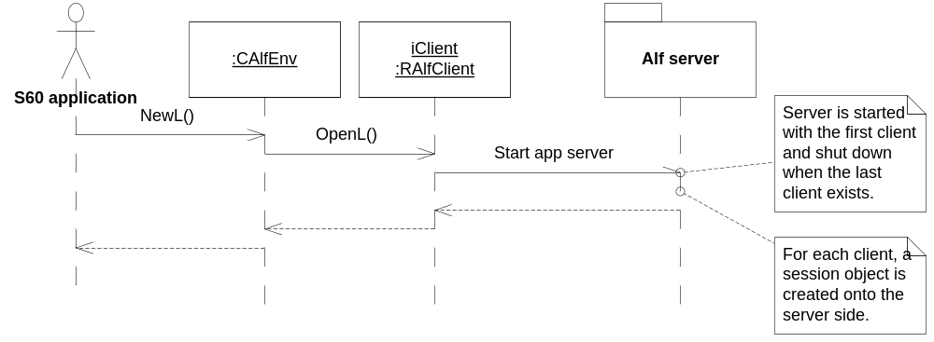
Figure 3.10 Create CAlfEnv

Allocating a control group
Operation | Creating CAlfControlGroup.
Preconditions | ALF Server is up and running. RAlfClient has been connected.
Description | The S60 application creates an instance of the class CAlfControlGroup by calling its NewLC. This connects the brush subsession and creates the instances on the server side. See the class diagram in Figure 3.6.
Inputs | Control group UID.
Modifies | Allocated objects from the classes CAlfControlGroup, RAlfControlGroupSubsession, and CAlfSrvControlGroupSubSession.
Outputs | Allocates the CHuiControlGroup instance on the server side.
Postconditions | New control group instances are allocated both on the client and the server side.
Related To | CAlfControlGroup::NewL(),RAlfControlGroupSubsession::Open().
Related Event
Exceptions | OOM.

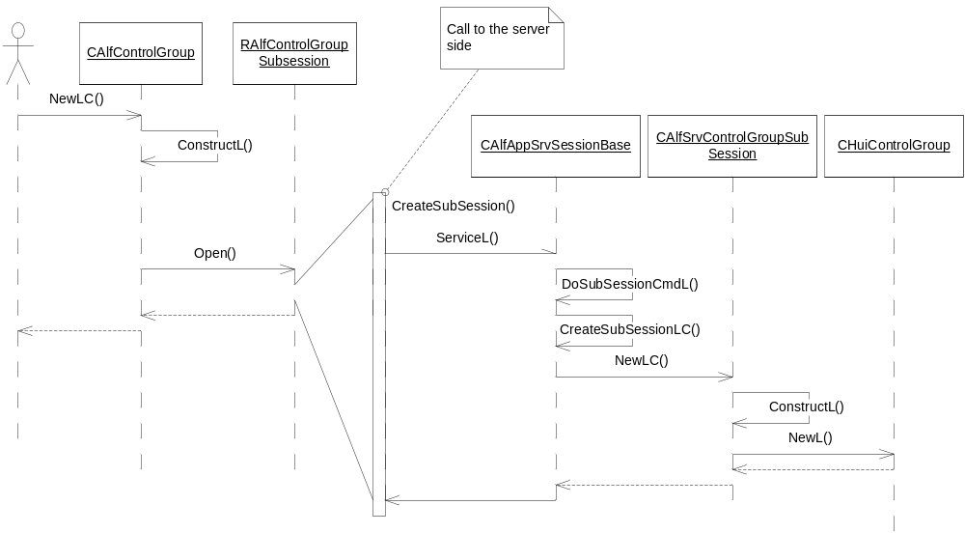
Figure 3.11 Creating control group

Backup and Restore
All the file handles (for textures) need to be released on the server side.

Variation
ALF does not support any other variation mechanism than application wide image creation time variation, i.e. the application can be included in or excluded from a ROM image.

System resource usage

Files
This component does not use any files.

Other data

Databases
This component does not use any databases.

Central Repository
This component uses Central Repository for getting system configuration related information

Key | Description
KUIAccelTKDefaultFrameRate | Default frame rate (frames per second).  Possible values: 0 - 999999 fps.
KUIAccelTKMaxCpuUsage | Maximum CPU usage for alfredserver.exe in percentage.  Possible values: 0 - 100 %.
KUIAccelTKRenderer | Used graphics renderer.  Possible values:  0 = Automatic selection  1 = Symbian bitgdi  2 = OpenVG 1.0 (Not implemented)  3 = OpenGL ES 1.0  4 = OpenGL ES 1.1
KUIAccelTKMaxResourceCache | Key for maximum cache size (in kilobytes) allocated for resources.  Possible values: 0 - 999999 KB (0 = no limit).
KUIAccelTKEffectsComplexity  Factor | Effect complexity.  Possible values: 1 - 10 (1 = simplest, 10 = most complex).
KUIAccelTKHWConfiguration  Flags | Flags for setting up the HW driver.  Possible values: TBD.

Publish and Subscribe
This component does not use Publish and Subscribe.

Memory consumption

ALF Server exe
Memory/Build | Consumption
User data area | None
WINS UDeb | 213 KB
ARMV5 URel | 1,50 KB

ALF Server Core
Memory/Build | Consumption
User data area | None
WINS UDeb | 5.84MB
ARMV5 URel | 32.6KB

ALF client
Memory/Build | Consumption
User data area | None
WINS UDeb | 17.8MB
ARMV5 URel | 61.7KB

Core toolkit
Memory/Build | Consumption
User data area | None
WINS UDeb | 5.80MB
ARMV5 URel | 139KB

Total
Memory/Build | Consumption
User data area | None
WINS UDeb | 41.7 MB
ARMI URel | 235 KB

Task allocation
The client runs in the application process/thread where it is used from. The server is started in its own process. The server code is run in the main thread of the server process.

Performance
The performance related issues have been taken into consideration in the implementation of this component.

Timers
Timer | Purpose | Interval | Lifetime
Command timer | Time the scheduled command on the client side | From 1 ms | When the user sends a timed command, a timer is created to determine the execution point.

Security

Capabilities of this component
Subcomponent | Capability | Justification
alfclient.dll | CAP_GENERAL_DLL | As a basic UI Framework library, the component must be usable by most of the processes.
alfappservercore.dll | CAP_GENERAL_DLL | As a basic UI Framework library, the component must be usable by most of the processes.
alfredserver.exe | SwEvent | Only the SwEvent capability is needed for WS event monitoring.

Input and output validation
This component does not require or make any validation for data.

Environmental assumptions
This component does not make any assumptions about its environment.

Additional enforcements
This component does not have any additional security enforcements.

Exception handling
The leave mechanism of the Symbian OS environment is used to handle memory exhaustion.

Usage

Building
Compile ALF which also compiles the core toolkit:
cd group
bldmake bldfiles
abld build

User's guide
See core toolkit programmer’s guide and the ALF migration guide.

