User Guide of Stub Server

Table of contents:

1. Introduction 4
2. General practices 5
3. APIs of stub server 6
3.1 Specification of an stubbed API 6
3.2 Interface of stub server 7
4. Examples 10
4.1 Use of QueueBehavior() and InvokeApi() 10
4.1.1 Step 1: API stubbing 10
4.1.2 Step 2: a test case implementation 11
4.2 Use of ESuspendIfNoBehaviorSet 12
4.2.1 API stubbing 12
4.2.2 Controlling the stubbed API in module test and test case implementation 13
5. Challenges 14

Introduction
The objective of stub server is to realize the possibility of module test automation by a generic stubbing control infrastructure.
Stub server provides a communication channel for module test applications and the stubbed modules to specify the expected behaviors of stubbed APIs, as illustrated in figure below.

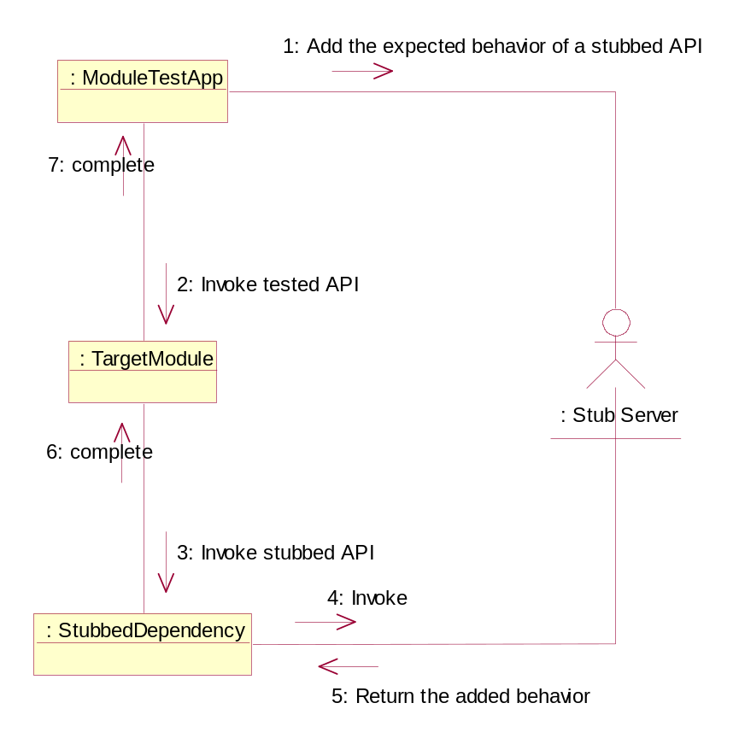
Stub server is started when the first client connects to it and it will shutdown itself when there is no client any longer.

General practices
- APIs that behavior differently responding to human interactions should be stubbed, for example, establishing a Bluetooth connection might have various results depending on the states of remote device, APIs involved in this operation should be stubbed in order for test application to simulate all possible real life scenarios.
- Only APIs called by the target module are needed to be stubbed.

APIs of stub server

Specification of an stubbed API

<apibehavior.h>
class TApiBehavior
{
public:
TUint iLib;
TUint iApi;
TInt iCompleteCode;
TInt iAsyncCompleteCode;
TBuf8<KApiOutputSize> iOutput;
};

Variable Name | Description
iLib | The identifier of the library that provides this API (UID3 of the stub can be used)
iApi | The identifier of this API in the library.  iLib and iApi identify a unique API in the scope of stub server.
iCompleteCode | The completion code of the API call.  Specifies the return error code the leave code if the function is leavable.  This filed should be ignored by APIs returning void.
iAsyncCompleteCode | The completion code of asynchronous service provided by this API.  This value should be return via TRequestStatus if this API handles async service via Active Object; it should be returned in the callback function if the async service is signaled via callback mechanism.  This should be ignored by synchronous API.
iOutput | A generic descriptor to specify the expected output of this API.

Interface of stub server
<stubber.h>
class MApiInvoker
{
public:
virtual void InvokeApiComplete(const TApiBehavior& aBeh) = 0;
};
NONSHARABLE_CLASS(CStubber) : public CActive
{
public:
IMPORT_C static CStubber* NewL(MStubApiInvoker& aInvoker);
IMPORT_C ~CStubber();
IMPORT_C void EnqueBehavior(const TApiBehavior& aBeh, TInt aExeDuration = 0);
IMPORT_C void DeleteBehaviors(TUint aLib, TUint aApi);
IMPORT_C void InvokeApi(TApiBehavior& aBeh,
TApiInvokeMode aMode = ECompleteIfNoBehaviorSet);
IMPORT_C void InvokeApiL(TUint aLib, TUint aApi,
TApiInvokeMode aMode = ECompleteIfNoBehaviorSet);
IMPORT_C void InvokeApiCancel();
};
Class or API Name | Description
MApiInvoker | The callback to receive InvokeApi completion event.
MApiInvoker:: InvokeApiComplete | Called when InvokeApi completes.  Parameter TApiBehavior contains the expected behavior.
CStubber | The public interface of stub server
CStubber::EnqueBehavior | Queues an API behavior specification to stub server.  This method is called by API behavior controllers, e.g. a module test, to specify the next expected behavior of an API. When InvokeApi() is called, the first queued behavior matching the lib and API identifier will be extracted and returned.  param aBeh specifyies the API behavior.  param aExeDuration specifies the execution time duration which InvokeApi() should spend in microseconds. Value less than 0 means never completing InvokeApi(); value 0 means completing InvokeApi() asap; value 1000000 means InvokeApi() takes 1 sec execution time; and so on.
CStubber::InvokeApi | Synchronous version.  If there is a queued behavior for this API, stub server will perform according to the execution setting; otherwise stub server will act according to the specified mode.  param aBeh contains the lib and API identifiers when passed in; will contain the behavior at function call completion.  param aMode the mode to be used if no queued behavior is found for the specified API; In case ECompleteIfNoBehaviorSet mode is specified, stub server will complete this function asap and return a default TApiBehavior(TUint, TUint); STUB will keep this function call pending until a behavior is queued if the mode is ESuspendIfNoBehaviorSet.
CStubber::InvokeApi | Asynchronous version.  MStubApiInvoker::InvokeApiComplete() will be called when this request is completed.  If there is a queued behavior for this API, stub server will perform this request according to the execution setting; otherwise stub server will act according to the specified mode.  Param aLib specifies the lib identifier.  Param aApi specifies the API identifier.  param aMode specifies the mode to be used if no queued behavior is found for the specified API; In case ECompleteIfNoBehaviorSet mode is specified, stub server will complete this function immediately and return a default TApiBehavior(TUint, TUint); Stub server will keep this function call pending until a behavior is queued if the mode is ESuspendIfNoBehaviorSet.
InvokeApiCancel | Cancel async InvokeApi()

Examples

Use of QueueBehavior() and InvokeApi()
Scenario: BTMAC will firstly do SDP search on the remote device to get the HFP RFComm channel when connect to accessory is requested by the caller.

Step 1: API stubbing
SDP query is performed by bteng async API CBTConnection::SearchRemoteChannelL().
bteng_stub.dll, the stub of bteng.dll, exported stubbed API identifiers:
< btengdll_stub.h>
const TInt KStubBtengDll = 0xA0000007;
enum TStubBtengApi
{
//CBTConnection::SearchRemoteChannelL()
EBtengSearchRemoteChannel = 1,
};

Bteng_stub.dll implements SearchRemoteChannelL():
<btconnection.cpp>
TInt CBTConnection::SearchChannelL(const CBTDevice& aDevice,
TUint aService, TUint& aChannel, TRequestStatus& aStatus)
{
if (iStubber)
User::Leave(KErrInUse);
iStubber = CStubber::NewL(*this);
iStubber->InvokeApi(KStubBtengDll, EBtengSearchRemoteChannel);
iChannel = &aChannel;
iRequestStatus = &aStatus;
aStatus = KRequestPending;
}
void CBTConnection::DequeueCompleteL(const TApiBehavior& aBeh)
{
TInt err = aBeh.iAsyncCompleteCode;
if (!err)
{
TPckgBuf<TUint> pkg;
pkg.Copy(aBeh.iOutput);
*iChannel = pkg();
}
delete iStubber;
iStubber = NULL;
User::RequestComplete(iRequestStatus, aBeh.iAsyncCompleteCode);
}

Step 2: a test case implementation
Test case:
Target: to test if BTMAC handles SDP query failure gracefully
precondition: BTMAC is loaded, no accessory is connected currently.
Variant: remote SDP query fails.
Test step: Call BTMAC’s ConnectToAccessory()
Expected result: connection fails and proper error code is returned.

Test case implementation:
<moduletest.cpp>
void CBtmacMT::TestConnectSDPFail()
{ // test case 1
// Do needed operations to setup precondition
// ….

// setup variant condition, controlling bteng remote channel search behavior
TApiBehavior sdpspec(KStubBtengDll, EBtengSearchRemoteChannel, 0, -6012,KNullDesC8);
iStubber->QueueBehavior(sdpspec);

// test case execution
TBTDevAddr addr;
iBtmac->ConnectToAccessory(addr, iStatus);
SetActive();
iWaiter->Start(); // CActiveSchedulerWait::Start()

// evaluation test result
LogTestCaseExe(1, iStatus == -6012); // if iStatus == -6012, test case passes.
}

Use of ESuspendIfNoBehaviorSet
Scenario: BTMAC listens to incoming Bluetooth accessory connection by calling CBluetoothSocket::Accept()when it is loaded.

API stubbing
CBluetoothSocket::Accept() is provided by Bluetooth.dll (a Symbian component).
bluetooth_stub.dll, the stub of Bluetooth.dll, exported stubbed API identifiers:
< bluetoothdll_stub.h>
const TInt KStubBluetoothDll = 0xA0000006;
enum TStubBluetoothApi
{
// CBluetoothSocket::Listen(unsigned int)
EBtSockListen = 1,
};

Bbluetooth_stub implements CBluetoothSocket::AcceptL():
<btsocket.cpp>
void CBTAccepter::ConstructL()
{
iStubber = CApiBehavior::NewL(*this);
}
CBTAccepter::~CBTAccepter
{
Delete iStubber;
}
void CBTAccepter::Accept()
{
iStubber->InvokeApi(KStubBluetoothDll, EBtSockAccept, ESuspendIfNoBehaviorSet);
}
void CBTAccepter::Accept(TDes8& aConnectData)
{
Accept();
}
void CBTAccepter:: InvokeApiComplete(const TApiBehavior& aBeh)
{
iParent.HandleAcceptCompleteL(aBeh.iAsyncCompleteCode);
}

Controlling the stubbed API in module test and test case implementation
Test case:
Target: incoming connection from an accessory
precondition: BTMAC is loaded, no accessory is connected currently.
Test step: an accessory initiates connection with BTMAC
Expected result: connection is established successfully.

Test case implementation:
<moduletest.cpp>
void CBtmacMT::TestIncomingConnection()
{ // test case 2
// Do needed operations to setup precondition
// ….

//controlling stub behavior
TBTDevAddr addr;
Addr.SetReadable(_L(“00000000000A”));
TApiBehavior acceptspec(KStubBluetoothDll, EBtSockAccept, 0, 0, KNullDesC8);
iStubber->QueueBehavior(acceptspec, 100 * 1000); // CBTAccepter:: InvokeApiComplete in Bluetooth_stub.dll should be triggered after about 0.1 sec
iStubber->QueueBehavior(TApiBehavior(KStubBluetoothDll, EBtRemoteName, 0, 0, addr.Des());
// test case execution
iStatus = KRequestPending;
SetActive();
iWaiter->Start(); // CActiveSchedulerWait::Start()

// evaluation test result
LogTestCaseExe(2, iNewAcc == addr);
}

Challenges
- The control of stubbed APIs in module test application is the most complex part. Enough time should be reserved for module test implementation and testing.
- Some of dependencies can’t be stubbed, e.g. PubSub is provided by euser.dll and obviously it is not realistic to stub it. A proposal is to change the involved PubSub API’s category identification in module test build.

