Bluetooth v9.4 Architectural Description

Status: | Issued
Version: | 1.2
Team/Department : | Shortlink / Core Development

Contents
1 Introduction 3
1.1 Purpose and Scope 3
2 Subsystem Overview and Background 3
3 Bluetooth Architecture 4
3.1 Bluetooth Core 4
3.1.1 Bluetooth / User 5
3.1.2 Bluetooth / Stack 5
3.1.3 Bluetooth / BTComm 6
3.1.4 Bluetooth / BTExtNotifiers 6
3.1.5 Bluetooth / HCI 6
3.1.6 Bluetooth / HCIProxy 6
3.1.7 Bluetooth / HCIv2 6
3.1.8 Bluetooth / Manager 8
3.1.9 Bluetooth / SDP 8
3.2 Bluetooth Profiles 8
3.2.1 Personal Area Networking Profile 9
3.2.2 Audio Video Distribution and Control Profiles 10
3.2.3 Phone Book Access Profile 12
4 System Architectural Requirements 14
5 Security 14
5.1 Data caging 14
5.2 Backup and restore 14
5.3 Capability ranges 14
5.3.1 Capabilities assigned to Bluetooth DLLs 14
5.3.2 Capabilities required to use Bluetooth 16
6 Further Information 18
6.1 References 18
6.2 Open Issues 18
6.3 Glossary 18

Introduction

Purpose and Scope
The Bluetooth v9.4 Architectural Description details the architecture and APIs exposed by the Bluetooth v9.4 Subsystem.

Subsystem Overview and Background
The Bluetooth subsystem provides support for the protocols and profiles specified by the Bluetooth Special Interest Group. For a general overview of the Bluetooth technology, please refer to [1].
Figure 1 shows the relationships between the Bluetooth subsystem and other subsystems in Symbian OS.

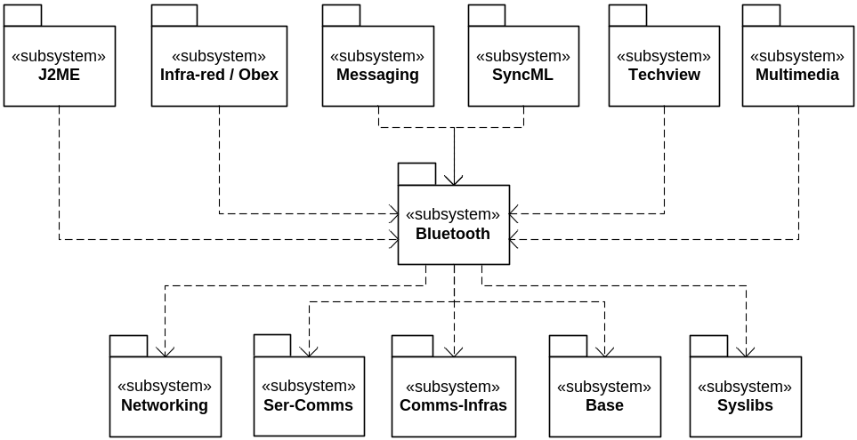
Figure 1 – Relationships with other subsystems

The relationships are summarised in the following table.
Subsystem Name | Relationship Type | Reason
J2ME | Export | Support for the Java Bluetooth APIs defined by JSR82
Infra-red / Obex | Export | To allow Obex to run over Bluetooth, enabling the object Bluetooth object exchange profiles
Messaging | Export | To allow the messaging subsystem to send and receive objects using the Bluetooth object exchange profiles
SyncML | Export | To allow SyncML to run over obex over Bluetooth
Techview | Export | Implementation of Bluetooth UI components
Multimedia | Export | Reference implementation of the Advanced Audio Distribution Profile
Networking | Import | PAN profile implementation
Ser-Comms | Import | Bluetooth CSY implementation. Reference HCI implementation.
Comms-Infras | Import | Bluetooth PRT implementation
Base | Import | Everything.
Syslibs | Import | DBMS support for Bluetooth registry. Character conversion between Unicode and utf-8. ECom for remote control plugin framework.

Bluetooth Architecture
This section describes the architecture of the Bluetooth stack. In order to simplify the document and diagrams, the description is split into two.
Firstly, support for the core Bluetooth functionality shall be described. This shall cover how the stack is implemented, Bluetooth security, persistent storage, SDP and the HCI. In terms of profiles, this shall cover the Generic Access and Serial Port Profiles.
Secondly, those non-trivial Bluetooth profiles for which Symbian has specifically developed new components shall be described.

Bluetooth Core
Core Bluetooth support in Symbian OS is provided as a plugin to the ESock framework. This is supported by various application-level DLLs, servers and a hardware abstraction layer. Figure 2 illustrates the architecture of the Bluetooth stack in Symbian OS. Figure 3 shows how that architecture maps into logical components, each of which is described in the following subsections.
Note that these figures do not include all components delivered by the Bluetooth subsystem – those involved in profile support will be covered later in this document.
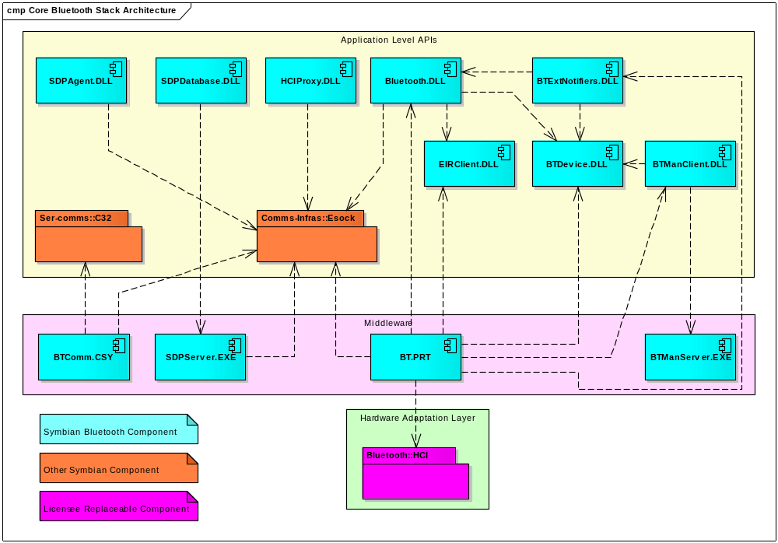
Figure 2 – Core Bluetooth Stack Architecture

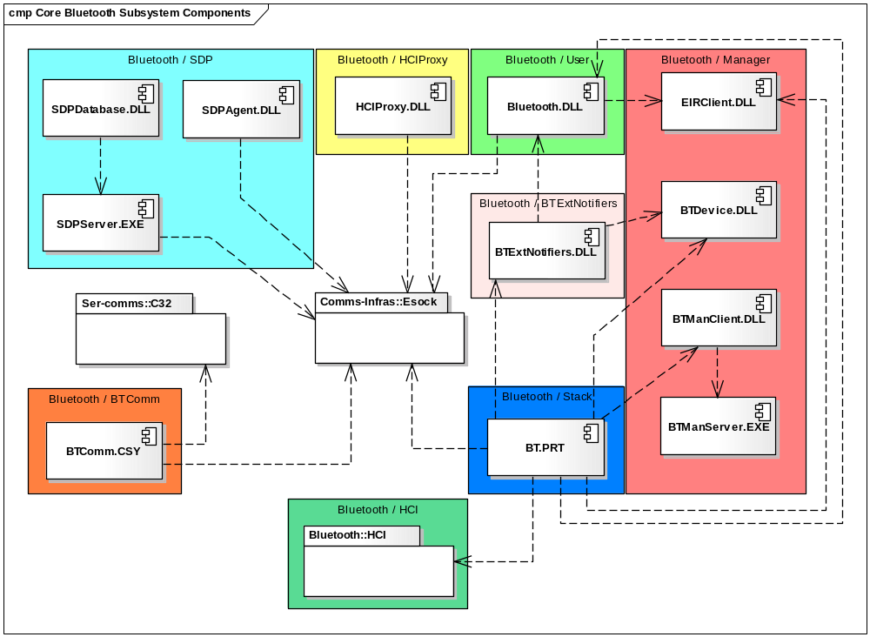
Figure 3 – Core Bluetooth Subsystem Components

Bluetooth / User
This component provides a large set of high-level APIs that allow applications to request low-level Bluetooth behaviour such as Bluetooth low-power modes, role-switching, packet-size control etc. Additional classes have been provided that extend the RSocket class so that Bluetooth-aware applications can use one convenient class incorporating data and control planes.

Bluetooth / Stack
The Bluetooth / Stack component is a PRT plugin to the ESock framework.
The BT.PRT module provides access to Link Manager, L2CAP, RFComm, AVDTP and AVCTP socket functionality. It encapsulates much of the functionality required to support the GAP and SPP. As a protocol module, BT.PRT fits into the existing socket server architecture. The module supports Inquiry and Name Requests through the RHostResolver class and most other functionality through the RSocket class. It also provides NetDB provides to deal with SDP client requests, although these are usually accessed via the SDP Agent API.
Bluetooth Security can be managed by an application via each individual socket. The Bluetooth / Stack component contains the Bluetooth security manager, which ensures the security requirements of each socket are met prior to connection.

Bluetooth / BTComm
The Bluetooth / BTComm component is a CSY plugin to the C32 serial comms server framework. The CSY internally uses an RFComm socket (RFComm is the Bluetooth serial comms emulation protocol - based on the ETSI TS 07.10 standard [3]). It offers clients an RS-232-like interface, already published by Symbian as the RComm class. Configuration of the virtual serial port is achieved via the Bluetooth / Manager APIs.
BTCOMM.CSY only provides serial DTE support and is intended for usage by legacy applications only.

Bluetooth / BTExtNotifiers
The Bluetooth / BTExtNotifiers component provides classes that describe the interface to the Bluetooth notifier framework plugins provided by licensees. Six different plugin interfaces are defined:
- A device search dialog that can return one or more devices chosen by the user
- Two passkey (PIN code) entry dialog used during pairing (one “legacy”, and one with additional support for secure simple pairing).
- A numeric comparison dialog used during some secure simple pairing processes.
- A passkey display dialog used during some secure simple pairing processes.
- An authorisation dialog.
The PIN code entry, numeric comparison, passkey display and authorisation dialogs are only used by the Bluetooth stack. The device search dialog is for use by applications and profiles to ascertain which device the user wishes to connect to.

Bluetooth / HCI
The Bluetooth HCI.dll provides access to the Bluetooth controller by implementing the standard Bluetooth Host Controller Interface as detailed in the 1.2 specification. Symbian implements both the on-board UART (non-error correcting) serial flavour of HCI and the proprietary Cambridge Silicon Radio (CSR) Blue Core Serial Protocol or BCSP. The design decision to deploy a separate HCI.DLL was taken to facilitate porting of the Symbian stack to different types of Bluetooth hardware.
Only the Bluetooth stack uses the HCI interface. Licensees must provide an implementation of the HCI interface targeted to their phone hardware.

Bluetooth / HCIProxy
The HCIProxy allows application-level code to issue vendor-specific commands to the HCI.

Bluetooth / HCIv2
From release v9.2 onwards, a redesigned HCI (Host Controller Interface) layer is available, known as HCIv2. From v9.5, this becomes the default HCI in the delivered binaries. There is a period of “overlap”, where either version of the HCI may be optionally built, but at some (to be agreed) future date, the older design will cease to be delivered. Bluetooth v2.1 support is only available on HCIv2.
The HCIv2 differs radically from the earlier version by being modular and readily customisable to suit the changing needs of Bluetooth Controller hardware and future Bluetooth specifications.
The following diagram shows the architecture of the HCIv2 layer.

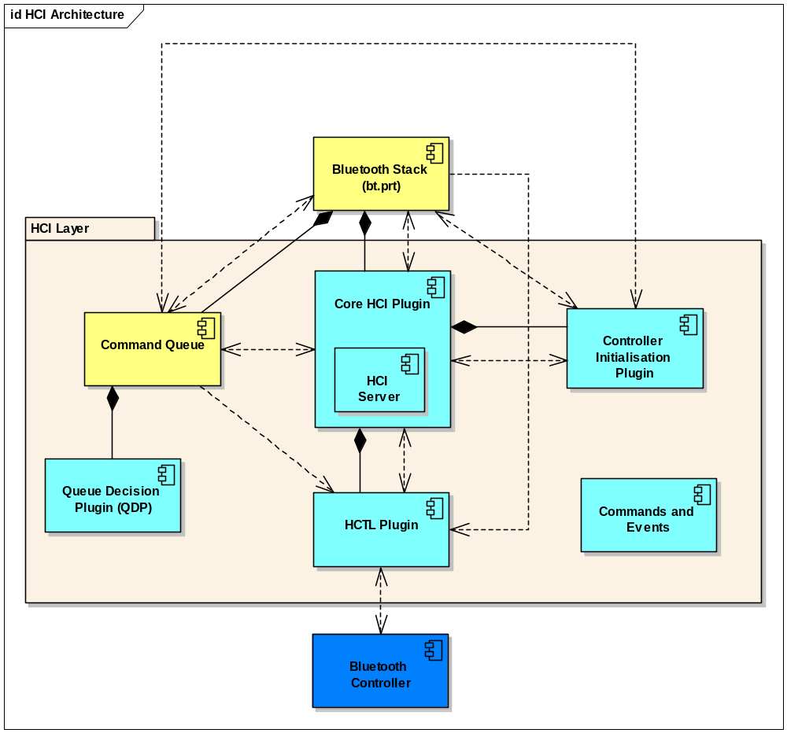
Figure 4 - HCIv2 Architecture

In the above diagram, the components shown in yellow are Symbian-owned code which cannot be changed by the licensee. The components shown in cyan are components supplied by Symbian in the form of reference code which it is likely that the licensee will need to change in order to adapt the HCI layer to a new hardware environment. The component shown in blue represents the Bluetooth Controller hardware component – the aim of HCI V2 is to make it easier for the licensee to use the hardware of their choice.
The diagram also uses the UML Composition notation (solid diamond) to indicate which components are responsible for loading and owning other components. It can be seen that the Stack loads the Command Queue and the Core HCI; the Command Queue loads the QDP; and the Core HCI loads the Controller Initialisation and HCTL plugins. In this last case though, because the Core HCI is itself a reference component, the licensee has some freedom to vary this pattern. For example, they could choose to implement the Core HCI, HCTL and Controller Initialisation all in one component so that Controller Initialisation and HCTL would not need to be loaded as separate plug-ins at all. So long as the correct external interfaces are provided, this would be a perfectly viable approach.
The Commands and Events component is made up of a large collection of classes, one for each HCI command and event. These are accessible to the Bluetooth stack and become the objects transported by the CmdQ.

Bluetooth / Manager
The Bluetooth Manager allows information about remote Bluetooth devices to be stored, retrieved, modified and deleted. It also provides a mechanism for BT.PRT to store information about the local Bluetooth device. Information is stored using DBMS.

Bluetooth / SDP
The Bluetooth SDP component provides access to both SDP client (known as the “SDP Agent”) and SDP registration functionality (the “SDP server”). SDP client functionality is used to construct SDP queries. SDP registration functionality is used by Bluetooth-aware applications to register application-specific SDP attributes in an SDP database. The SDP database (SDDB) is contained in volatile storage within the SDP Server process. Figure 5 shows this in more detail.
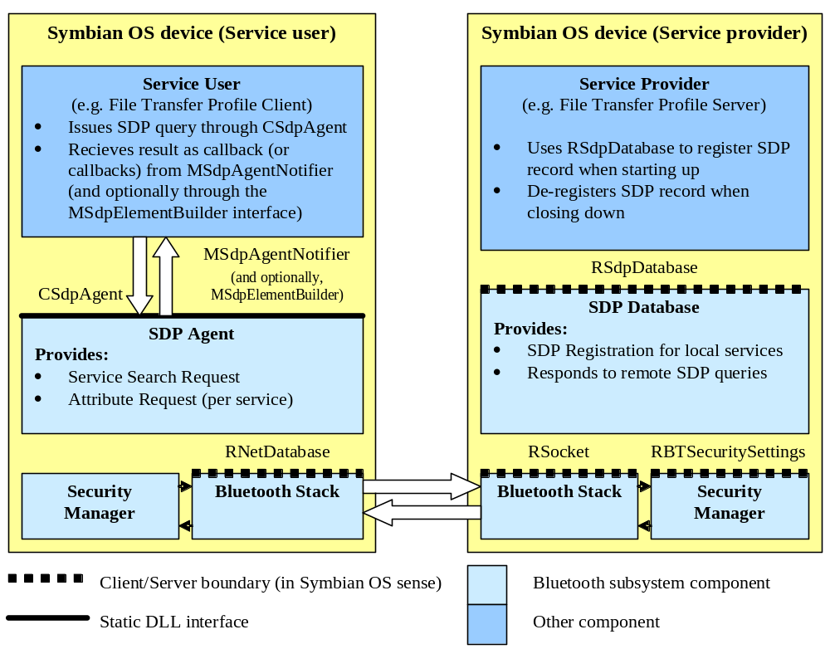
Figure 5 – Symbian OS SDP Architecture

Bluetooth Profiles
The Bluetooth subsystem provides extended support for those profiles that would be difficult to implement solely in application-level code. The following subsections describe the architecture of those profiles.

Personal Area Networking Profile
Symbian provides support for the PAN-U, PAN-GN, and PAN-NAP roles of the PAN profile. This is integrated into Symbian’s networking framework to make PAN look like a regular internet access provider, as illustrated by Figure 6. The profile allows for ad-hoc networking (e.g., creating a multiplayer gaming network) with as many as 7 other devise simultaneously, and also allows the Symbian device to be used as a gateway to an external network (e.g., GPRS, WiFi).
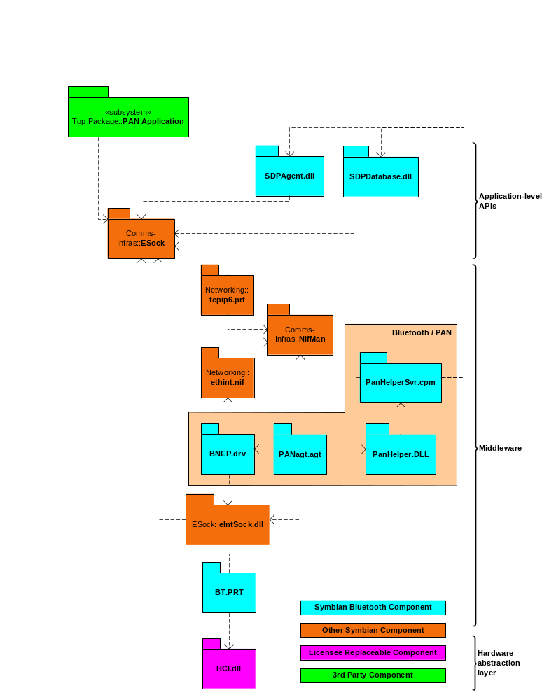
Figure 6 – PAN Profile

Bluetooth / PAN
The Bluetooth / PAN component contains two main elements:
- An implementation of the Bluetooth Network Encapsulation Protocol (BNEP), as a Symbian OS ethernet packet driver module
- A network interface agent used to create PAN connections

Audio Video Distribution and Control Profiles
In order to support the “Bluetooth stereo headset” use case, it is necessary to enable two new profiles: the Advanced Audio Distribution Profile, and Audio Video Remote Control Profile.
The Advanced Audio Distribution Profile (A2DP) defines how hi-fi audio can be sent over Bluetooth, and is built upon the Generic Audio Video Distribution Profile (GAVDP). A2DP specifies how the audio data must be encoded using the Bluetooth SIG-defined Sub Band Codec (SBC), then encapsulated in RTP packets, and transmitted using the Audio Video Distribution Transport Protocol (AVDTP) running over L2CAP.
The Audio Video Remote Control Profile (AVRCP) specifies how remote control commands, for example Play, Pause, VolumeUp, can be transmitted over Bluetooth. The commands are sent and received using the Audio Video Control Transport Protocol (AVCTP) running over L2CAP.
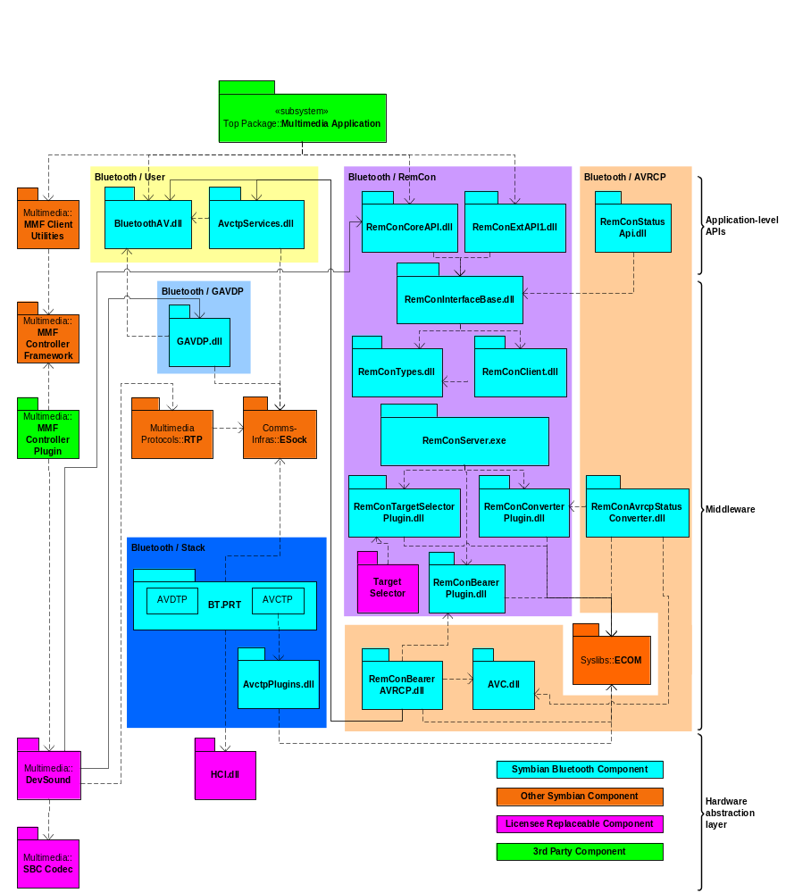
Figure 7 – Bluetooth Advanced Audio Distribution and Remote Control Profiles

Bluetooth / User
The Bluetooth / User component has been extended to support functionality common across the various Bluetooth AV profiles.

Bluetooth / Stack
The Bluetooth / Stack component has been extended to support the Audio Video Distribution Transport Proftol, and the Audio Video Control Transport Protocol. Both have been implemented in BT.PRT.

Bluetooth / GAVDP
The GAVDP component presents an API that resembles the functionality defined by the GAVDP profile. It is a thin layer over the ESock client APIs, and allows clients to configure, send and receive data over the AVDTP protocol running inside the BT.PRT ESock plugin.
The API will normally be used by DevSound in order to implement A2DP, or by applications or middleware wishing to implement the Video Distribution Profile (VDP).

Bluetooth / RemCon
RemCon is a bearer agnostic framework that allows applications to send and receive remote control commands regardless of the bearer used to transmit them. Bearer support is provided by dynamically loaded plugins, and licensees are free to add their own plugins to support their own after-market accessories. Plugins are not intended to be provided by ISVs.
RemCon uses the licensee-provided Target Selector Plugin to determine which application(s) should receive a given incoming command. This decision is made based on the process ID of the application. The Target Selector Plugin is also used to route outgoing commands where no target device was specified by the application.

Bluetooth / AVRCP
The AVRCP component is a bearer plugin to the RemCon framework. It implements the AVRCP profile. It also provides an application-level API extension to RemCon for receiving AV/C status commands.

Phone Book Access Profile
This profile is added to Symbian OS in order to support exchanging Phone Book objects, particularly for use case where a Car-Kit retrieves Phone Book objects from a Mobile device.

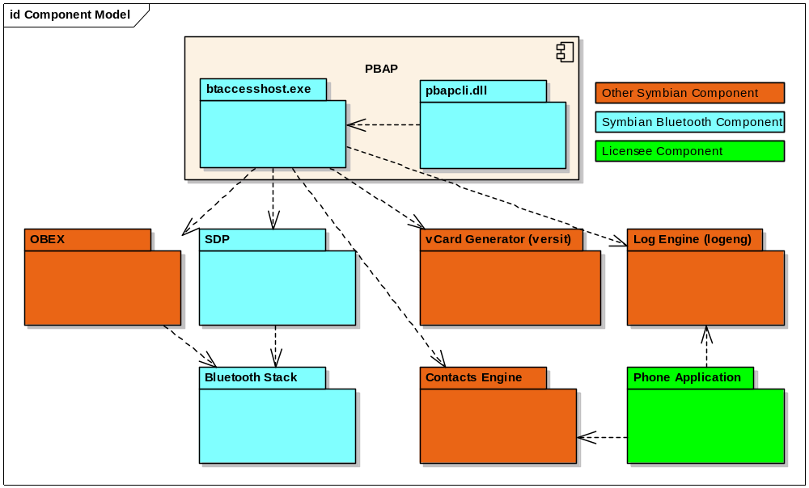
Figure 8 – Bluetooth Phone Book Access Profiles

Bluetooth / PbapClient
The Pbap Client component is responsible for creating and destroying the PBAP server and starting/stopping the profile. It can optionally initiate a password challenge of incoming connection from PBAP clients by enabling OBEX authentication

Bluetooth / PbapServer
The Pbap Server implements a set of services, which include:
- Listening for incoming Bluetooth PBAP connections
- Registering an SDP record
- Parsing and handling the incoming OBEX requests
- Navigating and maintaining the PBAP “virtual folder” structure to retrieve the desired information
- Interfacing to contacts to retrieve the phone book (pb) information
- Interfacing to Log Eng to retrieve the call history information (ich, och, mch & cch). Note that this assumes the licensee’s phone application has used the Symbian OS provided logeng interface to list the call history information.
- Implementation of the PBAP-defined XML DTD for folder listing objects.

System Architectural Requirements
This section shall be completed at a later date.

Security

Data caging
The Bluetooth subsystem uses the following files:
- BTRegistry.dat – stored in the protected data area of the DBMS server process.
  - The Bluetooth Registry implementation will set access policies on the DBMS server so that only the BTManServer.exe process can access the tables contained within BTRegistry.dat
- BT.esk – stored in the protected data area of the process c32exe.exe.

Backup and restore
The Bluetooth subsystem shall not require any files to be backed up or restored. This includes all data contained within the Bluetooth Registry, for example paired device settings. The main reason for this is that one of the principal use cases for backup/restore is to transfer data to a new device (e.g. after an old one was lost or broken). Any paired device settings would be invalid on the new device since it would have a different device address.

Capability ranges

Capabilities assigned to Bluetooth DLLs
The Bluetooth subsystem DLLs shall require the following capabilities in order to function.

DLL | Capabilities | Comments
bluetooth.dll | All –TCB
bt.prt | powermgmt commdd readdevicedata writedevicedata trustedui protserv networkcontrol networkservices localservices readuserdata writeuserdata | same as C32exe.exe
Btcomm.csy | powermgmt commdd readdevicedata writedevicedata trustedui protserv networkcontrol networkservices localservices readuserdata writeuserdata | Same as C32exe.exe
Btdevice.dll | All –TCB
btextnotifiers.dll | All –TCB
btmanclient.dll | All –TCB
btmanserver.exe | ProtServ
HciProxy.dll | All-TCB
hci.dll | powermgmt commdd readdevicedata writedevicedata trustedui protserv networkcontrol networkservices localservices readuserdata writeuserdata | Same as C32exe.exe
sdpagent.dll | All –TCB
sdpdatabase.dll | All –TCB
sdpserver.exe | Protserv localservices
PanHelperScr.cpm | powermgmt commdd readdevicedata writedevicedata trustedui protserv networkcontrol networkservices localservices readuserdata writeuserdata | Same as C32exe.exe
PanHelper.dll | powermgmt commdd readdevicedata writedevicedata trustedui protserv networkcontrol networkservices localservices readuserdata writeuserdata | Same as C32exe.exe
PANagt.agt | powermgmt commdd readdevicedata writedevicedata trustedui protserv networkcontrol networkservices localservices readuserdata writeuserdata | Same as C32exe.exe
BNEP.drv | powermgmt commdd readdevicedata writedevicedata trustedui protserv networkcontrol networkservices localservices readuserdata writeuserdata | Same as C32exe.exe
bluetoothAV.dll | All –TCB
GAVDP.dll | All –TCB
remconcoreapi.dll | All –TCB
remconextapi1.dll | All –TCB
remconinterfacebase.dll | All –TCB
remconclient.dll | All –TCB
RemConTypes.dll | All –TCB
RemConServer.exe | LocalServices, NetworkControl, NetworkServices, CommDD, ProtServ
remconbearerplugin.dll | LocalServices, NetworkControl, NetworkServices, CommDD, ProtServ | Same as RemConServer.exe
remcontargetselectorplugin.dll | LocalServices, NetworkControl, NetworkServices, CommDD, ProtServ | Same as RemConServer.exe
remconconverterplugin.dll | LocalServices, NetworkControl, NetworkServices, CommDD, ProtServ | Same as RemConServer.exe
avc.dll | LocalServices, NetworkControl, NetworkServices, CommDD, ProtServ | Same as RemConServer.exe
remconbeareravrcp.dll | LocalServices, NetworkControl, NetworkServices, CommDD, ProtServ | Same as RemConServer.exe
remconavrcpstatusconverter.dll | LocalServices, NetworkControl, NetworkServices, CommDD, ProtServ | Same as RemConServer.exe
remconstatusapi.dll | All –TCB
AvctpServices.dll | All –TCB
AvctpPlugins.dll | powermgmt commdd readdevicedata writedevicedata trustedui protserv networkcontrol networkservices localservices readuserdata writeuserdata | Same as C32exe.exe
btaccesshost.exe | ProtServ, LocalServices, ReadUserData
pbapcli.dll | All -TCB
eirclient.dll | All -TCB

Capabilities required to use Bluetooth
In general, applications will require the LocalServices capability in order to use Bluetooth. Applications wishing to use the Bluetooth PAN profile shall also require NetworkServices.
Certain APIs shall be further protected to prevent malware from accessing sensitive functionality, as detailed below.

BT.prt

General
All users of BT.prt shall require the LocalServices capability.
In addition to LocalServices, the NetworkControl capability shall be required to use the following services:
- TInt CBluetoothPhysicalLinks::Disconnect(const TBTDevAddr& aDevAddr)
- TInt CBluetoothPhysicalLinks::DisconnectAll()
- TInt CBluetoothPhysicalLinks::Broadcast(const TDesC8& aData)
- TInt CBluetoothPhysicalLinks::ReadRaw(TDes8& aData)
In addition to LocalServices, the ReadDeviceData capability shall be required to use the following services:
- TInt RBluetoothPairingResult::Open(RBluetoothPairingServer& aPairingServer)
- void RBluetoothPairingResult::SimplePairingResult(TBTDevAddr& aAddr, TRequestStatus& aStatus)
- void RBluetoothPairingResult::CancelSimplePairingResult()
- TInt RBluetoothAuthenticationResult::Open(RBluetoothPairingServer& aPairingServer)
- void RBluetoothAuthenticationResult::AuthenticationResult(TBTDevAddr& aAddr, TRequestStatus& aStatus)
- void RBluetoothAuthenticationResult::CancelAuthenticationResult()

HostResolver
Open will require LocalServices capability.

NetDatabase
Open will require LocalServices capability.

AVCTP
Use of all AVCTP services will require an SID == RemCon.exe

Publish/Subscribe
The Bluetooth subsystem uses the following two categories for publish and subscribe:
- KPropertyUidBluetoothCategory
  - Requires LocalServices capability for reading
  - Requires LocalServices and NetworkControl capabilities for writing
- KPropertyUidBluetoothControlCategory
  - Requires LocalServices and NetworkControl capabilities for reading and writing
In addition to these categories the setting of debug publish and subscribe keys has additional requirements:
- Setting secure simple pairing debug mode
  - Requires CommDD for writing

SDP
All clients of the SDP Server shall require the LocalServices capability.

BT Manager
All users of the BT Manager shall require the LocalServices capability. Additional capabilities will be required for certain services, as follows:
- The capability ReadDeviceData shall be required for the following service:
- Link Key Retrieval. Users of RBTRegistry::CreateView() and RBTRegistry::GetDevice() shall only be presented with the bluetooth link key if they possess the ReadDeviceData capability.
- The capability WriteDeviceData shall be required for the following services:
- void RBTRegistry::UnpairDevice(const TBTDevAddr& aAddress, TRequestStatus& aStatus)
- void RBTRegistry::UnpairAllInView(TRequestStatus& aStatus)
- void RBTRegistry::DeleteAllInView(TRequestStatus& aStatus)
  - unless the process requesting the deletion of the devices is the same process that created those same devices. In that case, only LocalServices capability shall be required.
- void RBTRegistry::ModifyDevice(const TBTNamelessDevice& aDevice, TRequestStatus& aStatus)
- void RBTRegistry::ModifyBluetoothDeviceNameL(const TBTDevAddr& aAddress, const TDesC& aNewName, TRequestStatus& aStatus)
  - Note also that modification of the friendly device name is allowed as long as the process has the LocalServices capability.
- TInt RBTLocalDevice::Modify(const TBTLocalDevice& aLocalDevice)
- void RBTLocalDevice::Modify(const TBTLocalDevice& aLocalDevice, TRequestStatus& aStatus)
- void RBTRegistry::AddDeviceL(const CBTDevice& aDeviceDetails, TRequestStatus& aStatus)
  - A device addition will be successful (from a capabilities point of view) without this capability, however the UI cookie provided will not be stored.

BTcomm.csy
All users of BTComm.csy shall require the LocalServices capability.

Remote Control Framework
The Remote Control Framework shall not itself determine the required capabilities of its client applications. The bearer plugins shall perform this activity since they may each require different capabilities.
The licensee-provided Target Selector Plugin shall perform capability checking on behalf of RemCon, using capability requirements provided by each of the bearer plugins. It may also perform further policing based on the process ID of the application.
See section 3.2.2 for more details.

AVRCP Bearer
Applications receiving commands (and sending responses to those commands) via the Bluetooth AVRCP bearer shall require no capabilities.
Applications sending commands via the Bluetooth AVRCP bearer shall require the LocalServices capability.

Further Information

References
No. | Document Reference | Version | Description
[1] | Bluetooth_Functional_Specification.doc |  | Bluetooth functional specification

Open Issues
The following issues need to be resolved before this document is completed;

Glossary
The following technical terms and abbreviations are used within this document.
Please do not include obvious terms (“Subsystem”, etc) in the glossary – only less widely known terms that need explanation.
Term | Definition

