Audio\Video Control Transport Protocol Design Document

Status: | <Issued>
Version: | <1.0>
Team/Department : | <Cambridge Shortlink>

Contents
1 Introduction 3
1.1 Purpose and Scope 3
1.2 Requirements 3
2 Design Overview 3
3 Detailed Design 5
3.1 Common Design Points 5
3.2 BluetoothAV Dll 5
3.2.1 TAvctpSockAddr 5
3.2.2 Packet Parsing 5
3.3 AvctpServices Dll 5
3.3.1 Overview 5
3.3.2 MAvctpEventNotify 6
3.3.3 RAvctp 7
3.3.4 CAvctpBody 8
3.4 AVCTP Protocol Layer 11
3.4.1 Overview 11
3.4.2 Security 13
3.4.3 Prototype 14
3.4.4 CAvctpProtocol 14
3.4.5 Control Plane 18
3.4.6 User Plane 24
3.5 AvctpPlugins Dll 33
3.5.1 Factory Plugins 33
3.5.2 RSubConnection Events 34
4 Scenarios 34
5 Design Considerations 35
6 Future Work 36
7 Further Information 36
7.1 References 36
7.2 Open Issues 36
7.3 Glossary 36

Introduction

Purpose and Scope
This document provides a complete design description of the Audio Video Control Transport Protocol (AVCTP) component which will form part of the Remote Control system and will initially only be used by the Audio Video Remote Control Profile (AVRCP) (see [R8]). The AVCTP specification is written so as to make AVCTP as generic as possible and allow other profiles to use it in future but as yet there are no such other profiles.
The target audience includes members of Cambridge Shortlink, defect fixers, users of the Remote Control system, testers, and licensees.

Requirements
- Symbian OS shall support the Bluetooth Audio Video Control Transport Protocol
- Controller, The Symbian OS Bluetooth subsystem shall support all Mandatory features of the AVCTP protocol specification for the controller role.
- Target, The Symbian OS Bluetooth subsystem shall support all Mandatory features of the AVCTP protocol specification for the target role.
- Controller: Message Fragmentation, The Symbian OS Bluetooth subsystem shall support the specification Optional feature of message fragmentation for controller [Item 1 in AVCTP PICS Table 2]
- Controller: Connect Request, The Symbian OS Bluetooth subsystem shall support the specification Optional feature of connect request for controller [Item 11 in AVCTP PICS Table 2]
- Controller: Disconnect Request, The Symbian OS Bluetooth subsystem shall support the specification Optional feature of disconnect request for controller [Item 12 in AVCTP PICS Table 2]
- Controller: Send Message, The Symbian OS Bluetooth subsystem shall support the specification Optional feature of send message for controller [Item 12 in AVCTP PICS Table 2]
- Target: Message Fragmentation, The Symbian OS Bluetooth subsystem shall support the specification Optional feature of message fragmentation for target [Item 1 in AVCTP PICS Table 3]
- Target: Connect Request, The Symbian OS Bluetooth subsystem shall support the specification Optional feature of connect request for target [Item 11 in AVCTP PICS Table 3]
- Target: Disconnect Request, The Symbian OS Bluetooth subsystem shall support the specification Optional feature of disconnect request for target [Item 12 in AVCTP PICS Table 3]
- Target: Send Message, The Symbian OS Bluetooth subsystem shall support the specification Optional feature of send message for target [Item 13 in AVCTP PICS Table 3]
- Low Power Mode, The Symbian OS Bluetooth subsystem shall allow for AVCTP connections to be placed into a Bluetooth low power mode

Design Overview
The AVCTP is a protocol that provides point-to-point distribution of audio/video control commands. This is done by encapsulating the commands in L2CAP packets over a single L2CAP channel as required by the AVCTP specification.
The AVCTP specification describes an optional fragmentation service. The Symbian OS Bluetooth subsystem implements this fragmentation service.
One of the major challenges of this work was to implement AVCTP as part of the EsockV3 framework. This was partly due to the fact that the V3 framework (see [R11]) was still being finished when we decided to use it. The reason for taking on this challenge was so that we could influence the framework before it was finalised and ensure that it correctly took into account the needs of Bluetooth protocols. The second difficulty presented by implementing AVCTP in the V3 framework was that the rest of the Bluetooth protocol stack was implemented in the V2 framework. This meant that the natural split of AVCTP, helped by EsockV3, into the control and user planes had to merge so as to meet the single plane L2CAP beneath it.
The figure below shows an architectural overview of the system (the higher layers are on the left and the lower layers are on the right). The diagram also shows the dependencies of the different dlls / components.
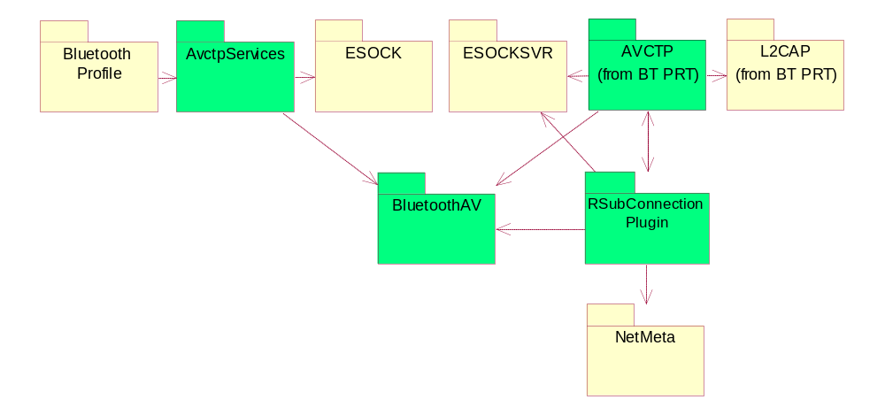
Figure 1 – The main dependencies of AVCTP Dlls (green)

AVCTP is implemented in Symbian OS using the following major dlls:
- AvctpServices is implemented in a static DLL and provides a layer 5 service interface for AVCTP similar to the one given in [R2]. It operates AVCTP sockets and connections on behalf of the client and wraps up the data and control planes into a single easy to use interface. This interface is needed because while sockets are good as data pipes for layers two and four in [R4], they aren’t great for layer five message passing such as here.
- Almost all of AVCTP will be in bt.prt so that it can easily access the functionality provided by the Bluetooth framework such as ControlPlane messages between protocols. Splitting up bt.prt into various protocol dlls was considered but turned out to be too big a job for the time allowed so AVCTP joined the other protocols in the Bluetooth family dll.
- The design of the AVCT protocol itself is split into the user-plane and the control-plane. It takes advantage of the new APIs provided in v3 ESock framework (see [R11]) and provides an RSocket to access the user-plane and an RSubConnection to access the control-plane. However the server side of RSubConnection can only be provided to ESock via an ECom plug-in, so a separate dll has to be provided to satisfy this.
- The BluetoothAV dll provides those parts of AVCTP that are used by both the client and server side of AVCTP, such as TAvctpSockAddr. It is separate from Bluetooth.lib to allow licensees to easily add or remove the Bluetooth AV functionality from their ROMs.

Detailed Design

Common Design Points
Flogging will be added, by using the ComsDbgUtil component, so that all of the methods in the sequence diagrams will be logged (where this doesn’t impact the functionality of debug builds) so that future maintainers of AVCTP can follow the flow of the code. The function calls will be suitably indented so as to show the flow control in an easy to read fashion.

BluetoothAV Dll
This dll provides the common client side functions for the audio / video components. This design document is concerned only with the AVCTP component so we will only focus on the aspects of the BluetoothAV Dll related to AVCTP.

TAvctpSockAddr
This is a simple class that extends the Comms-Infras class TSockAddr (via TBTSockAddr) as part of the AVCTP implementation of the protocol framework. It simply allows a PID to be specified on the client side code and provides a function to cast from a TSockAddr to a TAvctpSockAddr.
Note that this class is not expected to be used by clients of AVCTP as TAvctpSockAddr is only intended to be used internally by the AvctpServices dll to communicate across ESock.

Packet Parsing
There are a number of common packet parsing algorithms presented as global functions by BluetoothAV. To avoid cluttering up a BluetoothAV client’s namespace, these functions are located in the SymbianAvctp namespace.
These functions include ones to check for valid Transaction labels and to extract the Transaction ID, PID and payload etc from a descriptor containing an AVCTP packet. Those functions that are useful to AVCTP clients are given them in AvctpServices.h while those for internal use are placed in AvctpPacketStatics.h.

AvctpServices Dll

Overview
This dll is designed to be the main entry point for users of AVCTP and provides a simpler alternative to using the RSocket, RConnection and RSubConnection interfaces. It also provides functionality that all users of AVCTP would otherwise have to provide themselves. The package will implement a layer 5 type API (Session layer in the OSI model [R4]). Users of AVCTP should not go through the ESock interfaces directly.
Currently all of the exports of this dll have been given an internal interface tag because as yet no licensees need to use this API. However, it is expected that in future it will be used by licensees (but not by a wider audience) so the dll has been written with this in mind, in particular the handle/body pattern used by RAvctp / CAvctpBody.
This is a list of things that must be done by clients / users of RAvctp:
- They must register their service record with the SDP database themselves.
- AVCTP uses the transaction label in its packet headers to identify AVCTP packets that belong to the same message and is normally used to identify which response matches which command. Hence: “users of AVCTP shall therefore provide label values that permit differentiation between packets of different messages.” (from [R2]). Since there are only 16 transaction labels, clients of AVCTP have to be careful in their choice transaction label for each message they begin.
- In the AVCTP transaction model, the response message depends on the application not on the reliability of the transport. … “On unreliable L2CAP channels the transmission can fail: in such case it is up to the application to decide about the retransmission of the complete message.” (from [R2]). In other words as the response message is not guaranteed to reach its target, actual acknowledgement of a command is not supervised by the protocol itself and so it is up to the clients of AVCTP to deal with the unreliability of the transport as necessary. For instance, this could mean providing timeouts to see if a command is unacknowledged.

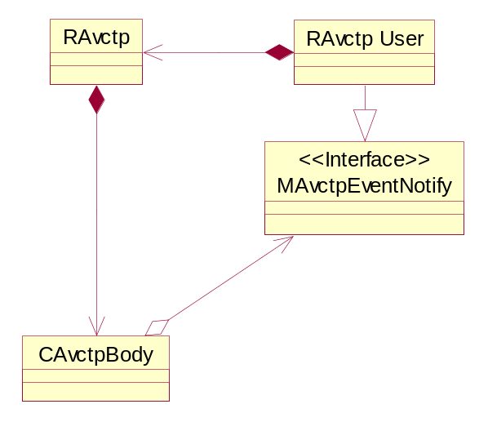
Figure 2
The above figure is a high level class diagram of the RAvctp / CAvctpBody pair that provides the AvctpServices.dll functionality by implementing the Handle / Body design pattern.

The interface offered by RAvctp follows the recommended service interface defined in the AVCTP specification. It allows clients to identify themselves using a Profile Identifier (PID) and hence send / receive messages for that particular profile. The API represents a whole profile through a single RAvctp object and as such these objects can each manage multiple remote devices.
CAvctpBody has active object helper classes to take responsibility for the sending & receiving through its RSocket; receiving device event notifications from its RSubConnection, and the asynchronous shutdown of RAvctp.
MAvctpEventNotify is an interface that apps inherit from if they want to be able to receive AVCTP events from RAvctp. There can only be one RAvctp object per PID. Similarly RAvctp users should only use the MAvctpEventNotify interface to receive events from one PID.
AvctpServices.dll has Capabilities All -Tcb since it is a client side dll and we don’t know what capabilities the client may have so we have to provide for reasonable ones.

There is a section for the RAvctp package in [R6] under Logical View -> AvctpServices that contains many of the diagrams in this section.

MAvctpEventNotify
MAvctpEventNotify is a class that applications inherit from if they want to be able to receive AVCTP events. Before they receive this information the derived class needs to use RAvctp to register its interest in a particular PID by Open()-ing an RAvctp object.
Each instance of a class deriving from this interface must be designed to get events for only one PID. No checks will be made that any derived class conforms to this pattern because the call-backs on this class don’t provide the associated PID of the event and so any such double-PID class would not be able to distinguish between events on different PIDs. The stipulation had been made to reduce the overhead in producing the events within the RAvctp since the main use case for this interface is on a per profile basis only. Clear API documentation will be used to ensure users know about this restriction on the use of MAvctpEventNotify. Hence, the derived class should have only one RAvctp object at a time.
The MAvctpEventNotify API is described in AvctpServices.h and is not duplicated here to minimise the drift between this document and the actual code. All of the functions have TBTDevAddr as part of the parameters so that the app implementing this interface knows exactly what remote device the events refer to. The PID of the event is not included since we stipulate that a class should derive from MAvctpEventNotify on a per PID basis and hence the derived class will already know the PID of the event.
The MAvctpEventNotify API follows the suggested call-backs in the AVCTP spec [R2] except for the following. (Note Maen stands for M Avctp Event Notify. The initials are used to distinguish the functions in the name space of the classes that derive from this interface. You could easily imagine a single class deriving from two M- classes that each have a Connect Confirm function).
- The MaenConnectConfirm call doesn’t support the suggested parameters Config Result & Status. This is because clients are not expected to want to change the L2CAP connection parameters and this assumption simplifies the implementation. If clients do wish to do so in future, an overload providing this functionality could be added without breaking BC.
- The Open method in RAvctp only allows for registration for all events rather than by event type. Again this is to reduce complexity within AvctpServices.dll as derivers of MAvctpEventNotify can just provide a null implementation for events they don’t care about.
- MAvctpEventNotify includes SendComplete which isn’t suggested in the spec [R2] because SendComplete is needed to asynchronous complete the SendMessage call RAvctp
- MaenErrorNotify() is used to provide an asynchronous error path referring to a particular device if possible or giving a general notification if not.
- MaenExtensionInterface() has been added to allow us to extend this interface without breaking binary compatibility in future. It is intended to be used in the following way if needed in future:
class A extends MAvctpEventNotify {
virtual void MaenExtensionInterface(TUid aInterface, void*& aObject);
};

const static TUint KMaenInterface1 = 0x1001FEEF;

MaenInterface1* RAvctp::GetMaenInterface1()
{
void* object = 0;
a::MaenExtensionInterface(KMaenInterface1, object);
return static_cast<MaenInterface1*>(object);
}
(a is an instance of class A)

(Courtesy of David Batchelor)

The MAvctpEventNotify class is defined in the same .h file as RAvctp so that only the one .h file needs to be exported to epoc32/include for the AvctpServices.dll. This will make the use of this dll easier for licensees.

RAvctp
This purpose of this class is to provide an API for the use of AVCTP but also to implement the handle part of the Handle / Body design pattern used in AvctpServices. RAvctp is just a shell that simply passes on all the commands to the Body class, CAvctpBody. The advantage of this is that we can make changes to the implementation of RAvctp (i.e. to CAvctpBody) without worrying about compatibility problems. Also CAvctpBody on its own behaves like an R-class but could not be bit-wise copied nor easily allocated on the stack so an R-Class handle fits this nicely. As well, this pattern gives us more freedom in implementing CAvctpBody since RAvctp will only pass on a subset of CAvctpBody’s public methods as exported functions.
The MAvctpEventNotify interface is provided for users of RAvctp to derive from so that they can receive call-backs relating to AVCTP events on a single PID. The MAvctpEventNotify interface can provide events from multiple remote Bluetooth devices at the same time.
RAvctp will use a single RSocket to access its PID. Since there can only be one RSocket per PID in the whole system for security reasons, there is a risk that some other application may take the only listening socket on AVRCP’s PID, for instance, and prevent AVRCP from working (see [R8]). To prevent this we require applications to have a specific SID to use a given PID. Currently the SID of the RemCon server is the only one allowed. This is done in the protocol layer following RAvctp::Open().

Because ESock will panic if, for instance, we call Write before we call Open on an RSocket, we need to check for misuses of our API that will result in these panics. RAvctp should catch these programming errors before they get to the RSocket and panic itself. The panics will actually be thrown in CAvctpBody rather than in RAvctp.

See AvctpServices.h / RAvctp.cpp for the RAvctp API

Since AVCTP doesn’t require specific L2CAP configuration, to simplify the API, it doesn’t provide users a way of configuring any of its L2CAP channels. This acceptable because we don’t expect profiles to mandate this; AVRCP, the only profile that currently uses AVCTP, doesn’t (see [R8]). We could extend the API in future, without a compatibility break, if it was to become necessary by providing overloads. Hence:
- We don’t support “local side configuration request” for the Connect Request service call (See Appendix A – AVCTP Upper Interface in [R2]) as there is no L2CAP configuration in this class.
- We don’t support “local side configuration response” for the Connect Response service call (See Appendix A – AVCTP Upper Interface in [R2]) as there is no L2CAP configuration stuff in this class.
Generally the RAvctp functions will return the errors generated by the RSocket or RSubConnection, either synchronously or asynchronously, without trying to hide or change them.
There is no CancelReceive API since this not deemed necessary as it would unnecessarily complicate CAvctpBody to provide this functionality when users of RAvctp could just drop any message from devices they’re not interested in. Similarly this API doesn’t provide a CancelAll method since users might think this meant a CancelReceive as well as a CancelConnect and a CancelSend. Receiving is only ‘cancelled’ on disconnection from the remote device.
The copy constructor for this class is made private so as to prevent its use because this would result in there being two handles to the same body. If this happens and one handle deletes the body, the other handle will panic when it tries to access the body. Also it makes no sense to have a deep copy of RAvctp since that would try to create another socket to AVCTP on the same PID which isn’t allowed by the protocol.
Upon closing the class, a synchronous shutdown will be performed on the AVCTP socket held by the CAvctpBody.
The RAvctp class will be implemented in its own .cpp file to increase the maintainability of the class by making the layout of the code more obvious. The class will be defined in AvctpServices.h so that clients get the pair of classes, RAvctp and MAvctpEventNotify, from this one header.

CAvctpBody
This section describes the design required to implement the API given in RAvctp. The whole class is @internalComponent since the Handle / Body pattern means that changes to this class will not affect any other component so no one else need know.
The class diagram for CAvctpBody and the surrounding classes is given in Figure 3
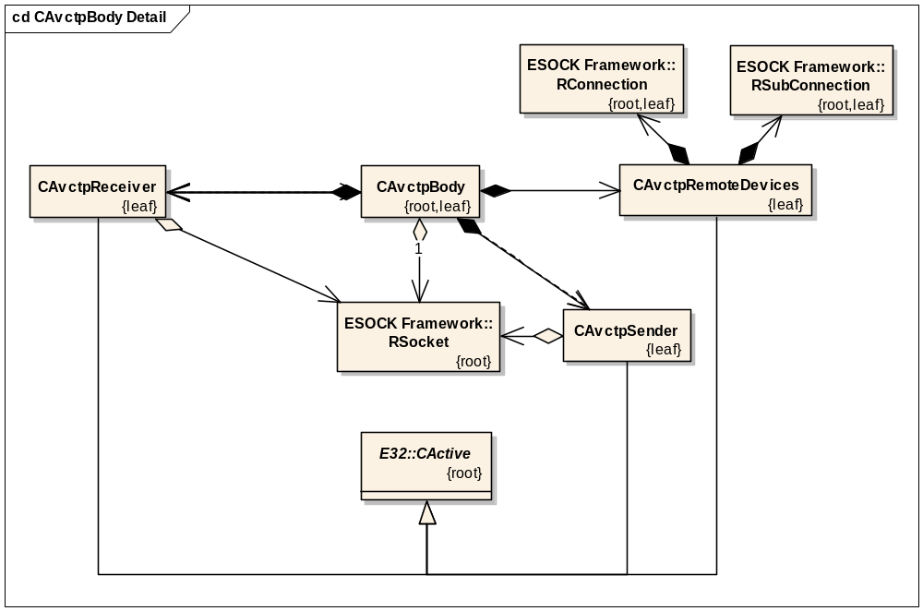
Figure 3

Each CAvctp… class has a reference to MAvctpEventNotify as well, so that they can each notify it of events without needing knowledge of CAvctpBody.
CAvctpBody has three helper AOs – CAvctpRemoteDevices, CAvctpReceiver and CAvctpSender to take responsibility for handling event notifications such as connection & disconnection events from the RSubConnection; closing the RSocket and CAvctpBody; as well as sending and receiving AVCTP packets. The AOs can share the same RSocket since they each use separate TRequestStatus objects and their operations do not overlap.
We have a number of AOs to deal with the single RSocket rather than one for a number of reasons:
- Each AO separates out a basic operation and encapsulates that.
- The basic RSocket operations, such as sending and receiving, can go on in parallel which avoids having to constantly cancel a receive to make way for another request.
The control of all the AOs will be the responsibility of CAvctpBody. All of the AOs contact the MAvctpEventNotify object directly so as to decouple their implementation from CAvctpBody as much as possible. This effectively makes CAvctpBody a management class. At first glance, it would appear to be unnecessary since the implementation of RAvctp could call these AOs directly but this would expose the implementation of RAvctp to clients.
As soon as CAvctpBody is created, it starts the CAvctpReceiver going. When CAvctpBody attempts to disconnect it cancels any outstanding requests on CAvctpSender, CAvctpReceiver and all of the CAvctpRemoteDevices objects.
When CAvctpBody is deleted, it cleans up after itself which includes deleting its AOs and closing its RSocketServ session. The deletion of the AOs results in them cleaning up the various R- classes they’re responsible for and cancelling any outstanding requests.
CAvctpBody and its associated AOs are each defined in their own .cpp / .h files to increase the maintainability of the code through the transparency of the code layout.

CAvctpSender
The CAvctpSender AO is fairly simple in that it is activated by a SendMessage via CAvctpBody and calls SendComplete with the result on MAvctpEventNotify object when it is completed.
Queuing of messages to be sent needs to be done by a higher level than CAvctpBody since this queuing would be application dependent. Hence, in this design, only one SendMessage call can be outstanding at any time. This is enforced by CAvctpSender erroring if it is active.
This class will police the use of the TAvctpTransactionLabel by the application. Hence an error will be given if we get a transaction label that uses more than the least significant four bits. This allows us to be assured of having the extra 4 bits to get round BC problems later. This also forces apps to use the transaction labels properly.
On being deleted this class just needs to call its Cancel function.

CAvctpReceiver
The CAvctpReceiver AO is complicated by the fact that it will be using the following RecvFrom API to handle the fact that the length of AVCTP packets is undefined (at least until you’ve received the header):
RecvFrom(TDes8& aDesc, TSockAddr& anAddr, TUint flags,
TRequestStatus& aStatus, TSockXfrLength& aLen);

This API is initially called to ask for the three byte header of the AVCTP packet that next comes into the prt for our particular PID. Once we’ve got the header, we resubmit the RecvFrom again if the packet contains anything in its “Message Information” field. To handle this CAvctpReceiver will have two states: EWaitingForPktHeader & EWaitingForMsgInfo. When we have the entire packet, MAvctpEventNotify:: MaenMessageReceivedIndicate is called providing the data received.
On being deleted this class just needs to call its Cancel function and clean up its data buffers.

CAvctpRemoteDevices
This class models the connections the client has asked for (i.e. explicit connections). To do this the class has a list of open connections. A connection that is not pending will not be on this list to avoid complicating the model. This is a compromise between handling client requests on the client side and avoiding duplicating state that is in the protocol itself. For instance, this design means that this class can directly error a client if they ask for a disconnect from a connection that doesn’t exist without resorting to an IPC call across to the socket server, ESock. However, a similar check can’t be done on the client side for pending connections so some CancelConnect calls are forwarded to the protocol across the process boundary. This is okay because CancelConnect is deemed to occur less often than Disconnect.
CAvctpRemoteDevices is used to communicate control plane information to the protocol across ESock. It does this using RSubConnection::Control calls to ask for services such as explicit connections and disconnections of remote devices. The responses to these requests are events for which this AO is constantly active by continually reposting RSubConnection::EventNotification. All of the AVCTP events received result in a call-back on the MAvctpEventNotify interface.
Since the AO is always waiting on an EventNotification, unsolicited events are also received, allowing the protocol to inform this class of remote initiated events such as disconnections.
The RSubConnection API provides a framework for these events via NetMeta [R9] and as such the events are provided as ECOM plugins in the AvctpPlugins Dll.
On being deleted this class just needs to call its Cancel function and close its RSubConnection and RConnection handles.

AVCTP Protocol Layer

Overview
These classes are designed to implement AVCTP as a connectionless protocol with a layer 4 type API (Transport layer in the OSI model [R4]), but also to follows the Bluetooth architecture pattern for protocols. The class diagram is given in Figure 5 below.
There is a section for the AVCTP protocol layer in [R6] under Logical View -> BT PRT -> <<subsystem>> AVCTP that contains many of the diagrams in this section.
The protocol layer was written to take advantage of the ESock version 3 architecture and in particular the Bearer Mobility work. The reason for this was two fold, one was that this allowed the Bluetooth team to influence this architecture as it was being finalised but mainly because it allows the protocol to be divided up into a user-plane and a control-plane. This was desirable because it clarifies the design considerably though it does introduce complications where AVCTP meets L2CAP since the latter was written for an earlier version of ESock that doesn’t facilitate the separation of control and user planes.
Another advantage of the ESock V3 architecture is that the framework classes are more intelligent and provide a greater amount of functionality than before, allowing the provider classes to be slimmer. Part of this is that version three providers own themselves and so are responsible for cleaning up after themselves.
The CAvctpProtocol class acts as the main access point for the socket server framework, as well as keeping track of all the AVCTP protocol specific stuff so that they can be init-ed, started, closed etc. This object lasts the lifetime of the AVCTP protocol layer and is used to keep track of all AVCTP objects that are active. CAvctpProtocol derives from MConnectionControlClient so that it can control a CAvctpConnection on to which all the CAvctpMuxers are put. It acts in both the control and user planes.
The main classes of the control plane are as follows:
- The CAvctpSapLinksMgr class is the AVCTP sub connection provider for ESock and models the explicit connections that a single profile has requested via AvctpServices.dll. Each CAvctpSapLinksMgr object has the same lifetime as the RAvctp session on the same PID. The class derives from MSubConnectionControlClient so it can control CAvctpMuxers. It also derives from MConnectionDataClient so it can be controlled by a CAvctpConnection.
- The CAvctpMuxer class acts as the “remote device management entity”. The class derives from MSocketNotify so that it can bind to L2CAP below it as an internal socket. There is one CAvctpMuxer object per remote device, to enforce the requirement that only one L2CAP connection exist between two devices for AVCTP. This class is forced by L2CAP to be involved in the user plane as well but does so in as minimal a way as possible. A CAvctpMuxer object remains alive at least as long as there is a CAvctpSapLinksMgr (i.e. a profile) interested in its connection to a remote device. The class derives from MConnectionDataClient so it can be controlled by a CAvctpConnection.
- CAvctpConnection plays a part in the control side only by fulfilling the obligations for AVCTP to have a connection provider so that it can have sub connections.
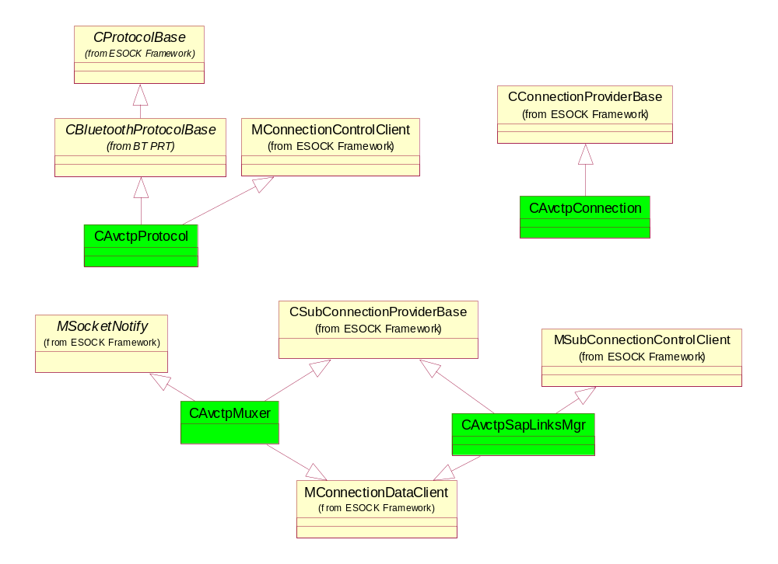
Figure 4
Control Plane Inheritance

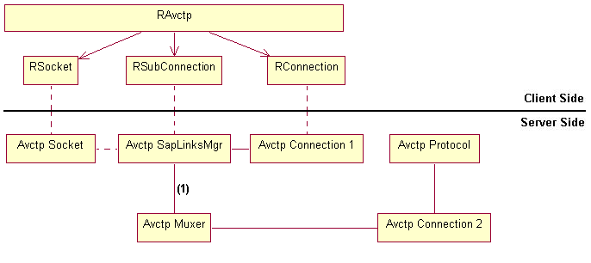
Figure 5
Control Plane example for one profile at Runtime

The above diagram shows the architecture of AVCTP at runtime with a single RAvctp object open. Each yellow box is a single object while the links represent communication paths between objects. The links are all two way though they aren’t symmetrical as for example Avctp Muxer is only able to access Avctp SapLinksMgr as a MSubConnectionControlClient whilst Avctp SapLinksMgr accesses Avctp Muxer as a CAvctpMuxer. The dotted lines represent the fact that the links are indirect and in fact go via Comms-Infras objects not represented here for clarity.
The Avctp Connection objects form a dual role here in that one role is to form the Connection provider for an RConnection handle and to fill in the connection role for Avctp SapLinksMgr. The second role is to fill in the connection role for Avctp Muxer. The fact that the second role is unconnected to an RConnection means that there is more flexibility in the architecture here which is taken advantage of by putting all CAvctpMuxer objects on the same CAvctpConnection and so reducing memory usage. If a second profile opened an additional RAvctp object, this would result in another RSocket, RSubConnection, RConnection, Avctp Socket, Avctp SapLinksMgr and an Avctp Connection 1.
The most significant link in the diagram is (1) because of its fluid nature. The link has multiplicity 0..n in both directions. If a CAvctpMuxer has no CAvctpSapLinksMgrs then this means no profile has explicitly requested a connection to its remote. If a CAvctpSapLinksMgr has no CAvctpMuxers then it means the profile that it represents has not yet asked for any explicit connections.

The main classes of the user plane are as follows:
- The CAvctpSap class is a communications endpoint and the interface from ESock. It is the service provider for an AVCTP RSocket. The class provides the data conduit for a profile to any remote devices that uses AVCTP. Since AVCTP is connectionless, the objects don’t maintain a static link to a remote device but acquire one as necessary. At the time of designing this, the Comms-Infras class CControlledServProvider wasn’t released otherwise CAvctpSap would’ve derived from it. However, Comms-Infras provide a shim that allows an old CServProviderBase-derived class to act in the new v3 framework as if it did derive from CControlledServProvider.
- The CAvctpPacketMgr class provides the data conduit to a particular device for CAvctpSap. It exists to group together all of the data plane functionality that would otherwise have been in CAvctpMuxer. So the class handles the fragmentation of AVCTP packets transparently to both CAvctpSap and CAvctpMuxer.
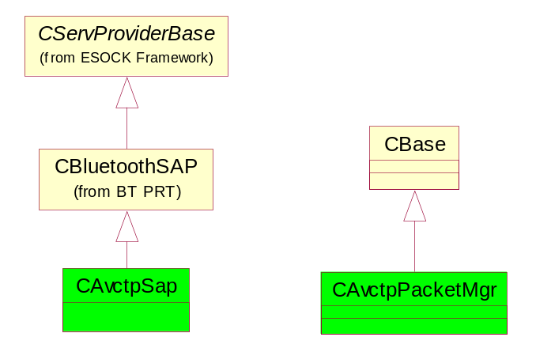
Figure 6
User Plane Inheritance

Security
AVCTP provides the same Bluetooth security to all connections and all profiles. The security chosen was:
Authentication: YES Authorisation: YES Encryption: YES
This was deemed to be acceptable as there weren’t any use cases that would be adversely affected by this and some that required it. For instance, you could imagine a Bluetooth remote control for your garage door which might require you to transmit a pin code before it’ll open which would definitely require authentication and encryption. Most other use-cases required authorisation.
For system security, only one SAP will be allowed to connect to each PID. The reason for this stipulation is that it would be a security risk to allow multiple SAPs per PID as we’d have to give each all the data for that profile. Secondly it would increase the complexity of this component since we’d not only have to deal with more possibilities but do deep copying of packets as well, which is inefficient. One worry about this is that some other application may take the only SAP on AVRCP’s PID say and prevent AVRCP from working (see [R8]). To prevent this we require applications to have a specific SID to use a specific PID (enforced in CAvctpSap).
The idea of restricting a whole profile to a single SAP / RSocket is something that seems restrictive but has been done before and works. An example is the Service Discovery Protocol SDP which only uses the one L2CAP port.
One security complication to note is that because use cases for AVCTP are frequently in conjunction with AVDTP it is not desirable for the user to have to go through more than more authentication procedure for what seems to them to be one use case. Hence the two protocols inform each other of devices that they have already authenticated. CBluetoothProtocolBase already provides a mechanism for this via its ControlPlaneMessage() method.

Prototype
The AVCTP spec [R2] suggests in some places that this protocol is connectionless and at others that it is connection-orientated. A prototype was written which implemented AVCTP in a connectionless manner to try to decide what the best approach was. The prototype highlighted some problems to be overcome such as:
- How and when to create a link between a SAP with a packet to send and a Muxer connected to the required remote device. There is no 1-1 linkage between the two classes as there might have been if the protocol was designed to be connection-orientated.
This has been solved in the following way:
  - Clients register connections that they wish to maintain indefinitely. This is recorded by creating a link between the CAvctpSapLinksMgr on the client’s PID and the CAvctpMuxer representing the connection to the remote device.
  - When a SAP comes to send a packet it asks for a connection to be created to provide the data path. If a suitable CAvctpMuxer exists then this request is simply a process of searching a list to find the correct object. Otherwise an indirect connection is created to provide the path. This path stays open as long as there is data that requires it.
- Should the final design be connection-orientated or connection-less?
An initial connection-orientated design was done following the prototype because it looked as if that would simplify the problem above. However it turned out to cause extra complications. For instance in this design, CAvctpBody and CAvctpSap both needed to use the state pattern to manage their internal state. However with the connectionless approach this isn’t needed since both classes have minimal state. The connectionless design also allows the easy separation of the control and data planes of the protocol.

CAvctpProtocol
Only one instance of this class will ever be instantiated by ESock. The class acts as the main access point for the socket server framework, as well as keeping track of all the AVCTP protocol specific stuff so that they can be init-ed, started, closed etc. This object lasts the lifetime of the AVCTP protocol layer.
See the Sequence diagram referenced in Scenarios section for the design of the behaviour of this class and interactions with the other protocol layer classes.
The class diagram below shows the main properties of the protocol class:
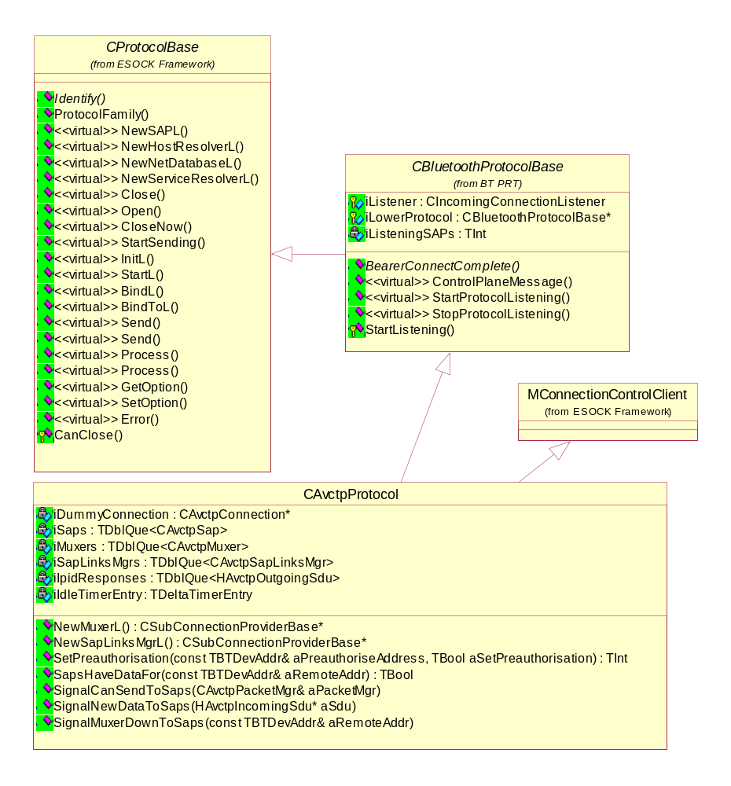
Figure 7
Most of the functionality for the protocol that is generic to Bluetooth is provided by CBluetoothProtocolBase and isn’t in the scope of this document or is too low level for this document. One thing to note is that CBluetoothProtocolBase deals with creating and managing a listening SAP on a specific port of the lower protocol, which is L2CAP at this time. This iListener object informs the protocol of any connection attempts of any new remotes (any existing devices would be routed through their Muxer instead).
The protocol defines itself to ESock in the following way using TServerProtocolDesc:

Property | Value
iName | “AVCTP”
iAddrFamily | KBTAddrFamily
iSockType | KSockDatagram
iProtocol | KAVCTP
iVersion | TVersion(KBTMajor,KBTMinor,KBTBuild)
iByteOrder | ELittleEndian
iServiceInfo | KSIConnectionLess  KSIReliable  KSIInOrder  KSIDatagram  KSIGracefulClose
iNamingServices | NULL
iSecurity | KSocketNoSecurity
iMessageSize | KSocketMessageSizeNoLimit
iServiceTypeInfo | ESocketSupport  ECantProcessMBufChains  EUseCanSend
iNumSockets | 100

The explanation for the less obvious choices is as follows:
- iServiceInfo doesn’t include KSIRequiresOwnerInfo because the AVCTP SAPs use CServProviderBase::SecurityCheck() instead to allow the SAP to check the client’s SID against the one required to use the requested PID.
- iSecurity == KSocketNoSecurity: If this was set to KSecureSockets, this would enforce encryption on our socket whereas, in Bluetooth, we want to selectively do this ourselves.
- iNamingServices == NULL to indicate that the protocol doesn’t provide a host resolver implementation. This is provided elsewhere in the Bluetooth stack.
- iServiceTypeInfo indicates mainly that the protocol can’t use MBufs. The reason descriptors are used was simply due to the fact that there wasn’t enough time to implement the use of MBufs which are slightly more complicated. This was deemed acceptable since the nature of the protocol means that a high performance data plane is not essential.

The protocol has the following groups of functions:
- Setup functions that open, initialise, start and bind the protocol into its position in a protocol stack.
- Exiting functions that clean up and close the protocol.
- An interface between the user and control planes.
- Functions that administer the SAPs.
- Functions that administer the SapLinksMgrs.
- Functions that administer the Muxers.
- Getters for AVCTP events.
- Virtual functions from MConnectionControlClient
- NewSAPL, NewMuxerL and NewSapLinksMgrL.
The first two groups of functions follow the pattern of the other protocols in the Bluetooth Stack and so their design won’t be discussed here. However one thing to note is that the Bluetooth security for AVCTP is enforced on inbound connections at the point that we create our listening socket in L2CAP.
The third group of functions provide a Muxer with a way of notifying all SAPs with information such as the fact that new data has arrived from a remote, that a Muxer has become unblocked (and is able to send again) or has died unexpectedly. The functions are provided by the protocol as it is in a good position to arbitrate between the control and user planes as it has the complete set of objects involved in both and will be around to query. One such function is SignalNewDataToSaps(…) which is called within the control plane and finds a suitable SAP for the data. In the case were no such SAP is found, the specification [R2] requires us to return an IPID response. However, since there is no suitable SAP to own this response, the protocol maintains a queue for this purpose and takes part in the user plane sufficiently to send these responses as a priority. Other functions in this group provide an interface for the user plane to obtain a connection. These getters will return a CAvctpPacketMgr / Muxer as appropriate if a suitable one exists otherwise they’ll create one and start the connecting process off so as to provide the required connection at some point later. The user plane will be notified when the connection comes up through one of the earlier mentioned function calls.
The functions described in points 4 – 6 all act in the same sort of way. For each class there is an Add, Remove and Find function that act in the obvious ways with the proviso that the protocol uses the first two to implement its idling functionality (see later for more). Also the Add functions check that there isn’t already an object of the same class on the requested PID or TBTDevAddr.
One of each type of AVCTP event is created when the protocol is created and the functions mentioned in point 7 provide access to these events. At first glance it looks as if these event objects are used asynchronously by the ESock framework which would cause problems with multiple uses. However ESock takes a copy on being asked to send an event so the usage with AVCTP is, in fact, synchronous. This means that there won’t be any OOM problems creating events and at the price of a small memory overhead will improve performance. All the users of the event have to do is set the event up with the correct device address etc.
The virtual functions from MConnectionControlClient, mentioned in point 8, are all implemented as dummy functions since the only functionality we want from MConnectionControlClient is to be able to attach the protocol as a control object on a CAvctpConnection. This allows the protocol to use the ESock V3 framework to control the lifetime of the CAvctpConnection. In this case we wish it to last at least as long as the life of the protocol so that we can use it to create any Muxers as sub connections on that connection.
The New…L functions, mentioned in point 9, simply provide the associate provider on ‘request’ by ESockSvr. The request takes two forms: NewSAPL is exported as the first ordinal of a prt and so ESockSvr can call that directly. If it were possible I think ESockSvr would’ve liked to call functions such as NewMuxerL etc as ordinal 1, 2, 3 etc. Instead connection and sub connection factories are implemented as ECOM plug-ins which provide ESockSvr with a path to these functions. The factories are described in more detail in section 3.5.1.
The remaining function of interest is BearerConnectComplete – called when an incoming connection occurs on the protocol’s listening L2CAP SAP. This should only be reached if there wasn’t a Muxer already on this aAddr since otherwise the Muxer should have got the message instead. However, assuming that this is a new connection, we attached the Muxer to all SapLinksMgrs and call NotifyClientEvent( Connect Indicate ) on each. The reason for these events is so that all profiles get notified of the new connection so that they can accept or deny it. The reason the Muxer is added to all SapLinksMgrs is so that we don’t get into a race condition between the Muxer’s idle timer and the time taken till the first profile responds with an accept.
As with other Bluetooth protocols, CAvctpProtocol doesn’t immediately destruct on being told there are no more clients as signalled by ESockSvr calling CloseNow().The protocol will not always be in use and so to save RAM, the protocol will shut down when there are no clients. However to smooth over small periods of not being used, the protocol will start a timer on being told of the absence of clients and then self-destruct when the timer expires. The protocol considers itself to be idle when CloseNow() has been called to respect the ESock framework. This translates to be when there are neither SAPs nor SapLinksMgrs since this reflects the fact that there are no clients of interest. A client we’re not interested in is one who has only an AVCTP RConnection. So a protocol could be idle even though it has connections open in the form of CAvctpMuxer objects however, without a SapLinksMgr these connections are no required and would only be idling themselves.
This class is published @InternalComponent since it provides an access point for AVCTP for other Bluetooth protocols which are also in the same file and so it shouldn’t be @InternalTechnology or more widely published since it’s not intended for use outside of BT.prt.

Control Plane
The design for the control plane is to split it into the following parts:
- The top portion is made up of CAvctpSapLinksMgr objects, each of which is associated with a particular profile and maintains the explicitly client-requested connections.
- The bottom portion is made up of CAvctpMuxer objects which each deal with a single remote device.
- CAvctpConnection objects fill the ESock requirement that each sub connection provider has connection provider. This class is discussed in section 3.5.1.2.
This design neatly splits the control plane functionality up and decouples AVCTP connections to remote devices from profiles as much as possible.
Note that the links between the top and bottom portions of this plane are long lasting whereas the corresponding links between the top and bottom portions of the user plane last for a much shorter time.

CAvctpSapLinksMgr
The CAvctpSapLinksMgr class is the AVCTP sub connection provider for ESock and models the explicit connections that a single profile has requested via AvctpServices.dll. Each CAvctpSapLinksMgr object has the same lifetime as the RAvctp session on the same PID. The class derives from MSubConnectionControlClient so it can control CAvctpMuxers. It also derives from MConnectionDataClient so it can be controlled by a CAvctpConnection.
CAvctpSapLinksMgr is a passive object with little state and reacts only as a result of events and function calls upon it.
See the Sequence diagram referenced in Scenarios section for the design of the behaviour of this class and interactions with the other protocol layer classes.
The class diagram below shows the main properties of the CAvctpSapLinksMgr class:
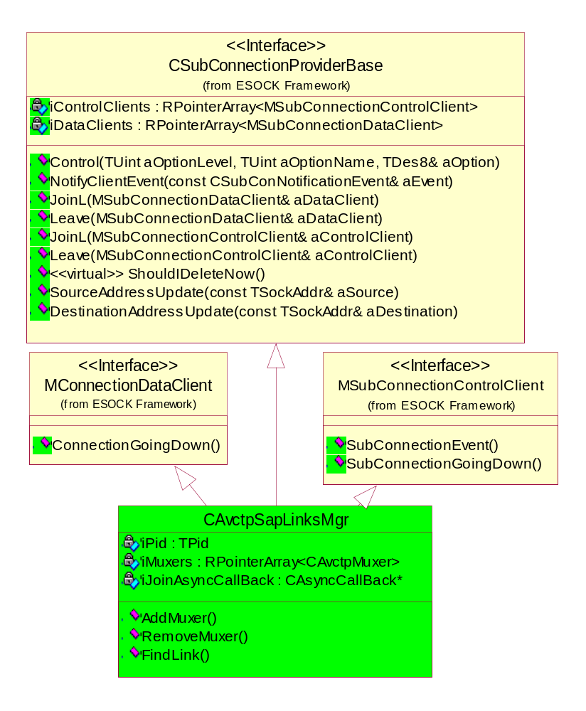
Figure 8
The class derives from MConnectionDataClient so it can be controlled by a CAvctpConnection and hence satisfy the ESock requirement that all sub connections have a connection.
A CAvctpSapLinksMgr object remains alive if it has control clients (i.e. ESock’s CSubConnections representing the RSubConnections held by the clients of AVCTP) and data clients (CAvctpSaps). This behaviour is the default for CSubConnectionProviderBase objects. There is no need for an idle time before deletion because on going down only the CAvctpSapLinksMgr object itself will go down. Hence if we were to need the CAvctpSapLinksMgr that’s just gone done, it’s relatively easy to create a new one so the complexity of an idle timer to smooth out the construction / destruction of these objects isn’t justified.
The explanations for the less obvious properties are as follows:
- The control plane framework provided by ESock provides 1 – many relationships between CSubConnectionProviderBase and the MSubConnectionDataClient & MSubConnectionControlClient classes using the iControlClients and iDataClients member variables. Usually these are sufficient but the links between CAvctpMuxer and CAvctpSapLinksMgr needs to be a many – many relationship. For example, the following situation is legitimate and represents one client of AVCTP requiring only connection B whereas the other client requiring both connections A & B:
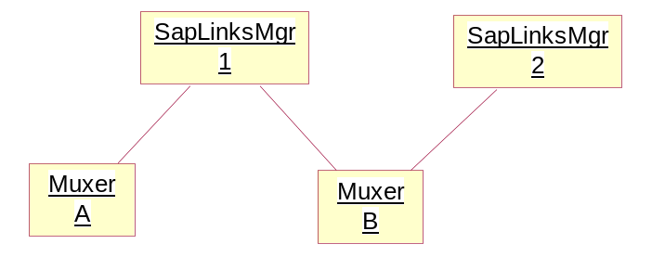
CAvctpSapLinksMgr needs to maintain a list of the Muxers so that it can Leave (NB this is the term used within ESock and should not be confused with TRAP / Leave) from them as a control client when it dies.
- The CSubConnectionProviderBase API requires that JoinComplete() is called asynchronously following notification that a control client wishes to join CAvctpSapLinksMgr. This is the only reason for the existence of iJoinAsyncCallBack. (NB DEF053296 was raised on Comms-Infras over this but it was rejected)
- The iDataClients array contains at most one object which will be a CControlledServProviderShim object that wraps up a CAvctpSap so that it can act as MSubConnectionDataClient.
- SubConnectionEvent() is called on an object of this class by CAvctpMuxer when it wishes to send an event such as CAvctpSubConEventConnectCfm to the client modelled by this object. We use the events to keep iMuxers up-to-date and then pass on the event to the clients of AVCTP by calling NotifyClientEvent().
- ConnectionGoingDown() occurs as a result of the associated RConnection going down and as such is fatal.
- The Control() function is used by AvctpServices.dll to pass messages from the client side to the protocol. The semantics of the function are very similar to CServProviderBase::SetOption(). This interface is used to transmit the following types of client requests each of which come with a TBTDevAddr as a parameter:
  - EConnectionReq – results in a request for a new Muxer from CAvctpProtocol. The Muxer generated is then responsible for sending the Connect Complete event.
  - EDisconnectReq – results in the link to and from the Muxer in question being dissolved and a Disconnect Confirm event being immediately generated.
  - EConnectRspAccept – results in nothing changing since the Muxer will have been Joined to the SapLinksMgr already in CAvctpProtocol::BearerConnectComplete.
  - EConnectRspDeny – results in the Muxer being removed from the SapLinksMgr. (It was Joined to the SapLinksMgr in CAvctpProtocol::BearerConnectComplete).
  - ECancelConnectRequest- results in a Control call on the Muxer to pass on the request and then the Muxer is removed from the SapLinksMgr.
As a result of there being no Start API on RSubConnection and the fact that the Open API doesn’t have a parameter to specify what address (in our case a PID), the CAvctpSapLinksMgr relies on the Source/DestinationAddressUpdate calls to set its PID. This is acceptable because we have control of the RSocket and RSubConnection used in AvctpServices and we can call SetLocalName on the RSocket after Opening both the RSocket and the RSubConnection.
This class is @InternalComponent since only classes inside bt.prt will be affected by changes to these classes.

CAvctpMuxer
The CAvctpMuxer class acts as the “remote device management entity”. The class derives from MSocketNotify so that it can bind to L2CAP below it as an internal socket. There is one CAvctpMuxer object per remote device, to enforce the requirement that only one L2CAP connection exists between two devices for AVCTP. This class is forced by L2CAP to be involved in the user plane as well but does so in as minimal a way as possible so that if L2CAP gets re-written for ESock V3 then AVCTP will not need to change much.
This class multiplexes potentially multiple CAvctpSapLinksMgr objects over a single L2CAP link to the remote device to satisfy the requirement for this behaviour in [R2].
See the Sequence diagram referenced in Scenarios section for the design of the behaviour of this class and interactions with the other protocol layer classes.
The class diagram below shows the main properties of the CAvctpMuxer class:
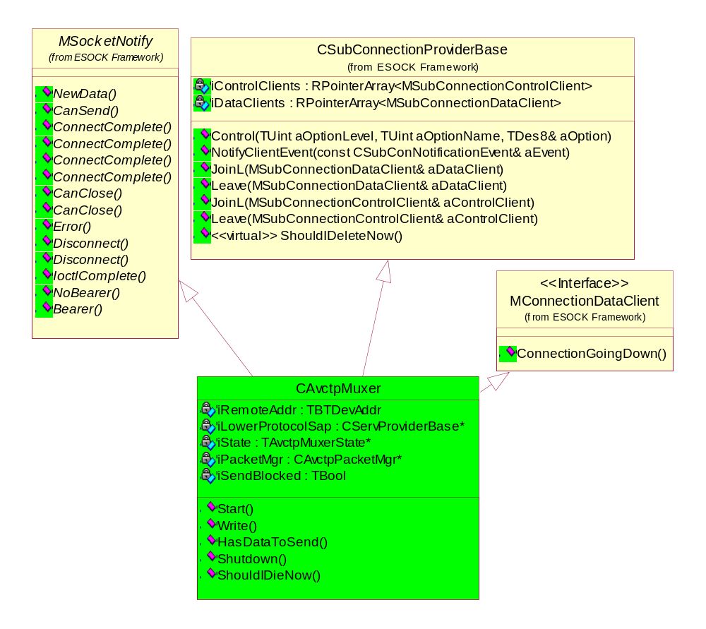
Figure 9
The class derives from MConnectionDataClient so it can be controlled by a CAvctpConnection and hence satisfy the ESock requirement that all sub connections have a connection.
A CAvctpMuxer object remains alive at least as long as it has control clients (i.e. CAvctpSapLinksMgrs) interested in its connection to a remote device. However, once the last CAvctpSapLinksMgr removes itself, the Muxer in question starts an idle timer. This timer will be stopped by any new CAvctpSapLinksMgr / profiles registering interest in the Muxer. Once the idle timer expires the Muxer will destroy itself. The reason for this behaviour is because the process of bringing up a connection is costly so we don’t want to tear one down only to immediately find a client has requested it.
The explanations for the less obvious properties are as follows:
- iDataClients is the list of data clients ‘joined’ to the Muxer. This list should however remain empty. The reason for this is that CAvcptSaps cannot be a data client for more than one sub connection at a time so instead no direct links are formed between the two classes.
- iPacketMgr is created and owned by the Muxer and is the object that deals with the user plane for the same remote device represented by the Muxer. The two objects have the same lifetime.
- iSendBlocked represents whether or not we are waiting for a CanSend call from L2CAP.
- Start() has two overloads which correspond to whether the Muxer was created to service an incoming connection request from L2CAP or a new outgoing connection request coming from above.
- Shutdown() is used within the protocol when a remote device has contravened the AVCTP specification or is otherwise misbehaving. The result of the call is to disconnect the remote device immediately. Since no client requested this, it appears to them as if the remote disconnected.
- CSubConnectionProviderBase uses the function ShouldIDieNow() to decided when to destroy itself. The default is to do this as soon as all data and control clients have gone but since we implement an idle timer, we override the default behaviour.
- The Control() API allows clients of CAvctpMuxer to send arbitrary messages such as CancelConnect requests. The requests all become events that the Muxer states deal with as appropriate.
On NewData calls informing the Muxer that there is data for us coming up from below we use a standard protocol pattern to minimise the time spent at the transport layer, synchronously processing what to do with the data. We do this by simply noting how much data that we have waiting for us before setting up a call-back to a function where we deal with the data.
The Muxer is not transparent to Ioctls or options– since RAvctp does not provide an API that allows its users to access them.
The fact that AVCTP has device specific security means that this class is the obvious place to enforce Bluetooth security measures for outgoing connections. This is done by providing the asking for the protocol wide security settings when setting up the L2CAP SAP.
The Muxer has the responsibility for the underlying L2CAP link to the remote device. It will use the default flow control and retransmission settings; neither flow control nor retransmission. This is because AVCTP doesn’t offer any guarantees of delivery of its packets. The overhead of doing flow control and retransmission is therefore deemed too high.
A Muxer is thought to be idle if (no control clients attached && there is no data in any of the AVCTP SAPs) for a specified default amount of time. This condition is checked and a timer started whenever a control client leaves and when we successfully send data. Similarly the timer is cancelled when a control client joins and when L2CAP blocks us from sending data.
CAvctpMuxer implements the state and flyweight design patterns (from [R10]) to implement its behaviour since this behaviour will change dramatically depending on whether its state, e.g. whether it has a connection or not. As you’ll see there are only four states so this design is slightly more complicated than necessary except for the fact that it allows future extensions and changes to be made more easily. Per device security is a good example of this since that would require at least one more state and probably two.
This class is @InternalComponent since only classes inside bt.prt will be affected by changes to these classes.

States
These classes act as the state classes in the State pattern (from [R10]), with the Muxer being the context. There are three categories of events represented as virtual functions. These are:
- Events originating in the user plane.
- Events from below originating in L2CAP.
- Artificial events like state Enter, Exit etc.
All states are flyweight classes managed by a singleton State factory (patterns from [R10]).
The design of the states is not to panic on any events that might possibly be the result of the behaviour of a remote device, however there is little scope for this due to the thin nature of the AVCTP protocol itself. What is more common is ASSERTs and panics to police the expect behaviour of the interfaces to/from ESock and L2CAP.
For debugging purposes, a state name is implemented to allow state changes to be logged.
All of the Muxer states are defined and implemented in the same .h and .cpp files to follow the pattern of the rest of bt.prt and because all of these classes are so interrelated. The state factory is also in these two files for the same reasons. I think it is also clearer to have all the states in one file than it is to have them spread out across numerous files.
The Muxer state diagram is given below:
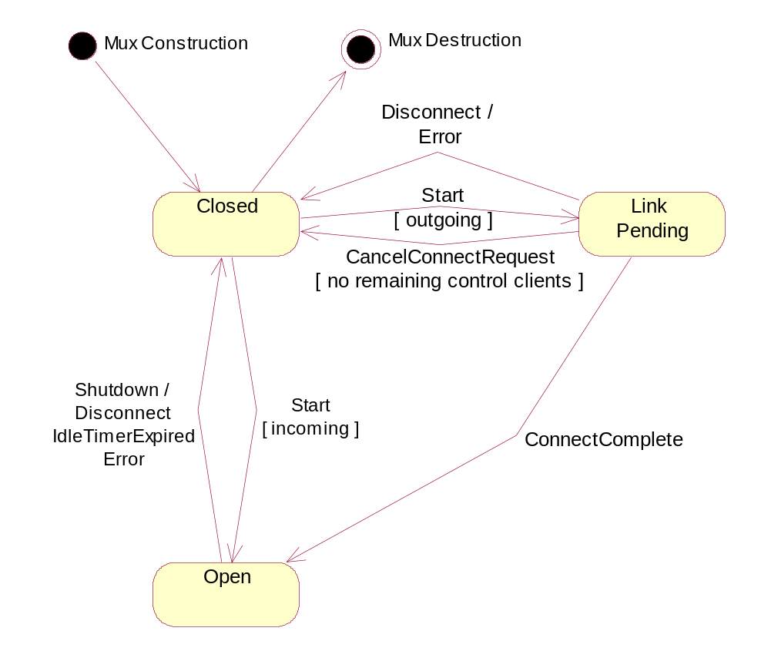
Figure 10

All states derive from the Default state. The purpose of this state is to provide both the base for all states to derive from and the default behaviour which could be to do nothing, such as for artificial events, or to use panics to police the interfaces exposed by ESock and L2CAP with the proviso that unexpected behaviour on the air should give rise to errors instead.
The Closed state – the state that newly created Muxers start in, and the state they end in. Initially this is a quiescent state from which the Muxer can go on to different states. To simplify the design, this is the only state that a Muxer should be destroyed in. A similar simplification is that a Muxer is irretrievable on re-entering the Closed state and just schedules itself for an asynchronous delete. The Muxer is deleted in this asynchronous way to avoid the general problem where a Muxer is accessed in a synchronous call after being deleted. So that no other object in the AVCTP system can access it before it actually gets deleted, the Muxer is Removed from the protocol. In state Closed this invariant must be maintained: There must be no CAvctpSapLinksMgrs attached to this Muxer.
The Link Pending state – represents the fact that the Muxer is attached to a valid L2CAP SAP and has asked for a connection from L2CAP and is waiting on the result. If a client asks for the pending connection to be cancelled and there are other profiles interested in the connection then this cancel will just be completed without error and all that will happen is the profile’s interest in the Muxer is removed. If there was no other client interested in the connection then the cancel immediately closes the Muxer and no idle timer is run. We could just ignore all cancel connections and happily bring up the connection, idle and then die (assuming no more clients register interest) however, then clients would never be able to stop a connection which is undesirable as it’s too inflexible.
The Open state – represents a Muxer with an open L2CAP link to a remote device which has had Bluetooth security enforced on it. This is the only state through which the user plane can send and receive packets to and from a remote device. If a packet is received to be sent to a remote device in any other state it will be blocked until this state is reached, when the user plane will be informed by calling SignalMuxerError on the Muxer’s CAvctpPacketMgr.
The various ways that the Muxer transitions between states result in events being given to its control clients via SubConnectionEvent().By sending the events to all of our control clients we inform all profiles that have expressed an interest in the Muxer’s remote device. The events generated are detailed below:
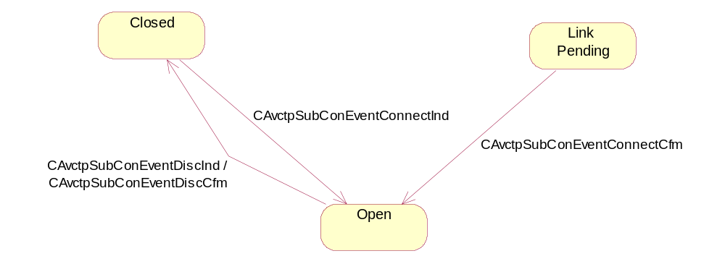
Figure 11
There is no need for the following states:
- AccessRequestPending – this state would be needed if AVCTP itself had to wait for the Bluetooth security manager to provide our requested security but L2CAP provides this functionality for us.
- Disconnecting – this state would only be needed if the Muxer itself has responsibility for draining away any packets that are waiting to be sent following a normal shutdown. However this is the SAP’s responsibility.
- Error –there is no need to have a separate error state from the Closed state since we don’t ever want to remain in an Errored state until the Muxer is deleted.
These classes are @InternalComponent since only CAvctpMuxer will be affected by changes to these classes.

User Plane
The design for the user plane is to split it into two parts:
- The top portion is made up of CAvctpSap objects which each deal with all SDUs for a profile whether inbound or outbound. As such it has no knowledge of fragmentation and deals with packets as indivisible units.
- The bottom portion is made up of CAvctpPacketMgr objects which each deal with all packets to a particular remote device whether inbound or outbound. This is the level at which fragmentation occurs, i.e. providing the mapping between multiple PDUs on the air and SDUs for/from CAvctpSap and above.
This design neatly splits the user plane functionality up and separates the main behaviour as much as possible. CAvctpSap is responsible for queuing all SDUs and so has most of the responsibility for scheduling data but is simplified by not needing to consider fragmentation. Placing all the responsibility for the scheduling in one class makes the design clearer than other alternatives.
CAvctpPacketMgr provides fragmentation and just enough packet scheduling to deal with a single connection which may block at any time.
Note that the links between the top and bottom portions of this plane do not really last since the appropriate CAvctpPacketMgr is obtained by CAvctpSap from CAvctpProtocol for each and every packet. This is in contrast to the control plane where the links between the two portions are longer lasting.

CAvctpSap
This class implements ESock‘s communications endpoint interface. The class provides a connectionless service access to a profile on remote devices that use AVCTP. Its main job is to funnel data addressed on a particular PID between multiple remote devices and a client interested in only that PID. The class is implemented as part of the ESock framework which handles the non-protocol specific part of this behaviour. Note that this class is entirely in the user plane and so has no responsibility for actually bringing up connections etc.
See the Sequence diagram referenced in Scenarios section for the design of the behaviour of this class and interactions with the other protocol layer classes.
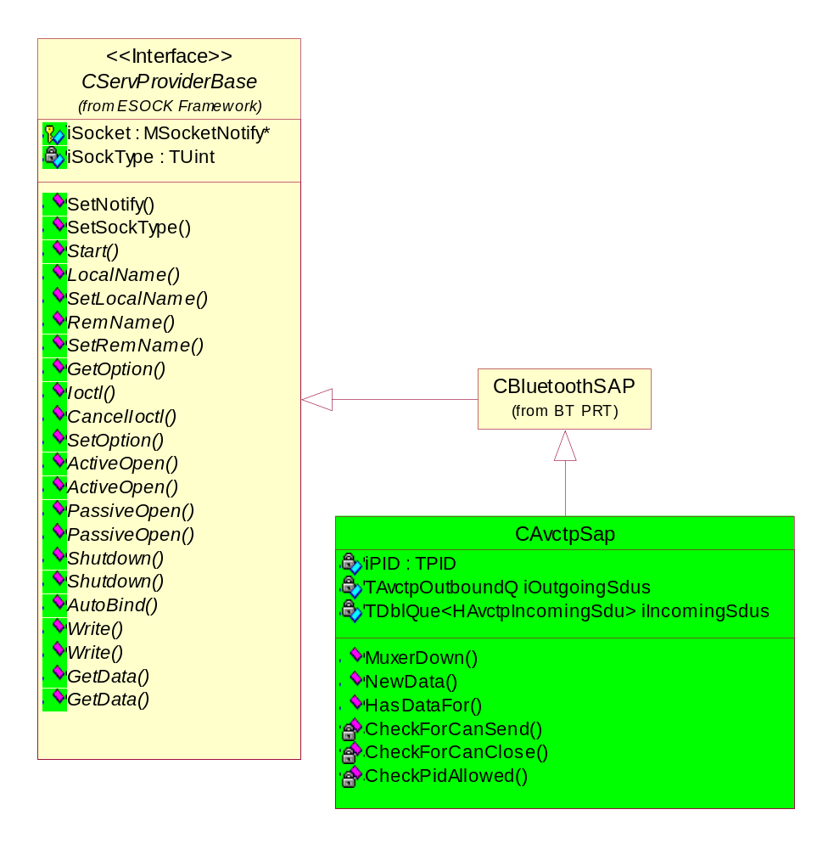
Figure 12

The class diagram above shows the main properties of the CAvctpSap class. CAvctpSap inherits from CServProviderBase so that we fit into the socket server framework as a communication endpoint. Similarly the class derives from CBluetoothSAP so that it fits into the Bluetooth framework for its own protocols. However, this is so that CAvctpSap is-a CBluetoothSAP and not so that it can make use of the BT security functionality that CBluetoothSAP provides to it’s derivers since that is functionality is provided in the AVCTP control plane instead.
CAvctpSap doesn’t support any client side socket options or Ioctls on AVCTP since they are not needed and will not forward any on since RAvctp doesn’t provide an API that allows AVCTP users to set options or Ioctls at all let alone for lower layers.
Despite the fact that AVCTP is implemented using descriptors, CAvctpSap only implements the RMBuf overload of GetData. The reason for this is that the descriptor based version only provides a constant descriptor of insufficient length to fit an arbitrary AVCTP packet into and so the RMBuf version is used as that allows us to adjust the size of the data receptacle given to ESock.
CAvctpSap has two queues to provide the scheduling of data within the user plane, an inbound and an outbound queue. The inbound queue is simply a linked list of SDUs and is unbounded because we don’t want to drop any packets by placing a limit on the number of incoming packets we can support at a time. An alternative to this would be to flow control off L2CAP but this was deemed an overly complicated solution due to the fact that a glut of incoming AVCTP packets is unlikely. The outbound queue is implemented in terms of TAvctpOutboundQ which is a thin wrapper round a linked list to provide a bound on the number of items in the list. The outbound queue has a maximum size because ESock provides a simple mechanism to “flow control” off a client. Secondly, the maximum outbound queue size protects us from a malicious client that is trying to swamp us with data. An additional reason for the limit on the size of the inbound queue is to limit the loss of packets which a client has asked us to send implicitly (i.e. without asking for a connection first) and are then subsequently dropped when the connection attempt fails. Note that within the AVCTP protocol layer, data is moved about synchronously for simplicity but in-between layers, (AVCTP <-> L2CAP or AVCTP <-> ESock) the common protocol pattern of NewData (which notifies of the presence / amount of data available) / GetData (used by the notified object to obtain some of the data available) is used. This enables more flexibility between layers which is worth the extra complexity.
CAvctpSap is a passive class with little state which is partly due to the fact that being connectionless it is not an error to call Write before Connect as it would be if the SAP was connection-orientated. The class is able to react to events generated by other parts of the system, e.g. it will try to write all data possible until all outbound packets are blocked, it’ll then wait until told that a connection has been unblocked and then try to write all data until … The events else where in the system are as follows:
- Calls by ESock onto the CServProviderBase interface. Most of these are dealt with in the obvious way but here are some important details –
  - A normal Shutdown will cause the SAP to throw away inbound SDUs because ESock clearly no longer cares about them. The SAP will then call CanClose to signify the Shutdown completing once the outbound queue has finished draining.
  - SetLocalName / SetRemName are prompts to set ask CAvctpProtocol to set the SAP’s PID. The protocol object is asked so that it can enforce the one SAP per PID requirement.
  - The SAP enforces the use of the LocalServices capability and the necessity for client processes to have RemCon’s SID through the SecurityCheck() API.
  - CAvctpSap will accept all data given as part of the Write() call as long as its outbound queue isn’t full. The data is placed on the outbound queue and an asynchronous call-back is set up to deal with it. The asynchronicity is to prevent the situation where ESock is waiting on AVCTP to finish its write but AVCTP is waiting on L2CAP to finish its write which is waiting on … That situation greatly reduces the responsiveness of the whole communications system.
This acceptance of the Write ultimately results in MaenMessageSendComplete being called on a client with no error despite the packet not yet actually being sent. The alternative would be to block the client from sending until L2CAP had accepted the packet however this is even worse because with the AVCTP RSocket being used to send to any remote, we don’t want a packet sent to remote A preventing a client sending to remote B as would happen if we blocked. Even if this wasn’t a problem, we can’t assume that once L2CAP has accepted a packet that it has been sent either. So the compromise solution is not to block in this situation which is acceptable since AVCTP is not a reliable transport and a client should expect packets to be dropped anyway.
- Calls from the Control Plane that require additional explanation here –
  - MuxerDown() which signifies to the SAP that a remote device has gone down and prompts it to throw away all packets destined for it. In this situation all such packets will be silently dropped with the client being informed of this fact as discussed above. The single exception to this rule is if there is a send pending due to the fact that the outbound queue is full then that packet will be errored if appropriate.
  - NewData(HAvctpIncomingSdu* aSdu) signifies that aSdu is has come in from a remote. ESock is informed of this fact and aSdu is put on a queue until retrieved by ESock via a GetData() call.
  - CanSend() is a signal from the Control plane that a connection has become unblocked. No address is provided since its almost the same amount of work to check if a Muxer on a particular address is blocked as to try and send and find out the Muxer is blocked in that way.
AVCTP doesn’t mandate responses so there is no need to provide timeouts in the SAP on sending packets.
The Write API used by CAvctpSap provides only the Message Information of the packet the client wishes to send (as the remaining header information is known or assumed) hence it’s not possible for an outgoing SDU to be invalid at this point. The allocation of incoming packets within CAvctpProtocol also prevents invalid packets reaching CAvctpSap. Therefore CAvctpSap is not concerned with IPID packets.
This class is published @InternalComponent since it provides an access point for AVCTP for other Bluetooth protocols which are also in the same file and so it shouldn’t be @InternalTechnology or more widely published since it’s not intended for use outside of BT.prt.

CAvctpPacketMgr
This class provides the data conduit to a particular device for CAvctpSap. It exists to group together all of the data plane functionality that would otherwise have been in CAvctpMuxer. The class handles the fragmentation of AVCTP packets transparently to both CAvctpSap and CAvctpMuxer. The lifetime of these objects matches that of the Muxers that own them which is enforced by the Muxers creating and destroying their Packet Mgrs in their own constructors and destructors.
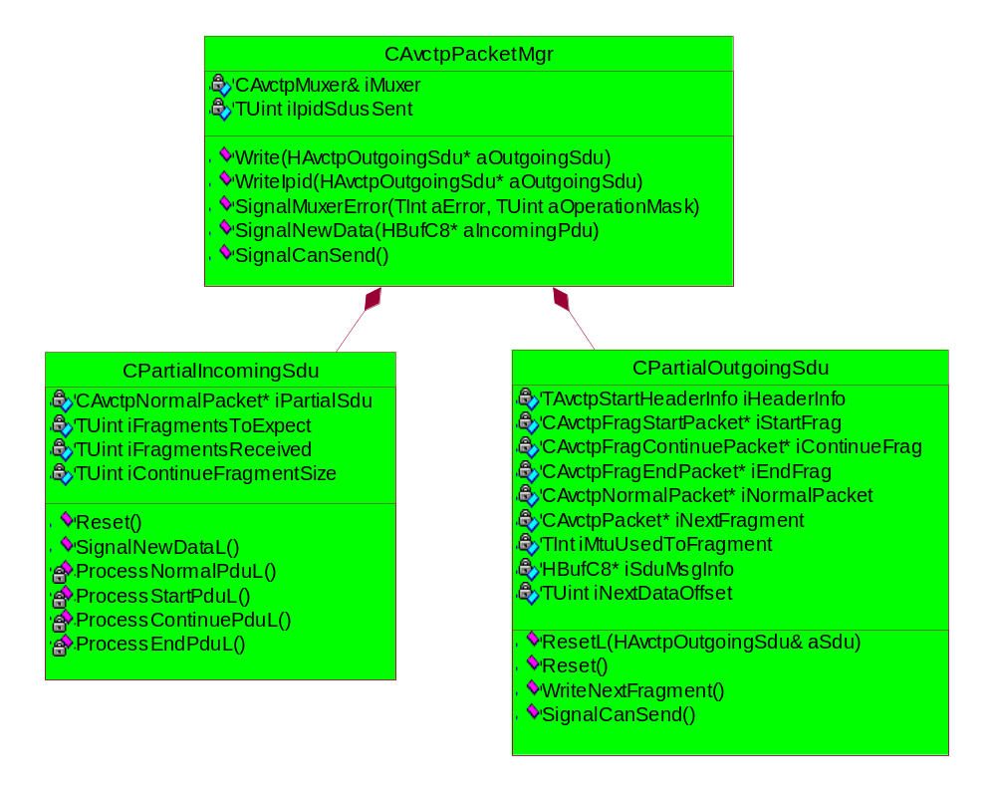
Figure 13

The class diagram above shows the main properties of the CAvctpPacketMgr class. One thing that isn’t made clear in the diagram is that CPartialIncomingSdu and CPartialOutgoingSdu are both defined as private sub-classes of CAvctpPacketMgr. The functionality in the sub-classes is not provided directly by CAvctpPacketMgr because of the clarity given by the separation of the incoming and outgoing functionality. The sub-classes are private because no-one else should access the functionality provided directly. One of the properties of the sub-classes is that they will only contain a valid portion of an SDU.
The explanations for the properties of CAvctpPacketMgr are as follows:
- The Write commands are called on the class (via CAvctpProtocol) in response to an attempt to send a SDU to the remote device represented by iMuxer (the owner of the CAvctpPacketMgr object in question). The function will return 0 if the send failed, or it will return the size of the SDU sent.
The IPID variant of Write is used directly by CAvctpProtocol to send IPID responses to the iMuxer’s TBTDevAddr. The variant is used so as to avoid checking whether an IPID response is being sent in the normal Write function so speeding up the data path. The reason that IPID SDUs are treated differently is so that we can keep track of how many have been sent to a remote device so that we can disconnect any remote that insists on constantly sending us rubbish. Note that if a remote was to disconnect and then reconnect then the count would be reset to 0. However, to make an IPID storm DoS attack effective the remote device would have to disconnect and reconnect repeatedly which would be suspicious to the Bluetooth Stack itself. This is a general Bluetooth DoS type attack that should be defended against at a lower layer than AVCTP and hence doesn’t need to be protected against here.
In both Writes we assume that we are being given a correctly formed packet. This is fine as we don’t let AVCTP clients actually create these packets but do it ourselves within the protocol layer.
- The Signal… functions are calls from iMuxer that pass onto this class the data plane messages it receives from below.
  - SignalCanSend is passed straight onto the CPartialOutgoingSdu.
  - In SignalMuxerError we assume that any errors are fatal to the SDU in the progress of being sent / received as appropriate (determined by aOperationMask) and hence throw away the associated Outgoing / Incoming Partial SDU.
  - SignalNewData passes in the data received from iMuxer’s remote device. Before passing this PDU onto CPartialIncomingSdu, we use a static CAvctpPacket function to extract the header information and check to see if the header was malformed. If the header is mal-formed we call Shutdown on iMuxer to disconnect the remote because it has broken the AVCTP specification. Otherwise we pass the PDU on to CPartialIncomingSdu to deal with.

CPartialIncomingSdu
This class contains the functionality to take valid incoming PDUs, combining them as necessary, to form SDUs and then pass these SDUs up the data plane via CAvctpProtocol to a suitable CAvctpSap.
The explanations for the properties of CPartialIncomingSdu are as follows:
- iPartialSdu is the object in which we are creating the SDU. The object pointed to will be transferred up the data plane once it is complete.
- The TUint member variables keep track of information that allows us to ensure that we are receiving the correct number and size of fragments so as to ensure that we receive the whole SDU. These variables are also used to detect badly behaved remotes.
- SignalNewDataL is called on this class by the owning CAvctpPacketMgr object on receiving new data from the associated Muxer. The trailing L is needed because we have to allocate a new iPartialSdu to begin each SDU. The function then calls Process…PduL() according to the type of PDU given to us in SignalNewDataL.
- ProcessNormalPduL() is called when we’ve received a normal PDU, i.e. one which is a SDU already. Since no recombination is needed, the SDU is passed straight onto the appropriate CAvctpSap via CAvctpProtocol.
Having done this the CPartialIncomingSdu is reset. The reason for this is that from a close reading of the AVCTP spec [R2], it has been decided the following situation is not allowed; to have the fragments from two complete AVCTP packets, sent from the same remote device, interleaved either on sending or receiving. An erratum was raised to clarify this since the spec [R2] wasn’t clear. The erratum has since been accepted. This means that the design can be simplified using this assumption since on receiving a new start fragment\normal packet we drop any partially completed packet.
- ProcessStartPduL() resets the variables of the class with the new data provided. Note that this means any partial SDU already collected is thrown away for the reasons described above
- ProcessContinuePduL() checks to see if we have previously received a Start PDU. If so the new PDU is check to see if it is compatible (i.e. we’re not waiting for an End PDU, it’s the correct length, …). If it is the message data is appended to iPartialSdu otherwise we disconnect the remote for breaking the AVCTP specification [R2].
- ProcessEndPduL() checks to see if we have previously received a Start PDU. If so the new PDU is checked to see if it is compatible (i.e. we’re waiting for an End PDU, it’s the correct length, …). If it is the message data is appended to iPartialSdu and signal the new data to the SAPs via CAvctpProtocol. If the PDU is not compatible we disconnect the remote for breaking the AVCTP specification [R2].
Note that CPartialIncomingSdu will only pass up complete reconstructed AVCTP packets and provide packet info already parsed and encapsulated in HAvctpIncomingSdu. (The PID is implied and hence not given since otherwise the SAP wouldn’t be receiving the packet) This is to simplify the design of CAvctpSap since it doesn’t need to deal with fragment packets nor does it need to delve into a packet to retrieve information since it’ll have it provided as a matter of course.

CPartialOutgoingSdu
This class contains the functionality to take valid outgoing SDUs, fragmenting them as necessary, to form PDUs and then pass these PDUS to a Muxer to be sent to a remote device.
The explanations for the properties of CPartialOutgoingSdu are as follows:
- iHeaderInfo is used to provide the initialisation information for each iNextPacket. This information is stored because the majority of the information remains the same between different PDUs.
- The following attributes are used to avoid churning the heap and to avoid OOM’ing by creating space for the objects up front and then resetting them when they are to be reused.
  - iStartFrag
  - iContinueFrag
  - iEndFrag
  - iNormalPacket
- iNextPacket points to one of iStartFrag, iContinueFrag, iEndFrag or iNormalPacket depending on what type of PDU is scheduled to be sent next. This pointer is needed because sometimes L2CAP is blocked and we need to remember which object has been prepared to be sent next.
- [R2] requires that all Start and Continue packets are the same size. It doesn’t say what that size must be but for efficiency reasons the outgoing L2CAP MTU is chosen for this. However since the actual MTU may change we need to store the value used in iMtuUsedToFragment so that we don’t break the specification. Note that since it’s possible for a remote to negotiate a smaller MTU than iMtuUsedToFragment in the middle of fragmenting a large SDU, we may be unable to finish that packet. Hence the outgoing MTU is checked before each PDU is sent and we disconnect any remote that has lowered this MTU so that we can no longer complete the SDU.
- iNextDataOffset records how far through iSduMessageInfo we are in the process of fragmenting the SDU. We could chop off and throw away the bits of iSduMessageInfo as they get sent but that would be less efficient.
- Reset() is called when we need to throw away any partially sent SDU where the next SDU to be sent isn’t provided.
- ResetL(HAvctpOutgoingSdu& aSdu) is called when we wish to abandon any partially sent SDU and begin sending the next. It might leave as the reset will require either a CAvctpNormalPacket or CAvctpFragStartPacket to be set up.
- WriteNextFragment() is called repeatedly by the CAvctpPacketMgr until either the entire SDU has been sent or L2CAP has blocked. The function attempts to send the PDU that has already been set up for sending in iNextPacket and if that succeeds, prepares the next fragment.
- SignalCanSend() will always follow a blocked Write and passes the CanSend up to CAvctpPacketMgr to deal with.
To prevent AVCTP packets being interleaved to the same remote address, which is against the spec [R2], the CPartialOutgoingSdu shall always send a complete SDU’s fragments sequentially (note there may be a pause at any time in this sequence if L2CAP is blocked) before accepting another outgoing SDU from its CAvctpPacketMgr.

These classes are @InternalComponent since only classes inside bt.prt will be affected by changes to these classes.

SDU Classes
These two classes are used mainly in CAvctpSap as a way of queuing whole SDUs either on their way up to a local client or on their way out to a remote device.
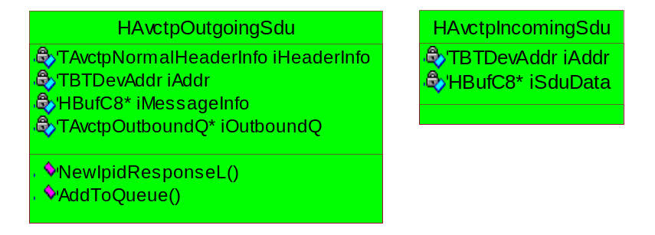
Figure 14
The incoming SDU class stores an SDU as it’s represented on the air in iSduData and in addition just contains the address of the remote device that it came from. These SDUs are queued in a normal TDblQue.
The outgoing SDU class stores an SDU in two parts; iHeaderInfo and then the message data part of the packet is contained in iMessageInfo. The difference in approach to the SDUs travelling in different directions is due to the way the SDUs are received. Outgoing SDUs are given by clients in pieces so that they don’t have to know how to format the packets. It’d be nice if in the future the incoming SDUs were separated into a similar format before being passed out of the protocol layer.
TAvctpOutboundQ is a class used by CAvctpSap to store HAvctpOutgoingSdu objects. A simple queue isn’t good enough because of the requirement that the queue be limited in size. Using an RArray of some sort was considered but was not considered to be quite right for the situation. One of the advantages of the close relationship between HAvctpOutgoingSdu and TAvctpOutboundQ is that the queue is automatically updated on the destruction of an outgoing SDU object, hence HAvctpOutgoingSdu’s un-owned pointer to iOutboundQ.
The NewIpidResponseL(const HAvctpIncomingSdu& aIncomingSdu) function constructs the appropriate HAvctpOutgoingSdu IPID response to aIncomingSdu which by this point will have been determined to be for an invalid by CAvctpProtocol. The function is defined in this class to prevent exposing iHeaderInfo to users of the class.

Packet Classes
These classes are used only with CPartialIncomingSdu and CPartialOutgoingSdu to help manage the conversion of SDUs into PDUs. The classes are designed to be created once on the heap and then reused over and over again for different actual packets. This is for efficiency reasons as only a reset needs to be called between uses rather than both a destruction and construction call. Similarly the reuse pattern prevents undesirable heap churn.
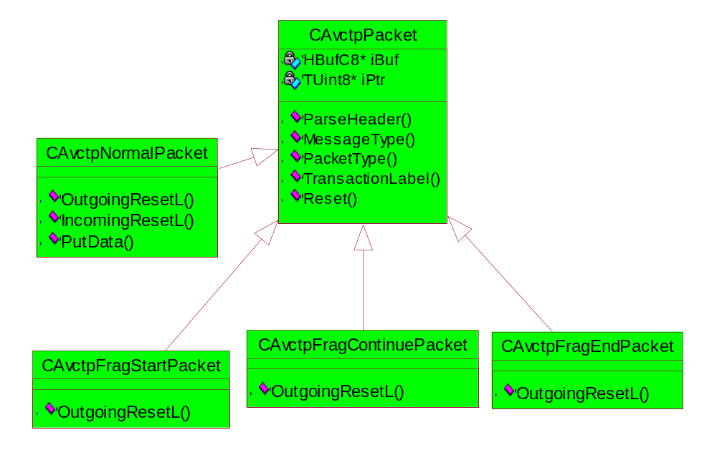
Figure 15
CAvctpPacket holds a direct binary representation of the packet in iBuf. The MessageType(), PacketType() and TransationLable() are just getter functions as this is an abstract class that manages the common behaviour.
- The Reset() provided in the base class blanks the object and restores it to an empty state waiting for reuse.
- A static function, ParseHeader(), is provided that will check a TAvctpHeaderInfo object given the air representation of a PDU.
The other classes all have an OutgoingResetL() function that allows users to reset the object in question and setup the new PDU with the header information and message data. This is the only point at which most of the fields in the header are set. The reason for this is that clients shouldn’t need to adjust these fields after the initial setup so no API is provided to do this to prevent misuse.
CAvctpNormalPacket is different to the other base classes above because it is used to build up a Normal Packet from fragments. To do this it has an IncomingResetL() function which allows the user to allocate memory for the whole SDU on receiving the first Start fragment which gives us this information. Secondly it provides the PutData() function so that users can append further message information as it comes in.

Header Classes
These classes could easily have been simple structs that provide convenient containers for the information that is contained in the headers transmitted over the air. They don’t provide any checking of the information they contain. The classes shown below are used mainly by the Packet Classes.
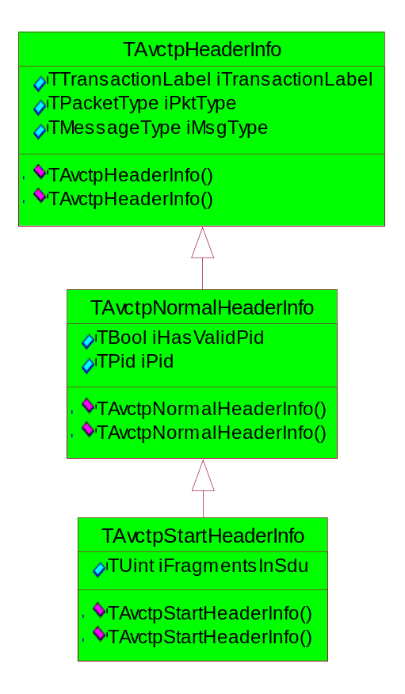
Figure 16

AvctpPlugins Dll
The simple reason for the existence of this dll is to provide the plugins required by the RSubConnection & RConnection APIs.
These plugins cannot be provided by bt.prt as ECOM plugins require the dll to have target type PLUGIN whereas Comms-Infras requires bt.prt to have target type DLL. Also it’s an architectural nicety to have all the plugins in one dll especially as the only viable alternative would be to have them in the client side dll which isn’t great for the ESockSvr side only plugins.

Factory Plugins
ESockSvr uses factory plugins as a means of obtaining the server side providers for RConnections and RSubConnections. The factories are given to the server in the protocol’s esk file. Since there are three such providers (CAvctpConnection, CAvctpSapLinksMgr and CAvctpMuxer), there are three factories (CAvctpConnectionFactory, CAvctpUpperSubConFactory and CAvctpLowerSubConFactory respectively).

Sub Connection Factories
Both CAvctpUpperSubConFactory and CAvctpLowerSubConFactory work in identical fashions by allowing ESockSvr to call the appropriate ‘NewL’. They do this by first ‘loading’ the AVCTP protocol via the SocketServExt API. Since the protocol will already be in memory by this point, this will be a quick call and is the only way of getting a pointer to CAvctpProtocol to call the ‘NewL’ functions NewSapLinksMgrL and NewMuxerL.

CAvctpConnection and CAvctpConnectionFactory
The fact that AVCTP doesn’t have a direct use for RConnections means that CAvctpConnectionFactory and CAvctpConnection only exist to satisfy the Comms-Infras framework and are both virtually dummy implementations. Both classes do the minimum amount of work to satisfy the requirements imposed on them by the architecture. One point to note is that the architecture places a restriction on these classes that they can’t synchronously complete some of the calls on them so the classes have a number of call-backs to work around this.
Whilst CAvctpConnection is mainly a dummy implementation, the Comms-Infras architecture allows us to specify the security required to open a connection provider object but it doesn’t allow this for sub connection providers which therefore all must have the same security restrictions (since a sub connection cannot be opened with out a connection). Hence we police the requirement that RSubConnections can only be opened with the capability LocalServices and a specific SID (currently RemCon server’s SID just as for RSockets) within CAvctpConnection.
The reason CAvctpConnectionFactory exists is to provide CAvctpConnection objects. It does this by creating one directly since the CAvctpConnection class lives in the same dll.

RSubConnection Events
These events all derive from CSubConNotificationEvent which hides as much of its ECOM and NetMeta nature as possible from derived classes. What is left for derived classes is to fill in the remaining details such as providing an ECOM resource file, a UID to the base class constructor to allow NetMeta to identify the class objects later and a NetMeta attribute table to be set up.
For the purposes of AVCTP these classes are just simple events to that partly provide information by their very nature. For instance, if CAvctpRemoteDevices receives a CAvctpSubConEventDiscInd event then this means a disconnection is being indicated.
To provide the additional information required, the AVCTP events derive from either CAvctpSubConDeviceEvent (which provides the remote address of the device that is associated with the event) or CAvctpSubConDeviceErrorEvent (which provides the remote address as well as an error).

Scenarios
There are eight sequence diagrams given in [R6] under Logical View -> BT PRT -> <<subsystem>> AVCTP. Unfortunately they are not up-to date in every detail but do at least show the basic ideas correctly.
- CreateNewConnection – This sequence shows the main steps required to set up a connection from a local Connect call on an RSubConnection down through the AVCTP protocol layer to the L2CAP boundary and back up again. This sequence is in the situation where there isn’t a Muxer already.
- CreateAnotherConnection – This sequence shows the main steps required to set up a connection from a local Connect call on an RSocket down through the AVCTP protocol layer to the L2CAP boundary and back up again. This sequence is in the situation where there is already a Muxer for the remote device. We also consider the more complicated case where we’ve been given a higher security setting than we had before
- RemoteConnection – This sequence shows the main sets required to set up a connection from on receiving a connection attempt from a remote device.
- LocalDisconnection – This sequence shows the main steps required to tear down a connection on receiving a disconnection request on the local device side.
  - Case 1: There is another client of the Muxer it won’t be closed.
  - Case 2: There is no other client of the Muxer so it should be closed.
- RemoteDisconnection – This sequence shows the main steps required to respond to a remote device disconnecting our underlying L2CAP link to them.
- RSocketClose –This sequence shows the main steps required to respond to the close of an RSocket
- SendData – This sequence shows the main steps required to send AVCTP data that we’ve been given by ESock via L2CAP.
- Case 1: RAvctp has already brought up a connection to the required remote address.
- Case 2: RAvctp has not brought up a connection to the required remote address.
- Case 3: RAvctp has brought up a connection to the required remote address but L2CAP Write blocks part way through sending the fragments of a packet
- Receive – This sequence shows the main steps required to process a packet received by L2CAP that is addressed to AVCTP up to an RSocket in the AvctpServices dll.
- Case 1: The received packet is not on a PID for which there is a SAP.
- Case 2: The received packet is on a PID for which there is a SAP.

Design Considerations
This section should contain any design considerations that have not been described elsewhere and that are important to understanding the design decisions taken. It may include:
- ROM/RAM Memory Strategy
- Error condition handling
- Non-functional issues
- Localisation issues
- Hardware/Platform assumptions
- Performance considerations
- Compatibility considerations (Binary, Source, Data)
- Interoperability considerations
- Platform Security
- Modularity
- Configurability and impact on Master Codeline

Future Work
- Currently each of the three AVCTP dlls implements its own logging macros etc. This should be rationalised in future to avoid duplication. This is an issue for the whole subsystem though and so should probably be done when the logging for the whole subsystem is changed.
- It would be good to have an AVCTP protocol module split out from the current bt.prt that contains all the Bluetooth protocols. This is an issue for a large part of the subsystem though and so should be done when the subsystem is updated along these lines.
- Currently only the RemCon server is allowed to open AVCTP RSockets & RConnections for security reasons. If this becomes too much of a restriction in future a resource / SPD file to match PIDs <-> SIDs could be created so that licensees don’t have to branch part of the qualified Bluetooth subsystem.
- Bluetooth security in AVCTP is currently quite inflexible as no choice is given. Future users may require security on a per device basis. This could be done by adding further states to CAvctpMuxer though any design would have to manage the security requests by different profiles for the same connection.
There is no point providing the ability to do security per (PID, remote device) pair because the spec (R[2]) mandates that all profiles to the same remote device go over the same L2CAP link so they would all have to have the same security settings anyway. If two profiles give different security requirements for the same remote device then the harsher security will be applied to both profiles on that remote device.
This security work was partially designed at one point so I’ve attached the notes I made below:
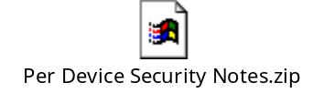
- The AVCTP protocol should be upgraded to use RMBufs rather than descriptors to take advantage of the zero-copy architecture provided by ESock. This would mean the User Plane classes would all use RMBufs to pass round data to reuse the code developed in the networking team to offer allocation and de-allocation of RMBufs in O(1) time from the MBuf Manager’s own memory chunk in the process. The RMBufs thus allocated exist in process context and can freely be passed between threads within the process and are thread safe. They provide a useful way of transferring the packet data around without the need for inefficient copying of the data.
- When the CControlledServProvider API is finalised, CAvctpSap should derive directly from that rather than from CServProviderBase to reduce the overhead on the user plane.
- Currently SDUs get passed from AvctpServices to the protocol layer as a package containing the header information and the message data in separate member variables whereas the SDUs going from the protocol layer to AvctpServices are given as a descriptor representing the whole packet. It would be good to have both directions operating in the same way for clarity.
- Update the scenarios in Section 4.

Further Information

References
No. | Document Reference | Version | Description
[R1] | “UML Explained” |  | by Kendall Scott  (http://www.amazon.co.uk/exec/obidos/tg/stores/detail/-/books/0201721821/toc/202-4456432-1159001)
[R2] | AVCTP Specification | 1.0 | \\Camfiler01\softeng\Departmental\PAN\Public\Bluetooth Specifications\AV\AVCTP Spec v1_0.pdf
[R3] | Bluetooth Core Specification | 1.2 | \\Camfiler01\softeng\Departmental\PAN\Public\Bluetooth Specifications\1.2\BT_Core_v1_2.pdf
[R4] | OSI 7-Layer Model |  | http://www.pcsupportadvisor.com/nasample/t04124.pdf.
[R5] | AVCTP PICs | 1.0 | \\Camfiler01\softeng\Departmental\PAN\Public\Bluetooth Specifications\AV\AVCTP PICS v1_0.pdf
[R6] | Bluetooth Rational Rose File | 0.9 | //EPOC/master/common/generic/37luetooth/latest/37luetooth/design/Bluetooth.mdl
[R7] | Bluetooth Assigned Numbers | 1.1 | \\Camfiler01\softeng\Departmental\PAN\Public\Bluetooth Specifications\1.1\core\Bluetooth_11_Assigned_Numbers.pdf
[R8] | Bluetooth_Design_AVRCP |  | //EPOC/master/common/generic/37luetooth/latest/documentation/Bluetooth_Design_AVRCP.doc
[R9] | NetMeta Design Document |  | //EPOC/master/common/generic/comms-infras/Elements/NetMeta/Documentation/NetMeta_Design_Document.doc
[R10] | Book |  | Design Patterns: Elements of Reusable Object-Oriented Software  by Erich Gamma, Richard Helm, Ralph Johnson, and John Vlissides
[R11] | ESock Design | 2.0 | //EPOC/Master/common/generic/comms-infras/esock/Documentation/ESock_Design.doc

Open Issues
The following issues need to be resolved before this document is completed;

Glossary
The following technical terms and abbreviations are used within this document.
Term | Definition
AVCTP | Audio\Video Control Transport Protocol
AVRCP | Audio\Video Remote Control Profile
L2CAP | Logical Link Control and Adaption Protocol
PID | Profile Identifier (port number to ESock). The spec [R2] mandates that a PID shall be identical to the 16-bits UUID of the service class defined for that profile in the Bluetooth Assigned Numbers document. [R7]
IPID | Invalid PID
AO | Active Object
MTU | Maximum Transmittable Unit
SAP | Service Access Point
IPC | Inter-Process Communication
PDU | Packet Data Unit – the message that goes over the air.
SDU | Signalling Data Unit – the complete / un-fragmented message. It’s possible for the SDU = PDU but size (SDU) is always >= size (PDU)

