AVRCP Design Document

Status: | Draft
Version: | 0.7
Team/Department: | Shortlink/Core

Contents
1 Introduction 4
1.1 Purpose and Scope 4
1.2 Top Level Requirements 4
1.2.1 Profile implementation 4
1.2.2 Plugin to Remote Control Framework 4
1.2.3 Extension command sets 4
1.2.4 Multiple connections 4
1.2.5 Multiple outstanding commands 4
2 Design Overview 4
3 Detailed Design 5
3.1 CRemConBearerAvrcp 6
3.1.1 Overview 6
3.1.2 Behaviour 6
3.2 CRcpRemoteDevice 7
3.2.1 Overview 7
3.3 Command Handlers 7
3.3.1 Overview 7
3.3.2 Behaviour 7
3.4 CRcpCommand 10
3.4.1 Overview 10
3.4.2 Behaviour 10
3.5 CRcpRouter 14
3.5.1 Overview 14
3.5.2 Behaviour 14
3.6 CAVCFrame 15
3.6.1 Overview 15
3.6.2 Behaviour 15
3.7 RemConAvrcpStatusConverter 15
3.8 RemConStatusApi 15
4 Scenarios 15
4.1 RemCon loads AVRCP plugin 15
4.2 RemCon makes connect request 15
4.3 RemCon makes disconnect request 16
4.4 Receive button press (play) then button release (play) from remote device 16
4.5 Receive button press (play) then button press (stop) from remote device 16
4.6 Receive unmatched button release (play) from remote device 17
4.7 Receive button press (unknown operation id) from remote device 17
4.8 Receive button press (vendor unique) from remote device 17
4.9 Receive Vendor dependent command from remote device 18
4.10 Receive button press/release (play) from RemCon 18
4.11 Receive button press (play) then button release (play) from RemCon 18
4.12 Receive button press (play) then button press (stop) from RemCon 18
4.13 Receive button release (play) from RemCon 18
4.14 Receive button press (unknown operation id) from RemCon 18
4.15 Receive button press (vendor unique) from RemCon 18
4.16 Receive Vendor dependent command from RemCon 18
5 Design Considerations 18
6 Further Information 19
6.1 References 19
6.2 Open Issues 19
6.3 Glossary 19
6.4 Errata 19

Introduction

Purpose and Scope
This is a draft document describing the design of the AVRCP component at one stage in its development. The design of the released component differs in some ways from that described here.
This document provides a design description of the AVRCP RemCon plugin. It is aimed at a target audience of members of the shortlink development and support teams as well as testers and licensees.
It should be read in conjunction with the RemCon Bearer plugin HOWTO, which describes the interface between RemCon and the bearer plugins and provides bearer generic information.
The location of AVRCP is in the bluetooth/profiles/avrcp/ directory.

Top Level Requirements

Profile implementation
The AVRCP implementation must support the complete command set defined in the Audio/Video Remote Control Profile specification [R3].

Plugin to Remote Control Framework
The AVRCP implementation must be provided as a plugin to the generic Remote Control Framework [R2]. It will accept generic remote control commands from RemCon and map them to the appropriate AVRCP command for delivery to the appropriate remote device. AVRCP responses must then be mapped back to generic remote control commands for delivery to RemCon. Similarly AVRCP must be able to listen for commands from remote devices and perform mapping to and from generic remote control commands to exchange commands and responses with RemCon.

Extension command sets
Extension commands may be provided in AVRCP with the Vendor Unique passthrough command and Vendor Specific commands. When receiving an extension command AVRCP must attempt to find an extension handler for that command. The handler should then attempt to map the command to the generic command set, and failing that map it to an extension interface. The command, be it part of the generic remote control interface or an extension one, may then be passed to RemCon as usual. The response from the application must also be dealt with by the handler before being returned to the remote device.

Multiple connections
AVRCP must support exchange of commands and responses with multiple remote devices.

Multiple outstanding commands
AVRCP must allow multiple commands to be outstanding. If multiple client applications are using RemCon then they may issue commands in parallel. By allowing multiple outstanding commands on one bearer this removes the requirement on RemCon to serialise these requests. This has the advantage (for bearers that support it) that a command where the response may not be immediate does not block the use of the bearer for other commands.

Design Overview
The diagram below shows a high level view of participating classes. Please refer to the Errata section at the end of this document for important information regarding changes to class names for production. The class CRemConBearerAvrcp is derived from CRemConBearerBase and is instantiated by RemCon.
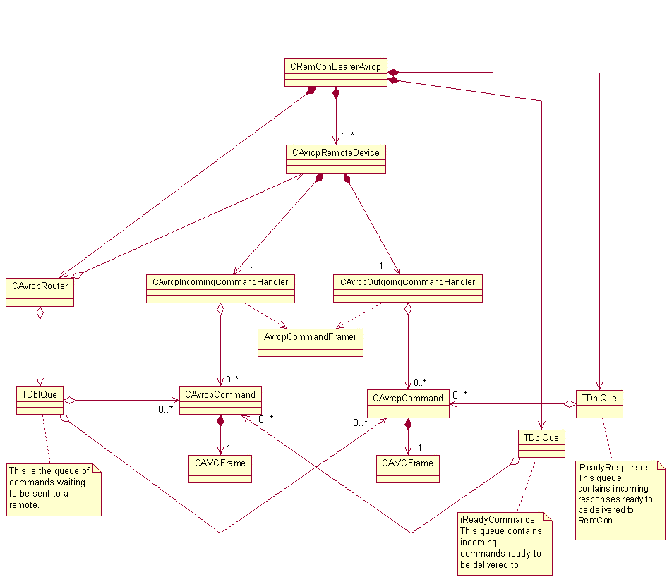

Detailed Design
The following table briefly describes the functional areas into which this component is broken down. The subsections below give more detail about each area.
Object name | Description | Associated (owned/dependant) objects
RemCon | Generalised Remote Control Framework
CRemConBearerAvrcp | Main bearer class derived from CRemConBearerBase instantiated from RemCon.
CRcpIncomingCommandHandler | - Maps between generic RemCon commands and AVRCP commands  - Handles timeouts  - Generates or swallows command or response events as required
CRcpOutgoingCommandHandler | - Maps between generic RemCon commands and AVRCP commands  - Handles timeouts  - Generates or swallows command or response events as required
CRcpRemoteDevice | Manages pair of command handlers for one remote.
CRcpCommand | Encapsulates an AVRCP command
CAVCFrame | Encasulates an AVC frame
AvrcpCommandFramer | Provides functionality to parse and create an AVRCP command
CRcpRouter | Manages connection to remote devices – queueing and send state
RAvctp | Provides interface to AVCTP protocol

CRemConBearerAvrcp

Overview
This provides the interface to RemCon. It is derived from CRemConBearerBase. It manages CRcpRemoteDevices, routing messages from RemCon to the one.

Behaviour
This is the interface between AVRCP and RemCon. It deals with exchange of commands and responses and connection management. The main issue is queuing. Bearers notify RemCon when they have new data, which is then requested by RemCon when it is ready to process it. Much of the command management behaviour is dependent on history for a particular remote device and so this suggests per device queues, but this means that the CRemConBearerAvrcp class must have a strategy for selecting ready commands. Three strategies for queuing have been considered and are described below. The selected strategy is 3.1.2.3, queues per remote device with a two ready queues in the bearer, one for commands and one for responses.

Queue shared between remote devices
This complicates command handling as much of this is dependent on per remote device state. The cost of having to search through the queue to recover the device history may not be justified by this simplification one queue offers. CRemConBearerAvrcp would still be obliged to search through the queue for a ready message, as for instance AVRCP will hold on to button press events for a short time to see if they can be sent to RemCon as a button click so the command at the front of the queue may not be the first one needing to be sent.

Per remote device queues, some form of selecting direct from queues
This has the advantage of keeping recent device history together. However the problem of selecting a ready command remains. Additionally it may be difficult to ensure a fair ordering of delivery of commands to RemCon without retaining some sort of queuing information, in which case the strategy outlined in section 3.1.2.3 is likely to prove more successful.

Per remote device queues, ready queue in CRemConBearerAvrcp
Commands and responses when received are queued by their CRcpRemoteDevice. When a message is ready to be given to RemCon the CRcpRemoteDevice handling it must inform CRemConBearerAvrcp. This may not be as soon as the command is received, for instance AVRCP will hold on to button press events for a short time to see if they can be sent to RemCon as a button click. If the command handler informs CRemConBearerAvrcp when a message is ready for delivery to RemCon (whether it has been received from a remote device or generated locally) CRemConBearerAvrcp can add this to its queue and inform RemCon that data is ready for collection. It can then deliver messages from this queue in order. Ownership of the command remains with the command handler. The command has a DecrementUsers() function which should be called by CRemConBearerAvrcp when the command has been delivered to RemCon. This may lead to timers being cancelled or deletion of the command.

CRcpRemoteDevice

Overview
This is a simple wrapper class that manages a pair of handlers, a CRcpIncomingCommandHandler and a CRcpOutgoingCommandHandler for one remote device.

Command Handlers
The command handlers perform much of the work in AVRCP. They have responsibility for parsing received messages and constructing outbound messages, and generating necessary command and responses to remote devices and RemCon.

Overview
Three classes contribute to the command handling framework, CRcpIncomingCommandHandler, CRcpOutgoingCommandHandler and CRcpCommand. The command handlers manage mapping between RemCon commands and AVRCP commands and each maintain a command queue. This consists of CRcpCommands, a class which encapsulates an AVRCP command including timeout management.
Command handling relies a lot on per remote device history, for example if a button press command with one operation id is followed by a button press with a different operation id a button release for the first operation id should be generated. For this reason it seems prudent to have separate queues for each remote device. All the state within the command handler is per queue, so rather than have multiple queues within a command handler there is a command handler pair (incoming and outgoing) per remote device.

Behaviour

Button Actions
Part of the functionality of the command handler is generating or swallowing events as appropriate. The main cause of this is button action handling. The AVRCP passthrough command includes a button action, either button press or button release. As button actions are a generic remote control concept they are also present in the RemCon client API. As well as the button press and release actions RemCon offers a momentary press/release action as in many cases when a button is pressed it is almost immediately followed by a button release.
For outgoing commands from RemCon it is straightforward to generate two AVRCP commands. The case of incoming commands is more complex. The AVRCP implementation must make decisions about when a momentary press/release should be generated. AVRCP mandates that a command shall not be judged to be press and hold until 300ms after the button press has been received. Additionally, if a button release has not been received after 2s, or a button press for a different operation is received a button release should be assumed by the client. The events the AVRCP should generate to RemCon as a result of these is summarised below. Received AVRCP commands are shown in black, events generated to RemCon are shown in red.
0ms | < 300ms | 300ms | 300ms > < 2s | 2s
Press1 | Release1 Momentary1
Press1 |  | Press1 | Release1 Release1
Press1 |  | Press1 |  | Release1
Press1 | Press2 Momentary1  (Press2 or Momentary2 will be generated depending on when Release2 is received)
Press1 |  | Press1 | Press2 Release1 (Press2 or Momentary2 will be generated depending on when Release2 is received)

By waiting for up to 300ms following a button press to determine if a momentary press/release the time between a press and release is reduced by 300ms. Additionally latency in the command delivery is introduced.
It is not clear that generating instantaneous press/release actions is the best strategy. Applications must deal with separate presses and releases anyway. If AVRCP guarantees generation of missing button releases and interim button presses in press and hold operations then the possible simplification of application logic may be outweighed by the disadvantage of higher command latency and altered spacing of press and release actions. It is the case however, that most commands will probably come in tightly coupled press and release actions and so the latency caused by waiting for the matching release is likely to be minimal in most cases and this behaviour simplifies requirements on the application in the common case.
An additional issue raised by not having a one to one mapping between AVRCP commands and RemCon commands is that of responses. For instance if an app sends a momentary press/release and the press generated by AVRCP is accepted by the remote device but the release is rejected it is not obvious what response should be returned to the application. The approach taken is use the response for the press. In most cases it is likely that the only information returned is whether the command is supported or not, and that is known once the press response has been received. If the release has failed in some way the remote must deal with this anyway.

Generated and Swallowed commands
In some situations other than with button actions it is necessary for command or response events to be generated or swallowed by AVRCP.
For passthrough commands AVRCP requires a response within 100ms. To ensure a client application responded within that timeframe would not be feasible. Instead AVRCP internally generates responses for passthrough commands. The response for any passthrough command in the RemCon client core API is and AV/C Accept. Otherwise an AV/C Not Implemented is returned. This is valid as the AV/C accept response only shows that the received command is being processed. It does not indicate that the operation has, or will be, successfully completed.
The AVRCP specification requires support for Unit Info and Subunit Info commands. These are device wide commands. For these two reasons it is not valid to pass through unit and subunit info to the client. This would place a requirement on all target clients to respond to the functions. The client applications are not well placed to respond as they only know about themselves, not the device as a whole. AVRCP internally generates responses containing the generic vendor id and does not inform RemCon about any received Unit Info and Subunit Info commands. The RemCon Status API may be used by client applications that wish to send outgoing Unit or Subunit Info commands.
The requirement to generate a response within 100ms is placed on all AVRCP commands. For vendor dependent commands final responses cannot be generated internally and must be provided by a client. For this reason AVRCP responds with an AV/C interim for vendor dependent commands that have been successfully converted.

Command/Response matching (May change if bearer i/f changes)
Multiple commands may be outstanding on AVRCP at any one time. This means that when a response is delivered to RemCon the command to which it is a response must be identified. This is done with a command id provided by RemCon when the command is issued. When an AVRCP command is sent over AVRCP it is matched with its response using an AVCTP transaction label. A CRcpCommand encapsulates an AVRCP command and as well as containing the command data maintains the knowledge of the AVCTP transaction label and RemCon command id associated with that command. This enables command response matching by the outgoing command handler.
This matching also takes place for incoming commands. However because the commands don’t arrive with a RemCon command id a request is issued on RemCon to provide a new command id when a new command that should be passed to RemCon is received.

Extension command handling
When a command is received from RemCon that cannot be mapped by AVRCP it must try and find an extension handler that can perform the mapping. Bearer extension handlers implement an ECom interface. The loading and management of these extension handlers are managed by the bearer base class.
An unknown command is then passed to this interface for packaging into an AVRCP command.
RemCon offers the client application a default interface containing a generic set of remote control commands. This interface is uniquely identified with a UID. Third parties may provide additional interfaces available to the client, each with a UID. Each interface contains a set of commands, with each command within the interface uniquely identified by a command id. In this way any command can be uniquely identified by the interface UID and command id pair. The bearer extension handler should parse the AVRCP command to generate the appropriate pair, if possible mapping the received AVRCP command to a command that is part of the generic interface.
Commands received from a remote device are handled by the same plugin, but in this case it maps from an AVRCP command to a RemCon command. This may be part of the generic interface, but also may be part of an extension interface. For this reason the extension handler parses the command to find the interface id and command id pair that uniquely identify this command to the client side interface above RemCon.

Timeouts
The AVRCP mandates a target respond to a command within 100ms. This must be a final response for passthrough commands (immediate transaction), but vendor dependent commands may return an interim response to indicate that the final response will follow later (deferred transaction). This 100ms refers to the time taken within the target to process the command. This means that the response may be received more than 100ms after the command was sent. As a compromise AVRCP uses a timeout of 200ms. AVRCP is permitted to retry sending of a command if a response is not received within the allotted time. This is not done however. A timed out response is generated to the RemCon, allowing the client application to make the decision if the command is still valid. In the case of a deferred transaction the timeout for receiving a final response should be set on a per command basis. As the only commands for which deferred transactions are permitted within AVRCP are vendor dependent the applicable timeouts are not known to us. These timeouts may be very long, for instance if a controller issues a Notify command and the status does not change for some time, so imposing a limit, even a very large one may cause issues. RemCon limits the number of commands outstanding per client, so this should place some limit on the number of items on the queue. The queue will be flushed on disconnect.

CRcpCommand

Overview
The CRcpCommand class encapsulates an AVRCP command including timeout management.

Behaviour
A CRcpCommand consists of the following:
TDblQueLink iHandlingLink - Used to form handling queue in command handlers
TSglQueLink iReadyLink - Used to form ready command queue in CRemConBearerAvrcp
TDblQueLink iSendLink - Used to form send queue in CRcpRouter

TUint iRemConId - the RemCon command cookie used for RemCon command/response matching
SymbianAvctp::TTransactionLabel iTransactionId – the AVCTP transaction label, used for AVCTP command/response matching

TBool iIsClick – Whether this is part of a click, i.e. a pair of commands that correspond to one RemCon command.

TDeltaTimerEntry* iTimerEntry – An entry on the timer queue
TAvrcpTimerExpiryInfo* iTimerExpiryInfo – Info used to deal with a timer expiry

CAVCFrame* iFrame – the AV/C frame corresponding to this command
TBTDevAddr iRemoteAddr – the remote device address associated with this command

TUid iInterfaceUid – the interface Uid for this command
TUint iOperationId – the operation Id for this command
RBuf8 iCommandData – the RemCon data for this command

TUint iUsers – Reference count for this command

Up to three objects need to know about any CRcpCommand. The bearer needs to know what commands are available for delivery to RemCon, the router needs to know what commands are waiting to be sent to a remote and the handler needs to process commands as they are received from either a remote or the bearer. Because these sets of commands are disjoint a CRcpCommand has three queue links to enable the bearer, router and handler to queue only those commands they are interested in.
A CRcpCommand owns itself. It offers two functions, IncrementUsers() and DecrementUsers() to allow it to reference count. A user of a CRcpCommand must call IncrementUsers() when it begins to be interested in a CRcpCommand and DecrementUsers() when it will not access that command any more. When the number of users is decremented to zero, the command will delete itself.
A CRcpCommand can be created from an AV/C frame, for incoming commands, or from RemCon data, for outgoing commands. Calling NewL() sets all the command data. Before a command can be used it must be processed, by calling:
TInt ProcessIncomingCommandL(MRemConBearerObserver& aObserver); or
void ProcessOutgoingCommandL(MRemConBearerObserver& aObserver);
ProcessIncomingCommandL() will leave if there is an environmental problem with the command processing, such as out of memory. In this case it is unlikely an appropriate action would be able to be taken and the command is dropped. The function also returns the result of processing as a TInt. This allows the command handler to perform the appropriate action with the command, for instance returned an error response to the remote or delivering the command to RemCon. ProcessOutgoingCommandL() does not need to return a result as both environmental errors and badly formed commands result in notifying RemCon of the failure to send the command.
There is clearly some duplication of data here as the CAVCFrame and the set of RemCon command information can be used to generate each other. However as AVRCP needs to parse received commands into the format for delivery it is considered that the memory impact of retaining the information is less important than timely delivery of commands when requested.
The sequence diagrams below show examples of message paths. Please refer to the Errata section at the end of this document for important information regarding changes to class names for production. The first diagram shows reception of a command and pick up of that command by RemCon. The second diagram shows merging of commands to form a single click command to RemCon. The third diagram shows separate button press and release commands.
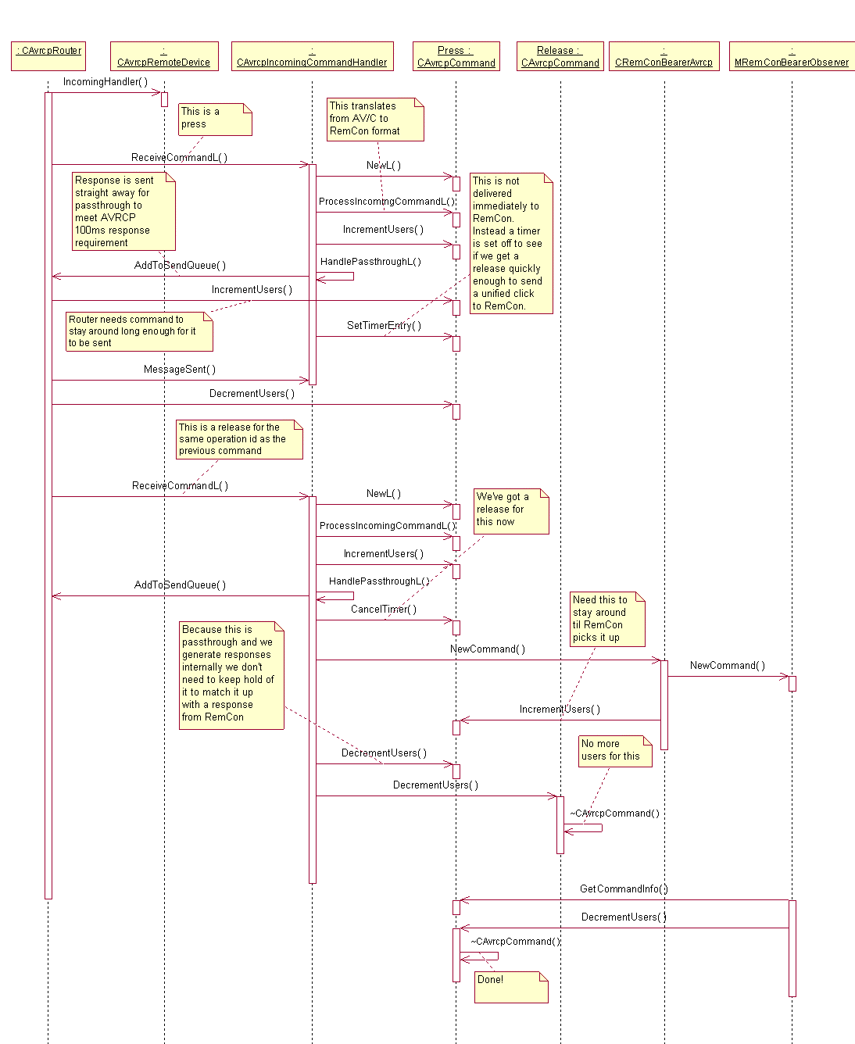

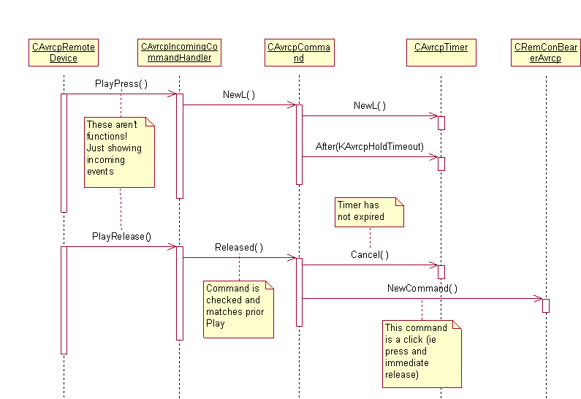

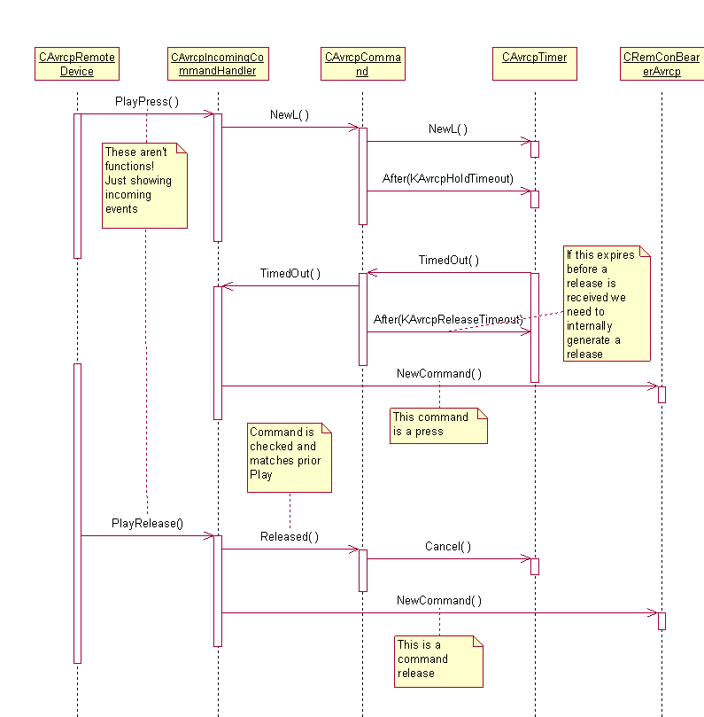

CRcpRouter

Overview
This manages an AVCTP connection to a remote device. This is done by owning an RAvctp and performing appropriate actions according to the state of the link and the events generated from the remote device and the local command handlers.

Behaviour
There are two type of event handled by the router, control events, such as connect requests, and data events, such as sends.
Control events are routed between the RAvctp and the bearer. Incoming control events are passed to the bearer enabling it to take appropriate actions, for instance creating a new CRcpRemoteDevice on a connection indication.
Data events are routed between the RAvctp and the command handlers. The router has a list of CRcpCommands (the commands are owned by themselves, and are the same commands as are present on the handling and bearer lists). This is an ordered queue. When a handler issues a send on the router the command is added to the end of the queue. If the router is not currently sending it will issue a send to the RAvctp. Otherwise the SendComplete from the RAvctp will trigger the router to examine its queue to see if there are any remaining commands to send.
The bearer owns a list of CRcpRemoteDevices which the router also has access to. It uses this to route incoming messages to the correct handler.

CAVCFrame

Overview
CAVCFrame is part of AVC.dll. A library providing functionality related to AVC frames.

Behaviour
A CAVCFrame can be created from a buffer. This is likely to be needed for data originating from a remote device. Alternatively the frame can be created by providing the required fields. Functions are provided to get and set the most common fields as well as allowing direct access to the data.

RemConAvrcpStatusConverter
This is a simple converter plugin to RemCon. It converts AVRCP Unit Info and Subunit Info commands from RemCon format to AV/C frames and responses from AV/C frames to RemCon format.

RemConStatusApi
This is a simple RemCon outer layer client API dll. It allows clients to issue AVRCP

Scenarios
This section details practical success and failure scenarios that demonstrate the interaction between the design units.

RemCon loads AVRCP plugin
CRemConBearerAvrcp::NewL() is called via ECom.
CRemConBearerAvrcp instantiates command handlers and CRcpRemoteDevice.
CRcpRemoteDevice is in the closed state.
CRcpRemoteDevice instantiates CAvctpClient.
CAvctpClient opens a listening AVCTP socket.

RemCon makes connect request
CRemConBearerAvrcp checks whether there is already a CRcpRemoteDevice for the requested remote.
If so the request is completed straight away.
FIXME Who reference counts connections – us or RemCon?
If not, CRemConBearerAvrcp creates a new CRcpRemoteDevice in the closed state.
CRcpRemoteDevice calls CAvctpClient::Connect(), the result of this is returned to RemCon.
When the socket connect initiated by CAvctpClient::Connect() is completed CAvctpClient calls ConnectConfirm() on CRcpRemoteDevice.
CRcpRemoteDevice transitions to the CanSend state.

RemCon makes disconnect request
CRemConBearerAvrcp passes the disconnect to the appropriate CRcpRemoteDevice.
CRcpRemoteDevice calls CAvctpClient::Disconnect.
CAvctpClient disconnects the AVCTP link.

Receive button press (play) then button release (play) from remote device
New AVRCP message is delivered to CRcpRemoteDevice from CAvctpClient.
CRcpRemoteDevice passes the command to CRcpIncomingCommandHandler.
CRcpIncomingCommandHandler parses the button press (play) command into a CRcpCommand.
CRcpCommand 300ms timer is started.
Either:
New AVRCP message is delivered to CRcpRemoteDevice from CAvctpClient.
CRcpRemoteDevice passes the command to CRcpIncomingCommandHandler.
CRcpIncomingCommandHandler parses the button release (play) command into a CRcpCommand.
AVRCP delivers button release (play) to RemCon.
Or:
CRcpCommand timer expires.
AVRCP delivers button press (play) to RemCon.
CRcpCommand 1.7s timer is started (to wait for rest of 2s for release)
At the earlier of timer expiration or button release (play) a button release (play) is delivered to RemCon.

Receive button press (play) then button press (stop) from remote device
New AVRCP message is delivered to CRcpRemoteDevice from CAvctpClient.
CRcpRemoteDevice passes the command to CRcpIncomingCommandHandler.
CRcpIncomingCommandHandler parses the button press (play) command into a CRcpCommand.
CRcpCommand 300ms timer is started.
New AVRCP message is delivered to CRcpRemoteDevice from CAvctpClient.
CRcpRemoteDevice passes the command to CRcpIncomingCommandHandler.
CRcpIncomingCommandHandler parses the button press (stop) command into a CRcpCommand.
CRcpCommand 300ms timer is started.
Timer for button press (play) command is cancelled.
AVRCP generates button release (play) to RemCon.

Receive unmatched button release (play) from remote device
(An unmatched button release may happen if a button press for one operation is followed by a button press for another, without an intervening release. In this case the profile specifies we must assume the missing release. If it then turns up later it should be ignored).
New AVRCP message is delivered to CRcpRemoteDevice from CAvctpClient.
CRcpRemoteDevice passes the command to CRcpIncomingCommandHandler.
CRcpIncomingCommandHandler parses the button release (play) command and discards it.

Receive button press (unknown operation id) from remote device
New AVRCP message is delivered to CRcpRemoteDevice from CAvctpClient.
CRcpRemoteDevice passes the command to CRcpIncomingCommandHandler.
CRcpIncomingCommandHandler parses the button press (unknown operation id) command.
CRcpIncomingCommandHandler creates a response with the result of rejected in a CRcpCommand and passes a reference to it to CRcpRemoteDevice for sending.
CRcpRemoteDevice adds the command to its queue.
Either:
CRcpRemoteDevice is in state CanSend.
Or:
CRcpRemoteDevice is in state Waiting.
CAvctpClient issues a SendComplete (due to an earlier send).
CRcpRemoteDevice transitions to state CanSend.
CRcpRemoteDevice passes command to CAvctpClient for sending and transitions to state Waiting.
CAvctpClient sends the command across the AVCTP link.
CAvctpClient issues a SendComplete.
CRcpRemoteDevice issues a SendComplete to CRcpIncomingCommandHandler.
CRcpIncomingCommandHandler removes the CRcpCommand for the rejection from its queue and deletes it.
FIXME Check avctpclient provides timeouts, so we can safely wait for a sendcomplete, even if it might be an error.

Receive button press (vendor unique) from remote device
New AVRCP message is delivered to CRcpRemoteDevice from CAvctpClient.
CRcpRemoteDevice passes the command to CRcpIncomingCommandHandler.
CRcpIncomingCommandHandler parses the button press (vendor unique) command into a CRcpCommand.
CRcpIncomingCommandHandler passes the command to extension handler FIXME elaborate here
CRcpRemoteDevice adds the command to its queue.
Either:
CRcpRemoteDevice is in state CanSend.
Or:
CRcpRemoteDevice is in state Waiting.
CAvctpClient issues a SendComplete (due to an earlier send).
CRcpRemoteDevice transitions to state CanSend.
CRcpRemoteDevice passes command to CAvctpClient for sending and transitions to state Waiting.
CAvctpClient sends the command across the AVCTP link.
CAvctpClient issues a SendComplete.
CRcpRemoteDevice issues a SendComplete to CRcpIncomingCommandHandler.
CRcpIncomingCommandHandler removes the CRcpCommand for the rejection from its queue and deletes it.

Receive Vendor dependent command from remote device

Receive button press/release (play) from RemCon

Receive button press (play) then button release (play) from RemCon

Receive button press (play) then button press (stop) from RemCon

Receive button release (play) from RemCon

Receive button press (unknown operation id) from RemCon

Receive button press (vendor unique) from RemCon

Receive Vendor dependent command from RemCon

Design Considerations
This section should contain any design considerations that have not been described elsewhere and that are important to understanding the design decisions taken. It may include:
- ROM/RAM Memory Strategy
- Error condition handling
- Non-functional issues
- Localisation issues
- Hardware/Platform assumptions
- Performance considerations
- Compatibility considerations (Binary, Source, Data)
- Interoperability considerations
- Platform Security
- Modularity
- Configurability and impact on Master Codeline

Further Information

References
No. | Document Reference | Version | Description
[R1] | “UML Explained” |  | by Kendall Scott  (http://www.amazon.co.uk/exec/obidos/tg/stores/detail/-/books/0201721821/toc/202-4456432-1159001)
[R2] | <filename> |  | Generic Remote Control Framework Design document
[R3] | \\Camfiler01\softeng\Departmental\PAN\Public\Bluetooth Specifications\AV\AVRCP Spec v10.pdf | 1.0 | Specification of the Bluetooth Audio/Video Remote Control Profile

Open Issues
The following issues need to be resolved before this document is completed;
- Updates as result of design review – this document does not reflect the current design of the component.
- Connection management – does a disconnect from RemCon always mean disconnect? Ie does RemCon know when a remote device is no longer needed by any of its clients.
- Command latency due to generation of momentary press/release – is this acceptable?

Glossary
The following technical terms and abbreviations are used within this document.
Term | Definition
AVCTP | Audio/Video Control Transport Protocol
AVRCP | Audio/Video Remote Control Profile

Errata
Certain class names appearing in the UML class diagram and sequence diagrams above have subsequently been changed for production, as follows:
Original name | Production name
CAvrcpRemoteDevice | CRcpRemoteDevice
CAvrcpRouter | CRcpRouter
CAvrcpIncomingCommandHandler | CRcpIncomingCommandHandler
CAvrcpOutgoingCommandHandler | CRcpOutgoingCommandHandler
CAvrcpCommand | CRcpCommand
CAvrcpTimer | A TDeltaTimerEntry / TAvrcpTimerExpiryInfo pairing per CRcpCommand, working in conjunction with a single CDeltaTimer in CRemConBearerAvrcp

